Non-Invasive Infrared Thermographic profiling of Surface Body Temperature in Adult Tripureswari Ducks: An Indigenous Duck Genetic Resource of Tripura, India

ABSTRACT

Infrared thermography (IRT) is a quick, non-contact, noninvasive and stress-free method for assessing the thermal physiology of livestock and birds. The Tripureswari duck, is an indigenous valuable duck genetic resource of Tripura registered by ICAR-NBAGR- INDIA_DUCK_1900_TRIPURESWARI_11004, are mostly reared under backyard and semi-intensive farming for egg and meat, with annual average egg production of 70 to 101 eggs, body weight of adult 1.199 kg at 12 months (ICAR-NBAGR; Kumar and Dwivedi, 2025). Being adapted and evolved in hot and humid climate of Tripura so far, no documentation about the surface thermal profile is available. So, the present preliminary study was undertaken to assess the different body anatomical region surface temperature using Infra-Red thermal camera in six apparently healthy adult male and six adults female Tripureswari ducks. The thermographic images were analyzed using Hikmicro analyzer software. Temperature recorded were expressed as mean ± standard error. Study revealed that Un covered area and highly vascularized regions, the leg (39.83 ± 0.37 °C and 39.53 ± 0.17 °C), periorbital area (39.20 ± 0.12 and 39.00 ± 0.17 °C) and under-wing surface (39.07 ± 0.11 and 38.82 ± 0.19 °C) respectively in adult male and female Tripureswari duck. These regions with the highest recorded temperatures are identified as primary thermal windows for radiative heat loss. In insulated densely feathered regions, like primary feather area (rump) (29.87 ± 0.32 and 30.18 ± 0.18 °C), flank (29.90 ± 0.14 and 30.62 ± 0.35 °C) and undertail coverts, were the lower temperature, justifying the insulation of plumage. The sharp temperature gradient between the hottest and coolest regions validates the role of plumage in regulating the core temperature while with selective peripheral heat dissipation. No distinct sex influences were recorded on surface temperature, with slightly warmer bill temperature in females than male and warmer mantle temperature in males. These preliminary observations, recorded for the first time in the Tripureswari Duck breed of Tripura, about the surface thermography will be helpful to validate the adaptation and hardiness to the humid wetland agro-climate of Tripura.
Keywords: Tripureswari duck, infrared thermography, thermal window, indigenous poultry genetic resource.

1. INTRODUCTION
Tripura holds the third-highest duck population rank (8.54 lakh) in the Northeast, after Assam and Manipur, as per the Livestock Census, 2019. Ducks (Anas platyrhynchos domesticus) play an important role as a household protein source, and rural livelihood security with meat and eggs, mostly reared in the wetland-rich, humid sub-tropical agro-climate of Tripura. The Tripureswari duck, an indigenous duck of Tripura, (ICAR-NBAGR- INDIA_DUCK_1900_TRIPURESWARI_11004), are mostly reared under backyard and semi-intensive farming for egg and meat, with an annual average egg production of 70 to 101 eggs, body weight of an adult 1.199 kg at 12 months (ICAR-NBAGR; Kumar and Dwivedi, 2025). The breed is distributed across the different district of Tripura and (Debnath et al., 2023). Despite this recent unique genotypic and phenotypic characterisation, no documented information is available about the surface thermal physiology of this Tripureswari duck, being well adapted and evolved in the hot, humid subtropical climate, hence pointing to a research gap in scientific understanding of its normal thermoregulatory adaptation.
Birds are homeothermic endotherms without any sweat glands, mostly dissipating metabolic heat by radiative, convective and evaporative pathways through featherless or sparingly feathered body surfaces, also called as thermal windows (Crandell et al., 2025). Duck plumage is highly insulative, so regions like legs, periorbital area, bill, under-wing surface and thinly feathered area remain the major sites for heat dissipation. The densely feathered areas, such as the back, flank and wing coverts, help to conserve heat and shield them against thermal fluctuation (McCafferty, 2013; Kim et al., 2021). Infrared thermography (IRT) is a very popular, non-contact, non-invasive, stress-free technology to track the differential radiative heat emission through the surface, and so this tool is progressively corroborated as a tool for identifying thermal status and physiological stress in avian species (Speakman and Ward, 1998; Jerem and Herborn, 2015; Tabh et al., 2021). Infrared Thermography is more applicable for field-level evaluation of indigenous and backyard poultry and ducks, as it does not require stressful restraint or invasive sampling, also guarding the animal welfare (McCafferty, 2013).
Surface temperature in chickens varies across different anatomical regions, with density of feathers, superficial cutaneous vascularity and proximity to the body maintaining regional thermal gradients (Kim et al., 2021). Featherless areas such as the periorbital area and legs respond delicately to ambient temperature changes and physiological stress (Tabh et al., 2021). To adapt in the aquatic habitat, the ducks and other aquatic birds need to maintain a equilibrium in thermal gradient between insulation and heat dissipation (Crandell et al., 2025). The Tripureswari duck is reared mostly in wetland paddy fields, ponds, and micro-habitats of Tripura in a hot, humid tropical climate. So a preliminary study about the thermographic profile shall provide useful baseline information about its thermal architecture and adaptation potency.
With the hypothesis that as in case of other avians the uninsulated, vascularised regions (leg, periorbital area and under-wing area) would exhibit higher surface temperatures than densely feathered regions (primary feather tract, flank and undertail coverts etc)(Kim et al., 2021). The present investigation was therefore undertaken for non-invasive mapping the surface body temperature in different anatomical body regions in adult male and female Tripureswari ducks using infrared thermography; identifying the prime thermal windows; and to understand sexual dimorphism of regional surface temperatures, if present.

2. MATERIALS AND METHODS

2.1 Location and climate
The study was carried out in Tripureswari ducks maintained under a semi-intensive, backyard, small-scale rearing system in Tripura, in and around West Tripura District. During the study period, the ambient temperature ranged from (Minimum-29⁰C to Maximum 34⁰C and relative humidity ranged from 74 % to 78%. Recording was performed during a period of thermally stable, clear-sky conditions to avoid confounding (Speakman and Ward, 1998; McCafferty, 2013).

2.2 Experimental birds
The surface temperature was recorded from a total of twelve apparently healthy, adult Tripureswari ducks (six adult males and six adult females) of comparable age (12-15 month) weighing approximately 1.35 kg (Male) and 1.2 Kg (female) were randomly selected from households in and around Agartala city of West Tripura. Imaging was performed from a distance on calm, unrestrained birds to avoid stress-related vasomotor changes (Jerem and Herborn, 2015; Tabh et al., 2021).

2.3 Thermographic imaging
Surface temperature was recorded using the protocol stated by Speakman and Ward, 1998; McCafferty, 2013). For thermography HIKMICRO MiniE thermal camera (Android 25Hz, Super IR (96 X 96) resolution images, with a measurement accuracy up to ±2°C, and can detect the temperature difference of 0.05°C. The camera was positioned approximately 1 m from birds (Tabh et al., 2021). Images were captured for each bird for three days. The images captured for each animal were analyzed in the "HIKMICRO Analyzer desktop app. Emissivity was set at 0.98. Recording was under shade calm environment, during early morning without disturbing and restraining the birds from a distance. The ambient temperature and humidity of that particular day were recorded accordingly.

2.4 Body regions evaluated
For each bird, surface temperature was recorded at eye, periorbital area, crown, nostrils, bill, chin, throat, breast, flank, leg (maximum), talon, undertail coverts, mantle, neck, ear and nape, primary feather area, secondary feather area, wing covert area, edge of the wing, back, and under-wing surface (McCafferty, 2013; Kim et al., 2021; Crandell et al., 2025).
The thermographic data’s were expressed as Mean ± standard error (SE). as per standard statistical methods in spread sheet and standard statistical software.

3. RESULTS AND DISCUSSION

3.1 Regional surface temperature distribution
The region wise surface temperature (mean ± SE) presented in Table no-1 for adult Tripureswari ducks (male and female) revealed that the mean surface temperature recorded varied across the different anatomical regions understudy study. The surface temperature ranged from a low of 29.87 °C and 29.90 °C in the primary feather area and flank to a high of 39.20°C and 39.83 °C in the periorbital area and leg area. This observations of regional gradient approximately of 10 °C between the coolest and warmest part of the same bird is consistent with other avian species, as feathered areas act as an effective insulative barrier while featherless or thinly feathered areas serve as window for heat dissipation (McCafferty, 2013; Kim et al., 2021; Crandell et al., 2025).

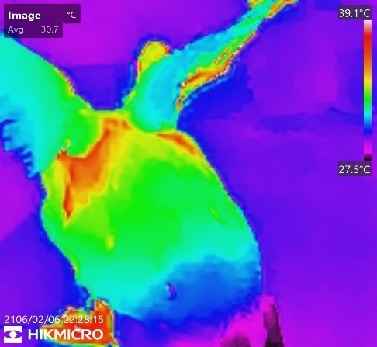
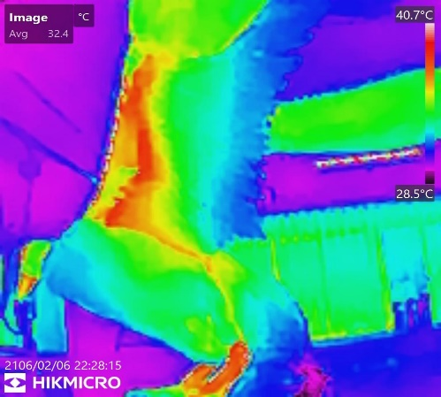
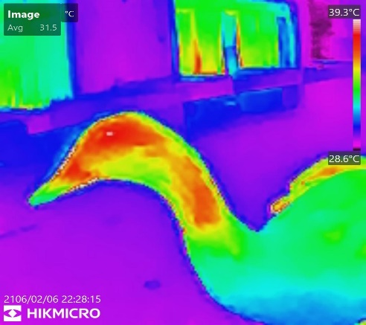
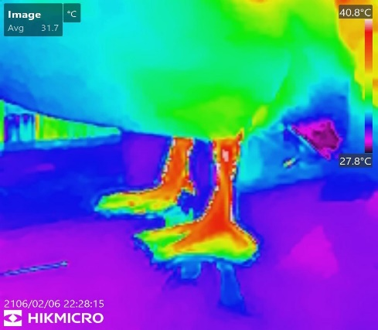
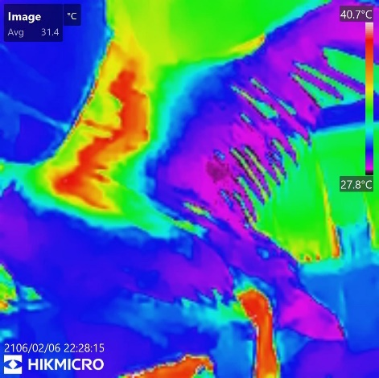
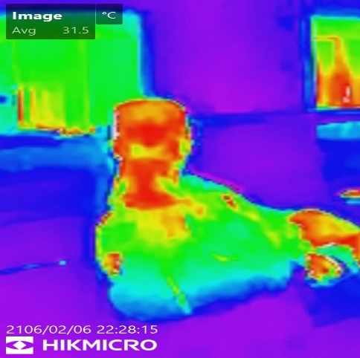
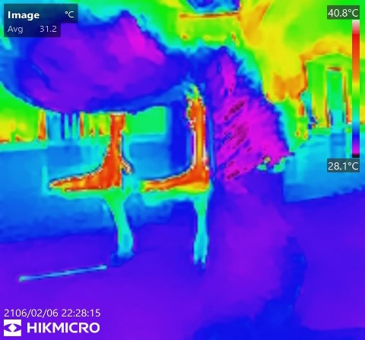
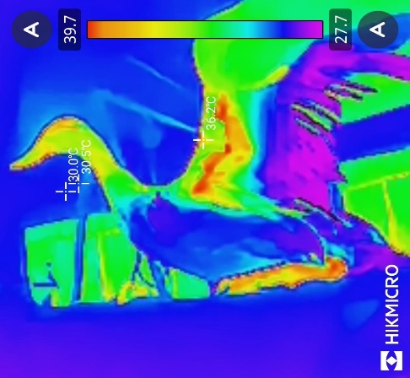
Fig-1 Surface thermographic profile of Adult Female Tripureswari Duck of Tripura
Fig: 2 Surface thermographic profile of Adult Female Tripureswari Duck of Tripura

Table 1. Region-wise surface body temperature (°C, Mean ± SE) of adult male (DM) and adult female (DF) Tripureswari ducks (n = 6 per sex)
Body Region | Adult Male (DM) Mean ± SE (°C) | Adult Female (DF) Mean ± SE (°C)
Eye | 37.60 ± 0.21 | 37.80 ± 0.19
Periorbital area | 39.20 ± 0.12 | 39.00 ± 0.17
Crown | 34.62 ± 0.33 | 34.78 ± 0.23
Nostrils | 37.10 ± 0.10 | 37.02 ± 0.18
Bill (lateral) | 37.00 ± 0.15 | 37.60 ± 0.17
Chin | 36.90 ± 0.10 | 36.60 ± 0.17
Throat | 34.83 ± 0.23 | 34.97 ± 0.20
Breast | 31.63 ± 0.21 | 31.43 ± 0.40
Flank | 29.90 ± 0.14 | 30.62 ± 0.35
Leg (max) | 39.83 ± 0.37 | 39.53 ± 0.17
Talon | 33.10 ± 0.42 | 33.20 ± 0.22
Undertail coverts | 31.70 ± 0.75 | 30.80 ± 0.38
Mantle | 35.10 ± 0.16 | 34.30 ± 0.34
Neck | 36.70 ± 0.11 | 36.70 ± 0.16
Ear and nape | 35.97 ± 0.33 | 35.97 ± 0.32
Primary feather area | 29.87 ± 0.32 | 30.18 ± 0.18
Secondary feather area | 31.48 ± 0.27 | 30.83 ± 0.42
Wing covert area | 36.10 ± 0.43 | 36.70 ± 0.23
Edges of the wing | 35.67 ± 0.22 | 36.22 ± 0.27
Back | 33.40 ± 0.40 | 33.80 ± 0.21
Under wing | 39.07 ± 0.11 | 38.82 ± 0.19
After considering the surface temperature recorded in all the (21 regions) regions it is grouped by thermal function and presented in Table 2. The regions such as leg (maximum), periorbital area and under wing surface found emerged consistently as the warmest thermal area in both sexes, while the primary feather area, flank and undertail coverts were the coolest and heavily feathered and insulated zones.
Table 2. Thermal-zone classification of body regions in adult male and female Tripureswari ducks
Thermal Zone | Body Region | Male (°C ± SD) | Female (°C ± SD) | Biological Role
Warmest (thermal windows) | Leg (maximum) | 39.83 ± 0.91 | 39.53 ± 0.41 | Featherless uninsulated & main heat dissipation site
 | Periorbital area | 39.20 ± 0.31 | 39.00 ± 0.42 | Vascularized and thinly feathered
 | Under wing | 39.07 ± 0.26 | 38.82 ± 0.46 | Thinly feathered and heat dissipation during flight and wing extension, proximity to the core body.
Coolest (feathered and insulated) | Primary feather area (Rump) | 29.87 ± 0.78 | 30.18 ± 0.45 | Plumage insulation
 | Flank | 29.90 ± 0.35 | 30.62 ± 0.86 | Fathered area for core body temperature retention
 | Undertail coverts | 31.70 ± 1.85 | 30.80 ± 0.93 | Waterproofing

3.2 Thermal windows of heat dissipation
In the present study, highest surface temperature was recorded in the leg (39.83 ± 0.37 °C in males and 39.53 ± 0.17 °C in females), Fig-1 and Fig-2 and these observations are in line with in general avian thermal window. The leg (tarsometatarsus) region is devoid of feather with a dense subcutaneous vascular network with counter-current arteriovenous network, for quick adjustment of arterial and venous blood flow for local heat dissipation (Crandell et al., 2025). The second warmest area recorded was in periorbital region (39.20 ± 0.12 °C in males; 39.00 ± 0.17 °C in females), may be due to its thin skin and high vascularization. This region has been similarly identified as a sensitive thermal and stress responsive site in domestic pigeons and laying hens (Kim et al., 2021; Tabh et al., 2021). The third warmest region was under wing surface (39.07 ± 0.11 °C and 38.82 ± 0.19 °C in males and females, respectively) reflects that this part gets exposed to convective air during the wing extension, locomotion and may be due to proximity to the core body. These observations can be well corelated with the wing associated heat dissipation pattern during and after flight in columbiform birds (Crandell et al., 2025). All together, these three regions were found to be as the primary heat radiators in Tripureswari indigenous duck of Tripura for rapid loss of excess metabolic and environmental heat while maintaining the insulation and waterproofing by the plumage and feathers.

3.3 Heavily insulated regions
In direct contrast, the primary feather area (29.87 ± 0.32 °C in males; 30.18 ± 0.18 °C in females), the flank (29.90 ± 0.14 °C and 30.62 ± 0.35 °C, respectively) Fig-1 and Fig-2 and the undertail coverts recorded the lowest surface temperatures of the entire body. These regions are characterised by dense plumage coverage that traps a layer of still air beneath the feathers, thereby minimizing radiative and convective heat loss and shielding the bird's thermal core from ambient fluctuation (McCafferty, 2013). The very low surface temperature of the primary and secondary feather areas is of particular functional relevance in a waterfowl species, since dense, well-maintained plumage in these regions is simultaneously responsible for water repellence and flight function; the concurrence of low surface temperature with high insulative value in this study is therefore consistent with the dual thermoregulatory–waterproofing role of duck plumage described for other Anatidae (Crandell et al., 2025).

3.4 Sex-wise comparison
The mean surface temperatures at most of the anatomical sites were not significantly differing between sexes (e.g., eye, nostrils, throat, breast, neck, ear and nape, talon, back), indicating a minimal sexual dimorphism in surface thermoregulatory pattern in Tripureswari Duck of Tripura Fig-1 and Fig-2. These observations are broadly in agreement with observations in laying hens by Kim et al., 2021 who stated that facial and peripheral temperature is mainly governed by ambient thermal load and vascular anatomy rather than by sex (Kim et al., 2021). The mean temperature recorded on the lateral sides of bill was slightly warmer in females (37.60 ± 0.17 °C) than in males (37.00 ± 0.15 °C). Bill surface temperature in Anatidae is highly labile and controlled by autonomic vasomotor system, and highly responsive to ambient and physiological state (Tabh et al., 2021). This difference recorded also may be due to transient peripheral blood flow, activity level but not anatomical dimorphism. The mantle region was slightly warmer in males (35.10 ± 0.16 °C) than in females (34.30 ± 0.34 °C), that may be due to differences in dorsal feather distribution density, however it will be too early to be identify as a sex-specific.
The flank was slightly cooler in males (29.90 ± 0.14 °C) than in females (30.62 ± 0.35 °C), suggestive of individual variability not a sex effect. Overall, these localised differences may be considered as minor physiological variation in thermoregulatory architecture in the two sexes.

3.5 Physiological and adaptive significance
The Tripureswari indigenous duck of Tripura is known for its resilience and adaptability to these wet, tropical and humid environments of Tripura, with low-input backyard management (NBAGR, 2025; Kumar and Dwivedi, 2025). The present preliminary study about the thermographic data is a support to understand recognized hardiness of this breed. The substantial temperature gradient between the heavily insulated primary feather and flank regions and leg, periorbital and under-wing thermal windows revealing a highly efficient plumage for metabolic heat conservation under cool conditions, while well-vascularised and thin skinned and featherless sites for rapid heat dissipation under hot humid conditions. This dual thermoregulatory strategy with efficient insulation and dissipation are advantageous for indigenous poultry genetic resources for maintaining thermal homeostasis across the wide seasonal climatic variation of North-East India (McCafferty, 2013; Crandell et al., 2025). These findings therefore supports, the recent molecular genetic characterisation of the breed (Debnath et al., 2023) by adding a physiological dimension about the surface thermographic profile of the Tripureswari duck, and strengthen its value as a genetic resource suited for sustainable duck husbandry.

3.6 Limitations
Infrared thermographic data at feathered sites representing radiative emission may be influenced by feather depth, condition and micro-orientation as well as by ambient radiative heat load (Speakman and Ward, 1998; Crandell et al., 2025). In this study the sample size (n = 6 per sex) evaluated are very small and stratified. So future work incorporating a larger sample, considering the seasons, and comparing with cloacal temperature and uniform rearing condition and management would strengthen inference about the detailed thermoregulatory status in this breed (Tabh et al., 2021).

4. CONCLUSION
This study is revealing the first non-invasive infrared thermographic evaluation body temperature of Tripureswari duck of Tripura at different anatomical region. The surface temperature varied across the body region. The leg, periorbital area and under-wing surface were the prime thermal windows for heat dissipation, and the primary feather area, flank and undertail coverts serves as the heat retaining regions. Minimum sex related variations were noted in surface thermography, with a minor difference in bill, mantle and flank. Almost 10 °C temperature gradient between the warmest and coolest body surfaces reflects a better adaptation and efficient plumage insulation, alongside highly vascularized, thinly feathered, proximity to the core body heat-exchange sites, consistent with the hardiness and adaptability of this indigenous breed. These baseline data about the thermal profile may serve as useful physiological reference for future studies on stress assessment, seasonal adaptation, and farming and conservation strategies of the Tripureswari duck of Tripura.

Declaration of AI Use

This manuscript was prepared through the intellectual contributions of the author(s) to the study design, data analysis, interpretation of results, and scholarly content. Grammarly and ChatGPT were used solely to assist with grammatical refinement and reference formatting during manuscript revision. The author(s) accept full responsibility for the accuracy, integrity, and final content of the manuscript.

REFERENCES
Crandell, K.E., Powers, D.R. and Tobalske, B.W. (2025). The role of plumage and heat dissipation areas in thermoregulation in doves. Journal of Experimental Biology, 228(4): jeb248200. https://doi.org/10.1242/jeb.248200
Debnath, B., Sahoo, A., Singh, N.S., Bhattacharya, D., Bandyopadhyay, S. and Sahoo, N.R. (2023). Genetic characterization of indigenous duck of Tripura state in India using microsatellite markers. Tropical Animal Health and Production, 55: 207. https://doi.org/10.1007/s11250-023-03629-w
Jerem, P., Herborn, K., McCafferty, D., McKeegan, D., & Nager, R. (2015). Thermal imaging to study stress non-invasively in unrestrained birds. JoVE (Journal of Visualized Experiments), (105), e53184.
Kim, N.Y., Kim, S.J., Oh, M., Jang, S.Y. and Moon, S.H. (2021). Changes in facial surface temperature of laying hens under different thermal conditions. Animal Bioscience, 34(7): 1235–1242.
Kumar, A. and Dwivedi, S. (2025). Tripureswari duck: A new feather in Indian poultry sector. Vigyan Varta, 6(3): 219–223.
McCafferty, D.J. (2013). Applications of thermal imaging in avian science. Ibis, 155(1): 4–15.
NBAGR (2025). Registration of Tripureswari duck as an indigenous duck breed of Tripura. ICAR-National Bureau of Animal Genetic Resources, Karnal, Haryana, India.
Speakman, J.R. and Ward, S. (1998). Infrared thermography: principles and applications. Zoology, 101: 224–232.
Tabh, J.K.R., Burness, G., Wearing, O.H., Tattersall, G.J. and Mastromonaco, G.F. (2021). Infrared thermography as a technique to measure physiological stress in birds: Body region and image angle matter. Physiological Reports, 9(10): e14865. https://doi.org/10.14814/phy2.14865

