GC-MS Profile, Antimicrobial Properties and Spectra Characterization of the Ethanol Extract of Theobroma Cacao Beans grown in Nigeria.

Abstract
Many bioactive chemicals found in cocoa (Theobroma cacao), such as polyphenols, flavonoids, and methylxanthines, have been linked to various biological functions, such as antibacterial properties. With Nigeria's prominence as a cocoa-producing nation and the increasing interest in natural products as possible antibacterial agents, this study sought to examine the biological potential of an ethanol extract from cocoa bean powder in Nigeria against specific microbes.
The phytochemical screening, which found secondary metabolites, was conducted in ethanol. Perkin Elmer Spectrum and GC-MS utilised a Fourier transform infrared spectrophotometer (FT-IR) to get infrared (IR) spectra. FT-IR spectra reveal that alcohols, alkenes, and esters include hydroxyl groups. The peaks at 3398.67 cm⁻¹, 2920.32 cm⁻¹, and 1689.70 cm⁻¹, respectively, correspond to the oxygen-hydrogen bonding stretching, carbon-hydrogen stretching, and ester stretching, respectively. According to the results of the antimicrobial test, the tested fungus is quite susceptible. The study discovered that cocoa powder extracts include a plethora of bioactive compounds used for many therapeutic purposes. Alkaloids, tannins, and phenolics are three of the main bioactive compounds found in cocoa powder, and they may be responsible for its antibacterial effects.

Keywords: Theobroma cacao phytochemical composition; antimicrobial activity; fr-ir, gc-mc, medicinal plant
1. Introduction
Cocoa beans, a tropical crop belonging to the Theobroma cacao plant, are utilised in the manufacturing of cocoa powder, chocolate, and various other edible items. Scientists are paying more and more attention to cocoa due to the wide variety of bioactive substances it contains, in addition to its nutritional and industrial value. Along with methylxanthines like theobromine and caffeine, fatty acids, and other phytochemicals, cocoa is rich in polyphenols including catechin, epicatechin, and procyanidins (Wollgast & Anklam, 2000; Rusconi & Conti, 2010; Ackar et al., 2013). The cocoa's genotype, its place of origin, and the conditions of fermentation, drying, and roasting after harvest all have a role in determining the amount and content of these components (Wollgast & Anklam, 2000; Ackar et al., 2013; Hurst et al., 2011). The cocoa's beneficial effects on health are thought to originate from its abundance of phytochemicals. The type of cocoa material, the procedures used for extraction, and the biological evaluation may determine the nature and extent of the benefits associated with antioxidant, anti-inflammatory, and antibacterial properties, while prior research has linked cocoa components with these abilities (Rusconi & Conti, 2010; Fideles et al., 2023; Żyżelewicz et al., 2021). As the development of resistance to frequently used antimicrobial drugs remains a significant obstacle in the fight against infectious disease, there is a rising interest in bioactive molecules derived from plants as potential novel antimicrobial substances (Cowan, 1999; Daglia, 2012). It’s possible that plant extracts include a wide variety of chemicals that can influence microbes in various ways. One example is the potential interference with microbial membranes, proteins, enzymes, and other biological processes by polyphenols and similar chemicals (Daglia, 2012; Cushnie & Lamb, 2005). The specific microorganism studied, the concentration of the extract, and its chemical makeup all have a role in its antibacterial action. This is why testing the antibacterial properties of natural compounds in an experimental setting is still essential. Multiple studies have shown that cocoa and its derivatives have antibacterial properties. Research has shown that cocoa extracts can suppress the development, adhesion, and biofilm formation of bacteria linked to oral and other types of diseases (Żyżelewicz et al., 2021). Evidence suggests that cocoa extracts have an effect on Fusobacterium nucleatum, reducing its ability to proliferate, produce biofilms, and attach to surface (Bouchard, et al., 2021). Studies on substances produced from cocoa beans have also shown antibacterial activity against several bacterial species; however, the exact nature of this activity varies greatly across different extraction solvents and test organisms. The possible importance of cocoa components recovered by ethanol in antimicrobial studies has been bolstered by a new report that an ethanol extract of cocoa beans showed antibacterial action against Streptococcus mutans (Joelijanto & Sutjiati, 2025).
The ability of ethanol to recover a wide variety of phytochemicals makes it a useful solvent for bioactive compound extraction from plant sources. Because it affects the final extract's composition and biological activity, the extraction solvent choice is crucial. Therefore, results from one cocoa extract study might not be generalisable to another study that used a different method or came from a different part of the world (Rusconi & Conti, 2010; Daglia, 2012; Nsor-Atindana 2012).
Research in Nigeria, a major cocoa producer, has a lot of promise for discovering cocoa's worth beyond its conventional commercial use. Since the composition of plant materials can be impacted by environmental conditions, geographical origin, and processing processes, studying cocoa that is sourced locally could offer valuable insights into its biological features and potential uses. This research looked at the antibacterial activity of an ethanol extract of cocoa bean powder that was sourced from Nigeria and tested it against a number of different microbes. This research adds to the increasing amount of data showing that T. cacao has biological potential and sheds light on how microbes react to components of cocoa bean powder from Nigeria that have been extracted using ethanol.
2. Material and methods
2.1 Preparation of Water Used
In order to make the reagent, distilled water was utilised. The distilled water was prepared using a distiller. The samples and extracts were kept free of contaminants by using distilled water.
2.2 Plant Collection and Authentication.
The Ilesa East Local Government in Osun State, located in the southwestern area of Nigeria, was the site of the 2025 cocoa bean harvest.
2.3 Plant Sample Preparation and Extraction
To dry the cocoa seeds, they were first wetted. For additional testing, a powdered sample was prepared from the dried seeds by grinding them.

2.4 Reagent Used
A solution of sodium hydroxide (NaOH), ferric chloride (FeCl₃), 10% ammonia, CHCl₃, 50% sulphuric acid, Fehling's, Meyer's, Dragendorf's, and Wagner's reagents
2.5 Qualitative Phytochemical Screening of Plant Extracts
In order to screen for the presence of several classes of plant secondary metabolites, the aqueous extracts of cocoa were subjected to phytochemical analysis according to the standardised method described by Sofowora, 1982, Harbone, 1984, and Trease & Evans, 1989.
2.5.1 Alkaloids
The test extracts were acidified in a steam bath with four (4) millilitres of 1% aqueous hydrochloric acid (HCl). The next step was to add a few drops of Meyer's reagent to 1 ml of the acidified solution individually. The presence of alkaloids is confirmed by a creamy white precipitate. This reagent was validated by an orange precipitate (Sofowora, 1982).
2.5.2 Tannins
The extract solution was concentrated by adding 5 drops of ferric chloride (FeCl₃) to 2 millilitres. The presence of tannins was established by the observation of a precipitate that was either dirty green or greenish black in colour (Sofowora, 1982).
2.5.3 Saponins
After rapidly shaking and heating to boiling, five (5) millilitres of distilled water were added to two (2) millilitres of the extracts. Saponins are indicated by the presence of a frothy layer and a creamy milk precipitate, although they were not seen (Sofowora, 1982).
2.5.4 Flavonoids
Two millilitres of the extract solution was mixed with four millilitres of water-based sodium hydroxide (NaOH). There were no flavonoids found, even though it is expected that a yellow solution will turn colourless when hydrochloric acid (HCl) is added (Harbone, 1984).
2.5.5 Glycosides
Mix the test extract with five (5) millilitres of sulphuric acid that is 50% concentrated. The ingredients were simmered for fifteen minutes in water that was boiling. The mixture was then brought to a boil by adding Fehling's solution. Unfortunately, the presence of glycosides as confirmed by the expected brick red precipitate was not seen (Trease & Evans, 1989).
2.5.6 Terpenoids (Salkowski test)
A thin layer was created by slowly adding two millilitres of chloroform (CHCl₃) and three millilitres of strong sulphuric acid (H₂SO₄) to two millilitres of the extract. There was no reddish-brown colouration of the interface, which would indicate the presence of terpenoids (Sofowora, 1982).
2.5.7 Phenol
The extracts were mixed with 5 millilitres of ferric chloride solution using precisely four drops. The existence of phenols was established by the production of a bluish black colour (Harbone, 1984).
2.5.8 Steroids
Concentrated sulphuric acid (H₂SO₄) was added in a 5-drop ratio to 1 millilitre of the extracts solution. Notably absent was the brownish-red hue that would have indicated the existence of steroids (Sofowora, 1982).
2.5.9 Anthraquinone
A 10-minute boiling process was carried out in a water bath at 100°C using five (5) millilitres of the extract in conjunction with 10% hydrochloric acid (HCl). A 10% ammonia (NH₃) solution was boiled with the filtrate and an equal volume of trichloromethane (CHCl₃) once the solution had cooled. It was not noted that the solution formed a rose-pink hue, which would indicate the presence of anthraquinone (Sofowora, 1982).
2.5.10 Phlobatanins
After dissolving five (5) millilitres of the extract in distilled water, it was filtered. The next step was to boil the filtrate in a solution of 2% hydrochloric acid (HCl). It was not noted that a crimson precipitate appeared, which supports the existence of phlobatanins (Sofowora, 1982).

2.5.11 Antimicrobial Activity Test
2.6 Preparation of Agar Plates
Following the manufacturer's instructions, Muller-Hinton agar was produced to test the extract's antibiotic activities against Klebsiella pneumoniae and Escherichia coli. After weighing and transferring approximately 19 grams of dried agar to a flask, 500 millilitres of distilled water was added. The combination was then autoclaved at 121 degrees Celsius for 20 minutes. Following autoclaving, it was cooled to around 45 ℃ before being transferred to many petri dishes. Once the agar had hardened, a sterile swap stick was used to inoculate the surface with a 0.5 McFarland standard bacterial suspension. The bacterial plates were kept at 35 ℃ for a duration of 24 hours (Clinical and Laboratory Standards Institute; 2018).
2.7 Antibiotic Sensitivity Test
A 100 mg/mL stock solution was prepared by dissolving 1 gram of ceftriaxone in 10 millilitres of sterile saline water. Diluting the stock solution resulted in concentrations of 50 mg/mL, 25 mg/mL, 12.5 mg/mL, 6.5 mg/mL, and 3.125 mg/mL, which were used to compare the antimicrobial action of the extract to that of a clinically used antibiotic. The organism-containing agar was each tested by boring five separate wells. Twenty microlitres of the Ceftriaxone solutions at the respective concentrations were added to the wells. The zone of inhibition for each test was monitored after 24 hours of incubation, during which triplicates of each test were prepared.

2.8 Antimicrobial Test of the Extract
A pre-weighed Bijou bottle was used to collect approximately 10 mL of the extract, which was then dried in an oven set at 45 0C to eliminate the ethanol used for extraction. Weighing the bottle and dried extract together yielded a weight of 0.13g for the dried extract. A 100 mg/mL stock solution was prepared by dissolving the dried extract in 1.3 mL of Dimethyl sulfoxide (DMSO). The stock solution was diluted serially with sterile saline water until the extract concentration reached 50 mg/mL, 25 mg/mL, 12.5 mg/mL, 6.25 mg/mL, and 3.125 mg/mL. Each well was supplemented with 20 µL of the extract solution at the relevant concentration. In order to track the zone of inhibition, each test was made three times and left to incubate for twenty-four hours.

2.9 GC-MS analysis of Extract
The plant material was moved into an empty tube containing pure ethanol, sonicated for five minutes, spun in a centrifuge for five minutes, and then 100 microlitres of the supernatant was collected for gas chromatography-mass spectrometry. A gas chromatograph connected to a mass spectrometer (GC-MS) with an Elite-5MS (5% diphenyl/95% dimethyl polysiloxane) fused to a capillary column (30 × 0.25 μm ID × 0.25 μm df) was used to conduct the GC-MS analysis of the plant ethanolic extracts. The apparatus utilised for this purpose was an Agilent 5977B GC/MSD system along with an Agilent 8860 auto-sampler. A 70 eV ionisation energy electron ionisation device was used for GC-MS detection in electron impact mode. A carrier gas of helium (99.999%) was utilised at a steady flow rate of 1 ml/min, with an injection volume of 1μl (a split ratio of 10:1).
Mass spectra were recorded at 70 eV with a scanning interval of 0.5 s and fragments ranging from 45 to 450 Da. The injector temperature was kept at 300 °C, the ion-source temperature was 250 °C, and the oven temperature was program to go from 100 °C (isothermal for 0.5 min) to 280 ℃ (2.5 min). One to three minutes was the typical delay.
2.10 Statistical Analysis
We measured the inhibitory zones of K. pneumoniae and E. coli bacteria for different extracts and concentrations of Ceftriaxone. The standard error of the mean (Mean ± SEM) was used to display the calculated mean values for all three tests. As a benchmark for measuring antibacterial activity, the data acquired were compared to the CLSI threshold. Graph Pad Prism 9.0's one-way ANOVA analysis revealed a statistically significant difference between the extract's and Ceftriaxone's activity at the same concentrations. Statistics were considered significant when p-values were less than 0.05.
2.11 Fourier Transform Infrared Analysis
With the help of a universal attenuated total reflector (ATR) sampling accessory, a Fourier transform infrared spectrophotometer (FT-IR) from Perkin Elmer Spectrum 100 was used to acquire infrared (IR) spectra. Using a Spectra 100 equipment from American manufacturer Perkin Elmer, functional groups in each percent of the isolated samples were identified by means of Fourier transform infrared spectroscopy (FTIR).

3. Results and discussion
3.1 Qualitative Phytochemical Screening of Phyto Constituents in Alkaloids, Tannins, Saponins, Flavonoids, Glycosides, Terpenoids, Phenols, Steroids, Anthraquinones, Phlobatanins of Ethanolic Extract of Theobroma Cacao Beans
There was no discernible impact on the medicinal properties or potency of the plants when ethanol was used as an extraction solvent, and the results show that cocoa has rich phytoconstituents. The existence of polar secondary metabolites in the plants is associated with this finding.

Table 1. Results of Phytochemical Screening of the crude extracts of Ethanolic Extract of Theobroma Cacao Beans
Phytoconstituents Ethanol Extracts
Alkaloids ++
Tannins ++
Saponins – –
Flavonoids – –
Glycosides – –
Terpenoids – –
Phenols ++
Steroids – –
Anthraquinones – –
Phlobatanins – –
+ = Rich in Phytoconstituents
++ = Very Rich in Phytoconstituents
– = Not Detected
Table 2. Antimicrobial Analysis of Ethanolic Extract of Theobroma Cacao Beans and Ceftriaxone against K. pneumoniae and E. coli
Zone of Inhibition (mm)
Test Concentration Extract Ceftriaxone
(mg/mL) K. pneumoniae E. coli K. pneumoniae E. coli

100 10.50 ± 0.5 0 23.00 ± 1.0^{a,b} 18.00 ± 1.0ª
50 8.00 ± 1.0 0 23.50 ± 0.5^{a.c} 12.50 ± 0.5ª
25 0 0 21.50 ± 1.5^{a,c} 11.50 ± 0.5ª
12.5 0 0 22.50 ± 0.5^{a,c} 12.00 ± 1.0ª
6.25 0 0 14.50 ± 0.5ª 11.50 ± 0.5ª
3.125 0 0 4.50 ± 2.5^{d} 11.50 ± 0.5ª

For each concentration and both bacteria, superscript a indicates a significant difference (p<0.001) in the inhibitory zones of Ceftriaxone and Extract. For the indicated treatment concentrations, superscript b indicates a significant difference (p<0.01) in the zones of inhibition of Ceftriaxone against K. pneumoniae and E. coli. At the indicated treatment concentration, superscript c indicates a significant difference (p<0.001) in the zones of inhibition of Ceftriaxone against K. pneumoniae and E. coli. At the stated treatment concentration, superscript d indicates a significant difference (p<0.01) between the zones of inhibition of Ceftriaxone and Extract against K. pneumoniae.

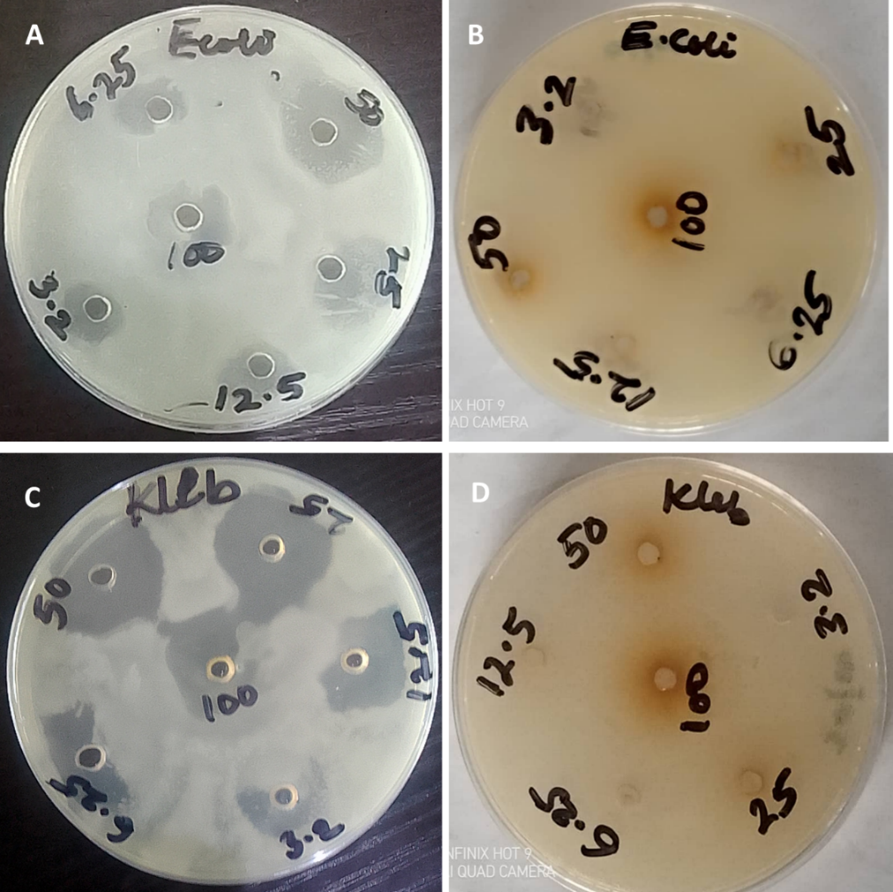
Fig. 1 (A) Ceftriaxone treatment of E. coli (B) Cocoa powder extract treatment of E. coli (C) Ceftriaxone treatment of K. pneumoniae (D) Cocoa powder extract treatment of K. pneumoniae (E): Images of the zones of inhibition of the treatment of E. coli and K. pneumoniae with Ceftriaxone and cocoa powder extract, respectively, are shown in Fig 1. The therapies are available in concentrations of 100, 50, 25, 12.5, 6.25, and 3.125 mg/mL.

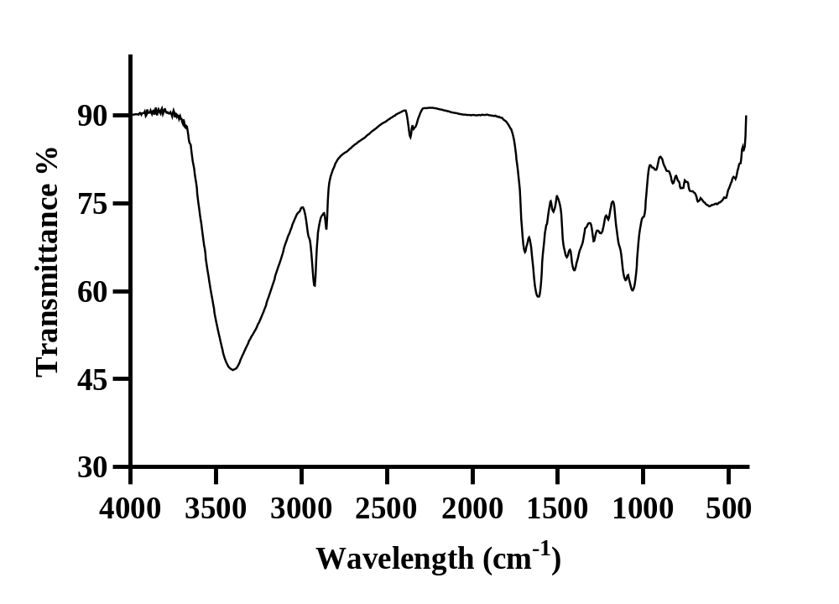
Fig 2: FTIR spectral of isolated compounds from the plants of study

Table 3: Interpretation of spectra of prominent peaks for the Cocoa beans extracts
Absorption Band Type of Vibration Frequency of Vibration
OH (hydrogen bonded) Stretching 3398.67cm⁻¹
C–H Stretching 2920.32cm⁻¹
C–H (Alkanes) Stretching 2850.88cm⁻¹
C=O of Ester Stretching 1689.70cm⁻¹
C-O. Stretching 1288.49cm-1

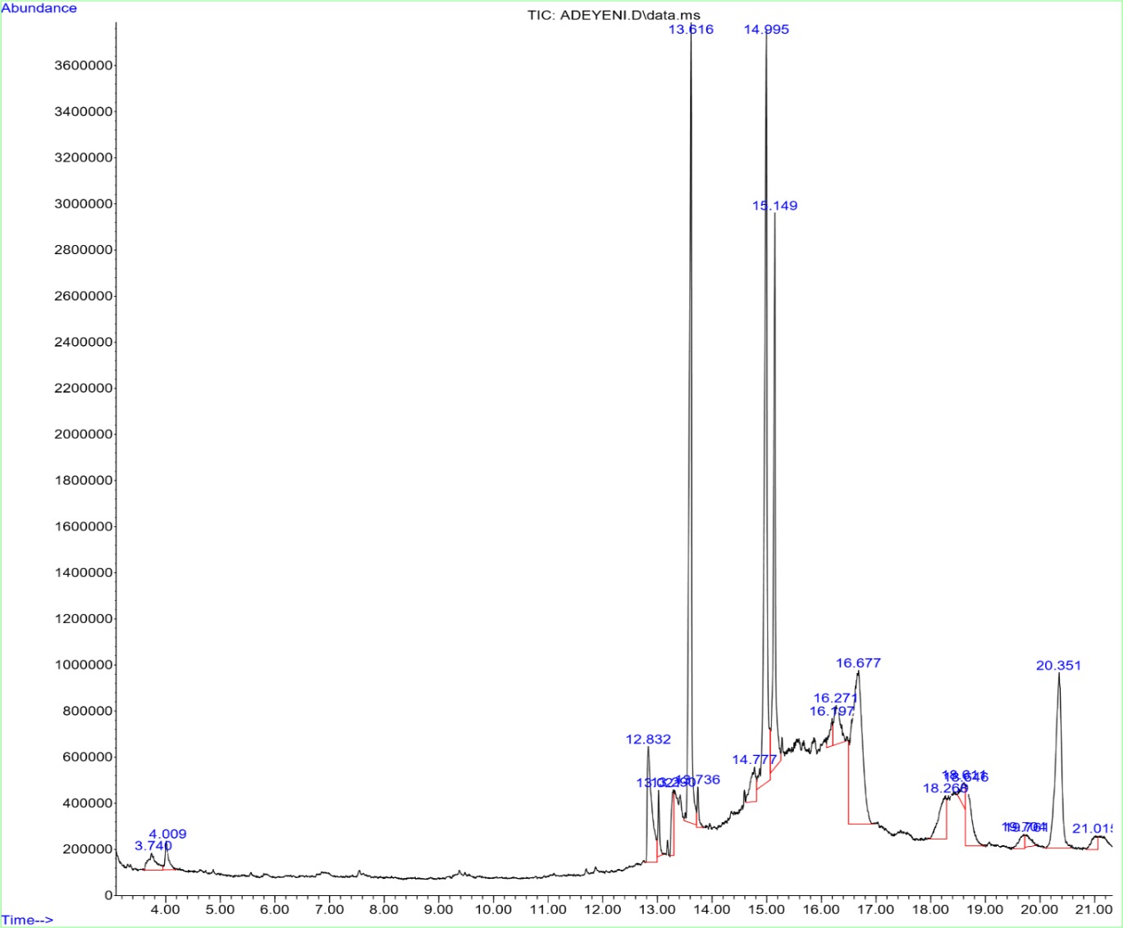
Fig 3: GC/MS spectral of crude extracts of ethanolic extracts of cocoa beans
3.2 Discussion
We used an ethanol solvent to conduct qualitative phytochemical analysis on the cocoa samples. Only alkaloids, tannins, and phenols were detected in the secondary metabolites analysis; no phlobatannins, saponins, terpenoids, or steroids were found. Cocoa is rich in a variety of phytoconstituents, as demonstrated here. Polyphenols, methylxanthines, procyanidins, catechins, and caffeine are some of the bioactive components found in cocoa that are known to have various biological actions (Kim et al., 2014; Oracz et al., 2020; Reis de Araujo et al., 2016). The current investigation found phenols, tannins, and alkaloids. One possible explanation is that cocoa contains some polyphenols. Crude cocoa extract's FTIR spectra revealed prominent peaks at 3398.67 cm⁻¹, 2920.32 cm⁻¹, 2850.88 cm⁻¹, 1689.70 cm⁻¹, and 1288.49 cm⁻1, in that order. It is possible that the sample contains alcohol and phenols, since the peak at 3398.67 cm⁻¹ could be attributed to O-H stretching vibrations. Unlike terminal alkynes or C≡C stretching, which typically happen at lower frequencies of about 2100 -2260 cm⁻¹, the maxima at 2920.32 and 2850.88 cm⁻¹ are in agreement with aliphatic C-H stretching vibrations, especially those of CH₂ and CH₃ groups (Nandiyanto et al., 2019; Stuart, 2004). Although FTIR cannot definitively differentiate among all potential carbonyl compounds, the absorption at 1689.70 cm⁻¹ suggests the existence of functional groups containing carbonyl. Alcohols, phenols, ethers, and esters may exhibit C-O stretching vibrations, which could explain the band at 1288.49 cm⁻¹ (Nandiyanto et al., 2019; Stuart, 2004). The various bioactive components found in cocoa may be linked to the many functional groups and chemical connections found in the extract, as demonstrated by these data.
The effectiveness of cocoa extract against Klebsiella pneumoniae and Escherichia coli, two Gram-negative bacteria, was investigated. In Table 2, the medication ceftriaxone is shown as the control. The average ± SEM of three independent tests showed the level of inhibition of the organisms being studied. Though it showed some action against Klebsiella pneumoniae, the extract's efficacy was inferior to the positive control. This variation could be because the crude extract contains antibacterial components, but at lower concentrations, and the microorganisms' susceptibility to the extract and the standard medicine is different. It is possible that the antimicrobial activity seen is linked to the cocoa phytochemicals and phenolic compounds that have been linked to many biological activities, including antimicrobial activity (Oracz et al., 2020; Reis de Araujo et al., 2016).
The GC-MS analysis of the caffeine-identifying ethanol extract in this investigation revealed the presence of fourteen chemicals belonging to six recognised chemical families. Isobutyl nonyl ester (5.45%), 1-heptadecanamine (2.75%), 6-deoxy-2-0-methyl-pentanoic acid (1.80%), 1, 1-dimethyl thiirane(9.81%), 1-heptadecanamine(2.75%), 2-methyl-2-isopropyl (62.06%). The results show that there were many chemical components in the extract. The relative abundance of individual compounds detected by GC-MS cannot be used to establish their presence without appropriate standards or spectral confirmation, so the chromatographic/mass-spectral identification criteria used in the study should mainly be relied upon when interpreting the caffeine identification.
Even though they may be in small quantities, the presence of phenolic and tannin components suggests the presence of other phytochemicals that were extracted at the same time, which could explain why the extract has some biological activity. The polyphenols and methylxanthines found in abundance in cocoa have several biological functions, including antioxidants (Kim et al., 2014; Oracz et al., 2020; Reis de Araujo et al., 2016 it would be premature to attribute the antioxidant or neuroprotective benefits of the current extract only to caffeine in the absence of direct tests in these areas. Caffeine and other phytochemicals that were extracted together may have these effects instead.
The extract comprises multiple classes of bioactive chemicals and functional groups, as evidenced by the link between the phytochemical and FTIR data. On the other hand, FTIR isn't able to determine a compound's identity, purity, or biological activity on its own; it mostly gives information on functional groups (Nandiyanto et al., 2019; Stuart, 2004). Rather than providing conclusive proof that the spectrum represents a single constituent, the FTIR results should be viewed as supplementary to the GC-MS and phytochemical investigations. The results show that the cocoa ethanol extract has antibacterial activity against K. pneumoniae and provide evidence that it contains phytochemicals with biological significance.
4. Conclusion
Ultimately, this study proved that ethanol extract from cocoa bean powder from Nigeria (Theobroma cacao) could be a good way to get bioactive chemicals that fight K. pneumoniae. The results show that cocoa has biological properties beyond its typical nutritional and industrial uses and that locally available cocoa from Nigeria could be valuable for future studies on natural products and antimicrobials, adding to the increasing body of evidence that cocoa has such properties.
The FTIR examination of the cocoa ethanol extract also revealed the presence of functional groups such hydroxyl, aliphatic C-H, carbonyl, and C-O groups. Although it was not as effective as ceftriaxone, it did show antimicrobial action against Klebsiella pneumoniae.
The chemical composition of the extract has been summarized by combining the data from the phytochemical, FTIR, and GC-MS studies. So, it may be said that the phytochemical components' biological activity were validated. Nevertheless, chromatographic and spectrometric analysis should bolster conclusions drawn from qualitative phytochemical and FTIR analyses, which have their limitations. Rather than studying the effects of caffeine alone, future biological investigations including this extract should account for the full chemical composition of the extract.

5. Limitation of the Study: This study was limited to crude leaf extracts of Theobroma cacao prepared with ethanol as solvents and focused on phytochemical, antimicrobial and identification of bioactive compounds using Fourier transformed infrared spectroscopy (FT-IR) and gas chromatography couple with mass spectrometry (GC-MS). The compounds responsible for the observed activities were not isolated or individually characterized. In addition, the antimicrobial evaluation involved a limited number of bacteria, and in vivo studies were not conducted to confirm efficacy and safety. Further work should include compound isolation, toxicity assessment and in vivo validation.
Declaration of AI Use

This manuscript was prepared through the intellectual contributions of the author(s) to the study design, data analysis, interpretation of results, and scholarly content. Grammarly and ChatGPT were used solely to assist with grammatical refinement and reference formatting during manuscript revision. The author(s) accept full responsibility for the accuracy, integrity, and final content of the manuscript.
Competing Interests
Authors have declared that no competing interests exist.
References
Ackar, D., Lendić, K. V., Valek, M., Babić, J., Šubarić, D., & Kopjar, M. (2013). Cocoa polyphenols: Can we consider cocoa and chocolate as potential functional food? Journal of Chemistry, 2013, Article 289392. https://doi.org/10.1155/2013/289392
Bouchard, D., et al. (2021). A cocoa (Theobroma cacao L.) extract impairs the growth, virulence properties, and inflammatory potential of Fusobacterium nucleatum and improves oral epithelial barrier function. PLoS ONE, 16(6), Article e0252029. https://doi.org/10.1371/journal.pone.0252029
Clinical and Laboratory Standards Institute. (2018). M07: Methods for dilution antimicrobial susceptibility tests for bacteria that grow aerobically (11th ed.). Clinical and Laboratory Standards Institute.
Cowan, M. M. (1999). Plant products as antimicrobial agents. Clinical Microbiology Reviews, 12(4), 564–582. https://doi.org/10.1128/CMR.12.4.564
Cushnie, T. P. T., & Lamb, A. J. (2005). Antimicrobial activity of flavonoids. International Journal of Antimicrobial Agents, 26(5), 343–356. https://doi.org/10.1016/j.ijantimicag.2005.09.002
Daglia, M. (2012). Polyphenols as antimicrobial agents. Current Opinion in Biotechnology, 23(2), 174–181. https://doi.org/10.1016/j.copbio.2011.08.007
Fideles, S. O. M., Ortiz, A. D. C., Reis, C. H. B., Buchaim, D. V., & Buchaim, R. L. (2023). Biological properties and antimicrobial potential of cocoa and its effects on systemic and oral health. Nutrients, 15(18), Article 3927. https://doi.org/10.3390/nu15183927
Harborne, J. B. (1984). Phytochemical methods: A guide to modern techniques of plant analysis (2nd ed.). Chapman and Hall.
Hurst, W. J., Krake, S. H., Bergmeier, S. C., Payne, M. J., Miller, K. B., & Stuart, D. A. (2011). Impact of fermentation, drying, roasting and Dutch processing on flavan-3-ol stereochemistry in cacao beans and cocoa ingredients. Chemistry Central Journal, 5, Article 53. https://doi.org/10.1186/1752-153X-5-53
Joelijanto, R., & Sutjiati, R. (2025). Antibacterial activity of ethanol extract of cocoa beans (Theobroma cacao L.): In silico and in vitro study. Journal of Dentomaxillofacial Science, 10(4), 198–202. https://doi.org/10.15562/jdmfs.v10i4.1884
Kim, J., Kim, J., Shim, J., Lee, C. Y., Lee, K. W., & Lee, H. J. (2014). Cocoa phytochemicals: Recent advances in molecular mechanisms on health. Critical Reviews in Food Science and Nutrition, 54(11), 1458–1472. https://doi.org/10.1080/10408398.2011.641041
Nandiyanto, A. B. D., Oktiani, R., & Ragadhita, R. (2019). How to read and interpret FTIR spectroscope of organic material. Indonesian Journal of Science and Technology, 4(1), 97–118.
Nsor-Atindana, J., Zhong, F., Mothibe, K. J., Bangoura, M. L., & Lagnika, C. (2012). Quantification of total polyphenolic content and antimicrobial activity of cocoa (Theobroma cacao L.) bean shells. Pakistan Journal of Nutrition, 11(7), 672–677. https://doi.org/10.3923/pjn.2012.672.677
Oracz, J., Nebesny, E., Żyżelewicz, D., Budryn, G., & Luzak, B. (2020). Bioavailability and metabolism of selected cocoa bioactive compounds: A comprehensive review. Critical Reviews in Food Science and Nutrition, 60(12), 1947–1985. https://doi.org/10.1080/10408398.2019.1619160
Reis de Araujo, Q., Gattward, J. N., Almoosawi, S., Silva, M. do C., Dantas, P. A. de S., & De Araújo Junior, R. F. (2016). Cocoa and human health: From head to foot—A review. Critical Reviews in Food Science and Nutrition, 56(16), 2547–2586.
Rusconi, M., & Conti, A. (2010). Theobroma cacao L., the food of the gods: A scientific approach beyond myths and claims. Pharmacological Research, 61(1), 5–13. https://doi.org/10.1016/j.phrs.2009.08.008
Santos, R. X., Oliveira, D. A., Sodré, G. A., Gosmann, G., Brendel, M., & Pungartnik, C. (2014). Antimicrobial activity of fermented Theobroma cacao pod husk extract. Genetics and Molecular Research, 13(3), 7725–7735. https://doi.org/10.4238/2014.September.26.10
Sofowora, A. (1982). Medicinal plants and traditional medicine in Africa. John Wiley & Sons.
Stuart, B. (2004). Infrared spectroscopy: Fundamentals and applications. John Wiley & Sons.
Trease, G. E., & Evans, W. C. (1989). Trease and Evans' pharmacognosy (13th ed.). Baillière Tindall.
Wollgast, J., & Anklam, E. (2000). Review on polyphenols in Theobroma cacao: Changes in composition during the manufacture of chocolate and methodology for identification and quantification. Food Research International, 33(6), 423–447. https://doi.org/10.1016/S0963-9969(00)00068-5
Żyżelewicz, D., Budryn, G., Oracz, J., Antolak, H., Kregiel, D., & Kaczmarska, M. (2021). Cocoa and cocoa bean shells role in human health: An updated review. Journal of Food Composition and Analysis, 103, Article 104115. https://doi.org/10.1016/j.jfca.2021.104115

