Simulation of Dependence-Aware Joint Chance-Constrained A-Star-Based Path Planning for Unmanned Ground Vehicles under Obstacle-Position Uncertainty

Abstract
Path planning for unmanned ground vehicles (UGVs) in uncertain environments requires more than geometric shortest-path optimization, particularly when narrow-passage traversability depends on imperfect obstacle-position estimates. This paper presents a dependence-aware joint chance-constrained A-Star-based planning framework in which successive passage widths are modeled as correlated random variables. The dependence arises naturally when adjacent passages share an uncertain obstacle boundary: a displacement that enlarges one passage may simultaneously reduce the neighboring passage. The proposed formulation maps obstacle-boundary uncertainty to passage-width covariance through a linear difference model, evaluates route-level feasibility using a multivariate Gaussian joint probability, and selects the shortest candidate route satisfying a prescribed reliability threshold. The framework is evaluated using two-passage validation, sensitivity analysis, a controlled route-selection testbed, a multi-passage extension, a randomized campaign of 5,000 scenarios, Monte Carlo verification, and runtime benchmarks. In the controlled testbed, the independence approximation accepts the shorter route with a predicted feasibility of 0.901279, whereas the dependence-aware model gives 0.898714 and Monte Carlo gives 0.898332, confirming a threshold-sensitive false-safe acceptance at P_{min} = 0.90. In the randomized campaign, 58 independence-based false-safe planner decisions were identified at P_{min} = 0.90; in all 58 cases, the dependence-aware estimate was closer to Monte Carlo, reducing mean absolute error by 84.82% and root-mean-square error by 81.47%. A threshold sweep from 0.85 to 0.99 further showed that false-safe independence-based decisions persisted across all tested reliability levels, while becoming less frequent as the acceptance criterion became more restrictive. Dependence-aware rerouting incurred an average path-length penalty of 18.34% in the 21 cases where a feasible alternative was available. For two correlated passages, the additional probability-evaluation cost was small in absolute terms, whereas higher-dimensional multivariate Gaussian evaluation exhibited a clear scalability limitation. These results indicate that explicitly modeling shared uncertainty improves route-level feasibility estimation and reduces threshold-sensitive false-safe selections in probabilistic graph-based UGV planning.

KEYWORDS: A-Star; unmanned ground vehicle; path planning; chance constraints; obstacle-position uncertainty; correlated passages; multivariate Gaussian probability; Monte Carlo simulation.

1. Introduction
Graph-search methods remain a fundamental tool for mobile-robot navigation because they transform a geometric navigation problem into a tractable search over discrete states or topological alternatives. The A-Star algorithm is particularly attractive because an admissible heuristic can guide the search toward a minimum-cost path while retaining optimality with respect to the chosen graph cost [1]. In deterministic maps, this formulation is effective when free space and obstacle boundaries are known accurately. Real UGV operation, however, rarely satisfies this assumption. Mapping error, limited sensor resolution, imperfect perception, and environmental change introduce uncertainty into obstacle locations and therefore into the widths of traversable corridors and narrow passages.
Planning under uncertain maps has consequently received substantial attention. Earlier work adapted probabilistic roadmaps to uncertain environment models [2], while chance-constrained formulations explicitly bound the probability of collision or constraint violation during motion [3]-[7]. Recent work has also emphasized environment uncertainty and exact or less-conservative collision-probability evaluation under Gaussian assumptions [6], as well as joint or scenario-based safety constraints over complete trajectories [8]. Finite-sample uncertainty in obstacle-location models has been incorporated into chance-constrained trajectory planning [12], and perception uncertainty has been explicitly propagated into risk-bounded motion planning [13]. These studies establish the importance of probabilistic safety reasoning, but the representation used for multiple local constraints is critical: route-level safety can be misestimated when the local events are treated as independent even though they share common uncertainty sources.
This paper focuses on a specific dependence mechanism that arises in narrow-passage navigation. Consider two consecutive passages whose widths are both affected by the position of a shared uncertain obstacle boundary. If that boundary shifts in one direction, the first passage

may become wider while the second becomes narrower. The corresponding random passage widths are therefore negatively correlated. A route-level approximation that multiplies the marginal passage probabilities ignores this dependence and can overestimate the probability that all passages remain traversable. The effect is especially important near a reliability decision threshold, where a small probability bias can change an ACCEPT decision into a false-safe selection.
The proposed method retains A-Star as the geometric search mechanism but evaluates each candidate route using a dependence-aware joint chance constraint. Obstacle-boundary uncertainties are mapped to a covariance matrix for passage widths, and the probability that every required passage is wide enough is evaluated jointly. Candidate routes that do not satisfy a specified minimum route-feasibility probability are rejected; among the remaining candidates, the shortest route is selected. The resulting method is A-Star-based: A-Star provides the geometric candidate-route search layer, while the proposed contribution is the dependence-aware route-level feasibility filter; it does not modify the internal node-expansion rule of A-Star.
The methodological novelty lies in propagating shared obstacle-boundary uncertainty into route-level passage covariance before candidate-route selection. The main contributions of this study are fourfold. First, a compact linear model is developed to derive the covariance of sequential passage widths directly from shared obstacle-position uncertainty. Second, a joint Gaussian route-feasibility measure is incorporated into graph-based route selection and contrasted with the conventional product-of-marginals approximation. Third, model-based probability estimates are validated against high-sample Monte Carlo simulations, including false-safe cases near a 0.90 reliability threshold and an extension from two to eight correlated passages. Fourth, the planning behavior is evaluated in a controlled corridor testbed and in 5,000 randomized two-route scenarios, including probability-estimation accuracy, threshold sensitivity, unsafe-selection behavior, rerouting cost, infeasibility detection, and computational scaling.
The remainder of this paper is organized as follows. Section 2 reviews related work on uncertain-map and chance-constrained motion planning. Section 3 formulates the correlated-passage model and route-level joint chance constraint. Section 4 describes the proposed dependence-aware A-Star-based route-selection framework. Section 5 presents the simulation design. Section 6 reports and discusses the results, and Section 7 concludes the paper and outlines future work.

2. Related Work

2.1 Graph-Based Planning under Map Uncertainty

A-Star provides a classical foundation for shortest-path search on graphs [1]. In robotics, graph search is frequently combined with occupancy grids, roadmaps, motion primitives, or topological abstractions. The principal limitation of a deterministic graph is that edge feasibility is normally treated as known. Missiuro and Roy extended probabilistic roadmaps to account for uncertain map geometry and demonstrated that explicit environment uncertainty can reduce collision-prone plans [2]. Kneebone and Dearden similarly considered navigation on probabilistic roadmaps when obstacle positions and edge traversability are uncertain [9]. Narrow-passage planning has also motivated specialized roadmap-sampling strategies to improve traversal through geometrically constrained regions [14], although such methods generally treat the passage geometry itself as deterministic. These approaches motivate graph-level reasoning about uncertain traversal rather than assuming a perfectly known map.

2.2 Chance-Constrained Motion Planning

Chance constraints provide a direct mechanism for limiting the probability of failure. Blackmore et al. formulated chance-constrained optimal path planning in the presence of uncertain localization, disturbances, and obstacle constraints [3]. Subsequent work has explored real-time chance-constrained collision avoidance with dynamic obstacles [4], chance-constrained search with motion primitives [5], and collision-probability evaluation under environment and state uncertainty [6]. Chance-constrained planning has also been extended to multi-robot settings with Gaussian uncertainty [7]. Lefkopoulos and Kamgarpour considered trajectory planning with uncertain obstacle locations and finite-sample safety guarantees [12], while Li et al. explicitly transferred deep-learning perception uncertainty into a risk-bounded motion planner [13]. Related safe-planning work has also used Gaussian-process predictions to represent uncertain environmental conditions during robot exploration [15]. These methods show that probabilistic constraints can be integrated with optimization and graph-search frameworks, but they also highlight the trade-off between fidelity, conservatism, and computational cost.

2.3 Joint versus Marginal Risk

A route or trajectory normally contains multiple potential failure events. Treating them independently is convenient because the probability of joint success can then be approximated by the product of marginal success probabilities. This factorization, however, is justified only when the events are statistically independent. Scenario-based and joint chance-constrained formulations have therefore received growing attention when safety must be enforced over an entire planning horizon [8]. The present work examines a complementary source of dependence that is geometric rather than temporal: adjacent passage widths share the same uncertain obstacle boundary. The contribution is not dependence-aware chance constraints in general, but a focused formulation of this shared-boundary mechanism and an evaluation of how ignoring it changes route-level A-Star decisions in narrow-passage navigation.
Accordingly, the gap addressed here is not the absence of chance-constrained planning, but the lack of an explicit route-level treatment of shared-boundary-induced dependence in narrow passages within an A-Star-based graph-selection workflow. Isolating this mechanism makes it possible to measure its effect on feasibility estimation, false-safe classification, and route choice separately from other uncertainty sources.

3. Methodology

3.1 UGV Route and Passage Requirement
A UGV moves through a two-dimensional environment represented by a graph or corridor-level abstraction. Each candidate route consists of a sequence of traversable segments and may contain one or more narrow passages. Let the physical vehicle width be w_{R} and let c₀ denote the required lateral clearance on each side. The minimum admissible passage width is
w_{req} = w_{R} + 2c₀ (1)
A passage is feasible if its realized width is not smaller than w_{req}. In the simulations, w_{R} = 0.60 m and c₀ = 0.05 m, giving w_{req} = 0.70 m.

3.2 Uncertain Obstacle Boundaries and Passage Widths
Let X_{i} denote the estimated position of obstacle boundary i. The boundary position is modeled as a Gaussian random variable with mean μ_{i} and zero-mean error e_{i}. For a route containing m sequential passages formed by m + 1 uncertain boundaries, the boundary-error vector is
e = [e₀, e₁, …, e_{m}]^{T}, e ∼ N(0, Σ_{X}) (2)
For the basic difference model, passage i is affected by the relative displacement of its right and left boundaries. Its width can be written as:
S_{i} = μS_{i} + e_{i} − e_{i−1} (3)
Collecting the passage widths gives the linear representation
S = μ_{S} + Ae (4)
where A is the first-difference matrix. For m passages, A has size m by (m+1), with -1 and +1 in adjacent columns of each row. The passage-width covariance follows directly as
Σ_{S} = AΣ_{X}A^{T} (5)
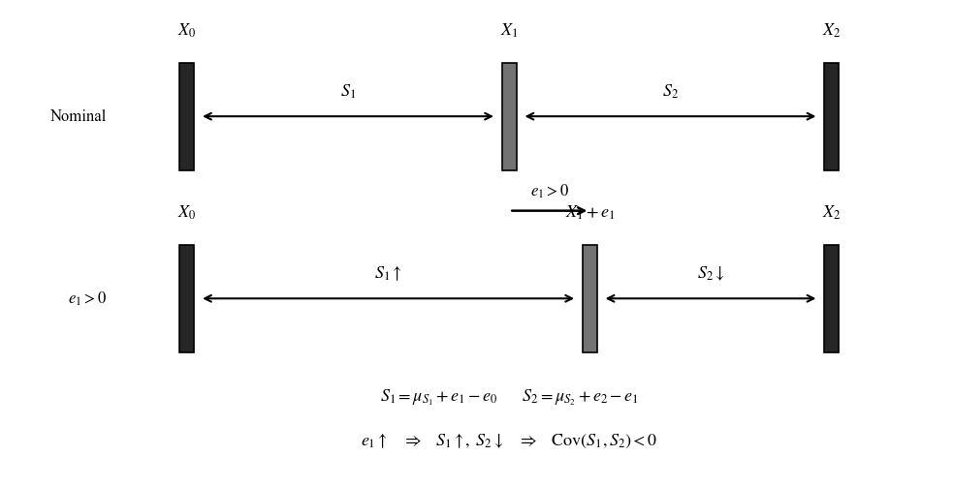
Figure 1 Shared-boundary mechanism producing negatively correlated adjacent passage widths.
For two passages sharing the middle boundary, the simplified expressions are S₁ = μS₁ + e₁ − e₀ and S₂ = μS₂ + e₂ − e₁. If the boundary errors are mutually independent, then
Cov(S₁, S₂) = −Var(e₁) = −σ₁² (6)
The covariance is negative because a positive displacement of the shared boundary increases one passage width and decreases the other. The corresponding correlation coefficient is
ρ₁₂ = −σ₁² / √((σ₀² + σ₁²)(σ₁² + σ₂²)) (7)

3.3 Route-Level Feasibility Probability
For a route P containing m required passages, route feasibility is the event that every passage exceeds the required width. The dependence-aware route probability is
P_{joint}(P) = Pr(S₁ ≥ w_{req}, …, S_{m} ≥ w_{req}) (8)
Under the Gaussian model in (4)-(5), this probability is a multivariate normal tail probability. A commonly used simplifying approximation is to multiply the marginal probabilities,
P_{ind}(P) = ∏^{m}_{i=1} Pr(S_{i} ≥ w_{req}) (9)
Equation (9) is exact only under independence. With the shared-boundary model, adjacent passage widths are generally correlated, so P_{ind} is an approximation. The planning reliability requirement is expressed as the joint chance constraint
P_{joint}(P) ≥ P_{min} = 1 − δ (10)
The experiments use P_{min} = 0.90 unless stated otherwise.
In this paper, a route-level false-safe instance is defined by P_{ind}(P) ≥ P_{min} while P_{joint}(P) < P_{min}. A planner-level false-safe decision occurs only when the independence-based planner actually selects such a route. This distinction is used throughout the simulation results.

4. Dependence-Aware A-Star-Based Method

4.1 Candidate-Route Generation
The geometric layer generates a finite set of candidate routes between the start and goal. A-Star supplies the shortest-path cost on the corridor-level graph, while alternative topological routes are represented explicitly by distinct corridor or passage signatures. This prevents near-duplicate node-level alternatives from being treated as meaningfully different physical routes and keeps the probabilistic comparison focused on distinct passage choices.

4.2 Dependence-Aware Route Evaluation
For each candidate route P_{k}, the planner identifies the uncertain boundaries associated with its required passages and constructs the corresponding difference matrix A_{k}. Given the boundary covariance Σ_{X}, the passage covariance is
Σ_{S,k} = A_{k}Σ_{X}A_{k}^{T} (11)
The route feasibility P_{joint}(P_{k}) is then evaluated numerically from the multivariate Gaussian distribution of the route passage-width vector. This calculation preserves the dependence induced by shared uncertainty sources rather than replacing the joint event with a product of marginal passage probabilities.

4.3 Route Selection
Let L_{k} be the geometric length or graph cost of candidate route k. The proposed planner selects
P* = arg min L_{k} for P_{k} ∈ C, subject to P_{joint}(P_{k}) ≥ P_{min} (12)
If no candidate satisfies (12), the planner reports that no route meets the requested reliability level rather than selecting a route that is falsely classified as safe. This behavior is distinguished from a planning failure: it is a reliability-aware infeasibility decision.

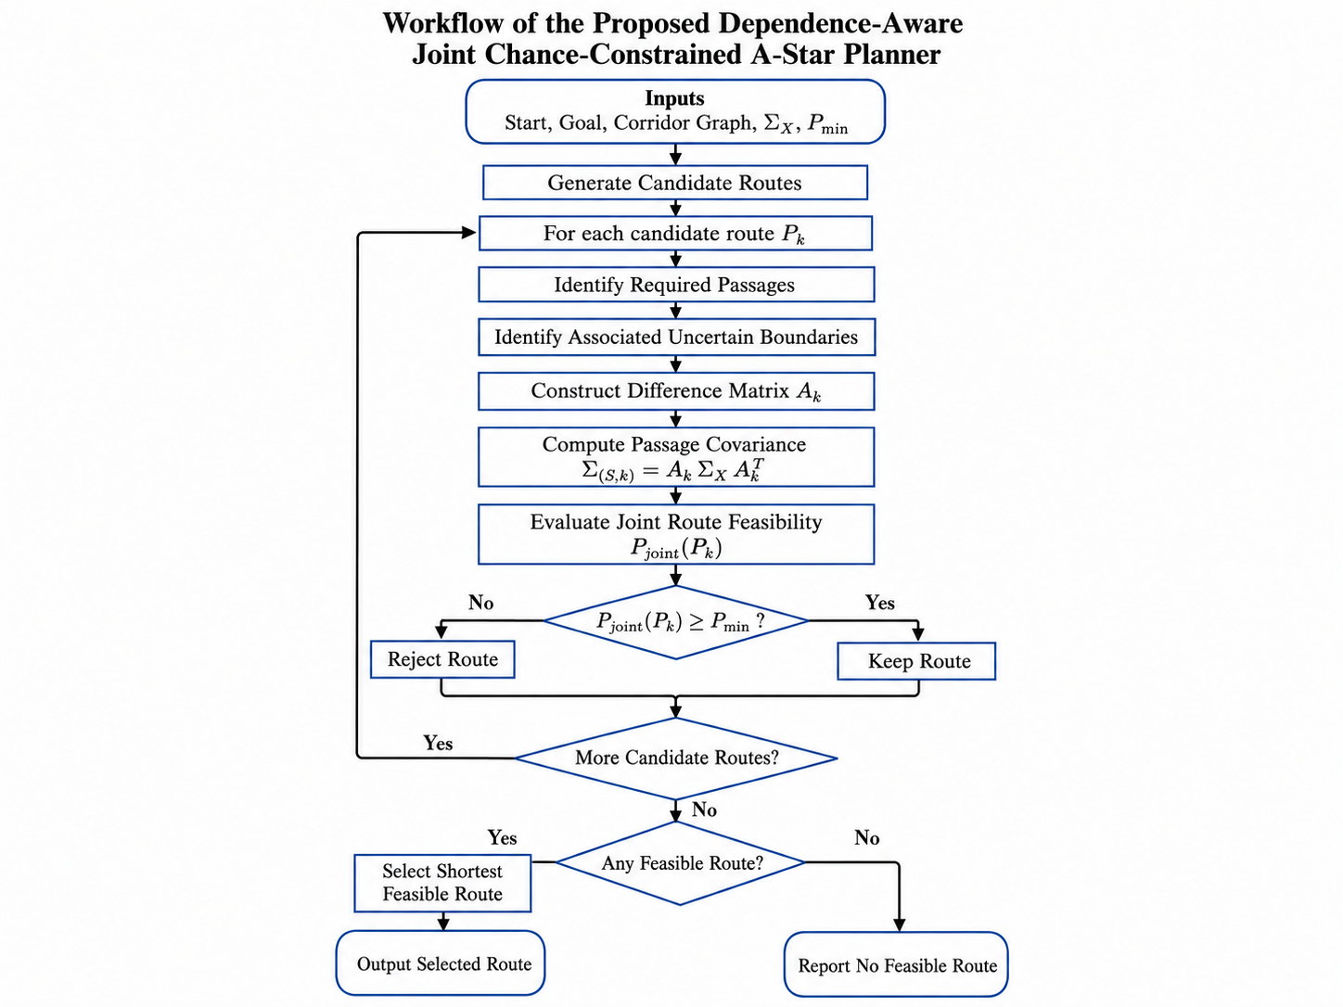
Figure 2 Workflow of the proposed dependence-aware joint chance-constrained A-Star-based planner.

5. Simulation Setup and Experimental Design

5.1 Numerical Environment and Validation Strategy

The simulation was implemented in Python using NumPy [10] for numerical operations, SciPy [11] for Gaussian probability evaluation, Pandas for tabulation, and Matplotlib for visualization. Model-based joint probabilities were validated against Monte Carlo estimates generated from the same underlying obstacle-boundary error variables. Unless otherwise stated, independent Gaussian boundary errors were sampled and converted into passage widths using the difference model in Section 3, ensuring that the model-based and Monte Carlo evaluations represented the same uncertainty process.

Accordingly, Monte Carlo simulation is used here to validate probability computation and decision consistency under the assumed generative model; it does not constitute empirical validation of the Gaussian boundary-error model against real perception data.

5.2 Two-Passage Dependence Validation

The first validation used three uncertain obstacle boundaries with equal standard deviation 0.10 m, mean passage widths of approximately 0.80 m, and w_{req} = 0.70 m. The theoretical correlation of the two passage widths is -0.5. With 100,000 Monte Carlo samples, the estimated correlation was -0.50181. The independence approximation gave P_{ind} = 0.57798, whereas the dependence-aware joint probability was approximately 0.53615 and Monte Carlo gave 0.53888. The experiment confirms that the dependence is generated directly by the shared boundary and that the independence approximation is optimistic in this configuration.

5.3 Sensitivity and False-Safe Analysis

A sensitivity study varied the mean passage width and the uncertainty of the shared boundary. With σ₁ = σ₃ = 0.05 m and σ₂ varied from 0.01 to 0.20 m, the adjacent-passage correlation becomes increasingly negative as shared-boundary uncertainty grows. A two-dimensional sweep over μ_{S} and σ₂ compared P_{ind}, P_{joint}, and Monte Carlo probability. The largest independence error occurred at μ_{S} = 0.70 m and σ₂ = 0.20 m, where ρ = -0.941176, P_{ind} = 0.25, P_{joint} = 0.054861, and P_{MC} = 0.053740. Across the sweep, the maximum independence error was 0.19626, whereas the maximum dependence-aware error relative to Monte Carlo was 0.006117.

A finer grid around P_{min} = 0.90 was then used to identify false-safe configurations satisfying P_{ind} ≥ 0.90 but P_{joint} < 0.90. The grid contained 10,201 parameter combinations, of which 126 fell inside the false-safe band. The resulting 1.235% proportion applies only to the selected zoomed parameter domain and is not interpreted as a universal failure probability.

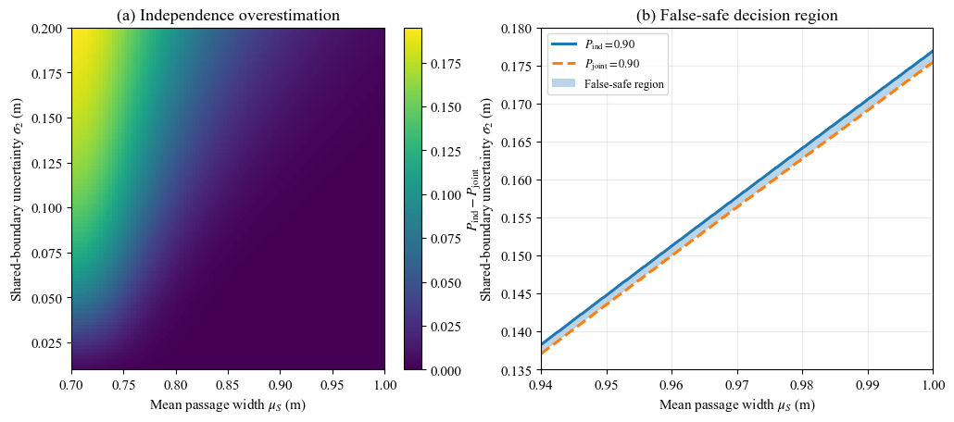
Figure 3 Sensitivity of independence error and the false-safe decision boundary.

5.4 Controlled Route-Selection Testbed

The controlled planner testbed contains two corridor-level alternatives. Route A is geometrically shorter, with length 80.0, and contains two correlated passages positioned close to the 0.90 chance-constraint boundary. Route B is longer, with length 94.031, but has wider passages and lower uncertainty. Standard A-Star therefore prefers Route A on geometric cost alone. The independence-based probabilistic planner also accepts Route A because its product-of-marginals estimate is slightly above 0.90, whereas the dependence-aware planner rejects Route A and selects Route B.
Table 1 Controlled route-selection results.
Metric | Route A | Route B
Length | 80.000 | 94.031
P_{ind} | 0.901279 | 0.994462
P_{joint} | 0.898714 | 0.994454
P_{MC} | 0.898332 | 0.994455

For Route A, a 2,000,000-sample Monte Carlo validation produced a 95% confidence interval of [0.897913, 0.898751], entirely below the 0.90 requirement. For Route B, the corresponding interval

was [0.994352, 0.994558]. The controlled test therefore provides a threshold-sensitive false-safe example: deterministic A-Star and the independence-based probabilistic planner choose Route A, while the dependence-aware planner selects the feasible alternative Route B.

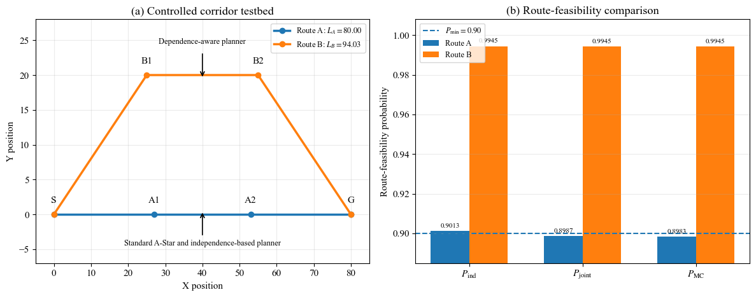
Figure 4 Controlled corridor-graph route selection by standard and dependence-aware planners.

5.5 Multi-Passage Extension

The dependence model was generalized to m sequential passages formed by m + 1 uncertain boundaries. With equal obstacle-position standard deviation of 0.10 m, the covariance matrix becomes tridiagonal, with diagonal entries of 0.02 and adjacent off-diagonal entries of -0.01. Numerically evaluated multivariate Gaussian probabilities and 200,000-sample Monte Carlo estimates were compared for m = 2,...,8. The dependence-aware joint probability remained close to Monte Carlo throughout. Relative overestimation by the independence approximation increased from 7.8% at m = 2 to 105.5% at m = 8, even though the absolute probability difference eventually decreased as all route probabilities approached zero.

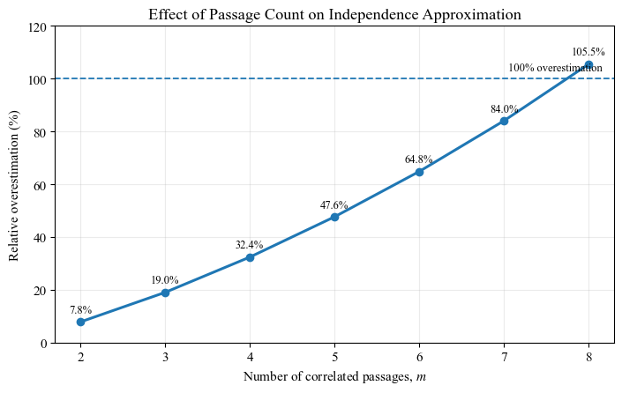
Figure 5 Relative overestimation of route-feasibility probability caused by the independence assumption as the number of correlated passages increases.

5.6 Randomized Scenario Campaign

To avoid relying on a single hand-designed scenario, a randomized campaign generated 5,000 two-route planning problems, corresponding to 10,000 route instances. Route A was always geometrically shorter, but both routes drew passage means and obstacle uncertainties from the same distributions, so Route B was not artificially forced to be safer. For each route, the simulation sampled mean passage width μ_{S} in [0.82, 1.02] m, left and right boundary standard deviations in [0.03, 0.08] m, and shared-boundary standard deviation in [0.05, 0.18] m. Route A length was sampled from 70 to 90 units, while Route B added a random detour of 5 to 25 units. Three planning strategies were compared: standard shortest-path selection, independence-based chance-constrained selection, and the proposed dependence-aware chance-constrained selection. Threshold sensitivity was evaluated at P_{min} = 0.85, 0.90, 0.95, and 0.99. The corresponding numbers of independence-based false-safe planner decisions were 97, 58, 27, and 1. Dependence-aware rerouting resolved 51, 21, 11, and 0 of these cases, while reliability-aware infeasibility was reported in the remaining 46, 37, 16, and 1 cases, respectively. The dependence-aware no-route rate increased from 10.74% at P_{min} = 0.85 to 71.78% at P_{min} = 0.99, reflecting the increasingly restrictive reliability requirement. The randomized parameter ranges were selected to span low-to-moderate passage-margin and boundary-uncertainty regimes, including configurations close to the reliability decision boundary. They are controlled synthetic ranges for stress-testing the planner and are not intended to represent a sensor model calibrated from field measurements.

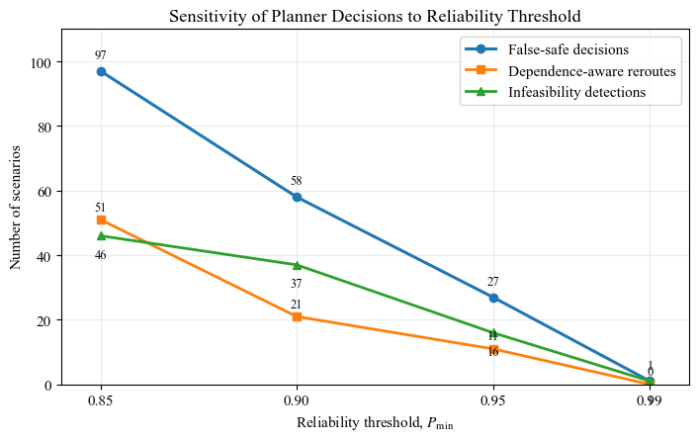
Figure 6 Sensitivity of planner decisions to the required reliability threshold Pmin.

5.7 Computational-Cost Benchmark

The computational-cost experiment measured probability-evaluation time separately from random scenario generation. For the two-passage case, 5,000 fixed route parameter sets were evaluated over seven repeats, and the median total time was used. A second benchmark measured multivariate joint-probability evaluation for m = 2,...,8 passages over 200 repetitions per dimension.

6. Results and Discussion

6.1 Dependence-Induced Probability Bias

The two-passage experiments consistently show that the independence approximation is optimistic under the negatively correlated shared-boundary model. The reason follows directly from the geometry: the same boundary displacement improves one adjacent opening while degrading the next, so simultaneous success is less likely than the product of the marginal success probabilities suggests. The effect grows with shared-boundary uncertainty because the magnitude of the negative correlation increases. In the most pronounced sensitivity case, independence predicted a route-feasibility probability of 0.25, while the joint model predicted 0.054861 and Monte Carlo gave 0.053740. This discrepancy shows that a simple factorization can substantially distort route-level risk when dependence is strong.

The multi-passage study reinforces the same conclusion. Although the absolute independence error peaks before m = 8 because the overall success probabilities become very small, the relative overestimation continues to increase and exceeds 100% at eight passages. Dependence is therefore not merely a two-passage artifact; its route-level effect can accumulate as the number of shared-boundary constraints increases.

6.2 False-Safe Decisions near the Chance-Constraint Boundary

The practical consequence of probability bias is most important near P_{min}. In the controlled scenario, Route A has P_{ind} = 0.901279 but P_{joint} = 0.898714. The independence-based planner therefore accepts the route at a 0.90 threshold, while the dependence-aware planner rejects it. Monte Carlo gives 0.898332 with a 95% confidence interval entirely below 0.90, confirming that the independence-based selection is false-safe for this model. The probability difference is only about 0.0026, yet it reverses the planning decision, illustrating why probability accuracy matters near a hard acceptance threshold.

The randomized campaign produced the same phenomenon without restricting samples to the narrow decision boundary. Among 10,000 randomly generated route instances, 88 satisfied P_{ind} ≥ 0.90 but P_{joint} < 0.90. At the planner level, 58 of the 5,000 scenarios resulted in an independence-based false-safe selected route. The dependence-aware planner rerouted to another feasible route in 21 of these scenarios and reported no route satisfying the joint reliability requirement in the remaining 37. The latter outcome is interpreted as reliability-aware infeasibility under the specified model and threshold rather than as a planning failure.

Table 2 Randomized planning campaign summary.
Metric | Result
Scenarios | 5,000
Route instances | 10,000
Standard A-Star unsafe-selection rate | 45.18%
Independence unsafe rate, all scenarios | 1.16%
Independence unsafe rate, selected cases | 1.461%
False-safe route instances | 88 (0.88%)
False-safe planner decisions | 58
Dependence-aware reroutes | 21
Dependence-aware infeasibility detections | 37
Different-route decisions | 21

The 45.18% standard A-Star unsafe-selection rate should be interpreted only within the synthetic sampling domain used in this campaign; it is not an estimate of real-world A-Star failure frequency. Likewise, the 0.88% false-safe route-instance rate and 1.16% false-safe planner-decision rate are conditional on the selected parameter ranges. The threshold

sweep further shows that the false-safe phenomenon is not unique to P_{min} = 0.90: false-safe independence-based decisions occurred at every tested threshold from 0.85 to 0.99. Their count decreased as the threshold increased because fewer routes were accepted at all, while the dependence-aware no-route rate rose as the reliability requirement became more stringent.

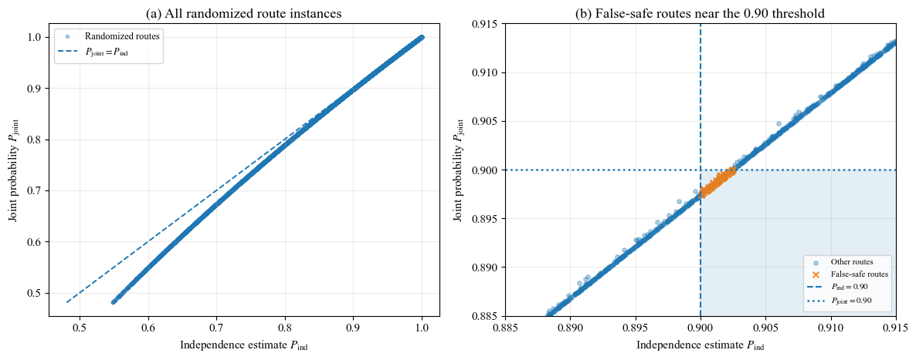
Figure 7 Randomized evaluation of route-feasibility estimates over 10,000 route instances: (a) independence-based versus dependence-aware joint probabilities; (b) enlarged view near the Pmin = 0.90 decision threshold highlighting false-safe route instances.

6.3 Monte Carlo Validation of Critical Decisions

All 58 independence-based false-safe planner decisions were re-evaluated with 500,000-sample Monte Carlo simulations. The dependence-aware model-based estimate was closer to Monte Carlo than the independence approximation in all 58 cases. Mean absolute error decreased from 0.002557 for P_{ind} to 0.000388 for P_{joint}, corresponding to an 84.82% reduction. Root-mean-square error decreased from 0.002606 to 0.000483, an 81.47% reduction. The median absolute errors were 0.002588 and 0.000301, respectively.
Table 3 Probability-estimation accuracy on 58 critical planner decisions.
Metric | Independence | Joint
MAE | 0.002557 | 0.000388
RMSE | 0.002606 | 0.000483
Median absolute error | 0.002588 | 0.000301
Closer to Monte Carlo | 0 / 58 | 58 / 58
Inside MC 95% CI | 0 / 58 | 51 / 58

With 500,000 samples per case, 55 of the 58 Monte Carlo point estimates were below 0.90 and 31 had a 95% confidence interval entirely below 0.90. Cases extremely close to the threshold require very large sample counts before the full confidence interval lies on one side of 0.90; therefore, confidence-interval coverage and error metrics are more informative validation measures than requiring every finite-sample point estimate to fall below the threshold. The joint model value lay inside the Monte Carlo 95% interval in 51 of 58 cases, whereas the independence value lay inside in none of the 58 cases, further supporting consistency of the dependence-aware model with the generating process.

6.4 Route-Length Trade-Off

Safety-aware rerouting has a geometric cost. In the 21 randomized cases where the dependence-aware planner rejected the independence-selected route but found another feasible route, the mean path-length penalty was 18.34%, the median was 16.17%, and the observed range was 8.26%-31.18%. This quantifies the main operational trade-off: more accurate route-level risk evaluation can require a longer path. The method therefore does not claim to improve distance optimality; it enforces the requested reliability level and minimizes length within the set of routes that satisfy that constraint.

6.5 Computational Cost and Scalability

For the two-passage route model used in the main controlled and randomized planner experiments, the median independence-evaluation time was 0.1283 ms per route, while the dependence-aware bivariate joint evaluation required 0.2847 ms per route. The joint calculation was therefore approximately 2.22 times slower, but the absolute additional cost was only about 0.1565 ms per route in this implementation.
Table 4 Median joint-probability runtime versus number of correlated passages.
m | Median time (ms)
2 | 0.180
3 | 8.749
4 | 25.408
5 | 49.143
6 | 90.250
7 | 243.572
8 | 1445.077

The higher-dimensional benchmark reveals a clear limitation. Runtime rises sharply with the dimension of the multivariate normal CDF. At m = 8, the median evaluation time was approximately 1.45 s, with substantial run-to-run variation in the numerical integration routine. Consequently, direct high-

accuracy multivariate Gaussian evaluation is practical for small correlated passage sets but becomes expensive as the jointly evaluated dimension grows. Future implementations should investigate decomposition, sparse-dependence exploitation, approximation, or risk-allocation strategies for long routes.
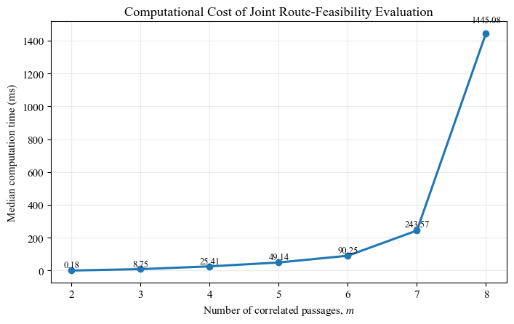
Figure 8 Computational cost of dependence-aware joint route-feasibility evaluation as the number of correlated passages increases.

6.6 Discussion

The experiments support the central hypothesis that shared obstacle-position uncertainty can create statistically dependent passage-feasibility events and that ignoring this dependence may produce optimistic route-level probabilities. The proposed method does not replace A-Star with a new shortest-path rule; A-Star continues to supply the geometric path cost. The contribution is the probabilistic route filter applied before final selection: route feasibility is evaluated jointly using the covariance induced by common uncertainty sources, and geometric optimality is then applied only among candidates that satisfy the reliability requirement.

The controlled and randomized experiments show why the distinction between marginal and joint probability is operationally important. A bias of only a few thousandths can be decisive when P_{min} is 0.90. In such cases, a product-of-marginals approximation may classify a route as feasible while the dependence-aware model and Monte Carlo generating process classify it as infeasible. Conversely, when individual passage probabilities are already very high, as in Route B, the numerical difference between P_{ind} and P_{joint} becomes small and both models lead to the same decision.

The method has several limitations. First, the present study assumes Gaussian obstacle-boundary errors and a linear passage-width model. Real perception errors may be non-Gaussian, multimodal, biased, or spatially correlated beyond the shared-boundary structure considered here. Second, the planner experiments use a corridor-level graph rather than a full online perception-to-control stack. Third, candidate corridors are assumed to be known or pre-extracted; automatic narrow-passage detection and association with uncertain obstacle features are outside the current scope. Fourth, high-dimensional multivariate Gaussian evaluation scales poorly, as demonstrated by the m = 7 and m = 8 timing results. Finally, the randomized campaign is synthetic; its reported rates quantify behavior only within the selected simulation ranges and should not be generalized directly to field operation. Relatedly, the Monte Carlo experiments validate the numerical probability calculation under the assumed model rather than the realism of the Gaussian error distribution itself.

7. Conclusion and Future Work

This paper presented a dependence-aware joint chance-constrained A-Star-based planning framework for UGV navigation under obstacle-position uncertainty. The key observation is that neighboring narrow passages can share an uncertain obstacle boundary, inducing statistical dependence in their widths. A linear difference model maps boundary uncertainty to passage covariance through Σ_{S} = AΣ_{X}AT, and a multivariate Gaussian joint probability evaluates the event that all required passages remain traversable. The planner then selects the shortest candidate route satisfying the route-level reliability constraint.

Simulation results show that the independence approximation can substantially overestimate route feasibility in strongly correlated cases and can produce false-safe decisions near the reliability threshold. In the controlled testbed, independence accepted the shorter route at P_{ind} = 0.901279, while the joint model predicted 0.898714 and Monte Carlo predicted 0.898332. In 5,000 randomized scenarios, 58 independence-based false-safe planner decisions were identified at P_{min} = 0.90; the dependence-aware method rerouted in 21 cases and reported reliability-aware infeasibility in 37. Across all 58 critical cases, the dependence-aware estimate was closer to Monte Carlo, reducing MAE by 84.82% and RMSE by 81.47%. The threshold sweep from 0.85 to 0.99 confirmed that false-safe independence-based decisions were not unique to the 0.90 setting. When rerouting was possible, the improved reliability assessment incurred an average path-length penalty of 18.34%.

For two correlated passages, the additional probability-evaluation cost was small in absolute terms, but direct multivariate Gaussian evaluation scaled poorly as the number of correlated passages approached eight. Future work will therefore focus on scalable approximations for long routes, automatic extraction of uncertain narrow passages from occupancy or perception maps, non-Gaussian uncertainty models, and closed-loop evaluation in higher-fidelity UGV simulations or physical experiments. These extensions will help determine how well the dependence-aware route-level formulation transfers from controlled simulation to real navigation systems.

Declaration of AI Use

This manuscript was prepared through the intellectual contributions of the author(s) to the study design, data analysis, interpretation of results, and scholarly content. Grammarly and ChatGPT were used solely to assist with grammatical refinement and reference formatting during manuscript revision. The author(s) accept full responsibility for the accuracy, integrity, and final content of the manuscript.

References

[1] P. E. Hart, N. J. Nilsson, and B. Raphael, “A formal basis for the heuristic determination of minimum cost paths,” IEEE Transactions on Systems Science and Cybernetics, vol. 4, no. 2, pp. 100–107, 1968, doi: 10.1109/TSSC.1968.300136.

[2] P. E. Missiuro and N. Roy, “Adapting probabilistic roadmaps to handle uncertain maps,” in Proceedings of the IEEE International Conference on Robotics and Automation (ICRA), 2006, pp. 1261–1267, doi: 10.1109/ROBOT.2006.1641882.

[3] L. Blackmore, M. Ono, and B. C. Williams, “Chance-constrained optimal path planning with obstacles,” IEEE Transactions on Robotics, vol. 27, no. 6, pp. 1080–1094, 2011, doi: 10.1109/TRO.2011.2161160.

[4] M. Castillo-Lopez, P. Ludivig, S. A. Sajadi-Alamdari, J. L. Sanchez-Lopez, M. A. Olivares-Mendez, and H. Voos, “A real-time approach for chance-constrained motion planning with dynamic obstacles,” IEEE Robotics and Automation Letters, vol. 5, no. 2, pp. 3620–3625, 2020, doi: 10.1109/LRA.2020.2975759.

[5] G. Gutow and J. D. Rogers, “AND/OR search techniques for chance constrained motion primitive path planning,” Robotics and Autonomous Systems, vol. 149, Art. no. 103991, 2022, doi: 10.1016/j.robot.2021.103991.

[6] A. Thomas, F. Mastrogiovanni, and M. Baglietto, “Safe motion planning with environment uncertainty,” Robotics and Autonomous Systems, vol. 156, Art. no. 104203, 2022, doi: 10.1016/j.robot.2022.104203.

[7] A. Theurkauf, J. Kottinger, N. R. Ahmed, and M. Lahijanian, “Chance-constrained multi-robot motion planning under Gaussian uncertainties,” IEEE Robotics and Automation Letters, vol. 9, no. 1, pp. 835–842, 2024, doi: 10.1109/LRA.2023.3337700.

[8] O. de Groot, L. Ferranti, D. M. Gavrila, and J. Alonso-Mora, “Scenario-based motion planning with bounded probability of collision,” The International Journal of Robotics Research, vol. 44, no. 9, pp. 1507–1525, 2025, doi: 10.1177/02783649251315203.

[9] M. Kneebone and R. Dearden, “Navigation planning in probabilistic roadmaps with uncertainty,” in Proceedings of the Nineteenth International Conference on Automated Planning and Scheduling (ICAPS), 2009.

[10] C. R. Harris et al., “Array programming with NumPy,” Nature, vol. 585, pp. 357–362, 2020, doi: 10.1038/s41586-020-2649-2.

[11] P. Virtanen et al., “SciPy 1.0: Fundamental algorithms for scientific computing in Python,” Nature Methods, vol. 17, pp. 261–272, 2020, doi: 10.1038/s41592-019-0686-2.

[12] V. Lefkopoulos and M. Kamgarpour, “Trajectory planning under environmental uncertainty with finite-sample safety guarantees,” Automatica, vol. 131, Art. no. 109754, 2021, doi: 10.1016/j.automatica.2021.109754.

[13] D. Li, B. Liu, Z. Huang, Q. Hao, D. Zhao, and B. Tian, “Safe motion planning for autonomous vehicles by quantifying uncertainties of deep learning-enabled environment perception,” IEEE Transactions on Intelligent Vehicles, vol. 9, no. 1, pp. 2318–2332, 2024, doi: 10.1109/TIV.2023.3297735.

[14] Y. Huang, H. Wang, L. Han, and Y. Xu, “Robot path planning in narrow passages based on improved PRM method,” Intelligent Service Robotics, vol. 17, no. 3, pp. 609–620, 2024, doi: 10.1007/s11370-024-00527-4.

[15] A. Stephens, M. Budd, M. Staniaszek, B. Casseau, P. Duckworth, M. Fallon, N. Hawes, and B. Lacerda, “Planning under uncertainty for safe robot exploration using Gaussian process prediction,” Autonomous Robots, vol. 48, Art. no. 18, 2024, doi: 10.1007/s10514-024-10172-6.

