Original Research Article
Effects of dietary Detarium microcarpum stem-bark extract on erythrocyte and leucocyte variables in Nile tilapia (Oreochromis niloticus)

Abstract
Plant-derived feed additives are increasingly investigated as locally available tools for sustainable aquaculture, but their physiological effects require careful assessment. The objective was to determine whether graded dietary supplementation with a hydroethanolic Detarium microcarpum stem-bark extract was associated with detectable changes in erythrocyte and leucocyte variables in Nile tilapia (Oreochromis niloticus). A 90-day completely randomised feeding trial was conducted in Loumbila, Burkina Faso, with haematological analyses performed in Bobo-Dioulasso in 2026. A total of 180 fingerlings (initial body weight 7.49 ± 1.43 g) were allocated to 12 tanks (15 fish/tank) and fed an unsupplemented control diet (RT) or diets containing 200, 300, or 400 mg dried extract/kg feed (R1, R2, and R3, respectively), with three replicate tanks per treatment. After 90 days, three fish per tank (n = 9/treatment) were sampled. Red and white blood cell counts, haemoglobin, haematocrit, erythrocyte indices, lymphocytes, and neutrophils were measured using a Sysmex XN-550 analyser, and dietary effects were assessed by nested analysis of variance. No significant dietary effect was detected for any of the nine haematological variables; treatment-effect P values ranged from .10 to .80. Red blood cell counts ranged from 1.37 ± 0.51 to 1.84 ± 0.52 ×10⁶/µL, haemoglobin from 7.17 ± 2.47 to 9.62 ± 2.62 g/dL, and haematocrit from 23.00 ± 7.10 to 30.96 ± 9.40%. White blood cells and lymphocytes were numerically highest in R2 but showed substantial within-treatment variability, while mean neutrophil-to-lymphocyte ratios remained descriptively similar (0.214-0.270). Under the conditions tested, dietary D. microcarpum stem-bark extract at 200-400 mg/kg did not produce a detectable adverse haematological effect. The numerical leucocyte changes do not establish immunostimulation and require confirmation using validated fish-specific cell-counting methods and complementary immune biomarkers.
Keywords: Detarium microcarpum; Oreochromis niloticus; haematology; hydroethanolic extract; phytogenic feed additive; dietary supplementation.
1. Introduction
Haematological assessment provides valuable information on the physiological condition of fish and is widely used to investigate responses to nutrition, environmental stressors, disease, and experimental interventions. Erythrocyte-related variables, including red blood cell count, haemoglobin concentration, haematocrit, mean corpuscular volume, mean corpuscular haemoglobin, and mean corpuscular haemoglobin concentration, provide information on the circulating red-cell compartment and oxygen-carrying capacity. In parallel, total and differential leucocyte counts can contribute to the assessment of immune and inflammatory responses. However, fish haematological profiles are influenced by multiple biological and environmental factors, including species, age, body size, nutritional status, water quality, handling conditions, and analytical procedures (Hrubec et al., 2000; Fazio, 2019; Bavia et al., 2024). These sources of variation make controlled feeding trials particularly useful for examining whether dietary interventions are associated with measurable changes in blood-cell profiles.
The increasing use of phytogenic products in aquafeeds has raised interest not only in their potential effects on growth and feed utilisation but also in their influence on fish physiology and health. Plant-derived supplements may contain a wide range of secondary metabolites capable of interacting with physiological and immune processes. Nevertheless, haematological responses to such products are not uniform. In Nile tilapia (Oreochromis niloticus), some dietary phytogenic interventions have been associated with changes in erythrocyte, haemoglobin, haematocrit, leucocyte, or immune-related variables, whereas other studies have reported limited or no significant haematological effects (Maccari et al., 2021; Youssef et al., 2023; Fadel et al., 2024; Fisseha et al., 2025). Consequently, the response to a plant-based additive must be established for each botanical source, preparation method, inclusion level, and experimental context rather than inferred from other phytogenic products.
Detarium microcarpum Guill. & Perr. is a multipurpose West African species used for both nutritional and traditional medicinal purposes. Investigations of different plant organs have reported several classes of secondary metabolites, including phenolic compounds, tannins, flavonoids, saponins, alkaloids, and terpenoids (Dogara, 2022; Hama Hamadou Habibou et al., 2022). Such chemical diversity supports interest in D. microcarpum as a potential source of functional feed ingredients. At the same time, repeated dietary exposure to a bioactive plant extract requires physiological evaluation, because the biological effects of phytochemicals may depend strongly on dose, extraction procedure, and chemical composition. In particular, information on the effects of D. microcarpum stem-bark extract on blood-cell variables in Nile tilapia remains scarce.
The feeding experiment from which the present data were obtained also generated growth and feed-utilisation results that have been reported separately (Soara et al., 2026). The present study addresses a different physiological endpoint by examining the haematological profile of fish exposed to graded dietary levels of hydroethanolic D. microcarpum stem-bark extract. Specifically, red blood cell count, haemoglobin, haematocrit, erythrocyte indices, total white blood cell count, lymphocytes, neutrophils, and the neutrophil-to-lymphocyte ratio were assessed after 90 days of dietary supplementation. The objective was to determine whether graded dietary supplementation with a hydroethanolic D. microcarpum stem-bark extract was associated with detectable changes in erythrocyte and leucocyte variables in Nile tilapia.
2. Materials and Methods
2.1. Study Area and Experimental Sites
Plant material was collected from a forest managed by the Department of Environment and Forests (DEF) of the Institute of Environment and Agricultural Research (INERA) in Saponé, Nazinon Region, Burkina Faso. Experimental fish were obtained from the Faso Centre of Expertise and Fish Production in Loumbila, Oubri Region, Burkina Faso. Haematological analyses were performed at the Institute of Sciences and Techniques (INSTech) in Bobo-Dioulasso, Burkina Faso.
2.2. Collection and Preparation of Detarium microcarpum Stem-Bark Extract
Fresh stem bark of D. microcarpum was collected in January 2026 after botanical identification. The bark was washed, cut into small pieces, and air-dried at ambient temperature (26.5 ± 2.9 °C) for two weeks, then ground into powder. The extract was prepared by maceration following general solid-liquid extraction principles (Handa et al., 2008). Briefly, 150 g of bark powder was macerated for 48 h in 750 mL of 70% hydroethanolic solvent (ethanol/water, 70:30, v/v), corresponding to a solid-to-solvent ratio of 1:5 (w/v). The mixture was homogenised using a magnetic stirrer and filtered through Whatman No. 5 filter paper. The filtrate was concentrated under reduced pressure using a Büchi rotary evaporator and dried in a forced-air oven at 45 °C for 24 h. The dried extract was stored in an airtight container until diet preparation.
2.3. Preparation of Experimental Diets
A commercial tilapia feed (Raanan) purchased locally was used as the basal diet. Four experimental diets were prepared: an unsupplemented control (RT) and diets supplemented with 200, 300, or 400 mg of dried D. microcarpum stem-bark extract per kilogram of basal feed, designated R1, R2, and R3, respectively. These doses corresponded to nominal inclusion levels of 0.020%, 0.030%, and 0.040% (w/w).
For each supplemented diet, the required quantity of dried extract was dissolved in 20 mL of distilled water per kilogram of basal feed and sprayed uniformly onto the feed surface using a coating procedure adapted from Ashour et al. (2020). The control diet received the same volume of distilled water without extract. Diets were thoroughly mixed, shade-dried at ambient temperature (27.8 ± 3.2 °C) for 24 h, placed in labelled airtight containers, and stored until use.
2.4. Fish, Experimental Design, and Rearing Conditions
A total of 180 apparently healthy Nile tilapia fingerlings (initial mean body weight 7.49 ± 1.43 g) were acclimatised for 14 days and fed the commercial basal diet. Fish were then randomly distributed among 12 tanks (50 × 35 × 30 cm) at 15 fish per tank. The four diets were randomly assigned to tanks with three replicate tanks per treatment (45 fish per treatment). Each tank constituted an experimental unit.
The feeding trial lasted 90 days. Fish received a daily ration equivalent to 7% of the biomass in each tank, divided among three meals at 08:00, 12:00, and 16:00. Biomass was assessed every two weeks and feeding allowances were adjusted accordingly. Approximately one-third of tank water was replaced daily with fresh groundwater. Water temperature, pH, dissolved oxygen, and electrical conductivity were monitored daily using a YINMIK multiparameter meter.
2.5. Blood Collection
At the end of the 90-day trial, three fish were randomly selected from each tank, yielding nine fish per treatment and 36 fish overall. Fish were fasted for 24 h before sampling. Each fish was anaesthetised by immersion in clove oil at 50 mg/L following Simões et al. (2011). After loss of equilibrium and reduced opercular movement, 0.5-1 mL of blood was collected from the caudal vessels using a sterile syringe and transferred to an EDTA tube. Samples were gently mixed by inversion, individually labelled with treatment and tank information, maintained at 2-8 °C during transport, and analysed within 18 h of collection. All treatment groups were handled under the same storage, transport, and analysis conditions.
2.6. Haematological Analyses
Whole blood collected in EDTA tubes was analysed using a Sysmex XN-550 automated haematology analyser. The instrument uses electrical impedance with hydrodynamic focusing for cell counting and volume characterisation, fluorescence flow cytometry for leucocyte analysis, and the cyanide-free sodium lauryl sulphate method for haemoglobin determination (Tailor et al., 2017). The variables retained were red blood cell count (RBC), haemoglobin (Hb), haematocrit (Hct), mean corpuscular volume (MCV), mean corpuscular haemoglobin (MCH), mean corpuscular haemoglobin concentration (MCHC), total white blood cell count (WBC), lymphocyte count (LYM), and neutrophil count (NEU). Haematocrit and erythrocyte indices were calculated automatically by the analyser.
Because fish erythrocytes are nucleated and automated analysers developed for mammalian blood can show species-specific limitations, the automated counts were interpreted cautiously and were not treated as validated diagnostic reference measurements for Nile tilapia (Witeska et al., 2022; Mesalles et al., 2025).
2.7. Neutrophil-to-Lymphocyte Ratio
The neutrophil-to-lymphocyte (N/L) ratio was calculated individually for each fish as the absolute neutrophil count divided by the absolute lymphocyte count. Individual ratios were calculated before treatment means, standard deviations, standard errors, and coefficients of variation were derived.
2.8. Statistical Analysis
Haematological data were organised in Microsoft Excel 2016. Results are reported as means ± standard deviations (SD). Figures display treatment means with descriptive standard errors of the mean (SEM) calculated across the sampled fish; inferential testing accounted for tank structure as described below. Coefficients of variation (CV, %) were calculated as SD/mean × 100. Normality and homogeneity of variances were assessed using the Shapiro-Wilk and Levene tests, respectively. Dietary treatment effects were evaluated in IBM SPSS Statistics version 25 using nested analysis of variance with tanks nested within dietary treatments. Statistical significance was assessed at α = .05. Because no significant dietary treatment effect was detected for the nine primary haematological variables, graphical dose-response patterns were treated as descriptive rather than as evidence of an optimum or biological dose-response. The N/L ratio was summarised descriptively because an inferential test for this derived variable was not reported in the source dataset.
Table 1. Declared nutrient composition of the commercial basal diet.
Component | Declared composition
Crude protein | 40%
Crude lipid | 7%
Moisture | 9%
Crude ash | 11%
Crude fibre | 2.5%
Phosphorus | 1.2%
Vitamin A | 15,000 IU/kg
Vitamin C | 300 mg/kg
3. Results
3.1. Erythrocyte Profile
Mean RBC counts ranged from 1.37 ± 0.51 ×10⁶/µL in R3 to 1.84 ± 0.52 ×10⁶/µL in R2. Haemoglobin ranged from 7.17 ± 2.47 g/dL in R3 to 9.62 ± 2.62 g/dL in R2, whereas haematocrit ranged from 23.00 ± 7.10% in R3 to 30.96 ± 9.40% in R1 (Table 2). MCV, MCH, and MCHC varied comparatively little across treatments. These differences are descriptive; nested ANOVA did not detect a significant dietary treatment effect for any erythrocyte-related variable, and the corresponding treatment-effect P values are reported in Table 4.
Table 2. Erythrocyte-related variables of Nile tilapia across dietary treatments (mean ± SD; MCHC in g/dL).
Diet | RBC (×10⁶/µL) | Hb (g/dL) | Hct (%) | MCV (fL) | MCH (pg) | MCHC
RT | 1.46 ± 0.54 | 7.90 ± 2.67 | 24.47 ± 10.50 | 167.29 ± 22.73 | 52.71 ± 3.79 | 30.52 ± 3.64
R1 | 1.77 ± 0.46 | 9.45 ± 2.48 | 30.96 ± 9.40 | 173.68 ± 21.44 | 53.26 ± 3.11 | 30.99 ± 3.39
R2 | 1.84 ± 0.52 | 9.62 ± 2.62 | 30.13 ± 9.28 | 161.43 ± 13.38 | 53.14 ± 4.01 | 33.11 ± 3.42
R3 | 1.37 ± 0.51 | 7.17 ± 2.47 | 23.00 ± 7.10 | 172.90 ± 21.94 | 53.03 ± 3.20 | 30.57 ± 4.77
3.2. Leucocyte Profile
Mean WBC counts ranged from 66.68 ± 52.03 ×10³/µL in R3 to 182.93 ± 113.87 ×10³/µL in R2. Lymphocyte and neutrophil means were also numerically highest in R2 (138.40 ± 86.15 and 30.09 ± 25.89 ×10³/µL, respectively), but within-treatment dispersion was substantial (Table 3). Nested ANOVA did not detect significant dietary treatment effects for WBC, LYM, or NEU; the corresponding treatment-effect P values are reported in Table 4. Therefore, the numerical R2 peak does not establish immunostimulation.
Table 3. Leucocyte-related variables of Nile tilapia across dietary treatments (mean ± SD).
Diet | WBC (×10³/µL) | LYM (×10³/µL) | NEU (×10³/µL)
RT | 97.37 ± 65.35 | 70.41 ± 53.22 | 18.04 ± 10.76
R1 | 101.94 ± 60.79 | 71.33 ± 47.29 | 16.51 ± 9.57
R2 | 182.93 ± 113.87 | 138.40 ± 86.15 | 30.09 ± 25.89
R3 | 66.68 ± 52.03 | 45.11 ± 38.49 | 12.19 ± 10.63
3.3. Descriptive Profiles and Within-Treatment Variability
Fig. 1 displays treatment means with SEM for the nine primary haematological variables. RBC, Hb, and Hct increased numerically from RT to R1/R2 and declined in R3, whereas erythrocyte indices remained comparatively stable. WBC, LYM, and NEU showed the largest numerical changes, with higher means in R2. Because the corresponding treatment effects were not statistically significant, these trajectories should be interpreted as descriptive patterns rather than fitted dose-response relationships or physiological optima.
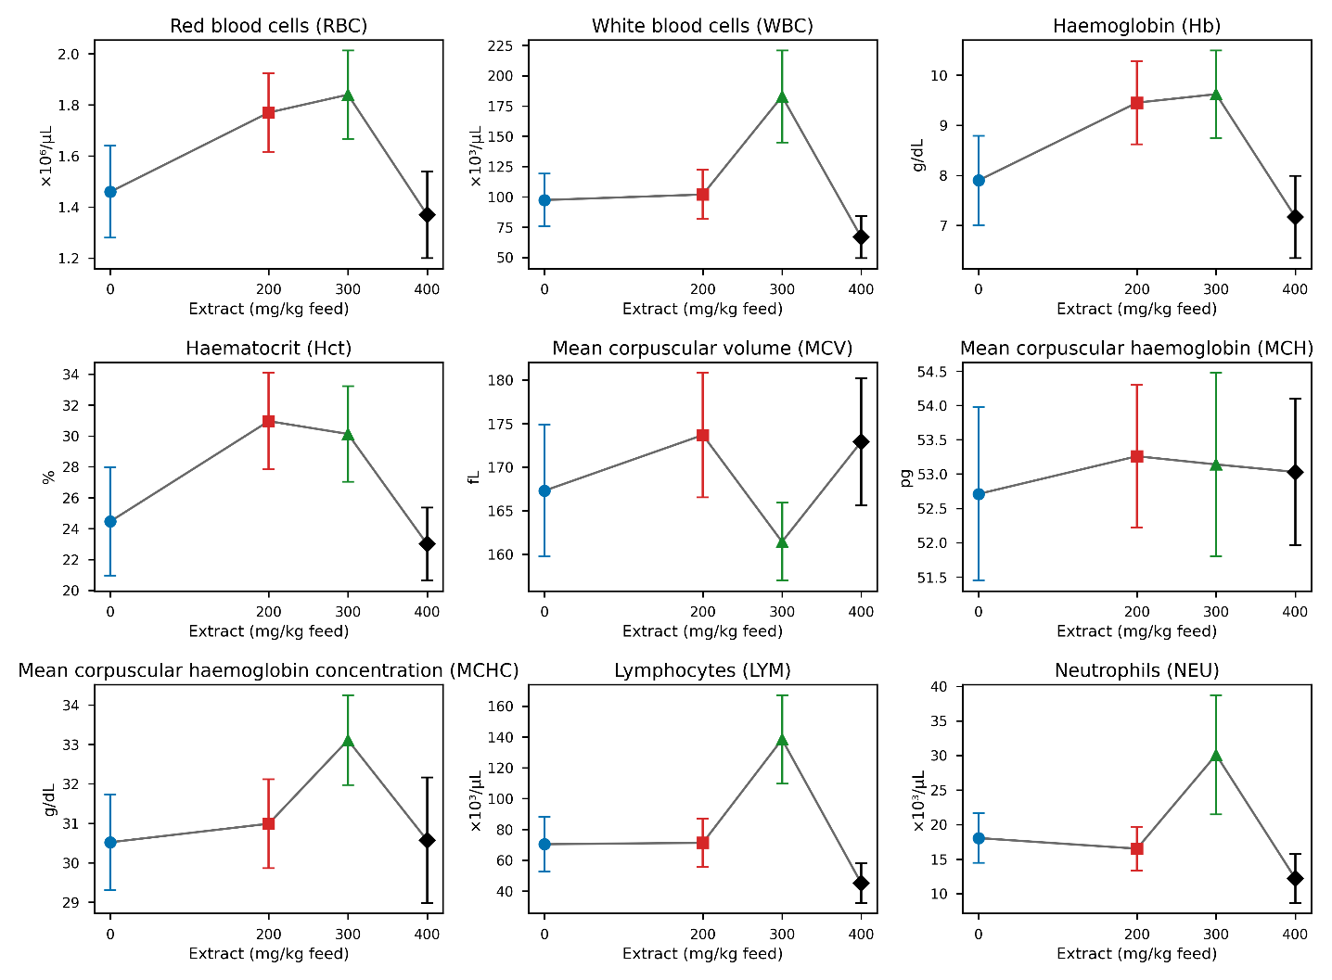
Fig. 1. Haematological profiles of Nile tilapia across graded dietary levels of D. microcarpum stem-bark extract.
Points represent treatment means calculated from nine sampled fish per treatment (three fish from each of three tanks); error bars represent descriptive fish-level SEM. Statistical inference used nested ANOVA accounting for tank within treatment. RT, R1, R2, and R3 correspond to 0, 200, 300, and 400 mg extract/kg feed, respectively. Treatment symbols/colors: RT, blue circle; R1, red square; R2, green triangle; R3, black diamond.
Coefficients of variation were lowest for the erythrocyte indices, particularly MCH, and generally higher for WBC, LYM, and NEU (Fig. 2). The high relative dispersion of leucocyte variables indicates substantial within-treatment heterogeneity and limits interpretation of differences among treatment means.
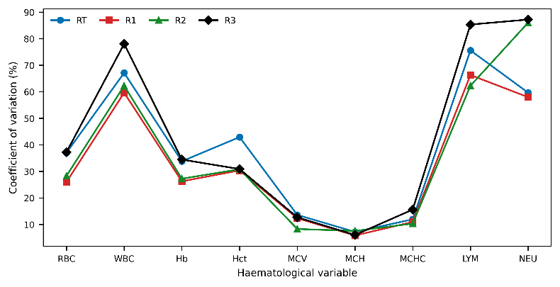
Fig. 2. Within-treatment coefficients of variation for the nine haematological variables in Nile tilapia.
CV (%) = SD/mean × 100. RT, R1, R2, and R3 correspond to 0, 200, 300, and 400 mg D. microcarpum stem-bark extract/kg feed, respectively.
3.4. Nested Analysis of Variance
Nested ANOVA detected no statistically significant dietary treatment effect for any of the nine primary haematological variables. The tank-within-treatment term was also non-significant in the reported analysis; exact P values are provided in Table 4. These results do not demonstrate equivalence among diets; rather, they indicate that the study did not detect a treatment effect under the tested conditions.
Table 4. Nested ANOVA results for haematological variables.
Parameter | Source | F-value | P-value
RBC | Diet | 1.534 | .23
 | Tank (Diet) | 0.324 | .95
WBC | Diet | 2.245 | .11
 | Tank (Diet) | 0.325 | .95
Hb | Diet | 1.672 | .20
 | Tank (Diet) | 0.279 | .97
Hct | Diet | 1.764 | .20
 | Tank (Diet) | 0.304 | .96
MCV | Diet | 0.894 | .46
 | Tank (Diet) | 0.362 | .93
MCH | Diet | 0.331 | .80
 | Tank (Diet) | 0.231 | .98
MCHC | Diet | 0.518 | .67
 | Tank (Diet) | 0.313 | .96
LYM | Diet | 2.284 | .10
 | Tank (Diet) | 0.330 | .95
NEU | Diet | 2.145 | .12
 | Tank (Diet) | 0.319 | .95
Treatment-effect P values are reported in Table 4; statistical significance was assessed at α = .05.
3.5. Neutrophil-to-Lymphocyte Ratio
Mean N/L ratios were 0.265 ± 0.081 in RT, 0.214 ± 0.062 in R1, 0.256 ± 0.074 in R2, and 0.270 ± 0.092 in R3 (mean ± SD). Their CVs ranged from 28.9% to 34.1% (Table 5). The ratios were descriptively close across treatments (Fig. 3). Because the source analysis did not report an inferential test for the N/L ratio, no claim of statistical equivalence or absence of a treatment effect is made for this derived variable.
Table 5. Neutrophil-to-lymphocyte ratio by dietary treatment.
Diet | N/L ratio (mean ± SD) | N/L ratio (mean ± SEM) | CV (%)
RT | 0.265 ± 0.081 | 0.265 ± 0.027 | 30.6
R1 | 0.214 ± 0.062 | 0.214 ± 0.021 | 29.0
R2 | 0.256 ± 0.074 | 0.256 ± 0.025 | 28.9
R3 | 0.270 ± 0.092 | 0.270 ± 0.031 | 34.1

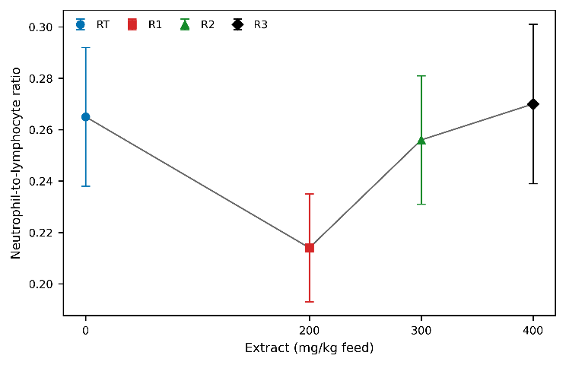
Fig. 3. Descriptive neutrophil-to-lymphocyte (N/L) ratio across dietary extract levels.
Values are treatment means ± descriptive fish-level SEM (9 sampled fish/treatment; 3 fish/tank). RT, R1, R2, and R3 = 0, 200, 300, and 400 mg extract/kg feed. Symbols/colors: blue circle, red square, green triangle, and black diamond, respectively. N/L was analysed descriptively.
4. Discussion
The clearest pattern in the present dataset was the relative stability of erythrocyte-related variables across dietary treatments. Red blood cell count, haemoglobin, haematocrit, and the three corpuscular indices showed only modest numerical fluctuations, and the nested analysis did not identify a dietary treatment effect. Considered together, these variables provide complementary information on circulating erythrocytes and oxygen-transport capacity; therefore, the absence of a coordinated shift across the erythrocyte profile is more informative than isolated differences between treatment means. The observed values also fell within broad ranges previously reported for tilapia (Hrubec et al., 2000; Swangneat et al., 2026), although such published ranges are population- and method-dependent and should not be interpreted as diagnostic reference intervals for the fish examined here.
Haematological responses to plant-derived feed additives in Nile tilapia are not uniform across studies. Fisseha et al. (2025) reported no significant changes in several haematological variables when lupin and grass pea meal was incorporated into diets for Nile tilapia fingerlings, whereas other phytogenic interventions have been associated with increases in selected erythrocyte, haemoglobin, or leucocyte variables (Youssef et al., 2023; Fadel et al., 2024). These contrasting findings indicate that blood-cell responses cannot be extrapolated from one botanical product to another and may depend on the plant source, extraction procedure, chemical composition, inclusion level, duration of exposure, and rearing conditions.
In contrast to the comparatively stable erythrocyte indices, the leucocyte compartment showed pronounced within-treatment dispersion. Mean WBC, lymphocyte, and neutrophil counts were numerically highest at 300 mg/kg, but the corresponding treatment effects were not statistically significant and the standard deviations were large. The R2 peak should therefore be regarded as an exploratory numerical pattern rather than evidence of immunostimulation. Leucocyte variables are particularly sensitive to handling, environmental conditions, social interactions, and subclinical health status, all of which may contribute to individual variability (Fazio, 2019; Costa et al., 2024). Although D. microcarpum contains classes of secondary metabolites with potential biological activity, including phenolics, flavonoids, tannins, saponins, alkaloids, and terpenoids (Dogara, 2022; Hama Hamadou Habibou et al., 2022), the extract used in the present trial was not quantitatively characterised. Moreover, functional immune endpoints such as lysozyme activity, complement activity, immunoglobulins, cytokines, or resistance to infectious challenge were not measured. The present leucocyte data therefore cannot establish an immunomodulatory mechanism.
The neutrophil-to-lymphocyte ratio provided an additional descriptive view of leucocyte balance. Mean ratios remained within a relatively narrow interval across treatments (0.214-0.270), and no monotonic pattern with increasing extract inclusion was evident. Because no inferential comparison of the N/L ratio was available in the source analysis and no universally validated threshold exists for Nile tilapia, these values should be interpreted as exploratory rather than as evidence of altered chronic stress or immune status.
Interpretation of the absolute cell counts also requires consideration of the analytical platform. The Sysmex XN-550 is designed primarily for mammalian haematology, whereas fish erythrocytes and thrombocytes are nucleated and may interfere with automated classification and counting. Methodological reviews have emphasised the importance of species-appropriate procedures in fish haematology (Witeska et al., 2022), and preliminary work with automated analysers in fish has highlighted the need for validation against manual counts and blood-smear examination (Mesalles et al., 2025). Consequently, the automated measurements in this study are most useful for within-study comparison among dietary groups and should not be interpreted as definitive reference values for Nile tilapia.
The experimental design imposes additional constraints on inference. The three replicate tanks per treatment represent the true experimental replication, while the three fish sampled from each tank are subsamples rather than independent treatment replicates. This limited tank replication, together with the high variability of several leucocyte measurements, may have reduced the ability to detect modest dietary effects. In addition, the lack of quantitative phytochemical characterisation prevents attribution of any numerical response to specific constituents of D. microcarpum. Future work would benefit from greater tank replication, chemical standardisation of the extract, manual blood-smear differentials or fish-validated automated counting, and complementary immune and oxidative-stress biomarkers.
Taken together, these findings extend the separately reported growth and feed-utilisation results from the same feeding experiment (Soara et al., 2026) by providing information on a distinct physiological endpoint. The present data are more consistent with relative haematological stability than with either a stimulatory or adverse blood-cell response to the extract at the tested inclusion levels. Whether D. microcarpum can exert beneficial immunomodulatory effects under challenge conditions remains unresolved and will require targeted functional studies.

5. Conclusion
Across the 90-day feeding period, Nile tilapia receiving 200, 300, or 400 mg/kg of hydroethanolic Detarium microcarpum stem-bark extract maintained erythrocyte and leucocyte profiles broadly comparable with those of the unsupplemented control. Erythrocyte-related variables remained relatively stable, while the numerical increase in WBC, lymphocytes, and neutrophils at 300 mg/kg was accompanied by substantial individual variability and was not supported by a significant dietary treatment effect. The findings therefore do not support claims of immunostimulation or an optimal inclusion level, but they also did not reveal a marked adverse haematological response under the conditions tested. Confirmation of these results will require stronger tank-level replication, quantitative phytochemical characterisation of the extract, validation of cell counts using fish-appropriate methods, and inclusion of functional immune and oxidative-stress endpoints.
6. Limitations
The study included three replicate tanks per dietary treatment and three sampled fish per tank, limiting experimental-unit replication. Several leucocyte variables showed high within-treatment variability. The hydroethanolic extract was not quantitatively phytochemically characterised, and the Sysmex XN-550 was not specifically validated for Nile tilapia blood. The N/L ratio was summarised descriptively because an inferential test for this derived variable was not available in the source analysis. These limitations restrict conclusions regarding immunostimulation, dose-response, physiological equivalence, and overall safety. Potential pre-analytical effects of the interval of up to 18 h between blood collection and haematological analysis cannot be excluded, although all treatment groups were handled under the same storage, transport, and analysis conditions.
Declaration of AI Use
The authors used Grammarly and ChatGPT for language editing and reference formatting. All AI-assisted content was reviewed and verified by the authors, who take full responsibility for the final manuscript.
Competing Interests
The authors declare that they have no competing interests.
Ethical Approval
All experimental procedures were approved by the Health Research Ethics Committee (CERS; approval No. 2026-03-145). Fish handling and blood-collection procedures were conducted to minimise pain and stress. Before blood collection, fish were anaesthetised by immersion in clove oil at 50 mg/L, following Simões et al. (2011).
Declaration of AI Use

This manuscript was prepared through the intellectual contributions of the author(s) to the study design, data analysis, interpretation of results, and scholarly content. Grammarly and ChatGPT were used solely to assist with grammatical refinement and reference formatting during manuscript revision. The author(s) accept full responsibility for the accuracy, integrity, and final content of the manuscript.

References
Ashour, M., Mabrouk, M. M., Ayoub, H. F., El-Feky, M. M. M. M., Zaki, S. Z., Hoseinifar, S. H., et al. (2020). Effect of dietary seaweed extract supplementation on growth, feed utilization, hematological indices, and non-specific immunity of Nile tilapia, Oreochromis niloticus, challenged with Aeromonas hydrophila. Journal of Applied Phycology, 32(5), 3467-3479. https://doi.org/10.1007/s10811-020-02178-1
Bavia, L., da Silva, A. P., Carneiro, M. C., Kmecick, M., Pozzan, R., Esquivel-Muelbert, J., et al. (2024). Health status biomarkers and hemato-biochemical indices in Nile tilapia. Comparative Immunology Reports, 7, 200168. https://doi.org/10.1016/j.cirep.2024.200168
Costa, D. S., Dutra, S. A. P., Pereira, I. L., Cardoso, L., de Medeiros, P. B., Riofrio, L. V. P., et al. (2024). Hematoimmunological responses of juvenile Nile tilapia (Oreochromis niloticus) receiving dietary supplementation of immunomodulators and different levels of vitamins after challenge with physical stress. Brazilian Journal of Veterinary Medicine, 46, e001124. https://doi.org/10.29374/2527-2179.bjvm001124
Dogara, A. M. (2022). Biological activity and chemical composition of Detarium microcarpum Guill. and Perr.-A systematic review. Advances in Pharmacological and Pharmaceutical Sciences, 2022, 7219401. https://doi.org/10.1155/2022/7219401
Fadel, A., Metwally, M. M. M., Hassan, H. U., Abdelmageed, A. A., Arai, T., Ahmed, M. Z., et al. (2024). Growth, immunomodulatory, histopathological, and antibacterial effects of phytobiotic-incorporated diets on Oreochromis niloticus in unchanged water. Frontiers in Marine Science, 11, 1473053. https://doi.org/10.3389/fmars.2024.1473053
Fazio, F. (2019). Fish hematology analysis as an important tool of aquaculture: A review. Aquaculture, 500, 237-242. https://doi.org/10.1016/j.aquaculture.2018.10.030
Fisseha, T., Geremew, A., Fetahi, T., & Abass, K. (2025). Impact of lupin and grass pea mixture meal as dietary inclusion on body composition and haematological parameters of Nile tilapia fingerlings in a recirculation aquaculture system. Aquaculture, Fish and Fisheries, 5(3), e70073. https://doi.org/10.1002/aff2.70073
Hama Hamadou Habibou, H., Mahamane Idi Issa Abdoulahi, M., Chaibou, M., Chaibou Ousmane Zakari, C., Hama Garba Rahila, H., & Ikhiri, K. (2022). Phytochemistry and pharmacology activities of Detarium microcarpum (Fabaceae) used in the treatment of parasitic diseases in Niger: A review. Journal of Pharmacognosy and Phytochemistry, 11(2), 60-67. https://doi.org/10.22271/phyto.2022.v11.i2a.14377
Handa, S. S., Khanuja, S. P. S., Longo, G., & Rakesh, D. D. (Eds.). (2008). Extraction technologies for medicinal and aromatic plants. International Centre for Science and High Technology, United Nations Industrial Development Organization. https://www.unido.org/publications/ot/9656660
Hrubec, T. C., Cardinale, J. L., & Smith, S. A. (2000). Hematology and plasma chemistry reference intervals for cultured tilapia (Oreochromis hybrid). Veterinary Clinical Pathology, 29(1), 7-12. https://doi.org/10.1111/j.1939-165X.2000.tb00389.x
Maccari, G. M. R., Damasceno, D. Z., Lins-Rodrigues, M., Bittencourt, F., Bruschi, M. L., Toledo, L. A. S., et al. (2021). Hematological parameters, liver integrity and growth of Nile tilapia fingerlings fed diets supplemented with propolis extract. Spanish Journal of Agricultural Research, 19(4), e0612. https://doi.org/10.5424/sjar/2021194-17279
Mesalles, M., Uroz, M., Brandts, I., Serrano, E., Cuenca, R., Pastor, J., & Teles, M. (2025). Preliminary evaluation of an automated blood cell analyzer for its use with blood samples from rainbow trout Oncorhynchus mykiss. Animals, 15(9), 1265. https://doi.org/10.3390/ani15091265
Simões, L. N., Lombardi, D. C., Gomide, A. T. M., & Gomes, L. C. (2011). Efficacy of clove oil as anesthetic in handling and transportation of Nile tilapia, Oreochromis niloticus (Actinopterygii: Cichlidae) juveniles. Zoologia, 28(3), 285-290. https://doi.org/10.1590/S1984-46702011000300001
Soara, A. E., Bayili, B., Da, N., Ouedraogo, S., & Ouattara, W. M. M. (2026). Effect of Detarium microcarpum Guill. & Perr. bark extract on growth and feed utilization of Nile tilapia (Oreochromis niloticus Linnaeus, 1758). Journal of Biology and Nature, 18(2), 502-511. https://doi.org/10.56557/joban/2026/v18i211077
Swangneat, K., Phromduang, D., Thang, T. N., Laovechprasit, W., & Pornpanom, P. (2026). Preliminary hematological reference values and morphology of blood cells in farmed sex-reversed male Nile tilapia (Oreochromis niloticus) from Southern Thailand. Veterinary World, 19(4), 1773-1784. https://doi.org/10.14202/vetworld.2026.1773-1784
Tailor, H., Mackie, I., Mellick, A., & Machin, S. (2017). Evaluation of the Sysmex XN-550, a novel compact haematology analyser from the XN-L series, compared to the XN-20 system. International Journal of Laboratory Hematology, 39(6), 585-589. https://doi.org/10.1111/ijlh.12701
Witeska, M., Kondera, E., Ługowska, K., & Bojarski, B. (2022). Hematological methods in fish-Not only for beginners. Aquaculture, 547, 737498. https://doi.org/10.1016/j.aquaculture.2021.737498
Youssef, I. M. I., Saleh, E. S. E., Tawfeek, S. S., Abdel-Fadeel, A. A. A., Abdel-Razik, A. R. H., & Abdel-Daim, A. S. A. (2023). Effect of Spirulina platensis on growth, hematological, biochemical, and immunological parameters of Nile tilapia (Oreochromis niloticus). Tropical Animal Health and Production, 55, 275. https://doi.org/10.1007/s11250-023-03690-5

