Comparative Phytochemical Analysis in Finger Millet Germplasm from Different Districts of Uttarakhand.

Abstract:
Earth's ecosystem possesses a remarkable ability to maintain ecological balance by providing essential conditions such as a life-supporting atmosphere, adequate water resources, and a stable temperature range. ). Apart from these, nature provides a wide variety of food resources that are essential for human survival and wellbeing. Millets can play a key role to combating hunger, ensuring sustainable food production, and supplying essential phytochemical, dietary fibre, vitamins and help prevent various life style -related diseases. Ragi is a lifeline crop in drought-prone areas, serving as a staple food that ensures food security. Ragi grains can be kept for longer periods without substantial damage from storage pests., making them an ideal food grain for regions vulnerable to famine and food scarcity. This paper showed noticeable qualitative phytochemical analysis differences among the finger millet treatments in the presence and concentration of bioactive compounds. The detection of alkaloids, tannins, saponins, terpenoids, phenolic compounds, proteins, and carbohydrates highlight the rich nutraceutical potential of finger millet and its importance as a functional food.
Key Word- Ecosystem, Food Security, Hunger, Nutritional

Introduction
Earth's ecosystem possesses a remarkable ability to maintain ecological balance by providing essential conditions such as a life-supporting atmosphere, adequate water resources, and a stable temperature range (Spiridonov et al., 2025). Apart from these, nature provides a wide variety of food resources that are essential for human survival and wellbeing. However, modern agricultural systems and dietary habits have become increasingly dependent on a few important cereal crops such as rice, wheat, and maize resulting in the underutilization of many nutrient-rich crops. Among these, millets have emerged as climate resilient and nutrient rich crops with remarkable potential to enhance food and nutritional security. They can play a key role to combating hunger, ensuring sustainable food production, and supplying essential phytochemical, dietary fibre, vitamins and help prevent various life style -related diseases.
Millets are ancient grains, small-seeded grasses grown for generations, particularly in arid and semiarid regions (Smith et al., 2017). It comprises several species such as finger millet (Eleusine coracana), pearl millet (Pennisetum glaucum) and sorghum (Sorghum bicolor) (Nayak, C.B. et al., 2021), (Patil, R. N., & Bhambulkar, A. V.,2020).
Millets are a nutritional powerhouse, playing a key role in food security, because they’re so nutritious, it’s important to boost their production and include them more in our diets. They're a staple meal in Asia and Africa, providing a reliable energy source with around 320-370 kcal/100g. Encouraging their production and use can boost nutrition, especially in regions where they're already a tradition. (Raturi et al., 2026)
Due to their high nutritious content and can grow well even in tough climates, which makes them important for food and nutrition security. Millets play a key role in people's everyday diets, particularly in Asia and Africa. However, over the past three decades, their production and consumption have drastically decreased, especially in India. The cultivation and total production of millets have decreased because of the decline in demand. Sorghum production, for example, decreased from 7 million tonnes in 2010–11 to 4.2 million tonnes in 2015–16. The production of finger millet (ragi) fell from 2.2 million tonnes to 1.8 million tonnes, pearl millet (bajra) from 10.4 million tonnes to 8.1 million tonnes, and tiny millets from 0.44 million tonnes to 0.39 million tonnes during the same time period. It is imperative to promote millets' production and consumption due to their high nutritional value and contribution to food security. (Rao et al., 2017).

Finger millet (Eleusine coracana L.) is a nutrient rich cereal grain cultivated in different parts of India and Africa, with promising health benefits (Devi et al., 2014; Chandra et al., 2016; Puranik et al., 2017; Ceasar et al., 2018; Ramashia et al., 2018). Its common names are ‘bulo’, ‘ragi’, and ‘wimbi’ (Uganda), ‘tamba’, ‘pwana’, and 'sarga’ (Nigeria), ‘dagussa’ (Ethiopia), ‘ragi’ and 'mandua’ (India), ‘wimbe’ (East Africa), and ‘rapoko’ in South Africa, while its common English names are African millet, birdsfoot, and coracana (Abioye et al., 2022).

Ragi is a major millet crop, with India leading global production at 41%, followed by Africa. Worldwide, it is considered the fourth most important millet after sorghum, pearl millet, and foxtail millet (Chandra et al., 2016).
Ragi is a important crop for food and nutrition security, particularly in developing countries and rain-fed areas. It's super adaptable, thriving in diverse environments from high-altitude areas to deserts, often outdoing other cereals. It is cultivated mainly by small farmers and hence is often called "poor man's food"(Kumar et al., 2019).
Ragi is a lifeline crop in drought-prone areas, serving as a staple food that ensures food security. Ragi grains can be kept for longer periods without substantial damage from storage pests., making them an ideal food grain for regions vulnerable to famine and food scarcity (Upadhyaya et al., 2008).
The content of fiber in ragi enhances satiety, regulation of blood sugar, and digestive health. Its fiber helps people manage their weight by increasing satiety, reducing excessive energy intake, and controlling hunger. Porridge of Ragi is frequently suggested as a suitable supplemental food for newborns and young children due to its positive benefits on gastrointestinal health. Ragi's insoluble fiber fraction supports overall gut health by enhancing intestinal motility, increasing stool size, improving digestive function, and helping to prevent and treat constipation. (Swamy, 2023).
Antioxidant activity in ragi is determined by a number of factors, such as total flavonoid content, total phenolic, DPPH and ABTS cation radical scavenging activities, ferrous ion chelating ability, ferric reducing antioxidant power, and oxygen radical absorption capacity. However, the grain's overall phenolic composition is determined by its activity. (Somarajan & Morya, 2022).

Materials and method: -
Study area: The study was carried out in Plantica Lab in Dehradun.
Sample collection: A total of 12-germplasm collected from 12 different district of Uttarakhand.
Lab equipment’s: -
Glassware: - worked with the glassware of BOROSIL company. Test tube, conical flask, pipette, rotatory shaker, amber bottles.
Plasticware: - pipette tips, dropper
General laboratory tools: - filter paper, muslin cloth, test tube stand, pestle & motor, tissue paper
Lab equipment’s: - Rotatory shaker, Hot air oven, analytical balance
Chemical use: -
For phytochemical analysis: - Mercuric chloride, potassium iodide, hydrochloric acid, 0.2% ninhydrin, ethanol, 1% potassium dichromate, chloroform, sulphuric acid, 5% alpha –
naphthol, folin & ciocalteu’s phenol reagent
Extraction of samples: -
We have done Agitated Maceration Extraction method for phytochemical analysis. In this method we used motor pestle, the samples were powdered and grounded.

Table 1: Summary of the experiment conditions for extraction

Parameter | Materials
Common solvents | Methanol
Temperature | Room temperature
Pressure | Not applicable
Time | 24hrs
Volume of solvents | 100ml
Speed | 100rpm

Preparation of extract using cold maceration method: -
The seeds samples were oven-dried n at 50 degree temperature. The dried seeds were grinding in motor pestle which become powder. The prepared powder was soaked in solvent. The powder was weighed before mixing in solvent, the ratio was used 1:10 w/v i.e 10g of powder in 100ml solvent. The flask containing the solvent & powder were placed on
rotatory shaker at room temperature.
After extraction the maceration mixture is filtered out using whatmann no. 1 filter paper.
Phytochemical analysis: -
Phytochemicals are naturally occurring plant derived substances obtain from the plants. The term is widely used to refer the huge number of optional metabolic mixes found in plants. Phytochemicals screening measure is a simple, rapid and cheap method that gives the analyst fast response to the different kind of phytochemicals in a mixture and in a bioactive compound examination.
Qualitative phytochemical analysis: -
The extract was tested for the presence of bioactive compounds by using standard methods .

Table 2: A summary for phytochemical screening for secondary metabolites-
Secondary metabolite | Test Name | Methodology | Results
Alkaloids | Mayer’s test | Reagent preparation: -  1.36g HgCl2+60ml distilled water  5g KI + 10ml distilled water Mix both solution and make final volume up to 100ml  Procedure: -  Take 2ml of crude extract with 1 -2 drops of HCL and add 2 to 3 drops of Mayer’s  reagent. | The formation of a yellowish cream  precipitate indicates the presence of alkaloids.
Tannins | Dichromate test | Crude extract was treated with 1% dichromate  solution. | Formation of  yellowish brown or dark brown  precipitate.
Phenolic compounds | Folin-ciocalteu  method. | Crude extract was treated with diluted folin-  ciocalteu’s reagent and then add 7 -10% Na2CO3. | Blue colour indicate presence of phenolic compounds.
Saponins | Foam / frothing test | 0.5 ml crude extract mixed with 5ml of distilled water in a test tube and it was shaken well. | The formation of frothing / foam indicated the presence of  saponins.

Results of phytochemical analysis:

Plate 1. Qualitative phytochemical screening for alkaloids in finger millet germplasm (T1–T12)

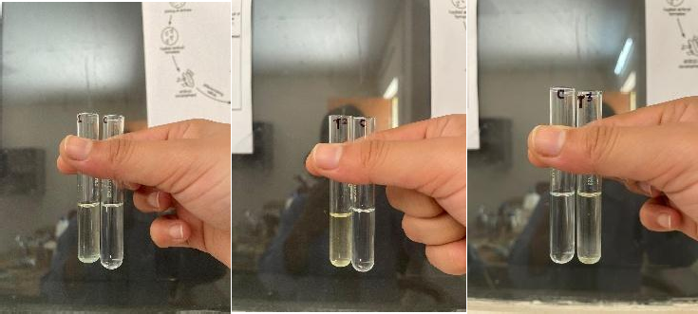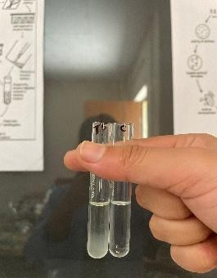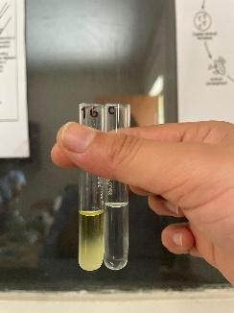
- T1
.
- T6
- T5
- T3
- T2
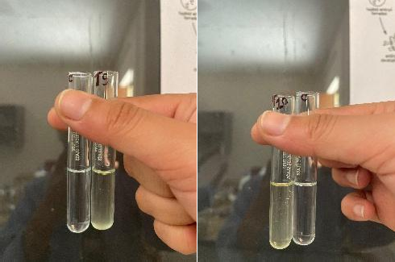
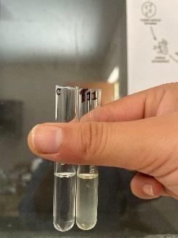
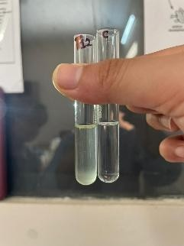
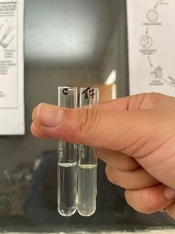
- T7
- T9
- T10
- T11
- T12

Plate 2. Qualitative phytochemical screening for tannins in finger millet germplasm (T1–T12)

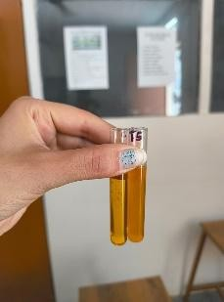
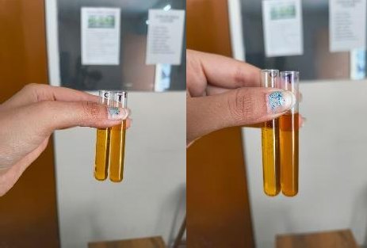
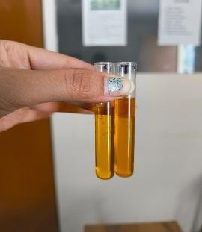
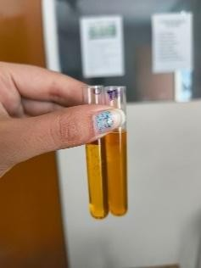
- T5
- T4
- T3
- T2
- T1
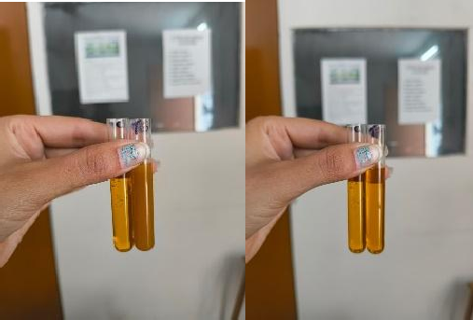
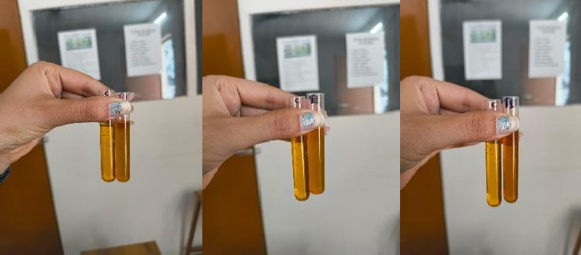
j.T10
i. T9
- T8
- T7
- T6
l. T12
k.T11
- T12
- T11
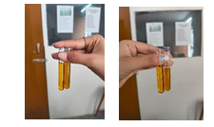
k.T11
l.T12

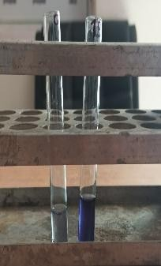
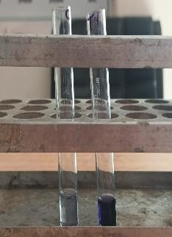
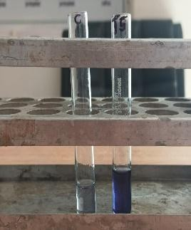
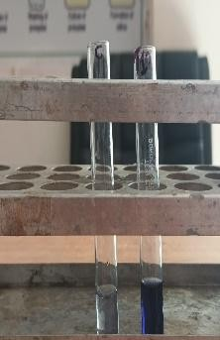
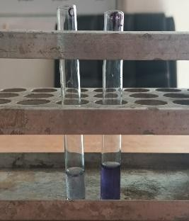
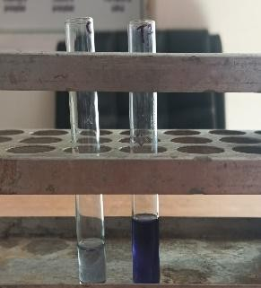
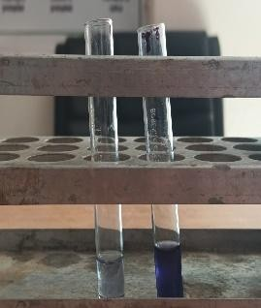
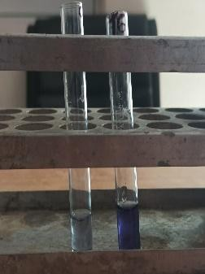
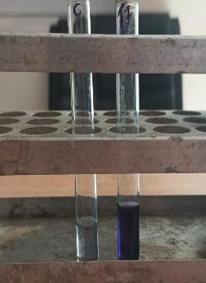
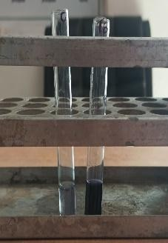
Plate 3. Qualitative phytochemical screening for proteins in finger millet germplasm (T1–T12)
- T4
- T3
- T2V
- T5
- T1
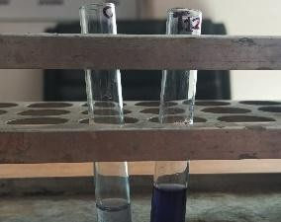
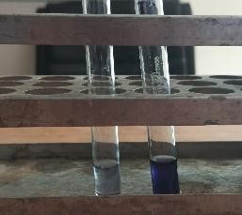
- T10
- T8
- T9
- T7
- T6
- T12
- T11
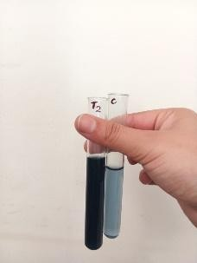
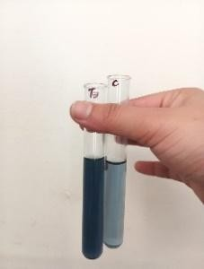
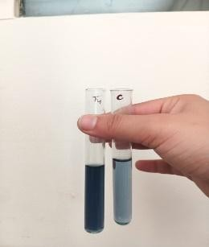
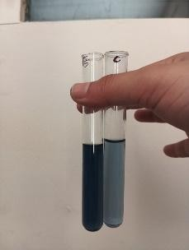
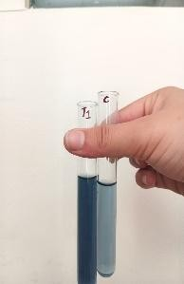
a.T1-eT5
e.T5
d.T4
c.T3
b.T2
a.T1

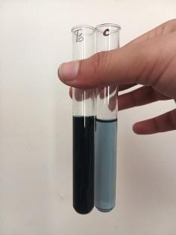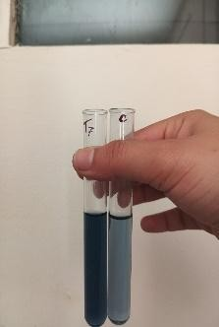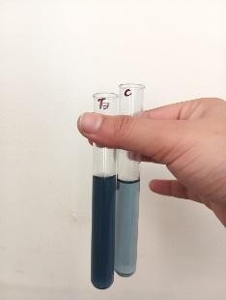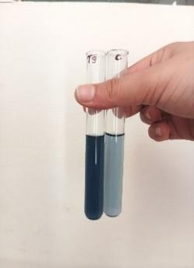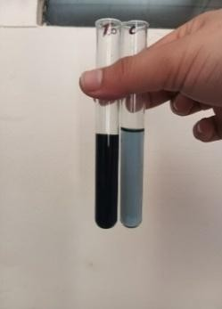

j.T10
i.T9
h.T8
g.T7
f.T6
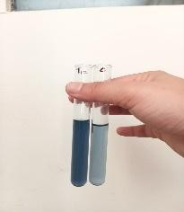
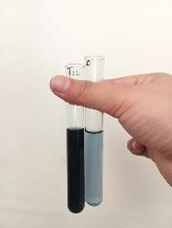
l.T12
k.T11

Plate 4. Qualitative phytochemical screening for phenolic compounds in finger millet germplasm (T1–T12)

Plate 5. Qualitative phytochemical screening for carbohydrates in finger millet germplasm (T1–T12)
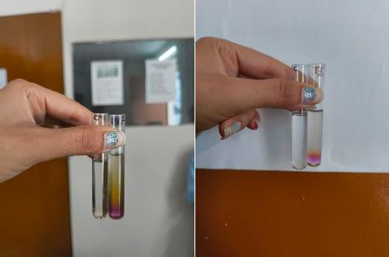
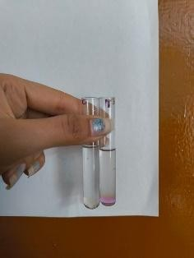
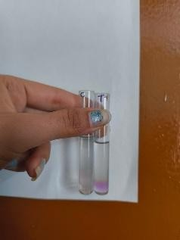
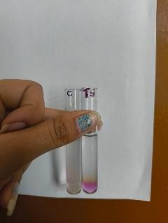
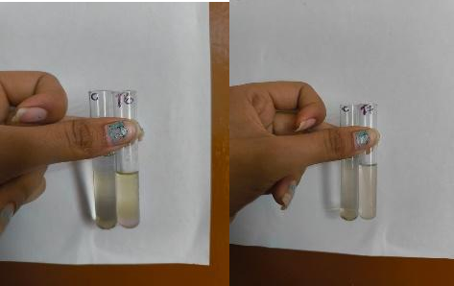
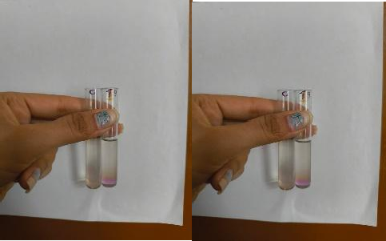
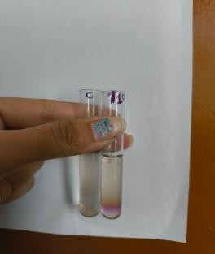
j.T10
i.T9
h.T8
g.T7
f.T6
- T5
d.T4
c.T3
b.T2
a.T1

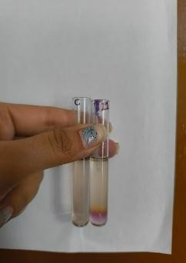
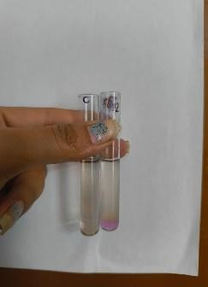
l.T12
k.T11

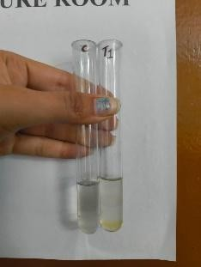
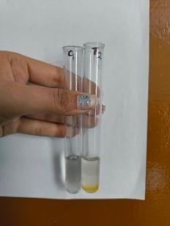
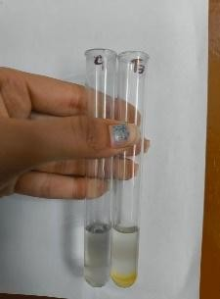
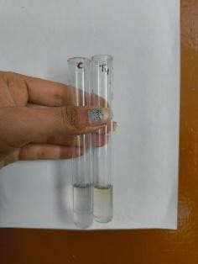
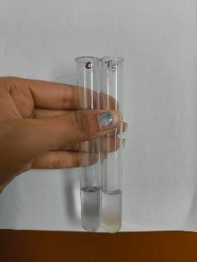
E: T5
C: T3
D: T4
B: T2
A:T1
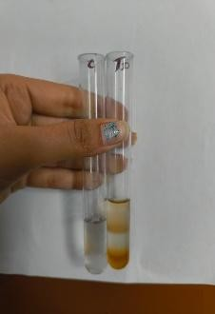
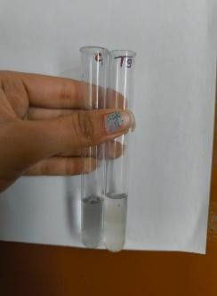
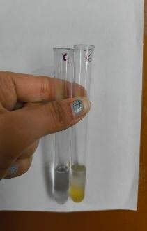
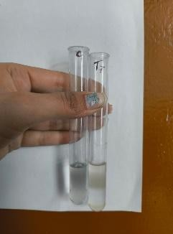
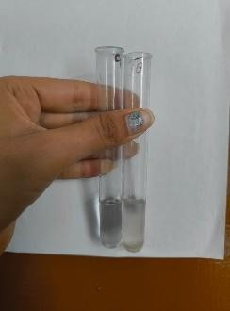
J:T10
I:T9
H:T8
F:T6
G:T7
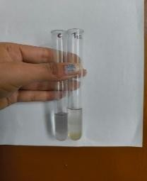
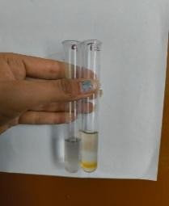
L:T12
K:T11

Plate 6. Qualitative phytochemical screening for terpenoids in finger millet germplasm (T1–T12)

Treatment | Germplasm district | Alkaloids | Tannins | Saponins | Carbohydrates | Trepenoids | Proteins | Phenolic compounds
T1 | Almora | - | + | + | ++ | + | ++ | +
T2 | Bageshwar | - | - | - | ++ | + | ++ | ++
T3 | Champawat | - | - | + | + | + | ++ | +
T4 | Chamoli | + | + | + | + | - | ++ | +
T5 | Dehradun | + | + | + | ++ | - | ++ | ++
T6 | Nainital | +++ | +++ | - | + | - | +++ | +++
T7 | Pauri garhwal | + | - | - | - | - | ++ | ++
T8 | Pithoragarh | - | + | + | ++ | - | ++ | ++
T9 | Rudraprayag | + | + | + | + | - | ++ | ++
T10 | Tehri | - | - | + | + | ++ | ++ | +++
T11 | Uttarkashi | + | - | + | + | + | ++ | +++
T12 | Uddham singh nagar | + | + | + | + | + | ++ | +
Table 3: phytochemical analysis of samples

Note : Slightly Positive (+)
Positive (++)
Strongly Positive (+++)

Results

Qualitative phytochemical test Tests on 12 finger millet samples (T1-T12) showed they're packed with beneficial compounds like alkaloids, tannins, saponins, carbs, terpenoids, proteins, and phenolics. Phytochemical constituent abundance was classified as absence (−), slightly positive (+), positive (++), and strongly positive (+++).
Proteins were present in every treatment among all the phytochemicals. Most treatments showed a positive (++) reaction, whereas T6 exhibited a strongly positive (+++) reaction, indicating the highest protein content.
Nearly every treatment contained carbohydrates. T1, T2, T5, and T8 had positive (++) reactions while the remaining treatments showed a slightly positive (+) reaction. T7 did not show the presence of carbohydrates.
Phenolic compounds varied across samples. Strongly positive (+++) reactions were recorded in T6, T10, and T11, whereas positive (++) reactions were observed in T2, T5, T7, T8, and T9. A marginally positive (+) response was observed for the remaining treatments.

Alkaloids were absent in T1, T2, T3, T8, and T10, while T6 exhibited the highest intensity (+++). The remaining treatments showed a slightly positive (+) reaction.

Tannins were strongly positive (+++) only in T6. Slightly positive (+) reactions were observed in T1, T4, T5, T8, T9, and T12, whereas no tannins were detected in T2, T3, T7, T10, and T11.
Saponins were absent in T2, T6, and T7, while the remaining treatments showed a slightly positive (+) reaction.
The occurrence of terpenoids was treatment-dependent. Positive results were observed in T1, T2, T3, T10, T11, and T12, whereas T4, T5, T6, T7, T8, and T9 showed no detectable terpenoids.
Overall, T6 exhibited the strongest phytochemical profile due to the highest levels of alkaloids, tannins, proteins, and phenolic compounds. In contrast, T7 showed the lowest phytochemical diversity, with the absence of carbohydrates, tannins, saponins, and terpenoids.
Because the +/++/+++ categories derive from visible qualitative reactions, they should be interpreted as relative screening intensities rather than direct measurements of compound concentration. Quantitative comparison among germplasm would require validated compositional assays, such as proximate protein analysis, spectrophotometric phenolic/tannin determination, or chromatographic profiling, as used in prior finger millet studies (Chethan & Malleshi, 2007; Nakarani et al., 2021; Xiang et al., 2019).
Discussion
The qualitative phytochemical analysis showed noticeable differences among the finger millet treatments in the presence and concentration of bioactive compounds. The detection of alkaloids, tannins, saponins, terpenoids, phenolic compounds, proteins, and carbohydrates highlights the rich nutraceutical potential of finger millet and its importance as a functional food.
Interpretation of qualitative phytochemical variation
Published finger millet studies demonstrate substantial varietal differences in phenolics, tannins, and broader phytochemical composition, supporting the plausibility of heterogeneity among the present germplasm. Nakarani et al. (2021) quantified genotype-dependent differences in phenolics and tannins among finger millet genotypes, while Xiang et al. (2019) reported varietal variation in phenolic profiles and antioxidant capacity. Chethan and Malleshi (2007) also showed that measured polyphenol recovery depends strongly on extraction conditions and grain fraction. Accordingly, the present qualitative pattern should be regarded as an initial comparative screen rather than a definitive ranking of absolute phytochemical concentration.
Protein was consistently detected at high levels across all the treatments, indicating that finger millet is an excellent source of dietary protein. Among the treatments, T6 exhibited the strongest protein response, suggesting superior nutritional quality. This variation may be due to the genetic differences among the finger millet treatments, which influence the accumulation of nutritional and phytochemical constituents.
Protein-related variation and nutritional interpretation
Genotypic differences in grain protein are well documented in finger millet. Vadivoo et al. (1998) observed wide protein variation among 36 genotypes, and Upadhyaya et al. (2011) identified substantial nutrient and protein diversity in a core germplasm collection. More recently, Puranik et al. (2020) linked variation in grain nutritional traits, including protein, to genomic regions, supporting a genetic contribution to nutritional diversity. Nevertheless, the stronger qualitative protein reaction of T6 should not be equated with a precise protein concentration until validated by a quantitative protein assay.
A stronger antioxidant potential was shown by the abundance of phenolic molecules in several treatments, especially T6, T10, and T11. In addition to protecting plants from oxidative stress and scavenging free radicals, phenolic chemicals also improve human health by lowering the risk of chronic illnesses.
Phenolic compounds, tannins, and antioxidant relevance
The stronger qualitative phenolic reactions in T6, T10, and T11 are consistent with the recognized prominence of phenolic compounds in finger millet, but antioxidant capacity cannot be inferred directly from reaction intensity alone. Xiang et al. (2019) demonstrated that finger millet varieties differ in both free and bound phenolics and in antioxidant activity, while Chethan and Malleshi (2007) showed that polyphenols are highly concentrated in the seed coat and are extraction-dependent. Nakarani et al. (2021) likewise reported genotype-level differences in total phenolics and tannins. These studies support further quantitative phenolic profiling of the high-reacting germplasm before making functional or health-related claims.
Similarly, finger millet's therapeutic and protective qualities are reflected in the presence of tannins, alkaloids, saponins, and terpenoids. The antibacterial, anti-inflammatory, antioxidant, and health-promoting properties of these phytochemicals are well-known. Variations in genetics, environmental factors, and secondary metabolite production could all contribute to treatment variance.
Secondary-metabolite pattern and sources of variation
Differences in alkaloid, tannin, saponin, and terpenoid reactions may reflect genetic background, grain tissue composition, and extraction or assay sensitivity. Large-scale genomic work has established substantial genetic diversity and population structure in finger millet germplasm (Backiyalakshmi et al., 2021), while compositional studies show that genotype can materially affect nutritional and phytochemical profiles (Nakarani et al., 2021; Xiang et al., 2019). Because the current assay is qualitative, absence of a visible reaction should be interpreted as 'not detected under the present test conditions' rather than proof that the metabolite is completely absent.
Overall, the findings indicate that T6 has the richest phytochemical profile among the evaluated treatments, making it a promising genotype for nutritional improvement and functional food applications. The variation observed among the different treatments provides valuable information for identifying and selecting superior finger millet genotypes with enhanced nutritional quality and higher phytochemical content. Such genotypes can be effectively utilized in future breeding programmes aimed at improving the health benefits and nutritional value of finger millet.
Implications for germplasm selection and breeding
The contrast between T6 and T7 is potentially useful for prioritizing accessions for follow-up analysis, but breeding decisions should be based on replicated quantitative phenotyping across environments. Upadhyaya et al. (2011) showed exploitable genetic diversity for grain nutrient traits in finger millet germplasm, and Puranik et al. (2020) identified genomic regions associated with nutritional traits. Genome-wide characterization has also confirmed broad diversity among global finger millet accessions (Backiyalakshmi et al., 2021). Thus, the present screening can serve as a preliminary basis for selecting contrasting materials for confirmatory biochemical assays, multi-environment evaluation, and subsequent genetic analysis.
Conclusion:
Finger millet is an important cereal crop because of its high nutritional value and its ability to grow successfully under a wide range of environmental conditions. Among the twelve treatments evaluated, T6 exhibited the most favourable phytochemical profile, showing strong positive reactions for alkaloids, tannins, proteins, and phenolic compounds. In contrast, T7 displayed the weakest phytochemical profile. These differences among the treatments suggest the presence of considerable genetic variation in the phytochemical composition of finger millet, highlighting the potential for identifying nutritionally superior genotypes for future breeding and crop improvement programmes.
Declaration of AI Use

This manuscript was prepared through the intellectual contributions of the author(s) to the study design, data analysis, interpretation of results, and scholarly content. Grammarly and ChatGPT were used solely to assist with grammatical refinement and reference formatting during manuscript revision. The author(s) accept full responsibility for the accuracy, integrity, and final content of the manuscript.

References.
Abioye, Victoria & Babarinde, Grace & Ogunlakin, Grace & Adejuyitan, Johnson & Olatunde, Sogo & Abioye, A.O.. (2022). Varietal and processing influence on nutritional and phytochemical properties of finger millet: A review. Heliyon. 8. e12310. 10.1016/j.heliyon.2022.e12310.

Anagha, K. K. (2023). Millets: Nutritional importance, health benefits, and bioavailability: A review. Energy, 329 (328), 361.

Cesar,S.A., Maharajan,T., Krishna,T.P.A., Ramakrishna , M., Roch, G.V., Satish, L.,Ignaciumuthu, S., 2018. Fingermillet (Eleusine coracana (L.) Gaertn.) improvement: current status future interventions of whole genome sequence . Plant Sci. Hum. Wellness 5(3), 149-155.

Chandra D, Chandra S, Sharma AK. Review of Finger millet (Eleusine coracana (L.) Gaertn): A power house of health benefiting nutrients. Food Science and Human Wellness. 2016;5(3):149-155. https://doi.org/10.1016/j.fshw.2016.05.004

Devi, P.B., Vijayabharathi, R., Sathyabama, S., Malleshi, N.G., Priyadarisini, V.B., 2014. Health benefits of finger millet (Eleusine coracana L.) polyphenols and dietary fiber: A Review. J. Food Sci. Technology.51 (6), 1021-1040.

Kumar, A., Chawla, H. S., Jeena, A. S., & Rohit. (2019). Morphological Characterization of Finger Millet Germplasm Collected from Uttrakhand Hills for Qualitative Traits. International Journal of Current Microbiology and Applied Sciences. https://doi.org/10.20546/ijcmas.2019.809.243.

Nayak, C. B., Parlikar, A. S.,Naik, C. V. (2021). An Experimental Study on Effect of Pharmaceutical Industrial Waste Water on Compressive Strength of Concrete. Journal of International Journal of Innovative Research in Science, Engineering and Technology, 10(8), 11068-11072.

Patil, R. N., & Bhambulkar, A. V. (2020). A Modern Aspect on Defluoridation of Water: Adsorption. Design Engineering, 1169-1186.

Puranik S, Kam J, Sahu PP, Yadav R, Srivastava RK, Ojulong H and Yadav R (2017) Harnessing Finger Millet to Combat Calcium Deficiency in Humans: Challenges and Prospects. Front. Plant Sci. 8:1311. doi: 10.3389/fpls.2017.01311.

Raturi, A., Meena, H., & Badoni, A. (2026). An Agronomic Review of Finger Millet (Eleusine coracana): Adaptability, Nutritional Value and Importance for Sustainable Agriculture. Asian Journal of Advances in Agricultural Research, 26(3), 1–9. https://doi.org/10.9734/ajaar/2026/v26i3713

Ramashia, S.E., Gwata, E.T., Meddows-Taylor, S., Anyasi, T.A., Jideani, A.I.O., 2018. Some physical and functional properties of finger millet (Eleusine coracana) obtained in sub-Saharan Africa. Food Res. Int. 104, 113–118.

Rao, D. B., Malleshi, N. G., Annor, G. A., & Patil, J. V. (2017). Nutritional and health benefits of millets. In Millets value chain for nutritional security: A replicable success model from India (p. 112). Indian Institute of Millets Research (IIMR). https://doi.org/10.1079/9781780648309

Smith, A. B., & Johnson, C. D. (2017). Constraints in millet production and distribution: A review. Agricultural Economics Journal, 14(3), 189-201.

Spiridonov, V., Ćurić, M., & Novkovski, N. (2025). Biosphere: ecosystem diversity and environmental change. In Atmospheric perspectives: unveiling earth's environmental challenges (pp. 51-81). Cham: Springer Nature Switzerland.

Swamy, K. R. M. (2023). Origin, domestication, taxonomy, botanical description, genetics and cytogenetics, genetc diversity, breeding of ragi (eleusine coracana l.). International Journal of Current Research, 15(08), 25589-25610. https://doi.org/10.24941/ijcr.45819.08.2023

Upadhyaya, H D and Reddy, V G and Sastry, D V S S R (2008) Regeneration Guidelines Finger Millet. In: Crop specific regeneration guidelines [CD-ROM]. CGIAR System-wide Genetic Resource Programme, Rome, Italy, pp. 1-7. https://oar.icrisat.org/4010/1/Regeneration_guidelines__Finger_millet_2008.pdf
Backiyalakshmi, C., Vetriventhan, M., Deshpande, S., Babu, C., Allan, V., Naresh, D., Gupta, R., & Azevedo, V. C. R. (2021). Genome-wide assessment of population structure and genetic diversity of the global finger millet germplasm panel conserved at the ICRISAT Genebank. Frontiers in Plant Science, 12, 692463. https://doi.org/10.3389/fpls.2021.692463
Chethan, S., & Malleshi, N. G. (2007). Finger millet polyphenols: Optimization of extraction and the effect of pH on their stability. Food Chemistry, 105(2), 862-870. https://doi.org/10.1016/j.foodchem.2007.02.012
Nakarani, U. M., Singh, D., Suthar, K. P., Karmakar, N., Faldu, P., & Patil, H. E. (2021). Nutritional and phytochemical profiling of nutracereal finger millet (Eleusine coracana L.) genotypes. Food Chemistry, 341, 128271. https://doi.org/10.1016/j.foodchem.2020.128271
Puranik, S., Sahu, P. P., Beynon, S., Srivastava, R. K., Sehgal, D., Ojulong, H., & Yadav, R. (2020). Genome-wide association mapping and comparative genomics identifies genomic regions governing grain nutritional traits in finger millet (Eleusine coracana L. Gaertn.). Plants, People, Planet, 2(6), 649-662. https://doi.org/10.1002/ppp3.10120
Somarajan, A. K., & Morya, S. (2022). A review on finger millet properties, processing, health benefits, and applications. The Pharma Innovation Journal, 11(7), 3388-3395. https://doi.org/10.22271/tpi.2022.v11.i7aq.14538
Upadhyaya, H. D., Ramesh, S., Singh, S. K., Varshney, S. K., Sarma, N. D. R. K., Ravishankar, C. R., Narasimhudu, Y., Reddy, V. G., Sahrawat, K. L., Dhanalakshmi, Sharma, S., Parzies, H. K., Gowda, C. L. L., & Singh, S. (2011). Genetic diversity for grain nutrients contents in a core collection of finger millet (Eleusine coracana (L.) Gaertn.) germplasm. Field Crops Research, 121(1), 42-52. https://doi.org/10.1016/j.fcr.2010.11.017
Vadivoo, A. S., Joseph, R., & Ganesan, N. M. (1998). Genetic variability and diversity for protein and calcium contents in finger millet (Eleusine coracana (L.) Gaertn) in relation to grain color. Plant Foods for Human Nutrition, 52(4), 353-364. https://doi.org/10.1023/A:1008074002390
Xiang, J., Apea-Bah, F. B., Ndolo, V. U., Katundu, M. C., & Beta, T. (2019). Profile of phenolic compounds and antioxidant activity of finger millet varieties. Food Chemistry, 275, 361-368. https://doi.org/10.1016/j.foodchem.2018.09.120

