Effects of Amaranthus hybridus leaf ethanol extract and flavonoid-rich extract against cadmium-induced hippocampal CA2 neurotoxicity and social behavioral impairment in Wistar rats

Abstract
Background
Environmental pollutants such as cadmium (Cd) pose a significant threat to neuronal health by inducing oxidative stress, neuronal damage, and behavioral impairments, particularly within the hippocampus a critical brain region for learning, memory, and social behaviors. Amaranthus hybridus, a leafy vegetable rich in flavonoids and phenolic compounds, has shown promise as a natural antioxidant with potential neuroprotective effects. However, its efficacy against cadmium-induced hippocampal neurotoxicity and associated behavioral deficits remains underexplored.
Aim
This study aimed to evaluate the protective effects of A. hybridus leaf ethanol extract (EEAH) and flavonoid-rich extract (FREAH) against cadmium-induced hippocampal CA2 neurotoxicity and social behavioral impairments in Wistar rats.
Methods
Adult male Wistar rats (36) between the weight range of 70-140 were randomly assigned into six groups of 6 animals each: control, cadmium-only (5 mg/kg), cadmium + EEAH (500 mg/kg), cadmium + FREAH (500 mg/kg), EEAH alone, and FREAH alone. Administrations of the cadmium and the extracts were concurrently through an oral gavage for 8 weeks. Behavioral assessments included social recognition tests measuring investigation time, discrimination index, habituation rate, and novel preference. Post-administration, hippocampal tissues were subjected to histological analysis (H&E staining), and biochemical assays measured oxidative stress markers superoxide dismutase (SOD), catalase (CAT), glutathione (GSH), and malondialdehyde (MDA). Data analysis used one-way ANOVA with p<0.05 considered significant.
Results
Cadmium exposure significantly impaired social recognition behavior, reducing investigation times in familiar (10.24 seconds) (p<0.05) and novel phases (16.73 seconds) (p<0.05), with decreased discrimination index (24.01%) (p<0.05) and habituation rate (38.22%) (p<0.05). Histologically, cadmium caused disorganized hippocampal CA2 neurons with vacuolations and gliosis, which were notably ameliorated by A. hybridus extracts, especially FREAH with familiar (16.91 seconds) (p<0.05) and novel phases (30.53 seconds) (p<0.05), with decreased discrimination index (28.72%) (p<0.05) and habituation rate (52.43%) (p<0.05). Biochemically, cadmium elevated MDA (10.77 µmol/ml/mg) (p<0.05) and decreased SOD (37.13 µmol/ml/mg), CAT (32.54 µmol/ml/mg), GSH GSH (19.63 µmol/ml/mg) activities (p<0.05), indicating oxidative stress. Both EEAH and FREAH significantly reduced MDA (6.47 µmol/ml/mg) (p<0.05) and normalized antioxidant enzyme levels closer to control values, with FREAH SOD (59.23 µmol/ml/mg), CAT (57.38 µmol/ml/mg), GSH GSH (26.22 µmol/ml/mg) activities (p<0.05) demonstrating superior efficacy.
Conclusion
Amaranthus hybridus leaf extracts, particularly the flavonoid-rich extract, exhibit significant neuroprotective effects against cadmium-induced hippocampal neurotoxicity and behavioral deficits. These findings suggest that A. hybridus could serve as a natural therapeutic agent to mitigate environmental neurotoxins' adverse effects and improve neurobehavioral outcomes.

Keywords: Cadmium, Amaranthus hybridus, neuroprotection, oxidative stress, hippocampus, social behavior.
Introduction
Neurotoxicity caused by environmental pollutants has become a significant public health concern worldwide. Among these pollutants, cadmium (Cd) is a highly toxic heavy metal that poses serious risks to human health due to its widespread presence in industrial emissions, contaminated food and water, and cigarette smoke (Nordberg & Nordberg, 2022, Ganguly et al., 2018). Cadmium exposure has been linked to various adverse health effects, including renal dysfunction, skeletal damage, and notably, neurodegeneration (Yan & Allen, 2022, Reyes-Hinojosa et al., 2019, Arruebarrena et al., 2023). The neurotoxic effects of cadmium are particularly concerning because they can impair cognitive functions and behavioral processes mediated by the hippocampus—a brain region essential for learning, memory, and emotional regulation (Chatterjee & Kortenkamp, 2022).
The neurotoxic effects of cadmium are primarily mediated through oxidative stress, disruption of calcium homeostasis, and induction of apoptosis in neuronal cells (Branca et al., 2020, Matsushita & Xia, 2024, Yuan et al., 2018). Cadmium can cross the blood-brain barrier (BBB) and accumulate in the hippocampus, leading to neuronal damage and impaired synaptic plasticity (Matsushita & Xia, 2021). Histopathological studies have demonstrated that cadmium exposure results in neuronal degeneration, gliosis, and structural alterations within hippocampal subregions such as CA1, CA2, and dentate gyrus (Matsushita & Xia, 2024, Vijaya et al., 2020, Pulido et al., 2019).
While the entire hippocampus is involved in cognitive processes, the CA2 region has garnered interest due to its distinctive role in social memory and behavioral modulation (Tzakis & Holahan, 2019). Damage to this region correlates with deficits in social interaction and exploratory behaviors, which are often observed in neurodegenerative and neurotoxic models (Modi et al., 2019). Studies have shown that cadmium exposure leads to impairments in these behaviors, possibly through oxidative neuronal damage and synaptic dysfunction in the hippocampus (Wang et al., 2019).
Given the oxidative stress pathway implicated in cadmium neurotoxicity, antioxidants have been explored as potential protective agents. Several plant extracts rich in flavonoids and polyphenols exhibit potent antioxidant properties that can scavenge free radicals, reduce oxidative damage, and support neuronal survival (Jalouli et al., 2025). Amaranthus hybridus commonly called green and different names by the different regions in Nigeria which includes Akwụkwọ nri, Inyangafia, Alaiho, and Ẹ̀fọ́ Tẹ̀tẹ̀ by the Igbos, Efiks, Hausas and the Yourubas respectively, a leafy vegetable traditionally consumed in various cultures, is known to contain bioactive compounds such as flavonoids, phenolic acids, and vitamins with antioxidant and anti-inflammatory activities (Kant et al., 2026). Preliminary studies suggest that A. hybridus extracts can mitigate oxidative stress-induced damage in neuronal tissues, although comprehensive studies focusing on cadmium-induced hippocampal neurotoxicity are limited (Gautam et al., 2022).
Despite mounting evidence of cadmium’s neurotoxic potential and the promising antioxidative properties of A. hybridus, there remains a significant gap in understanding the detailed histopathological changes within the hippocampal CA2 region following cadmium exposure, and whether A. hybridus extracts can effectively ameliorate these changes. Furthermore, behavioral assessments such as social interaction and exploratory behaviors have not been thoroughly correlated with histological findings in this context. Addressing this gap is crucial for developing potential dietary or pharmacological interventions against environmental neurotoxins.

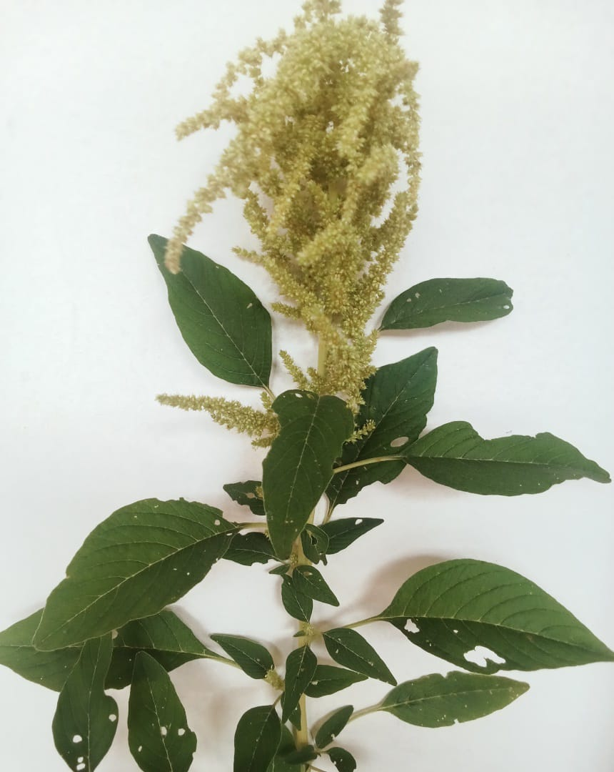
FIG. 1: Amaranthus hybridus
(Source: Researcher)

MATERIALS AND METHODS
Study Design
This study was an experimental animal study designed to investigate the effects of cadmium chloride-induced neurotoxicity and the protective effects of Amaranth extract and flavonoid-rich extract (FRAH) on hippocampal structure, cognitive function, astrocytic morphology, and inflammatory responses.
The study evaluated behavioral performance using the social interaction test, hippocampal histoarchitecture using Haematoxylin and Eosin (H&E) staining, and oxidative responses through quantification of anti-oxidant and marker of lipid peroxidation using enzyme-linked immunosorbent assay (ELISA).
Materials
Experimental Animals
Adult Wistar rats (Rattus norvegicus) with 70-140g body weight was obtained from the Animal Facility of the College of Medical Sciences, University of Calabar, were carefully examined for health and housed in clean, well-ventilated wooden cages with adequate space to prevent overcrowding. The cages, labeled according to experimental groups, were maintained under controlled environmental conditions with a 12-hour light/dark cycle using an automatic lighting system. The rats were provided ad libitum access to commercially available standard laboratory feed and clean water, with regular cleaning and replenishment to prevent contamination. Following a 14-day acclimatization period, during which their behavior, body condition, and health were monitored, baseline body weights were recorded. Animals were then randomly assigned to experimental groups to minimize bias. All procedures adhered to ethical guidelines and were conducted under the supervision of the institutional animal ethics committee. An ethical approval number was given (814ANA20726). Throughout the study, the rats were maintained under consistent environmental and nutritional conditions to ensure that any observed effects were attributable to the treatments administered.
Preparation of Plant Extracts
Preparation of the Ethanol Extract of Amaranthus hybridus
Fresh leaves of Amaranthus hybridus were collected from farms in Calabar, Cross River State, Nigeria and authenticated by Dr. Effa, Effa, A, where a voucher specimen was deposited for future reference (Voucher No.: Bot/Herb/UCC/95^{A}).
The collected leaves were sorted to remove extraneous materials, damaged leaves, and other plant debris. The leaves were thoroughly washed under running tap water to remove adhering soil and contaminants and then rinsed with distilled water. The cleaned leaves were air-dried under shade at room temperature for 2–3 weeks until a constant weight was obtained. Direct exposure to sunlight was avoided to minimize degradation of heat- and light-sensitive phytochemicals.
The dried leaves were pulverized into a fine powder using an electric laboratory grinder. The powdered material was sieved through a fine mesh to obtain a uniform particle size and stored in clean, airtight containers until extraction.
A known weight of the powdered plant material (500 kg) was transferred into a clean glass container and macerated in 100% ethanol at a plant-to-solvent ratio of approximately 1:5 (w/v) (or the ratio used in your study). The mixture was tightly covered and allowed to stand for 72 hours at room temperature with intermittent shaking every 6–8 hours to facilitate solvent penetration and extraction of phytochemical constituents.
At the end of the extraction period, the mixture was filtered initially through a clean muslin cloth to remove coarse plant debris and subsequently through Whatman No. 1 filter paper to obtain a clear filtrate.
The filtrate was concentrated under reduced pressure using a rotary evaporator maintained at 40–45°C to remove the ethanol solvent. The concentrated extract was further dried on a water bath maintained at 40°C (in a vacuum oven/freeze dryer) until a thick, semi-solid extract of constant weight was obtained.
The dried ethanol extract was transferred into labelled amber glass bottles, sealed tightly, and stored at 4°C until required for the experimental study.
Before administration to the experimental animals, the extract was freshly reconstituted in distilled water to obtain the required concentration.
Preparation of Flavonoid-Rich Extract of Amaranthus hybridus (FREAH)
A known weight of the powdered plant material (500 kg) was transferred into a clean glass container and macerated in 80% Methanol at a plant-to-solvent ratio of approximately 1:5 (w/v) (or the ratio used in your study). The mixture was tightly covered and allowed to stand for 72 hours at room temperature with intermittent shaking every 6–8 hours to facilitate solvent penetration and extraction of phytochemical constituents.
At the end of the extraction period, the mixture was filtered initially through a clean muslin cloth to remove coarse plant debris and subsequently through Whatman No. 1 filter paper to obtain a clear filtrate.
The filtrate was concentrated under reduced pressure using a rotary evaporator maintained at 40–45°C to remove the ethanol solvent. The concentrated extract was further dried on a water bath maintained at 40°C (in a vacuum oven/freeze dryer) until a thick, semi-solid extract of constant weight was obtained.
The dried ethanol extract was transferred into labelled amber glass bottles, sealed tightly, and stored at 4°C until required for the experimental study.
Before administration to the experimental animals, the extract was freshly reconstituted in distilled water to obtain the required concentration.
Preparation of Chemicals (Cadmium Chloride)
Cadmium Chloride (CdCl₂): 100grams of Analytical grade CdCl₂ (≥99%, Sigma-Aldrich, USA) was purchased at Globus scientific company, No 70 Mayne Avenue Calabar. The cadmium chloride was dissolved in distilled water at 0.001mg/ml at a standard dose of 5mg/kg.
Acute Toxicity Study (LD₅₀ Determination) of Amaranthus hybridus Extracts
The acute toxicity study of the ethanol extract and flavonoid-rich extract of Amaranthus hybridus was carried out to determine their safety profile and establish the appropriate dosage for administration in the experimental animals. The median lethal dose (LD₅₀) was determined using the method described by Lorke (1983).
The acute toxicity evaluation was performed using graded doses of the ethanol extract and flavonoid-rich extract of Amaranthus hybridus. Following extract administration, the animals were observed for signs of toxicity and mortality during the observation period. The behavioural and physical changes monitored included alterations in locomotor activity, feeding behaviour, respiratory pattern, general appearance, and other visible signs of toxicity.
No mortality was recorded in any of the animals administered with either the ethanol extract or flavonoid-rich extract at the highest tested dose of 5000 mg/kg body weight. Based on the absence of mortality, the LD₅₀ of both extracts was considered to be greater than 5000 mg/kg body weight.
For the main experimental study, a dose equivalent to 10% of the LD₅₀ value was selected as the therapeutic experimental dose. Therefore, a dose of 500 mg/kg body weight was used for administration of both the ethanol extract and flavonoid-rich extract of Amaranthus hybridus throughout the treatment period.
Experimental Grouping and Treatment Protocol
The experimental design comprised six groups of rats, each assigned randomly to evaluate the effects of cadmium exposure and the potential protective role of Amaranthus hybridus extracts. The control group received standard feed and water without any exposure to cadmium or plant extracts. The cadmium chloride group was administered only cadmium to induce neurotoxicity. Two treatment groups received cadmium alongside different A. hybridus extracts: one with the ethanol extract (CdCl₂ + EEAH) and another with the flavonoid-rich extract (CdCl₂ + FReAH). Additional groups received either the ethanol extract alone (EEAH) or the flavonoid-rich extract alone (FREAH) to assess their individual effects. This grouping allowed for comprehensive evaluation of cadmium’s neurotoxic effects and the neuroprotective potential of A. hybridus phytochemicals (as seen in Table 1).
TABLE 1 : Experimental Grouping and Treatment Protocol
The table showing the experimental groups:

Groups | Description | Treatments
A | Normal Control (Control) | Animals received normal feed and water without exposure to cadmium or extract. And where administered distilled water at 5ml/kg b.w.
B | Neurotoxicity Control | Animals received cadmium chloride (CdCl2) administration only.
C | Ethanol Extract Treatment Group | Animals received Cadmium Chloride + Ethanol Extract of Amaranthus hybridus (CdCl₂ + EEAH)
D | Flavonoid-Rich Extract Treatment Group | Animals received Cadmium Chloride + Flavonoid-Rich Extract of Amaranthus hybridus (CdCl + FREAH)
E | Ethanol Extract only Group | Animals received Ethanol Extract of Amaranthus hybridus (EEAH) only
F | Flavonoid-Rich Extract only Group | Animals received Flavonoid-Rich Extract of Amaranthus hybridus (FREAH)

Administration was performed through oral gavage/intraperitoneal injection for 8 weeks
The doses administered were:
- Cadmium chloride: 5mg/kg b.w
- EEAH: 500mg/kg b.w
- FREAH: 500mg/kg b.
Social interaction test
Investigation Time
Investigation time refers to the total duration that each rat spent exploring or interacting with a specific stimulus or object during the behavioral tests. It was recorded manually or via video analysis during the designated observation periods. Investigation was typically defined as the time spent sniffing, examining, or orienting towards the object or conspecific within a set timeframe.
Habituation Rate
The habituation rate was assessed by measuring the decrease in investigation time across repeated exposures to the same environment or object. It provides an index of learning and memory. The habituation rate was calculated as the percentage decrease in investigation time over successive trials using the formula:
Habituation Rate (%) = Investigation Time_initial - Investigation Time_subsequent Investigation/ Time_initial x 100
where Investigation Time_initial is the exploration duration during the first exposure, and Investigation Time_subsequent is during the later exposure.
Discrimination Index / Novelty Preference
The discrimination index assesses the animal’s ability to distinguish between familiar and novel stimuli, reflecting memory and recognition capability. It was calculated during the novelty preference trial as:
Discrimination Index (DI) = Time spent exploring the novel object - Time spent exploring the familiar object / Total exploration time of both objects
A higher DI indicates a preference for novelty, suggestive of intact recognition memory.
Intertrial Interval (ITI)
The intertrial interval (ITI) is the duration between successive trials or exposures during behavioral testing sessions. It was carefully controlled and recorded to ensure consistent intervals across subjects, typically set at a fixed duration (1 hr). The ITI ensures standardization in testing conditions and prevents carry-over effects from previous trials.

Histological Assessment of the CA2 Region of the Hippocampus
Following the experimental period, the rats were anesthetized with an appropriate anesthetic agent and transcardially perfused with 0.9% saline, followed by 10% neutral buffered formalin to fix the tissue. The brains were then carefully extracted and immersed in formalin for 24 hours to ensure proper fixation. Coronal sections (5 µm thick) containing the hippocampal CA2 region were prepared using a microtome. These sections were stained with Hematoxylin and Eosin (H&E) following standard protocols to evaluate neuronal morphology, including neuronal integrity, cellular density, and any morphological alterations. The stained sections were examined under a light microscope at a magnification of x400, and the neuronal architecture of the CA2 region was assessed and documented to identify any histopathological changes resulting from the experimental procedures.
Biochemical Assays
The levels of oxidative stress markers and antioxidant enzymes in hippocampal tissue were assessed using established spectrophotometric and colorimetric methods. Malondialdehyde (MDA), an indicator of lipid peroxidation, was measured using the thiobarbituric acid reactive substances (TBARS) assay. In this method, tissue homogenates were mixed with thiobarbituric acid (TBA) reagent and heated at 95°C for 60 minutes. After cooling, the resultant pink chromogen was extracted, and its absorbance was measured at 532 nm using a spectrophotometer. The concentration of MDA was calculated against a standard curve and expressed as nmol/mg protein.
Superoxide dismutase (SOD) activity was determined using a spectrophotometric assay based on its ability to inhibit the reduction of nitroblue tetrazolium (NBT) by superoxide radicals. Tissue homogenates were incubated with a reaction mixture containing xanthine, xanthine oxidase, and NBT. The rate of NBT reduction was measured at 560 nm, and SOD activity was calculated by comparing the inhibition percentage to a standard curve. Results were expressed as units/mg protein, where one unit of SOD activity is defined as the amount of enzyme required to inhibit the rate of NBT reduction by 50%.
Catalase (CAT) activity was assessed using a standard enzymatic activity kit following the manufacturer’s instructions. Briefly, tissue homogenates were added to a reaction mixture containing hydrogen peroxide (H₂O₂), and the decomposition of H₂O₂ was monitored spectrophotometrically at 240 nm over time. The rate of decrease in absorbance was used to calculate catalase activity, which was expressed as units/mg protein, based on the enzyme's ability to catalyze the breakdown of hydrogen peroxide.
Glutathione (GSH) levels were measured using Ellman’s reagent (5,5'-dithiobis-(2-nitrobenzoic acid), DTNB). Tissue homogenates were deproteinized with trichloroacetic acid, and the supernatant was mixed with DTNB reagent. The formation of the yellow-colored 5-thio-2-nitrobenzoic acid (TNB) was measured spectrophotometrically at 412 nm. GSH concentrations were calculated using a standard curve generated with reduced glutathione and expressed as nmol/mg protein.
Statistical Analysis
Data were expressed as mean ± standard error of the mean (SEM). Statistical comparisons among groups were performed using one-way ANOVA followed by Turkey’s post hoc test. A p-value < 0.05 was considered statistically significant.

Results
Social Recognition Test
Normal Control (NC):
The NC group showed high investigation times during both the familiar (16.04 seconds) and novel (29.46 seconds) phases, with a total investigation time of 45.50 seconds. The habituation index was approximately 41.86%, and the discrimination index was 29.51%. The novel preference was high at 64.76%, indicating normal social recognition behavior. (Figures 2-7)
Cadmium Chloride (CdCl₂)
This group demonstrated significantly reduced investigation times in both phases (familiar: 10.24 seconds; novel: 16.73 seconds) compared to NC, with p<0.05. The total investigation time was 26.97 seconds, with lower habituation and discrimination indices (38.22% and 24.01%), reflecting impaired social recognition. Novel preference also decreased slightly compared to controls (Figures 2-7)
CdCl₂ + Ethanol Extract of Amaranthus Hybridus (CdCl₂ + EEAH)
Investigation times improved compared to CdCl₂ alone (familiar: 10.94 seconds; novel: 17.88 seconds), with p<0.05 for the familiar and novel phases. The total investigation time increased to 28.82 seconds, with indices (39.96% and 23.90%) showing partial recovery. The improvement suggests a neuroprotective effect of EEAH. (Figures 2-7)
CdCl₂ + Flavonoid Rich Extract of Amaranthus Hybridus (CdCl₂ + FREAH)
Investigation times were similar to the NC group (familiar: 16.91 seconds; novel: 30.53 seconds), with p<0.05 in comparison to the CdCl₂ group, indicating significant restoration of social recognition functions. The total investigation time was 47.44 seconds, and indices (52.43% and 28.72%) were comparable to controls, supporting the efficacy of FREAH. (Figures 2-7)
Ethanol Extract of Amaranthus Hybridus Only (EEAH)
This group showed investigation times (familiar: 12.88 seconds; novel: 24.91 seconds) slightly lower than NC but significantly higher than CdCl₂, with p<0.05 in the familiar and novel phases. The total investigation time was 37.79 seconds, and indices (45.04% and 31.95%) were similar to controls, indicating preserved social recognition. (Figures 2-7)
Flavonoid Rich Extract of Amaranthus Hybridus Only (FREAH):
Investigation times (familiar: 16.22 seconds; novel: 30.65 seconds) were not significantly different from NC, with p<0.05 in comparison to the CdCl₂ group, and total investigation time was 46.87 seconds. The indices (45.90% and 30.81%) confirmed maintained social recognition, similar to control levels. (Figures 2-7)
NC: Normal Control
CdCl₂: Administered Cadmium Chloride only
CdCl₂+EEAH: Administered Cadmium Chloride and Ethanol Extract of Amaranthus Hybridus
CdCl₂+FREAH: Administered Cadmium Chloride and Flavonoid Rich Extract of Amaranthus Hybridus
EEAH: Administered Ethanol Extract of Amaranthus Hybridus only
FREAH: Administered Flavonoid Rich Extract of Amaranthus Hybridus only

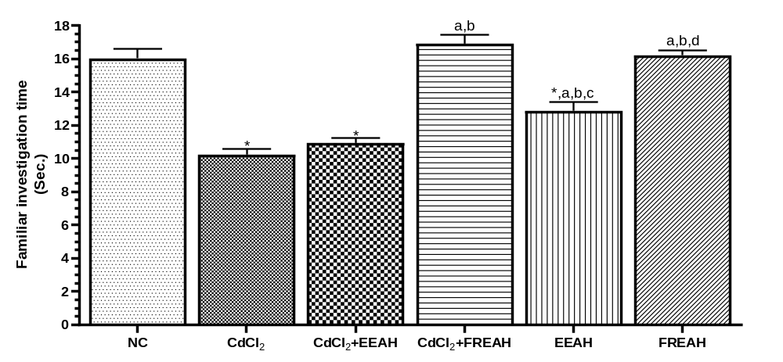
FIG. 2: Familiar investigating time of experimental groups.
Values are expressed as Mean ± SEM, n=5. Using One way Analysis of Variance (ANOVA).
*= significantly different from NC at p<0.05
a= significantly different from CdCl₂ at p<0.05
b= significantly different from CdCl₂+EEAH at p<0.05
c= significantly different from CdCl₂+FREAH at p<0.05
d= significantly different from EEAH at p<0.05
- CdCl₂ Familiar investigating time significantly lesser compared to NC
- CdCl₂+EEAH Familiar investigating time significantly lesser compared to NC
- CdCl₂+FREAH Familiar investigating time significantly higher compared to CdCl₂ and CdCl₂+EEAH
- EEAH Familiar investigating time significantly lesser compared to NC and CdCl₂+FREAH but significantly higher compared to CdCl2 and CdCl2+EEAH.
- FREAH Familiar investigating time significantly higher compared to CdCl2, CdCl2+EEAH and EEAH.

NC: Normal Control
CdCl₂: Administered Cadmium Chloride only
CdCl₂+EEAH: Administered Cadmium Chloride and Ethanol Extract of Amaranthus Hybridus
CdCl₂+FREAH: Administered Cadmium Chloride and Flavonoid Rich Extract of Amaranthus Hybridus
EEAH: Administered Ethanol Extract of Amaranthus Hybridus only
FREAH: Administered Flavonoid Rich Extract of Amaranthus Hybridus only

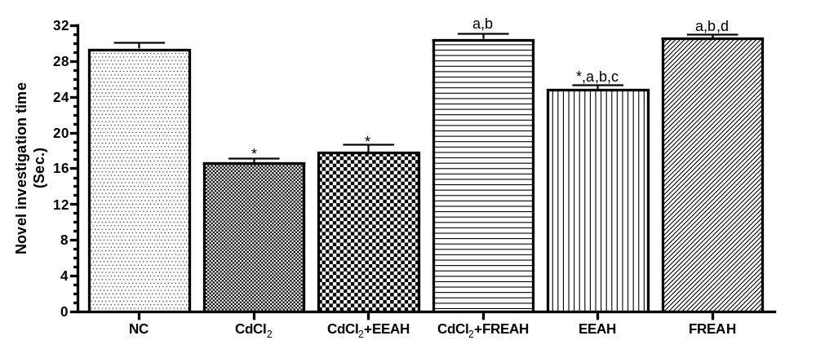
FIG. 3: Novel investigating time of experimental groups.
Values are expressed as Mean ± SEM, n=5. Using One way Analysis of Variance (ANOVA).
*= significantly different from NC at p<0.05
a= significantly different from CdCl₂ at p<0.05
b= significantly different from CdCl₂+EEAH at p<0.05
c= significantly different from CdCl₂+FREAH at p<0.05
d= significantly different from EEAH at p<0.05
- CdCl₂ Familiar investigating time significantly lesser compared to NC
- CdCl₂+EEAH Familiar investigating time significantly lesser compared to NC
- CdCl₂+FREAH Novel investigating time significantly higher compared to CdCl₂ and CdCl₂+EEAH
- EEAH Novel investigating time significantly lesser compared to NC and CdCl₂+FREAH but significantly higher compared to CdCl2 and CdCl2+EEAH.
- FREAH Novel investigating time significantly higher compared to CdCl2, CdCl2+EEAH and EEAH.

NC: Normal Control
CdCl₂: Administered Cadmium Chloride only
CdCl₂+EEAH: Administered Cadmium Chloride and Ethanol Extract of Amaranthus Hybridus
CdCl₂+FREAH: Administered Cadmium Chloride and Flavonoid Rich Extract of Amaranthus Hybridus
EEAH: Administered Ethanol Extract of Amaranthus Hybridus only
FREAH: Administered Flavonoid Rich Extract of Amaranthus Hybridus only

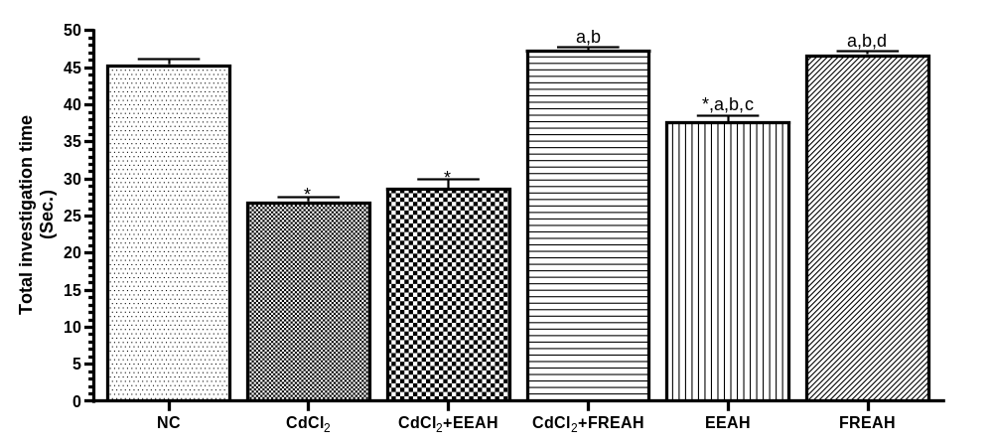
FIG. 4: Total investigating time of experimental groups.
Values are expressed as Mean ± SEM, n=5. Using One way Analysis of Variance (ANOVA).
*= significantly different from NC at p<0.05
a= significantly different from CdCl₂ at p<0.05
b= significantly different from CdCl₂+EEAH at p<0.05
c= significantly different from CdCl₂+FREAH at p<0.05
d= significantly different from EEAH at p<0.05

- CdCl₂+FREAH Total investigating time significantly higher compared to CdCl₂ and CdCl₂+EEAH
- EEAH Total investigating time significantly higher compared to NC, CdCl2, CdCl2+EEAH but significantly lesser CdCl₂+FREAH
- FREAH Total investigating time significantly higher compared to CdCl2, CdCl2+EEAH and CdCl₂+EEAH.
NC: Normal Control
CdCl₂: Administered Cadmium Chloride only
CdCl₂+EEAH: Administered Cadmium Chloride and Ethanol Extract of Amaranthus Hybridus
CdCl₂+FREAH: Administered Cadmium Chloride and Flavonoid Rich Extract of Amaranthus Hybridus
EEAH: Administered Ethanol Extract of Amaranthus Hybridus only
FREAH: Administered Flavonoid Rich Extract of Amaranthus Hybridus only

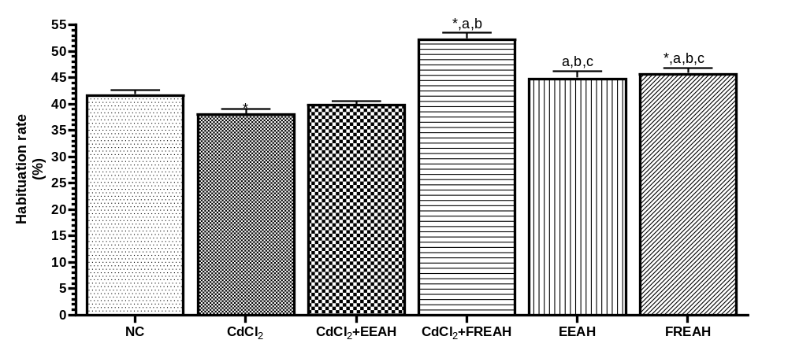
FIG. 5: Habituation rate of experimental groups.
Values are expressed as Mean ± SEM, n=5. Using One way Analysis of Variance (ANOVA).
*= significantly different from NC at p<0.05
a= significantly different from CdCl₂ at p<0.05
b= significantly different from CdCl₂+EEAH at p<0.05
c= significantly different from CdCl₂+FREAH at p<0.05
- CdCl₂+FREAH Habituation rate significantly higher compared to NC, CdCl₂ and CdCl₂+EEAH
- EEAH Habituation rate significantly higher compared to CdCl2, CdCl2+EEAH but significantly lesser CdCl₂+FREAH
- FREAH Habituation rate significantly higher compared to NC, CdCl2, CdCl2+EEAH but significantly lesser compared CdCl₂+FREAH.
NC: Normal Control
CdCl₂: Administered Cadmium Chloride only
CdCl₂+EEAH: Administered Cadmium Chloride and Ethanol Extract of Amaranthus Hybridus
CdCl₂+FREAH: Administered Cadmium Chloride and Flavonoid Rich Extract of Amaranthus Hybridus
EEAH: Administered Ethanol Extract of Amaranthus Hybridus only
FREAH: Administered Flavonoid Rich Extract of Amaranthus Hybridus only

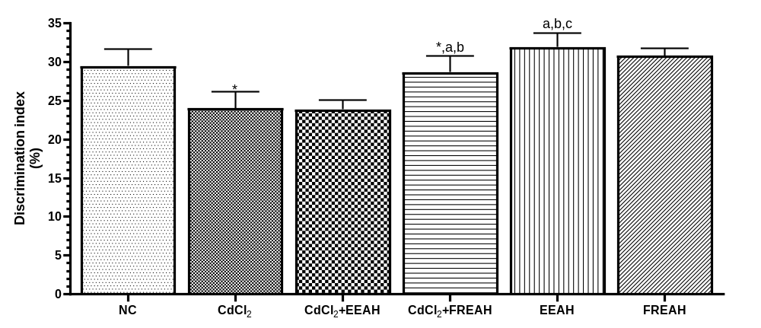
FIG. 6: Discrimination index of experimental groups.
Values are expressed as Mean ± SEM, n=5. Using One way Analysis of Variance (ANOVA).
*= significantly different from NC at p<0.05
a= significantly different from CdCl₂ at p<0.05
b= significantly different from CdCl₂+EEAH at p<0.05
c= significantly different from CdCl₂+FREAH at p<0.05
- CdCl₂+FREAH Discrimination index significantly higher compared to NC, CdCl₂ and CdCl₂+EEAH
- EEAH Discrimination index significantly higher compared to CdCl2, CdCl2+EEAH and CdCl₂+FREAH

NC: Normal Control
CdCl₂: Administered Cadmium Chloride only
CdCl₂+EEAH: Administered Cadmium Chloride and Ethanol Extract of Amaranthus Hybridus
CdCl₂+FREAH: Administered Cadmium Chloride and Flavonoid Rich Extract of Amaranthus Hybridus
EEAH: Administered Ethanol Extract of Amaranthus Hybridus only
FREAH: Administered Flavonoid Rich Extract of Amaranthus Hybridus only

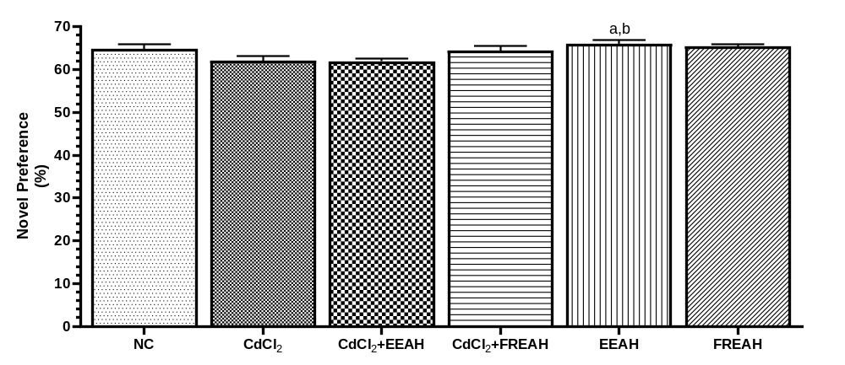
FIG. 7: Novel preference of experimental groups.
Values are expressed as Mean ± SEM, n=5. Using One way Analysis of Variance (ANOVA).
*= significantly different from NC at p<0.05
a= significantly different from CdCl₂ at p<0.05
b= significantly different from CdCl₂+EEAH at p<0.05
c= significantly different from CdCl₂+FREAH at p<0.05
d= significantly different from EEAH at p<0.05
- EEAH Novel preference significantly higher compared to CdCl₂ and CdCl₂+EEAH

Histological observation of the Hippocampal CA2 Region
The histological examination of the hippocampal CA2 region across six experimental groups reveals varying degrees of cytoarchitectural integrity and cellular morphology:
Group A (control) displays a normal hippocampal architecture with clearly defined molecular layer, pyramidal cell layer, and polymorphic layer. Pyramidal neurons, blood vessels, and glial cells are identifiable, exhibiting typical morphology and organization. (See Plate 1)
Group B (cadmium chloride-treated) shows significant neurotoxic alterations, including enlarged pyramidal neurons with vacuolations, shrunken nuclei, disorganization of pyramidal cells, increased gliosis, dilated blood vessels, and wide empty spaces, indicative of hypertrophy, vacuolations, pyknosis, gliosis, and vascular dilation. (See Plate 2)
Group C (cadmium + ethanol extract) demonstrates partial neuroprotection, with pyramidal neurons displaying enlarged cell bodies and some empty spaces around them, but overall less disorganization than Group B. (See Plate 3)
Group D (cadmium + flavonoid-rich extract) shows reduced pyramidal neuron enlargement and fewer empty spaces compared to Group C, suggesting mitigation of cadmium-induced damage and improved cellular organization. (See Plate 4)
Group E (flavonoid-rich extract alone) presents pyramidal neurons with enlarged cell bodies and perineural vacuolations, indicating hypertrophy and vacuolation without the disorganization characteristic of cadmium exposure. (See Plate 5)
Group F (ethanol extract alone) exhibits pyramidal neurons with normal soma size and fewer empty spaces around neurons compared to Group E, indicating preserved cellular morphology and reduced neurotoxicity. (See Plate 6)

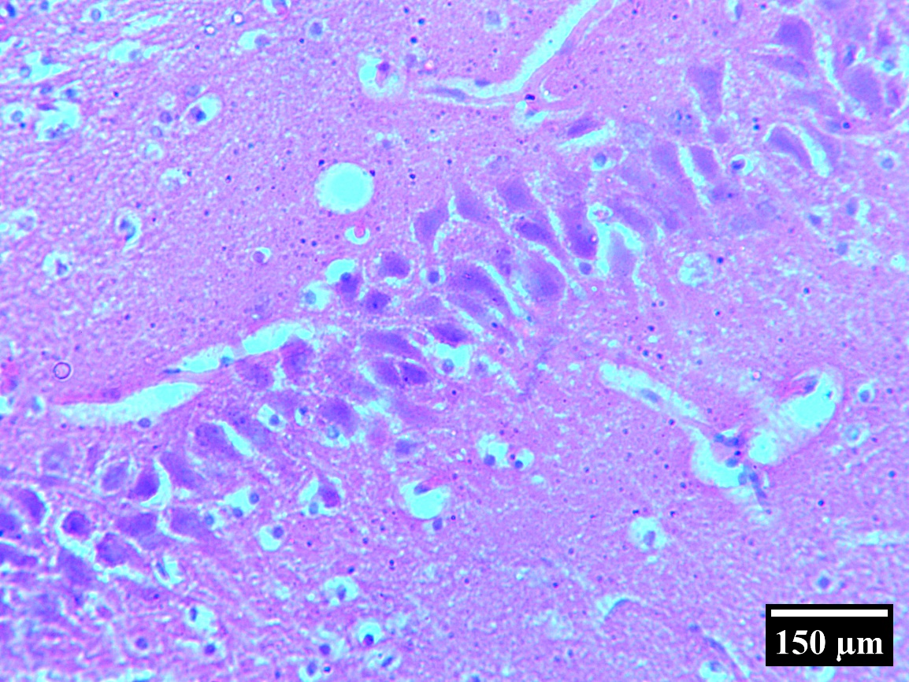
PML
PCL
ML
PC
V
G

A

PLATE 1: Photomicrograph of the hippocampal CA2 of the Group A animals administered distilled water at 10ml/kg showing the molecular layer (ML), pyramidal cell layer (PCL) and the polymorphic layer (PML). Pyramidal neurons (PC), Blood vessels (V) and glial cells (G) were identified. The overall cytoarchitecture appeared normal. Hematoxylin and Eosin staining, Magnification x400.

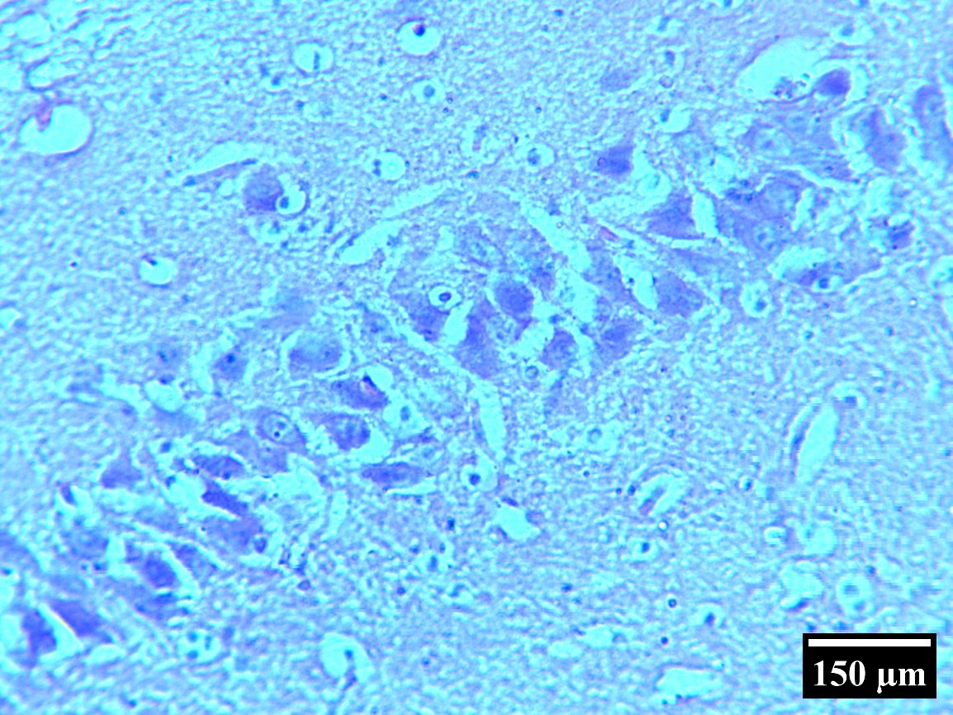
PC
*
ML

V
PCL
#
G
PML

BR

PLATE 2: Photomicrograph of the hippocampal CA2 of the Group B animals administered cadmium chloride at 5mg/kg showing the molecular layer (ML), pyramidal cell layer (PCL) and the polymorphic layer (PML). Pyramidal neurons (PC), Blood vessels (V) and glial cells (G) were identified. Pyramidal neurons appeared with enlarged cell body and there are empty spaces around the pyramidal neurons (asterisk). Some pyramidal neurons appeared with shrunken nuclei (S). There is increased presence of glial cells. And numerous blood vessels were identified in polymorphic layer with wide empty spaces around them. The pyramidal neurons appeared to disorganized. Hematoxylin and Eosin staining, Magnification x400.

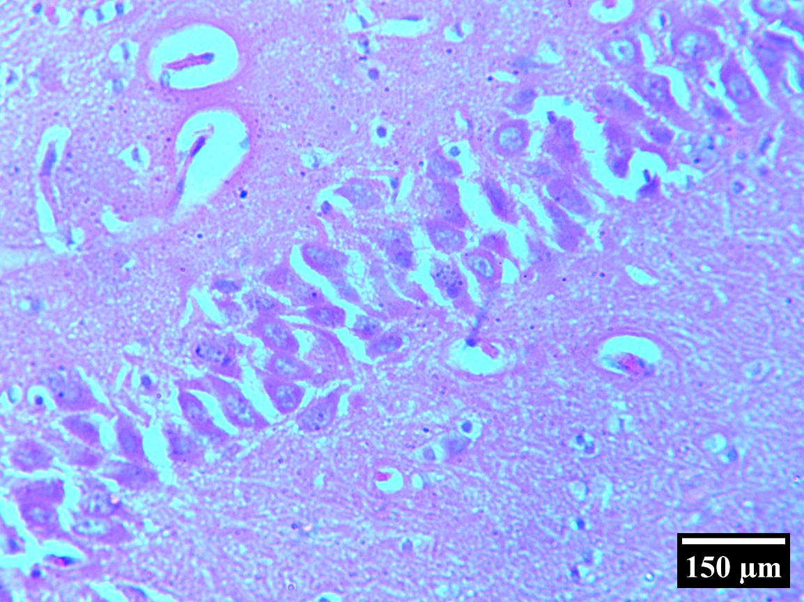
*
ML
PC

V
PCL

PML
G
C

PLATE 3: Photomicrograph of the hippocampal CA2 of the Group C animals administered cadmium chloride at 5mg/kg and treated with ethanol extract of amaranthus hybridus at 500mg/kg the molecular layer (ML), pyramidal cell layer (PCL) and the polymorphic layer (PML). Pyramidal neurons (PC), Blood vessels (V) and glial cells (G) were identified. Pyramidal neurons appeared with enlarged cell body and there are empty spaces around the pyramidal neurons (asterisk). Hematoxylin and Eosin staining, Magnification x400.

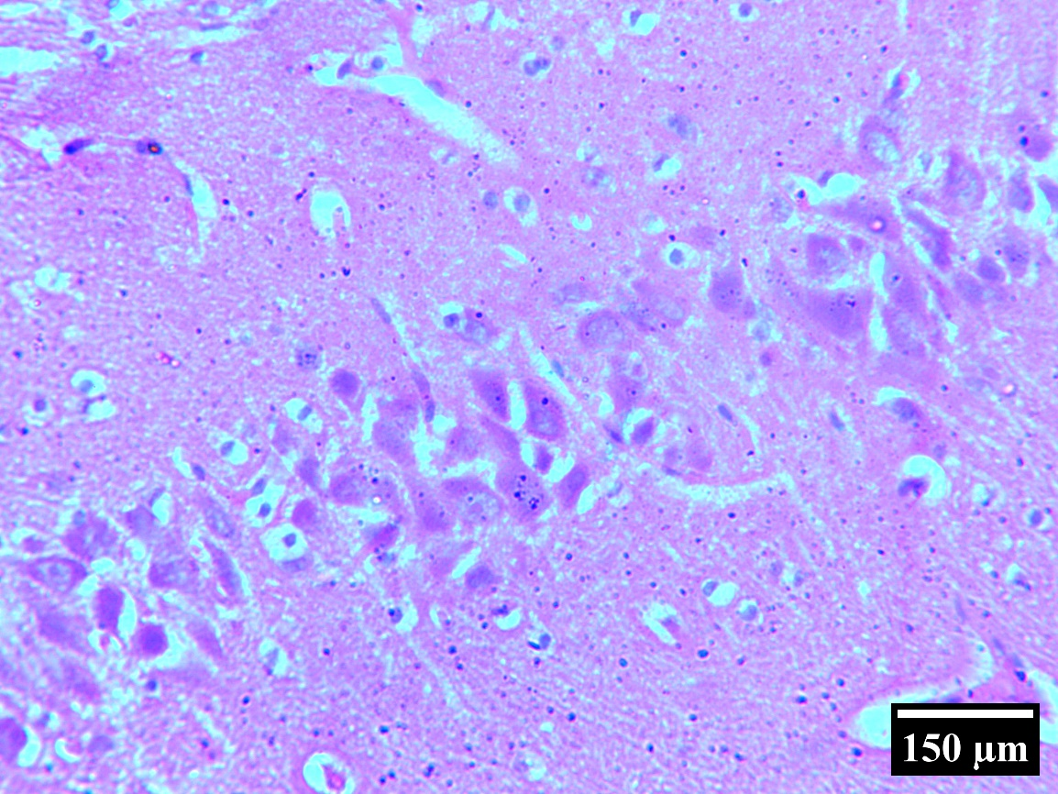

ML
PC
V
PCL
G
PML

D

PLATE 4: Photomicrograph of the hippocampal CA2 of the Group D animals administered cadmium chloride at 5mg/kg and treated with flavonoid rich extract of amaranthus hybridus at 500mg/kg showing the molecular layer (ML), pyramidal cell layer (PCL) and the polymorphic layer (PML). Pyramidal neurons (PC), Blood vessels (V) and glial cells (G) were identified. Pyramidal neurons with enlarged cell body are lesser compared to group C. The empty spaces around the pyramidal neurons (asterisk) also reduced compared to Group C. Hematoxylin and Eosin staining, Magnification x400.

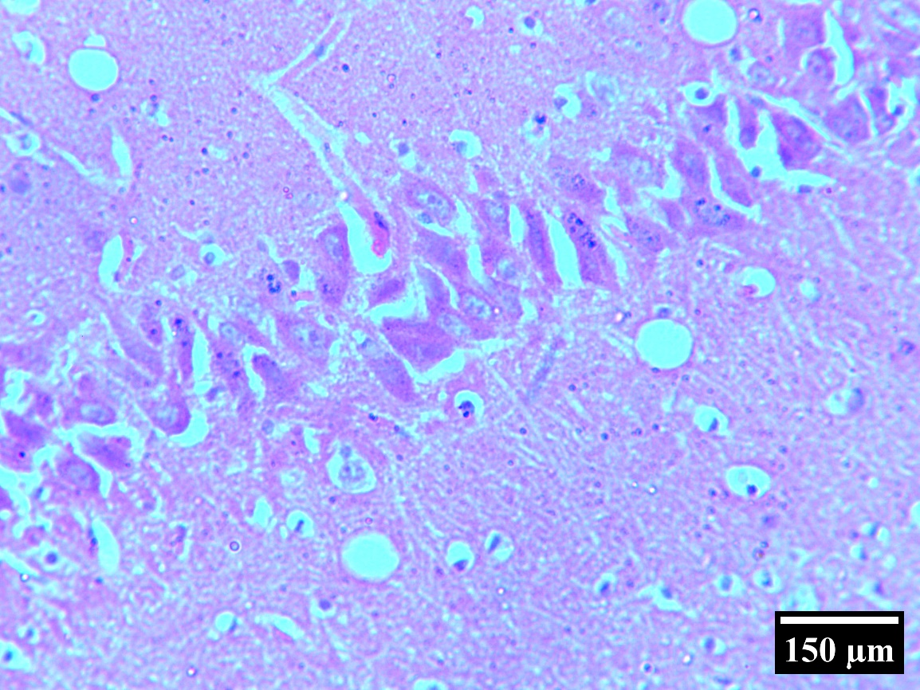
PC
ML
*

PCL

V
PML

G
E

PLATE 5: Photomicrograph of the hippocampal CA2 of the Group E animals administered flavonoid rich extract of amaranthus hybridus at 500mg/kg showing the molecular layer (ML), pyramidal cell layer (PCL) and the polymorphic layer (PML). Pyramidal neurons (PC), Blood vessels (V) and glial cells (G) were identified. Pyramidal neurons appeared with enlarged cell body and there are empty spaces around the pyramidal neurons (asterisk). Hematoxylin and Eosin staining, Magnification x400. Indicating hypertrophy and perineural vacoulations.

PC
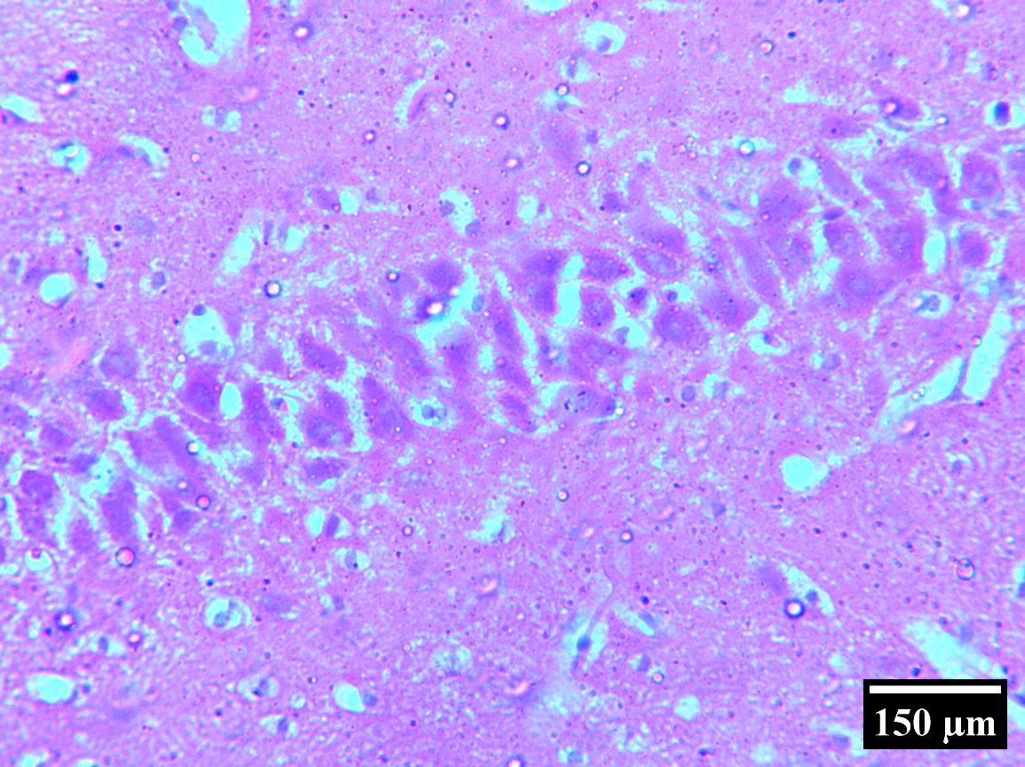
*
V
G
ML
PCL
PML
F

PLATE 6. Photomicrograph of the hippocampal CA2 of the Group F animals administered ethanol extract of amaranthus hybridus at 500mg/kg showing the molecular layer (ML), pyramidal cell layer (PCL) and the polymorphic layer (PML). Pyramidal neurons (PC), Blood vessels (V) and glial cells (G) were identified. Pyramidal neurons soma are not enlarge and the empty spaces around the pyramidal neurons (asterisk) reduced compared to Group E. Hematoxylin and Eosin staining, Magnification x400.

Antioxidants and Oxidative Stress Markers
Normal Control (NC)
The NC group exhibited baseline levels of antioxidant enzymes and oxidative stress markers, with SOD (73.95 µmol/ml/mg), CAT (90.86 µmol/ml/mg), GSH (32.66 µmol/ml/mg), and MDA (3.91 µmol/ml/mg). These values represent normal oxidative balance. (Figures 8-11)
Cadmium Chloride (CdCl₂)
This group showed significant increases in SOD (37.13 µmol/ml/mg), CAT (32.54 µmol/ml/mg), and GSH (19.63 µmol/ml/mg), all marked with p<0.05, indicating elevated oxidative stress response and antioxidant enzyme activity. Additionally, MDA, a marker of lipid peroxidation, was significantly increased (10.77 µmol/ml/mg, p<0.05), reflecting heightened oxidative damage. (Figures 8-11)
CdCl₂ + Ethanol Extract of Amaranthus Hybridus (CdCl₂ + EEAH)
The addition of EEAH resulted in decreased levels of SOD (41.13 µmol/ml/mg), CAT (33.54 µmol/ml/mg), and GSH (28.63 µmol/ml/mg) compared to CdCl₂ alone, with all marked p<0.05 versus CdCl₂, indicating partial normalization of antioxidant enzyme levels. MDA decreased to 7.84 µmol/ml/mg, also significantly lower (p<0.05), suggesting reduced lipid peroxidation and oxidative damage. (Figures 8-11)
CdCl₂ + Flavonoid Rich Extract of Amaranthus Hybridus (CdCl₂ + FREAH)
Further reduction in oxidative stress markers was observed with FREAH treatment: SOD (59.23 µmol/ml/mg), CAT (57.38 µmol/ml/mg), GSH (26.22 µmol/ml/mg), and MDA (6.47 µmol/ml/mg). All these values were significantly different from CdCl₂ (p<0.05), indicating a stronger antioxidative effect and mitigation of oxidative stress. (Refer to Table 2; Figures 8-11)
Ethanol Extract of Amaranthus Hybridus Only (EEAH)
The EEAH group showed antioxidant enzyme levels (SOD: 70.46, CAT: 67.38, GSH: 28.26) and MDA (4.56) that were significantly different from CdCl₂ (p<0.05) and closer to control levels, demonstrating antioxidant properties in the absence of cadmium toxicity. (Figures 8-11)
Flavonoid Rich Extract of Amaranthus Hybridus Only (FREAH)
The FREAH group had SOD (75.40), CAT (73.10), GSH (30.27), and MDA (4.19) levels not significantly different from the NC group in some markers, but notably, SOD and GSH were significantly different from CdCl₂ (p<0.05). The MDA level was close to normal, indicating effective antioxidative activity and protection against oxidative stress. (Figures 8-11)

NC: Normal Control
CdCl₂: Administered Cadmium Chloride only
CdCl₂+EEAH: Administered Cadmium Chloride and Ethanol Extract of Amaranthus Hybridus
CdCl₂+FREAH: Administered Cadmium Chloride and Flavonoid Rich Extract of Amaranthus Hybridus
EEAH: Administered Ethanol Extract of Amaranthus Hybridus only
FREAH: Administered Flavonoid Rich Extract of Amaranthus Hybridus only

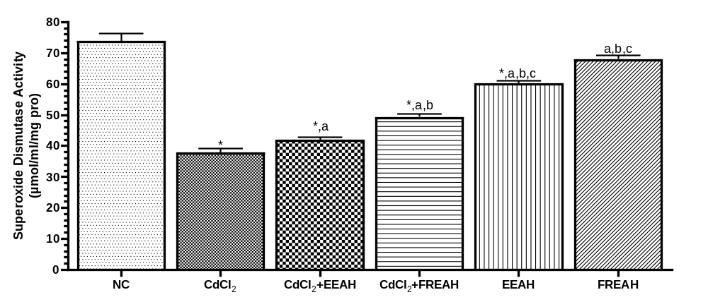
FIG. 8: Superoxide dismutase activity of experimental groups.
Values are expressed as Mean ± SEM, n=5. Using One way Analysis of Variance (ANOVA).
*= significantly different from NC at p<0.05
a= significantly different from CdCl₂ at p<0.05
b= significantly different from CdCl₂+EEAH at p<0.05
c= significantly different from CdCl₂+FREAH at p<0.05
- CdCl₂ Superoxide dismutase activity significantly lesser compared to NC
- CdCl₂+EEAH Superoxide dismutase activity significantly lesser compared to NC but significantly higher compared to CdCl₂
- CdCl₂+FREAH Superoxide dismutase activity significantly lesser compared to NC but significantly higher compared to CdCl₂ and CdCl₂+EEAH
- EEAH Superoxide dismutase activity significantly lesser compared to NC but significantly higher compared CdCl2, CdCl2+EEAH and CdCl₂+FREAH
- FREAH Superoxide dismutase activity significantly higher compared to CdCl2, CdCl2+EEAH and CdCl₂+FREAH and EEAH

NC: Normal Control
CdCl₂: Administered Cadmium Chloride only
CdCl₂+EEAH: Administered Cadmium Chloride and Ethanol Extract of Amaranthus Hybridus
CdCl₂+FREAH: Administered Cadmium Chloride and Flavonoid Rich Extract of Amaranthus Hybridus
EEAH: Administered Ethanol Extract of Amaranthus Hybridus only
FREAH: Administered Flavonoid Rich Extract of Amaranthus Hybridus only

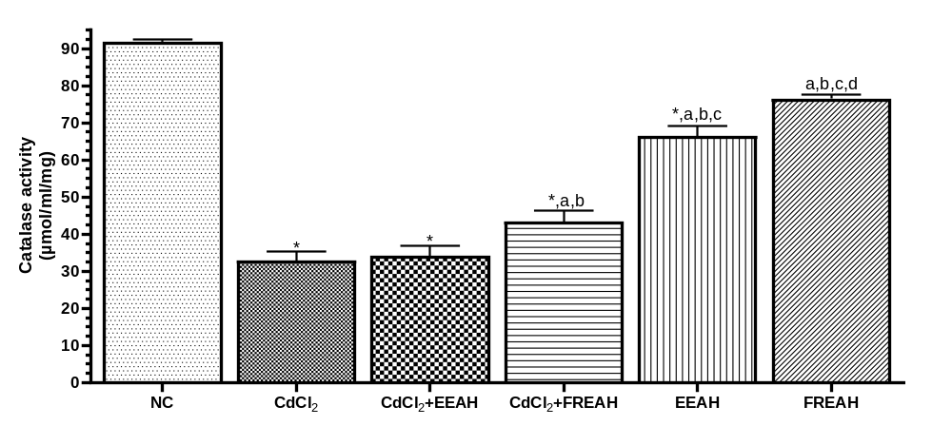
FIG. 9: Catalase activity of experimental groups.
Values are expressed as Mean ± SEM, n=5. Using One way Analysis of Variance (ANOVA).
*= significantly different from NC at p<0.05
a= significantly different from CdCl₂ at p<0.05
b= significantly different from CdCl₂+EEAH at p<0.05
c= significantly different from CdCl₂+FREAH at p<0.05
d= significantly different from EEAH at p<0.05
- CdCl₂ Superoxide dismutase activity significantly lesser compared to NC
- CdCl₂+EEAH Superoxide dismutase activity significantly lesser compared to NC
- CdCl₂+FREAH Superoxide dismutase activity significantly lesser compared to NC but significantly higher compared to CdCl₂ and CdCl₂+EEAH
- EEAH Superoxide dismutase activity significantly lesser compared to NC but significantly higher compared CdCl2, CdCl2+EEAH and CdCl₂+FREAH
- FREAH Superoxide dismutase activity significantly higher compared to CdCl2, CdCl2+EEAH and CdCl₂+FREAH and EEAH

NC: Normal Control
CdCl₂: Administered Cadmium Chloride only
CdCl₂+EEAH: Administered Cadmium Chloride and Ethanol Extract of Amaranthus Hybridus
CdCl₂+FREAH: Administered Cadmium Chloride and Flavonoid Rich Extract of Amaranthus Hybridus
EEAH: Administered Ethanol Extract of Amaranthus Hybridus only
FREAH: Administered Flavonoid Rich Extract of Amaranthus Hybridus only

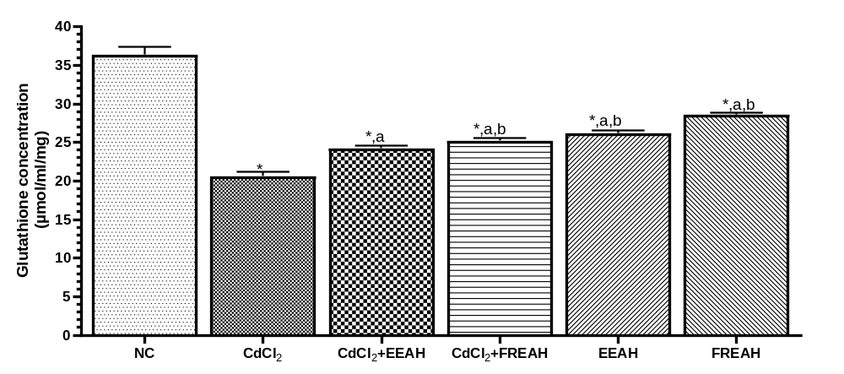
FIG. 10: Glutathione concentration of experimental groups.
Values are expressed as Mean ± SEM, n=5. Using One way Analysis of Variance (ANOVA).
*= significantly different from NC at p<0.05
a= significantly different from CdCl₂ at p<0.05
b= significantly different from CdCl₂+EEAH at p<0.05
- CdCl₂ Superoxide dismutase activity significantly lesser compared to NC
- CdCl₂+EEAH Superoxide dismutase activity significantly lesser compared to NC but significantly higher compared to CdCl₂.
- CdCl₂+FREAH Superoxide dismutase activity significantly lesser compared to NC but significantly higher compared to CdCl₂ and CdCl₂+EEAH
- EEAH Superoxide dismutase activity significantly lesser compared to NC but significantly higher compared CdCl2 and CdCl2+EEAH
- FREAH Superoxide dismutase activity significantly lesser compared to NC but significantly higher compared CdCl2 and CdCl2+EEAH.

NC: Normal Control
CdCl₂: Administered Cadmium Chloride only
CdCl₂+EEAH: Administered Cadmium Chloride and Ethanol Extract of Amaranthus Hybridus
CdCl₂+FREAH: Administered Cadmium Chloride and Flavonoid Rich Extract of Amaranthus Hybridus
EEAH: Administered Ethanol Extract of Amaranthus Hybridus only
FREAH: Administered Flavonoid Rich Extract of Amaranthus Hybridus only

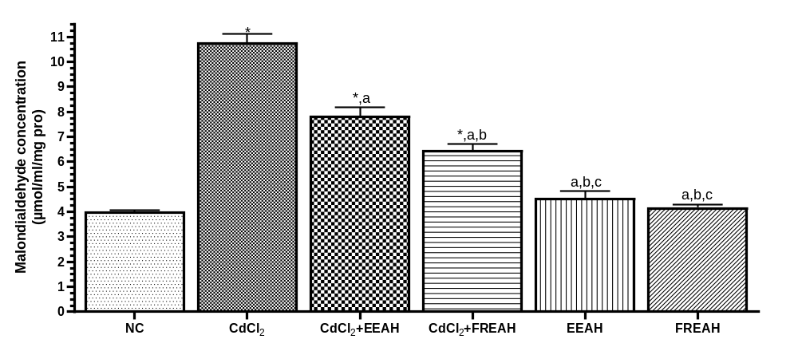
FIG. 11: Malondialdehyde concentration of experimental groups.
Values are expressed as Mean ± SEM, n=5. Using One way Analysis of Variance (ANOVA).
*= significantly different from NC at p<0.05
a= significantly different from CdCl₂ at p<0.05
b= significantly different from CdCl₂+EEAH at p<0.05
c= significantly different from CdCl₂+FREAH at p<0.05
- CdCl₂ Superoxide dismutase activity significantly higher compared to NC
- CdCl₂+EEAH Superoxide dismutase activity significantly higher compared to NC but significantly lower compared to CdCl₂.
- CdCl₂+FREAH Superoxide dismutase activity significantly higher compared to NC but significantly lower compared to CdCl₂ and CdCl₂+EEAH
- EEAH Superoxide dismutase activity significantly lesser compared to compared to CdCl₂ and CdCl₂+EEAH and CdCl₂+FREAH
- FREAH Superoxide dismutase activity significantly lesser compared to NC but significantly higher compared CdCl2 and CdCl2+EEAH

Discussion
The present study investigated the neuroprotective effects of Amaranthus hybridus leaf ethanol extract (EEAH) and flavonoid-rich extract (FREAH) against cadmium (Cd)-induced hippocampal CA2 neurotoxicity and associated social behavioral impairments in Wistar rats. The findings demonstrate significant neurobehavioral, histopathological, and oxidative stress alterations induced by cadmium exposure, which were mitigated by pretreatment with A. hybridus extracts, particularly the flavonoid-rich extract.
Cadmium chloride (CdCl₂) exposure resulted in marked impairments in social recognition memory, evidenced by decreased investigation times during the familiar and novel phases, and reduced discrimination and habituation indices. These findings align with previous reports indicating that cadmium exposure disrupts cognitive and social behaviors mediated by hippocampal circuits (Wang et al., 2019; Modi et al., 2019). Cadmium is known to induce oxidative stress and neuronal damage within the hippocampus, impairing synaptic plasticity essential for learning and memory (Yan & Allen, 2022). The significant decline in investigation times and recognition indices in the CdCl₂ group corroborate these reports, suggesting compromised social memory functions.
Pretreatment with A. hybridus extracts, especially FREAH, significantly restored exploration and recognition behaviors. The ability of FREAH to normalize investigation times, discrimination index, and habituation rate (Figures 2-7) supports its neuroprotective potential, likely mediated by its high flavonoid content known for antioxidative and anti-inflammatory properties (Kant et al., 2026; Gautam et al., 2022). The partial but notable recovery observed in the ethanol extract group suggests that A. hybridus may offer behavioral resilience against cadmium-induced neurotoxicity through its phytochemicals.
Histological examination revealed that control rats maintained the normal cytoarchitecture of the hippocampal CA2 region, with well-organized pyramidal neurons, blood vessels, and glial cells (Plate 1). Conversely, cadmium-treated rats exhibited significant neuronal damage characterized by enlarged pyramidal neurons with vacuolations, nuclear shrinkage, disorganization, gliosis, and vascular dilation (Plate 2). These changes are consistent with previous studies demonstrating cadmium-induced oxidative neuronal damage, pyknosis, and gliosis (Branca et al., 2020; Pulido et al., 2019).
Treatment with A. hybridus extracts mitigated these histopathological alterations. The ethanol extract group (Plate 3) showed less disorganization and neuronal swelling, while the flavonoid-rich extract group (Plate 4) demonstrated significant preservation of neuronal architecture with reduced vacuolations and disorganization. The groups receiving only the plant extracts (Plates 5 and 6) displayed relatively normal histology, indicating that A. hybridus has intrinsic neuroprotective properties that can preserve hippocampal integrity even in the presence of cadmium toxicity. These findings align with reports that flavonoids and phenolic compounds can attenuate neurodegeneration through antioxidative mechanisms (Jalouli et al., 2025; Kant et al., 2026).
Cadmium exposure markedly disturbed oxidative homeostasis, evidenced by elevated levels of lipid peroxidation marker MDA and increased activities of endogenous antioxidant enzymes SOD, CAT, and GSH (Figures 8-11; Table 2). The elevation of these enzymes likely reflects a compensatory response to cadmium-induced oxidative stress, as previously documented (Branca et al., 2020; Matsushita & Xia, 2024). The increased MDA levels further confirm enhanced lipid peroxidation and neuronal membrane damage.
Treatment with A. hybridus extracts significantly attenuated oxidative stress markers. Both EEAH and FREAH reduced MDA levels, indicating decreased lipid peroxidation, with FREAH showing a more pronounced effect. Additionally, antioxidant enzyme activities were modulated toward baseline levels, with FREAH restoring SOD, CAT, and GSH closer to control values. The antioxidative effects of flavonoids, such as quercetin and kaempferol, are well-documented and are believed to scavenge free radicals, chelate metal ions, and enhance endogenous antioxidant defenses (Kant et al., 2026; Jalouli et al., 2025). The observed normalization of oxidative stress markers suggests that A. hybridus phytochemicals effectively counteract cadmium-induced oxidative neuronal damage, which is a critical pathogenic mechanism in neurotoxicity (Yuan et al., 2018).
The findings underscore the neuroprotective potential of Amaranthus hybridus, particularly its flavonoid constituents, in mitigating cadmium-induced hippocampal neurotoxicity and associated behavioral deficits. The histopathological and biochemical data collectively suggest that flavonoids exert antioxidative and anti-inflammatory effects, stabilizing neuronal architecture and maintaining oxidative balance. These results are consistent with previous reports highlighting the neuroprotective roles of plant-derived flavonoids in heavy metal toxicity models (Gautam et al., 2022; Jalouli et al., 2025).
Further investigations are warranted to elucidate the precise molecular pathways involved, including assessments of inflammatory cytokines, apoptotic markers, and synaptic plasticity-related proteins. Additionally, exploring dose-response relationships and the therapeutic window of A. hybridus extracts can optimize their application as dietary supplements or adjunct therapies.
Conclusion
In conclusion, cadmium chloride induces significant neurobehavioral impairments, hippocampal neuronal damage, and oxidative stress in rats. Administration with Amaranthus hybridus leaf extracts, especially the flavonoid-rich extract, confers notable neuroprotection, preserving hippocampal structure and restoring behavioral functions. These findings support the potential utility of A. hybridus as a natural antioxidant-rich dietary agent against environmental neurotoxins such as cadmium, with promising implications for preventing or mitigating neurodegenerative processes related to heavy metal exposure.
Declaration of AI Use

This manuscript was prepared through the intellectual contributions of the author(s) to the study design, data analysis, interpretation of results, and scholarly content. Grammarly and ChatGPT were used solely to assist with grammatical refinement and reference formatting during manuscript revision. The author(s) accept full responsibility for the accuracy, integrity, and final content of the manuscript.

References
- Arruebarrena, M. A., Hawe, C. T., Lee, Y. M., & Branco, R. C. (2023). Mechanisms of cadmium neurotoxicity. International Journal of Molecular Sciences, 24(23), 16558. https://doi.org/10.3390/ijms242316558
- Branca, J. J. V., Fiorillo, C., Carrino, D., Paternostro, F., Taddei, N., Gulisano, M., Pacini, A., & Becatti, M. (2020). Cadmium-Induced Oxidative Stress: Focus on the Central Nervous System. Antioxidants, 9(6), 492. https://doi.org/10.3390/antiox9060492
- Chatterjee, M., & Kortenkamp, A. (2022). Cadmium exposures and deteriorations of cognitive abilities: Estimation of a reference dose for mixture risk assessments based on a systematic review and confidence rating. Environmental Health, 21(1), 69. https://doi.org/10.1186/s12940-022-00881-9
- Ganguly, K., Levänen, B., Palmberg, L., Åkesson, A., & Lindén, A. (2018). Cadmium in tobacco smokers: A neglected link to lung disease? European Respiratory Review, 27(147), 170122. https://doi.org/10.1183/16000617.0122-2017
- Gautam, A., Kothiyal, P., & Kumar, N. (2020). Evaluation of neuroprotective effect of Amaranthus hybridus in brain of memory impaired rat. https://doi.org/10.13140/RG.2.2.15987.04642
- Jalouli, M., Rahman, M. A., Biswas, P., Rahman, H., Harrath, A. H., Lee, I. S., Kang, S., Choi, J., Park, M. N., & Kim, B. (2025). Targeting natural antioxidant polyphenols to protect neuroinflammation and neurodegenerative diseases: A comprehensive review. Frontiers in Pharmacology, 16, 1492517. https://doi.org/10.3389/fphar.2025.1492517
- Kant, K., Bora, K. S., & Singh, Y. P. (2026). Phytochemical and therapeutic potential of Amaranthus hybridus Linn: A systematic review. International Journal of Drug Delivery Technology, 16(3), 86–94. https://doi.org/10.25258/ijddt.16.3.12
- Matsushita, M. T., & Xia, Z. (2024). Cadmium inhibits calcium activity in hippocampal CA1 neurons of freely moving mice. Toxicological Sciences, 200(1), 199–212. https://doi.org/10.1093/toxsci/kfae048
- Modi, B., Pimpinella, D., Pazienti, A., Zacchi, P., Cherubini, E., & Griguoli, M. (2019). Possible implication of the CA2 hippocampal circuit in social cognition deficits observed in the neuroligin 3 knock-out mouse, a non-syndromic animal model of autism. Frontiers in Psychiatry, 10, 513. https://doi.org/10.3389/fpsyt.2019.00513
- Nordberg, M., & Nordberg, G. F. (2022). Metallothionein and cadmium toxicology—Historical review and commentary. Biomolecules, 12(3), 360. https://doi.org/10.3390/biom12030360
- Pulido, G., Treviño, S., Brambila, E., Vázquez-Roque, R., Moreno-Rodriguez, A., Peña Rosas, U., Moran-Perales, J. L., Handal Silva, A., Guevara, J., Flores, G., & Diaz, A. (2019). The administration of cadmium for 2, 3, and 4 months causes a loss of recognition memory, promotes neuronal hypotrophy and apoptosis in the hippocampus of rats. Neurochemical Research, 44(2), 485–497. https://doi.org/10.1007/s11064-018-02703-2
- Reyes-Hinojosa, D., Lozada-Pérez, C. A., Zamudio Cuevas, Y., López-Reyes, A., Martínez-Nava, G., Fernández-Torres, J., Olivos-Meza, A., Landa-Solis, C., Gutiérrez-Ruiz, M. C., Rojas Del Castillo, E., & Martínez-Flores, K. (2019). Toxicity of cadmium in musculoskeletal diseases. Environmental Toxicology and Pharmacology, 72, 103219. https://doi.org/10.1016/j.etap.2019.103219
- Tzakis, N., & Holahan, M. R. (2019). Social memory and the role of the hippocampal CA2 region. Frontiers in Behavioral Neuroscience, 13, 233. https://doi.org/10.3389/fnbeh.2019.00233
- Vijaya, P., Kaur, H., Garg, N., et al. (2020). Protective and therapeutic effects of garlic and tomato on cadmium-induced neuropathology in mice. Journal of Basic and Applied Zoology, 81, 23. https://doi.org/10.1186/s41936-020-00160-4
- Wang, H., Abel, G. M., Storm, D. R., & Xia, Z. (2019). Cadmium exposure impairs adult hippocampal neurogenesis. Toxicological Sciences, 171(2), 501–514. https://doi.org/10.1093/toxsci/kfz152
- Yan, L. J., & Allen, D. C. (2021). Cadmium-induced kidney injury: Oxidative damage as a unifying mechanism. Biomolecules, 11(11), 1575. https://doi.org/10.3390/biom11111575
- Yuan, Y., Zhang, Y., Zhao, S., Chen, J., Yang, J., Wang, T., Zou, H., Wang, Y., Gu, J., Liu, X., Bian, J., & Liu, Z. (2018). Cadmium-induced apoptosis in neuronal cells is mediated by Fas/FasL-mediated mitochondrial apoptotic signaling pathway. Scientific Reports, 8(1), 8837. https://doi.org/10.1038/s41598-018-27106-9

