Original Research Article

MORPHOLOGICAL VARIATIONS AND MORPHOMETRIC CHARACTERISTICS OF THE FEMORAL ARTERY IN NIGERIAN CADAVERS: A CADAVERIC STUDY

.
ABSTRACT
Background: The femoral artery and its branches show considerable anatomical variation with important clinical implications. However, comprehensive cadaveric data on their morphology and morphometry in Nigerian populations remain limited. This study investigated these characteristics in adult Nigerian cadavers.
Methods: A descriptive cross-sectional cadaveric study was conducted on 20 adult Nigerian cadavers (14 males and 6 females) from three South-South Nigerian universities. Standard dissection techniques were used to expose the femoral arteries and branches. The origins and directions of the profunda femoris, medial circumflex femoral, and lateral circumflex femoral arteries were recorded. Morphometric parameters included relevant arterial distances, femoral triangle dimensions, and femoral artery inner diameter. Data were analyzed using descriptive statistics, paired-samples t-tests for laterality, and independent-samples t-tests for sex differences, with significance set at p < 0.05.
Results: The PFA showed considerable variation, with posterolateral origin being the most common pattern on both the right (50%) and left (40%) sides. The LCFA originated from the PFA in 70% of right-sided limbs and 65% of left-sided limbs, while the MCFA originated from the PFA in 65% of right-sided limbs and 60% of left-sided limbs. No significant right-left differences were observed in any morphometric parameter. However, males had a significantly greater right-sided distance from the inguinal ligament to the apex of the femoral triangle than females (232.34 ± 18.36 mm vs. 206.20 ± 19.13 mm; p = 0.010).
Conclusion: The femoral arterial system shows substantial morphological variation in Nigerian cadavers, particularly in the origins of the PFA and circumflex femoral arteries, with relative bilateral consistency in morphometric parameters. These findings provide population-specific anatomical data relevant to surgical and vascular procedures and highlight the importance of recognizing femoral arterial variations in clinical practice.

Keywords: Femoral artery; Profunda femoris artery; Circumflex femoral arteries; Morphometry; Anatomical variation.

1. INTRODUCTION

The femoral artery is the principal arterial vessel supplying the lower limb and represents the continuation of the external iliac artery distal to the inguinal ligament. After passing beneath the inguinal ligament, it enters the thigh and traverses the femoral triangle before continuing through the adductor canal and passing through the adductor hiatus, where it becomes the popliteal artery. Within the femoral triangle, the artery has important anatomical relationships with the femoral vein, femoral nerve, sartorius, pectineus, and adductor muscles. The femoral artery is relatively superficial in this region, making it readily accessible for physical examination, vascular imaging, arterial catheterization, and other interventional procedures (Lee et al., 2022; Kapor et al., 2026). The femoral artery gives rise to several branches that contribute to the vascularization of the thigh, with the profunda femoris artery being its largest and most important deep branch. The profunda femoris artery usually originates from the posterolateral aspect of the femoral artery a few centimetres distal to the inguinal ligament and passes posteriorly in relation to the femoral vessels before giving rise to the circumflex femoral arteries and perforating branches (Manjappa & Prasanna, 2014; Rajani et al., 2015).
Considerable morphological variation has been documented in the femoral arterial system, particularly in the origin, course, branching pattern, and relationships of the profunda femoris and circumflex femoral arteries. Manjappa and Prasanna (2014), in a cadaveric study of South Indian specimens, reported variation in the origin of the profunda femoris artery and its branches, including differences in the level and surface of origin. Rajani et al. (2015) similarly documented variations in the origin and course of the profunda femoris artery, including high origins and uncommon relationships with the femoral vessels and surrounding structures. Variations have also been demonstrated in the lateral circumflex femoral artery. Sinkeet et al. (2012), in a study of 84 lateral circumflex femoral arteries from 42 Black Kenyan cadavers, identified variant origins of the artery, while Mogale et al. (2021) reported variation in the origin and branching pattern of the lateral circumflex femoral artery in 90 lower limbs from South African cadavers. These findings demonstrate that the conventional description of femoral arterial anatomy does not encompass the full range of anatomical configurations that may be encountered during dissection and clinical practice (Manjappa & Prasanna, 2014; Rajani et al., 2015; Sinkeet et al., 2012; Mogale et al., 2021).
Morphometric assessment provides quantitative information that complements morphological descriptions by allowing arterial dimensions and spatial relationships to be objectively characterized. Such measurements may vary according to sex, age, body habitus, anatomical location, and laterality (Lee et al., 2022; Kapor et al., 2026). Lee et al. (2022), using computed tomography measurements in 584 patients, demonstrated that common femoral artery size was associated with demographic and anthropometric factors and that the anatomical relationship between the common femoral artery and vein varied according to the level examined. More recently, Kapor et al. (2026), in a cadaveric study of 48 adult cadavers and 96 femoral regions, demonstrated sex-related differences in selected morphometric and anatomical characteristics of the femoral and profunda femoris arteries. These findings emphasize the value of quantitative assessment in characterizing femoral arterial anatomy and suggest that sex and other biological variables may need to be considered when establishing anatomical reference values (Lee et al., 2022; Kapor et al., 2026).
The morphological and morphometric characteristics of the femoral arterial system are clinically important because the common femoral artery is frequently used for arterial access during angiography, endovascular interventions, and other catheter-based procedures. The position of the common femoral artery bifurcation in relation to the femoral head and inguinal ligament is particularly important when determining an appropriate arterial puncture site, while variations in the origin and course of the profunda femoris and circumflex femoral arteries may influence surgical exposure and increase the risk of vascular injury or unexpected bleeding (Brahmandam et al., 2024; Manjappa & Prasanna, 2014; Rajani et al., 2015). The occurrence of these variations across South Asian and African populations also demonstrates the importance of population-specific anatomical studies. Studies conducted in Kenya and South Africa have documented clinically relevant variations in circumflex femoral arterial anatomy (Sinkeet et al., 2012; Mogale et al., 2021), while studies from South Asian populations have demonstrated considerable variation in the profunda femoris artery and its branches (Manjappa & Prasanna, 2014; Rajani et al., 2015). Consequently, anatomical findings from one population should not necessarily be extrapolated to another, and the establishment of regional reference data is important for both anatomical and clinical applications.
The occurrence of femoral arterial variations across South Asian and African populations highlights the importance of population-specific anatomical studies. Studies from Kenya and South Africa have reported variations in circumflex femoral arterial anatomy, while South Asian studies have demonstrated variation in the profunda femoris artery and its branches (Sinkeet et al., 2012; Mogale et al., 2021; Manjappa & Prasanna, 2014; Rajani et al., 2015). Similarly, Nigerian cadaveric studies have documented morphological and morphometric variations in other major arterial systems, supporting the need for population-specific anatomical reference data (Gwunireama et al., 2023a; Gwunireama et al., 2023b). Despite these findings, comprehensive cadaveric data on the morphology and morphometry of the femoral arterial system in Nigerian populations remain limited. Therefore, this study aims to provide a comprehensive morphological and morphometric analysis of the femoral artery in a Nigerian population using adult human cadavers.

2. material and methods
2.1 Study Design
This study adopted a descriptive cross-sectional study design to investigate the morphological and morphometric characteristics of the femoral artery and its branches within the femoral triangle in a Nigerian population using adult human cadavers.
The study utilized adult male and female cadavers of Nigerian origin obtained from the Department of Human Anatomy, University of Port Harcourt, Rivers State University, and Bayelsa Medical University, all located in the South-South region of Nigeria. A total of 20 adult cadavers, comprising 14 males and 6 females, were conveniently sampled from the study area. These represented the available cadavers that met the inclusion criteria.
The study included adult cadavers of Nigerian origin, comprising both males and females, with no evidence of trauma or tumours involving the femoral triangle region and which had been adequately fixed with formalin. Cadavers that did not meet these inclusion criteria were excluded from the study.
2.2 Dissection Procedure
Exposure of the femoral artery and its branches was carried out following the standard dissection procedures described in Cunningham’s Manual of Practical Anatomy, Volume 1 (Koshi, 2017). The skin and superficial fascia were incised and reflected from the anterior aspect of the thigh. The superficial inguinal lymph nodes and great saphenous vein were resected, and the fascia lata was incised to expose the femoral triangle. The inguinal ligament was identified and preserved, and the boundaries and contents of the femoral triangle were carefully identified.
The femoral sheath was dissected to expose the femoral artery and its major branches. The venae comitantes of the smaller arteries were carefully resected to obtain a clear view of the arrangement of the vessels within the femoral triangle. The upper part of the femoral artery was cleaned, and its branches were carefully exposed and preserved for morphological and morphometric assessment.
The root of the profunda femoris artery was identified, and its was carefully examined. The profunda femoris artery was traced distally, together with the profunda femoris vein, behind the femoral vessels until it left the femoral triangle. The medial and lateral circumflex femoral arteries were identified and their origins were carefully examined.
2.3 Morphometric Measurements
The following morphometric parameters of the femoral arterial system within the femoral triangle were measured:
- Distance from the inguinal ligament to the origin of the profunda femoris artery.
- Distance from the inguinal ligament to the apex of the femoral triangle.
- Distance from the origin of the profunda femoris artery to the origin of the medial circumflex femoral artery.
- Distance from the origin of the profunda femoris artery to the origin of the lateral circumflex femoral artery.
- Inner diameter of the femoral artery measured 10 mm proximal to the origin of the profunda femoris artery.
2.4 Morphological Assessment
The following morphological characteristics were carefully examined and recorded to determine their frequencies and identify possible anatomical variations:
- Site of origin of the profunda femoris artery.
- Site of origin of the medial circumflex femoral artery.
- Site of origin of the lateral circumflex femoral artery.
- Direction of origin of the profunda femoris artery.

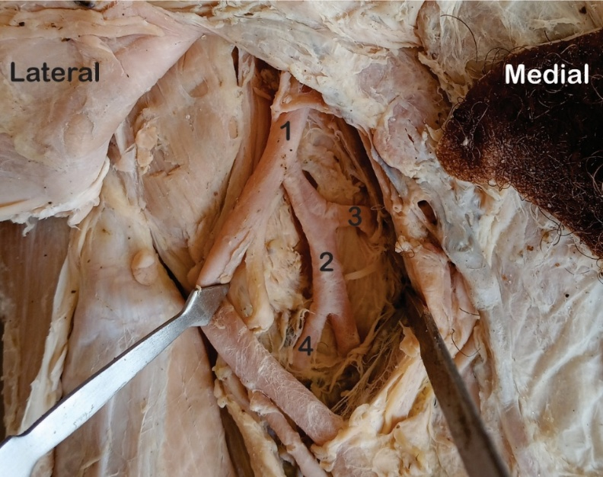
Figure 1: Femoral artery and its branches. The medial and lateral circumflex femoral arteries branching from the profunda femoris.
1= Femoral Artery, 2= Profunda Femoris, 3= Medial Circumflex Femoral, 4= Lateral Circumflex Femoral

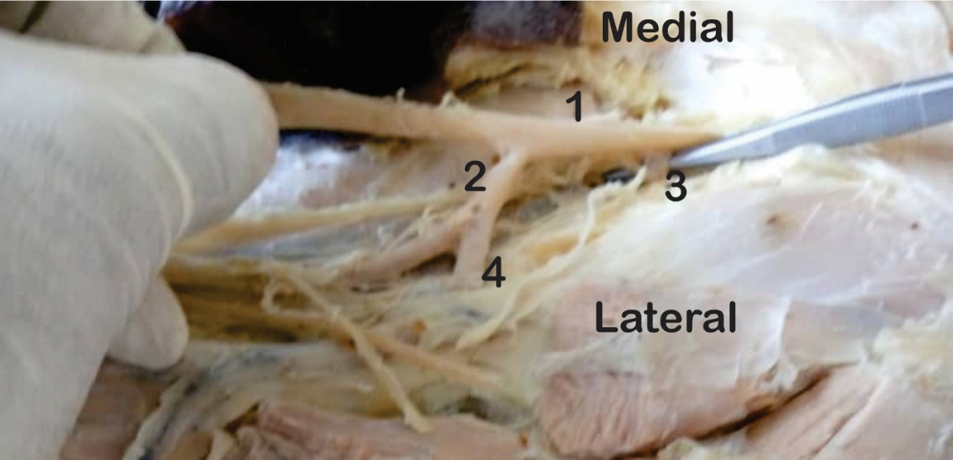
Figure 2: Femoral artery and its branches. The medial circumflex femoral artery branching from the femoral artery and lateral medial circumflex femoral artery branching from profunda femoris.
1= Femoral Artery, 2= Profunda Femoris, 3= Medial Circumflex Femoral, 4= Lateral Circumflex Femoral

2.5 Methods of Data Analysis
Data obtained from the study were analyzed using IBM Statistical Package for the Social Sciences (IBM SPSS) version 25. Descriptive statistics, including mean, standard deviation, frequency, and percentage, were used to summarize the data. An independent-samples t-test was used to compare morphometric measurements between male and female cadavers. A paired-samples t-test was used to compare measurements between the right and left sides to assess differences associated with laterality. Statistical significance was set at an alpha level of 0.05, with p < 0.05 considered statistically significant. A 95% confidence level was adopted for the statistical analyses.

3. results and discussion

3.1 RESULTS
The results of the study were presented in tables and figures.
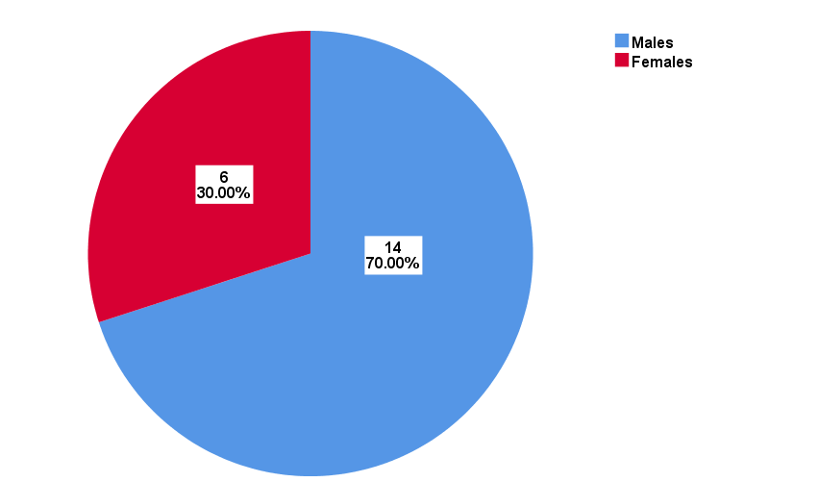
Figure 3: Demographic distribution of study samples by sex (males and females)

Table 1: Descriptive statistics and paired sample t-test comparison between the right and left sides of male samples.
Variables (mm) | Right (n=14) |  |  | Left (n=14) |  |  | t-test
Variables (mm) | Min. | Max. | Mean±SD | Min. | Max. | Mean±SD | t-value | p-value | Inference
IL - OPF | 42.00 | 103.60 | 75.34±20.86 | 40.90 | 103.60 | 72.49±19.23 | 0.49 | 0.633 | NS
IL - AFT | 196.40 | 250.00 | 232.34±18.36 | 196.40 | 250.00 | 231.75±19.83 | 0.00 | 1.000 | NS
PF - MCF | 9.20 | 85.90 | 34.59±24.46 | 9.20 | 114.90 | 43.40±33.64 | -0.86 | 0.408 | NS
PF - LCF | 12.00 | 36.30 | 23.36±8.68 | 12.00 | 103.10 | 37.88±30.36 | -1.54 | 0.150 | NS
IDFA | 5.00 | 12.30 | 8.26±2.60 | 5.00 | 12.30 | 8.13±2.35 | 0.24 | 0.814 | NS
IL= Inguinal Ligament; OPF= Origin of ProfundaFemoris; AFT= Apex of Femoral Triangle; PF= ProfundaFemoris; MCF= Medial Circumflex Femoral Artery; LCF= Lateral Circumflex Femoral Artery; IDFA= Inner Diameter of Femoral Artery; mm= millimeter; Min= Minimum; Max= Maximum; SD= Standard Deviation; NS= Not Significant

Table 2: Descriptive statistics and paired sample t-test comparison between the right and left sides of female samples.
Variables (mm) | Right (n=6) |  |  | Left (n=6) |  |  | t-test
Variables (mm) | Min. | Max. | Mean±SD | Min. | Max. | Mean±SD | t-value | p-value | Inference
IL - OPF | 37.80 | 67.90 | 56.53±14.62 | 44.60 | 92.40 | 66.97±21.51 | -2.26 | 0.073 | NS
IL - AFT | 188.60 | 230.00 | 206.20±19.13 | 207.60 | 220.00 | 215.87±6.40 | -1.55 | 0.181 | NS
PF - MCF | 17.10 | 17.90 | 17.60±0.39 | 17.70 | 38.40 | 25.27±10.21 | -1.77 | 0.136 | NS
PF - LCF | 16.30 | 24.20 | 20.07±3.54 | 16.30 | 28.20 | 23.77±5.82 | -2.33 | 0.068 | NS
IDFA | 5.00 | 11.80 | 8.27±3.05 | 7.40 | 18.00 | 11.20±5.28 | -0.89 | 0.414 | NS
IL= Inguinal Ligament; OPF= Origin of ProfundaFemoris; AFT= Apex of Femoral Triangle; PF= ProfundaFemoris; MCF= Medial Circumflex Femoral Artery; LCF= Lateral Circumflex Femoral Artery; IDFA= Inner Diameter of Femoral Artery; mm= millimeter; Min= Minimum; Max= Maximum; SD= Standard Deviation; NS= Not Significant.

Table 3: Independent sample t-test comparison between male and female samples on the right and left sides.
Variables (mm) | t-value | df | p-value | MD | SED | 95% Confidence Interval |  | Inference
 |  |  |  |  |  | Lower | Upper | Inference
Right Side
IL - OPF | 1.99 | 18 | 0.062 | 18.81 | 9.43 | -1.01 | 38.63 | NS
IL - AFT | 2.88 | 18 | 0.010 | 26.14 | 9.06 | 7.10 | 45.18 | S
PF - MCF | 1.68 | 18 | 0.111 | 16.99 | 10.14 | -4.32 | 38.29 | NS
PF - LCF | 0.89 | 18 | 0.387 | 3.29 | 3.71 | -4.51 | 11.09 | NS
IDFA | -0.01 | 18 | 0.994 | -0.01 | 1.33 | -2.81 | 2.79 | NS
Left Side
IL - OPF | 0.57 | 18 | 0.577 | 5.52 | 9.71 | -14.87 | 25.91 | NS
IL - AFT | 1.89 | 18 | 0.074 | 15.88 | 8.39 | -1.74 | 33.50 | NS
PF - MCF | 1.28 | 18 | 0.218 | 18.13 | 14.19 | -11.69 | 47.95 | NS
PF - LCF | 1.11 | 18 | 0.280 | 14.11 | 12.68 | -12.53 | 40.75 | NS
IDFA | -1.84 | 18 | 0.083 | -3.07 | 1.67 | -6.58 | 0.44 | NS
IL= Inguinal Ligament; OPF= Origin of ProfundaFemoris; AFT= Apex of Femoral Triangle; PF= ProfundaFemoris; MCF= Medial Circumflex Femoral Artery; LCF= Lateral Circumflex Femoral Artery; IDFA= Inner Diameter of Femoral Artery; mm= millimeter; Min= Minimum; Max= Maximum; SD= Standard Deviation; NS= Not Significant; S= Significant; df= Degree of Freedom; MD= Mean Difference; SED= Standard Error Difference

Table 4: Direction of origin of the profunda femoris from the femoral artery.
 | Right Side (n=20) |  | Left Side (n=20)
Site of origin | Frequency | Percentage | Frequency | Percentage
Posterior-laterally | 10 | 50% | 8 | 40%
Posteriorly | 4 | 20% | 6 | 30%
Laterally | 3 | 15% | 4 | 20%
Medially | 3 | 15% | 2 | 10%

Table 5: The site of origin of Lateral Circumflex Femoral Artery (LCFA)
 | Right Side (n=20) |  | Left Side (n=20)
Site of origin | Frequency | Percentage | Frequency | Percentage
Femoral artery above OPF | 2 | 10% | 2 | 10%
Femoral artery at OPF | 3 | 15% | 4 | 20%
Femoral artery below OPF | 1 | 5% | 1 | 5%
PF | 14 | 70% | 13 | 65%
PF= Profunda Femoris; OPF= Origin of Profunda Femoris

Table 6: The site of origin of Medial Circumflex Femoral Artery (MCFA)
 | Right Side (n=20) |  | Left Side (n=20)
Site of origin | Frequency | Percentage | Frequency | Percentage
Femoral artery above OPF | 2 | 10% | 3 | 15%
Femoral artery at OPF | 3 | 15% | 3 | 15%
Femoral artery below OPF | 2 | 10% | 2 | 10%
PF | 13 | 65% | 12 | 60%
PF= Profunda Femoris; OPF= Origin of Profunda Femoris

DISCUSSION
The present study demonstrated appreciable morphological variation in the femoral arterial system, particularly in the origin of the profunda femoris artery (PFA) and the circumflex femoral arteries, while most morphometric parameters did not demonstrate significant differences according to laterality. The PFA originated posterolaterally in 50% of right-sided and 40% of left-sided specimens, followed by posterior, lateral, and medial origins. This predominance of posterolateral origin agrees with previous cadaveric studies. Manjappa and Prasanna (2014) reported a posterolateral origin of the PFA in 50% of right and 70% of left limbs in a South Indian population, while Rajani et al. (2015) reported that posterolateral and lateral origins together accounted for 71.21% of specimens. Similarly, Nasr et al. (2014), in a study of 90 femoral triangles, reported posterolateral origin as the most frequent pattern in both male and female limbs. The present findings therefore reinforce the observation that although the posterolateral origin represents the predominant anatomical pattern, substantial variation exists in the exact surface of origin of the PFA.
The present study also demonstrated considerable variation in the origins of the lateral circumflex femoral artery (LCFA) and medial circumflex femoral artery (MCFA). The LCFA arose from the PFA in 70% of right and 65% of left limbs, whereas direct origins from the femoral artery accounted for the remaining cases. The MCFA similarly originated from the PFA in 65% of right and 60% of left limbs, with the remainder arising directly from the femoral artery at different levels. These findings are broadly consistent with Manjappa and Prasanna (2014), who reported PFA origins for the LCFA in 80% of right and 70% of left limbs, and for the MCFA in 40% of right and 60% of left limbs. However, the present frequencies differ from those reported in other populations, emphasizing population-related variation. Sinkeet et al. (2012), for example, found that the LCFA arose from the PFA in only 65.5% of 84 arteries from Black Kenyan cadavers and documented several unusual origins, while Mogale et al. (2021) reported PFA origin of the LCFA in 78.9% of 90 South African lower limbs. The differences in frequencies observed among Nigerian, South African, Kenyan, and South Asian samples demonstrate that the origin of the circumflex femoral arteries is variable across cadaveric series; however, differences in sample characteristics and methodological classification should also be considered before attributing these variations solely to population differences.
With respect to morphometry, the present study found no significant right-left differences in any of the measured parameters among either males or females. Within the limits of the present sample, these findings indicate no statistically significant evidence of bilateral differences in the distances from the inguinal ligament to the PFA origin and apex of the femoral triangle, the distances between the PFA and circumflex femoral arteries, and femoral artery inner diameter. Comparable bilateral consistency has been reported in other cadaveric vascular studies. Gwunireama et al. (2023a), studying 26 Nigerian carotid arterial specimens, found no significant right-left differences in arterial diameters or distances of external carotid artery branches from the carotid bifurcation. Similarly, Kapor et al. (2026), in a study of 96 femoral regions from 48 adult cadavers, reported no significant left-right asymmetry in femoral arterial anatomy. These findings suggest that substantial bilateral asymmetry may not be a consistent feature of the measured femoral arterial parameters, although larger studies are required to confirm this observation
An important finding of the present study was the significant sex difference in the distance from the inguinal ligament to the apex of the femoral triangle on the right side, with males demonstrating a greater mean distance than females (232.34 ± 18.36 mm versus 206.20 ± 19.13 mm; p = .010). No significant sex differences were observed for the remaining parameters on either side. The finding of a sex-related difference in femoral arterial anatomy is consistent with the recent cadaveric study by Kapor et al. (2026), which identified significant sex-specific differences in femoral artery morphology and reported a greater mean distance between the femoral artery origin and the inguinal canal in males than females.
The morphological variations identified in this study have important clinical and surgical implications. The variable origins of the PFA, LCFA, and MCFA may influence surgical dissection, vascular reconstruction, perforator-based flap procedures, catheterization, and the risk of inadvertent vascular injury. Sinkeet et al. (2012) specifically emphasized that unusual LCFA origins may increase vulnerability to iatrogenic injury during surgery and catheterization, while Mogale et al. (2021) highlighted the potential for femoral arterial variations to contribute to intraoperative bleeding. In addition, Brahmandam et al. (2024) demonstrated considerable variability in the relationship between the inguinal ligament, femoral head, and common femoral artery bifurcation, emphasizing the importance of accurate anatomical knowledge for safe femoral arterial access. The present findings therefore contribute additional population-specific evidence from Nigerian cadavers.

4. Conclusion

The present study demonstrates considerable morphological variation in the femoral arterial system among Nigerian cadavers, particularly in the origins of the profunda femoris artery and the medial and lateral circumflex femoral arteries, with the posterolateral origin of the profunda femoris artery representing the predominant pattern. Despite these anatomical variations, the measured morphometric parameters showed no statistically significant right-left differences in either sex, indicating relative bilateral consistency in the assessed dimensions. A significant sex-related difference was observed in the distance from the inguinal ligament to the apex of the femoral triangle on the right side, with males exhibiting greater values than females. Overall, the findings highlight the variability of femoral arterial anatomy and provide valuable population-specific morphometric and morphological data from Nigerian cadavers. Such information is relevant to anatomical education, surgical dissection, vascular reconstruction, catheter-based procedures, and other interventions involving the femoral region, and may contribute to improved recognition of anatomical variants and reduction of procedure-related vascular complications.

Competing interests

The authors declare that they have no competing interest related to this study, its authorship, or publication.

Declaration of AI Use

This manuscript was prepared through the intellectual contributions of the author(s) to the study design, data analysis, interpretation of results, and scholarly content. Grammarly and ChatGPT were used solely to assist with grammatical refinement and reference formatting during manuscript revision. The author(s) accept full responsibility for the accuracy, integrity, and final content of the manuscript.

References
Brahmandam, A., Huttler, J., Bellamkonda, K., Setia, O., Cardella, J. A., Stewart, W., Guzman, R., & Chaar, C. I. (2024). The radiographic relationship of the femoral head, inguinal ligament, and common femoral artery bifurcation for optimal vascular access. JVS-Vascular Science, 5, 100196.
Gwunireama, I.U, Adheke, O.M., & Collins, G.U. (2023a). Morphometry of carotid bifurcations and branches of external carotid artery in adult Nigerian cadavers. Human Biology Review 12 (4), 263-273.
Gwunireama, I.U, Bob-Manuel, I.F., & Collins, G.U. (2023b). A study of morphological variations of carotid bifurcation and branching pattern of external carotid artery in adult Nigerian cadavers. Archives of Current Research International, 23(5), 40-48
Kapor, S., Cezayirli, E., Bjelogrlic, P., Eric, D., & Djulejic, V. (2026). Consistent sex-specific patterns in the anatomy of the femoral and profunda femoris arteries: A cadaveric study. Cureus, 18(1), e100849.
Koshi, R. (2017). Cunningham’s Manual of Practical Anatomy Volume 1. 16th Edition. Oxford University Press. Page; 174. ISBN 978–0–19–874936–3
Lee, S. H., Yu, D. U., Kim, T. K., Jeon, J. C., Jin, S. C., Choi, W. I., & Lee, J. H. (2022). Analysis of the common femoral artery and vein: anatomical morphology, vessel relationship, and factors affecting vessel size. Medicina, 58(2), 325.
Manjappa, T., & Prasanna, L. C. (2014). Anatomical variations of the profunda femoris artery and its branches—A cadaveric study in South Indian population. Indian Journal of Surgery, 76(4), 288–292.
Mogale, N., Olorunju, S. A. S., Matshidza, S., & Briers, N. (2021). Anatomical variations in the origins of the lateral circumflex femoral arteries in a South African sample: A cadaver study. Translational Research in Anatomy, 22, 100098.
Nasr, A. Y., Badawoud, M. H., Al-Hayani, A. A., & Hussein, A. M. (2014). Origin of profunda femoris artery and its circumflex femoral branches: anatomical variations and clinical significance. Folia morphologica, 73(1), 58-67.
Rajani, S. J., Ravat, M. K., Rajani, J. K., & Bhedi, A. N. (2015). Cadaveric study of profunda femoris artery with some unique variations. Journal of Clinical and Diagnostic Research, 9(5), AC01–AC03
Sinkeet, S. R., Ogeng'o, J. A., Elbusaidy, H., Olabu, B. O., & Irungu, M. W. (2012). Variant origin of the lateral circumflex femoral artery in a black Kenyan population. Folia Morphologica, 71(1), 15–18.

