Effect of spirulina (Spirulina platensis) administered in drinking water on growth performance and health of the rabbit (Oryctolagus cuniculus) in the post-weaning period

.
Abstract
Aims: To evaluate the effect of three doses of spirulina (Spirulina platensis) administered in drinking water on the growth performance and health of weaned rabbits (Oryctolagus cuniculus) in the post-weaning period.
Study Design: Randomized controlled trial with four groups: a control group and three groups receiving increasing doses of spirulina in drinking water.
Place and Duration of Study: Rabbit farm in the village of Adiopodoumé, north of the commune of Yopougon (Abidjan, Côte d'Ivoire); from weaning (35 days of age) to 70 days of age.
Methodology: Fifty-six Oryctolagus cuniculus rabbits, weaned at 35 days and weighing on average 400 g, were allocated to four groups of 14 animals housed in individual cages: a control group (T) receiving industrial commercial pelleted feed without supplementation, and three groups additionally receiving 10 mg (D1), 50 mg (D2) or 100 mg (D3) of spirulina per day in drinking water. Feed intake, mean body weight, average daily gain (ADG), feed conversion ratio (FCR) and health risk index (HRI) were monitored from weaning to 70 days of age.
Results: No significant effect of spirulina dose was observed on feed intake (86 g/d on average), mean body weight (≈1005.5 ± 26.5 g at 70 d), ADG (24 g/d) or FCR (4.6), whereas age significantly influenced these four parameters (P<0.01). The health risk index differed significantly between groups only over the 35–50-day interval (P=0.04), with group D2 being the most affected.
Conclusion: At the doses tested, spirulina administered in drinking water does not improve growth performance or health status of the rabbit in the post-weaning period.
Keywords: Rabbit; Oryctolagus cuniculus; Spirulina platensis; growth performance; health; post-weaning.

1. INTRODUCTION
In Côte d'Ivoire, livestock farming contributes only 4.5% to agricultural GDP, far behind crop production, with a deficit in animal-derived foodstuffs estimated at 60% (FAO, 2006; Kouablé Bi and Tré, 2014). Among short-cycle production sectors, rabbit farming shows a particular lag, related notably to insufficient mastery of rearing techniques and the high cost of industrial feed, which represents more than 70% of production costs (Gidenne, 2003; Kadi, 2012).
The development of this sector requires quality feed at lower cost, which has led to exploring the use of additives such as probiotics and microalgae. Spirulina (Spirulina platensis) attracts attention for its high protein content (50 to 70% of dry weight), its balanced composition of essential amino acids and fatty acids, and its richness in minerals and vitamins (Ciferri, 1983; Falquet and Hurni, 2006). Unlike other microorganisms proposed as protein sources, it lacks a cellulosic cell wall and has high digestibility, on the order of 83% (Falquet, 1996).
Spirulina has been mainly studied in fish and poultry production; in the rabbit, the available Ivorian studies mainly concern haematological parameters (Bleyère et al., 2015; Kambou et al., 2015), while data relating to growth performance remain fragmentary. More recent work carried out on growing rabbits, with spirulina incorporated into feed rather than drinking water, reports variable effects depending on dose and route of administration (Cullere et al., 2013; Rehman et al., 2024), which justifies specifically studying the drinking-water route and low doses.
This study aimed to evaluate the effect of spirulina Spirulina platensis, administered at three doses in drinking water, on growth performance (feed intake, mean body weight, average daily gain, feed conversion ratio) and health (health risk index) of the rabbit Oryctolagus cuniculus in the post-weaning period, in order to assess the value of this route of administration in rabbit farming.
2. MATERIALS AND METHODS
2.1 Site, animals and material
The trial was conducted on a rabbit farm in the village of Adiopodoumé, a locality north of the commune of Yopougon (Abidjan, Côte d'Ivoire). Fifty-six (56) Oryctolagus cuniculus rabbits, weaned at 35 days of age with a mean weight of 400 g, were used. Sex was not taken into account in this study. The rabbits were allocated to four groups of 14 animals, each group being subdivided into three replicates (cages) of homogeneous mean weight. The animals were housed in individual cages (0.5 m² × 25 cm) mounted in batteries of four compartments per level, equipped with metal feeders and drinkers, in a sheet-metal-roofed building.
The plant material consisted of dry Spirulina platensis powder supplied by the Société Agro-Piscicole (SAP de la Mé), Adzopé department (Côte d'Ivoire). The base feed was a commercial industrial pellet, distributed ad libitum to all groups (detailed composition in Table 1).
Table 1. Chemical composition of the commercial pelleted feed and of the spirulina used
Parameter | Commercial feed (%) | Spirulina (per 10 g)
Dry matter | 90.33 | —
Crude fat | 2.40 | 4–7%
Total nitrogenous matter | 2.94 | 55–70%
NDF | 51.10 | —
ADF | 36.03 | —
ADL | 9.50 | —
NFE | 23.73 | 15–25% (carbohydrates)
Energy (Kcal/kg) | 1811 | —
Minerals | — | 7–13%
2.2 Experimental design and treatments
The design comprised a control group (T), receiving the commercial industrial feed alone with tap water, and three experimental groups (D1, D2, D3) additionally receiving, respectively, 10 mg, 50 mg and 100 mg of spirulina per animal per day, dissolved in 0.25 L of drinking water after a brief period of prior water restriction, so that each animal received its full daily dose.
The animals were fed pelleted feed at a rate of 100 g per day per animal. No preventive veterinary treatment (vaccine or antibiotic) was administered, in order to be able to assess any therapeutic properties of spirulina.
2.3 Zootechnical and health monitoring
Feed intake was checked daily per cage, by difference between the quantity of feed distributed and the refusals the following day. Mean body weight (BW) was determined by two weekly weighings, on Monday and Friday, up to 70 days of age. Average daily gain (ADG) and feed conversion ratio (FCR) were calculated according to the usual formulas: ADG = (final weight − initial weight) / number of days; FCR = quantity of feed ingested / weight gain.
Health monitoring was based on a twice-daily check of morbidity (animals with diarrhoea or showing a decrease in intake/weight) and mortality. The health risk index (HRI) corresponded to the sum of the number of morbid animals and the number of dead animals.
2.4 Chemical and statistical analyses
Dry matter, total nitrogenous matter (Kjeldahl method) and fibre fractions (NDF, ADF, ADL, method of Goering and Van Soest, 1972) of the experimental feed were determined according to standard protocols. Feed intake, ADG and FCR data were analysed by two-way ANOVA (spirulina dose × age) under R (version 3.1.0), at the 5% significance threshold, with Dunnett's post-hoc test in case of a significant difference. Morbidity and mortality rates and the HRI were compared using the Chi-squared test.
3. RESULTS AND DISCUSSION
The effect of spirulina on the growth and health performance of the rabbit was assessed through evaluation of feed intake, mean body weight (BW), feed conversion ratio (FCR), average daily gain (ADG) and health risk index (HRI) parameters. To better assess the effect of spirulina on the evolution of these parameters, the age of the animals was taken into account.
3.1 Effects of spirulina on mean body weight
There was no interaction between the age factor and the spirulina dose factor in this trial. The different groups of animals that received the different treatments showed similar weight growth. The four groups of animals showed a mean body weight of approximately 1005.5 ± 26.5 g at 70 d of age (Table 2). However, taking age into account, these various parameters differed statistically among the different groups.
Table 2. Mean body weight of the animals as a function of spirulina dose and age
 | DOSE (D) |  |  |  | AGE (A) |  |  |  | RMS | P>F
 | T | D1 | D2 | D3 | 35 | 50 | 60 | 70 | RMS | D | A | D x A
BW (g) | 1019 | 1045 | 967 | 991 | 577c | 934b | 1182a | 1328a | 48219 | 0.83 | <0.01 | 1
T: control group; D1: 10 mg/day spirulina; D2: 50 mg/day spirulina; D3: 100 mg/day spirulina. P>F: probability; RMS: Residuals Mean Square.
Figure 1 shows the mean body weight of the four groups given different doses of spirulina according to age class. Thus, at 35th days of age the rabbits had a mean body weight of 577 g. At 50, 60 and 70 days of age the mean body weight of the rabbits was 934 g, 1182 g and 1328 g, respectively.
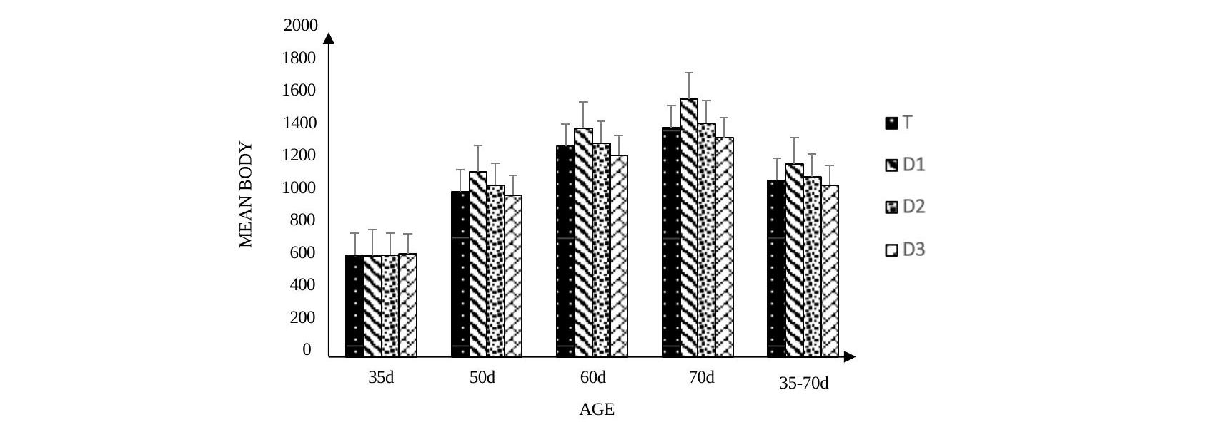
Figure 1: Mean body weight of the animals as a function of age
3.2 Effects of spirulina on feed intake, average daily gain and feed conversion ratio
Examination of Table 3 shows that there was no interaction between the age of the animals and the dose of spirulina ingested. Furthermore, the analyses indicate no significant difference in feed intake among the four groups of animals. Mean intake was 86 g/d. The same observation applies to average daily gain and feed conversion ratio, whose observed means were 24 g/d and 4.6, respectively. However, taking age into account, these various parameters differed statistically among the different groups.
Table 3. Effect of spirulina and age on feed intake, ADG and FCR of the animals
 | DOSE (D) |  |  |  | AGE (A) |  |  | RMS | P>F
 | T | D1 | D2 | D3 | 35-50 | 51-60 | 61-70 | RMS | D | A | D x A
Intake (g/d) | 82 | 84 | 86 | 91 | 69b | 91a | 98a | 119 | 0.47 | <0.01 | 0.78
ADG (g/d) | 23 | 28 | 24 | 21 | 28a | 29.5a | 15b | 62.2 | 0.52 | <0.01 | 0.97
FCR | 4.7 | 3.9 | 4.5 | 5.4 | 2.7b | 3.1b | 8a | 2.2 | 0.43 | <0.01 | 0.94
T: control group; D1: 10 mg/day spirulina; D2: 50 mg/day spirulina; D3: 100 mg/day spirulina. P>F: probability; RMS: Residuals Mean Square.
3.3 Effects of spirulina on feed intake
Throughout the study, no significant difference in feed intake was observed among the four groups of animals subjected to the different treatments. The animals had a similar intake, averaging 86 g/d.
Figure 2 shows the quantities of feed ingested by the four groups according to age class.
Thus from the 35th to the 50th day of age the different groups had a similar intake of 69 g/d. The same trend was observed in the 51–60-day and 61–70-day age classes, with mean intakes of 91 g/d and 78 g/d, respectively.
The rabbits ingested 22 g more between 51 and 60 days of age than those aged between 35 and 50 days. Conversely, at 61 to 70 days of age the rabbits ingested 13 g less than those aged between 51 and 60 days.
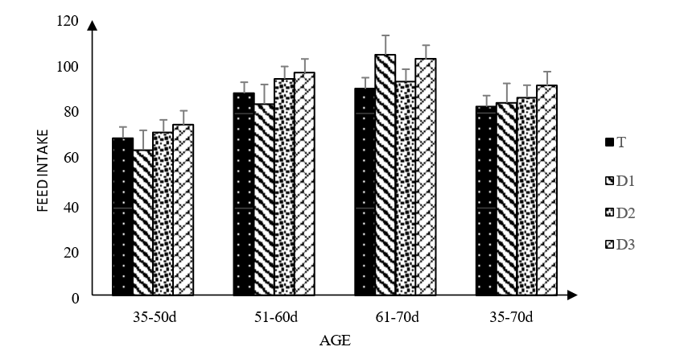
Figure 2: Feed intake of the animals as a function of age
3.4 Effects of spirulina on average daily gain
Throughout the study, no significant difference in average daily gain (ADG) was recorded among the animals of the different groups subjected to the different spirulina treatments. Mean ADG was 24 g/d.
Figure 3 shows the ADG of the four groups given different doses of spirulina according to age class. Thus, from the 35th to the 50th day of age the different groups showed an ADG of 28 g/d. The same observation was made for the 51–60-day and 61–70-day age classes, where the ADG of the rabbits was 29.5 g/d and 15 g/d, respectively.
Between 51 and 60 days of age, the rabbits had an ADG slightly higher, by 1.5 g/d, than those aged between 35 and 50 days. Conversely, between 61 and 70 days of age, ADG was 15.5 g/d lower than the ADG observed at 51–70 days.
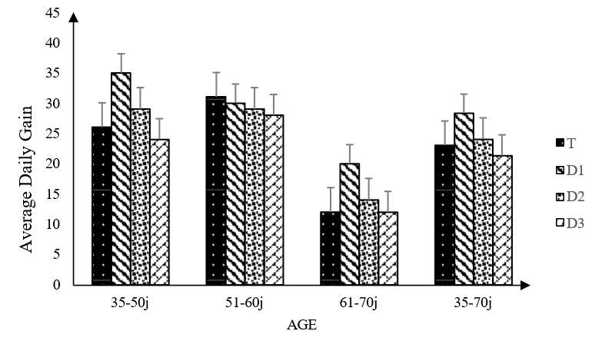
Figure 3: Average daily gain (ADG) of the animals as a function of age
3.5 Effects of spirulina on feed conversion ratio
Throughout the study, no significant difference in feed conversion ratio (FCR) was observed among the four groups of animals subjected to the different treatments. The animals had a similar FCR, averaging 4.6.
Figure 4 shows the feed conversion ratio (FCR) of the four groups according to age class. Thus from the 35th to the 50th day of age the different groups had an FCR of 2.7. The same trend was observed in the 51–60-day and 61–70-day age classes, with FCR values of 3.1 and 8, respectively.
The rabbits showed an FCR 0.4 higher between 51 and 60 days of age than those aged between 35 and 50 days. Likewise, at 61 to 70 days of age the rabbits had an FCR 4.9 higher than those aged between 51 and 60 days.
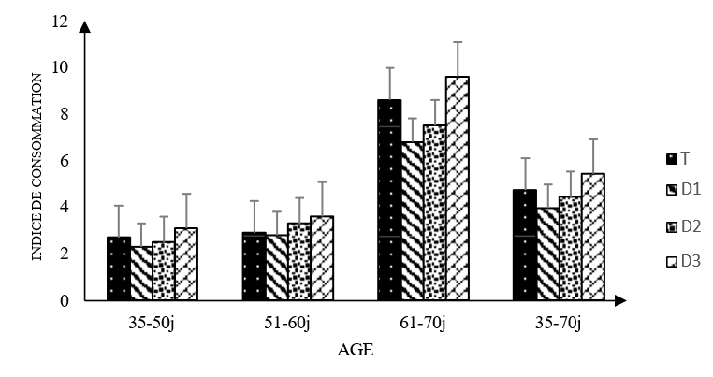
Figure 4: Feed conversion ratio of the animals as a function of age
3.6 Effects of spirulina on animal health
Thirty-one (31) animals out of 56 showed health disorders between weaning and 70 days of age. Twenty-three deaths were recorded among the 31 morbid animals (Table 4). Throughout the study, the four groups of animals given the different doses of spirulina did not show major differences in health risk index (P=0.16), except in the 35–50-day age interval (P=0.04). In the 35–50 d interval, the HRI was highest in the D2 group's animals. The latter recorded an HRI respectively 7, 4 and 6 points higher than that of groups T, D1 and D3. Regarding morbidity and mortality, no significant difference was observed among the different groups throughout the study. Thus mean morbidity and mortality were 2 and 6, respectively, across the different groups.

Table 4. Morbidity and mortality rates and health risk index as a function of spirulina dose and age
 | Treatments |  |  |  | P>F
 | T | D1 | D2 | D3 | P>F
35–50 d n | 14 | 14 | 14 | 14
Morbidity (%) | 0(0.0) | 1(7.1) | 3(21.4) | 1(7.1) | 0.24
Mortality (%) | 3(21.4) | 5(35.7) | 7(50) | 3(21.4) | 0.31
HRI (%) | 3(21.4) | 6(42.9) | 10(71.4) | 4(28.6) | 0.04
51–60 d n | 11 | 9 | 7 | 11
Morbidity (%) | 0(0.0) | 0(0.0) | 0(0.0) | 1(9.1) | 0.47
Mortality (%) | 1(9.1) | 2(22.2) | 0(0.0) | 1(9.1) | 0.51
HRI (%) | 1(9.1) | 2(22.2) | 0(0.0) | 2(18.2) | 0.39
61–70 d n | 10 | 7 | 7 | 10
Morbidity (%) | 0(0.0) | 1(14.3) | 0(0.0) | 1(10) | 0.51
Mortality (%) | 0(0.0) | 1(14.3) | 0(0.0) | 0(0.0) | 0.26
HRI (%) | 0(0.0) | 2(28.6) | 0(0.0) | 1(10) | 0.17
35–70 d n | 14 | 14 | 14 | 14
Morbidity (%) | 0(0.0) | 2(14.3) | 3(21.4) | 3(21.4) | 0.32
Mortality (%) | 4(28.6) | 8(57.1) | 7(50) | 4(28.6) | 0.28
HRI (%) | 4(28.6) | 10(71.4) | 7(50) | 7(50) | 0.16
T: control group; D1: 10 mg/day spirulina; D2: 50 mg/day spirulina; D3: 100 mg/day spirulina; P>F: probability; RMS: Residuals Mean Square; HRI: Health Risk Index.
Discussion
In this study, four groups of animals were used, one control and three experimental. The latter groups were subjected to variable doses of spirulina with the aim of evaluating its effects on growth and health performance. Evaluation of the growth parameters showed similarity in mean body weight, average daily gain and feed conversion ratio among the four groups.
This would be due to the fact that feed intake in the rabbit is regulated more by the fibre content of the feed than by any other element. The different groups of animals received the same feed and therefore the same fibre content. This observation was made by Gidenne et al. (2009), who showed that the rabbit regulates its intake according to the level of digestible energy in the feed. Furthermore, Gerencsér et al. (2013) found no significant differences between animals receiving feed supplemented with 5% spirulina and those receiving feed without spirulina. These authors obtained higher intake than in this study, at 133 g/d. The results of the present study showed a difference in intake according to the age of the rabbits. These results corroborate those of Gerencsér et al. (2013), who observed a 15% increase in intake between the first three weeks and the last three weeks of age. Although no statistical difference was observed, the intake of the D3 group animals, which received 100 mg/d of spirulina, was higher than that of the other groups.
In the rabbit diet, the use of 10, 50 and 100 mg of spirulina showed no major difference in average daily gain (ADG) or feed conversion ratio (FCR) of the animals. The animals had a similar ADG and FCR, of 24 and 4.6, respectively. This absence of a difference in ADG and FCR among the different groups of animals in this work would be a consequence of the absence of variation in the quantity of feed ingested. The results of Gerencsér et al. (2013) are consistent with those obtained here. These authors supplemented spirulina at 5% and recorded a similar average daily gain of 38.6 and a similar FCR of 3.5 between animals receiving spirulina and controls not receiving spirulina.
Regarding the effect of age on ADG and FCR, significant differences were observed. We recorded a stable average daily gain (ADG) between 35–50 days and 51–60 days, with a mean of 29, whereas in the last interval it was 15, a decrease of 32%. For FCR, observations were similar, with a 44% increase between 51–60 days and 61–70 days. The results obtained by Gerencsér et al. (2013) show the same trends. They recorded a high average daily gain (ADG) between 35–56 days of age, which then decreased by 10% between 56–77 days. They also recorded a 24% increase in feed conversion ratio between 35–56 days and 56–77 days.
Furthermore, even though the highest quantity of feed ingested was observed in animals receiving the 100 mg spirulina/day dose (group D3), it was the animals receiving 10 mg spirulina/day (group D1) that showed the best feed efficiency in terms of average daily gain (ADG) and feed conversion ratio (FCR). Regarding mean body weight, no difference was observed between animals given different doses of spirulina and those not receiving spirulina. The animals showed a similar mean body weight of approximately 1005.5 g. This is all the more logical given that no difference was detected in intake or feed efficiency in this study. These results are consistent with those of Peiretti and Meineri (2008), who observed no significant difference when they supplemented spirulina at 5%, 10% and 15% in the rabbit diet. Regarding the health risk index (HRI), the results of this study showed a significant difference among the different groups of animals in the 35–50 d age interval. The majority of morbidity and mortality cases were recorded in the first two weeks (35–50 days) of the study, at 62.5% and 78.3% respectively. These observed health disorders could be due to the fact that no vaccination or preventive treatment was administered before the start of the experiments. One of our objectives was to evaluate the effect of spirulina on animal health; most mortality cases were due to either diarrhoea or bloating, which could have been prevented by treatments prior to the start of the experiment. The results of Gerencsér and collaborators (2013) confirm that morbidity and mortality rates are high in the first weeks after weaning, although they observed lower rates than in our study. Indeed, they recorded respective morbidity and mortality rates of 9.5% and 2.4% during the period from the 35th to the 56th day of age.
4. Conclusion
Under the conditions of this trial, daily administration of Spirulina platensis through drinking water at doses of 10 mg, 50 mg, and 100 mg per rabbit did not significantly improve feed intake, body weight, average daily gain, feed conversion ratio, or overall health status during the post-weaning period. Age influenced growth-related parameters, while the health risk index differed significantly only during the early post-weaning interval. These findings indicate that the tested doses and route of spirulina administration were not effective in improving zootechnical performance or reducing health risk in growing rabbits.
Competing Interests
No conflict of interest is mentioned in the source document. No veterinary product was administered to the animals during the trial, this methodological choice being aimed at isolating the specific effect of spirulina on animal health.
Ethical Approval
Animal Ethic committee approval has been collected and preserved by the author(s).
Declaration of AI Use

This manuscript was prepared through the intellectual contributions of the author(s) to the study design, data analysis, interpretation of results, and scholarly content. Grammarly and ChatGPT were used solely to assist with grammatical refinement and reference formatting during manuscript revision. The author(s) accept full responsibility for the accuracy, integrity, and final content of the manuscript.

References
Barone R., Pavaux C., Blin P.C., Cuq P., 1973. Atlas d'anatomie du lapin. Masson et Cie, Paris, France.
Bleyère M.N., Kambou P.S., Attemene S.D.D., Tiahou G.G., Dembele A., Sess D.E., 2015. Antianaemic effect of spirulina in rabbits (Oryctolagus cuniculus), a made and used food supplement in Côte d'Ivoire. Sch. Acad. J. Biosci., 3(9): 725-732.
Ciferri O., 1983. Spirulina, the Edible Microorganism. Microbiol. Rev., 47: 551-578.
Cullere M., Dal Bosco A., Dalle Zotte A., 2013. Effect of dietary supplementation of spirulina (Arthrospira platensis) and thyme (Thymus vulgaris) on apparent digestibility and productive performance of growing rabbits. World Rabbit Sci., 22: 1-9.
Falquet J., 1996. Spiruline : aspects nutritionnels. Antenna Technologies, Genève.
Falquet J., Hurni J.-P., 2006. Spiruline : aspects nutritionnels. Antenna Technologies, Genève.
FAO, 2006. Les impacts de l'élevage sur l'environnement. AG21 Magazine Focus, FAO, Rome.
Gerencsér Zs., Matics Zs., Radnai I., Szendrő Zs., 2013. Effect of dietary supplementation of spirulina (Arthrospira platensis) and thyme (Thymus vulgaris) on apparent digestibility and productive performance of growing rabbits. World Rabbit Sci.
Gidenne T., 2003. Fibres in rabbit feeding for digestive troubles prevention: respective role of low-digested and digestible fibre. Livest. Prod. Sci., 81: 105-117.
Gidenne T., Combes S., Carabaño R., Badiola I., Garcia J., Licois D., 2008. Ecosystème caecal et nutrition du lapin : interactions avec la santé digestive. INRA Prod. Anim., 21: 239-250.
Gidenne T., Combes S., Feugier A., Jehl N., Arveux P., Boisot P., Briens C., Corrent E., Fortune H., Montessuy S., Verdelhan S., 2009. Feed restriction strategy in the growing rabbit. 2. Impact on digestive health, growth and carcass characteristics. Animal, 3: 509-515.
Kadi S.A., 2012. Alimentation du lapin de chair : valorisation de sources de fibres disponibles en Algérie. Thèse, Université Mouloud Mammeri de Tizi-Ouzou, Algérie.
Kambou P.S., Bleyere M.N., Attemene S.D.D., Tiahou G.G., Camara Cisse M., 2015. Assessment of immunostimulatory activity of Spirulina platensis in rabbits (Oryctolagus cuniculus) in Côte d'Ivoire. Int. J. Pharm. Pharm. Res., 4(3): 113-128.
Kouablé Bi B.N., Tré B.T.C.O., 2014. Rapport définitif de l'étude évolution des exportations du bétail malien suite aux récentes crises. Côte d'Ivoire, 49 p.
Peiretti P.G., Meineri G., 2008. Effects of diets with increasing levels of Spirulina platensis on the performance and apparent digestibility in growing rabbits. Livest. Sci., 118: 173-177.
Rehman R., Ismail A., Sial N., Hussain R., 2024. Nutritional interventions alleviate heat stress effects on rabbit health and performance: role of Spirulina platensis and selenium nanoparticles. J. Popul. Ther. Clin. Pharmacol.
Goering H.K., Van Soest P.J., 1972. Forage fiber analyses (apparatus, reagents, procedures and some applications). USDA Agric. Handbook n°379, Washington DC.

