Original Research Article

EXPRESSION OF N-GLYCANS IN BREAST CARCINOMA

ABSTRACT
Breast cancer is the most common malignant tumor and the second leading cause of cancer mortality in women and characterized by distinct shifts in the N-glycome, including increased multi-antennary branching and hypersialylation. High-mannose structures are consistently upregulated in both tissue and serum, offering high diagnostic accuracy for early-stage detection. The aim of this study is to evaluate the expression of N-glycans in paraffin-embedded blocks from breast tissues diagnosed with breast carcinoma. Lectin histochemistry, were used to examine the expression and distribution of N-glycan in paraffin-embedded blocks from 10 breast tissues diagnosed with fibroadenoma, breast carcinoma and as control 5 healthy tissue samples, using lectins from Ulex europaeus I, Lens culinaris, Canavalia ensiformis, Lotus tetragonolobus and Triticum vulgaris. The lectins from Lotus tetragonolobus and Ulex europaeus I remained constant suggesting a ubiquitous binding target regardless of pathology; lectins such as Lens culinaris and Triticum vulgaris show a loss of reactivity associated with more advanced stages of malignancy (grade III). In contrast, the biphasic behavior of Canavalia ensiformis requires further investigation to determine whether the recovery observed in grade III is due to specific changes in membrane glycosylation during tumor progression. Our results suggest that the variability in lectin affinity reflects alterations in cellular N-glycosylation, making it possible to distinguish between different stages of histological tumor progression; further studies are required to confirm this

Keywords: N-glycans, Breast Cancer, Lectin histochemistry.

1. INTRODUCTION.
Breast cancer remains the leading cause of cancer deaths in women worldwide. The chances of a woman developing this disease in her lifetime have increased significantly over the past few decades from 1 in 11 in 1975 to 1 in 8 in 2016 (Scott & Drake, 2019). While the mortality rate from breast cancers confined to the breast or associated draining lymph nodes is low, the majority of breast cancer deaths are due to the spread of the disease. When breast cancer spreads to other vital organs such as the lung, liver, brain and bones, it can result in an impairment of the organ’s ability to function and ultimately death (Ibrahim E et al, 2009). Glycosylation is a term used to describe the biosynthetic enzymatic process that involves the sequential removal and addition of individual carbohydrates to proteins and lipids (Munkley J et al, 2016). For glycoproteins, the attached glycans are classified as either N-linked (Asn) or O-linked (Ser/Thr) based off the amino acid residue to which they are attached. N-linked glycosylation of newly synthesized proteins occurs co-translationally in the endoplasmic reticulum. N-linked glycans are further processed by a highly regulated sequential series of glycosidases and glycosyltransferases in the endoplasmic reticulum (ER) and Golgi apparatus. Individual glycosyltransferases may exhibit overlapping specificities in some instances (Kuzmanov et al, 2013, Spiro 2002). N-linked glycans most commonly contain mannose, galactose, N-acetylglucosamine, fucose, and sialic acid sugars, and less commonly N-acetylgalactosamine and glucose. In cancer, oncogenic transformation associated with changes in glycosylation was first documented over seven decades ago (Taniguch & 2 Kizuka, 2015). the N-glycome undergoes dynamic remodeling that facilitates tumor cell survival, migration, and colonization of distant organs. Understanding these patterns is essential for the development of next-generation biomarkers and therapies that can overcome the limitations of current clinical tools (Lee et al, 2020). The aim of this study is to evaluate the expression of N-glycans in paraffin-embedded blocks from breast tissues diagnosed with breast carcinoma.

MATERIAL AND METHODS

2.1 Reagents
The biotinylated lectins from, Ulex europaeus I, Lens culinaris, Canavalia ensiformis, Lotus tetragonolobus and Triticum vulgaris were obtained from Vector Laboratories, (Burlingame, CA USA). streptavidin-peroxiodase, and chemical reagents were from (Sigma Chemical Co, USA), 3-Amino-9-Ethyl-carbazole (AEC) kit as substrate for peroxidase was obtained from Vector Laboratories
2.2 Source of tissues
10 Paraffin-embedded blocks from breast tissues diagnosed with breast carcinoma were kindly donated by Paulina Leyva from the Pathology Department of the School of Medicine, UABJO, Oaxaca, Mexico. 10 healthy control tissue samples were obtained from cosmetic procedures at the Plastic Surgery service from the Mexican Institute of Social Security (IMSS for its initials in Spanish), Mexico.
2.3 Ethical approval
The study protocol was approved by the Institutional Review Board of Research of the Medical School of UABJO.
2.4 Immunohistochemistry
Paraffin-embedded blocks from breast carcinoma and normal control were cut in 6 µm-thick sections. Select sections were labeled with lectins (5µg/ml) overnight at 4ºC. After incubation, the slides were washed with PBS, pH 7.4, and covered with 300 μl of 5% skimmed milk in PBS, pH 7.4, and incubated for 12 h at 4°C. Then, after washing with PBS, pH 7.4, the samples were labeled with streptavidin-peroxidase (1:1000 in PBS) for 1 h at 37°C. Unbound conjugate was removed by washing six times with PBS. The binding of lectins or antibody was revealed by incubating with 3-amino-9-ethyl-carbazole (AEC), following instructions of manufacturer (Invitrogen), during 15 min at 37°C. The reaction was stopped by washing with water. Slides were observed with an AXIOSCOP 40 microscope (Zeiss, Germany) equipped with a digital camera AXIOCAM MRC (Zeiss) and micrographs were analyzed with the ZEN 2011 Software (Zeiss).

  - Lectin specificity
To determinate the lectin specificity in control breast epithelium and carcinoma, assays using lectin histochemistry were performed using lectins incubated with 200 mM of their specific monosaccharide 30 min before use to histochemistry. The presence and absence of staining in samples was recorded as follow: No stain (0), ductal stain (1), ductal and estromal stain (2), ductal and some stromal cells stain (3).

2.9 Statistical Analysis
Fisher’s exact test was performed using GraphPad InStat version 3.00 (GraphPad Software, San Diego, CA).

3. RESULTS
3.1 Immunohistochemistry
Table No.1 shows the oligosaccharide structures recognized by the lectins used

TABLE 1
Lectins and the oligosaccharide structures they recognize
Lectin | Abbreviation | Oligosaccharide structure
Lens culinaris | LCA | Manα1,6(Manα1,3)Manβ14(Fucα1,2)GlcNAc-Asn.
Canavalia ensiformis | Con A | Manα1,2Manα1,2ManαGlcNAcβ1,2Man
Triticum vulgaris | WGA | GlcNAcβ1,4GlcNAc  β1-4GlcNAc; Neu5Ac
Ulex europaeus I | UEA I | α-L-Fucosa  Fuc(α1,2)Gal(β1,4)GlcNAc
Lotus tetragonolobus | LTL | Fuc(α1,2)Gal(β1,4){Fuc(α1,3)}GlcNAc

The number of positive and negative samples that the lectins recognized is displayed in Table 2. The lectins LTL and LCA recognized two samples and did not recognize two samples in the normal breast tissues, while UEA 1, WGA, and Con A recognized three samples and did not recognize one.
Regarding the fibroadrmona samples, ten samples are recognized by the UEA-1 and LTL lectins. Eight samples are recognized by the WGA lectin, while two are not. Finally, only four samples are recognized by the LCA lectin, while six samples are negative; five samples are recognized by the Con A lectin, while five samples are negative.
The UEA, LTL, and WGA lectins were found to recognize eight tissues in the samples with grade II moderately differentiated ductal carcinoma, while the LCA and Con A lectins only recognized two tissues, with the remaining eight being negative.
In samples of breast tissue containing grade III poorly differentiated ductal carcinoma, it was found that the UEA lectin recognized eight samples, two of which were negative; the LTL lectin recognized seven samples, three of which were negative; the Con A lectin recognized six samples, four of which were negative; the WGA lectin recognized three samples, seven of which were negative; and lastly, the LCA lectin only interacted with two samples, eight of which were negative.
TABLE 2
Number of samples recognised by the lectins used
LECTIN | NORMAL  (+) (-) | FIBROADENOMA  (+) (-) | CANCER  II  (+) (-) | CANCER  III  (+) (-)
Ulex europaeus I | 3 1 | 10 0 | 8 2 | 8 2
Lens culinaris | 2 2 | 4 6 | 3 7 | 2 8
Triticum vulgaris | 3 1 | 8 2 | 8 2 | 3 7
Lotus tetragonolobus | 2 2 | 10 0 | 8 2 | 7 3
Canavalia ensiformis | 3 1 | 5 5 | 3 7 | 6 4
+ Positive recognition
- No recognition
Figure 1 shows the recognition of Ulex europaeus I (UEA-1) lectin in normal tissue (A), in fibroadenoma (B), in samples of grade II ductal carcinoma (C) and in samples of grade III ductal carcinoma (D); in all cases, the lectin recognises the epithelial cells of the ducts and the intraductal component.

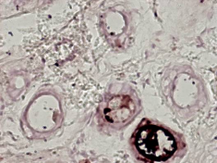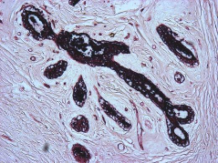
A
B
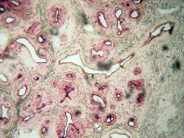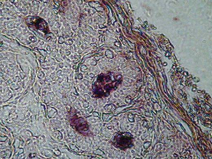
C
D
Figure 1. The results of histochemistry using Ulex europaeus I lectin are shown. A) shows lectin binding in the ducts of normal tissue. B) lectin binding is observed in the ducts of tissue samples containing fibroadenoma. C) shows lectin recognition in the ducts of grade II invasive ductal carcinoma. D) shows lectin recognition in the ducts of grade III invasive ductal carcinoma. The yellow arrows indicate the site of lectin recognition. Microphotographs 10x.

Figure 2 shows the recognition of Lens culinaris (LCA) lectin in normal tissue (A), the lectin recognises the epithelial cells of the ducts and the intraductal component. In fibroadenoma (B), the lectin recognises the epithelial cells of the ducts and the intraductal component and the stroma. In samples of grade II ductal carcinoma (C) and in samples of grade III ductal carcinoma (D); the lectin recognises the epithelial cells of the ducts and the intraductal component.
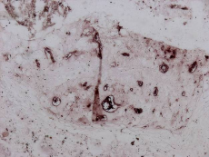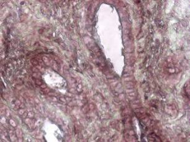
A
B
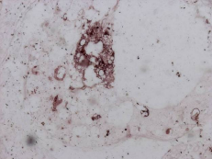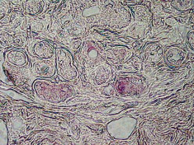
D
C
Figure 2. The results of histochemistry using Lens culinaris lectin are shown. A) shows lectin binding in the ducts of normal tissue. B) lectin binding is observed in the ducts and stroma of tissue samples containing fibroadenoma. C) shows lectin recognition in the ducts of grade II invasive ductal carcinoma. D) shows lectin recognition in the ducts of grade III invasive ductal carcinoma. The yellow arrows indicate the site of lectin recognition in ducts. The white arrow indicates the site of lectin recognition in stroma. Microphotographs 10x.

Figure 3 shows the recognition of Triticum vulgaris (LCA) lectin in normal tissue (A), the lectin recognises the epithelial cells of the ducts and the intraductal component. In fibroadenoma (B), the lectin recognises the epithelial cells of the ducts and the intraductal component and the stroma. In samples of grade II ductal carcinoma (C) and in samples of grade III ductal carcinoma (D); the lectin recognises the epithelial cells of the ducts and the intraductal component.


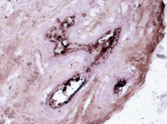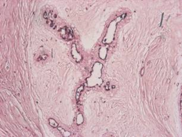
A
B
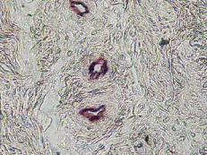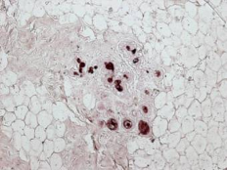
D
C
Figure 3. The results of histochemistry using Triticum vulgaris lectin are shown. A) shows lectin binding in the ducts of normal tissue. B) lectin binding is observed in the ducts and stroma of tissue samples containing fibroadenoma. C) shows lectin recognition in the ducts of grade II invasive ductal carcinoma. D) shows lectin recognition in the ducts of grade III invasive ductal carcinoma. The yellow arrows indicate the site of lectin recognition in ducts. The white arrow indicates the site of lectin recognition in stroma. Microphotographs 10x.

Figure 4 shows the recognition of Lotus tetragonolobus (LTL) lectin in normal tissue (A), the lectin recognises the epithelial cells of the ducts and the intraductal component. In fibroadenoma (B), the lectin recognises the epithelial cells of the ducts and the intraductal component and the stroma. In samples of grade II ductal carcinoma (C) and in samples of grade III ductal carcinoma (D); the lectin recognises the epithelial cells of the ducts and the intraductal component.

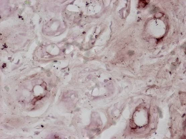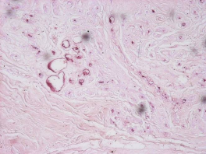
B
A
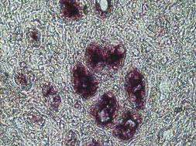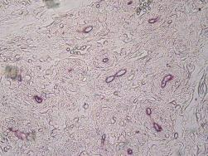
D
C
Figure 4. The results of histochemistry using Lotus tetragonolobus lectin are shown. A) shows lectin binding in the ducts of normal tissue. B) lectin binding is observed in the ducts and stroma of tissue samples containing fibroadenoma. C) shows lectin recognition in the ducts of grade II invasive ductal carcinoma. D) shows lectin recognition in the ducts of grade III invasive ductal carcinoma. The yellow arrows indicate the site of lectin recognition in ducts. The white arrow indicates the site of lectin recognition in stroma. Microphotographs 10x.

Figure 5 shows the recognition of Canavalia ensiformis (Con A) lectin in normal tissue (A), lectin in normal tissue (A), in fibroadenoma (B), in samples of grade II ductal carcinoma (C) and in samples of grade III ductal carcinoma (D); in all cases, the lectin recognises the epithelial cells of the ducts and the intraductal component.

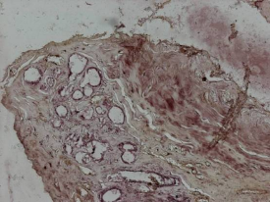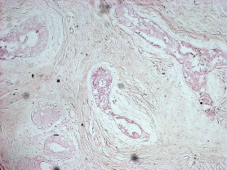
B
A
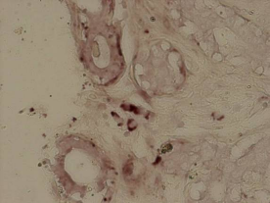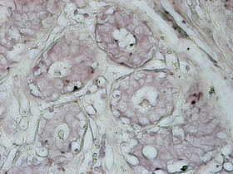
D
C

Figure 5. The results of histochemsitry using Canavalia ensiformis lectin are shown. A) shows lectin binding in the ducts of normal tissue. B) lectin binding is observed in the ducts of tissue samples containing fibroadenoma. C) shows lectin recognition in the ducts of grade II invasive ductal carcinoma. D) shows lectin recognition in the ducts of grade III invasive ductal carcinoma. The yellow arrows indicate the site of lectin recognition in ducts. Microphotographs 10x.

3.2 analysis
The results of the statistical analysis indicate that none of the comparisons carried out between the different tissue types (Normal, Fibroadenoma, Cancer II, Cancer III) for any of the lectins reached the threshold for statistical significance (p < 0.05).

4. DISCUSSION
Breast cancer comprises ~30% of new cancer diagnoses, and is one of the most common causes of cancer mortality in women (Siegel et al., 2017). Among the most significant molecular alterations observed in breast cancer is the dysregulation of N-glycosylation, a complex post-translational modification that profoundly influences protein function, stability, and cellular signaling (Lee et al, 2020, Liang et al. 2023 and Gupta et al., 2023).
The results obtained through lectin histochemistry in human breast tissue reveal significant variations in the expression of glycans associated with tumour progression, highlighting the dynamic remodelling of the N-glycomic profile in ductal carcinoma. Altered glycosylation is a hallmark of malignant transformation, facilitating processes such as cell migration, invasion and immune evasion.
The loss of reactivity observed for Lens culinaris (LCA) and Triticum vulgaris (WGA) in grade III (poorly differentiated) ductal carcinomas, compared with grade II samples and normal tissues, suggests a reduction in the presence of specific structures recognised by these lectins as the degree of malignancy increases. LCA specifically binds to glycans with α 1-6 linked fucose residues, whilst the WGA detects traces of N-acetylglucosamine (GlcNAc). In breast cancer, changes in fucosylation are heavily associated with increased invasiveness and altered cell-matrix interactions (Fohona et al, 2017). Lens culinaris agglutinin, binds specifically to hepatocellular carcinoma -associated glycovariant of α-fetoprotein (Taketa et al, 1993).
The lectin from Triticum vulgaris is widely used to study the altered glycocalyx (the carbohydrate-rich layer) of cancer cells. Altered expression of the carbohydrates recognised by WGA is involved in tumor-related processes such as cell adhesion, motility, angiogenesis and apoptosis. (Vieira-de-Mello et al, 2013). In cell culture studies, WGA has been shown to considerably influence and potentially inhibit the growth of human breast cancer cell lines (MCF-7 and T 47D). (Valentiner et al, 2003).
The reduction in these oligosaccharide structures, recognised by LCA and WGA lectins, in advanced stages (grade III) may reflect an alteration in the glycosylation machinery (glycosyltransferases) leading to the simplification of certain N-glycan structures or to masking by hypersialylation, a phenomenon documented in the progression of various breast tumors.
The lectin from Lotus tetragonolobus exhibits the same recognition pattern across all the breast tissue samples studied, suggesting that the fucosylated epitope it recognizes is a conserved structural feature of breast tissue, regardless of its pathological status.
Lotus tetragonolobus lectin has been used in cancer research to detect aberrant fucosylation on breast cancer cells. (Hashim et al., 2017). Lotus tetragonolobus lectin binds to Lewis^{X} and Lewis^{Y} in fucosylated semen clusterin, but not serum clusterin or recombinant clusterin in breast cancer cells frequently overexpress these altered fucose chains (Merlotti et al., 2019 & Listinsky et al., 2011).
These results may be due to the cellular origin of the cancer. Basal and luminal adenomas do not share the same glycosyltransferases responsible for glycosylating proteins. In this case, the fucosyltransferases (Lai et al., 2019).
The lectin from Ulex europaeus I exhibit the same recognition pattern across all the breast tissue samples studied. The lectin from Ulex europaeus I have been used in histochemistry on breast cancer tissue samples and was associated with disease-free interval and survival (Fenlon et al., 1987). Lectin binding was also compared with pathological prognostic factors and details of clinical follow-up, as well as paraffin-embedded tissue samples from breast carcinoma (Erhan et al., 1996). Receptors sites for Ulex europaeus I stained non-malignant epithelium of patients with blood group H but did not stain malignant cells (Skutelsky et al., 1988). Ulex europeus I lectin has also been used to capture circulating SW480 colon cancer cells (Tian et al., 2022).
Canavalia ensiformis is a well-studied plant lectin (carbohydrate-binding protein) extracted from jack bean sedes, exhibited limited cytotoxicity in breast and liver cancer cells (Marey et al., 2026). Canavalia ensiformis inhibited the growth of MCF-7 cells in dose- and time-dependent manners (Shi et al., 2013). The most studied receptor of ConA biology is MT1-MMP (Membrane-Type Matrix MetalloProteinase-1). It evidenced that the tumor cells benefit from MT1-MMPs since they cause a simpler metastasis and neovascularization by activating different MMPs (Sato et al., 2005, Sounni) et al., 2025, Cavada et al., 2023).
The lectin from Canavalia ensiformis exhibits biphasic behaviour, as its recognition decreases in grade II cancer samples, whilst it increases in grade III samples; this suggests that the expression of the oligosaccharide structures recognised by this lectin exhibits high intratumoural heterogeneity, and further studies are therefore required to elucidate this observed behaviour.
5.CONCLUSIONS
This study examined lectin-binding patterns associated with selected N-glycan-related structures in normal breast tissue, fibroadenoma, and ductal carcinoma. The findings showed variable lectin recognition among tissue categories, with relatively stable binding for Ulex europaeus I and Lotus tetragonolobus, reduced recognition of Lens culinaris and Triticum vulgaris in grade III carcinoma, and a variable pattern for Canavalia ensiformis. These observations suggest that breast tissue glycosylation may change during histological tumor progression. However, because the statistical comparisons did not reach significance, the findings should be interpreted cautiously. Larger studies with quantitative glycomic validation are required to confirm these preliminary observations.

6. LIMITATION OF THIS STUDY
Although this study provides valuable information on glycomic remodelling in ductal breast carcinoma, it is essential to recognize the following limitations inherent in the methodological design: as this is an observational cross-sectional study with a limited number of tissue samples, this may restrict the ability to generalize the findings to the entire population of patients with breast carcinoma. The study relies primarily on the intensity of histochemical staining (qualitative or semi-quantitative analysis). This approach is limited in its ability to define the exact changes in the structure of N-glycans.

COMPETING INTERESTS
All authors declare no competing interests.
Declaration of AI Use

This manuscript was prepared through the intellectual contributions of the author(s) to the study design, data analysis, interpretation of results, and scholarly content. Grammarly and ChatGPT were used solely to assist with grammatical refinement and reference formatting during manuscript revision. The author(s) accept full responsibility for the accuracy, integrity, and final content of the manuscript.

REFERENCES
Cavada BS, Oliveira MV, Osterne VJS, Pinto-Junior VR, Martins FWV, Correia-Neto C, Pinheiro RF, Leal RB, Nascimento KS. Recent advances in the use of legume lectins for the diagnosis and treatment of breast cancer. Biochimie. 2023 May;208:100-116 DOI: https://doi.org/10.1016/j.biochi.2022.12.015
Erhan Y, Alkanat MB, Akyildiz M, Icoz G, Yilmaz R, Erhan Y. Ulex Europeus Agglutinin (UEA-I) lectin binding in breast carcinoma and its relationship to prognostic factors. Ann Saudi Med. 1996 DOI: https://doi.org/10.5144/0256-4947.1996.509
Fenlon S, Ellis IO, Bell J, Todd JH, Elston CW, Blamey RW. Helix pomatia and Ulex europeus lectin binding in human breast carcinoma. J Pathol. 1987 DOI: https://doi.org/10.1002/path.1711520305
Fohona S. Coulibaly, Bi-Botti C. Youan. Current status of lectin-based cancer diagnosis and therapy[J]. AIMS Molecular Science, 2017, 4(1): 1-27. DOI: https://www.aimspress.com/article/doi/10.3934/molsci.2017.1.1
Gupta R, Ponangi R, Indresh KG. Role of glycosylation in breast cancer progression and metastasis: implications for miRNA, EMT and multidrug resistance. Glycobiology. 2023 Aug 14;33(7):545-555 DOI: https://doi.org/10.1093/glycob/cwad046
Hashim OH, Jayapalan JJ, Lee CS. Lectins: an effective tool for screening of potential cancer biomarkers. PeerJ. 2017 Sep 7;5:e3784. DOI: https://doi.org/10.7717/peerj.3784
Ibrahim E, Al-Gahmi AM, Zeenelin AA, Zekri JM, Elkhodary TR, Gaballa HE, Fawzy EE, El sayed ME, Alzahrani MS. Basal vs. luminal A breast cancer subtypes: a matched case-control study using estrogen receptor, progesterone receptor, and HER-2 as surrogate markers. Med Oncol. 2009 ;26(3):372-8. DOI: https://doi.org/10.1007/s12032-008-9131-6
Kuzmanov U, Kosanam H, Diamandis EP. The sweet and sour of serological glycoprotein tumor biomarker quantification. BMC Med. 2013 Feb 7;11:31.DOI: https://doi.org/10.1186/1741-7015-11-31
Lai TY, Chen IJ, Lin RJ, Liao GS, Yeo HL, Ho CL, Wu JC, Chang NC, Lee AC, Yu AL. Fucosyltransferase 1 and 2 play pivotal roles in breast cancer cells. Cell Death Discov. 2019 Mar 6;5:74.DOI: https://doi.org/10.1038/s41420-019-0145-y
Lee SB, Bose S, Ahn SH, Son BH, Ko BS, Kim HJ, Chung IY, Kim J, Lee W, Ko MS, Lee K, Chang S, Park HS, Lee JW, Kim DC. Breast cancer diagnosis by analysis of serum N-glycans using MALDI-TOF mass spectroscopy. PLoS One. 2020 Apr 9;15(4):e0231004. DOI: https://doi.org/10.1371/journal.pone.0231004
Liang D, Gao Q, Meng Z, Li W, Song J, Xue K. Glycosylation in breast cancer progression and mammary development: Molecular connections and malignant transformations. Life Sci. 2023 Aug 1;326:121781. DOI: https://doi.org/10.1016/j.lfs.2023.121781
Listinsky JJ, Siegal GP, Listinsky CM. The emerging importance of α-L-fucose in human breast cancer: a review. Am J Transl Res. 2011 Aug 15;3(4):292-322.
Marey, M. M., El-Akhras, B. A., Mona, M., & Talaat, R. M. Targeting breast and liver cancer cells with Phaseolus vulgaris (PHA), Phytolacca americana (PAA), and Canavalia ensiformis (Concanavalin A) lectin by inducing apoptosis and autophagy. Next Research, 2026. 101772. DOI: https://doi.org/10.1016/j.nexres.2026.101772
Merlotti A, Malizia AL, Michea P, Bonte PE, Goudot C, Carregal MS, Nuñez N, Sedlik C, Ceballos A, Soumelis V, Amigorena S, Geffner J, Piaggio E, Sabatte J. Aberrant fucosylation enables breast cancer clusterin to interact with dendritic cell-specific ICAM-grabbing non-integrin (DC-SIGN). Oncoimmunology. 2019 Jun 24;8(9):e1629257. DOI: https://doi.org/10.1080/2162402X.2019.1629257
Munkley J, Elliott DJ. Hallmarks of glycosylation in cancer. Oncotarget. 2016 Jun 7;7(23):35478-89.DOI: https://doi.org/10.18632/oncotarget.8155
Sato H, Takino T, Miyamori H. Roles of membrane-type matrix metalloproteinase-1 in tumor invasion and metastasis. Cancer Sci. 2005 Apr;96(4):212-7.DOI: https://doi.org/10.1111/j.1349-7006.2005.00039.x
Scott DA, Drake RR. Glycosylation and its implications in breast cancer. Expert Rev Proteomics. 2019 Aug;16(8):665-680 DOI: https://doi.org/10.1080/14789450.2019.1645604
Shi Z, Chen J, Li CY, An N, Wang ZJ, Yang SL, Huang KF, Bao JK. Antitumor effects of concanavalin A and Sophora flavescens lectin in vitro and in vivo. Acta Pharmacol Sin. 2014 Feb;35(2):248-56. DOI: https://doi.org/10.1038/aps.2013.151
Siegel RL, Miller KD, Jemal A. Cancer Statistics, 2017. CA Cancer J Clin. 2017 Jan;67(1):7-30. doi: 10.3322/caac.21387. Epub 2017 Jan 5.DOI: https://doi.org/10.3322/caac.21387
Skutelsky E, Hoenig S, Griffel B, Alroy J. The distribution of lectin receptor sites in human breast lesions. Pathol Res Pract. 1988 Aug;183(4):469-75 DOI: https://doi.org/10.1016/s0344-0338(88)80095-5
Sounni NE, Noel A. Membrane type-matrix metalloproteinases and tumor progression. Biochimie. 2005 Mar-Apr;87(3-4):329-4DOI: https://doi.org/10.1016/j.biochi.2004.07.012
Spiro RG. Protein glycosylation: nature, distribution, enzymatic formation, and disease implications of glycopeptide bonds. Glycobiology. 2002 Apr;12(4):43R-56R. DOI: https://doi.org/10.1093/glycob/12.4.43r
Taketa K, Endo Y, Sekiya C, Tanikawa K, Koji T, Taga H, Satomura S, Matsuura S, Kawai T, Hirai H. A collaborative study for the evaluation of lectin-reactive alpha-fetoproteins in early detection of hepatocellular carcinoma. Cancer Res. 1993 Nov 15;53(22):5419-23.
Taniguchi N, Kizuka Y. Glycans and cancer: role of N-glycans in cancer biomarker, progression and metastasis, and therapeutics. Adv Cancer Res. 2015;126:11-51.DOI: https://doi.org/10.1016/bs.acr.2014.11.001
Tian R, Li X, Zhang H, Ma L, Zhang H, Wang Z. Ulex Europaeus Agglutinin-I-Based Magnetic Isolation for the Efficient and Specific Capture of SW480 Circulating Colorectal Tumor Cells. ACS Omega. 2022 Aug 17;7(34):30405-30411. DOI: https://doi.org/10.1021/acsomega.2c03702
Valentiner U, Fabian S, Schumacher U, Leathem AJ. The influence of dietary lectins on the cell proliferation of human breast cancer cell lines in vitro. Anticancer Res. 2003 Mar-Apr;23(2B):1197-206.
Vieira-de-Mello, G. S., Silva-Filho, A. F., Barros, P. S., Rêgo, M. J. B. M., & Beltrão, E. I. C. Lectin histochemistry reveals changes in carbohydrate expression on morphological types of breast ductal carcinoma in situ. J Cytol Histol, 2013. 4, 1-4. DOI: https://doi.org/10.4172/2157-7099.1000179

