Assessment of the Impact of Aerosol Deposits on the Electrical Performance of a Photovoltaic Module Using an IoT System: Application to the Context of Ouagadougou, Burkina Faso

.
ABSTRACT

Our study focuses on the energy production of solar installations and aims to evaluate the impact of aerosol deposits on the electrical performance of photovoltaic modules under the climatic conditions of the city of Ouagadougou in the Sudano-Sahelian region. To this end, we designed and installed an experimental setup consisting of two identical 50 Wp monocrystalline modules, installed under the same exposure conditions. Each module incorporates an IoT system comprising two microcontrollers, sensors, and a data acquisition system to monitor the module’s power output. The results indicate a gradual degradation of the electrical current in the soiled module, with weekly relative losses ranging from 4.27% to 9.58%, reflecting increasing variability in the effect of soiling. This current behavior contrasts with the voltage trend, which remains relatively stable under the experimental conditions considered. An analysis of power output shows a profile identical to that of current, suggesting that power output is largely dependent on current, thereby confirming the significant impact of dust deposits on energy production. In terms of energy output, this translates to a notable loss of production during the sunniest hours, with an estimated weekly power loss ranging from 8.65% to 19.50%. Furthermore, the increase in daily loss rates and the decline in production efficiency as illustrated by the soiling ratio combined with the average weekly losses, confirm the importance of reliable, continuous, and autonomous monitoring of photovoltaic system performance via an IoT system, particularly in Sahelian regions heavily affected by an increased frequency of dust events.

Keywords: Aerosols, Photovoltaic module, IoT system, electrical performance, energy losses, Ouagadougou

1. INTRODUCTION

Solar energy, in particular, is the most suitable form of renewable energy, as it is readily available, environmentally friendly, and non-polluting (Jacobson et al., 2017; Millstein et al., 2017). The African continent particularly its northern and southern regions have enormous solar energy potential well-suited for photovoltaic conversion (Lu & Wang, 2025; Neher et al., 2020). Several previous studies based on in situ measurements and satellite observations have demonstrated the significant solar potential available in northern regions particularly the Sahel and the Sahara where average monthly irradiance can reach up to 6 kWh/m²/day (Goni et al., 2019; Nébon et al., 2019; Niang et al., 2023). According to the International Energy Agency, photovoltaic systems could supply 11% of the world’s renewable energy, equivalent to a significant reduction of 2.3 gigatons of carbon dioxide (CO₂) emissions per year (Shaik et al., 2023). In the context of the global energy transition, renewable energy plays a central role in strategies to ensure sustainable development by reducing greenhouse gas emissions and improving access to clean, sustainable energy (Almulhim & Abubakar, 2026). In Burkina Faso, solar photovoltaic energy is emerging as a preferred solution to the challenges of electricity access, in a context characterized by abundant sunshine and reliance on highly polluting fossil fuels (Nébon et al., 2019). However, solar photovoltaic energy production is intermittent and depends on several climatic and environmental factors that affect the efficiency of solar photovoltaic modules (Bado et al., 2026). In fact, the efficiency of a solar photovoltaic system depends heavily on solar radiation, which is an unpredictable quantity (Mondol et al., 2007)and is influenced in various ways by weather conditions, seasonal variations, location, time of day, and the sun's position and altitude (Fouad et al., 2017; Prema & Uma Rao, 2015). Furthermore, the performance of photovoltaic modules is significantly affected by aerosol deposits, an issue that has not yet been sufficiently studied in the West African climate context. To this end, Burkina Faso, like most Sahelian countries, experiences recurring Saharan dust storms and dry haze, exacerbated by the northeastern harmattan winds (Bado et al., 2024). The particles thus suspended in the air gradually settle on the glass surfaces of the panels, reducing the transmission of solar radiation and, consequently, the energy efficiency of the installations (Khodakaram-Tafti et al., 2025; Said et al., 2018). These atmospheric particles particularly aerosols act by absorbing or scattering solar radiation, thereby reducing the amount of solar radiation transmitted for photovoltaic conversion (Mani & Pillai, 2010). However, these dust deposits are influenced by environmental factors such as wind speed, humidity, convective systems, emission sources, particle type, and the nature of the PV solar module surface (Shaik et al., 2023). In light of this, the emergence of Internet of Things (IoT) technologies opens new possibilities for real-time monitoring of photovoltaic solar panel performance. Thus, the overall objective of this study is to evaluate the impact of aerosol deposits on the electrical performance of photovoltaic solar installations using an IoT system under the Sudano-Sahelian climatic conditions of the city of Ouagadougou in Burkina Faso. To this end, this study specifically aims to design a monitoring system based on microcontrollers coupled with sensors that measure dust concentration and electrical parameters; experimentally compare the electrical performance of a clean, regularly cleaned panel with that of a soiled panel over a period of continuous measurements; and finally, analyze the collected data to quantify the efficiency losses caused by soiling.

2. material and methods

2.1 Photovoltaic modules and installation conditions

The selected module is a low-power monocrystalline panel from the ET-M53650 series, particularly well-suited for degradation studies and precise experimental measurements. Its structure consists of an array of high-efficiency silicon cells protected by approximately 3 mm of tempered glass with an anti-reflective coating to optimize solar radiation transmission. Under standard test conditions, this module delivers a maximum power output of 50 watts. At its optimal operating point, the voltage is 18.22 V and the current is 2.75 A. In open-circuit conditions, the measured voltage is 21.96 V, while the short-circuit current reaches 3.04 A. These electrical characteristics allow the module to withstand a maximum system voltage of 1,000 V DC, with a series fuse rated at 10 amps. For our study, we are using two photovoltaic solar modules installed at the Ouagadougou site (12.20°N; -1.40°E), located in the Sudano-Sahelian zone. In Burkina Faso, and more generally throughout the Northern Hemisphere, solar panels are oriented due south to capture the maximum amount of solar radiation and produce the most electrical energy. In addition, the tilt of the modules depends on the site's latitude, which is 12.20°N; generally, a tilt equal to the latitude is recommended. However, to ensure the modules self-clean during rainfall, their tilt should remain above 10°. The tilt angle of photovoltaic modules is highly dependent on the site’s latitude, due to variations in the sun’s apparent altitude and, consequently, the angle of incidence of solar radiation on the plane of the modules (Yadav & Chandel, 2013). This explains why the tilt angle of our modules ranges from 12° to 15°. Our study was conducted in an area carefully selected for its exposure to natural and anthropogenic aerosols particularly desert dust and its ease of access. The location has the advantage of being free of shaded areas, which is a crucial criterion for preventing measurement errors and ensuring uniform exposure of the photovoltaic cells to the sun throughout the day.

2.2 Experimental Protocol

In our IoT system, we use two microcontrollers that share the tasks. The Arduino UNO collects data from sensors, including dust, temperature, humidity, current, and voltage. Next, the ESP retrieves this data via interfaces such as UART or I2C, then sends it to the ThingSpeak platform using Wi-Fi and the MQTT protocol. In fact, the IoT device we designed operates as a chain for collecting and disseminating information. It all starts with the sensors, which continuously measure various parameters. This data is first transmitted to an Arduino UNO board, which acts as a local controller. Subsequently, a second electronic board the ESP32 or the ESP8266 transmits this information via Wi-Fi to a web platform called ThingSpeak, allowing us to observe and analyze it (H et al., 2023). We developed two (2) separate IoT systems: one designed to monitor the output of the soiled panel that collects aerosol particles, and the other to monitor the clean panel that is regularly cleaned. The first IoT system for the soiled panel consists of a DHT22 temperature and humidity sensor, an INA 226 current, voltage, and power sensor, a DMS501 dust sensor, and an LCD screen. The second system, meanwhile, consists of a DHT11 temperature and humidity sensor, an ACS712 current sensor, and a B25 voltage sensor. It is connected to the reference panel, which is cleaned every two days. These sensors have virtually the same accuracy, so this does not affect our measurement readings. This distinction stems from the fact that one of the panels is exposed to the elements, while the other is cleaned regularly to prevent aerosol buildup, which explains the absence of dust sensors in the second IoT system.

2.3 IoT System Architecture and Sensor Placement

Our system is based on a well-structured IoT architecture designed to collect, process, and transmit environmental and electrical data in real time. At the heart of this architecture is the Arduino UNO, which acts as the main “brain” of the experimental device. Programmed to coordinate operations, this microcontroller interacts directly with all sensors simultaneously. Specifically, the DSM501 sensor monitors the concentration of airborne particles, particularly PM2.5, allowing us to assess aerosol accumulation that could reduce the solar panel’s efficiency. At the same time, the INA226 sensor accurately measures the voltage, current, and power generated by the photovoltaic module, providing essential data for analyzing its performance. Finally, the DHT22 sensor records ambient temperature and relative humidity. All sensors are powered by the Arduino, ensuring simple setup and centralized data management. The Arduino UNO works in tandem with an ESP32 module to establish IoT connectivity. Sensor data, collected by the Arduino, is sent to the ESP32 via serial communication. The ESP32, powered by an external source, connects to the Wi-Fi network and uses the ThingSpeak API key to transmit this data to the IoT platform, where it is stored and displayed in real time as graphs. For the reference panel, the process remains the same, but this time the Arduino UNO interacts with an ACS712 current sensor and a B25 0-25 DC voltage sensor, which tracks changes in the solar panel’s output voltage. Additionally, the DHT11 is used to record ambient temperature and relative humidity. The ESP32 receives data from the Arduino UNO and then sends it to the ThingSpeak platform for storage and visualization.

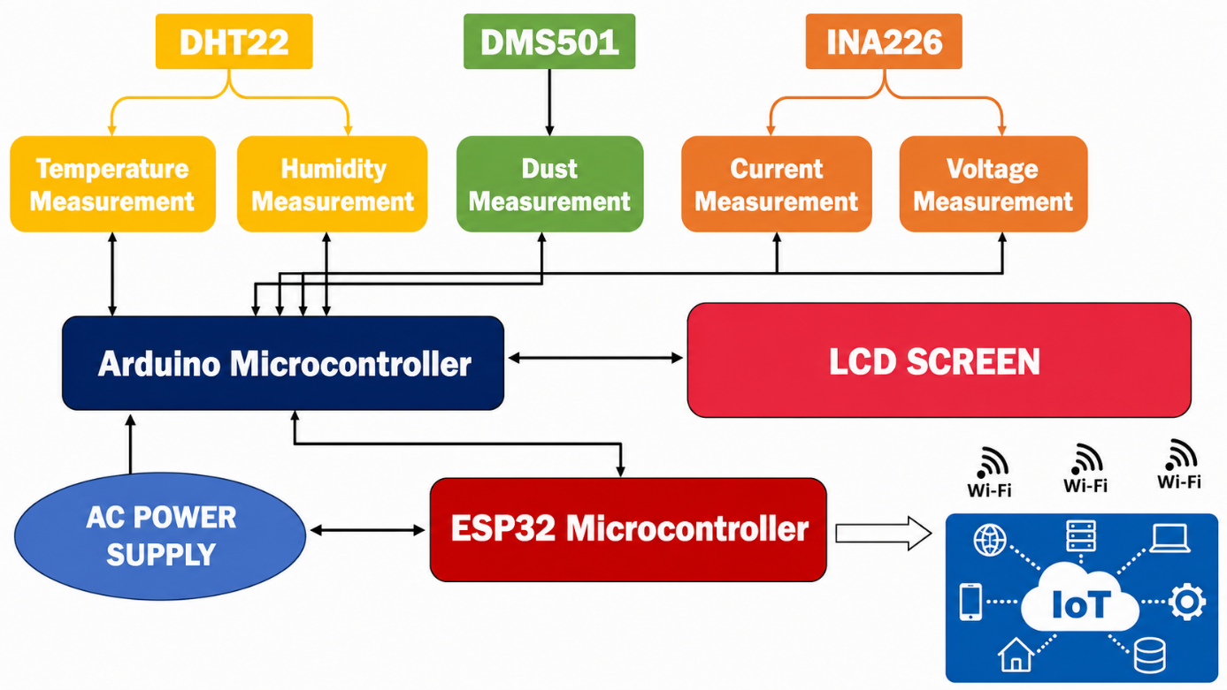
Fig. 1. Block diagram of the component layout
2.4 Overview of the experimental setup

The experimental study is based on an instrumented photovoltaic system comprising two identical modules subjected to different levels of soiling. The first module is cleaned every two days and serves as the reference panel, while the second is intentionally left exposed to aerosol deposits and serves as the soiled panel. This configuration enables direct quantification of the impact of aerosol deposits on the modules’ electrical performance. Figure 2 below depicts both the clean and soiled panels, while Figure 3 illustrates the connectivity of the various components and sensors in the IoT system.
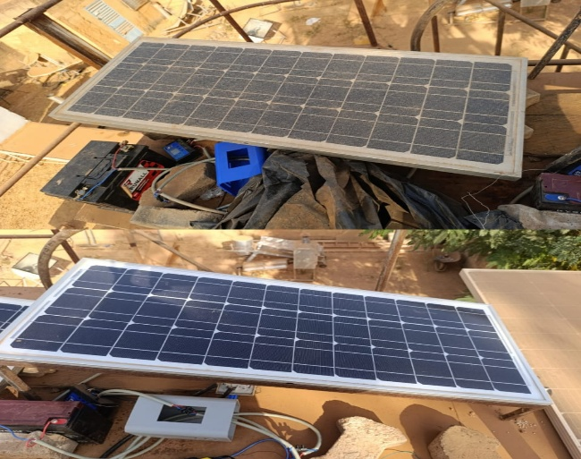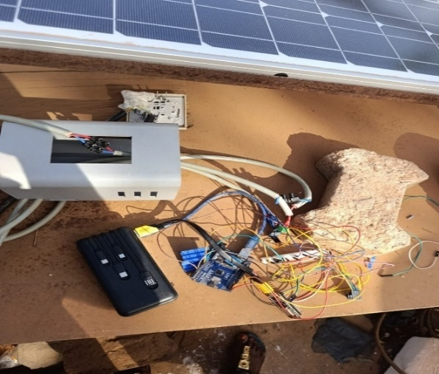
Fig. 2. Clean panel and recessed pane Fig. 3. Illustration of the designed and built IoT system

Each chain is equipped with sensors that measure electrical and environmental parameters, namely current, voltage, power, ambient temperature, relative humidity, and airborne dust concentration. The data is recorded at 5-minute intervals throughout the entire measurement campaign, covering several weeks of continuous operation. This data, recorded every 5 minutes for each system on the Thinkspeak platform, is exported to a Google Sheets spreadsheet and then downloaded for processing and analysis.

2.5 Data and Methodology

Our study is purely experimental and based on monitoring the electrical parameters of photovoltaic modules using an IoT device. These measurements include current, voltage, and electrical power at 5-minute intervals. To better characterize these electrical parameters, we use the single-diode electrical model of the photovoltaic solar cell presented in the following diagram (Abdulrazzaq et al., 2022):
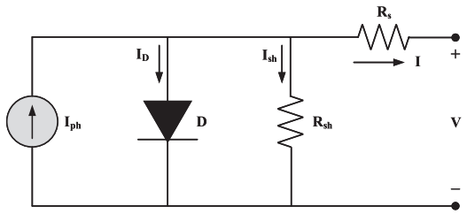
Fig. 4. Equivalent circuit of a single-diode photovoltaic cell

By applying the node theorem, we define the electric current (I) supplied by the photovoltaic module according to the following equation (Korsaga et al., 2026; Nafa et al., 2025):
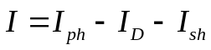 (1)
In this equation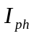 represents the photocurrent, which depends on the irradiance,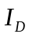 represents the diode current (D), and 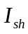 represents the current through the shunt resistor (R_{sh}) where:
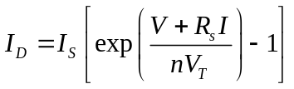 (2)
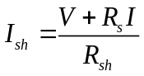 (3)
Hence, the I-V characteristic of the photovoltaic module is defined by equation (4):
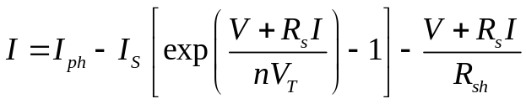 (4)
Parameters such as 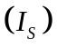 denote the diode’s saturation current, 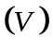 the module voltage,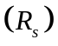 the series resistance,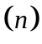 the diode’s ideality factor and 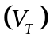 the thermal voltage. From the measured current 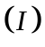 and voltage , the electrical power 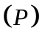 is derived according to (Ouedraogo et al., 2025):
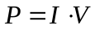 (5)
To quantify the effect of aerosol deposits on the module’s electrical performance, we calculate the soiling ratio (SR), which reflects the efficiency of the soiled module, and the soiling rate 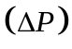 , which illustrates the relative losses, where 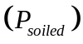 is the power output of the soiled module and 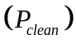 is that of the clean module (Shukla et al., 2026):
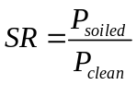 (6)
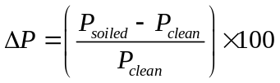 (7)

3. results and discussion

3.1 Analysis of the profile of the electrical current
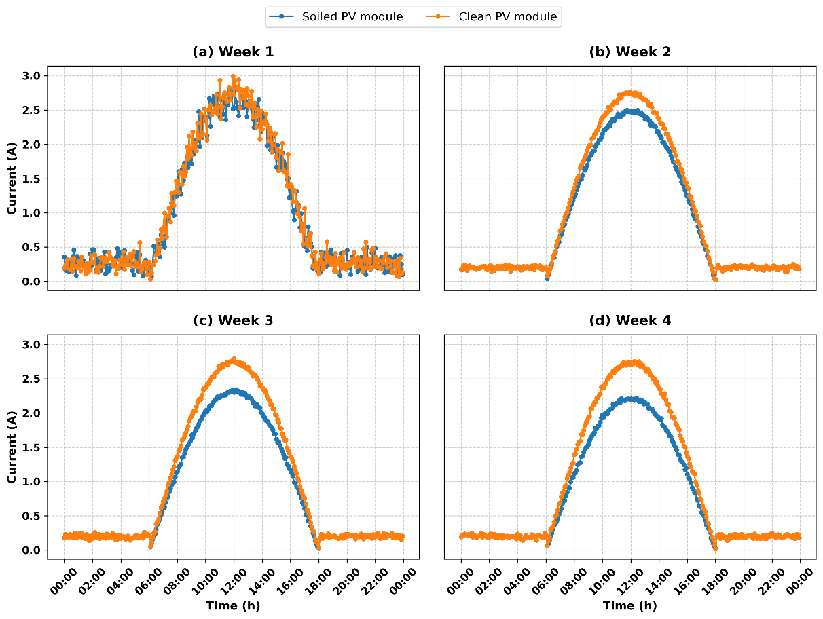
Fig. 5. Weekly electrical current profile of the panels

In general, the average current profile follows a near-Gaussian curve, with a gradual rise in the early morning, a peak around noon, and then a decline until late afternoon at 6:00 p.m. We consistently observe that the current generated by the soiled panel remains lower than that of the clean panel for most of the day, reflecting the attenuating effect of dust on the incident light flux and, consequently, on the generation of charge carriers. This physical phenomenon is fully consistent with the conclusions of Ndiath et al., 2023 (Ndiath et al., 2023), who demonstrated through their experimental work that the accumulation of particles on the glass surface drastically reduces the current by acting as an absorbing optical barrier. The discrepancy between the two curves is particularly pronounced around the current peak at 12:00 p.m., when the impact of soiling on the module’s efficiency becomes more apparent. Furthermore, it should be noted that at these times, incident solar radiation is at its maximum, which explains the observed current peaks. The analysis also reveals that the effect of so f soiling on the photovoltaic current tends to increase over the study period which spans nearly a month and is reflected in an average relative loss visible starting in the second week. These losses are estimated at 4.27%, 7.65%, and 9.58% for the second, third, and fourth weeks, respectively. These figures indicate a gradual degradation of the electrical current from the soiled module compared to the clean module. In addition, the dispersion of the losses also increases, with a standard deviation rising from 5.14%, 7.92%, and 10.02% for the second, third, and fourth weeks, respectively, reflecting an increasing variability in the effect of soiling.
3.2 Analysis of the Electrical Voltage Profile
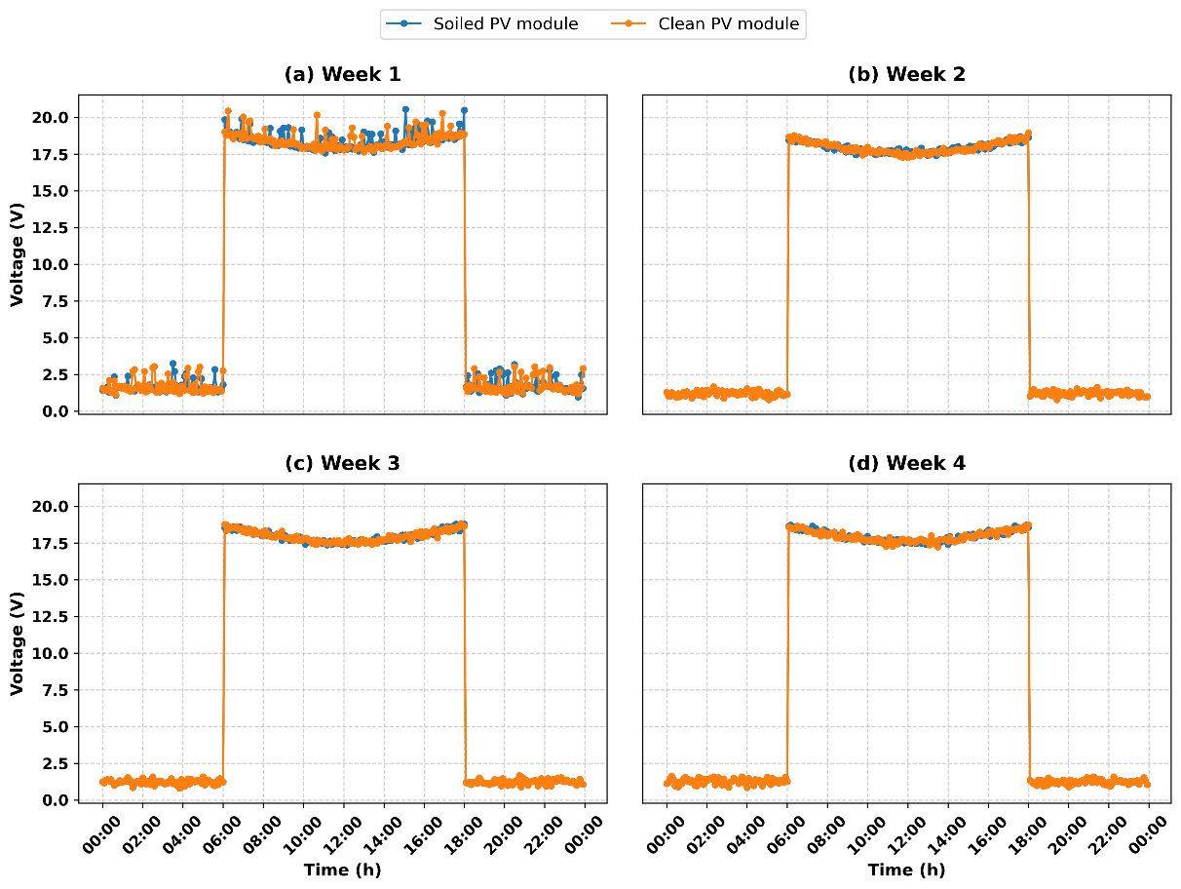
Fig. 6. Weekly voltage profile of the panels

The average voltage curves show an almost identical voltage trend for both modules throughout the day, with less pronounced variations. Thus, overall, we can conclude that the figures indicate the fouling under study does not cause any significant systematic variation in the photovoltaic module’s voltage, particularly for the measurements taken from the second through the fourth week. This behavior contrasts with the trend in relative current losses, which increase gradually over the same period. The effects of deposits on electrical performance thus appear to manifest primarily as a reduction in the current produced, while the voltage remains relatively stable under the experimental conditions considered. This observation is consistent with the behavior of a photovoltaic module in which soiling primarily affects the panel’s current, while the voltage varies less significantly, resulting in a more pronounced difference in the current profiles than in the voltage profiles, in line with the analyses by Ndiath et al., 2023 (Ndiath et al., 2023). Furthermore, this difference in sensitivity between current and voltage underscores the importance of analyzing the module’s electrical parameters separately to characterize the impact of soiling.

3.3 Analysis of the Electrical Power Profile
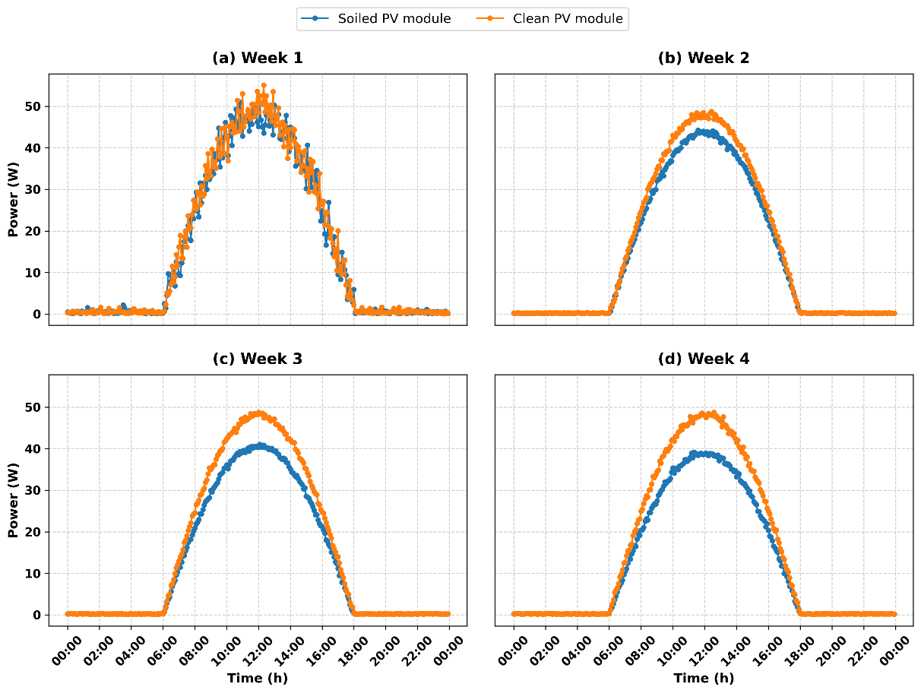
Fig. 7. Weekly profile of the panels’ electrical power

The weekly hourly average power exhibits a well-defined bell-shaped profile, concentrated around a single peak corresponding to maximum irradiance. Over the diurnal cycle, the power output of the soiled panel remains below that of the clean panel, with the greatest difference occurring near the power peak. This profile is identical in appearance to the current profile, suggesting that power is largely dependent on current. This also indicates that this power trend confirms the significant impact of dust on the system’s energy production. The reduction in power observed on the soiled panel accumulates over the entire duration of the measurement campaign and results, in energy terms, in a significant loss of production particularly noticeable during the sunniest hours, notably between 8 a.m. and 4 p.m. Furthermore, an estimate of relative power losses shows a gradual increase over the course of the experimental period, becoming apparent starting in the second week. In fact, the average loss increases from 8.65% during the second week to 15.51% and 19.50% during the third and fourth weeks, respectively. The first week, however, shows a high degree of variation in losses, with a standard deviation of 20.60% and a minimum value of -105.55%. Such values indicate that the soiled module occasionally performs better than the clean module and are likely associated with fluctuations in measurement conditions, temporal variations in irradiance, or relatively low power output due to the modules’ intrinsic characteristics. Furthermore, the median value of 4.19% suggests that a power loss was already present during this first week of the experiment. Starting in the second week, the results become much more consistent. Average losses reached 8.65% in the second week, 15.51% in the third week, and 19.50% in the fourth week, while the medians were 8.86%, 15.49%, and 19.23%, respectively. The small difference between the average and median losses indicates a relatively even distribution of losses. Furthermore, the minimum values become positive starting in the third week and are 4.46% and 6.77% for the fourth week, showing that all observations recorded during these two weeks indicate a decrease in power output for the soiled module compared to the clean module. This gradual increase in losses is consistent with the accumulation of particulate deposits on the surface of the photovoltaic module during the experiment. The increase in deposits can gradually reduce the fraction of solar radiation reaching the photovoltaic cells and, consequently, decrease their electricity production.

3.4 Study of the Impact of Aerosol Deposits on Solar Panel Output

3.4.1 Analysis of electrical power as a function of aerosol deposits
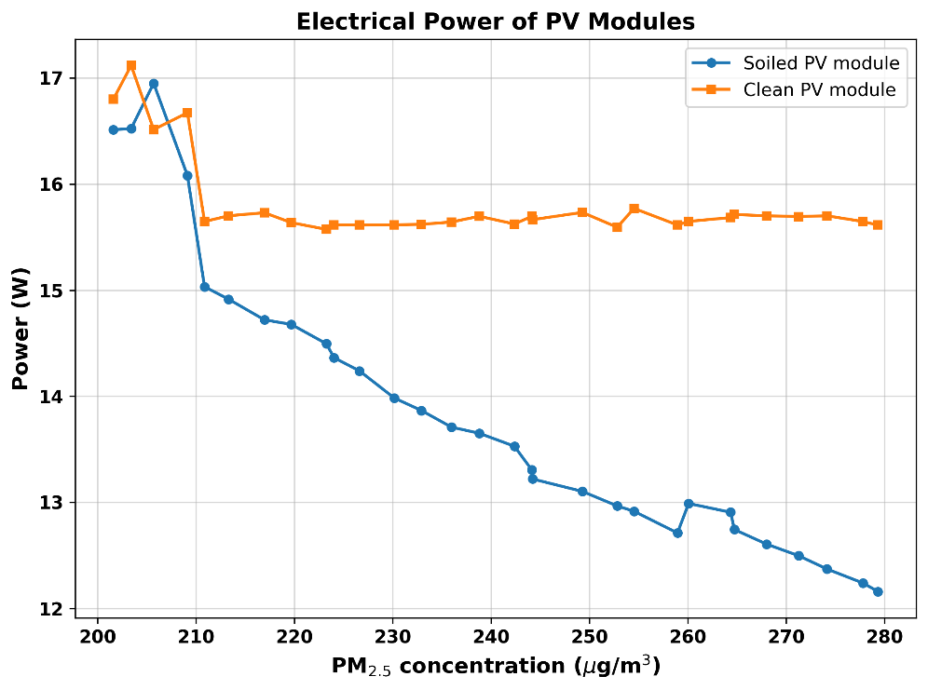
Fig. 8. Plot of average daily power output versus dust concentration

Figure 8 illustrates how the average daily power output varies with dust concentration over the entire measurement period and helps illustrate the direct link between dust emissions and the electrical energy produced. This graph compares the average daily output of a clean panel with that of a dirty panel to calculate a performance score. This ratio thus allows for the precise quantification of the fraction of energy lost due to dust deposits. By plotting both curves on the same graph, the direct impact of dust is clearly visible. At the very beginning of the experiment, when the dust concentration remained low at around 200 µg/m³, both modules exhibit similar performance, ranging between 16.5 W and 17 W. This common starting point validates the consistency of the initial state of the two panels, a methodological rigor also emphasized in the experimental work of Jed et al (Jed et al., 2021). However, as soon as exposure continues and dust levels exceed 210 µg/m³, the divergence between the two curves becomes clear. On the one hand, the clean module stabilizes rapidly, forming a nearly perfect horizontal plateau around 15.7 W. This consistency demonstrates the effectiveness of mitigation strategies involving regular cleaning to maintain nominal performance, in full alignment with the technical-economic analysis by Ilse et al (Ilse et al., 2019) which demonstrates the financial viability of maintenance schedules in the face of solar revenue losses. The same holds true for the conclusions of Shen et al (Shen et al., 2024), which show that periodic cleaning instantly restores performance by preventing the cementation of dust layers. Conversely, the blue curve for the soiled module drops steadily, eventually falling below 12.5 W. This gradual decline represents a power loss of more than 20%. This phenomenon of reduced electrical performance due to dry deposition in the Sahelian region exactly corroborates the results of Diop et al (Diop et al., 2020)as well as the field study conducted by Adama Ouedraogo et al (Ouedraogo et al., 2025)under Sudano-Sahelian conditions. This direct comparison provides indisputable evidence that, in the Sahel, dust accumulation acts as a major optical barrier, making daily cleaning essential to prevent the energy performance of photovoltaic systems from being stifled.

3.4.2 Analysis of the soiling rate as a function of aerosol deposits

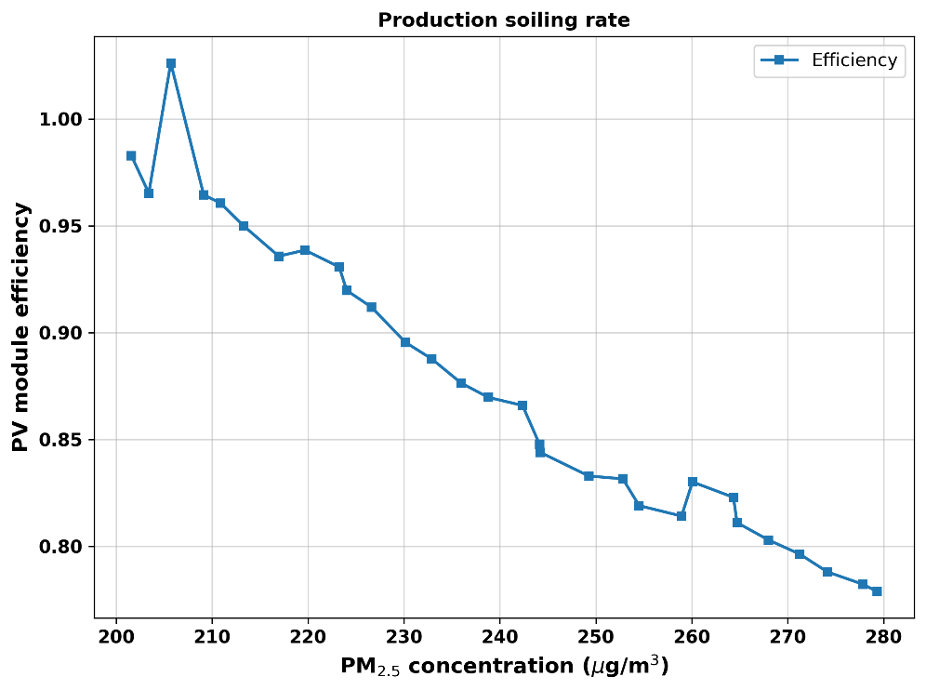
Fig. 9. Representation of the daily efficiency of the soiled module

Figure 9 shows the soiling rate of solar photovoltaic production throughout the entire experimental period. To do this, we calculated the soiling rate by dividing the average daily power output of the soiled solar panel by that of the clean module. This assessment highlights the efficiency of the soiled PV module’s power output, showing that the more aerosols there are in the air, the more the panel’s efficiency drops compared to that of the clean solar module. Furthermore, we clearly observe that the soiling rate decreases as the concentration of dust deposits on the solar panel’s surface increases, proving that accumulated dirt eventually stifles the PV module’s energy production.

3.4.3 Assessment of Daily Electrical Power Losses
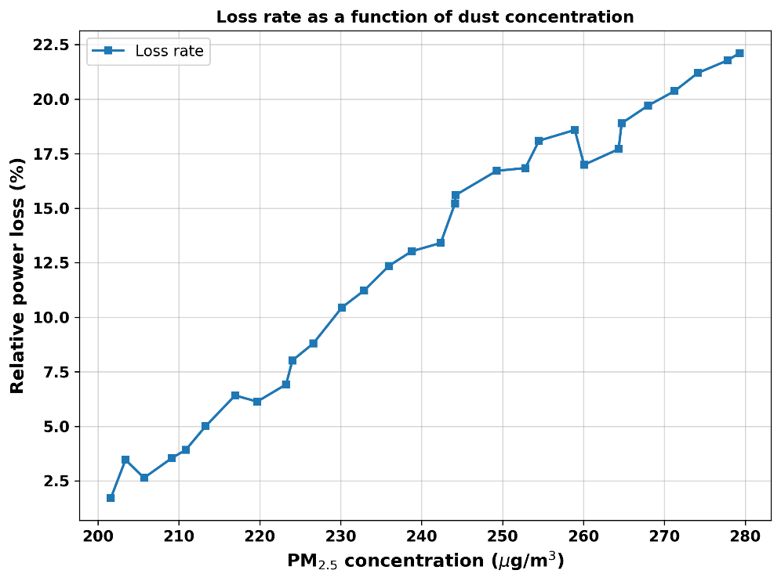
Fig. 10. Illustration of daily electrical power loss

To track this degradation trend, the loss rate ΔP was calculated for each day of the experimental period based on the measured average daily electrical power. This daily-scale analysis captures short-term variations linked to daily weather conditions particularly periods of wind that temporarily limit particle accumulation, especially in the case of dry deposition unlike a purely weekly analysis, which smooths out these fluctuations. Figure 10 shows the trend in the estimated daily loss rate over the entire 30-day study period. Analysis of this figure reveals a gradual and continuous deterioration in electrical performance, which is fully explained by the physical mechanisms highlighted in the literature: obstruction of incident radiation by the dust layer, the thermal insulation effect that causes the module to overheat, physical or chemical damage to the glass, and high heat absorption by carbonaceous particles. After brief fluctuations during the first three days due to noise and spurious signals, the power loss begins a nearly linear increase starting on day 4, rising from 2.5% to a maximum of 22.3% on day 30. This drop of nearly one-quarter in power output in just one month directly corroborates the conclusions of the study by Ndiath et al (Ndiath et al., 2023), who estimate that dust deposition creates an opaque barrier that reduces the transmittance of the panel’s front glass plate. By blocking a significant fraction of the incident solar radiation, this passive layer reduces the panel’s electrical current and, consequently, causes a drastic and continuous decline in the maximum power delivered by the module over the course of several days. Furthermore, this illustration shows that without cleaning measures to remove these surface deposits, the installation experiences a predictable and severe decline in efficiency, confirming that particulate accumulation is a critical factor for the profitability of solar projects.

4. Conclusion

Scientifically, the study revealed that dust deposits primarily hinder the electricity production of photovoltaic modules, particularly under Sahelian climatic conditions. As they settle, aerosols promote the formation of an opaque layer on the surface of the modules and significantly reduce the solar radiation transmitted to the PV cells for photovoltaic conversion. Thus, these particulate deposits affect the electrical parameters of solar panels notably current and power and lead to electrical losses and, consequently, a decline in the performance of photovoltaic solar systems. A combined analysis of daily and weekly losses also showed that the degradation, although generally monotonous, is not perfectly linear; but is punctuated by episodes of natural cleaning by the wind, suggesting that a condition-based maintenance strategy triggered by a dust concentration threshold measured in real time-would be more appropriate than a fixed cleaning schedule. Furthermore, this study makes an original contribution to the existing scientific literature on photovoltaic soiling in Burkina Faso by proposing a continuous, quantitative measurement of dust concentration in conjunction with electricity generation. This approach opens up concrete prospects for the predictive maintenance of photovoltaic installations in the Sahel region. However, the quantitative attribution of power losses exclusively to soiling must be interpreted with caution, as photovoltaic power output is also influenced by solar irradiance, module temperature, and electrical operating conditions.

Competing interests

Authors have declared that no competing interests exist.

Consent

Not applicable.

Ethical approval

Not applicable.
Declaration of AI Use

This manuscript was prepared through the intellectual contributions of the author(s) to the study design, data analysis, interpretation of results, and scholarly content. Grammarly and ChatGPT were used solely to assist with grammatical refinement and reference formatting during manuscript revision. The author(s) accept full responsibility for the accuracy, integrity, and final content of the manuscript.

References

Abdulrazzaq, A. K., Bognár, G., & Plesz, B. (2022). Accurate method for PV solar cells and modules parameters extraction using I–V curves. Journal of King Saud University - Engineering Sciences, 34(1), 46–56. https://doi.org/10.1016/j.jksues.2020.07.008

Almulhim, A. I., & Abubakar, I. R. (2026). The role of renewable energy in achieving the Sustainable Development Goals: A systematic review and conceptual framework. Renewable and Sustainable Energy Reviews, 230(July 2025), 116679. https://doi.org/10.1016/j.rser.2025.116679

Bado, N., Bazyomo, S. D., Wende, G., Ouedraogo, P., Korgo, B., Dramé, M. S., Kieno, F. P., & Kam, S. (2024). Contribution of Satellite Observations in the Optical and Microphysical Characterization of Aerosols in Burkina Faso, West Africa. Atmospheric and Cli- Mate Sciences, 14, 154–171. https://doi.org/10.4236/acs.2024.141010

Bado, N., Dianda, B., Drame, M. S., Namoano, Y., Kieno, F. P., & Kam, S. (2026). Study of the Seasonal Effect of Atmospheric Parameters on Solar Photovoltaic Production in Burkina Faso, West Africa. International Journal of Atmospheric and Oceanic Sciences, 10(1), 25–37. https://doi.org/http://www.sciencepg.com/journal/ijaos

Diop, D., Drame, M. S., Diallo, M., Malec, D., Mary, D., & Guillot, P. (2020). Modelling of Photovoltaic Modules Optical Losses Due to Saharan Dust Deposition in Dakar, Senegal, West Africa. Smart Grid and Renewable Energy, 11(07), 89–102. https://doi.org/10.4236/sgre.2020.117007

Fouad, M. M., Shihata, L. A., & Morgan, E. S. I. (2017). An integrated review of factors influencing the performance of photovoltaic panels. Renewable and Sustainable Energy Reviews, 80(July 2016), 1499–1511. https://doi.org/10.1016/j.rser.2017.05.141

Goni, S., Adannou, H. A., Diop, D., Kriga, A., Khayal, ahamoud Y., Nebon, B., Cheidikh Beye, A., Aziz Niang, S. A., & Drame, M. S. (2019). Observation and Simulation of Available Solar Energy at N’Djamena, Chad. Smart Grid and Renewable Energy, 10(06), 165–178. https://doi.org/10.4236/sgre.2019.106011

H, M., O, D., Reddy, J. T., & S, R. (2023). IoT Based Solar Power Monitoring System. International Journal of Engineering Research & Technology, 11(05), 279–283. https://doi.org/10.1088/1757-899X/981/3/032037

Ilse, K., Micheli, L., Figgis, B. W., Lange, K., Daßler, D., Hanifi, H., Wolfertstetter, F., Naumann, V., Hagendorf, C., Gottschalg, R., & Bagdahn, J. (2019). Techno-Economic Assessment of Soiling Losses and Mitigation Strategies for Solar Power Generation. Joule, 3(10), 2303–2321. https://doi.org/10.1016/j.joule.2019.08.019

Jacobson, M. Z., Delucchi, M. A., Bauer, Z. A. F., Goodman, S. C., Chapman, W. E., Cameron, M. A., Bozonnat, C., Chobadi, L., Clonts, H. A., Enevoldsen, P., Erwin, J. R., Fobi, S. N., Goldstrom, O. K., Hennessy, E. M., Liu, J., Lo, J., Meyer, C. B., Morris, S. B., Moy, K. R., … Yachanin, A. S. (2017). 100% Clean and Renewable Wind, Water, and Sunlight All-Sector Energy Roadmaps for 139 Countries of the World. Joule, 1(1), 108–121. https://doi.org/10.1016/j.joule.2017.07.005

Jed, M. E. H., Logerais, P. O., Malye, C., Riou, O., Delaleux, F., & El Bah, M. (2021). Analysis of the performance of the photovoltaic power plant of Sourdun (France). International Journal of Sustainable Engineering, 14(6), 1756–1768. https://doi.org/10.1080/19397038.2021.1971321

Khodakaram-Tafti, A., Yaghoubi, M., & Ferrantelli, A. (2025). Outdoor assessment and modeling of dust deposition impact on optimal tilt angle and operating temperature of photovoltaics. International Journal of Environmental Science and Technology, 22(15), 16061–16078. https://doi.org/10.1007/s13762-025-06723-8

Korsaga, E., Bado, N., Bonkoungou, D., Guingane, T. T., Savadogo, H., Sosthene, S., Tassembedo, L., & Koalaga, Z. (2026). Influence of Climatic Parameters on the Performance of Polycrystalline and Monocrystalline Silicon Photovoltaic Solar Modules: The Case of the City of Koudougou. International Journal of Sustainable and Green Energy, 15(1), 14–22. https://doi.org/https://doi.org/10.11648/j.ijsge.20261501.12

Lu, E., & Wang, D. (2025). Impacts of Climate Change on River Regimes in Africa. River Studies, 2(1), 174–185. https://doi.org/10.61848/rst.v2i1.59

Mani, M., & Pillai, R. (2010). Impact of dust on solar photovoltaic (PV) performance: Research status, challenges and recommendations. Renewable and Sustainable Energy Reviews, 14(9), 3124–3131. https://doi.org/10.1016/j.rser.2010.07.065

Millstein, D., Wiser, R., Bolinger, M., & Barbose, G. (2017). The climate and air-quality benefits of wind and solar power in the United States. Nature Energy, 2(9). https://doi.org/10.1038/nenergy.2017.134

Mondol, J. D., Yohanis, Y. G., & Norton, B. (2007). The impact of array inclination and orientation on the performance of a grid-connected photovoltaic system. Renewable Energy, 32(1), 118–140. https://doi.org/10.1016/j.renene.2006.05.006

Nafa, A. Z. M., Obed, A. A., Abid, A. J., Yaqoob, S. J., Bajaj, M., & Shabaz, M. (2025). Sensorless real-time solar irradiance prediction in grid-connected PV systems using PSO-MPPT and IoT-enabled monitoring. In Energy Informatics (Vol. 8, Number 1). https://doi.org/10.1186/s42162-025-00563-z

Ndiath, H. D., Senghor, A., Traoré, P. T., Mbow, B., & Youm, I. (2023). Effect of dust on the performance characteristics of different modules technologies. International Journal of Innovation and Applied Studies, 39(1), 216–224. https://doi.org/http://www.ijias.issr-journals.org

Nébon, B., Dramé, M. S., Bruno, K., Hassime, G., Niang, D. N., Sall, S. M., Florent, K. P., & Joseph, B. D. (2019). Study of Aerosol Impact on the Solar Potential Available in Burkina Faso, West Africa. International Journal of Environment and Climate Change, 9(5), 297–310. https://doi.org/10.9734/ijecc/2019/v9i530116

Neher, I., Crewell, S., Meilinger, S., Pfeifroth, U., & Trentmann, J. (2020). Photovoltaic power potential in West Africa using long-term satellite data. Atmospheric Chemistry and Physics, 20(21), 12871–12888. https://doi.org/10.5194/acp-20-12871-2020

Niang, S. A. A., Gueye, A., Sarr, A., Diop, D., Goni, S., & Nebon, B. (2023). Comparative Study of Available Solar Potential for Six Stations of Sahel. Smart Grid and Renewable Energy, 14(08), 153–167. https://doi.org/10.4236/sgre.2023.148009

Ouedraogo, A., Ouedraogo, P. Y., Korgo, B., Ouedraogo, O. A. Y., Ky, T. S. M., Bathiebo, D. J., & Kam, S. (2025). Analyses of the dust influence on individual efficiencies of the silicon PV module in Sudano-Sahelian conditions. Results in Optics, 21(October), 100906. https://doi.org/10.1016/j.rio.2025.100906

Prema, V., & Uma Rao, K. (2015). Development of statistical time series models for solar power prediction. Renewable Energy, 83, 100–109. https://doi.org/10.1016/j.renene.2015.03.038

Said, S. A. M., Hassan, G., Walwil, H. M., & Al-Aqeeli, N. (2018). The effect of environmental factors and dust accumulation on photovoltaic modules and dust-accumulation mitigation strategies. Renewable and Sustainable Energy Reviews, 82(May 2017), 743–760. https://doi.org/10.1016/j.rser.2017.09.042

Shaik, F., Lingala, S. S., & Veeraboina, P. (2023). Effect of various parameters on the performance of solar PV power plant: a review and the experimental study. Sustainable Energy Research, 12(1). https://doi.org/10.1186/s40807-025-00180-0

Shen, Y., Fouladirad, M., & Grall, A. (2024). Impact of dust and temperature on photovoltaic panel performance: A model-based approach to determine optimal cleaning frequency. Heliyon, 10(16), e35390. https://doi.org/10.1016/j.heliyon.2024.e35390

Shukla, A., Pachauri, R. K., Walia, R., & Gupta, V. (2026). Machine learning-based prediction of soiling losses in photovoltaic modules under different cleaning frequencies: an experimental investigation. Scientific Reports, 16(1), 1–40. https://doi.org/10.1038/s41598-026-45485-2

Yadav, A. K., & Chandel, S. S. (2013). Tilt angle optimization to maximize incident solar radiation: A review. Renewable and Sustainable Energy Reviews, 23, 503–513. https://doi.org/10.1016/j.rser.2013.02.027

