PRODUCTION AND CHARACTERIZATION OF PULP AND PAPER FROM DIFFERENT PARTS RAPHIA PALM TREE
Abstract
The increasing demand for sustainable raw materials for pulp and paper production has created significant interest in the use of non-wood lignocellulosic biomass. This study investigated the potential of different parts of Raphia palm waste, namely, fronds, petioles, piassava, and tie-tie, as alternative raw materials for pulp and paper production. The materials were subjected to soda pulping using 15% soda liquor at a solid-to-liquor ratio of 1:10 for 3 h at 120 °C using laboratory digester. The resulting pulps were mechanically treated, washed, and bleached with sodium hypochlorite. Pulp yield, Kappa number, residual lignin, water solubility, and 1% sodium hydroxide solubility were determined according to Technical Association of the Pulp and Paper Industry (TAPPI) standards. Structural changes resulting from pulping and bleaching were examined using Fourier-transform infrared (FTIR) spectroscopy. Handsheets were produced from the different pulps using a laboratory hand mould, and the effect of starch as a bonding agent on the properties of the handsheets was evaluated. The results showed that the unbleached pulp yield ranged from 44.18% for piassava to 54.49% for frond. Kappa numbers ranged from 34.60 to 37.35, corresponding to residual lignin contents of 4.50 – 4.86%. Pulp yields of bleached pulp ranged from 57.40% for tie-tie to 81.62% for petiole. FTIR spectra showed characteristic lignocellulosic functional groups, while the reduction or disappearance of carbonyl and aromatic lignin-associated bands after pulping and bleaching confirmed the removal of substantial amounts of hemicellulose, extractives, and lignin. Handsheets produced from frond, petiole, and piassava showed good formation, whereas tie-tie exhibited poorer sheet formation. Starch addition generally increased the grammage and thickness of the paper sheets. This finding showed that different parts of Raphia hookeri waste can serve as promising non-wood fibre resources for pulp and paper production.

Introduction
The increasing demand for sustainable raw materials for pulp and paper production has intensified the search for non-wood lignocellulosic biomass as an alternative to conventional wood resources. The continuous dependence on wood has contributed to deforestation, biodiversity loss, and depletion of forest reserves, especially in developing countries where industrial wood plantations are limited (FAO, 2022). Consequently, agricultural residues and palm wastes have gained considerable attention as renewable, inexpensive, and environmentally friendly feedstocks for pulp and paper manufacturing.These non woody materials including Raphia palm have a physicochemical properties suitable for pulp and paper making (Akpakpan et al., 2012a; Hurter, 1988; Akpakpan et al., 2025).
These none wood materials are widely available in large quantities in Nigeria as agricultural and agro-industrial residues, particularly in Niger Delta region where they are generated continuously during farming, harvesting, and processing activities. Their abundance ensures a sustainable and cost-effective supply of raw materials for the pulp and paper industry. Most non-wood lignocellulosic biomasses possess appreciable cellulose content, which serves as the principal structural polymer responsible for the strength, flexibility, and durability of paper products (Hurter, 1988). In addition, many of these materials contain relatively lower lignin content than most hardwoods and softwoods, making them easier to delignify during chemical pulping (Hurter, 1988; Akpakpan et al., 2012a). The lower lignin content reduces the consumption of pulping chemicals and energy, shortens cooking time, improves pulp yield and brightness, and minimizes the formation of environmentally harmful bleaching by-products. The utilization of agricultural and agro-industrial residues for pulp and paper production minimizes waste disposal problems, reduces environmental pollution (Akpabio and Akpakpan, 2012) and also conserves forest resources, enhances resource efficiency, creates value from biomass wastes, promotes the principles of a sustainable circular bioeconomy (Ashori, 2006), and can enhance industrialization of Nigerian economy (Osung and Akpakpan, 2012).
Raphia palm (Raphia hookeri) is one of the most abundant indigenous palms in the freshwater swamp forests of West and Central Africa, particularly in southern and Niger Delta region of Nigeria (Oduah and Ohimain, 2015). The palm plays significant economic and cultural roles, providing materials for roofing, furniture, baskets, ropes, brooms, mats, wine production, and other domestic applications (Odera et al., 2015 ; Obahiagbon, 2020). Despite these traditional uses, substantial quantities of Raphia palm residues are generated and are often discarded or openly burned, creating environmental and waste management challenges (Sunderland, 2012). The utilization of these residues as raw materials for pulp and paper production will offer an effective strategy for waste valorization while creating additional economic value (Pydimalla et al., 2023; Obahiagbon, 2020).
The various anatomical parts of Raphia hookeri, including the fronds, petioles, piassava fibres, and tie-tie, possess distinct structural and chemical characteristics that enhance their suitability for papermaking (Akpakpan et al., 2025). These plant parts has different physicochemical properties, fibre dimensions and morphological indices, all of which significantly affect pulping efficiency, pulp yield, bleaching response, paper strength, and overall product quality (Smook, 2002; Biermann, 1996,). Fibre dimensions and morphological indices of different parts of Raphia palm have been reported in our previous studies (Akpakpan et al., 2025). Fibre dimension such as fibre length, lumen diameter, cell wall thickness, and morphological indices such as slenderness ratio and Runkel ratio are particularly important because they determine fibre bonding, sheet formation, and tensile strength, burst strength, and tear resistance of the resulting paper (Rowell, 2012).
Comparative investigation of pulp and paper produced from different parts of Raphia hookeri is particularly important because each biomass fraction possesses unique anatomical and chemical properties that can influence processing performance and end-use applications. Understanding these differences will facilitate appropriate selection of the most suitable raffia palm part for specific grades of paper while promoting efficient utilization of the entire plant. Such an approach aligns with sustainable resource management by maximizing biomass utilization and minimizing waste generation.
Therefore, this study focuses on the production and characterization of pulp and paper from different parts of Raphia palm waste, namely, the fronds, petioles, piassava, and tie-tie. The findings are expected to provide scientific information on the suitability of Raffia palm waste materials as an alternative non-wood raw material for the pulp and paper industry, thereby contributing to sustainable biomass utilization, environmental conservation, and the development of renewable bio-based material. The picture of Raphia palm tree and it parts are shown in Figure 1.
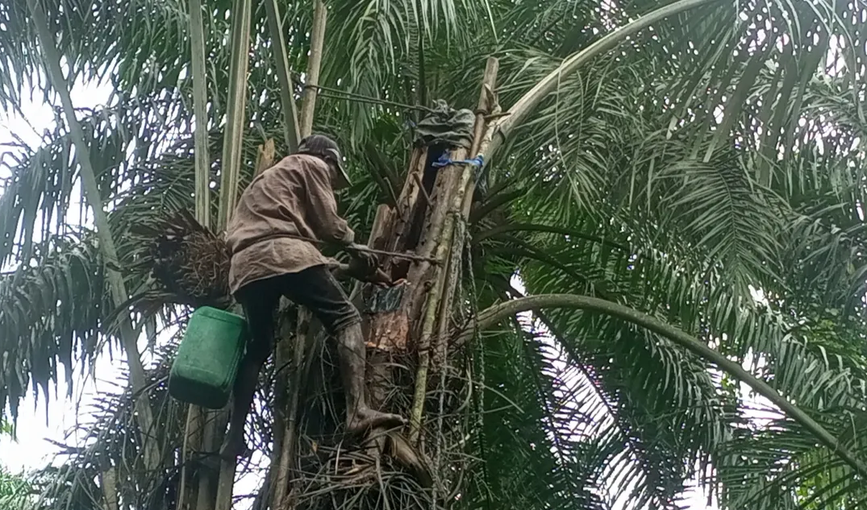

Raphia Palm Tree

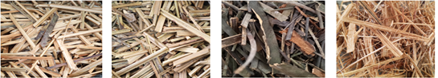
Piassava
Tie-tie
Frond
Petiole

Figure 1 :Tapped Raphia palm tree and its different parts used in pulp and paper production

2.0 Material and methods

2.1 Sample Collection and Preparation
A mature Raphia palm tree that had previously been tapped for palm wine production and subsequently abandoned was selected for this study. After the palm had been felled, the different part such as fronds, petioles, piassava, and tie-tie were carefully separated from the trunk using a sharp machete. Each component was sorted individually to avoid cross-contamination. The separated materials were thoroughly cleaned to remove adhering dirt, dust, and other extraneous matter before being manually cut into chips of approximately 1 cm × 1 cm to ensure uniform size and promote efficient penetration of the pulping liquor. The chipped samples were then air-dried under ambient laboratory for 3 weeks. The dried samples were subsequently stored in clean, moisture-free polyethylene bags pending pulp production.

2.2 Pulping Process
Different parts of Raphia hookeri (fronds, petioles, tie-tie, and piassava) were individually subjected to soda pulping using a 10 L laboratory-scale digester. Briefly 300 g of each sample was impregnated with 15% soda pulping liquor at a solid-to-liquid ratio of 1:10 (w/v) to ensure adequate contact between the biomass fibres and the cooking chemicals. The pulping process was carried out in a 10 L laboratory digester for 3 hours at 120ºC to facilitate the breakdown and removal of lignin and other non-cellulosic components, thereby promoting the liberation of cellulose fibres. After completion of the pulping process, the resultant pulp was removed from the digester and separated from the black liquor through filtration. The pulp was subsequently subjected to mechanical beating to enhance fibre development, improve fibre bonding, increase fibre flexibility and fibrillation. Thereafter, the pulp was thoroughly washed with clean tap water until a neutral pH was achieved. The washed pulp was dried in the oven and then kept in an air tight container pending characterization, bleaching and paper sheet production.
2.3 Bleaching of the pulp
The pulp obtained was bleached by soaking 50 g of each pulp in sodium hypochlorite solution at the ratio of 1: 15, the mixture was kept for 24 hours. Thereafter, the pulp was filtered and washed with tap water to neutral pH. The yield of the bleached pulp and solubility of the pulp in different solvents were determined. The schematic diagram of pulp production is presented in Figure 2.
Raw material chips
Pulping
Filtration
Mechanical treatment/washing
Unbleached pulp
Bleached pulp
Bleaching

Figure 2: Pulping flow diagram
2.3. Characterization of the Pulp
2.3.1 Pulp Yield
Pup yield was calculated using gravimetric method as given in equation below:
Pulp yield (%) = $\frac{w_{1}}{w_{2}}$ x 100
Where w₁ = weight of the sample
w₂= weight of the pulp
2.3.2 Determination of Kappa Number
Kappa number is used to describe the relative hardness, the degree of delignification obtained in a chemical pulping process, the bleachability or whitening aptitude of the pulp. It is define as the volume (in milliliters) of 0.1N (0.02M) potassium permanganate solution consumed by one gram of moisture-free pulp. The results are corrected to 50% consumption of the permanganate added. Kappa number was determined using TAPPI standard, T 236 OM-99.
About 0.5g of the oven dried pulp was disintegrated in 100 mL of distilled water using electric blender until the pulp is free of fibre clots. Disintegrated pulp was then transferred into 500 mL reaction beaker, 100 mL distilled water was added to bring the total volume to 200 mL. The beaker was place on a magnetic stirrer with continuously stirring. 25 ml of 2M (4N) sulphuric acid solution was measured and 25ml of 0.02M (0.1N) potassium permanganate solution was pipeted, they were added to the disintegrated test specimen simultaneously, starting a stopwatch. At the end of exactly 10.0 min, reaction was stop with the addition of 5 mL of 1M (1N) potassium iodide solution. Immediately after mixing, but without filtering out the fibres, it was titrated with 0.2M (0.2N) sodium thiosulphate solution, few drops of starch indicator was added toward the end of the reaction. The blank determination using exactly the same method as above but omitting the pulp was carried out. Kappa number was calculated as follows:

K = $\frac{p x f}{w}$ x 100
Where
p =$\frac{(b-a )N}{0.1}$
Where:
K = Kappa number
f = factor for correction to a 50% permanganate consumption,
w = weight of moisture-free pulp in the specimen, g
p = amount of 0.1N permanganate actually consumed by the test specimen, mL
b = amount of the thiosulfate consumed in the blank determination, mL
a = amount of the thiosulfate consumed by the test specimen, mL
N = normality of the thiosulfate

2.3.3 Determination of Residual Klason Lignin
Residual klason lignin was calculated from kappa number as recommended by TAPPI standard method designated T236-OM-99.
% Residual Klason Lignin (RKL) = Kappa number x 0.13
2.3.4 Determination of Solubility in different solvents
Solubility of the pulp in cold and hot water was determined using TAPPI satandard method designated T207 cm-22.
For cold water solubility, 2 g of oven dried pulp was placed in a 250 mL beaker and 100 mL of distilled water slowly added, making sure that the pulp is well wetted initially to avoid tendency to float. The extraction was done at room temperature with constant stirring for 48 h using magnetic stirrer. The pulp was filtered and dried to constant weight at 105 " 3°C.
On the other hand, Hot water solubility was determined by Transferring 2 g of the test specimen to a 250-mL Erlenmeyer flask, 100 mL of hot distilled water was added and placed in a boiling water bath. Reflux condenser was attached and digests for 3 h. After digestion, the pulp was filtered washed with hot 200 mL of hot water and dried in the oven to constant weight at 105 " 3°C,
Cold or hot water solubility was determined using equation below:
Hot or cold water solubility (%) = $\frac{A-B}{A} x 100$
Where
A = initial weight of the test specimen, g oven dry (o.d.)
B = weight of the test specimen after extraction, g (o.d.)
2.3.5 Determination of solubility 1% NaOH
Solubility in 1% sodium hydroxide was done in accordance with the TAPPI standard designated T 212 om – 02. Briefly 1 g of oven dried pulp was dispersed in 100 ml of 1% NaOH, the mixture was heated in the water bath for 1 hour with sequential stirring with stirring rod at 5 min intervals. After 1 hour it was filtered and washed with 25 mL of 10% acetic acid followed by washing with distilled water to a neutral pH.
2.4 Paper making
Paper handsheets were produced using a locally fabricated hand sheet mould fitted with a wire screen measuring 14 cm × 17 cm. For each sample, 7.5 g (oven-dry basis) of pulp was dispersed in 1000 mL of distilled water and mechanically disintegrated using an electric blender to obtain a uniform fibre suspension. The resulting slurry was transferred into a 10 L plastic bucket, and additional water was added to obtain a total stock volume of 3000 mL.
For handsheet formation, the mould was first immersed in a basin containing clean water. Thereafter, 1000 mL of the pulp slurry from the stock was gently poured onto the mould screen. The mould was carefully shaken in both horizontal directions to ensure uniform fibre dispersion and sheet formation. The mould was slowly lifted from the water, and excess water was removed by couching with a foam sponge. The wet handsheet was then carefully detached from the mould the sheets were subsequently calendered using a hot electric pressing iron to improve surface smoothness, fibre bonding, and sheet uniformity and dried in the oven at 85 °C until a constant weight was achieved.
To investigate the effect of starch as a strengthening additive and bonding agent, additional paper sheets were prepared by incorporating 1 mL and 2 mL of 1% (w/v) starch solution into 1000 mL portions of the pulp slurry before sheet formation, the pulp slurry was stirred using glass rod. The starch acted as a natural bonding agent, enhancing inter-fibre bonding and improving the mechanical integrity of the resulting paper sheets. All paper sheets were produced following the same procedure to ensure consistency and enable comparison among the different Raphia palm parts. The flow diagram of paper making is shown in Figure 3 below.
Stock
Preparation
Sheet
Formation
Coaching/
Calendaring
Drying
Finished
Paper sheet

Figure 3: Paper making flow diagram

2.5 Characterization of the papers
The physical properties such as grammage, thickness, bulk, and density of the paper sheets produced were determined using TAPPI standard designated respectively as T410 for grammage, T411for thickness and T220 for density and bulk.
Grammage is the mass of paper per unit area, expressed in g/m² (gsm). It was determined by measuring the length and width of each paper using a ruler and the weight of each paper was measured using an analytical balance. The grammage was calculated as follows:
Grammage = $\frac{Mass ofthe paper (g)}{Area (m^{2})}$
The thickness of each paper sheet was measured at 10 different points using a digital micrometer screw gauge, and the mean thickness was recorded. The thickness values were subsequently used to determine the density of the paper. Paper density was determined as the mass of paper per unit volume and expressed in kg/m³. Density of each paper sheet was calculated as follows:
Density (kg/m³) = $\frac{Grammage }{Thickness}$
The bulk of the paper indicates the volume occupied by a unit mass of paper and provides information about the porosity and compactness of the sheet. It was determined using:
Bulk (cm³/g) = $\frac{1000}{Density}$
Results and Discussion
The characteristics of the hand sheets obtained from the unbleached and bleached pulp of different part of Raphia palm tree are presented in Table 1 and 2 respectively.

Table 1: Physicochemical properties of unbleached pulp
Sample | Yield of unbleached pulp (%) | Kappa No | Residual lignin  (%) | Solubility of unbleached in cold water (%) | Solubility of unbleached in hot water (%) | Solubility of unbleached in 1% NaOH  (%)
Frond | 54.49 | 37.35 | 4.86 | 10.80 | 12.80 | 19.00
Petiole | 46.20 | 34.60 | 4.50 | 11.20 | 11.60 | 26.08
Pissava | 44.18 | 35.80 | 4.65 | 7.60 | 8..80 | 16.12
Tie-tie | 51.81 | 36.25 | 4.71 | 15.00 | 15.20 | 31.00

Table 2: Physicochemical properties of bleached pulp
Sample | Yield (%) | Solubility in cold water (%) | Solubility in hot water (%) | Solubility in 1%  NaOH (%)
Frond | 79.12 | 18.40 | 22.40 | 28.00
Petiole | 81.62 | 22,40 | 22.80 | 27.12
Pissava | 69.56 | 19.20 | 21.20 | 17.00
Tie-tie | 57.40 | 19.20 | 20.56 | 26.00
The unbleached pulp yield ranged from 44.18 to 54.49%, with the frond giving the highest yield (54.49%), and piassava the lowest pulp yield (44.18%). The relatively high pulp yields indicate that all four parts of Raphia palm contain appreciable amounts of carbohydrate polymers that can be retained during alkaline pulping. The higher yield obtained from the frond suggests that it may possess a more favourable fibre composition. Conversely, the lower yield of piassava may indicate greater removal of lignin, hemicellulose and extractive materials during pulping. The yield obtained in the present study is comparable with the general range reported for many non-wood lignocellulosic materials (Jahan et al., 2006; Ashori, 2006; Akpakpan et al., 2012a). Non-wood fibres are considered promising since its gives appreciable pulp yield, hence reducing dependence on conventional wood resources. Pictures of unbleached pulp is presented in Figure 4.
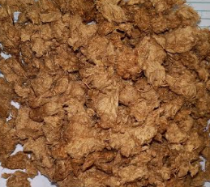
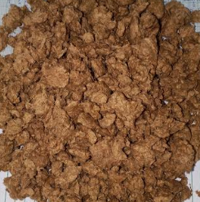
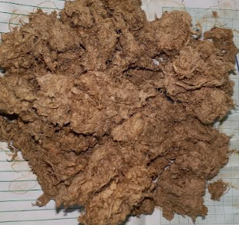
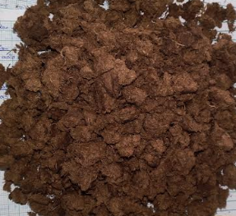
Frond
Petiole
Piassava
Tie-tie

Figure 4: Unbleached pulps
Bleached pulp yields were 81.62% (petiole), 79.12% (frond), 69.56% (piassava), and 57.40% (tie-tie). The higher yields was obtained from petiole and frond which suggest better retention of cellulose during bleaching, possibly due to fewer accessible lignin–cellulose ether linkages and less carbohydrate degradation. The lower yields for piassava and tie-tie may reflect greater removal of lignin, hemicellulose, extractives, and cleavage of lignin–carbohydrate complexes. However, bleaching effectively removed non-cellulosic components while retaining substantial cellulose-rich pulp.
The Kappa number varied from 34.60 to 37.35, with the frond having the highest value and the petiole the lowest. Since Kappa number is related to the amount of residual lignin in the pulp, the relatively high Kappa numbers indicate that appreciable amount of lignin remained in the pulp after the soda pulping. This agrees with the measured residual lignin values, which ranged from 4.50% in the petiole to 4.86% in the frond. This may be attributed to its greater hardness and stiffness, which likely restricted penetration and diffusion of the pulping chemicals into the fibre matrix, thereby limiting lignin removal compared with the softer petiole, piassava and tie-tie samples. The petiole therefore showed the greatest extent of delignification, whereas the frond retained slightly more lignin. Residual lignin content is important because the remaining lignin would subsequently influence the bleaching requirement and optical properties of the paper. The values of Kappa number and residual lignin reported are comparable to that of Nypa fruitican reported by Akpakpan et al., (2012a), but higher than that of the soda-organosolv pulping (Akpakpan et al., 2012b).
Cold-water solubility of the unbleached pulps ranges from 7.60% for piassava to 15.00% for tie-tie. Similarly, hot-water solubility ranged from 8.80% for piassava to 15.20% for tie-tie. These values are generally much lower than those of corresponding raw materials reported in our previous work (Akpakpan et al., 2025). This is due to the fact that during soda pulping, water-soluble extractives, part of the hemicellulose fraction, lignin and other low-molecular-weight components are removed. Hence, the resultant pulp now contains a larger proportion of relatively insoluble cellulose fibres and therefore shows lower water solubility. Bleaching increased cold-water solubility to 18.40 – 22.40% and hot-water solubility to 20.56 – 22.80%.
The 1% NaOH solubility is commonly associated with the amount of alkali-soluble low-molecular-weight carbohydrates, degraded cellulose, hemicelluloses and other non-cellulosic components. The relatively high value for tie-tie (31%) suggests that a considerable amount of alkali-soluble material remained in this pulp, whereas the low value for piassava (16%) suggests more extensive removal of such components during pulping.
The higher water and 1% NaOH solubility of the bleached pulps may be attributed to oxidative degradation of residual lignin and hemicelluloses during bleaching, together with the formation of more hydrophilic functional groups, which increased the accessibility and dissolution of non-cellulosic components. The increase is especially noticeable for the frond, whose cold-water solubility increased from 10.80 to 18.40%, while hot-water solubility increased from 12.80 to 22.40%.
The FTIR was used to investigate the effect of soda pulping and bleaching on the surface functional groups of resultant pulps. The results are presented in Figure 6 – 17and Table 4.
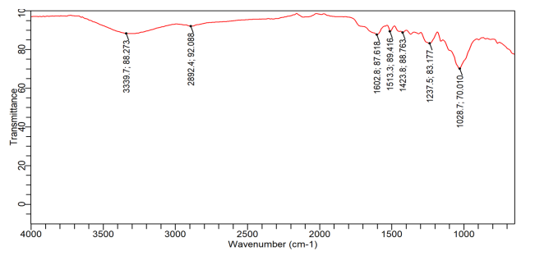
Figure 6: FTIR spectra of Tie-tie raw material

Figure 7: FTIR spectra of piassava raw material

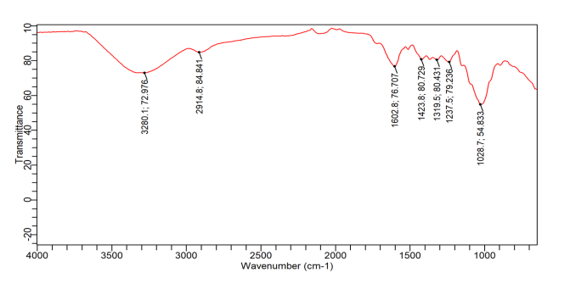
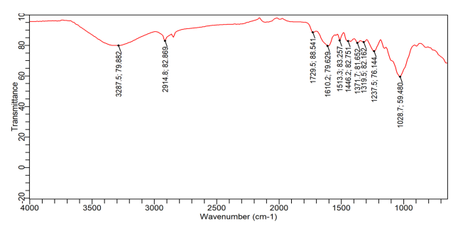
Figure 8: FTIR spectra of petiole raw material

Figure 9: FTIR spectra of frond raw material

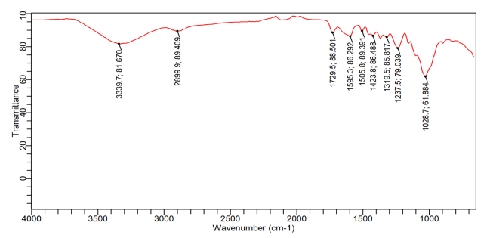
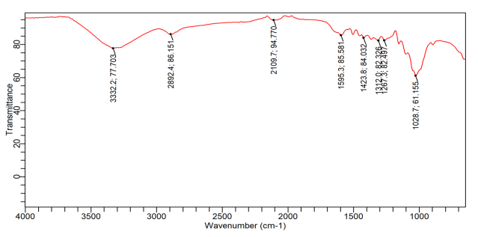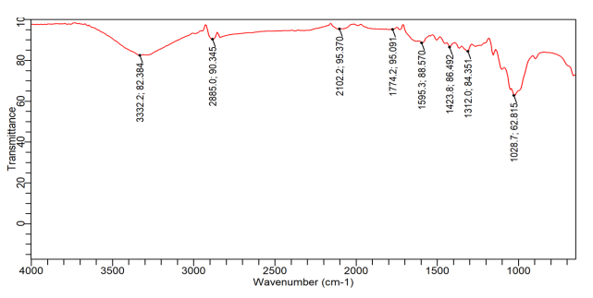
Figure 11: FTIR spectra of piassava unbleached pulp

Figure 10: FTIR spectra of Tie-tie unbleached pulp

The FTIR results of the raw materials (Figures 5-9 ), unbleached pulps (Figures 10-13 ) and bleached pulps (Figures 14-17 ) are presented in Table 4. The results revealed the characteristic pattern of lignocellulosic biomass. The broad absorption at approximately 3280–3340 cm⁻¹ is attributable principally to O–H stretching of hydroxyl groups present in cellulose, hemicellulose and lignin (Akpanudo et al., 2026). Its broad nature indicates extensive hydrogen bonding within the biomass. The bands around 2890 –2925 cm⁻¹ correspond to aliphatic C–H stretching of –CH, –CH₂ and –CH₃ groups. These bands are present in both carbohydrate and lignin fractions. An important difference occurs in the carbonyl region. Petiole and frond show clear absorptions C=O stretching associated with hemicellulose acetyl/uronic groups, ester groups and other oxygenated extractives at approximately 1729 cm⁻¹ (Ntuen et al., 2025; Okon et al., 2026) whereas this feature is not prominent in tie-tie and piassava. The strong band near 1028 cm⁻¹ in all four materials is associated with C–O/C–C stretching in polysaccharides, especially cellulose. Thus, all four raw materials possess a substantial carbohydrate/cellulose framework (Okon et al., 2026)
The conversion from raw biomass to unbleached pulp produces noticeable spectral changes. The most important observation is the reduction or disappearance of the 1729 cm⁻¹ carbonyl band that is evident in raw petiole and frond. In their unbleached pulps, this feature is no longer prominent. This indicates removal or substantial reduction of carbonyl-containing hemicellulosic components and extractives during pulping.
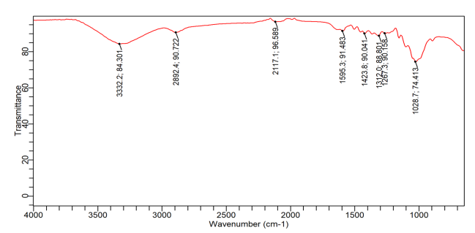
Figure 13: FTIR spectra of frond unbleached pulp

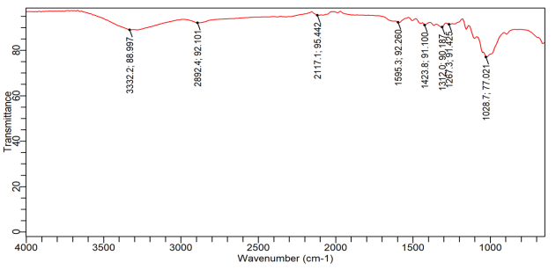
Figure 12: FTIR spectra of Petiole unbleached pulp

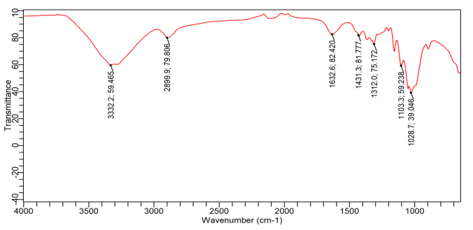
Figure 15: FTIR spectra of bleached piassava pulp

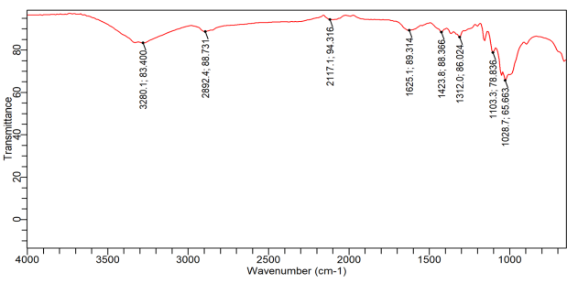
Figure 14: FTIR spectra of bleached tie-tie pulp

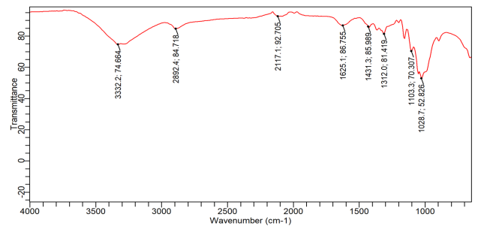
Figure 17: FTIR spectra of bleached frond pulp

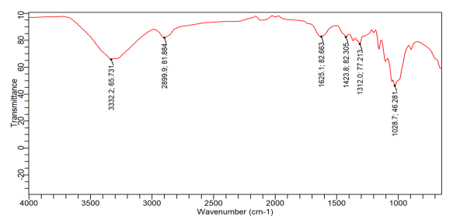
Figure 16: FTIR spectra of bleached petiole pulp

Table 3: Comparative FTIR Peak Assignments of the Lignocellulosic Samples
Wave number (cm⁻¹) | Main functional group assignment | Samples |  |  | Significance
Wave number (cm⁻¹) | Main functional group assignment | Raw materials | Unbleached pulps | Bleached pulps | Significance
~3280–3340 | O–H  stretching | Strong/broad in all | Strong/  broad | Strong/broad | Cellulose, hemicellulose and lignin hydroxyl groups; hydrogen bonding
~2890–2925 | Aliphatic  C–H stretching | Present in all | Present | Present | –CH, –CH₂ and –CH₃ groups of carbohydrates/lignin
~1725–1775 | C=O stretching | Present in (PT and FD) | Mostly reduced/  absent | Essentially absent | Carbonyl groups of hemicellulose, esters and other oxygenated extractives
~1625–1610 | C=C/aromatic skeletal vibration | Present in some raw samples | Present | Present, generally around 1625–1633 | Aromatic/lignin structures
~1515–1500 | Aromatic skeletal vibration | Present in some raw materials | Reduced | Mostly absent/weak | Characteristic of lignin aromatic rings
~1425 | CH₂ bending | Present | Present | Present | Associated with cellulose and lignocellulosic structure
~1375–1310 | C–H bending / O–H | Present | Present | Present | Polysaccharide framework
~1237–1215 | C–O stretching / lignin–hemicellulose contribution | Present | Reduced | Weak or absent in some | Useful indicator of non-cellulosic components
~1105–1028 | C–O, C–C stretching | Strong in all | Very strong | Strong | Dominantly cellulose/polysaccharide structure
Similarly, the aromatic/lignin-related bands become less pronounced after pulping. For example, the petiole raw material contains a distinct band around 1503 cm⁻¹, whereas the band is absent in it corresponding unbleached pulp. This is because pulping preferentially removes part of the lignin and hemicellulose, leaving a pulp enriched in cellulose. However, the unbleached pulps still retain some important bands such as –OH around 3320 cm⁻¹. Therefore, the FTIR results confirm that pulping did not destroy the cellulose backbone.
The effect of bleaching on the functional groups was also investigated. The strong ~1729 cm⁻¹ C=O bands was observed in raw petiole and frond, the intensity of this band was reduced in unbleached pulp and are absent in the bleached pulps. This indicates further removal of residual hemicellulose and lignin. The aromatic bands around 1500–1515 cm⁻¹, which are more evident in some raw materials, become very weak or disappear after bleaching, showing that bleaching has reduced the residual lignin content. Also, the bands around 1028–1105 cm⁻¹ remain prominent after bleaching. This shows the present of high cellulose content in the bleached pulp.
However, the FTIR results strongly support the effectiveness of the pulping and bleaching treatments in converting the four raw lignocellulosic materials into progressively more cellulose-rich pulps.
The results of the paper sheets characterizations are presented in Table 4, and the paper sheets pictures are shown in Figure18. Frond, petiole and piassava gave paper with good formation, while tie-tie gave paper with poor formation. This may be due to short fibre length of tie-tie as reported in our previous work (Akpakpan et al., 2025). The tie-tie paper sheets were not characterized due to poor formation.
Table 4: Characterization of the paper sheets
Paper  Sample | Volume of  1% starch solution (mL) | Weight  (g) | Gramme  (g/m²) | Thickness  (mm) | Density (kg/m³) | Bulk  cm³/g
Frond | - | 1.62 | 68.10 | 0.2863 | 237.86 | 4.20
 | 1 | 1.71 | 71.85 | 0.3046 | 235.88 | 4.24
 | 2 | 1.77 | 74.40 | 0.3324 | 223.83 | 4.47
Petiole | - | 1.55 | 65.10 | 0.3186 | 204.33 | 4.89
 | 1 | 1.66 | 69.70 | 0.3376 | 206.46 | 4.84
 | 2 | 1.88 | 79.00 | 0.3782 | 208.88 | 4.79
Piassava | - | 1.67 | 70.17 | 0.2560 | 274.10 | 3.65
 | 1 | 1.95 | 81.90 | 0.3005 | 272.55 | 3.67
 | 2 | 2.06 | 86.55 | 0.3834 | 225.74 | 4.43
The Hand-sheet properties varied with the amount of starch added and among the different Raphia palm parts. Grammage increased progressively with starch addition, from 68.10 to 74.40 g/m² for frond, 65.10 to 79.00 g/m² for petiole and 70.17 to 86.55 g/m² for piassava. Similarly, thickness also increased with starch addition, indicating greater sheet consolidation and material deposition. Density generally decreased at higher starch levels, while bulk showed variable behaviour. Piassava produced paper with the highest grammage (86.55 g/m²), whereas petiole paper exhibited the highest initial bulk (4.89 cm³/g). Starch addition influenced sheet structure, fibre bonding and physical properties, with 2 mL generally producing thicker and heavier sheets.

Conclusion
This study has shown that different parts of Raphia palm waste can be successfully converted into pulp and paper using the soda pulping process. The four materials showed noticeable differences in pulp yield and quality, with the frond producing the highest unbleached pulp yield, while the petiole gave the highest bleached pulp yield. The relatively low residual lignin values and the FTIR results confirmed the removal of substantial amounts of non-cellulosic components during pulping and bleaching. Handsheets produced from frond, petiole, and piassava showed good formation, while tie-tie produced comparatively poor sheets. Starch addition generally improved the weight and thickness of the paper sheets. Based on these findings, Raphia hookeri wastes, particularly fronds. Petioles and piassava are recommended as promising alternative non-wood fibre sources for pulp and paper production.
Competing Interests
Authors have declared that no competing interests exist.
Declaration of AI Use

This manuscript was prepared through the intellectual contributions of the author(s) to the study design, data analysis, interpretation of results, and scholarly content. Grammarly and ChatGPT were used solely to assist with grammatical refinement and reference formatting during manuscript revision. The author(s) accept full responsibility for the accuracy, integrity, and final content of the manuscript.

References
Akpabio, U. D., Udiong, D. S. and Akpakpan, A. E. (2012). The Physicochemical Characteristics of Plantain (Musa paradisiaca) and Banana (Musa sapientum) Pseudostem Wastes. Advances in Natural and Applied science 6(2): 167-172.

Akpabio, U.D. and Akpakpan, A. E. (2012). Pulp and Paper from Agricultural waste: Plantain pseudostem wastes and screw pine leaves. International Journal of Modern Chemistry 2(3): 100-107
Akpakpan, A. E. Enengedi, I. S., Nsi, E. W. and Umo. A.M. (2025). “Evaluation of Percentage Solubles, Fibre Dimensions and Morphological Indices of Different Parts of Raphia Hookies As Raw Materials for Pulp and Paper Production”. Journal of Materials Science Research and Reviews 8 (3):600-609.

Akpakpan, A., E. Akpabio. U. D. and Obot, I. B. (2012a). Evaluation of Physicochemical Properties and Soda Pulping of Nypa fruticans Frond and Petiole. Elixir Journal of Applied Chemistry 45: 7664-7668.

Akpakpan, A. E., B. O. Ogunsile, U. D. Akpabio and U. M. Eduok (2012b). Comparative Study on the Soda-Ethanol and Soda-Butanol Pulping of Nypa fruiticans Petioles. International Journal of Advance Scientific Research and Technology, 1(2): 312-324.
Akpanudo, N. W., Ntuен, I., & Akpakpan, A. E. (2026). Phytochemical composition and functional group characterization of Dacryodes edulis exudate: Implications for sustainable industrial applications. International Journal of Research (IJR), 13(7):48-67
Ashori, A. (2006). Nonwood fibers—A potential source of raw material in papermaking. Polymer-Plastics Technology and Engineering, 45(10), 1133–1136.
Biermann, C. J. (1996). Handbook of Pulping and Papermaking (2nd ed.). Academic Press.

FAO. (2022). The State of the World's Forests 2022. Food and Agriculture Organization of the United Nations.

Fengel, D., & Wegener, G. (1989). Wood: Chemistry, Ultrastructure, Reactions. Walter de Gruyter.
Hurter, A.M. 1988. Utilization of annual plants and agricultural residues for the production of pulp and paper. Proceeding of TAPPI Pulping Conference October 30– November 2, 1988. New Zealand.124-129.
Jahan, M. S., Chowdhury, D. A. N., & Islam, M. K. (2006). Characterization and evaluation of golpata frond as pulping raw materials. Bioresource Technology, 97(2): 401–406.
Ntuen, I. U., Akpakpan, A. E., Enin, G.N. Enengedi, I. S., Uwantta, E. J., Nsi, E W. Udo, I. E. Ikpe, E. E. & Akpabio, U. D (2024). Preparation and Characterization of Ink from Hibiscus sabdariffa, Curcuma longa and Sorghum vulgare. Nepal J Biotechnol. 12 (2): 183-193

Obahiagbon, F. I. (2020). A review of the origin, morphology, cultivation, economic products, health and physiological implications of Raphia palm. Advances in Food Science and Technology, 8(6), 1–7.
Odera, R. S., Onukwuli, O. D., & Atuanya, C. U. (2015). Characterization of the thermo-microstructural analysis of raffia palm fibers proposed for roofing sheet production. Journal of Minerals and Materials Characterization and Engineering, 3, 335–343.

Oduah, A. A., & Ohimain, E. I. (2015). Ethnobotany of raffia palm (Raphia hookeri), productivity assessment and characterization of raffia palm oil from the Niger Delta, Nigeria. Research Journal of Phytomedicine, 1(1): 33-38
Okon, E. S., Olatunji, O. M., & Ekop, I. E. (2026), Characterization of Functional Groups in Adonidia Merrillii and Dacryodes Edulis Seed Residues Using FTIR Spectroscopy. International Research in Material and Environment 6(1), 47-58.
Osung, O. E. & Akpakpan, A. E. (2012) Application of Wood and Paper Chemistry to the Industrialization of the Nigeria’s Economy: A Review. International Journal of Environment and Bioenergy, 4(2): 46-63
Pydimalla, M., Chirravyri, H. V., & Uttargavalli, A. N. (2023). An overview on non-wood fiber characteristics for paper production: Sustainable management approach. Materials Today: Proceedings.
Rowell, R. M., Han, J. S., & Rowell, J. S. (2000). Characterization and factors affecting fiber properties. In Natural Polymers and Agro Fibers Composites (pp. 115–134).
Smook, G. A. (2002). Handbook for Pulp and Paper Technologists (3rd ed.). Angus Wilde Publications.

Sunderland, T. C. H. (2012). Raphia Palms: Past, Present and Future. The Botanical Review, 78, 1–22.
Technical Association of the Pulp and Paper Industry. (2022). Water solubility of wood and pulp (TAPPI T 207 cm 22). TAPPI Press.1-5
Technical Association of the Pulp and Paper Industry. (2002). One percent sodium hydroxide solubility of wood and pulp (TAPPI T 212 om-02). TAPPI Press. 1-5

