Comparative Study on the Physicochemical Properties of Soaps Prepared Using Palm Kernel Oil and Tallow.

Abstract
This study evaluated and compared the physicochemical properties of soaps produced from palm kernel oil and tallow using sodium hydroxide as the saponifying agent. The study was carried out to determine the influence of different lipid sources on soap quality and to assess their suitability as locally available raw materials for soap production. Soap samples were prepared separately from palm kernel oil and tallow under controlled conditions using cold process method and analyzed for pH, moisture content, total fatty matter (TFM), free caustic alkali, foam height, foam stability, hardness, lathering ability, and cleansing efficiency. The results showed that the type of lipid significantly influenced the characteristics of the produced soaps. Palm kernel oil soap exhibited higher foam height (14.52 cm), foam stability (89.74 %), lathering ability (9.3 ), and cleansing efficiency (94.61%) compared with tallow soap. Conversely, tallow soap showed superior hardness (4.58 kg cm⁻²) and lower moisture content (8.91 %), indicating improved durability and reduced dissolution during use. Both soap samples recorded acceptable pH values and low free caustic alkali content, suggesting effective saponification and suitability for domestic applications. The findings demonstrate that palm kernel oil is more suitable for producing soaps with excellent foaming and cleansing properties, while tallow is advantageous for producing harder and longer-lasting soap products. A combination of both raw materials may provide a balanced formulation with improved functional properties.

Keywords: Soap; Pal kernel oil, Tallow and Physicochemical Properties

- Introduction
Soap is among the most widely used surfactants for personal hygiene, domestic cleaning and industrial sanitation. Its effectiveness in removing dirt, oils or grease and microorganisms has made it indispensable in maintaining public health and preventing the transmission of infectious diseases. Chemically, soap consists of the sodium or potassium salts of long-chain fatty acids produced through the saponification of triglycerides with a strong alkali, typically sodium hydroxide (NaOH) or potassium hydroxide (KOH) (Spitz, 1996). The physicochemical characteristics of soap—including hardness, foaming capacity, cleansing efficiency, moisture content, pH and total fatty matter (TFM)—are determined largely by the fatty acid composition of the oils or fats used during manufacture (Warra, 2013).
Cleaning products play an essential role in our daily lives. By safely and effectively removing soil, germs and other contaminants, they help us to stay healthy, care for our homes and possessions, and make our surrounding more pleasant. Soap is a mixture of sodium salt of various naturally occurring fatty acids. Total alkali and fatty matter contents are the most important characteristics describing the quality of soap and it is always specified in commercial transactions of some commonly used toilet and washing soaps ( Betsy et al., 2013).
The choice of lipid source is therefore one of the most important factors influencing soap quality. Vegetable oils and animal fats differ considerably in their fatty acid profiles, leading to variations in the physical, chemical and functional properties of the finished soap. Vegetable oils such as palm kernel oil and coconut oil are rich in medium-chain saturated fatty acids, particularly lauric acid, which enhances lather formation, foaming ability and cleansing efficiency (Gunstone et al., 2007). Animal fats such as tallow contain relatively higher concentrations of long-chain saturated fatty acids, especially palmitic and stearic acids, which contribute to soap hardness, reduced solubility and improved durability (O'Brien, 2009). Consequently, understanding how different lipid sources influence soap quality is essential for optimizing formulations to meet specific consumer and industrial requirements.
Palm kernel oil (PKO) is extracted from the kernels of the African oil palm (Elaeis guineensis), an economically important crop cultivated extensively in West and Central Africa, Southeast Asia, and South America. Unlike palm oil, which is extracted from the fruit mesocarp, palm kernel oil is characterized by a high proportion of lauric acid (approximately 45–55%), together with myristic, caprylic, capric, and oleic acids (Gunstone et al., 2007 ; Imoisi et al.,2020). This unique fatty acid c’omposition makes palm kernel oil highly desirable in soap manufacturing because sodium laurate produces soaps with rapid lather formation, excellent foaming characteristics, and effective grease removal, even in hard water. Palm kernel oil is therefore widely used in the manufacture of toilet soaps, laundry soaps, shampoos, and synthetic detergent formulations.
Nigeria remains one of Africa's largest producers of oil palm, and palm kernel oil represents an important agricultural commodity with considerable industrial value. The use of locally sourced palm kernel oil in soap production supports agricultural development, reduces dependence on imported raw materials, and promotes value addition within the local economy. Furthermore, the increasing global emphasis on renewable and sustainable industrial feedstocks has renewed interest in vegetable oils as alternatives to petroleum-derived surfactants and synthetic detergents (Knothe et al., 2015 ;Ntuen et al.,2024).
Tallow, on the other hand, is rendered animal fat obtained primarily from cattle and sheep. Historically, it has served as one of the earliest and most important raw materials for soap manufacture due to its abundance and favorable physicochemical properties (Spitz, 1996). Tallow contains substantial amounts of palmitic acid (C16:0), stearic acid (C18:0), and oleic acid (C18:1), resulting in soaps with superior hardness, structural integrity, and longer service life. Although tallow soaps generally produce less foam than soaps derived from lauric oils, they exhibit slower dissolution during use and greater resistance to wear, making them economically attractive for household and industrial applications (O'Brien, 2009).
The quality of soap is commonly evaluated through physicochemical analyses that provide objective measures of product performance and compliance with quality standards. Among the most important parameters are pH, moisture content, total fatty matter (TFM), free caustic alkali, foam height, foam stability, hardness, lathering ability, and cleansing efficiency. Soap pH is particularly important because excessively alkaline products may cause skin irritation and reduce consumer acceptance (Mabrouk, 2005). Moisture content affects texture, storage stability, and shelf life, while TFM is widely recognized as an indicator of soap quality because it reflects the proportion of fatty acids available for cleansing (Barel,2014). Free caustic alkali measures the amount of residual sodium hydroxide remaining after saponification; high concentrations may damage skin and fabrics, making its determination an essential quality-control parameter (Warra, 2013).
Foaming characteristics remain among the most valued consumer attributes of soap. Although foam volume is not always directly proportional to cleaning performance, consumers frequently associate abundant and stable foam with superior cleansing ability. Lauric acid-rich oils such as palm kernel oil generally produce higher foam volumes than fats rich in palmitic and stearic acids (Gunstone et al., 2007). Conversely, soaps containing greater proportions of saturated long-chain fatty acids typically exhibit enhanced hardness, reduced water solubility, and prolonged durability (O'Brien, 2009). These contrasting characteristics highlight the importance of selecting appropriate raw materials based on the intended application of the soap.
Several studies have examined the production of soap from different vegetable oils, including palm oil, coconut oil, neem oil, castor oil, soybean oil, and groundnut oil (Warra, 2013; Adebayo et al., 2022). Other investigations have explored the use of animal fats such as tallow in commercial soap manufacture because of their favorable mechanical properties and economic advantages. However, relatively few studies have directly compared soaps produced exclusively from palm kernel oil and tallow under identical production conditions using standardized physicochemical analyses. Such comparative investigations are particularly important in regions where both raw materials are readily available and manufacturers seek to optimize product quality while minimizing production costs.
The growing demand for environmentally sustainable manufacturing has also increased interest in utilizing renewable and locally available feedstocks (Akpakpan et al.,2024). Vegetable oils are biodegradable, renewable, and generally perceived as environmentally friendly, while tallow represents an effective means of valorizing animal by-products that might otherwise become waste. Evaluating these materials from both performance and resource-utilization perspectives contributes to more sustainable soap manufacturing practices and supports circular economy principles within the oleochemical industry.
This study therefore compares the physicochemical properties of soap produced from palm kernel oil and tallow using sodium hydroxide as the saponifying agent. Specifically, the study evaluates pH, moisture content, total fatty matter, free caustic alkali, hardness, foam height, foam stability, lathering ability, and cleansing efficiency to determine the influence of lipid source on soap quality. The findings are expected to provide useful information for researchers, soap manufacturers, and the oleochemical industry regarding the selection of appropriate raw materials for the production of high-quality soaps from locally available resources.

2. Materials and Methods
  - Study Area
The study was conducted in Nna Umiang Village, Mbierebe Clan, Ibesikpo Asutan Local Government Area, Akwa Ibom State, Nigeria. Nna Umiang is one of the communities within the Mbierebe Clan, located in the central part of Ibesikpo Asutan Local Government Area. The area lies within the humid tropical rainforest belt, annual rainfall is generally high averaging between 2,000 and 3,000 mm, while temperatures range from approximately 25°C to 32°C with consistently high relative humidity throughout the year and is characterized by abundant oil palm plantations and agricultural activities. Palm kernel (Elaeis guineensis) oil , is readily available from local palm oil processors, while tallow was obtained from slaughterhouses within the study area. The availability of both vegetable and animal lipid sources made the area suitable for investigating their comparative suitability for soap production.

2.2 Materials
Fresh palm kernel oil was purchased from local processors in Nona Umiang market while rendered beef tallow was obtained from a local abattoir in Itu Local Government Area, Akwa Ibom State. Sodium hydroxide (analytical grade), distilled water, ethanol, phenolphthalein indicator, hydrochloric acid, weighing balance, beakers, conical flasks, thermometer, magnetic stirrer, soap moulds, drying oven, pH meter, desiccator, graduated cylinders, stopwatches, and other laboratory glassware were used during the study.

2.3 Soap Production
The required quantity of sodium hydroxide was dissolved in distilled water to prepare the lye solution and allowed to cool. Palm kernel oil and tallow were separately heated to approximately 45–50°C. The cooled lye solution was gradually added to each oil sample while stirring continuously until trace was achieved. The soap mixtures were poured into molds and allowed to harden for 24 hours before curing for four weeks (Muhammed et al 2022). Formulation of laundry

2.4 Physicochemical Analysis
The soap samples were analyzed for selected physicochemical properties after curing using standard analytical procedures. The following parameters were determined:
- pH
- Moisture content
- Total fatty matter (TFM)
- Foam height
- Foam stability
- Hardness
- Free caustic alkali
- Lathering ability and
- Cleansing efficiency
The results obtained for both soap samples were compared.

2.5 Data Analysis
All experiments and physicochemical analyses were carried out in triplicate (n = 3), and the results were expressed as mean ± standard deviation (SD). Descriptive statistics were used to summarize the physicochemical properties of soaps produced from palm kernel oil and tallow.

2.6 Methods
The palm kernel oil was filtered through a muslin cloth followed by Whatman No. 1 filter paper to remove suspended impurities before use. The oil was stored in clean airtight containers at room temperature until required for soap production.
Fresh beef fat obtained from the local slaughterhouse was washed thoroughly with clean water to remove blood and adhering tissues. The fat was cut into small pieces and heated gently at approximately 90–100°C until complete rendering occurred. The molten fat was filtered through a clean muslin cloth to remove solid impurities and then allowed to cool and solidify before use.
The cured soap samples were subjected to physicochemical analysis using standard analytical procedures. All determinations were carried out in triplicate, and the mean values were calculated.
The pH of the soap samples was determined by dissolving 1 g of grated soap in 10 mL of distilled water. The solution was allowed to equilibrate before measurement using a calibrated digital pH meter (Ikpe et al.,2019)
The moisture content was determined by weighing 5 g of each soap sample into a pre-weighed moisture dish and drying in a hot-air oven at 105°C until a constant weight was achieved. The percentage moisture content was calculated from the weight loss after drying (Ikpe et al.,2025).
The total fatty matter (TFM) was determined by dissolving a known quantity of soap in hot distilled water and acidifying the solution with dilute hydrochloric acid to release the fatty acids. The separated fatty matter was collected, dried to constant weight, and expressed as a percentage of the original soap sample.
The free caustic alkali content was determined by dissolving the soap sample in neutralized ethanol and titrating against standardized hydrochloric acid using phenolphthalein as an indicator. The amount of residual sodium hydroxide was calculated and expressed as a percentage of the soap sample.
The foam height was evaluated by dissolving 2 g of soap in 100 mL of distilled water in a graduated cylinder. The mixture was shaken vigorously for a fixed period, allowed to stand briefly, and the height of foam produced was measured in centimetres. Foam stability was determined by measuring the decrease in foam height after five minutes and expressing the remaining foam as a percentage of the initial foam volume.
The hardness of the soap samples was assessed after curing by measuring their resistance to deformation or penetration. Higher resistance values indicated harder soap with improved durability.
The lathering ability was determined by preparing standardized soap solutions and shaking under identical conditions. The amount and persistence of foam produced were evaluated and recorded as an indication of lather performance.
The cleansing efficiency of the soap samples was determined using oil-stained cotton fabric. Equal concentrations of soap solutions were used to wash the stained fabrics under controlled conditions, and the percentage removal of oil was calculated based on the difference in weight before and after washing.
Statistical Analysis
All determinations were carried out in triplicate, and the results were expressed as mean ± standard deviation. Statistical analysis was performed using Statistical Package for the Social Sciences (SPSS) version 25.0. Differences between the palm kernel oil soap and tallow soap were evaluated using the independent samples t-test. Statistical significance was accepted at p < 0.05.
The results obtained from all analyses were expressed as mean ± standard deviation and used to compare the effects of palm kernel oil and tallow on the quality characteristics of the produced soaps.

3. Results and Discussion
3.1 Physicochemical Properties of Soap Produced from Palm Kernel Oil and Tallow
The physicochemical properties of soap produced from palm kernel oil and tallow are presented in Table 1. The results indicate noticeable differences between the two soap samples, reflecting the influence of the fatty acid composition of the raw materials on the quality of the finished products.

3.2 Discussion
The physicochemical properties of soaps produced from palm kernel oil and tallow are presented in Table 1. The results showed variations in the quality characteristics of the two soap samples, indicating that the type of lipid used as the raw material had a significant influence on the properties of the final soap product. These differences are mainly related to variations in the fatty acid composition of palm kernel oil and tallow. Palm kernel oil contains a high proportion of medium-chain fatty acids, particularly lauric acid, which enhances foaming and cleansing properties, whereas tallow contains higher amounts of long-chain saturated fatty acids, such as palmitic and stearic acids, which contribute to soap hardness and durability.
The pH is the quantitative measurement of acidity or alkalinity of an aqueous or a liquid solution. To determine the pH of a specific soap, the 5 % (w/w) soap sample was prepared by dissolving soap sample in hot water which was heated on a hot plate. The prepared clear solution was allowed to reach ambient temperature (25 °C). The pH of the solution was determined by a pH meter. The pH values of the palm kernel oil soap and tallow soap were 9.68 ± 0.04 and 9.42 ± 0.05, respectively. Both samples showed alkaline characteristics, which is expected for soaps produced through sodium hydroxide saponification. The slightly higher pH observed in palm kernel oil soap may be attributed to differences in fatty acid composition and the interaction between the oil components and sodium hydroxide during the saponification process. The recorded pH values are within the acceptable range for household soaps, indicating that the saponification reaction was properly completed and that the products contained minimal residual alkalinity. Excessively high pH values may result in skin irritation; therefore, the relatively moderate values obtained suggest suitability for domestic cleaning applications.
The moisture content of palm kernel oil soap (10.82 ± 0.31%) was higher than that of tallow soap (8.91 ± 0.28%). The higher moisture retention observed in palm kernel oil soap may be associated with the presence of shorter-chain fatty acid salts, which have greater affinity for water and tend to produce more soluble soaps. In contrast, the lower moisture content of tallow soap suggests a denser soap structure with reduced water retention. Lower moisture content is generally associated with improved storage stability, increased hardness, and slower dissolution during use, which may explain the greater durability observed in the tallow-based soap.
The total fatty matter (TFM) values were 79.45 ± 0.52% for palm kernel oil soap and 76.83 ± 0.61% for tallow soap. The higher TFM value recorded for palm kernel oil soap indicates a greater proportion of fatty acid salts in the finished product. Total fatty matter is an important quality parameter because it reflects the amount of active soap components available for cleansing. Higher TFM values are generally associated with improved soap performance, better cleansing ability, and reduced harshness. The values obtained for both samples indicate that they possess acceptable soap quality characteristics. TFM is a measure of identifying the amount of fatty matter present in soap. Bureau of Indian Standards (BIS) has categorized bath or toilet soaps as ‘normal’, ‘baby, transparent, and antibacterial soaps. The last three are called specialty soaps targeted to specific users. A toilet soap is a cosmetic by law and it must fulfill the requirements of the relevant Indian standard. BIS categorized toilet soaps in to three grades based on the total fatty matter present in them. If TFM is above 76%, grade I, which is having good quality. TFM above 60%, belongs to grade II and TFM above 50% belongs to grade III. According to International Standards (ISO), good quality soaps must have TFM above 76% (K.J. Betsy, et al., 2013).
The free caustic alkali content of palm kernel oil soap and tallow soap was 0.07 ± 0.01% and 0.05 ± 0.01%, respectively. The low values recorded in both samples indicate effective utilization of sodium hydroxide during saponification, resulting in minimal unreacted alkali. Free caustic alkali is an important safety parameter because excessive residual sodium hydroxide can cause skin irritation and reduce consumer acceptability. The low levels observed suggest that both soaps were properly formulated and are suitable for household applications.
Palm kernel oil soap showed superior foaming characteristics compared with tallow soap. The foam height of palm kernel oil soap was 14.52 ± 0.41 cm, while tallow soap produced 9.83 ± 0.36 cm. Similarly, foam stability after five minutes was higher in palm kernel oil soap (89.74 ± 1.20%) compared with tallow soap (76.38 ± 1.35%). The improved foaming ability of palm kernel oil soap can be attributed to its high lauric acid content. Lauric acid forms sodium laurate during saponification, and this soap molecule has excellent water solubility and surface activity, resulting in rapid and stable foam formation. Although foam production does not always directly determine cleaning ability, it remains an important consumer preference characteristic in soap products.
The hardness results showed a contrasting trend, with tallow soap recording a higher hardness value (4.58 ± 0.15 kg cm⁻²) than palm kernel oil soap (2.84 ± 0.12 kg cm⁻²). This difference can be explained by the fatty acid composition of tallow, which contains higher concentrations of saturated long-chain fatty acids such as stearic and palmitic acids. These fatty acids form tightly packed soap structures that increase firmness and resistance to dissolution. Therefore, tallow-based soap is expected to have greater durability and a longer lifespan during repeated use compared with palm kernel oil soap.
The lathering ability results followed a similar pattern to foam production. Palm kernel oil soap recorded a higher lathering score (9.3 ± 0.2) compared with tallow soap (7.4 ± 0.3). The superior lathering performance of palm kernel oil soap is associated with its higher concentration of medium-chain fatty acids, which produce highly soluble sodium salts capable of reducing surface tension and promoting foam formation. This property makes palm kernel oil a preferred raw material for soaps where abundant lather and rapid cleansing action are desired.
Cleansing efficiency was also higher in palm kernel oil soap (94.61 ± 1.05%) than in tallow soap (87.24 ± 1.11%). The improved cleansing performance of palm kernel oil soap may be related to its higher total fatty matter, better lathering ability, and greater concentration of lauric acid-derived soap molecules. These characteristics enhance the ability of the soap to emulsify oils and remove dirt from surfaces. Although tallow soap showed comparatively lower cleansing efficiency, its greater hardness provides advantages in applications requiring long-lasting soap bars. Figure 1 to 9 shows the physico-chemical differences existing between the Palm and Tallow oiL soap.

Table 1. Physicochemical properties of soaps produced from palm kernel oil and tallow
Parameter | Palm Kernel Oil Soap | Tallow Soap
pH | 9.68 ± 0.04 | 9.42 ± 0.05
Moisture Content (%) | 10.82 ± 0.31 | 8.91 ± 0.28
Total Fatty Matter (TFM, %) | 79.45 ± 0.52 | 7 6.83 ± 0.61
Free Caustic Alkali (%) | 0.07 ± 0.01 | 0.05 ± 0.01
Foam Height (cm) | 14.52 ± 0.41 | 9.83 ± 0.36
Foam Stability after 5 min (%) | 89.74 ± 1.20 | 76.38 ± 1.35
Hardness (kg cm⁻²) | 2.84 ± 0.12 | 4.58 ± 0.15
Lathering Ability (Score, 1–10) | 9.3 ± 0.2 | 7.4 ± 0.3
Cleansing Efficiency (%) | 94.61 ± 1.05 | 87.24 ± 1.11
Values are presented as mean ± standard deviation (n = 3).

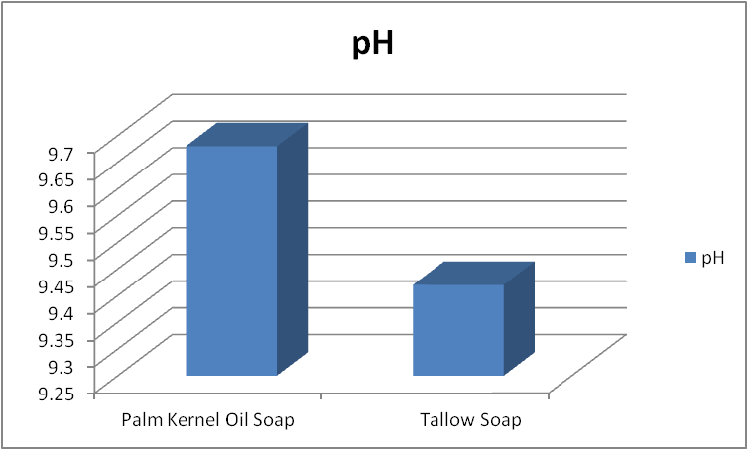
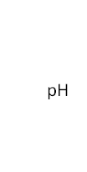

Figure 1: Column chart showing Palm kernel and Tallow oil soap

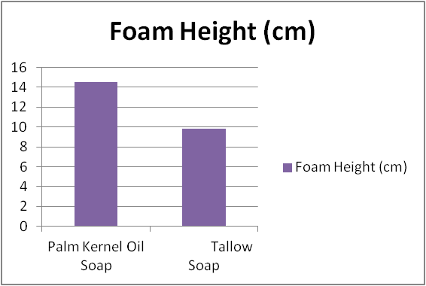


Figure2: Column Chart showing Foam height between Palm kernel and Tallow oil soap

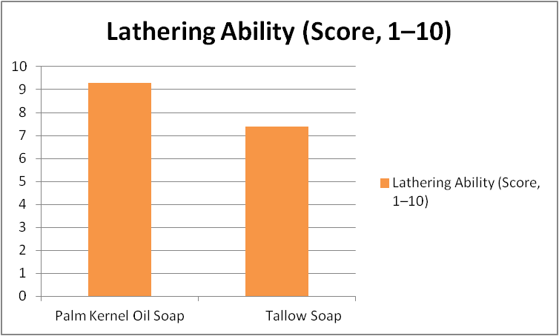


Figure3: Column chart showing Lathering ability between palm kernel and Tallow oil soap

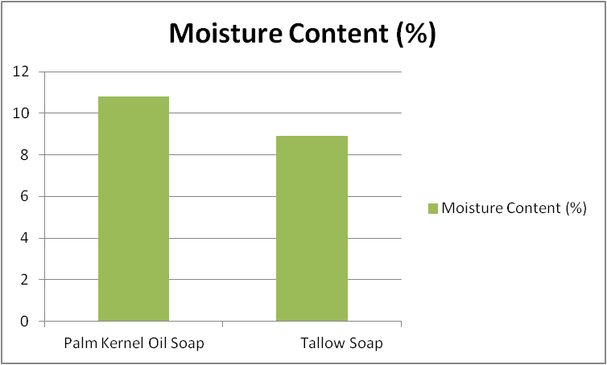


Figure 4:Column chart showing Moisture content between Palm kernel and Tallow oil soap

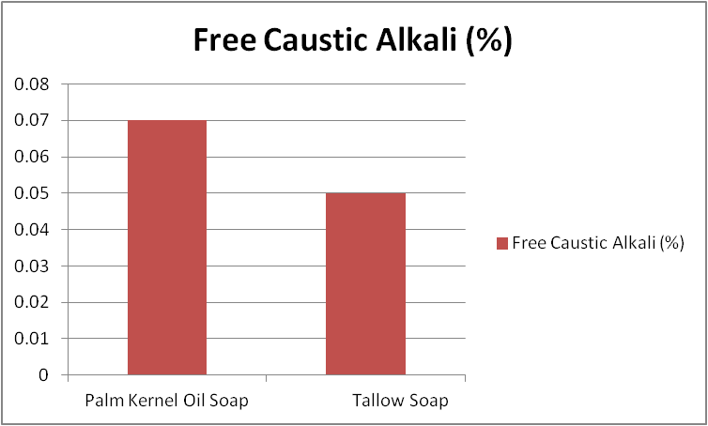


Figure 5: Column chart showing Free Caustic alkali between Palm kernel and Tallow oil soap

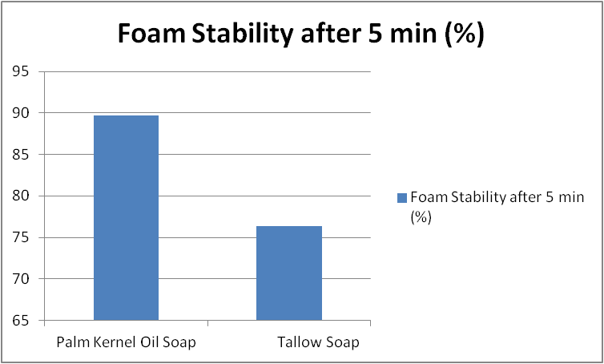


Figure 6:Column chart showing Foam stability between Palm kernel and Tallow oil soap
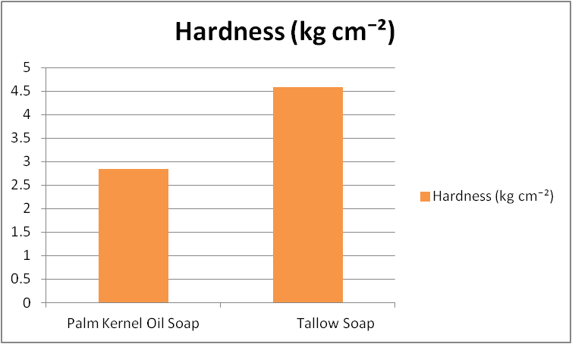


Figure 7: Column chart showing Hardness between Palm kernel and Tallow oil soap


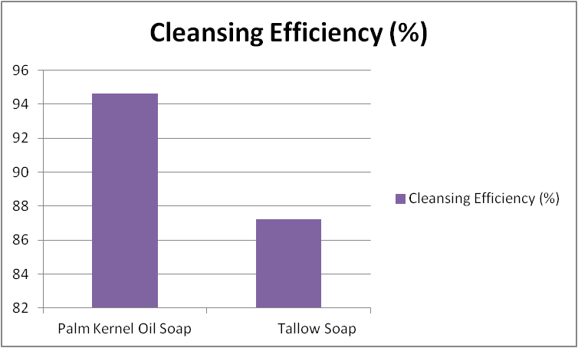

Figure 8:Column chart showing Cleansing efficiency between Palm kernel and Tallow oil soap

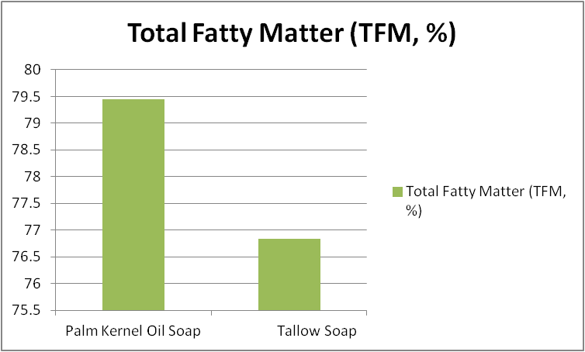
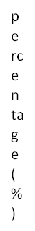

Figure 9: Column chart showing Total fatty acid between Palm kernel and Tallow oil

4. Conclusion
The study concludes that both palm kernel oil and tallow are suitable raw materials for soap production, although each offers distinct advantages. Palm kernel oil is more appropriate for manufacturing soaps with superior lathering and cleansing properties, whereas tallow is preferable for producing harder, more durable soaps. These findings provide valuable information for soap manufacturers seeking to optimize soap quality through the use of locally available raw materials. Both soaps had acceptable pH values and low free caustic alkali content, indicating their suitability for domestic use. A combination of both raw materials may provide a balanced soap with improved cleansing ability and durability.

Declaration of AI Use

This manuscript was prepared through the intellectual contributions of the author(s) to the study design, data analysis, interpretation of results, and scholarly content. Grammarly and ChatGPT were used solely to assist with grammatical refinement and reference formatting during manuscript revision. The author(s) accept full responsibility for the accuracy, integrity, and final content of the manuscript.

REFERENCES

Adebayo, G. B., Mohammed, B. D., & Ibrahim, A. O. (2022). Physicochemical evaluation of soaps
produced from selected vegetable oils. Nigerian Journal of Technological Research, 17(2), 45–54.

Akpakpan, A. E., Udo, I. E., Uwanta, E. J., Akpanudo, N. W., Ikpe, E. E., Fatunla, O. K., Udoakpan, U. I., Sunday, D. G., Umoh, G. O., & Umo, A. M. (2024). Influence of operating variables on the adsorption of Pb²⁺ and Cd²⁺ from wastewater using Gmelina arborea and its ester derivatives. Journal of Natural and Applied Sciences, Pakistan, 6(2), 1950–1968.

Barel, A. O., Paye, M., & Maibach, H. I. (2014). Handbook of Cosmetic Science and Technology
(4th ed.). CRC Press.

Cavitch, S. M. (2001). The Soapmaker's Companion. Storey Publishing.

Gunstone, F. D., Harwood, J. L., & Dijkstra, A. J. (2007). The Lipid Handbook (3rd ed.). CRC
Press.

Ikpe, E. E., Akpakpan, A. E., Akpan, P., Ukpong, E. G., & Okon, O. E. (2019). Evaluation of proximate composition of Callinectes sapidus, Procambarus clarkii and sediment from Qua Iboe River, Nigeria. International Journal of Advanced Research in Engineering Technology & Science, 6(4), 1–8.

Ikpe,E. E.,Nsi,E.W.,Udo, I.G.,Akpan,A.O.,Akpakpan, A.E. and Osagie, F.A.(2025) Investigation of Total Hydrocarbon Contents and Heavy Metals in Termitaria within Akwa Ibom State University,Ikot Akpaden,Nigeria.Asian Journal of Chemical Sciences, vol 15, issue 2. 73-85.

Imoisi, O. B., Ukhun, M. E., & Ikpe, E. E. (2020). Quality parameters of palm olein, palm kernel oil and its blends subjected to thermal stress using photometric technology. European Journal of Agriculture and Food Sciences, 2(5), 3–6.

Knothe, G., Van Gerpen, J., & Krahl, J. (2015). The Biodiesel Handbook (2nd ed.). AOCS Press.

KJ Betsy, M Jilu, R Fathima, JT Varkey, Determination of alkali content & total fatty matter in cleansing agents. Asian J. Sci. Appl. Technol, 2 (1) (2013).

Kuntom, Ainie, Hamirin Kifli, and Peang‐Kean Lim. "Chemical and physical characteristics of soap made from distilled fatty acids of palm oil and palm kernel oil." Journal of the American Oil Chemists' Society 73.1 (1996): 105-108.

Mabrouk, S. T. (2005). Making Usable, Quality Opaque or Transparent Soap. SABSON
Publishers.

Mitsui, T. (1997). New Cosmetic Science. Elsevier Science.

Muhammed, H.A., Abdulrazaq, Y., Abdullah, S.S. and Adam, A.A. 2022. Formulation of laundry
soap using locally made Palm Kernel Oil in Nigeria. Dutse Journal of Pure and Applied Sciences. 8, 1b (May 2022), 51–57

.Ntuen, I. U., Akpakpan, A. E., Enin, G. N., Enengedi, I. S., Uwanta, E. J., Nsi, E. W., Udo, I. E., Ikpe, E. E., & Akpabio, U. D. (2024). Preparation and characterization of ink from Hibiscus sabdariffa, Curcuma longa, and Sorghum vulgare. Nepal Journal of Biotechnology, 12(2), 183–193.

O'Brien, R. D. (2009). Fats and Oils: Formulating and Processing for Applications (3rd ed.). CRC
Press.

Spitz, L. (1996). Soap Manufacturing Technology. AOCS Press.

Warra, A. A. (2013). Production of soap using locally available alkaline extract from Milletia
thonningii. African Journal of Pure and Applied Chemistry, 7(12), 401–405.

Warra, A. A. (2013). Soap preparation from locally available raw materials and its properties.
African Journal of Pure and Applied Chemistry, 7(12), 401–405.

.

