Original Research Article
EVALUATION OF NUTRITIONAL AND ANTI-NUTRITIONAL CONTENTS OF Capsicum annuum L. FRUITS

Abstract
Capsicum annuum L. is widely cultivated in northern and southern Nigeria and is used as food and for medicinal purposes. The study was aimed at determining the proximate composition, vitamin content, mineral elements and anti-nutritional composition of the fruits of C. annuum L. Mineral and vitamin contents were determined using standard analytical methods, including Atomic Absorption Spectrophotometry for selected mineral elements, while proximate and anti-nutritional contents were determined using standard methods. The proximate analysis indicated moisture (36.00 ± 1.00%), crude fibre (24.00 ± 1.00%), carbohydrate (15.03 ± 2.84%), crude protein (12.96 ± 1.38%), crude fat (6.67 ± 1.44%) and ash (5.17 ± 0.29%). The elemental analysis indicated Mg (15.27 ± 0.15 ppm), Ca (4.23 ± 0.15 ppm), Mn (51.00 ± 0.18 ppm) and Zn (14.93 ± 0.12 ppm). The vitamin analysis indicated vitamin A (20.91 ± 0.35 mg/100 g), vitamin C (22.89 ± 0.52 mg/100 g) and vitamin E (11.60 ± 0.90 mg/100 g). The anti-nutritional analysis indicated oxalate (1.83 ± 0.21%), phytate (4.76 ± 0.59%) and flavonoids (39.56 ± 0.77%). The results indicate that C. annuum L. fruits contain appreciable nutritional constituents and bioactive compounds.
Keywords: Food; nutritional composition; anti-nutritional factors; oxalate; carbohydrates.

1.0 Introduction
In recent years, increasing attention has been directed towards maintaining good health through the consumption of foods with high nutritional value, bioactive compounds, and antioxidant properties. Fruits and vegetables are important sources of nutraceutical compounds, including vitamins, minerals, phenolic compounds, natural antioxidants, dietary fibre, and other bioactive constituents. Regular consumption of fruits and vegetables has been associated with beneficial health outcomes, including reduced risks of cardiovascular diseases, cancer, degenerative diseases, and age-related disorders (Chávez-Mendoza et al., 2015).
Pepper is an important horticultural crop cultivated in many parts of the world. Capsicum annuum L. belongs to the family Solanaceae and the genus Capsicum. It is widely consumed because of its characteristic taste, attractive colour, and distinctive biochemical composition (Soare et al., 2017).
Capsicum species constitute an important component of the Nigerian diet. In addition to their use in the preparation of stews and as flavour-enhancing ingredients, peppers are also used as preservatives and in traditional medicinal practices. Smallholder farmers, particularly women, are involved in pepper production for household consumption and local markets, especially in southwestern Nigeria. It has been reported that approximately 100,000–200,000 hectares of land are devoted to pepper cultivation annually in Nigeria (Omotayo et al., 2015).
The fruit of C. annuum L. is well known for its high content of bioactive compounds and antioxidant activity. It is one of the widely consumed fresh vegetables because of its combination of colour, flavour, and nutritional value. The species originated in North and South America and is well adapted to warm climates. It is currently cultivated and consumed as food and used for medicinal purposes in Africa and other parts of the world (Chávez-Mendoza et al., 2015).
C. annuum L. is characterized by its intense red colour, characteristic sweet or pungent flavour, crispy texture, and thin waxy layer. The fruit is valued for its bioactive constituents, including carotenoids, flavonoids, polyphenols, and vitamins A, C, and E, as well as minerals such as zinc, iron, copper, potassium, calcium, and magnesium. These constituents contribute to the nutritional and antioxidant properties of the fruit. Bioactive compounds such as capsaicin and capsanthin have also been associated with the antioxidant characteristics of C. annuum fruits (Otulak-Kozieł et al., 2020).
The consumption of C. annuum L. contributes to dietary nutrition and may enhance the palatability of meals, thereby improving food intake. The fruit can be consumed either raw or cooked, while the leaves may also be used in soups. Pepper production is influenced by several factors, including soil fertility and adequate nutrient availability, which are important for optimum growth and yield (Juroszek & Tsai, 2009).
Despite the nutritional and potential health benefits associated with C. annuum L., information on its combined nutritional and anti-nutritional composition remains important for assessing its dietary value. Therefore, this study evaluated the proximate composition, selected mineral elements, vitamin content, and anti-nutritional constituents of C. annuum L. fruits. 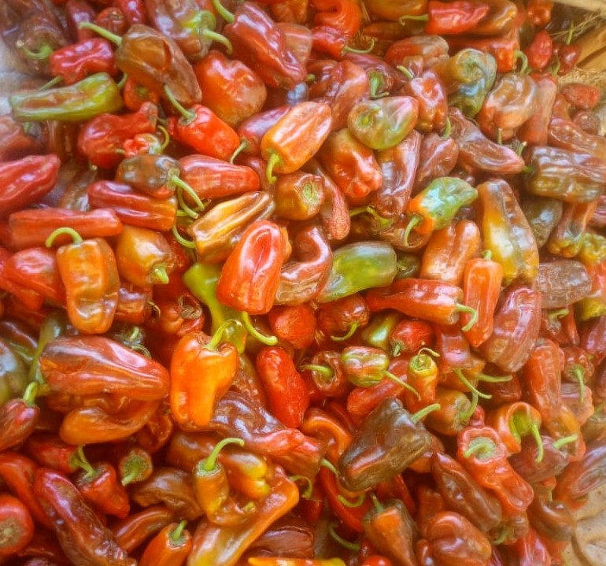
Figure 1. Capsicum annuum L. fruits.
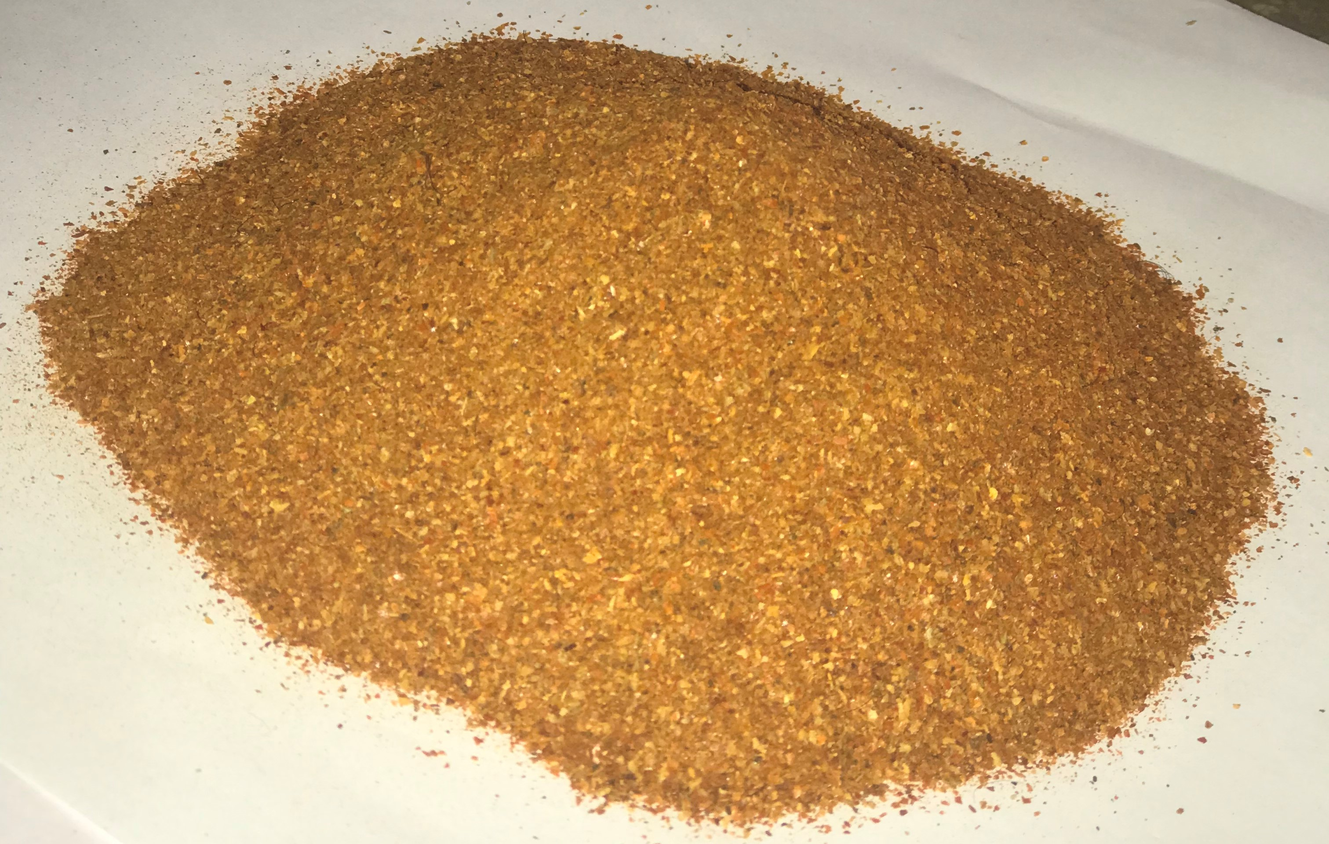
Figure 2. Powdered Capsicum annuum L. fruits.

2.0 MATERIALS AND METHODS

2.1 Sample Collection and Identification
Fresh fruits of Capsicum annuum L. were purchased from a local market in Aliero, Kebbi State, Nigeria. The samples were identified and authenticated by a botanist in the Department of Plant Sciences and Biotechnology, Kebbi State University of Science and Technology, Aliero. Taxonomic identification of the fruit was confirmed in the same department under voucher number (KSUSTA/PSB/H/VUCHER NO: S. N.)

2.2 Sample Preparation
The fruit samples were thoroughly washed and thinly sliced before being allowed to dry at room temperature. The dried samples were subsequently ground into powder using a mortar and pestle, as shown in Figure 2. The powdered samples were stored in airtight containers until required for the determination of proximate composition, mineral elements, vitamins, and anti-nutritional constituents.

2.3 Determination of Proximate Composition

2.3.1 Determination of Moisture Content
Moisture content was determined using the method described by the Association of Official Analytical Chemists (AOAC, 1990). The percentage moisture content was calculated using the following equation:
Moisture content (%) = [(W₃ − W₁) / (W₂ − W₁)] × 100
where W₁ is the weight of the empty crucible, W₂ is the weight of the crucible plus sample before drying, and W₃ is the weight of the crucible plus sample after drying in the oven.

2.3.2 Determination of Crude Protein
Crude protein content was determined using the Kjeldahl method described by AOAC (1990). The percentage nitrogen was calculated from the titre value, molarity, sample weight, and aliquot volume using the following equation:
% Nitrogen = (TV × MA × 0.014 × 50 × 100) / (Weight of sample × Aliquot)
where TV represents the titre value and MA represents the molarity of the distillation solution.
The crude protein content was subsequently calculated using a nitrogen-to-protein conversion factor of 6.25:
% Crude protein = % Nitrogen × 6.25

2.3.3 Determination of Crude Lipid
Crude lipid content was determined using the Soxhlet extraction method described by AOAC (1990). The percentage crude lipid was calculated as:
% Crude lipid = [(W₂ − W₁) / W₀] × 100
where W₀ is the weight of the sample, W₁ is the weight of the empty receiving vessel, and W₂ is the weight of the receiving vessel plus extracted oil.

2.3.4 Determination of Crude Fibre
Crude fibre was determined according to the method described by AOAC (1990). The percentage crude fibre was calculated using:
Crude fibre (%) = [(W₁ − W₂) / W₀] × 100
where W₁ is the weight of the crucible plus sample after oven drying, W₂ is the weight of the crucible plus residue after ashing in a muffle furnace, and W₀ is the weight of the sample.

2.3.5 Determination of Ash Content
Ash content was determined using the method described by AOAC (1990). Exactly 2 g of the powdered sample was placed in a previously weighed crucible and ignited in a muffle furnace at 550 °C for 6 h. The crucible was subsequently cooled in a desiccator and weighed at room temperature. Ash content was calculated using:
Ash content (%) = [(W₃ − W₁) / (W₂ − W₁)] × 100
where W₁ is the weight of the empty crucible, W₂ is the weight of the crucible plus sample before ashing, and W₃ is the weight of the crucible plus ash after ashing.

2.3.6 Determination of Carbohydrate Content
Carbohydrate content was determined by difference according to AOAC (1990). It was calculated by subtracting the sum of the percentages of moisture, crude lipid, crude protein, crude fibre, and ash from 100:
Carbohydrate (%) = 100 − [Moisture + Crude lipid + Crude protein + Crude fibre + Ash]

2.4 Determination of Anti-Nutritional Factors

2.4.1 Determination of Oxalate Content
Oxalate content was determined using the titrimetric method described by Nuhu et al. (2015). Exactly 1.0 g of the powdered sample was weighed into a conical flask, and 75 mL of 3 N H₂SO₄ was added. The mixture was stirred intermittently using a magnetic stirrer for 1 h and subsequently filtered through Whatman No. 1 filter paper. A 25-mL aliquot of the filtrate was heated to approximately 80–90 °C and titrated against 0.1 N KMnO₄ solution until a faint pink colour persisted for at least 30 s.
The oxalate content was calculated according to the procedure described by Nuhu et al. (2015), using the average titre value. One millilitre of 0.1 N KMnO₄ was reported as equivalent to 0.00450 g of anhydrous oxalic acid.

2.4.2 Determination of Phytic Acid Content
Phytic acid content was determined using the titrimetric method described by Nuhu et al. (2015). Exactly 2.0 g of the powdered sample was weighed into a 250-mL beaker and soaked in 100 mL of 2% HCl for 3 h. The extract was filtered through a double layer of hardened filter paper. A 50-mL aliquot of the filtrate was transferred into another 250-mL beaker and diluted with distilled water. Subsequently, 10 mL of 0.3% ammonium thiocyanate solution was added as an indicator. The solution was titrated against standard ferric chloride solution containing 0.00195 g iron per millilitre.
The titration was carried out in triplicate, and the average titre value was used for calculation. Phytic acid content was calculated as:
% Phytic acid = X × 1.19
where X is the product of the average titre value and the mass of iron per millilitre (0.00195 g).

2.4.3 Determination of Flavonoid Content
Flavonoid content was determined using the ethyl acetate precipitation method described by Bohn and Kocital (1994). The percentage flavonoid content was calculated from the difference between the weight of the filter paper containing the precipitate and the weight of the empty filter paper relative to the sample weight.
% Flavonoid = [(W₂ − W₁) / Weight of sample] × 100
where W₁ is the weight of the empty filter paper and W₂ is the weight of the filter paper plus precipitated flavonoid.

2.5 Vitamin Analysis
The vitamin contents of C. annuum L. fruits were determined using standard methods described by Cemeroglu (2007).

2.5.1 Determination of Vitamin A Content
Vitamin A was determined according to the method described by Cemeroglu (2007). Three clean, dry test tubes were labelled Test, Standard, and Blank. Appropriate quantities of sample, ethanol, standard solution, petroleum ether, and distilled water were added according to the analytical procedure.
The tubes were thoroughly shaken and centrifuged at 3,000 rpm for 5 min. The absorbance of the resulting supernatant was measured at 450 nm against the reagent blank.
The concentration of β-carotene was calculated using:
Concentration of β-carotene = (Absorbance of sample × Concentration of standard) / Absorbance of standard

2.5.2 Determination of Vitamin C Content
Vitamin C content was determined using the method described by Cemeroglu (2007). The concentration of vitamin C was calculated from the absorbance of the sample relative to that of the standard:
Vitamin C concentration (mmol/L) = (Absorbance of sample × Concentration of standard) / Absorbance of standard

2.5.3 Determination of Vitamin E Content
Vitamin E content was determined according to the method described by Cemeroglu (2007). The concentration was calculated using the relationship between the absorbance of the sample and that of the standard:
Vitamin E concentration = (Absorbance of sample × Concentration of standard) / Absorbance of standard

2.6 Mineral Analysis
Mineral analysis was conducted using the method described by AOAC (1990). Five grams of the powdered sample were digested with 10 mL of 5 N concentrated hydrochloric acid. The mixture was heated on a water bath and evaporated almost to dryness. The digest was allowed to cool, filtered into a 100-mL standard volumetric flask, and made up to volume with distilled water.
Selected mineral elements were subsequently determined using an Atomic Absorption Spectrophotometer (AAS) following acid digestion of the samples.

2.6.1 Determination of Magnesium Content
Magnesium content was determined by complexometric titration using EDTA according to AOAC (1990). The concentration of magnesium was calculated from the titre value obtained:
Concentration (mg/100 mL) = (TV × NE × AM × DF) / (WD × AT)
where TV is the titre value, NE is the normality of EDTA, AM is the atomic mass of magnesium, DF is the dilution factor, WD is the weight of the digested sample, and AT is the aliquot volume used for titration.

2.6.2 Determination of Calcium Content
Calcium content was determined by complexometric titration using EDTA according to AOAC (1990). The concentration was calculated using:
Concentration (mg/100 mL) = (TV × NE × AM × DF) / (WD × AT)
where TV is the titre value, NE is the normality of EDTA, AM is the atomic mass of calcium, DF is the dilution factor, WD is the weight of the digested sample, and AT is the aliquot volume used for titration.

2.6.3 Determination of Zinc and Manganese
The digested C. annuum L. samples were used for the determination of zinc (Zn) and manganese (Mn) using Atomic Absorption Spectrophotometry as described by Pal et al. (2014).
Atomic Absorption Spectrophotometry determines individual elements based on their characteristic absorption wavelengths. During analysis, the instrument directs light of a specific wavelength through the atomized sample, and the amount of light absorbed is measured by the detector. The absorbance is proportional to the concentration of the corresponding element in the sample.

3.0 RESULTS

3.1 Proximate Composition of Capsicum annuum L.
The proximate composition of Capsicum annuum L. fruits is presented in Table 1. The fruits contained measurable amounts of moisture, ash, crude fibre, crude fat, crude protein, and carbohydrate. Moisture had the highest proportion (36.00 ± 1.00%), followed by crude fibre (24.00 ± 1.00%), carbohydrate (15.03 ± 2.84%), crude protein (12.96 ± 1.38%), crude fat (6.67 ± 1.44%), and ash (5.17 ± 0.29%).
Table 1. Proximate composition of Capsicum annuum L. fruits
Parameter | Composition (%)
Moisture | 36.00 ± 1.00
Ash | 5.17 ± 0.29
Crude fibre | 24.00 ± 1.00
Crude fat | 6.67 ± 1.44
Crude protein | 12.96 ± 1.38
Carbohydrate | 15.03 ± 2.84
Values are expressed as mean ± standard deviation (SD), n = 3.

3.2 Mineral Element Composition of Capsicum annuum L.
The selected mineral element composition of Capsicum annuum L. fruits is presented in Table 2. Among the minerals analysed, manganese had the highest concentration (51.00 ± 0.18 ppm), followed by magnesium (15.27 ± 0.15 ppm), zinc (14.93 ± 0.12 ppm), and calcium (4.23 ± 0.15 ppm).
Table 2. Selected mineral element composition of Capsicum annuum L. fruits
Mineral element | Composition (ppm)
Magnesium (Mg) | 15.27 ± 0.15
Calcium (Ca) | 4.23 ± 0.15
Manganese (Mn) | 51.00 ± 0.18
Zinc (Zn) | 14.93 ± 0.12
Values are expressed as mean ± standard deviation (SD), n = 3.

3.3 Vitamin Composition of Capsicum annuum L. Fruits
The vitamin composition of Capsicum annuum L. fruits is presented in Table 3. Vitamin C had the highest concentration (22.89 ± 0.52 mg/100 g), followed by vitamin A (20.91 ± 0.35 mg/100 g) and vitamin E (11.60 ± 0.90 mg/100 g).
Table 3. Vitamin composition of Capsicum annuum L. fruits
Vitamin | Composition (mg/100 g)
Vitamin A | 20.91 ± 0.35
Vitamin C | 22.89 ± 0.52
Vitamin E | 11.60 ± 0.90
Values are expressed as mean ± standard deviation (SD), n = 3.

3.4 Anti-Nutritional and Flavonoid Contents of Capsicum annuum L. Fruits
The anti-nutritional and flavonoid contents of Capsicum annuum L. fruits are presented in Table 4. Flavonoids had the highest recorded value (39.56 ± 0.77%), followed by phytate (4.76 ± 0.59%) and oxalate (1.83 ± 0.21%).
Table 4. Anti-nutritional and flavonoid contents of Capsicum annuum L. fruits
Constituent | Composition (%)
Oxalate | 1.83 ± 0.21
Phytate | 4.76 ± 0.59
Flavonoids | 39.56 ± 0.77
Values are expressed as mean ± standard deviation (SD), n = 3.

4.0 DISCUSSION

4.1 Proximate Composition
The proximate analysis of Capsicum annuum L. fruits revealed appreciable amounts of moisture, ash, crude fibre, crude fat, crude protein, and carbohydrate. The moisture content is an important quality parameter because water availability influences several biochemical, physiological, and microbiological processes in food materials (Onwuka, 2005). The moisture content recorded in this study suggests that the dried powdered sample has relatively good storage potential, since foods with higher moisture contents are generally more susceptible to microbial growth and deterioration (Ruberto & Baratta, 2000).
The ash content obtained in this study was relatively low. Ash represents the inorganic or mineral fraction of a food material and provides an indication of its total mineral content. The relatively low ash content observed may have implications for the mineral contribution of the fruit and may also be relevant to quality assessment of products derived from the sample (Ibanga & Ekpa, 2009).
The crude fat content of C. annuum L. was 6.67 ± 1.44%. This value is within the range reported for some commonly consumed legumes and was reported to be comparable with that of scarlet runner bean and higher than values reported for cowpea and Kersting groundnut (Aremu et al., 2006). Dietary fat is an important source of energy and also contributes to the absorption of fat-soluble vitamins. It therefore plays an important nutritional role when consumed as part of a balanced diet (Ogunlade et al., 2012).
The crude fibre content was 24.00 ± 1.00%, which was relatively high compared with values reported for some legumes, including cowpea and Bambara groundnut (Aremu et al., 2008). Dietary fibre is important for maintaining normal gastrointestinal function and may contribute to overall digestive health. However, excessive fibre intake may reduce the bioavailability of certain mineral elements by binding or interacting with them.
The crude protein content of C. annuum L. was 12.96 ± 1.38%. This value was higher than those reported by Esayas et al. (2011) for some Capsicum varieties, including Bako Local, Odaharo, and Marakofana. Although the protein content of the fruit is appreciable, it remains lower than that of some protein-rich oilseeds and legumes commonly consumed in Nigeria. Therefore, C. annuum L. should be considered mainly as a complementary source of dietary protein rather than a major protein source.
The carbohydrate content was 15.03 ± 2.84%. The relatively moderate carbohydrate content may partly reflect the moisture composition of the fruit. The value was higher than that reported for cayenne pepper by Oluwasola et al. (2019). Carbohydrates are important dietary energy sources and contribute to the provision of readily available fuel for physiological activities. They also play important roles in the normal functioning of nervous tissues (Onwuka, 2005).

4.2 Mineral Element Composition
The mineral analysis showed that C. annuum L. fruits contain appreciable amounts of magnesium, calcium, manganese, and zinc. The observed order of abundance was Mn > Mg > Zn > Ca, with manganese having the highest concentration (51.00 ± 0.18 ppm), followed by magnesium (15.27 ± 0.15 ppm), zinc (14.93 ± 0.12 ppm), and calcium (4.23 ± 0.15 ppm).
Mineral elements are essential for normal growth and physiological functioning. They contribute to the development and maintenance of bones and teeth and participate in processes such as enzyme activity, muscle contraction, nerve transmission, and blood clotting. The relatively high manganese and magnesium contents suggest that C. annuum L. may contribute useful quantities of these minerals to the diet.
Manganese is involved in the activation of several enzymes and participates in metabolic processes associated with the synthesis and metabolism of carbohydrates, lipids, and proteins. Magnesium is also an essential mineral required for several physiological processes, including regulation of muscle and nerve function, blood glucose levels, and blood pressure, as well as protein, bone, and DNA synthesis (Farsinejad et al., 2016).
The zinc concentration obtained in this study indicates that C. annuum L. can contribute to dietary zinc intake. Zinc plays important roles in numerous biological processes, including enzyme activity, immune function, protein synthesis, and normal metabolic processes. The presence of zinc in the fruit therefore adds to its nutritional significance.
Calcium recorded the lowest concentration among the minerals analysed. Nevertheless, calcium remains an essential mineral because of its role in maintaining healthy bones and teeth. It also participates in blood clotting, muscle contraction, normal cardiac function, and nerve transmission (Farsinejad et al., 2016)

4.3 Vitamin Composition
The vitamin analysis showed that vitamin C had the highest concentration among the vitamins determined, followed by vitamin A and vitamin E. The concentrations recorded were 22.89 ± 0.52, 20.91 ± 0.35, and 11.60 ± 0.90 mg/100 g for vitamins C, A, and E, respectively.
Vitamins A, C, and E are important micronutrients that contribute to normal physiological functions and antioxidant protection. The relatively high vitamin C content observed in C. annuum L. highlights its potential contribution to dietary vitamin C intake. Vitamin C is involved in several physiological processes and also enhances the absorption of non-haem iron in the gastrointestinal tract.
Vitamin C can improve iron absorption by facilitating the conversion of ferric iron to the more readily absorbed ferrous form. This property may make vitamin-C-rich foods useful as part of diets intended to improve iron availability. Vitamin C also functions as an antioxidant and contributes to the protection of cells from oxidative damage.
Vitamin E is another important antioxidant nutrient that contributes to protection against oxidative stress. Its antioxidant function complements that of vitamin C and other antioxidant compounds present in plant foods. Vitamin A is essential for normal growth and development, immune function, and vision. In the visual system, vitamin A derivatives participate in the formation of rhodopsin, a light-sensitive pigment required for normal vision (Tanumihardjo, 2011).
The presence of vitamins A, C, and E therefore contributes substantially to the nutritional and potential health-promoting value of C. annuum L. fruits.

4.4 Anti-Nutritional and Flavonoid Composition
The analysis of anti-nutritional and bioactive constituents showed that flavonoids had the highest concentration (39.56 ± 0.77%), followed by phytate (4.76 ± 0.59%) and oxalate (1.83 ± 0.21%). The relatively high flavonoid content indicates the presence of considerable quantities of these bioactive compounds in C. annuum L.
Flavonoids are important secondary metabolites in plants and have been associated with antioxidant activity. Their ability to scavenge free radicals may contribute to the potential protective properties of plant-derived foods. Thus, the relatively high flavonoid content observed in the present study may contribute to the antioxidant potential of C. annuum L. fruits.
Oxalate was detected at a concentration of 1.83 ± 0.21%. Oxalates can interact with minerals, particularly calcium, and may consequently reduce their bioavailability when present at high concentrations. However, the oxalate level observed in this study was relatively low compared with the levels associated with toxic effects reported in previous studies (Pearson, 1976; Noonan and Savage, 1999). Akwaowo et al. (2000) also reported that high dietary oxalate may interfere with mineral metabolism and reduce calcium bioavailability.
Phytate content was 4.76 ± 0.59%. Phytic acid is commonly found in fibre-rich plant foods and has both nutritional and anti-nutritional implications. Although phytate has been associated with beneficial physiological effects and has been investigated for potential protective effects against some chronic diseases, it can also reduce the bioavailability of minerals because of its strong binding affinity for mineral elements (Norhaizan and Faizadatul, 2009; Ekholm et al., 2003). The phytate content observed in the present study indicates that this compound is present in C. annuum L.; however, its nutritional significance should be interpreted in relation to dietary intake and overall food composition.
Overall, the findings demonstrate that C. annuum L. fruits contain a combination of nutritional constituents, essential minerals, vitamins, and bioactive compounds, together with measurable anti-nutritional factors. The nutritional benefits of the fruit should therefore be considered alongside the levels of compounds such as phytate and oxalate.
5.0. CONCLUSION AND RECOMMENDATIONS
The study revealed that the capsicum annuum L. species contain substantial quantities of minerals, vitamins, and anti-nutrient compounds. The findings suggest thatcapsicum annuum L.varieties contain appreciable amounts of nutrients; however the cultivation and consumption of capsicum annuum L.fruit should be encouraged due to their higher nutritional and medicinal qualities inherent in them. It was observed that capsicum annuum L. variety alone is not rich in all nutrients; hence the need to consume the capsicum annuum L. as combinations with other capsicum annuum varieties is very important.
Based on the findings of this study, the cultivation and consumption of Capsicum annuum L. should be encouraged because of its appreciable nutritional and potential medicinal value. Consumers are encouraged to include C. annuum fruits as part of a balanced and diversified diet and to combine them with other varieties of pepper, vegetables, fruits, and other nutrient-rich foods to obtain a wider range of essential nutrients. Farmers should adopt appropriate cultivation, harvesting, drying, and storage practices to maintain the nutritional quality of the fruits. Further research should also be conducted on different varieties of C. annuum L. to compare their nutritional, mineral, vitamin, antioxidant, and anti-nutritional compositions. In addition, further studies are recommended to evaluate the bioavailability and nutritional significance of compounds such as phytate and oxalate and to investigate the potential health benefits of the bioactive compounds present in the fruits.
Declaration of AI Use

This manuscript was prepared through the intellectual contributions of the author(s) to the study design, data analysis, interpretation of results, and scholarly content. Grammarly and ChatGPT were used solely to assist with grammatical refinement and reference formatting during manuscript revision. The author(s) accept full responsibility for the accuracy, integrity, and final content of the manuscript.

REFERENCES

Akin, O., Claudia, R., Anthony, K. O. & Ayodele, F. (2015). Evaluation of exotic cultivars of pepper (Capsicum spp.) among small holder farmers in South-Western. International Conference on Geological and Civil Engineering, 8, 80–16.

Akwaowo, E. U., Ndon, B. A., & Etuk, E. U. (2000). Minerals and antinutrients in fluted pumpkin (Telfairia occidentalis Hook f.). Journal of Food Chemistry, 70(2), 235–240. https://doi.org/10.1016/S0308-8146(99)00207-1.

Aremu, M. O., Olaofe, O., & Akintayo, E. T. (2006). Chemical composition and physicochemical characteristics of two varieties of Bambara groundnut (Vigna subterranea) flours. Journal of Applied Sciences, 6(9), 1900–1903. https://doi.org/10.3923/jas.2006.1900.1903.

Aremu, M. O., Olaofe, O. & Orjioke, C. A. (2008). Chemical composition of Bambara groundnut (Vigna subterranea), Kersting groundnut (Kerstingiella geocarpa) and Scarlet Runner beans (Phaseolus coccineus) protein concentrates. La Rivista Taliana Delle Sostanze Grasse, 85, 56–62.

Association of Official Analytical Chemists (AOAC). (1990). Official Methods of Analysis. 5th ed. Washington, DC.

Chávez-Mendoza, C., Sanchez, E., Muñoz-Márquez, E., Sida-Arreola, J. P., & Flores-Cordova, M. A. (2015). Bioactive compounds and antioxidant activity in different grafted varieties of bell pepper. Antioxidants, 4(2), 427–446. https://doi.org/10.3390/ antiox4020427

Dickinson, H. O., Nicolson, D. J., Cook, J. V., Campbell, F., Beyer, F. R., Ford, G. A., & Mason, J. (2006). Calcium supplementation for the management of primary hypertension in adults. Cochrane Database of Systematic Reviews, 2006(2), Article CD004639. https://doi.org/10.1002/14651858.CD004639.pub2.

Ekholm, P., Virkki, L., Ylinen, M., & Johansson, L. (2003). The effect of phytic acid and some natural chelating agents on the solubility of mineral elements in oat bran. Journal of Food Chemistry, 80(2), 165–170. https://doi.org/10.1016/S0308-8146(02)00249-2.

Esayas, K., Shimelis, A., Ashebir, F., Negussie, R., Tilahun, B., & Gulelat, D. (2011). Proximate composition, mineral content and antinutritional factors of some Capsicum annuum varieties grown in Ethiopia. Bulletin of the Chemical Society of Ethiopia, 25(3), 451–454. https://doi.org/10.4314/bcse.v25i3.68602.

Al-Fartusie, F. S., & Mohssan, S. N. (2017). Essential trace elements and their vital roles in human body. Indian Journal of Advances in Chemical Science, 5(3), 127–136. https://doi.org/10.22607/IJACS.2017.503003.

Farsinejad-Marj, M., Saneei, P., & Esmaillzadeh, A. (2016). Dietary magnesium intake, bone mineral density and risk of fracture: A systematic review and meta-analysis. Osteoporosis International, 27(4), 1389–1399. https://doi.org/10.1007/s00198-015-3400-y.

Ibanga, O. I., & Ekpa, O. D. (2009). Minerals and anti-nutrients in two varieties of African pear (Dacryodes edulis). Journal of Food Technology, 7(4), 106–110. https://doi.org/10.36478/jftech.2009.106.110.

Joseph, A. I. (2020). Evaluation of bell pepper. International Journal of Agriculture and Research, 3(12).

Juroszek, P., & Tsai, H.-H. (2009). Yields of organically grown sweet pepper cultivars and lines during the hot-wet and cool-dry season in the tropics. HortTechnology, 19(2), 418–422. https://doi.org/10.21273/HORTTECH.19.2.418

Katarzyna, R., Artur, W., Dorota, W. R., Oleksii, P. & Małgorzata, N. (2020). The effect of traditional and non-thermal treatments on the bioactive compounds and sugars content of red bell pepper. Molecules, 25, 42–87.

Norhaizan, M. E. & Faizadatul, A. A. W. (2009). Determination of phytate, iron, zinc, calcium contents and their molar ratios in commonly consumed raw and prepared foods in Malaysia. Journal of Nutrition, 15(2), 213–222.

Nuhu, A. H., Shitu, F. A. & Tijani, R. A. (2015). Determination of proximate, anti-nutrients and some trace elements of Trinidad moringa scorpion, bell pepper and cayenne pepper. Proceedings of the Academic Conference of African Scholar Publications & Research International on Challenge and Prospects, 8(1).

Ogunlade, I., Alebiosu, A. A., & Osasona, A. I. (2012). Proximate, mineral composition, antioxidant activity and total phenolic content of some pepper varieties (Capsicum species). International Journal of Biology and Chemical Sciences, 6(5), 2221–2227.

Okwu, D. E. & Morah, F. N. (2004). Mineral and nutritive value of Dennettia tripetala fruits. Journal of Fruits, 59, 437–442.
Oluwasola, E. I., Oje, O. J., Jeje, O. A. & Akinbuli. (2019). Effect of substitutional soup ingredient on the proximate composition of milled soup. Applied Tropical Agriculture, 24(1), 33–35.

Omotayo, A., Ribeiro, C., Oluleye, K. A., & Fajinmi, A. (2015). Introduction and participatory evaluation of exotic cultivars of pepper (Capsicum spp.) among small holder farmers in South-Western Nigeria. Proceedings of the 2015 2nd International Conference on Geological and Civil Engineering, 8, 80–86.

Otulak-Kozieł, K., Kozieł, E., Escalante, C., & Valverde, R. A. (2020). Ultrastructural analysis of cells from bell pepper (Capsicum annuum) infected with bell pepper endornavirus. Frontiers in Plant Science, 11, 491. https://doi.org/10.3389/fpls.2020.00491.

Onwuka, G. I. (2005). Food Analysis and Instrumentation: Theory and Practice. 1st ed. Napthal Prints, Surulere, Lagos, Nigeria.

Rodica, S., Maria, D., Cristina, B., Mihaela, P. & Alin, P. (2017). Nutritional value and antioxidant activities in fruit of some cultivars of pepper (Capsicum annuum L.). Journal of Agroalimentary Processes and Technologies, 23(4).

Ruberto, G., & Baratta, M. T. (2000). Antioxidant activity of selected essential oil components in two lipid model systems. Food Chemistry, 69(2), 167–174. https://doi.org/10.1016/S0308-8146(99)00247-2

Rybak, K., Wiktor, A., Witrowa-Rajchert, D., Parniakov, O., & Nowacka, M. (2020). The effect of traditional and non-thermal treatments on the bioactive compounds and sugars content of red bell pepper. Molecules, 25(18), 4287. https://doi.org/10.3390/molecules25184287.

Soare, R., Dinu, M., Băbeanu, C., Popescu, M., & Popescu, A. (2017). Nutritional value and antioxidant activities in fruit of some cultivars of pepper (Capsicum annuum L.). Journal of Agroalimentary Processes and Technologies, 23(4), 217–222.

Tanumihardjo, S. A. (2011). Vitamin A: Biomarkers of nutrition for development. The American Journal of Clinical Nutrition, 94(2), 658S–665S. https://doi.org/10.3945/ajcn.110.005777.

