DIVERSITY AND DISTINCTIVENESS OF DUCKWEEDS FROM A SELECTED TALUK IN VIRUDHUNAGAR, TAMIL NADU

ABSTRACT
Duckweed was an aquatic monocotyledonous herb, with five genera and 36 species. It commonly thrived in nutrient-rich water bodies, such as brackish water, agricultural wastewater, industrial wastewater, and contaminated water sources. The diversity of duckweed among the districts of Tamil Nadu had been minimally studied. To address this knowledge gap, collection of duckweed strains from specific and selected water bodies in the Virudhunagar district was done. Subsequently, 11 duckweed strains were collected from various water bodies in the Rajapalayam, Sivakasi, and Srivilliputhur talukas. The morphological characteristics, and reproductive characteristics of the collected samples were studied. Based on the characteristical study and microscopic observations, a total of 3 genera and 5 species were identified. The most dominant species was Spirodela intermedia, as it was found in all three taluks. In contrast, the most recessive species was Lemna aequinoctialis, as it was present in only one taluk. This study provided insights into the duckweed populations present in the aquatic environment of the Virudhunagar district.
Key words: Diversity, Duckweed, Morphological study, Tamil Nadu.
INTRODUCTION
The Lemnaceae family, commonly known as duckweeds or water lentils, are monocotyledonous aquatic plants that belong to the order Alismatales (Les et al., 2002; APG 2009). Despite being the smallest known flowering plants on Earth, these are remarkably ubiquitous, inhabiting water bodies across the globe (Tippery and Les, 2020). Duckweed is typically found in eutrophic or nutrient-rich environments, except for Polar Regions that remain continuously frozen and lack open water. This is adaptable to a wide range of climates and geographic zones, but the majority of species are found in tropical and temperate regions with moderate conditions (Skillicorn et al., 1993).
Lemnaceae development and survival are controlled by a range of environmental conditions, including water temperature, pH, nutrient concentration, crowding caused by colony overgrowth, competition from other plants for light and nutrients, etc. (Guha, 1997). Species of duckweed thrive best within a temperature range of 17.5°C to 30°C (Culley et al., 1981), can tolerate a wide pH range from 2 to 10, and its optimal growth occurs between 6.5 and 8.0. This pH range favours the ammonium ion as the most readily available form of nitrogen (Jha and Pokharel, 2015).
Lemnaceae predominantly reproduce through vegetative growth, with flowering and seed production, i.e., sexual reproduction, occurring less frequently (Landolt, 1998). In temperate regions, the survival of duckweeds during the winter months is not solely dependent on seeds. Evidence suggests that various duckweed species are able to adapt to cold conditions by sinking to the bottom of water bodies and transforming into specialized dormant structures called turions, which can withstand freezing temperatures (Kuehdorf et al., 2014). Furthermore, the dispersal is not solely reliant on their own means of propagation, but can also be facilitated by biotic vectors, such as migrating waterfowl. These birds can inadvertently transport duckweeds over vast distances, either by carrying the small plants within their gastrointestinal tracts or by having them attach to their bodies (Kimball et al., 2003; Green, 2016).
Duckweeds can be categorized into two subfamilies: Lemnoideae and Wolffioideae. This aquatic plant group comprises a total of 5 genera and 36 species. The Lemnoideae subfamily contains 15 species, while the Wolffioideae subfamily encompasses 21 species (Bog et al., 2020; Sree et al., 2016).
This study provides valuable information about the diversity of duckweed populations in the Virudhunagar district of Tamil Nadu, India. The findings shed light on how duckweed species and their characteristics can vary across different water bodies and locations within the district.
MATERIALS AND METHODS
Survey of Duckweed Strains
Duckweed species were collected from various water bodies, including ponds, springs, streams, and waterholes, located in and around the Virudhunagar district of Tamil Nadu. The survey locations were selected based on the availability of duckweeds.
Collection of duckweed
The duckweed plant samples were collected in duplicate, with each sample placed in a 100 mL plastic container. The containers were then stored in a refrigerated cooler maintained at approximately 10°C and transported to the laboratory within 48 hours of the initial collection. At each confirmed collection site, the pH value of the water was measured using litmus paper. Once the samples arrived at the laboratory, the electric conductivity of the water (which indicates its salinity) was measured using a conductivity meter (Friedjung Yosef et al., 2022).
Sterilization and maintenance of sample
The study involved washing the plants in tap water, transferring them to a laboratory, determining their pH value, sterilizing them with 0.5% sodium hypochlorite, and keeping them in NaClO for 30 seconds (Friedjung Yosef et al., 2022). The cleaned fronds were then moved into Hoagland nutritive media (Hoagland and Snyder, 1933); the composition of the growth medium is given in Table 1, and daughter plants were kept as stock cultures under persistent lighting conditions [24 h] with 100 µmol/m²s light intensity from fluorescent light tubes [18W/54] at 25°C (McLaren and Smith, 1976). The individual fronds were chosen for the experiment. The process ensured proper growth and preservation of the plants.
Identification of sample
The collected duckweed strains were identified based on manual identification, and the samples were distinguished in the format of genus and species mainly based on their morphological characteristics (Les et al., 1997; Bog et al., 2020; Azer, 2013). A light microscope and magnifying lens were used to identify morphological features. We examined the different parts of the duckweed sample, such as the fronds, papillae, root tip, root sheath, and turions, before moving on to identification. A duckweed sample was recognized at the genus and species level, specifically based on the number of roots, the number of shoot veins, the size and pattern of the fronds, the root sheath, the root tip, and other characteristics.
RESULTS
The duckweed species collected originated from the water bodies of Sivakasi, Rajapalayam, Srivilliputur, Chatrapatti, and Mamsapuram in the Virudhunagar District of Tamil Nadu. Five species and three genera were identified: Spirodela intermedia, Spirodela polyrhiza, Lemna gibba, Lemna aequinoctialis, and Wolffia globosa. The collected locations and duckweed diversity from the water bodies of Rajapalayam, Sivakasi, Srivilliputhur taluks of Virudhunagar district, Tamil Nadu are presented in Figure 1 and 2.
Collection sites
The collection locations and number of collected strains are provided in Table 2, with the corresponding collection photographs and location maps presented in Figures 2 and 3. The most dominant duckweed species of the four locations are presented here. The most prominent morphological characters, such as frond shape, rhizoids, frond apex, turions, and the presence or absence of internal organelles, clearly distinguish the duckweed clones. In this present study, the variation in the number of roots, internal structure of fronds, and frond shape significantly contributed to the identification of specific propagules.
Species identification and characterization
Spirodela intermedia
Spirodela intermedia was an aquatic floating species, with its leaves modified into fronds. When observed under the light microscope, the fronds were found to have 12-16 nerves (veins). The dorsal (upper) view of the fronds did not show any papillae (small projections). The outline/margin of the fronds was entire, without any indentations. The budding pouch had a deltoid (triangular) shape, and it is presented in 2 portions. The tip of the fronds was of the elongate (elongated) type. Turions, which are seed-like overwintering structures, were absent in this aquatic species. This species displayed 16-20 roots, with a length of up to 4 cm. The root sheath was wingless, and the root tip was acute (pointed).
Spirodela polyrhiza
S. polyrhiza is a floating aquatic plant. It consists of a single thallus that is typically 3-9 mm in size and has an oval to obovate shape. The upper surface of the thallus is generally green in colour and has numerous air pockets, which enable the plant to float. The lower surface of the thallus is purple in colour due to pigmentation. Around 5-11 veins originate from the node at the base of the thallus, and around 11 very thin and slender roots or rhizoids, up to 10 mm long with pointed or blunted tips, also originate from this basal node. The root sheath lacked wings. The daughter fronds are formed by budding from the point where the roots attach to the parent plant.
S. polyrhiza exhibits a form of vegetative propagation where temporary clusters of 2-4 thalli are formed, but these eventually split off into individual plants. The plant also produces small structures called turions, which are olive-pale green or brownish in colour. During the winter, the turions form on the underside of the thallus, near the node where the rootlets originate. These turions detach from the parent plant and sink to the bottom of the water body, where they remain throughout the winter. In the spring, the turions rise back to the surface of the water to begin the growth process again.
Lemna gibba
The thallus is shaped from obovate to almost round. Typically, the size falls between 2 and 10 mm in length and 1.5 and 8 mm in breadth. On the bottom surface, the thallus is considerably inflated or gibbous, or bloated. It is thick. Usually green in hue, the upper surface is flat to slightly convex. Because anthocyanin pigments are present, the bottom surface has a purple or reddish-purple tint. A single, unbranched root that can grow up to 10 cm in length is present in each thallus. The slender roots are frequently reddish-purple in colour.
Lemna aequinoctialis
The species L. aequinoctialis exhibits a prominent winged root sheath near the basal attachment node. One of the distinctive features of this species is the presence of a conspicuous apical papule on the upper side of the frond. It has only a single rhizoid with an obtuse root tip. The air space layer is distributed in a well-defined manner, with 1-3 layers present. Anthocyanin pigmentation is observed in this species. The maximum number of frond veins appears to be 1. The epidermal cell wall is distinctly present.
Wolffia globosa
The identified Wolffia globosa species was a floating species. The surface of the fronds was globose (spherical). The fronds were nerveless, meaning they lacked distinct veins. The tip of the fronds was elongated. The species had a single budding pouch, which was conical in shape. Minute-level turions, which are seed-like overwintering structures, were present in this species. After the completion of its life cycle, the species would become submerged underwater. This species completely lacked any kind of root structure, including the root tip, root sheath, and other root features. The overall important highlighted characteristics of the collected species are shown in Table 3.
DISCUSSION
A similar kind of study by Landolt (1975), who had used morphological characterization and geographical distribution for the identification of duckweed species, especially duckweed belonging to the genus Lemna. The species identification was done based on habit, morphological characteristics, anatomical characteristics, pigments and reproductive characteristics.
As reported by Zhuang (2013), Spirodela is distributed across North and South America and also some parts of Europe. Its abundance varies according to the habitat, such as lakes, ponds, backwaters of rivers and marshes. It has also been reported that flower and turion formation are affected by habitat as well as by the nutrient composition of the water bodies. Lemon and Posluszny (2000) have revealed that this plant tends to produce propagules by means of asexual reproduction. Fronds can be produced by branching, followed by fragmenting of the shoots into different units. They also observed that the growth rate of this plant was very fast, and its doubling time under optimal growth conditions is high. Our collected species of Spirodela mostly grows in brackish, contaminated and nutrient-rich water, because these kinds of habitats have higher levels of nutrients compared to other freshwater habitats.
Azer (2013), who had also studied the classification of the genus Lemna, categorized it into three clusters according to morphological and anatomical characters. The first cluster was reported to be L. gibba and L. minor, and the remaining second and third clusters included L. trisulca and L. aequinoctialis. In contrast to this, Bog et al. (2010) categorized the genus Lemna into four sections. It was also suggested that L. gibba and L. minor have similarities in specific morphological characteristics.
Al-Dakhil et al. (2021) reported the traits of duckweed samples collected from different locations in Saudi Arabia (Riyadh, Dhahran, Tohama, Al-Baha, Al-Taif). Some of the peculiar traits, such as longer roots and fronds with higher vein numbers, were noticed in L. minor and less so in L. gibba, but such traits were not observed in L. aequinoctialis and L. trisulca. Recently, different plastid markers have been widely used to identify duckweed clones, since a lack of experience and expertise limits morphological and anatomical identification.
Kaplan et al. (2019) studied Wolffia globosa, which grows in mats on the surface of calm, freshwater environments like ponds, lakes, and marshes. It is an extremely small, oval-shaped plant that lacks leaves, stems, and roots. The plant's body, known as a frond, is transparent green in colour and measures less than a millimetre in width. Wolffia globosa has been described as the smallest flowering plant in the world, with a diameter of only 0.1-0.2 mm (0.004-0.008 inches). Our study also indicated similar characteristics of W. globosa, which is consistent with the observations of Kaplan et al. (2019).
CONCLUSION
The detailed characterization and microscopic analysis of the collected duckweed samples revealed a total of 3 genera and 5 distinct species in the Virudhunagar district. Among the identified species, Spirodela intermedia was found to be the most prevalent, as it was present across all three taluks (Rajapalayam, Sivakasi, and Srivilliputhur) surveyed. In contrast, Lemna aequinoctialis was determined to be the most recessive species, as it was only observed in a single taluk within the study area.
Overall, this investigation has provided valuable insights into the diversity and distribution of duckweed populations inhabiting the aquatic environments of the Virudhunagar district. The findings contribute to a better understanding of the duckweed flora present in this region of Tamil Nadu.
Declaration of AI Use

This manuscript was prepared through the intellectual contributions of the author(s) to the study design, data analysis, interpretation of results, and scholarly content. Grammarly and ChatGPT were used solely to assist with grammatical refinement and reference formatting during manuscript revision. The author(s) accept full responsibility for the accuracy, integrity, and final content of the manuscript.

REFERENCES
Al-Dakhil M, Alghamdi S, Migdadi H, Afzal M and Ali A A 2021. Morphological characterization and DNA barcoding of Duckweed species in Saudi Arabia. Plants 10(11): 2438.
Angiosperm Phylogeny Group (APG) 2009. An update of the Angiosperm Phylogeny Group classification for the orders and families of flowering plants: APG III. Botanical Journal of the Linnean Society 161(2): 105-121.
Azer S A 2013. Taxonomic revision of genus Lemna L. (Lemnaceae Gray) in Egypt. Annals of Agricultural Sciences 58(2): 257-263.
Bog M, Baumbach H, Schween U, Hellwig F, Landolt E and Appenroth K J 2010. Genetic structure of the genus Lemna L. (Lemnaceae) as revealed by amplified fragment length polymorphism. Planta 232: 609-619.
Bog M, Sree K S, Fuchs J, Hoang P T, Schubert I, Kuever J, Rabenstein A, Paolacci S, Jansen M A and Appenroth K J 2020. A taxonomic revision of Lemna sect. Uninerves (Lemnaceae). Taxon 69(1): 56-66.
Culley Jr D D, Rejmánková E, Květ J and Frye J B 1981. Production, chemical quality and use of duckweeds (Lemnaceae) in aquaculture, waste management, and animal feeds. Journal of the World Mariculture Society 12(2): 27-49.
Friedjung Yosef A, Ghazaryan L, Klamann L, Kaufman K S, Baubin C, Poodiack B, Ran N, Gabay T, Didi-Cohen S, Bog M and Khozin-Goldberg I 2022. Diversity and differentiation of duckweed species from Israel. Plants 11(23): 3326.
Green A J 2016. The importance of waterbirds as an overlooked pathway of invasion for alien species. Diversity and Distributions 22(2): 239-247.
Guha R 1997. Duckweeds. ENVIS Newsletter, Indian Institute of Science, Bangalore 5-9.
Hoagland D R and Snyder W C 1933. Nutrition of strawberry plant under controlled conditions: (a) effects of deficiencies of boron and certain other elements, (b) susceptibility to injury from sodium salts. Proceedings of the American Society for Horticultural Science 30: 288-294.
Jha S and Pokharel B 2015. Duckweed: The hidden treasure. Nepalese Journal of Biosciences 5(1): 1-20.
Kaplan A, Zelicha H, Tsaban G, Meir A Y, Rinott E, Kovsan J, Novack L, Thiery J, Ceglarek U, Burkhardt R and Willenberg A 2019. Protein bioavailability of Wolffia globosa duckweed, a novel aquatic plant – a randomized controlled trial. Clinical Nutrition 38(6): 2576-2582.
Kimball R T, Crawford D J, Les D H and Landolt E 2003. Out of Africa: molecular phylogenetics and biogeography of Wolffiella (Lemnaceae). Biological Journal of the Linnean Society 79(4): 565-576.
Kuehdorf K, Jetschke G, Ballani L and Appenroth K J 2014. The clonal dependence of turion formation in the duckweed Spirodela polyrhiza – an ecogeographical approach. Physiologia Plantarum 150(1): 46-54.
Landolt E 1975. Morphological differentiation and geographical distribution of the Lemna gibba-Lemna minor group. Aquatic Botany 1: 345-363.
Landolt E 1998. Lemnaceae. In: Flowering Plants · Monocotyledons: Alismatanae and Commelinanae (except Gramineae). Berlin, Heidelberg: Springer Berlin Heidelberg 264-270.
Lemon G D and Posluszny U 2000. Comparative shoot development and evolution in the Lemnaceae. International Journal of Plant Sciences 161(5): 733-748.
Les D H, Landolt E and Crawford D J 1997. Systematics of the Lemnaceae (duckweeds): inferences from micromolecular and morphological data. Plant Systematics and Evolution 204: 161-177.
Les D H, Crawford D J, Landolt E, Gabel J D and Kimball R T 2002. Phylogeny and systematics of Lemnaceae, the duckweed family. Systematic Botany 27(2): 221-240.
McLaren J S and Smith H 1976. The effect of abscisic acid on growth, photosynthetic rate and carbohydrate metabolism in Lemna minor L. New Phytologist 76(1): 11-20.
Skillicorn P, Spira W and Journey W 1993. A new aquatic farming system for developing countries. The World Bank Group 76: 76.
Sree K S, Bog M and Appenroth K J 2016. Taxonomy of duckweeds (Lemnaceae), potential new crop plants. Emirates Journal of Food & Agriculture 28(5).
Tippery N P and Les D H 2020. Tiny plants with enormous potential: phylogeny and evolution of duckweeds. The Duckweed Genomes 19-38.
Zhuang X 2013. Spirodela polyrhiza. The IUCN Red List of Threatened Species 2013: e.T164229A5788133.

Nutrients | Stock solution | Use (mL/L)
Macronutrients:  MgSO₄·7H₂O  Ca(NO₃)₂·4H₂O  KH₂PO₄  KNO₃. | g/100 mL  24.6  23.6  13.6  10.1 | 1  2.3  0.5  2.5
Micronutrients:  H₃BO₃  MnCl₂·4H₂O  ZnSO₄·7H₂O  Na₂MoO₄·2H₂O  CuSO₄·5H₂O | g/L  2.86  1.82  0.22  0.09  0.09 | 0.5
Fe.EDTA solution:  FeCl3·6H₂O  EDTA | g/100 mL  0.121  0.375 | 20
Table1. Composition of the Hogland nutrient solutions used in duckweed culture maintenance.
Species | No.of strains | Location | Populations
Wolffia globosa | 2 | Chatrapatti, Sivakasi | ++
Lemna aequinoctialis | 1 | Rajapalayam | +
Lemna gibba | 2 | Rajapalayam | ++
Spirodela polyrhiza | 2 | Keelarajakularaman, Rajapalayam | ++
Spirodela intermedia | 4 | Rajapalayam, Srivilliputur, M.K.pudupatti, Sivakasi. | +++
Table2. Collected species among different locations of Rajapalayam, Srivilliputhur and Sivakasi taluks. *+ - low, ++ - moderate, +++ - high.

S. No | Characters | Spirodela polyrrhiza | Spirodela punctata | Lemna  gibba | Lemna aequinotialis
 | Habitat | Aquatic | Aquatic | Aquatic | Aquatic
 | Frond | Floating | Floating | Floating | Floating
 | Seasonality | Perennial | Perennial | Seasonal | Seasonal
 | Fronds | Flat | Inflated | Inflated | Flat
 | Fronds margin | Entire | Entire | Entire | Entire
 | Rhizoids | 13 | 8 | single | single
 | Root tip | Acute | Acute | Obtuse | Obtuse
 | Maximum number of frond nerves | 16 | 7 | 3 | 1
 | Root sheath | wingless | winged | winged | wingless
 | Number of fronds | 4-5 | 4-5 | 3-4 | 3-4
 | No of air space layers | Present  2-3 | Present  2-3 | Present  1-3 | Present  1-3
 | Pigment cells | Present throughout | Present throughout | Present | present
 | Anthocyanin | Present | present | present | present
 | Epidermal cell wall | Straight to slightly undulated | Straight to slightly undulated | Distinctly undulated | Distinctly undulated
 | Root trachids | Present | present | absent | absent
Table3. Important and highlighted characteristics of collected species.

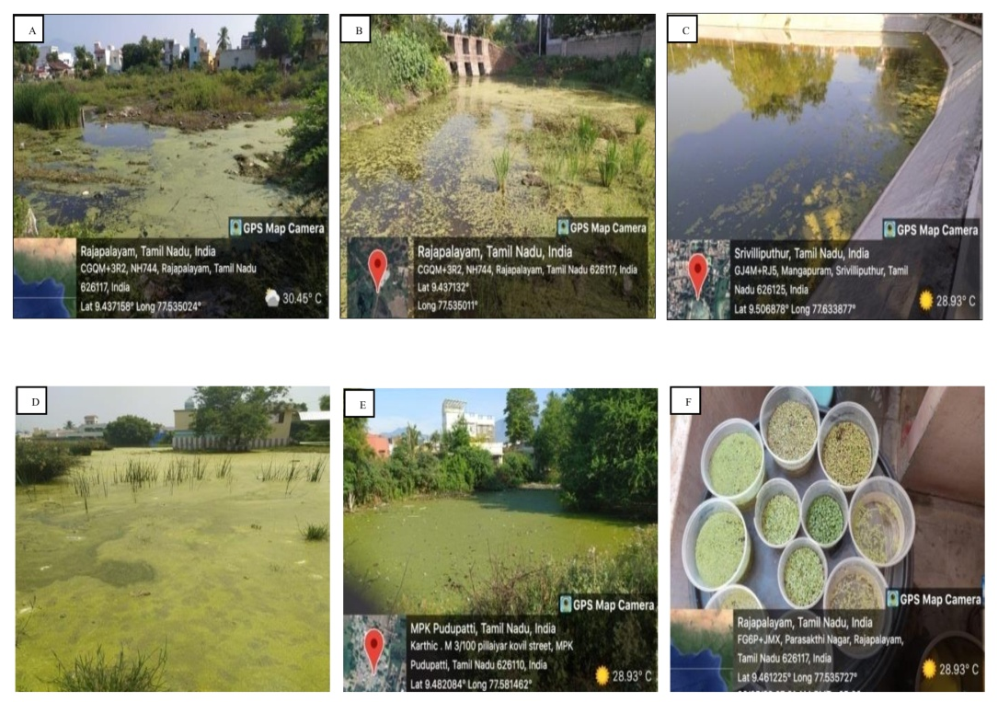

Figure1 . Collected locations of duckweeds from the water bodies of Rajapalayam, Sivakasi, Srivilliputhur taluks of Virudhunagar district, Tamil Nadu.

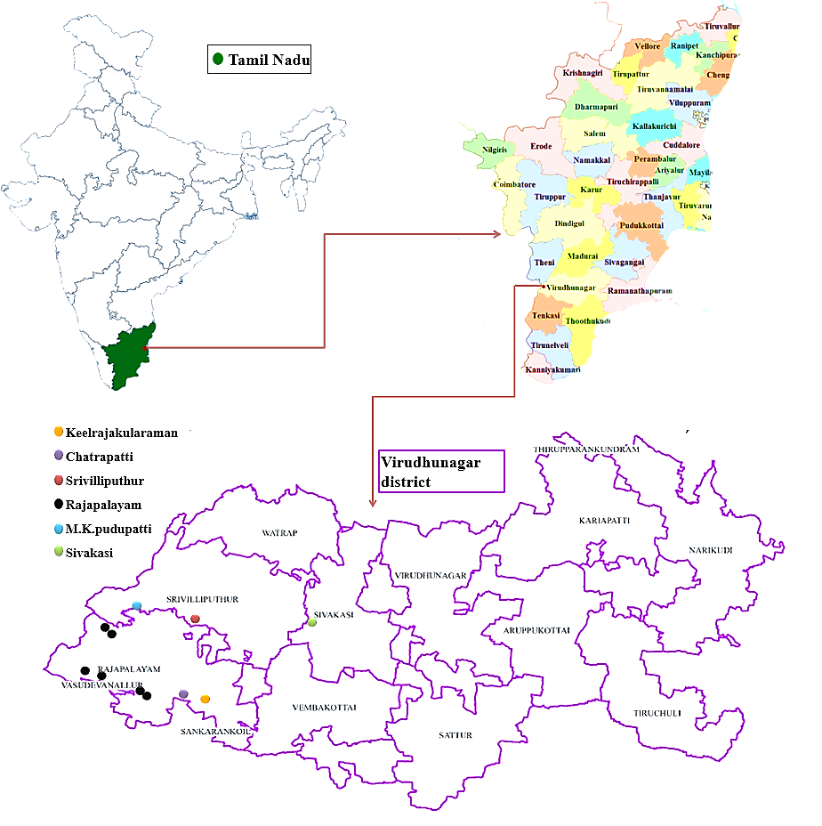
Figure3. The collected locations of Duckweed species in taluks (Rajapalayam, Srivilliputhur and Sivakasi) of Virudhunagar district, Tamilnadu.

