TITRATION-DERIVED LIME REQUIREMENT AND BUFFERING CAPACITY OF INLAND VALLEY SWAMP SOILS IN MOYAMBA DISTRICT, SIERRA LEONE

ABSTRACT
This study was conducted to determine the lime requirement (LR) and lime-buffering capacity (LBC) of selected inland valley swamp (IVS) soils in Moyamba District, Sierra Leone, using a calcium chloride/calcium hydroxide titration procedure, and to identify contrasting soils for subsequent lime-response calibration. Laboratory analytical survey of 51 IVS soils with triplicate titration determinations, descriptive classification of LR and LBC, replicate precision assessment, bivariate LR-LBC evaluation, exploratory clustering, and spatial interpretation. Soil samples were collected from 51 IVS sites in Moyamba District and analysed at the Njala University Quality Control Laboratory, Sierra Leone. Composite topsoil samples (0-20 cm) were air-dried, sieved to 2 mm, and titrated in 0.01 M CaCl₂. A 20 g soil subsample was equilibrated with 20 mL CaCl₂, after which 3 mL increments of 0.1 M Ca(OH)₂ were added with shaking and repeated pH measurement until pH 6.5 was attained. Added Ca(OH)₂ was converted to CaCO₃ equivalent, LBC was derived from the neutralizing requirement per unit pH change, and LR was expressed as t CaCO₃ ha⁻¹. Determinations were performed in triplicate. Titration-derived LR ranged from approximately 1.40 to 5.57 t CaCO₃ ha⁻¹. Forty-seven soils (92.2%) were classified as medium LR (2.0-4.0 t ha⁻¹), while two soils each (3.9%) were low (<2.0 t ha⁻¹) and high (>4.0 t ha⁻¹). LBC also varied substantially: 36 soils (70.6%) were medium (520-720 mg CaCO₃ kg⁻¹ soil pH unit⁻¹), eight (15.7%) were low, and seven (13.7%) were high. LR increased overall with LBC, but the relationship was dispersed, confirming that buffering capacity alone did not determine LR. Replicate precision was satisfactory for most soils, with most LR coefficients of variation below about 10%. Nyalahun (3.73 t CaCO₃ ha⁻¹) and Njala Junction (5.57 t CaCO3 ha⁻¹) represented contrasting medium- and high-LR soils, respectively. The IVS soils showed substantial heterogeneity in both acidity-neutralization demand and resistance to pH change. Soil pH alone is therefore inadequate for district-wide lime prescription. A soil-specific titration approach that integrates initial acidity, target pH, and buffering capacity provides a defensible basis for selecting lime rates, but the laboratory estimates should be calibrated under incubation and field conditions before recommendation to farmers.
Keywords: acid soil; calcium hydroxide titration; inland valley swamp; lime-buffering capacity; lime requirement; rice; Sierra Leone

1. INTRODUCTION
Rice (Oryza sativa L.) is Sierra Leone's principal staple and remains central to food security and agricultural development. The country's high rice consumption and persistent supply deficit continue to place pressure on domestic production systems. Inland valley swamps (IVSs) are especially important because their hydrological setting can support relatively reliable lowland rice production, but their productivity is constrained by strongly weathered soils, nutrient imbalance, and acidity-related limitations.
Soil acidity is a major fertility constraint in humid tropical environments. Intensive weathering and leaching progressively deplete basic cations and increase the relative importance of H⁺ and Al³⁺ on the soil exchange complex. The agronomic consequences include restricted root growth, altered nutrient availability, reduced phosphorus efficiency, and lower availability of Ca and Mg. Liming is the principal amendment used to neutralize soil acidity, yet the amount required cannot be inferred reliably from soil pH alone because pH measures the intensity of acidity rather than the quantity of acidity that must be neutralized (Van Lierop, 1990; Goulding, 2016).
Lime requirement is therefore best considered as a function of the difference between initial and target pH together with the soil's buffering capacity. Direct or single-addition titration with Ca(OH)₂ has been proposed as an alternative to conventional buffer methods because the rise in pH following known additions of base can be used to quantify pH-buffering capacity and estimate the lime needed to reach a target pH (Liu et al., 2004; Kissel et al., 2007). Studies of acidic soils have also shown that buffer capacity varies with organic carbon, clay, effective cation exchange capacity, pH-dependent charge, and exchangeable acidity, explaining why soils with similar initial pH may require different lime rates (Aitken et al., 1990a).
For West African inland valleys, this issue is particularly important because soils vary over short distances in hydrology, sediment deposition, parent material, landscape position, and organic matter accumulation (Andriesse & Fresco, 1991). In submerged rice soils, subsequent flooding also changes redox conditions and pH dynamics, meaning that laboratory LR estimates should be treated as the first stage of a calibration process rather than as final field recommendations (Ponnamperuma, 1972).
The present study therefore determined titration-derived LR and LBC for 51 IVS soils in Moyamba District, Sierra Leone. The specific objectives were to quantify the range and distribution of LR and LBC, evaluate their relationship and replicate precision, identify broad LR-LBC management groups, and select contrasting soils for subsequent incubation, pot, and field validation.

2. METHODOLOGY

2.1 Study Area
The study was conducted in Moyamba District in the Southern Province of Sierra Leone. The district has a tropical monsoon climate with a pronounced rainy season and contains extensive inland valley systems that receive water from direct rainfall, upland runoff, shallow groundwater, and localized stream inflows. These valley bottoms are important lowland rice environments but differ substantially in drainage, flooding duration, soil development, and management history.
A total of 51 IVS sites were purposively selected to represent variability in hydrology, land use, geographic distribution, accessibility, and potential for subsequent monitoring. The spatial distribution of the selected sampling locations is shown in Fig. 1.
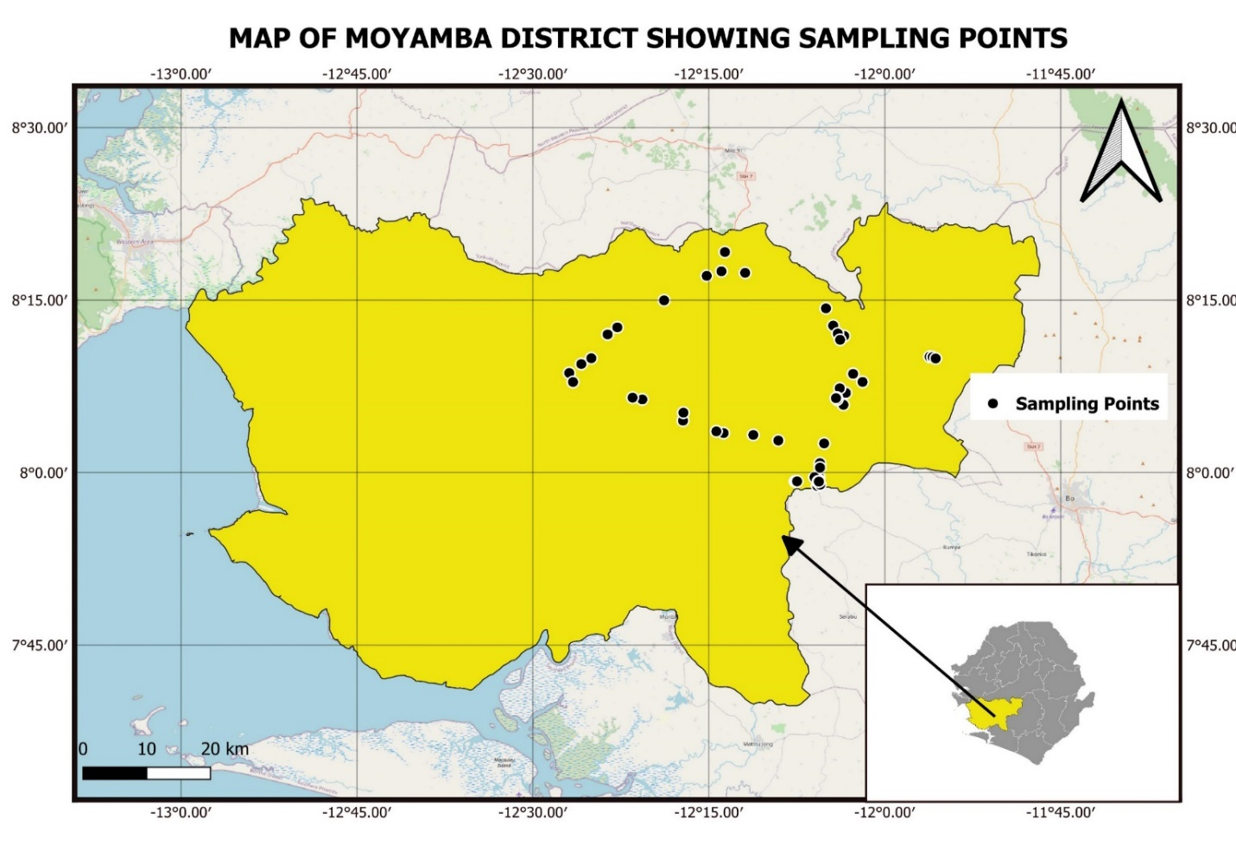
Fig. 1. Location of the 51 inland valley swamp sampling sites in Moyamba District, Sierra Leone.

2.2 Soil Sampling and Sample Preparation
At each IVS, a composite soil sample consisting of 10 cores was collected from the 0-20 cm topsoil layer. Samples were labelled and transported to the Njala University Quality Control Laboratory. In the laboratory, samples were air-dried at room temperature, gently crushed, and passed through a 2 mm sieve before analysis.
The broader soil characterization included texture, soil pH, exchangeable acidity and Al, exchangeable Ca and Mg, organic carbon, total N, and available P using standard analytical procedures. For the present manuscript, the analytical focus is the titration-based determination of LR and LBC.

2.3 Calcium Chloride/Calcium Hydroxide Titration
A modified Ca(OH)₂ titrimetric procedure buffered in CaCl₂ solution was used to estimate the amount of neutralizing material required to raise each soil to a target pH of 6.5. A 20 g subsample of air-dried, 2 mm-sieved soil was placed in a labelled centrifuge tube and mixed with 20 mL of 0.01 M CaCl₂ to provide a constant ionic-strength background. The suspension was shaken for 5 min and the initial pH was measured using a calibrated glass-electrode pH meter.
Thereafter, 3 mL aliquots of 0.1 M Ca(OH)₂ were added sequentially. Following each addition, the soil suspension was shaken for 5 min and pH was re-measured. The addition-equilibration-measurement cycle was continued until the target pH of 6.5 was reached. All titrations were performed in triplicate to assess analytical repeatability.

2.4 Calculation and Classification of Lime Requirement and Buffering Capacity
The volume and molarity of Ca(OH)₂ added to each soil were converted to CaCO₃ equivalent. Lime-buffering capacity was expressed as the amount of CaCO₃ equivalent required per kilogram of soil for a unit change in pH. Lime requirement to pH 6.5 was then calculated from the initial-to-target pH difference and the measured buffering response, and was expressed as t CaCO₃ ha⁻¹. A 0.6 adjustment factor was applied in the calculation procedure used for the study.
For interpretation, LR classes were defined as low (<2.0 t CaCO₃ ha⁻¹), medium (2.0-4.0 t CaCO₃ ha⁻¹), and high (>4.0 t CaCO₃ ha⁻¹). LBC was grouped as low (<520 mg CaCO₃ kg⁻¹ soil pH unit⁻¹), medium (520-720 mg CaCO₃ kg⁻¹ soil pH unit⁻¹), and high (>720 mg CaCO₃ kg⁻¹ soil pH unit⁻¹).

2.5 Data Analysis
Replicate titration results were summarized by site using means and measures of replicate variation. Coefficients of variation (CV) were examined as an analytical quality-control indicator. Class frequencies and percentages were calculated for LR and LBC. The relationship between mean LBC and mean LR was examined graphically with a fitted linear trend, while standardized LR and LBC values were also explored using K-means clustering with k = 3 to identify broad multivariate acidity-management groups. Spatial plots were used to examine the geographic distribution of continuous LR/LBC values and their classes.
Because the principal purpose of this phase was laboratory determination and classification, the analyses were interpreted as calibration-support diagnostics rather than as final agronomic recommendations.

3. RESULTS AND DISCUSSION

3.1 Variation in Titration-Derived Lime Requirement
The 51 IVS soils differed markedly in the amount of lime required to reach the target pH of 6.5 (Fig. 2). LR ranged from approximately 1.40 t CaCO₃ ha⁻¹ at Waterloo to 5.57 t CaCO₃ ha⁻¹ at Njala Junction. Magbondo also occurred near the upper end of the LR distribution, whereas Senehun and Waterloo had the smallest requirements. Most soils, however, occupied a relatively narrow central band between the low and high extremes.
This variability demonstrates why a uniform lime rate based only on district location or initial soil pH would be poorly justified. Soil pH indicates acidity intensity, whereas LR reflects the amount of acidity that must be neutralized to achieve a target condition (Van Lierop, 1990). Direct titration studies similarly show that LR is governed by both initial pH and the slope of the soil pH response to added base (Liu et al., 2004; Kissel et al., 2007). The relatively high LR at Njala Junction and Magbondo therefore indicates greater acidity-neutralization demand, which may reflect higher reserve acidity, stronger pH-dependent buffering, or a larger initial-to-target pH gap.
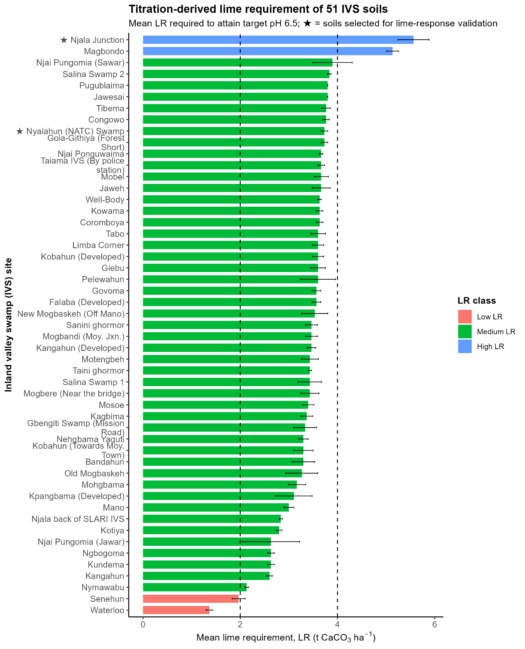
Fig. 2. Titration-derived lime requirement of 51 inland valley swamp soils to attain pH 6.5. Error bars represent variation among titration replicates; colours indicate low, medium, and high LR classes.

3.2 Distribution of Lime-Requirement Classes
The LR classification was strongly concentrated in the medium category. Forty-seven of the 51 soils (92.2%) required 2.0-4.0 t CaCO₃ ha⁻¹, whereas two soils (3.9%) were classified as low LR and two (3.9%) as high LR (Fig. 3a; Table 1). This concentration suggests that a similar order of lime input may be relevant to many IVS soils, but it does not support a single blanket rate because the tails of the distribution represent soils at greater risk of under-liming or over-liming.
The need for calibration is particularly important because laboratory LR values do not automatically translate to identical field rates. Liming-material purity and particle size, effective calcium carbonate equivalent, incorporation depth, soil moisture, and field reaction time can all alter the realized pH response. Aitken et al. (1990b) showed that laboratory methods vary in their ability to predict the lime needed to achieve a target pH, reinforcing the value of subsequent incubation and field testing.

3.3 Lime-Buffering Capacity of the IVS Soils
LBC also varied substantially among sites (Fig. 3b and Fig. 4). Thirty-six soils (70.6%) were medium LBC, eight (15.7%) were low, and seven (13.7%) were high. Thus, although the middle class predominated, almost 30% of the sampled soils fell outside the central buffering range.
The agronomic significance of this pattern is straightforward: high-LBC soils require more neutralizing material to achieve a given unit increase in pH, whereas weakly buffered soils can respond rapidly to smaller lime additions and may therefore be more vulnerable to over-liming. Buffering capacity is affected by organic matter, clay content and mineralogy, effective CEC, exchangeable acidity, and pH-dependent surface charge. In acidic Queensland soils, Aitken et al. (1990a) found large differences in pH-buffer capacity and demonstrated that pH-dependent charge and related soil properties explained much of the variation. The present results similarly show that two IVS soils with comparable initial pH should not be assumed to have equivalent lime needs.
Table 1. Summary of titration-derived lime requirement and lime-buffering capacity classes among the 51 IVS soils.
Indicator | Class | Threshold | No. of soils | Proportion (%)
Lime requirement | Low | <2.0 t CaCO3 ha-1 | 2 | 3.9
Lime requirement | Medium | 2.0-4.0 t CaCO3 ha-1 | 47 | 92.2
Lime requirement | High | >4.0 t CaCO3 ha-1 | 2 | 3.9
Buffering capacity | Low | <520 mg CaCO3 kg-1 pH unit-1 | 8 | 15.7
Buffering capacity | Medium | 520-720 mg CaCO3 kg-1 pH unit-1 | 36 | 70.6
Buffering capacity | High | >720 mg CaCO3 kg-1 pH unit-1 | 7 | 13.7
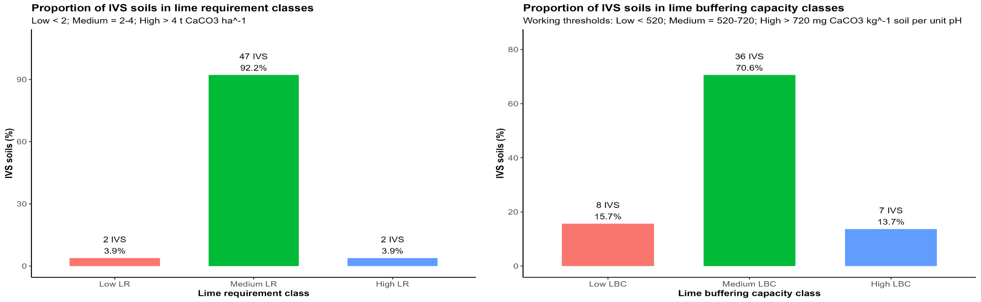
Fig. 3. Distribution of the 51 IVS soils among (a) lime-requirement classes and (b) lime-buffering-capacity classes.
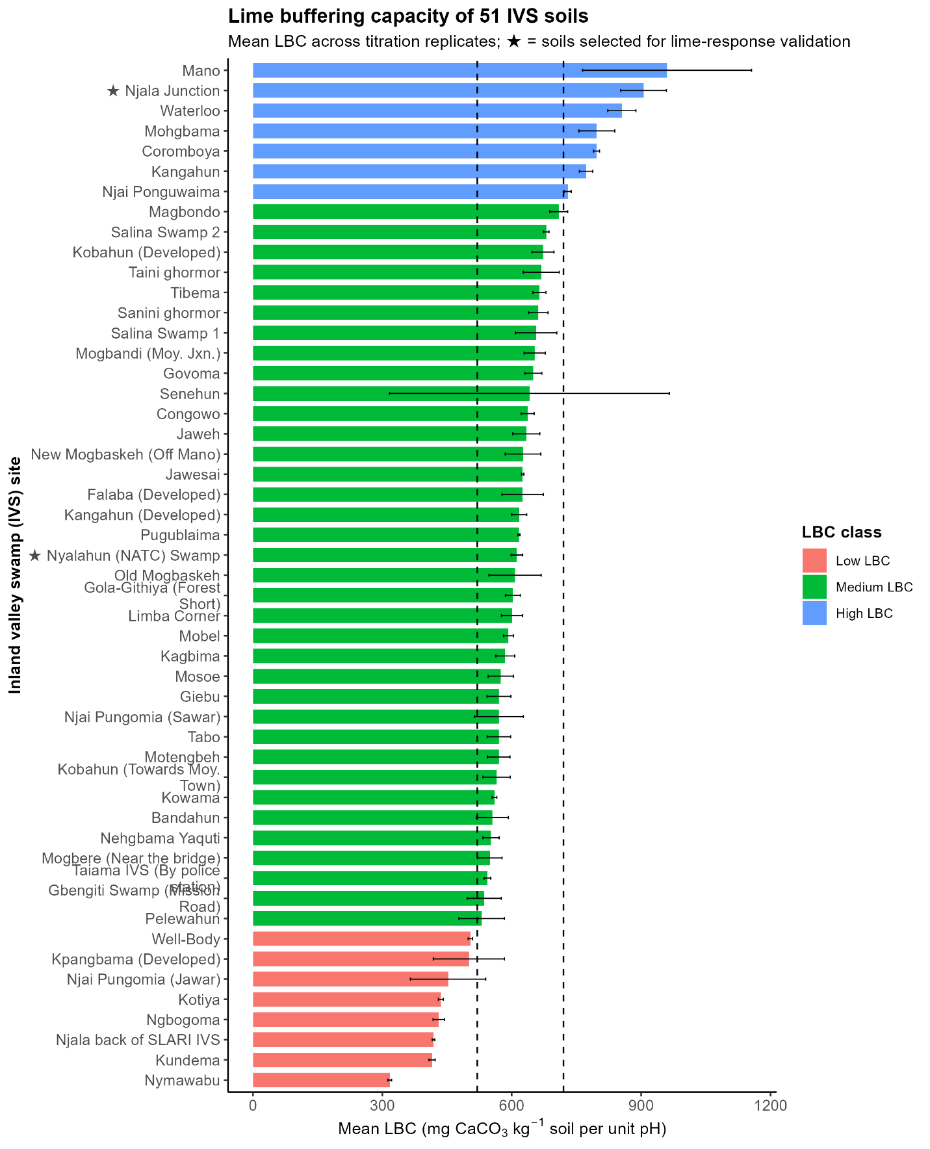
Fig. 4. Lime-buffering capacity of the 51 IVS soils. Error bars represent replicate variation; colours indicate low, medium, and high LBC classes.

3.4 Relationship Between Buffering Capacity and Lime Requirement
Mean LR showed an overall positive association with mean LBC (Fig. 5): soils that resisted pH changes more strongly generally required more CaCO₃ to attain pH 6.5. However, the observations were widely dispersed around the fitted trend, particularly at relatively high LBC. This indicates that LBC is an important determinant of LR but is not sufficient on its own to predict the required lime rate.
The pattern is consistent with the conceptual formulation used in titration-based LR methods. Kissel et al. (2007) define LR from the combined effects of initial pH, target pH, and soil pH-buffering capacity. Accordingly, a strongly buffered soil that begins relatively close to pH 6.5 can have a smaller LR than another soil with comparable buffering but a much lower starting pH. The apparent outliers in the present data are therefore agronomically informative because they may represent different combinations of reserve acidity, mineralogy, organic-matter buffering, and initial pH rather than analytical error alone.
This distinction has practical relevance for soil-test interpretation. If only pH is measured, the quantity of neutralizable acidity is unknown; if only LBC is considered, the starting acidity and target-pH gap are ignored. A robust lime advisory system therefore needs both components.
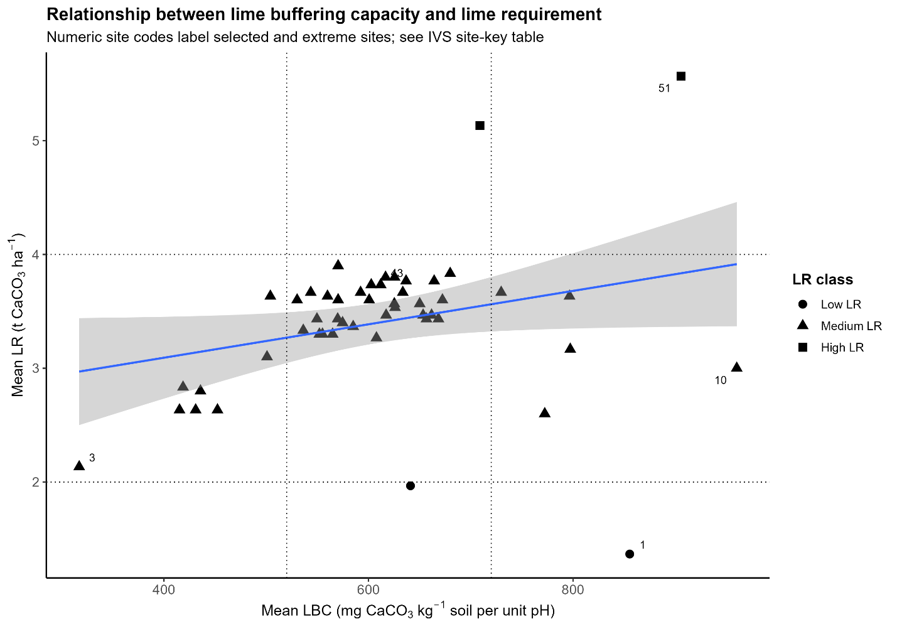
Fig. 5. Relationship between mean lime-buffering capacity and titration-derived lime requirement of the 51 IVS soils. The fitted line summarizes the overall trend; symbols denote LR classes.

3.5 Precision of the Titration Procedure
Replicate precision was generally satisfactory. Most soils had LR replicate CV values below approximately 10%, while a smaller number had moderate variability and two sites showed CV values above 20%. This pattern suggests that the titration procedure was reproducible for most samples, but that a limited number of soils require closer quality-control review.
Higher replicate variability can arise from heterogeneity within the composite sample, incomplete homogenization, endpoint instability, unequal equilibration, or small pH-reading differences that propagate into calculated buffering capacity and LR. The importance of standardization is supported by Kissel et al. (2007), who reported that Ca(OH)₂-based titration can yield precise LR estimates when the analytical procedure is carefully controlled. For routine soil-testing use, replicate CV therefore provides a useful trigger for re-analysis of atypical samples.

3.6 Exploratory LR-LBC Grouping
Joint analysis of standardized LR and LBC separated the soils into three exploratory clusters. The dominant cluster contained 39 soils (76.5%), while the remaining clusters contained seven (13.7%) and five (9.8%) soils. The predominance of the central group is consistent with the univariate class distributions, which also showed that most soils occupied intermediate LR and LBC ranges.
The value of the cluster approach is not that it produces final recommendation zones, but that it identifies soils with different combinations of acidity-neutralization demand and pH resistance. These groups can be used to select representative soils for calibration experiments and to identify atypical sites where a general recommendation is least likely to perform reliably.

3.7 Selection of Contrasting Soils for Validation and Spatial Implications
Nyalahun and Njala Junction were selected as contrasting soils for subsequent validation (Fig. 6). Nyalahun had a mean LR of about 3.73 t CaCO₃ ha⁻¹ and was classified as medium LR, whereas Njala Junction had a mean LR of 5.57 t CaCO₃ ha⁻¹ and represented the high-LR class. This contrast provides a useful test of whether laboratory differences in acidity-neutralization demand translate into different pH, soil-chemical, and crop responses under incubation and agronomic conditions.
Spatial plots of LR and LBC showed local heterogeneity rather than a single geographic gradient. High and low values could occur within the same broad sampling region. This is expected in inland valleys, where hydrology, parent material, erosion and deposition, organic-matter accumulation, and landscape position vary over short distances (Andriesse & Fresco, 1991). The result argues against a district-wide blanket lime rate and instead supports site-specific soil testing or, where resources are limited, management domains that are first validated biologically.
The need for validation is especially strong for flooded rice systems. Soil submergence alters redox potential and can shift pH, Fe chemistry, and nutrient transformations relative to the aerobic laboratory state (Ponnamperuma, 1972). Consequently, titration-derived LR should be interpreted as a technically defensible starting estimate whose agronomic effectiveness must be confirmed under the intended water regime.
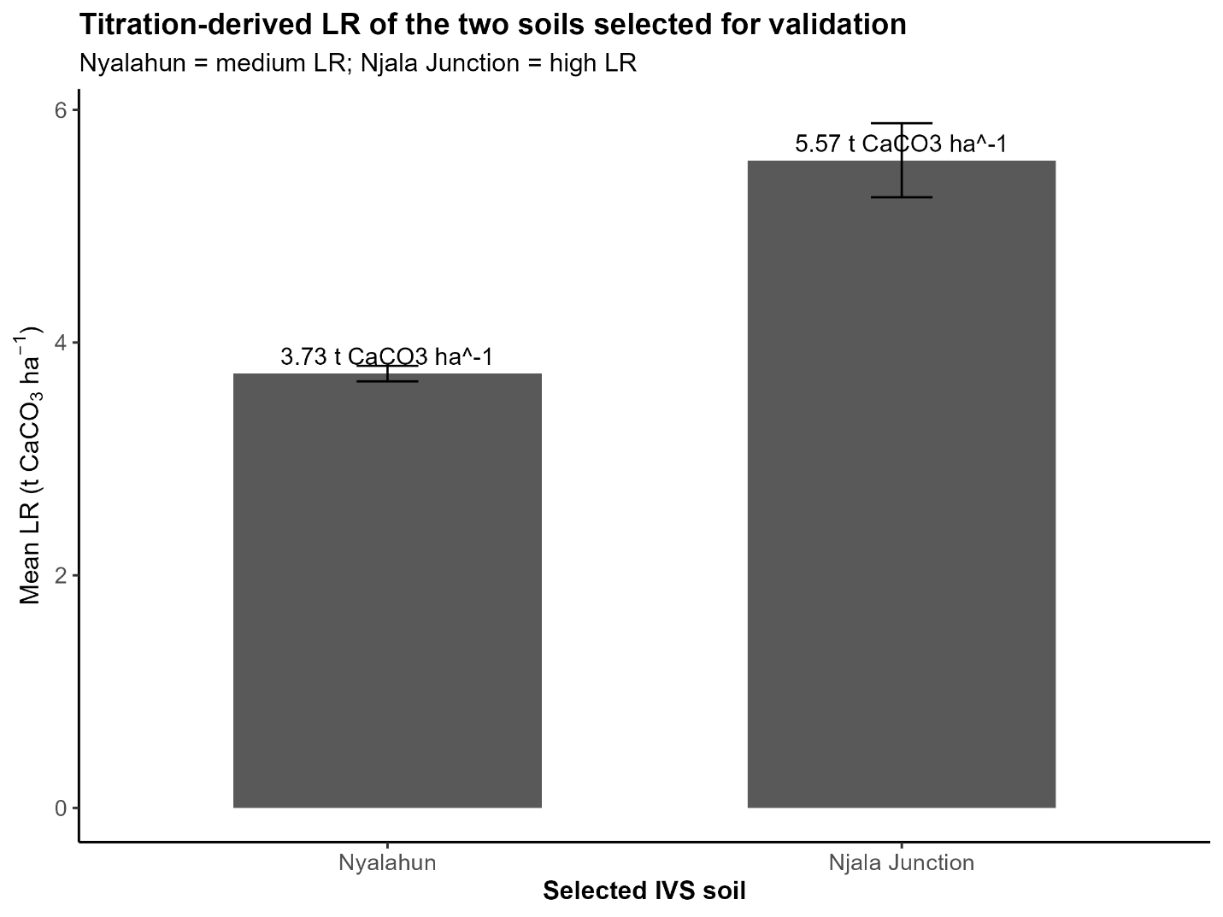
Fig. 6. Titration-derived LR of Nyalahun and Njala Junction IVS soils selected for subsequent lime-response validation. Error bars represent replicate variation.

4. CONCLUSION
The CaCl₂/Ca(OH)₂ titration procedure revealed substantial variation in both lime requirement and lime-buffering capacity among 51 inland valley swamp soils of Moyamba District. LR ranged from about 1.40 to 5.57 t CaCO₃ ha⁻¹, with 92.2% of soils in the medium LR class, while 70.6% of soils had medium buffering capacity. The positive but dispersed LR-LBC relationship confirmed that greater buffering generally increases the lime needed to reach pH 6.5, but also demonstrated that buffering capacity does not determine LR independently of initial soil acidity and target pH.
These findings establish a laboratory basis for site-specific acidity management and show that soil pH alone is insufficient for prescribing a uniform lime rate across the IVS landscape. Nyalahun and Njala Junction provide suitable contrasting soils for subsequent validation because they represent medium and high acidity-neutralization demand, respectively. Before practical recommendations are issued, the titration-derived rates should be calibrated against pH and chemical responses during incubation and against rice growth, yield, and soil acidity under pot and field conditions.

COMPETING INTERESTS
Authors have declared that no competing interests exist.

DATA AVAILABILITY
The data supporting the findings of this study are available from the corresponding author on reasonable request.
Declaration of AI Use

This manuscript was prepared through the intellectual contributions of the author(s) to the study design, data analysis, interpretation of results, and scholarly content. Grammarly and ChatGPT were used solely to assist with grammatical refinement and reference formatting during manuscript revision. The author(s) accept full responsibility for the accuracy, integrity, and final content of the manuscript.

REFERENCES
Aitken, R. L., Moody, P. W., & McKinley, P. G. (1990a). Lime requirement of acidic Queensland soils. I. Relationships between soil properties and pH buffer capacity. Australian Journal of Soil Research, 28(5), 695-701. https://doi.org/10.1071/SR9900695
Aitken, R. L., Moody, P. W., & McKinley, P. G. (1990b). Lime requirement of acidic Queensland soils. II. Comparison of laboratory methods for predicting lime requirement. Australian Journal of Soil Research, 28(5), 703-715. https://doi.org/10.1071/SR9900703
Andriesse, W., & Fresco, L. O. (1991). A characterization of rice-growing environments in West Africa. Agriculture, Ecosystems & Environment, 33(4), 377-395. https://doi.org/10.1016/0167-8809(91)90059-7
Goulding, K. W. T. (2016). Soil acidification and the importance of liming agricultural soils with particular reference to the United Kingdom. Soil Use and Management, 32(3), 390-399. https://doi.org/10.1111/sum.12270
Kissel, D. E., Isaac, R. A., Hitchcock, R., Sonon, L. S., & Vendrell, P. F. (2007). Implementation of soil lime requirement by a single-addition titration method. Communications in Soil Science and Plant Analysis, 38(9-10), 1341-1352. https://doi.org/10.1080/00103620701328735
Liu, M., Kissel, D. E., Vendrell, P. F., & Cabrera, M. L. (2004). Soil lime requirement by direct titration with calcium hydroxide. Soil Science Society of America Journal, 68(4), 1228-1233. https://doi.org/10.2136/sssaj2004.1228
Owusu-Bennoah, E., Acquaye, D. K., & Terkpertey, A. (1995). Comparative study of selected lime requirement methods for some acid Ghanaian soils. Communications in Soil Science and Plant Analysis, 26, 937-950. https://doi.org/10.1080/00103629509369346
Ponnamperuma, F. N. (1972). The chemistry of submerged soils. Advances in Agronomy, 24, 29-96. https://doi.org/10.1016/S0065-2113(08)60633-1
Van Lierop, W. (1990). Soil pH and lime requirement determination. In R. L. Westerman (Ed.), Soil testing and plant analysis (3rd ed., pp. 73-126). Soil Science Society of America. https://doi.org/10.2136/sssabookser3.3ed.c5
World Bank. (2022, December 15). World Bank approves additional financing to strengthen the resilience of food systems in Sierra Leone. World Bank. https://www.worldbank.org/en/news/press-release/2022/12/15/world-bank-approves-additional-financing-to-strengthen-the-resilience-of-food-systems-in-sierra-leone

