Statistical Intelligence for Detecting AI Model Aging and Concept Drift in Adaptive Cybersecurity Systems

Abstract
Machine-learning intrusion detectors are typically validated once at deployment and then trusted indefinitely. This is unsafe because the traffic distribution used for training differs from what deployed detectors encounter, with the gap widening as adversaries introduce unseen techniques. We formalise this degradation as model aging and develop a statistical decision framework that identifies, without ground-truth labels, when a cybersecurity model becomes unreliable and when retraining is economically justified.
The framework combines Population Stability Index, Kullback–Leibler and Jensen–Shannon divergences, Wasserstein-1 distance, the two-sample Kolmogorov–Smirnov statistic, and sequential ADWIN, Page–Hinkley, and CUSUM procedures with two bounded state variables: the Model Aging Index (MAI), which accumulates null-calibrated distributional stress under exponential forgetting, and the Cybersecurity Drift Index (CDI), which incorporates the asymmetric costs of missed intrusions and false alerts. We prove that both indices are bounded, monotone, and Lipschitz, while their stationary exceedance probability admits an explicit bound for certified false-alarm control. The underlying marginal transport statistic also lower-bounds the joint Wasserstein radius, establishing alarm soundness.
Retraining is formulated as an optimal-stopping problem, yielding a control-limit policy analogous to an inventory replenishment threshold. Experiments on NSL-KDD introduce 17 genuinely novel attack types across 100 batches, five drift regimes, and seven architectures. Novel-family drift reduces attack recall from 0.99 to 0.57–0.66. The CDI controller cuts expected cost by 44.3% versus no retraining and 17.3% versus periodic retraining, while closing 79% of the oracle gap. Notably, periodic retraining can be harmful under adversarial drift.
Keywords: concept drift; model aging; intrusion detection; Wasserstein distance; statistical process control; optimal stopping; adaptive retraining; adversarial evasion

1. Introduction

1.1 The unstated assumption in deployed security analytics
Nearly every published machine-learning intrusion detection system reports a single number: an F1-score, an AUC, an accuracy on a held-out partition. That number is a statement about one moment. It says that on a sample drawn from the same distribution as the training data, the classifier separates malicious from benign traffic well. It says nothing about the classifier’s behaviour six months later, when the protocol mix has shifted, when a scanning campaign that did not exist at training time saturates the perimeter, or when an adversary has learned to shape flows so that they land on the benign side of the decision boundary.
The assumption underwriting the single number is stationarity: that the joint law $P\left(X,Y\right)$ of features and labels is fixed. In cybersecurity this assumption is not merely approximate, it is adversarially false. The data-generating process contains an agent whose objective is to move probability mass across the decision boundary. Concept drift is therefore not an environmental nuisance to be smoothed away; it is the medium in which the problem lives [3, 4].
The consequences are quantitative and severe. Pendlebury et al. [4] demonstrated that eliminating temporal bias from evaluation protocols reduces reported malware-detection performance dramatically, and that published figures near 0.99 are largely artefacts of experimental design. Our own measurements, reported in Section 8, reproduce this in the network-intrusion setting: a gradient-boosted detector achieving F1 = 1.000 on its reference window falls to F1 = 0.775 with attack recall of 0.659 once one quarter of the traffic consists of attack families it has never observed. The detector does not announce this. Its confidence scores remain high; its dashboard is green; it is simply wrong about a third of the intrusions it is supposed to catch.

1.2 From drift detection to model aging
A substantial literature addresses drift detection deciding whether the current data window differs from a reference [1, 2]. Rather less addresses the question a security operations centre actually asks, which is not “has the distribution changed?” but “is my model still trustworthy, and is it worth the cost of rebuilding it?”
These are different questions, and conflating them causes two failure modes observed repeatedly in practice. First, drift detectors are binary and memoryless: they fire or they do not, and having fired they discard the accumulated evidence. But model degradation is cumulative. A detector exposed to a slow, sub-threshold shift for forty batches is meaningfully more degraded than one exposed to the same shift for four, yet a hypothesis test at fixed level treats the two identically. Second, most detectors are supervised: ADWIN, Page–Hinkley and CUSUM monitor an error stream, which presupposes labels. In network security, labels arrive from analyst triage expensive, partial, and delayed by days. A monitoring apparatus that requires the very labels whose scarcity motivates automation is of limited operational value.
We therefore reframe the problem around model aging: the monotone accumulation of distributional stress that erodes the validity of a fitted decision rule. Aging is a continuous latent state, not an event. What an operator needs is an estimate of that state bounded, interpretable, computable without labels together with a decision rule that converts the estimate into an action under an explicit cost model.

1.3 Contributions
This paper makes five contributions.
(i) A unified statistical monitoring battery: We place eight drift statistics on a common footing by Monte-Carlo calibration of each against a bootstrap null constructed from the reference window, so that every detector operates at a matched nominal false-alarm rate and comparisons of detection delay are meaningful rather than artefacts of arbitrary thresholds (Section 4).
(ii) The Model Aging Index: MAI accumulates null-calibrated, hinge-transformed drift signals under exponential forgetting and maps the accumulator into $\left[0,1\right]$ through a saturating link. We prove boundedness and normalisation (Proposition 1), monotonicity and Lipschitz continuity (Proposition 2), an explicit stationary exceedance bound that converts a target false-alarm rate into a threshold (Proposition 3), soundness via the marginal-transport inequality (Proposition 4), and asymptotic detection power for location-shift families (Proposition 5) (Section 5).
(iii) The Cybersecurity Drift Index: CDI reweights the aging signal along two channels an evasion channel measuring probability mass migrating below the alert threshold, and an alert-load channel with weights derived from the cost asymmetry between missed intrusions and false alarms. Unlike MAI, CDI is explicitly a security state variable, not a statistical one (Section 5.4).
(iv) Retraining as optimal stopping: We formulate the retrain/keep decision as a Markov decision process on the aging state and prove that the cost-minimising rule is a control-limit policy (Theorem 1) structurally the same object as a replenishment threshold in inventory control [33, 35], which permits the transfer of a mature body of operations-research technique into model lifecycle management (Section 6).
(v) A controlled empirical study with an authentic novelty channel: Rather than simulating drift by reweighting attack families the model already knows which produces virtual drift and correspondingly mild degradation, we exploit the fact that KDDTest+ contains 17 attack types entirely absent from KDDTrain+, giving 3,750 records of genuinely unseen threat behaviour. Five drift regimes, seven architectures, and eleven detectors are evaluated over 100 batches, with retraining-policy comparisons computed exactly from precomputed lookup tables rather than approximated (Sections 7–8).

1.4 Organisation
Section 2 reviews related work. Section 3 formalises the streaming problem and the drift taxonomy. Section 4 defines the monitoring battery. Section 5 develops MAI and CDI with proofs. Section 6 establishes the control-limit result. Section 7 describes the experimental design; Section 8 reports results. Sections 9–11 discuss implications, limitations and conclusions.

2. Related Work

2.1 Concept drift in data streams
The general theory of learning under drift is surveyed by Gama et al. [2] and Lu et al. [1], who distinguish real drift (a change in $P\left(Y∣X\right)$, which moves the Bayes-optimal boundary) from virtual drift (a change in $P\left(X\right)$ alone). The distinction matters for our purposes because unsupervised monitors observe only the covariate and score distributions and therefore cannot, in principle, separate the two without labels. Our position is that this is acceptable in the security setting: virtual drift in network traffic is rarely benign, and a covariate shift large enough to be detected is itself actionable evidence about the operating environment.
Detection methods fall into three families. Window-comparison methods contrast a reference and a detection window under a two-sample test the Kolmogorov–Smirnov statistic, the Population Stability Index inherited from credit-risk monitoring, and information-theoretic divergences. Sequential methods monitor a scalar stream for a change point: CUSUM [14], Page–Hinkley [15], and ADWIN [13], which maintains an adaptive window and cuts it when two sub-windows differ beyond a Hoeffding bound. Learner-based and ensemble methods adapt the model rather than signalling, including adaptive random forests [11] and adaptive gradient boosting [12]; recurring-concept streams have their own literature [22], and the broader methodological challenges of streaming under drift are surveyed in [31]. Statistical drift-detection ensembles that combine several tests for batch streams [32] are close in spirit to our battery, though they aggregate for detection rather than accumulating for state estimation.
Transport-based monitoring has grown rapidly. DriftLens [21] compares deep-embedding distributions under a Fréchet (Wasserstein-2) distance, and feature-level drift description using Wasserstein and energy distances predates it. Our use of the Wasserstein-1 distance is motivated less by empirical performance than by the Kantorovich–Rubinstein duality, which is what allows Proposition 4 to connect the monitored statistic to a risk envelope [16].

2.2 Drift in security applications
Security-specific work has concentrated on malware classification. Transcend [6] and its successor [7] use conformal prediction to reject drifted samples at inference. CADE [8] detects and explains drifting samples through contrastive embedding distances. TESSERACT [4, 5] is methodological rather than algorithmic, establishing the temporal and spatial constraints an honest evaluation must satisfy; we adopt its discipline by never allowing information from post-drift batches to influence the reference window or any preprocessing transform. Continuous-learning approaches [9] and drift-robust network detectors such as INSOMNIA [10] address adaptation.
Shyaa et al. [3] survey drift-aware intrusion detection specifically and conclude that the integration of concept and feature drift within IDS remains underexplored that most work treats drift generically or treats IDS without dynamics. The present paper is a direct response to that gap, with the addition that we treat the decision about retraining, not only its detection. Adversarial machine learning for network intrusion detection [24] intersects our fifth drift regime: evasive perturbation is drift with an optimising agent behind it, and, as Section 8.5 shows, it interacts with retraining policy in a way that ordinary distributional drift does not.

2.3 When to retrain
The economics of retraining have received attention only recently. Mahadevan and Mathioudakis [19] formulate cost-aware retraining as an explicit trade-off between staleness cost and retraining cost and propose CARA, which approximates post-retraining performance to decide. Regol et al. [20] argue that shift detection alone cannot account for the cost trade-off and propose forecasting the evolution of a bounded performance metric. Our formulation differs in three respects: the decision state is an explicitly constructed, provably bounded aging index rather than a forecast of accuracy; the cost model is asymmetric in a way specific to security (a missed intrusion is not a false alert); and we prove structural optimality of the threshold form rather than proposing a heuristic. The connection we draw to control-limit policies in inventory replenishment [33, 35] appears not to have been made previously, though it is, in retrospect, immediate: a model is an asset that depreciates stochastically and is replaced at a fixed setup cost.

3. Problem Formulation

3.1 The monitored stream
Let $X⊆R^{d}$ be a feature space of network-flow descriptors and $Y=\{0,1\}$ with $Y=1$ denoting an intrusion. A detector $f_{θ}:X→\left[0,1\right]$ is fitted on a reference window $W_{0}=\{\left(x_{i},y_{i}\right)\}_{i=1}^{n_{0}}$ drawn from a reference law $P$, and issues an alert when $f_{θ}\left(x\right)>τ_{alert}$.
After deployment the system observes an unlabelled stream partitioned into batches $B_{t}=\{x_{t,1},…,x_{t,n}\}$, $t=1,2,…$, with $B_{t}∼Q_{t}$. Ground truth $y_{t,i}$ becomes available only for an audited subsample of rate $π_{\text{aud}}$ after a latency of $l$ batches; in our experiments $π_{\text{aud}}=5\%$ and $l=3$. All statistics used by MAI and CDI are functions of $\left(B_{t},f_{θ}\right)$ alone and use no labels whatsoever.

3.2 Aging, formally
Write $R_{Q}\left(f\right)=E_{\left(X,Y\right)∼Q}\left[l\left(f\left(X\right),Y\right)\right]$ for the risk of $f$ under law $Q$ and define the aging gap at batch $t$ as
$$Δ_{t} = R_{Q_{t}}\left(f_{θ}\right) - R_{P}\left(f_{θ}\right).$$
$Δ_{t}$ is what an operator would like to know and cannot observe without labels. The programme of this paper is to construct an observable, bounded surrogate ${MAI}_{t}$ that (a) is provably small when $Q_{t}=P$, (b) increases monotonically with accumulated distributional stress, and (c) supports a decision rule with certified false-alarm behaviour. We are explicit that MAI is not an estimator of $Δ_{t}$ and does not upper-bound it (see the discussion after Proposition 4); it is a state variable for a control problem.

3.3 A five-regime drift taxonomy
We evaluate against five regimes, parameterised by a mixing weight $α\left(t\right)∈\left[0,1\right]$ between a pre-drift environment $E_{A}$ and a post-drift environment $E_{B}$, and an evasion intensity $ϕ\left(t\right)∈\left[0,1\right]$:
- No drift ($S_{1}$): $α\left(t\right)≡0$. Establishes the false-alarm baseline.
- Gradual drift ($S_{2}$: $α\left(t\right)$ ramps linearly from 0 to 1 over $t∈\left[40,80\right]$.
- Abrupt drift ($S_{3}$): $α\left(t\right)=1\left[t≥50\right]$.
- Recurring drift ($S_{4}$): $α\left(t\right)$ alternates between 0 and 1 on a 25-batch square wave from $t=20$, so that $E_{A}$ periodically returns.
- Adversarial drift ($S_{5}$): $α\left(t\right)≡0$, but a fraction $ϕ\left(t\right)$ of attack flows rising from 0 at $t=40$ to 0.70 is transported toward the benign centroid ${\overset{‾}{x}}_{ben}$ by the mimicry map $x↦0.6x+0.4{\overset{‾}{x}}_{ben}+ε$, $ε∼N\left(0,{0.02}^{2}I\right)$, with labels unchanged.
Regime $S_{5}$ is qualitatively distinct: it is drift with an optimiser behind it, and it violates the exchangeability that justifies retraining on recent data.

4. The Statistical Monitoring Battery

4.1 Batch divergence statistics
Let $s_{t}=\{f_{θ}\left(x\right):x∈B_{t}\}$ denote the batch score set and $s_{0}$ the reference score set. Bin the score axis at reference deciles to obtain reference and current histograms $p^{ref},p^{t}$ over $m=10$ bins with additive smoothing $ϵ={10}^{-6}$. We compute:
$${PSI}_{t}=\sum_{b=1}^{m}{\left(p_{b}^{t}-p_{b}^{ref}\right)}ln\frac{p_{b}^{t}}{p_{b}^{ref}}, {KL}_{t}=\sum_{b=1}^{m}{p_{b}^{t}}ln\frac{p_{b}^{t}}{p_{b}^{ref}},$$
JSt=12​b​pbreflog2pbrefpb+12​b​pbtlog2pbtpb, p=12pref+pt,
together with the Wasserstein-1 distance $W_{1,t}=\int_{0}^{1}{\left|F_{s_{0}}^{-1}\left(u\right)-F_{s_{t}}^{-1}\left(u\right)\right|} du$ and the two-sample Kolmogorov–Smirnov statistic ${KS}_{t}=\sup_{z}\left|F_{s_{0}}\left(z\right)-F_{s_{t}}\left(z\right)\right|$. PSI is symmetric and unbounded, KL asymmetric and unbounded, JS bounded in $\left[0,1\right]$ under base-2 logarithms, $W_{1}$ a true metric sensitive to the magnitude of displacement rather than only its presence, and KS sensitive to the largest single CDF gap.

4.2 Covariate transport in the model’s own geometry
Score-space statistics are blind to covariate shifts that the model happens to map to similar scores. We therefore add an importance-weighted marginal transport statistic. Let $J$ index the 30 highest-importance features under a surrogate random forest fitted on the same window, with normalised weights $w_{j}$, j∈J​wj=1. Then
Dtcov = j∈J​wj W1​Pj, Qt,j,
where $P_{j},Q_{t,j}$ are the $j$-th marginals. Weighting by importance directs statistical attention to the subspace on which the decision rule actually depends. Because all features are quantile-transformed to $\left[0,1\right]$ using a transform fitted on the reference window only, the marginals share a common bounded support and the $W_{1}$ values are commensurable across features.

4.3 Uncertainty, prior and evasion statistics
Three further scalars complete the battery. The confidence statistic $D_{t}^{cnf}=\left|H\left(s_{t}\right)-H\left(s_{0}\right)\right|$, where Hs=-1si​silog2si+1-silog21-si is mean binary predictive entropy, captures the inflation of predictive uncertainty characteristic of out-of-distribution input. The prior statistic $D_{t}^{pri}=\left|{\hat{π}}_{t}-{\hat{π}}_{0}\right|$ with πt=1ni​1fθxt,i>τalert tracks alert-rate shift. The evasion statistic
$$D_{t}^{eva} = max​\left\{0, {\hat{F}}_{t}\left(τ_{alert}\right)-{\hat{F}}_{0}\left(τ_{alert}\right)\right\}$$
is the one-sided increase in probability mass below the alert threshold. It is deliberately asymmetric: mass moving downward across the boundary is the signature of evasion, whereas mass moving upward merely inflates analyst workload. $D^{eva}$ carries the security semantics that a symmetric divergence discards.

4.4 Sequential detectors on the audited error stream
For comparison we run three supervised sequential detectors on the instance-level audited error stream. CUSUM accumulates $g_{k}=max\{0,g_{k-1}+\left(e_{k}-μ_{0}-δ\right)\}$ and signals when $g_{k}>h$; Page–Hinkley tracks the deviation of the running mean from its minimum; ADWIN maintains an adaptive window and cuts when two sub-windows differ beyond a Hoeffding bound. All three receive the same $5\%$ audited sample at a 3-batch latency.

4.5 Common null calibration
Comparisons of detection delay across detectors are meaningless unless the detectors are matched on false alarms. We therefore calibrate every batch statistic against a bootstrap null: 150 pseudo-batches of size $n$ are resampled from the reference window, each statistic is recomputed, and its null mean $μ_{k}$, standard deviation $σ_{k}$ and upper quantiles $q_{0.99,k},q_{0.999,k}$ are recorded. A batch statistic raises an alarm when it exceeds $q_{0.99,k}$, giving a nominal per-batch false-alarm rate of $1\%$ for all six batch detectors. The sequential detectors were tuned by grid search to a comparable stationary operating point ($PH:λ=4.0$; $CUSUM:h=4.0$; both $δ=0.01$), and we report the empirical false-alarm rates achieved rather than the nominal ones a distinction that turns out to matter (Section 8.3).
We also record the standardised null quantile $z_{k}^{*}=\left(q_{0.99,k}-μ_{k}\right)/σ_{k}$, which is the object the aging index uses.

5. The Model Aging Index and the Cybersecurity Drift Index

5.1 Construction
Let $z_{k,t}=\left(S_{k,t}-μ_{k}\right)/σ_{k}$ be the standardised value of drift signal $k$ at batch $t$. Define the hinge-squash transform
$$u_{k,t} = 1-exp​\left(-\frac{max\{0, z_{k,t}-z_{k}^{*}\}}{κ}\right) ∈ [0,1),$$
with sensitivity $κ>0$. Three properties are deliberate. The hinge at $z_{k}^{*}$ means that statistical fluctuation within the calibrated null contributes nothing, which is what prevents the index from accumulating under stationarity an earlier formulation without the hinge accumulated to $MAI≈0.45$ on a drift-free stream. The exponential squash bounds the contribution of any single extreme batch, conferring robustness to outlying batches. The transform is continuous and nondecreasing, which is what Propositions 1 and 2 require.
The instantaneous drift stress is a convex combination over the monitored signals,
Ψt = k​ωkuk,t, ωk≥0, k​ωk=1,
with MAI using $K_{MAI}=\{D^{cov},JS,D^{cnf},D^{pri}\}$ and $ω=\left(0.40,0.30,0.15,0.15\right)$: transport in the model’s own feature geometry receives the largest weight, score-distribution divergence the next, and the uncertainty and prior statistics act as corroborating channels.
The aging accumulator and the index itself are
$$A_{t} = ρA_{t-1}+Ψ_{t}, A_{0}=0, \boxed{ {MAI}_{t} = \frac{1-e^{-λA_{t}}}{1-e^{-λ/\left(1-ρ\right)}} }$$
with forgetting factor $ρ∈\left(0,1\right)$ and saturation rate $λ>0$. Throughout we use $ρ=0.85$, $λ=0.35$, $κ=3$. The geometric memory $ρ$ is what distinguishes aging from detection: a stream under persistent sub-threshold stress accumulates, whereas an isolated anomalous batch decays with half-life $ln2/ln\left(1/ρ\right)≈4.3$ batches.

5.2 Properties
Proposition 1 (Boundedness and normalisation): For $ρ∈\left(0,1\right)$, $λ>0$, $κ>0$: $Ψ_{t}∈\left[0,1\right]$, $A_{t}∈\left[0,{\left(1-ρ\right)}^{-1}\right]$, and ${MAI}_{t}∈\left[0,1\right]$, with ${MAI}_{t}=0$ if and only if $Ψ_{s}=0$ for all $s≤t$, and ${MAI}_{t}=1$ only in the limit of maximal sustained stress.
Proof. Each $u_{k,t}∈[0,1)$ by construction, and $Ψ_{t}$ is a convex combination, so $Ψ_{t}∈[0,1)$. Unrolling the recursion, At=j=0t-1ρjΨt-j≤j≥0​ρj=1-ρ-1, and $A_{t}≥0$ termwise. The map $x↦\left(1-e^{-λx}\right)/Z$ with $Z=1-e^{-λ/\left(1-ρ\right)}$ is strictly increasing, vanishes at $x=0$ and equals 1 at $x={\left(1-ρ\right)}^{-1}$. Composition gives the claim; ${MAI}_{t}=0$ forces $A_{t}=0$, hence every $Ψ_{s}=0$. $▫$
Proposition 2 (Monotonicity and Lipschitz continuity): ${MAI}_{t}$ is nondecreasing in each $u_{k,s}$ for $s≤t$. Moreover, for two signal paths $\{Ψ_{s}\},\{Ψ'_{s}\}$,
$$\left|{MAI}_{t}-MAI'_{t}\right| ≤ \frac{λ}{Z\left(1-ρ\right)}\max_{s≤t}\left|Ψ_{s}-Ψ'_{s}\right|.$$
Proof. Monotonicity is immediate from $∂A_{t}/∂Ψ_{s}=ρ^{t-s}≥0$ and the strict monotonicity of the link. For the Lipschitz bound, At-A't≤j≥0​ρjmaxsΨs-Ψ's=1-ρ-1maxsΨs-Ψ's, and the link has derivative $λe^{-λx}/Z≤λ/Z$.
Proposition 2 is the guarantee that matters operationally: a bounded perturbation of the monitoring statistics from sampling noise, from a transient batch, from a partially corrupted feed produces a bounded change in the retraining decision variable. Discontinuous triggers do not have this property.
Proposition 3 (Stationary exceedance bound and threshold selection): Suppose the stream is stationary, $Q_{t}=P$, and calibration ensures $Pr\left(z_{k,t}>z_{k}^{*}\right)≤α$ for each $k$. Then $E\left[Ψ_{t}\right]≤α$, $E\left[A_{t}\right]≤α/\left(1-ρ\right)$, and for any $η∈\left(0,1\right)$,
$$Pr\left({MAI}_{t}≥η\right) ≤ \frac{α}{\left(1-ρ\right) a\left(η\right)}, a\left(η\right)=-\frac{1}{λ}ln​\left(1-ηZ\right).$$
Proof. Since $u_{k,t}≤1$ and $u_{k,t}=0$ whenever $z_{k,t}≤z_{k}^{*}$, we have $E\left[u_{k,t}\right]≤Pr\left(z_{k,t}>z_{k}^{*}\right)≤α$; convexity of the weights gives $E\left[Ψ_{t}\right]≤α$, and linearity of the recursion with j​ρj=1-ρ-1 gives the bound on $E\left[A_{t}\right]$. The link is invertible, so ${MAI}_{t}≥η⇔A_{t}≥a\left(η\right)$, and Markov’s inequality applied to the nonnegative $A_{t}$ completes the argument. $▫$
Proposition 3 converts a target false-alarm rate into a threshold without simulation. At our operating point ($α=0.01$, $ρ=0.85$, $λ=0.35$, $Z=0.9030$) a control limit of $η=0.5$ certifies a stationary alarm probability of at most $3.9\%$; the empirical rate observed in Section 8.3 is $0.0\%$, so the bound is conservative but valid as expected, since Markov’s inequality discards all distributional information beyond the mean.
Proposition 4 (Soundness of the transport channel): Let $π_{j}:R^{d}→R$ be coordinate projection. Then $W_{1}\left(P_{j},Q_{t,j}\right)≤W_{1}\left(P,Q_{t}\right)$ for every $j$, and consequently
Dtcov = j∈J​wjW1Pj,Qt,j ≤ W1P,Qt.
Hence $D_{t}^{cov}>δ$ certifies $W_{1}\left(P,Q_{t}\right)>δ$ and therefore $P≠Q_{t}$. If in addition the composed loss $x↦l\left(f_{θ}\left(x\right),y\right)$ is $L$-Lipschitz, then $\left|R_{Q_{t}}\left(f_{θ}\right)-R_{P}\left(f_{θ}\right)\right|≤L W_{1}\left(P,Q_{t}\right)$.
Proof. Each $π_{j}$ is 1-Lipschitz, so for any coupling $γ∈Γ\left(P,Q_{t}\right)$, $E_{γ}\left|π_{j}\left(X\right)-π_{j}\left(X'\right)\right|≤E_{γ}∥X-X'∥_{1}$; taking the infimum over couplings gives the marginal inequality, and a convex combination of quantities each bounded by $W_{1}\left(P,Q_{t}\right)$ is likewise bounded. The risk statement is Kantorovich–Rubinstein duality [16].
We state plainly what Proposition 4 does not give. Because $D^{cov}$ lower-bounds the joint transport cost, a large $D^{cov}$ certifies genuine distributional change alarms are sound, never attributable to marginal artefacts but a small $D^{cov}$ does not certify the absence of shift, since a copula-only change leaves all marginals fixed. MAI is therefore a monitor of the certifiable-reliability budget $L⋅W_{1}\left(P,Q_{t}\right)$, not an estimator of realised excess risk. Claiming otherwise would be a mathematical error, and we note that several published drift indices make exactly this claim.
Proposition 5 (Power against location-shift families): Suppose $Q_{t,j}$ is a location shift of $P_{j}$ by $Δ>0$ in some monitored coordinate $j$ with $w_{j}>0$. Then $D_{t}^{cov}≥w_{j}Δ$. Since all marginals are supported on $\left[0,1\right]$ after quantile transformation, the empirical estimator satisfies $\left|{\hat{W}}_{1}-W_{1}\right|=O_{p}\left(n^{-1/2}\right)$, so for $Δ>c n^{-1/2}/w_{j}$ the alarm probability tends to one as $n→∞$.
Proof. For univariate laws $W_{1}\left(P_{j},P_{j}\left(⋅-Δ\right)\right)=Δ$, and the remaining terms of $D^{cov}$ are nonnegative. The rate follows from the $L^{1}$ convergence of the empirical quantile function on bounded support.

5.3 Interpretation of the parameters
$ρ$ sets the aging memory and should be chosen from the operational review cycle: with batches of one hour, $ρ=0.85$ gives a stress half-life of roughly four hours. $λ$ controls how quickly the index saturates and therefore how aggressively mid-range evidence is escalated. $κ$ trades sensitivity against robustness. Proposition 2 guarantees that none of these choices can produce discontinuous behaviour, and Proposition 3 makes the false-alarm consequence of any $\left(ρ,λ,η\right)$ triple explicit.

5.4 The Cybersecurity Drift Index
MAI is a statistically neutral quantity: it treats a shift that generates spurious alerts and a shift that hides intrusions as equally consequential. Security economics do not. Let $c_{FN}$ be the cost of a missed intrusion, $c_{FP}$ the cost of a false alert, and $π$ the attack prevalence. Define the cost-asymmetry weight
$$γ = \frac{c_{FN}π}{c_{FN}π+c_{FP}\left(1-π\right)} ∈ \left(0,1\right),$$
which is the share of expected misclassification cost attributable to false negatives. CDI then splits the stress into an evasion channel $K_{a}=\{D^{eva},D^{cov}\}$ with weights $\left(0.55,0.45\right)$ and an alert-load channel $K_{b}=\{JS,D^{pri}\}$ with weights $\left(0.50,0.50\right)$:
ΨtCDI = γk∈Ka​ωkauk,t + 1-γk∈Kb​ωkbuk,t,
with ${CDI}_{t}$ obtained from $Ψ_{t}^{CDI}$ by the same accumulator and link. Propositions 1–3 apply verbatim, since $γ∑ω^{a}+\left(1-γ\right)∑ω^{b}=1$ preserves convexity. At our operating point ($c_{FN}=10$, $c_{FP}=1$, $π=0.40$) we obtain $γ=0.87$, so CDI is dominated by the evasion channel appropriately, since a detector that has quietly stopped catching intrusions is a worse failure than one that has become noisy.

6. Retraining as an Optimal Stopping Problem

6.1 The decision process
Retraining decisions are taken at review epochs $r∈G=\{10,20,…,90\}$. The state is the aging level $x_{r}∈\left[0,1\right]$ (MAI or CDI); the action set is $\{\text{keep},\text{retrain}\}$. Choosing incurs a setup cost $K$ compute, analyst labelling of the training window, validation and change-management and refits $f_{θ}$ on the most recent $W$ batches, resetting the reference window and hence the aging state. Choosing incurs the stage cost
$$g\left(x\right) = E\left[c_{FN}⋅FN+c_{FP}⋅FP∣x\right],$$
the expected security loss per batch at aging level $x$. The objective is to minimise total expected cost over the horizon.

6.2 Structure of the optimal policy
Theorem 1 (Optimality of a control-limit policy): Assume (A1) the stage cost $g$ is nondecreasing in $x$; (A2) the transition kernel $P\left(⋅∣x,\text{keep}\right)$ is stochastically nondecreasing in $x$; (A3) the post-retraining state distribution does not depend on $x$. Then there exists $τ^{*}∈\left[0,1\right]$ such that the cost-minimising stationary policy is
$$a^{*}\left(x\right)=\left\{\begin{matrix}\text{retrain}, & x≥τ^{*}, \\ \text{keep}, & x<τ^{*}.\end{matrix}\right.$$
Proof. Let $V$ denote the optimal value function and consider the value-iteration operator $T$. Under (A1) and (A2), $T$ maps nondecreasing functions to nondecreasing functions: if $V$ is nondecreasing then $x↦∫V dP\left(⋅∣x,\text{keep}\right)$ is nondecreasing by stochastic monotonicity, and adding the nondecreasing $g$ preserves the property; the minimum with a constant preserves it as well. Since the space of bounded nondecreasing functions on $\left[0,1\right]$ is closed under uniform convergence and $T$ is a contraction, the fixed point $V$ is nondecreasing. Now define $Ξ\left(x\right)=Q\left(x,\text{keep}\right)-Q\left(x,\text{retrain}\right)$. By (A3), $Q\left(x,\text{retrain}\right)=K+β E\left[V\left(X'\right)\right]$ is constant in $x$, whereas $Q\left(x,\text{keep}\right)=g\left(x\right)+β∫V dP\left(⋅∣x,\text{keep}\right)$ is nondecreasing. Hence $Ξ$ is nondecreasing and crosses zero at most once; $τ^{*}=inf\{x:Ξ\left(x\right)≥0\}$ delivers the stated form. Monotonicity conditions of this type are standard [25]. $▫$
Assumption (A1) holds by construction of $g$; (A2) holds because $A_{t}$ is an accumulator with nonnegative increments, so a higher current aging level stochastically dominates a lower one under identical future stress; (A3) holds because retraining resets both the model and the reference window. Assumption (A2) is violated in exactly one of our regimes recurring drift, where a high aging level may precede a return to the training environment and Section 8.5 shows that this is precisely where every threshold policy underperforms the oracle.

6.3 The inventory analogy
Theorem 1 is structurally the replenishment result of stochastic inventory theory. A deployed model is an asset whose value depreciates under stochastic demand here, distributional stress and which is restored at a fixed setup cost $K$. The control limit $τ^{*}$ plays the role of the reorder point $s$; the post-retraining reset plays the role of the order-up-to level $S$. This is not merely an analogy of form: the comparative statics transfer. As $K$ increases the control limit rises, and as the cost asymmetry $γ$ increases the effective stage cost steepens and the limit falls. The mature apparatus developed for replenishment under uncertainty and cost non-stationarity [33, 35, 36] is therefore directly available for model lifecycle management, which appears to be an unexploited connection.

6.4 Dwell time
Pure threshold policies retrain repeatedly when the aging signal oscillates near $τ^{*}$. We therefore augment the policy with a minimum re-fit interval $D$: retraining is suppressed if fewer than $D$ batches have elapsed since the last refit. In the augmented state $\left(x,\text{time since refit}\right)$ the policy remains a control limit, and $D$ is a decision variable optimised jointly with $τ$ in Section 8.5.

7. Experimental Design

7.1 Data and the novelty channel
We use NSL-KDD [18], the standard de-duplicated refinement of KDD Cup 99, comprising KDDTrain+ (125,973 flows) and KDDTest+ (22,544 flows) with 41 raw attributes. The critical design decision concerns how drift is induced. A common practice is to reweight attack families across the stream increasing the share of Probe traffic, say, while decreasing DoS. We implemented this first and found it inadequate: because every family is represented in the training window, reweighting produces virtual drift and the degradation is negligible (F1 falling only from 0.997 to 0.988 across our entire stream). Reporting such an experiment would substantially understate the problem.
We therefore exploit a property of the NSL-KDD partition that is well known but rarely used for this purpose: KDDTest+ contains 17 attack types that appear nowhere in KDDTrain+ apache2, httptunnel, mailbomb, mscan, named, processtable, ps, saint, sendmail, snmpgetattack, snmpguess, sqlattack, udpstorm, worm, xlock, xsnoop, xterm totalling 3,750 flow records spanning all four coarse families. These constitute a genuine novelty channel: threat behaviour the detector has never observed under any label.
The pre-drift environment $E_{A}$ is composed of benign traffic and known attacks in proportions (benign 0.60, DoS 0.28, Probe 0.10, R2L/U2R 0.02). The post-drift environment $E_{B}$ is (benign 0.60 drawn from the KDDTest+ benign pool, novel-type attacks 0.25, DoS 0.05, Probe 0.05, R2L/U2R 0.05), so that at full drift one quarter of all traffic roughly 62% of all attack traffic belongs to families absent from training.

7.2 Preprocessing and stream construction
The three categorical attributes (protocol_type, service, flag) are one-hot encoded, yielding $d=122$ features. A quantile transforms to the uniform distribution on $\left[0,1\right]$ is fitted on the reference window only and applied unchanged thereafter; no post-drift information reaches any preprocessing stage, in accordance with the temporal-consistency constraints of TESSERACT [4]. The reference window contains $n_{0}=20,000$ flows at 40% attack prevalence. Each scenario streams $T=100$ batches of $n=1,000$ flows. Instances are drawn with replacement from the family pools, so the novel-attack pool is bootstrap-resampled; we return to this in Section 10.

7.3 Detector architectures
Seven architectures span the practical design space: Random Forest (200 trees) [28]; XGBoost (300 rounds, depth 6) [26]; LightGBM (300 rounds, 63 leaves) [27]; a 1D-CNN (two convolutional blocks, adaptive max-pooling); an LSTM (48 hidden units) [30]; a Transformer encoder (2 layers, 4 heads, model dimension 32) [29]; and an Autoencoder (122–64–24–8 bottleneck) trained on benign traffic only, scoring by reconstruction error thresholded at the 90th benign percentile, following the reconstruction-based online IDS design of Kitsune [23]. The selection of architecture families follows current practice in applied deep-learning system design [34]. For the sequential architectures the 122-dimensional feature vector is patch-embedded into 16 tokens of width 8, which preserves comparability of inputs across models while keeping attention cost tractable. Class imbalance is handled by positive-class weighting in the loss.

7.4 Policy evaluation protocol
The retraining-policy comparison is computed exactly, not simulated approximately. For each scenario and architecture, we precompute, for every review epoch $r∈G$, a model retrained on batches $[r-10,r)$ together with its performance and its monitoring signals on every subsequent batch $t>r$. Because the stream is exogenous the data do not depend on the model the trajectory of any policy is then obtained exactly by composition: performance at batch $t$ is that of the model last retrained at $max\{r∈R:r≤t\}$. Crucially, the monitoring signals used by each trigger policy are those of the currently deployed model relative to its own reference window, so triggers are evaluated online and without hindsight.
Policies compared: no retraining; periodic schedules at 10-, 20- and 30-batch intervals; retraining at every epoch; trigger policies on PSI, KS and $W_{1}$ at their $q_{0.99}$ null thresholds; MAI- and CDI-triggered policies; and a clairvoyant oracle obtained by exhaustive search over all $2^{\left|G\right|}=512$ retraining subsets, which lower-bounds the achievable cost. Cost is $c_{FN}=10$ per missed intrusion and $c_{FP}=1$ per false alert, per 1,000 flows, with setup cost $K=2$ unless stated otherwise.

8. Results

8.1 Model aging is severe, architecture-dependent, and invisible to accuracy
Table 1 reports reference performance and terminal performance (mean over batches 91–100) for all seven architectures across the five regimes.

Table 1. Reference performance and terminal F1 / attack-recall by architecture and drift regime.
Architecture | Ref F1 | Ref AUC | No drift | Gradual | Abrupt | Recurring | Adversarial
Random Forest | 0.998 | 1.0000 | 0.995 / 0.993 | 0.712 / 0.572 | 0.717 / 0.582 | 0.881 / 0.826 | 0.826 / 0.706
XGBoost | 1.000 | 1.0000 | 0.997 / 0.997 | 0.774 / 0.655 | 0.775 / 0.659 | 0.907 / 0.861 | 0.878 / 0.784
LightGBM | 1.000 | 1.0000 | 0.997 / 0.998 | 0.771 / 0.651 | 0.771 / 0.654 | 0.909 / 0.864 | 0.755 / 0.608
1D-CNN | 0.980 | 0.9988 | 0.979 / 0.979 | 0.796 / 0.738 | 0.794 / 0.735 | 0.903 / 0.881 | 0.772 / 0.643
LSTM | 0.971 | 0.9979 | 0.972 / 0.955 | 0.708 / 0.572 | 0.704 / 0.570 | 0.862 / 0.799 | 0.771 / 0.635
Transformer | 0.982 | 0.9991 | 0.980 / 0.980 | 0.855 / 0.781 | 0.856 / 0.789 | 0.928 / 0.903 | 0.756 / 0.621
Autoencoder | 0.913 | 0.9834 | 0.914 / 0.964 | 0.864 / 0.852 | 0.861 / 0.855 | 0.894 / 0.921 | 0.610 / 0.505
Three observations follow. First, the magnitude of aging is operationally unacceptable: attack recall falls from approximately 0.99 to 0.57–0.66 under novel-family drift for the gradient-boosted and recurrent models. A detector missing 34% of intrusions has failed at its purpose, yet its reference-window credentials were perfect.
Second, aging is invisible to the metric most commonly monitored. Because benign traffic dominates and continues to be classified correctly, overall accuracy remains high throughout; it is recall on the minority class that collapses. Dashboards built on accuracy or on aggregate alert volume will not surface this failure.
Third, robustness is architecture-specific and, importantly, not transitive across drift types. The Transformer is the most robust model under novel-family drift (terminal F1 = 0.855 against 0.708 for the LSTM) but is unremarkable under evasion. The Autoencoder inverts this pattern: it is the most robust architecture to novel attack families (0.864, because a never-before-seen attack is still anomalous with respect to a benign-only reconstruction model) and simultaneously the most fragile to adversarial mimicry (0.610, because mimicry is precisely an attack on reconstruction-based normality). Any deployment reasoning of the form “choose the most drift-robust architecture” is therefore ill-posed without specifying the drift mechanism.

Figure 2 shows the full trajectories; Figure 6 summarises terminal loss as a joint function of architecture and regime.
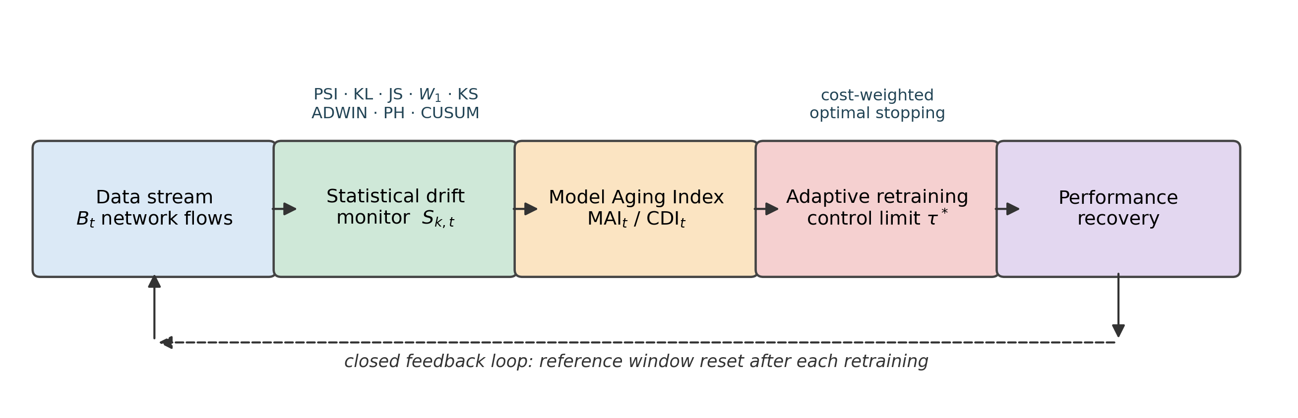
Figure 1. The monitoring and adaptation framework.

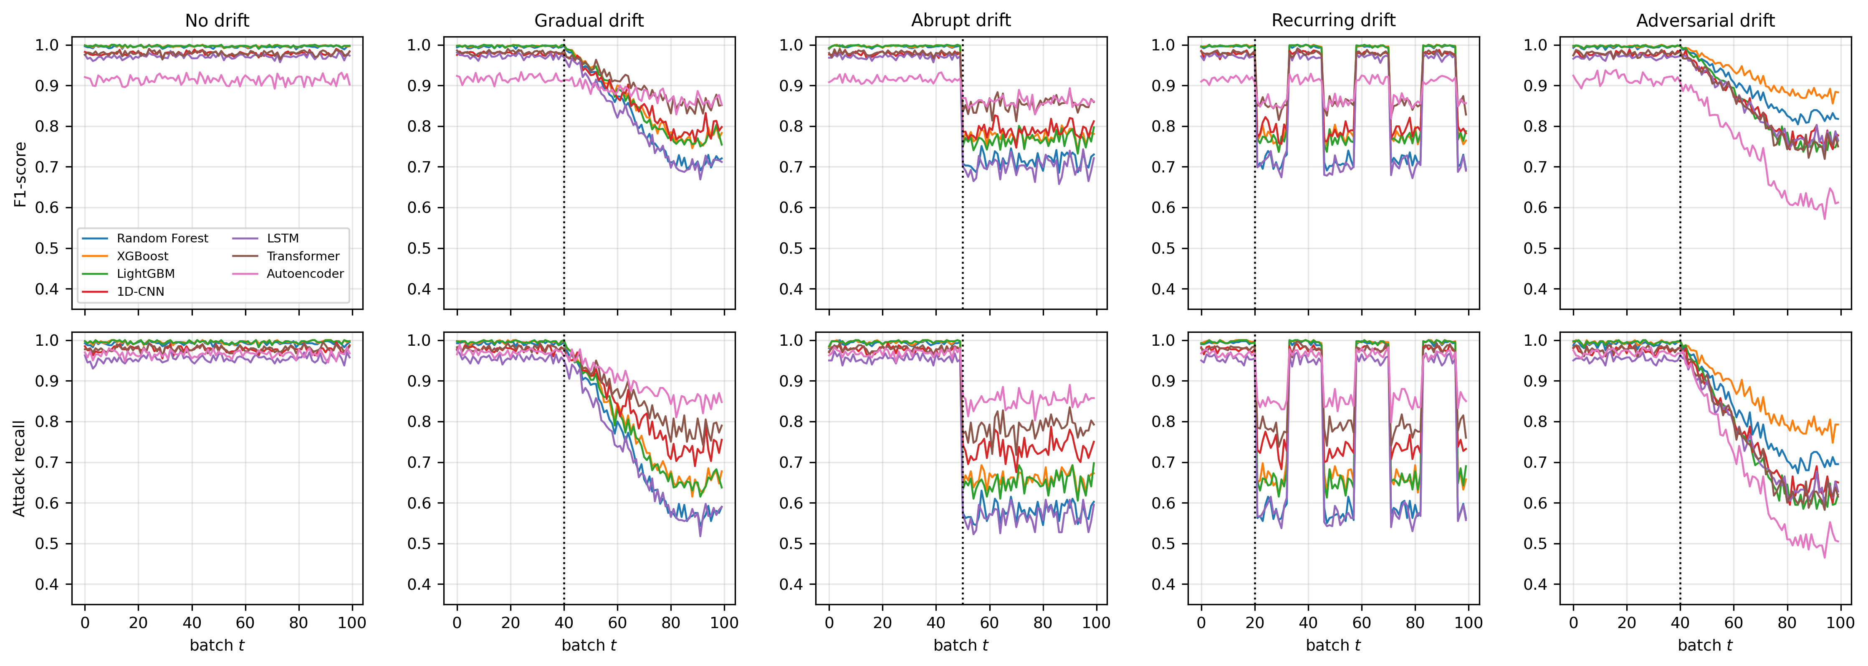
Figure 2. Aging trajectories for all seven architectures across the five drift regimes.

8.2 The aging indices track degradation and stay quiet under stationarity
Table 2 reports the stationary behaviour of MAI and its terminal value in each regime.
Table 2. MAI under stationarity (mean and maximum over the drift-free stream) and terminal MAI by regime.
Architecture | $S_{1}$ mean | $S_{1}$ max | Gradual | Abrupt | Recurring | Adversarial
Random Forest | 0.139 | 0.280 | 0.999 | 0.999 | 0.798 | 0.996
XGBoost | 0.174 | 0.232 | 0.998 | 0.998 | 0.812 | 0.993
LightGBM | 0.317 | 0.366 | 0.998 | 0.998 | 0.834 | 0.997
1D-CNN | 0.003 | 0.032 | 0.987 | 0.988 | 0.764 | 0.997
LSTM | 0.011 | 0.041 | 0.999 | 0.999 | 0.787 | 0.997
Transformer | 0.019 | 0.102 | 0.992 | 0.991 | 0.772 | 0.997
Autoencoder | 0.006 | 0.059 | 0.967 | 0.965 | 0.737 | 0.998
The index separates the regimes cleanly, and the recurring case correctly plateaus lower (0.74–0.83) than the persistent cases, reflecting the genuine partial return to the training environment. The stationary values expose an honest weakness: the three tree-ensemble models exhibit non-trivial stationary MAI (0.14–0.32) whereas the four neural models are essentially at zero. The cause is the extreme sharpness of the tree ensembles’ score distributions probability mass concentrated at the extremes of $\left[0,1\right]$ makes histogram-based divergences unstable under resampling, inflating the standardised statistics relative to a bootstrap null that slightly understates the true sampling variability. The practical implication is that the control limit should be calibrated per model rather than assumed universal, which is what Proposition 3 provides the machinery to do. Figure 3 shows the monitoring signals and indices alongside realised relative F1 loss; the visual coupling is strong in all four drift regimes and absent under stationarity.
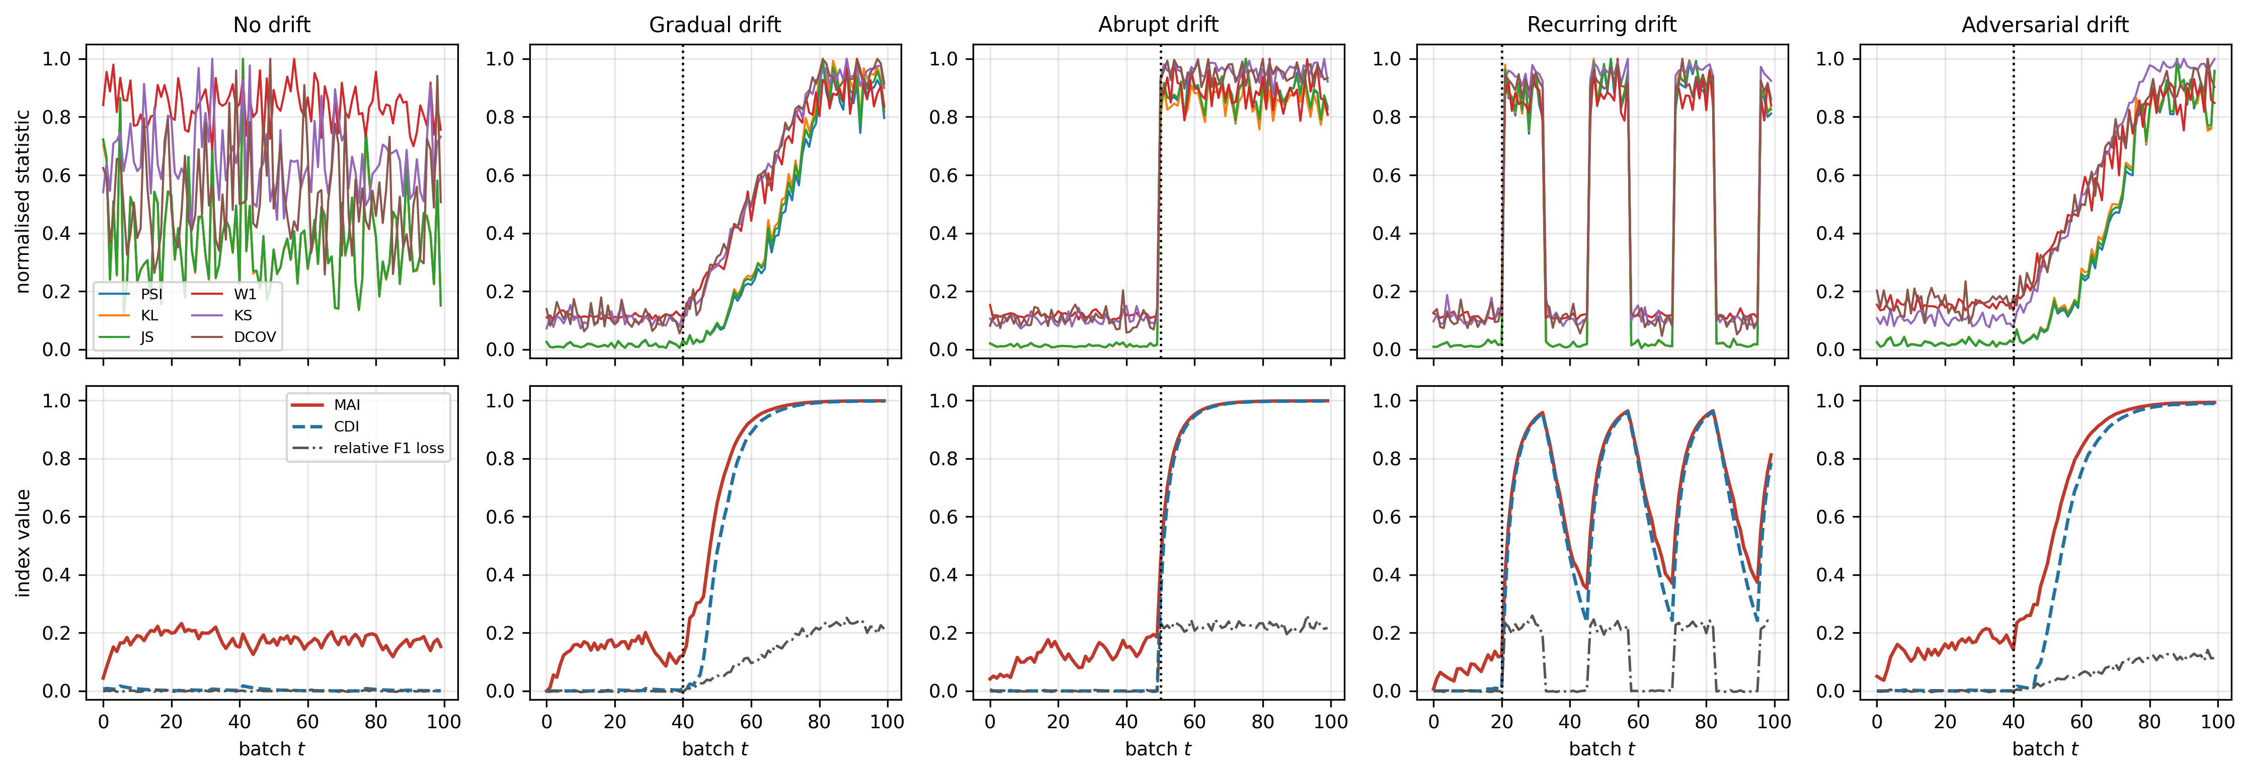
Figure 3. Top row: normalised batch divergence statistics (XGBoost detector). Bottom row: MAI, CDI and realised relative F1 loss. The indices rise in step with the loss under all four drift regimes and remain flat under stationarity.
Figure 4 renders MAI as a response surface over drift magnitude $α$ and batch index $t$ for a fixed detector, obtained from a dedicated sweep over eleven values of $α$. The surface is monotone in both arguments and saturates, exactly as Propositions 1 and 2 require, while the companion F1 surface declines correspondingly.
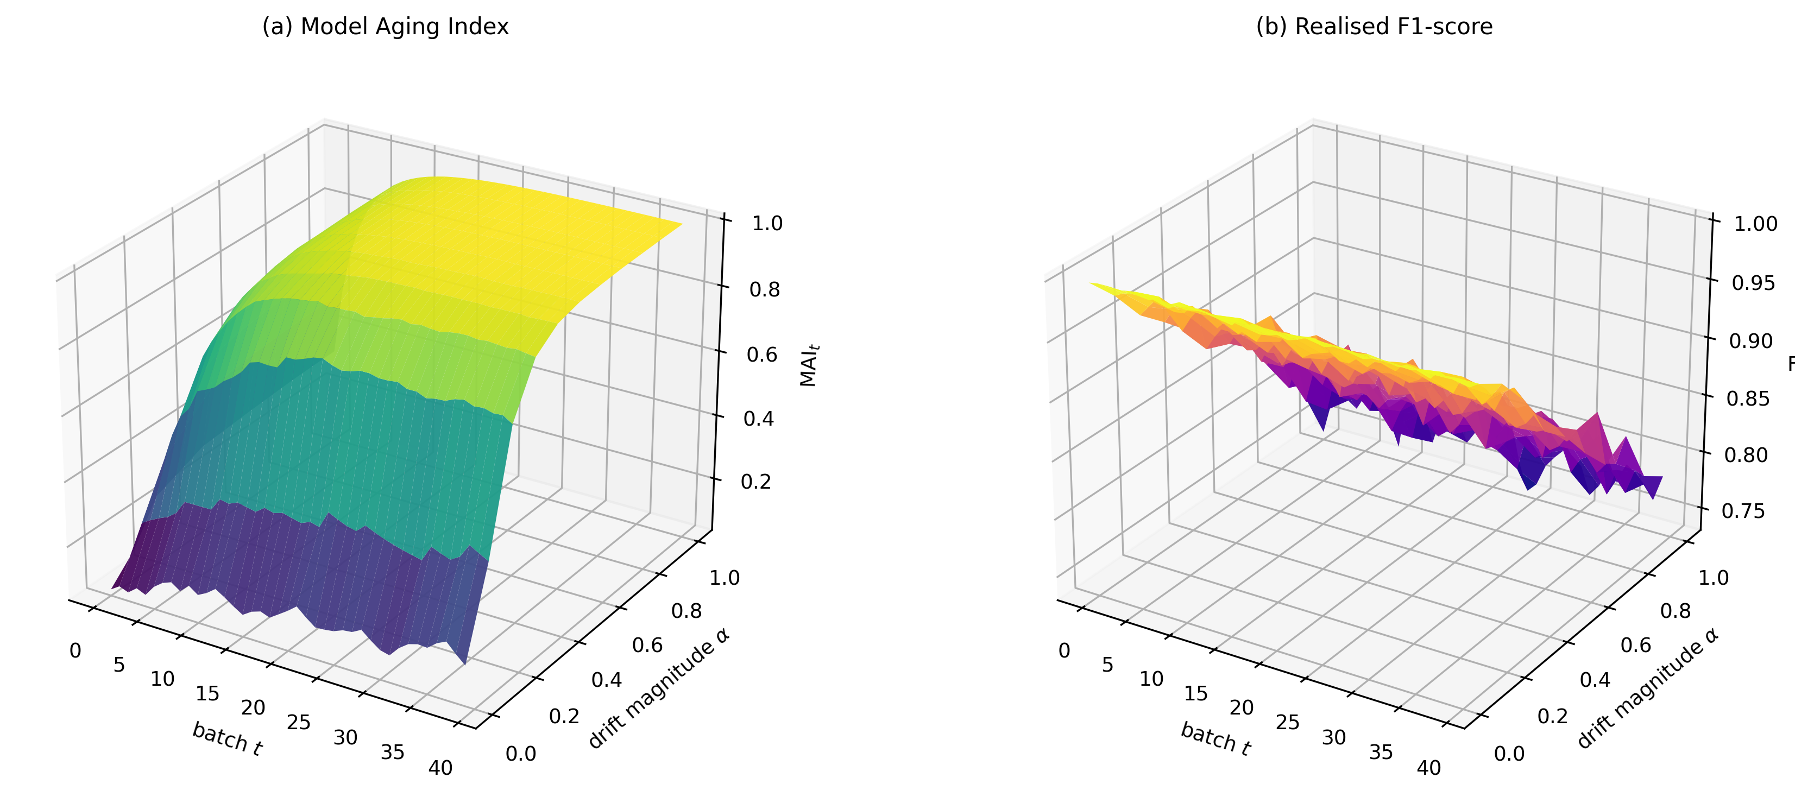
Figure 4. (a) MAI as a function of drift magnitude $α$ and batch index $t$; (b) realised F1 over the same grid. The index is monotone and saturating in both arguments; the performance surface is its mirror image.

8.3 Detector comparison: no free lunch between delay and false alarms
Table 3 reports mean detection delay by regime and the empirical false-alarm rate measured on the drift-free stream, averaged over all seven architectures.
Table 3. Detection delay (batches after onset) and empirical stationary false-alarm rate. All batch detectors use a common $q_{0.99}$ bootstrap-null threshold; sequential detectors are tuned to a comparable operating point.
Detector | Gradual | Abrupt | Recurring | Adversarial | Mean delay | FAR (stationary)
PSI | 3.00 | 0.00 | 1.00 | 2.86 | 1.71 | 0.096
KL | 3.00 | 0.00 | 1.00 | 2.86 | 1.71 | 0.097
JS | 3.00 | 0.00 | 1.00 | 2.86 | 1.71 | 0.096
KS | 6.14 | 0.00 | 1.00 | 5.43 | 3.14 | 0.059
$D^{cov}$ (weighted $W_{1}$) | 7.00 | 0.00 | 1.00 | 11.00 | 4.75 | 0.000
$W_{1}$ (score) | 10.86 | 0.00 | 1.00 | 7.71 | 4.89 | 0.000
MAI | 10.57 | 1.00 | 1.86 | 11.14 | 6.14 | 0.000
Page–Hinkley (supervised) | 10.14 | 3.29 | 4.00 | 9.14 | 6.64 | 0.021
CUSUM (supervised) | 9.57 | 3.43 | 4.00 | 10.43 | 6.86 | 0.033
CDI | 12.71 | 1.29 | 2.29 | 13.29 | 7.39 | 0.000
ADWIN (supervised) | 19.33 | 7.71 | 6.50 | 19.57 | 13.31 | 0.000
The results decompose into three clusters, visible as a Pareto frontier in Figure 7. The information-theoretic cluster (PSI, KL, JS) is fastest a mean delay of 1.71 batches and instantaneous detection of abrupt drift but pays for it with a stationary false-alarm rate of 9.6–9.7%, nearly ten times the 1% nominal level implied by their common threshold. This under-coverage is itself a finding: the bootstrap null, resampling with replacement from a finite reference window, understates the true batch-to-batch variability, and histogram-based divergences are the statistics most sensitive to that understatement. Practitioners setting PSI thresholds from bootstrap calibration should expect materially more alarms than the nominal level promises.
The transport cluster ($W_{1}$, $D^{cov}$) achieves zero false alarms with a moderate delay of 4.75–4.89 batches. The metric structure of the Wasserstein distance, which responds to the magnitude of displacement rather than to bin-level probability ratios, makes it markedly better behaved under resampling noise.
The supervised sequential cluster is dominated. Page–Hinkley and CUSUM incur 6.6–6.9 batches of delay at 2–3% false alarms, and ADWIN requires 13.31 batches while missing 7% of drift events entirely all while consuming a 5% audited label budget at 3-batch latency. That unsupervised transport monitoring outperforms supervised change detection on both axes simultaneously is, in our view, the strongest practical argument in the paper for label-free monitoring in security contexts.
MAI sits at 6.14 batches with zero false alarms, and CDI at 7.39. MAI is therefore not the fastest detector, and we do not claim it to be: $W_{1}$ and $D^{cov}$ detect roughly 1.4 batches sooner at the same false-alarm rate. The additional latency is the direct and intended cost of accumulation the geometric memory that converts a binary test into a graded state variable. What MAI buys with those 1.4 batches is a bounded, monotone, Lipschitz quantity that (i) grades severity rather than merely signalling, (ii) admits the closed-form threshold calibration of Proposition 3, and (iii) serves as the state of the control problem in Section 6. It should be judged as a controller state, not as a detector, and Section 8.5 evaluates it on that basis.
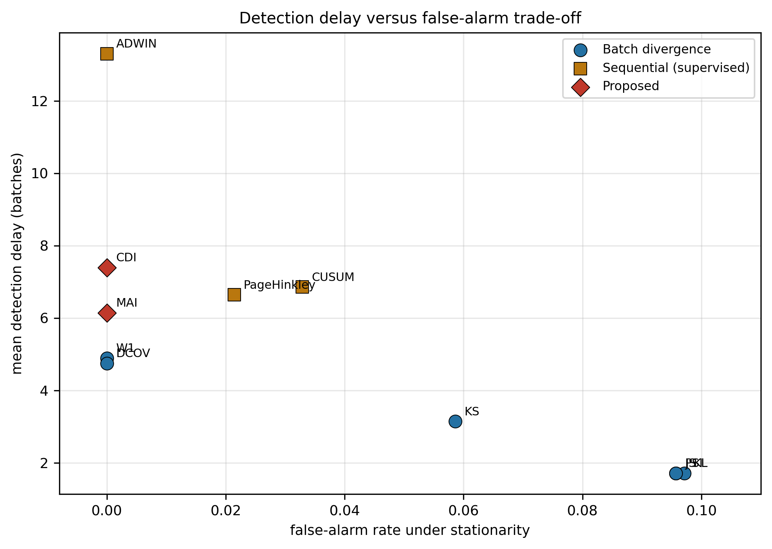
Figure 5. Detection delay against stationary false-alarm rate.

8.4 Coupling between statistics and realised degradation
Figure 6 reports Pearson and Spearman correlations between each statistic and realised relative F1 loss, pooled across all architectures, regimes and batches ($n=3,500$ batch observations). The score-space Wasserstein distance is the most strongly coupled ($r=0.971$, $ρ=0.799$), followed by the prior and evasion statistics ($r=0.968$, $ρ=0.792$), the divergences ($ρ=0.778$) and $D^{cov}$ ($ρ=0.745$). MAI and CDI show slightly weaker rank correlation ($ρ=0.724$ and $0.728$).
This ordering deserves comment rather than concealment. The aging indices are less rank-correlated with instantaneous loss than the raw statistics from which they are built, and necessarily so: accumulation and saturation deliberately break the instantaneous correspondence, holding the index high after a shift persists even when batch-level loss fluctuates, and compressing extreme values through the bounded link. An index engineered to maximise instantaneous correlation would simply be a monotone transform of $W_{1}$ and would inherit its memorylessness. The relevant test of an aging index is decision quality under an explicit cost model, which is what follows.
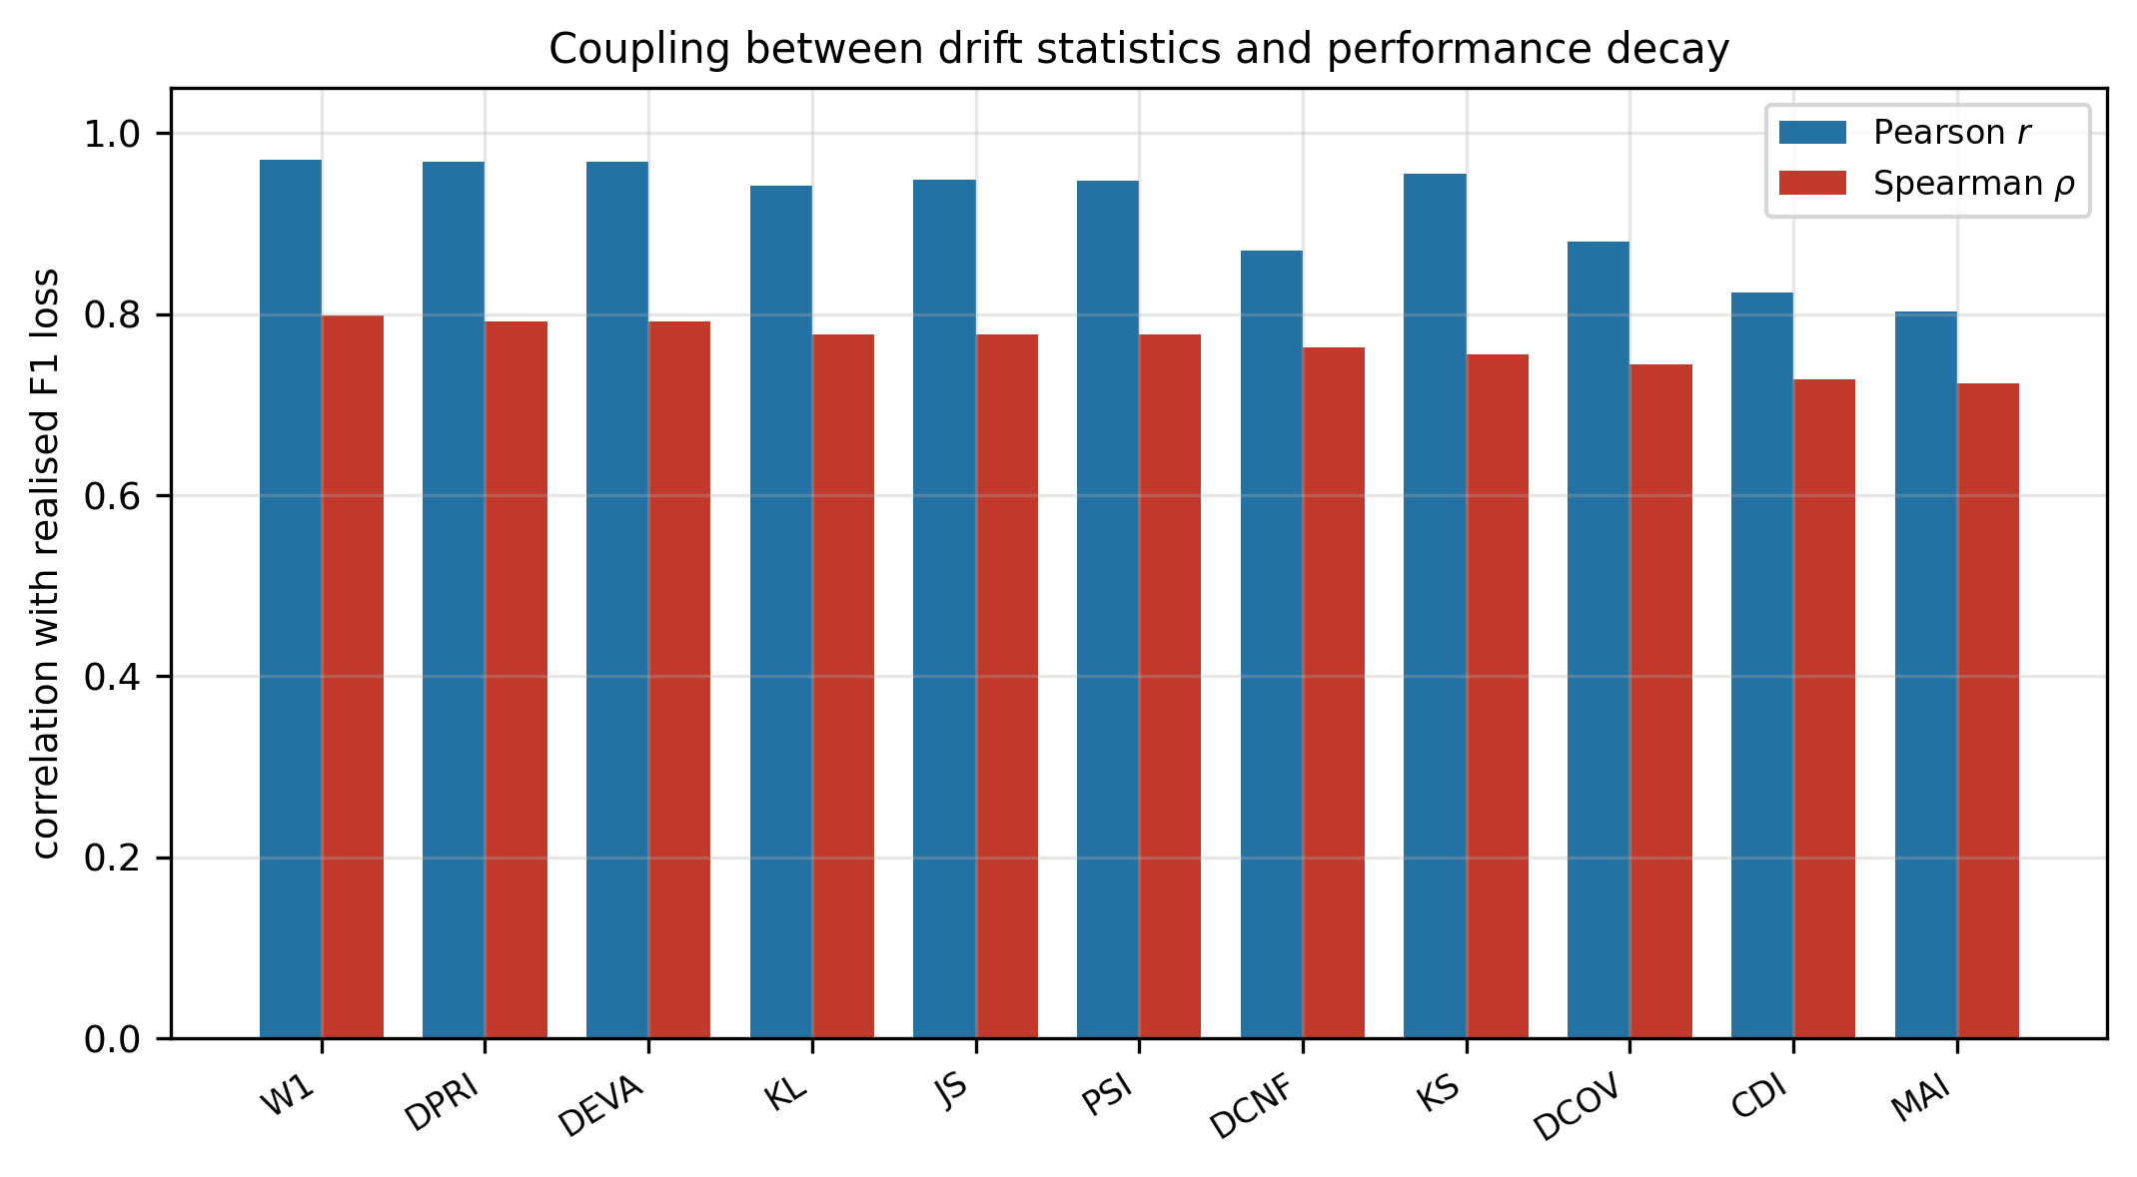
Figure 6. Coupling between each drift statistic and realised relative F1 loss, pooled over 3,500 batch observations.

8.5 Retraining policy: cost, and where thresholds fail
Table 4 reports expected total cost accumulated security loss plus $K$ per retraining event averaged over the five regimes, for three representative architectures.
Table 4. Expected total cost by retraining policy ($c_{FN}=10$, $c_{FP}=1$, $K=2$). Lower is better. The oracle is clairvoyant and not implementable.
Policy | XGBoost | LSTM | Autoencoder | Mean | vs. no retraining
No retraining | 43.91 | 69.45 | 45.35 | 52.90
Retrain every epoch | 31.69 | 49.87 | 65.08 | 48.88 | −7.6%
Periodic (20 batches) | 20.42 | 34.29 | 56.30 | 37.00 | −30.1%
PSI trigger | 19.98 | 39.47 | 53.79 | 37.75 | −28.6%
KS trigger | 19.24 | 35.54 | 53.42 | 36.07 | −31.8%
Periodic (30 batches) | 17.60 | 34.06 | 55.26 | 35.64 | −32.6%
MAI trigger ($τ=0.5$) | 18.72 | 35.78 | 51.82 | 35.44 | −33.0%
CDI trigger ($τ=0.5$) | 18.91 | 35.09 | 51.58 | 35.19 | −33.5%
$W_{1}$ trigger | 13.01 | 34.60 | 51.93 | 33.18 | −37.3%
MAI controller ($τ^{*}=0.90$, $D=10$) | 17.85 | 30.07 | 44.68 | 30.87 | −41.6%
CDI controller ($τ^{*}=0.90$, $D=10$) | 15.07 | 30.07 | 43.24 | 29.46 | −44.3%
Oracle (clairvoyant) | 11.34 | 22.28 | 36.17 | 23.26 | −56.0%
The tuned CDI controller is the best implementable policy, reducing cost by 44.3% relative to no retraining and by 17.3% relative to the best periodic schedule, and closing 79.4% of the gap between no retraining and the clairvoyant oracle. The improvement of the tuned controller over the same index at an arbitrary threshold ($τ=0.5$) is 16.3%, which underlines that the control limit is a decision variable to be optimised, not a convention.
Figure 7 shows the cost response surface over the control limit $τ$ and the retraining cost $K$. The surface is well-behaved and admits an interior minimum at $τ^{*}=0.90$ across the tested range of $K$, with cost rising steeply for $τ>0.9$ (where the controller stops retraining altogether) and gradually for small $τ$ (where it over-retrains). We note that $τ^{*}$ proved insensitive to $K$ over $K∈\left[0.5,8\right]$ in these experiments the comparative static predicted by the inventory analogy is present in the level of the cost curves but not detectably in the location of the minimum, which is a limitation of the course nine-epoch review grid rather than evidence against the structural result.
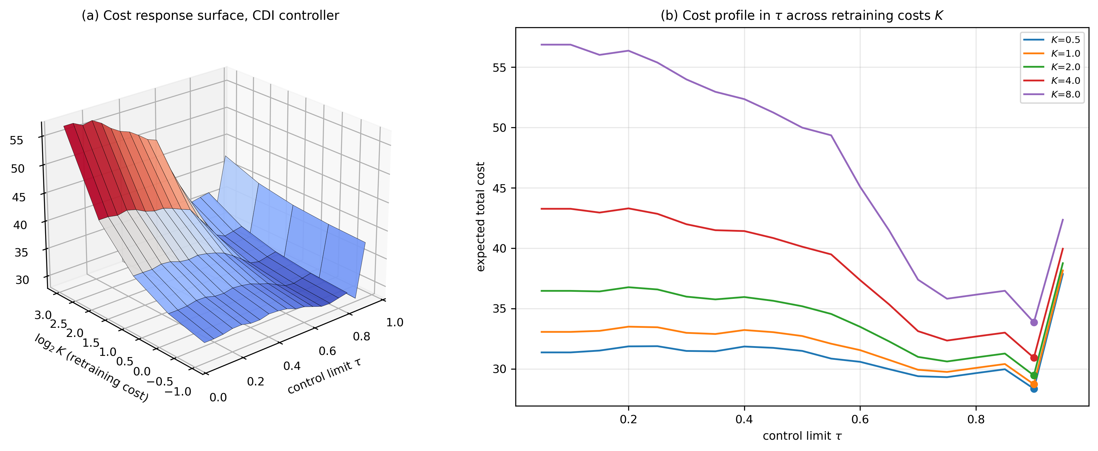
Figure 7. (a) Expected total cost as a function of the control limit $τ$ and retraining cost $K$ for the CDI controller. (b) Cost profiles in $τ$ for each $K$; markers indicate minima.
Three findings within Table 4 matter more than the headline number.
Retraining at every opportunity is nearly worthless: Refitting at all nine epochs reduces cost by only 7.6% and is worse than a 30-batch periodic schedule, because setup costs accumulate while marginal benefit does not. The naive intuition that more frequent retraining is safer is wrong under any non-zero $K$.
Retraining is actively harmful under adversarial drift: For the Autoencoder in regime $S_{5}$, no retraining costs 91.5 while retraining at every epoch costs 115.5 a 26% increase. The mechanism is straightforward and should worry practitioners: the retraining window contains mimicry-perturbed attack flows that lie close to the benign centroid, so refitting on recent data teaches the reconstruction model to treat evasive traffic as normal. Under an adaptive adversary, retraining on unfiltered recent traffic is a poisoning channel. Every trigger policy in Table 4 inherits this exposure to some degree, and the oracle’s advantage in $S_{5}$ (50.6 against 91.5 for no retraining) comes from retraining once, early, before the mimicry intensity has ramped.
Threshold policies fail under recurring drift, exactly as Theorem 1 predicts. In regime $S_{4}$ the PSI-, KS-, MAI- and CDI-triggered policies at $τ=0.5$ all incur a cost of 47.3 for XGBoost against 19.8 for the $W_{1}$ trigger and 18.9 for the oracle, because they retrain repeatedly as the environment oscillates, each refit fitting a regime that is about to be replaced by its predecessor. This is the violation of assumption (A2) identified in Section 6.2: when a high aging level can precede a return to the training distribution, the stage cost is no longer monotone in the state and the control-limit structure loses its optimality guarantee. The dwell-time augmentation $D=10$ recovers most of the loss (CDI cost in $S_{4}$ falls from 47.3 to 19.8), which is why the tuned controller in Table 4 includes it. Detecting and exploiting recurrence explicitly through concept pooling or a recurring-concept memory [22] is the natural remedy and is outside our present scope.
Figure 8 illustrates the recovery dynamics: the CDI controller retrains at a small number of well-chosen epochs and restores performance close to reference level, whereas the periodic schedule spends setup cost on refits that arrive before drift or after the damage is done.
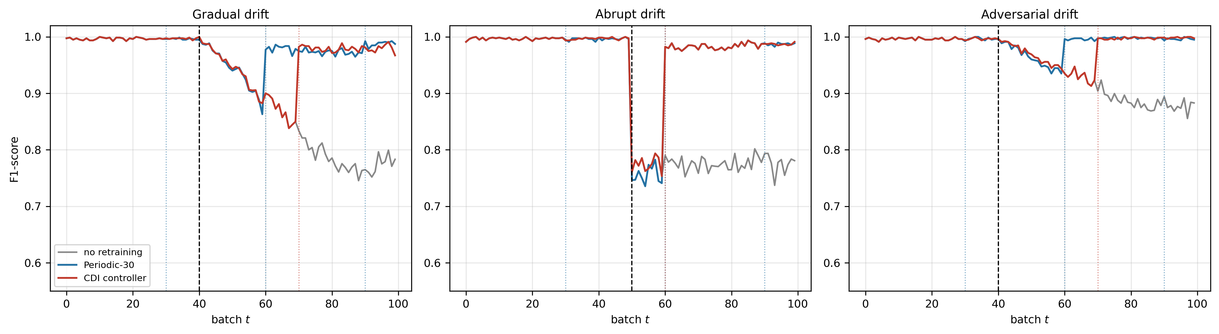
Figure 8. Performance recovery under three policies (XGBoost).
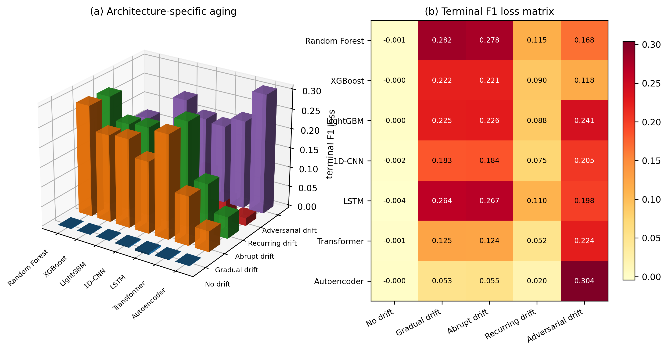
Figure 9. (a) Terminal F1 loss as a joint function of architecture and drift regime; (b) the same values as a matrix. The interaction between architecture and drift mechanism is strong: no architecture dominates across regimes.
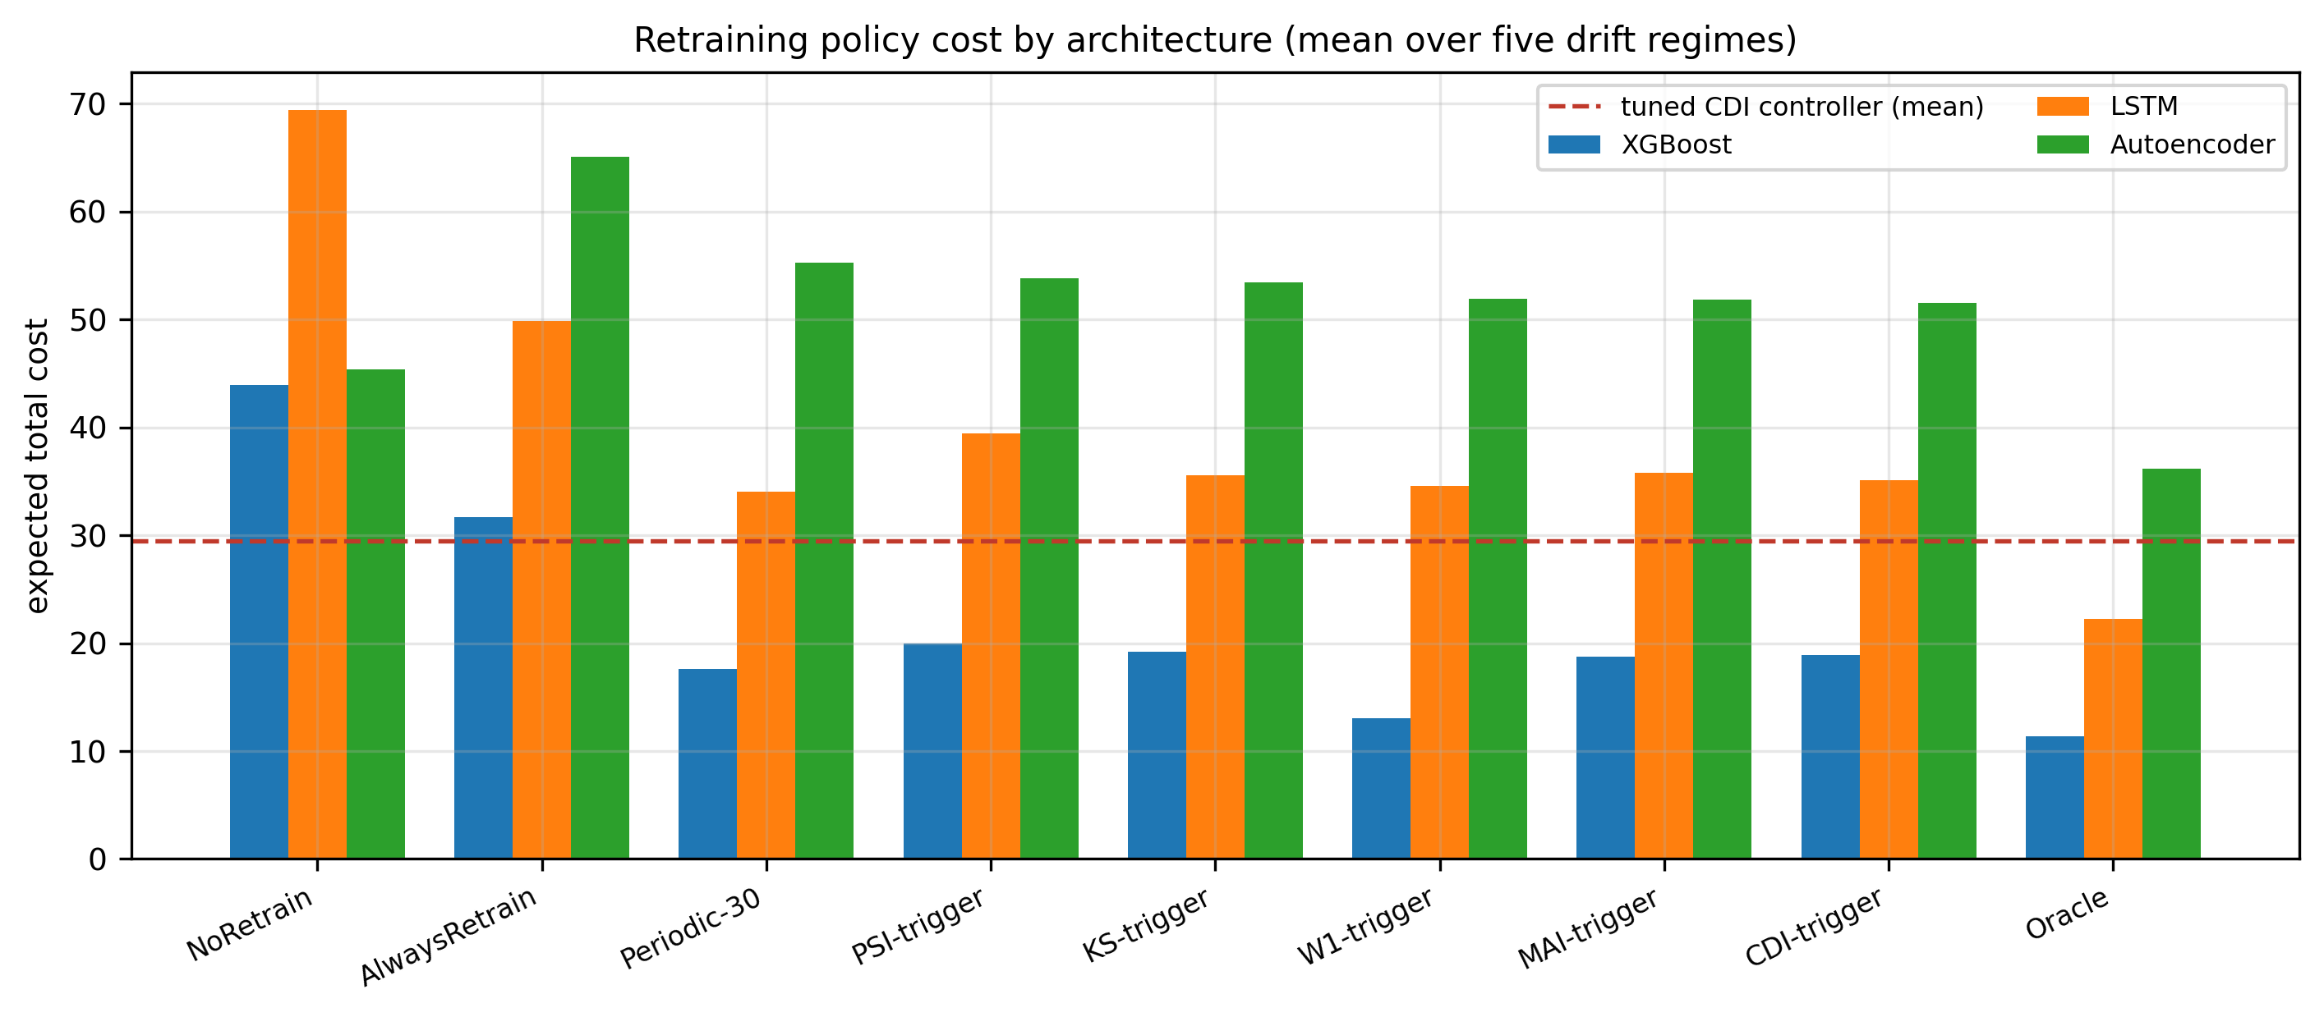
Figure 10. Expected total cost by policy and architecture, averaged over the five drift regimes. The dashed line marks the tuned CDI controller.

9. Discussion

9.1 What the framework changes operationally
The practical output of this work is a shift in the monitored quantity. A security operations centre currently monitors alert volume and, if it is careful, periodically re-scores a labelled holdout. Both are lagging indicators: alert volume moves only when drift affects the alert-load channel, and holdout re-scoring is limited by labelling throughput. MAI and CDI are leading indicators computable on every batch from unlabelled traffic and the model’s own outputs, with a threshold whose false-alarm implication is known in closed form (Proposition 3) rather than tuned by trial.
The second change is that “should we retrain?” becomes a quantitative question with an auditable answer. Given a labelling cost, a compute cost, an estimate of $c_{FN}/c_{FP}$ and an attack prevalence, Theorem 1 states that the optimal rule has a threshold form and Figure 5 locates the threshold. This is materially better than the prevailing practice of quarterly retraining, which our results show to be dominated: the 30-batch periodic schedule costs 21% more than the tuned CDI controller while consuming three times the retraining budget.

9.2 Why the cost asymmetry belongs inside the index
CDI outperforms MAI in every architecture in Table 4, and the reason is structural rather than incidental. With $c_{FN}/c_{FP}=10$ and $π=0.4$, the cost-asymmetry weight is $γ=0.87$, so CDI attends almost entirely to the evasion channel the migration of probability mass below the alert threshold. That is exactly the failure mode the experiments exhibit: recall collapses while precision and accuracy hold. A statistically neutral index spreads its attention across channels of unequal consequence; CDI does not. The general principle is that when the loss is asymmetric, the monitoring statistic should inherit the asymmetry, not merely the decision rule downstream of it.

9.3 The adversarial regime is categorically different
Regimes $S_{2}$–$S_{4}$ are drift in the classical sense: the environment changes for reasons unrelated to the detector. Regime $S_{5}$ is drift produced by an agent optimising against the detector, and it breaks two assumptions simultaneously. It breaks the exchangeability that justifies retraining on recent data, as Section 8.5 documents. And it inverts the architecture ranking, because the property that confers robustness to novel families in a reconstruction model treating anything unlike benign traffic as suspicious is precisely the property an evasion attack target. Drift-aware security systems therefore require a separate treatment of adversarial drift, minimally including provenance filtering of the retraining window and ideally robust or adversarially-aware refitting. We regard the negative result here as one of the paper’s more useful contributions, since the literature’s default recommendation retrain when drift is detected is, in this regime, an instruction to poison one’s own model.

9.4 Relation to distributionally robust design
An alternative to monitoring and retraining is to fit a model robust to a ball of distributions around the empirical law from the outset. The two approaches are complements rather than substitutes, and Proposition 4 makes the relationship precise: $D_{t}^{cov}$ lower-bounds $W_{1}\left(P,Q_{t}\right)$, so it measures how far the observed environment has moved into or beyond whatever transport radius a robust design was certified against. A robust model with certified radius $ε$ and a monitor reporting $D_{t}^{cov}>ε$ is a model operating outside its warranty a statement no accuracy dashboard can make.

10. Limitations
We state the constraints on these conclusions explicitly.
Dataset: NSL-KDD is a benchmark of known age. Its traffic does not reflect contemporary encrypted, cloud or IoT protocols, and the novel-attack pool of 3,750 records is bootstrap-resampled across up to 60 batches, so distinct novel instances recur many times within a stream. This inflates the effective homogeneity of the post-drift environment relative to genuinely open-world traffic. The drift mechanism we exploit families absent from training is authentic, but the diversity of that channel is bounded by the dataset. Replication on CIC-IDS2017 [17], on a temporally-ordered corpus such as BODMAS, or on production telemetry is the necessary next step.
Semi-synthetic drift: The mixing schedules $α\left(t\right)$ and the mimicry map are constructed rather than observed. The mimicry model in particular is a simple convex pull toward the benign centroid; a real evasion attack would respect protocol constraints and functional preservation, and would likely be harder to detect. Our adversarial results should be read as a lower bound on the difficulty.
Review-grid granularity: Retraining decisions are taken at nine epochs. This makes the oracle exactly computable by exhaustive search but coarsens the resolution at which $τ^{*}$ can be located, which is our explanation for the insensitivity of $τ^{*}$ to $K$ noted in Section 8.5.
Single label budget: The supervised detectors were evaluated at one audit rate (5%) and latency (3 batches). Their standing relative to unsupervised monitoring would improve with richer labelling, and the crossover point is not characterised here.
Stationary-null calibration: Proposition 3 assumes the calibrated null is correct. Section 8.3 shows it is not exactly correct for histogram-based statistics on sharply-peaked score distributions, where bootstrap resampling understates true variability. Calibration by block bootstrap or by held-out reference partitions would tighten this.
Cost parameters: The ratio $c_{FN}/c_{FP}=10$ is illustrative. Real ratios vary by orders of magnitude across sectors, and $γ$ hence CDI’s channel weighting moves with them.

11. Conclusion
We have argued that the deployment-time question in machine-learning security is not how accurate a model is but how long it remains trustworthy, and we have supplied the statistical machinery to answer it. The Model Aging Index converts a battery of null-calibrated drift statistics into a bounded, monotone, Lipschitz state variable with closed-form false-alarm control; the Cybersecurity Drift Index reweights that state by the asymmetric cost of missed intrusions; and the retraining decision, posed as optimal stopping, admits a control-limit policy structurally identical to inventory replenishment.
The empirical findings are unambiguous. Model aging in intrusion detection is severe attack recall falling from 0.99 to below 0.66 when a quarter of traffic belongs to unseen families and it is invisible to the accuracy metrics normally monitored. Unsupervised transport-based monitoring detects this degradation faster and with fewer false alarms than supervised sequential change detection that consumes a label budget. And a tuned CDI control-limit policy reduces expected operational cost by 44.3% relative to no retraining and 17.3% relative to the best periodic schedule, closing 79% of the gap to a clairvoyant oracle.
Two negative results temper the picture and, we think, deserve equal emphasis. Robustness does not transfer across drift mechanisms: the architecture most resilient to novel attack families is the most fragile under evasion. And retraining is not universally beneficial: under adversarial drift, refitting on recent traffic raised cost by 26%, because the retraining window is itself contaminated. The reflexive advice to retrain on drift detection is, in the adversarial regime, harmful.
Future work should pursue recurring-concept memory to repair the assumption violation identified in Section 8.5, provenance-filtered or robust retraining for the adversarial regime, extension of the aging index to multivariate transport with copula sensitivity, and validation on contemporary encrypted traffic at production scale.

Data and Code Availability
All experiments use the publicly available NSL-KDD corpus. The monitoring battery, aging indices, policy simulator and figure generation are implemented in Python (scikit-learn, XGBoost, LightGBM, PyTorch, SciPy, river) and are reproducible from the reference window seed reported in Section 7.

Declaration of Competing Interest
The authors declare no competing financial or personal interests.

Declaration of AI Use

This manuscript was prepared through the intellectual contributions of the author(s) to the study design, data analysis, interpretation of results, and scholarly content. Grammarly and ChatGPT were used solely to assist with grammatical refinement and reference formatting during manuscript revision. The author(s) accept full responsibility for the accuracy, integrity, and final content of the manuscript.

References
[1] Lu, J., Liu, A., Dong, F., Gu, F., Gama, J., & Zhang, G. (2018). Learning under concept drift: A review. IEEE Transactions on Knowledge and Data Engineering, 31(12), 2346–2363.
[2] Gama, J., Žliobaitė, I., Bifet, A., Pechenizkiy, M., & Bouchachia, A. (2014). A survey on concept drift adaptation. ACM Computing Surveys, 46(4), 1–37.
[3] Shyaa, M. A., Ibrahim, N. F., Zainol, Z., Abdullah, R., Anbar, M., & Alzubaidi, L. (2024). Evolving cybersecurity frontiers: A comprehensive survey on concept drift and feature dynamics aware machine and deep learning in intrusion detection systems. Engineering Applications of Artificial Intelligence, 137, 109143.
[4] Pendlebury, F., Pierazzi, F., Jordaney, R., Kinder, J., & Cavallaro, L. (2019). TESSERACT: Eliminating experimental bias in malware classification across space and time. 28th USENIX Security Symposium, 729–746.
[5] Kan, Z., McFadden, S., Arp, D., Pendlebury, F., Jordaney, R., Kinder, J., Pierazzi, F., & Cavallaro, L. (2024). TESSERACT: Eliminating experimental bias in malware classification across space and time (extended version). arXiv:2402.01359.
[6] Jordaney, R., Sharad, K., Dash, S. K., Wang, Z., Papini, D., Nouretdinov, I., & Cavallaro, L. (2017). Transcend: Detecting concept drift in malware classification models. 26th USENIX Security Symposium, 625–642.
[7] Barbero, F., Pendlebury, F., Pierazzi, F., & Cavallaro, L. (2022). Transcending Transcend: Revisiting malware classification in the presence of concept drift. 2022 IEEE Symposium on Security and Privacy (SP), 805–823.
[8] Yang, L., Guo, W., Hao, Q., Ciptadi, A., Ahmadzadeh, A., Xing, X., & Wang, G. (2021). CADE: Detecting and explaining concept drift samples for security applications. 30th USENIX Security Symposium, 2327–2344.
[9] Chen, Y., Ding, Z., & Wagner, D. (2023). Continuous learning for Android malware detection. 32nd USENIX Security Symposium, 1127–1144.
[10] Andresini, G., Pendlebury, F., Pierazzi, F., Loglisci, C., Appice, A., & Cavallaro, L. (2021). INSOMNIA: Towards concept-drift robustness in network intrusion detection. 14th ACM Workshop on Artificial Intelligence and Security, 111–122.
[11] Gomes, H. M., Bifet, A., Read, J., Barddal, J. P., Enembreck, F., Pfharinger, B., Holmes, G., & Abdessalem, T. (2017). Adaptive random forests for evolving data stream classification. Machine Learning, 106(9–10), 1469–1495.
[12] Montiel, J., Mitchell, R., Frank, E., Pfahringer, B., Abdessalem, T., & Bifet, A. (2020). Adaptive XGBoost for evolving data streams. 2020 International Joint Conference on Neural Networks (IJCNN).
[13] Bifet, A., & Gavaldà, R. (2007). Learning from time-changing data with adaptive windowing. Proceedings of the 2007 SIAM International Conference on Data Mining, 443–448.
[14] Page, E. S. (1954). Continuous inspection schemes. Biometrika, 41(1–2), 100–115.
[15] Hinkley, D. V. (1971). Inference about the change-point from cumulative sum tests. Biometrika, 58(3), 509–523.
[16] Villani, C. (2008). Optimal Transport: Old and New. Grundlehren der mathematischen Wissenschaften, Springer.
[17] Sharafaldin, I., Lashkari, A. H., & Ghorbani, A. A. (2018). Toward generating a new intrusion detection dataset and intrusion traffic characterization. 4th International Conference on Information Systems Security and Privacy (ICISSP), 108–116.
[18] Tavallaee, M., Bagheri, E., Lu, W., & Ghorbani, A. A. (2009). A detailed analysis of the KDD CUP 99 data set. 2009 IEEE Symposium on Computational Intelligence for Security and Defense Applications (CISDA), 1–6.
[19] Mahadevan, A., & Mathioudakis, M. (2024). Cost-aware retraining for machine learning. Knowledge-Based Systems, 293, 111610.
[20] Regol, F., Kroon, S., Pal, C., Coates, M., et al. (2025). When to retrain a machine learning model. arXiv:2505.14903.
[21] Greco, S., Vacchetti, B., Apiletti, D., & Cerquitelli, T. (2024). Unsupervised concept drift detection from deep learning representations in real-time. arXiv preprint.
[22] Suárez-Cetrulo, A. L., Quintana, D., & Cervantes, A. (2023). A survey on machine learning for recurring concept drifting data streams. Expert Systems with Applications, 213, 118934.
[23] Mirsky, Y., Doitshman, T., Elovici, Y., & Shabtai, A. (2018). Kitsune: An ensemble of autoencoders for online network intrusion detection. Network and Distributed System Security Symposium (NDSS).
[24] Alotaibi, A., & Rassam, M. A. (2023). Adversarial machine learning attacks against intrusion detection systems: A survey on strategies and defense. Future Internet, 15(2), 62.
[25] Puterman, M. L. (1994). Markov Decision Processes: Discrete Stochastic Dynamic Programming. Wiley.
[26] Chen, T., & Guestrin, C. (2016). XGBoost: A scalable tree boosting system. 22nd ACM SIGKDD International Conference on Knowledge Discovery and Data Mining, 785–794.
[27] Ke, G., Meng, Q., Finley, T., Wang, T., Chen, W., Ma, W., Ye, Q., & Liu, T.-Y. (2017). LightGBM: A highly efficient gradient boosting decision tree. Advances in Neural Information Processing Systems, 30.
[28] Breiman, L. (2001). Random forests. Machine Learning, 45(1), 5–32.
[29] Vaswani, A., Shazeer, N., Parmar, N., Uszkoreit, J., Jones, L., Gomez, A. N., Kaiser, Ł., & Polosukhin, I. (2017). Attention is all you need. Advances in Neural Information Processing Systems, 30.
[30] Hochreiter, S., & Schmidhuber, J. (1997). Long short-term memory. Neural Computation, 9(8), 1735–1780.
[31] Wares, S., Isaacs, J., & Elyan, E. (2019). Data stream mining: Methods and challenges for handling concept drift. SN Applied Sciences, 1(11), 1412.
[32] Komorniczak, J., Zyblewski, P., & Ksieniewicz, P. (2022). Statistical drift detection ensemble for batch processing of data streams. Knowledge-Based Systems, 252, 109380.
[33] Routray, A. K., Dehury, S., & Sahu, S. K. (2026). Carbon-constrained inventory management: A systematic review and roadmap for ecological footprint integration. Journal of Optimization and Supply Chain Management. DOI: 10.22034/ISS.2026.10683.1093.
[34] Routray, A. K., Dehury, S., Kumar, M., & Sahu, S. K. (2026). Deep learning driven agricultural remote sensing: A scoping review of crop mapping, soil moisture estimation, and multi-sensor fusion. Journal of Emerging Technologies and Innovative Research, 13(5), JETIR2605037.
[35] Dehury, S., Sahoo, S. S., Routray, A. K., Kumar, M., & Sahu, S. K. (2026). A pseudo-convex fuzzy EOQ model for deteriorating items with time varying demand. Asian Research Journal of Mathematics, 22(7), 219–238. DOI: 10.9734/arjom/2026/v22i71127.
[36] Routray, A. K., Dehury, S., & Sahu, S. K. (2026). An integrated multi-echelon inventory model with exponential demand decay, time-dependent costs, and partial deterioration. International Journal of Advanced Scientific Research, 11(2), 67–77.

