Techno economic Evaluation of a Hand operated Draper Separator for Decorticated Groundnut

ABSTRACT
Performance studies of small post-harvest cleaning machines almost always report cleaning efficiency and impurity as percentages, and stop there. For the farmer who has to pay for the machine, however, the quantity that matters is the cost of producing a quintal of clean kernel, and that cost is governed as much by the kernel thrown away with the shell as by the cost of running the machine. A hand-operated inclined draper separator for decorticated groundnut, fabricated for Rs. 9085, was therefore evaluated techno-economically using the 54 cleaning trials of a 3 x 3 x 2 factorial experiment (deck angle 17, 22 and 27 degrees; conveyor speed 0.19, 0.34 and 0.55 m/s; feed rate 45 and 85 kg/h), in which every gram fed was accounted for by a closed mass balance. The hourly operating cost was Rs. 72.03, of which only Rs. 7.26 (10.1 %) was fixed, so the economics of the machine are almost entirely governed by how it is operated rather than by what it cost to build. Converting each treatment mean into a cost per quintal of clean kernel, using an assumed kernel value of Rs. 100/kg derived from minimum support price, gave a range of Rs. 391 to Rs. 10 279 per quintal, a 26-fold spread produced by settings of the same machine. Kernel lost to the shell outlet accounted for 67 % of the cost even at the cheapest setting and for more than 90 % at poor settings, so loss and not machine cost is the dominant economic term. The cheapest setting was 27 degrees at 0.55 m/s and 85 kg/h (Rs. 391 per quintal), which is neither the treatment that maximised cleaning efficiency nor the one selected by a desirability analysis of efficiency and shell loss; it wins because it delivers 55.4 kg/h of clean kernel against 21 to 23 kg/h for the alternatives at almost the same efficiency. The ranking was unchanged for kernel values from Rs. 70 to Rs. 130/kg. Operating at this setting shortens the payback period from 1.12 to 0.34 year and lowers the break-even use from 30.4 to 10.2 h/year. It is further shown that the break-even expression as commonly written for farm machinery, with total operating cost in the denominator, double-counts the fixed cost and overstates the break even use by 18 % for this machine; the variable cost must be used instead.
Keywords: Groundnut; draper separator; techno-economic analysis; cost of cleaning; kernel loss; break-even point; payback period; custom hiring

1. INTRODUCTION
Groundnut (Arachis hypogaea L.) is the fourth most important source of edible oil and the third most important source of vegetable protein in the world, and India ranks first in area and second in production, with an annual coverage of about 70 lakh hectares (Anonymous, 2017). Most of that crop is decorticated on small, manually or pedal-operated machines that do not carry a cleaning unit, so the kernel-shell mixture leaving the decorticator is separated by hand winnowing or by an air blast (Akande, 2014; Gitau et al., 2013). An inclined draper separator, which exploits the difference in shape and surface texture between kernel and shell, replaces that operation with a machine that needs no fan, no sieve and no motor (Waddle and Rex, 1961; Akintunde et al., 2005; Hud et al., 2023).
Whether such a machine is worth building is an economic question, and it is one that the literature on small cleaning equipment answers only partially. Performance studies for this class of machine, including recent optimisation work on peanut cleaning devices (Liu et al., 2023; Zhu et al., 2023; Ling et al., 2024) and on groundnut shelling (Muhammad et al., 2021), report cleaning efficiency, loss and impurity as percentages and select an operating point on those percentages alone. Economic assessments of farm machinery, on the other side, are usually carried out for a single nominal operating condition and reduce to a cost per hour, a break-even use and a payback period (Thorat et al., 2014; Kamboj, 2012). The two are rarely joined, and the omission matters, because the percentages and the money do not rank the operating settings in the same order.
The reason is throughput. A cleaning efficiency of 98 % achieved at 40 kg/h and one of 97 % achieved at 92 kg/h are almost indistinguishable as percentages, but the second spreads the same hourly cost of the machine over more than twice as much product. In the opposite direction, kernel that leaves with the shell is not merely a percentage of an efficiency: it is saleable produce that has been thrown away, and at prevailing groundnut prices its value per hour can exceed the entire cost of running the machine. An economic reading of a cleaning experiment therefore has to price both terms and add them, and there is no reason to expect the sum to be minimised at the setting that maximises efficiency.
The present study takes the 54 cleaning trials of a factorial experiment on a hand-operated draper separator, reported elsewhere for their statistical structure, and re-reads them in these terms. Because every gram fed to the machine was recovered and weighed, each trial is closed by a mass balance and can be converted without assumption into a rate of clean kernel produced and a rate of kernel lost. The specific objectives were (i) to establish the cost of owning and operating the developed separator and its break-even and payback characteristics, (ii) to express the outcome of each of the 18 treatments as a cost per quintal of clean kernel comprising a machine term and a kernel-loss term, (iii) to identify the economically optimal operating point and test its robustness to the price of kernel and to the assumptions of the costing, and (iv) to compare that point with the optima selected on cleaning efficiency alone and by a desirability analysis of the two technical responses.

2. MATERIALS AND METHODS

2.1 The machine and the cleaning trials
The work was carried out at the Farm Machinery Workshop, Swami Vivekananda College of Agricultural Engineering and Technology and Research Station, IGKV, Raipur, on a manually operated inclined draper separator developed for the purpose. The unit consists of an adjustable M.S. angle-iron frame, two crowned rollers of 90 mm diameter running on four ball bearings, a hand crank on the upper roller shaft with an alternative pulley drive for coupling to a decorticator, a non-stretch velvet belt with a flat seam, guide side-rails, a brush that strips adhering shell from the return run of the belt, and two transport wheels. The decorticated mixture is dropped onto the centre of the uphill-travelling belt; the rounder, smoother kernels roll and slide back down the incline and leave at the lower end as clean seed, while the flatter, rough-textured shell is carried up and discharged separately. The design, fabrication and material selection are described in a companion paper.
Deck angle and conveyor speed were tested at three levels each and feed rate at two, giving the 3 x 3 x 2 factorial arrangement of 18 treatment combinations shown in Table 1. The experiment was laid out in a randomised block design with three replications, giving 54 cleaning trials of one minute each. Groundnut cv. Kadari-9 at 13.36 % moisture content was used throughout.
Table 1: Factors, levels and treatment coding
Factor | Symbol | Level 1 | Level 2 | Level 3
Deck angle (degree) | A | A1 = 17 | A2 = 22 | A3 = 27
Conveyor speed (m/s) | S | S1 = 0.19 | S2 = 0.34 | S3 = 0.55
Feed rate (kg/h) | F | F1 = 45 | F2 = 85 | -
Each treatment is coded AiSjFk; for example A3S3F2 denotes a deck angle of 27 degrees, a conveyor speed of 0.55 m/s and a feed rate of 85 kg/h.

2.2 Mass balance and the derived rates
For each trial the material leaving the machine was separated by hand into four fractions and weighed to 0.1 g: clean seed recovered (m1), separated shell (m2), seed lost with the shell (m3) and shell retained in the clean seed (m4). The first two are correctly routed and the last two are mis-routed, and the four together account for the whole of the material fed, so
m₁ + m₂ + m₃ + m₄= input mass
holds identically for every trial. The two technical responses follow as cleaning efficiency CE = m₁/( m₁ + m₃) x 100 and shell loss SL = m₄/(m₄ + m₂) x 100. For the economic analysis the same masses are converted, using the feed rate actually recorded during the trial, into two rates:
Clean kernel output, Q (kg/h) = F_{f} x m1 / (m₁ + m₂ + m₃ + m₄)
Kernel loss rate, Q_{l} (kg/h) = F_{f} x m₃ / (m₁ + m₂ + m₃ + m₄)
where F_{f} is the measured feed rate of the mixture. Because the mass balance closes, no recovery factor or assumed kernel fraction is needed: Q and Ql are read directly from the weighings. A third quantity, the purity of the clean-seed stream, P = m1/(m₁ + m₄) x 100, is also reported, because it expresses contamination as a fraction of the product delivered rather than as a fraction of the shell present and is therefore the form in which a buyer encounters it.

2.3 Cost of owning and operating the separator
The fabrication cost was obtained by summing the cost of the main frame, roller, shaft, bearings, V-pulley, V-belt, chain and sprocket, side rails, draper material, paint, labour and miscellaneous charges. The cost of operation was worked out as the sum of a fixed component (depreciation by the straight-line method, interest on the average investment, and housing and taxes) and a variable component (repair and maintenance, and labour wages), following the procedure used for small farm machinery by Thorat et al. (2014) and Kamboj (2012). The machine is hand-cranked, so there is no fuel or power cost.
The break-even use is the annual use at which the revenue earned by hiring the machine out exactly covers the cost of owning and running it. Setting revenue equal to total cost, CH x h = FCa + VC x h, and solving for h gives
BEP (h/year) = FCa / (CH - VC)
where FCa is the annual fixed cost (Rs./year), VC is the variable cost of operation (Rs./h) and CH is the custom-hiring charge (Rs./h). It should be stressed that the denominator must contain the variable cost and not the total operating cost. The expression is frequently written with the total cost per hour in the denominator, which counts the fixed cost twice - once in the numerator and once again inside the hourly cost that is being subtracted and inflates the break-even estimate. For the present machine the difference is 18 %, as shown in section 3.6.
The payback period was computed as PBP (year) = IC / ANP, where IC is the initial cost of the machine (Rs.) and ANP is the average net annual profit (Rs./year), taken as (CH - C) x h with C the total operating cost per hour.

2.4 Cost of cleaning per quintal and the value of lost kernel
Two costs are incurred in producing a quintal of clean kernel. The first is the cost of running the machine for long enough to produce it, and the second is the value of the kernel that leaves with the shell while it is being produced. Both were expressed per quintal of clean kernel so that they can be added:
Cm (Rs./q) = 100 x C / Q and Cl (Rs./q) = 100 x (Ql / Q) x Pk
Ct (Rs./q) = Cm + Cl
where C is the total operating cost per hour, Q and Ql are the clean-kernel output and kernel-loss rates defined above, and Pk is the value of kernel (Rs./kg). The minimum support price announced for groundnut for the 2025-26 kharif marketing season is Rs. 7263 per quintal of in-shell pods (Government of India, 2025); at a shelling outturn of about 70 % this corresponds to roughly Rs. 104 per kg of kernel, and a round value of Pk = Rs. 100/kg was adopted for the base case. Because this is the single most uncertain input in the analysis, the ranking of the treatments was recomputed over Pk = Rs. 70 to 130/kg, a range of plus or minus 30 %.

2.5 Multi-objective comparison and sensitivity analysis
Three candidate operating points were compared: the treatment that maximises cleaning efficiency; the treatment selected by the desirability approach of Derringer and Suich (1980) applied to cleaning efficiency and shell loss, in which each response is range scaled to an individual desirability and the two are combined as their geometric mean; and the treatment that minimises the total cost of cleaning Ct. Break even use and payback period were mapped over annual use from 60 to 360 h/year and custom hiring charge from Rs. 75 to 150/h to show how far the conclusions depend on those two assumptions. All computations and figures were produced in R (R Core Team, 2024) from the recorded trial masses; the analysis scripts and the tidy dataset accompany this paper.

3. RESULTS AND DISCUSSION

3.1 Where the material goes, and what it is worth
Because every gram fed to the machine was accounted for, the trials can be re-expressed as a mass balance that shows where the material actually went (Fig. 1). Averaged over speeds and feed rates, kernel reporting to the shell outlet - material that is simply lost - fell from 25.7 % of the input at 17 degrees to 14.3 % at 22 degrees and 3.8 % at 27 degrees, while clean seed recovered rose from 31.0 % to 42.4 % and then 54.0 % of the input. Over the same range the shell fraction contaminating the clean seed grew only from 2.7 % to 3.5 % of the input at the low feed rate. Steepening the deck by ten degrees therefore converted roughly a fifth of the input mass from a loss into recovered product, at the cost of less than one percentage point of additional contamination.
Priced at Rs. 100/kg, that band of lost kernel is worth Rs. 1722/h at 17 degrees, Rs. 969/h at 22 degrees and Rs. 236/h at 27 degrees, against a total cost of running the machine of Rs. 72.03/h. At the shallowest deck the separator is destroying about twenty-four times its own operating cost in produce every hour it runs; at the steepest it is still destroying about three times. This single comparison sets the scale of everything that follows: for a machine of this kind the interesting economic variable is not what it costs to run but what it loses while running.
The mass balance also exposes a limitation of the shell loss percentage as a performance measure. Expressed as a fraction of the shell present it appears to worsen at the steepest deck; expressed as a fraction of the input mass it barely changes, and expressed as the purity of the clean seed stream the form the buyer sees it is essentially unchanged. All three statements are arithmetically correct, and a reader who sees only the first would draw the wrong conclusion about the merit of a steep deck.
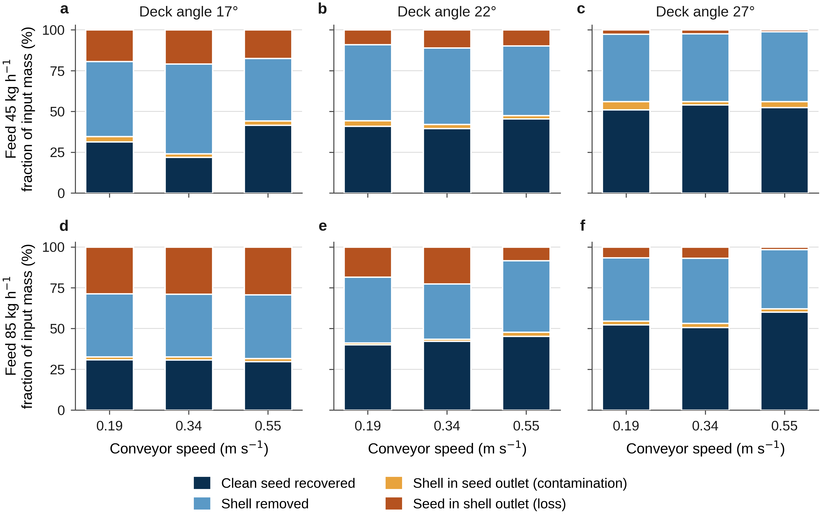
Fig. 1 Fate of the input mass at feed rates of 45 kg/h (a-c) and 85 kg/h (d-f) for deck angles of 17 degrees (a, d), 22 degrees (b, e) and 27 degrees (c, f). Each bar accounts for 100 % of the material fed, divided into the two correctly routed fractions and the two mis-routed fractions.

3.2 Cost of owning and operating the separator
The total fabrication cost of the developed draper separator was Rs. 9085 (Table 2). The cost of operation worked out to Rs. 72.03/h, made up of a fixed cost of Rs. 7.26/h covering depreciation, interest on investment and housing, and a variable cost of Rs. 64.77/h covering repair, maintenance and labour wages. Labour dominates the variable component, which is exactly what would be expected of a hand-cranked machine that consumes no fuel or electricity and embodies very little capital.
The proportions are the point of interest (Fig. 2a). Only one rupee in ten of the hourly cost is fixed. A machine with this cost structure behaves quite differently from a tractor drawn or engine-driven implement, whose economics are dominated by capital recovery and which must therefore be used for many hours a year to be viable. Here the fixed burden is so small that spreading it over more hours buys comparatively little: raising annual use from 100 to 300 h/year lowers the hourly cost only from Rs. 79.3 to Rs. 69.6, a saving of 12 % (Fig. 2b). The corollary is that the economics of this machine are not improved much by using it more often. They are improved by using it better, which is a statement about deck angle, speed and feed rate rather than about utilisation.
The same conclusion appears in a second form in Fig. 2a. The identical Rs. 72.03 of hourly cost becomes Rs. 130 per quintal of clean kernel when the machine is set to deliver 55.4 kg/h of clean kernel, and Rs. 750 per quintal when a poor setting reduces that delivery to 9.6 kg/h. The cost of the machine per unit of product varies almost six-fold without a single rupee of the cost structure changing.
Table 2: Cost of owning and operating the developed draper separator
Item | Value | Remarks
Fabrication cost of the machine, Rs. | 9085 | frame, rollers, shafts, bearings, drive, belt, labour
Assumed annual use, h/year | 200 | assumption of the costing
Fixed cost, Rs./h | 7.26 | depreciation, interest, housing (10.1 % of total)
Variable cost, Rs./h | 64.77 | repair, maintenance, labour (89.9 % of total)
Total operating cost, Rs./h | 72.03 | no fuel or power cost; hand-cranked
Annual fixed cost, Rs./year | 1452 | 7.26 x 200
Custom-hiring charge, Rs./h | 112.55 | equivalent to Rs. 2.25 per kg of mixture at 50 kg/h
Net annual profit, Rs./year | 8104 | (112.55 - 72.03) x 200
Break-even use, h/year | 30.4 | FCa / (CH - VC); see section 3.6
Payback period, year | 1.12 | 9085 / 8104
The annual use and custom-hiring charge are assumptions of the costing rather than measurements. They are stated explicitly here because the break-even and payback figures cannot be interpreted without them; section 3.5 shows how the conclusions move if they are changed.
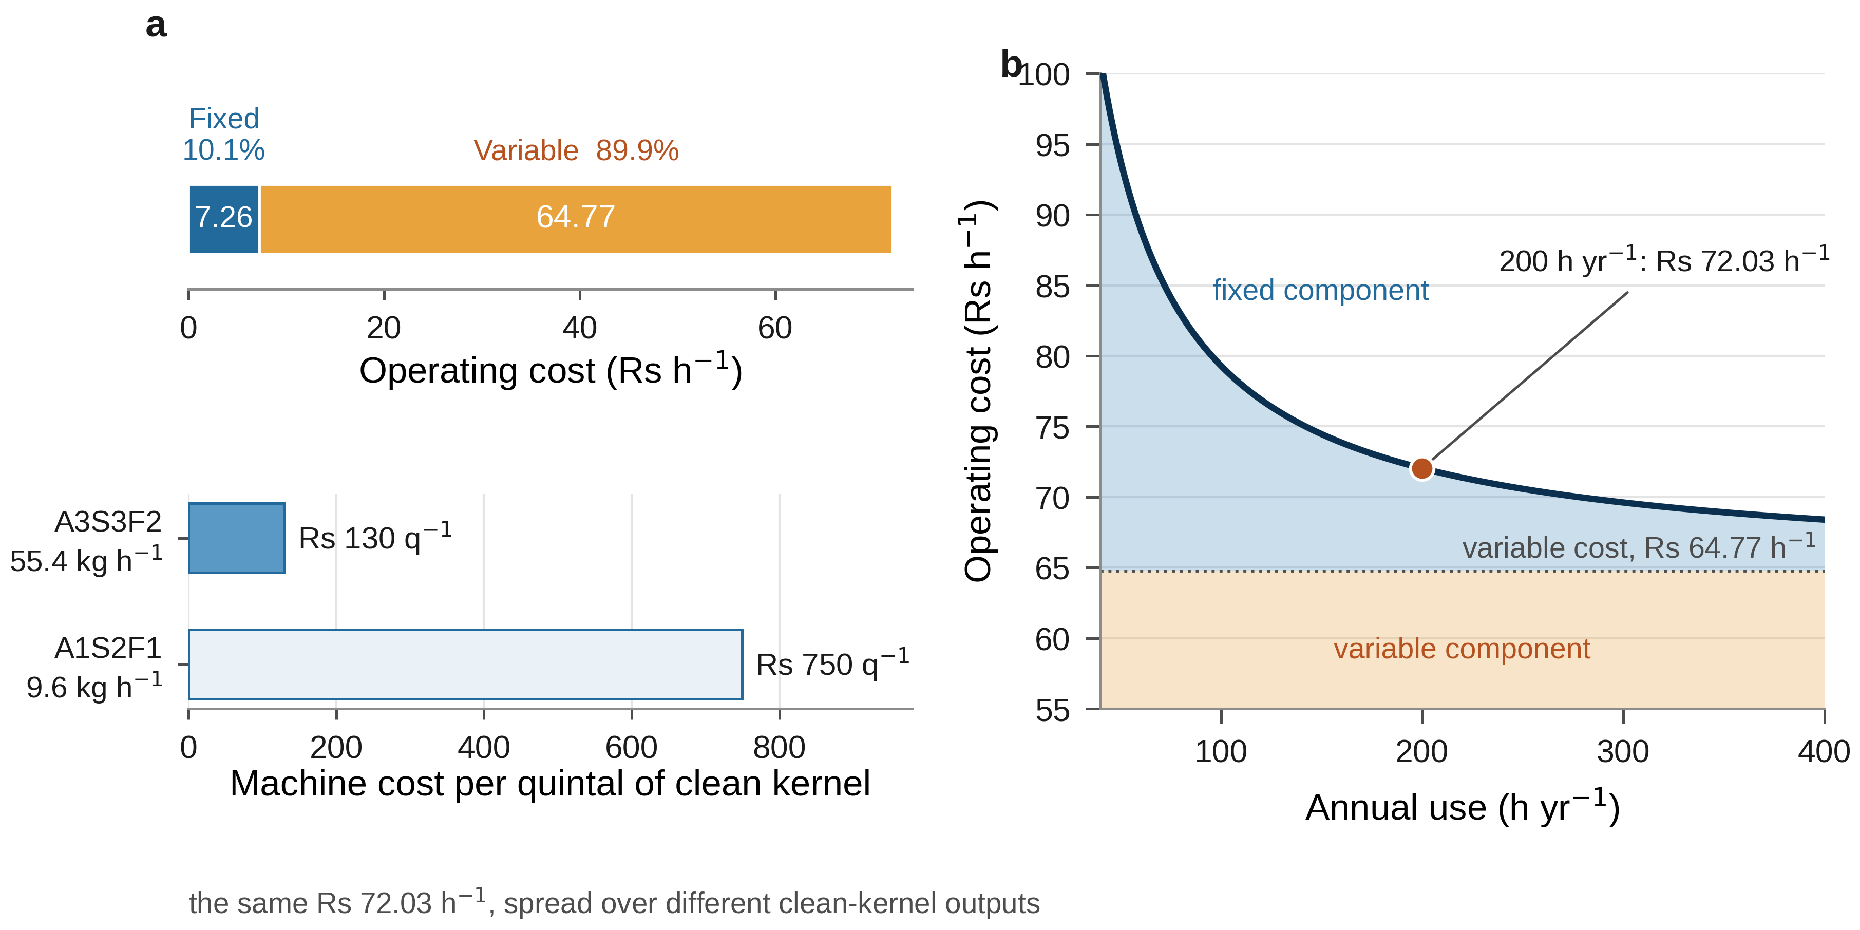
Fig. 2 Cost structure of the developed draper separator. (a) The hourly operating cost of Rs. 72.03 divided into its fixed and variable components (upper bar), and the same hourly cost expressed per quintal of clean kernel at the best and worst clean-kernel outputs recorded in the experiment (lower bars). (b) Fall of the hourly operating cost with annual use, showing that the fixed component is too small for utilisation to be an important economic lever.

3.3 The cost of cleaning a quintal of groundnut kernel
Adding the machine term and the kernel-loss term gives the total cost of producing a quintal of clean kernel at each of the 18 settings (Table 3, Fig. 3). It ranges from Rs. 391 to Rs. 10 279 per quintal - a factor of twenty-six - and every rupee of that spread is produced by the way the same machine is set, since the machine, the crop, the operator and the cost structure are identical throughout.
Two features of Fig. 3 carry the argument. The first is that the kernel-loss term dominates the total almost everywhere. Even at the cheapest setting it is Rs. 261 of the Rs. 391 total, or 67 %; across the twelve worst settings it exceeds 85 %, and at the four dearest it exceeds 92 %. The machine term, by contrast, never exceeds Rs. 750 per quintal and is usually between Rs. 130 and Rs. 400. Any effort to improve the economics of this separator that concentrates on reducing its cost of operation is therefore working on the smaller of the two terms; the return lies in reducing the kernel that leaves with the shell.
The second is that the ordering of the treatments by cost follows deck angle almost perfectly - the six cheapest settings are all at 27 degrees and the five dearest are all at 17 degrees - but within the steepest deck it is throughput that separates the winners. A3S3F2 costs Rs. 391 per quintal against Rs. 544 for A3S3F1, although the two differ in cleaning efficiency by only 0.6 percentage points (97.46 % against 98.04 %). The difference is that A3S3F2 delivers 55.4 kg/h of clean kernel and A3S3F1 only 21.1 kg/h, so the same hourly cost is spread over 2.6 times as much product.
Table 3: Techno-economic performance of the eighteen treatments, ranked by total cost of cleaning
Treatment | CE (%) | SL (%) | Purity (%) | Clean kernel output (kg/h) | Machine cost (Rs./q) | Kernel-loss cost (Rs./q) | Total cost (Rs./q)
A3S3F2 | 97.46 | 5.17 | 96.81 | 55.4 | 130 | 261 | 391
A3S3F1 | 98.04 | 7.77 | 93.69 | 21.1 | 344 | 200 | 544
A3S2F1 | 95.81 | 4.60 | 96.42 | 23.3 | 310 | 437 | 747
A3S1F1 | 95.28 | 10.87 | 90.94 | 20.9 | 347 | 496 | 843
A3S1F2 | 88.85 | 5.63 | 95.77 | 41.3 | 174 | 1256 | 1430
A3S2F2 | 88.05 | 5.75 | 95.41 | 36.9 | 195 | 1358 | 1553
A2S3F2 | 83.48 | 5.51 | 94.58 | 37.5 | 201 | 2049 | 2250
A2S3F1 | 82.14 | 4.63 | 95.61 | 23.0 | 317 | 2183 | 2500
A2S1F1 | 81.88 | 6.68 | 92.45 | 20.2 | 358 | 2224 | 2581
A2S2F1 | 77.36 | 5.09 | 93.74 | 18.6 | 410 | 3002 | 3412
A1S3F1 | 70.36 | 6.34 | 94.11 | 19.7 | 367 | 4216 | 4583
A2S1F2 | 68.41 | 2.71 | 97.28 | 31.6 | 228 | 4618 | 4846
A2S2F2 | 65.09 | 3.82 | 96.93 | 40.9 | 176 | 5364 | 5540
A1S1F1 | 61.26 | 6.72 | 90.63 | 13.4 | 573 | 6677 | 7249
A1S1F2 | 51.84 | 4.60 | 94.30 | 27.8 | 259 | 9300 | 9559
A1S2F2 | 51.61 | 4.46 | 94.49 | 27.4 | 263 | 9381 | 9644
A1S3F2 | 50.38 | 4.45 | 94.24 | 26.5 | 272 | 9860 | 10132
A1S2F1 | 51.21 | 3.91 | 90.72 | 9.6 | 750 | 9529 | 10279
CE = cleaning efficiency; SL = shell loss expressed as a fraction of the shell present; Purity = kernel as a fraction of the clean-seed stream delivered. Costs are per quintal of clean kernel at an operating cost of Rs. 72.03/h and a kernel value of Rs. 100/kg. Means of three replications.
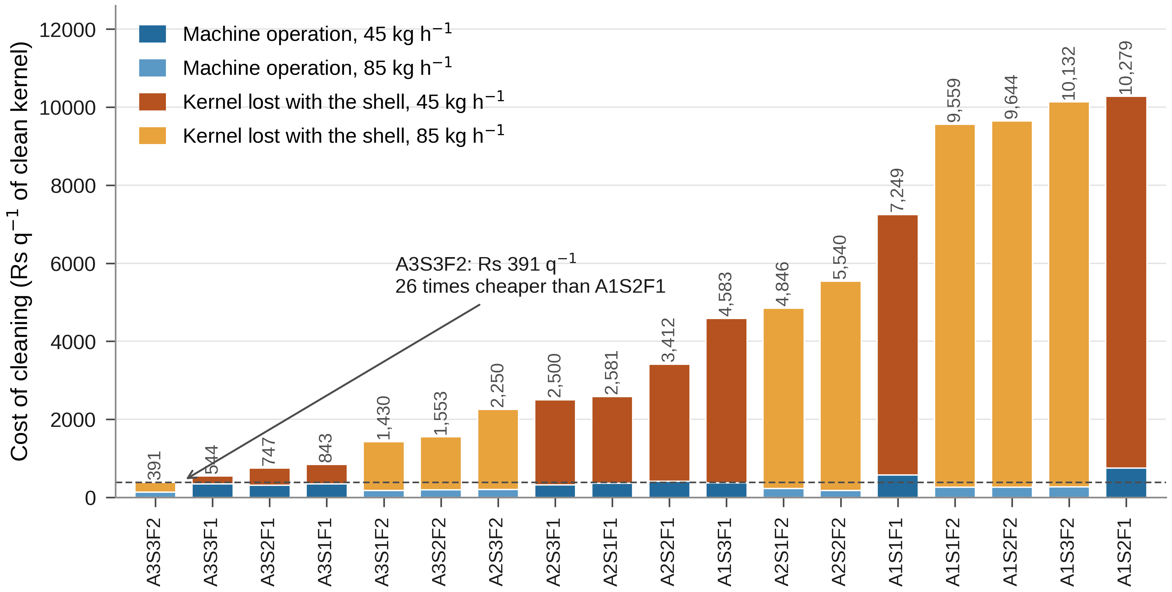
Fig. 3 Cost of producing one quintal of clean groundnut kernel at each of the eighteen settings, ranked, and divided into the cost of operating the machine and the value of the kernel lost with the shell. Bars are shaded by feed rate. The kernel-loss term dominates the total at every setting, and the twenty-six-fold spread between the cheapest and the dearest setting is produced entirely by how the machine is operated.

3.4 Efficiency, contamination and the choice of an operating point
Ranking the treatments on cleaning efficiency alone selects A3S3F1 (98.04 %), and a single-objective reading of the experiment would recommend it. It carries, however, a shell loss of 7.77 %, the second-highest value recorded anywhere in the experiment. Combining the two technical responses through the desirability function (Fig. 4) resolves that conflict differently: the highest overall desirability is obtained at A3S2F1 (D = 0.856; 95.81 % efficiency at 4.60 % shell loss), with A3S3F2 a close second (D = 0.831; 97.46 % at 5.17 %), while A3S3F1 ranks only eighth (D = 0.616).
The economic criterion agrees with neither. It selects A3S3F2, which both the desirability analysis and the efficiency ranking placed second, at Rs. 391 per quintal against Rs. 747 for the desirability optimum A3S2F1 and Rs. 544 for the efficiency optimum A3S3F1. Operating at the desirability optimum instead of the economic one costs 91 % more per quintal of kernel produced.
The reason the three criteria disagree is instructive, and it is not simply that the economic criterion values throughput. Shell loss as defined here is expressed as a fraction of the shell present, and that denominator falls as the deck steepens and more shell is routed correctly, which mechanically inflates the percentage at exactly the settings that work best. Expressed instead as the purity of the clean-seed stream, the quantity a buyer actually assesses, A3S3F2 delivers 96.81 % kernel and A3S2F1 96.42 % (Table 3) - that is, the treatment penalised by the desirability analysis is marginally the cleaner of the two. Once contamination is measured on the product rather than on the shell, the technical and the economic criteria cease to conflict and both select A3S3F2.
This is a general caution for the reporting of separator performance rather than a peculiarity of these data. A ratio whose denominator is itself a function of the treatment cannot be used to rank treatments without checking what the denominator is doing, and the check is cheap when the mass balance closes.
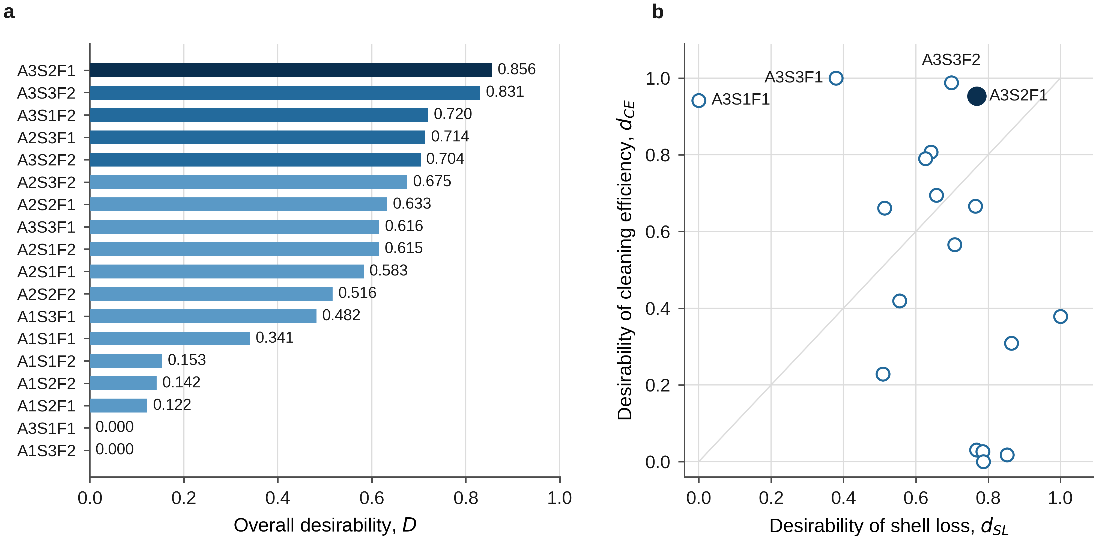
Fig. 4 Multi-objective optimisation of the two technical responses by the desirability approach. (a) Overall desirability D of the eighteen treatments, ranked, with the optimum highlighted. (b) The same treatments in desirability space; the diagonal marks equal desirability on both objectives, so points near it are balanced compromises and points far from it are specialists.

3.5 The economic optimum and how far it can be trusted
The cost-efficiency plane (Fig. 5a) shows the shape of the result. Total cost falls by more than an order of magnitude as cleaning efficiency rises from 50 % to 98 %, and the two feed rates lie on the same descending band, with the high feed rate displaced downwards wherever efficiency is comparable. There is no interior optimum and no trade-off in the economic domain: within the region tested, the settings that clean best are also the settings that cost least, and the high feed rate is preferred whenever the deck is steep enough for efficiency not to suffer.
The ranking survives the assumptions. Recomputing the total cost over kernel values from Rs. 70 to Rs. 130/kg left A3S3F2 the cheapest setting throughout, its cost moving from Rs. 313 to Rs. 469 per quintal; the ordering of the leading treatments is unchanged because A3S3F2 would be overtaken by its nearest rival A3S3F1 only at a kernel value above Rs. 350/kg, three and a half times the base case and far outside any plausible price. Halving or doubling the assumed annual use changes the machine term at the optimum by at most Rs. 13 per quintal, under 4 % of the total, and cannot alter the ranking either. The conclusion that the machine should be run at the steepest deck available and fed as fast as the decorticator will supply it is therefore robust to every input of the costing that is genuinely uncertain.
The economic optimum also changes the investment case materially. At the nominal custom-hiring rate of Rs. 2.25 per kg of mixture, a machine operated at A3S3F2 handles 92.1 kg/h and earns Rs. 207.4/h against Rs. 72.03/h of cost, giving a net annual profit of Rs. 27 074 at 200 h/year, a payback period of 0.34 year and a break-even use of 10.2 h/year. The same machine operated at A3S3F1 handles only 40.4 kg/h, earns Rs. 90.8/h, and its payback stretches to 2.42 year with a break-even use of 55.7 h/year. Choosing the operating point on cleaning efficiency rather than on cost thus turns a four-month payback into a twenty-nine-month one, on identical hardware.
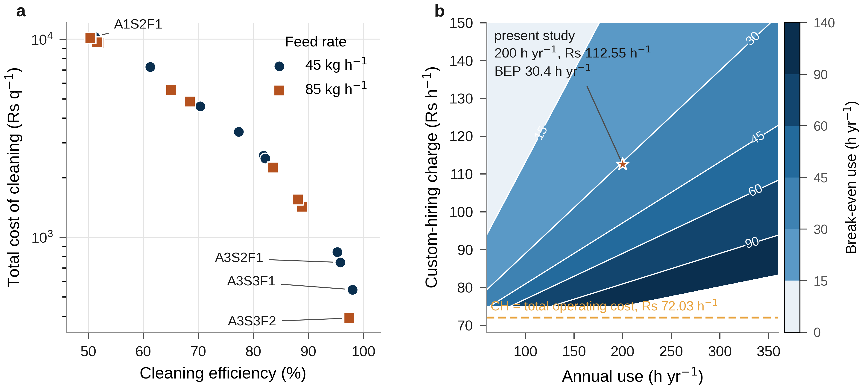
Fig. 5 (a) Total cost of cleaning against cleaning efficiency for the eighteen treatments, on a logarithmic cost scale, separated by feed rate. (b) Break-even use of the separator as a joint function of annual use and custom-hiring charge, computed with the variable cost in the denominator; contours are labelled in h/year and the star marks the assumptions adopted here. Below the broken line the hiring charge falls short of the total operating cost of Rs. 72.03/h, so the machine cannot recover its fixed cost at any level of use.

3.6 Break-even use, payback, and a correction to the break-even formula
At the assumed annual use of 200 h/year and custom-hiring charge of Rs. 112.55/h, the annual fixed cost is Rs. 1452 and the break-even use is 1452 / (112.55 - 64.77) = 30.4 h/year, or about 15 % of the assumed annual use. The payback period is 9085 / 8104 = 1.12 year. Both figures are comfortable, and Fig. 5b shows that they remain so over the plausible range of the two assumptions: at the assumed 200 h of annual use the break-even use stays below 45 h/year for any hiring charge above Rs. 97/h, that is for any charge exceeding the total operating cost by more than about a third, and falls to 26 h/year at Rs. 120/h.
One point of arithmetic deserves emphasis because it recurs in the farm-machinery literature. The break-even expression is often written as FCa / (CH - C) with C the total operating cost per hour. That form is not correct. Total cost already contains the fixed cost distributed over the assumed hours, so subtracting it from the hiring charge removes the fixed cost a second time; the numerator then has to be recovered from a margin that has been reduced by an amount that is itself part of the numerator. For the present machine the incorrect form gives 1452 / (112.55 - 72.03) = 35.8 h/year against the correct 30.4 h/year, an overstatement of 18 %. The error is conservative, in that it makes the machine look worse than it is, but it is an error, and it grows with the fixed share of the hourly cost. The variable cost is the quantity that belongs in the denominator, because at the margin one more hour of operation adds only the variable cost.
Set against the alternative the machine replaces, the case is straightforward. Hand winnowing of the decorticated mixture is weather-dependent, generates dust and typically occupies one or two workers; the separator replaces it with a device costing Rs. 9085 that pays for itself within a season at modest use, needs no fuel or electricity, and produces no dust. Its performance at the recommended setting - 97.5 % of the kernel recovered at 96.8 % purity, at 92 kg/h of mixture - is of the same order as that reported for powered air-screen and negative-pressure peanut cleaners (Liu et al., 2023; Zhu et al., 2023; Ling et al., 2024), which is the relevant comparison for a smallholder deciding between a hand-cranked separator and no machine at all.

4. CONCLUSIONS
The 54 cleaning trials of a factorial experiment on a hand-operated inclined draper separator were re-analysed as a techno-economic problem, converting each treatment into a cost per quintal of clean groundnut kernel. The following conclusions are drawn.
1. The separator was fabricated for Rs. 9085 and cost Rs. 72.03/h to operate, of which only Rs. 7.26/h (10.1 %) was fixed. Because the fixed share is so small, raising annual use from 100 to 300 h/year reduces the hourly cost by only 12 %; utilisation is not an important economic lever for a machine of this kind.
2. Kernel lost with the shell, and not the cost of running the machine, governs the economics. At Rs. 100/kg the lost kernel is worth Rs. 1722/h at a deck angle of 17 degrees and Rs. 236/h at 27 degrees, against an operating cost of Rs. 72.03/h. The loss term accounted for 67 % of the total cost of cleaning even at the best setting and for more than 90 % at poor settings.
3. The cost of producing a quintal of clean kernel ranged from Rs. 391 to Rs. 10 279 across the eighteen settings of the same machine, a twenty-six-fold spread produced entirely by deck angle, conveyor speed and feed rate.
4. The economically optimal setting is a deck angle of 27 degrees with a conveyor speed of 0.55 m/s and a feed rate of 85 kg/h (A3S3F2), at Rs. 391 per quintal. It is neither the setting that maximises cleaning efficiency (A3S3F1, Rs. 544) nor the one selected by a desirability analysis of efficiency and shell loss (A3S2F1, Rs. 747), because those criteria are blind to throughput: A3S3F2 delivers 55.4 kg/h of clean kernel against 21 to 23 kg/h for the alternatives at almost the same efficiency.
5. The disagreement between the technical and economic criteria is partly an artefact of how contamination is expressed. Shell loss measured as a fraction of the shell present penalises the steepest deck, whereas the purity of the delivered clean seed - 96.81 % at A3S3F2 against 96.42 % at A3S2F1 - does not. Measured on the product rather than on the shell, the technical and economic optima coincide.
6. The ranking is robust: it is unchanged for kernel values from Rs. 70 to Rs. 130/kg and for annual use halved or doubled. Operating at the economic optimum shortens the payback period from 1.12 to 0.34 year and lowers the break-even use from 30.4 to 10.2 h/year on identical hardware.
7. The break-even expression for farm machinery must carry the variable cost, not the total operating cost, in its denominator. Using the total cost double-counts the fixed cost and overstated the break-even use of this machine by 18 %.
The principal limitation of the analysis is that the economic optimum, like the technical one, lies on the boundary of the region tested: 27 degrees was the steepest deck and 85 kg/h the highest feed rate examined, so the data can show only that the optimum is at or beyond them. Trials at steeper decks and higher feed rates, where kernel loss should eventually rise and reverse the trend, are needed to locate the turning point. The costing also rests on an assumed custom-hiring charge and annual use, and on a single crop, variety and moisture content; the framework, however, requires only a closed mass balance and a price, and applies unchanged to any separator for which those are available.

COMPETING INTERESTS DISCLAIMER:
Authors have declared that they have no known competing financial interests OR non-financial interests OR personal relationships that could have appeared to influence the work reported in this paper.

Declaration of AI Use

This manuscript was prepared through the intellectual contributions of the author(s) to the study design, data analysis, interpretation of results, and scholarly content. Grammarly and ChatGPT were used solely to assist with grammatical refinement and reference formatting during manuscript revision. The author(s) accept full responsibility for the accuracy, integrity, and final content of the manuscript.

REFERENCES
Akande, B.N. 2014. Design and construction of a groundnut decorticating machine. Int. J. Mgt. Sci. & Tech. 2(10).
Akintunde, B.O., Oyawale, F.A. and Akintunde, T.Y. 2005. Design and fabrication of a cassava peeling machine. Nigerian Food J. 23: 231-238.
Anonymous. 2017. Survey of groundnut crop, Kharif-2017. Indian Oilseeds and Produce Export Promotion Council.
Derringer, G. and Suich, R. 1980. Simultaneous optimization of several response variables. Journal of Quality Technology. 12(4): 214-219. https://doi.org/10.1080/00224065.1980.11980968
Gitau, A.N., Mboya, P., Njoroge, B.N.K. and Mburu, M. 2013. Optimizing the performance of a manually operated groundnut (Arachis hypogaea) decorticator. Open J. Optimization. 2: 26-32.
Government of India. 2025. Cabinet approves Minimum Support Prices (MSP) for Kharif Crops for Marketing Season 2025-26. Press Information Bureau, Cabinet Committee on Economic Affairs, New Delhi, 28 May 2025.
Hud, V., Lyashuk, O., Hevko, I., Ungureanu, N., Vladut, N.V., Stashkiv, M., Hevko, O. and Pik, A. 2023. Enhancement of agricultural materials separation efficiency using a multi-purpose screw conveyor-separator. Agriculture. 13(4): 870. https://doi.org/10.3390/agriculture13040870
Kamboj, P. 2012. Study of farm machinery services provided by selected cooperative societies. Agric. Engg. Int.: CIGR Journal. 14(4): 123-133.
Ling, J., Gu, M., Luo, W., Shen, H., Hu, Z., Gu, F., Wu, F., Zhang, P. and Xu, H. 2024. Simulation analysis and test of a cleaning device for a fresh-peanut-picking combine harvester based on computational fluid dynamics-discrete element method coupling. Agriculture. 14(11): 1953. https://doi.org/10.3390/agriculture14111953
Liu, Z., Yu, Y., Wang, J., Kang, Z., He, F. and Gao, L. 2023. Numerical simulation and optimization of peanut sheller air-screen cleaning device. Agriculture. 13(10): 1997. https://doi.org/10.3390/agriculture13101997
Muhammad, A.I., Isiaka, M., Attanda, M.L., Shittu, S.K., Lawan, I. and Bomoi, M.I. 2021. Performance optimization of groundnut shelling using response surface methodology. Acta Technologica Agriculturae. 24(1): 1-7. https://doi.org/10.2478/ata-2021-0001
R Core Team. 2024. R: A language and environment for statistical computing. R Foundation for Statistical Computing, Vienna, Austria.
Thorat, D.S., Sahoo, P.K., De, D. and Iquebal, M.A. 2014. Design and development of ridge profile power weeder. J. Agric. Engg. 51(4): 7-13.
Waddle, B.M. and Rex, F.C. 1961. Producing of cotton and other fiber crops. Yearbook of Agriculture. 188-92.
Zhu, C., Chen, B., Li, J., Liu, Y., Yang, L., Wang, W. and Zhang, H. 2023. Design and testing of the peanut pod cleaning device. Processes. 11(1): 106. https://doi.org/10.3390/pr11010106

