Original Research Article

Phenotypic Diversity and Correlation Analysis of Morphological Traits in rice (Oryza sativa L.)

Abstract
Sixty rice genotypes were evaluated during the Kharif season of 2023 at the Norman E. Borlaug Crop Research Centre (NEBCRC), G.B. Pant University of Agriculture and Technology, Pantnagar, Uttarakhand, using an alpha-lattice design with two replications to quantify phenotypic diversity and examine associations among 15 morphological and yield-related traits. The traits comprised plant height, flag-leaf length, flag-leaf breadth, leaf area, days to 50% flowering, number of panicles per plant, panicle length, number of grains per panicle, grain yield, biological yield, harvest index, grain length, grain breadth, grain length/breadth ratio and test weight. Pearson correlation analysis revealed that grain yield was strongly and positively associated with harvest index (r = 0.81, P < 0.01) but negatively associated with biological yield (r = -0.35, P < 0.01). Biological yield was positively associated with days to 50% flowering (r = 0.79, P < 0.01), flag-leaf length (r = 0.69, P < 0.01), leaf area (r = 0.68, P < 0.01), grains per panicle (r = 0.36, P < 0.01), plant height (r = 0.27, P < 0.05) and panicle length (r = 0.27, P < 0.05). Standardised Euclidean-distance-based hierarchical analysis partitioned the genotypes into five clusters containing 19, 8, 14, 10 and 9 entries, respectively. The greatest inter-cluster distance occurred between Clusters II and IV (6.885), while the smallest occurred between Clusters I and II (4.826). Cluster V showed the largest within-cluster distance (4.713), indicating comparatively high heterogeneity. Genotypes belonging to the widely separated Clusters II and IV constitute useful parental pools, provided their trait means and agronomic performance are also complementary. The results demonstrate appreciable morphological differentiation and identify trait relationships relevant to selection for rice improvement.
Keywords: agromorphological traits; cluster analysis; Euclidean distance; genetic resources; grain yield; Pearson correlation; rice germplasm

1. Introduction
Rice (Oryza sativa L.) serves as a staple food crop for a large share of the world's population, and continuous genetic enhancement is essential to keep pace with growing demand amid ever more unpredictable growing conditions. In India, rice occupies around 47.8 million hectares with an annual production of 137.83 million tonnes and an average productivity of about 2,884 kg/ha (Department of Agriculture and Farmers’ Welfare, Government of India, 2024). The effectiveness of a breeding programme aimed at closing such gaps depends on the availability, characterisation and purposeful use of diverse germplasm. Morphological evaluation remains a practical first step because it is inexpensive, directly connected with field performance and can identify contrasting parents for subsequent breeding and molecular characterisation. Morphological characterisation using Mahalanobis’s D² statistic (Mahalanobis, 1936), together with genotypic (GCV) and phenotypic (PCV) coefficients of variation calculated following Burton (1952), is therefore valuable for identifying useful breeding material across rice and other crop germplasm (Hien et al., 2007; Kumar et al., 2024; Kumari et al., 2023).
Yield is a complex quantitative trait determined by the joint action of component characters and the environment. Correlation analysis helps identify traits that vary together with grain yield, although correlation alone does not establish causation or a direct genetic effect. In rice, panicle attributes, seed number and seed weight have frequently shown useful associations with yield, and phenotypic and genotypic correlations have been used to identify potential selection criteria (Ashfaq et al., 2012; Vanlalrinngama et al., 2023a). Multivariate procedures complement pairwise correlation by summarising simultaneous differences among genotypes. Morphology-based clustering and divergence analysis have successfully differentiated rice landraces and cultivars and identified contrasting parental groups (Kumari et al., 2025; Sinha & Mishra, 2013; Vanlalrinngama et al., 2023b).
Recent rice studies have similarly reported agro-morphological variability and trait associations, while phenotype-based clustering has been used to distinguish contrasting genotype groups across germplasm panels (Umamaheswar et al., 2024; Win et al., 2025). Independent analyses of aus and aromatic rice germplasm have likewise shown that multi-trait phenotyping can resolve structured diversity and support germplasm characterisation for breeding applications (Sar et al., 2024; Bairwa et al., 2024).
For the 60 genotypes evaluated at Pantnagar, the extent to which the 15 recorded morphological and yield-related traits are interrelated and whether the genotypes form clearly divergent phenotypic groups remained to be determined. A combined assessment of trait correlations and multivariate phenotypic divergence is therefore needed to characterise this specific panel and identify contrasting groups for parental consideration.
The present study was undertaken to (i) assess phenotypic relationships among 15 morphological and yield-related traits in 60 rice genotypes, (ii) group the genotypes according to multivariate phenotypic similarity, and (iii) identify divergent groups that may be useful in parental selection for rice improvement.

2. Materials and methods

2.1 Experimental material and field design
The experimental material consisted of 60 rice genotypes, including UPR and CGIL breeding lines and released or locally adapted cultivars (Table 1). The trial was conducted at Pantnagar, Uttarakhand, India, during the Kharif 2023 crop season. The genotypes were evaluated in an alpha-lattice design comprising six incomplete blocks, each containing 10 genotypes, with two replications. Recommended agronomic practices were followed to raise a uniform crop.
Table 1. Rice genotypes evaluated at Pantnagar during the Kharif, 2023 crop season.
S. No. | Genotype | S. No. | Genotype
1 | UPR-4466-13-1-1-1 | 31 | CGIL-865-3
2 | UPR-4572-3-1-1-1 | 32 | CGIL-1072-3
3 | UPR-4574-3-1-1-1 | 33 | CGIL-718-2
4 | UPR-4571-2-1-1-1 | 34 | CGIL-1419-1
5 | UPR-4079-10-1-1-1 | 35 | CGIL-853-3
6 | UPR-4084-14-1-1-1 | 36 | CGIL-644-2
7 | UPR-4088-1-1-1 | 37 | CGIL-754-3
8 | UPR-4218-17-1-1-2 | 38 | CGIL-908-3
9 | UPR-4246-9-1-1-3 | 39 | CGIL-648-2
10 | UPR-4257-8-1-1-1 | 40 | CGIL-936-1
11 | UPR-4259-2-1-1-3 | 41 | CGIL-801-3
12 | UPR-4259-9-1-1-2 | 42 | CGIL-919-3
13 | UPR-4451-2-1-1-1 | 43 | CGIL-861-1
14 | UPR-4451-7-1-1-1 | 44 | CGIL-918-3
15 | UPR-4458-4-1-1-1 | 45 | PD 23
16 | UPR-4707-7-1-1-1 | 46 | HANSRAJ
17 | UPR-4707-9-1-1-1 | 47 | PRASAD
18 | UPR-4706-1-1-1-1 | 48 | GOVIND BHOG
19 | UPR-4715-9-1-1-1 | 49 | BINDATI
20 | UPR-4712-6-2-1-1 | 50 | IR 64
21 | UPR-4714-4-1-1-1 | 51 | GOVIND
22 | UPR-4713-1-1-1-1 | 52 | IR 24
23 | UPR-4724-10-2-1-1 | 53 | PSD 17
24 | UPR-4707-1-1-1-1 | 54 | TRAORI
25 | UPR-4466-2-1-1-1 | 55 | PD 28
26 | UPR-4707-6-2-1-1 | 56 | PANT BAS 1
27 | CGIL-1303-3 | 57 | PSD 27
28 | CGIL-803-1 | 58 | PD 24
29 | CGIL-1065-3 | 59 | PUSA 44
30 | CGIL-96-2 | 60 | IET-4687-9-1-1-1

2.2 Traits recorded
Observations were recorded for 15 traits: plant height (PH), flag-leaf length (FLL), flag-leaf breadth (FLB), leaf area (LA), days to 50% flowering (DFF), number of panicles per plant (NPP), panicle length (PL), number of grains per panicle (NG/P), grain yield per plant (GY), biological yield per plant (BY), harvest index (HI), grain length (GL), grain breadth (GB), grain length/breadth ratio (L/B) and test weight (TW).

2.3 Statistical analysis
Pearson product-moment correlation coefficients (r) were calculated among genotypes using adjusted means in R version 4.3.0, and the correlation matrix was visualised using the ggcorrplot and ggplot2 packages. The coefficient was calculated following Pearson (1895), and its recent application to phenotypic trait associations in rice is described by Islam et al. (2025). Significance testing was used to determine whether phenotypic correlation coefficients differed significantly from zero using a t-test, accounting for the effective degrees of freedom from the incomplete-block design (Steel et al., 1997). Standardised morphological data were subjected to agglomerative hierarchical cluster analysis. Pairwise dissimilarities were calculated using Euclidean distance, and clusters were formed using Ward's linkage algorithm as implemented by the ward.D method in R (Murtagh & Legendre, 2014).

3. Results

3.1 Correlation among traits
The correlation matrix showed coordinated variation among plant architecture, phenology, yield components and grain dimensions (Figure 1). Grain yield had a strong positive correlation with harvest index (r = 0.81, P < 0.01), indicating that genotypes allocating a larger proportion of biomass to grain tended to yield more. In contrast, grain yield was negatively correlated with biological yield (r = -0.35, P < 0.01). Grain yield showed no statistically significant correlation with the remaining measured traits.
Biological yield was positively correlated with DFF (r = 0.79, P < 0.01), FLL (r = 0.69, P < 0.01), LA (r = 0.68, P < 0.01), NG/P (r = 0.36, P < 0.01), PH (r = 0.27, P < 0.05) and PL (r = 0.27, P < 0.05), but was negatively associated with HI (r = -0.81, P < 0.01). Strong structural relationships included PH with PL (r = 0.95, P < 0.01), FLL with DFF (r = 0.92, P < 0.01), DFF with LA (r = 0.73, P < 0.01), FLL with LA (r = 0.73, P < 0.01), and FLB with LA (r = 0.69, P < 0.01). PL was positively correlated with NG/P (r = 0.40, P < 0.01). Grain dimensions were interdependent: GL correlated positively with L/B (r = 0.74, P < 0.01) and TW (r = 0.31, P < 0.05); GB correlated negatively with L/B (r = -0.80, P < 0.01) but positively with TW (r = 0.74, P < 0.01); and L/B correlated negatively with TW (r = -0.33, P < 0.01).
Figure 1. Pearson correlation matrix among 15 traits evaluated in 60 rice genotypes at Pantnagar during Kharif, 2023.
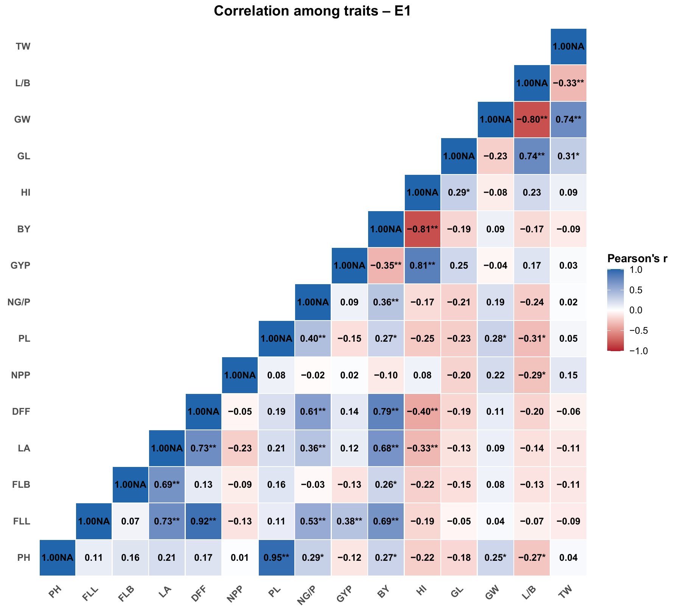
PH, plant height; FLL, flag-leaf length; FLB, flag-leaf breadth; LA, leaf area; DFF, days to 50% flowering; NPP, number of panicles per plant; PL, panicle length; NG/P, grains per panicle; GYP/GY, grain yield per plant; BY, biological yield per plant; HI, harvest index; GL, grain length; GW/GB, grain breadth; L/B, length/breadth ratio; TW, test weight. *P < 0.05; **P < 0.01. “NA” attached to diagonal values is a plotting-label artefact and does not represent missing data.

3.2 Phenotypic clustering and divergence
Hierarchical clustering partitioned the 60 genotypes into five groups (Figure 2; Table 2). Cluster I was the largest (19 genotypes), followed by Cluster III (14), Cluster IV (10), Cluster V (9) and Cluster II (8). The clusters contained mixtures of advanced breeding lines and named cultivars, showing that the observed phenotypic grouping was not determined solely by the genotype naming series.
Table 2. Cluster composition and within-cluster distance of 60 rice genotypes.
Cluster | n | Intra-cluster distance | Genotypes
1 | 19 | 4.012 | UPR-4466-13-1-1-1, UPR-4571-2-1-1-1, UPR-4079-10-1-1-1, UPR-4084-14-1-1-1, UPR-4246-9-1-1-3, UPR-4458-4-1-1-1, UPR-4706-1-1-1-1, UPR-4714-4-1-1-1, UPR-4466-2-1-1-1, CGIL-96-2, CGIL-1419-1, CGIL-754-3, CGIL-908-3, CGIL-918-3, BINDATI, PSD 17, TRAORI, PD 28, PSD 27
2 | 8 | 3.667 | UPR-4572-3-1-1-1, UPR-4574-3-1-1-1, UPR-4451-7-1-1-1, UPR-4715-9-1-1-1, CGIL-853-3, CGIL-861-1, HANSRAJ, IR 24
3 | 14 | 4.063 | UPR-4088-1-1-1, UPR-4259-2-1-1-3, UPR-4707-7-1-1-1, UPR-4707-6-2-1-1, CGIL-1303-3, CGIL-1065-3, CGIL-644-2, CGIL-648-2, CGIL-936-1, CGIL-801-3, PRASAD, IR 64, GOVIND, PD 24
4 | 10 | 4.455 | UPR-4218-17-1-1-2, UPR-4257-8-1-1-1, UPR-4259-9-1-1-2, UPR-4451-2-1-1-1, UPR-4707-9-1-1-1, UPR-4713-1-1-1-1, UPR-4707-1-1-1-1, CGIL-803-1, PD 23, GOVIND BHOG
5 | 9 | 4.713 | UPR-4712-6-2-1-1, UPR-4724-10-2-1-1, CGIL-865-3, CGIL-1072-3, CGIL-718-2, CGIL-919-3, PANT BAS 1, PUSA 44, IET-4687-9-1-1-1
Within-cluster distance ranged from 3.667 in Cluster II to 4.713 in Cluster V. Thus, Cluster II was the most internally homogeneous group, whereas Cluster V showed the greatest dispersion among its members. Inter-cluster distances ranged from 4.826 to 6.885 (Table 3). The greatest separation was observed between Clusters II and IV (6.885), closely followed by Clusters II and III (6.851). The smallest distance occurred between Clusters I and II (4.826), suggesting comparatively greater phenotypic resemblance between these groups.
Table 3. Average intra- and inter-cluster D² values among five clusters.
Cluster | I | II | III | IV | V
I | 4.012 | 4.826 | 5.682 | 5.365 | 5.337
II |  | 3.667 | 6.851 | 6.885 | 5.941
III |  |  | 4.063 | 5.085 | 5.303
IV |  |  |  | 4.455 | 5.519
V |  |  |  |  | 4.713

Note: Diagonal (shaded) values indicate intra-cluster distances; off-diagonal values indicate inter-cluster distances.
Table 4. Cluster mean values for 15 morphological and yield-related traits in 60 rice genotypes.
Cluster | PH | FLL | FLB | LA | DFF | NPP | PL | NG/P | GY | BY | HI | GL | GB | L/B | TW
I | 116.23 | 33.97 | 1.64 | 41.50 | 94.06 | 15.57 | 28.44 | 172.15 | 33.51 | 74.35 | 45.36 | 7.71 | 2.01 | 3.93 | 24.65
II | 97.67 | 28.62 | 1.52 | 32.73 | 88.38 | 17.84 | 23.71 | 152.13 | 29.64 | 69.97 | 42.71 | 8.15 | 1.94 | 4.26 | 25.71
III | 103.74 | 44.32 | 1.68 | 55.76 | 103.86 | 17.28 | 25.19 | 209.76 | 43.35 | 85.34 | 51.20 | 6.86 | 2.28 | 3.04 | 25.00
IV | 117.91 | 43.49 | 1.69 | 54.73 | 102.25 | 17.88 | 27.27 | 209.74 | 40.10 | 90.69 | 44.57 | 8.14 | 1.87 | 4.54 | 24.93
V | 112.84 | 36.27 | 1.64 | 44.76 | 97.11 | 26.28 | 25.82 | 196.10 | 38.18 | 85.91 | 44.94 | 7.55 | 2.44 | 3.16 | 27.04
Note: PH, plant height (cm); FLL, flag-leaf length (cm); FLB, flag-leaf breadth (cm); LA, leaf area (cm²); DFF, days to 50% flowering; NPP, number of panicles per plant; PL, panicle length (cm); NG/P, number of grains per panicle; GY, grain yield per plant (g); BY, biological yield per plant (g); HI, harvest index (%); GL, grain length (mm); GB, grain breadth (mm); L/B, grain length/breadth ratio; TW, test weight (g). Cluster sample sizes (n) correspond to those reported in Table 2.
Cluster mean values (Table 4) clarify the biological basis of the observed groupings. Cluster IV combined the tallest plants (PH = 117.91 cm) with the highest biological yield (BY = 90.69 g) but a comparatively low harvest index (44.57%), whereas Cluster II, the most compact and earliest-flowering group (PH = 97.67 cm; DFF = 88.38 days), combined the lowest biomass (BY = 69.97 g) with the boldest, most rounded grains (lowest L/B = 4.26 among the higher end, alongside comparatively high GB and TW). Cluster III combined the largest flag leaves and leaf area (FLL = 44.32 cm; LA = 55.76 cm²) with the highest number of grains per panicle (NG/P = 209.76) and the highest harvest index (51.20%), identifying it as the most efficient group in partitioning biomass to grain. Cluster V was distinguished by the greatest number of panicles per plant (NPP = 26.28) and the highest test weight (TW = 27.04 g). These trait-level contrasts between Clusters II and IV — in plant stature, flowering time, biomass accumulation and grain dimensions — substantiate the wide D² distance separating them (Table 3) and indicate that the two clusters differ not only in overall phenotypic distance but also in specific, breeding-relevant traits.

Figure 2. Hierarchical clustering of 60 rice genotypes based on standardized morphological traits and Euclidean distance.
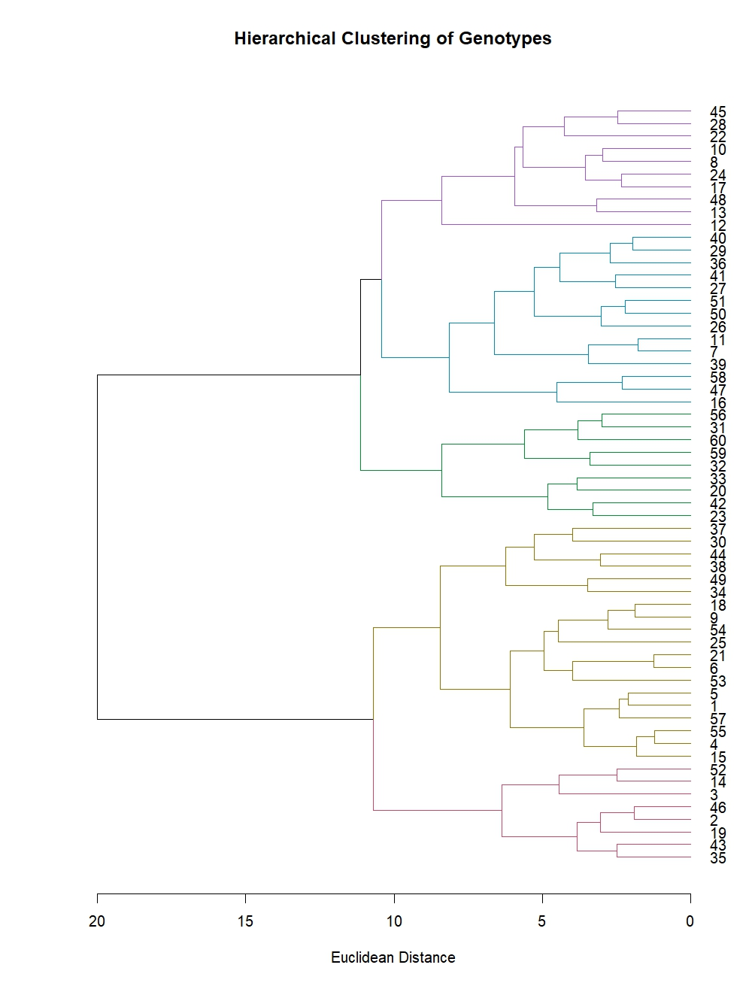
Dendrogram labels 1-60 correspond to the genotype codes reported in Table 1. Branch colours indicate the five-cluster solution.

4. Discussion
The sizeable correlations among leaf dimensions, flowering time, plant height, panicle length and biomass indicate that major components of rice phenotype did not vary independently. The strong PH-PL correlation suggests coordinated expression of plant stature and panicle architecture in this material. Likewise, the positive relationships of FLL and LA with DFF and BY indicate that later-flowering genotypes tended to develop a larger photosynthetic canopy and greater total biomass. Recent rice studies have similarly shown that yield improvement benefits from joint consideration of correlation, path effects and agro-morphological variability, although the magnitude and direction of associations depend on the germplasm and target environment (Ali et al., 2021; Singh et al., 2022; Singh Yadav et al., 2024).
It should be noted that harvest index is mathematically derived from grain yield and biological yield (HI = GY/BY); therefore, the observed HI–GY and HI–BY relationships are partly structural rather than strictly biological. While this limits a purely causal interpretation, the consistent trend across entries suggests that differences in partitioning efficiency, rather than biomass accumulation alone, likely contributed to yield variation in this experiment. The negative GY-BY correlation should not be interpreted as evidence that biomass is intrinsically undesirable; it may reflect differences in maturity, partitioning or the scale used for plot measurements. Path analysis and multi-environment evaluation would be needed to distinguish direct from indirect effects. The direction and magnitude of individual associations can differ among germplasm sets, reinforcing the need to validate selection criteria in the target population and environment.
The grain-dimension correlations were biologically coherent. Longer grains produced higher L/B ratios, while broader grains lowered the ratio. Test weight was positively related to grain breadth and grain length, but negatively related to L/B, indicating that heavier samples were associated more strongly with grain width than with slenderness. Recent phenotypic-diversity assessments have likewise identified grain dimensions, grain weight and other quantitative descriptors as important sources of differentiation among rice genotypes (Hamidah et al., 2024; Quan et al., 2024). These relationships are relevant when simultaneously breeding for grain type and yield-related attributes.
The five-cluster differentiation demonstrates broad phenotypic variation within the 60-genotype panel. Recent studies using agro-morphological descriptors, Euclidean or D² distances, principal components and molecular markers have similarly resolved rice panels into distinct groups and emphasised the use of widely separated, agronomically complementary parents (Chakravorty, 2024; Farheen et al., 2022; Fatamatuzzohora et al., 2024; Howlader et al., 2025; Remme et al., 2024). The large distance between Clusters II and IV identifies them as contrasting parental pools. However, distance alone is not sufficient for choosing parents: breeders should select specific members of these clusters only after comparing cluster means, individual adjusted means, adaptation, grain quality and the direction of target traits. This qualification is important because cluster separation reflects an aggregate multivariate distance: Table 4 shows that Clusters II and IV differ specifically in plant height, flowering time, biomass accumulation, panicle number and grain dimensions, and breeders should weigh these individual trait differences alongside adaptation and grain quality when choosing specific parents.
This study was conducted in a single environment with two replications during Kharif 2023; hence, the results reflect phenotypic divergence specific to Pantnagar conditions in that season. Evaluation across multiple locations and years would be necessary to confirm the stability of the observed trait relationships, while combining morphological data with molecular-marker information would strengthen inferences about the genetic basis underlying the identified phenotypic groups. Nonetheless, morphological characterisation remains a rapid and efficient preliminary screening tool and can effectively guide the selection of diverse, contrasting genotypes for subsequent breeding and genomic studies.

5. Conclusion
The study identified measurable phenotypic diversity among 60 rice genotypes evaluated for 15 morphological and yield-related traits under Pantnagar conditions during Kharif 2023. Grain yield was most strongly associated with harvest index, suggesting the importance of biomass partitioning in this set of materials. Biological yield was associated with flowering time, leaf traits, plant height, panicle length and grains per panicle. Hierarchical clustering separated the genotypes into five groups, with the widest divergence observed between Clusters II and IV. These clusters may provide useful contrasting material for parental selection, provided that individual genotype performance, trait means, adaptation and grain quality are further evaluated. The findings provide a preliminary phenotypic basis for germplasm classification and future breeding work.
Limitation
This study was conducted in a single environment at Pantnagar during Kharif 2023 with two replications; therefore, the observed correlations and phenotypic groupings are specific to the evaluated season and location. The analysis was based on morphological and yield-related traits, and the stability of the identified relationships and clusters across environments was not assessed. Multi-location, multi-year evaluation, together with molecular-marker information, would strengthen inference regarding the consistency and genetic basis of the observed phenotypic diversity.

Declaration of AI Use
This manuscript was prepared through the intellectual contributions of the author(s) to the study design, data analysis, interpretation of results, and scholarly content. Grammarly and ChatGPT were used solely to assist with grammatical refinement and reference formatting during manuscript revision. The author(s) accept full responsibility for the accuracy, integrity, and final content of the manuscript.

Conflict of interest
The authors declare no conflict of interest.

Data availability
The phenotypic data supporting this study are available from the corresponding author on reasonable request.

References
Ali, S. S., Suresh, B. G., & Lavanya, G. R. (2021). Genetic diversity and correlation studies in rice (Oryza sativa L.). International Journal of Chemical Studies, 9(1), 2768–2772. https://doi.org/10.22271/chemi.2021.v9.i1am.11643
Ashfaq, M., Khan, A. S., Khan, S. H. U., & Ahmad, R. (2012). Association of various morphological traits with yield and genetic divergence in rice (Oryza sativa L.). International Journal of Agriculture & Biology, 14, 55–62. https://www.fspublishers.org/published_papers/26537_..pdf
Bairwa, R. K., Yadav, M. C., Tiwari, S., Mahendran, A., Ellur, R. K., & Krishnan, S. G. (2024). Aromatic rice (Oryza sativa L.) landraces of Indo-Gangetic Plains of India harbor rich genetic diversity. Crop Science, 64(3), 1711–1728. https://doi.org/10.1002/csc2.21211
Burton, G. W. (1952). Quantitative inheritance in grasses. In Proceedings of the Sixth International Grassland Congress (Vol. 1, pp. 277–283).
Chakravorty, A. (2024). Genetic diversity analysis in some lowland rice landraces using agro-morphological traits. Applied Biological Research, 26(2), 246–252. https://doi.org/10.48165/abr.2024.26.01.28
Department of Agriculture and Farmers’ Welfare, Government of India. (2024). Final estimates of major agricultural crops for 2023–24. Press Information Bureau. https://www.pib.gov.in/PressReleasePage.aspx?PRID=2058534
Farheen, M., Murthy, K. G. K., Mohan, Y. C., & Kumar, J. H. (2022). Genetic diversity analysis for yield and morpho-physiological traits in elite rice (Oryza sativa L.) genotypes under semi-dry system through D² statistics. International Journal of Environment and Climate Change, 12(11), 827–835. https://doi.org/10.9734/ijecc/2022/v12i1131045
Fatamatuzzohora, M., Islam, M. S., Rabbee, M. F., Hossain, M. S., Kang, S. G., & Matin, M. N. (2024). Genetic variation, population structure, and cluster analysis of rice (Oryza sativa L.) genotypes using morphological characteristics and molecular markers. Cereal Research Communications, 52(4), 1751–1768. https://doi.org/10.1007/s42976-024-00569-5
Hamidah, Sunaryo, W., Rusdiansyah, & Nurhasanah. (2024). Genetic diversity and cluster analysis of local pigmented rice from East and North Kalimantan, Indonesia based on quantitative and qualitative characters. Biodiversitas, 25(5), 1938–1945. https://doi.org/10.13057/biodiv/d250510
Hien, N. L., Sarhadi, W. A., Oikawa, Y., & Hirata, Y. (2007). Genetic diversity of morphological responses and the relationships among Asia aromatic rice (Oryza sativa L.) cultivars. Tropics, 16(4), 343–355. https://doi.org/10.3759/tropics.16.343
Howlader, N. C., Bulbul, M. T. A., Islam, M. Z., Arafat, E., Rana, M. S., & Hasan, M. Z. (2025). Assessing rice genotypes based on agro-morphological characterization and diversity analysis in southern Bangladesh. Discover Plants, 2, Article 189. https://doi.org/10.1007/s44372-025-00253-w
Islam, M. Z., Chakrabarty, T., Akter, N., Khalequzzaman, M., Prince, M. F. R. K., Pittendrigh, B. R., Tomita, M., & Ali, M. P. (2025). Genetic variability, correlation and path coefficient analysis of phenotypic traits and genetic diversity of Aman rice landraces (Oryza sativa L.). Scientific Reports, 15, Article 18606. https://doi.org/10.1038/s41598-025-03547-x
Kumar, B., Singh, M. K., Kumari, N., Kumari, S., Banshidhar, & Singh, D. (2024). Variability assessment and screening of superior rice (Oryza sativa L.) genotypes for grain micronutrients and yield components. Electronic Journal of Plant Breeding, 15(3), 794–800. https://doi.org/10.37992/2024.1503.088
Kumari, N., Singh, M. K., Kumar, B., Kumari, S., Banshidhar, & Singh, D. (2025). Genetic divergence in rice genotypes for grain micronutrients and yield. International Journal of Plant and Environment, 11(3), 630–635. https://doi.org/10.18811/ijpen.v11i03.22
Kumari, S., Kumari, N., Singh, M. K., & Kumar, B. (2023). Variability assessment for yield component and protein content in chickpea (Cicer arietinum L.) genotype. The Pharma Innovation Journal, 12(2), 578–582. https://www.thepharmajournal.com/archives/?ArticleId=19344&issue=2&vol=12&year=2023
Mahalanobis, P. C. (1936). On the generalized distance in statistics. Proceedings of the National Institute of Sciences of India, 2(1), 49–55. https://www.researchgate.net/publication/240311080_On_the_Generalized_Distance_in_Statistics
Murtagh, F., & Legendre, P. (2014). Ward’s hierarchical agglomerative clustering method: Which algorithms implement Ward’s criterion? Journal of Classification, 31(3), 274–295. https://doi.org/10.1007/s00357-014-9161-z
Pearson, K. (1895). Note on regression and inheritance in the case of two parents. Proceedings of the Royal Society of London, 58, 240–242. https://doi.org/10.1098/rspl.1895.0041
Quan, C., Li, S., Li, H., Yu, W., & Jin, J. (2024). Genetic diversity study of phenotypic traits of 73 rice varieties by approved in Jinlin Province. Crops, 40(3), 64–75. https://doi.org/10.16035/j.issn.1001-7283.2024.03.009
Remme, R. N., Joti, S., & Islam, M. Z. (2024). Agro-morphological characterization and genetic diversity assessment of nineteen BRRI-released rice varieties. Khulna University Studies, 21(1), 84–97. https://doi.org/10.53808/KUS.2024.21.01.978-ls
Sar, P., Gupta, S., Behera, M., Chakraborty, K., Ngangkham, U., Verma, B. C., Banerjee, A., Hanjagi, P. S., Bhaduri, D., Shil, S., Kumar, J., Mandal, N. P., Kole, P. C., Purugganan, M. D., & Roy, S. (2024). Exploring genetic diversity within aus rice germplasm: Insights into the variations in agro-morphological traits. Rice, 17, Article 20. https://doi.org/10.1186/s12284-024-00700-4
Singh, S., Dixit, S., Tarkeshwar, Yadav, K., & Dutt, A. (2022). Direct and indirect effect computed between different phenotypic and genotypic level of yield relatable traits in rice (Oryza sativa L.) under sodic soil. The Pharma Innovation Journal, 11(7), 692–697. https://doi.org/10.22271/tpi.2022.v11.i7i.13732
Singh Yadav, S. P., Bhandari, S., Ghimire, N. P., Mehata, D. K., Majhi, S. K., Bhattarai, S., Shrestha, S., Yadav, B., Chaudhary, P., & Bhujel, S. (2024). Genetic variability, character association, path coefficient, and diversity analysis of rice (Oryza sativa L.) genotypes based on agro-morphological traits. International Journal of Agronomy, 2024, Article 9946332. https://doi.org/10.1155/2024/9946332
Sinha, A. K., & Mishra, P. K. (2013). Morphology-based multivariate analysis of phenotypic diversity of landraces of rice (Oryza sativa L.) of Bankura district of West Bengal. Journal of Crop and Weed, 9(2), 115–121. https://cwss.in/Journal/Complete_jurnal/Vol.9%20No.2__21.pdf
Steel, R. G. D., Torrie, J. H., & Dickey, D. A. (1997). Principles and procedures of statistics: A biometrical approach (3rd ed.). McGraw-Hill.
Umamaheswar, N., Roy, S. K., Kundu, A., Hijam, L., Chakraborty, M., Sen, S., Das, B., Barman, R., & Vishnupriya, S. (2024). Genetic variability and character association studies in diverse rice (Oryza sativa L.) genotypes for agro-morphological traits in Terai Region of West Bengal. Journal of Advances in Biology & Biotechnology, 27(5), 805–820. https://doi.org/10.9734/jabb/2024/v27i5843
Vanlalrinngama, C., Jha, B., Singh, S. K., Tigga, A., Kumar, B., Kumari, N., & Singh, M. K. (2023a). Trait association studies in diverse genotypes of rice for their utilization in biofortification. Environment Conservation Journal, 24(3), 152–156. https://doi.org/10.36953/ECJ.14472440
Vanlalrinngama, C., Jha, B., Singh, S. K., Tigga, A., Kumar, B., Kumari, N., & Singh, M. K. (2023b). Variability and divergence studies on rice genotypes for micronutrient potential and its utility in biofortification. Environment Conservation Journal, 24(1), 151–156. https://doi.org/10.36953/ECJ.10662286
Win, N. N., Khaing, A. A., Moe, K., & Thu, M. K. (2025). Diversity of upland rice (Oryza sativa L.) genotypes in Myanmar. Asian Research Journal of Current Science, 7(1), 240–250. https://doi.org/10.56557/arjocs/2025/v7i1147

