Original Research Article

Rapid Micropropagation Using Nodal Explants of Bacopa monnieri (L.) Pennell: An Endangered Medicinal Plant

Abstract:
This study evaluated an in vitro micropropagation protocol for Bacopa monnieri using nodal explants. Healthy nodal segments were collected from nursery-grown plants, surface sterilised, and cultured on Murashige and Skoog medium supplemented with different plant growth regulators. The sterilisation sequence consisted of 1% Bavistin for 10 min, 70% ethanol for 30 s, and 0.01% mercuric chloride for 5 min, followed by repeated rinsing with sterile distilled water. For shoot initiation, nodal explants were cultured on MS medium containing different concentrations of 6-benzylaminopurine. Among the tested treatments, MS medium supplemented with 3.0 mg/L BAP showed the strongest shoot initiation response, with bud break observed within 7–10 days. For shoot multiplication, the best response was obtained on MS medium supplemented with 4.0 mg/L BAP and 0.5 mg/L NAA. Elongated shoots were transferred to half-strength MS medium containing IBA at 0.1–0.4 mg/L for root induction, and the highest rooting response was observed at 0.4 mg/L IBA. Rooted plantlets were subsequently acclimatised through primary and secondary hardening before transfer to soil conditions. The study indicates that nodal explants can be used for rapid in vitro propagation of B. monnieri, although further validation with additional replication and statistical analysis is required. All experiments were conducted in triplicate, and the data were subjected to appropriate statistical analysis.
Keywords: Plant tissue culture, Nodal explants, BAP, NAA, IBA, In vitro culture, Acclimatization

Introduction

Bacopa monnieri (L.) Pennell, commonly known as Brahmi or Nirbrahmi, is a prominent, semi-aquatic perennial herb belonging to the family Scrophulariaceae (Dixit & Thakur, 2017). It is one of the most valued medicinal plants in the Ayurvedic system of medicine and has been recognised as a Medhya Rasayana (memory enhancer) for over 3,000 years. This nootropic herb is widely used to treat nervous disorders, anxiety, epilepsy, and cognitive decline (Behera et al., 2015). Pharmacological studies attribute these properties to a complex mixture of triterpenoid saponins, primarily bacosides, which facilitate neuroprotection, neuron repair, and synaptic restoration (Saha et al., 2020). Beyond cognitive health, B. monnieri exhibits immune-modulating, anti-inflammatory, and adaptogenic properties (Yamada et al., 2011). Naturally distributed across tropical and subtropical wetlands, the commercial demand for B. monnieri is substantial, with annual raw-material demand estimated at about 1,000 tonnes (Bansal et al., 2016; Ved & Goraya, 2008). Unfortunately, this demand is primarily met through indiscriminate wild harvesting.
Such harvesting is pushing the species into the threatened category in several regional ecosystems (Sharma et al., 2016; Ved & Goraya, 2008). The species exhibits remarkable adaptability to waterlogged environments but demonstrates slow natural propagation due to its dependence on seasonal conditions and a low seed germination rate (Tiwari et al., 1998). Furthermore, field-grown material can show substantial seasonal and accession-related fluctuations in bacoside A levels (Bansal et al., 2016). Plant tissue culture provides a valuable biotechnological strategy to overcome these ecological bottlenecks, offering alternative pathways for secondary metabolite production and germplasm conservation (Rahe et al., 2020). In vitro micropropagation can enable rapid, large-scale production of uniform plant material while supporting conservation of elite germplasm (Banerjee & Shrivastava, 2008; Chauhan & Shirkot, 2020; Ramesh et al., 2011). Successful in vitro morphogenesis relies heavily on the coordinated application of exogenous plant growth regulators, specifically auxins and cytokinins, within a nutrient-rich basal medium based on Murashige and Skoog (MS) salts and supplemented with sucrose as a carbon source. Given the commercial demand for and conservation status of this valuable medicinal resource, the objective of this study was to optimise and standardise a rapid, highly reproducible in vitro regeneration protocol for B. monnieri using single-node explants.
Recent literature indicates that micropropagation responses depend on explant type, culture conditions, and plant growth regulator regimes (Abebe et al., 2024; Krishnan et al., 2025; Sudheer et al., 2023; Swathi & Sarada, 2026).
Recent studies have demonstrated that in vitro culture is an effective approach for the propagation and conservation of Bacopa monnieri, reducing the need for continuous field collection (Ali et al., 2021; Haque et al., 2017). However, the regeneration response depends on factors such as explant type, culture medium, and plant growth regulator composition (Viswanathan et al., 2022). The findings of the present study further support the importance of optimising culture conditions for efficient micropropagation. However, joint optimisation of surface sterilisation and BAP, NAA, and IBA regimes for a reproducible nodal-explant protocol remains insufficiently addressed under the conditions of the present study. The present study aimed to optimise a rapid and reproducible in vitro micropropagation protocol for Bacopa monnieri using nodal explants and to evaluate the effects of different concentrations and combinations of plant growth regulators on shoot induction and multiplication.

Materials and Methods

Place and Duration of Study: The present study was conducted in the Department of Life Sciences and Biotechnology, Chhatrapati Shivaji Maharaj University, Panvel, Navi Mumbai, Maharashtra, India, from January 2026 to June 2026.
Plant Material and Source of Explants
Healthy mother plants of Bacopa monnieri were collected from a local nursery. The botanical identity of the plant was authenticated. Active, semi-hardwood shoots containing distinct nodal regions were harvested in the morning, washed thoroughly under running tap water for 20 minutes to remove surface debris, and excised into small segments approximately 1.5 to 2.0 cm long, each containing a single node.

Optimisation of Surface Sterilisation
The sterilisation workflow was performed inside a clean, certified laminar airflow hood to preserve explant health while reducing fungal and bacterial contamination. Explants were initially washed under running tap water for 10 minutes to remove surface debris.
Freshly trimmed nodal explants were first submerged in a 1% (w/v) aqueous solution of Bavistin (a broad-spectrum systemic fungicide) for 10 minutes under gentle agitation, followed by 3–4 rinses with sterile distilled water. The explants were then briefly immersed in 70% (v/v) ethanol for 30 seconds to rapidly disrupt microbial cell membranes, after which they were immediately rinsed with sterile water to prevent tissue dehydration. Subsequently, surface sterilisation was achieved by treating the nodes with a 0.01% (w/v) mercuric chloride (HgCl2) solution for 5 minutes to remove surface-bound microorganisms. Finally, the chemical sterilant was safely decanted, and the nodal explants were subjected to 5–6 sequential rinse cycles with autoclaved, double-distilled water to remove residual chemical sterilant prior to culture inoculation.
Culture Medium and Culture Conditions
Nodal explants of Bacopa monnieri were cultured on Murashige and Skoog (MS) basal medium supplemented with appropriate concentrations of plant growth regulators (PGRs) for shoot induction, multiplication, and rooting. The culture medium contained 30 g/L sucrose as the carbon source and 100 mg/L myo-inositol. The medium was solidified with 8 g/L agar. The pH of the medium was adjusted to 5.7 ± 0.2 prior to the addition of agar and sterilisation. The prepared medium was sterilised by autoclaving at 121°C under 15 psi pressure for 20 min. After inoculation, cultures were maintained in a growth room at 25 ± 2°C under a 16 h light/8 h dark photoperiod, illuminated with cool white fluorescent lamps providing a light intensity of 1000-2000 lux and a relative humidity of 50-60%.

Inoculation, Shoot Initiation, and Multiplication
Under aseptic conditions, the damaged edges of the sterilised nodal explants were trimmed and vertically inoculated into basal MS medium containing varying concentrations of 6-Benzylaminopurine (BAP: 1.0, 2.0, 3.0, 3.5, and 4.0 mg/L) for shoot bud induction.
Upon successful bud break, emerging microshoots were subcultured onto a multiplication medium containing a matrix of BAP (4.0 mg/L) paired with alpha-Naphthaleneacetic acid (NAA: 0.5 mg/L). The percentage of responding cultures and the number of shoots per explant were recorded systematically.

Root Induction
Elongated, robust microshoots (> 3 cm) were excised from the clusters and transferred onto a root-induction matrix consisting of half-strength basal MS salts supplemented with varying concentrations of Indole-3-butyric acid (IBA: 0.1, 0.2, 0.3, 0.4 mg/L).

Data Collection and Hardening
The cultures were observed periodically to record shoot initiation percentage, shoot multiplication, number of leaves, and root initiation percentage. Plantlets were hardened before being transferred to soil.

Experimental Design
The study was carried out under controlled laboratory conditions following a completely randomised design (CRD). Each treatment consisted of three independent replicates, and observations were recorded systematically from every replicate during the experimental period.
Statistical Analysis
The data obtained from all experimental treatments were processed using Microsoft Excel, and the results were expressed as the mean of three independent replicates.

Results and Discussion
Sterilisation Optimisation and Shoot Initiation
The sequential sterilisation technique tested here (Bavistin, ethanol, HgCl2) was effective, yielding aseptic cultures without inducing tissue necrosis, as shown in Figure 1.
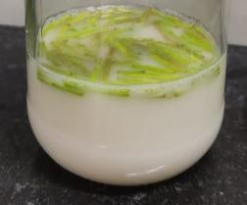
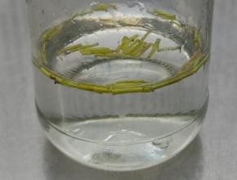
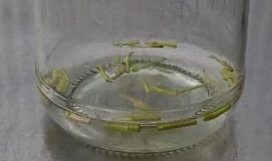

1% Bavistin 0.01% HgCl2 70% Ethanol

Figure No.1: Surface sterilization treatments employed for explant preparation

Axillary bud break was observed within 7–10 days of inoculation. Among the single-PGR concentrations evaluated, MS medium supplemented with 3.0 mg/L BAP consistently produced the greatest shoot initiation response across the three independent replicates, with a bud break frequency of 99.9%. Cytokinins such as BAP promote cell division and axillary bud proliferation. Lower BAP concentrations (1.0-2.0 mg/L) resulted in a slower initiation response, whereas an increase to 4.0 mg/L resulted in a slight reduction in bud break frequency under the experimental conditions, as shown in Figure 2.
Previous studies have reported that Bavistin effectively reduces microbial contamination during culture establishment and may also enhance shoot bud induction in Bacopa monnieri (Tiwari et al., 2006; Tiwari et al., 2012). Similarly, BAP has been widely recognised for promoting axillary bud induction and shoot initiation under in vitro conditions. The findings of the present study are in agreement with these earlier reports.
Table No. 1: Effect of Different PGR’s Concentrations on Shoot Initiation (Values are expressed as mean ± SE of three independent replicates)
Treatment | PGR’s  Concentration | No. of Explant inoculated | No. of leaves | Shoot Induction Frequency
T0 | PGR’s (00 mg/L) | 6 | 0 | 0
T1 | BAP (1.0 mg/L) | 6 | 5 | 83.33%
T2 | BAP (1.5 mg/L) | 6 | 3 | 50%
T3 | BAP (2.0 mg/L) | 6 | 4 | 66.66%
T4 | BAP (2.5 mg/L) | 6 | 1 | 16.6%
T5 | BAP (3.0mg/L) | 6 | 6 | 99.9 %
T6 | BAP (3.5 mg/L) | 6 | 4 | 66.66 %
T7 | BAP (4.0 mg/L) | 6 | 3 | 50 %

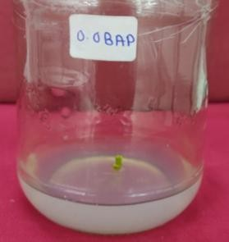
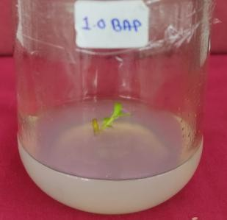
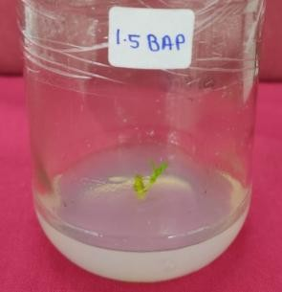
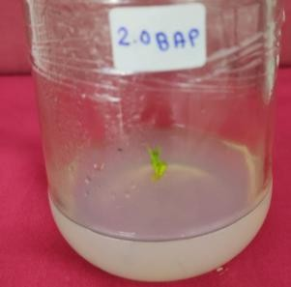

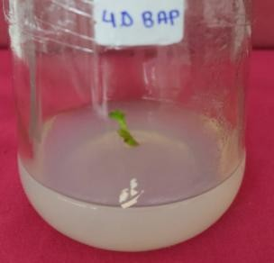
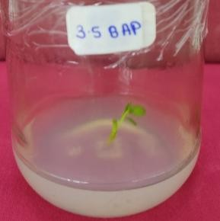
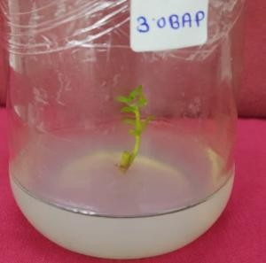
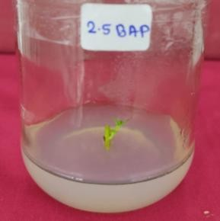
Figure No. 2: Shoot initiation on MS medium supplemented with BAP (1.0-4.0 mg/L) Shoot

Shoot Multiplication and Proliferation
Although BAP alone effectively induced shoot initiation, transferring the clusters to a combined cytokinin–auxin matrix stimulated shoot proliferation. The highest shoot multiplication rate (100%) occurred on MS medium supplemented with (4.0 mg/L) BAP and (0.5 mg/L) NAA after 3 weeks. The enhanced shoot multiplication observed with the combination of BAP and NAA is consistent with the known role of cytokinin–auxin interactions in regulating shoot development. Similar responses have been reported in Bacopa monnieri, although the optimum concentration of plant growth regulators varies with the explant type and culture conditions (Antony Ceasar et al., 2010; Haque et al., 2017; Shrivastava & Rajani, 1999; Viswanathan et al., 2022). In the present study, 4.0 mg/L BAP combined with 0.5 mg/L NAA produced the best shoot multiplication response among the treatments evaluated, as shown in Table 2 and Figure 3. Shoot induction frequency (%) was calculated using the following equation: Shoot induction frequency (%) = (Number of explant producing shoots / Total number of explants cultured) × 100

Table No. 2: Different Concentrations of BAP and NAA for Multiplication (Values are expressed as mean ± SE of three independent replicates)
Treatment | PGR’s Concentration |  | No. of  Explant inoculated | Shoot  Multiplication | Shoot  multiplication Frequency (%)
T0 | PGR’s (0 mg/L) | 0.5  NAA  mg/L | 6 | 1 | 16.6%
T1 | BAP (1.0 mg/L) | 0.5  NAA  mg/L | 6 | 2 | 33.3%
T2 | BAP (1.5 mg/L) | 0.5  NAA  mg/L | 6 | 3 | 50%
T3 | BAP (2.0 mg/L) | 0.5  NAA  mg/L | 6 | 2 | 33.3%
T4 | BAP (2.5 mg/L) | 0.5  NAA  mg/L | 6 | 2 | 33.3%
T5 | BAP (3.0mg/L) | 0.5  NAA  mg/L | 6 | 4 | 66.66%
T6 | BAP (3.5 mg/L) | 0.5  NAA  mg/L | 6 | 3 | 50%
T7 | BAP (4.0 mg/L) | 0.5  NAA  mg/L | 6 | 6 | 100%
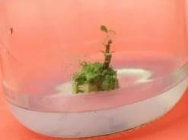
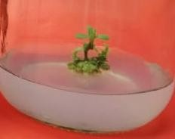
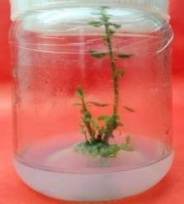
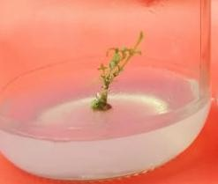
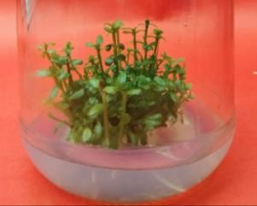
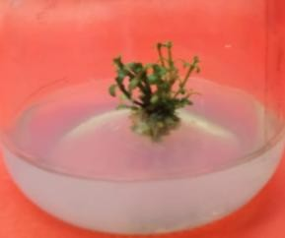
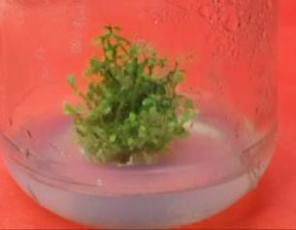
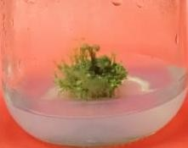

Figure No. 3: Shoot multiplication on MS medium supplemented with BAP (1.0-4.0 mg/L) and (0.5 mg/L) NAA
In vitro rooting
Root initiation was observed within 2-3 weeks after transferring elongated shoots to half-strength MS medium supplemented with IBA (0.1-0.4 mg/L). IBA is highly stable and slowly metabolised by the plant, which encourages uniform, thick adventitious roots. A concentration of 0.4 mg/L produced robust, branching root structures covered with healthy root hairs, preparing the plantlets for subsequent transfer to soil. The enhanced rooting response observed with increasing IBA concentrations is consistent with previous reports on Bacopa monnieri, where half-strength MS medium supplemented with IBA effectively promoted root induction (Antony Ceasar et al., 2010; Goel et al., 2018; Tiwari et al., 2001). Similar findings have been reported in other regeneration studies, although the optimal IBA concentration may vary with explant type and culture conditions (Ali et al., 2021). In the present study, 0.4 mg/L IBA produced the best rooting response, as shown in Table 3 and Figure 4.

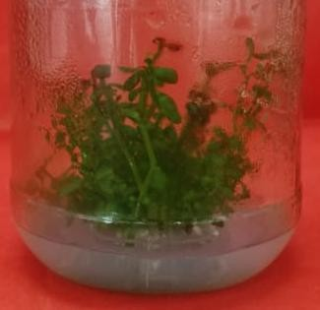
Table No.3: Different concentrations of IBA for root initiation
Sr. No. | Treatment | Concentration of IBA (mg/L) | Root Induction Frequency (%)
1 | T0 | Control | 0
2 | T1 | IBA (0.1mg/L) | 43.1%
3 | T2 | IBA (0.2mg/L) | 65%
4 | T3 | IBA (0.3mg/L) | 77.3%
5 | T4 | IBA (0.4mg/L) | 89.7%
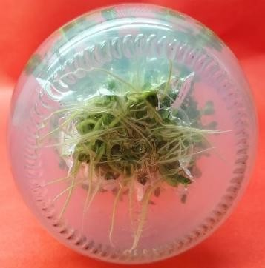
Figure No. 4: In vitro rooting on MS medium supplemented with IBA (0.4 mg/L)

Hardening and Acclimatisation
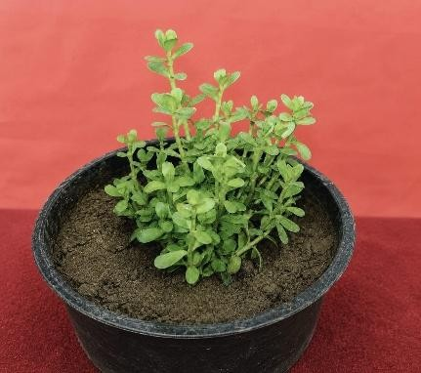
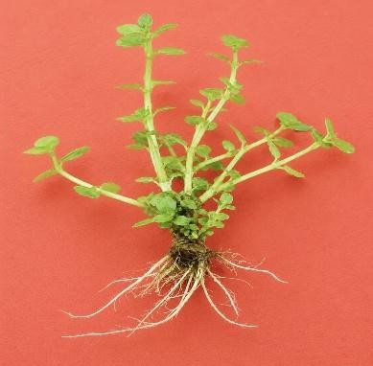
After 5 weeks on the complete rooting medium, elongated and rooted plantlets were removed from the culture vessels, and the roots were thoroughly washed with tap water to remove the agar. The plantlets were cultured on half-strength MS medium without organic components and incubated in the tissue culture room. The cultures were subcultured twice a week over a two-week period. Subsequently, the plantlets were transplanted into plastic pots containing a sterilised substrate consisting of garden soil, river sand, and cocopeat (1:1:1, v/v/v). The potted plantlets were maintained under greenhouse or polyhouse conditions at 25±2°C, 70-80% relative humidity, and a 16 h light/8 h dark photoperiod. The pots were covered with transparent polyethylene bags for the first week to maintain humidity. Plantlets were watered with distilled water every 2-3 days and monitored weekly for survival and growth. After 4 weeks of acclimatisation, a total of 20-25 plantlets were subjected to hardening, of which 80-85% survived the acclimatisation process.
Figure No. 5: In vitro regenerated plantlets and hardened plant of Bacopa monnieri

Conclusion
The present investigation demonstrated the potential of an in vitro regeneration protocol for Bacopa monnieri using nodal explants. Among the different concentrations of BAP evaluated for shoot induction, MS medium supplemented with 3.0 mg/L BAP produced the highest shoot initiation frequency (99.9%), with axillary bud break occurring within 7-10 days of culture. For shoot multiplication, MS medium containing 4.0 mg/L BAP and 0.5 mg/L NAA showed the most favourable response, resulting in a high rate of shoot proliferation and the development of healthy shoots. Root induction was achieved on half-strength MS medium supplemented with IBA (0.1–0.4 mg/L), with well-developed root systems observed within 2-3 weeks of culture. The regenerated plantlets were successfully acclimatised under greenhouse conditions, indicating that the protocol may provide a suitable approach for the micropropagation of B. monnieri under the conditions tested. The protocol developed in the present study may provide a useful method for the in vitro propagation and conservation of Bacopa monnieri under the experimental conditions investigated. The results indicate its potential application in producing planting material for conservation and cultivation purposes.

Limitations
This study was conducted under controlled laboratory conditions with three independent replicates per treatment. The evaluation was restricted to nodal explants and the tested BAP, NAA, and IBA concentrations. Statistical reporting was limited to treatment means, and the abstract itself notes the need for broader replication and statistical analysis. Acclimatisation was assessed using 20–25 plantlets, with 80–85% survival after 4 weeks. Therefore, the reproducibility of the protocol beyond the tested conditions requires further validation.

Conflict of Interest: The authors declare that there is no conflict of interest

Declaration of AI Use
This manuscript was prepared through the combined contributions of all author(s), including contributions to the study design, data, content development, results, interpretation, and related scholarly work. The author(s) acknowledge the use of Grammarly and ChatGPT to assist with grammar checking, language refinement, reference formatting. These AI-assisted tools were not used as authors and did not replace the intellectual contributions or scholarly judgment of the author(s). All AI-assisted outputs, including content, references, and interpretations, were carefully reviewed, revised, verified, and approved by the author(s). The author(s) accept full responsibility for the accuracy, integrity, and final content of the manuscript.

References
Abebe, K. S., Menamo, T. M., Yohannes, D. B., Gebrehiwet, B. M., & Barnabas, J. (2024). Micropropagation of selected hybrid tomato (Solanum lycopersicum L.) varieties using shoot tip culture. BIONATURE, 44(2), 61–72. https://doi.org/10.56557/bn/2024/v44i22043
Ali, D., Alarifi, S., & Pandian, A. (2021). Somatic embryogenesis and in vitro plant regeneration of Bacopa monnieri (Linn.) Wettst., a potential medicinal water hyssop plant. Saudi Journal of Biological Sciences, 28(1), 353–359. https://doi.org/10.1016/j.sjbs.2020.10.013
Antony Ceasar, S., Lenin Maxwell, S., Bhargav Prasad, K., Karthigan, M., & Ignacimuthu, S. (2010). Highly efficient shoot regeneration of Bacopa monnieri (L.) using a two-stage culture procedure and assessment of genetic integrity of micropropagated plants by RAPD. Acta Physiologiae Plantarum, 32, 443–452. https://doi.org/10.1007/s11738-009-0419-8
Banerjee, M., & Shrivastava, S. (2008). An improved protocol for in vitro multiplication of Bacopa monnieri (L.). World Journal of Microbiology and Biotechnology, 24, 1355–1359. https://doi.org/10.1007/s11274-007-9612-3
Bansal, M., Reddy, M. S., & Kumar, A. (2016). Seasonal variations in harvest index and bacoside A contents amongst accessions of Bacopa monnieri (L.) Wettst. collected from wild populations. Physiology and Molecular Biology of Plants, 22, 407–413. https://doi.org/10.1007/s12298-016-0366-y
Behera, S., Nayak, N., Shasmita, Barik, D. P., & Naik, S. K. (2015). An efficient micropropagation protocol of Bacopa monnieri (L.) Pennell through two-stage culture of nodal segments and ex vitro acclimatization. Journal of Applied Biology & Biotechnology, 3(3), 16–21. https://doi.org/10.7324/JABB.2015.3304
Chauhan, R., & Shirkot, P. (2020). Micropropagation of endangered medicinal plant Bacopa monnieri (L.) Pennell. Journal of Pharmacognosy and Phytochemistry, 9(2), 1614–1620. https://www.phytojournal.com/archives/2020.v9.i2.11083/micropropagation-of-endangered-medicinal-plant-bacopa-monnieri-l-pennell
Dixit, H., & Thakur, A. (2017). In vitro propagation of a medicinal important plant Bacopa monnieri from nodal explants. Indian Journal of Research in Pharmacy and Biotechnology, 5(1), 1–4. https://europub.co.uk/articles/in-vitro-propagation-of-a-medicinal-important-plant-bacopa-monnieri-from-nodal-explants-A-33420
Goel, A., Kaur, A., & Kumar, A. (2018). Biochemical and histological changes during in vitro rooting of microcuttings of Bacopa monnieri (L.) Wettst. Acta Physiologiae Plantarum, 40, Article 64. https://doi.org/10.1007/s11738-018-2641-8
Haque, S. M., Chakraborty, A., Dey, D., Mukherjee, S., Nayak, S., & Ghosh, B. (2017). Improved micropropagation of Bacopa monnieri (L.) Wettst. (Plantaginaceae) and antimicrobial activity of in vitro and ex vitro raised plants against multidrug-resistant clinical isolates of urinary tract infecting (UTI) and respiratory tract infecting (RTI) bacteria. Clinical Phytoscience, 3, Article 17. https://doi.org/10.1186/s40816-017-0055-6
Krishnan, S., Krishnan, A., Biju, B. M., & Jyothilekshmi, S. (2025). Micropropagation of Bacopa monnieri (L.) Pennell. Journal of Advances in Biology & Biotechnology, 28(9), 1025–1034. https://doi.org/10.9734/jabb/2025/v28i92951
Rahe, M. A., Mollika, S. R., Khan, M. S., Banu, T. A., Al Amin, G. M., Habib, M. A., Akter, S., Islam, M., & Sharmin, R. A. (2020). In vitro micropropagation of Bacopa monnieri (L.) Penn. – An important medicinal plant. Plant Tissue Culture & Biotechnology, 30(1), 57–63. https://doi.org/10.3329/ptcb.v30i1.47791
Ramesh, M., Vijayakumar, K. P., Karthikeyan, A., & Pandian, S. K. (2011). RAPD based genetic stability analysis among micropropagated, synthetic seed derived and hardened plants of Bacopa monnieri (L.): A threatened Indian medicinal herb. Acta Physiologiae Plantarum, 33, 163–171. https://doi.org/10.1007/s11738-010-0534-6
Saha, P. S., Sarkar, S., Jeyasri, R., Muthuramalingam, P., Ramesh, M., & Jha, S. (2020). In vitro propagation, phytochemical and neuropharmacological profiles of Bacopa monnieri (L.) Wettst.: A review. Plants, 9(4), 411. https://doi.org/10.3390/plants9040411
Sharma, N., Singh, R., & Pandey, R. (2016). In vitro propagation and conservation of Bacopa monnieri L. In S. M. Jain (Ed.), Protocols for in vitro cultures and secondary metabolite analysis of aromatic and medicinal plants (2nd ed., Methods in Molecular Biology, Vol. 1391, pp. 153–171). Humana Press. https://doi.org/10.1007/978-1-4939-3332-7_11
Shrivastava, N., & Rajani, M. (1999). Multiple shoot regeneration and tissue culture studies on Bacopa monnieri (L.) Pennell. Plant Cell Reports, 18, 919–923. https://doi.org/10.1007/s002990050684
Sudheer, W. N., Thiruvengadam, M., & Nagella, P. (2023). A comprehensive review on tissue culture studies and secondary metabolite production in Bacopa monnieri L. Pennell: a nootropic plant. Critical Reviews in Biotechnology, 43(6), 956–970. https://doi.org/10.1080/07388551.2022.2085544
Swathi, S., & Sarada, D. V. (2026). Integrated in vitro regeneration and methyl jasmonate elicitation enhance bacoside accumulation in Bacopa monnieri via coordinated activation of terpenoid biosynthetic pathways. Plant Cell, Tissue and Organ Culture, 166, Article 26. https://doi.org/10.1007/s11240-026-03537-5
Tiwari, K. N., Tiwari, V., Singh, J., Singh, B. D., & Ahuja, P. (2012). Synergistic effect of trimethoprim and bavistin for micropropagation of Bacopa monniera. Biologia Plantarum, 56, 177–180. https://doi.org/10.1007/s10535-012-0038-x
Tiwari, V., Singh, B. D., & Tiwari, K. N. (1998). Shoot regeneration and somatic embryogenesis from different explants of Brahmi [Bacopa monniera (L.) Wettst.]. Plant Cell Reports, 17, 538–543. https://doi.org/10.1007/s002990050438
Tiwari, V., Tiwari, K. N., & Singh, B. D. (2001). Comparative studies of cytokinins on in vitro propagation of Bacopa monniera. Plant Cell, Tissue and Organ Culture, 66, 9–16. https://doi.org/10.1023/A:1010652006417
Tiwari, V., Tiwari, K. N., & Singh, B. D. (2006). Shoot bud regeneration from different explants of Bacopa monniera (L.) Wettst. by trimethoprim and bavistin. Plant Cell Reports, 25, 629–635. https://doi.org/10.1007/s00299-006-0126-5
Ved, D. K., & Goraya, G. S. (2008). Demand and supply of medicinal plants in India. Bishen Singh Mahendra Pal Singh. https://www.ncbi.nlm.nih.gov/nlmcatalog/101494031
Viswanathan, P., Gosukonda, J. S., Sherman, S. H., Joshee, N., & Gosukonda, R. M. (2022). Prediction of in vitro organogenesis of Bacopa monnieri using artificial neural networks and regression models. Heliyon, 8(12), e11969. https://doi.org/10.1016/j.heliyon.2022.e11969
Yamada, K., Hung, P., Park, T. K., Park, P. J., & Lim, B. O. (2011). A comparison of the immunostimulatory effects of the medicinal herbs Echinacea, Ashwagandha and Brahmi. Journal of Ethnopharmacology, 137(1), 231–235. https://doi.org/10.1016/j.jep.2011.05.017

