Mineral Profiling of Advanced Soybean (Glycine max (L.) Merr.) Breeding Lines Using Atomic Absorption Spectroscopy: Assessment of Nutritional Variability

Abstract

Soybean (Glycine max (L.) Merr.) is a leguminous crop known for its high nutritional potential and its capacity to address prevalent nutrient deficiencies through breeding and biofortification strategies. The current study assessed the mineral composition of 97 advanced soybean breeding lines using atomic absorption spectroscopy (AAS) to measure two macronutrients - calcium (Ca) and magnesium (Mg) - and four micronutrients - iron (Fe), zinc (Zn), copper (Cu) and manganese (Mn). The observations were subjected to correlation analysis, principal component analysis (PCA) and hierarchical clustering, and a nutritional index was calculated. Considerable differences were observed in mineral distribution profiles among the genotypes and among the minerals. Calcium showed the highest variability, while magnesium displayed more consistent accumulation. A weak to moderate positive relationship was detected among several micronutrients, especially Fe–Zn, Fe–Cu and Fe–Mn, suggesting potential for simultaneous enhancement of multiple nutritional traits in the breeding programmes. PCA and hierarchical clustering categorised the genotypes into distinct groups based on their mineral composition, confirming noticeable diversity within the breeding material. PS 26 had high calcium content, PS 1505 showed high iron content, PS 1733 had high magnesium content and NRC 142 had high copper content according to these observations. The nutritional index highlighted PS 1670, PS 1521, PS 1734, EC 69729 and NRC 142 as outstanding genotypes with balanced and above-average levels of overall mineral composition as indicated by the nutritional index. These results demonstrate informative genetic diversity in seed mineral content and identify promising donor lines for soybean biofortification and nutrient enhancement. The study offers essential insights for the development of mineral-rich soybean cultivars aimed at promoting sustainable agriculture and improving human nutrition.
Keywords: Glycine max; mineral profiling; micronutrient; macronutrient; atomic absorption spectroscopy; biofortification; principal component analysis; hierarchical clustering; nutritional index; genetic diversity

Introduction
Soybean (Glycine max (L.) Merr.) is one of the world's most important grain legumes, owing to its exceptional nutritional composition and wide range of applications in food, feed, and industrial products (Dwevedi & Kayastha, 2011; Singer et al., 2023). It is a highly nutritious food rich in protein, essential fatty acids, dietary fibre, vitamins, minerals and various bioactive substances (Fatima et al., 2025; Rotundo et al., 2024). In addition, soybean is an important biological nitrogen fixer that enriches the soil, improves its fertility and supports sustainable agriculture (Zveushe et al., 2023).
Plant-based foods constitute a major part of the diets of billions of people in developing countries, where micronutrient deficiencies, or "hidden hunger", are prevalent (Lowe, 2021; Ofori et al., 2022). Essential minerals, such as iron (Fe), zinc (Zn), copper (Cu), manganese (Mn), calcium (Ca), and magnesium (Mg) perform vital functions, including oxygen transport, maintenance of the immune system, skeletal development and regulation of several metabolic processes (Del Vecchio

et al., 2024). Improving the mineral density of soybean seeds has therefore become indispensable in biofortification and crop improvement programmes designed to address global nutritional challenges.
Recent characterisation of diverse soybean genotypes has also documented substantial phenotypic variability, supporting systematic germplasm evaluation for parental selection and genetic improvement (Jhariya et al., 2025).
Recent field studies in soybean have further demonstrated that agronomic biofortification can increase seed zinc content or broader micronutrient density under defined foliar zinc-based treatments (Han et al., 2024; Makdoh et al., 2025; Qureshi et al., 2026).

Seed mineral composition is a complex quantitative attribute that is influenced by genetic and environmental factors. Different breeding lines vary in the concentrations of specific minerals. In addition to genotypic variation, mineral concentrations in soybean seeds are influenced by factors including soil type, mineral content, agronomic management strategies, and environment-specific interactions (Malle et al., 2020; Wang et al., 2022). Individual mineral elements may also exhibit different inheritance and accumulation patterns, making the simultaneous improvement of various nutrients challenging. Thus, characterising mineral variability within breeding populations is essential for identifying nutritionally superior genotypes that can be used as parental materials in biofortification and cultivar development programmes.
Field evidence from soybean grown under iron-deficient soil conditions further indicates that mineral nutrition management can influence iron uptake and associated nutrient status, underscoring the environmental component of mineral acquisition in the crop (Kamble et al., 2022).

The systematic analysis of various macro- and micro-nutrients using analytical methods that are accurate, reproducible and capable of detecting trace levels of various elements is vital for selecting breeding lines with superior nutrient profiles, recognising the genetic variability associated with mineral accumulation, and supporting the integration of nutritional traits into soybean breeding programmes. Atomic absorption spectroscopy (AAS) is a highly sensitive and precise method for mineral analysis (Miller et al., 2025; Mohd Fairulnizal et al., 2019). It is widely used as an analytical technique to determine nutritional profiles and characterise germplasm in crop improvement research.
The present study addresses the need to integrate AAS-based quantification of Ca, Mg, Fe, Zn, Cu and Mn with correlation analysis, principal component analysis, hierarchical clustering and a composite nutritional index within the same set of advanced soybean breeding lines to enable consistent differentiation of balanced and element-specific mineral profiles.
Objective of the Study

In the present investigation, the seed mineral composition of 97 advanced soybean breeding lines was evaluated using AAS to quantify six vital mineral elements, including calcium, magnesium, iron, zinc, copper, and manganese, which are nutritionally important. The aim of the study was to determine the extent of genetic variability in seed mineral composition, identify mineral-rich breeding lines and provide an informative dataset for biofortification strategies. The findings are expected to support soybean breeding programmes by providing useful information for developing nutrient-rich cultivars, thereby contributing to sustainable agriculture, nutritional security and human health.

Materials and Methods
Plant Material and Sample Preparation
In the current study, ninety-seven advanced soybean breeding lines (Table 1) were sown in the kharif 2025 season at Norman E. Borlaug Crop Research Centre, Govind Ballabh Pant University of Agriculture and Technology, Pantnagar, U.S. Nagar, Uttarakhand, India (29°N latitude, 79.30°E longitude; altitude 243.8 m above mean sea level). The experiment was conducted in randomised block design (RBD) with three replications. Each genotype was sown in a plot consisting of five rows, each 4 m in length, with an inter-row spacing of 45 cm and an intra-row spacing of 5 cm. All recommended agronomic practices were followed throughout the crop growth period. The seeds

were harvested upon maturity, pooled, dried and cleaned to remove dirt and other debris.

Table 1: Soybean advance breeding lines under study

S.No. | Genotype | S.No. | Genotype | S.No. | Genotype | S.No. | Genotype | S.No. | Geno
1 | PS 1670 | 21 | PS 1661 | 41 | AGS 25 | 61 | PK 262 | 81 | PS 16
2 | EC 69729 | 22 | JS 20-69 | 42 | EC 241780 | 62 | PK 327 | 82 | PS 17
3 | NRC 149 | 23 | MACS 303 | 43 | Doko | 63 | PS 1682 | 83 | PS 17
4 | NRC 142 | 24 | PS 1584 | 44 | JS 20-34 | 64 | PK 416 | 84 | PS 17
5 | PSS1 | 25 | PK 515 | 45 | MAUS 768 | 65 | PK 472 | 85 | PS 17
6 | PS 1347 | 26 | PS 1225 | 46 | NRCSL 4 | 66 | PK 564 | 86 | PS 17
7 | EC172654 | 27 | JS 20-116 | 47 | DSb 21 | 67 | PS 1024 | 87 | PS 17
8 | KBSL 23-36 | 28 | Pb 1 | 48 | Hardee x G. soja | 68 | PS 1042 | 88 | PS 17
9 | ASB 101 | 29 | EC 241778 | 49 | JS 335 x Glycine soja | 69 | PS 1241 | 89 | PS 17
10 | NRC 268 | 30 | JS 20-98 | 50 | Glycine soja | 70 | PS 1368 | 90 | PS 17
11 | DS 13-18 | 31 | RKS 54 | 51 | NRC 260 | 71 | PS 1477 | 91 | PS 17
12 | NRC 127 | 32 | JS 20-76 | 52 | PS 1722 | 72 | PS 1475 | 92 | PS 17
13 | RVSM 2011-35 | 33 | DS 97-12 | 53 | PS 1737 | 73 | PS 1480 | 93 | PS 17
14 | Himso 1690 | 34 | MLT-19-15423 | 54 | Co-118614 | 74 | PS 1505 | 94 | PS 17
15 | JS 20-11 | 35 | MLT-19-15523 | 55 | DS1589 | 75 | PS 1521 | 95 | PS 17
16 | UPSM 534 x G.soja | 36 | RVSM 2011-77 | 56 | Himso 1689 | 76 | PS 1556 | 96 | PS 17
17 | UPSM 534 | 37 | JS 21-71 | 57 | Bragg | 77 | PS 1569 | 97 | PS 17
18 | TGX 1681-3f | 38 | SL 1074 | 58 | Ankur | 78 | PS 1583
19 | PS 26 | 39 | NRC 128 | 59 | Alankar | 79 | PS 1605
20 | RVSM 2011-10 | 40 | TGX 849-D-13-4 | 60 | Shilajeet | 80 | PS 1693

Mineral Analysis of the Lines
For mineral estimation, seeds of each genotype were rinsed with 10N HCl for 1 min to remove seed debris, followed by rinsing with distilled water. The cleaned seeds were dried in a hot-air oven for 36

hours at 80°C. The dried seeds were ground to a fine powder using a mortar and pestle. A 500 mg portion of fine powder from each genotype was digested in the presence of 5 ml acid solution containing HNO3 (65% w/w) and H2O2 (35%, w/w), as described by Acar et al., (2016), in sealed digestion cartridges using a microwave digestion system (Multiwave Go; Anton Paar GmbH, Austria) (Zarcinas et al., 1987). The digestion process was conducted for 45 min at a maximum microwave temperature of 160°C within the microwave digestion system. The digested samples were decanted from the depressurised cartridges into a 50 ml graduated Falcon tube, and the volume was adjusted to 25 ml using deionised water. The solution was filtered using Whatman Grade 41 filter paper.
Samples were prepared in technical triplicates to reduce measurement variability.
The AAS system (Shimadzu AA-7000, Japan) was initially calibrated for each mineral being analysed with standards of 0, 0.5, 1.0, 2.0, 3.0, 4.0 and 5.0 ppm for Fe; 0, 0.1, 0.2, 0.3, 0.4, 0.6 and
0.8 ppm for Zn; 0, 0.1, 0.2, 0.4, 0.6 and 0.8 ppm for Mn and Cu; 2, 4, 6, 8 and 10 ppm for Ca and Mg. The calibration standards were prepared with pure chemicals sourced from HiMedia Laboratories (HiMedia Laboratories, 2026). The samples were analysed, with the instrument recalibrated using standards after every 25 samples.
Standard calibration plots were prepared for each mineral by plotting absorbance (optical density, OD) on the y-axis and standard concentrations on the x-axis. The concentration of the samples was determined by interpolating their absorbance values from the respective calibration curves. The mean of the technical triplicate readings was used for further analysis.

Statistical Analysis
Basic descriptive statistics, such as mean, standard deviation (SD), minimum, maximum, coefficient of variation (CV) and range, were calculated for each element across the genotypes. The mineral distribution across the genotypes was visualised using density distributions and boxplots to detect outliers in the data. Pairwise correlations among the elements were calculated using Pearson's correlation coefficients (Pearson, 1895) to study the relationships between the elements. Relationships among all the elements were presented in a correlation matrix with a colour-coded heatmap. Principal component analysis (PCA) was used to reduce the dimensionality of the mineral dataset and identify the main contributors to diversity among the genotypes. The principal components with the highest eigenvalues were represented in the biplot, illustrating the distribution of genotypes along axes of the components, while the individual mineral elements were represented as vectors contributing to the observed variation. Hierarchical cluster analysis was conducted using Euclidean distances and Ward's minimum variance method (Ward, 1963) to categorise the genotypes into related clusters, which were illustrated in a cluster dendrogram representing the similarities in element composition between the genotypes. The mineral nutritional index (eqn-2) was calculated using the mean standardised values (eqn-1) of all the minerals for each of the genotypes. The genotypes were ranked based on the index, to identify those with superior overall mineral composition. All analyses were conducted in the R programming language using appropriate packages.

Standardized value ( Z −score) , Z
X ij−μ j
ij= σ

j
eqn-1 (Hair et al., 2019; Johnson & Wichern, 2007)

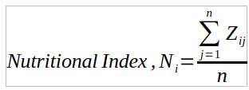
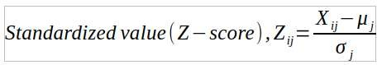
where:
- X_{ij} = observed value of mineral j in genotype i
- μ_{j} = mean concentration of mineral j
- σ_{j} = standard deviation of mineral j
Nutritional Index , N =
i
n
∑ Zij eqn-2 (Everitt et al., 2011; Rencher & Christensen, 2012)
j=1
n
Where:
- N_{i} = Nutritional Index of the ith genotype
- Z_{ij} = standardized (Z-score) value of mineral j
- n = number of minerals under consideration
Results and Discussion
Variation in Mineral Composition among soybean Genotype

Table 2: Descriptive statistics

Mineral | Mean (ppm*) | SD  (ppm) | Median (ppm) | Min (ppm) | Max (ppm) | Range (ppm) | CV (%) | Ske
Calcium | 1945.712 | 283.072 | 1976.267 | 973.900 | 2497.200 | 1523.300 | 14.549
Magnesium | 971.842 | 67.469 | 968.167 | 807.633 | 1142.000 | 334.367 | 6.942
Copper | 34.829 | 6.951 | 34.633 | 11.300 | 57.900 | 46.600 | 19.958
Iron | 267.640 | 28.738 | 262.500 | 210.900 | 339.200 | 128.300 | 10.738
Manganese | 52.369 | 5.507 | 52.400 | 40.867 | 74.267 | 33.400 | 10.516
Zinc | 99.452 | 14.783 | 99.500 | 43.000 | 127.833 | 84.833 | 14.864

*ppm = Parts-per-million

The distribution plots (Figure 1;Figure 2) and the boxplots (Figure 3) together demonstrated differences in mineral variation among the evaluated soybean genotypes (Table 2). Calcium (Ca) had the highest mean concentration (1945.71 ppm) and the widest variation (973.90–2497.20 ppm; SD = 283.07 ppm), with most genotypes clustered between 1700 and 2200 ppm. A few calcium-rich lines exceeded 2400 ppm, consistent with the slight negative skewness (−0.72). The median (1976.27 ppm) was greater than the mean, indicating that a few low-value genotypes reduced the overall mean. Magnesium (Mg), in contrast, showed a very narrow range (807.63–1142.00 ppm; SD = 67.47 ppm) and a symmetric distribution (skewness =
−0.03), with its median (968.17 ppm) and the mean (971.84 ppm) almost coinciding. Calcium had a broader spread and larger interquartile range than Mg, exemplifying greater genetic variation in calcium accumulation among the genotypes.

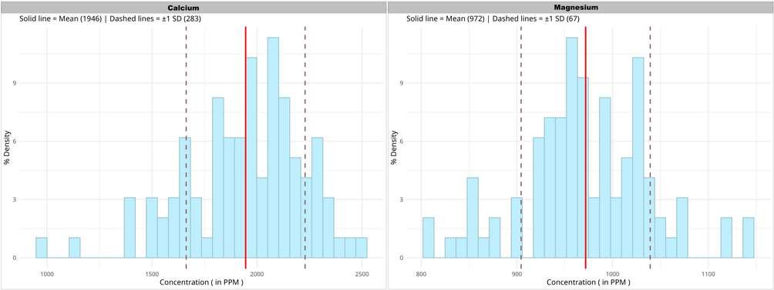
Figure 1: Density distribution of Major elements among the 97 soybean genotypes

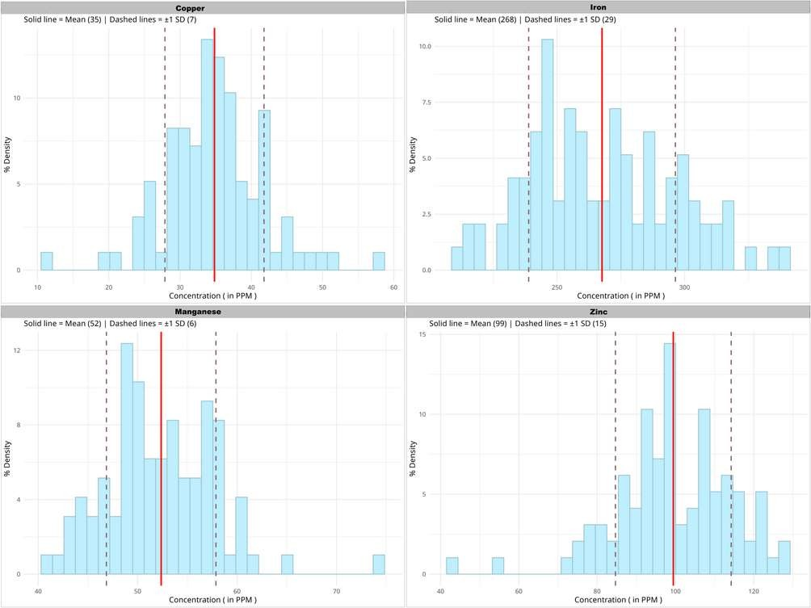
Figure 2: Density distribution of Minor elements among the 97 soybean genotypes

Iron (Fe) had the highest mean value (267.64 ppm) among the micronutrients. It exhibited a broad distribution with a slight positive skew, indicating iron-rich genotypes in the pool. This was followed by zinc (Zn; 99.45 ppm), manganese (Mn; 52.37 ppm), and copper (Cu; 34.83 ppm) with zinc and copper showing considerable variation, reflecting the occurrence of both nutrient-rich and nutrient-poor lines. However, manganese displayed the narrowest range, suggesting relatively stable accumulation across the genotypes. These observations demonstrate that the variability in both macro- and micronutrients is due to genetic diversity among the breeding lines. This information provides valuable insights for selecting nutritionally superior genotypes for soybean biofortification and breeding programmes.

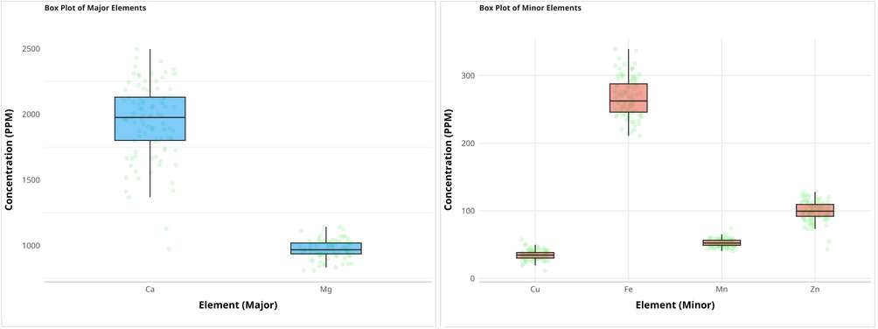
Figure 3: Boxplots illustrating variability and outliers for the six mineral elements.

Correlation among Mineral Elements
The accumulation of most of the elements under consideration was largely independent, as indicated by the weak to moderate correlation values of the pairwise comparisons shown in the correlation plot (Figure 4), generated using the R package ‘corrplot’ (Wei & Simko, 2024). A positive association was observed between zinc and iron, with r = 0.33, indicating that the Zn-rich genotypes might also have higher Fe concentrations. The other positive associations were between Fe and Cu with r = 0.30 and between Fe and Mn with r = 0.27. Both these moderate positive correlations show that genotypes with high iron might also accumulate slightly greater amounts of Cu and Mn.
Other relationships, though weaker, were found between Cu and Zn (r = 0.23) and between Mn and Zn (r = 0.22). Calcium showed a weak negative correlation with Zn (r = −0.23), but almost no correlation with iron (r = −0.02) or copper (r = −0.03) indicating that these elements are accumulated independently of each other. Mg showed very weak correlations (r ~ 0.11) with the other minerals, indicating independent accumulation. However, these values were too low to establish strong correlations among the elements. It is interesting to note that no association exceeded r = 0.35, indicating that no strong relationships could be relied upon for simultaneous nutritional enhancement efforts. However, this relative independence may allow breeders to improve a specific element without substantially affecting the other minerals in their breeding programmes.

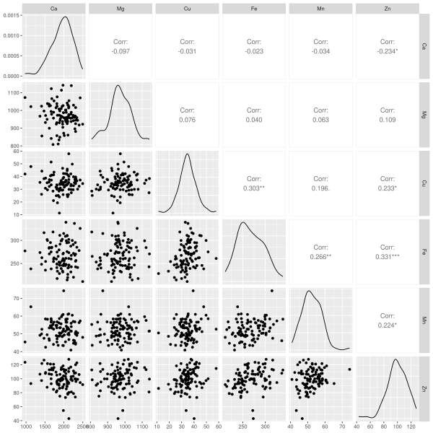

Principal component analysis (PCA) was used to derive components representing variance among the different minerals across the breeding lines. The scree plot (Figure 5) (Kassambara & Mundt, 2026) represents the eigenvalues of each principal component, which measure the contribution of each component to the total variance. The first three components accounted for 65% of the total variance of the dataset, with the first two components accounting for 49.2%. The first three components were considered adequate to represent the variance of the minerals across the breeding lines tested. Accordingly, these three components were used in subsequent multivariate analyses, such as biplot interpretation and genotype classification, with
Figure 4: Correlation among different elements
Principal Component Analysis

minimum information loss.

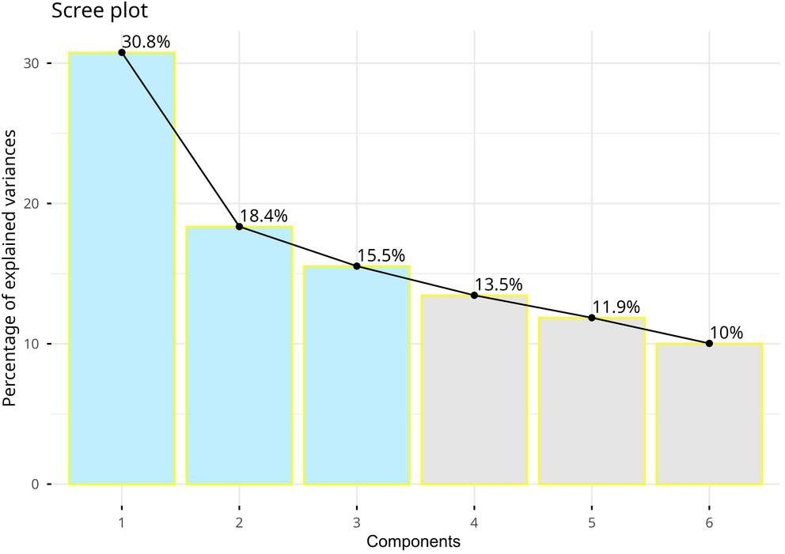
Figure 5: Scree plot displaying the Eigen values of respective principal components

The PC1 vs. PC2 PCA biplot (Figure 6) generated using the packages ‘FactoMineR’ (Lê et al., 2008) and ‘factoextra’ (Kassambara & Mundt, 2026), showed that the elements iron, zinc, copper and manganese contributed substantially to the variance explained by PC1, while the microelements, Ca and Mg, contributed to PC2, with calcium contributing positively and magnesium negatively. This also suggests that calcium and magnesium may have an inverse relationship with each other. Iron, copper and manganese were collinear, which may reflect their positive correlations with each other.
Thus, PC1 represents the microelements while major elements are represented by PC2. The PC2 vs. PC3 biplot showed that the second (18.4%) and third (15.5%) principal components accounted for 33.9% of the total variation. Calcium exhibited strong loadings on both PC2 and PC3, while Magnesium had a high loading on PC3. Minor elements had relatively smaller loadings to either component in this plane. Copper, iron and manganese showed high correlations, despite smaller loadings. Zinc showed a negative correlation with the other three minor elements. Genotypes close to a specific mineral vector tend to have higher concentrations of that mineral; greater distance from the origin in the direction of the vector indicates a higher concentration. The majority of genotypes were clustered near the origin, indicating a moderate mineral composition, whereas a few genotypes positioned farther from the centre exhibited unique mineral profiles. Because the plots are two-dimensional projections, genotypes should be compared across both plots to assess the consistency of their alignment with a particular vector in multidimensional space. Comparison of the distributions in both plots showed that genotype 19 (PS 26, pink circle) was aligned with the calcium vector.
Genotype 4 (NRC 142, red circle) showed higher copper, genotype 74 (PS 1505, blue circle) showed a high iron concentration, and genotype 91 (PS 1733, green circle) showed a high magnesium concentration.

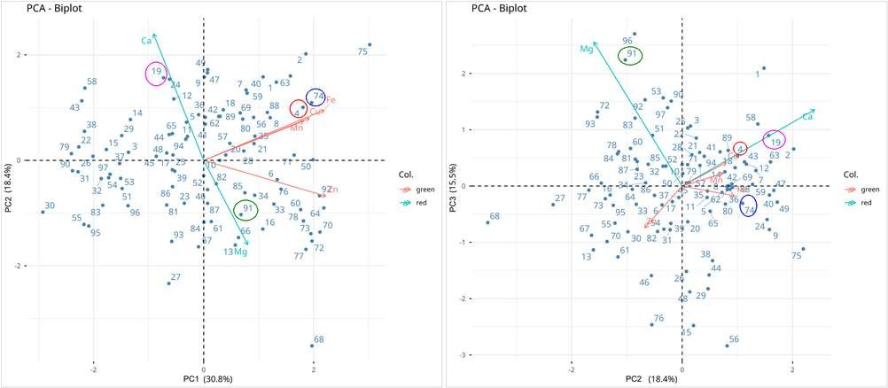
Figure 6: PCA biplots showing distribution of soybean genotypes and mineral loadings.

Hierarchical Cluster Analysis
The hierarchical clustering technique categorised ninety-seven soybean genotypes based on their similarities in mineral composition. The resulting dendrogram heatmap, generated using the package ‘pheatmap’ (Kolde, 2025), revealed several distinct clusters, exemplifying the considerable diversity present within the gene pool. The separation of clusters by linkage distances suggests that the genes within the same cluster have evolved to display similar patterns of mineral deposition, despite the presence of increased linkage distances. This method of grouping helps to identify the various parental species that have experienced reticence in evolutionary diversification within the human diet. The heatmap (Figure 7) employed standardised (Z-score) values indicating the number of standard deviations by which each genotype differed from the overall mean.
Red represents above-average concentrations, blue denotes below-average concentrations, and white indicates values near the population mean. The genotypes were partitioned into three clusters based on the similarity in the mineral profile shown by the individuals. Cluster 1 contained genotypes with high calcium and iron levels, indicated by values ranging from approximately +1 to
+2 SD from the mean. This cluster contained many genotypes with moderate to high levels of Manganese, with genotype PS 1521 showing potentially very high Mn content. The presence of PS 1505 in this cluster also supports the PCA interpretation that it might have a high iron content. Cluster 2 contained genotypes with low mineral compositions (indicated by negative SD values and bluish colouring in the heatmap). A few genotypes also showed high calcium levels in this cluster, for example PS 26, in agreement with the biplot analysis. Cluster 3 represented genotypes with higher Cu, Mn and Zn levels. NRC 142, which was identified from the biplots, was present in this cluster, emphasising its copper richness. Iron levels are moderate in this cluster, with calcium and magnesium levels varying widely. The genotypes in this cluster may be of high importance for selection and biofortification programmes for enhancing micronutrient density in the population.

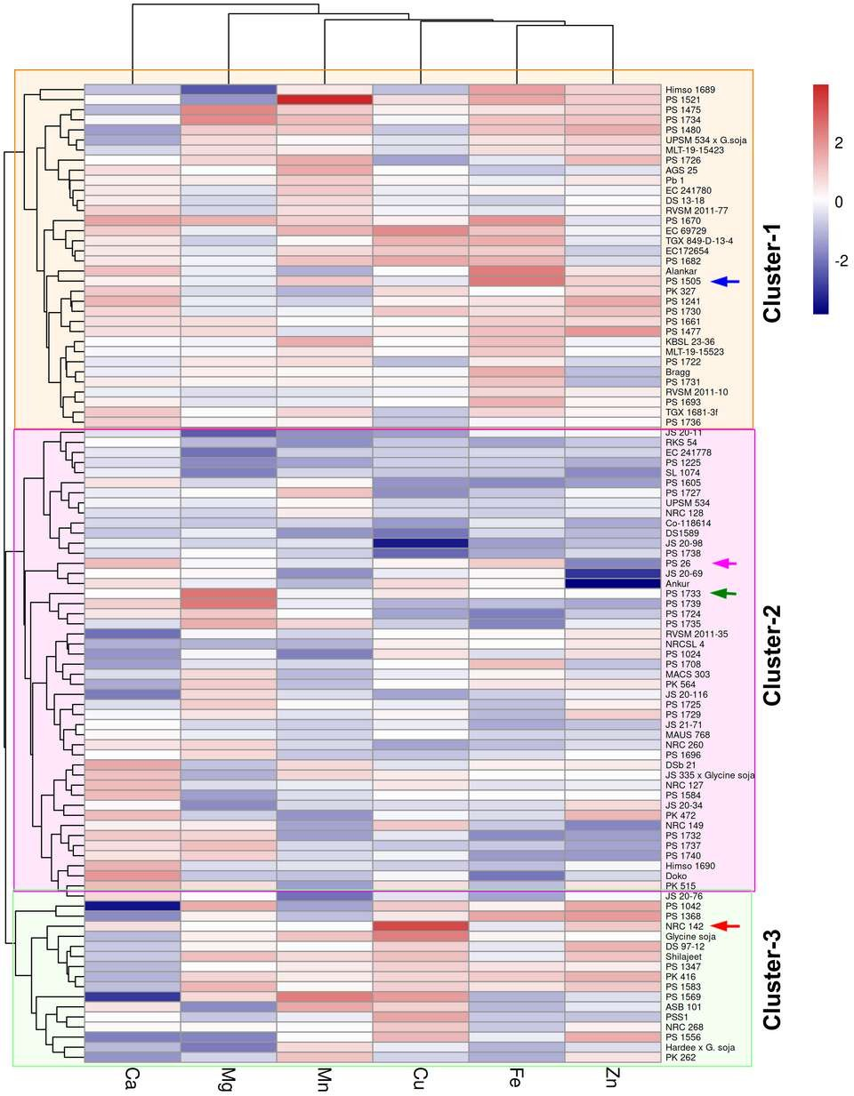

Figure 7: Heatmap of standardized mineral concentrations among soybean genotypes.

Identification of Nutritionally Superior Genotypes
The nutritional index, which is a composite of the standardised mean values of all of the minerals, provided a comprehensive assessment of the overall nutritional rating of each genotype rather than of a single element. Being a composite index, it takes the weighted contribution of each element into account. Hence, genotypes with high values for several minerals will have a high nutritional rating, whereas a negative or low index indicates deficiency in one or more nutrients in the genotype. This equalisation within the index facilitates comparison among multiple genotypes. Genotypes with a high nutritional index are suitable candidates for breeding programmes aimed at nutritional improvement. After ranking (Figure 8), the genotypes PS 1670, PS 1521, PS 1734, EC 69729 and NRC 142 were found to have high nutritional quality, with higher-than-average concentrations of multiple minerals. Notably, these highest-ranked genotypes accumulated increased levels of several minerals together, rather than excelling in just one of them, highlighting their overall nutritional profiles. These soybean genotypes are candidates for biofortification programmes aimed at developing nutritionally enhanced cultivars with improved overall mineral quality.

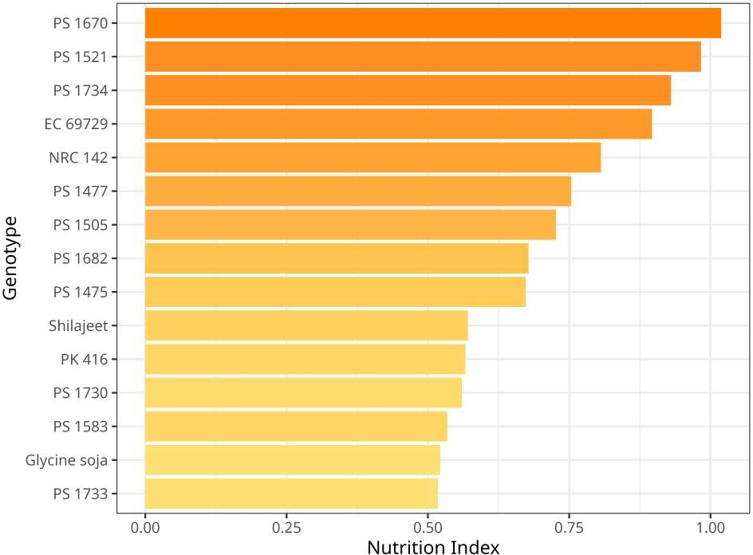
Figure 8: Top fifteen soybean genotypes ranked according to the composite mineral nutritional index.

Limitations

The study was conducted at a single location. Mineral accumulation in soybean is influenced not only by genotypic factors but also by environmental interactions. Environmental factors such as soil fertility, rainfall, temperature and agronomic practices may also influence the observed values.
Therefore, it is difficult to clearly conclude whether the identified mineral-rich genotypes would maintain similar performance across different environments.

Another limitation concerns the nutritional index. It is a composite index that shows the overall weighted mineral composition. A deficiency in one mineral may be masked by higher levels of other minerals. Also, a high nutritional index does not necessarily indicate that all or many elements are present at high levels, since a genotype with a very high value for a single mineral might show a high nutritional index. Hence, the index should be interpreted cautiously when drawing conclusions.

Only six mineral elements were included in this study. Because mineral uptake, accumulation and physiology involve complex interactions among multiple minerals, the exclusion of other essential minerals from the study might have influenced the overall nutritional assessment of the screened genotypes.

Conclusion
The present investigation demonstrated substantial genetic variation in seed mineral composition among 97 advanced soybean breeding lines, confirming the presence of valuable genetic resources for nutritional improvement. AAS quantified two macronutrients (Ca and Mg) and four micronutrients (Fe, Zn, Cu and Mn), indicating differences in the accumulation of each mineral across the evaluated germplasm. Calcium exhibited the highest variability, whereas magnesium accumulation was comparatively stable; the micronutrients showed sufficient variation to distinguish nutritionally superior genotypes.
The generally weak to moderate correlations among mineral elements indicate that most nutrients are accumulated largely independently. This provides flexibility for breeders to improve specific minerals without drastically affecting others. At the same time, a few positive associations observed among Fe, Zn, Cu and Mn suggest opportunities for simultaneous enhancement of selected micronutrients. Principal component analysis and hierarchical clustering efficiently classified the breeding lines into distinct groups based on their mineral profiles, validating the existence of meaningful nutritional diversity within the breeding population. The composite nutritional index further identified superior breeding lines, with PS 1670, PS 1521, PS 1734, EC 69729 and NRC 142 exhibiting above-average concentrations of multiple minerals. These genotypes represent a valuable donor pool for soybean biofortification and nutritional breeding programmes aimed at developing mineral-rich cultivars.
In summary, this study provides a comprehensive baseline of mineral variability in advanced soybean breeding material. It underscores the importance of AAS-based mineral profiling combined with multivariate statistical analyses for germplasm characterisation. The identified mineral-rich breeding lines provide a promising genetic pool for enhancing the nutritional quality of soybean, contributing to long-term efforts towards biofortification, sustainable agriculture and human nutrition. These results agree with previous research suggesting that soybean genetic diversity encompasses substantial natural variation in essential nutrient content, which can be effectively exploited in biofortification studies (Hacisalihoglu & Settles, 2017; Moreira et al., 2016; Taliercio et al., 2019). This study identifies genotypes with superior nutritional quality and provides valuable genetic

resources for the development of soybean varieties with improved micro- and macro-nutrient content, thus contributing to longer-term strategies aimed at reducing micronutrient deficiencies. Further studies integrating mineral profiling with multi-environment evaluation and genomic approaches could facilitate the development of stable, nutrient-rich soybean cultivars.

Conflict of Interest
The authors declare that there is no conflict of interest regarding the publication of this work.

Declaration of AI Use

This manuscript was prepared through the combined contributions of all author(s), including contributions to the study design, data, content development, results, interpretation, and related scholarly work. The author(s) acknowledge the use of Grammarly and ChatGPT to assist with grammar checking, language refinement, reference formatting. These AI-assisted tools were not used as authors and did not replace the intellectual contributions or scholarly judgment of the author(s). All AI-assisted outputs, including content, references, and interpretations, were carefully reviewed, revised, verified, and approved by the author(s). The author(s) accept full responsibility for the accuracy, integrity, and final content of the manuscript.

References
Acar, O., Tunçeli, A., & Türker, A. R. (2016). Comparison of wet and microwave digestion methods for the determination of copper, iron and zinc in some food samples by FAAS. Food Analytical Methods, 9(11), 3201–3208. https://doi.org/10.1007/s12161-016-0516-4
Del Vecchio, L., Girelli, D., Vinchi, F., Cozzolino, M., Elliott, S., Mark, P. B., Valenti, L., Qian, C., Guo, Q., Qian, Z.-M., Ciceri, P., & Locatelli, F. (2024). Iron biology. Nephrology Dialysis Transplantation, 39(9), 1404–1415. https://doi.org/10.1093/ndt/gfae095
Dwevedi, A., & Kayastha, A. M. (2011). Soybean: A multifaceted legume with enormous economic capabilities. In T.-B. Ng (Ed.), Soybean—Biochemistry, chemistry and physiology (pp. 165–188). InTech. https://doi.org/10.5772/15505
Everitt, B. S., Landau, S., Leese, M., & Stahl, D. (2011). Cluster analysis (5th ed.). John Wiley & Sons. https://doi.org/10.1002/9780470977811
Fatima, Z., Itrat, N., Israr, B., & Ahmad, A. M. R. (2025). Therapeutic efficacy of soy-derived bioactives: A systematic review of nutritional potency, bioactive therapeutics, and clinical biomarker modulation. Foods, 14(19), 3447. https://doi.org/10.3390/foods14193447
Hacisalihoglu, G., & Settles, A. M. (2017). Quantification of seed ionome variation in 90 diverse soybean (Glycine max) lines. Journal of Plant Nutrition, 40(20), 2808–2817. https://doi.org/10.1080/01904167.2017.1382528
Hair, J. F., Black, W. C., Babin, B. J., & Anderson, R. E. (2019). Multivariate data analysis (8th ed.). Cengage Learning. https://www.cengage.uk/c/multivariate-data-analysis-8e-hair-babin-anderson-black/9781473756540/
Han, Ş., Sönmez, İ., Qureshi, M., Güden, B., Gangurde, S. S., & Yol, E. (2024). The effects of foliar amino acid and Zn applications on agronomic traits and Zn biofortification in soybean (Glycine max L.). Frontiers in Plant Science, 15, 1382397. https://doi.org/10.3389/fpls.2024.1382397
HiMedia Laboratories. (2026). Microbiology culture media and laboratory products. https://himedialabs.com
Jhariya, R., Tripathi, M. K., Mishra, R., Sharma, S., Solanki, R., & Sikarwar, R. S. (2025). Appraisal of variability across soybean genotypes based on qualitative traits. Journal of Biology and Nature, 17(2), 58–72. https://doi.org/10.56557/joban/2025/v17i29443
Johnson, R. A., & Wichern, D. W. (2007). Applied multivariate statistical analysis (6th ed.). Pearson Prentice Hall. https://www.pearson.com/en-us/subject-catalog/p/Johnson-Applied-Multivariate-Statistical-Analysis-Classic-Version-6th-Edition/P200000006217/9780137980963
Kamble, B. M., Meena, R., & Gajbhiye, P. N. (2022). Influence of iron nutrition on soil properties, uptake and yield of soybean grown on iron deficient Inceptisol. Journal of Experimental Agriculture International, 44(11), 131–142. https://doi.org/10.9734/jeai/2022/v44i112059
Kassambara, A., & Mundt, F. (2026). factoextra: Extract and visualize the results of multivariate data analyses (Version 2.0.0) [R package]. CRAN. https://doi.org/10.32614/CRAN.package.factoextra
Kolde, R. (2025). pheatmap: Pretty heatmaps (Version 1.0.13) [R package]. CRAN. https://doi.org/10.32614/CRAN.package.pheatmap
Lê, S., Josse, J., & Husson, F. (2008). FactoMineR: An R package for multivariate analysis. Journal of Statistical Software, 25(1), 1–18. https://doi.org/10.18637/jss.v025.i01
Lowe, N. M. (2021). The global challenge of hidden hunger: Perspectives from the field. Proceedings of the Nutrition Society, 80(3), 283–289. https://doi.org/10.1017/S0029665121000902
Makdoh, B., Singh, A. P., Zhiipao, R. R., Biswakarma, N., Nayak, S., Sangma, C. B. K., Aochen, C., Jamir, A., Touthang, L., Angami, T., Solo, V., Singh, L. S., Nongmaithem, D., Jamir, S., Ozukum, C., Thinley, P., & Newmai, Z. K. (2025). Zinc-based agronomic bio-fortification strategies for soybean in the North Eastern Himalayas of India. Scientific Reports, 15, 36152. https://doi.org/10.1038/s41598-025-17007-z
Malle, S., Morrison, M., & Belzile, F. (2020). Identification of loci controlling mineral element concentration in soybean seeds. BMC Plant Biology, 20, 419. https://doi.org/10.1186/s12870-020-02631-w
Miller, K. A., Spencer, J. D., Krishnan, H. B., Mendoza, O. F., McCallum, M. N., Mahoney, J. A., Burrough, E. R., & Gabler, N. K. (2025). Increasing dietary soybean trypsin inhibitor protein attenuates nursery pig performance. Translational Animal Science, 9, txaf089. https://doi.org/10.1093/tas/txaf089
Mohd Fairulnizal, M. N., Vimala, B., Rathi, D. N., & Mohd Naeem, M. N. (2019). Atomic absorption spectroscopy for food quality evaluation. In J. Zhong & X. Wang (Eds.), Evaluation technologies for food quality (pp. 145–173). Woodhead Publishing. https://doi.org/10.1016/B978-0-12-814217-2.00009-3
Moreira, A., Moraes, L. A. C., Souza, L. G. M., & Bruno, I. P. (2016). Bioavailability of nutrients in seeds from tropical and subtropical soybean varieties. Communications in Soil Science and Plant Analysis, 47(7), 888–898. https://doi.org/10.1080/00103624.2016.1146899
Ofori, K. F., Antoniello, S., English, M. M., & Aryee, A. N. A. (2022). Improving nutrition through biofortification–A systematic review. Frontiers in Nutrition, 9, 1043655. https://doi.org/10.3389/fnut.2022.1043655
Pearson, K. (1895). Note on regression and inheritance in the case of two parents. Proceedings of the Royal Society of London, 58(347–352), 240–242. https://doi.org/10.1098/rspl.1895.0041
Qureshi, M., Sönmez, İ., Güden, B., Kordrostami, M., Shakoor, A., Kiemde, O., Han, Ş., Gölükcü, M., & Yol, E. (2026). Treatment-induced metabolic shifts of soybean seeds through amino acid–zinc biofortification enhances oil quality and micronutrient density. BMC Plant Biology, 26, 908. https://doi.org/10.1186/s12870-026-08751-z
Rencher, A. C., & Christensen, W. F. (2012). Methods of multivariate analysis (3rd ed.). John Wiley & Sons. https://doi.org/10.1002/9781118391686
Rotundo, J. L., Marshall, R., McCormick, R., Truong, S. K., Styles, D., Gerde, J. A., Gonzalez-Escobar, E., Carmo-Silva, E., Janes-Bassett, V., Logue, J., Annicchiarico, P., De Visser, C., Dind, A., Dodd, I. C., Dye, L., Long, S. P., Lopes, M. S., Pannecoucque, J., Reckling, M., … Rufino, M. C. (2024). European soybean to benefit people and the environment. Scientific Reports, 14, 7612. https://doi.org/10.1038/s41598-024-57522-z
Singer, W. M., Lee, Y., Shea, Z., Vieira, C. C., Lee, D., Li, X., Cunicelli, M., Kadam, S. S., Khan, M. A. W., Shannon, G., Mian, M. A. R., Nguyen, H. T., & Zhang, B. (2023). Soybean genetics, genomics, and breeding for improving nutritional value and reducing antinutritional traits in food and feed. The Plant Genome, 16(4), e20415. https://doi.org/10.1002/tpg2.20415
Taliercio, E., Scaboo, A., Baxter, I., & Locke, A. M. (2019). The ionome of a genetically diverse set of wild soybean accessions. Crop Science, 59(5), 1983–1991. https://doi.org/10.2135/cropsci2019.02.0079
Wang, H., Jia, J., Cai, Z., Duan, M., Jiang, Z., Xia, Q., Ma, Q., Lian, T., & Nian, H. (2022). Identification of quantitative trait loci (QTLs) and candidate genes of seed iron and zinc content in soybean [Glycine max (L.) Merr.]. BMC Genomics, 23, 146. https://doi.org/10.1186/s12864-022-08313-1
Ward, J. H. (1963). Hierarchical grouping to optimize an objective function. Journal of the American Statistical Association, 58(301), 236–244. https://doi.org/10.1080/01621459.1963.10500845
Wei, T., & Simko, V. (2024). R package “corrplot”: Visualization of a correlation matrix (Version 0.95) [R package]. CRAN. https://doi.org/10.32614/CRAN.package.corrplot
Zarcinas, B. A., Cartwright, B., & Spouncer, L. R. (1987). Nitric acid digestion and multi-element analysis of plant material by inductively coupled plasma spectrometry. Communications in Soil Science and Plant Analysis, 18(1), 131–146. https://doi.org/10.1080/00103628709367806
Zveushe, O. K., de Dios, V. R., Zhang, H., Zeng, F., Liu, S., Shen, S., Kang, Q., Zhang, Y., Huang, M., Sarfaraz, A., Prajapati, M., Zhou, L., Zhang, W., Han, Y., & Dong, F. (2023). Effects of co-inoculating Saccharomyces spp. with Bradyrhizobium japonicum on atmospheric nitrogen fixation in soybeans (Glycine max (L.)). Plants, 12(3), 681. https://doi.org/10.3390/plants12030681

