Character association and path coefficient analysis of yield and quality traits in early and mid-late sugarcane (Saccharum spp. Complex)
Abstract
The genetic improvement of sugarcane (Saccharum spp. complex) for cane and sugar yield relies heavily on understanding the intricate associations among yield-attributing traits and partitioning their causal direct and indirect effects. This study evaluated 30 diverse sugarcane genotypes (27 advanced generation clones and 3 commercial standards) using a Randomized Block Design with three replications to estimate phenotypic and genotypic correlations, alongside path coefficients, for seventeen morphological and biochemical quality traits. Correlation studies revealed that cane yield had significant and positive association with CCS (t/ha) followed by single cane weight, stalk length, number of millable canes at harvest and Brix % at 8th month. Path analysis revealed that the characters viz., Pol % at 8th month, CCS % at 10th month, CCS (t/ha), CCS % at 8th month, Brix % at 10th month, single cane weight, number of millable canes at harvest, number of tillers at 120 DAP and stalk length recorded positive direct effects on dependent variable i.e. cane yield and the other traits also showed their indirect positive effects on cane yield through these characters, indicating that these characters are the major contributing traits to cane yield in sugarcane. Sugarcane clones viz., 15-1805, 16-266 and 16-123 were significantly or numerically superior over the best check Co-0238 for both cane yield and quality attributes. These clones require further testing in multi-locational trials to sustain sugarcane productivity.
Key words: Sugarcane, Character association, Path coefficient analysis, Cane yield, Early maturity.
Introduction
Sugarcane (Saccharum spp. complex) is a perennial, monocotyledonous C4 grass belonging to the tribe Andropogoneae within the family Poaceae. It stands as a critical pillar of the global agricultural economy, functioning as the primary source of sugar, ethanol, and a multitude of bioenergy byproducts (Agrawal and Kumar 2023; Singh et al., 2019). The global macroeconomic reliance on sugarcane is immense, driven by concurrent demands for food security and renewable energy. (Forecasts 2025/26) predicted global sugar production to reach a record 185.3 million metric tonnes, representing a robust 3.0 to 5.5 percent increase over the previous year (FAO, 2025). Brazil continues to dominate the global landscape, contributing approximately 24 percent of global production, followed closely by India at 16 percent (FAO, 2025). In the Indian context, sugarcane cultivation is inextricably linked to rural livelihoods and national energy security, with production surging from 405.39 million tonnes in the 2020-21 season to 454.61 million tonnes in 2024-25, and an average productivity hovering around 84.8 tonnes per hectare (Ministry of Agriculture and Farmers Welfare, 2025).
The genetic improvement of sugarcane presents unique challenges unmatched by most other agricultural crops. Modern cultivated sugarcane varieties are highly heterozygous, interspecific polyploid hybrids (2n = 100 to 300) originating primarily from complex hybridization events between Saccharum officinarum and Saccharum spontaneum (De Morais et al. 2015; Hewawansa et al., 2024; Mahadevaiah et al. 2021; Vavilov 1951). Because yield and quality traits in sugarcane are quantitatively inherited, highly influenced by environmental factors, and characterized by relatively low narrow-sense heritability, direct phenotypic selection for cane yield is notoriously inefficient (Patra et al., 2022).
To navigate this genetic complexity, plant breeders rely on dissecting cane yield into its fundamental morphological and biochemical components with respect to plant microbes (Tolera et al., 2024; Sharma et al., 2026). However, simple correlation coefficients only quantify the mutual association between two variables, failing to elucidate true biological cause-and-effect relationships. To resolve this dimensional entanglement, path coefficient analysis is utilized to partition the total correlation coefficient into direct effects and indirect effects (Wright, 1921; Dewey and Lu, 1959; Mukesh et al., 2025^{B}). Therefore, the primary objective of this comprehensive study is to exhaustively evaluate the character associations of morphological and quality traits and their subsequent partitioning into direct and indirect effects on cane yield within advanced sugarcane clones.

Materials and Methods
To investigate these intricate genetic interrelationships, a comprehensive field trial was executed at the Regional Research Station of Chaudhary Charan Singh Haryana Agricultural University in Kaul, Kaithal, India, during the 2022-23 cropping season (Hitesh et al., 2026). The experimental material comprised a highly diverse set of 30 sugarcane genotypes, consisting of 27 advanced generation clones generated through complex inter-varietal crosses and multi-stage selection, alongside three established commercial standard varieties (Co 0238, Co 05009 and CoJ 64) acting as checks (Hitesh et al., 2026). A detailed list of the utilized genotypes and their parentage is provided in Table 1.

Table 1: List of advanced generation clones/varieties of sugarcane
Sr.  No. | Entry no. | Parentage | Sr.  No. | Entry no. | Parentage
1. | S10-31 | CoH 119 x Co 86011 | 16. | S15-98 | CoH 119 GC
2. | S12-38 | CoH 119 GC | 17. | S16-123 | CoH 56 GC
3. | S14-105 | Co 89003 x Co 775 | 18. | S16-168 | CoH 104 x Co 755
4. | S14-178 | Co 89003 x CoPant 97222 | 19. | S16-174 | CoH 104 x Co 755
5. | S15-1743 | Co 86011 GC | 20. | S16-246 | CoS 8436 x Co 89003
6. | S15-1745 | Co 86011 GC | 21. | S16-249 | CoS 8436 x Co 89003
7. | S15-1765 | Co 86011 GC | 22. | S16-77 | CoH 92 GC
8. | S15-1805 | CoH 99 GC | 23. | S15-1763 | Co 86011 GC
9. | S15-197 | CoS 510 GC | 24. | S15-2314 | CoJ 82315 GC
10. | S15-2975 | CoH 92 GC | 25. | S15-2387 | CoJ 82315 GC
11. | S15-3017 | CoH 92 GC | 26. | S16-266 | CoS 8436 x Co 89003 GC
12. | S15-350 | Co 98010 x Co 1148 | 27. | S16-369 | CoVc 89101 PC
13. | S15-352 | Co 98010 x Co 1148 | 28. | Check | Co 0238
14. | S15-365 | Co 98010 x Co 1148 | 29. | Check | Co 05009
15. | S15-377 | Co 98010 x Co 1148 | 30. | Check | CoJ 64
The trial was laid out using a Randomized Block Design with three replications. The crop was sown in March 2022. Each genotype was planted in plots consisting of four rows, six meters in length, with an inter-row spacing of 90 cm to ensure adequate expression of tillering and canopy architecture (Hitesh et al., 2026).
Stringent phenotypic profiling was conducted across seventeen distinct morphological, yield and biochemical traits. Early growth and morphological parameters included the number of tillers at 120 days after planting (DAP), number of shoots at 240 DAP, number of millable canes (NMC) at harvest, stalk length (cm), stalk diameter (cm), single cane weight (kg) and cane yield (t/ha) (Hitesh et al., 2026). Juice quality was assessed at two critical maturation phases: the 8th month (8M) and the 10th month (10M) post-planting, recording Brix %, Pol %, Purity %, Commercial Cane Sugar (CCS %), CCS (t/ha), and Extraction % (Hitesh et al., 2026).
The pooled data from the three replications were subjected to Analysis of Variance (ANOVA). The concept of correlation was first proposed by Galton (1888) and later it was elaborated by Fisher (1918). Genotypic and Phenotypic correlation coefficients were computed utilizing variance and covariance components (Fisher, 1925; Burton and De Vane, 1953; Mukesh et al., 2025^{A}; Mukesh et al., 2025^{B}). To decipher the causal structure of these associations, genotypic correlation coefficients were subsequently subjected to Path Coefficient Analysis, utilizing the simultaneous equation models developed by Al-jibouri et al. (1958); Dewey and Lu (1959). Matrix inversion techniques were applied to a 16x16 correlation matrix to isolate the independent path values, with residual effects calculated to measure the influence of unaccounted variables. All statistical procedures, including ANOVA, correlation analysis, and path coefficient modelling, were conducted utilizing R statistical software packages (specifically agricolae and corrplot)

Results and Discussion
Genetic Variability and Heritability
The preliminary requirement for effective selection in any crop improvement program is the presence of substantive genetic variation. The ANOVA indicated highly significant differences among the 30 sugarcane genotypes for all 17 traits evaluated (Sharma et al., 2023). Consistent with quantitative genetic theory, the Phenotypic Coefficients of Variation (PCV) marginally exceeded the Genotypic Coefficients of Variation (GCV) across all traits.
Recent assessments of genetic variability, heritability and genetic advance in this specific sugarcane population confirmed the preponderance of additive gene action for critical yield traits (Hitesh et al., 2026). Crucially, very high broad-sense heritability (h² > 70%) coupled with a high genetic advance as a percentage of the mean (GAM) was recorded for CCS yield (t/ha) (h² = 73.67%, GAM = 31.95%), Cane Yield (h² = 71.36%, GAM = 27.63%), and Single Cane Weight (h² = 77.31%, GAM = 20.84%) (Hitesh et al., 2026). High heritability associated with high genetic advance implies that these characters are governed predominantly by additive gene action, rendering them highly responsive to direct selection in early breeding cycles (Sharma et al., 2024).
Character Associations in Sugarcane Clones
Correlation coefficient is a statistical measure used to determine the degree of correlation between two or more variables. The complete matrix of the genotypic and phenotypic correlation coefficients is detailed comprehensively in Table 2 and Table 3. Furthermore, genotypic and phenotypic correlations among morphological and quality traits are visually represented through correlograms (Figure 1 and Figure 2, respectively). These correlograms add interpretive value by visually highlighting clusters of highly synergistic traits through colour intensity, thereby offering rapid biological insight into trait co-selection that matrix tables alone may obscure.
The presence of genotypic correlation coefficients that were higher than phenotypic ones indicated that the association was mostly due to genetic factors, suggesting that selection can be done based on phenotype (Alam et al., 2017). The present investigation showed that CCS (t/ha) and single cane weight had a very strong significant and positive association with cane yield at both the genotypic and phenotypic levels. Selection on the basis of these two traits could be highly beneficial. Moderate significant and positive genotypic and phenotypic correlation with cane yield was expressed by stalk length, number of millable canes at harvest, and Brix % at the 8th month, while a weak association was exhibited by purity at the 8th month and purity at the 10th month. Positive and significant associations with these traits imply that selection based on these parameters would be rewarding.
These results align with Hardeep et al. (2023), who noted that cane yield showed a strong significant and positive association with CCS (t/ha) and single cane weight at both levels. Rakesh et al. (2023) detected that CCS (t/ha), number of millable canes and single cane weight exhibited positive and significant correlations with cane yield. Tabassum et al. (2023); Tena et al. (2016) and Singh et al. (2022) reported similar positive associations. Contrary to these findings, Reddy et al. (2020) reported that Brix %, Sucrose %, Purity %, and CCS % showed a negative correlation with cane yield.

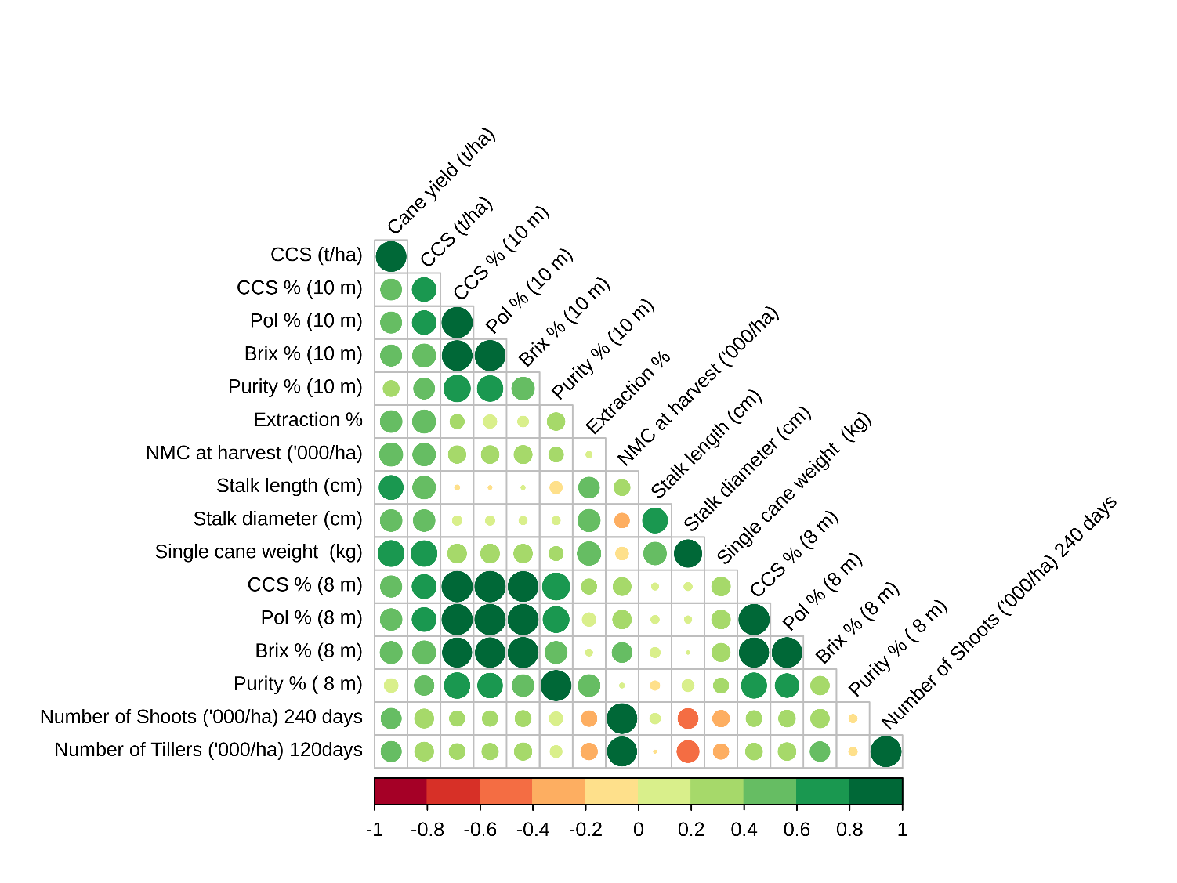
Fig. 1 Correlogram Showing Genotypic Correlations
(A graphical representation emphasizing positive/negative genotypic associations based on colour intensity)
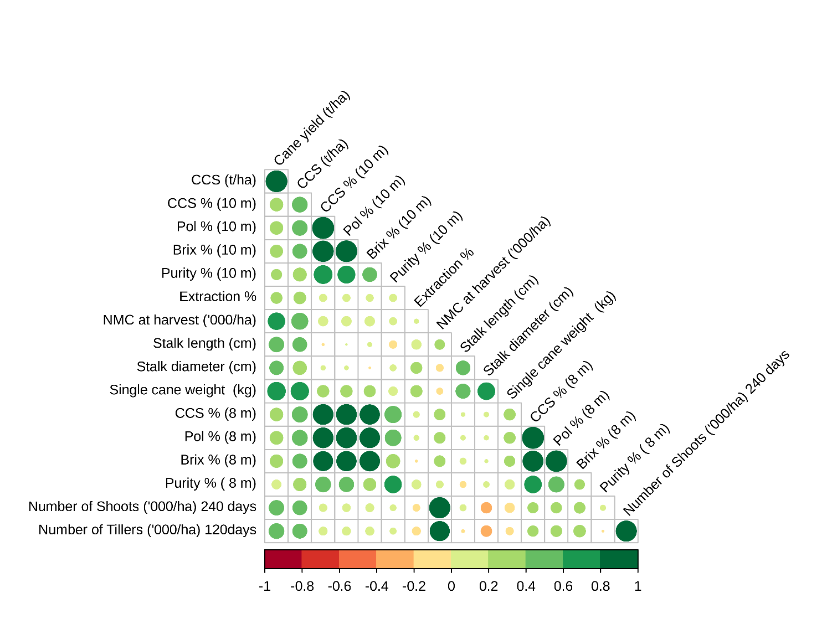
Fig. 2. Correlogram Showing Phenotypic Correlations
(A graphical representation emphasizing positive/negative phenotypic associations based on colour intensity)
Path Coefficient Analysis
The information provided through simple correlation analysis remains incomplete in the sense that it does not throw light on the underlying causes that are operative for various interrelationships (Prakash et al., 2010). The expression of a complex character such as cane yield depends upon the interplay of a number of component attributes. The path matrix specifying direct and indirect effects is presented in Table 4.
Note on Model Methodology: The variable CCS yield (t/ha) was explicitly excluded as an independent predictor variable during causal interpretation. Because CCS yield is mathematically derived from cane yield and juice quality, its inclusion as a predictor of cane yield introduces circular reasoning and mathematical dependency, which artificially inflates path coefficients.
From the path coefficient analysis, it was recorded that Pol % at the 8th month exhibited a high positive direct effect on cane yield, followed by CCS % at the 10th month, CCS % at the 8th month, Brix % at 10th month, single cane weight, number of millable canes at harvest, number of tillers at 120 DAP and stalk length. Selection based on these characters may lead to higher cane yield and juice quality. These findings generally agree with Ahmed et al. (2019), Viradiya et al. (2015) and Singh et al. (2020), who reported similar positive direct effects for sucrose components and single cane weight on overall yield. From a mechanistic biological perspective, the strong positive direct effect of Pol % at the 8th month highlights the physiological importance of early sucrose synthesis and sink strength establishment during the grand growth phase. In contrast, the potential negative direct effects observed for traits such as Pol % at the 10th month may reflect a biological trade-off; as the cane reaches peak maturity, metabolic energy heavily partitioned toward final sucrose concentration might compete with the maintenance of overall vegetative biomass, thereby negatively impacting total cane yield. The residual effect was notably low (0.01328), demonstrating that the selected suite of independent variables effectively captured the maximal extent of genotypic variation determining cane yield, leaving minimal environmental variance. The superior genotypes identified based on mean performance for cane yield and sugar yield showed that sugarcane clones 15-1805, 16-266, and 16-123 performed favourably compared to the check Co 0238 in terms of cane yield (t/ha), commercial cane sugar (t/ha), Pol % at the 8th month and CCS % at the 10th month
Conclusion
Correlation studies revealed that cane yield had significant and positive association with CCS (t/ha) followed by single cane weight, stalk length, number of millable canes at harvest and Brix % at 8th month. Path analysis revealed that the characters viz., Pol % at 8th month, CCS % at 10th month, CCS (t/ha), CCS % at 8th month, Brix % at 10th month, single cane weight, number of millable canes at harvest, number of tillers at 120 DAP and stalk length recorded positive direct effects on dependent variable i.e. cane yield and the other traits also showed their indirect positive effects on cane yield through these characters, indicating that these characters are the major contributing traits to cane yield in sugarcane. Sugarcane clones viz., 15-1805, 16-266 and 16-123 were significantly or numerically superior over the standards Co 0238 for both cane yield and quality attributes. These clones require further testing in multi-locational trials to sustain sugarcane productivity.
Declaration of AI Use
This manuscript was prepared through the combined contributions of all author(s), including contributions to the study design, data, content development, results, interpretation, and related scholarly work. The author(s) acknowledge the use of Grammarly and ChatGPT to assist with grammar checking, language refinement, reference formatting. These AI-assisted tools were not used as authors and did not replace the intellectual contributions or scholarly judgment of the author(s). All AI-assisted outputs, including content, references, and interpretations, were carefully reviewed, revised, verified, and approved by the author(s). The author(s) accept full responsibility for the accuracy, integrity, and final content of the manuscript.

Table 2: Genotypic correlation matrix of morphological and quality traits.
Characters | Cane Yield (t/ha) | CCS (t/ha) | CCS% (10M) | Pol% (10M) | Brix% (10M) | Purity% (10M) | Extraction (%) | NMC at Harvest (‘000/ha) | Stalk Length (cm) | Stalk Diameter (cm) | Single Cane Weight (Kg) | CCS% (8M) | Pol% (8M) | Brix% (8M) | Purity% (8M) | Number of Shoots 240 DAP (‘000/ha) | Number of Tillers 120 DAP (‘000/ha)
Cane Yield (t/ha)
CCS (t/ha) | 0.967**
CCS% (10M) | 0.466** | 0.604**
Pol% (10M) | 0.473** | 0.600** | 0.997**
Brix% (10M) | 0.476** | 0.571** | 0.963** | 0.980**
Purity% (10M) | 0.264* | 0.466** | 0.754** | 0.703** | 0.547**
Extraction (%) | 0.505** | 0.570** | 0.206 | 0.182 | 0.116 | 0.326**
NMC at Harvest (‘000/ha) | 0.573** | 0.544** | 0.319** | 0.329** | 0.343** | 0.226* | 0.036
Stalk Length (cm) | 0.616** | 0.550** | -0.022 | -0.012 | 0.014 | -0.152 | 0.458** | 0.265*
Stalk Diameter (cm) | 0.502** | 0.501** | 0.088 | 0.084 | 0.065 | 0.067 | 0.528** | -0.224* | 0.667**
Single Cane Weight (kg) | 0.724** | 0.713** | 0.374** | 0.373** | 0.361** | 0.204 | 0.588** | -0.169 | 0.548** | 0.812**
CCS% (8M) | 0.483** | 0.614** | 0.999** | 0.998** | 0.968** | 0.793** | 0.240* | 0.340** | 0.048 | 0.063 | 0.367**
Pol% (8M) | 0.500** | 0.613** | 0.996** | 0.997** | 0.985** | 0.726** | 0.189 | 0.365** | 0.065 | 0.050 | 0.368** | 0.994**
Brix% (8M) | 0.516** | 0.578** | 0.924** | 0.945** | 0.977** | 0.518** | 0.046 | 0.418** | 0.103 | 0.009 | 0.350** | 0.929** | 0.963**
Purity% (8M) | 0.196 | 0.405** | 0.703** | 0.654** | 0.504** | 0.981** | 0.507** | 0.021 | -0.085 | 0.149 | 0.235* | 0.682** | 0.600** | 0.363**
Number of Shoots 240 DAP (‘000/ha) | 0.437** | 0.381** | 0.239* | 0.248* | 0.266* | 0.182 | -0.254* | 0.960** | 0.113 | -0.425** | -0.286** | 0.261* | 0.292** | 0.362** | -0.067
Number of Tillers 120 DAP (‘000/ha) | 0.439** | 0.376** | 0.265* | 0.281** | 0.318** | 0.142 | -0.287** | 0.918** | -0.007 | -0.518** | -0.246* | 0.295** | 0.330** | 0.409** | -0.071 | 0.995**
** = Significant at 1% level
* = Significant at 5% level
(NMC = Number of Millable Canes, CCS (t/ha) = Commercial Cane Sugar (tonnes per hectare), CCS % = Commercial Cane Sugar per cent, 8M and 10M = 8th month and 10th month)
Table 3: Phenotypic correlation matrix of morphological and quality traits.
Characters | Cane Yield (t/ha) | CCS (t/ha) | CCS% (10M) | Pol% (10M) | Brix% (10M) | Purity% (10M) | Extraction (%) | NMC at Harvest (‘000/ha) | Stalk Length (cm) | Stalk Diameter (cm) | Single Cane Weight (kg) | CCS% (8M) | Pol% (8M) | Brix% (8M) | Purity% (8M) | Number of Shoots 240 DAP (‘000/ha) | Number of Tillers 120 DAP (‘000/ha)
Cane Yield (t/ha)
CCS (t/ha) | 0.968**
CCS% (10M) | 0.356** | 0.488**
Pol% (10M) | 0.353** | 0.479** | 0.995**
Brix% (10M) | 0.329** | 0.430** | 0.931** | 0.963**
Purity% (10M) | 0.231* | 0.375** | 0.710** | 0.642** | 0.424**
Extraction (%) | 0.264* | 0.304** | 0.114 | 0.114 | 0.107 | 0.113
NMC at Harvest (‘000/ha) | 0.608** | 0.577** | 0.192 | 0.197 | 0.199 | 0.113 | 0.038
Stalk Length (cm) | 0.469** | 0.422** | -0.009 | 0.004 | 0.035 | -0.121 | 0.191 | 0.200
Stalk Diameter (cm) | 0.400** | 0.390** | 0.041 | 0.030 | -0.005 | 0.078 | 0.264* | -0.106 | 0.419**
Single Cane Weight (kg) | 0.692** | 0.680** | 0.291** | 0.290** | 0.273** | 0.159 | 0.279** | -0.082 | 0.444** | 0.624**
CCS% (8M) | 0.355** | 0.505** | 0.874** | 0.875** | 0.833** | 0.594** | 0.072 | 0.249* | 0.028 | 0.045 | 0.270**
Pol% (8M) | 0.361** | 0.497** | 0.875** | 0.883** | 0.857** | 0.550** | 0.051 | 0.255* | 0.044 | 0.039 | 0.268* | 0.992**
Brix% (8M) | 0.346** | 0.436** | 0.810** | 0.833** | 0.854** | 0.394** | -0.009 | 0.251* | 0.078 | 0.020 | 0.235* | 0.895** | 0.945**
Purity% (8M) | 0.176 | 0.346** | 0.496** | 0.457** | 0.327** | 0.616** | 0.172 | 0.103 | -0.076 | 0.065 | 0.188 | 0.620** | 0.514** | 0.205
Number of Shoots 240 DAP (‘000/ha) | 0.467** | 0.429** | 0.121 | 0.128 | 0.140 | 0.074 | -0.099 | 0.919** | 0.080 | -0.241* | -0.194 | 0.229* | 0.240* | 0.252* | 0.058
Number of Tillers 120 DAP (‘000/ha) | 0.487** | 0.438** | 0.141 | 0.145 | 0.148 | 0.081 | -0.143 | 0.822** | -0.018 | -0.249* | -0.119 | 0.235* | 0.258* | 0.297** | -0.007 | 0.911**
** = Significant at 1% level
* = Significant at 5% level
(NMC = Number of Millable Canes, CCS (t/ha) = Commercial Cane Sugar (tonnes per hectare), CCS % = Commercial Cane Sugar per cent, 8M and 10M = 8th month and 10th month)
Table 4: Path coefficient analysis of morphological and quality traits.
Characters | CCS (t/ha) | CCS% (10M) | Pol% (10M) | Brix% (10M) | Purity% (10M) | Extraction (%) | NMC at Harvest (‘000/ha) | Stalk Length (cm) | Stalk Diameter (cm) | Single Cane Weight (Kg) | CCS% (8M) | Pol% (8M) | Brix% (8M) | Purity% (8M) | Number of Shoots at 240 DAP (‘000/ha) | Number of Tillers at 120 DAP (‘000/ha) | Cane Yield (t/ha)
CCS (t/ha) | 0.754 | 0.390 | -0.504 | 0.125 | -0.003 | -0.004 | 0.097 | 0.004 | -0.001 | 0.167 | 0.329 | 0.521 | -0.667 | -0.268 | -0.005 | 0.035 | 0.968
CCS% 10M | 0.368 | 0.798 | -1.046 | 0.270 | -0.007 | -0.002 | 0.032 | 0.000 | 0.000 | 0.072 | 0.569 | 0.916 | -1.240 | -0.385 | -0.001 | 0.011 | 0.356
Pol% 10M | 0.361 | 0.794 | -1.052 | 0.279 | -0.006 | -0.002 | 0.033 | 0.000 | 0.000 | 0.071 | 0.570 | 0.924 | -1.276 | -0.355 | -0.001 | 0.012 | 0.353
Brix% 10M | 0.324 | 0.743 | -1.012 | 0.290 | -0.004 | -0.001 | 0.034 | 0.000 | 0.000 | 0.067 | 0.542 | 0.898 | -1.307 | -0.253 | -0.002 | 0.012 | 0.329
Purity% 10M | 0.282 | 0.567 | -0.675 | 0.123 | -0.009 | -0.002 | 0.019 | -0.001 | 0.000 | 0.039 | 0.387 | 0.576 | -0.603 | -0.478 | -0.001 | 0.007 | 0.231
Extraction % | 0.229 | 0.091 | -0.120 | 0.031 | -0.001 | -0.014 | 0.006 | 0.002 | 0.000 | 0.069 | 0.047 | 0.053 | 0.015 | -0.134 | 0.001 | -0.011 | 0.264
NMC at Harvest (‘000/ha) | 0.435 | 0.153 | -0.207 | 0.058 | -0.001 | -0.001 | 0.168 | 0.002 | 0.000 | -0.020 | 0.162 | 0.267 | -0.384 | -0.080 | -0.010 | 0.066 | 0.608
Stalk Length (cm) | 0.318 | -0.007 | -0.004 | 0.010 | 0.001 | -0.003 | 0.034 | 0.009 | -0.001 | 0.109 | 0.018 | 0.046 | -0.119 | 0.059 | -0.001 | -0.001 | 0.469
Stalk Diameter (cm) | 0.294 | 0.033 | -0.031 | -0.002 | -0.001 | -0.004 | -0.018 | 0.004 | -0.001 | 0.153 | 0.029 | 0.041 | -0.030 | -0.050 | 0.003 | -0.020 | 0.400
Single Cane Weight (Kg) | 0.513 | 0.232 | -0.305 | 0.079 | -0.001 | -0.004 | -0.014 | 0.004 | -0.001 | 0.246 | 0.176 | 0.280 | -0.360 | -0.146 | 0.002 | -0.009 | 0.692
CCS% 8M | 0.381 | 0.697 | -0.920 | 0.241 | -0.005 | -0.001 | 0.042 | 0.000 | 0.000 | 0.067 | 0.651 | 1.039 | -1.370 | -0.481 | -0.003 | 0.019 | 0.355
Pol % 8M | 0.375 | 0.698 | -0.928 | 0.249 | -0.005 | -0.001 | 0.043 | 0.000 | 0.000 | 0.066 | 0.645 | 1.047 | -1.447 | -0.399 | -0.003 | 0.021 | 0.361
Brix% 8M | 0.329 | 0.646 | -0.876 | 0.248 | -0.004 | 0.000 | 0.042 | 0.001 | 0.000 | 0.058 | 0.582 | 0.990 | -1.531 | -0.159 | -0.003 | 0.024 | 0.346
Purity% 8M | 0.261 | 0.396 | -0.481 | 0.095 | -0.006 | -0.002 | 0.017 | -0.001 | 0.000 | 0.046 | 0.403 | 0.539 | -0.314 | -0.776 | -0.001 | -0.001 | 0.176
Number of Shoots at 240 DAP (‘000/ha) | 0.324 | 0.097 | -0.135 | 0.040 | -0.001 | 0.001 | 0.155 | 0.001 | 0.000 | -0.048 | 0.149 | 0.252 | -0.386 | -0.045 | -0.011 | 0.073 | 0.467
Number of Tillers at 120 DAP (‘000/ha) | 0.330 | 0.112 | -0.152 | 0.043 | -0.001 | 0.002 | 0.138 | 0.000 | 0.000 | -0.029 | 0.153 | 0.270 | -0.455 | 0.005 | -0.010 | 0.080 | 0.487
Residual = 0.01328
(NMC = Number of Millable Canes, CCS (t/ha) = Commercial Cane Sugar (tonnes per hectare), CCS % = Commercial Cane Sugar per cent, 8M and 10M = 8th month and 10th month).
References
Agrawal, D., Kumar, V. (2023). Recent progress on sugarcane-bagasse based lactic acid production: Technical advancements, potential and limitations. Industrial Crops and Products, 193: 116-132.
Ahmed, I., Moger, N.B., Patil, S.B., Hanamaratti, N.G. and Nadgouda, B.T. 2019. Correlation and path analysis in sugarcane hybrid clones of proven cross. Journal of Pharmacognosy and Phytochemistry, 8(2): 781-783.
Alam, M.N., Nath, U.K., Karim, K.M.R., Ahmed, M.M. and Mitul, R.Y. 2017. Genetic variability of exotic sugarcane genotypes. Scientifica, 2017: 1-9.
Al-Jibouri, H. A., Miller, A. R., Robinson, H. F. (1958). Genotypic and environmental variances and covariances in upland cotton crosses of interspecific origin. Agronomy Journal, 50: 633-637.
Burton, G.W. and De Vane, E.W. 1953. Estimating heritability in tall fescue (Festuca arundinacea) from replicated clonal material. Agronomy Journal, 45(10): 478-481.
De Morais, L.K., De Aguiar, M.S., De Albuquerque E Silva, P., Marinho Câmara, T.M., Cursi, D.E., Fernandes Jú Nior, A.R., Chapola, R.G., Carneiro, M.S. and Bespalhok Filho, J.C. 2015. Breeding of sugarcane. Industrial Crops: Breeding for Bioenergy and Bioproducts, 29-42.
Dewey, D.R. and Lu, K.H. 1959. A correlation and path-coefficient analysis of components of crested wheatgrass seed production. Agronomy Journal, 51(9): 515-518.
FAO. 2025. Food Outlook: Biannual Report on Global Food Markets. Food and Agriculture Organization of the United Nations, Rome. Available from: https://openknowledge.fao.org/server/api/core/bitstreams/c6c5ab30-5487-4734-adad-04394f439a82/content
Fisher, R. A. (1918). The correlation between relatives on the supposition of mendelian inheritance. Transactions of the Royal Society of Edinburgh, 52: 399-433.
Fisher, R.A. 1925. Statistical methods for research workers. Oliver and Boyd, London.
Galton, F. (1888). Co-relations and their measurement, chiefly from anthropometric data. Proceedings of the Royal Society of London, 45: 135-145.
Hardeep, Sharma, S., Kumar, R. and Bhawana. 2023. Genetic variability and character association of morphological and quality traits in advanced generation clones of sugarcane. The Pharma Innovation Journal, 12(6): 2824-2829.
Hewawansa, U.H.A.J., Houghton, M.J., Barber, E., Costa, R.J.S., Kitchen, B. and Williamson, G. 2024. Flavonoids and phenolic acids from sugarcane: Distribution in the plant, changes during processing, and potential benefits to industry and health. Comprehensive Reviews in Food Science and Food Safety, 23(2): e13307.
Hiremath, G., Nagaraja, T.E., Uma, M.S., Patel, V.N. and Anand, M. 2015. Character association and path analysis for cane and sugar yield in selected clones of sugarcane (Saccharum officinarum L). Trends in Biosciences, 8(6): 1466-1469.
Hitesh, Sharma, S., Kumar, R., Gupta, V., Dilbagh and Bansal, D. 2026. Assessment of Genetic Variability, Heritability and Genetic Advance for Enhancing Cane Yield and Quality Traits in Sugarcane (Saccharum spp. Complex). Indian Journal of Agricultural Research, 60(5): 654-660. doi: 10.18805/IJARe.A-6400.
Mahadevaiah, C., Appunu, C., Aitken, K., Suresha, G. S., Vignesh, P., Mahadeva Swamy, H. K., & Ram, B. (2021). Genomic selection in sugarcane: Current status and future prospects. Frontiers in Plant Science, 12: 708-233.
Ministry of Agriculture and Farmers Welfare. 2025. Sugarcane Cultivation. Press Information Bureau. Available from: https://www.pib.gov.in/PressReleasePage.aspx?PRID=2203206
Mukesh, Sonika, Priyashree, L., Konsam, S., Chongtham, C., and Shankar, L. (2025^{A}). Unravelling genetic relationships in spring mung bean genotypes using morphological and molecular markers under the foothill condition of Manipur. Plant Science Today, 12(4). https://doi.org/10.14719/pst.9126
Mukesh., Yumnam, S., Laishram, P., Kumar, H., Senjam, P., Singh, L. N. K., Gopimohan, N., & Jat, J. K. (2025^{B}). Genetic basis of yield variation in spring mung bean (Vigna radiata L.): a correlation and path analysis study. International Journal of Bio-resource and Stress Management, 15(12), 01-07.
Patra, D., Jagadev, P.N. and Mohanty, S. 2022. Genetic variability, association and path coefficient studies in sugarcane. The Pharma Innovation Journal, 11(8): 559-563.
Prakash, R., Ganesamurthy, K., Nirmalakumari, A. and Nagarajan, P. 2010. Correlation and path analysis in sorghum (Sorghum bicolor L. Moench). Electronic Journal of Plant Breeding, 1(3): 315–318.
Rakesh, G., Reddy, G.E., Swapna, N., Saicharan, M., Swathi, Y. and Balaji, B. 2023. Correlation and path analysis in sugarcane advanced clones. The Pharma Innovation Journal, SP-12(10): 415-422.
Reddy, G.E., Rakesh, G., Naik, P.J., Swapna, N., Swathi, Y., Bharathi, Y., Kumar, M.V. and Venkataiah, M. 2020. Character association among yield and quality traits in early maturing sugarcane clones. Current Journal of Applied Science and Technology, 39(30): 137-143.
Sharma, M., Prabhakar, S. S., Chandrahas, A. H., Laishram, P., Tagra, D., Yumnam, S., and Kumar, A. (2026). Plant Holobionts in a Changing Climate: Genome–Microbiome Integration for Sustainable Food Systems. Total Environment Microbiology, 100098.
Sharma, S., Gupta, V., Kumar, R. and Sangwan, O. 2024. Genetic variability, correlation studies and path analysis in sugarcane early clones. International Journal of Research in Agronomy, 7(5S): 242-245.
Sharma, S., Sangwan, O. and Gupta, V. 2023. Studies on estimates of genetic variability, character association and path analysis of yield components in sugarcane. The Pharma Innovation Journal, 12(7): 1289-1292.
Singh, P., Singh, S.N., Tiwari, A.K., Pathak, S.K., Singh, A.K., Srivastava, S. and Mohan, N. 2019. Integration of sugarcane production technologies for enhanced cane and sugar productivity targeting to increase farmers income: strategies and prospects. 3 Biotech, 9(2): 48.
Singh, R., Kamat, D.N., Kumar, B., Kumari, P. and Govindbhai, Z.R. 2020. Genetic variability analysis of early maturing sugarcane (Saccharum officinarum L.) clones using morphological characters. Current Journal of Applied Science and Technology, 39(26): 105-112.
Singh, R., Kamat, D.N., Kumari, P., Zala, R.G., Singh, B. (2022). Correlation and path analysis in early maturing sugarcane: Climate Change and Environmental Impact. International Journal of Environment and Climate Change, 12(11): 180-190.
Tabassum, Jeena, A.S. and Rohit. 2023. Estimation of genetic variability, character association and path coefficient using sugarcane segregating population. Electronic Journal of Plant Breeding, 14(2): 665–674.
Tena, E., Mekbib, F. and Ayana, A. 2016. Correlation and path coefficient analyses in sugarcane genotypes of Ethiopia. American Journal of Plant Sciences, 07(10): 1490-1497.
Tolera, B., Gedebo, A. and Tena, E. 2024. Genetic variability, character association and path analysis in sugarcane genotypes. Archives of Agronomy and Soil Science, 70(1): 1-15.
Vavilov, N.I. (1951). Origin, variation, immunity and breeding of cultivated plants. An international collection of studies in the methods and history of biology and agriculture. Chron. Botanica, 13.
Viradiya, Y.A., Damor, P.R., Joshi, H.K., Koladiya, P.B. and Gadhiy, A.A. 2015. Correlation and path coefficient analyses in sugarcane. The Bioscan, 10(1): 1-4.
Wright, S. 1921. Correlation and causation. Journal of Agricultural Research, 20: 557-585.

