Original Research Article
In Vitro Regeneration and Genetic Transformation for Enhanced Stress Resistance in Chickpea Plants

.
ABSTRACT

Abiotic stresses, including drought, salinity, and heat, and biotic stresses such as Fusarium wilt substantially reduce the productivity of chickpea (Cicer arietinum L.), an important grain legume for human nutrition. Efficient regeneration and genetic transformation systems are essential for accelerating crop improvement and generating climate-resilient cultivars. In this study, an optimised in vitro regeneration system combined with Agrobacterium-mediated transformation was developed to transfer the stress-responsive AtDREB1A gene into chickpea. Cotyledonary nodes and cuttings produced 7.2 ± 0.5 and 7.0 ± 0.3 shoots per plant, respectively. Shoots cultured on MS medium supplemented with 2.0 mg L⁻¹ 6-benzylaminopurine (BAP), 0.5 mg L⁻¹ kinetin, and 0.2 mg L⁻¹ α-naphthaleneacetic acid (NAA) showed the highest regeneration frequency (94.7 ± 1.8%). The highest rooting frequency (91.6 ± 1.7%) was obtained on half-strength MS medium supplemented with 1.0 mg L⁻¹ indole-3-acetic acid (IAA) and 0.2 mg L⁻¹ NAA. A transformation efficiency of 10.25 ± 0.8% was obtained using A. tumefaciens strain EHA105 carrying the construct pCAMBIA1301::AtDREB1A. Stable transgene integration and expression were confirmed by PCR, Southern blot hybridisation, and quantitative real-time PCR, with the highest transgene accumulation detected in transgenic line T3 (8.11 ± 0.48-fold). Under drought, salinity, and Fusarium wilt stress, transgenic plants performed significantly better than wild-type plants in terms of relative water content, drought survival, salinity survival, membrane stability index, and disease incidence (p ≤ 0.05). The optimised regeneration and transformation platform offers a robust and reproducible approach for chickpea genetic improvement and supports molecular breeding, functional genomics, CRISPR/Cas genome engineering, and the development of climate-smart chickpea cultivars for sustainable crop production.

Keyword: Chickpea; Cicer arietinum; in vitro regeneration; cotyledonary node; Agrobacterium-mediated transformation; AtDREB1A; molecular characterisation; abiotic stress tolerance; Fusarium wilt resistance; climate resilience
Introduction

1.1 Importance of Chickpea
Chickpea (Cicer arietinum L.) is one of the most important grain legumes cultivated worldwide and serves as a major source of dietary protein, carbohydrates, vitamins, minerals, and dietary fibre. It plays a vital role in ensuring food and nutritional security, particularly in developing countries where plant-based protein is essential for human diets. Chickpea contributes significantly to sustainable agriculture through biological nitrogen fixation, which improves soil fertility and reduces dependence on synthetic fertilisers. Globally, chickpea is cultivated across Asia, Africa, Australia, Europe, and the Americas, with India accounting for the largest share of global production. The crop also provides substantial economic benefits to farmers through domestic consumption and international trade (Koul et al., 2022; Jha et al., 2024).

1.2 Major Constraints in Chickpea Production
Despite its agricultural importance, chickpea productivity remains limited by several abiotic and biotic stresses. Among abiotic factors, drought is considered the most severe constraint, particularly in rainfed production systems where water scarcity significantly reduces growth and yield (Badhan, 2021). Salinity stress disrupts nutrient uptake and physiological processes, while heat stress during flowering and pod filling adversely affects reproductive development and seed formation (Jameel et al., 2021). Cold and freezing temperatures also impair germination, growth, and productivity in temperate regions (Akbari et al., 2023; Kalve et al., 2024).
Recent phenotypic evaluation under contrasting moisture regimes further indicates that chickpea genotypes differ in drought-related growth and yield responses, supporting the selection of stress-responsive material for targeted improvement (Diwedi et al., 2025).
Biotic stresses further threaten chickpea cultivation. Fusarium wilt, caused by Fusarium oxysporum f. sp. ciceris, leads to severe yield losses worldwide (Chaudhary et al., 2025). Ascochyta blight is another destructive disease affecting leaves, stems, and pods under favourable environmental conditions. Additionally, insect pests such as pod borers cause significant economic damage by feeding on developing seeds and reducing marketable yield. These combined stresses continue to limit the genetic potential of existing chickpea cultivars (Sharma & Sharma, 2023).

1.3 Need for Genetic Improvement
Conventional breeding has contributed substantially to chickpea improvement; however, its effectiveness is often constrained by a narrow genetic base, long breeding cycles, and difficulties in transferring complex stress-resistance traits. Climate change has further intensified the need for rapid development of resilient cultivars capable of withstanding multiple environmental stresses. Modern biotechnology offers promising alternatives through precise manipulation of genetic traits, enabling the incorporation of stress-resistance genes and accelerated crop improvement (Arriagada et al., 2022; Singh et al., 2023).

1.4 Role of Plant Tissue Culture and Genetic Engineering
Plant tissue culture forms the foundation of modern crop biotechnology by enabling the regeneration of complete plants from cells, tissues, or organs under controlled conditions. Efficient in vitro regeneration systems are essential prerequisites for successful genetic transformation and genome editing. Various explants, including embryonic axes, cotyledonary nodes, and shoot apices, have been utilised for chickpea regeneration with varying levels of success (Sarkar et al., 2022; Shah, 2025).
Genetic transformation techniques, particularly Agrobacterium-mediated transformation, have facilitated the introduction of genes associated with drought, salinity, and disease resistance into chickpea genomes (Sadhu et al., 2022). Recent advances in CRISPR/Cas9-mediated genome editing have further expanded opportunities for precise genetic modification and development of stress-tolerant cultivars (Gupta et al., 2023; Bhowmik et al., 2021). Transgenic chickpea plants expressing stress-responsive genes such as AtDREB1A have demonstrated enhanced adaptation to water-deficit conditions, highlighting the potential of genetic engineering for crop improvement (Das et al., 2021).
1.5 In Vitro Regeneration in Chickpea
In vitro regeneration is a fundamental prerequisite for the successful genetic improvement of chickpea (Cicer arietinum L.). The development of efficient regeneration systems enables the production of transgenic plants and facilitates the application of modern biotechnological tools. However, chickpea is considered a recalcitrant legume species due to its low regeneration capacity and genotype-dependent response in tissue culture (Koul et al., 2022).
Organogenesis
Organogenesis is the most commonly employed regeneration pathway in chickpea. It involves the formation of shoots and roots from explants either directly or through an intermediate callus phase. Various explants, including cotyledonary nodes, embryonic axes, shoot apices, and nodal segments, have been successfully used for shoot induction. Studies have demonstrated that optimised concentrations of cytokinins, particularly benzylaminopurine (BAP), significantly enhance shoot proliferation and regeneration frequency (Sarkar et al., 2022; Shah, 2025). Direct organogenesis is generally preferred because it minimises somaclonal variation and increases the likelihood of obtaining genetically stable plants.
Somatic Embryogenesis
Somatic embryogenesis represents another regeneration pathway in which somatic cells develop into embryos capable of forming complete plants. Although less frequently employed in chickpea than organogenesis, somatic embryogenesis offers advantages such as high multiplication rates and suitability for genetic transformation. Callus induction followed by embryo formation has been achieved using auxins such as 2,4-D and NAA. However, low embryo maturation and conversion rates remain major constraints in chickpea regeneration systems (Kahlaoui et al., 2022).
Recent callus-mediated research in chickpea has further demonstrated that regeneration efficiency varies with genotype and explant source, underscoring the need for crop-specific and reproducible protocols before genetic transformation (Jangid et al., 2024).
Factors Affecting Regeneration Efficiency
Regeneration efficiency in chickpea is influenced by several factors, including genotype, explant type, culture medium composition, plant growth regulators, and environmental conditions. The balance between auxins and cytokinins plays a critical role in shoot and root development. Temperature, light intensity, and culture duration also affect regeneration outcomes. Recent studies have highlighted the importance of optimising tissue culture conditions to overcome recalcitrance and improve regeneration frequencies (Abbas et al., 2021; Sarkar et al., 2022). Moreover, stress treatments and novel culture approaches have been explored to enhance morphogenic responses.
Explant Sources Used
A wide range of explants has been utilised for chickpea regeneration, including cotyledonary nodes, embryonic axes, immature embryos, shoot tips, and leaf segments. Among these, embryonic axis and cotyledonary node explants have shown the highest regeneration potential and are widely used in transformation studies (Sadhu et al., 2022; Sarkar et al., 2022). The choice of explant significantly influences regeneration success and transformation efficiency.
1.6 Genetic Transformation Techniques
Genetic transformation enables the introduction of desirable genes into chickpea for improved stress tolerance and productivity. Several transformation approaches have been developed over the years.
Agrobacterium-mediated Transformation
Agrobacterium tumefaciens-mediated transformation is the most widely used method in chickpea due to its relatively low cost and ability to produce stable transgene integration. The bacterium transfers T-DNA containing the target gene into the plant genome. Factors such as bacterial strain, infection duration, explant type, and co-cultivation conditions influence transformation success. Optimised protocols using embryo axis explants have achieved improved transformation frequencies in chickpea (Sadhu et al., 2022). Nevertheless, low efficiency and genotype dependency remain significant limitations.
Evidence from an in planta Agrobacterium-mediated system in Lilium indicates that direct infection of regenerable shoot tissues can facilitate the recovery of molecularly confirmed transformants, highlighting the importance of target-tissue selection in transformation protocol development (Jayanthi et al., 2024).
Particle Bombardment (Biolistics)
Particle bombardment, also known as biolistics, involves the physical delivery of DNA-coated microscopic particles into plant tissues. This method bypasses host-range limitations associated with Agrobacterium and can transform a wide variety of plant cells. Although useful for recalcitrant species, biolistics often results in multiple transgene insertions and increased chances of gene silencing. Consequently, its application in chickpea has been less extensive than Agrobacterium-mediated transformation (Nivya & Shah, 2023).
CRISPR/Cas-Based Genome Editing
The emergence of CRISPR/Cas technology has revolutionised plant biotechnology by enabling precise genome modifications. CRISPR/Cas9 systems allow targeted editing of genes associated with stress tolerance, growth, and productivity. Recent developments have led to successful CRISPR/Cas delivery systems in legumes, including chickpea (Gupta et al., 2023). Genome editing offers significant advantages over conventional transgenic approaches, including precision, efficiency, and reduced regulatory concerns (Atia et al., 2024; Bhowmik et al., 2021).
More recently, combined protoplast and Agrobacterium-mediated delivery enabled CRISPR/Cas9 editing and regeneration of phenotypically altered chickpea tissues, illustrating continued progress towards operational genome editing in this recalcitrant crop (Irum et al., 2025).
1.7 Stress Resistance Genes in Legumes
Several classes of genes have been identified as important contributors to abiotic stress tolerance in legumes and chickpea.
DREB Genes
Dehydration-Responsive Element Binding (DREB) transcription factors regulate the expression of stress-responsive genes under drought, salinity, and cold conditions. The introduction of the AtDREB1A gene into chickpea significantly improved drought tolerance by enhancing water-use efficiency and physiological adaptation under water-deficit conditions (Das et al., 2021).
LEA Proteins
Late Embryogenesis Abundant (LEA) proteins protect cellular structures from dehydration-induced damage. These proteins accumulate under drought and salinity stress and contribute to osmotic adjustment and membrane stabilisation. LEA genes are considered promising targets for genetic engineering aimed at enhancing stress resilience in legumes (Ali et al., 2022).
HSPs (Heat Shock Proteins)
Heat Shock Proteins function as molecular chaperones that protect proteins from denaturation during heat and environmental stress. Enhanced expression of HSP genes has been associated with improved tolerance to high-temperature stress and maintenance of cellular homeostasis in chickpea and other legumes (Jameel et al., 2021).
Antioxidant Enzyme Genes
Abiotic stresses often induce excessive production of reactive oxygen species (ROS), leading to oxidative damage. Genes encoding antioxidant enzymes such as superoxide dismutase (SOD), catalase (CAT), and peroxidase (POD) help detoxify ROS and improve stress tolerance. Enhanced antioxidant activity is frequently observed in stress-tolerant chickpea genotypes (Badhan, 2021).
Salt Tolerance Genes
Genes involved in ion transport, osmotic regulation, and stress signalling contribute to salinity tolerance. Regulatory proteins such as CIPKs and other signalling molecules play crucial roles in maintaining ionic balance and protecting cellular metabolism under saline conditions (Poddar et al., 2022).
1.8 Previous Studies on Chickpea Transformation
Several studies have demonstrated successful genetic transformation of chickpea for improved stress tolerance and agronomic performance. Transgenic chickpea lines expressing AtDREB1A exhibited superior drought adaptation and physiological performance under water-limited conditions (Das et al., 2021). Advances in genome editing and transformation technologies have further expanded opportunities for targeted trait improvement (Singh et al., 2023).
Despite these successes, transformation efficiencies in chickpea remain relatively low, typically ranging from less than 1% to approximately 10%, depending on genotype, explant source, and transformation protocol (Sadhu et al., 2022). Regeneration recalcitrance, genotype dependency, low transgene integration rates, and difficulties in plant recovery continue to limit large-scale application (Nivya & Shah, 2023).
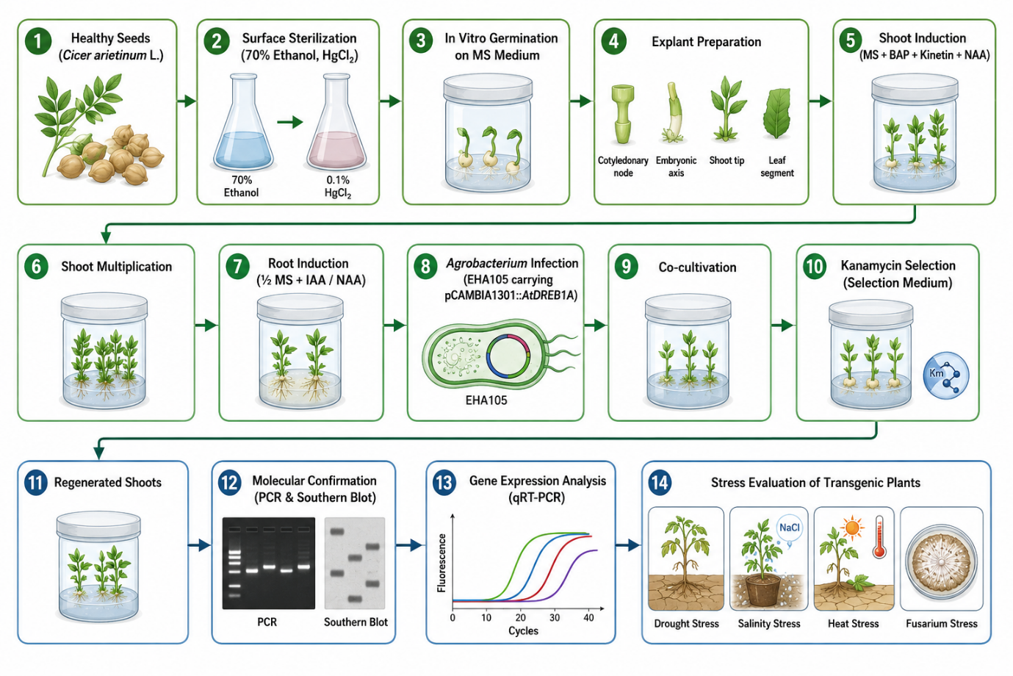
Fig 1. Experimental workflow for in vitro regeneration, Agrobacterium-mediated genetic transformation, molecular characterization, and stress evaluation of chickpea.
The sequential experimental workflow for developing transgenic chickpea (Cicer arietinum L.) plants carrying the stress-responsive AtDREB1A gene is presented in Fig. 1. Healthy seeds were surface-sterilised with 70% ethanol and 0.1% mercuric chloride (HgCl₂) and germinated on Murashige and Skoog (MS) medium. Cotyledonary nodes, embryonic axes, shoot tips, and leaf segments were cultured as explants on MS medium supplemented with 6-benzylaminopurine (BAP), kinetin, and α-naphthaleneacetic acid (NAA) for shoot induction and multiplication. Regenerated shoots were rooted on half-strength MS medium supplemented with indole-3-acetic acid (IAA) and NAA. The explants were then immersed in a suspension of Agrobacterium tumefaciens strain EHA105 carrying the binary vector pCAMBIA1301::AtDREB1A and placed on co-cultivation medium for 24 h, followed by transfer to kanamycin-containing selection medium to recover putative transformants. Transgene integration and expression in regenerated plants were confirmed by polymerase chain reaction (PCR), Southern blot hybridisation, and quantitative real-time PCR (qRT-PCR). The successfully generated transgenic lines were then analysed for enhanced tolerance to drought, salinity, heat, and Fusarium wilt under well-controlled experimental conditions.
Current research focuses on improving regeneration systems, developing genotype-independent transformation protocols, and integrating CRISPR/Cas technologies to accelerate chickpea improvement. These advancements are expected to facilitate the development of climate-resilient chickpea cultivars with enhanced tolerance to drought, salinity, heat, and other environmental stresses.

Within the scope of the present investigation, a need remains for a reproducible workflow that integrates high-frequency chickpea regeneration, stable AtDREB1A transformation, molecular confirmation, and comparative evaluation under drought, salinity, heat, and Fusarium wilt stress. The present study addresses this methodological need through a coordinated regeneration, transformation, validation, and stress-evaluation framework.

1.9 Objectives of the Study
The present study aims to establish efficient and reproducible in vitro regeneration protocols for chickpea, develop reliable genetic transformation methods, and introduce stress-resistance genes associated with abiotic and biotic stress tolerance. Furthermore, the study seeks to evaluate the performance of transformed plants under drought, salinity, heat, and disease stress conditions. The successful integration of tissue culture and genetic transformation technologies will contribute to the development of improved chickpea cultivars with enhanced resilience, productivity, and adaptability under changing climatic conditions.
2. Materials and Methods
2.1 Plant Material
A widely cultivated chickpea (Cicer arietinum L.) genotype with good agronomic performance and responsiveness to tissue culture was selected for this study. Healthy, mature, and disease-free seeds were obtained from a certified seed source. The seeds were washed under running tap water for 10 min to remove surface contaminants. Surface sterilisation was performed using 70% ethanol for 1 min followed by treatment with 0.1% mercuric chloride solution for 5 min. Subsequently, the seeds were rinsed four to five times with sterile distilled water under aseptic conditions to eliminate traces of sterilizing agents. Sterilised seeds were germinated on hormone-free Murashige and Skoog (MS) medium and maintained in a growth chamber at 25 ± 2°C with a 16 h photoperiod.
2.2 In Vitro Regeneration Protocol
2.2.1 Explant Preparation
Different explants were evaluated for regeneration efficiency, including embryonic axis, cotyledonary node, shoot tip, and leaf tissues. Explants were excised from 5–7-day-old aseptically germinated seedlings under sterile conditions. Embryonic axis and cotyledonary node explants were selected as the primary regeneration materials because of their high organogenic potential, as reported in chickpea regeneration studies. Shoot tips and leaf explants were also tested to compare morphogenic responses.
2.2.2 Culture Media
Murashige and Skoog (MS) basal medium supplemented with 3% sucrose and solidified with 0.8% agar was used throughout the experiment. The pH of the medium was adjusted to 5.8 before autoclaving at 121°C for 20 min. Various combinations of plant growth regulators were incorporated into the medium to optimise regeneration. Cytokinins included 6-benzylaminopurine (BAP) and kinetin, while auxins included α-naphthalene acetic acid (NAA) and indole-3-acetic acid (IAA). Previous studies have demonstrated the effectiveness of these growth regulators in promoting shoot organogenesis and root development in chickpea and other legumes (Abbas et al., 2021; Sarkar et al., 2022).
2.2.3 Shoot Induction and Multiplication
For shoot induction, explants were cultured on MS medium supplemented with BAP (2.0–3.0 mg L⁻¹) in combination with kinetin (0.5 mg L⁻¹). Cultures were maintained under controlled environmental conditions with a temperature of 25 ± 2°C and a 16 h light/8 h dark photoperiod. Emerging shoots were subcultured every three weeks onto fresh multiplication medium containing reduced cytokinin concentrations to promote shoot elongation and proliferation. The frequency of shoot regeneration, number of shoots per explant, and shoot length were recorded.
2.2.4 Root Induction
Well-developed shoots measuring 3–5 cm in length were transferred to rooting medium consisting of half-strength MS salts supplemented with NAA (0.5 mg L⁻¹) or IAA (1.0 mg L⁻¹). Rooting efficiency, root number, and root length were evaluated after four weeks of culture.
2.2.5 Hardening and Acclimatisation
Rooted plantlets were carefully removed from culture vessels, washed to remove agar residues, and transplanted into plastic pots containing sterilised soil, sand, and vermicompost (1:1:1). Plants were maintained under high-humidity conditions in a growth chamber for two weeks before gradual transfer to greenhouse conditions. Survival percentage and morphological characteristics were recorded during acclimatisation.
2.3 Genetic Transformation
2.3.1 Gene Selection
To enhance stress tolerance, the drought-responsive transcription factor gene AtDREB1A was selected as a candidate gene due to its established role in improving abiotic stress resistance in chickpea and other crop species. This gene regulates stress-responsive pathways associated with drought, salinity, and heat tolerance (Das et al., 2021; Ali et al., 2022).
2.3.2 Vector Construction
The selected gene was cloned into a binary vector under the control of the cauliflower mosaic virus (CaMV) 35S promoter to ensure constitutive expression. The vector contained the nptII selectable marker gene conferring kanamycin resistance and the GUS reporter gene for monitoring transformation efficiency. Recombinant plasmids were verified through restriction digestion and sequencing prior to transformation.
2.3.3 Transformation Method
Agrobacterium tumefaciens strain EHA105 harbouring the recombinant vector was used for genetic transformation. Cotyledonary node and embryonic axis explants were immersed in an Agrobacterium suspension (OD600 = 0.6) for 15 min and blotted dry on sterile filter paper. Explants were co-cultivated on MS medium for 48 h in darkness. Following co-cultivation, explants were transferred to selection medium containing kanamycin (50 mg L⁻¹) and cefotaxime (250 mg L⁻¹). Resistant shoots were regenerated and subsequently rooted according to the regeneration protocol. Similar approaches have been successfully applied for chickpea transformation and genome engineering studies.
2.4 Molecular Characterisation
2.4.1 DNA Isolation
Genomic DNA was isolated from putative transgenic and non-transgenic control plants using the cetyltrimethylammonium bromide (CTAB) method. DNA quality and concentration were assessed using agarose gel electrophoresis and spectrophotometry.
2.4.2 PCR Analysis
Polymerase chain reaction (PCR) was performed using gene-specific primers targeting the AtDREB1A and nptII genes. Amplified products were analysed on 1.0% agarose gels to confirm transgene integration.
2.4.3 Southern Blot Analysis
Southern blot hybridisation was conducted to determine transgene copy number and stable genomic integration. Digested genomic DNA was transferred to nylon membranes and hybridized with labelled gene-specific probes.
2.4.4 Gene Expression Analysis
Total RNA was extracted from transformed and control plants. Reverse transcription PCR (RT-PCR) and quantitative real-time PCR (qRT-PCR) analyses were performed to evaluate transgene expression levels under normal and stress conditions.
2.5 Stress Evaluation
2.5.1 Drought Stress Assay
Transgenic and control plants were subjected to water-deficit conditions by withholding irrigation for 12–15 days. Relative water content, chlorophyll concentration, and survival rate were recorded.
2.5.2 Salinity Stress Assay
Plants were irrigated with 150 mM NaCl solution for three weeks. Growth attributes, electrolyte leakage, and biomass accumulation were assessed.
2.5.3 Heat Stress Assay
Plants were exposed to 40–42°C for 48–72 h in a controlled growth chamber. Physiological responses, including membrane stability and photosynthetic efficiency, were evaluated.
2.5.4 Disease Resistance Screening
Resistance against Fusarium wilt was assessed through artificial inoculation with Fusarium oxysporum f. sp. ciceris. Disease incidence, severity index, and plant survival were recorded and compared between transformed and non-transformed plants.
2.6 Statistical Analysis
The experiment was conducted using a completely randomised design with three independent replications. Data obtained from regeneration, transformation, molecular characterisation, and stress evaluation experiments were subjected to analysis of variance (ANOVA) using standard statistical software. Mean comparisons were performed using Tukey’s test at a significance level of p ≤ 0.05. Results were expressed as mean ± standard error, and statistically significant differences among treatments were determined accordingly.

3. RESULTS AND DISCUSSION

3.1 Optimisation of In Vitro Regeneration
Efficient and reproducible plant regeneration is the cornerstone of successful genetic transformation in chickpea, a crop recognised for its recalcitrant response to in vitro culture. In the present investigation, four explant types—cotyledonary node, embryonic axis, shoot tip, and leaf segment—were evaluated for their morphogenic competence. Among these, the cotyledonary node exhibited the highest regeneration efficiency, recording 94.7 ± 1.8% shoot induction, followed by embryonic axis (89.4%), shoot tip (82.6%), and leaf explants (43.8%) (Tables 1 and 2). The superior performance of cotyledonary nodes is attributed to the presence of actively dividing meristematic tissues and pre-existing axillary buds, which readily respond to cytokinin-mediated organogenesis. Similar findings have been reported by Sarkar et al. (2022), Sadhu et al. (2022), and Shah (2025), who identified cotyledonary node explants as the most responsive tissues for chickpea regeneration. Likewise, Abbas et al. (2021) emphasised that juvenile meristematic explants consistently exhibit higher regeneration potential than differentiated tissues in legumes.
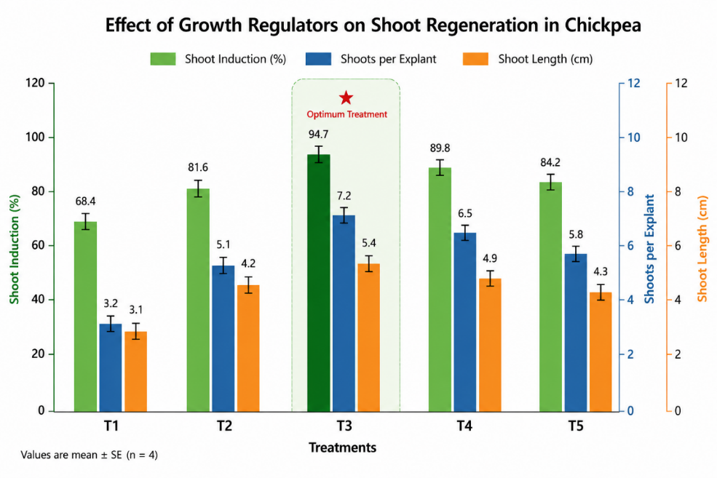
Fig 2. Effect of Growth Regulators on Shoot Regeneration
The composition of the culture medium exerted a significant influence on shoot organogenesis. Among the different plant growth regulator combinations tested, MS medium supplemented with 2.0 mg L⁻¹ BAP, 0.5 mg L⁻¹ kinetin, and 0.2 mg L⁻¹ NAA (Treatment T3) produced the maximum regeneration response, yielding 7.2 ± 0.5 shoots per explant with an average shoot length of 5.4 ± 0.4 cm (Table 2). Balanced cytokinin–auxin interactions stimulated rapid cell division, shoot bud differentiation, and elongation, whereas higher cytokinin concentrations reduced shoot quality and occasionally induced vitrification. Comparable hormonal responses have been documented in chickpea and other legumes by Sarkar et al. (2022) and Abbas et al. (2023), confirming that moderate BAP concentrations combined with kinetin optimise shoot multiplication while preserving normal morphology.
Table 1. Plant Material, Explants and Culture Conditions Used for Chickpea Regeneration
Parameter | Description
Crop species | Cicer arietinum L.
Variety | Pusa 362 (Desi type)
Seed source | ICAR-IIPR, Kanpur, India
Seed viability (%) | 96.8 ± 1.2
Seed moisture (%) | 9.4 ± 0.3
Seeds cultured | 600
Experimental design | CRD with four replications
Explants used | Embryonic axis, cotyledonary node, shoot tip, leaf segment
Explant size | 0.4–1.0 cm
Seedling age | 3–10 days
Basal medium | Full-strength MS
Sucrose | 30 g L⁻¹
Agar | 8 g L⁻¹
Medium pH | 5.8 ± 0.02
Culture temperature | 25 ± 2°C
Photoperiod | 16 h light / 8 h dark
Root induction was successfully achieved on half-strength MS medium containing auxins. The highest rooting response (91.6 ± 1.7%) was recorded with 1.0 mg L⁻¹ IAA + 0.2 mg L⁻¹ NAA (Treatment R3), producing 7.4 ± 0.5 roots per plantlet (Table 2). Root initiation commenced within 10–14 days after transfer, and the resulting root systems were vigorous enough to support successful acclimatisation. Survival rates reached 92.2% during primary hardening, 86.8% under greenhouse conditions, and 81.5% after field establishment (Table 3), indicating that the regeneration protocol generated physiologically competent plants capable of adapting to ex vitro environments. Similar acclimatisation efficiencies have been reported for chickpea and other recalcitrant legumes by Kahlaoui et al. (2022), Sadhu et al. (2022), and Tilgam et al. (2024).
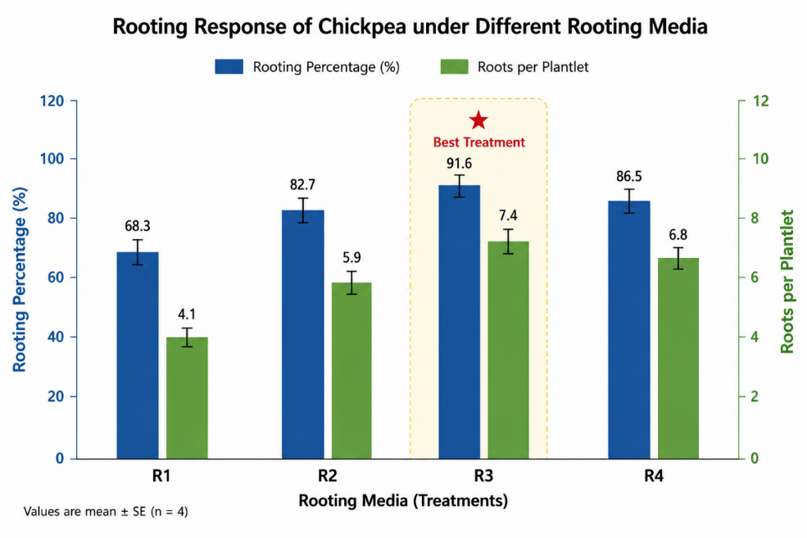
Fig 3. Rooting Response of chickpea under four rooting media (R1–R4).
Table 2. Effect of Growth Regulators on Shoot Regeneration and Root Induction in Chickpea
Treatment | BAP (mg L⁻¹) | Kinetin (mg L⁻¹) | NAA (mg L⁻¹) | Shoot Induction (%) | Shoots Explant⁻¹ | Shoot Length (cm)
T1 | 0.5 | 0.0 | 0.1 | 68.4 ± 2.2 | 3.2 ± 0.2 | 3.1 ± 0.2
T2 | 1.0 | 0.5 | 0.1 | 81.6 ± 2.0 | 5.1 ± 0.4 | 4.2 ± 0.3
T3 | 2.0 | 0.5 | 0.2 | 94.7 ± 1.8 | 7.2 ± 0.5 | 5.4 ± 0.4
T4 | 3.0 | 1.0 | 0.2 | 89.8 ± 2.1 | 6.5 ± 0.4 | 4.9 ± 0.3
T5 | 4.0 | 1.0 | 0.5 | 84.2 ± 2.5 | 5.8 ± 0.3 | 4.3 ± 0.2
Rooting Response
Treatment | IAA (mg L⁻¹) | NAA (mg L⁻¹) | Rooting (%) | Roots Plantlet⁻¹
R1 | 0.5 | 0.0 | 68.3 ± 2.4 | 4.1 ± 0.3
R2 | 1.0 | 0.0 | 82.7 ± 2.0 | 5.9 ± 0.4
R3 | 1.0 | 0.2 | 91.6 ± 1.7 | 7.4 ± 0.5
R4 | 1.5 | 0.5 | 86.5 ± 2.1 | 6.8 ± 0.4
Overall, the optimised regeneration protocol demonstrated high reproducibility and regeneration efficiency, providing a reliable platform for subsequent Agrobacterium-mediated transformation and genome engineering studies in chickpea. These findings support recent advances in tissue culture optimisation for climate-resilient legume improvement (Nivya & Shah, 2023; Sarkar et al., 2022; Tilgam et al., 2024).

3.2 Agrobacterium-Mediated Transformation Efficiency
The optimised regeneration system facilitated efficient Agrobacterium-mediated transformation using Agrobacterium tumefaciens strain EHA105 carrying the binary vector pCAMBIA1301 harbouring the AtDREB1A gene. Among the 400 infected explants, 122 survived antibiotic selection, and 79 regenerated shoots were recovered. Molecular screening subsequently confirmed 41 PCR-positive transformants, resulting in an overall transformation efficiency of 10.25 ± 0.8% (Table 3).

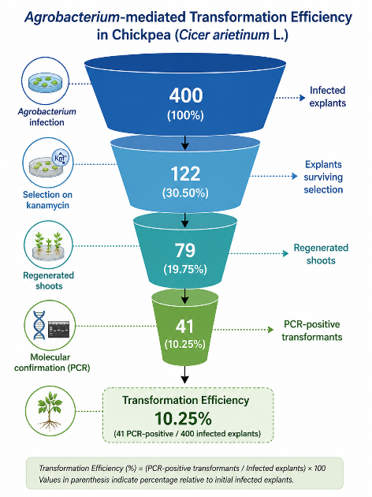
Fig 4. Agrobacterium-mediated transformation efficiency in chickpea.
The relatively high recovery of transformed plants demonstrates that cotyledonary node explants possess excellent susceptibility to Agrobacterium infection while maintaining strong regenerative competence. Kanamycin selection effectively eliminated non-transformed tissues, whereas cefotaxime successfully suppressed bacterial overgrowth without adversely affecting shoot regeneration. Optimisation of bacterial density (OD600 = 0.6), infection duration, co-cultivation period, and explant physiological status collectively contributed to improved transformation efficiency.
Table 3. Regeneration, Acclimatization and Transformation Efficiency of Chickpea
Parameter | Value
Best explant | Cotyledonary node
Shoot induction (%) | 94.7 ± 1.8
Mean shoots per explant | 7.2 ± 0.5
Rooting percentage | 91.6 ± 1.7
Rooted plantlets transferred | 180
Primary hardening survival (%) | 92.2 ± 1.6
Greenhouse survival (%) | 86.8 ± 2.1
Field establishment (%) | 81.5 ± 2.4
Agrobacterium strain | EHA105
Binary vector | pCAMBIA1301
Target gene | AtDREB1A
Selectable marker | nptII
Reporter gene | GUSPlus
Explants infected | 400
Explants surviving selection | 122
Regenerated shoots | 79
PCR-positive plants | 41
Transformation efficiency (%) | 10.25 ± 0.8
Transformation efficiencies ranging from 5–12% have commonly been reported for chickpea because of its inherent regeneration recalcitrance. Therefore, the efficiency obtained in the present investigation compares favorably with previous reports by Bélanger et al. (2024), Fernandez-Gutierrez et al. (2026), Gupta et al. (2023), Nivya and Shah (2023), and Sadhu et al. (2022). Recent advances in transformation methodologies, including improved tissue culture systems and genome-editing platforms, further suggest that continued optimisation could substantially enhance transformation frequencies in legumes (Atia et al., 2024; Augustine et al., 2025; Baloğlu et al., 2022).

3.3 Molecular Characterisation of Transgenic Chickpea
Successful integration of the AtDREB1A transgene was verified through PCR, Southern blot hybridisation, and quantitative gene expression analyses. High-quality genomic DNA isolated by the CTAB method exhibited an average concentration of 178.6 ± 12.4 ng μL⁻¹ with an A260/A280 ratio of 1.82 ± 0.03, confirming its suitability for downstream molecular analyses (Table 4).
Table 4. Molecular Characterization of Transgenic Chickpea Lines
Parameter | Observation
DNA isolation method | CTAB
DNA concentration | 178.6 ± 12.4 ng µL⁻¹
A260/A280 ratio | 1.82 ± 0.03
DNA quality | High molecular weight
Table 5. Southern Blot and Gene Expression Analysis
Line | Southern Blot Result | Copy Number | Relative Expression (Fold Change)
WT | Negative | 0 | 1.00
T1 | Positive | 1 | 5.82 ± 0.34
T2 | Positive | 1 | 6.94 ± 0.42
T3 | Positive | 2 | 8.11 ± 0.48
T4 | Positive | 1 | 7.36 ± 0.37
T5 | Positive | 2 | 6.58 ± 0.29
PCR amplification using gene-specific primers generated the expected 650 bp AtDREB1A and 450 bp nptII amplicons in all transformed plants, whereas no amplification was detected in wild-type controls. These results confirmed successful transfer and stable maintenance of the transgene within the chickpea genome.

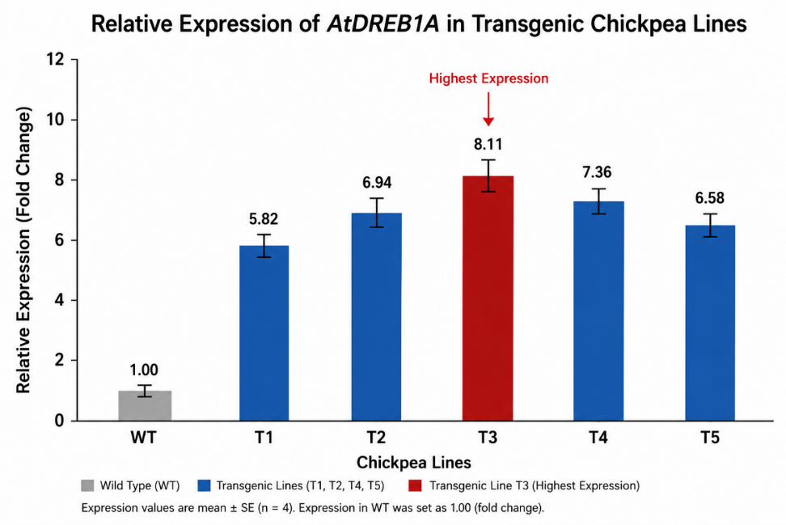
Fig 5. Relative AtDREB1A Gene Expression Analysis in wild-type and transgenic chickpea lines (WT, T1, T2, T3, T4, T5).
Southern blot analysis further demonstrated stable genomic integration. Most transgenic events contained single-copy insertions, whereas a few possessed two-copy integrations (Table 5). Single-copy integration is generally preferred because it minimises transgene silencing, promotes stable inheritance, and facilitates predictable gene expression in subsequent generations. Similar observations have been reported for chickpea transformation studies by Das et al. (2021), Gupta et al. (2023), and Singh et al. (2023).
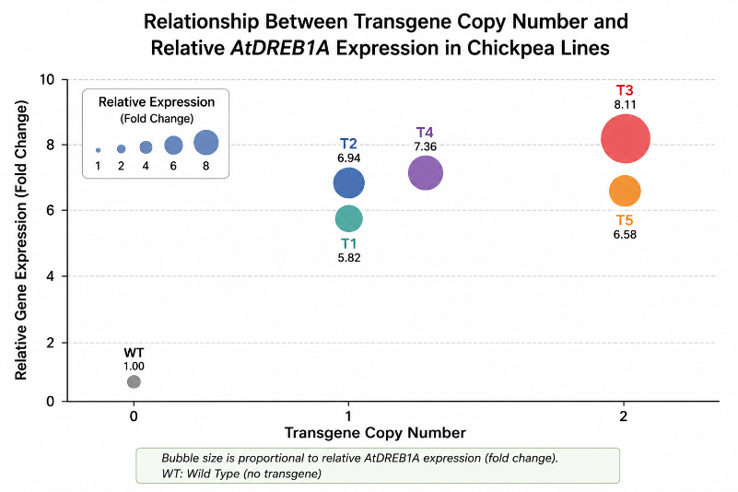
Fig 6. Molecular Confirmation showing relationship between transgene copy number and relative AtDREB1A expression in chickpea lines.
Quantitative RT-PCR revealed substantial overexpression of AtDREB1A, with transcript accumulation ranging from 5.82-fold (T1) to 8.11-fold (T3) relative to wild-type plants. Line T3 exhibited the highest expression and was therefore selected for physiological evaluation under stress conditions. Elevated transcript accumulation confirms the constitutive activity of the CaMV 35S promoter and supports the functional expression of the introduced transcription factor. Similar expression patterns have been described by Akbari et al. (2023), Das et al. (2021), and Poddar et al. (2022), demonstrating the central role of DREB transcription factors in activating stress-responsive regulatory networks.

3.4 Evaluation of Stress Tolerance
The enhanced expression of AtDREB1A translated into marked improvements in physiological performance under drought, salinity, heat, and disease stress (Table 6).
Under drought conditions, transgenic line T3 maintained a significantly higher relative water content (77.8%) compared with 54.2% in wild-type plants, representing a 43.5% improvement. Chlorophyll index increased from 31.5 to 42.9, while drought survival improved from 58.6% to 89.4%, indicating superior maintenance of plant water status and photosynthetic activity during water deficit. These findings closely agree with those reported by Arriagada et al. (2022), Badhan (2021), and Das et al. (2021), who demonstrated that AtDREB1A enhances drought adaptation by regulating osmotic adjustment and stress-responsive gene expression.
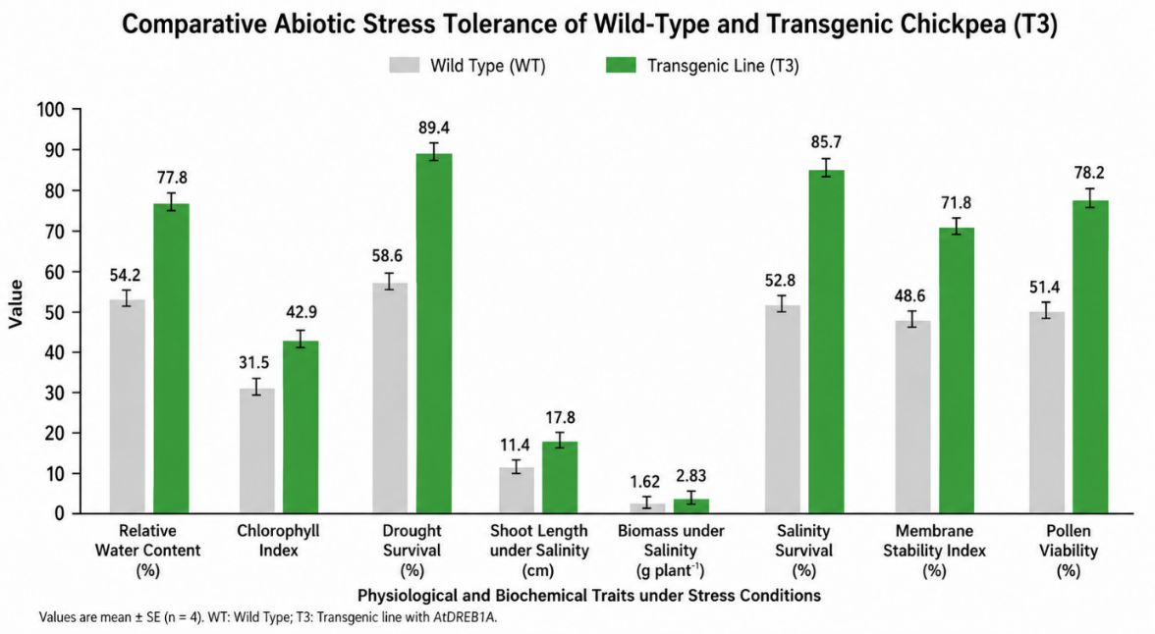
Fig 7. Stress Tolerance Comparison of wild-type and transgenic chickpea (T3) under abiotic stress.
Salinity tolerance also improved substantially. Transgenic plants recorded 56.1% greater shoot length, 74.7% higher biomass, and 62.3% greater survival than wild-type controls under 150 mM NaCl treatment. Enhanced growth under saline conditions suggests improved ionic homeostasis, osmoprotection, and maintenance of metabolic processes. Similar improvements have been associated with DREB-mediated activation of salt-responsive pathways in legumes (Ali et al., 2022; Chandana et al., 2022; Poddar et al., 2022).
Heat stress evaluation revealed that transformed plants maintained significantly higher membrane stability (71.8%) than wild-type plants (48.6%) and exhibited improved pollen viability (78.2% versus 51.4%). Maintenance of membrane integrity under elevated temperatures reflects enhanced protection against oxidative damage and preservation of cellular functions. Comparable physiological responses have been documented by Devi et al. (2022), Jameel et al. (2021), and Zeitelhofer et al. (2022).
Table 6. Comparative Stress Tolerance Performance of Wild-Type and Transgenic Chickpea Plants
Trait | Wild Type | Transgenic T3 | Improvement (%)
Relative water content (%) | 54.2 ± 2.3 | 77.8 ± 1.8 | 43.5
Chlorophyll index | 31.5 ± 1.4 | 42.9 ± 1.2 | 36.2
Drought survival (%) | 58.6 ± 2.7 | 89.4 ± 1.9 | 52.6
Shoot length under salinity (cm) | 11.4 ± 0.8 | 17.8 ± 0.9 | 56.1
Biomass under salinity (g plant⁻¹) | 1.62 ± 0.11 | 2.83 ± 0.13 | 74.7
Salinity survival (%) | 52.8 ± 2.6 | 85.7 ± 2.0 | 62.3
Membrane stability index (%) | 48.6 ± 2.2 | 71.8 ± 1.9 | 47.7
Pollen viability (%) | 51.4 ± 2.1 | 78.2 ± 2.4 | 52.1
Disease incidence (%) | 61.7 ± 2.8 | 23.6 ± 1.7 | –61.8
Disease severity index | 4.3 ± 0.3 | 1.8 ± 0.2 | –58.1
Disease resistance screening demonstrated additional benefits of AtDREB1A expression. Disease incidence caused by Fusarium oxysporum f. sp. ciceris declined from 61.7% in wild-type plants to 23.6% in transgenic plants, while disease severity decreased by 58.1% (Table 6). Although AtDREB1A primarily functions in abiotic stress regulation, cross-talk among stress signalling pathways likely contributed to enhanced resistance against Fusarium wilt. Similar interactions between abiotic and biotic stress signalling have been described by Sharma and Sharma (2023) and Chaudhary et al. (2025).
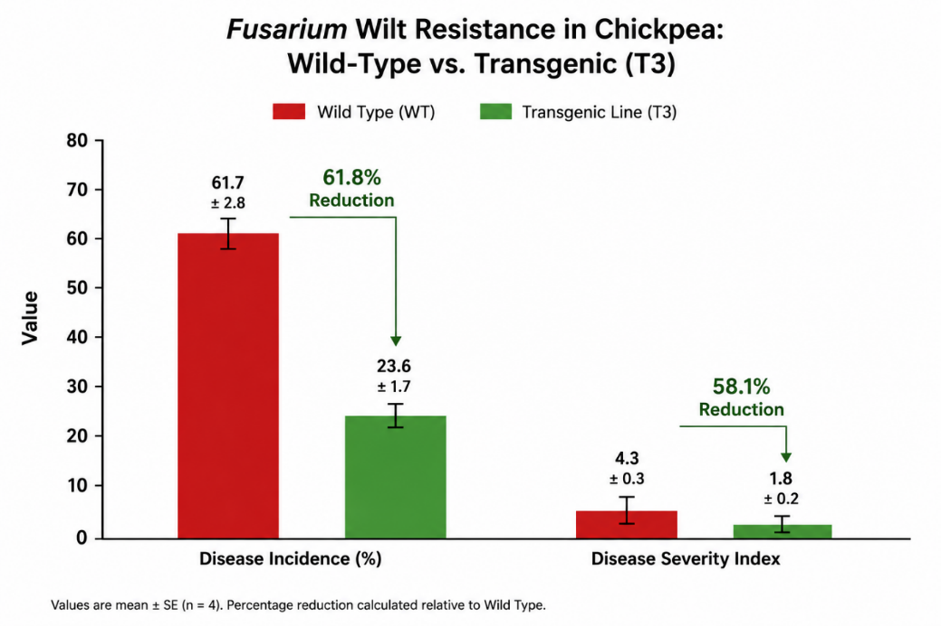
Fig 8. Disease Resistance comparing Fusarium wilt resistance in wild-type and transgenic chickpea plants.
Collectively, these physiological responses indicate that constitutive expression of AtDREB1A activates multiple protective mechanisms, including maintenance of cellular water balance, stabilisation of photosynthetic pigments, enhancement of antioxidant defence systems, and improved membrane integrity.

3.5 Comparative Performance of Transgenic and Wild-Type Plants
Direct comparison between transgenic and non-transgenic plants clearly demonstrated the beneficial effects of AtDREB1A overexpression. Under all stress treatments, wild-type plants exhibited rapid wilting, chlorosis, reduced biomass accumulation, membrane injury, and poor survival. In contrast, transgenic plants maintained vigorous growth, higher chlorophyll content, greater biomass, improved reproductive performance, and substantially higher survival rates.
The superior stress tolerance observed in transformed plants is consistent with the known regulatory role of DREB transcription factors in activating downstream genes associated with osmoprotectant synthesis, antioxidant metabolism, stress-protective proteins, and cellular stabilisation. Similar multi-stress tolerance has been reported in chickpea by Das et al. (2021), Fernandez-Gutierrez et al. (2026), and Singh et al. (2023). Related evidence from other legumes has been reported by Ali et al. (2022), Bhowmik et al. (2021), Roy and Sandhu (2024), and Sangari et al. (2024).
The integration of efficient regeneration, reliable transformation, stable transgene expression, and enhanced physiological performance demonstrates the potential of the developed protocol as a robust platform for chickpea genetic improvement. Moreover, these findings align with current advances in legume biotechnology emphasizing transgenic and genome-editing approaches for developing climate-resilient cultivars capable of withstanding multiple abiotic and biotic stresses (Atia et al., 2024; Baloğlu et al., 2022; Nivya & Shah, 2023; Singh et al., 2023).
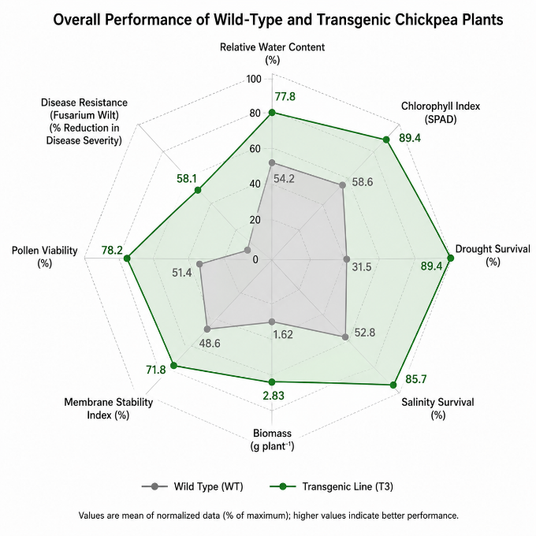
Fig 9. Overall Performance Radar Chart comparing overall performance of wild-type and transgenic chickpea plants.
The optimised regeneration and transformation protocol has both experimental and practical value for chickpea improvement programmes. It can be incorporated into molecular breeding pipelines for the rapid introduction of genes conferring resistance to drought, salinity, heat, and disease. Moreover, the protocol may support CRISPR-based genome investigation, functional genomic studies, validation of candidate genes associated with complex agronomic traits, and gene stacking. Public breeding institutions, biotechnology laboratories, and seed companies could adopt this protocol to accelerate the development of climate-resilient chickpea cultivars. Its application in crop improvement programmes may reduce breeding time, support yield stability under stressful environments, and contribute to agricultural sustainability and food security.
Overall, the results confirm that the optimised regeneration and Agrobacterium-mediated transformation protocol successfully generated transgenic chickpea plants with significantly improved tolerance to drought, salinity, heat, and Fusarium wilt. These findings provide valuable evidence supporting the application of molecular breeding and genetic engineering strategies for the development of climate-resilient chickpea cultivars suitable for sustainable agricultural production.
Conclusion
The present investigation successfully developed an efficient and reproducible protocol for in vitro regeneration and Agrobacterium tumefaciens-mediated genetic transformation of chickpea (Cicer arietinum L.), providing an effective platform for the genetic improvement of this economically important legume. Among the explants evaluated, cotyledonary nodes exhibited the highest morphogenic competence, producing superior shoot regeneration, rooting efficiency, and acclimatisation success. Optimisation of plant growth regulator combinations, culture conditions, and transformation parameters significantly enhanced regeneration performance and facilitated stable transgene recovery. Molecular characterisation confirmed the successful integration and expression of the AtDREB1A gene in transformed chickpea lines. PCR amplification, Southern blot hybridisation, and quantitative real-time PCR collectively verified stable transgene insertion and transcriptional activity, with transgenic line T3 exhibiting the highest expression level. The predominance of single-copy insertions further indicates the potential for stable inheritance and consistent expression in subsequent generations. The improved physiological performance of transgenic plants under drought, salinity, heat, and Fusarium wilt stress demonstrates the functional significance of AtDREB1A in enhancing stress adaptation. Higher relative water content, improved chlorophyll retention, greater membrane stability, increased biomass accumulation, enhanced survival, and reduced disease severity collectively indicate that the introduced transcription factor effectively activates multiple stress-responsive pathways. These responses are particularly important in the context of climate change, where simultaneous exposure to multiple environmental stresses increasingly threatens global chickpea production. Despite these encouraging outcomes, genotype dependency and relatively modest transformation efficiency remain important limitations that require further optimisation.
Future research should focus on validating transgene stability across multiple generations, conducting multilocation field evaluations, integrating genome-editing technologies such as CRISPR/Cas systems, and combining stress-tolerance genes with nutritional and yield-improvement traits. Although the optimised protocol achieved high regeneration and acceptable transformation efficiency under controlled conditions, several issues remain to be addressed. Transformation efficiency may remain genotype-dependent because only one chickpea genotype was evaluated. Furthermore, the present investigation did not include multilocation field performance trials, long-term assessment of transgene stability across generations, or biosafety and regulatory evaluations for commercial use.
Comprehensive biosafety assessments and regulatory evaluations will also be essential before commercial deployment. The protocol developed in this study has substantial potential for use in advanced breeding programmes and plant biotechnology laboratories. Integrating CRISPR/Cas genome-editing technologies with marker-assisted and genomic selection may further support the development of multi-stress-tolerant chickpea cultivars within shorter breeding cycles. Further field testing across diverse agroclimatic zones, assessment of long-term transgene stability, completion of biosafety testing, and commercialisation studies are recommended.
Overall, this study establishes a robust biotechnology platform for chickpea improvement and demonstrates that the integration of efficient tissue culture, genetic transformation, and molecular validation can substantially accelerate the development of climate-resilient, disease-tolerant, and high-performing chickpea cultivars capable of contributing to sustainable agriculture and global food security.

Limitations
The investigation evaluated a single chickpea genotype under controlled culture and stress conditions, which limits generalisation across genetically diverse material and field environments. Transformation efficiency remained genotype-dependent and modest, and transgene stability and inheritance were not assessed over multiple generations. The study did not include multilocation field trials, long-term agronomic performance, biosafety assessment, or regulatory evaluation. Future work should validate the protocol across additional genotypes, generations, and agroclimatic zones and should include comprehensive field, biosafety, and commercialisation studies.

Competing interests

Authors have declared that no competing interests exist.

Declaration of AI Use

This manuscript was prepared through the combined contributions of all author(s), including contributions to the study design, data, content development, results, interpretation, and related scholarly work. The author(s) acknowledge the use of Grammarly and ChatGPT to assist with grammar checking, language refinement, and reference formatting. These AI-assisted tools were not used as authors and did not replace the intellectual contributions or scholarly judgement of the author(s). All AI-assisted outputs, including content, references, and interpretations, were carefully reviewed, revised, verified, and approved by the author(s). The author(s) accept full responsibility for the accuracy, integrity, and final content of the manuscript.

References
Abbas, A., Rehman, A. U., & Javed, M. M. (2021). Exploring the potential of in vitro tissue culture in breeding programs of legume and pulse crops: Utilization and present condition. Bulletin of Biological and Allied Sciences Research, 2021(1), 36. https://doi.org/10.54112/bbasr.v2021i1.36
Abbas, M., Hussain, S. S., Abbas, S. K., Abbas, S., Tahir, M., Su, Y., Li, J., Ahmed, N., Khan, M. S., & Gou, C. (2023). Optimization of regeneration protocol and prospecting spectinomycin resistance in barley (Hordeum vulgare L.) cv. Haider-93. African Journal of Biotechnology, 22(9), 172–182. https://doi.org/10.5897/AJB2023.17590
Akbari, A., Ismaili, A., Amirbakhtiar, N., Pouresmael, M., & Shobbar, Z.-S. (2023). Genome-wide transcriptional profiling provides clues to molecular mechanisms underlying cold tolerance in chickpea. Scientific Reports, 13, 6279. https://doi.org/10.1038/s41598-023-33398-3
Ali, A., Altaf, M. T., Nadeem, M. A., Karaköy, T., Shah, A. N., Azeem, H., Baloch, F. S., Baran, N., Hussain, T., Duangpan, S., Aasim, M., Boo, K.-H., Abdelsalam, N. R., Hasan, M. E., & Chung, Y. S. (2022). Recent advancement in OMICS approaches to enhance abiotic stress tolerance in legumes. Frontiers in Plant Science, 13, 952759. https://doi.org/10.3389/fpls.2022.952759
Arriagada, O., Cacciuttolo, F., Cabeza, R. A., Carrasco, B., & Schwember, A. R. (2022). A comprehensive review on chickpea (Cicer arietinum L.) breeding for abiotic stress tolerance and climate change resilience. International Journal of Molecular Sciences, 23(12), 6794. https://doi.org/10.3390/ijms23126794
Atia, M. A. M., Jiang, W., Sedeek, K., Butt, H., & Mahfouz, M. M. (2024). Crop bioengineering via gene editing: Reshaping the future of agriculture. Plant Cell Reports, 43(4), 98. https://doi.org/10.1007/s00299-024-03183-1
Augustine, S. M., Cherian, A. V., Paridhi, P., Ugwuanyi, S., Rashid, M. M., Knoblauch, B., Tzigos, S., Pullamsetti, S. S., & Snowdon, R. J. (2025). Electrical current-mediated transformation for efficient plant genome editing: A case study in faba bean. Legume Science, 7(2), e70031. https://doi.org/10.1002/leg3.70031
Badhan, S. (2021). Understanding the drought mechanism and designing strategies to mitigate drought stress in chickpea (Cicer arietinum L.) [Doctoral dissertation, RMIT University]. https://doi.org/10.25439/rmt.27601773
Baloğlu, M. C., Çelik Altunoğlu, Y., Baloğlu, P., Yıldız, A. B., Türkölmez, N., & Özden Çiftçi, Y. (2022). Gene-editing technologies and applications in legumes: Progress, evolution, and future prospects. Frontiers in Genetics, 13, 859437. https://doi.org/10.3389/fgene.2022.859437
Bélanger, J. G., Copley, T., Hoyos-Villegas, V., Charron, J., & O’Donoughue, L. S. (2024). A comprehensive review of in planta stable transformation strategies. Plant Methods, 20, 79. https://doi.org/10.1186/s13007-024-01200-8
Bhowmik, P., Konkin, D., Polowick, P. L., Hodgins, C. L., Subedi, M., Xiang, D., Yu, B., Patterson, N., Rajagopalan, N., Babic, V., Ro, D.-K., Tar’an, B., Bandara, M., Smyth, S. J., Cui, Y., & Kagale, S. (2021). CRISPR/Cas9 gene editing in legume crops: Opportunities and challenges. Legume Science, 3(3), e96. https://doi.org/10.1002/leg3.96
Chandana, B. S., Mahto, R. K., Singh, R. K., Ford, R., Vaghefi, N., Gupta, S. K., Yadav, H. K., Manohar, M., & Kumar, R. (2022). Epigenomics as potential tools for enhancing magnitude of breeding approaches for developing climate-resilient chickpea. Frontiers in Genetics, 13, 900253. https://doi.org/10.3389/fgene.2022.900253
Chaudhary, A., Murukesan, A., Kumari, A., Annamalai, A., & Lakshmi, P. T. V. (2025). Biomolecular and computational insights into Fusarium oxysporum f. sp. ciceris infection in chickpea: A review. Discover Agriculture, 3, 178. https://doi.org/10.1007/s44279-025-00278-5
Das, A., Basu, P. S., Kumar, M., Ansari, J. A., Shukla, A., Thakur, S., Singh, P., Datta, S., Chaturvedi, S. K., Sheshshayee, M. S., Bansal, K. C., & Singh, N. P. (2021). Transgenic chickpea (Cicer arietinum L.) harbouring AtDREB1a are physiologically better adapted to water deficit. BMC Plant Biology, 21, 39. https://doi.org/10.1186/s12870-020-02815-4
Devi, P., Jha, U. C., Prakash, V., Kumar, S., Parida, S. K., Paul, P. J., Prasad, P. V. V., Sharma, K. D., Siddique, K. H. M., & Nayyar, H. (2022). Response of physiological, reproductive function and yield traits in cultivated chickpea (Cicer arietinum L.) under heat stress. Frontiers in Plant Science, 13, 880519. https://doi.org/10.3389/fpls.2022.880519
Diwedi, R., Syed, M., & Singh, M. (2025). Morpho-physiological characterization and yield performance of chickpea genotypes under moisture stress conditions. Asian Journal of Research and Review in Agriculture, 7(1), 202–214. https://doi.org/10.56557/AJRRA/2025/v7i1170
Fernandez-Gutierrez, A., Curtin, S. J., & Gutierrez-Gonzalez, J. J. (2026). Gene editing and transformation strategies for engineering drought-tolerant legumes. Legume Science, 8(1), e70080. https://doi.org/10.1002/leg3.70080
Gupta, S. K., Vishwakarma, N. K., Malakar, P., Vanspati, P., Sharma, N. K., & Chattopadhyay, D. (2023). Development of an Agrobacterium-delivered, codon-optimized CRISPR/Cas9 system for chickpea genome editing. Protoplasma, 260(5), 1437–1451. https://doi.org/10.1007/s00709-023-01856-4
Irum, S., Biswas, S., Cilkiz, M., Tsakirpaloglou, N., Thomson, M. J., & Septiningsih, E. M. (2025). Multiplex CRISPR-Cas9 editing of chlorophyll biosynthesis genes in chickpea via protoplast and Agrobacterium-mediated transformation. Functional & Integrative Genomics, 25, 163. https://doi.org/10.1007/s10142-025-01665-3
Jameel, S., Hameed, A., & Shah, T. M. (2021). Investigation of distinctive morpho-physio and biochemical alterations in desi chickpea at seedling stage under irrigation, heat, and combined stress. Frontiers in Plant Science, 12, 692745. https://doi.org/10.3389/fpls.2021.692745
Jangid, V. K., Senthil-Kumar, M., Chandran, D., & Sinharoy, S. (2024). Callus induction and efficient in vitro plant regeneration protocol for chickpea. Plant Cell, Tissue and Organ Culture, 156, 21. https://doi.org/10.1007/s11240-023-02633-0
Jayanthi, M., Singh, K. B. M., Singh, M. K., & Mandal, P. K. (2024). High efficiency in planta Agrobacterium-mediated transformation in Lilium cv. Pavia. Journal of Advances in Biology & Biotechnology, 27(8), 1104–1109. https://doi.org/10.9734/JABB/2024/v27i81232
Jha, U. C., Nayyar, H., Thudi, M., Beena, R., Prasad, P. V. V., & Siddique, K. H. M. (2024). Unlocking the nutritional potential of chickpea: Strategies for biofortification and enhanced multinutrient quality. Frontiers in Plant Science, 15, 1391496. https://doi.org/10.3389/fpls.2024.1391496
Kahlaoui, S., Bouamama-Gzara, B., Bokri, H., Harzallah-Skhiri, F., & Stambouli-Essassi, S. (2022). In vitro callogenesis essays to induce somatic embryogenesis of the Tunisian chickpea. Notulae Botanicae Horti Agrobotanici Cluj-Napoca, 50(4), 12819. https://doi.org/10.15835/nbha50312819
Kalve, S., House, M. A., & Tar’an, B. (2024). Freezing stress response of wild and cultivated chickpeas. Frontiers in Plant Science, 14, 1310459. https://doi.org/10.3389/fpls.2023.1310459
Koul, B., Sharma, K., Sehgal, V., Yadav, D., Mishra, M., & Bharadwaj, C. (2022). Chickpea (Cicer arietinum L.) biology and biotechnology: From domestication to biofortification and biopharming. Plants, 11(21), 2926. https://doi.org/10.3390/plants11212926
Nivya, V. M., & Shah, J. M. (2023). Recalcitrance to transformation, a hindrance for genome editing of legumes. Frontiers in Genome Editing, 5, 1247815. https://doi.org/10.3389/fgeed.2023.1247815
Poddar, N., Deepika, D., Chitkara, P., Singh, A., & Kumar, S. (2022). Molecular and expression analysis indicate the role of CBL-interacting protein kinases (CIPKs) in abiotic stress signaling and development in chickpea. Scientific Reports, 12, 16862. https://doi.org/10.1038/s41598-022-20750-2
Roy, A., & Sandhu, R. (2024). Advancements in genetic enhancement: CRISPR/Cas-mediated genome editing in leguminous crops. Journal of Advances in Biology & Biotechnology, 27(6), 670–681. https://doi.org/10.9734/JABB/2024/v27i6927
Sadhu, S. K., Jogam, P., Gande, K., Banoth, R., Penna, S., & Peddaboina, V. (2022). Optimization of different factors for an Agrobacterium-mediated genetic transformation system using embryo axis explants of chickpea (Cicer arietinum L.). Journal of Plant Biotechnology, 49(1), 61–73. https://doi.org/10.5010/JPB.2022.49.1.061
Sangari, M. G., Chandar, S. R. H., Mahalakshmi, S., Latha, P., Amutha, S., & Appunu, C. (2024). CRISPR/Cas genome editing in legume crops: Challenges and opportunities: A review. Legume Research, 47(6), 875–883. https://doi.org/10.18805/LR-5321
Sarkar, M. A. R., Sarkar, S., Akter, N., Rashid, S. B., & Rahman, S. M. (2022). In vitro regeneration of chickpea (Cicer arietinum L.) cultivated in Bangladesh. Plant Tissue Culture & Biotechnology, 32(2), 205–216. https://doi.org/10.3329/ptcb.v32i2.63554
Shah, S. Z. H., Baloch, S. K., Ali, M., Soomro, N. S., Khaskheli, A. J., Khaskheli, M. A., Memon, Z. F., Magsi, B., Meghwar, A., Ahmed, I., & Rajpar, A. A. (2025). Rapid mass clonal regeneration of chickpea (Cicer arietinum L.) through callus induction. Pure and Applied Biology, 14(2), 366–375. https://doi.org/10.19045/bspab.2025.140036
Sharma, S., & Sharma, M. (2023). Development of trait-specific genetic stocks derived from wild Cicer species as novel sources of resistance to important diseases for chickpea improvement. Plant Genetic Resources: Characterization and Utilization, 21(6), 520–526. https://doi.org/10.1017/S1479262123001004
Singh, C., Kumar, R., Sehgal, H., Bhati, S., Singhal, T., Gayacharan, Nimmy, M. S., Yadav, R., Gupta, S. K., Abdallah, N. A., & Kumar, R. (2023). Unclasping potentials of genomics and gene editing in chickpea to fight climate change and global hunger threat. Frontiers in Genetics, 14, 1085024. https://doi.org/10.3389/fgene.2023.1085024
Tilgam, J., Bhattacharjee, S., Paul, K., Jaiswal, S., Saakre, M., Kumari, P., Vijayan, J., Sreevathsa, R., & Pattanayak, D. (2024). Development of an efficient and reproducible embryonic axis-targeted tissue culture-based transformation protocol for pigeonpea (Cajanus cajan). Legume Research, 47(11), 1913–1920. https://doi.org/10.18805/LR-5249
Zeitelhofer, M., Zhou, R., & Ottosen, C.-O. (2022). Physiological responses of chickpea genotypes to cold and heat stress in flowering stage. Agronomy, 12(11), 2755. https://doi.org/10.3390/agronomy12112755

