Methodology of Nutritional and Yield Evaluation of Advanced Potato Clones for Eastern Indo-Gangetic Plains of India

Abstract

Potato (Solanum tuberosum L.) is a modified stem crop of global significance and is recognised as one of the most important vegetable commodities worldwide. This study evaluated ten advanced potato clones (PS/19-02, PS/19-04, PS/19-12, PS/19-24, PS/19-26, PS/19-31, PS/19-41, PS/19-43, PS/19-44, and PS/19-50), together with five control varieties (Kufri Lohit, Kufri Manik, Kufri Lalit, Kufri Lalima, and Kufri Neelkanth), for yield, quality, and nutritional traits relevant to breeding red-skinned varieties suitable for the Eastern Indo-Gangetic Plains of India. Field experiments were conducted at the ICAR-Central Potato Research Institute, Regional Centre, Patna, Bihar, and laboratory analyses were conducted at ICAR-CPRI, Shimla, during 2023–2024 and 2024–2025. The trials were laid out in a randomised block design (RBD) with three replications. Potato tubers were planted on ridges at a spacing of 20 cm (plant-to-plant) × 60 cm (row-to-row) and a depth of 4–5 cm. Two crop durations, 75 and 90 days, were tested. The measured parameters included total tuber yield (t/ha), marketable yield (t/ha), dry matter content (%), and nutritional composition (Fe, Zn, carotenoids, ascorbic acid, and anthocyanins). Superior performance was observed in clone PS/19-50, which recorded a marketable yield of 32.51 t/ha at 75 days, and in PS/19-41, which achieved 36.88 t/ha at 90 days. Both clones exhibited low storage losses under ambient conditions (7.37% for PS/19-50 and 17.4% for PS/19-41). Nutritional profiling revealed high mineral contents, with Fe at 34.65 ppm in PS/19-24 and Zn at 25.31 ppm in PS/19-50. Key selection traits included ovoid-to-round tuber shape, red skin colour, pigmented flesh ranging from dark to light red, shallow eyes, and desirable organoleptic qualities. The primary objective was to assess the agronomic and nutritional performance of advanced potato clones to support the breeding of red-skinned varieties adapted to the Eastern Indo-Gangetic Plains of India.
KEYWORDS: Potato; advanced clones; control varieties; tuber yield; dry matter; plant emergence.

Introduction

Potato (Solanum tuberosum L.) is an important tuberous vegetable crop and ranks after wheat, rice, and maize among global food crops (Food and Agriculture Organization of the United Nations [FAO], 2019–2022; Lutaladio & Castaldi, 2009; Rukundo, 2019). Global potato tuber production was estimated at 390 million metric tonnes in 2025. China, with approximately 95 million tonnes, led global production, followed by India with 60 million tonnes, accounting for nearly 15% of global output in 2025. In terms of potato area, India ranked third after China and Russia (FAO, 2025). Potato is a starchy vegetable crop with multiple uses. In the future, potato is expected to play an important role in global food and nutritional security, particularly in Asian countries, including India (Burgos et al., 2020; Horton, 1987). The major potato-growing states in India are Uttar Pradesh, West Bengal, Bihar, Gujarat, Madhya Pradesh, Punjab, Assam, and Haryana (Saxena & Mathur, 2013). Per capita potato consumption in India is comparatively lower (28 kg/annum) than the global average (33 kg/annum). Potato is a popular vegetable among people of different age groups and is an integral component of foods and traditional dishes, such as chips and papad prepared during Indian festivals, including Holi and Makar Sankranti. It is now likely to occupy a more prominent place in dietary patterns across Indian states. Since 1958, the ICAR–Central Potato Research Institute (CPRI), Shimla, has developed more than 66 potato varieties for cultivation across diverse agroclimatic regions of India (Singh et al., 2023; Tiwari et al., 2019). In Bihar, several local varieties, such as Kala Aloo, Lal Gulab, and C-40, together with unreleased hybrids and exotic types such as ‘Holland’, have been cultivated for decades. Many of these exotic varieties were introduced by the British before independence, whereas some processing-specific types were later introduced by industry stakeholders for commercial purposes (Hardigan et al., 2017; Hawkes & Francisco-Ortega, 1993; Singh & Rana, 2014). Although local varieties lack an organised seed potato production programme, they persist in limited areas because of specific preferences (Context Network, 2016; Muhinyuza et al., 2012). These varieties are valued for distinctive traits, including skin and flesh colour, taste, and suitability for traditional dishes. However, potato quality and storage life are often compromised by moisture loss, decay, and physiological breakdown (Kibar, 2012; Luthra, 2001). Therefore, efficient post-harvest technologies and robust marketing systems are important for the production–consumption chain because of the crop’s bulkiness and semi-perishable nature (Yadav, Luthra, Kapoor, et al., 2024; Yadav, Luthra, Singh, et al., 2024). An evaluation of advanced potato clones under Eastern Indo-Gangetic Plain conditions reported significant differences in plant emergence, total and marketable tuber yields, and dry matter content and identified several promising clones for multilocation testing (Yadav et al., 2025). Recent field evaluations indicate that potato varieties can differ in total and marketable tuber yields, dry matter content, and related quality traits, supporting careful comparative assessment before advancement (Hassanpanah, 2010; Patel et al., 2006; Siano et al., 2024; Tsagaye et al., 2025). Zinc nutrition may contribute to tuber productivity and biofortification, whereas growing temperature can influence yield and anthocyanin accumulation in pigmented potatoes (Chen et al., 2024; Singh et al., 2025). However, comparative information on the combined agronomic, storability, and nutritional performance of advanced red-skinned clones under the Eastern Indo-Gangetic Plains across two crop durations remains limited. In the present study, the advanced clones were evaluated for plant emergence, yield, dry matter, storability, and nutritional quality. Outstanding advanced clones were introduced into ‘All India Coordinated Multi-location Testing’, a preliminary step towards the release of a promising variety.

2. Materials and Methods

Potato is recognised as a cool-season tuberous vegetable crop that grows best under moderate temperatures, adequate moisture, and fertile soils (Cutter, 1978). For successful experimentation and cultivation, a well-prepared and well-drained field is essential. The crop performs optimally when soil temperatures remain between 17 and 19 °C, as this range supports both vegetative growth and tuber initiation (Amador et al., 2001; Haverkort et al., 1990). Potatoes can be grown in a wide range of soils, including sandy loam, clay loam, silt loam, and clayey soils, provided that drainage is sufficient. Soil acidity also plays an important role, with a pH range of 5.0–6.5 being most suitable for crop germination, growth, development, tuberisation, and stolon development. A cool climate, proper soil preparation, and balanced soil conditions promote favourable growth and productivity of the potato crop.

2.1 Experimental Materials

The experimental materials planted in this study comprised ten advanced potato clones: PS/19-02, PS/19-04, PS/19-12, PS/19-24, PS/19-26, PS/19-31, PS/19-41, PS/19-43, PS/19-44, and PS/19-50. These clones were compared with five controls, namely the popular potato varieties Kufri Neelkanth, Kufri Manik, Kufri Lohit, Kufri Lalima, and Kufri Lalit.

2.2 Location of Experimental Trials

The experimental trials were conducted at the Crop Improvement Experimental Field of ICAR-CPRI Regional Station, Patna, during the 2023–24 and 2024–25 agricultural seasons to evaluate advanced potato clones under the Institute Research Programme “Breeding for Table Potatoes”. The work was undertaken as part of the project “Breeding Medium-Maturing Red-Skinned Potato Varieties for the Eastern Plains”. Patna is located at approximately 25.6°N latitude and 85.1°E longitude and receives an average annual rainfall of 997–1329 mm. Rainfall is generally concentrated during the monsoon months from June to September, with July being the wettest month.

2.3 Experimental Design

The experiment was conducted using a Completely Randomised Block Design (CRBD) with three replications to ensure statistical reliability and minimise experimental error (Chaudhary Charan Singh Haryana Agricultural University [CCS HAU], 2023). Two sets of trials, differing in crop duration, were established: one was harvested at 75 days after planting and the other at 90 days, enabling the assessment of advanced clones under contrasting maturity periods (Bonierbale et al., 2007). Each clone, together with the control varieties, was planted in five rows of 12 tubers per plot, with a plot size of 3.0 m × 2.4 m (7.8 m²). This design provided a framework for evaluating yield potential, maturity behaviour, and adaptability traits within the breeding programme for developing medium-maturing, red-skinned potato varieties suited to the Eastern Plains.
Photos: Breeding programme of Potato
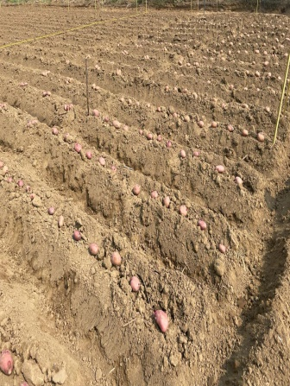 | 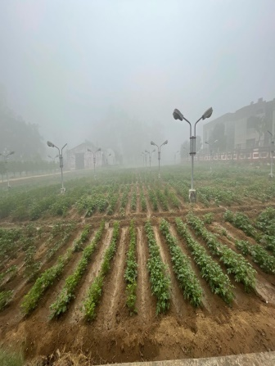 | 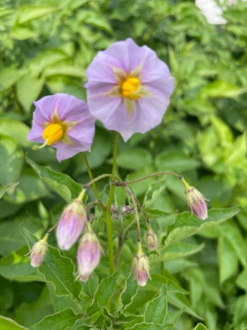 | 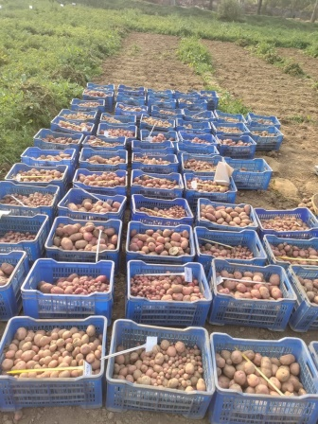
Ridge planting | Potato hybridization block | Potato flower | Harvesting

2.4 Land Preparation

Proper field preparation is essential for optimal crop growth and development. The experiment evaluated medium-maturing, red- and purple-skinned advanced potato clones. The field was prepared by deep ploughing to 20–25 cm using a soil-turning plough, followed by 2–3 cross-harrowing operations and 2–3 shallow ploughings, and was finally levelled to achieve a fine tilth. Effective tuberisation requires a well-prepared field. Planking was performed as an important cultural practice to conserve soil moisture at sowing and promote uniform crop germination.

2.5 Planting Material Standards

Tubers weighing 30–50 g are considered standard and suitable for planting (Bist et al., 2023; Kumar et al., 2023; Mulatu et al., 2005). In this experiment, whole tubers of standard size were planted on ridges at a spacing of 20 cm between plants and 60 cm between rows. Immediately after planting, light irrigation was applied to ensure adequate soil moisture, thereby promoting uniform sprouting and crop establishment.

2.6 Nutrient Management Practices

Potato is a heavy feeder and requires substantial nutrient inputs, typically 180:80:100 kg/ha of N:P:K (Yadav et al., 2021). In addition to chemical fertilisers, farmyard manure (FYM) plays an important role in maintaining soil structure and supporting beneficial microflora and fauna. In this experiment, 25–30 t/ha of well-decomposed FYM was incorporated during land preparation to allow thorough mixing with the soil. Chemical fertilisers were applied as follows: nitrogen as urea, phosphorus as diammonium phosphate (DAP), and potassium as muriate of potash (MOP). Half of the recommended N:P:K dose was applied as a basal treatment, while the remaining nitrogen was top-dressed after earthing-up, 25–30 days after planting.

2.7 Sowing Methodology and Crop Establishment

Potato tubers were planted on ridges prepared after land preparation using either a tractor-driven ridge maker or manual spade operations. Experimental beds were laid out according to the design, with each bed measuring 3 m in length × 60 cm in width and containing five rows. The tubers were planted using a khurpi (a local tool) at a depth of 7–8 cm and were subsequently covered with the surrounding soil. Immediately after planting, light irrigation was applied to ensure adequate soil moisture and promote uniform germination of the experimental material.

2.8 Intercultural Operations and Management Techniques

Intercultural operations play an important role in determining yield and yield-attributing traits in potato. Weed infestation is a major constraint, with common weed species including moth grass, Gajar grass, palak grass, and Trifolium spp. To suppress weed emergence, Oxyfluorfen 23.5% SC was applied at 500 ml/ha as a pre-emergence spray. Subsequent intercultural practices, including manual weeding and earthing-up, were carried out 25–30 days after planting. Following hoeing, the remaining half dose of nitrogen, supplied as urea, was applied in furrows and incorporated during earthing-up to enhance nutrient availability for tuberisation. The crop received 4–5 irrigations at intervals of 10–15 days, adjusted according to soil moisture status. Late blight (Phytophthora infestans) posed a significant threat to leaves, stems, and tubers and was managed with one prophylactic spray of Mancozeb 75 WP, followed by two sprays of Cymoxanil 8% + Mancozeb 64% WP at 15-day intervals (Haverkort et al., 2009). Insect pests, such as aphids, leaf cutters, and cutworms, were controlled by spraying Imidacloprid 17.8% SL at 45 days after planting.

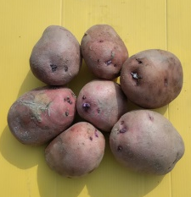 | 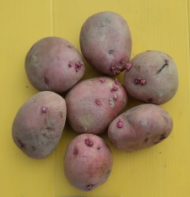 | 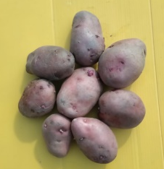 | 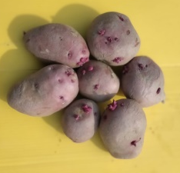 | 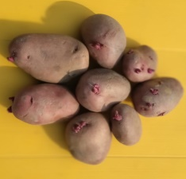
PS/19-02 | PS/19-04 | PS/19-12 | PS/19-24 | PS/19-26
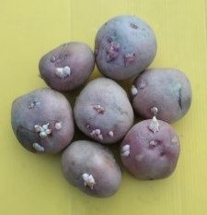 | 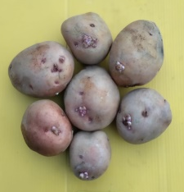 | 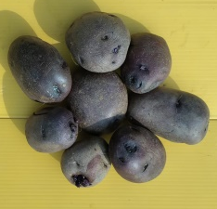 | 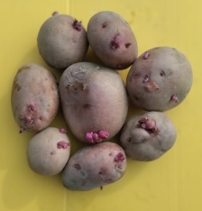 | 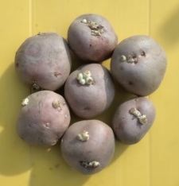
PS/19-31 | PS/19-41 | PS/19-43 | PS/19-44 | PS/19-50
Plate 2: Tuber colour variation in sprouted tubers of advanced clones

2.9 Observations and Data Recording Protocols
The principal observations recorded were plant emergence (%), total tuber yield (t/ha), marketable tuber yield (t/ha), dry matter content (%), and biochemical components (Abong et al., 2010). Plant emergence was assessed 30 days after planting by counting emerged plants and calculating the percentage relative to the total number of tubers planted per plot. Total tuber yield was determined by weighing the entire harvest from each plot, whereas marketable yield was calculated by excluding undersized tubers and expressing the remaining weight as marketable yield per plot. Dry matter content (%) was estimated by collecting 200 g of fresh tubers from each replication at harvest, cutting them into small pieces, and drying them in a hot-air oven for 72 h. The dried samples were weighed using an electronic balance, and dry matter percentage was calculated for each clone and variety. Biochemical parameters, including zinc (Zn) and iron (Fe), were analysed using standard protocols in the CPB&PHT Division laboratory, ICAR-CPRI, Shimla. Carotenoids, anthocyanins, and ascorbic acid were similarly quantified using established procedures in the Post-Harvest Technology Laboratory, ICAR-CPRI, Shimla.
Formulae
Plant Emergence (%) | = | No. of plants germinated (30 DAP) | x | 100
Plant Emergence (%) | = | No. of total tubers planted per plot | x | 100

Total Tuber yield (t/ha) | = | Weight of the harvested total tubers per plot (kg) | x | 10000
Total Tuber yield (t/ha) | = | Area of the plot (m²) | x | 10000

 |  | Total tuber wt. (kg) per plot –
Marketable Tuber yield (t/ha) | = | wt. of mini tubers per plot (kg) | x | 10000
Marketable Tuber yield (t/ha) | = | Area of the plot (m²) | x | 10000

Dry matter (%) | = | Weight of the sliced, oven and shade dried potato | x | 100
Dry matter (%) | = | fresh weight of the potato | x | 100

Results and Discussion

3.1 Statistical Analysis and Interpretation of Results

1. Plant Emergence (%)
Plant emergence was assessed 30 days after planting (Table 1). In the 75-day crop, emergence ranged from 72.22% in clone PS/19-43 to 85.56% in clone PS/19-12. In the 90-day crop, emergence ranged from 65.0% in PS/19-26 to 85.0% in PS/19-50, indicating variation in establishment among the evaluated clones.

Advanced clones /Varieties | Emergence (%)
Advanced clones /Varieties | 75-days crop | 90- days crop
PS/19-02 | 81.11 | 70.00
PS/19-04 | 77.78 | 71.11
PS/19-12 | 85.56 | 84.45
PS/19-24 | 80.00 | 77.78
PS/19-26 | 73.33 | 65.00
PS/19-31 | 78.89 | 77.78
PS/19-41 | 81.11 | 78.33
PS/19-43 | 72.22 | 70.56
PS/19-44 | 76.67 | 70.00
PS/19-50 | 73.33 | 85.00
K.Lalima | 84.44 | 82.22
K.Lalit | 81.11 | 79.44
K.Lohit | 74.44 | 72.22
K.Manik | 73.34 | 68.89
K.Neelkanth | 82.22 | 78.89
CD (0.05) : | 12.88 | 12.99
CV (%) : | 10.54 | 11.01
Table & Fig. 1: Plant Emergence (pooled data) of advanced clones (2023-25)

2. Total Tuber Yield (t/ha)
Total tuber yield is an important economic parameter in potato cultivation (Rukundo et al., 2019; Yadav et al., 2020). In the 75-day crop experiment, the maximum total tuber yield was recorded in PS/19-12 (24.67 t/ha), followed by PS/19-41 (24.66 t/ha). In the 90-day crop experiment, the highest total tuber yield was recorded in PS/19-12 (37.47 t/ha), followed by PS/19-24 (36.56 t/ha); these clones performed better than or were comparable to the controls (Table 2).
Advanced clones /Varieties | Total tuber Yield (t/ha)
Advanced clones /Varieties | 75-days crop | 90-days crop
PS/19-02 | 23.55 | 33.00
PS/19-04 | 22.16 | 32.25
PS/19-12 | 24.67 | 37.47
PS/19-24 | 22.69 | 36.56
PS/19-26 | 14.72 | 23.87
PS/19-31 | 18.26 | 26.80
PS/19-41 | 24.66 | 33.17
PS/19-43 | 22.67 | 28.59
PS/19-44 | 22.33 | 30.45
PS/19-50 | 24.54 | 25.71
K. Lalima | 15.68 | 21.18
K. Lalit | 22.73 | 29.48
K. Lohit | 21.13 | 29.92
K. Manik | 13.33 | 19.12
K.Neelkanth | 14.74 | 37.57
CD (0.05) | 10.25 | 11.29
CV (%): | 34.12 | 24.77
Table & Fig. 2: Total tuber Yield (t/ha) of advanced clones (2023-25)

- Marketable Tuber Yield (t/ha)
Marketable tuber yield was calculated by subtracting the weight of undersized tubers from the total tuber yield. In the 75-day crop, clone PS/19-50 recorded the highest marketable yield (24.31 t/ha), which was significantly superior to the control varieties. In the 90-day crop, the maximum marketable yield was observed in PS/19-12 (34.99 t/ha), closely followed by PS/19-24 (34.91 t/ha); both were statistically comparable to most control varieties (Table 3).

Advanced clones /Varieties | Mkt. tuber Yield (t/ha)
Advanced clones /Varieties | 75 days crop | 90 days crop
PS/19-02 | 22.30 | 31.07
PS/19-04 | 22.00 | 31.12
PS/19-12 | 23.85 | 34.99
PS/19-24 | 22.19 | 34.91
PS/19-26 | 14.64 | 23.03
PS/19-31 | 17.86 | 25.30
PS/19-41 | 23.87 | 31.50
PS/19-43 | 22.20 | 26.99
PS/19-44 | 21.58 | 29.13
PS/19-50 | 24.31 | 24.20
K. Lalima | 15.15 | 20.21
K. Lalit | 22.25 | 28.20
K. Lohit | 20.85 | 28.11
K. Manik | 12.79 | 18.11
K.Neelkanth | 14.20 | 34.36
CD (0.05) : | 10.03 | 11.01
CV (%) : | 34.23 | 25.55
Table & Fig. 3: Marketable tuber Yield (t/ha) of advanced clones (2023-25)

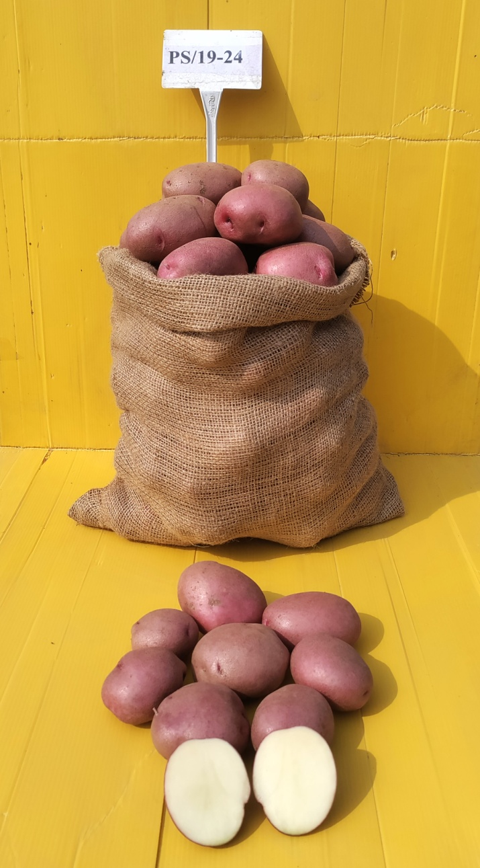 | 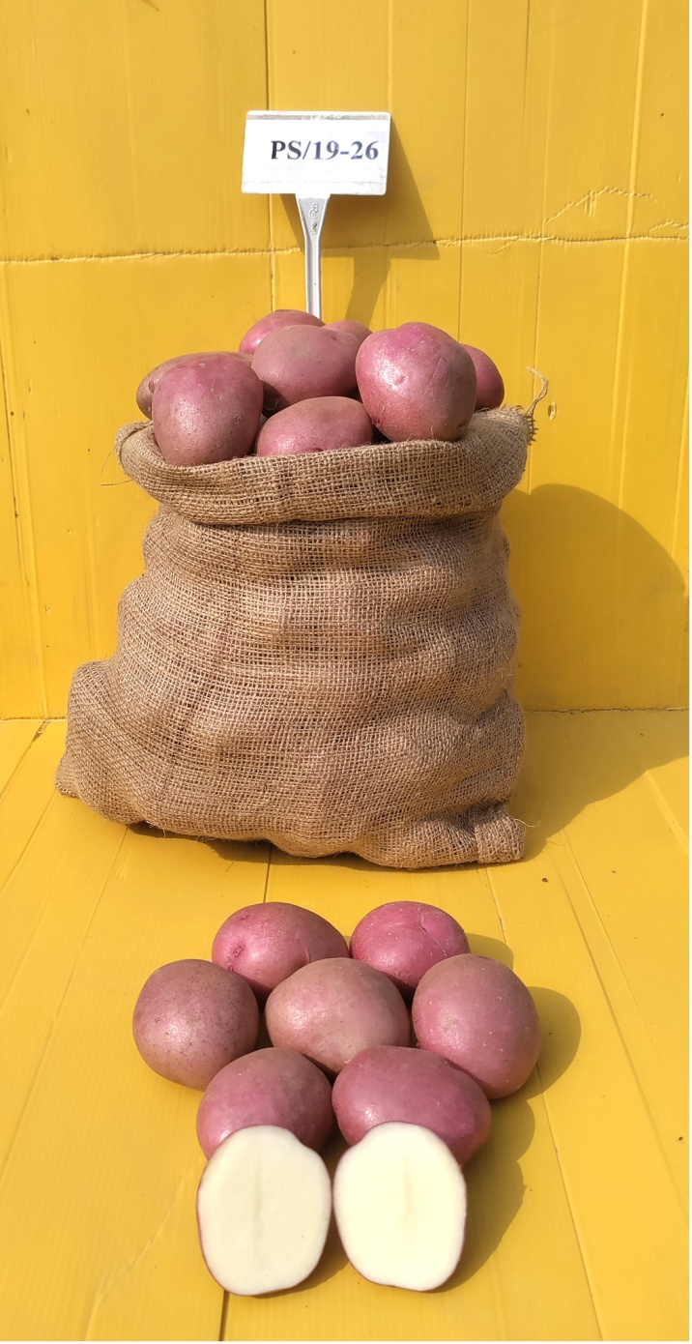 | 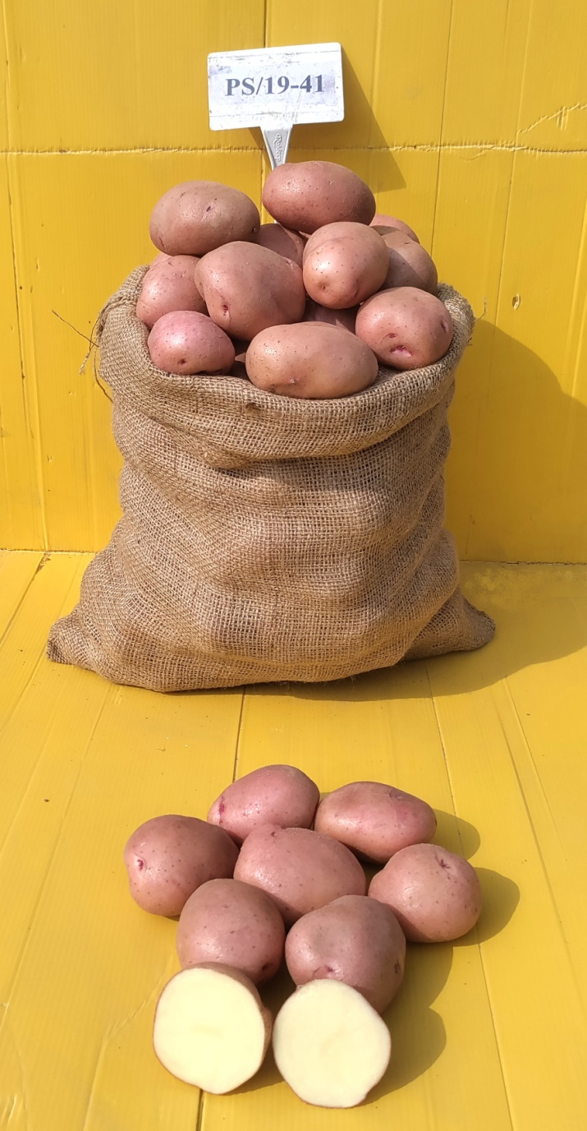 | 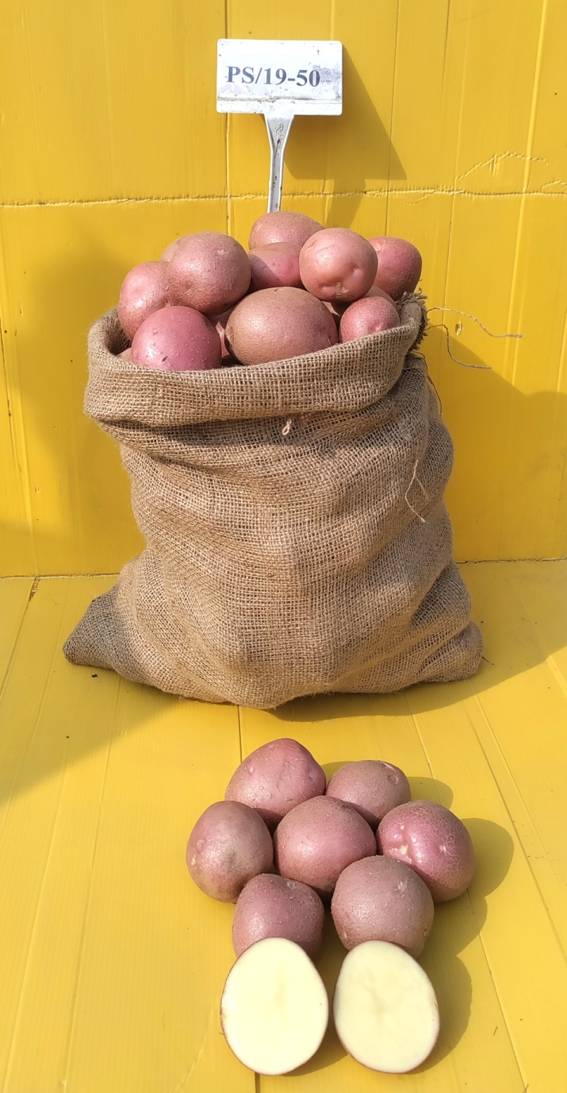
PS/19-24 | PS/19-26 | PS/19-41 | PS/19-50
photos 3: Tubers of promising advanced clones

- Dry Matter (%)
Dry matter content is an important criterion for selecting potato clones. During 2023–24, values ranged from 24.83% in clone PS/19-02 to 14.17% in PS/19-04. In 2024–25, the values ranged from 19.67% in PS/19-50 to 12.17% in the control variety K. Lohit, indicating notable variation among genotypes and years.
Fig 4 (a): Dry Matter (%) of advanced clones (2023-24)
Advanced clones /Varieties | Dry Matter % at 90 days
PS/19-02 | 24.83
PS/19-04 | 14.17
PS/19-12 | 17.83
PS/19-24 | 17.83
PS/19-26 | 14.83
PS/19-31 | 17.50
PS/19-41 | 17.33
PS/19-43 | 17.17
PS/19-44 | 14.83
PS/19-50 | 18.50
K.Lalima | 15.67
K.Lalit | 15.17
K.Lohit | 14.83
K.Manik | 17.67
K.Neelkanth | 17.33
CD (0.05) : | 1.27
CV (%) : | 4.60

Advanced clones /Varieties | Dry Matter %
Advanced clones /Varieties | At 75 days | At 90 days
PS/19-02 | 15.67 | 18.67
PS/19-04 | 15.00 | 16.17
PS/19-12 | 15.83 | 17.50
PS/19-24 | 18.67 | 20.50
PS/19-26 | 16.17 | 20.00
PS/19-31 | 15.50 | 20.00
PS/19-41 | 17.17 | 21.33
PS/19-44 | 17.83 | 18.83
PS/19-50 | 19.67 | 21.17
K.Lalit | 18.33 | 23.17
K.Lohit | 12.17 | 17.67
K.Manik | 15.00 | 16.67
CD (0.05) | 2.02 | 2.76
CV (%) | 7.25 | 8.52
Table & Fig. 4 (b): Dry Matter (%) of advanced clones (2024-25)

- 5. Nutritional Values and Clone Performance
Potatoes are a rich source of carbohydrates and constitute a nutrient-rich staple food. A medium baked potato (150 g, with skin) provides approximately 110–133 calories, is naturally fat-free, and supplies substantial amounts of potassium, vitamin C, vitamin B6, fibre, and protein (Bártová et al., 2015; Beals, 2019; Kowalczewski et al., 2019). Potatoes of different colours, including white, purple, pink, red, and dark red, are now bred to develop varieties rich in anthocyanins and carotenoids (Dalamu et al., 2019). These coloured potatoes are used for preparing bhujia and chips and for boiling. Zinc and iron are important minerals for maintaining the health of women and children and are present in potato tubers in substantial amounts (Yadav, Luthra, Singh, et al., 2024). Zinc content was highest in the control variety Kufri Lohit (26.85 ppm). Iron and carotenoid contents were highest in PS/19-24 (34.65 ppm and 82.2 µg/100 g fresh weight, respectively), whereas anthocyanin content was highest in PS/19-50 (24.6 mg/100 g fresh weight). Vitamin C content was highest in the potato variety Kufri Manik (32.2 mg/100 g fresh weight) (Table 5 and Graph 1).

Table 5: nutritional components of potato varieties and advanced clones

S. No. | Sample | Zn  (ppm) | Fe  (ppm) | Carotenoid  (µg/100-gram fresh weight) | Anthocyanin  (mg/100-gram fresh weight) | Vitamin C  (mg/100-gram fresh weight)
1. | PS/19-24 | 22.54 | 34.65 | 82.2 | 13.5 | 27.4
2. | PS/19-26 | 21.37 | 31.20 | 34.8 | 12.8 | 23.3
3. | PS/19-41 | 23.48 | 34.24 | 64.8 | 2.4 | 18.5
4. | PS/19-50 | 25.31 | 32.07 | 66.0 | 24.6 | 25.1
5. | K. Manik | 26.31 | 33.24 | 77.0 | 11.76 | 32.2
6. | K. Lohit | 26.85 | 34.37 | 73.5 | 0.84 | 29.8

The medium-maturing, red-skinned advanced clones PS/19-41 and PS/19-50 were identified as suitable for table potato use. Among the evaluated genotypes, the highest total tuber yield was recorded in PS/19-12 (37.47 t/ha), followed by PS/19-24 (36.56 t/ha), PS/19-41 (33.17 t/ha), PS/19-02 (33.00 t/ha), and PS/19-50 (25.71 t/ha). Clones PS/19-24, PS/19-41, and PS/19-50 produced attractive red-skinned tubers with yellow or creamy flesh, which were preferred by consumers for their appearance and taste. The tubers were round, shallow-eyed, and exhibited desirable culinary qualities. Dry matter content, an important trait for processing suitability, was positively correlated with product quality in chips and French fries (Das et al., 2021). Organoleptic evaluation indicated that these clones had a mealy texture and pleasant flavour and cooked within 15–18 minutes. Boiled tubers remained free from discolouration after cooking. Furthermore, the clones exhibited no internal or external defects at harvest or during storage, indicating their potential for table and processing purposes.

Conclusion
The evaluated potato clones showed variability in emergence, total tuber yield, marketable yield, dry matter content, and nutritional quality traits under the Eastern Indo-Gangetic Plains conditions (Ortiz & Golmirzaie, 2003; Roy & Singh, 2006; Salehi Jozani et al., 2003). PS/19-12 and PS/19-24 performed well for marketable yield at 90 days, whereas PS/19-50 showed better marketable yield at 75 days and higher anthocyanin content among the tested clones. PS/19-24 had comparatively high iron and carotenoid contents. The findings suggest that selected advanced clones, particularly PS/19-24, PS/19-41, and PS/19-50, may be useful for further evaluation as red-skinned table potato materials (Gopal, 2015; Jansky, 2009; Muthoni et al., 2014). However, multilocation and multiseason testing with consistent quality assessment is necessary before any clone is recommended for wider cultivation or varietal release (Mulema et al., 2008).

Limitation

The study was conducted at one experimental location over two agricultural seasons and assessed two crop durations. Consequently, the observed performance may not represent the full range of environments within the Eastern Indo-Gangetic Plains. Several quality and nutritional measurements were reported for selected genotypes rather than for every clone and control. Further multilocation, multiseason, and consistently replicated quality assessments are therefore required to confirm the stability of yield, storability, and nutritional traits.

Declaration of AI Use

This manuscript was prepared through the combined contributions of all authors, including contributions to the study design, data, content development, results, interpretation, and related scholarly work. The authors acknowledge the use of Grammarly and ChatGPT to assist with grammar checking, language refinement, and reference formatting. These AI-assisted tools were not used as authors and did not replace the intellectual contributions or scholarly judgement of the authors. All AI-assisted outputs, including content, references, and interpretations, were carefully reviewed, revised, verified, and approved by the authors. The authors accept full responsibility for the accuracy, integrity, and final content of the manuscript.

Acknowledgements

The authors are grateful to the ICAR (Indian Council of Agricultural Research) for providing laboratory and greenhouse facilities for this research.

Competing Interests
Authors have declared that they have no known competing financial interests or non-financial interests or personal relationships that could have appeared to influence the work reported in this paper.

References
Abong, G. O., Okoth, M. W., Imungi, J. K., & Kabira, J. N. (2010). Evaluation of selected Kenyan potato cultivars for processing into potato crisps. Agriculture and Biology Journal of North America, 1(5), 886–893. https://doi.org/10.5251/abjna.2010.1.5.886.893
Amador, V., Bou, J., Martínez-García, J. F., Monte, E., Rodríguez-Falcón, M., Russo, E., & Prat, S. (2001). Regulation of potato tuberization by daylength and gibberellins. The International Journal of Developmental Biology, 45(S1), S37–S38. https://doi.org/10.1387/ijdb.01450037
Bártová, V., Bárta, J., Brabcová, A., Zdráhal, Z., & Horáčková, V. (2015). Amino acid composition and nutritional value of four cultivated South American potato species. Journal of Food Composition and Analysis, 40, 78–85. https://doi.org/10.1016/j.jfca.2014.12.006
Beals, K. A. (2019). Potatoes, nutrition and health. American Journal of Potato Research, 96, 102–110. https://doi.org/10.1007/s12230-018-09705-4
Bist, L., Sharma, R., & Thakurathi, B. (2023). Effect of seed tuber size on growth and yield of potato (Solanum tuberosum L.) variety Desiree in Dadeldhura. Contemporary Research: An Interdisciplinary Academic Journal, 6(2), 110–123. https://doi.org/10.3126/craiaj.v6i2.60251
Bonierbale, M., de Haan, S., & Forbes, A. (Eds.). (2007). Procedures for standard evaluation trials of advanced potato clones: An international cooperators’ guide. International Potato Center. https://agris.fao.org/search/en/providers/122619/records/647248dd53aa8c896304ef8a
Burgos, G., Zum Felde, T., André, C., & Kubow, S. (2020). The potato and its contribution to the human diet and health. In H. Campos & O. Ortiz (Eds.), The potato crop: Its agricultural, nutritional and social contribution to humankind (pp. 37–74). Springer. https://doi.org/10.1007/978-3-030-28683-5_2
Chaudhary Charan Singh Haryana Agricultural University. (2023). OPSTAT: Online statistical analysis tools [Computer software]. https://hau.ac.in/page/o-p-stat
Chen, B.-C., Wu, X.-J., Guo, H.-C., & Xiao, J.-P. (2024). Effects of appropriate low-temperature treatment on the yield and quality of pigmented potato (Solanum tuberosum L.) tubers. BMC Plant Biology, 24, Article 274. https://doi.org/10.1186/s12870-024-04951-7
Context Network. (2016). Rwanda early generation seed study: Country report. United States Agency for International Development. https://reliefweb.int/report/rwanda/rwanda-early-generation-seed-study-country-report
Cutter, E. G. (1978). Structure and development of the potato plant. In P. M. Harris (Ed.), The potato crop: The scientific basis for improvement (pp. 70–152). Springer. https://doi.org/10.1007/978-1-4899-7210-1_3
Dalamu, Sharma, J., Kumar, S., Luthra, S. K., Sharma, A. K., Sharma, V., & Dua, V. K. (2019). Mineral content of red-skinned potatoes of Eastern India. Journal of Horticultural Sciences, 14(1), 79–82. https://doi.org/10.24154/jhs.v14i1.708
Das, S., Mitra, B., Saha, A., Mandal, S., Paul, P. K., El-Sharnouby, M., Hassan, M. M., Maitra, S., & Hossain, A. (2021). Evaluation of quality parameters of seven processing-type potato (Solanum tuberosum L.) cultivars in the Eastern Sub-Himalayan Plains. Foods, 10(5), Article 1138. https://doi.org/10.3390/foods10051138
Food and Agriculture Organization of the United Nations. (2019–2022). FAOSTAT: Crops and livestock products [Data set]. https://www.fao.org/faostat/en/#data/QCL
Food and Agriculture Organization of the United Nations. (2025). FAOSTAT: Crops and livestock products [Data set]. https://www.fao.org/faostat/en/#data/QCL
Gopal, J. (2015). Challenges and way-forward in selection of superior parents, crosses and clones in potato breeding. Potato Research, 58, 165–188. https://doi.org/10.1007/s11540-015-9292-6
Hardigan, M. A., Laimbeer, F. P. E., Newton, L., Crisovan, E., Hamilton, J. P., Vaillancourt, B., Wiegert-Rininger, K., Wood, J. C., Douches, D. S., Farré, E. M., Veilleux, R. E., & Buell, C. R. (2017). Genome diversity of tuber-bearing Solanum uncovers complex evolutionary history and targets of domestication in the cultivated potato. Proceedings of the National Academy of Sciences of the United States of America, 114(46), E9999–E10008. https://doi.org/10.1073/pnas.1714380114
Hassanpanah, D. (2010). Analysis of G × E interaction by using the additive main effects and multiplicative interaction in potato cultivars. International Journal of Plant Breeding and Genetics, 4(1), 23–29. https://doi.org/10.3923/ijpbg.2010.23.29
Haverkort, A. J., Struik, P. C., Visser, R. G. F., & Jacobsen, E. (2009). Applied biotechnology to combat late blight in potato caused by Phytophthora infestans. Potato Research, 52, 249–264. https://doi.org/10.1007/s11540-009-9136-3
Haverkort, A. J., van de Waart, M., & Bodlaender, K. B. A. (1990). Interrelationships of the number of initial sprouts, stems, stolons and tubers per potato plant. Potato Research, 33, 269–274. https://doi.org/10.1007/BF02358456
Hawkes, J. G., & Francisco-Ortega, J. (1993). The early history of the potato in Europe. Euphytica, 70, 1–7. https://doi.org/10.1007/BF00029633
Horton, D. (1987). Potatoes: Production, marketing, and programs for developing countries. Westview Press. https://ifad.tind.io/record/1508?ln=en
Jansky, S. H. (2009). Breeding, genetics, and cultivar development. In J. Singh & L. Kaur (Eds.), Advances in potato chemistry and technology (pp. 27–62). Academic Press. https://doi.org/10.1016/B978-0-12-374349-7.00002-7
Kibar, H. (2012). Design and management of postharvest potato (Solanum tuberosum L.) storage structures. Ordu University Journal of Science and Technology, 2(1), 23–48. https://dergipark.org.tr/en/pub/ordubtd/issue/11063/132149
Kowalczewski, P. Ł., Olejnik, A., Białas, W., Rybicka, I., Zielińska-Dawidziak, M., Siger, A., Kubiak, P., & Lewandowicz, G. (2019). The nutritional value and biological activity of concentrated protein fraction of potato juice. Nutrients, 11(7), Article 1523. https://doi.org/10.3390/nu11071523
Kumar, H., Bajpai, R., Sadawarti, M. J., Tiwari, S., Singh, S. P., & Samadhiya, R. K. (2023). Evaluation of potato (Solanum tuberosum L.) hybrids and varieties for medium maturity and quality components for North-Central India. Biological Forum—An International Journal, 15(2), 1245–1250. https://www.researchtrend.net/bfij/evaluation-of-potato-solanum-tuberosum-l-hybrids-and-varieties-for-medium-maturity-and-quality-components-for-north-central-india-6282
Lutaladio, N., & Castaldi, L. (2009). Potato: The hidden treasure. Journal of Food Composition and Analysis, 22(6), 491–493. https://doi.org/10.1016/j.jfca.2009.05.002
Luthra, S. K. (2001). Heritability, genetic advance and character association in potato. Journal of the Indian Potato Association, 28(1), 1–3. https://www.researchgate.net/publication/271479406_Heritability_genetic_advance_and_character_association_in_potato
Muhinyuza, J. B., Shimelis, H., Melis, R., Sibiya, J., & Nzaramba, M. N. (2012). Participatory assessment of potato production constraints and trait preferences in potato cultivar development in Rwanda. International Journal of Development and Sustainability, 1(2), 358–380. https://isdsnet.com/ijds-v1n2-23.pdf
Mulatu, E., Ibrahim, O. E., & Bekele, E. (2005). Improving potato seed tuber quality and producers’ livelihoods in Hararghe, Eastern Ethiopia. Journal of New Seeds, 7(3), 31–56. https://doi.org/10.1300/J153v07n03_03
Mulema, J. M. K., Adipala, E., Olanya, O. M., & Wagoire, W. (2008). Yield stability analysis of late-blight-resistant potato selections. Experimental Agriculture, 44(2), 145–155. https://doi.org/10.1017/S0014479708006133
Muthoni, J., Shimelis, H., & Melis, R. (2014). Genetics and reproductive biology of cultivated potato (Solanum tuberosum L.): Implications in breeding. In K. G. Ramawat, J.-M. Mérillon, & K. R. Shivanna (Eds.), Reproductive biology of plants (pp. 163–194). CRC Press. https://doi.org/10.1201/b16535
Ortiz, R., & Golmirzaie, A. M. (2003). Genetic parameters for agronomic characteristics. I. Early and intermediate breeding populations of true potato seed. Hereditas, 139(3), 212–216. https://doi.org/10.1111/j.1601-5223.2003.01734.x
Patel, R. N., Patel, N. H., Pandey, S. K., Kanbi, V. H., & Patel, C. K. (2006). Yield performance and shelf life of some advanced potato hybrids in Gujarat. Potato Journal, 33(3–4), 149–150. https://epubs.icar.org.in/index.php/PotatoJ/article/view/33230
Roy, A. K., & Singh, P. K. (2006). Genetic variability, heritability and genetic advance for yield in potato (Solanum tuberosum L.). International Journal of Plant Sciences, 1(2), 282–285. https://researchjournal.co.in/online/IJPS/IJPS%201%282%29/1_A-282-285.pdf
Rukundo, P. (2019, August 15). Overview of the potato sector in Rwanda [Presentation]. Rwanda Agriculture and Animal Resources Development Board. https://www.agroberichtenbuitenland.nl/documenten/presentaties/2019/08/20/overview-potato-sector-in-rwanda-2019
Rukundo, P., Ndacyayisenga, T., Ntizo, S., Kirimi, S., & Nshimiyimana, J. C. (2019). Yield and yield components of CIP advanced potato clones under Rwandan agro-ecologies. Journal of Applied Biosciences, 136, 13909–13920. https://doi.org/10.4314/jab.v136i1.7
Salehi Jozani, G. R., Abd-Mishani, S., Hoseinzadeh, A. H., & Seied Tabatabaei, B. E. (2003). Genetic diversity analysis of commercial potato cultivars (Solanum tuberosum) in Iran using RAPD-PCR technique [Article in Persian with an English abstract]. Iranian Journal of Agricultural Sciences, 34(4), 1021–1029. https://journals.ut.ac.ir/article_17568.html
Saxena, R., & Mathur, P. (2013). Analysis of potato production performance and yield variability in India. Potato Journal, 40(1), 38–44. https://epubs.icar.org.in/index.php/PotatoJ/article/view/31805
Siano, A. B., Roskruge, N., Kerckhoffs, H., & Sofkova-Bobcheva, S. (2024). Effects of abiotic stress associated with climate change on potato yield and tuber quality under a multi-environment trial in New Zealand. Potato Research, 67, 1603–1624. https://doi.org/10.1007/s11540-024-09695-3
Singh, B. P., & Rana, R. K. (2014). History of potato and its emerging problems in India. In Souvenir—National seminar on emerging problems in potato (pp. 7–21). Indian Potato Association. https://www.researchgate.net/publication/272791459_History_of_Potato_and_its_Emerging_Problems_in_India
Singh, M., Kumar, N., Singh, A., Nim, P., & Gupta, S. P. (2025). Effect of zinc nutrition on productivity, quality and biofortification in potato (Solanum tuberosum). Journal of Advances in Biology & Biotechnology, 28(7), 383–391. https://doi.org/10.9734/jabb/2025/v28i72557
Singh, R. K., Tiwari, J. K., Kumar, M., & Singh, B. (2023). Potato varieties and impact of technologies: A boon for doubling farmers’ income. Indian Horticulture, 68(2), 56–61. https://epubs.icar.org.in/index.php/IndHort/article/view/135849
Tiwari, J. K., Kumar, V., Bhardwaj, V., Luthra, S. K., Singh, R. K., Pandey, N. K., & Chakrabarti, S. K. (2019). Indian potato varieties. Indian Horticulture, 64(1). https://epubs.icar.org.in/index.php/IndHort/article/view/87812
Tsagaye, D., Fufa, N., Fikre, D., & Wegayehu, G. (2025). Evaluation of potato (Solanum tuberosum L.) varieties for growth and yield components at Bekoji, south-eastern Ethiopia. Asian Journal of Agriculture and Allied Sciences, 8(1), 90–98. https://doi.org/10.56557/ajaas/2025/v8i155
Yadav, S., Kumar, M., & Singh, R. K. (2020). Screening and evaluation of initial clonal generations of potato hybrids for yield and yield-attributing characters. Journal of AgriSearch, 7(4), 198–201. https://doi.org/10.21921/jas.v7i04.19389
Yadav, S., Kumar, M., & Yadav, S. K. (2021). Optimization of phosphoric fertilizers for cultivation of potato under high-phosphorus soils of Eastern Indo-Gangetic Plains of Bihar. Journal of AgriSearch, 8(2), 79–82. https://doi.org/10.21921/jas.v8i2.7287
Yadav, S., Luthra, S. K., Kapoor, V., Gupta, V. K., & Singh, B. (2024). Evaluation of red-skinned advanced potato (Solanum tuberosum L.) clones for tuber yield and yield parameters in the Eastern Indo-Gangetic Plains of India. Journal of Advances in Biology & Biotechnology, 27(10), 1222–1231. https://doi.org/10.9734/jabb/2024/v27i101544
Yadav, S., Luthra, S. K., Kapoor, V., Singh, S. P., Singh, R. K., Sharma, J., Dutta, S., & Singh, B. (2025). Evaluation of advanced clones of potato (Solanum tuberosum L.) for tuber yield and dry matter content. Plant Archives, 25(Supplement 2), 2787–2794. https://doi.org/10.51470/PLANTARCHIVES.2025.v25.supplement-2.356
Yadav, S., Luthra, S. K., Singh, R. K., & Singh, S. P. (2024). Evaluation of red- and purple-skinned advanced clones suitable for the Eastern Indo-Gangetic Plains of India. Journal of Advances in Biology & Biotechnology, 27(11), 23–32. https://doi.org/10.9734/jabb/2024/v27i111588

