Methodological Approaches to Hybridisation and Selection in the Initial Generations of Potato (Solanum tuberosum L.) Clones

Abstract
Potato (Solanum tuberosum L.) breeding is complicated by tetraploidy, high heterozygosity, and clonal propagation, making systematic selection across early generations essential. This study evaluated hybridisation and stage-wise clonal selection for developing red-skinned, medium-maturing table potato cultivars suitable for the eastern plains of India during 2020–21 and 2021–22. Female parents were selected for early maturity, early bulking, tuber skin and flesh colour, shape, and eye depth, whereas male parents were selected for plant type, tuber colour, and pollen viability. Hybridisation was conducted at ICAR-Central Potato Research Institute facilities in Patna and Shimla, and progenies were evaluated at Patna. In total, 83,440 and 109,603 true potato seeds from 84 and 26 successful crosses, respectively, were sown, and 57,758 and 52,333 seedlings were transplanted. Selection based on tuber colour, shape, flesh colour, eye depth, yield, and disease reaction retained 1,619 and 1,660 F₁ clones in the respective years. Subsequent evaluation retained 169 and 113 F₁C₁ cultures, 79 and 52 F₁C₂ cultures, and 28 and 17 F₁C₃ cultures. Selected F₁C₃ clones were advanced for preliminary yield evaluation. The results demonstrate a progressive, trait-based selection procedure for reducing large seedling populations to manageable clonal sets. Replicated, multi-location, and multi-year testing remains necessary to confirm the yield stability and adaptation of the advanced clones.
Key words: Potato breeding; hybridisation; true potato seed; early clonal generations; clonal selection; red-skinned potato; tuber yield; tuber quality

Introduction
Potato (Solanum tuberosum L.) is an important vegetable crop cultivated throughout India. Uttar Pradesh, West Bengal, and Bihar are major contributing states, where the crop is primarily cultivated during the Rabi season and remains an important vegetable source throughout the year. Potato provides carbohydrates, protein, and minerals such as Zn and Fe. The crop is also regarded as a poor man's friend and was introduced into India from Europe in the early seventeenth century (Hawkes & Francisco-Ortega, 1993; Pandey & Kaushik, 2003; Singh, 2001). It is an economical vegetable that provides low-cost dietary energy and contributes to food security for a growing population. It ranks as the fourth most important crop after rice, wheat, and maize (Singh et al., 2015). Potato was identified as a “hidden treasure” during the International Year of the Potato in 2008 and has been recognised for its potential contribution to global food security and poverty alleviation (ICAR-Central Potato Research Institute [CPRI], 2015). It is a short-duration, cool-season crop, generally requiring approximately three months, and its ease of cultivation and worldwide adoption have made it a valuable cash crop for millions of farmers. India is the second-largest potato-producing country after China (Department of Agriculture, Cooperation and Farmers Welfare, 2020; Food and Agriculture Organization of the United Nations [FAO], n.d.). Potato area, production, and productivity increased over the previous six decades by 8.5, 29.4, and 3.5 times, respectively (Kaur et al., 2017). With its rapidly increasing population, India may face multiple challenges related to potato production and yield. Potato demand is expected to reach approximately 125 million tonnes by 2050, compared with recent production of approximately 51 million tonnes (Indian Council of Agricultural Research-Indian Agricultural Statistics Research Institute [ICAR-IASRI], 2024). Potatoes are rich sources of starch, vitamins, particularly vitamins C and B₁, and minerals such as Fe, Zn, Ca, and K.
Contemporary potato improvement is challenged by the crop's highly heterozygous tetraploid genome and clonal propagation, which complicate the fixation of favourable alleles and constrain cumulative genetic gain (Muthoni et al., 2014). Current breeding strategies therefore combine conventional crossing and clonal selection with genomic and hybrid-breeding approaches to improve the precision and efficiency of cultivar development (Lindqvist-Kreuze et al., 2024; Cheng et al., 2025).
Within such programmes, the quality of seedling tubers and the systematic assessment of early clonal generations are important because variation in starting material may influence crop establishment and yield expression during field selection (Stockem et al., 2024).
Recent evaluations have also demonstrated that potato hybrids and varieties differ in tuber shape, skin colour, flesh colour, eye depth, growth, yield, and related quality attributes, supporting multi-trait and location-specific selection before clone advancement (Lautre et al., 2026; Tsagaye et al., 2025; Yadav et al., 2022, 2025, 2026; Yadav, Luthra, Kapoor, et al., 2024; Yadav, Luthra, Singh, et al., 2024).
Despite ongoing advances in potato breeding, the stage-wise performance of red-skinned, medium-maturing potato progenies under eastern plains conditions requires further evaluation, particularly across the F₁, F₁C₁, F₁C₂, and F₁C₃ generations. The present study therefore documents parental selection, hybridisation, progeny establishment, and progressive clonal selection within the stated breeding programme.
The study aimed to develop cultivars with consumer-preferred tuber colour and shape, high tuber yield, and improved quality among red- and coloured-skinned potato varieties. The breeding and selection of initial potato clones were conducted during 2020-21 and 2021-22. First, parents were selected according to the breeding programme objective. Female parents were selected for desirable traits, including early maturity, early bulking, tuber skin colour, flesh colour, shape, and eye depth, whereas male parents were selected for plant type, tuber colour, and pollen viability. The initial generations were planted and evaluated, and selection was conducted according to the breeding programme objective.
The principal objectives of the experiment were as follows:
- Hybridisation and development of an F₁ population with desirable traits, including red skin colour and superior nutritional characteristics, such as coloured flesh and high organoleptic value.
- Planting and evaluation of selected desirable clones in the first and second clonal generations, together with yield and dry-matter evaluation in initial evaluation trials.
- Selection of initial clones for preliminary yield evaluation.

Materials and methods

Location and selection of field
The field experiments were conducted during the consecutive years 2020-21 and 2021-22 at the ICAR-Central Potato Research Station, Patna, Bihar. Potato requires fertile, well-drained soils ranging from sandy loam to loam for suitable growth and development and performs well in sandy loam soils. It is cultivated as a Rabi-season crop in the plains and as a Kharif-season crop in the hills and southern parts of India (Singh, 2001; Yadav et al., 2020, 2022).

Research material
The experimental material consisted of the initial clonal generations of potato, namely F₁, F₁C₁, F₁C₂, and F₁C₃. These clones were derived from berries obtained through hybridisation, and the clonal generations were planted in the experimental field of the Crop Improvement Section, ICAR-CPRI Regional Station, Patna, Bihar.
Plate 1. Pollen viability categories observed in selected male parents.
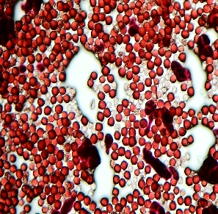 | 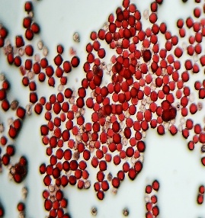 | 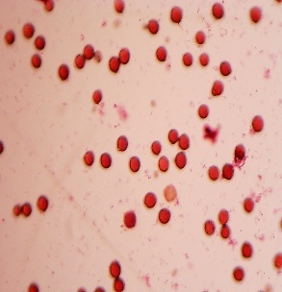 | 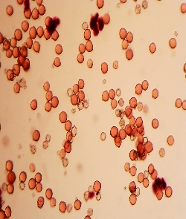
Pollens of selected male parent | Dark stained live pollen grains | _{Low pollen load} | _{Non-viable pollen grains}

Nursery preparation and planting
Male and female parents with desirable traits, including plant type, tuber colour, tuber shape, and flesh colour, were selected and planted in the hybridisation blocks at ICAR-CPRI Regional Station, Patna, Bihar, and the Kufri-Fagu Unit, Shimla, Himachal Pradesh. Hybridisation was carried out in all possible combinations among the desirable parents. In successful crosses, berry development began within one week after hybridisation, and the potato berries matured 40-50 days after setting. Mature berries were harvested and retained for a further 15 days to ripen and soften. True potato seeds were extracted from the ripened berries by maceration and straining. The extracted seeds were shade-dried for 4-5 days and then stored in airtight containers. Treatment with a 1,500 ppm gibberellic acid solution for 24 hours enhanced true potato seed germination (Almekinders, 1991). The treated seeds were subsequently strained and mixed with cocopeat. Seeds from different crosses were kept separately in cotton-cloth Potali bags, which were placed in a seed incubator at 24-25 °C for one week. True potato seed requires optimum temperature and adequate moisture for germination, which may vary among crosses. Germinated seeds were sown on raised nursery beds measuring 15m x 1m x 60cm. The nursery was sown during the last week of September, and the potato clones were planted from the last week of October to the first week of November. Seedlings were transplanted at 10 cm spacing on the ridge of the furrow, followed by light irrigation (Yadav et al., 2025). Gap filling was conducted one week after transplanting by identifying damaged or unestablished seedlings, followed by earthing up.

Experimental Design
Potato seedlings aged 25-30 days were planted in a well-prepared main field at spacings of 10 cm between plants and 45 cm between rows. The potato clones were planted in unreplicated plots comprising one plant in F₁, five plants in F₁C₁, 30 plants in F₁C₂, and 120 plants in F₁C₃ (Yadav et al., 2020). Depending on the number of harvested and selected tubers, the F₁C₂ and F₁C₃ generations were planted in a randomised block design with two replications. Clonal screening and selection were based on early bulking, tuber size, tuber shape, eye depth, tuber colour, and field resistance to potato late blight (Federer & Crossa, 2012; Haverkort et al., 2009).
Intercultural Operations and Fertiliser Requirements
Potato is a heavy-feeding crop. During land preparation, 25-30 tonnes of farmyard manure and 1/2 N+P+K were applied to the soil. Chemical fertilisers were applied as urea, DAP, and MOP at the rate of 150: 80: 100: N:P: K. Tubers were planted in 3 m rows at spacings of 15 cm between plants and 60 cm between rows. Earthing up was conducted 25-30 days after planting. Hand weeding was followed by application of the remaining N dose to support tuber development.

Data Recording and Analysis
The experiments comprised 83,440 true potato seeds from 84 successful crosses during 2020-21 and 109,603 true potato seeds from 26 successful crosses during 2021-22. These seeds were produced at the ICAR-Central Potato Research Institute, Patna, Bihar, and Kufri, Shimla, through hand emasculation and bulk pollination during the Rabi and Kharif seasons, respectively. In F₁C₁, 764 and 747 cultures were planted in single rows of five tubers each, with a row length of 3 m and a plant-to-plant spacing of 15 cm. In F₁C₂, 175 and 164 cultures were planted in two 3 m rows during 2020-21 and 2021-22, respectively. Forty-three and 45 F₁C₃ cultures, together with the listed controls, were evaluated at 75 days in a 3.6 m² area using a randomised block design with two replications during 2020-21 and 2021-22, respectively. The cultures were evaluated for total tuber yield, tuber shape, colour, and disease reactions before advancement to the preliminary yield trial. Germination count was recorded 30 days after planting. Rouging was conducted to remove diseased and off-type plants before irrigation. The other clonal generations were harvested manually 90 days after planting (Yadav et al., 2020). Initial clones with higher tuber yield and desirable tuber characteristics were selected for further evaluation. After harvest, selected clones were retained as planting material for evaluation in the next generation. In F₁, 1,619 and 1,660 clones were retained during 2020-21 and 2021-22, respectively. For subsequent evaluation, 10, 100, 200, and 200 tubers were retained from F₁, F₁C₁, F₁C₂, and F₁C₃, respectively (Yadav et al., 2020). All observations were recorded according to the Protection of Plant Varieties and Farmers’ Rights Authority [PPV&FRA] (2009) guidelines, and statistical analyses were conducted using the methodology of Panse and Sukhatme (1978). Differences between means were tested against the critical difference at the 5% probability level.

RESULTS AND DISCUSSION

1. Hybridisation, True Potato Seed Production, and Seedling Transplanting
A total of 83,440 and 109,603 true potato seeds from 84 and 26 successful crosses, respectively, were sown in nursery beds, from which 57,758 and 52,333 seedlings were transplanted into the main field. The seedlings were harvested 90 days after planting and selected for tuber colour, shape, flesh colour, and eye depth. A total of 1,619 and 1,660 clones were selected during 2020-21 and 2021-22, respectively, for further evaluation in the F₁C₁ generation (Table 1).

Plate 2. Stages of hybridization, true potato seed production, nursery preparation, seedling transplanting, and field establishment.
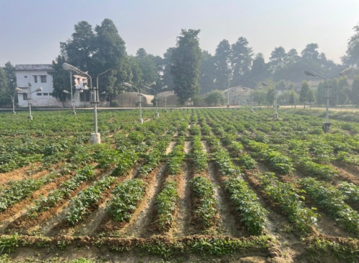
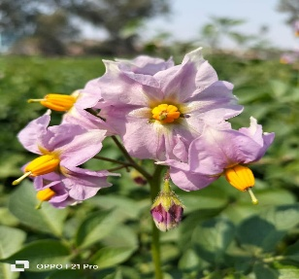
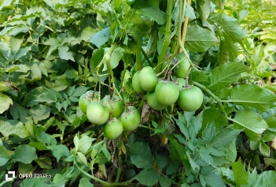
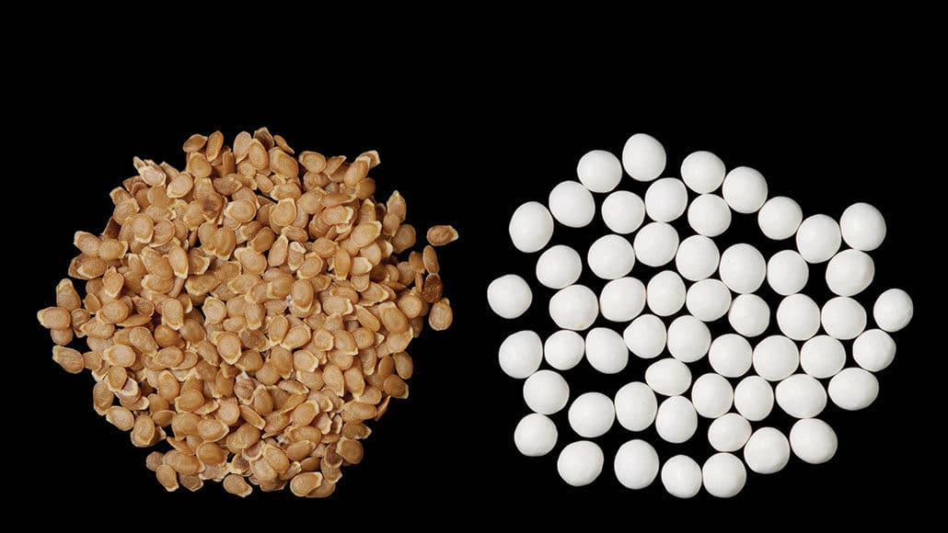
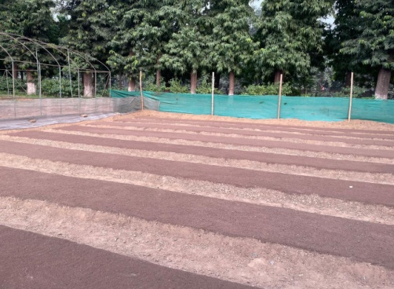
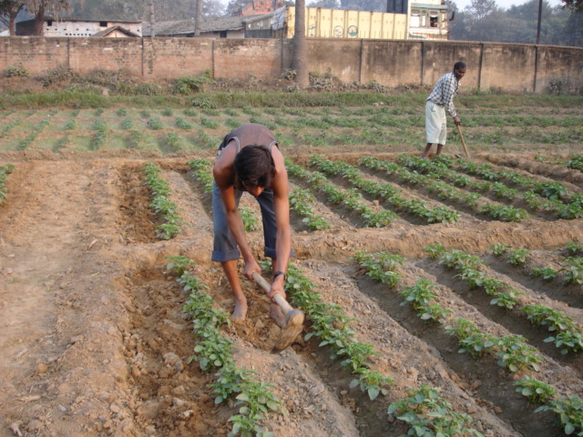
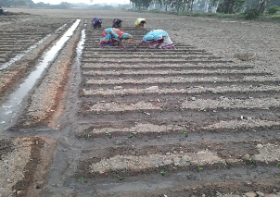
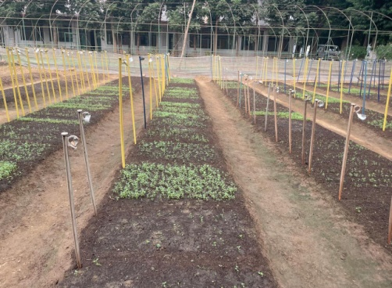
Hybridization Block
Potato Flowers
Berry Development
True Potato Seeds
Nursery Preparation
Seedling Transplanting
Transplanted Field

TPS Nursery

Table 1. Hybridization methodology, seeds sown, seedlings transplanted, and clones selected in the F1 generation of potato hybrids during 2020-21 and 2021-22

Hybridization methodology | Seeds sown in nursery |  | Seedling transplanted in main field |  | Number of Clones selected
Hybridization methodology | 2020-21 | 2021-22 | 2020-21 | 2021-22 | 2020-21 | 2021-22
Emasculation and pollination method | 22550 | 30653 | 19605 | 19173 | 739 | 745
Bulk pollination | 60890 | 78950 | 38153 | 33160 | 880 | 915
Total | 83440 | 109603 | 57758 | 52333 | 1619 | 1660

Figure 1. Seedling transplanting percentage under different hybridization methodologies.

Figure 2. Clonal selection percentage under different hybridization methodologies.
Plate 2 summarises the operational sequence from parental hybridisation to field establishment, whereas Figures 1 and 2 present the corresponding transplanting and clonal-selection percentages. The numerical differences between the emasculation-and-pollination treatment (4%) and the bulk-pollination treatment (2% and 3%) should be interpreted cautiously because progeny size reflects the number of seeds generated, parental fertility, cross-compatibility, and the subsequent establishment of genetically heterogeneous seedlings rather than breeding value alone. Potato hybridisation studies indicate that parental combining ability and cross-specific effects can influence progeny performance, whereas true-potato-seed systems require consistent germination, seedling emergence, and plantlet establishment before field performance can be evaluated reliably (Lindhout et al., 2011; Ortiz et al., 1988; van Dijk et al., 2025). Accordingly, the transplanting and selection percentages reported here are useful operational indicators, although comparisons among hybridisation methods would be more informative if accompanied by the numbers of crosses attempted, berry set, seeds per berry, germination percentage, and family-specific survival.

2. Evaluation of the F₁C₁ and F₁C₂ Generations
In F₁C₁, 764 and 747 cultures were planted in single rows of five tubers, of which 169 and 113 cultures from 44 and 18 crosses, respectively, were selected for further evaluation in F₁C₂ during 2020-21 and 2021-22. In F₁C₂, 175 and 164 cultures were planted, of which 79 and 52, respectively, were selected for further evaluation in F₁C₃ during 2020-21 and 2021-22 (Table 2).

Table 2. Selection of clones during 2020-21 and 2021-22 in the initial clonal generations (ICG)
Clonal generation | No. of clones planted |  | No. of clones selected
Clonal generation | 2020-21 | 2021-22 | 2020-21 | 2021-22
F₁C₁ | 764 | 747 | 169 | 113
F₁C₂ | 175 | 164 | 79 | 52
F₁C₃ | 45 | 45 | 28 | 17
* ICG- Initial Clonal Generations

Figure 3. Clonal selection percentage across the initial clonal generations.

The generation-wise reduction in the number of retained cultures is consistent with deliberate selection pressure across the F₁C₁ (30%), F₁C₂ (22%), and F₁C₃ (18%) stages (Figure 3); however, selection percentages alone do not quantify the accuracy with which genetically superior clones were identified. Earlier research indicates that visual selection for tuber colour, shape, and eye depth can be informative in initial generations, whereas yield and other environmentally sensitive traits generally require cautious negative selection followed by replicated evaluation (Brown et al., 1987; Gopal et al., 1992, 1994). Recent evidence further indicates that pedigree, genomic, and multispectral information can improve breeding-value accuracy when early-stage potato clones cannot yet be tested across multiple environments (Maggiorelli et al., 2025). Therefore, the contrasting retention rates between years may reflect differences in population composition, selection intensity, and seasonal conditions and should not, by themselves, be interpreted as evidence that one year produced inherently superior breeding material.

3. Evaluation of the F₁C₃ Generation
Forty-three cultures, together with five listed controls (K. Ganga, K. Ashoka, K. Pukhraj, K. Neelkanth, and K. Lalit), were evaluated 75 days after planting in a 7.2 m² area using a randomised block design with three replications. Of these, 28 cultures were selected during 2020-21. During 2021-22, 45 cultures, together with seven controls (K. Ganga, K. Pukhraj, K. Neelkanth, K. Lalit, K. Lalima, K. Jyoti, and K. Mohan), were evaluated 75 days after planting in a 7.2 m² area using a randomised block design with three replications. Of these, 17 cultures were selected on the basis of total tuber yield, shape, colour, and disease reactions (Gopal et al., 1994; Luthra, 2001; Luthra et al., 2005).

Table 3. Yield performance of selected initial clones in the initial evaluation trial (F₁C₃) at 75 days after planting

2020-21 |  |  |  | 2021-22
Adv. Clone code | Germination | Yield (t/ha) |  | Adv. Clone code | Germination | Yield (t/ha)
PS/17-09 | 98.33 | 29.58 |  | PS/18-1 | 96.66 | 31.47
PS/17-10 | 94.44 | 23.43 |  | PS/18-2 | 93.33 | 26.75
PS/17-11 | 93.33 | 26.11 |  | PS/18-3 | 90.83 | 29.16
PS/17-12 | 94.67 | 32.78 |  | PS/18-4 | 92.50 | 25.24
PS/17-13 | 95.56 | 26.57 |  | PS/18-8 | 98.66 | 32.60
PS/17-14 | 96.67 | 24.91 |  | PS/18-11 | 91.66 | 22.77
PS/17-15 | 95.56 | 26.46 |  | PS/18-21 | 91.66 | 31.90
PS/17-16 | 95.56 | 29.63 |  | PS/18-28 | 91.66 | 25.74
PS/17-17 | 96.67 | 29.17 |  | PS/18-31 | 96.66 | 37.21
PS/17-18 | 95.56 | 29.96 |  | PS/18-33 | 92.50 | 24.20
PS/17-19 | 97.78 | 31.63 |  | PS/18-43 | 96.66 | 39.82
PS/17-20 | 96.67 | 28.63 |  | PS/18-44 | 91.66 | 26.66
PS/17-21 | 97.78 | 29.94 |  | PS/18-46 | 92.50 | 26.53
PS/17-22 | 94.44 | 32.66 |  | PS/18-48 | 93.33 | 23.26
PS/17-23 | 96.67 | 37.49 |  | PS/18-53 | 93.33 | 22.71
PS/17-26 | 94.44 | 27.93 |  | PS/18-60 | 98.33 | 32.15
PS/17-27 | 95.56 | 27.87 |  | PS/18-65 | 93.33 | 28.34
PS/17-32 | 93.33 | 27.78
PS/17-33 | 96.00 | 21.23 |  | K. Lalit | 95.00 | 28.48
PS/17-34 | 90.00 | 30.13 |  | K. Mohan | 98.33 | 45.72
PS/17-35 | 91.11 | 29.35 |  | K. Ganga | 96.66 | 38.16
PS/17-45 | 95.00 | 24.72 |  | K. Jyoti | 93.33 | 33.02
PS/17-55 | 92.22 | 23.36 |  | K. Pukhraj | 95.00 | 39.09
PS/17-56 | 90.00 | 26.20 |  | K. Lalima | 93.33 | 35.38
PS/17-58 | 90.00 | 23.33 |  | K. Neelkanth | 93.33 | 29.26
PS/17-64 | 92.67 | 28.47 |  | SE(d): | 6.90 | 6.60
PS/17-67 | 91.11 | 28.49 |  | CD (0.05): | 9.55 | 7.81
PS/17-68 | 90.00 | 19.72 |  | CV (%): | 10.89 | 11.86
K. Lalit | 93.33 | 22.74
K. Mohan | 95.00 | 20.00
K. Ganga | 96.67 | 36.51
K. Jyoti | 96.67 | 24.96
K. Pukhraj | 96.67 | 34.32
K. Neelkanth | 96.67 | 24.72
SE(d): | 5.39 | 5.68
CD (0.05): | 8.50 | 9.01
CV (%): | 10.89 | 12.16

During 2020-21, germination ranged from 90.00% in PS/17-68 to 98.33% in PS/17-09, whereas tuber yield ranged from 19.72 t/ha in PS/17-68 to 37.49 t/ha in PS/17-23. During 2021-22, germination ranged from 90.83% in PS/18-3 to 98.66% in PS/18-8, whereas yield ranged from 22.71 t/ha in PS/18-53 to 45.72 t/ha in the check K. Mohan. Cultures showing favourable performance relative to the planted checks were selected for further evaluation in the preliminary yield trial (Table 3).
The broad ranges in germination and tuber yield indicate substantial phenotypic variability among the F₁C₃ clones and controls. Nevertheless, yield at 75 days is influenced not only by genotype but also by maturity class, physiological seed quality, crop duration, and field environment; consequently, single-location or limited-season comparisons should be regarded as preliminary (Haverkort & Struik, 2015; Keutgen et al., 2020). Multi-environment and multi-year analyses are generally required to distinguish mean performance from genotype-by-environment interaction and to identify clones that combine high yield with stability (Ahmed et al., 2024). Within the present dataset, PS/17-23 and PS/18-43 were the highest-yielding advanced clones in their respective years. The performance of the selected clones was assessed using total tuber yield, tuber quality, disease reaction, dry matter, and stability relative to the appropriate checks.

Conclusion
The principal objective of potato breeding is to enhance tuber yield and quality relative to existing released varieties. The major selection criteria in this breeding programme included skin colour, flesh colour, eye depth, tuber shape and size, early bulking, and resistance to insect pests and diseases. The initial clonal generations were developed from true potato seed and screened for agro-morphological traits and yield performance under irrigated conditions. Planting the selected clones as single-row F₁C₁, double-row F₁C₂, and replicated F₁C₃ materials in a randomised block design enabled progressively more rigorous evaluation, maintenance, and selection of the initial clonal generations (Yadav, Luthra, Kapoor, et al., 2024). The systematic evaluation of yield-attributing characters supported reliable selection (Yadav et al., 2020). Morphological traits, including tuber skin and flesh colour, eye depth, shape, and field resistance to major diseases, were important in evaluating the initial potato clones. These characteristics supported the selection of superior genotypes aligned with market and consumer preferences. The better-performing initial clones may contribute to the subsequent development of high-performing potato varieties.

Limitations
The study was conducted primarily at a single evaluation location over two cropping seasons, limiting assessment of environmental variability and wider adaptation. Early clonal generations were evaluated in unreplicated or minimally replicated plots, which may reduce the precision of yield-based selection. Future studies should use harmonised data reporting and replicated multi-location, multi-year trials to confirm yield stability and the adaptability of selected clones.

Declaration of AI Use
This manuscript was prepared through the combined contributions of all author(s), including contributions to the study design, data, content development, results, interpretation, and related scholarly work. The author(s) acknowledge the use of Grammarly and ChatGPT to assist with grammar checking, language refinement, and reference formatting. These AI-assisted tools were not used as authors and did not replace the intellectual contributions or scholarly judgement of the author(s). All AI-assisted outputs, including content, references, and interpretations, were carefully reviewed, revised, verified, and approved by the author(s). The author(s) accept full responsibility for the accuracy, integrity, and final content of the manuscript.

Acknowledgements
The authors are grateful to the ICAR (Indian Council of Agricultural Research) for providing laboratory and greenhouse facilities for this research.

Competing Interests
Authors have declared that they have no known competing financial interests or non-financial interests or personal relationships that could have appeared to influence the work reported in this paper.

References
Ahmed, I., Biswas, J. C., Jahan, M. A. H. S., Ishtiaque, S., Zahan, T., Islam, M. A., Al-Shuraym, L. A., Sayed, S., Gaber, A., & Hossain, A. (2024). Yield stability among potato varieties suitable for different agroecological regions of Bangladesh. Heliyon, 10(11), Article e31633. https://doi.org/10.1016/j.heliyon.2024.e31633
Almekinders, C. J. M. (1991). Flowering and true seed production in potato (Solanum tuberosum L.). 2. Effects of stem density and pruning of lateral stems. Potato Research, 34, 379–388. https://doi.org/10.1007/BF02360574
Brown, J., Caligari, P. D. S., Mackay, G. R., & Swan, G. E. L. (1987). The efficiency of visual selection in early generations of a potato breeding programme. Annals of Applied Biology, 110(2), 357–363. https://doi.org/10.1111/j.1744-7348.1987.tb03266.x
Cheng, L., Wang, N., Bao, Z., Zhou, Q., Guarracino, A., Yang, Y., Wang, P., Zhang, Z., Tang, D., Zhang, P., Wu, Y., Zhou, Y., Zheng, Y., Hu, Y., Lian, Q., Ma, Z., Lassois, L., Zhang, C., Lucas, W. J., . . . Huang, S. (2025). Leveraging a phased pangenome for haplotype design of hybrid potato. Nature, 640, 408–417. https://doi.org/10.1038/s41586-024-08476-9
Department of Agriculture, Cooperation and Farmers Welfare. (2020). Monthly report on potato for May 2020. Government of India. https://agriwelfare.gov.in/sites/default/files/Monthly%20Report%20on%20Potato%20for%20May%2C%202020%20%281%29.pdf
Federer, W. T., & Crossa, J. (2012). I.4 screening experimental designs for quantitative trait loci, association mapping, genotype-by-environment interaction, and other investigations. Frontiers in Physiology, 3, Article 156. https://doi.org/10.3389/fphys.2012.00156
Food and Agriculture Organization of the United Nations. (n.d.). FAOSTAT: Crops and livestock products [Data set]. Retrieved July 30, 2026, from https://www.fao.org/faostat/en/#data/QCL
Gopal, J., Gaur, P. C., & Rana, M. S. (1992). Early generation selection for agronomic characters in a potato breeding programme. Theoretical and Applied Genetics, 84(5–6), 709–713. https://doi.org/10.1007/BF00224173
Gopal, J., Gaur, P. C., & Rana, M. S. (1994). Heritability and intra- and inter-generation associations between tuber yield and its components in potato (Solanum tuberosum L.). Plant Breeding, 112(1), 80–83. https://doi.org/10.1111/j.1439-0523.1994.tb01280.x
Haverkort, A. J., Struik, P. C., Visser, R. G. F., & Jacobsen, E. (2009). Applied biotechnology to combat late blight in potato caused by Phytophthora infestans. Potato Research, 52(3), 249–264. https://doi.org/10.1007/s11540-009-9136-3
Haverkort, A. J., & Struik, P. C. (2015). Yield levels of potato crops: Recent achievements and future prospects. Field Crops Research, 182, 76–85. https://doi.org/10.1016/j.fcr.2015.06.002
Hawkes, J. G., & Francisco-Ortega, J. (1993). The early history of the potato in Europe. Euphytica, 70(1–2), 1–7. https://doi.org/10.1007/BF00029633
ICAR–Central Potato Research Institute. (2015). Vision 2050. Indian Council of Agricultural Research. https://icar.gov.in/en/vision-2050
Indian Council of Agricultural Research–Indian Agricultural Statistics Research Institute. (2024). Agricultural research data book 2024 [Data set]. https://iasri.res.in/agridata/24data/Info.HTML
Kaur, R. P., Chaudhary, B., & Alam, W. (2017). Associations among yield and yield-contributing traits of potato (Solanum tuberosum) in the north-western plains of India. The Indian Journal of Agricultural Sciences, 87(10), 1409–1411. https://doi.org/10.56093/ijas.v87i10.75060
Keutgen, A. J., Keutgen, N., Wszelaczyńska, E., Pobereżny, J., Milczarek, D., Tatarowska, B., & Flis, B. (2020). Evaluation of photosynthetic and yield traits in ten potato clones and cultivars under farming conditions in Poland. Potato Research, 63(1), 75–95. https://doi.org/10.1007/s11540-019-09429-w
Lautre, R., Sadawarti, M. J., Singh, S. P., Kumar, H., Dangi, R. S., Samadhiya, R. K., Tirkey, S., & Patidar, P. (2026). Quality characteristics and table purpose suitability of short duration potato (Solanum tuberosum L.) hybrids and varieties grown in the Chambal region of Madhya Pradesh, India. Journal of Advances in Biology & Biotechnology, 29(1), 262–269. https://doi.org/10.9734/jabb/2026/v29i13525
Lindhout, P., Meijer, D. A., Schotte, T., Hutten, R. C. B., Visser, R. G. F., & van Eck, H. J. (2011). Towards F1 hybrid seed potato breeding. Potato Research, 54(4), 301–312. https://doi.org/10.1007/s11540-011-9196-z
Lindqvist-Kreuze, H., Bonierbale, M., Grüneberg, W. J., Mendes, T., De Boeck, B., & Campos, H. (2024). Potato and sweetpotato breeding at the International Potato Center: Approaches, outcomes, and the way forward. Theoretical and Applied Genetics, 137, Article 12. https://doi.org/10.1007/s00122-023-04515-7
Luthra, S. K. (2001). Heritability, genetic advance, and character association in potato. Journal of the Indian Potato Association, 28(1), 1–3.
Luthra, S. K., Gopal, J., Pandey, S. K., & Singh, B. P. (2005). Genetic parameters and character associations in tuberosum potatoes. Potato Journal, 32, 234. https://agris.fao.org/search/en/records/64747361bf943c8c798310f5
Maggiorelli, A., Thelen, K., Prigge, V., Bruckmüller, J., Muders, K., Hartje, S., & Stich, B. (2025). Enhancing the accuracy of genetic values of tested early-stage potato clones utilizing genotypic, pedigree, and drone-retrieved spectral information. The Plant Phenome Journal, 8(1), Article e70053. https://doi.org/10.1002/ppj2.70053
Muthoni, J., Shimelis, H., & Melis, R. (2014). Genetics and reproductive biology of cultivated potato (Solanum tuberosum L.): Implications in breeding. In K. G. Ramawat, J.-M. Mérillon, & K. R. Shivanna (Eds.), Reproductive biology of plants (pp. 164–194). CRC Press. https://doi.org/10.1201/b16535-9
Ortiz, R., Iwanaga, M., & Mendoza, H. A. (1988). Combining ability and parental effects in 4x–2x crosses for potato breeding. Potato Research, 31, 643–650. https://doi.org/10.1007/BF02361857
Pandey, S. K., & Kaushik, S. K. (2003). Origin, evolution, history, and spread of potato. In S. M. P. Khurana, J. S. Minhas, & S. K. Pandey (Eds.), The potato: Production and utilization in the subtropics (pp. 15–24). Mehta Publishers.
Panse, V. G., & Sukhatme, P. V. (1978). Statistical methods for agricultural workers (3rd rev. ed.). Indian Council of Agricultural Research. https://agris.fao.org/search/en/providers/122535/records/65ddd65b7c7033e84be8472c
Protection of Plant Varieties and Farmers’ Rights Authority. (2009). Guidelines for the conduct of test for distinctiveness, uniformity and stability on potato. Government of India. https://plantauthority.gov.in/sites/default/files/fpotato.pdf
Singh, C. (2001). Potato. In Modern techniques of crop production (pp. 449–463). Oxford & IBH Publishing.
Singh, S. K., Lal, S. S., Dua, V. K., & Singh, R. K. (2015). Nitrogen management in maize + potato intercropping system under the eastern Indo-Gangetic plains of Bihar. Journal of AgriSearch, 2(4), 244–250. https://journal.jsure.org.in/index.php/jas/article/view/155
Stockem, J. E., Bus, M. D., de Vries, M. E., & Struik, P. C. (2024). Opening eyes on seedling tuber quality in potato: Size matters. Potato Research, 67(4), 1691–1715. https://doi.org/10.1007/s11540-024-09703-6
Tsagaye, D., Fufa, N., Fikre, D., & Wegayehu, G. (2025). Evaluation of potato (Solanum tuberosum L.) varieties for growth and yield components at Bekoji, south-eastern Ethiopia. Asian Journal of Agriculture and Allied Sciences, 8(1), 90–98. https://doi.org/10.56557/ajaas/2025/v8i155
van Dijk, L. C. M., Kacheyo, O. C., Lieftink, W. C., Lommen, W. J. M., & Struik, P. C. (2025). Is field-sowing of hybrid true potato seeds feasible for seed or ware potato production under Dutch conditions? An analysis based on a review and twenty experiments. Potato Research, 68(4), 3705–3732. https://doi.org/10.1007/s11540-025-09889-3
Yadav, S., Kumar, M., & Singh, R. K. (2020). Screening and evaluation of initial clonal generations of potato hybrids for yield and yield attributing characters. Journal of AgriSearch, 7(4), 198–201. https://doi.org/10.21921/jas.v7i04.19389
Yadav, S., Singh, R. K., Luthra, S. K., & Kapoor, V. (2022). Performance evaluation of advanced clones of potato (Solanum tuberosum L.) suitable for eastern plains. Frontiers in Crop Improvement, 10(III), 1804–1811.
Yadav, S., Luthra, S. K., Kapoor, V., Gupta, V. K., & Singh, B. (2024). Evaluation of red-skinned advance potato (Solanum tuberosum L.) clones for tuber yield and yield parameters in eastern Indo-Gangetic plains of India. Journal of Advances in Biology & Biotechnology, 27(10), 1222–1231. https://doi.org/10.9734/jabb/2024/v27i101544
Yadav, S., Luthra, S. K., Singh, R. K., & Singh, S. P. (2024). Evaluation of red- and purple-skinned advance clones suitable for eastern Indo-Gangetic plains of India. Journal of Advances in Biology & Biotechnology, 27(11), 23–32. https://doi.org/10.9734/jabb/2024/v27i111588
Yadav, S., Luthra, S. K., Kapoor, V., Singh, S. P., Singh, R. K., Sharma, J., Dutta, S., & Singh, B. (2025). Evaluation of advance clones of potato (Solanum tuberosum L.) for tuber yield and dry matter content. Plant Archives, 25(Supplement 2), 2787–2794. https://doi.org/10.51470/PLANTARCHIVES.2025.v25.supplement-2.356
Yadav, S., Luthra, S. K., Kapoor, V., Singh, R. K., Singh, S. P., Sharma, J., Dutta, S., & Singh, B. (2026). Performance of advanced potato clone for tuber yield and yield attributes with nutritional parameters suitable for cultivation in eastern plains of India. Plant Archives, 26(1), 1697–1702. https://doi.org/10.51470/PLANTARCHIVES.2026.v26.no.1.234

