Sedimentological Characterization and Reconstruction of the Depositional Environments of Detrital Formations in the Mohoua Region (Eastern Onshore Basin of Côte d’Ivoire) Based on Lithostratigraphic, Grain-Size, and Morphoscopic Data

ABSTRACT
This study characterises the lithostratigraphy, grain-size properties, and quartz-grain morphology of detrital formations encountered in the GOTTA 1, GOTTA 2, and GOTTA 3 wells in the Mohoua region of the eastern onshore sedimentary basin of Côte d’Ivoire. The objective was to reconstruct sediment-transport conditions and depositional environments using lithological descriptions, grain-size statistics, cumulative-curve analysis, and morphoscopy. The well successions are dominated by sandy units with clayey intervals and locally include lateritic crust, sandstone, gravel, and marl, indicating vertical changes in depositional conditions. Grain-size data comprise mainly medium sand, with locally coarse and fine fractions, and show moderate to poor sorting with variable skewness. Cumulative curves display predominantly sigmoidal facies. Transport interpretation indicates that bedload movement, particularly rolling, is important, with additional contributions from saltation and suspension. The Md–So diagrams indicate approximately equal river and beach affinities, while the Sk–Md diagrams indicate stronger coastal-dune than continental-dune affinities. Quartz grains are predominantly subrounded, with rounded, subangular, and angular forms also present. Glossy grains indicate transport in water, whereas matte surfaces suggest an aeolian contribution. Together, the lithological, grain-size, and morphoscopic evidence indicates a mixed depositional system in which fluvial, coastal-marine, and aeolian processes interacted in the Mohoua area during the analysed depositional history.
Key words: Sedimentology, grain-size analysis, morphoscopy, depositional environment, sediment transport, Mohoua, Côte d’Ivoire sedimentary basin

1. Introduction
The sedimentary basin of Côte d’Ivoire is part of the group of marginal basins that line the Atlantic coast of West Africa, from Morocco to the Gulf of Guinea. It formed during the break-up of the supercontinent Gondwana and the opening of the South Atlantic in the Lower Cretaceous, following the separation of Africa and South America (Blarez, 1986; Digbehi, 1987; Chierici, 1996). This geodynamic evolution led to the formation of a passive margin characterised by successive episodes of rifting, subsidence, and marine transgressions and regressions that controlled the accumulation of the basin’s sedimentary sequences. Recent work has further examined the Cretaceous geological and petroleum framework of the eastern Côte d’Ivoire Basin (Li et al., 2024).
According to the stratigraphic summaries proposed by Digbehi (1987) and Chierici (1996), and as cited by Bié et al. (2012), the geological history of the Ivorian basin can be subdivided into four major phases. An initial rifting phase (Barremian–Albian) is marked by continental and margin-fluvial deposits. This is followed by a phase of early oceanic expansion (Cenomanian–Lower Senonian) characterised by significant marine transgressions. A third phase, spanning the Campanian to the Maastrichtian, corresponds to a period of active subsidence that favoured the accumulation of marine clays. Finally, the Tertiary is marked by maximum expansion of the basin, accompanied by significant eustatic fluctuations responsible for the alternation of
continental, lagoonal, and marine environments. The economic importance of the Ivorian basin stems from its significant oil potential. The first indications of hydrocarbons were reported in the Eboïnda region in the late 19th century, while the first commercial discoveries were made offshore at the Bélier field in 1974. Since then, several major fields, such as Espoir, Foxtrot, Baobab, Lion, and Panthère, have been identified, confirming the importance of the Ivorian Basin within the Gulf of Guinea oil province (Sombo et al., 2003; Kouamé et al., 2018). From a scientific perspective, numerous studies have improved our understanding of the basin’s stratigraphy and depositional environments. Djeya et al. (2010) showed that Upper Cretaceous deposits are dominated by black clays associated with sandstone and limestone interbeds. Gbangbot et al. (2012) identified fluvial, coastal, and marine depositional environments in the Bingerville and Assinie areas. More recently, Assalé (2013) demonstrated that the eastern part of the Ivorian basin has undergone a complex succession of fluvial, lagoonal, marine, and mangrove environments from the Late Cretaceous through the Tertiary. Palynological studies have also provided important information on the evolution of the basin. The pioneering studies by Jardine and Magloire (1965) laid the foundation for the palynostratigraphy of the Ivorian Cretaceous. Subsequently, Loukou (1999), Digbehi et al. (2011), and Bié et al. (2012) helped refine the biostratigraphic and palaeoenvironmental frameworks of the formations in the Ivorian offshore basin.
Recent sedimentological work on the Abidjan–Assinie shelf used grain-size and grain-surface evidence to interpret sediment transport and depositional settings (Aimé et al., 2024). Grain-size variation in coastal cores has likewise been used to identify sedimentary change (Essefi et al., 2022). Recent Gulf of Guinea modelling also documents spatial and temporal variability in wave-driven longshore sediment transport (Dahunsi et al., 2024).
Despite these numerous studies, certain areas of the onshore basin remain insufficiently documented, particularly in its eastern part. The Mohoua region is of particular interest because of the diversity of its detrital formations (which can serve as reservoirs) and its location within the coastal and lagoon systems of eastern Côte d’Ivoire. Analysing the lithological, grain-size, and morphoscopic characteristics of the sediments in this region is therefore a relevant approach for reconstructing the transport processes, hydrodynamic conditions, and depositional environments that governed their formation.
This study aims to characterise the sedimentary formations encountered in the GOTTA 1, GOTTA 2, and GOTTA 3 wells through an integrated approach combining lithostratigraphy, grain-size analysis, and morphoscopy of quartz grains. The expected results will contribute to a better understanding of the sedimentary and palaeoenvironmental evolution of the eastern part of the onshore basin of Côte d’Ivoire and will provide useful data for regional geological studies. These wells are located in the Ivorian sedimentary basin.
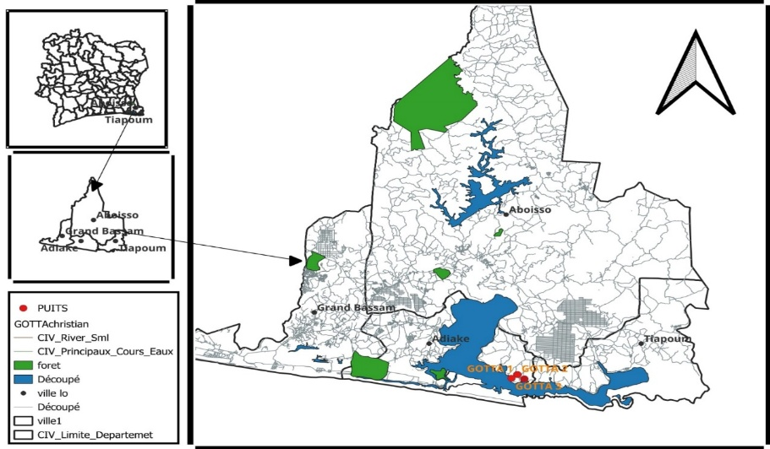
Fig. 1. Study area

2. Materials and methods
The methodology employed is based on grain-size analysis of the sandy fractions (63 µm to 2 mm) to characterise transport conditions and depositional environments. The samples underwent pre-treatment, including washing (to remove impurities and organic matter), drying, and sieving. The sandy fraction was used for grain-size analysis. The grain-size data were processed using Gradistat software to obtain quantiles and distributions.
Statistical parameters (mean, standard deviation, skewness, median, and mode), calculated using the formulas of Folk and Ward (1957), were used to evaluate the energy of palaeoflows and the degree of sediment sorting. Analysis of the grain-size curves (histograms, frequency distributions, and cumulative distributions) enabled the identification of different facies (sigmoidal, logarithmic, and parabolic) associated with the depositional processes.
Cumulative curves were also used to determine transport modes (suspension, saltation, and bedload transport) according to Visher (1969). Depositional environments were identified using the discriminant diagrams of Friedman (1967) and Moiola and Weiser (1968), which enabled the distinction between fluvial and coastal settings. Finally, morphoscopic analysis of quartz grains complemented the study by providing information on transport distance and sedimentary agents.
3. Results and discussion
3.1 Sedimentology
Macroscopic observation of the drill cuttings provided the lithological descriptions of the GOTTA 1, GOTTA 2, and GOTTA 3 wells. Analysis of the drill cuttings led to the following lithological divisions from the base to the top, together with the resulting interpretations.

3.1.1 Lithostratigraphy of the Formations in Wells GOTTA 1, GOTTA 2, and GOTTA 3
3.1.1.1 Lithostratigraphic Description of the Formations in Well GOTTA 1
Well GOTTA 1 extends to a depth of approximately 61 metres. The lithostratigraphy of this well comprises five lithological units: sand, clayey sand, sandy clay, clay, and lateritic crust. In the direction of sedimentation (from the base to the top), the sequence is as follows: a 36.8 m-thick sand unit interbedded with a 2 m-thick layer of sandy clay. This sand is overlain by a 2.35 m-thick layer of sandy clay and a 17.65 m-thick layer of clay. Above the clay, a 3.1 m-thick lateritic crust was deposited.
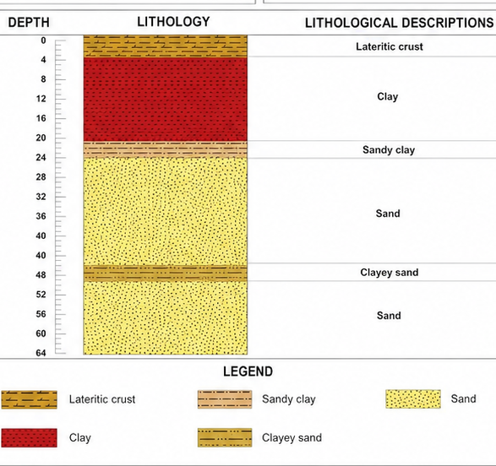

Fig. 2. Lithological log of the GOTTA 1 well

3.1.1.2 Lithostratigraphic Description of the Formations in the GOTTA 2 Well.
The GOTTA 2 well extends to a depth of approximately 60 metres. This well comprises six lithological units: sand, clayey sand, clay, sandstone, bedrock, and gravel. In the direction of sedimentation (from the base to the top), the sequence is as follows: a 14.35 m-thick sand unit interbedded with a thin, 1.5 m-thick layer of clayey sand. Above this sand, a 1.90 m-thick layer of clay was deposited, followed by a 1.75 m-thick layer of sandstone. Above the sandstone, there is a 15 m-thick layer of sand and a 20.95 m-thick layer of clay. Above the clay, a 4.6 m-thick layer of gravel and a 0.53 m-thick layer of fine gravel were deposited.
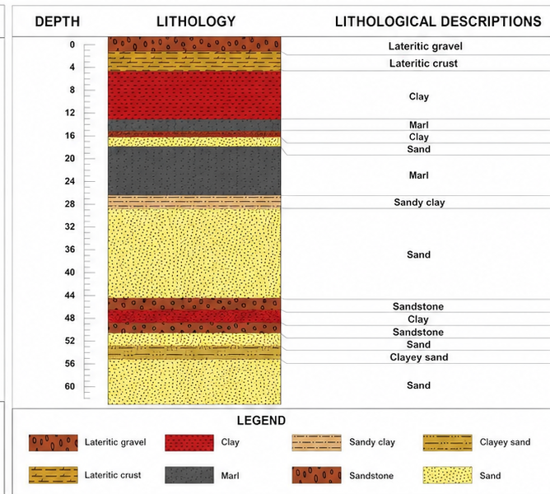

Fig. 3. Lithological log of the GOTTA 2 well.

3.1.1.3 Lithostratigraphic Description of the Formations in the GOTTA Well 3.
The GOTTA 3 well extends to a depth of approximately 46 metres. This well comprises three lithological units: sand, clayey sand, and clay. In the direction of sedimentation (from the bottom to the top), the sequence is as follows: a 28 m-thick sand unit interbedded with a thin, 2 m-thick layer of clayey sand. Above this sand, a 16 m-thick layer of clay was deposited.

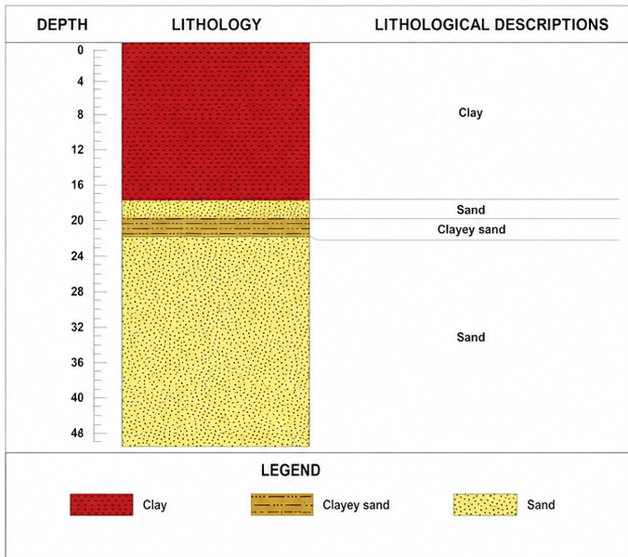

Fig. 4. Lithological log of the GOTTA 3 well

3.1.1.4 Lithological Interpretation
The red colour, associated with the presence of Fe₂O₃, indicates intense oxidation during diagenesis, often in a poorly confined, well-ventilated marine environment with moderate to high depositional energy. This type of colouration is evidence of active fluid circulation and prolonged exposure to oxygen. The yellow colour, caused by iron hydroxides such as goethite or limonite, results from the recent weathering of iron-bearing minerals. It is typical of a continental or transitional setting with low to moderate energy, often subject to intermittent phases of hydration and oxygenation in a semi-confined environment. Black indicates a large amount of organic matter or bitumen deposited in an anoxic or suboxic environment, generally confined, such as lagoons, marshes, or deep basins. The depositional energy is very low, and current dynamics are virtually non-existent, which promotes the accumulation of organic matter. The greyish colour results from the complete leaching of iron oxides, often in a well-drained continental environment with moderate energy, reflecting prolonged freshwater circulation. This type of deposit is common in fluvial transition zones. The variegated colours observed in sands and clays (kaolins) indicate partial leaching caused by irregular water flow in an unstable, poorly confined environment with variable environmental dynamics. This reflects water-level fluctuations and a random distribution of iron oxides and hydroxides. Finally, the brown colour, resulting from iron oxidation, indicates a prolonged period of sandy deposition in a well-oxygenated environment—often continental or coastal—with moderate depositional energy, reflecting relative current stability and good sediment aeration.
3.2 Lithological and Environmental Correlation of the GOTTA 1, GOTTA 2, and GOTTA 3 Wells
3.2.1 Lithological Correlation of the GOTTA Wells
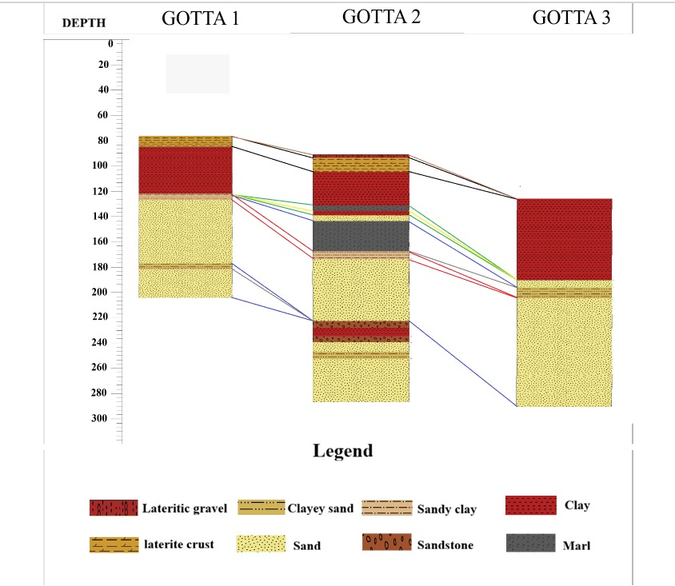
The three (3) wells examined contain relatively few layers; however, the GOTTA 2 well exhibits the greatest lithological diversity, meaning that it has the largest number of layers. Compared with the other wells (GOTTA 1 and GOTTA 3), certain layers are absent from GOTTA 2. Nevertheless, although the GOTTA 2 well exhibits the greatest lithological diversity, some lithological layers observed in the GOTTA 1 and GOTTA 3 wells are absent from GOTTA 2. These missing layers include: the lateritic crust with a yellow clay base, hardened crusted clay, blackish clay (marl), yellowish sandy clay, yellowish sand, purplish sand, brownish sand, yellowish clayey sand, coarse purplish sand, brownish sand, green sulfur-bearing clay, blackish (marl) sulfur-bearing clay containing liquid bitumen and limestone, bituminous sand, hardened sandy-clayey sandstone at the beginning of the section, yellowish clayey sand, fine- to medium-grained purplish sand with angular quartz, fine yellowish sand, coarse yellowish sand with quartz fragments, fine- to medium-grained purplish sand with angular quartz, coarse yellowish sand with subangular quartz fragments, and fine- to medium-grained brownish sand with quartz fragments. These various lithological layers are present in the GOTTA 1 and GOTTA 3 wells, but not in GOTTA 2.

Fig. 5. Lithological correlation of the GOTTA wells
Interpretation
There are two possible explanations for the absence of certain layers in the wells. The first explanation is that the layers were deposited and subsequently eroded by erosive agents (water and wind). According to the second explanation, the layers were not deposited because geological events, such as erosion, tectonic movements, and sea-level changes, interrupted or altered sediment deposition at the time of their formation.
3.2.2 Environmental Correlation of the GOTTA Wells
The sediments from the three wells examined show two (2) types of deposits: continental deposits and marine deposits near the continent. This is due to variations in sea level and environmental conditions at the time of sedimentation.
- At the GOTTA 1 well:
24.1 m to 60.9 m : Yellowish sand to brownish sand, continental deposits.
4.1 m to 24.1 m : Lateritic clay to yellowish sandy clay, nearshore marine deposits.
1 m to 4.1 m : Lateritic crust with a yellow clay base, continental deposit.
- At the GOTTA 2 well:
43.65 m to 59.45 m : Iron-rich sandstone to coarse brownish sand, continental deposits.
41.7 m to 43.65 m : Variegated clay interbedded with a hardened zone, continental deposit.
24.95 m to 41.7 m: Fine-grained greyish sand to iron-bearing sandstone, continental deposits.
15.95 m to 24.95 m: Sulfur-bearing marl (black clay) to hardened yellowish sandy clay, near-shore marine deposits.
14.52 m to 15.95 m: Hardened, armored fine sand, continental deposit.
4 m to 14.52 m: Lateritic clay to clay with bituminous intrusions, near-shore marine deposits.
0.27 m to 4 m: Lateritic gravel to clayey sand to iron-rich lateritic crust with a yellowish base, continental deposits.
- At the GOTTA 3 well:
0.9 m to 17.9 m: Lateritic clay to blackish clay (marl) containing sulfur, liquid bitumen, and limestone; near-shore marine deposits
17.9 m to 45.9 m: Bituminous sand to brownish sand with fine to medium grain size and quartz
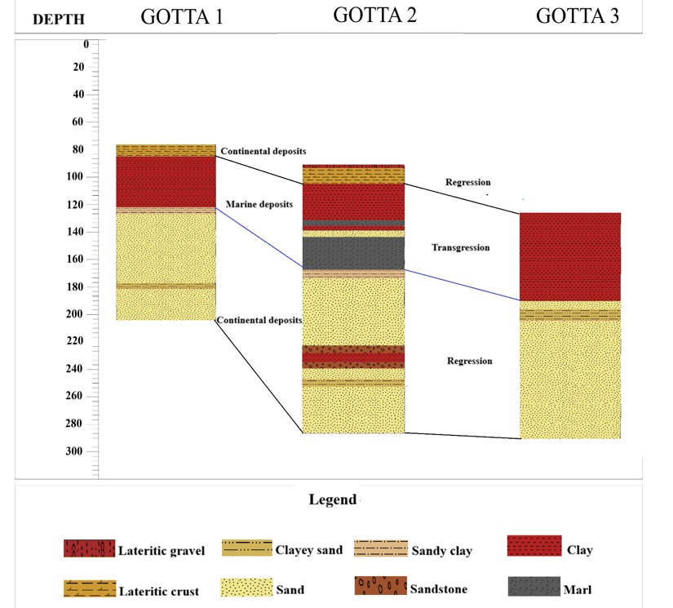
fragments; near-shore marine deposits.

Fig. 6. Environmental Correlation of the GOTTA Wells
Interpretation
The sediments in the studied wells were deposited according to grain size and depositional energy. Coarse- and medium-sized grains were deposited under high- and medium-energy conditions, respectively, in a turbulent environment, whereas fine grains were deposited under low depositional-energy conditions in a calm environment. The marine deposits near the continent are attributed to the presence of both clay (marine environment) and sand (continental environment). These sediments were deposited through two (2) sequences:
- The transgressive sequence, during which sediments were deposited as water levels rose, and the regressive sequence, characterised by a drop in water level, during which they were exposed.
- The presence of iron-rich sandstone is attributed to the sediments’ exposure to sunlight following a drop in water level.

3.3 Grain Size Distribution of Sands from Different Wells
Grain-size analysis identified various parameters relating to grain-size distribution, grain-size facies, transport mode, and the depositional environment of the sandy fractions for each well.
3.3.1 Grain-size parameters
Grain-size distribution parameters are used to determine the mean grain size (Mz), grain size sorting (So), and asymmetry (Sk). The values of the various grain-size parameters are expressed in phi (Փ).
Table 1. Particle size parameters for the GOTTA 1 well
Ech | Mz | So | Sk | Analysis
E28 | 1,404 | 0,823 | -0,384 | Medium-grained sand, moderately graded, highly asymmetrical toward the coarser grains
E35 | 1,348 | 0,823 | -0,309 | Medium-grained sand, moderately graded, highly asymmetrical toward the coarser grains
E25 | 1,614 | 1,023 | -0,150 | Medium-grained sand, poorly graded, with a tendency toward coarser grains
E34 | 0,831 | 1,006 | 0,089 | Coarse sand, poorly graded, symmetrical
E33 | 0,739 | 1,078 | 0,007 | Coarse sand, poorly graded, symmetrical
E32 | 0,775 | 1,120 | -0,007 | Coarse sand, poorly graded, symmetrical
E30 | 1,359 | 0,850 | -0,314 | Medium-grained sand, moderately graded, highly asymmetrical toward the coarser grains
E24 | 1,712 | 0,980 | -0,141 | Medium-grained sand, moderately graded, asymmetrical toward the coarser grains
E36 | 1,315 | 1,169 | -0,261 | Medium-grained sand, poorly graded, with a tendency toward coarser grains
E26 | 1,755 | 0,952 | -0,146 | Medium-grained sand, medium-sized, asymmetrical toward the coarser grains

Table 2. Particle size parameters for the GOTTA 2 well
Ech | Mz | So | Sk | Analysis
E24 | 1,880 | 0,825 | -0,061 | Medium sand, moderately graded, symmetrical
E26 | 2,161 | 1,022 | -0,585 | Fine sand, of poor quality, highly asymmetrical toward the coarser grains
E23 | 1,143 | 0,842 | 0,290 | Medium-grained sand, medium-sized, asymmetrical toward the finer grains
E28 | 1,638 | 0,882 | -0,151 | Medium-grained sand, medium-sized, asymmetrical toward the coarser grains
E36 | 1,819 | 0,993 | -0,208 | Medium-grained sand, medium-sized, asymmetrical toward the coarser grains
E27 | 1,656 | 0,909 | -0,156 | Medium-grained sand, medium-sized, asymmetrical toward the coarser grains
E38 | 1,309 | 0,770 | -0,380 | Medium-grained sand, moderately graded, highly asymmetrical toward the coarser grains
E29 | 1,418 | 0,733 | -0,361 | Medium-grained sand, moderately graded, highly asymmetrical toward the coarser grains
E33 | 1,131 | 0,988 | -0,390 | Medium-grained sand, moderately graded, highly asymmetrical toward the coarser grains
E37 | 1,150 | 0,826 | 0,254 | Medium-grain sand, medium-grade, asymmetrical toward the ends
Table 3. Particle size parameters for the GOTTA 3 well
Ech | Mz | So | Sk | Analysis
E31 | 1,625 | 0,806 | -0,030 | Medium sand, moderately graded, symmetrical
E25 | 1,638 | 0,911 | -0,109 | Medium-grained sand, medium-sized, with a tendency toward coarser grains
E24 | 2,301 | 0,698 | -0,548 | Fine sand, medium-grained, with a strong asymmetry toward coarser grains
E16 | 1,713 | 0,814 | -0,020 | Medium sand, moderately graded, symmetrical
E17 | 1,762 | 0,817 | -0,009 | Medium sand, moderately graded, symmetrical
E18 | 1,357 | 0,752 | -0,298 | Medium-grained sand, medium-sized, with a tendency toward coarser grains
E20 | 1,616 | 0,805 | -0,004 | Medium sand, moderately graded, symmetrical
E22 | 1,742 | 0,846 | -0,026 | Medium sand, moderately graded, symmetrical
E27 | 1,410 | 0,920 | -0,455 | Medium-grained sand, moderately graded, with a strong asymmetry toward the coarser grains
E28 | 1,666 | 0,864 | 0,033 | Medium sand, moderately graded, symmetrical
E29 | 1,298 | 1,334 | -0,323 | Medium-grained sand, poorly graded, with a strong tendency toward coarser grains

3.3.1.1 Medium
The sandy fractions of the sediments consist of three grain types: coarse sand, medium sand, and fine sand.
Coarse sand : This type of coarse sand is found only in the GOTTA 1 well in samples E34, E33, and E32, with grain sizes ranging from 0.73 Փ < Mz < 0.83 Փ.
Medium sand : Medium sand is found in all wells. The medium sand in the GOTTA 1 well is found in the intervals of E28, E35, E25, E30, E24, E36, and E26, with grain sizes ranging from 1.34 Փ < Mz < 1.75 Փ. For well GOTTA 2, the fine sands in question are those from samples such as E24, E23, E28, E36, E27, E38, E29, E33, and E37. The average grain size of the medium sands ranges from 1.13 Փ < Mz < 1.88 Փ. And those from the GOTTA 3 well are present in samples E3, E25, E16, E17, E18, E20, E22, E27, E28, and E29, with sizes ranging from 1.29 Փ < Mz < 1.74 Փ.
Fine sands : These sands are present in the GOTTA 2 and GOTTA 3 wells. The fine sands from the GOTTA 2 well are found in sample E26, with a grain size of 2.16 Փ. In the GOTTA 3 well, fine sands are found in sample E24, with an average grain size of 2.30 Փ.

Interpretation of Grain Size
The variations observed in grain size depend on the distance the sediments have travelled in the aquatic environment, as well as on the strength of the transport energy. The greater the distance from their source, the smaller the sediment size becomes. Furthermore, the larger the sediment size (coarser), the greater the transport energy.
3.3.1.2 Sorting
Sorting distinguishes between two (2) types of grading: moderately graded and poorly graded.
Moderately graded sands : These sands are found in all three (3) wells. For the GOTTA 1 well, the sorting value ranges from 0.82 < σ < 0.98 in samples E28, E35, E30, E24, and E26. For the GOTTA 2 well, the sorting value ranges from 0.77 < σ < 0.98 in samples E24, E23, E28, E36, E27, E38, E29, E33, and E37; overall, the sorting value ranges from 0.77 < σ < 0.99. For the GOTTA 3 well, the sorting value ranges from 0.69 < σ < 0.92. The samples include E31, E25, E24, E16, E17, E18, E20, E22, E27, and E28.
Poorly graded sands : This type of grading is found in all three (3) wells. In the GOTTA 1 well, it occurs in samples E25, E34, E33, E32, and E36, with values ranging from 1.00 < σ < 1.16. The poorly sorted sands in the GOTTA 2 well are found in sample E26, with a value of 1.02, while those in the GOTTA 3 well are found in sample E29, with a sorting value of 1.33.
Interpretation of the Sorting
The sorting reflects a mixture of grain sizes. This mixture may result from a sudden decrease in transport energy or from the confluence of watercourses.
3.3.1.3 Skewness
Sediments in the eastern part of the Ivorian onshore basin are characterised by four (4) types of skewness: curves skewed towards coarse grains, curves highly skewed towards coarse grains, nearly symmetrical curves, and curves skewed towards fine grains.
Skew toward the coarser grains : This skewness is observed in all three (3) wells. The skewness value ranges from -0.14 < Sk < -0.26 for the GOTTA 1 well; between -0.15 < Sk < -0.20 for well GOTTA 2; and between -0.10 < Sk < -0.29 for well GOTTA 3.
Highly skewed toward coarse grains : This skewness is observed in all three (3) wells. The skewness value ranges from -0.30 < Sk < -0.38 for well GOTTA 1; from -0.39 < Sk < -0.58 for well GOTTA 2; and from -0.32 < Sk < -0.54 for well GOTTA 3.
Nearly symmetrical : The sands in the GOTTA 1 well that are skewed towards coarser grains have skewness values ranging from -0.007 < Sk < -0.08. GOTTA 2 sample E24 has a skewness value of -0.06, while values in the GOTTA 3 well range from -0.004 < Sk < -0.03.
Asymmetric towards fine grains : This type is found only in the GOTTA 2 well (E23 and E37). The skewness value ranges from 0.25 < Sk < 0.29.
3.3.2 Grain-size facies of the sands
The semi-logarithmic cumulative curves for the sands studied in the three wells show a sigmoidal grain-size facies.
3.3.2.1 Grain-size facies of the sands in the GOTTA 1 well
The sands in the GOTTA 1 well are of the sigmoid type.

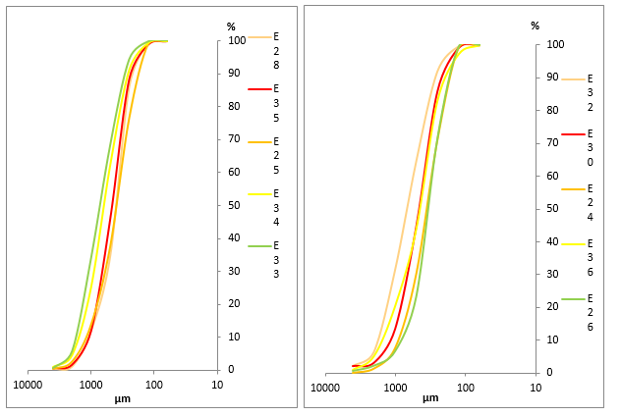

Fig. 7. Sigmoid facies of the sands in the GOTTA 1 well
3.3.2.2 Grain-size facies of the sands in the GOTTA 2 well
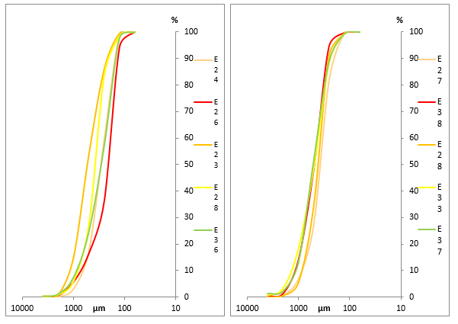
The sands exhibit a sigmoidal trend.

Fig. 8. Sigmoid facies of the sands in the GOTTA 2 well

3.3.2.3 Grain-size facies of the sands in the GOTTA 3 well
The sands in the GOTTA 3 well exhibit a sigmoidal grain-size facies.

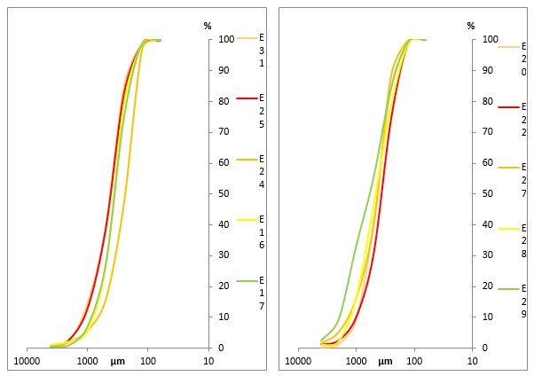

Fig. 9. Sigmoid facies of the sands in the GOTTA 3 well
Interpretation of the grain-size facies
The sigmoid facies shows a gradual reduction in the transport agent (Pinot, 1994) and suggests sedimentation by free accumulation.
3.3.3 Transport modes of sands
According to Visher’s diagram (1969), the loose sediments from the wells show three (3) populations (A-B-C), with population C being the most dominant. This can be explained by the fact that the sediments are generally transported by bedload.
3.3.3.1 Mode of transport of sands from the GOTTA 1 well
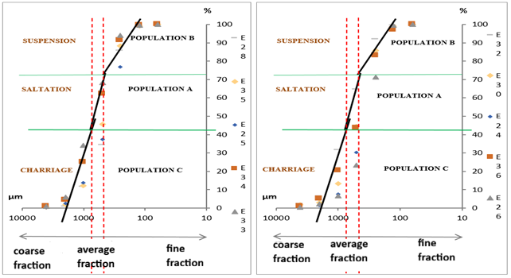
Analysis of these samples shows that rolling (60%) is the dominant mode of transport, followed by saltation (30%) and suspension (10%).

Fig. 10. Diagram of the transport mechanism for sand from the GOTTA 1 well
3.3.3.2 Mode of transport of sediments from the GOTTA 2 well
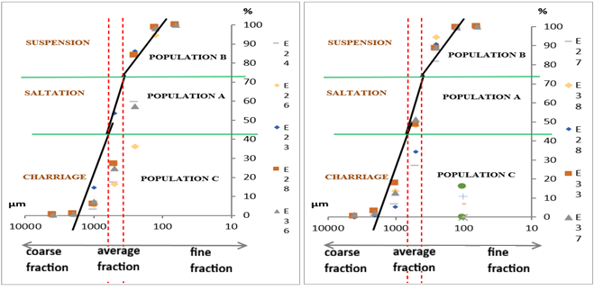
Samples from GOTTA 2 show that rolling (85%) is slightly more prevalent than suspension (10%), followed by saltation (5%).

Fig. 11. Diagram of the sand transport mechanism in the GOTTA 2 well

3.3.3.3 Mode of transport of sediments from the GOTTA 3 well
Samples from GOTTA 3 show that rolling (85%) is slightly more prevalent than rolling (10%), followed by suspension (5%).
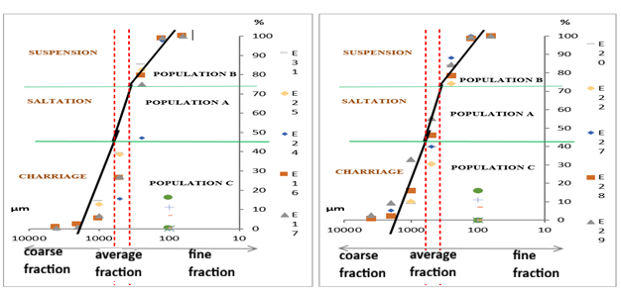

Fig. 12. Diagram of the transport mechanism for sand from the GOTTA 3 well
Interpretation of the mode of sand transport
Rolling : With an average of 65%, this is the dominant mode of transport and indicates that heavy or large grains move along the bottom. This implies that the area has sufficient bottom dynamics to move the grains by rolling.
Saltation : With an average of 25%, this indicates that medium-sized grains move by saltation. This means that currents are sometimes capable of lifting the grains, but are not always strong enough to keep them in suspension.
Suspension : Also averaging 10%, this indicates that the hydrodynamic conditions in the area are strong enough to keep some of the grains in suspension. This phenomenon may be associated with significant turbulence or strong currents that prevent the grains from settling quickly.
3.3.4 Sand Deposition Environment
The distribution of points in the Md-So diagram reveals that 50% of the sediments originate from the river domain and 50% from the beach domain. Furthermore, the Sk-Md diagram shows a scatter plot in which 60% of the data points are concentrated in the coastal dune domain and 40% in the continental dune domain. Based on this grain-size distribution, it can be concluded that the sediments in the Mohoua area consist primarily of river and coastal dune sands (Figs. 13, 14, and 15).
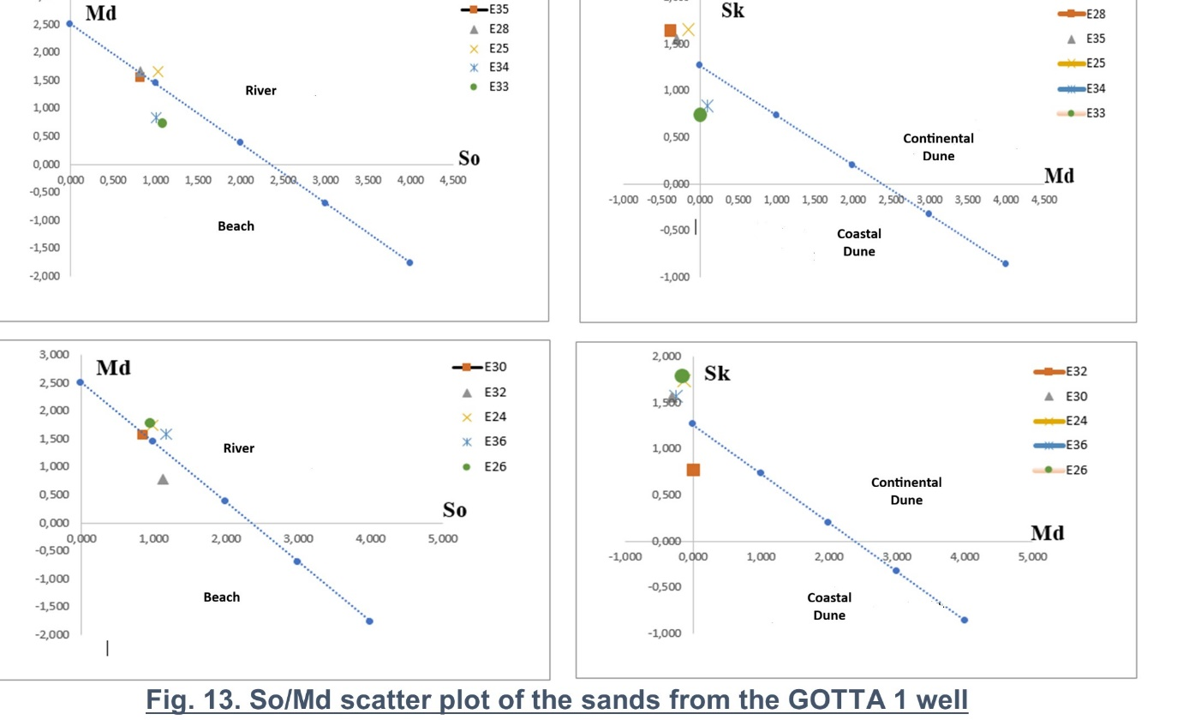
Fig. 13. So / Md Scatter plot of the sands from the Gotta 1 Well

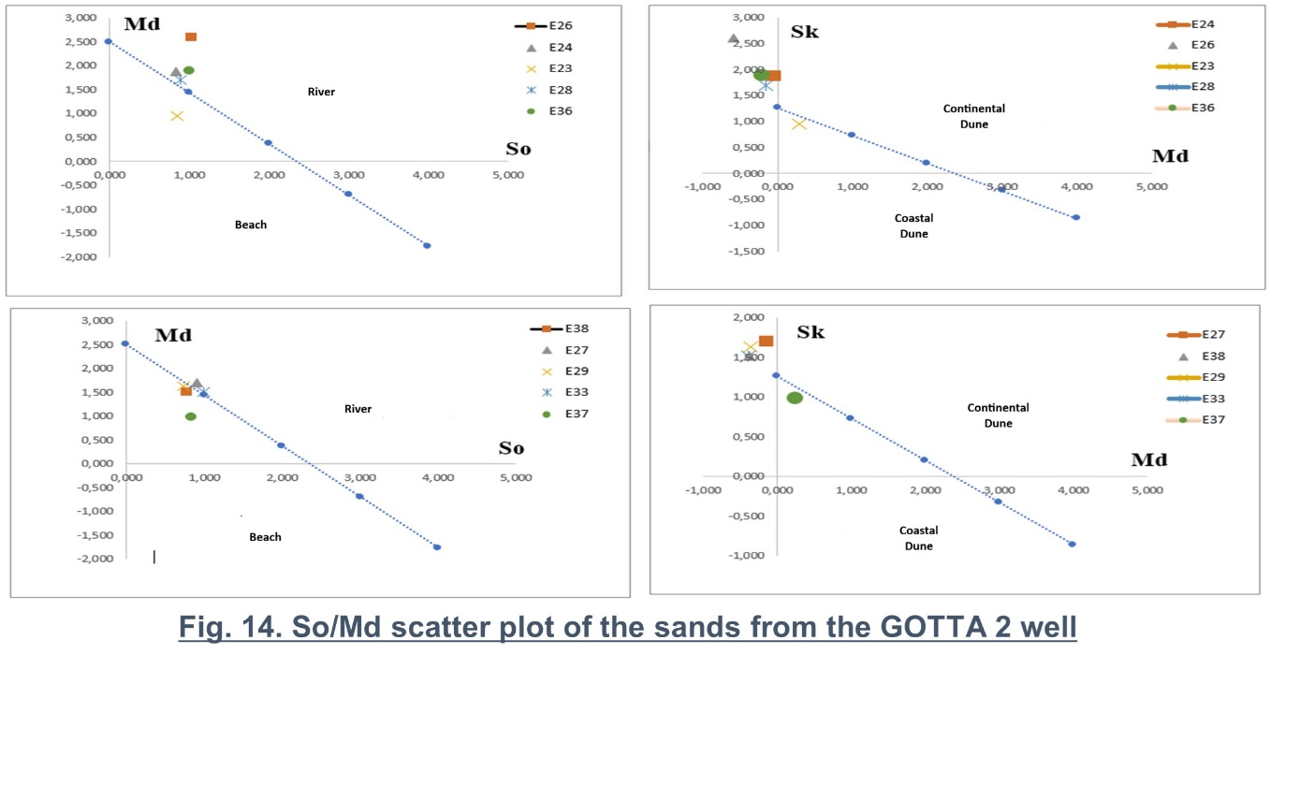
Fig. 14. So / Md Scatter plot of the sands from the Gotta 2 Well

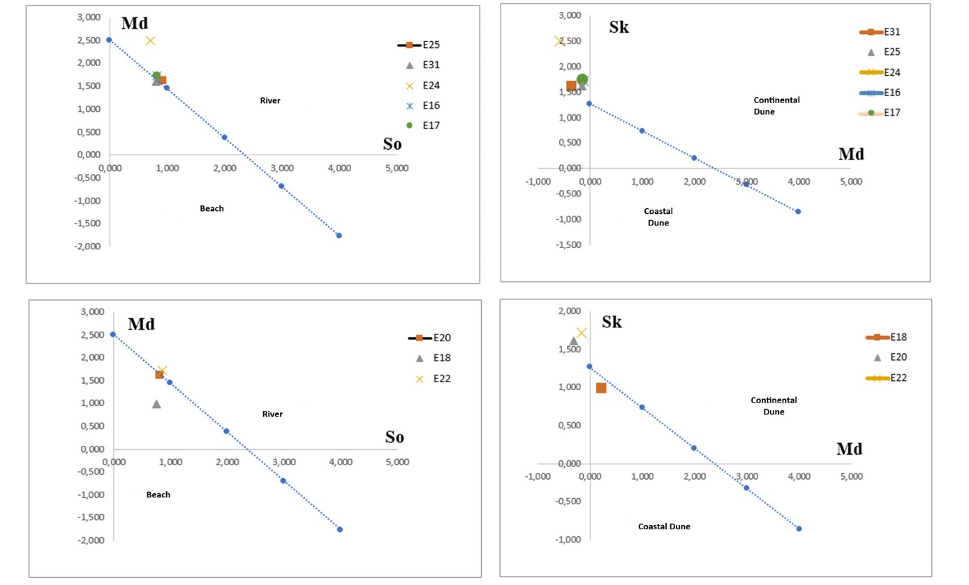
Fig. 15. So / Md Scatter plot of the sands from the Gotta 3 Well

Interpretation of the depositional environment
Sediments originating from the river system account for 50% of the total: this indicates a significant contribution from fluvial sources, likely related to upstream soil erosion and the transport of fine particles by watercourses. Sediments originating from the beach system also account for 50%: this suggests a marine influence, with sediments transported by waves and tides from surrounding beaches. The presence of sediments originating from both the river and the beach indicates a complex interaction between fluvial and marine environments. Coastal dune sands account for 60% of the sediments: coastal dunes are formed by wind action, which transports and deposits sand grains. Their presence indicates active aeolian processes in the coastal region. Continental dune sands account for 40% of the sediments: these sediments originate from inland dunes, which are also formed by wind action but in a more continental setting. The distribution of sediments between coastal and continental dunes indicates variations in depositional conditions, such as wind speed and direction, as well as fluctuations in sea level.
3.3.5 Morphology of Quartz Grains
The grains in the sediments from the three (3) boreholes are subrounded (60%), rounded (10%), subangular (8%), and angular (2%). The rounded grains were transported over a long distance, while the subangular and subrounded grains were transported over a medium distance. The angular grains, on the other hand, were transported over a short distance. The whitish quartz grains observed are blunt and glossy, indicating that they were transported by water, and they show cracks likely caused by collisions between grains during transport. Overall, subrounded grains (60%) predominate. The orange and orange-yellow grains have a matte surface, suggesting they were transported by wind. These grains are primarily subrounded to rounded.
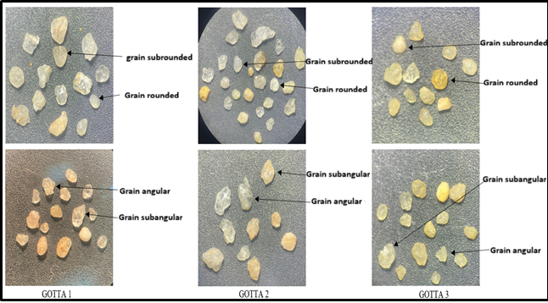

Fig. 16. Morphological examination of several quartz grains from the GOTTA wells

4. Conclusion
Sedimentological evidence from the GOTTA 1, GOTTA 2, and GOTTA 3 wells shows that the Mohoua subsurface succession is dominated by sandy deposits with clayey intervals and locally occurring lateritic, sandstone, gravel, and marl units. Grain-size distributions are mainly medium sand, with local coarse- and fine-sand fractions, and exhibit moderate to poor sorting and variable skewness. The sigmoidal cumulative curves indicate progressive reduction in transport capacity during deposition. Transport-mode interpretations show an important bedload component, accompanied by saltation and suspension. Depositional-environment discrimination indicates both river and beach affinities, together with coastal- and continental-dune signatures. Quartz morphoscopy further records mixed transport histories: predominantly subrounded grains indicate appreciable transport, glossy surfaces support aqueous transport, and matte surfaces indicate an aeolian contribution. Taken together, these observations support a depositional system shaped by interacting fluvial, coastal-marine, and aeolian processes, with hydrodynamic conditions varying through the stratigraphic succession across the three wells within the study area.

Limitations
The interpretation is based on lithological descriptions of well cuttings, grain-size characteristics of sandy fractions, cumulative-curve analysis, depositional discrimination diagrams, and quartz-grain morphoscopy from three wells. Consequently, the reconstructed environments represent sedimentological tendencies at the sampled borehole locations rather than a continuous spatial model of the wider eastern onshore basin. The environmental interpretation integrates multiple sedimentological indicators, but the relative influence of fluvial, coastal-marine, and aeolian processes should be understood as specific to the analysed materials and the stratigraphic intervals represented in the GOTTA wells.

Declaration of AI Use

This manuscript was prepared through the intellectual contributions of the author(s) to the study design, data analysis, interpretation of results, and scholarly content. Grammarly and ChatGPT were used solely to assist with grammatical refinement and reference formatting during manuscript revision. The author(s) accept full responsibility for the accuracy, integrity, and final content of the manuscript.

References

Aimé, G. B. Y., Mathurin, S. A. A., Albéric, A. C., Sylvain, S. Z., Marie-Paule, K. C. J., & Sylvain, M. (2024). Characterisation and spatial distribution of sediments on the Côte d’Ivoire continental shelf (Abidjan to Assinie). Journal of Geography, Environment and Earth Science International, 28(10), 101–115. https://doi.org/10.9734/jgeesi/2024/v28i10828
Assalé, F. Y. P. (2013). Caractérisation sédimentologique, palynologique, géochimique et paléoenvironnementale des formations sédimentaires connexes à la faille des lagunes (Est du bassin onshore de Côte d’Ivoire) [Doctoral dissertation, Université Félix Houphouët-Boigny].
Bié, G. R., Digbéhi, Z. B., Yao, K. R., Téa-Yassi, J., Kangah, K. D., & Tahi, I. (2012). Stratigraphie palynologique du Maastrichtien supérieur–Éocène supérieur du bassin sédimentaire offshore de Côte d’Ivoire, Afrique de l’Ouest. International Journal of African Studies, 6, 40–57.
Blarez, E. (1986). La marge continentale de Côte d’Ivoire-Ghana : Structure et évolution d’une marge continentale transformante [Doctoral dissertation, Université Paris VI]. https://theses.fr/1986PA066020
Chierici, M. A. (1996). Stratigraphy, palaeoenvironments and geological evolution of the Ivory Coast-Ghana basin. In S. Jardiné, I. de Klasz, & J.-P. Debenay (Eds.), Géologie de l’Afrique et de l’Atlantique Sud (Mémoire 16, pp. 293–303). Elf Aquitaine.
Dahunsi, A. M., Dada, O. A., Bonou, F., & Baloïtcha, E. (2024). Spatio-temporal variations of future wave climate-driven longshore sediment transport in the Gulf of Guinea. Coastal Engineering Journal, 66(2), 234–269. https://doi.org/10.1080/21664250.2023.2290316
Digbehi, Z. B. (1987). Étude comparée de la sédimentation des premiers stades d’ouverture de l’Atlantique : Golfe de Guinée–Golfe de Gascogne. Sédimentologie, biostratigraphie [Doctoral dissertation, Université de Pau et des Pays de l’Adour].
Digbehi, Z. B., Guédé, K. E., Yao, N. J.-P., Affian, K., Toé Bi, K. K. K., Yao, K. R., & Tahi, I. (2011). Palynostratigraphy and depositional palaeoenvironment of Cretaceous-Palaeogene (K-Pg) boundary deposits on Abidjan margin (Côte d’Ivoire). Journal of Geography and Regional Planning, 4(11), 644–655. https://doi.org/10.5897/JGRP.9000110
Djeya, K. L., Digbehi, Z. B., Affian, K., Goua, T. E., Kouamé, N. J., N’da, L. V., & Yao, K. R. (2010). Apport de l’étude sédimentologique et microfaunistique à la caractérisation biostratigraphique et paléoenvironnementale des dépôts d’âge crétacé supérieur de Côte d’Ivoire. BIOTERRE: Revue Internationale des Sciences de la Vie et de la Terre, 10, 38–52. https://www.revues-ufhb-ci.org/fichiers/FICHIR_ARTICLE_25.pdf
Essefi, E., Hajji, S., & Bedoui, S. (2022). Pollution and sedimentary change along a core from the subtidal of the coast of Sfax, southeastern Tunisia. Asian Journal of Plant and Soil Sciences, 7(1), 288–293. https://doi.org/10.56557/ajopss/2022/v7i162
Folk, R. L., & Ward, W. C. (1957). Brazos River bar [Texas]: A study in the significance of grain size parameters. Journal of Sedimentary Research, 27(1), 3–26. https://doi.org/10.1306/74D70646-2B21-11D7-8648000102C1865D
Friedman, G. M. (1967). Dynamic processes and statistical parameters compared for size frequency distribution of beach and river sands. Journal of Sedimentary Research, 37(2), 327–354. https://doi.org/10.1306/74D716CC-2B21-11D7-8648000102C1865D
Gbangbot, J.-M. K., Digbehi, Z. B., Yao, N. J.-P., Mondé, S., & Yao, A. N. (2012). Lithostratigraphie des dépôts de subsurface des régions de Bingerville et d’Assinie, Sud et Sud-est, Basse Côte d’Ivoire : Essai de comparaison des environnements de dépôts au cours du Tertiaire. European Journal of Scientific Research, 86(1), 41–52. https://univ-ujlog.academia.edu/Departments/Environnement/Documents
Jardine, S., & Magloire, L. (1965). Palynologie et stratigraphie du Crétacé des bassins du Sénégal et de Côte d’Ivoire. Mémoires du Bureau de Recherches Géologiques et Minières, 32, 187–245. https://pascal-francis.inist.fr/vibad/index.php?action=getRecordDetail&idt=19271820
Kouamé, L. N., Djroh, S. P., Kouadio, F. J.-L. H., Coulibaly, L., & Sombo, B. C. (2018). Mise en évidence d’un autre style structural de la marge continentale de la Côte d’Ivoire à partir de la sismique réflexion : Compression et magmatisme. International Journal of Engineering Science Invention, 7(10), 19–27. https://www.ijesi.org/papers/Vol%287%29i10/Version-3/D0710031927.pdf
Li, L., Li, Q., Cheng, T., Yang, S., Rao, Y., Liu, X., & Ding, W. (2024). Geochemical characteristics and origins of natural gases in the eastern Cote d’Ivoire Basin, West Africa. Acta Oceanologica Sinica, 43(8), 26–36. https://doi.org/10.1007/s13131-024-2335-6
Loukou, B. H.-J. (1999). Étude palynologique de la série marine Paléocène–Éocène du puits Tiémé-1 [DEA dissertation, UFR Sciences de la Terre et des Ressources Minières, Université d’Abidjan].
Moiola, R. J., & Weiser, D. (1968). Textural parameters: An evaluation. Journal of Sedimentary Research, 38(1), 45–53. https://doi.org/10.1306/74D718C5-2B21-11D7-8648000102C1865D
Pinot, J.-P. (1994). Manipulations sédimentologiques courantes (M.W. TURGAL.07.SEDI, édition de février 1994).
Sombo, B. C., Djro, S. C., Yacé, P., & Bobier, C. (2003). Marge ivoirienne et ouverture de l’Atlantique Sud : Analyse synthétique. BIOTERRE: Revue Internationale des Sciences de la Vie et de la Terre, 3(1), 69–97.
Visher, G. S. (1969). Grain size distributions and depositional processes. Journal of Sedimentary Research, 39(3), 1074–1106. https://doi.org/10.1306/74D71D9D-2B21-11D7-8648000102C1865D

