1
2
3
4
5
6
7
8
9
10
11
12
13
14
15
16 .

Hydrological Condition Analysis Using the SWAT Model and Statistical Analysis Based on Streamflow and Sediment Yield in the Bajing Sub-Watershed, Jember, Indonesia

17 ABSTRACT
18
This study aimed to assess the hydrological conditions of the Bajing Sub-watershed, Jember, Indonesia, by integrating the Soil and Water Assessment Tool (SWAT) with statistical analysis of streamflow and sediment yield to provide scientific evidence for sustainable watershed management. A quantitative approach combining GIS-based spatial analysis, SWAT hydrological modelling, and statistical analysis was applied using climate, land cover, soil, and topographic data for the 2016–2024 period. Streamflow and sediment yield were simulated at the watershed outlet and analysed using descriptive statistics, coefficient of variation (CV), trend analysis, boxplots, and linear regression to evaluate hydrological variability and the relationship between streamflow and sediment yield. The Bajing Sub-watershed was dominated by forest cover (67.90%), Andisols (54.60%), and flat to gentle slopes (51.35%), indicating generally favourable watershed conditions. Simulated streamflow ranged from 2.24 to 430.00 m³/s, with a mean of 132.93 m³/s (CV = 73.17%), while sediment yield ranged from 0 to 1.60 tons, with a mean of 0.30 tons (CV = 113.90%). A strong positive correlation was observed between streamflow and sediment yield (r = 0.90), with streamflow explaining 81% of sediment-yield variability (R² = 0.81). Despite the predominance of forest cover, high seasonal variability in streamflow indicates that intense rainfall and steep slopes may increase runoff and sediment transport during peak-flow periods. Integrating SWAT simulation with statistical analysis effectively characterised the hydrological dynamics of the Bajing Sub-watershed and identified key factors influencing streamflow and sediment transport. The findings provide a scientific basis for sustainable watershed management by emphasising the importance of maintaining forest cover, implementing soil conservation on steep slopes, and controlling land-use change to reduce erosion risk and preserve watershed hydrological functions.
19
20 Keywords: SWAT Model, Streamflow, Sediment Yield.
21
22
23

24 1. INTRODUCTION
25
- Watersheds are fundamental hydrological units that regulate the movement, storage, and
- distribution of water through the interaction of climate, topography, soil properties, and land
- use. The hydrological condition of a watershed is commonly evaluated through streamflow
- and sediment yield, which serve as key indicators of watershed health, water resource
- sustainability, and land degradation. Well-maintained vegetation cover enhances infiltration,
- reduces surface runoff, sustains baseflow, and minimises soil erosion, thereby contributing to
- stable hydrological processes. Conversely, land degradation and land-use changes can
- significantly alter watershed hydrological responses by increasing runoff, peak discharge, and
- sediment transport. In Jember Regency, East Java, Indonesia, the Mayang Watershed is one
- of the most important river basins, covering approximately 33% of the regency's total area and
- supplying water for agriculture, domestic consumption, and industrial activities. Consequently,
- understanding its hydrological condition is essential for sustainable watershed management.

- Over the past decades, the Mayang Watershed has experienced considerable land-use
- changes, particularly the conversion of forested areas into intensive agricultural land and the
- expansion of built-up areas. These changes have been reported to increase hydrological
- hazards, especially flooding in downstream regions (Hakim et al., 2023; Indarto et al., 2023).
- The reduction in natural vegetation decreases infiltration capacity while increasing surface
- runoff and peak streamflow. Furthermore, land degradation in the upstream area has
- accelerated soil erosion, generating substantial sediment loads transported through the river
- network (Rafif et al., 2024). Excessive sediment transport not only reduces river conveyance
- capacity through sediment deposition but also increases flood susceptibility and degrades
- aquatic ecosystems. Therefore, streamflow and sediment yield are essential hydrological
- variables for assessing watershed conditions and identifying potential environmental
- degradation.

- Accurate assessment of watershed hydrological processes requires a physically based
- hydrological model capable of representing spatial heterogeneity. The Soil and Water
- Assessment Tool (SWAT) has been widely applied worldwide to simulate watershed
- hydrology, including surface runoff, streamflow, soil erosion, and sediment yield under various
- land-use and climatic conditions. The model has demonstrated reliable performance in tropical
- watersheds, including those in Indonesia (Kardhana et al., 2024). The accuracy of SWAT
- simulations largely depends on the quality of climatic, land-use, topographic, and soil datasets,
- as demonstrated by previous studies on SWAT parameter sensitivity. Although SWAT
- effectively simulates hydrological processes, model outputs require statistical evaluation to
- better characterise watershed behaviour. Statistical indicators such as maximum, minimum,
- mean, standard deviation, coefficient of variation, temporal trends, and the relationship
- between streamflow and sediment yield provide additional insights into watershed hydrological
- dynamics and variability (Liu et al., 2024; Chelkeba Tumsa, 2023).
- Recent SWAT+ evaluations indicate that combining performance metrics can strengthen
- model assessment, while uncertainty analysis highlights input data quality
- (Cecconello et al., 2025). Recent SWAT studies support joint runoff/streamflow and sediment-yield analysis for
- evaluating watershed responses (Weleslasie & Seyoum, 2026; Dogiso et al., 2025).
- Integrated morphometric and land-use/land-cover analysis can support spatial
- prioritization of watershed management units (Keshri et al., 2024).

- The Bajing Sub-Watershed, one of the upstream catchments within the Mayang Watershed,
- is characterised by predominantly forested land cover and hilly to mountainous terrain.
- Although no major flood events have been recorded in this sub-watershed, ongoing land-use
- changes may alter its hydrological response in the future. Despite its strategic role in
- maintaining downstream hydrological stability, comprehensive studies investigating
- streamflow and sediment yield characteristics in the Bajing Sub-Watershed remain limited,
- particularly those integrating physically based hydrological modelling with statistical analysis.
- Such information is crucial for understanding flow variability, sediment production, and the
- interaction between hydrological processes within the watershed.

- Provide a factual background, clearly defined problem, proposed solution, a brief literature survey and the scope
- and justification of the work done.
- Therefore, this study aims to analyse the hydrological condition of the Bajing Sub-Watershed
- using the SWAT model integrated with statistical analysis of simulated streamflow and
- sediment yield. Specifically, the study (i) evaluates the temporal characteristics of streamflow
- and sediment yield, (ii) quantifies hydrological variability using descriptive and trend statistics,
- and (iii) examines the relationship between streamflow and sediment yield as indicators of
- watershed condition. The findings are expected to provide scientific evidence supporting
- sustainable watershed management and conservation planning in the Mayang Watershed and
- other tropical watersheds with similar environmental characteristics.
82

2. MATERIAL AND METHODS
- 2.1 STUDY AREA
- The study was conducted in the Bajing Sub-Watershed, which is part of the Mayang
- Watershed located in Jember Regency, East Java, Indonesia. The study area covers portions
- of Tempurejo and Mumbulsari Districts and is geographically located between 8°18′02.2″–
- 8°21′09.5″ S and 113°40′41.8″–113°45′51.8″ E (Figure 1).
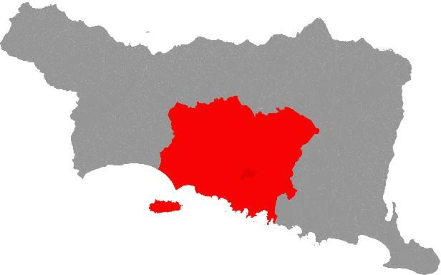
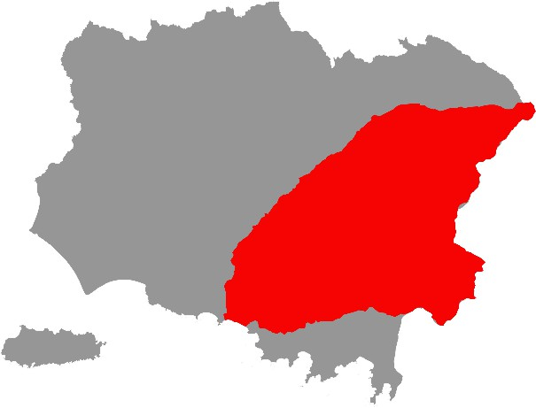

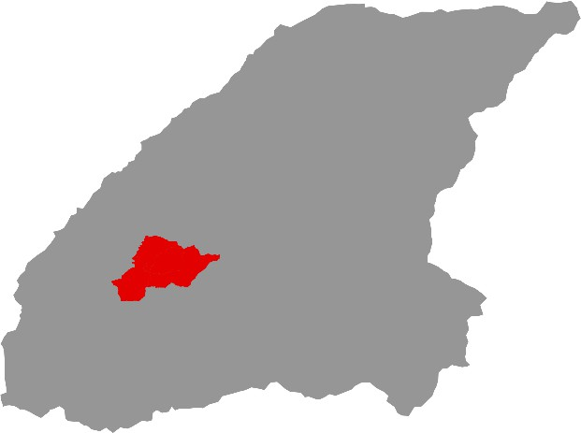

89

Fig. 1. Location of the Bajing Sub-Watershed

- This study utilised both primary and secondary datasets. Primary data consisted of field soil
- surveys and laboratory analyses, whereas secondary data included soil type, topographic,
- land-use, and climatic datasets. The SWAT (Soil and Water Assessment Tool) model was
- employed to simulate watershed hydrological processes, particularly streamflow and sediment
- yield. Spatial analyses were conducted using Landsat 8 Operational Land Imager/Thermal
- Infrared Sensor (OLI/TIRS) and Sentinel-2 MultiSpectral Instrument (MSI) satellite imagery.
- Land-use and land-cover (LULC) changes were identified using a supervised classification
- approach based on the Maximum Likelihood algorithm.
99

100 Table 1. Data sources used in this study.
Data Type | Data Source
Satellite imagery (Landsat 8 OLI/TIRS and Sentinel-2 MSI) | USGS, ESA
Rainfall and climate data | NASA POWER, BMKG Jember
Soil type and topographic data | DEMNAS, FAO
Field soil observations and laboratory analyses | Field survey and laboratory analysis
101

2.2 Hydrological Modelling Using the SWAT Model

- Hydrological simulations were performed using the Soil and Water Assessment Tool (SWAT),
- a semi-distributed, physically based watershed model designed to simulate the effects of land
- use, soil properties, topography, and climate on watershed hydrological processes. The SWAT
- modelling procedure consisted of the following steps:

2.2.1 Watershed Delineation.

- Digital Elevation Model (DEM) data and the river network were used to delineate the
- watershed boundary and divide the study area into multiple sub-basins. This process
- established the spatial framework for subsequent hydrological simulations.

2.2.2 Hydrologic Response Unit (HRU) Definition.

- Hydrologic Response Units (HRUs) were generated by overlaying land-use, soil type, and
- slope maps. Each HRU represents a unique combination of these characteristics and contains
- information on sub-basin identification, land-use class, soil type, slope category, and HRU
- area.

2.2.3 Climate Data Input.

- Daily climatic variables, including precipitation, maximum and minimum air temperature,
- relative humidity, solar radiation, and wind speed, were incorporated into the SWAT model.
- The simulation period was determined according to the availability of the climate dataset.

2.2.4 Model Simulation.

- After all spatial and climatic input data had been prepared, the SWAT model was executed to
- simulate watershed hydrological processes. The principal model outputs analysed in this study
- were streamflow and sediment yield, which were subsequently evaluated using statistical
- methods to characterise the hydrological condition of the Bajing Sub-Watershed.

125
126
127
128
129
130
131
132
133
134
135
136
137
138
139
140
141

142
143
144
145
146

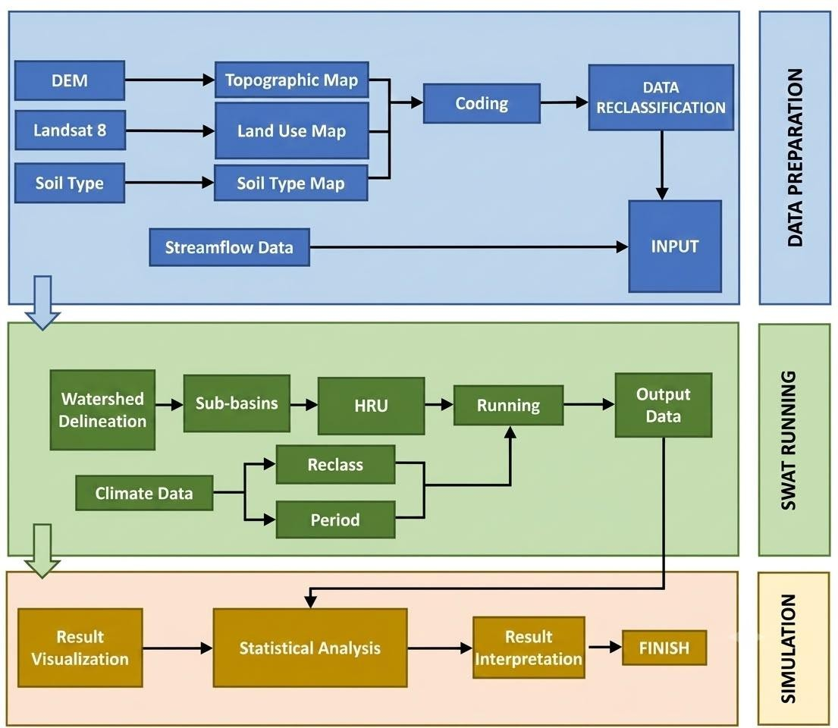
Fig. 2. SWAT Simulation
Due to the absence of a streamflow gauging station within the Bajing Sub-Watershed, model calibration and validation against observed discharge data could not be performed. Therefore, the SWAT model was implemented as a spatially distributed hydrological simulation tool to evaluate the hydrological response under the available climatic, topographic, soil, and land-use data. Consequently, the results should be interpreted as a hydrological assessment rather than a calibrated predictive model.

RESULTS AND DISCUSSION
  - SLOPE
Slope is one of the key factors controlling surface runoff and soil erosion processes. Spatial analysis revealed that the Bajing Sub-watershed exhibits considerable variation in slope classes, as presented in Table 2.

Table 2. Slope Classification of the Bajing Sub-watershed
Slope (%) | Class | Area (Ha) | Percentage (%)
0-8 | Datar | 756.07 | 27,61
8-15 | Landai | 649.81 | 23,74
15-25 | Agak curam | 482.51 | 17,64
25-40 | Curam | 497.78 | 18,19
>40 | Sangat curam | 351.81 | 12,82

The results indicate that the study area has diverse topographic conditions, with flat (27.61%) and gentle (23.74%) slopes being the dominant classes. These slope classes indicate that most of the area has relatively stable topography and can potentially support agricultural, plantation, and other land-use activities with relatively low erosion risk. Low-gradient slopes

147
148
149
150
151
152
153
154
155
156
157
158
159
160
161
162
163

164
165
166
167
168
169
170
171
172

173
174
175
176
tend to minimise surface runoff and soil loss compared with steeper slopes (de Oliveira Serrão et al., 2022; dos Santos et al., 2023). The moderately steep slope class (17.64%) indicates increasing susceptibility to erosion due to the greater flow energy associated with surface runoff, which can accelerate soil particle detachment and transport. Therefore, land use in this zone requires more intensive soil conservation measures, such as terracing, contour planting, and ground-cover vegetation (Liu et al., 2024; Hermiyanto et al., 2025). Cultivation remains feasible under conservation-oriented management; however, land use should be adjusted to the land-carrying capacity and physical characteristics of the area to minimise the potential for soil degradation. In contrast, areas with steep (18.19%) and very steep (12.82%) slopes have significant limitations for intensive land utilisation because of their high susceptibility to erosion, landslides, and land degradation. Steeper slopes contribute to accelerated surface runoff and sediment production; therefore, these areas are more appropriately designated for protection or conservation purposes to maintain slope stability, reduce sediment delivery to the river system, and support the sustainability of the overall hydrological functions of the watershed (Chen et al., 2022; Zhang et al., 2025). Integrated landscape conservation approaches, including reforestation and the establishment of protected zones, have been demonstrated to effectively reduce erosion and improve ecosystem functions in steep terrain.
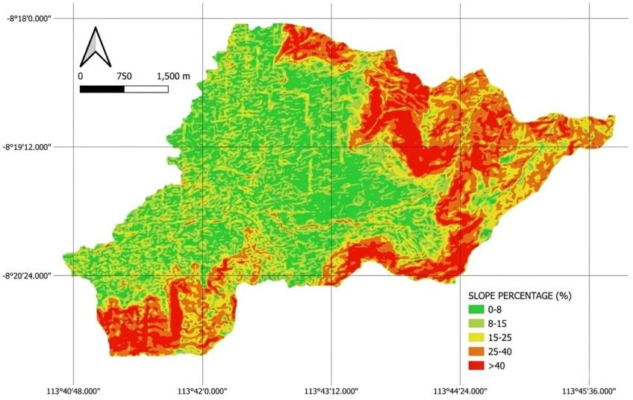

https://tanahair.indonesia.go.id/

Fig. 3. Slope map
  - SOIL TYPES
Variations in soil types influence infiltration, water-holding capacity, and hydrological responses. The results of the soil map interpretation are presented in Table 3.

Table 3. Soil Type Classification of the Bajing Sub-watershed
FAO Soil Type | Area (ha) | Percentage (%)
Andisol | 1495 | 54,60
Ultisol | 956 | 34,92
Inceptisol | 287 | 10,48

The results show that Andisol is the dominant soil type in the study area, covering 1,495 ha (54.60%). Andisols develop from volcanic parent materials and are characterised by high porosity, friable soil structure, and high infiltration and water-storage capacities influenced by their

177
178
179
180
181
182
183
184
185
186
187
188
189
190
191
192
193
194
195
196
197
198
199
200
201

202
203
204
205
206
207
208
209
210
211
specific mineralogical properties. These soils contain amorphous minerals such as allophane and imogolite, which influence their physical and chemical properties and generally provide high fertility potential, although this is also dependent on their organic matter content (Roa García et al., 2021). However, under the conditions of the study area, the analysis indicates relatively low to very low organic carbon content, which may reduce aggregate stability and soil water retention capacity. Consequently, Andisols may remain susceptible to runoff and erosion under high-intensity rainfall events (Hou et al., 2025). Land use on Andisols should therefore prioritise permanent vegetation, such as forests, agroforestry systems, or conservation-oriented cultivation, to maintain soil structure and minimise soil loss through erosion. Ultisols, covering 956 ha (34.92%), are characterised by advanced weathering, low inherent fertility, and limited organic matter content. Their structure tends to be less stable and their infiltration capacity is generally lower than that of Andisols (Apriliani et al., 2024). The relatively unstable physical properties of Ultisols may increase surface runoff and erosion when the land is intensively cultivated without adequate conservation measures. Therefore, Ultisol management should be integrated with appropriate soil management practices, including organic matter amendments, cover crops, and surface-runoff control, to improve soil structure and reduce erosion. Meanwhile, Inceptisols, which cover 287 ha (10.48%), exhibit a moderate degree of soil development and relatively variable physical properties. Previous studies have indicated that Inceptisols may have relatively better water-storage capacity than Ultisols and soil textures that are more favourable for plant root development, making them potentially suitable for limited agricultural activities (Ermawati et al., 2023). Overall, the distribution of soil types indicates that a substantial proportion of the watershed has physical and hydrological limitations. Therefore, land management should be adapted to the characteristics of each soil type to optimise land utilisation while maintaining the sustainability of watershed hydrological functions.
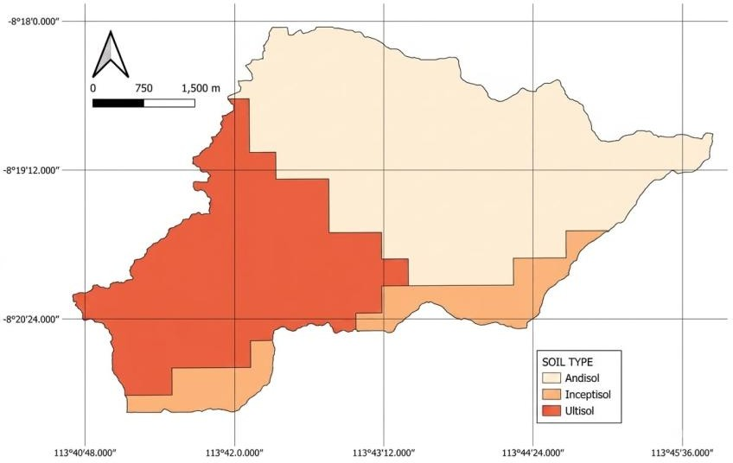

https://www.fao.org/

Fig. 4. Soil type map

  - CLIMATIC CONDITIONS
Climate data were obtained from NASA POWER through the Data Access Viewer by entering the coordinates of the Bajing Sub-watershed and selecting parameters including solar radiation, precipitation, air temperature, wind speed, and relative humidity. NASA POWER provides satellite-derived and reanalysis-based data with a spatial resolution of approximately 0.5° × 0.5° (approximately 55 km), making it suitable for climate analyses over relatively broad

212
213
214
215
216
217
218
219
220
221
222
223
224
225
226
227
228
229
230

231

232
233
234
235
236
237
238
239
240
areas. The data were downloaded in CSV format for subsequent processing. Meanwhile, climate data from a local weather station were obtained through direct measurements from instruments such as rain gauges, maximum–minimum thermometers, anemometers, and hygrometers. These data have daily-to-monthly temporal resolution and are therefore useful for validating satellite-derived climate data. For biophysical conditions, slope data were obtained from the National Digital Elevation Model (DEMNAS), released by the Geospatial Information Agency of Indonesia (BIG), with a spatial resolution of 8.25 m. The DEM data were downloaded in GRID/TIFF format and processed using GIS software (QGIS) through terrain analysis to generate slope maps expressed in percentages or degrees. Soil data were obtained from FAO/UNESCO soil maps or SoilGrids, which provide a spatial resolution of 250 m. The soil data were clipped to the boundaries of the Bajing Sub-watershed and analysed to extract USDA/FAO soil classes. All datasets from NASA POWER, DEMNAS, and FAO were processed using raster- and vector-based GIS methods to generate spatially consistent climatic and biophysical information.

LAND COVER
Land-cover analysis was conducted to characterise the biophysical conditions and human activities within the Bajing Sub-watershed. The results are presented in Table 4.

Table 4. Land Cover of the Bajing Sub-watershed
Land Use | Area (ha) | Percentage (%)
Forest | 1859 | 67,90
Cropland/Plantation | 477 | 17,42
Residential | 156 | 5,70
Grassland | 246 | 8,98
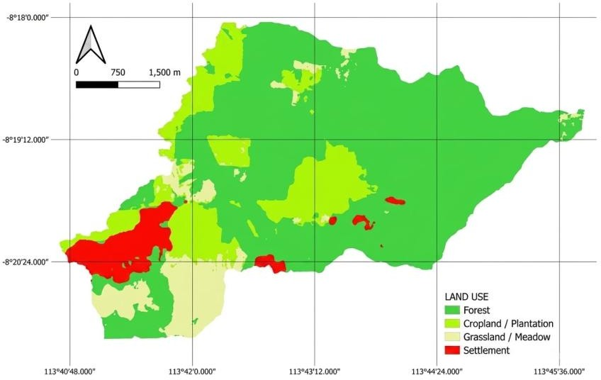

https://earthexplorer.usgs.gov/

Fig. 5. Land-use map
The land-cover data indicate that the study area is dominated by forest, including primary and production forests, covering 67.90% of the area. This reflects relatively good vegetation cover, which plays an important role in maintaining watershed hydrological functions. Various studies have shown that forest cover contributes significantly to enhanced infiltration, reduced surface runoff, and erosion and sedimentation control through the functions of the canopy, litter layer,

    - and well-developed root systems (Anley & Minale, 2024; Kulsoontornrat & Puangkaew, 2025).
    - In general, forest dominance within a watershed is associated with greater flow-regime stability
    - and reduced risks of flooding and land degradation.
244
- In addition to forests, plantation areas covering 17.42% indicate land utilisation by local
- communities, generally in the form of mixed plantations or agroforestry systems. Recent
- studies indicate that agroforestry systems can maintain hydrological and ecological functions
- approaching those of natural forests, particularly by enhancing infiltration, reducing runoff, and
- minimising soil loss when managed according to soil and water conservation principles
- (Bruijnzeel et al., 2025; Hoek van Dijke et al., 2022). Thus, mixed plantations can continue to
- function as hydrological buffers within the watershed when managed sustainably. Grasslands,
- which cover 8.98% of the study area, function as open areas or grazing land but may also
- become sources of runoff and erosion when vegetation cover is sparse or degraded,
- particularly on moderate to steep slopes. Recent studies have shown that grassland
- degradation can substantially increase surface runoff and sediment production compared with
- forested or agroforestry areas (González-Cao et al., 2022). Therefore, grassland management
- should be implemented carefully to prevent accelerated land degradation. Residential areas
- account for only 5.70% of the study area, indicating relatively low urbanisation pressure.
- Nevertheless, residential development can affect hydrological processes through the
- expansion of impervious surfaces, which accelerate surface runoff and reduce infiltration.
- Despite their limited spatial extent, several studies have confirmed that residential expansion
- in upstream and middle watershed areas can significantly alter hydrological responses (Xu et
- al., 2025; Zwirglmaier et al., 2024). Overall, the dominance of natural and semi-natural
- vegetation provides substantial opportunities for maintaining and optimising sustainable
- watershed management.
266

3.5 HYDROLOGICAL ANALYSIS USING SWAT
- The Soil and Water Assessment Tool (SWAT) model was implemented using QGIS 3.40.9
- with the SWAT+ 3.0.8 module. The modelling was conducted to estimate the hydrological
- response of the Bajing Sub-watershed.
271

3.5.1 Sub-watershed Delineation
- The delineation process divided the study area into four sub-basins based on topography and
- the river network. This subdivision is important for understanding the spatial distribution of
- runoff and erosion processes.

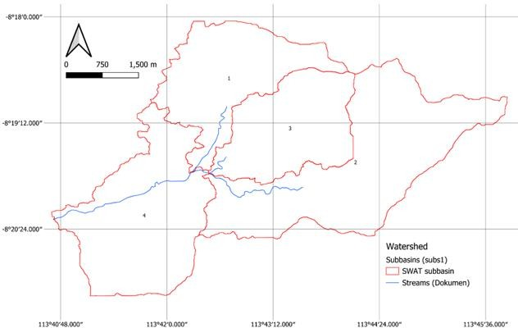

276
277
278

Fig. 6. Sub-basin delineation

279 Table 5. Sub-basin
Sub-sub Basin | Area (ha) | Percentage (%)
1 | 537.67 | 19,64
2 | 944.54 | 34,50
3 | 496.36 | 18,13
4 | 759.42 | 27,74
280

3.5.2 HRU Formation
- Hydrologic Response Units (HRUs) were generated through an overlay process involving land
- cover, soil type, and slope classes to produce hydrologically homogeneous land units. Each
- combination of these parameters represents the smallest unit with similar biophysical
- characteristics, including infiltration capacity, surface-runoff potential, and response to rainfall.
- By grouping the study area into representative HRUs, the SWAT model can simulate
- hydrological processes more accurately, including surface runoff, erosion, evapotranspiration,
- and water movement through the soil profile. This approach ensures that spatial variations in
- field conditions are adequately represented, thereby producing more realistic hydrological
- analysis results that correspond to the spatial characteristics of the Bajing Sub-watershed.
291

3.5.3 Climate Data for the Model
- The climate input data are presented in Table 7.

Table 7. Annual Climate Data for the Bajing Sub-watershed, 2016–2024
Year | Precipitatio n (mm/year) | Solar Radiation (MJ/m²/day  ) | Wind Speed (m/s) | Relative Humidity (%) | Maximum Temperatur e (°C) | Minimum Temperatur e (°C)
2016 | 3159 | 9.42 | 2.89 | 82 | 29.14 | 25.87
2017 | 1940 | 9.22 | 3.39 | 82 | 28.24 | 25.94
2018 | 1503 | 9.67 | 3.49 | 80 | 28.42 | 25.94
2019 | 1311 | 10.13 | 3.31 | 80 | 28.90 | 25.94
2020 | 2232 | 9.52 | 3.40 | 81 | 28.88 | 25.86
2021 | 2556 | 9.28 | 3.13 | 82 | 28.47 | 25.93
2022 | 2674 | 9.10 | 3.08 | 83 | 28.48 | 25.93
2023 | 1604 | 9.80 | 3.26 | 82 | 28.56 | 25.93
2024 | 1621 | 9.48 | 3.34 | 82 | 29.31 | 25.85
- https://power.larc.nasa.gov/
- From 2016 to 2024, the climatic variables exhibited clear interannual variability, particularly in
- precipitation. The highest annual precipitation occurred in 2016 (3,159 mm/year), whereas the
- lowest occurred in 2019 (1,311 mm/year), indicating pronounced differences between wet and
- dry years. Interannual precipitation variability is a common characteristic of tropical regions
- and is frequently associated with monsoon dynamics and global climate phenomena such as
- the El Niño–Southern Oscillation (ENSO), which strongly influence the intensity and
- distribution of annual rainfall (Marzuki et al., 2025). In contrast, solar radiation remained
- relatively stable, ranging from 9.10 to 10.13 MJ/m²/day, but tended to increase during years
- with lower precipitation. This pattern indicates an inverse relationship between precipitation
- and solar radiation, whereby reduced cloud cover during dry periods increases the amount of
- solar radiation reaching the Earth's surface (Chai et al., 2021; Sardans et al., 2024). Wind
- speed, ranging from 2.89 to 3.49 m/s, and relatively high and stable relative humidity (80–
- 83%) reflect a humid climatic regime with relatively low variability in non-precipitation climatic
- variables, which is typical of maritime tropical environments (Hendrawan et al., 2024).
- Maximum air temperature (28.24–29.31 °C) and minimum air temperature (25.85–25.94 °C)

- exhibited relatively limited interannual variation, indicating the annual thermal stability
- characteristic of tropical regions. Overall, the climatic dynamics of the study area were
- primarily governed by variations in precipitation and solar radiation rather than by other
- climatic variables. These variations have direct implications for water availability,
- evapotranspiration rates, and watershed hydrological balance and should therefore be
- considered in water resource management planning and climate-variability adaptation
- strategies (Thakur et al., 2025).
318

3.5.4 SWAT Model Reclassification
- The reclassification of SWAT input codes corresponding to the thematic maps is presented in
- Table 8.

Table 8. Reclassification of Model Inputs
Map | Classification | SWAT code | Area
 |  |  | Ha | %
Batas Sub Das
Land Cover | Forest | FRST | 1.859 | 67,90
 | Plantation | AGRR | 477 | 17,42
 | Residential | URML | 156 | 5,70
 | Grassland | RNGB | 246 | 8,98
Total |  |  | 2738 | 100
 | Andisol | Tv38-1bc 4580 | 1495 | 54,60
 | Ultisol | Je65-2-3a-3752 | 956 | 34,92
 | Inceptisol | I-Lc-3b-4510 | 287 | 10,48
Total |  |  | 2738 | 100
Slope | Flat | - | 756 | 27,61
 | Gentle | - | 650 | 23,74
 | Moderately steep | - | 483 | 17,64
 | Steep | - | 498 | 18,19
 | Very steep | - | 351 | 12,82
Total |  |  | 2738 | 100
323
- Input data coding was conducted to ensure that all spatial parameters could be properly
- recognised and processed by the SWAT model. For the land-cover map, each class was
- assigned a standard SWAT code, including FRST for forest, AGRR for plantations, RNGB for
- grassland, and URML for residential areas. This coding ensures that each land-cover category
- is recognised by SWAT according to its respective hydrological attributes, including surface-
- runoff characteristics, evapotranspiration, and ground-cover properties. For soil data, each
- FAO-classified soil type, including Andisol, Ultisol, and Inceptisol, was linked to the
- corresponding identification codes in the SWAT soil database through attributes such as Tv38-
- 1bc-4580, Je65-2-3a-3752, and I-Lc-3b-4510. Meanwhile, slope was classified into flat,
- gentle, moderately steep, steep, and very steep classes and subsequently used as a criterion
- in the formation of Hydrologic Response Units (HRUs). Although slope classes do not have
- specific SWAT codes in the table, each slope class was represented as a separate spatial
- layer for the overlay process. This structured coding procedure enables land cover, soil type,

337
338
339
340
341
342
343
344
345
346

347
348

349
350
351
352
353
354
355
356
357
358
359
360
361
362
363
364
365
366
367
368
369
370
and slope characteristics to be consistently integrated, thereby generating valid HRUs for SWAT simulations.

3.5.5 Streamflow Simulation
After all input data had been integrated, the SWAT model was run to simulate streamflow and sediment yield at the outlet of the Bajing Sub-watershed. The simulation accounted for the interactions among precipitation, infiltration, evapotranspiration, surface runoff, subsurface flow, and groundwater flow within the watershed water balance. The SWAT approach has been widely applied to simulate streamflow and sediment yield and to evaluate watershed hydrological responses to variations in biophysical conditions and land use.
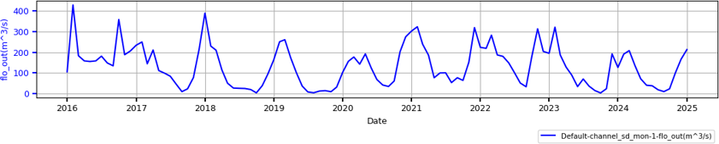

Fig. 6. Monthly Simulated Streamflow from the SWAT Model
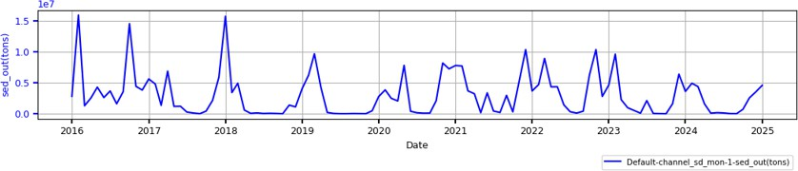

Fig. 7. Monthly Simulated Sediment Yield from the SWAT Model
The simulation results presented in Figure 6 show a distinct seasonal streamflow pattern, with discharge generally increasing during the wet season, particularly from December to February, and decreasing during the dry season. The sediment-yield pattern in Figure 7 also tends to follow variations in streamflow, with higher values occurring during periods of high flow. This condition indicates that increased surface runoff and streamflow can enhance sediment mobilization and transport from the catchment area towards the outlet. This response results from the interaction among precipitation, topography, soil properties, and land use, which are subsequently examined quantitatively through statistical analysis (de Oliveira Serrão et al., 2022; Manawko Tefera & Kasiviswanathan, 2023).
It should be noted that the simulated streamflow and sediment yield were not calibrated or validated against observed discharge records because no streamflow gauging station is available within the Bajing Sub-Watershed. Therefore, the simulation results should be interpreted as an assessment of the watershed's hydrological response under the available climatic, topographic, soil, and land-use conditions rather than as a calibrated prediction of absolute discharge values. Nevertheless, the SWAT model remains a widely accepted tool for evaluating hydrological processes and identifying temporal patterns and relative changes in data-scarce watersheds, thereby providing useful scientific information for watershed management and conservation planning.

3.6 STATISTICAL ANALYSIS OF STREAMFLOW AND SEDIMENT YIELD

Table 9. Statistical Characteristics of Simulated Streamflow and Sediment Yield
Streamflow | Streamflow | Sediment Yield
Max | 430 | 1.60
Min | 2.24 | 0.00
Average | 132.93 | 0.30
Standard deviation (SD) STDV.S | 97.27 | 0.34
Coefficient of variation (CV, %) CV | 73.17 | 113.90
Trend | -0.43 | 0
Regresi
Correlation coefficient (r) | 0.9
- * Authors’ analysis based on Excel data processing
374
- Statistical analysis was conducted to characterise streamflow and sediment yield generated
- by the SWAT simulation, including descriptive statistics, coefficient of variation (CV), trend
- analysis, and correlation analysis. Statistical assessment of SWAT outputs is important for
- evaluating the variability of streamflow and sediment yield and their relationships with
- biophysical conditions and land-use characteristics (Bak et al., 2025; Quamar et al., 2025). As
- shown in Table 9, streamflow ranged from a maximum of 430.00 m³/s to a minimum of 2.24
- m³/s, with a mean of 132.93 m³/s and a standard deviation of 97.27 m³/s. The coefficient of
- variation of 73.17% indicates a high degree of streamflow variability. The maximum streamflow
- occurred in February, whereas the minimum occurred in October, indicating a pronounced
- seasonal pattern associated with the distribution of precipitation. Meanwhile, sediment yield
- ranged from a maximum of 1.60 tons to a minimum of 0 tons, with a mean of 0.30
- tons and a standard deviation of 0.34 tons. The coefficient of variation reached 113.90%,
- indicating very high variability in sediment yield. This high variability suggests that sediment
- production is not controlled solely by streamflow but is also influenced by precipitation, slope,
- soil properties, and land use. SWAT-based studies have similarly demonstrated that land-use
- changes can affect surface runoff and sediment yield differently among sub-watersheds. The
- analysis yielded a streamflow trend value of −0.43, indicating a descriptive tendency towards
- decreasing streamflow, whereas the sediment-yield trend was approximately zero and
- therefore did not indicate a substantial descriptive change over the analysed period.
- Furthermore, the correlation coefficient between streamflow and sediment yield was r = 0.90,
- indicating a very strong positive relationship, whereby increases in streamflow tended to be
- accompanied by increases in sediment yield. However, this relationship does not imply that
- streamflow is the sole controlling factor of sediment yield, because erosion and sediment-
- transport processes are also governed by soil characteristics, slope, precipitation, and land
- use. To strengthen the interpretation, data distributions were visualised using boxplots, while
- the relationship between streamflow and sediment yield was examined using linear
- regression. This approach is consistent with SWAT-based studies that employ statistical and
- non-parametric approaches to evaluate trends in flow, runoff, and sediment yield.

403
404
405
406
407
408
409
410
411
412
413
414
415
416

417
418
419
420
421
422
423
424

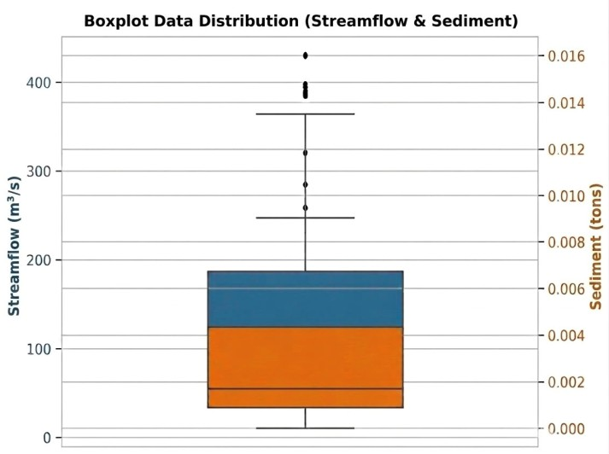
Fig. 8. Boxplot Distribution of Streamflow and Sediment Yield
Figure 8 presents the distribution of streamflow and sediment yield using boxplots. Both variables exhibit positively skewed distributions with several outliers, reflecting the occurrence of relatively high values during particular periods, especially when streamflow increased. Streamflow had a mean of 132.93 m³/s, a range of 2.24–430.00 m³/s, and a CV of 73.17%. Meanwhile, sediment yield had a mean of 0.30 tons, a range of 0–1.60 tons, and a CV of 113.90%. The substantially higher variability in sediment yield indicates that sediment-transport responses are more variable and are controlled not only by streamflow but also by precipitation, slope, soil characteristics, and land use. SWAT-based research has likewise demonstrated that runoff and sediment yield are governed by interactions among land use/land cover (LULC), soil properties, and slope characteristics (Chen et al., 2022; Opiyo, 2025).
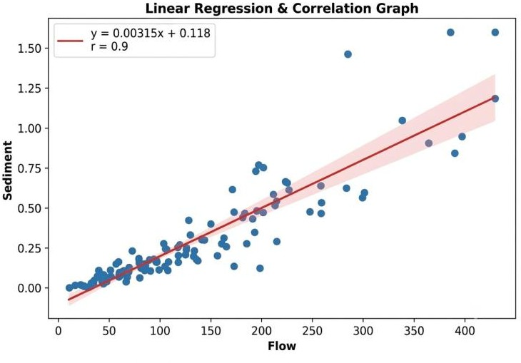

Fig. 9. Linear Regression and Correlation between Streamflow and Sediment Yield

Linear regression analysis revealed a very strong positive relationship between streamflow and sediment yield (r = 0.90; R² = 0.81), with the regression equation:
Sediment Yield = 0.00315 × Streamflow − 0.118
The R² value indicates that approximately 81% of the variability in sediment yield can be statistically explained by variations in streamflow, while the remaining 19% is associated with

- other factors not represented in the regression equation. The positive regression coefficient
- indicates that increasing streamflow tends to be accompanied by increasing sediment yield,
- consistent with the enhanced capacity of flowing water to mobilise and transport eroded
- materials. Nevertheless, the relationship between streamflow and sediment yield is not
- necessarily linear under all hydrological conditions because sediment production is also
- influenced by sediment availability, soil properties, land-cover conditions, and slope
- characteristics (de Oliveira Serrão et al., 2022; Manawko Tefera & Kasiviswanathan, 2023).
432
433 4. CONCLUSION
434
- This study assessed the hydrological conditions of the Bajing Sub-watershed, Jember,
- Indonesia, using the SWAT model and statistical analysis of streamflow and sediment yield.
- The results indicate that the watershed is generally supported by favourable land-cover and soil
- conditions, particularly the dominance of forest cover (67.90%) and Andisols (54.60%).
- However, steep to very steep slopes (31.01%) and substantial rainfall variability may increase
- the potential for runoff, erosion, and sediment transport.

- SWAT simulations showed pronounced seasonal variability, with streamflow ranging from
- 2.24 to 430.00 m³/s and sediment yield from 0 to 1.60 tons. Streamflow and sediment yield
- exhibited a strong positive correlation (r = 0.90), with R² = 0.81, indicating that streamflow
- statistically explained 81% of the variation in sediment yield. These findings emphasise the
- close interaction between hydrological processes and sediment transport in the Bajing Sub-
- watershed.

- This study contributes to the understanding of hydrological dynamics in a data-limited tropical
- watershed by integrating SWAT simulation with statistical analysis to characterise streamflow
- and sediment-yield variability. The findings provide a scientific basis for supporting watershed
- management, particularly in maintaining forest cover, implementing soil conservation
- practices on steep slopes, and controlling land-use changes to reduce erosion risk and sustain
- watershed hydrological functions. These results may also serve as a reference for hydrological
- assessment and sustainable watershed management in other watersheds with similar
- environmental characteristics.
455

LIMITATIONS OF THE STUDY

- This study has two main limitations. First, model calibration and validation could not be
- performed because no streamflow gauging station is available within the Bajing Sub-
- Watershed. Consequently, observed discharge data required to evaluate model performance
- using indicators such as NSE, PBIAS, and R² were unavailable. Therefore, the simulation
- results should be interpreted as a hydrological assessment rather than a fully calibrated
- predictive model.

- Second, the climate data used in this study covered the period from 2016 to 2024, which may
- not fully represent long-term climatic variability. The use of climate data spanning 30 years or
- more is recommended in future studies to better characterise rainfall regimes and improve the
- reliability of hydrological simulations.
467

468 Declaration of AI Use
This manuscript was prepared through the combined contributions of all author(s), including contributions to the study design, data, content development, results, interpretation, and related scholarly work. The author(s) acknowledge the use of Grammarly and ChatGPT to assist with grammar checking, language refinement, and reference formatting. These AI-assisted tools were not used as authors and did not replace the intellectual contributions or scholarly judgment of the author(s). All AI-assisted outputs, including content, references, and interpretations, were carefully reviewed, revised, verified, and approved by the author(s). The author(s) accept full responsibility for the accuracy, integrity, and final content of the manuscript.

472

473 ACKNOWLEDGEMENTS
474
475 The authors gratefully acknowledge the University of Jember for financial support and all
476 parties who contributed to this research.
477

478
488

REFERENCES
- Anley, M. A., & Minale, A. S. (2024). Modeling the impact of land use land cover change on the estimation of soil loss and sediment export using InVEST model at the Rib watershed of Upper Blue Nile Basin, Ethiopia. Remote Sensing Applications: Society and Environment, 34, 101177. https://doi.org/10.1016/j.rsase.2024.101177
- Apriliani, R., Sulistyo, B., & Muktamar, Z. (2024). Improvement of selected soil physical properties and mustard yield after the application of Tithonia compost in Ultisols. TERRA: Journal of Land Restoration, 7(2), 66–71. https://doi.org/10.31186/terra.7.2.66-71
- Bak, S., Lee, S., Han, J., Jeong, Y., Choi, Y., Lee, G., Engel, B. A., & Lim, K. J. (2025). Enhancement of sediment routing method of SWAT model considering sediment occurrence trends of rise and fall of streamflow. JAWRA Journal of the American Water Resources Association, 61(4), e70023. https://doi.org/10.1111/1752-1688.70023
- Bruijnzeel, L. A., Peña-Arancibia, J. L., Sheil, D., Ziegler, A. D., Zhang, J., Zwartendijk, B. W., Birkel, C., Sun, G., Wang, Y., & Zhang, X. (2025). Potential for improved groundwater recharge and dry-season flows through forest landscape restoration on degraded lands in the tropics. Forest Ecosystems, 14(2), 100376. https://doi.org/10.1016/j.fecs.2025.100376
- Cecconello, S. T., Bressiani, D., Nunes, M. C. M., & Timm, L. C. (2025). Analysis of SWAT+ model performance: A comparative study using different software and algorithms. Environmental Modelling & Software, 188, 106425. https://doi.org/10.1016/j.envsoft.2025.106425
- Chai, R., Mao, J., Chen, H., Wang, Y., Shi, X., Jin, M., Zhao, T., Hoffman, F. M., Ricciuto, D. M., & Wullschleger, S. D. (2021). Human-caused long-term changes in global aridity. npj Climate and Atmospheric Science, 4(1), 65. https://doi.org/10.1038/s41612-021-00223-5
- Chelkeba Tumsa, B. (2023). The response of sensitive LULC changes to runoff and sediment yield in a semihumid urban watershed of the Upper Awash Subbasin using the SWAT+ model, Oromia, Ethiopia. Applied and Environmental Soil Science, 2023, 6856144. https://doi.org/10.1155/2023/6856144
- Chen, H., Shi, R., He, J., Zheng, L., & Wang, W. (2022). Simulation analysis of runoff and sediment yield under the change of land-use type: A case study of the Upper Jianjiang River Basin, China. Polish Journal of Environmental Studies, 31(3), 2527–2536. https://doi.org/10.15244/pjoes/143883
- de Oliveira Serrão, E. A., Silva, M. T., Ferreira, T. R., de Ataide, L. C. P., dos Santos, C. A., de Lima, A. M. M., da Silva, V. de P. R., de Sousa, F. de A. S., & Gomes, D. J. C. (2022). Impacts of land use and land cover changes on hydrological processes and sediment yield determined using the SWAT model. International Journal of Sediment Research, 37(1), 54–69. https://doi.org/10.1016/j.ijsrc.2021.04.002
- Dogiso, D., Muluneh, A., & Ketema, A. (2025). Surface runoff and sediment yield responses to land use and cover changes: Implications for watershed management in the Gidabo Watershed, Ethiopia. Hydrological Processes, 39(8), e70245. https://doi.org/10.1002/hyp.70245
- dos Santos, F. M., de Souza Pelinson, N., de Oliveira, R. P., & Di Lollo, J. A. (2023). Using the SWAT model to identify erosion prone areas and to estimate soil loss and sediment transport in Mogi Guaçu River basin in São Paulo State, Brazil. Catena, 222, 106872. https://doi.org/10.1016/j.catena.2022.106872
- Ermawati, E., Kusuma, Z., & Wicaksono, K. S. (2023). Impact of land use on soil water retention in Inceptisols of the Upper Konto Watershed. Journal of Tropical Soils, 29(3), 167–177. https://doi.org/10.5400/jts.2024.v29i3.167-177
- González-Cao, J., Fernández-Nóvoa, D., García-Feal, O., Figueira, J. R., Vaquero, J. M., Trigo, R. M., & Gómez-Gesteira, M. (2022). The Rivillas flood of 5–6 November 1997 (Badajoz, Spain) revisited: An approach based on Iber+ modelling. Journal of Hydrology, 610, 127883. https://doi.org/10.1016/j.jhydrol.2022.127883
- Hakim, F. L., Indarto, I., Hidayah, E., & Cahyono, B. E. (2023). Five decades of land use and land cover change in Bedadung watershed: Learning from Landsat data. AIP Conference Proceedings, 2583(1), 060007. https://doi.org/10.1063/5.0117116
- Hendrawan, V. S. A., Mawandha, H. G., Sakti, A. D., Karlina, Andika, N., Shahid, S., & Jayadi, R. (2024). Future exposure of rainfall and temperature extremes to the most populous island of Indonesia: A projection based on CORDEX simulation. International Journal of Climatology, 44(10), 3529–3547. https://doi.org/10.1002/joc.8537
- Hermiyanto, B., Mawarni, C., Winarso, S., & Budiman, S. A. (2025). Soil quality assessment and land capability evaluation for determining integrated watershed management model through SWOT analysis and AHP method in Arjasa Sub-watershed, Indonesia. Watershed Ecology and the Environment, 7, 104–118. https://doi.org/10.1016/j.wsee.2025.02.001
- Hoek van Dijke, A. J., Herold, M., Mallick, K., Benedict, I., Machwitz, M., Schlerf, M., Pranindita, A., Theeuwen, J. J. E., Bastin, J.-F., & Teuling, A. J. (2022). Shifts in regional water availability due to global tree restoration. Nature Geoscience, 15(5), 363–368. https://doi.org/10.1038/s41561-022-00935-0
- Hou, K., Wang, J., & Zhang, X. (2025). Simulation and response of runoff to climate and land-use changes in the Yanhe River Basin, Loess Plateau: A SWAT model-based analysis. Water, 17(7), 1042. https://doi.org/10.3390/w17071042
- Indarto, I., Hidayah, E., & Setiawan, E. B. (2023). Water balance assessment, land use land cover change and increasing water demand in three major watersheds in Jember, East Java, Indonesia. Geosfera Indonesia, 8(2), 170–188. https://doi.org/10.19184/geosi.v8i2.39131
- Kardhana, H., Lihawa, A. W. I., Rohmat, F. I. W., Wulandari, S., Harjupa, W., Adiprawita, W., Kardena, E., & Kusuma, M. S. B. (2024). Water balance analysis in the Majalaya Watershed: Two-step calibration and application of the SWAT+ model for low-flow conditions. Water, 16(23), 3498. https://doi.org/10.3390/w16233498
- Keshri, R., Tripathi, M. P., Khalkho, D., & Das, B. (2024). Prioritization of Milli watershed of Kodar River Catchment based on integrated approach of morphometric and land use land cover analysis. Asian Journal of Current Research, 9(1), 71–85. https://doi.org/10.56557/ajocr/2024/v9i18532
- Kulsoontornrat, J., & Puangkaew, N. (2025). Assessing the impacts of land use and land cover changes on sediment yield using the SWAT model: A case study in the Khlong Bang Yai Watershed, Phuket Island, Thailand. International Journal of Geoinformatics, 21(5), 62–79. https://doi.org/10.52939/ijg.v21i5.4161
- Liu, J., Zhang, X., Wu, X., Yang, Y., & Zheng, Y. (2024). Impacts of LULC changes on runoff from rivers through a coupled SWAT and BiLSTM model: A case study in Zhanghe River Basin, China. Ecological Informatics, 84, 102866. https://doi.org/10.1016/j.ecoinf.2024.102866
- Manawko Tefera, W., & Kasiviswanathan, K. S. (2023). Potential assessment of calibration approaches using the SWAT hydrological model for streamflow and sediment yield for a large-scale catchment. Hydrological Sciences Journal, 68(13), 1895–1914. https://doi.org/10.1080/02626667.2023.2243463
- Marzuki, M., Ramadhan, R., Yusnaini, H., Vonnisa, M., Muharsyah, R., Nugraha, Y., Sari, A. Y., & Erajalita, A. (2025). Long-term spatial–temporal variability, trends and extreme rainfall events over Indonesia based on 43 years of CHIRPS data. International Journal of Climatology, 45(14), e70107. https://doi.org/10.1002/joc.70107
- Opiyo, S. B. (2025). Modeling the impacts of land use and land cover changes on streamflow and sediment yield with the SWAT model in Migori River Watershed, Lake Victoria Basin Region, Kenya. African Geographical Review, 44(1), 48–69. https://doi.org/10.1080/19376812.2024.2324279
- Quamar, S., Kumar, P., & Singh, H. P. P. (2025). Streamflow and sediment simulation in the Song River basin using the SWAT model. Frontiers in Water, 7, 1500086. https://doi.org/10.3389/frwa.2025.1500086
- Rafif, M. A., Widiarti, W. Y., Hidayah, E., Saifurridzal, S., & Ma’ruf, M. F. (2024). Effects of land use change on land erosion and land critical level using GIS in the Mayang Watershed. Geosfera Indonesia, 9(2), 122–143. https://doi.org/10.19184/geosi.v9i2.39670
- Roa García, C., Brown, S., Krzic, M., Lavkulich, L., & Roa-García, M. C. (2021). Relationship of soil water retention characteristics and soil properties: A case study from the Colombian Andes. Canadian Journal of Soil Science, 101(1), 147–156. https://doi.org/10.1139/cjss-2020-0066
- Sardans, J., Miralles, A., Tariq, A., Zeng, F., Wang, R., & Peñuelas, J. (2024). Growing aridity poses threats to global land surface. Communications Earth & Environment, 5(1), 776. https://doi.org/10.1038/s43247-024-01935-1
- Thakur, V., Markonis, Y., Kumar, R., Thomson, J. R., Vargas Godoy, M. R., Hanel, M., & Rakovec, O. (2025). Unveiling the impact of potential evapotranspiration method selection on trends in hydrological cycle components across Europe. Hydrology and Earth System Sciences, 29(18), 4395–4416. https://doi.org/10.5194/hess-29-4395-2025
- Weleslasie, M., & Seyoum, T. (2026). Runoff and sediment yield analysis at Ariqua Watershed, Tekeze Basin, Ethiopia: An approach for Soil and Water Assessment Tool (SWAT) model. Asian Journal of Research in Agriculture and Forestry, 12(1), 83–97. https://doi.org/10.9734/ajraf/2026/v12i1470
- Xu, Q., He, S., Jiang, J., Zeng, Z., Wang, Z., & Duan, H. (2025). Assessing the compound impacts of urbanization and climate change on flood hazards in rapid urbanized basin: A case study of Chebei River Basin, South China. Journal of Hydrology: Regional Studies, 62, 102942. https://doi.org/10.1016/j.ejrh.2025.102942
- Zhang, L., Deng, C., Wei, J., & Zou, J. (2025). Assessing the impacts of climate change and land use/land cover data characteristics on streamflow using the SWAT model in the Upper Han River Basin. Journal of Hydrology: Regional Studies, 61, 102764. https://doi.org/10.1016/j.ejrh.2025.102764
- Zwirglmaier, V., Reimuth, A., & Garschagen, M. (2024). How suitable are current approaches to simulate flood risk under future urbanization trends? Environmental Research Letters, 19(7), 073003. https://doi.org/10.1088/1748-9326/ad536f

