Shifts detection in rainfall regime as an indicator of climate variability at the Kolda station

Abstract
Rainfall variability is a major concern in the Sahel because it affects rain-fed agriculture, water availability, and natural-resource management. This study evaluates shifts in the rainfall regime at the Kolda station in southern Senegal using a 75-year record covering 1951–2025. Annual and monthly rainfall series obtained from the National Agency for Civil Aviation and Meteorology were analysed with the Pettitt, Buishand, Hubert segmentation, and Lee–Heghinian tests implemented in KHRONOSTAT at a 10% significance level. The annual analyses indicated downward shifts, although the estimated break dates varied among the methods. The Lee–Heghinian test identified 1958, Hubert segmentation identified 1967, and the Pettitt and Buishand tests identified 1971. For the monthly series, the tests indicated an upward shift at the beginning of the rainy season: April according to Pettitt, May according to Buishand and Lee–Heghinian, and June according to Hubert segmentation. The Lee–Heghinian posterior probabilities were 0.1688 for the annual shift and 0.2803 for the monthly shift. The convergence of complementary tests supports the presence of non-stationary behaviour in the Kolda rainfall series, while the variation in estimated break dates reflects differences among the statistical procedures. These findings provide locally relevant evidence for agricultural planning and water-resource management. However, their interpretation is limited to rainfall observations from a single station and does not directly establish the climatic mechanisms underlying the detected shifts.

Keywords: Climate variability; rainfall regime; change-point detection; hydroclimatic time series; KHRONOSTAT; Pettitt test; Buishand test; Hubert segmentation; Lee–Heghinian test

1. Introduction
Climate change and variability are central contemporary concerns for scientists (Kouassi, 2007; World Meteorological Organization, 2024) and policymakers worldwide because of their immediate and lasting effects on the natural environment (Sighomnou, 2004; Swain et al., 2025). According to Ahoussi et al. (2013) and the Intergovernmental Panel on Climate Change (2023), the climatic variations observed in recent decades have significantly affected water resources across Africa. Climate is a natural resource that influences most human activities, including agricultural production, energy consumption, and the use of resources such as water (Sabeur, 2022; Nazeri Tahroudi, 2025). Consequently, climate variability and water resources are of particular interest to both populations and ecosystems (Lakehal & Hamdi, 2021; Biasutti, 2019). Climate studies gained global attention following several large-scale events, including the drought that affected both tropical belts of the planet, particularly the Sahelian countries of West Africa (Sircoullon, 1976; Yate & Ren, 2025). According to Traore et al. (2017) and Nicholson (2013), the water cycle is one of the principal manifestations of climate; consequently, monitoring it can improve understanding of certain aspects of climate change. Variables suitable for climate monitoring include river discharge, lake levels, precipitation, temperature, and groundwater levels (Ouarda et al., 1999; Servat et al., 1998). Numerous studies of climate variability in West Africa (Paturel et al., 1998; Ouédraogo, 2001; Ardoin et al., 2003; Ardoin-Bardin, 2004; Brou, 2005; Bigot et al., 2005) indicate a trend towards drought beginning around 1960. Most climate-characterisation studies are based on annual and monthly measurements of local atmospheric data (Sabeur, 2022; Yilmaz & Perera, 2015). Statistical tests are commonly used to assess the stationarity of time-series data by detecting breaks and trends and determining their directions (Lubès-Niel et al., 1998a; Sokol et al., 2026). During the last century, analyses of precipitation and temperature over long time series have become important for identifying climate change and its socio-economic and environmental consequences (Sabeur, 2022; Yildirim & Rahman, 2022). Possible changes in climatic variables can be reduced to two main types: changes in the mean and changes in the variance (Traore et al., 2014; Lund et al., 2023). In Senegal, research in this field generally focuses on rainfall monitoring, particularly in the southern part of the country. Rainfall is the principal climatic factor considered in this study. The study focuses on the Kolda region and characterises its climate using monthly and annual rainfall data recorded at the Kolda station (Agence Nationale de la Statistique et de la Démographie, 2018). This region was selected because more than 90% of the local population relies on rain-fed agriculture. Understanding climate variability and instability, and their relationship with water resources, is therefore crucial. Accordingly, we conducted a statistical analysis using homogeneity tests (Pettitt, Hubert, Lee–Heghinian, and Buishand ellipse tests). KHRONOSTAT software was applied at a significance level of 10% to detect abrupt changes and identify the direction and magnitude of the observed trends. The data used in this study come from the ANACIM (National Agency for Civil Aviation and Meteorology) database, which supports the quality and reliability of the series. Recent regional evidence indicates that the onset, cessation, and duration of the rainy season remain variable across West Africa, with direct implications for agricultural planning (Mendes et al., 2025). Projections for West Africa and the wider Sahel further suggest increasing risks associated with extreme rainfall and interannual variability, strengthening the case for sustained, location-specific rainfall monitoring (Ilori & Adeyewa, 2025; Yang et al., 2026). Comparable station-based and multi-station analyses have also shown that long rainfall records can support the characterisation of rainfall variability for climate resilience and agricultural water planning (Abatcha et al., 2024; Sujalu et al., 2026). However, a station-specific assessment jointly comparing annual and monthly break dates obtained using the Pettitt, Hubert, Buishand, and Lee–Heghinian procedures over the complete 1951–2025 Kolda record remains insufficiently documented. Addressing this local methodological gap is necessary to determine whether the rainfall changes detected are consistent across complementary tests and relevant to water-resource planning. This study therefore aims to establish the relationship between climate instability and water availability in order to support strategies for the sustainable and efficient management of water resources.

2. Presentation of the Physical Environment
Kolda is one of Senegal's 14 administrative regions and is located in Upper Casamance between latitudes 12°20′ and 13°40′ N and longitudes 13° and 16° W. It is bordered by The Gambia to the north, Guinea-Bissau and Guinea-Conakry to the south, the Tambacounda region to the east, and the Sédhiou region to the west (Agence Nationale de la Statistique et de la Démographie, 2018) (Figure I.1). The region covers 13,721 km², representing 7% of the national territory. Kolda has a hot, dry South Sudanian climate (Mballo et al., 2019). It is characterised by a rainy season from June to October, with a peak between August and September, and a dry season from November to May. Annual rainfall is favourable and sometimes exceeds 1,000 mm over 72 rainy days (Agence Nationale de la Statistique et de la Démographie, 2012). The mean annual temperature is 28°C, with substantial variation between a minimum of 20.3°C and a maximum of 35.4°C (Nsangou, 2023). These temperatures, combined with more than 2,500 hours of sunshine per year, radiation of approximately 580 cal/cm²/day, and relative humidity reaching 97% during the rainy season, result in potential annual evapotranspiration of approximately 2,100 mm. The prevailing winds are the hot, dry continental trade wind from the north-east and the hot, humid monsoon from the south-east, which brings rainfall (Malou, 2014). The Kolda region is partly flat and slopes towards the river over more than 700 ha (Agence Nationale de la Statistique et de la Démographie, 2018; Office National de l’Assainissement du Sénégal, 2017). Soil studies have identified several predominantly clayey soil types: Vertisols, raw mineral or undeveloped soils, hydromorphic soils, poorly developed colluvial soils, red soils, ochre (ferruginous) soils, and beige soils (Dubois, 1948; Fauck et al., 1963; Diome et al., 2008). Kolda is a wooded savannah region (Ndiaye, 2013). Its hydrographic network comprises the Casamance River and its tributaries (Agence Nationale de la Statistique et de la Démographie, 2018). The hydrological regime is seasonal, with flow observed from June to March; the river is dry in places during the remainder of the year (Office National de l’Assainissement du Sénégal, 2017). The minimum daily water level is approximately 0.64 m between January and June, while the maximum daily level reaches 3.29 m between July and September (Brunet-Moret, 1970). The region's geology is relatively simple. Except in the south-eastern sector, it comprises a highly homogeneous facies formed by continental deposits (Fauck et al., 1963). Several groundwater aquifers are continuously replenished by high rainfall and a fault network, including shallow, semi-deep, and Maastrichtian aquifers (Office National de l’Assainissement du Sénégal, 2017). The regional economy is based primarily on agriculture and livestock farming. Agricultural activities employ approximately 80% of the regional workforce for 8–9 months each year. Livestock farming is the second-largest primary-sector activity after agriculture and provides income and protein through the sale and consumption of products such as meat and milk (Ministère de l’Élevage et des Productions animales, 2022). These activities contribute to reducing youth unemployment through the direct and indirect employment they generate. The region's location also gives it considerable geostrategic potential within the economic, social, and cultural dynamics of the subregion (Agence Nationale de la Statistique et de la Démographie, 2014).

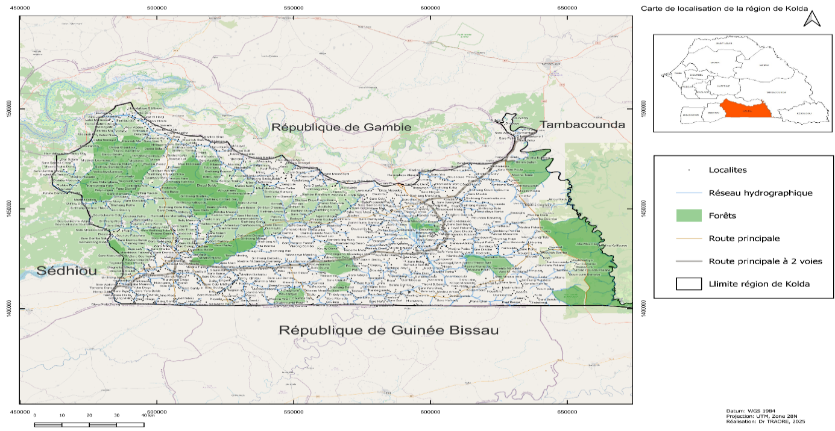
Figure 1. Location of the Kolda region
3. Climate Hazards and Water Availability
Climate insecurity and water availability are closely linked because climate change disrupts the water cycle (Tatar & Regad, 2015).
3.1. Water Insecurity
Climate change, now widely recognised as a reality, has a substantial effect on water resources. The principal indicators of water insecurity include the following (Larivière, 2011):
- Freshwater scarcity: Rising temperatures lead to more frequent and intense droughts, which dry up freshwater sources and accelerate desertification;
- Extreme events: Climate change intensifies flooding, which can contaminate drinking-water reserves, and promotes the salinisation of coastal aquifers through sea-level rise;
- Effects on sectors: Agriculture, the largest consumer of water, is particularly vulnerable because it depends on often unreliable rainfall. Water availability is also threatened for energy production, industry, drinking-water supply, and sanitation.
3.2. Consequences
The effects of climate change on access to water include the following (Ziervogel & Ericksen, 2010):
- Health: Limited access to safe drinking water increases the risk of disease;
- Food: Reduced agricultural productivity resulting from water scarcity can cause food crises, increase food prices, and intensify food insecurity;
- Social and economic effects:
- Inequality: The most vulnerable populations are disproportionately affected, thereby exacerbating existing inequalities;
- Population displacement: Water scarcity and environmental degradation can force people to migrate;
- Conflict: Competition for access to water resources can trigger or intensify tensions and conflicts.
Only integrated and sustainable water management can help societies address the challenges associated with water availability, extreme weather events, and uncertainty in resource availability, thereby supporting water security and progress towards the Sustainable Development Goals (Boualem et al., 2021).
4. Materials and Methods
4.1. Hypothesis Testing
The ultimate purpose of hypothesis testing is to decide between two hypotheses, only one of which is considered true on the basis of sample results (Saporta, 1990): the null or fundamental hypothesis (H₀) and the alternative hypothesis (H₁). The null hypothesis, H₀, corresponds to the absence of an experimental effect and is either rejected or not rejected. The alternative hypothesis, H₁, represents the effect or change under investigation and is the counterpart of the null hypothesis. More generally, a hypothesis is a proposed explanation of how a phenomenon operates or an assessment based on a set of sample data. According to Lubès-Niel et al. (1998b), the null hypothesis corresponds to a stationary condition, whereas the alternative hypothesis reflects a change, such as a break or trend. A fundamental concept in hypothesis testing is the probability of error. Two types of error can occur:
- Type I error, alpha (α): rejecting the null hypothesis, H₀, when it is true. This is a false positive, and the probability of making this error is α;
- Type II error, beta (β): failing to reject the null hypothesis when it is false. This is a false negative, and the probability of making this error is generally denoted by β.
Ideally, both types of error should be minimised; however, for a given sample, reducing the risk of a Type I error can increase the risk of a Type II error (Lubès et al., 1994). In practice, the Type I error rate is controlled by assigning a probability, α, known as the significance level of the test. This value is used to define the corresponding confidence level (Bobée et al., 1978).
4.2. Break Detection Test
4.2.1. Concept of Break
A break in a series of random variables is defined as a change over time in their probability distribution (Lubès et al., 1994). According to Lubès-Niel et al. (1998b), such a change occurs at a point that is usually unknown. Paturel et al. (1996) define a break as a significant change in the mean of an annual precipitation series identified by all the procedures applied. Berkes et al. (2009) and Bărbulescu and Dumitriu (2025) similarly state that a break may involve a change in the mean, variance, correlation structure, or underlying distribution of the data. In most cases, the means before and after the break differ; this is described as an abrupt break. In other cases, a trend emerges after the break, which may complicate trend detection (Basseville & Nikiforov, 1993; da Silva et al., 2024). Less pronounced breaks may also occur, including changes limited to the mean or variance. According to Jandhyala et al. (2002), break-detection procedures can be classified into two categories:
- tests for univariate distributions;
- tests for multivariate distributions.
4.2.2. Importance of a Break Test
Break detection is important for several reasons (Perreault et al., 2000):
- Prediction: A model developed from data containing an undetected break may produce erroneous predictions;
- Causal analysis: Breaks may indicate external events that affected the system under study;
- Quality control: In some contexts, breaks may indicate technical problems or changes in a process.
4.2.3. Choice of Break Test
The choice of statistical test depends on its reliability, accuracy, adaptability, and, above all, robustness. The principal steps in selecting a break-detection test described by Lubès-Niel et al. (1998b) are:
- Define the study objective, such as identifying break points in a time series, detecting changes in a distribution, or testing parameter stability;
- Consider the nature of the data, including whether the distribution is normal or non-normal and whether the variables are continuous and quantitative;
- Choose a parametric test when the data follow a normal distribution, or a non-parametric test when they do not follow a normal distribution or the number of observations is small;
- Consider the study context and complexity;
- Offline model: The complete data sample is available in advance;
- Online model: Observations arrive sequentially and must be detected rapidly;
- Number of breaks: Some tests detect a single break, whereas others can identify multiple breaks;
- Verify that the conditions for applying the test are satisfied.
Some parametric tests require homogeneity of variances. If this condition is not satisfied, another test may be required (Scariano & Watkins, 1988). This study applied the Pettitt, Buishand, Hubert, and Lee–Heghinian tests incorporated into KHRONOSTAT software.
4.3. Presentation of KHRONOSTAT Software
KHRONOSTAT is statistical software developed by the IRD (French Research Institute for Development) at the Maison des Sciences de l'Eau in Montpellier (Sané et al., 2017). It was developed within a study of climate variability in West and Central Africa and focuses on the analysis of hydroclimatic series (Boyer, 2002). It can operate at annual, monthly, or daily scales, depending on the study requirements, and can be applied to climatic, hydrological, meteorological, and other variables (Traore et al., 2014). The first category of tests included in KHRONOSTAT assesses the randomness of a series (rank-correlation and autocorrelogram tests); these tests assume that the series mean remains constant throughout the observation period. The second category assesses series homogeneity using the Pettitt, Buishand, Hubert, and Lee–Heghinian tests (Sabeur, 2022) (Figure 2). KHRONOSTAT was selected because of the robustness of these tests and their successful application in similar studies in sub-Saharan Africa. It is also used in meteorological and climatological analyses of drought. However, the software does not accommodate gaps in the data series analysed (Traore et al., 2017).
Figure 2. Tests available in the Khronostat software
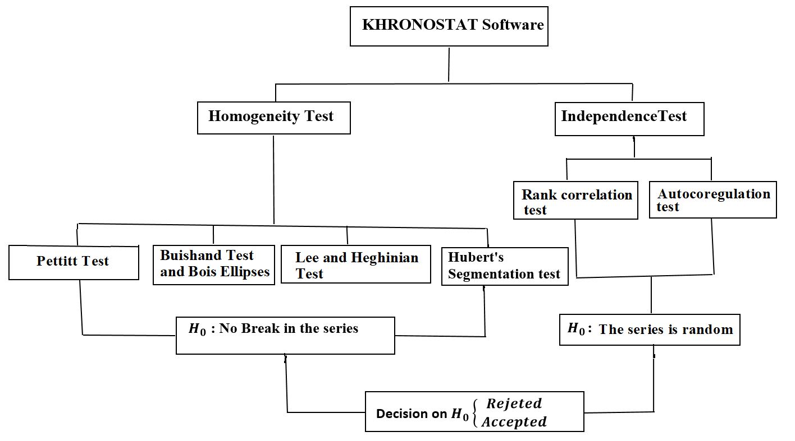

4.3. Data, Station Selection and Application
This study used precipitation data from the ANACIM (National Agency for Civil Aviation and Meteorology) database for the 75-year period from 1951 to 2025. The agency's database supports the quality and reliability of the time series used. The precipitation variable was selected for the reasons identified by Traore et al. (2017):
- it is the most widely used climatic variable for diagnosing and analysing climate and its spatial evolution;
- it plays a key role in planning and sustainably managing water resources;
- it is the principal source of water for agricultural production, while irrigation covers only 10% of cultivated land;
- the time series is complete and contains no gaps, as required by KHRONOSTAT.

A single rainfall station was selected because it provided a long, continuous, and homogeneous series (1951–2025), which is essential for reliably detecting climatic shifts. The Kolda station is representative of local climatic conditions and permits analysis of the temporal evolution of rainfall patterns. However, the findings are primarily applicable to its immediate area of influence. Future studies should incorporate multiple stations or satellite data to improve spatial representativeness.
The study has two objectives: first, to identify the climatic conditions and characteristics of the study area during the observation period; and second, to examine the general distribution of precipitation and assess its temporal and spatial extent. We therefore applied the Pettitt, Hubert, Buishand, and Lee–Heghinian break tests at a significance level of 10% using KHRONOSTAT software. Irrespective of the test applied, the statistical procedure comprised the following steps:
- Define the null hypothesis, H₀, and the alternative hypothesis;
- Calculate the value of the decision variable from the data;
- Define the significance level of the test, denoted by α;
- Consult the table of values corresponding to the reference value of the variable for the test applied;
- Decide whether to reject or not reject the formulated null hypothesis, H₀, and interpret the result.
The information generated by this analysis provides a basis for examining the phenomena associated with climate change and for understanding the relationship between climatic instability and water-resource instability. It also supports the estimation and sustainable management of water resources.

4.4. Choice of KHRONOSTAT and a 10% Significance Level
KHRONOSTAT was selected because of its reliability and recognised use in hydrology and climatology for time-series analysis. It incorporates several break-detection tests (Pettitt, Buishand, Hubert, and Lee–Heghinian), enabling comparison of results and strengthening the robustness of the analysis. Because rainfall series are highly variable, KHRONOSTAT facilitates the identification of significant changes in precipitation patterns and provides cross-validation of the detected breaks. It is therefore an appropriate methodological tool for assessing climate variability and supporting decisions on water-resource management and climate-change adaptation.
The 10% significance level was selected because the high variability of rainfall series can reduce test sensitivity when stricter thresholds of 5% or 1% are applied. This threshold provides a compromise between the risk of identifying a false break and the risk of failing to detect a genuine change. Its use is further supported by the application of four break-detection tests (Pettitt, Buishand, Hubert, and Lee–Heghinian), for which convergence increases confidence in the findings. The 10% threshold is commonly used in climatological and hydrological studies to detect gradual climatic changes, although the results must be interpreted cautiously.
5. Results and Analysis
This section presents the results of the break tests applied to the annual and monthly rainfall series recorded at the Kolda station to assess the null hypothesis of no break.
5.1. Annual Homogeneity Tests
- Buishand Test and Bois Ellipse
The Buishand test applied to the annual rainfall series from the Kolda station for 1951–2025 indicates a significant break at the 90% confidence level, leading to rejection of the null hypothesis of no break (Table 1). This conclusion is supported by the Bois ellipse, which graphically represents the test. Under this criterion, the null hypothesis is rejected when a substantial number of points lie outside the confidence ellipse, whereas it is not rejected when all or almost all points remain within the ellipse. Figure 3 shows that, at the 10% significance level, the Bois ellipse does not encompass the entire point cloud, confirming a break in the rainfall series. The break occurred in 1971, which corresponds to the maximum cumulative sum of deviations from the mean under the Buishand test. These findings therefore indicate a significant change in the rainfall pattern from 1971 onwards.

Station | Study period | Null Hypothesis | Series type  Chronological | Confidence threshold  90%
KOLDA | 1951 /2025 | Rejeted | Random | Confidence threshold  90%
Table1: Results of the Buishand test for annual rainfall
Figure 3. The Bois Ellipse of Annual Rainfall

- Hubert's Segmentation Test
Hubert segmentation identifies changes in the mean of a time series and assesses its homogeneity. The null hypothesis assumes that the series is homogeneous and contains no break. At the 10% significance level, the results shown in Figure 4 indicate at least one significant break in the annual precipitation series, leading to rejection of the null hypothesis. The break occurred in 1967 and is characterised by a reduction in mean precipitation, indicating a shift towards a drier rainfall regime.

Figure 4. Hubert segmentation diagram of annual rainfall
- Pettitt Test
The Pettitt test assumes under the null hypothesis that the series is homogeneous and contains no break. This hypothesis is rejected when the probability associated with the test statistic (p-value) is lower than the selected significance level, which was 10% in this study. The KHRONOSTAT results (Table 2 and Figure 5) show a probability of 0.0566, which is below 0.10. The null hypothesis is therefore rejected at the 90% confidence level, indicating a significant break in the annual rainfall series in 1971.
Station | Study period | Null Hypothesis | Series type  Chronological | Confidence threshold  90%
KOLDA | 1951 /2025 | Rejeted | Random | Confidence threshold  90%
Table 2 : Results of Pettit's test for annual rainfall

Figure 5. Pettit’s test diagram of annual rainfall
- Lee and Heghinian Test
The Lee–Heghinian Bayesian method was applied to the rainfall series from the Kolda station to estimate the probability distribution of the break magnitude (Figure 6), assess the probability of a mean change in each year of the study period (Figure 7), and identify the most probable date of that change. The results indicate a break in the rainfall series. The Lee–Heghinian test identifies 1958 as the most probable break date, with a posterior probability of 0.1688, indicating a change in the rainfall regime. The evidence from the complementary tests further supports the presence of a change during the study period.
In summary, the statistical tests applied to the Kolda rainfall series indicate a break in the rainfall regime. The Pettitt, Buishand, Hubert, and Lee–Heghinian tests identify different break dates, ranging from 1958 to the early 1970s, owing to their distinct methodological characteristics.

Table 3 : Results of Pettit's test for annual rainfall
Station | Study period | Null Hypothesis | Probability | Year of rupture
KOLDA | 1951 /2025 | rejected at the 90% threshold | 0,1688 | 1958

Figure 6. Annual rainfall probability density

Figure 7. Lee and Heghinian test diagram of annual rainfall

5.2. Monthly Homogeneity Tests
- Buishand test and Bois ellipse
The results of the Buishand test applied to the monthly rainfall series are presented in Table 4, and the corresponding Bois ellipse is shown in Figure 8. At the 10% significance level (90% confidence level), the test indicates a significant break in the monthly rainfall series. This conclusion is supported by the Bois ellipse, which shows that the scatter plot is not entirely contained within the confidence ellipse. The points outside the ellipse indicate a break in the homogeneity of the series.
The test statistic locates the break in May, corresponding to the minimum cumulative sum of deviations from the mean in the Bois ellipse analysis. The null hypothesis of homogeneity is therefore rejected, indicating a significant break in the monthly rainfall regime at the Kolda station.

Station | Study period | Null Hypothesis | Series type  Chronological | Confidence threshold  90%
KOLDA | 1951 /2025 | Rejeted | Random | Confidence threshold  90%
Table 4 : Results of the Buishand test of average monthly rainfall over the period (1951-2025)
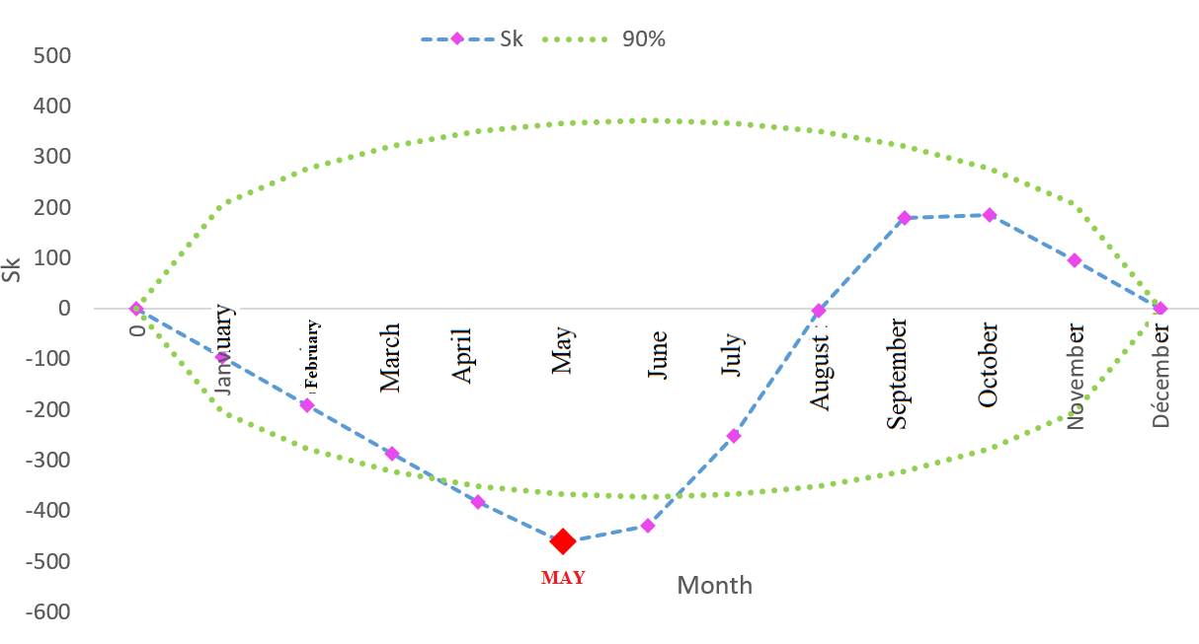
Figure 8. Ellipse of average monthly rainfall over the period (1951-2025)

- Hubert's Segmentation Test
The results of the Hubert segmentation test applied to the monthly rainfall series are presented in Table 5, and the corresponding graphical representation is shown in Figure 9. At the 10% significance level (90% confidence level), the test indicates a significant break in the series, leading to rejection of the null hypothesis of homogeneity. The break occurs in June and reflects a change in the monthly rainfall pattern. The segmentation indicates an upward break characterised by an increase in mean rainfall from June onwards. This change marks the beginning of the rainy season and precedes the higher rainfall totals generally observed from July to September, the core wet-season period in the Kolda region. The monthly rainfall series therefore cannot be considered homogeneous throughout the year.
Table 5 : Results of the Hubert test of average monthly rainfall over the period (1951-2025)
Start | End | Average | Standard deviation
January | December | 96,433 | 130,475

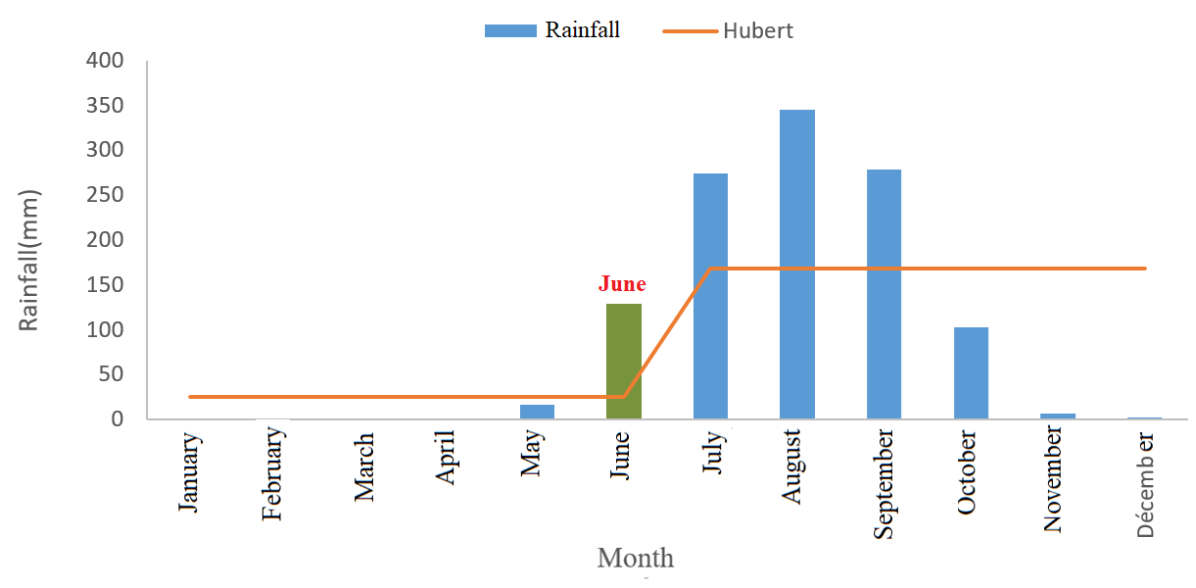
Figure 9. Hubert segmentation diagram of average monthly rainfall over the period (1951-2025)
- Pettitt Test
The results of the Pettitt test applied to the monthly rainfall series are presented in Table 6 and Figure 10. At the 10% significance level (90% confidence level), the test indicates a significant break in the monthly rainfall series at the Kolda station. The associated p-value is 0.0751 for April, which is below the selected significance level (α = 0.10). The null hypothesis of homogeneity is therefore rejected, and April is identified as the point at which monthly rainfall behaviour changes.
Station | Study period | Null Hypothesis | Series type  Chronological | Confidence threshold
 |  |  |  | 90%
KOLDA | 1951 /2025 | Rejeted | Random | 90%
Table 6 : Results of the Pettit test for average monthly rainfall

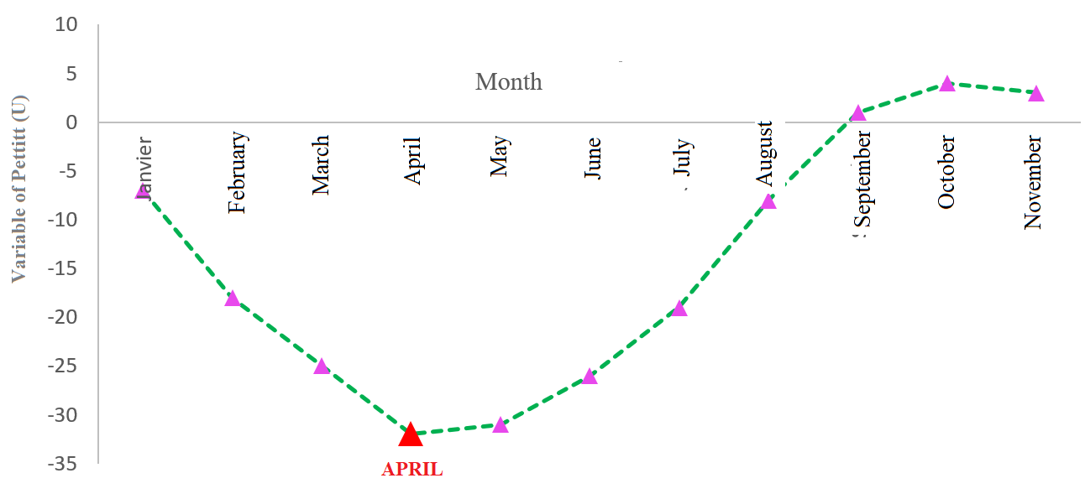
Figure 10. Pettit test diagram of average monthly rainfall over the period (1951-2025)
- Lee and Heghinian Test
The results of the Lee–Heghinian Bayesian test applied to the monthly rainfall series are presented in Table 7, while Figures 11 and 12 show the associated graphical representations. At the 10% significance level (90% confidence level), the test indicates a significant break in the series, leading to rejection of the null hypothesis of no break. The posterior probability distribution identifies May as the most probable point of change, with a probability of 0.2803. The graphical results support this estimate. The monthly rainfall series is therefore not homogeneous and exhibits a significant intra-annual change in regime. Overall, the Pettitt, Buishand, Hubert, and Lee–Heghinian tests identify break points between April and June, with most results centred on May; differences in the precise month reflect the methodological characteristics of the individual tests.

Table 7 : Results of the Lee and Heghinian test of average monthly rainfall
Station | Study period | Null Hypothesis | Probability | breakup month
KOLDA | 1951/2025 | rejected at the 90% threshold | 0,2803 | May

Figure 11. Probability density of average monthly rainfall over the period (1951-2025)
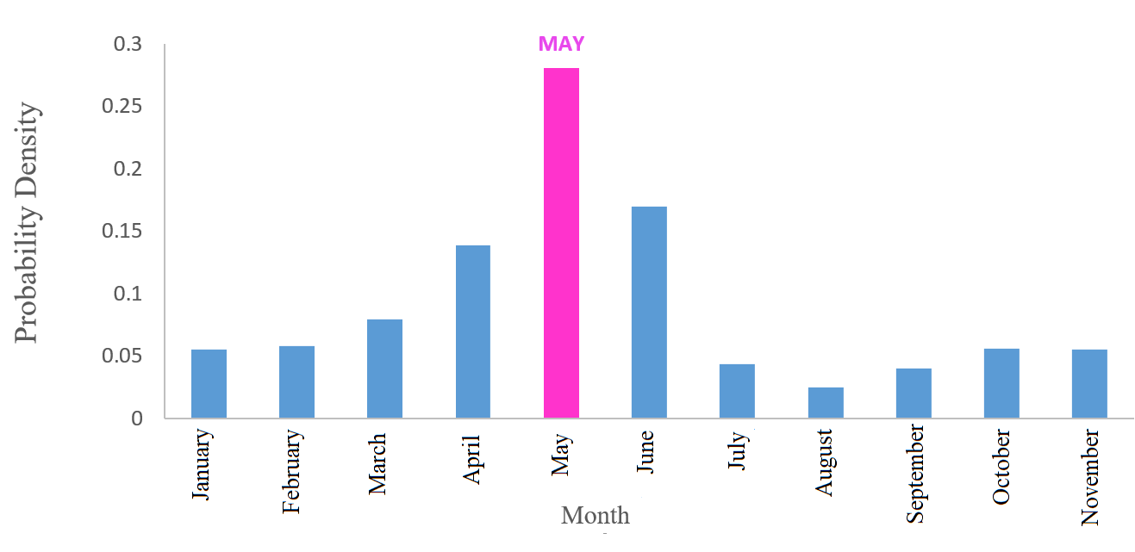
Figure 12. Lee and Heghinian diagram of average monthly rainfall over the period (1951-2025)

6. Discussion
Analysis of the annual rainfall series from the Kolda station for 1951–2025 using KHRONOSTAT indicates changes in the rainfall regime that reflect climatic variability in West Africa. The Pettitt, Buishand, and Lee–Heghinian tests and Hubert segmentation are suited to detecting changes in the means of climatic time series and are widely applied in hydroclimatic studies. Studies conducted in Senegal have generally identified breaks in the late 1960s and early 1970s, corresponding to the onset of the major Sahelian drought. A second break is often reported between the late 1990s and early 2000s, indicating a partial rainfall recovery without a return to pre-1970 levels. At Kolda, the results indicate break dates of approximately 1958 according to Lee–Heghinian and 1967 according to Hubert, both associated with reduced precipitation relative to the preceding period. A recent study focused on Kolda reported that the Lee–Heghinian and Hubert methods identified a break around 1991. In addition, Bodian (2014) found an initial break in 1969 for the southern Sahelian zone and in 1967 for the northern and southern Sudanian zones using the Pettitt test. The Lee–Heghinian and Hubert tests placed the first break in 1967 across Senegal, corresponding to the Pettitt dates for the three zones. More generally, the analysis reported by Lubès-Niel et al. (1998b) places the first break across stations between 1967 and 1969. For the Kolda station, the Pettitt and Buishand tests identify a break in 1971. The differences among the break dates produced by the Pettitt, Hubert, Lee–Heghinian, and Buishand methods arise primarily from their distinct statistical principles and sensitivities. Pettitt is designed to detect a single break, Hubert identifies multiple homogeneous segments, Lee–Heghinian provides a Bayesian estimate of change, and Buishand is designed to detect a change in the mean. Differences of several years therefore do not necessarily imply inconsistency; rather, they may reflect the characteristics of the rainfall series and the assumptions of each test. Conversely, convergence across several methods provides stronger evidence of a climatic or hydrological break, whereas substantial divergence warrants further assessment of data quality, multiple breaks, and statistical significance.
The detected breaks reflect regional climatic variability across West Africa. The decline in rainfall after the 1960s has been associated with changes in atmospheric circulation, sea-surface temperatures in the Atlantic and Indian Oceans, and fluctuations in the West African monsoon. Since the 1990s, several regions have experienced a relative rainfall recovery accompanied by greater interannual variability and more frequent extreme events, including droughts and intense rainfall. These changes have important implications for water-resource management, rain-fed agriculture, and land-use planning in the Kolda region. A shift in the rainfall regime alters surface-water and groundwater availability, affects agricultural calendars, and increases population vulnerability to climatic hazards. Accounting for these changes is therefore important when developing climate-change adaptation strategies. Overall, the KHRONOSTAT results indicate that rainfall at the Kolda station was non-stationary during 1951–2025. Although the methods produced different break dates, they consistently indicate a reorganisation of the rainfall regime, including a deficit phase associated with the Sahelian drought and a partial rainfall recovery in recent decades without a sustained return to pre-1970 rainfall levels.

7. Conclusion
This study examined the Kolda region in Upper Casamance, southern Senegal, where the economy is dominated by rain-fed agriculture, livestock farming, and forestry. Rainfall is the principal source of water for agricultural production, and monitoring rainfall patterns can therefore improve understanding of climatic change and its implications for water availability. A 75-year rainfall series (1951–2025) was analysed using break-detection tests implemented in KHRONOSTAT. The analysis characterised rainfall variability at annual and monthly scales and identified changes in the rainfall regime. The Pettitt, Hubert, Buishand, and Lee–Heghinian tests were applied at a 10% significance level (90% confidence level). At the annual scale, the tests indicated downward breaks in 1958, 1967, and 1971, depending on the method applied; the Lee–Heghinian posterior probability was 0.1688. At the monthly scale, upward breaks were identified in April by Pettitt, May by Lee–Heghinian and Buishand, and June by Hubert; the Lee–Heghinian posterior probability was 0.2803. These findings can support climate and water-sector stakeholders in examining the relationship between climatic instability and water availability. However, the analysis considered rainfall alone, and KHRONOSTAT does not accommodate gaps in time-series data. Future work should apply methods that can address incomplete records and jointly analyse rainfall, temperature, and runoff. Probability-based assessments of dry and wet periods could also improve understanding of variations in regional water-resource availability.

- Implications of rainfall regime shifts
The breaks detected in Kolda's rainfall record indicate a sustained change in rainfall patterns, with implications for water resources, agriculture, and ecosystems. These changes may reduce water reserves, disrupt agricultural calendars, and increase the risks of drought, flooding, and soil degradation. The findings support the development of adaptation measures, including sustainable water-resource management, resilient agricultural practices, and improved infrastructure planning. Break detection can therefore contribute to decision-making aimed at strengthening the resilience of communities in southern Senegal to climate variability.

- Limitations of the study

This study characterises rainfall-regime changes at a single station using break tests implemented in KHRONOSTAT. Its spatial generalisability is therefore limited to the immediate area represented by the Kolda station. The findings also depend on the quality and homogeneity of the rainfall series, the assumptions and sensitivities of the selected tests, and the 10% significance threshold. Because only rainfall was analysed, the detected breaks cannot directly establish underlying climatic mechanisms or their hydrological effects. Future studies should incorporate multiple stations, satellite observations, temperature and runoff data, and complementary projection models.

Declaration of AI Use

This manuscript was prepared through the combined contributions of all author(s), including contributions to the study design, data, content development, results, interpretation, and related scholarly work. The author(s) acknowledge the use of Grammarly and ChatGPT to assist with grammar checking, language refinement, reference formatting. These AI-assisted tools were not used as authors and did not replace the intellectual contributions or scholarly judgment of the author(s). All AI-assisted outputs, including content, references, and interpretations, were carefully reviewed, revised, verified, and approved by the author(s). The author(s) accept full responsibility for the accuracy, integrity, and final content of the manuscript.

References

Abatcha, I., Mustapha, A., & Barkindo, A. (2024). Comprehensive analysis of rainfall variability in urban Maiduguri, Nigeria: Implications for climate resilience and sustainable development. International Journal of Environment and Climate Change, 14(3), 149–159. https://doi.org/10.9734/ijecc/2024/v14i34027
Agence Nationale de la Statistique et de la Démographie. (2012). Situation économique et sociale régionale de Kolda, 2012. https://www.ansd.sn/ses-regionales?field_regions_ses_target_id=14&field_year_value=All
Agence Nationale de la Statistique et de la Démographie. (2014). Situation économique et sociale régionale de Kolda, 2014. https://www.ansd.sn/ses-regionales?field_regions_ses_target_id=14&field_year_value=All
Agence Nationale de la Statistique et de la Démographie. (2018). Situation économique et sociale régionale de Kolda, 2017–2018. https://www.ansd.sn/ses-regionales?field_regions_ses_target_id=14&field_year_value=All
Agence Nationale de la Statistique et de la Démographie. (2018). Situation économique et sociale régionale de Kolda, 2017–2018. https://www.ansd.sn/ses-regionales?field_regions_ses_target_id=14&field_year_value=All
Ardoin-Bardin, S. (2004). Variabilité hydroclimatique et impacts sur les ressources en eau de grands bassins hydrographiques en zone soudano-sahélienne [Doctoral dissertation, Université Montpellier II].
Ardoin, S., Lubès-Niel, H., Servat, E., Dezetter, A., Boyer, J.-F., Mahé, G., & Paturel, J.-E. (2003). Analyse de la persistance de la sécheresse en Afrique de l’Ouest: Caractérisation de la situation de la décennie 1990. In Hydrology of the Mediterranean and semiarid regions (IAHS Publication No. 278, pp. 223–228).
Bărbulescu, A., & Dumitriu, C. Ș. (2025). Shifts in precipitation variability near the Danube Delta Biosphere Reserve (1965–2019). Water, 17(18), Article 2692. https://doi.org/10.3390/w17182692
Basseville, M., & Nikiforov, I. V. (1993). Detection of abrupt changes: Theory and application. Prentice Hall.
Berkes, I., Gombay, E., & Horváth, L. (2009). Testing for changes in the covariance structure of linear processes. Journal of Statistical Planning and Inference, 139(6), 2044–2063. https://doi.org/10.1016/j.jspi.2008.09.004
Biasutti, M. (2019). Rainfall trends in the African Sahel: Characteristics, processes, and causes. WIREs Climate Change, 10(4), Article e591. https://doi.org/10.1002/wcc.591
Bigot, S., Brou, Y. T., Oszwald, J., & Diedhiou, A. (2005). Facteurs de la variabilité pluviométrique en Côte d’Ivoire et relations avec certaines modifications environnementales. Sécheresse, 16(1), 5–13.
Bobée, B., Boucher, P., & Demard, H. (1978). Demande résidentielle en eau: Analyse statistique des débits de pointe (Rapport scientifique no 90). INRS-Eau.
Bodian, A. (2014). Caractérisation de la variabilité temporelle récente des précipitations annuelles au Sénégal (Afrique de l’Ouest). Physio-Géo, 8, 297–312. https://doi.org/10.4000/physio-geo.4243
Boualem, F., Boukharouba, I., & Djeninat, K. (2021). Étude de l’impact des conditions climatiques sur les rendements des céréales (blé dur) dans la wilaya de Tiaret [Master’s thesis, Université Ibn Khaldoun de Tiaret].
Boyer, J. (2002). Épidémiologie et modélisation: L’exemple de la fièvre de la vallée du Rift au Sénégal [Doctoral dissertation, École nationale vétérinaire de Toulouse].
Brou, Y. T. (2005). Climat, mutations socio-économiques et paysages en Côte d’Ivoire [Habilitation thesis, Université des sciences et technologies de Lille]. https://pepite.univ-lille.fr/ori-oai-search/notice/view/univ-lille-18095
da Silva, A. R., Bolonhez, B. F., & Pinheiro, H. D. (2024). Homogeneity analysis of daily precipitation series in Paraná State, southern Brazil. Theoretical and Applied Climatology, 155, 8077–8088. https://doi.org/10.1007/s00704-024-05119-x
Sighomnou, D. (2004). Analyse et redéfinition des régimes climatiques et hydrologiques du Cameroun: Perspectives d’évolution des ressources en eau [Doctoral dissertation, Université de Yaoundé I].
Nsangou, D. (2023). Modélisation des interactions eaux de surface–eaux souterraines et impacts sur les risques d’inondation dans la partie amont du bassin versant de la Mefou, Sud-Cameroun [Doctoral dissertation, Université de Yaoundé I]. https://hdl.handle.net/20.500.12177/11898
Diome, F., Mabiala, E., & Sarr, J. H. (2008). Les potentialités agricoles et la répartition des sols du Sénégal oriental et de la Haute-Casamance. Journal des Sciences et Technologies, 6(2), 56–65.
Dubois, J. (1948). Esquisse des différents types de sols de la moitié sud du Sénégal. In Actes de la Conférence africaine des sols, Goma, Congo belge (Communication no 163).
Fauck, R., Turenne, J.-F., & Vizier, J.-F. (1963). Étude pédologique de la Haute-Casamance. Tome 2: Documents cartographiques—Carte pédologique de la Haute-Casamance au 1:200 000. ORSTOM. http://biblio.uadb.edu.sn/pmb/opac_css/index.php?lvl=notice_display&id=8539
Ilori, O. W., & Adeyewa, D. Z. (2025). Projected changes in extreme rainfall events over West Africa and its sub-regions: A multi-scenario climate analysis. Meteorology and Atmospheric Physics, 137, Article 33. https://doi.org/10.1007/s00703-025-01081-z
Intergovernmental Panel on Climate Change. (2023). Climate change 2023: Synthesis report. Contribution of Working Groups I, II and III to the Sixth Assessment Report of the Intergovernmental Panel on Climate Change (Core Writing Team, H. Lee, & J. Romero, Eds.). https://doi.org/10.59327/IPCC/AR6-9789291691647
Mballo, I., Sy, O., & Faye, C. (2019). Variabilité climatique et production alimentaire en Haute-Casamance (Sud-Sénégal). Espace Géographique et Société Marocaine, 28–29, 161–178.
Jandhyala, V. K., Fotopoulos, S. B., & Hawkins, D. M. (2002). Detection and estimation of abrupt changes in the variability of a process. Computational Statistics & Data Analysis, 40(1), 1–19. https://doi.org/10.1016/S0167-9473(01)00108-6
Kouassi, A. M. (2007). Caractérisation d’une modification éventuelle de la relation pluie-débit et ses impacts sur les ressources en eau en Afrique de l’Ouest: Cas du bassin versant du N’zi (Bandama) en Côte d’Ivoire [Doctoral dissertation, Université de Cocody].
Ahoussi, K. E., Koffi, Y. B., Kouassi, A. M., Soro, G., Soro, N., & Biémi, J. (2013). Étude de la variabilité hydroclimatique et de ses conséquences sur les ressources en eau du Sud forestier et agricole de la Côte d’Ivoire: Cas de la région d’Abidjan-Agboville. International Journal of Pure & Applied Bioscience, 1(6), 30–50.
Lakehal, S., & Hamdi, A. (2021). Étude de la variabilité climatique à travers les séries pluviométriques: Exemple du bassin versant de la Tafna (Nord-Ouest algérien) [Master’s thesis, Centre universitaire de Maghnia]. https://dspace.cu-maghnia.dz/collections/8c913f21-0efc-49dc-aa49-2537d0dba0a3
Lubès, H., Masson, J.-M., Servat, E., Paturel, J.-E., Kouamé, B., & Boyer, J.-F. (1994). Caractérisation des fluctuations d’une série chronologique par application de tests statistiques: Étude bibliographique (Rapport no 3). ORSTOM.
Lubès-Niel, H., Masson, J.-M., Paturel, J.-E., & Servat, E. (1998). Variabilité climatique et statistiques: Étude par simulation de la puissance et de la robustesse de quelques tests utilisés pour vérifier l’homogénéité de chroniques. Revue des Sciences de l’Eau, 11(3), 383–408. https://doi.org/10.7202/705313ar
Lubès-Niel, H., Masson, J.-M., Paturel, J.-E., & Servat, E. (1998). Variabilité climatique et statistiques: Étude par simulation de la puissance et de la robustesse de quelques tests utilisés pour vérifier l’homogénéité de chroniques. Revue des Sciences de l’Eau, 11(3), 383–408. https://doi.org/10.7202/705313ar
Lund, R. B., Beaulieu, C., Killick, R., Lu, Q., & Shi, X. (2023). Good practices and common pitfalls in climate time-series changepoint techniques: A review. Journal of Climate, 36(23), 8041–8057. https://doi.org/10.1175/JCLI-D-22-0954.1
Mendes, O., Correia, E., & Fragoso, M. (2025). Variability and trends of the rainy season in West Africa with a special focus on Guinea-Bissau. Theoretical and Applied Climatology, 156, Article 242. https://doi.org/10.1007/s00704-025-05471-6
Sané, M. L., Sambou, S., Ndione, D. M., Leye, I., Kane, S., & Badji, M. L. (2017). Analyse et traitement des séries de débits annuels et mensuels sur le fleuve Sénégal en amont du barrage de Manantali: Cas des stations de Bafing Makana et Dakka Saidou. Revue Ivoirienne des Sciences et Technologie, 30, 102–120.
Ministère de l’Élevage et des Productions animales. (2022). Programme national de développement intégré de l’élevage au Sénégal: Cadre de gestion environnementale et sociale—Rapport final. https://www.fao.org/faolex/country-profiles/general-profile/see-more/en/?area=Policy&countryname=Senegal&iso3=SEN
Nazeri Tahroudi, M. (2025). Comprehensive global assessment of precipitation trend and pattern variability considering their distribution dynamics. Scientific Reports, 15, Article 22458. https://doi.org/10.1038/s41598-025-06050-5
Ndiaye, A. (2013). Caractérisation biophysique des parcs à Adansonia digitata L. (baobab) en Moyenne et Haute-Casamance: Dynamique, production fruitière et anthropisation [Master’s thesis, Université Assane Seck de Ziguinchor].
Nicholson, S. E. (2013). The West African Sahel: A review of recent studies on the rainfall regime and its interannual variability. ISRN Meteorology, 2013, Article 453521. https://doi.org/10.1155/2013/453521
Office National de l’Assainissement du Sénégal. (2017). Études des plans directeurs d’assainissement des eaux usées et des eaux pluviales des villes de Kolda et Vélingara à l’horizon 2030.
Ouarda, T. B. M. J., Rasmussen, P. F., Cantin, J.-F., Bobée, B., Laurence, R., Hoang, V. D., & Barabé, G. (1999). Identification d’un réseau hydrométrique pour le suivi des modifications climatiques dans la province de Québec. Revue des Sciences de l’Eau, 12(2), 425–448. https://doi.org/10.7202/705359ar
Ouédraogo, M. (2001). Contribution à l’étude de l’impact de la variabilité climatique sur les ressources en eau en Afrique de l’Ouest: Analyse des conséquences d’une sécheresse persistante, normes hydrologiques et modélisation régionale [Doctoral dissertation, Université Montpellier II]. https://www.hydrosciences.fr/sierem/Bibliotheque/index.asp
Paturel, J.-E., Servat, E., Kouamé, B., Boyer, J.-F., Lubès-Niel, H., & Masson, J.-M. (1996). Procédures d’identification de « ruptures » dans des séries chronologiques: Modification du régime pluviométrique en Afrique de l’Ouest non sahélienne. In P. Chevallier and B. Pouyaud (Eds.), L’hydrologie tropicale: Géosciences et outil pour le développement (IAHS Publication No. 238, pp. 99–110). IAHS. https://www.documentation.ird.fr/hor/fdi:010009805
Paturel, J.-E., Servat, E., Delattre, M.-O., & Lubès-Niel, H. (1998). Analyse de séries pluviométriques de longue durée en Afrique de l’Ouest et centrale non sahélienne dans un contexte de variabilité climatique. Hydrological Sciences Journal, 43(6), 937–946. https://doi.org/10.1080/02626669809492188
Perreault, L., Bernier, J., Bobée, B., & Parent, E. (2000). Bayesian change-point analysis in hydrometeorological time series. Part 2: Comparison of change-point models and forecasting. Journal of Hydrology, 235(3–4), 242–263. https://doi.org/10.1016/S0022-1694(00)00271-7
Malou, R. (2014). Impact du climat sur les ressources en eau souterraines en zone soudano-sahélienne [Doctoral dissertation, Université Cheikh Anta Diop]. https://hdl.handle.net/20.500.12177/2905
Sabeur, K. (2022). Étude statistique de la pluviométrie et caractérisation climatique: Application à un bassin versant de l’oued Sebdou (Nord-Ouest algérien) [Master’s thesis, Université Abou Bekr Belkaïd de Tlemcen].
Saporta, G. (1990). Probabilités, analyse des données et statistique. Technip.
Scariano, S. M., & Watkins, T. A. (1988). Nonparametric point estimators for the change-point problem. Communications in Statistics—Theory and Methods, 17(11), 3645–3675. https://doi.org/10.1080/03610928808829826
Servat, E., Paturel, J.-E., Kouamé, B., Travaglio, M., Ouédraogo, M., Boyer, J.-F., Lubès-Niel, H., Fritsch, J.-M., Masson, J.-M., & Marieu, B. (1998). Identification, caractérisation et conséquences d’une variabilité hydrologique en Afrique de l’Ouest et centrale. In E. Servat, D. Hughes, J.-M. Fritsch, and M. Hulme (Eds.), Water resources variability in Africa during the 20th century (IAHS Publication No. 252, pp. 323–337). IAHS. https://www.documentation.ird.fr/hor/fdi:010017941
Sircoulon, J. (1976). Les données hydropluviométriques de la sécheresse récente en Afrique intertropicale: Comparaison avec les sécheresses de 1913 et 1940. Cahiers ORSTOM, Série Hydrologie, 13(2), 75–134.
Sokol, Z., Řezáčová, D., & Popová, J. (2026). Estimating changes in precipitation-event characteristics with projected temperature increase in the 21st century. Atmospheric Research, 331, Article 108698. https://doi.org/10.1016/j.atmosres.2025.108698
Sujalu, A. P., Napitupulu, M., Jannah, N., Yulianthi, R., Orianto, K. S., Hadi, N., & Anggra, M. R. (2026). Investigation of rainfall variability across different regions in Paser Regency, East Kalimantan, Indonesia. BIONATURE, 46(1), 404–411. https://doi.org/10.56557/bn/2026/v46i12118
Swain, D. L., Prein, A. F., Abatzoglou, J. T., Albano, C. M., Brunner, M., Diffenbaugh, N. S., Singh, D., Skinner, C. B., & Touma, D. (2025). Hydroclimate volatility on a warming Earth. Nature Reviews Earth & Environment, 6, 35–50. https://doi.org/10.1038/s43017-024-00624-z
Tatar, H., & Regad, N. (2015). Variabilité climatique et ressources en eau en milieu semi-aride: Cas des bassins versants des oueds Chemora, Reboa et Gueiss (Hauts Plateaux constantinois, Algérie). Annals of the University of Bucharest: Geography Series, 19–36. https://annalsreview.geo.unibuc.ro/2015.html
Traore, V. B., Ndiaye, M. L., Mbow, C., Malomar, G., Sarr, J., Beye, A. C., & Diaw, A. T. (2017). Khronostat model as statistical analysis tools in Low Casamance River Basin, Senegal. World Environment, 7(1), 10–22. https://doi.org/10.5923/j.env.20170701.02
Traore, V. B., Sambou, S., Cisse, M. T., Tamba, S., Fall, S., Diaw, A. T., Sambou, H., & Nimy, M. E. (2014). Trends and shifts in time series of rainfall and runoff in the Gambia River watershed. International Journal of Environmental Protection and Policy, 2(4), 138–146. https://doi.org/10.11648/j.ijepp.20140204.13
Larivière, V. (2011). La vulnérabilité et l’adaptation aux changements climatiques: Une étude de cas à Kuujjuarapik et Whapmagoostui [Master’s thesis, Université du Québec à Montréal]. https://archipel.uqam.ca/4345/
World Meteorological Organization. (2024). State of the climate in Africa 2023. https://public.wmo.int/resources/publication-series/state-of-climate-africa/state-of-climate-africa-2023
Yang, K., Wang, G., Cai, W., Mohino, E., Rodríguez-Fonseca, B., Ng, B., & Yeh, S.-W. (2026). Increased interannual variability of Sahel rainfall under greenhouse warming. Nature Communications, 17, Article 1125. https://doi.org/10.1038/s41467-025-67885-0
Yate, T. A., & Ren, G. (2025). An overview of observed changes in precipitation totals and extremes over global land, with a focus on Africa. Earth-Science Reviews, 262, Article 105063. https://doi.org/10.1016/j.earscirev.2025.105063
Yildirim, G., & Rahman, A. (2022). Homogeneity and trend analysis of rainfall and droughts over Southeast Australia. Natural Hazards, 112(2), 1657–1683. https://doi.org/10.1007/s11069-022-05243-9
Yilmaz, A. G., & Perera, B. J. C. (2015). Spatiotemporal trend analysis of extreme rainfall events in Victoria, Australia. Water Resources Management, 29(12), 4465–4480. https://doi.org/10.1007/s11269-015-1070-3
Brunet-Moret, Y. (1970). Études hydrologiques en Casamance: Rapport définitif. ORSTOM. https://www.documentation.ird.fr/hor/fdi:04581
Ziervogel, G., & Ericksen, P. J. (2010). Adapting to climate change to sustain food security. WIREs Climate Change, 1(4), 525–540. https://doi.org/10.1002/wcc.56

