UNDER PEER REVIEW

Soil Quality Assessment on Former Agricultural Sites of the University
of Man , Côte d'Ivoire
Abstract: Former agricultural soils may retain trace metals after cultivation has ceased, particularly where chemical fertilisers were previously applied. This study assessed selected soil-quality indicators and residual lead (Pb) and arsenic (As) at three former agricultural sites and one control site at the University of Man, Côte d’Ivoire. Composite soil samples were collected from depths of 0–20 cm and 20–40 cm. Soil pH and redox potential were measured using a multiparameter analyser, organic matter was estimated from organic carbon, and Pb and As concentrations were determined by inductively coupled plasma optical emission spectrometry following acid digestion. Contamination and ecological risk were evaluated using the geo-accumulation index and the single-metal ecological risk index. Soil pH ranged from 4.06 to 5.30, indicating acidic conditions, while organic matter content ranged from 10% to 17%. Arsenic concentrations ranged from 0.06 to 0.39 mg/kg, and lead concentrations ranged from 0.04 to 0.30 mg/kg. Concentrations were generally higher at the former agricultural sites than at the control site and tended to decrease with depth. Geo-accumulation index values were negative at all sites, while ecological risk values ranged from 0.38 to 1.89 for As and from 0.01 to 0.08 for Pb, remaining below the low-risk threshold. These findings indicate low contamination and ecological risk for the two assessed metals under the indices and reference values applied.
Keywords: Soil quality; former agricultural land; arsenic; lead; geo-accumulation index; ecological risk; redox potential; organic matter; chemical fertilisers
1. Introduction
The use of chemical fertilisers has become an important means of supplying nutrients to plants, increasing agricultural production and improving crop quality (Giroux et al., 2005; Asadu et al., 2024). This approach can also improve infertile soils (Food and Agriculture Organization of the United Nations & International Fertilizer Industry Association, 2000; Guo & Wang, 2021). Each year, large quantities of chemical fertilisers are applied to soils to increase productivity. Between 1970 and 2000, fertiliser use increased by 450% in Asia, 200% in Latin America and 100% in Africa (Ramade, 2005). These fertilisers contain copper (Cu), iron (Fe), manganese (Mn) and zinc (Zn). When supplied in appropriate quantities, these micronutrients promote plant growth (Aziz et al., 2015). However, when their concentrations exceed acceptable limits, they may become toxic to plants (Simon et al., 2016; Wen et al., 2017; Chen et al., 2018; Guo & Wang, 2021). Furthermore, phosphate-based chemical fertilisers are recognised as sources of metallic and radioactive pollutants (Nziguheba & Smolders, 2008). Trace metals such as arsenic (As), cadmium (Cd), zinc (Zn), iron (Fe) and lead (Pb), rare-earth elements such as lanthanum (La), cerium (Ce), ytterbium (Yb) and samarium (Sm), and naturally occurring radioactive elements such as uranium (U), thorium (Th), potassium (K) and radium (Ra) may accumulate in soils following fertilisation (Gupta et al., 2014). Several studies have shown that the irrational use of fertilisers increases the concentrations of trace metallic elements in soils (Huang et al., 2018). These elements may also migrate through the soil, pollute groundwater and enter the food chain (Simon et al., 2016).
Recent reviews further recognise agricultural inputs as contributors to heavy-metal accumulation in soils and emphasise the need for site-specific contamination assessment (Tripathi et al., 2024; Rabha & Dhaneesh, 2024).
Mineral fertilisers are also identified as anthropogenic sources of heavy metals in agricultural soils, while soil properties may influence metal availability and accumulation (Wan et al., 2024).
Evidence from a long-term field experiment indicates that repeated NPK fertilisation can alter trace-metal pools, although the magnitude of change varies among metals and management regimes (Barłóg et al., 2024).
Man, a town in western Côte d’Ivoire, is considered one of the most fertile areas in the country because of its rainy, mountainous environment. As the population increased from 153,427 in 2014 to 241,969 in 2021, agricultural practices increasingly relied on fertilisers and pesticides to meet the growing demand for food within a limited area. The excessive use of fertilisers and plant-protection products may affect soils, water, plants and living organisms. The University of Man site formerly contained extensive cultivated fields, and some crops remain on the plots. It is therefore necessary to assess the long-term persistence of residual heavy metals associated with fertiliser use in these soils.
Accordingly, a site-specific assessment is needed to clarify whether Pb and As persist in these former agricultural soils after cultivation has ceased and whether their current concentrations present an ecological risk.
Within this context, the study assessed the long-term impact of chemical fertiliser use on former agricultural plots by evaluating soil quality. Specifically, it determined soil pH, redox potential, organic matter content, lead (Pb) and arsenic (As) concentrations, and the degree of soil contamination and ecological risk across the investigated sites.
2. Materials and methods
2.1. Materials
The equipment comprised an auger for sampling, plastic bags for packaging the samples, a GARMIN 64 Sx GPS for recording sampling-point coordinates, and sturdy plastic bags for transporting and mixing the samples. The analyses were performed using a HANNA multiparameter meter to determine pH and redox potential, an OPTIMA 2100 Dual View (ICP-OES 2100 DV) spectrometer to determine Pb and As concentrations, and an asbestos test kit to determine organic matter.
2.2. Methods

2.2.1. Soil sampling
Samples were collected from agricultural soils at the University of Man site in Côte d’Ivoire. The sites were selected according to crop type and identified from visible evidence of previous cultivation. Three former agricultural sites and one control site were included. Soil sampling was conducted at three points within each site using a composite sampling approach. Thirty soil cores were combined to obtain six samples per site. Samples were collected from two depth intervals: 0–20 cm and 20–40 cm.
Table 1: Crop sites.
Site | Culture | Area | Coordinates
Site 1 | Rubber plantation (Hevea brasiliensis) | 3 ha | Latitude 7°20′28″N  Longitude 7°37′21″W
Site 2 | Coffee plantation (Coffea arabica) | 1.5 ha | Latitude 7°20′57″N  Longitude 7°36′38″W
Site 3 | Palm tree plantation (Elaeis guineensis) | 3.5 ha | Latitude 7°21′00″N  Longitude 7°36′51″W
Control site | – | – | Latitude 7°20′59″N  Longitude 7°37′39″W
2.2.2. Sample preparation
In the laboratory, the soil samples underwent standard preparation procedures for soil analysis, namely drying, quartering, grinding and sieving. The samples were air-dried at room temperature, away from direct sunlight, for one week. After drying, coarse materials, including stones, leaves, roots and snail shells, were removed. Quartering reduced each sample to the volume required for analysis, and grinding was performed using a mortar. Samples intended for physicochemical analysis were then passed through a 63 µm sieve in accordance with ISO 11464:2006 (International Organization for Standardization, 2006).
2.2.3. Physicochemical analyses
2.2.3.1. pH, redox potential and organic carbon
Soil pH and redox potential were measured using a HANNA multiparameter analyser. Ten grams of soil was suspended in 100 mL of distilled water. The mixture was stirred for 1 h using a magnetic stirrer and then allowed to stand for 2 h. The pH and redox potential were determined by immersing the probe in the supernatant.
Organic carbon was determined using the Walkley–Black method (Walkley & Black, 1934). Organic matter was oxidised by a cold mixture of potassium dichromate and sulphuric acid, and the excess dichromate was titrated with Mohr’s salt. The following reagents were used:
Potassium dichromate (Cr₂O₇K₂). The reagent was dried in a desiccator containing calcium chloride (CaCl₂) or sulphuric acid (H₂SO₄). Subsequently, 50 g of potassium dichromate (Cr₂O₇K₂) was dissolved in 1,000 mL of distilled water.
Mohr’s salt. A mass of 196.05 g of Mohr’s salt [SO₄Fe, SO₄(NH₄)₂·6H₂O] was dissolved in 1,000 mL of sulphuric acid.
Diphenylamine. A mass of 0.5 g was dissolved in 100 mL of concentrated sulphuric acid (SO₄H₂), carefully poured into 20 mL of water, and stored in a brown bottle.
Sodium fluoride powder.
After the reagents had been prepared, 10 g of soil was placed in a conical flask. Ten millilitres of dichromate and 20 mL of concentrated sulphuric acid were added, and the mixture was stirred for 1 min. It was then allowed to stand for 30 min on a sheet of asbestos paper. Subsequently, 200 mL of water, 10 mL of phosphoric acid (d = 1.71) and three drops of diphenylamine were added. The excess dichromate was titrated with Mohr’s salt solution directly in the digestion flask. The colour changed from bluish-grey to light green, and shortly before the endpoint, the solution became purplish before changing abruptly. Organic matter concentration was calculated using Equation (1).
MO (%) = C × 1.724 (1)
C = [(10 − V × X) × 0.39] / P
where C is the organic carbon concentration;
P is the mass of the soil sample;
V is the volume of Mohr’s salt used (mL); and
X is the correction factor for Mohr’s salt.
2.2.3.2. Trace metals
Trace-metal analysis was conducted in two stages: extraction of the metals from the soil matrix by dissolution, followed by instrumental analysis. Extraction was performed using hydrofluoric acid (HF) and perchloric acid (HClO₄) in accordance with NF X31-147 (Association Française de Normalisation, 1996). One hundred grams of soil, dried at 105 °C and passed through a 315 µm sieve, was calcined at 450 °C for 3 h. The resulting ash was moistened with a few drops of distilled water, after which 5 mL of HF (40%) and 1.5 mL of HClO₄ (70%) were added. The mixture was heated in a sand bath until a cake formed. One millilitre of HNO₃ and 5 mL of distilled water were then added. The mixture was heated for several minutes, filtered and made up to the required volume with distilled water.
Arsenic and lead were analysed using an OPTIMA 2100 Dual View (ICP-OES 2100 DV) spectrometer. The instrument had a detection limit of 5 µg/L. A calibration curve was established for each analytical series using standards of 5, 10 and 20 µg/L prepared from a PERKIN ELMER stock solution containing 30 elements. Arsenic analysis followed ISO 11885:2007 (International Organization for Standardization, 2007). Trace-element concentrations were calculated using Equation (3).
T (mg/kg) = C × V / S (3)
where T is the concentration of the element (mg/kg);
C is the measured concentration of the element (mg/L);
S is the mass of the soil sample (g); and
V is the extraction volume (mL).
2.2.4. Determination of soil toxicity levels
The degree of arsenic and lead contamination in the agricultural soils was assessed using the geo-accumulation index (Igeo) described by Müller (1969), as shown in Equation (4).
Igeo = log₂[CETM / (1.5 × Creference)] (4)
where log₂ is the logarithm to base 2;
CETM is the concentration of the trace metal in the soil sample; and
Creference is the reference concentration of the trace metal in the Earth’s crust (As = 2 mg/kg; Pb = 17 mg/kg) (Wedepohl, 1995).
Table 2: Classification of soil contamination levels based on determined Igeo values (Müller, 1969).
Classes | Igeo values | Soil contamination level
Class 0 | Igeo ≤ 0 | No contamination
Class 1 | 0 < Igeo < 1 | No contamination to moderate contamination
Class 2 | 1 < Igeo < 2 | Moderate contamination
Class 3 | 2 < Igeo < 3 | Moderate to heavy contamination
Class 4 | 3 < Igeo < 4 | Heavy contamination
Class 5 | 4 < Igeo < 5 | Heavy to extreme contamination
Class 6 | Igeo > 5 | Extreme contamination
The ecological risk posed by arsenic and lead was determined using the ecological risk index for a single metal. The index was calculated using Equation (5), as described by Hakanson (1980).
Eᵢᵣ = Tᵢᵣ × CETM / Creference (5)
where Tᵢᵣ is the biological toxicity factor of the individual element (As = 10; Pb = 5) (Hakanson, 1980);
CETM is the concentration of the trace metal in the soil; and
Creference is the reference concentration of the trace metal in the Earth’s crust (As = 2 mg/kg; Pb = 17 mg/kg) (Wedepohl, 1995).
Table 3: Soil ecological risk classes according to Hakanson (1980).
Eᵢᵣ value | Soil ecological risk level
Eᵢᵣ < 40 | Low
40 ≤ Eᵢᵣ < 80 | Moderate
80 ≤ Eᵢᵣ < 160 | Significant
160 ≤ Eᵢᵣ < 320 | High
Eᵢᵣ ≥ 320 | Very high
2.2.5. Statistical analysis
Statistical analysis was performed using analysis of variance (ANOVA), and a t-test (p < 0.05) was used to compare arsenic and lead concentrations among the groups of normally distributed soil samples.
3. Results and Discussion
3.1. Hydrogen ion concentration
Figure 1 shows the variation in pH among the investigated sites. Mean pH values ranged from 4.06 ± 0.33 to 4.11 ± 0.07 at the coffee plantation, from 4.56 ± 0.36 to 4.10 ± 0.04 at the palm plantation, from 4.36 ± 0.27 to 4.31 ± 0.59 at the rubber plantation, and from 5.30 ± 0.25 to 5.20 ± 0.31 at the control site. The highest pH values were recorded at the control site. Overall, pH values ranged from 4.06 to 5.30, indicating acidic conditions. This acidity may be associated with phosphate fertiliser application because phosphate fertilisers can increase soil acidity (Chen et al., 2006). The values were broadly similar to those reported by Korzeniowska et al. (2025) in Jelcz-Laskowice near Wrocław, Poland. In contrast, Kao et al. (2007) reported alkaline pH values of 8.36–8.59 in agricultural soils in Settat, Morocco.
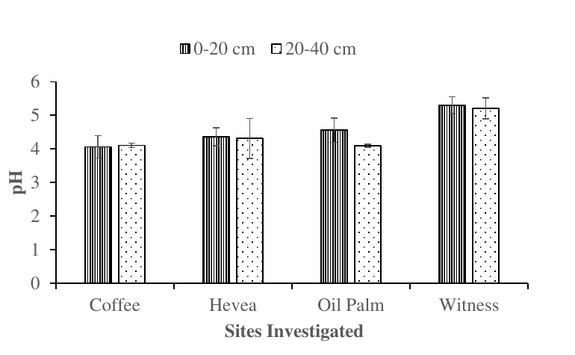
Figure 1: Variation in pH at the sites investigated as a function of depth.
Figure 2 presents the variation in redox potential. At the coffee plantation, Eh values ranged from 304.9 to 316.4 mV, with mean values of 310.6 ± 5.53 and 307.9 ± 2.74 mV. At the rubber plantation, values ranged from 228.2 to 320.7 mV, with mean values of 282.3 ± 46.82 and 309.6 ± 16.23 mV. At the palm plantation, values ranged from 258.1 to 305.1 mV, with mean values of 276.3 ± 17.24 and 295.6 ± 12.38 mV. At the control site, mean values were 260 ± 18.31 and 258.1 ± 15.99 mV. Redox potential was therefore slightly lower at the control site. Overall, the measured values ranged from 228.5 to 316.4 mV and fell within the range of moderately reducing environments (100–400 mV) described by Husson (2013). The slight increase in redox potential at the rubber and palm plantations may be related to root penetration, which can loosen and aerate soil (Obeidy et al., 2016).
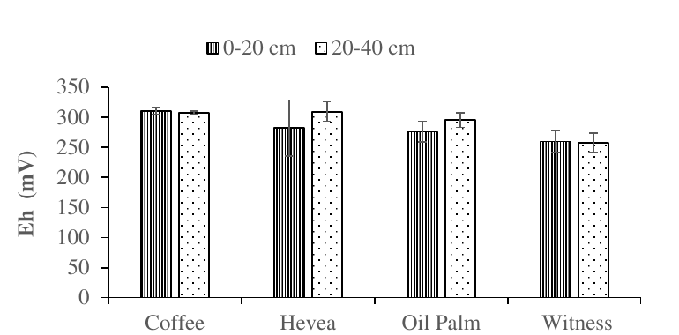
Figure 2: Variation in the redox potential of the sites investigated with respect to depth
3.3. Organic matter
Figure 3 shows the variation in soil organic matter concentration among sites and soil depths. Organic matter concentrations ranged from 10% to 15% at the coffee plantation, 12% to 17% at the rubber plantation, 11% to 16% at the palm plantation and 10% to 11% at the control site. The lowest concentrations occurred in the control soil. Across all soils, organic matter content ranged from 10% to 17%. According to the French non-genetic classification, the investigated soils were moderately rich in organic matter. This richness may be related to previous fertiliser use and may reduce the availability and mobility of some elements (Guo et al., 2012). These values were higher than the 4.20% reported by Majour et al. (2024) in the north-east of Algeria.
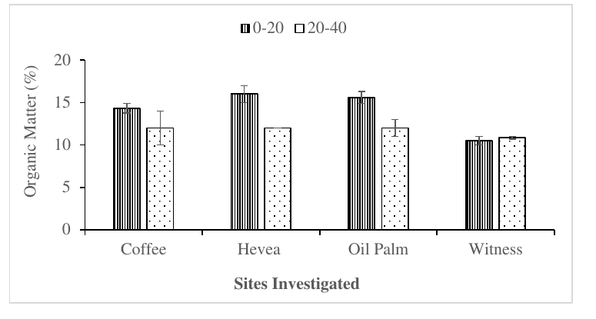
Figure 3: Variation in organic matter content at the investigated sites with depth.
3.4. Heavy metal concentrations
Figure 4 presents lead concentrations at the sampling sites. Lead concentrations were higher in the upper soil layer (0–20 cm). Mean Pb concentrations decreased slightly with depth and were lower at the control site than at the former agricultural sites. The concentrations did not differ significantly within or among the former agricultural sites; the control site was the exception in the t-test. Mean concentrations for the 0–20 cm and 20–40 cm depths, respectively, were 0.30 and 0.27 mg/kg at the coffee plantation, 0.29 and 0.265 mg/kg at the rubber plantation, 0.29 and 0.27 mg/kg at the palm plantation, and 0.05 and 0.04 mg/kg at the control site.
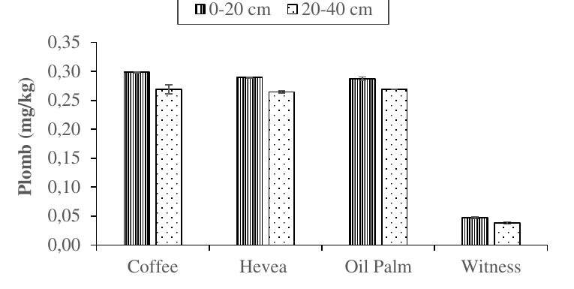
Figure 4: Variation in lead concentrations at the sites investigated at U-Man according to depth.
Figure 5 shows arsenic concentrations at the different sites. Concentrations were broadly similar among the former agricultural sites and decreased with depth. The lowest values occurred at the control site. ANOVA indicated no significant difference between depths within the same site or among the former agricultural sites; the control site was the exception. Mean concentrations ranged from 0.37 to 0.39 mg/kg at the coffee plantation, 0.37 to 0.38 mg/kg at the palm plantation, 0.36 to 0.38 mg/kg at the rubber plantation, and 0.06 to 0.10 mg/kg at the control site.
Arsenic and lead concentrations ranged from 0.06 to 0.39 mg/kg and from 0.04 to 0.30 mg/kg, respectively. Concentrations were higher at the former agricultural sites than at the control site. However, As and Pb concentrations in all soil layers were below the Canadian agricultural soil guideline values of 12 mg/kg for As and 70 mg/kg for Pb (Canadian Council of Ministers of the Environment, 1997, 2025). These low concentrations may reflect the cessation of cultivation and the absence of further fertiliser-derived inputs. Concentrations also decreased with depth at all former agricultural sites. This pattern may be influenced by soil properties, particularly organic matter content and pH. Organic matter can bind metal ions to form complexes, thereby reducing their availability and mobility (Guo et al., 2012). Higher pH can reduce metal solubility, whereas lower pH may promote migration from the solid phase into water and plants (Katana et al., 2013). Li et al. (2014) described such a profile as characteristic of anthropogenic pollution, while Alengebawy et al. (2021) identified chemical fertilisers as an important anthropogenic source of heavy metals in agricultural soils.
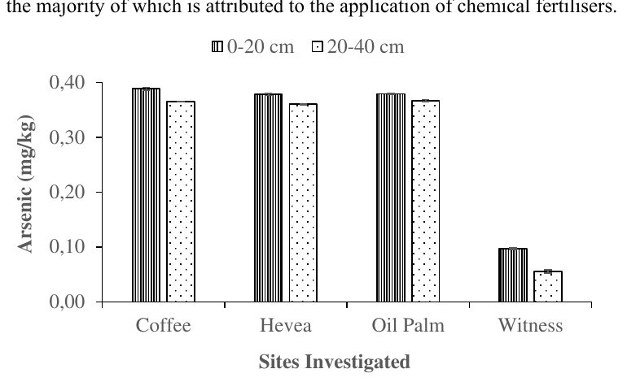
Figure 5: Variation in arsenic levels at the sites investigated at U-man according to depth.
3.5. Soil toxicity levels
3.5.1. Geoaccumulation indices for heavy metals in the soils investigated
Table 4 presents the geo-accumulation index values for heavy metals at the former agricultural sites of the University of Man. All sites had negative geo-accumulation index values (Igeo ≤ 0). However, As had higher geo-accumulation index values than Pb at all sites.
Table 4: Heavy metal geo-accumulation index values at the sites investigated.
Sites | Lead (Pb) | Arsenic (As)
Control site | −9.23 | −5.30
Coffee plantation | −6.49 | −2.99
Rubber plantation | −6.52 | −3.02
Palm tree plantation | −6.52 | −3.01
3.5.2. Ecological risk posed by lead and arsenic at the sites investigated
Table 5 presents the ecological risk values for arsenic and lead. Lead values ranged from 0.01 to 0.08, while arsenic values ranged from 0.38 to 1.89. Ecological risk values were higher for arsenic than for lead, but all values were below 40. Together with the negative geo-accumulation indices, these results indicate low ecological risk for the two measured metals under the assessment criteria used. These findings differ from those of Bounar et al. (2020), who reported varying degrees of trace-metal contamination and potential public-health risks in the Wilaya of Jijel.
Table 5: Ecological risk of the metals studied.
Sites | Pb | As
Control site | 0.01 | 0.38
Coffee plantation | 0.08 | 1.89
Rubber plantation | 0.08 | 1.85
Palm tree plantation | 0.08 | 1.87
4. Conclusions
The study evaluated selected physicochemical properties and trace-metal concentrations in former agricultural soils at the University of Man. The soils were acidic, had moderate to high organic matter contents and showed moderately reducing conditions. Lead and arsenic were detected at the former agricultural sites and the control site, with generally higher concentrations at the previously cultivated sites. Nevertheless, the measured concentrations of both metals remained low in all samples. Geo-accumulation index values were negative at all sites, and ecological risk values for lead and arsenic were below the threshold for low ecological risk. The findings therefore indicate that the investigated soils were not contaminated by lead or arsenic according to the indices and reference values applied in this study. This interpretation is limited to the measured elements and selected soil indicators. Regular monitoring remains necessary, particularly if future agricultural activities involve fertilisers, pesticides, herbicides or fungicides that may contain trace metallic elements.
5. Limitations
This study was limited to three former agricultural sites and one control site within the University of Man area. Only lead and arsenic were analysed, although other metals may also be relevant to agricultural soil quality. The assessment did not include soil texture, nutrient status, cation-exchange capacity, microbial indicators or crop uptake. The sampling design and statistical outputs were limited, and seasonal variation was not considered. The findings should therefore be interpreted as a preliminary assessment of selected soil-quality indicators.

UNDER PEER REVIEW
Declaration of AI Use
This manuscript was prepared through the combined contributions of all author(s), including contributions to the study design, data, content development, results, interpretation, and related scholarly work. The author(s) acknowledge the use of Grammarly and ChatGPT to assist with grammar checking, language refinement, reference formatting. These AI-assisted tools were not used as authors and did not replace the intellectual contributions or scholarly judgment of the author(s). All AI-assisted outputs, including content, references, and interpretations, were carefully reviewed, revised, verified, and approved by the author(s). The author(s) accept full responsibility for the accuracy, integrity, and final content of the manuscript.
Conflict of interest
The authors declare no conflicts of interest.
References
Alengebawy, A., Abdelkhalek, S. T., Qureshi, S. R., & Wang, M.-Q. (2021). Heavy metals and pesticides toxicity in agricultural soil and plants: Ecological risks and human health implications. Toxics, 9(3), Article 42. https://doi.org/10.3390/toxics9030042
Asadu, C. O., Ezema, C. A., Ekwueme, B. N., Onu, C. E., Onoh, I. M., Adejoh, T., Ezeorba, T. P. C., Ogbonna, C. C., Otuh, P. I., Okoye, J. O., & Emmanuel, U. O. (2024). Enhanced efficiency fertilizers: Overview of production methods, materials used, nutrients release mechanisms, benefits and considerations. Environmental Pollution and Management, 1, 32–48. https://doi.org/10.1016/j.epm.2024.07.002
Association Française de Normalisation. (1996). NF X31-147: Soil quality—Soils, sediments—Total solubilizing by acid attack. https://www.boutique.afnor.org/en-gb/standard/nf-x31147/soil-quality-soils-sediments-total-solubilizing-by-acid-attack/fa038958/14416
Aziz, R. A., Abd Rahim, S., Sahid, I., Idris, W. M. R., & Bhuiyan, M. A. R. (2015). Determination of heavy metals uptake in soil and paddy plants. American-Eurasian Journal of Agricultural & Environmental Sciences, 15(2), 161–164. https://doi.org/10.5829/idosi.aejaes.2015.15.2.12510
Barłóg, P., Hlisnikovský, L., Łukowiak, R., & Kunzová, E. (2024). Effect of long-term application of pig slurry and NPK fertilizers on trace metal content in the soil. Environmental Science and Pollution Research, 31, 60004–60022. https://doi.org/10.1007/s11356-024-34993-1
Bounar, A., Boukaka, K., & Leghouchi, E. (2020). Determination of heavy metals in tomatoes cultivated under green houses and human health risk assessment. Quality Assurance and Safety of Crops & Foods, 12(1), 76–86. https://doi.org/10.15586/QAS2019.639
Canadian Council of Ministers of the Environment. (1997). Canadian soil quality guidelines for the protection of environmental and human health: Arsenic (inorganic). In Canadian environmental quality guidelines. https://ccme.ca/en/chemical/9
Canadian Council of Ministers of the Environment. (2025). Canadian soil quality guidelines for the protection of environmental and human health: Lead. In Canadian environmental quality guidelines. https://ccme.ca/en/chemical/124
Chen, J., Lü, S., Zhang, Z., Zhao, X., Li, X., Ning, P., & Liu, M. (2018). Environmentally friendly fertilizers: A review of materials used and their effects on the environment. Science of the Total Environment, 613–614, 829–839. https://doi.org/10.1016/j.scitotenv.2017.09.186
Chen, S., Sun, T.-H., Sun, L.-N., Zhou, Q.-X., & Chao, L. (2006). Influences of phosphate nutritional level on the phytoavailability and speciation distribution of cadmium and lead in soil. Journal of Environmental Sciences, 18(6), 1247–1253. https://doi.org/10.1016/S1001-0742(06)60070-3
[First author changed from Chen, J. to Chen, S.]
Food and Agriculture Organization of the United Nations, & International Fertilizer Industry Association. (2000). Fertilizers and their use: A pocket guide for extension officers (4th ed.). Food and Agriculture Organization of the United Nations. https://agris.fao.org/search/en/providers/122621/records/6472419c2c1d629bc978f90f
Giroux, M., Chassé, R., Deschênes, L., & Côté, D. (2005). Étude sur les teneurs, la distribution et la mobilité du cuivre et du zinc dans un sol fertilisé à long terme avec des lisiers de porcs. Agrosol, 16(1), 23–32. https://irda.blob.core.windows.net/media/2180/giroux-et-al-2005_article_teneurs_mobilite_cu_zn_sol_lisier_porc_lt.pdf
Guo, W., Dai, J. L., & Wang, R. Q. (2012). Progress in the effect of dissolved organic matter on adsorption of heavy metals by soil. Chinese Journal of Soil Science, 43(3), 761–768. https://doi.org/10.19336/j.cnki.trtb.2012.03.043
Guo, Y., & Wang, J. (2021). Spatiotemporal changes of chemical fertilizer application and its environmental risks in China from 2000 to 2019. International Journal of Environmental Research and Public Health, 18(22), Article 11911. https://doi.org/10.3390/ijerph182211911
Gupta, D. K., Chatterjee, S., Datta, S., Veer, V., & Walther, C. (2014). Role of phosphate fertilizers in heavy metal uptake and detoxification of toxic metals. Chemosphere, 108, 134–144. https://doi.org/10.1016/j.chemosphere.2014.01.030
Hakanson, L. (1980). An ecological risk index for aquatic pollution control: A sedimentological approach. Water Research, 14(8), 975–1001. https://doi.org/10.1016/0043-1354(80)90143-8
Huang, Y., Chen, Q., Deng, M., Japenga, J., Li, T., Yang, X., & He, Z. (2018). Heavy metal pollution and health risk assessment of agricultural soils in a typical peri-urban area in southeast China. Journal of Environmental Management, 207, 159–168. https://doi.org/10.1016/j.jenvman.2017.10.072
Husson, O. (2013). Redox potential (Eh) and pH as drivers of soil/plant/microorganism systems: A transdisciplinary overview pointing to integrative opportunities for agronomy. Plant and Soil, 362(1–2), 389–417. https://doi.org/10.1007/s11104-012-1429-7
International Organization for Standardization. (2006). ISO 11464:2006 soil quality—Pretreatment of samples for physico-chemical analysis. https://www.iso.org/standard/37718.html
International Organization for Standardization. (2007). ISO 11885:2007 water quality—Determination of selected elements by inductively coupled plasma optical emission spectrometry (ICP-OES). https://www.iso.org/standard/36250.html
Kao, T., El Mejahed, K., & Bouzidi, A. (2007). Évaluation de la pollution métallique dans les sols agricoles irrigués par les eaux usées de la ville de Settat (Maroc). Bulletin de l’Institut Scientifique, Rabat, Section Sciences de la Vie, 29, 89–92. https://www.israbat.ac.ma/wp-content/uploads/2015/02/11-%20Kao%20et%20al.%20%2889-92%29.pdf
Katana, C., Jane, M., & Harun, M. (2013). Speciation of zinc and copper in open-air automobile mechanic workshop soils in Ngara area, Nairobi, Kenya. Resources and Environment, 3(5), 145–154. https://doi.org/10.5923/j.re.20130305.06
Korzeniowska, J., Stanisławska-Glubiak, E., & Brosig, J. (2025). The effect of pH on fertilizer phosphorus use efficiency in sandy soil. Agriculture, 15(15), Article 1599. https://doi.org/10.3390/agriculture15151599
Li, Z., Ma, Z., van der Kuijp, T. J., Yuan, Z., & Huang, L. (2014). A review of soil heavy metal pollution from mines in China: Pollution and health risk assessment. Science of the Total Environment, 468–469, 843–853. https://doi.org/10.1016/j.scitotenv.2013.08.090
Majour, H., Sedrati, N., Halimi, F., & Attoui, B. (2024). Impact of agriculture on soil and water quality in the north-east of Algeria: Boumaiza Plain. Geomatics, Landmanagement and Landscape, 4, 7–21. https://doi.org/10.15576/GLL/192448
Müller, G. (1969). Index of geoaccumulation in sediments of the Rhine River. GeoJournal, 2(3), 108–118. https://cir.nii.ac.jp/crid/1571135650738121472?lang=en
Nziguheba, G., & Smolders, E. (2008). Inputs of trace elements in agricultural soils via phosphate fertilizers in European countries. Science of the Total Environment, 390(1), 53–57. https://doi.org/10.1016/j.scitotenv.2007.09.031
Obeidy, C., Bravin, M. N., Bouchardon, J.-L., Conord, C., Moutte, J., Guy, B., & Faure, O. (2016). Plants increase arsenic in solution but decrease the non-specifically bound fraction in the rhizosphere of an alkaline, naturally rich soil. Ecotoxicology and Environmental Safety, 126, 23–29. https://doi.org/10.1016/j.ecoenv.2015.12.010
Rabha, S., & Dhaneesh, K. V. (2024). The impact of heavy metal accumulation on agricultural soils and its mitigation. Uttar Pradesh Journal of Zoology, 45(20), 77–89. https://doi.org/10.56557/upjoz/2024/v45i204567
Ramade, F. (2005). Éléments d’écologie: Écologie appliquée (6th ed.). Dunod.
Simon, F., Mtei, K. M., & Kimanya, M. (2016). Heavy metals contamination in agricultural soil and rice in Tanzania: A review. International Journal of Environmental Protection and Policy, 4(1), 16–23. https://doi.org/10.11648/j.ijepp.20160401.13
Tripathi, K. M., Kumar, D., & Mishra, S. (2024). Effect of contamination of heavy metals in soil and its mitigation strategies: A review. International Journal of Plant & Soil Science, 36(7), 135–146. https://doi.org/10.9734/ijpss/2024/v36i74715
Wan, Y., Liu, J., Zhuang, Z., Wang, Q., & Li, H. (2024). Heavy metals in agricultural soils: Sources, influencing factors, and remediation strategies. Toxics, 12(1), Article 63. https://doi.org/10.3390/toxics12010063
Walkley, A., & Black, I. A. (1934). An examination of the Degtjareff method for determining soil organic matter, and a proposed modification of the chromic acid titration method. Soil Science, 37(1), 29–38. https://doi.org/10.1097/00010694-193401000-00003
Wedepohl, K. H. (1995). The composition of the continental crust. Geochimica et Cosmochimica Acta, 59(7), 1217–1232. https://doi.org/10.1016/0016-7037(95)00038-2
Wen, P., Wu, Z., Han, Y., Cravotto, G., Wang, J., & Ye, B.-C. (2017). Microwave-assisted synthesis of a novel biochar-based slow-release nitrogen fertilizer with enhanced water-retention capacity. ACS Sustainable Chemistry & Engineering, 5(8), 7374–7382. https://doi.org/10.1021/acssuschemeng.7b01721

