Short Research Article
How are the Physico-anatomical Properties of Original Bark Different from Regenerated Bark? - A Novel Evidence for Sustainable Harvesting of Arjuna

ABSTRACT
Arjuna (Terminalia arjuna) is a highly traded medicinal tree whose bark is widely used as a medicinal raw material. Sustainable utilisation requires an understanding of whether regenerated bark differs from original bark in physical and anatomical properties. This study compared original bark collected in February 2023 with one-year regenerated bark harvested from the same marked strips in February 2024 on ten mature trees at Navsari Agricultural University, Gujarat. Fresh weight, bark thickness, basic density, moisture content, and volumetric shrinkage were assessed, together with ray and fibre dimensions. Original bark had significantly greater fresh weight and thickness than regenerated bark, whereas basic density, moisture content, and volumetric shrinkage did not differ significantly. Original bark was characterised mainly by uniseriate rays with a few biseriate rays. In regenerated bark, rays were mainly multiseriate or aggregate towards the phelloderm and became uniseriate or biseriate near the sapwood. Fibre length was significantly greater in original bark, while ray width was significantly greater in regenerated bark. Fibre width, fibre lumen width, fibre cell-wall thickness, and ray height did not differ significantly between bark types. These findings show that original and regenerated Arjuna bark can be distinguished using selected physical and anatomical attributes. The observed recovery also supports the potential for sustainable bark harvesting, although longer-term assessment is required before repeated harvesting intervals can be defined.
Keywords: Arjuna bark; bark anatomy; bark regeneration; fibre dimensions; medicinal tree; phloem rays; physical properties; regenerated bark; sustainable harvesting; Terminalia arjuna

- INTRODUCTION
According to the World Health Organization, the majority of the world’s population, particularly in developing countries, depends on traditional medicines prepared from medicinal and aromatic plants (WHO, 2002). Moreover, interest in plant-based medicines has increased, possibly because of their effectiveness, fewer side effects, the rising cost of modern medicines, cultural acceptability, and the lack of alternative medical options (WHO, 2002; Warrier et al., 1996). Thus, there has been a global shift from synthetic to herbal medicines for the prevention and treatment of diseases. Owing to its rich diversity of medicinal plants and abundance of traditional medicinal systems, India has attracted global attention.
Among medicinal plants, Arjuna [Terminalia arjuna (Roxb. ex DC.) Wight & Arn.], belonging to the family Combretaceae, is a notable medicinal tree species distributed across tropical regions, particularly throughout much of the Indian peninsula, where it occurs along rivers, streams, ravines, and dry watercourses (Warrier et al., 1996; Dwivedi & Jauhari, 1997). Arjuna bark, an important cardiac tonic, is used to treat myocardial infarction, angina, coronary artery disease, heart failure, atherosclerosis, hypercholesterolaemia, ischaemia, and hypertension (Dwivedi & Jauhari, 1997; Harika et al., 2013; Wadekar & Salunkhe, 2024), as well as dysentery, asthma, menstrual problems, anaemia, and other diseases (Vijaya et al., 2015; Orwa et al., 2009). It also plays an important role in the tanning industry (Orwa et al., 2009) and is used as a nutritive additive to enhance fish health (Meena et al., 2025). Owing to its broad healthcare applications, Arjuna bark is in high demand and ranks among 70 highly traded (≥ 100 MT/year) medicinal plant species from tropical forests (Ved & Goraya, 2008). Arjuna is generally considered safe for medicinal use; however, some studies have reported potential toxicity and adverse effects following consumption, including gastrointestinal disturbances such as abdominal pain, diarrhoea, and nausea (Rajaram et al., 2024). Recent studies have further documented the phytochemical, antioxidant, therapeutic, and industrial relevance of T. arjuna bark (Kumar et al., 2023; Singh et al., 2025). Recent documentation of medicinal timber species in India has also emphasised the need to align continued use with conservation and sustainable utilisation (Dharasurkar et al., 2025).
Recent peer-reviewed syntheses indicate that the pharmacological interest in T. arjuna bark is associated with triterpenoids, flavonoids, polyphenols, tannins, and glycosides, while also emphasising that extract standardisation, dose definition, safety assessment, and adequately designed clinical studies remain necessary for reproducible therapeutic use (Kapoor et al., 2014; Maulik & Talwar, 2012; Ramesh & Palaniappan, 2023).
However, plants are threatened by unscientific bark-harvesting practices in the wild; therefore, sustainable bark harvesting is important. Efforts to develop sustainable practices have been undertaken for Arjuna (Gunaga et al., 2017; Sinha et al., 2022; Jadhav, 2025), and harvesting regenerated bark is essential for maintaining a sustainable bark supply (Gunaga et al., 2017). Generally, bark regeneration in Arjuna is completed within 8–12 months after harvesting the original bark (Sinha et al., 2022). Evidence from other medicinal tree species further shows that bark regeneration depends on species, harvesting intensity, stem diameter, season, and the area and geometry of the removed patch; therefore, anatomical identification of regenerated tissue should complement measurements of recovery rates when harvest cycles are defined (Delvaux et al., 2009, 2010a; Hanumantha & Vasudeva, 2022). In addition, validated chromatographic markers have been proposed to distinguish T. arjuna bark from common Terminalia adulterants, indicating that anatomical descriptors may provide a useful complementary first-line quality-control tool (Tulsi & Vidhu, 2022).
Evidence from other tree species indicates that bark regeneration and wound closure can vary with wound size, bark increment, and stem growth, supporting species-specific harvesting intervals and recovery assessments (Hoffmann et al., 2024; Peixoto et al., 2024). However, although both original and regenerated bark are commercially exploited for medicinal purposes, scientific information comparing their physical and anatomical properties remains limited among medicinal trees, particularly in Arjuna. Such comparative information may support assessments of bark quality, functionality, and therapeutic potential while contributing to sustainable harvesting, long-term conservation, and raw-material quality control, including the detection of adulteration. Therefore, this study aimed to compare the physical and anatomical properties of original and regenerated Arjuna bark.

- MATERIAL AND METHODS
The study was conducted in an Arjuna plantation established at Navsari Agricultural University, Navsari, in the south-western zone of Gujarat, located at 20°37′ N latitude and 72°54′ E longitude, at an altitude of approximately 12 m above mean sea level (MSL) (Plate 1).
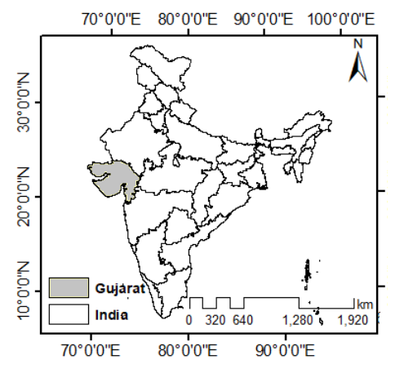 | 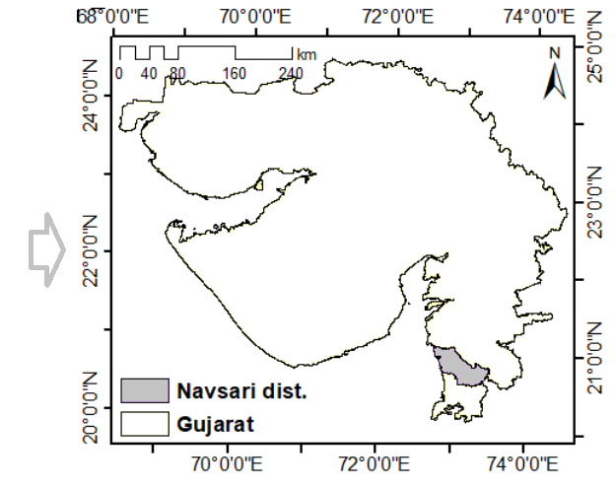 | 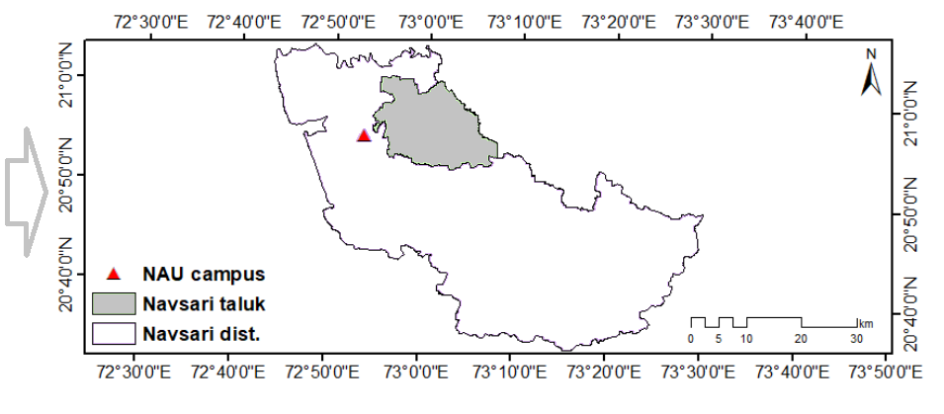
Plate 1: Geographic location of study site

A total of ten healthy, mature Arjuna trees with girths of approximately 100–150 cm were randomly selected and marked for bark collection. A longitudinal strip of original bark measuring 10 cm (length) × 5 cm (width) was removed from each tree at breast height (DBH) in February 2023. Similarly, regenerated bark from the same strip on each tree was harvested in the subsequent year, i.e. February 2024 (Plate 1). The samples were brought to the laboratory for assessment of their physical and anatomical properties. Uniform procedures were followed for processing and analysing both bark samples in each respective year.
The moisture content was determined using the oven-dry method, while basic density was determined using the water-displacement method. The anatomical properties of original and regenerated Arjuna bark were measured under a microscope equipped with an image-analysis system, using the maceration technique and 25 µm-thick sections prepared in transverse and tangential directions with a sliding microtome (Sinha et al., 2022; Jadhav, 2025). Bark ray dimensions (height and width) were measured at 10× magnification using tangential sections examined under a Leica trinocular microscope with LAS measurement software. To determine fibre dimensions, including fibre length, fibre width, lumen width, and fibre cell-wall thickness, bark samples were macerated using Schultz’s method (Jane, 1956; Sinha et al., 2022). A minimum of 25 observations were recorded for fibre dimensions in accordance with the guidelines of the International Association of Wood Anatomists (IAWA) Committee (Wheeler et al., 1989). The data were subsequently subjected to a t-test to determine whether the differences between original and regenerated bark were significant.

- RESULTS AND DISCUSSION
Bark biomass (weight) is an important physical property that determines raw-material availability for large-scale drug production and helps estimate the yield of active ingredients per tree, thereby informing the optimisation of harvesting practices to maintain medicinal potency and sustainability. The present study revealed that the fresh weight of original bark was significantly greater than that of regenerated bark, consistent with the findings of Gunaga et al. (2017) for Arjuna.
In the present study, fresh weight ranged from 43.16 to 87.28 g for original bark and from 22.62 to 49.10 g for regenerated bark. This indicates that the fresh weight of Arjuna bark varies among trees and ultimately affects bark biomass (Table 1). Pandey and Kori (2011) reported a wider variation in the fresh weight of original Arjuna bark, ranging from 20.56 to 117.75 g for the same blaze size of 10 cm × 5 cm across different locations in Chhattisgarh. In addition to weight, original bark was significantly thicker than regenerated bark. The lower thickness of regenerated bark was attributable to its age of one year; however, basic density, moisture content, and volumetric shrinkage did not differ significantly between original and regenerated bark (Table 1).
The substantially lower fresh weight and thickness of the one-year-old regenerated bark are consistent with an incomplete recovery interval rather than equivalence to mature original bark. Comparable debarking studies have shown that regrowth is highly dependent on species and treatment and may vary with harvesting intensity, season, stem size, patch geometry, and post-harvest protection. These findings support the need to define species-specific minimum intervals before repeated harvesting (Delvaux et al., 2009, 2010a; Hanumantha & Vasudeva, 2022).
Table 1. Physical properties of original and regenerated bark of Arjuna
Physical Properties | Original Bark |  | Regenerated Bark |  | ‘t’ value
Physical Properties | Range | Mean ± SD | Range | Mean ± SD | ‘t’ value
Fresh weight (g) | 43.16-87.28 | 64.34  ± 8.56 | 22.62-49.1 | 29.99  ± 6.30 | 12.58**
Bark thickness (mm) | 9.17-13.83 | 11.98  ± 1.45 | 4.51-5.88 | 4.99  ± 0.45 | 15.61**
Basic density (g/cm³) | 0.366-0.601 | 0.467  ± 0.08 | 0.383-0.522 | 0.443  ± 0.05 | 1.39^{NS}
Moisture content (%) | 92.83-182.17 | 133.42  ± 28.05 | 109.62-170.22 | 140.24  ± 20.95 | -0.90^{NS}
Volumetric shrinkage (%) | 32.11-55.39 | 47.66  ± 7.40 | 42.89-59.60 | 52.00  ± 6.12 | -1.94^{NS}
**Significant at 1 % level, ^{NS}Non-significant
Regarding bark anatomy, original bark was mostly uniseriate, although a few biseriate rays were also observed (Table 2). Conversely, rays in regenerated bark were mostly multiseriate or aggregate towards the phelloderm and transitioned to uniseriate or biseriate rays near the sapwood (Plate 2). In both original and regenerated bark, the fibres were libriform, non-septate, and rounded to polygonal in shape. Among the fibre dimensions, fibre length was significantly greater in original bark (1352.76 µm) than in regenerated bark (1181.17 µm), whereas fibre width, lumen width, and cell-wall thickness did not differ significantly. Ray width was significantly greater in regenerated bark (58.22 µm) than in original bark (40.19 µm; Table 2), while ray height did not differ significantly between bark types. Variation in ray characteristics in regenerated bark may result from the formation of surface callus and wound cambium at the incision site during rapid recovery; quantitative anatomical properties may also vary with tree age (Sinha et al., 2022).
The occurrence of wider and more aggregated rays in regenerated bark is biologically plausible because bark removal initiates surface-callus formation, wound-cambium establishment, and the reconstruction of secondary vascular tissues. Studies of debarked trees have documented staged callus development and substantial wound-induced anatomical remodelling, while broader comparative work has identified conducting phloem and vascular re-establishment as important determinants of bark recovery (Delvaux et al., 2010b, 2013; Karunarathne et al., 2024; Stobbe et al., 2002). Accordingly, the greater ray width observed in the present study may represent an early regenerative configuration; however, longitudinal sampling beyond one year is required before this feature can be regarded as a stable diagnostic characteristic of mature regenerated bark.
Table 2. Anatomical properties of original and regenerated bark of Arjuna
Anatomical Properties | Original Bark |  |  | Regenerated Bark |  | ‘t’ value
Anatomical Properties | Range | Mean ± SD | Range |  | Mean ± SD | ‘t’ value
Ray height (µm) | 221.55-38.60 | 291.90  ± 43.79 | 257.53-388.35 |  | 307.16  ± 41.19 | -0.79^{NS}
Ray width (µm) | 35.60-48.25 | 40.19  ± 4.07 | 44.73-77.43 |  | 58.22  ± 9.95 | -5.23**
Fiber length (µm) | 1158.96-1680.88 | 1352.76 ±178.45 | 950.33-1401.43 |  | 1181.17  ± 117.50 | 2.84*
Fiber width (µm) | 18.98-22.58 | 20.68  ± 1.47 | 19.14-24.28 |  | 21.35  ± 1.56 | -1.10^{NS}
Fiber cell-wall  thickness (µm) | 4.28-6.09 | 5.25  ± 0.53 | 4.41-5.99 |  | 5.41  ± 0.46 | -0.74^{NS}
Fiber lumen  width (µm) | 8.65-11.74 | 10.19  ± 1.07 | 8.96-12.82 |  | 10.52  ± 1.11 | -0.96^{NS}
*Significant at 5%, **Significant at 1 % level, ^{NS}Non-significant
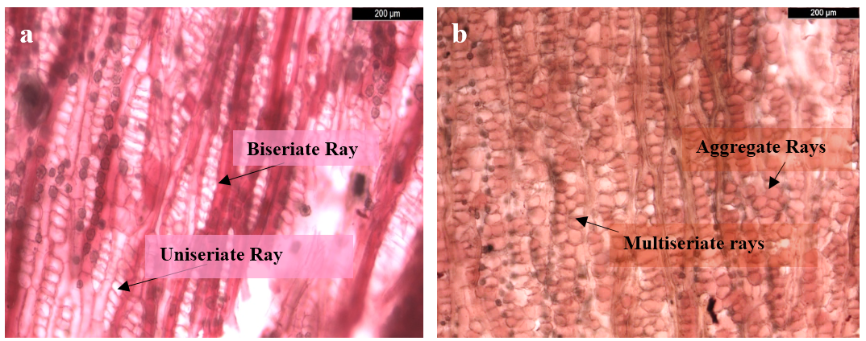
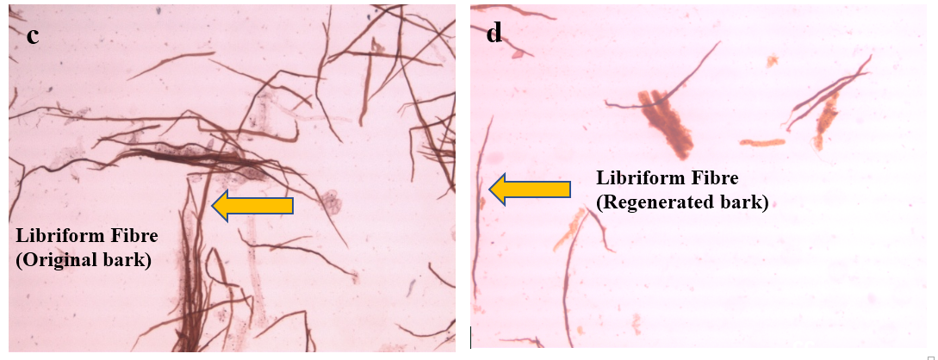
Plate 2: Anatomical features of phloem rays and phloem fibers in original and regenerated bark of Arjuna, a) Tangential section (TLS) of original bark showing Uniseriate to Biseriate ray cells with scattered crystals, b) Tangential section (TLS) of regenerated bark showing Multiseriate or Aggregate ray cells with scattered crystals, c) Phloem fibers (libriform and non-septate) of original bark, d) Phloem fibers (libriform and non-septate) of regenerated bark

- CONCLUSION
The study demonstrates that one-year regenerated Arjuna bark remains physically and anatomically distinct from original bark. Original bark had greater fresh weight, bark thickness, and fibre length, whereas regenerated bark had greater ray width. Basic density, moisture content, volumetric shrinkage, ray height, fibre width, fibre lumen width, and fibre cell-wall thickness did not differ significantly between bark types. The predominance of uniseriate rays, with occasional biseriate rays, characterised original bark, while regenerated bark showed mainly multiseriate or aggregate rays towards the phelloderm, transitioning to uniseriate or biseriate rays near the sapwood. These characteristics provide practical anatomical indicators for distinguishing regenerated bark from original bark and may assist raw-material identification. The findings also indicate that bark regeneration occurs after harvesting and that regenerated bark may contribute to a more sustainable supply of Arjuna bark. However, because the regenerated samples represented a single one-year recovery period, the results should not be interpreted as establishing a definitive reharvesting interval. Longer-term observations are required to determine when regenerated bark attains stable physical and anatomical characteristics comparable with mature bark.

Limitation

The study was limited to ten mature trees from a single plantation and compared original bark with regenerated bark after one year. Consequently, the findings may not represent variation across sites, age classes, seasons, or longer recovery periods. Chemical composition, medicinal efficacy, and repeated-harvest responses were not assessed. Longitudinal and multi-site studies are therefore required before the observed anatomical features can be treated as stable diagnostic characters or used to establish definitive reharvesting intervals.

COMPETING INTERESTS
Authors have declared that no competing interests exist.

Declaration of AI Use

This manuscript was prepared through the combined contributions of all author(s), including contributions to the study design, data, content development, results, interpretation, and related scholarly work. The author(s) acknowledge the use of Grammarly and ChatGPT to assist with grammar checking, language refinement, reference formatting. These AI-assisted tools were not used as authors and did not replace the intellectual contributions or scholarly judgment of the author(s). All AI-assisted outputs, including content, references, and interpretations, were carefully reviewed, revised, verified, and approved by the author(s). The author(s) accept full responsibility for the accuracy, integrity, and final content of the manuscript.

REFERENCES
Delvaux, C., Sinsin, B., Darchambeau, F., & Van Damme, P. (2009). Recovery from bark harvesting of 12 medicinal tree species in Benin, West Africa. Journal of Applied Ecology, 46(3), 703–712. https://doi.org/10.1111/j.1365-2664.2009.01639.x
Delvaux, C., Sinsin, B., & Van Damme, P. (2010a). Impact of season, stem diameter and intensity of debarking on survival and bark re-growth pattern of medicinal tree species, Benin, West Africa. Biological Conservation, 143(11), 2664–2671. https://doi.org/10.1016/j.biocon.2010.07.009
Delvaux, C., Sinsin, B., Van Damme, P., & Beeckman, H. (2010b). Wound reaction after bark harvesting: Microscopic and macroscopic phenomena in ten medicinal tree species (Benin). Trees, 24(5), 941–951. https://doi.org/10.1007/s00468-010-0465-2
Delvaux, C., Sinsin, B., Van Damme, P., & Beeckman, H. (2013). Size of conducting phloem: The “key” factor for bark recovery of 12 tropical medicinal tree species. Flora, 208(2), 111–117. https://doi.org/10.1016/j.flora.2013.02.004
Dharasurkar, A. N., Vimala, Basole, S., Sharma, B. P., Tailor, V., Kumar, S., & Agrahari, D. (2025). Documenting the medicinal potential of timber species across ecologically distinct zones of India. BIONATURE, 45(2), 210–219. https://doi.org/10.56557/bn/2025/v45i22082
Dwivedi, S., & Jauhari, R. (1997). Beneficial effects of Terminalia arjuna in coronary artery disease. Indian Heart Journal, 49(5), 507–510. https://imsear.searo.who.int/items/1c006f38-76c2-4f02-bd36-5156d91f4ed3
Gunaga, R. P., Dobriyal, M. J., Hegde, H. T., Mehta, A. A., & Sinha, S. K. (2017). Sustainable bark harvesting techniques in Terminalia arjuna (Research Report XIII, Combined Joint AGRESCO). Directorate of Research, Navsari Agricultural University. https://old.nau.in/files/22114_Final%20%20Proceeding%20joint%20agresco-2017.pdf
Hanumantha, M., & Vasudeva, R. (2022). Influence of patch geometry, post-bark-extraction treatment on bark recovery and standardizing number of sprouts for bark harvest from coppices in Cinnamomum zeylanicum Blume: Implications for sustainable harvesting. Environmental Monitoring and Assessment, 194, Article 214. https://doi.org/10.1007/s10661-022-09882-0
Harika, D., Swamy, A. V. V. S., Subhashini, V., & Rani, C. H. (2013). Potential of Terminalia arjuna as a source of diverse drugs. Indian Journal of Applied Research, 3(1), 1–2. https://www.worldwidejournals.com/indian-journal-of-applied-research-%28IJAR%29/article/potential-of-terminalia-arjuna-as-a-source-of-diverse-drugs/ODk2/
Hoffmann, W. A., Flake, S. W., Rossatto, D. R., De Antonio, A. C., Durigan, G., & Abreu, R. C. R. (2024). Stem wound healing is dependent upon bark and trunk growth rates in Brazilian savanna. Trees, 38, 197–204. https://doi.org/10.1007/s00468-023-02477-3
Jadhav, R. M. (2025). Investigation on physico-anatomical and chemical properties and regeneration potential of Arjuna [Terminalia arjuna (Roxb. ex DC.) Wight & Arn.] bark [Doctoral dissertation, Navsari Agricultural University].
Jane, F. W. (1956). The structure of wood. Adam & Charles Black.
Kapoor, D., Vijayvergiya, R., & Dhawan, V. (2014). Terminalia arjuna in coronary artery disease: Ethnopharmacology, pre-clinical, clinical, and safety evaluation. Journal of Ethnopharmacology, 155(2), 1029–1045. https://doi.org/10.1016/j.jep.2014.06.056
Karunarathne, S. I., Spokevicius, A. V., Bossinger, G., & Golz, J. F. (2024). Trees need closure too: Wound-induced secondary vascular tissue regeneration. Plant Science, 339, Article 111950. https://doi.org/10.1016/j.plantsci.2023.111950
Kumar, V., Sharma, N., Saini, R., Mall, S., Zengin, G., Sourirajan, A., Khosla, P. K., Dev, K., & El-Shazly, M. (2023). Therapeutic potential and industrial applications of Terminalia arjuna bark. Journal of Ethnopharmacology, 310, Article 116352. https://doi.org/10.1016/j.jep.2023.116352
Maulik, S. K., & Talwar, K. K. (2012). Therapeutic potential of Terminalia arjuna in cardiovascular disorders. American Journal of Cardiovascular Drugs, 12(3), 157–163. https://doi.org/10.2165/11598990-000000000-00000
Meena, D. K., Das, B. K., Sahoo, A. K., & Satvik, K. (2025). Terminalia arjuna bark powder as a nutritive additive for enhancing fish health and environmental sustainability. Discover Food, 5, Article 61. https://doi.org/10.1007/s44187-025-00329-2
Orwa, C., Mutua, A., Kindt, R., Jamnadass, R., & Simons, A. (2009). Terminalia arjuna. In Agroforestree database: A tree reference and selection guide (Version 4.0). World Agroforestry Centre. https://apps.worldagroforestry.org/treedb2/speciesprofile.php?Spid=18136
Pandey, A. K., & Kori, D. C. (2011). Non-destructive harvesting practices of Terminalia arjuna (Arjuna), Phyllanthus emblica (Aonla), and Andrographis paniculata (Kalmegh). Indian Forester, 137(11), 1269–1279. https://doi.org/10.36808/if/2011/v137i11/12845
Peixoto, O. C. M. O., Carvalho, M. S., Sousa Júnior, J. R., & Monteiro, J. M. (2024). Wound response of the bark of two semiarid medicinal tree species: Implications for conservation. Environment, Development and Sustainability. Advance online publication. https://doi.org/10.1007/s10668-024-05756-2
Rajaram, V., Namasivayam, A., Shanmugam, R., Mahendra, J., Sudhakar, U., Munusamy, T., & Subbiah, U. (2024). Terminalia arjuna: An overview of its magical properties. Bioinformation, 20(12), 2080–2085. https://doi.org/10.6026/9732063002002080
Ramesh, P., & Palaniappan, A. (2023). Terminalia arjuna, a cardioprotective herbal medicine—Relevancy in the modern era of pharmaceuticals and green nanomedicine—A review. Pharmaceuticals, 16(1), Article 126. https://doi.org/10.3390/ph16010126
Singh, H., Ambwani, S., & Ambwani, T. K. (2025). Evaluation of in vitro antioxidant potential of hydromethanolic bark extract of Terminalia arjuna (Roxb. ex DC.) Wight & Arn. bark extract. Journal of Advances in Biology & Biotechnology, 28(2), 565–574. https://doi.org/10.9734/jabb/2025/v28i22016
Sinha, S. K., Gunaga, R. P., Hegde, H. T., Sondarva, R. L., & Bhusara, J. B. (2022). Anatomical response of regenerated bark in Terminalia arjuna (Roxb.) Wight & Arn. Indian Journal of Ecology, 49(1), 42–45. https://doi.org/10.55362/IJE/2022/3474
Stobbe, H., Schmitt, U., Eckstein, D., & Dujesiefken, D. (2002). Developmental stages and fine structure of surface callus formed after debarking of living lime trees (Tilia sp.). Annals of Botany, 89(6), 773–782. https://doi.org/10.1093/aob/mcf137
Tulsi, J. R., & Vidhu, A. (2022). Marker-based standardization of Terminalia arjuna bark for the detection of probable adulterants by quantitative high-performance thin-layer chromatography. JPC – Journal of Planar Chromatography – Modern TLC, 35(2), 169–179. https://doi.org/10.1007/s00764-022-00177-1
Ved, D. K., & Goraya, G. S. (2008). Demand and supply of medicinal plants in India. Bishen Singh Mahendra Pal Singh & Foundation for Revitalisation of Local Health Traditions. https://agris.fao.org/search/en/providers/122535/records/65ddd23063b8185d9ca4d58b
Vijaya, T., Asha Krishna, V., & Sujathamma, P. (2015). Medicinal uses of Terminalia arjuna Roxb.: A review. HortFlora Research Spectrum, 4(2), 176–178.
Wadekar, P. P., & Salunkhe, V. R. (2024). Formulation and evaluation of nanobiotherapeutics of Terminalia arjuna through plant tissue culture for atherosclerosis. Future Journal of Pharmaceutical Sciences, 10, Article 42. https://doi.org/10.1186/s43094-024-00613-5
Warrier, P. K., Nambiar, V. P. K., & Ramankutty, C. (Eds.). (1996). Indian medicinal plants: A compendium of 500 species (Vol. 5, pp. 253–257). Orient Longman. https://agris.fao.org/search/en/providers/122535/records/65ddd407b766d82b18fa2049
Wheeler, E. A., Baas, P., & Gasson, P. E. (Eds.). (1989). IAWA list of microscopic features for hardwood identification with an appendix on non-anatomical information. IAWA Bulletin New Series, 10(3), 219–332. https://doi.org/10.1163/22941932-90000496
World Health Organization. (2002). WHO traditional medicine strategy 2002–2005. https://www.who.int/publications/i/item/WHO-EDM-TRM-2002.1

