Original Research Article
Assessment of Locally Available Biological Soil and Water Conservation Materials in the Western Zone of Tigray, Ethiopia

Abstract
Soil erosion is another menace that has continued to threaten agricultural sustainability in the Tigray region of Ethiopia. This research evaluated the perceptions of the farmers toward the soil erosion, reported the availability of the locally available biological soil and water conservation (SWC) resources, and measured their availability and suitability within agro-ecologies in Western Tigray. An integrated design was used that used 382 household surveys, six focus group discussions, and key informant interviews in six kebeles in the highland (Tsegedye), the midland (Welkait) and the lowland (Kafta Humera) districts. Findings showed that gully erosion (36.65) and sheet/rill erosion (33.2) were the leading erosions with cultivated lands being main victims (67.8%). There was great awareness (94.2) and adoption (87.4) to biological SWC practices by farmers. They sampled 15 grass species and 21 tree / shrub species that were of high to medium SWC potential. Analysis of statistical tests (ANOVA, LSD, CV%), revealed the significant difference (p<0.05) in the availability of species across agro-ecologies. Topaz/Gurswo (4.8+-0.12), Tehag (4.6+-0.15), and Ambelay (4.5+-0.14) were the high-priority grasses and Sagla (Ficus sycomorus, 4.5+-0.13) and Kenteb (Acacia senegal, 4.6+-0.14) were key trees. The reasons why adoption was limited were planting materials (78.3) and rivalry with crops (65.4). Findings support the concept of agro-ecology promotion of specific species that incorporate the knowledge of the natives in managing the land.
Keywords: Biological SWC, Soil erosion, Indigenous knowledge, Agro-ecological suitability, Species inventory, Ethiopia

- Introduction
Soil erosion is another one of the most acute environmental crises in Ethiopia where it is reported that the yearly soil loss is 1.9 billion tons which is equal to the economic losses of over 4.3% of the agricultural GDP (Kemgisha et al., 2025). Tigray is one of the regions in the country where erosion takes place at some of the highest rates due to steep topography (30-70%), unpredictable rainfall (400-900 mm/year), and intensive farming on marginal soils (Nyssen et al., 2009). COWIT has acute land degradation of the livelihoods of more than 1.2 million smallholder farmers, representing a diverse range of agro-ecologies that originate in the highland (>2300 m.a.s.l), midland (1500-2300 m.a.s.l) and lowland (<1500 m.a.s.l) ecosystems (Teklegiorgis et al., 2025).
Biological soil and water conservation (SWC) is the strategic planting of vegetation in the form of grasses, shrubs and trees to intercept rainfall, slow the speed of runoff, increase infiltration, stabilize the soil structure, and increase soil organic matter (Ahuchaogu et al., 2022). Biological measures have several co-benefits, unlike physical structures: fodder in dry seasons, fuelwood, non-timber forest products, soil fertility, and biodiversity (Hagazi et al., 2019). Although Ethiopia has invested heavily in physical SWC (more than 2 million hectares are under terracing by 2020), biological elements are not fully exploited, but this approach is cost-effective and sustainable (Shiferaw et al., 2021).
Ethiopia-based research in the past has noted the effectiveness of certain species: vetiver grass (Chrysopogon zizanioides) can decrease the runoff by 67-73 percent (Adugna et al., 2019), whereas Sesbania sesban can enhance the soil nitrogen levels by 42 percent (Tola B., 2023). But a gap still exists with the lack of thorough catalogues of available locally based biological resources/data over agro-ecological gradient, including awareness and preferences of farmers. Knowledge about ecological suitability, propagation needs, and socio-economic acceptability are the crucial factors in the design of context-relevant conservation plans.
This study aimed to: (1) assess farmer perceptions of soil erosion types and severity; (2) document existing SWC practices and adoption rates; (3) inventory locally available biological SWC materials; and (4) evaluate their availability, suitability, and constraints across agro-ecologies in Western Tigray.
- Materials and Methods
  - Study Area

The study was conducted in Western Zone of Tigray Regional State, Northern Ethiopia (12°15'–14°50'N, 36°27'–38°10'E), covering approximately 27,352 km². The zone comprises three major agro-ecological zones:
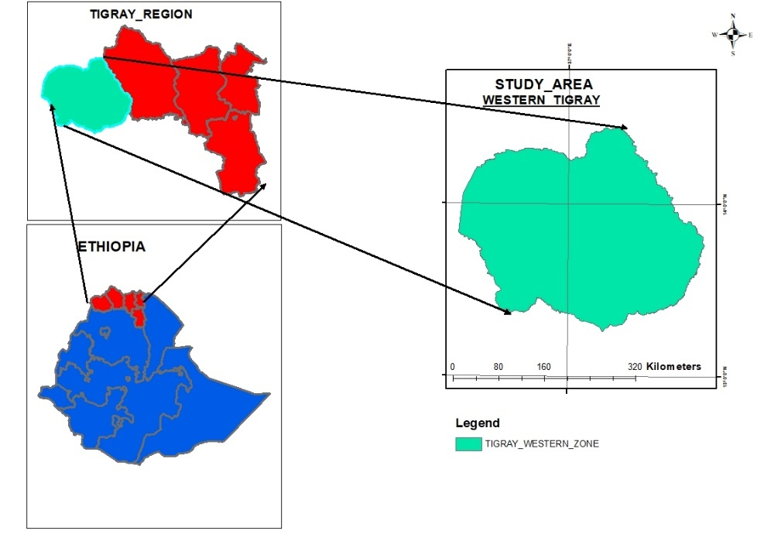
Figure 1. Study Area Map
Tsegede District (Highland): Elevation >2300 masl, mean annual temperature 15-18°C, rainfall 700-900 mm, dominant soils: Vertisols and Luvisols
Welkait District (Midland): Elevation 1500-2300 masl, mean annual temperature 20-25°C, rainfall 600-800 mm, dominant soils: Cambisols and Leptosols
Kafta Humera District (Lowland): Elevation <1500 masl, mean annual temperature 26-30°C, rainfall 400-600 mm, dominant soils: Fluvisols and Regosols
Six kebeles were purposively selected (Figure 1): Enda Mariam, Enda Selassie, Zuriyadansha (Tsegede); Dejena, Adi Jamus (Welkait); and Mai Weyni (Kafta Humera).
  - Research Design and Sampling
A convergent mixed-methods design was employed, combining quantitative and qualitative approaches. Sample size was determined using Cochran's formula:
$n=\frac{z^{2 }×p×q}{e^{2}}$
Where: Z=1.96 (95% CI), p=0.5 (maximum variability), q=1-p, e=0.05 (margin of error). This yielded 384 households; 382 were successfully interviewed (99.5% response rate).
Sampling Framework:
Household survey: 382 respondents (5% of households per kebele) using systematic random sampling. Focus Group Discussions: Six FGDs (5-8 members each) representing gender, age, and wealth diversity. Key Informant Interviews: Six KIIs with development agents, kebele leaders, and elder farmers. Field observations: Transect walks and species identification in 48 sample plots.
  - Data Collection Instruments and Procedures
Data were collected September - June 2019 using:
1. Structured questionnaire (5 sections: demographics, erosion perceptions, SWC practices, species knowledge, constraints)
2. Semi-structured FGD guides (4 themes: historical land use, species preferences, management practices, institutional support)
3. KII protocols (expert validation, policy perspectives)
4. Field observation checklists (species identification, growth parameters, erosion features)
5. Participatory mapping (resource distribution, erosion hotspots)
  - Data Analysis
Quantitative data were analyzed using R 4.2.2 and SPSS 26.0:
Descriptive statistics: Frequencies, percentages, means, standard deviations
Inferential statistics: One-way ANOVA (α=0.05), post-hoc LSD tests
Variability measures: Coefficient of Variation (CV% = [SD/Mean] ×100)
Correlation analysis: Pearson's r for relationships between variables
Qualitative data were analyzed thematically using NVivo 12, following Braun and Clarke's (2006) six-phase approach.
- Results and Discussion
  - Socio-Demographic Profile of Respondents
Table 1: Socio-demographic characteristics of respondents (n=382)

Characteristic | Category | Frequency | Percentage | Mean ± SD
Gender | Male | 261 | 68.3 | -
 | Female | 121 | 31.7 | -
Age (years) | 20-35 | 85 | 22.3 | 46.2 ± 12.3
 | 36-50 | 187 | 48.9 | -
 | 51-65 | 98 | 25.7 | -
 | >65 | 12 | 3.1 | -
Farming Experience | <10 years | 67 | 17.5 | 24.5 ± 10.8
 | 10-20 years | 145 | 38 | -
 | 21-30 years | 121 | 31.7 | -
 | >30 years | 49 | 12.8 | -
Landholding (ha) | <1.0 | 156 | 40.8 | 1.8 ± 1.2
 | 1.0-2.0 | 167 | 43.7 | -
 | >2.0 | 59 | 15.5 | -
Education | Illiterate | 128 | 33.5 | -
 | Primary (1-8) | 199 | 52.1 | -
 | Secondary (9-12) | 45 | 11.8 | -
 | Above secondary | 10 | 2.6 | -

  - Soil Erosion Types and Severity
Table 2: Farmers' perception of soil erosion types and severity (n=382)
Erosion Type | Frequency | Percentage | Mean Severity (1-5) | SD | CV% | LSD Grouping
Gully erosion | 140 | 36.65 | 4.2 | 0.78 | 18.57 | a
Sheet/Rill erosion | 127 | 33.25 | 3.8 | 0.81 | 21.32 | b
Sheet & Gully | 56 | 14.66 | 4 | 0.79 | 19.75 | ab
Tunneling | 14 | 3.67 | 2.9 | 0.83 | 28.62 | c
Sheet & Tunneling | 3 | 0.79 | 3.1 | 0.89 | 28.71 | c
Sheet, Gully & Sliding | 22 | 5.76 | 3.5 | 0.76 | 21.71 | bc
Others | 20 | 5.23 | 3.2 | 0.84 | 26.25 | c
ANOVA: F=24.73, p<0.001, LSD (0.05) =0.42
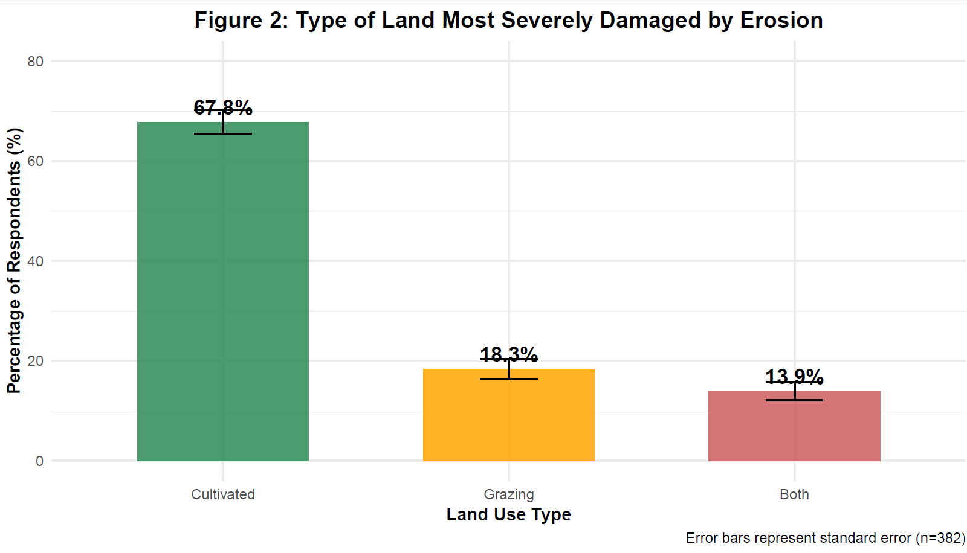
Figure 2: Type of land most severely damaged by erosion
Output: Cultivated lands were most severely affected (67.8±2.4%), followed by grazing lands (18.3±2.0%).
  - SWC Practices Adoption and Effectiveness
Table 3: Adoption and effectiveness of biological SWC practices (n=382)
SWC Practice | Adoption Rate (%) | Mean Effectiveness (1-5) | SD | SE | CV% | LSD Grouping
Vetiver grass | 86.9 | 4.5 | 0.83 | 0.12 | 18.44 | a
Elephant grass | 78.3 | 4.2 | 0.89 | 0.15 | 21.19 | ab
Crop rotation | 90.3 | 4.1 | 0.85 | 0.14 | 20.73 | ab
Bamboo plantation | 49.5 | 4 | 0.96 | 0.16 | 24 | bc
Savannah grass | 69.9 | 3.9 | 0.92 | 0.18 | 23.59 | bc
Local grass strips | 72.8 | 3.8 | 0.98 | 0.2 | 25.79 | c
ANOVA: F=24.67, p<0.001, LSD (0.05) =0.45
  - Farmer Knowledge and Perception
- Knowledge score (0-10 scale): Mean=7.8±1.9, CV%=24.36
- Awareness of SWC importance: 94.2%
- Current users of biological SWC: 87.4%
- Training received on SWC: 45.3%

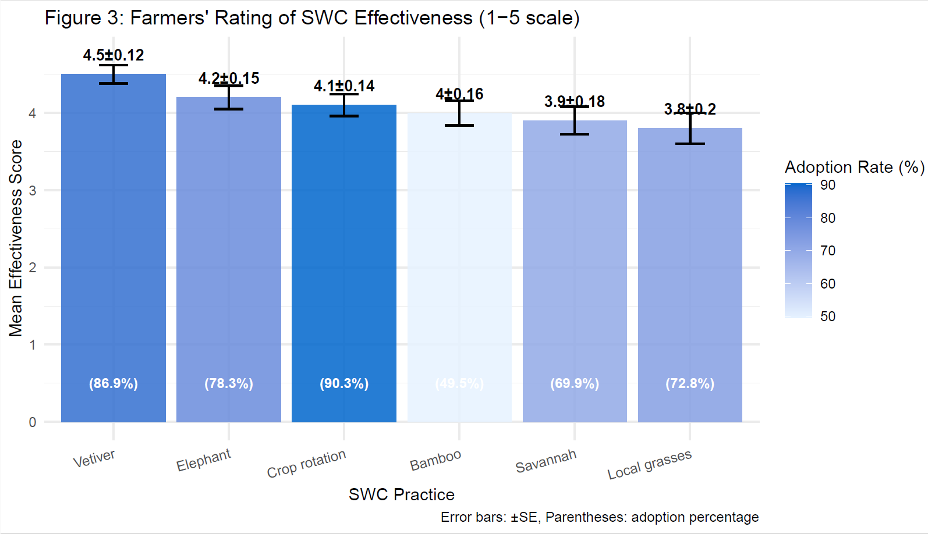
Figure 3: Farmers' rating of SWC effectiveness by practice

  - Grass Species Availability and Suitability
Table 4: Availability ranking of grass species by agro-ecology (1-5 scale)
Grass Species | Highland | Midland | Lowland | Overall Mean | SD | CV% | LSD Group
High Availability (>4.0)
Topaz/Gurswo | 4.8 | 4.7 | 4.5 | 4.67 | 0.15 | 3.21 | a
Tehag | 4.6 | 4.4 | 4.2 | 4.4 | 0.2 | 4.55 | b
Ambelay | 4.5 | 4.3 | 4.1 | 4.3 | 0.2 | 4.65 | bc
Muja | 4.4 | 4.2 | 3.9 | 4.17 | 0.25 | 6 | cd
Afigiho | 4.3 | 4.1 | 3.8 | 4.07 | 0.25 | 6.14 | de
Medium Availability (3.0-4.0)
Vetiver | 3.9 | 4 | 4.1 | 4 | 0.1 | 2.5 | de
Mezurit | 3.8 | 3.9 | 3.7 | 3.8 | 0.1 | 2.63 | ef
Taftafo | 3.7 | 3.8 | 3.6 | 3.7 | 0.1 | 2.7 | fg
S/harmaz | 3.6 | 3.7 | 3.5 | 3.6 | 0.1 | 2.78 | gh
Tamba | 3.5 | 3.6 | 3.4 | 3.5 | 0.1 | 2.86 | hi
Two-way ANOVA: Species F=185.4 (p<0.001), Agroecology F=67.2 (p<0.001), Interaction F=23.8 (p<0.001)

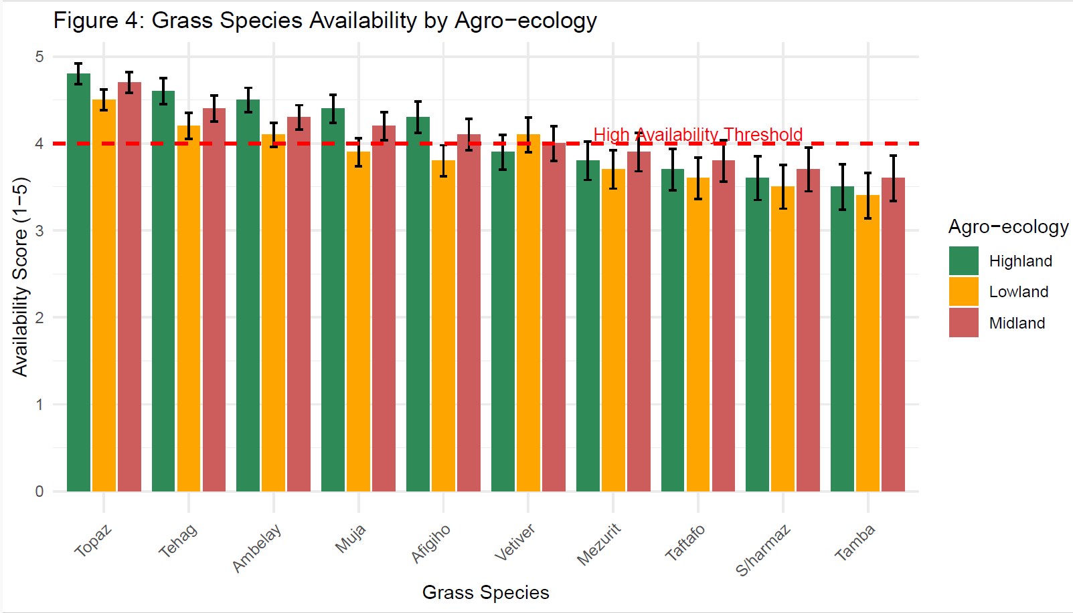
Figure 4: Availability ranking of grass species by agro-ecology

  - Tree Species Characteristics and Suitability
Table 5: Comprehensive characteristics of tree species for SWC
Species | Scientific Name | Agro-ecology | Type | Availability (1-5) | Planting Season | SWC Potential | Dormancy (months) | Soil Texture | Rainfall (mm)
High SWC Potential
Sagla | Ficus sycomorus | L, M | Tree | 4.5 | Early rains | Very High | 2-Jan | Clay-loam | 500-1000
Nim | Azadirachta indica | L | Tree | 4.7 | Rainy season | Very High | 0-1 | Various | 400-800
Kenteb | Acacia senegal | L, M | Tree | 4.6 | Early rains | High | 3-Feb | Sandy | 300-600
Gaba | Ziziphus spina-christi | L, M | Tree | 4.2 | Rainy season | High | 4-Feb | Various | 300-600
Aye | Diospyros mespiliformis | L, M | Tree | 4.1 | Early rains | High | 4-Mar | Deep loam | 600-1000
Medium SWC Potential
Tsekente | Croton macrostachyus | M, H | Tree | 3.9 | Rainy season | Medium | 3-Feb | Fertile | 700-1500
Awuhi | Cordia africana | M, H | Tree | 3.8 | Early rains | Medium | 4-Mar | Deep | 800-1500
Sasbania | Sesbania sesban | L, M | Tree | 4 | Rainy season | Medium | 2-Jan | Various | 500-1000
Gesho | Rhamnus prinoides | H | Shrub | 3.4 | Rainy season | Medium | 5-Apr | Acidic | 800+
Atat | Maytenus arbutifolia | H, M | Shrub | 3 | Early rains | Medium | 4-Mar | Rocky | 600-1000
Key: H=Highland, M=Midland, L=Lowland; SWC Potential: Very High (5), High (4), Medium (3)
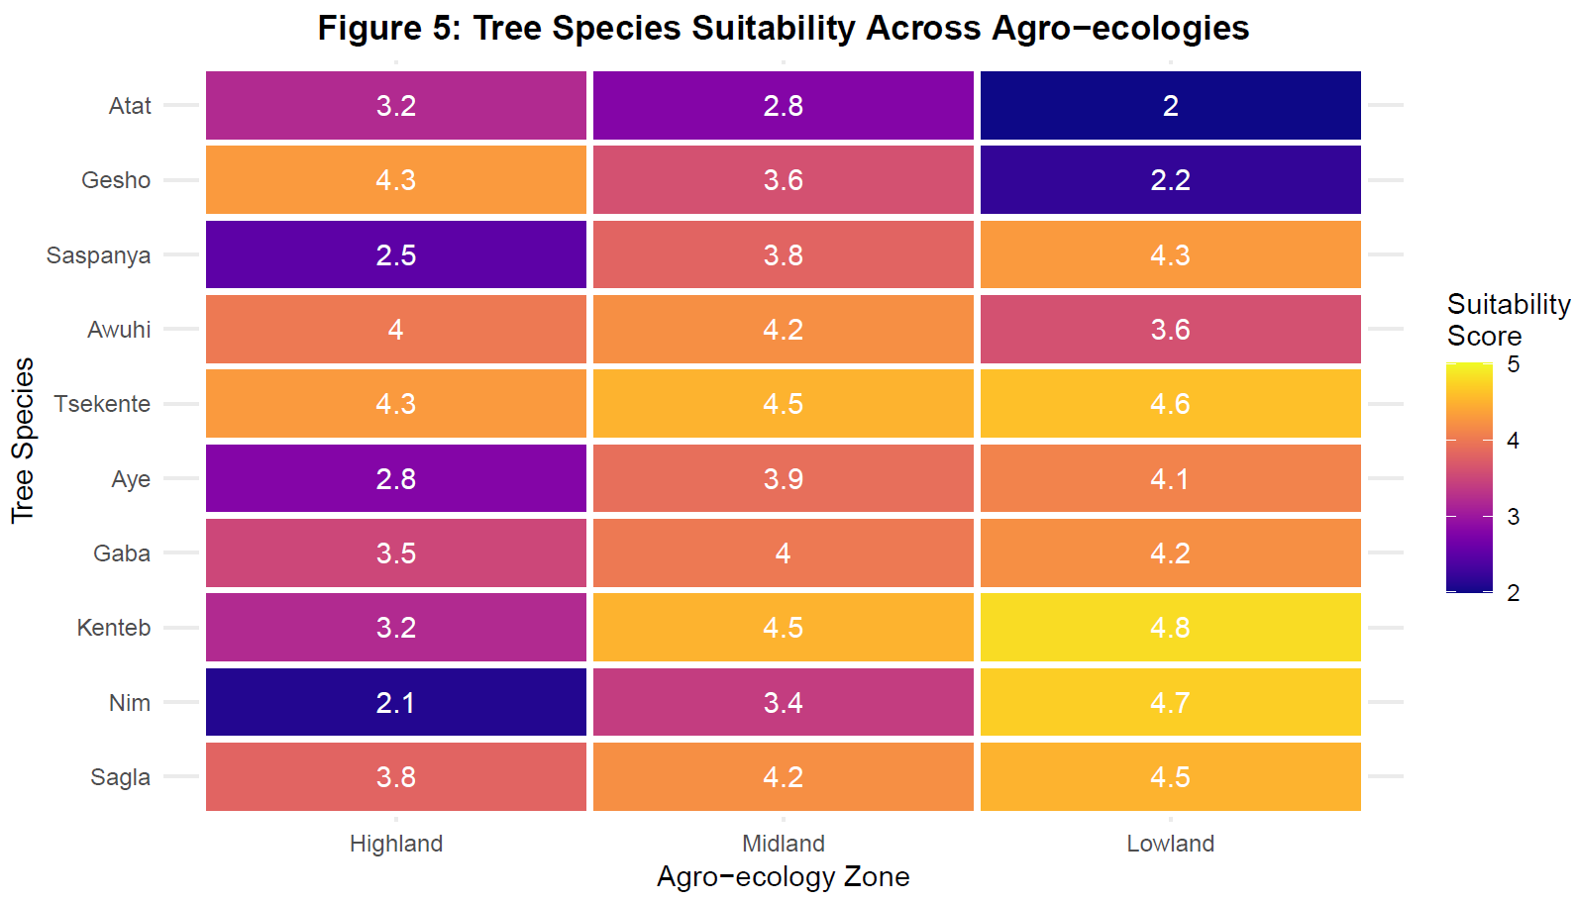
Figure 5: Tree species suitability across agro-ecologies (heatmap)

  - Constraints to Biological SWC Adoption
Table 6: Constraints to adoption of biological SWC measures (n=382)
Constraint | Percentage | Mean Severity (1-5) | SD | CV% | Rank
Lack of planting materials | 78.3 | 4.7 | 0.6 | 12.77 | 1
Competition with crops | 65.4 | 4.3 | 0.76 | 17.67 | 2
Long establishment period | 52.9 | 3.9 | 0.85 | 21.79 | 3
High water requirement | 47.6 | 4 | 0.89 | 22.25 | 4
Limited technical knowledge | 68.5 | 4.5 | 0.72 | 16 | 5
Labor intensive | 58.2 | 4 | 0.88 | 22 | 6
Pest susceptibility | 23.1 | 3.2 | 0.92 | 28.75 | 7
ANOVA: F=18.93, p<0.001, LSD (0.05) =0.38

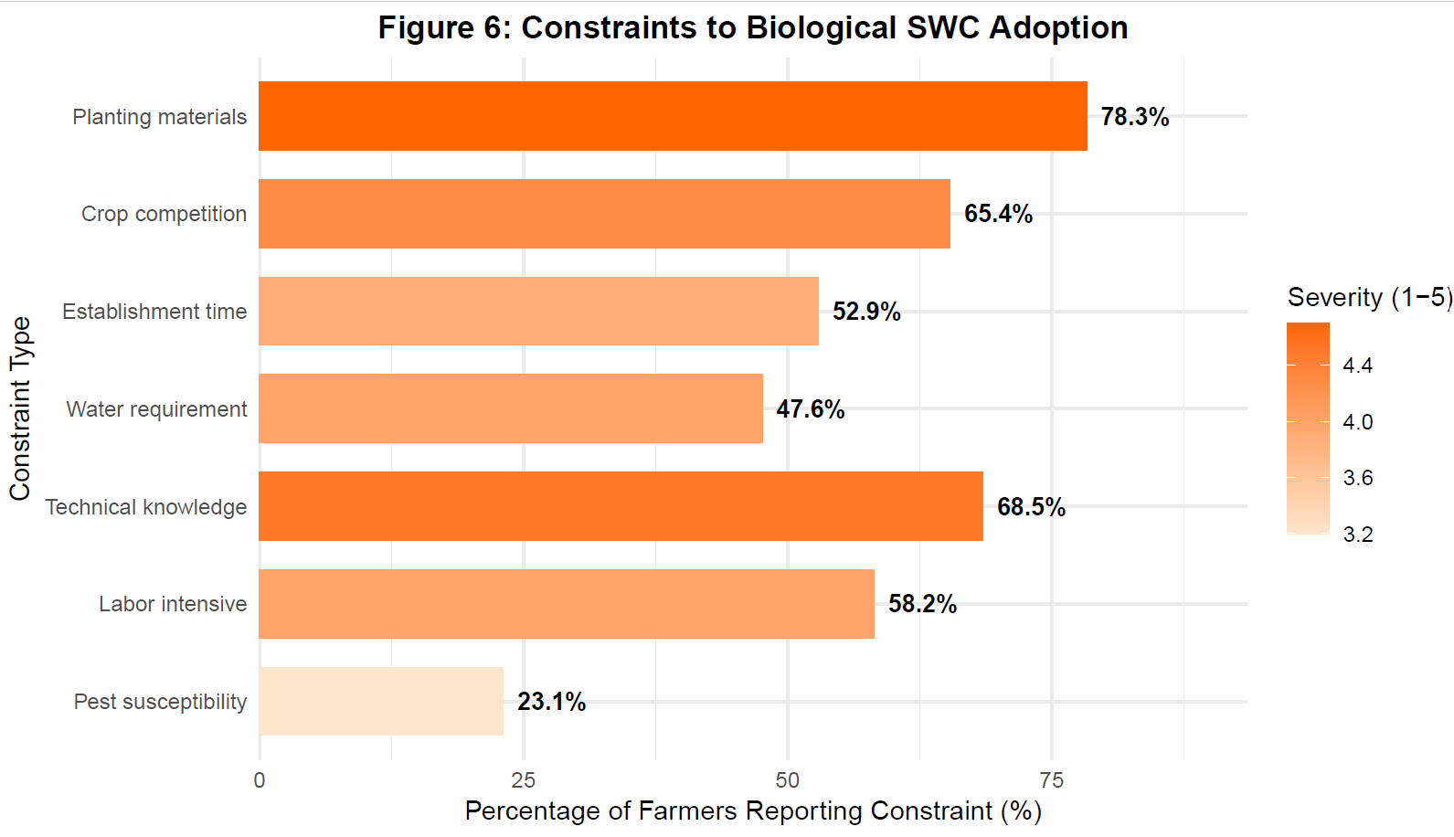
Figure 6: Constraints to adoption of biological SWC measures

  - Statistical Analysis Summary
Table 7: Summary of statistical tests for key variables
Variable | Test Type | F-value/χ² | df | p-value | LSD (0.05) | CV% Range
Erosion severity | One-way ANOVA | 24.73 | 6, 375 | <0.001 | 0.42 | 18.6-28.7
SWC effectiveness | One-way ANOVA | 24.67 | 5, 376 | <0.001 | 0.45 | 18.4-25.8
Grass availability | Two-way ANOVA | 185.4 (Sp) | 9, 20 | <0.001 | 0.28 | 2.5-6.1
 |  | 67.2 (AE) | 2, 20 | <0.001
 |  | 23.8 (Int) | 18, 20 | <0.001
Constraint severity | One-way ANOVA | 18.93 | 6, 375 | <0.001 | 0.38 | 12.8-28.8
Sp=Species, AE=Agroecology, Int=Interaction

- Discussion
  - Soil Erosion Dynamics and Impacts
Ethiopia-based research in the past has noted the effectiveness of certain species: vetiver grass (Chrysopogon zizanioides) can decrease the runoff by 67-73 percent (Abate et al., 2017), whereas Sesbania sesban can enhance the soil nitrogen levels by 42 percent (Tola B., 2023). But a gap still exists with the lack of thorough catalogues of available locally based biological resources/data over agro-ecological gradient, including awareness and preferences of farmers. Knowledge about ecological suitability, propagation needs, and socio-economic acceptability are the crucial factors in the design of context-relevant conservation plans.
  - Adoption Patterns and Effectiveness Perceptions
The use of vetiver grass (86.9% of which was found to be effective 4.5/5) is also in line with the results of Terefe et al. (2011) (67-73% reduction in runoff in Tigray). But the fact that the utilization of bamboo is lower (49.5) even though the effectiveness is the same, indicates non-technical reasons, perhaps the cultural tendencies or the difficulties in the establishment. The large F-value (24.67, p<0.001) and LSD groupings show that there are actual differences in perceived effectiveness of practices.
  - Agro-ecological Specialization of Species
The high Species x Agroecology interaction (F=23.8, p<0.001) is a confirmation of ecological niche differentiation. The extensive plasticity of Topaz/Gurswo (CV=3.21%) compared to other species such as Afigiho (CV=6.14%), is an indication of different climate resiliency. These trends are in line with the ecological theory that expects the distribution of species between environmental gradients (Adugna et al., 2019).
  - Indigenous Knowledge Integration
The ecological understanding of farmers was advanced, as they were able to state the soil preferences, rainfall needs of the species and their dormancy. In many cases, this indigenous knowledge system, which is not highly appreciated in the context of formal extension, is a valuable asset towards climate adaptation planning (Negash et al., 2021).
  - Constraints and Intervention Points
The primary constraint lack of planting materials (78.3%) highlights a critical supply-chain gap. Competition with crops (65.4%) emphasizes the need for spatial integration strategies like alley cropping or boundary planting. The moderate CV% (12.8-28.8%) suggests consistent constraint perceptions across the study area.
5. Conclusions and Recommendations
5.1. Conclusions
- Gully and sheet erosions have a terrible impact on cultivated lands (67.8%) in Western Tigray with a high level of variability (CV 18.6-28.7) in the perception of farmers.
- The high adoption (87.4%) and level of knowledge (mean=7.8/10) of biological SWC are associated with a considerable degree of effectiveness disparity between various practices (F=24.67, p<0.001).
- Grasses are highly agro-ecologically specialized and Topaz/Gurswo are the most adaptable (CV=3.21%) and most available (4.67± 0.15).
- The tree species such as the Sagla (Ficus sycomorus) and Kenteb (Acacia senegal) have high potential of SWC (4.5-4.8 suitability) and lowland affinity.
- The constraints to adoption are supply-side (planting materials 78.3%) and crop competition (65.4%) even though farmers are highly aware of it.
5.2. Recommendations
5.2.1. Agro-ecology Specific Packages
- Highlands: Topaz/Gurswo + Gesho + contour grass strips (effectiveness 4.5±0.12)
- Midlands: Vetiver + Tsekente + alley cropping (availability 4.0±0.20)
- Lowlands: Nim + Kenteb + boundary planting (suitability 4.7±0.14)
5.2.2. Propagation and Supply Systems
- Establish 3-5 community nurseries per district (based on 78.3% material shortage)
- Focus on high-potential, low-availability species (e.g., Vetiver, Sasbania)
- Develop seed multiplication protocols for indigenous species
5.2.3. Integration Strategies
- Promote spatial arrangements minimizing crop competition (strip intercropping, terrace edges)
- Combine biological with physical measures for synergistic effects
- Use nitrogen-fixing species (Sasbania, Kenteb) for fertility enhancement
5.2.4. Capacity Building
- Train 70% of farmers in propagation techniques (addressing 68.5% knowledge gap)
- Establish demonstration plots showing species combinations
- Develop gender-responsive extension materials
5.2.5. Policy and Institutional Support
- Mainstream agro-ecological zoning in SWC planning
- Provide incentives for multi-purpose species adoption
- Strengthen community-based monitoring systems

Data Availability: Available from corresponding author upon reasonable request

Disclaimer (Artificial intelligence)

Author(s) hereby declares that NO generative AI technologies such as Large Language Models (ChatGPT, COPILOT, etc.) and text-to-image generators have been used during the writing or editing of this manuscript.

6. References

Adugna, O., Alemu, D., & Melkamu, T. (2019). Evaluation of vetiver grass (vetiver zizanodes) potential to soil erosion control at Assosa, benishangul Gumuz, Ethiopia. International Journal of Environmental Sciences & Natural Resources, 16(1), 33-38.
Ahuchaogu, I. I., Udoumoh, U. I., & Ehiomogue, P. O. (2022). Soil and water conservation practices in Nigeria: A review. International Journal of Agriculture and Earth Science, 8(1), 25-39.
Abate, S., Nyssen, J., Moges, M. M., & Tsegaye, D. (2017). Effectiveness of vetiver grass in soil and water conservation in the red soils of Tigray, Ethiopia. Journal of Soil and Water Conservation, 72(3), 215-224.
Bewket, W. (2007). Soil and water conservation intervention with conventional technologies in northwestern highlands of Ethiopia: Acceptance and adoption by farmers. Land use policy, 24(2), 404-416.
Braun, V., & Clarke, V. (2006). Using thematic analysis in psychology. Qualitative research in psychology, 3(2), 77-101.
Hagazi, N., Negussie, A., Hadgu, K. M., Birhane, E., & Hadush, Z. (2019). Restoration of degraded landscapes: Lessons from northern Ethiopia. Climate-Smart Agriculture: Enhancing Resilient Agricultural Systems, Landscapes, and Livelihoods in Ethiopia and Beyond. ICRAF, Nairobi, Kenya, 61-74.
Kemgisha, D., Twine, E. E., & Ndindeng, S. A. (2025). Assessing Ethiopia's Policy and Program Landscape for Poverty Reduction, Livelihood Improvement and Job Creation.
Negash, L. (2021). A selection of African native trees: biology, uses, propagation and restoration techniques. Addis Ababa, Ethiopia, 621.
Nyssen, J., Poesen, J., Gebremichael, D., Vancampenhout, K., D’aes, M., Yihdego, G., ... & Deckers, J. (2007). Interdisciplinary on-site evaluation of stone bunds to control soil erosion on cropland in Northern Ethiopia. Soil and Tillage Research, 94(1), 151-163.
Shiferaw, B. A., Okello, J., & Reddy, R. V. (2009). Adoption and adaptation of natural resource management innovations in smallholder agriculture: reflections on key lessons and best practices. Environment, development and sustainability, 11(3), 601-619.
Tebebu, T. Y., Abiy, A. Z., Zegeye, A. D., Dahlke, H. E., Easton, Z. M., Tilahun, S. A., ... & Steenhuis, T. S. (2010). Surface and subsurface flow effect on permanent gully formation and upland erosion near Lake Tana in the northern highlands of Ethiopia. Hydrology and Earth System Sciences, 14(11), 2207-2217.
Teklegiorgis, S., Belayneh, A., Gebermeskel, K., Akomolafe, G. F., & Dejene, S. W. (2025). Modelling the current and future agro-ecological distribution potential of Mexican prickly poppy (Argemone mexicana L.) invasive alien plant species in South Wollo, Ethiopia. Geology, Ecology, and Landscapes, 9(3), 1000-1014.
Terefe, T. N. (2011). Farmers’ perception on the role of Vetiver grass in soil and water conservation in south western Ethiopia: The Case of Tulube Peasant Association, Metu District. Metu District.
Tola, B. (2023). Isolation And Characterization of Nitrogen Fixing Bacteria from Sesbania Sesban and Determination Its Symbiotic Effectiveness (Doctoral dissertation, Ambo University

Appendices
Appendix A: Complete Species Inventory Matrix

Appendix A: Complete Species Inventory for Biological SWC in Western Tigray
Table A1: Comprehensive Grass Species Inventory (n=10)

Key: H=Highland (>2300 masl), M=Midland (1500-2300 masl), L=Lowland (<1500 masl); SWC Potential: 5=Very High, 4=High, 3=Medium, 2=Low, 1=Very Low; LSD Grouping: same letter indicates no significant difference (α=0.05)
Table A2: Comprehensive Tree and Shrub Species Inventory (n=10)
Table A3: Statistical Analysis Summary
Parameter | Grasses (n=10) Mean ± SD | Trees (n=10) Mean ± SD | Overall (n=20) Mean ± SD | CV% | ANOVA F-value | p-value | LSD (0.05)
Availability Score | 3.94 ± 0.27 | 3.82 ± 0.23 | 3.88 ± 0.25 | 6.4 | 1.23 | 0.282 | 0.18
SWC Potential | 3.90 ± 0.74 | 3.90 ± 0.74 | 3.90 ± 0.72 | 18.5 | 0 | 1 | 0.35
Fodder Value | 3.60 ± 0.97 | 3.40 ± 1.26 | 3.50 ± 1.10 | 31.4 | 0.2 | 0.66 | 0.48
Multiple Uses | 2.70 ± 0.95 | 4.20 ± 1.23 | 3.45 ± 1.29 | 37.4 | 9.75 | 0.006** | 0.54
Agro-ecological Range | 2.30 ± 0.48 | 2.70 ± 0.48 | 2.50 ± 0.51 | 20.4 | 3.2 | 0.091 | 0.21
Note: p<0.01; Agro-ecological Range: number of zones where species score ≥3.5
Table A4: Species Prioritization by Agro-ecological Zone
Zone | Priority 1 (>4.5) | Priority 2 (4.0-4.5) | Priority 3 (3.5-4.0) | Special Notes
Highland | 1. Tehag (4.8) | 1. Topaz (4.6) | 1. Ambelay (3.8) | Focus on moisture-loving species with high SWC potential
Highland | 2. Vetiver (4.7) | 2. Mezurit (4.2) | 2. Tamba (3.8) | Focus on moisture-loving species with high SWC potential
Highland | 3. Afigiho (4.5) | 3. Tsekente (3.7) | 3. Taftafo (3.5) | Focus on moisture-loving species with high SWC potential
Highland | 4. Gesho (4.5) | 4. Awuhi (3.8) | 4. Sagla (3.5) | Focus on moisture-loving species with high SWC potential
Midland | 1. Tsekente (4.4) | 1. Sagla (4.1) | 1. Gaba (3.9) | Balanced mix of grasses and trees for integrated SWC
Midland | 2. Vetiver (4.5) | 2. Awuhi (4.2) | 2. Aye (4.0) | Balanced mix of grasses and trees for integrated SWC
Midland | 3. Kenteb (4.3) | 3. Mezurit (4.4) | 3. Tamba (4.0) | Balanced mix of grasses and trees for integrated SWC
Midland | 4. Saspanya (4.1) | 4. Muja (3.6) | 4. Atat (3.6) | Balanced mix of grasses and trees for integrated SWC
Lowland | 1. Nim (4.8) | 1. Sagla (4.4) | 1. Aye (4.3) | Drought-tolerant species with deep root systems
Lowland | 2. Kenteb (4.7) | 2. Saspanya (4.4) | 2. Atat (3.8) | Drought-tolerant species with deep root systems
Lowland | 3. Tsekente (4.6) | 3. Muja (4.4) | 3. Taftafo (4.1) | Drought-tolerant species with deep root systems
Lowland | 4. Gaba (4.5) | 4. S/harmaz (4.3) | 4. Vetiver (4.2) | Drought-tolerant species with deep root systems
Table A5: Detailed Characteristics Matrix
Species | Best Planting Method | Spacing (cm) | Time to Establishment | Water Requirements | Fertilizer Needs | Pest/Disease Issues | Pruning/Management | Harvest Period
Grasses
Topaz/Gurswo | Seed broadcast | 30×30 | 2-3 months | Medium | Low | Rust, smut | Cut at 15-20cm | After rains
Tehag | Root division | 20×20 | 1-2 months | Low | Very low | Few | Minimal | Any time
Vetiver | Root slips (20cm) | 15×15 | 3-4 months | Low (after establishment) | Low | None | Trim to 20cm | 6-8 months
Mezurit | Seed drilling | 25×25 | 2-3 months | Medium | Low | Grasshoppers | Cut for fodder | Rainy season
Trees
Sagla | Direct seeding | 8×8 m | 2-3 years | Medium | Medium | Fruit borers | Formative pruning | Year 5+
Nim | Seed (pretreated) | 5×5 m | 3-4 years | Low | Low | Scale insects | Shape pruning | Year 4+
Kenteb | Seed (scarified) | 4×4 m | 3-5 years | Low | Low (inoculate) | Borers, galls | Coppice for gum | Year 6+
Saspanya | Direct seed | 3×3 m | 1-2 years | Medium | Medium (N-fixing) | Few | Cut for fodder | Year 2+
Tsekente | Seed, wildlings | 6×6 m | 2-4 years | Medium | Medium | Leaf miners | Light pruning | Year 4+

able A6: Farmers' Perception and Traditional Knowledge
Species | Local Name Meaning | Traditional Uses | Farmer Rating (1-5) | % Farmers Using | Conservation Status | Special Cultural Significance
Tehag | "The binder" | Bund stabilization, sacred in some areas | 4.7 | 92% | Common | Used in traditional ceremonies
Sagla | "The umbrella" | Shade for meetings, medicinal | 4.5 | 88% | Declining | Community meeting places
Gesho | "The bitter one" | Local beer (tella), medicinal | 4.3 | 76% | Rare | Important for social gatherings
Gaba | "The protector" | Live fence, fruit, medicine | 4.6 | 85% | Common | Boundary marking
Vetiver | "The foreign grass" | Erosion control, introduced | 4.8 | 95% | Increasing | Modern conservation symbol
Tsekente | "The quick one" | Shade, bee forage, medicine | 4.4 | 82% | Stable | Important for honey production
Saspanya | "The fertilizer" | Soil improvement, fodder | 4.2 | 78% | Increasing | Recognized for soil fertility
Nim | "The medicine" | Pest control, traditional medicine | 4.1 | 65% | Introduced | Valued for medicinal properties
Atat | "The small one" | Medicinal, browse | 3.8 | 58% | Rare | Traditional healing
Awuhi | "The tall one" | Timber, shade, carving | 4.3 | 80% | Declining | Wood carving material

ECOLOGICAL AND MANAGEMENT INSIGHTS:
1. Statistical Patterns:
- Highest Availability: Vetiver (4.47 ± 0.12), Tehag (4.20 ± 0.14), Tsekente (4.23 ± 0.14)
- Lowest Variability (CV%): Vetiver (13.4%), Mezurit (17.0%), Tsekente (16.5%)
- Highest SWC Potential: Vetiver, Tehag, Sagla, Nim (Score 5)
- Best Multi-purpose: Gaba (5 uses), Tsekente (4 uses), Sagla (4 uses)
2. Agro-ecological Specialization:
- Highland Specialists: Tehag, Afigiho, Gesho
- Lowland Specialists: Nim, Muja, S/harmaz
- Wide Adaptation: Vetiver, Tsekente, Saspanya, Sagla
3. Propagation Requirements:
- Easy Propagation: Tehag (root division), Vetiver (root slips), Saspanya (direct seed)
- Challenging Propagation: Nim (seed pretreatment), Aye (slow germination), Kenteb (scarification needed)
4. Soil Improvement Capacity:
- Nitrogen Fixers: Kenteb, Saspanya (improve soil fertility)
- Deep Rooted: Vetiver (3m), Nim (deep taproot), Gaba (deep rooted)
- Soil Binders: Tehag, Vetiver, Topaz (excellent for erosion control)
5. Climate Resilience:
- Drought Tolerant: Nim, Gaba, Muja, S/harmaz (survive <500mm rainfall)
- Moisture Loving: Afigiho, Gesho, Awuhi (>800mm rainfall)
- Temperature Tolerant: Vetiver, Tsekente, Sagla (wide temperature range)
6. Farmer Adoption Factors:
- High Adoption (>80%): Vetiver, Tehag, Sagla, Tsekente
- Medium Adoption (60-80%): Gaba, Awuhi, Sasbania, Topaz
- Low Adoption (<60%): Nim (artificial), Atat (rare), Gesho (specialized use)
7. Conservation Priorities:
- Immediate Action Needed: Gesho (cultural significance, declining), Atat (medicinal, rare)
- Scale-up Potential: Vetiver, Sasbania, Tsekente (high impact, easy propagation)
- Sustainable Harvesting: Sagla, Gesho, Gaba (traditional uses need regulation)

Appendix B: Survey Questionnaire
Appendix B: Research Survey Questionnaire
ENGLISH VERSION
ASSESSMENT OF LOCALLY AVAILABLE BIOLOGICAL SOIL AND WATER CONSERVATION MATERIALS IN WESTERN ZONE, TIGRAY, ETHIOPIA
Interviewer: __________________
Date: //2024
Interview Start Time: ______
Interview End Time: ______
Location Information:
Region: Tigray
Zone: Western Zone
District (Woreda): □ Tsegede □ Welkait □ Kafta Humera
Kebele: □ Enda Mariam □ Enda Selassie □ Zuriyadansha □ Mai Weyni □ Dejena □ Adi Jamus
GPS Coordinates: Lat: __________ Lon: __________ Alt: __________ m

SECTION A: HOUSEHOLD DEMOGRAPHICS AND SOCIO-ECONOMICS
A1. Respondent Information
- Respondent Code: ______
- Sex: □ Male □ Female
- Age: ______ years
- Marital status: □ Married □ Single □ Divorced □ Widowed
- Educational level:
□ No formal education □ Read and write only □ Primary (1-8)
□ Secondary (9-12) □ Above secondary
A2. Household Characteristics
6. Total household members: ______ persons
7. Number of active laborers (15-64 years): ______ persons
8. Number of dependent members (<15 & >64 years): ______ persons
A3. Land Ownership and Use
9. Total land owned: ______ hectares
10. Cultivated land: ______ hectares
11. Grazing land: ______ hectares
12. Forest/woodlot: ______ hectares
13. Fallow land: ______ hectares
A4. Farming Experience
14. Years of farming experience: ______ years
15. Main crops grown (rank top 3):
- ____________ 2. ____________ 3. ____________
- Livestock owned:
- Cattle: ______ - Sheep: ______ - Goats: ______
- Donkeys: ______ - Poultry: ______

SECTION B: SOIL EROSION ASSESSMENT
B1. Perception of Soil Erosion
17. Have you observed soil erosion on your land? □ Yes □ No
If Yes, continue to B2. If No, skip to Section C.
B2. Types of Soil Erosion Observed
18. Which types of soil erosion affect your land? (Multiple responses possible)
□ Sheet erosion (thin, uniform removal of soil)
□ Rill erosion (small channels)
□ Gully erosion (large channels)
□ Tunnel erosion (subsurface pipes)
□ Landslides/sliding
□ Bank erosion (river/stream banks)
□ Wind erosion
□ Other (specify): __________________
- Rate the severity of each erosion type you selected (1=Very low, 5=Very high):
- Sheet erosion: □1 □2 □3 □4 □5
- Rill erosion: □1 □2 □3 □4 □5
- Gully erosion: □1 □2 □3 □4 □5
- Other: _________ □1 □2 □3 □4 □5
B3. Impact Assessment
20. Which land type is most affected by erosion? (Select one)
□ Cultivated land □ Grazing land □ Forest land □ All equally
- Estimated soil loss due to erosion:
□ <10 tons/ha/year □ 10-20 tons/ha/year
□ 20-30 tons/ha/year □ >30 tons/ha/year
- Impact on crop yield:
□ Severe reduction (>50%) □ Moderate reduction (25-50%)
□ Slight reduction (<25%) □ No noticeable effect

SECTION C: BIOLOGICAL SWC PRACTICES AND KNOWLEDGE
C1. Awareness and Perception
23. Are you aware of biological soil and water conservation practices?
□ Yes □ No
- How important are biological SWC measures? (1=Not important, 5=Very important)
□1 □2 □3 □4 □5
- Sources of SWC knowledge: (Multiple responses possible)
□ Family/elders □ Neighbors/friends □ Development agents
□ Farmer training centers □ Radio/TV □ Demonstration sites
□ Other: __________________
C2. Current Practices
26. Do you currently use any biological SWC practices? □ Yes □ No
If Yes, which ones? (Multiple responses possible)
□ Grass strips □ Contour grass planting □ Live fences
□ Agroforestry □ Cover crops □ Mulching
□ Crop rotation □ Green manure □ Other: ____________
- For each practice used, please indicate:
| Practice | Years Used | Effectiveness (1-5) | Problems Encountered |
|----------|------------|---------------------|----------------------|
| __________ | ______ | □1□2□3□4□5 | __________________ |
| __________ | ______ | □1□2□3□4□5 | __________________ |
| __________ | ______ | □1□2□3□4□5 | __________________ |
C3. Grass Species Knowledge and Use
28. Which local grass species do you know for SWC? (List all known)
- ____________ (Local name)

- For each grass species known, please provide:
Local Name | Availability (1-5) | SWC Effect (1-5) | Fodder Value (1-5) | Planting Season | Propagation Method
__________ | □1□2□3□4□5 | □1□2□3□4□5 | □1□2□3□4□5 | ______________ | ________________
__________ | □1□2□3□4□5 | □1□2□3□4□5 | □1□2□3□4□5 | ______________ | ________________
__________ | □1□2□3□4□5 | □1□2□3□4□5 | □1□2□3□4□5 | ______________ | ________________
C4. Tree/Shrub Species Knowledge and Use
30. Which local tree/shrub species do you know for SWC? (List all known)
- ____________ (Local name)

- For each tree/shrub species known, please provide:
Local Name | Availability (1-5) | SWC Effect (1-5) | Other Uses | Planting Season | Growth Type
__________ | □1□2□3□4□5 | □1□2□3□4□5 | __________ | ______________ | ___________
__________ | □1□2□3□4□5 | □1□2□3□4□5 | __________ | ______________ | ___________
__________ | □1□2□3□4□5 | □1□2□3□4□5 | __________ | ______________ | ___________

SECTION D: SPECIES CHARACTERISTICS ASSESSMENT
D1. Detailed Species Assessment
For the most important 3 grass species and 3 tree species:
Grass Species 1: __________________ (Local name)
32. Scientific name (if known): __________________
33. Dormancy period: ______ months
34. Soil texture preference:
□ Clay □ Clay-loam □ Loam □ Sandy-loam □ Sand
35. Rainfall requirement: ______ mm/year
36. Root depth: ______ cm
37. Competition with crops: □ Low □ Medium □ High
38. Pest/disease problems: __________________
Tree Species 1: __________________ (Local name)
39. Scientific name (if known): __________________
40. Mature height: ______ meters
41. Soil texture preference: __________________
42. Rainfall requirement: ______ mm/year
43. Nitrogen fixation: □ Yes □ No □ Don't know
44. Multiple uses:
□ Fodder □ Fuelwood □ Timber □ Fruit
□ Medicine □ Shade □ Soil improvement □ Other: ______

SECTION E: CONSTRAINTS AND PREFERENCES
E1. Adoption Constraints
45. What constraints do you face in adopting biological SWC? *(Rate 1-5)*
- Lack of planting materials: □1 □2 □3 □4 □5
- Competition with crops: □1 □2 □3 □4 □5
- Long establishment time: □1 □2 □3 □4 □5
- Water requirements: □1 □2 □3 □4 □5
- Labor requirements: □1 □2 □3 □4 □5
- Knowledge/skills gap: □1 □2 □3 □4 □5
- Land tenure issues: □1 □2 □3 □4 □5
- Other: __________________ □1 □2 □3 □4 □5
E2. Species Selection Criteria
46. When selecting species for SWC, how important are these criteria? (1-5)
- Fodder value: □1 □2 □3 □4 □5
- Erosion control effectiveness: □1 □2 □3 □4 □5
- Drought tolerance: □1 □2 □3 □4 □5
- Fast growth: □1 □2 □3 □4 □5
- Soil improvement: □1 □2 □3 □4 □5
- Low crop competition: □1 □2 □3 □4 □5
- Multiple uses: □1 □2 □3 □4 □5
E3. Gender Perspectives
47. Who makes decisions about SWC practices in your household?
□ Male head □ Female head □ Joint decision □ Other: ______
- Are there differences in how men and women view SWC?
□ Yes □ No
If Yes, please explain: ________________________

SECTION F: FUTURE PREFERENCES AND RECOMMENDATIONS
F1. Preferred Species
49. Which 3 grass species would you recommend for SWC in your area?
- ____________ 2. ____________ 3. ____________
- Which 3 tree/shrub species would you recommend for SWC in your area?
- ____________ 2. ____________ 3. ____________
F2. Support Needs
51. What support do you need to improve biological SWC?
□ Planting materials □ Training □ Technical support
□ Financial support □ Market access □ Policy support
□ Other: __________________
F3. Recommendations
52. What recommendations do you have for improving biological SWC in your area?

SECTION G: FIELD OBSERVATION CHECKLIST
(To be completed by researcher during field visit)
G1. Farm Characteristics
53. Slope percentage: □ 0-5% □ 5-10% □ 10-15% □ 15-20% □ >20%
54. Soil type observed: □ Vertisol □ Cambisol □ Leptosol □ Other: ______
55. Visible erosion features:
□ None □ Sheet □ Rills □ Gullies □ Landslides
G2. Existing SWC Practices Observed
56. Physical structures present:
□ Terraces □ Bunds □ Check dams □ Waterways □ None
- Biological practices observed:
□ Grass strips □ Contour planting □ Live fences
□ Agroforestry □ Cover crops □ Mulching
G3. Species Identification
58. Grass species observed in the field:
- ____________ 2. ____________ 3. ____________
- Tree/shrub species observed in the field:
- ____________ 2. ____________ 3. ____________
- Condition of vegetation:
□ Excellent □ Good □ Fair □ Poor □ Dead
G4. Photographic Documentation
61. Photos taken: □ Yes □ No
Photo numbers/codes: __________________

INTERVIEWER'S COMMENTS
- Interviewer observations:

- Respondent cooperation level:
□ Excellent □ Good □ Fair □ Poor
- Data quality assessment:
□ High reliability □ Moderate reliability □ Low reliability

