Case report
Delayed diagnosis of advanced CYLD cutaneous syndrome with extensive multifocal Scalp cylindromas and spiradenomas: A Case Report

.
ABSTRACT

Background: CYLD cutaneous syndrome (CCS), formerly known as Brooke–Spiegler syndrome, is a rare autosomal dominant genodermatosis caused by pathogenic variants in the CYLD gene. It is characterized by the development of multiple skin adnexal tumours, including cylindromas, spiradenomas, and trichoepitheliomas, which may progressively coalesce into a scalp "turban tumour."
Aims: To report a rare case of advanced CYLD cutaneous syndrome with multifocal cylindromas and spiradenomas culminating in a giant turban tumour, and to highlight the clinical, dermoscopic, histopathological, and management features that facilitate diagnosis.
Case Presentation: An 81-year-old woman presented with multiple cutaneous tumours affecting the scalp, face, trunk, and extremities since the age of 19. The scalp lesions progressively coalesced into a classical turban tumour. Two distinct tumour morphologies were identified clinically: painless skin-coloured cylindromas and tender violaceous spiradenomas. A positive family history involving two affected children suggested autosomal dominant inheritance. Histopathological examination of the excised dominant scalp lesion, reviewed by the CARADERM national rare skin tumour network, confirmed a benign hybrid cylindrospiradenoma without malignant transformation. Immunohistochemistry demonstrated diffuse SOX10 positivity, focal EMA expression, negative BerEP4, androgen receptor and CD45, with a Ki-67 proliferation index below 5%. Germline CYLD genetic testing was initiated.
Discussion: This case illustrates the diagnostic value of combining clinical examination, dermoscopy, histopathology, immunohistochemistry, and expert multidisciplinary review in recognizing CYLD cutaneous syndrome. It also highlights the importance of early diagnosis, genetic counselling, and lifelong surveillance because of the risk of malignant transformation.
Conclusion: Advanced CYLD cutaneous syndrome should be suspected in patients presenting with multiple familial adnexal tumours, particularly when cylindromas and spiradenomas coexist. Referral to specialized rare-tumour networks facilitates accurate diagnosis and appropriate management, while long-term follow-up and genetic counselling remain essential components of care.

Keywords Brooke-Spiegler syndrome; CYLD cutaneous syndrome; CYLD gene; cylindrospiradenoma; rare genodermatosis; skin appendageal tumour; turban tumour

1. INTRODUCTION

Brooke-Spiegler syndrome (BSS; OMIM #605041), now unified under the designation CYLD cutaneous syndrome (CCS), is a rare autosomal dominant genodermatosis resulting from heterozygous loss-of-function mutations in the CYLD gene, located on chromosome 16q12-q13 (Bignell et al., 2000). CYLD encodes a deubiquitinase that removes K63-linked ubiquitin chains from key signalling intermediates including NEMO, TRAF2, TRAF6, and BCL-3, thereby acting as a negative regulator of the NF-κB signalling pathway (Rajan & Ashworth, 2015). Loss of CYLD function leads to constitutive NF-κB activation, promoting tumour growth in skin appendages and resulting in the development of multiple benign skin appendageal tumours, predominantly cylindromas, spiradenomas, and trichoepitheliomas, with a predilection for the scalp, face, and trunk (Rajan & Ashworth, 2015).
The clinical hallmark of CCS is the progressive accumulation of coalescing scalp nodules forming a so-called turban tumour (cylindromatosis capitis), which can cause significant functional, aesthetic, and psychological burden (Rajan & Ashworth, 2015). While the majority of tumours remain benign, malignant transformation to cylindrocarcinoma or spiradenocarcinoma has been reported, particularly in patients over 50 years of age, and confers a poor prognosis with metastatic potential (Rajan & Ashworth, 2015; Kazakov et al., 2009).
The syndrome encompasses three historically distinct phenotypes, namely BSS (mixed tumours), familial cylindromatosis (predominant cylindromas), and multiple familial trichoepithelioma (predominant trichoepitheliomas), now recognised as a single clinical spectrum under the CCS designation, given their shared molecular basis in CYLD pathogenic variants. To date, more than 100 different disease-causing mutations have been published for the CYLD gene, with 86% expected to lead to truncated proteins; most families carry private mutations with few mutational hotspots (Blake & Toro, 2009).
Recent integrative molecular analyses have further refined the understanding of CCS tumour biology. Yurchenko et al. (2026) demonstrated that CCS tumours exhibit a low mutational burden, with a driver landscape defined by mutations in CYLD, DNMT3A, and BCOR, and specific activation of the noncanonical NF-κB pathway in cylindromas, highlighting a potential therapeutic target.
Recent publications have reinforced the value of integrating clinical phenotype, histopathological assessment, and molecular testing in CYLD cutaneous syndrome, while newly reported families continue to broaden the documented spectrum of CYLD-associated disease (Marín-Rubio et al., 2023; Brambullo et al., 2024; Rodríguez Rojas et al., 2024).
Despite these advances, detailed clinicopathological documentation remains limited for very long-standing, extensively multifocal CYLD cutaneous syndrome in which clinically distinct cylindromas and spiradenomas coexist with a histologically confirmed cylindrospiradenoma and the diagnosis is established late in life through expert network review.
We report an illustrative case of CCS presenting with multifocal cylindromas and spiradenomas culminating in a turban tumour in an elderly woman with a positive family history, in which histopathological analysis identified a cylindrospiradenoma, a combined spiradenoma-cylindroma lesion, and expert review was obtained through the French national rare skin tumour network CARADERM.

2. PRESENTATION OF CASE

An 81-year-old woman was referred to the dermatology department for evaluation of multiple cutaneous tumours. The patient reported the onset of scalp lesions at the age of 19, followed by the appearance of similar tumours on the face from the age of 20, with additional lesions developing on the trunk and extremities over the following decades. The scalp lesions had progressively increased in number and size, gradually coalescing into a large, lobulated, skin-coloured mass consistent with a turban tumour appearance.
The recent rapid enlargement of one dominant scalp nodule raised concern for malignant transformation, prompting surgical referral.
Past medical history was notable for a primary lung carcinoma diagnosed and treated eight years prior, in complete remission at the time of current presentation. No other relevant systemic comorbidities were reported.
Family history was highly significant: two of the patient's children presented with similar multiple cutaneous tumours on the scalp, strongly suggesting an autosomal dominant inheritance pattern and supporting a hereditary syndrome. No prior genetic testing had been performed in the family.

Physical Examination

Examination revealed multiple firm, dome-shaped nodules distributed across the scalp, face, ears, trunk, and extremities. Two distinct clinical morphologies were identified (Figures 1).
The majority of lesions were skin-coloured to slightly erythematous, well-circumscribed, non-tender nodules firmly attached to the dermis, consistent with cylindromas. The scalp lesions were the most numerous and the largest; the facial and truncal lesions were smaller but morphologically identical.
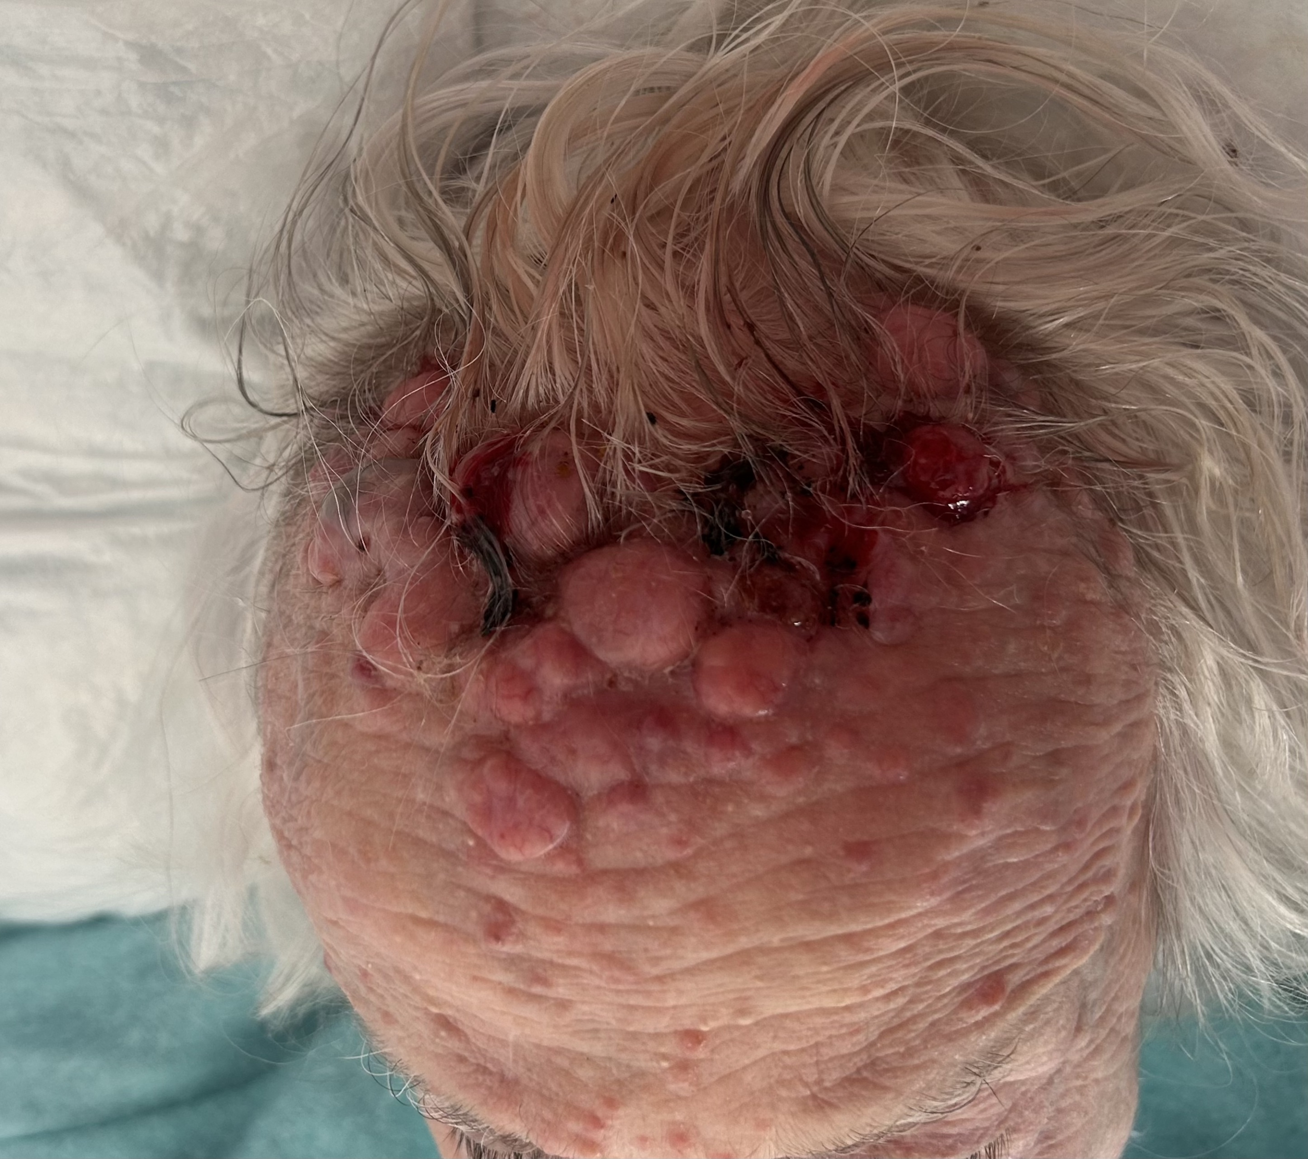
Figure 1. Clinical photograph of the index patient showing multiple confluent erythematous nodules and tumours of the scalp producing a turban tumour appearance, with smaller skin-coloured and erythematous papules on the forehead.
In addition, several violaceous, tender nodules were identified on the scalp and extremities, clinically consistent with spiradenomas

The coexistence of painless skin-coloured nodules and painful violaceous nodules at multiple anatomical sites in a patient with a positive family history constituted a compelling clinical presentation for CYLD cutaneous syndrome, even prior to histopathological confirmation.
No regional lymphadenopathy was detected. No parotid or salivary gland tumours were identified on palpation.

Familial Examination
Clinical examination of one of the patient's affected daughters revealed multiple smaller but morphologically identical dome-shaped, skin-coloured nodules on the scalp and face (Figure 2). Dermoscopic examination of a representative scalp lesion showed a violaceous homogeneous background with linear irregular vessels, a pattern consistent with spiradenoma (Figure 3), further supporting the familial nature of the condition and the clinical diagnosis of CYLD cutaneous syndrome. The second affected child was not available for clinical examination at the time of this report but reported a similar history of multiple scalp nodules.

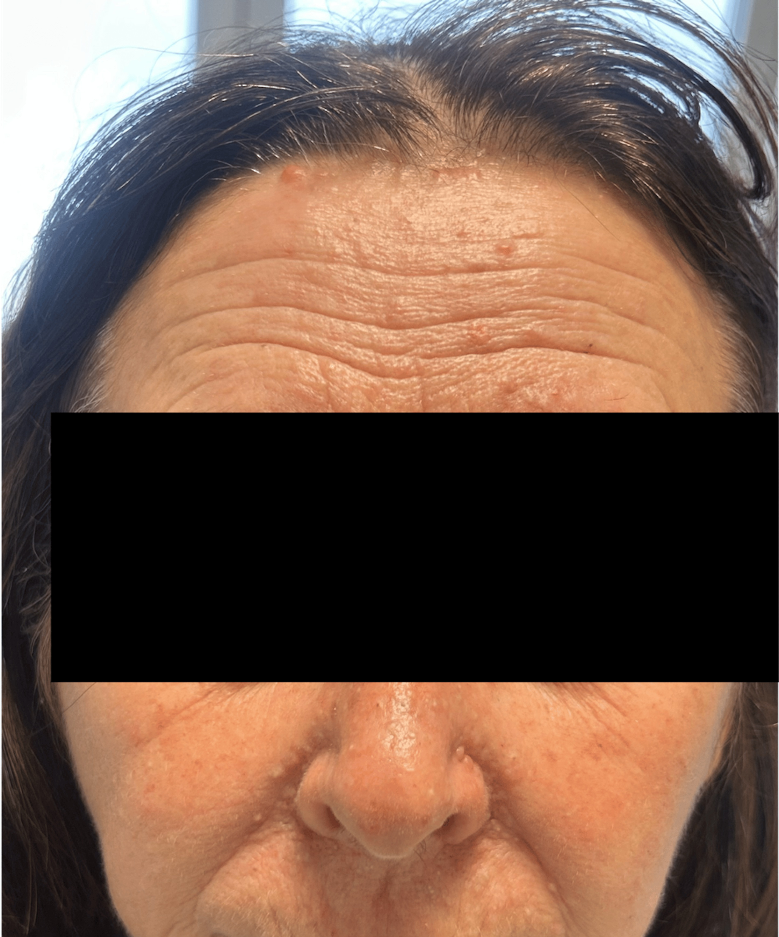
Figure 2. Clinical photograph of the patient's daughter showing numerous skin-coloured papules on the face and scalp, clinically suggestive of trichoepitheliomas, with an erythematous forehead nodule clinically consistent with cylindroma. (Face partially masked to preserve patient anonymity.)
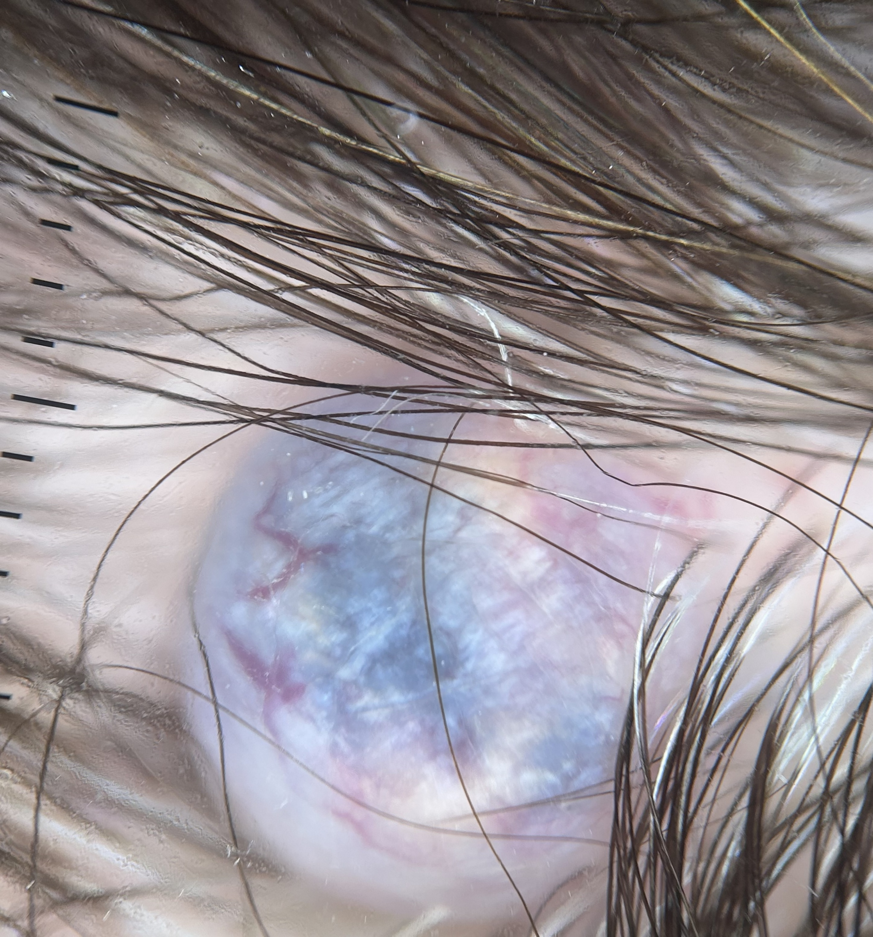
Figure 3. Dermoscopic image (polarised light) of a scalp nodule in the patient's daughter, showing a violaceous homogeneous background with linear irregular vessels, consistent with spiradenoma.
Dermoscopic Findings
Dermoscopic examination was performed on representative lesions of the index patient using a polarised contact dermoscope. The clinical distinction between the two tumour morphologies was further supported by their dermoscopic patterns. The skin-coloured scalp nodules consistent with cylindromas displayed a pink-to-red homogeneous background with prominent arborising vessels visible on the tumour surface. No pigmented structures, blue-grey ovoid nests, leaf-like areas, spoke-wheel structures, or ulceration were identified (Figure 4a). The violaceous, tender nodules on the scalp and extremities, consistent with spiradenomas, displayed a blue-to-violaceous homogeneous background with blue-red lacunae-like areas and linear irregular vessels, without arborising vessels (Figure 4b).

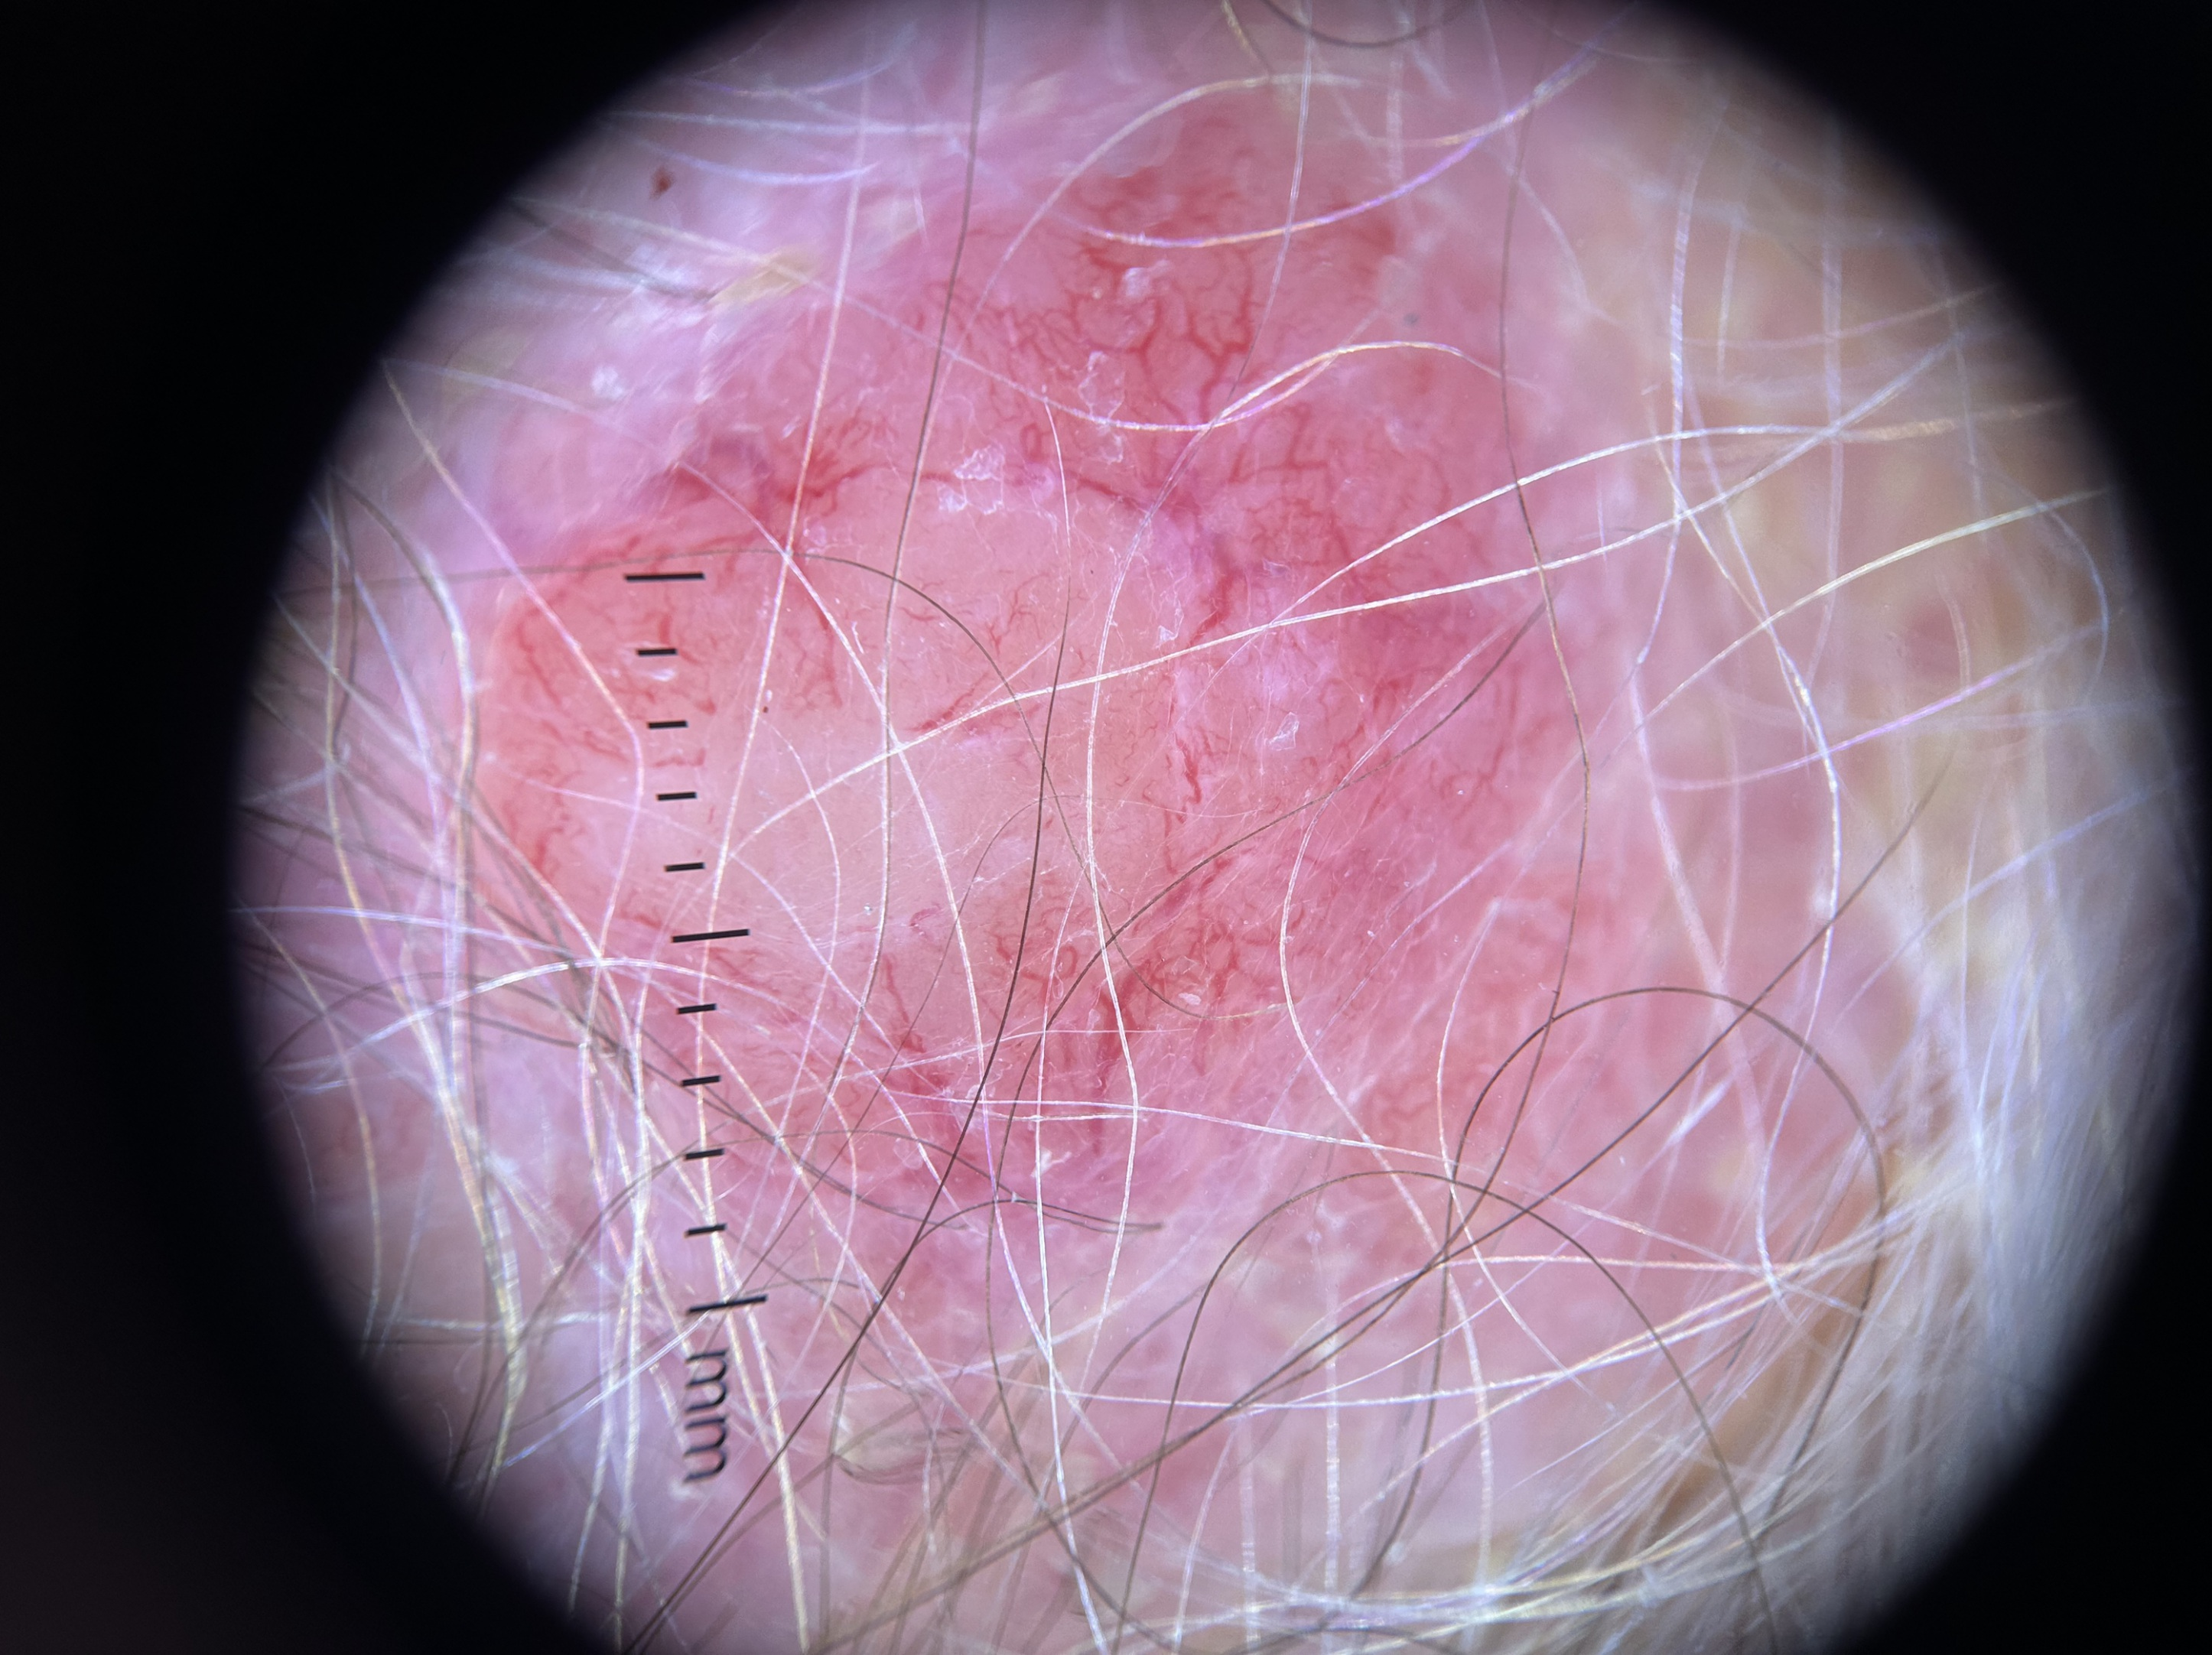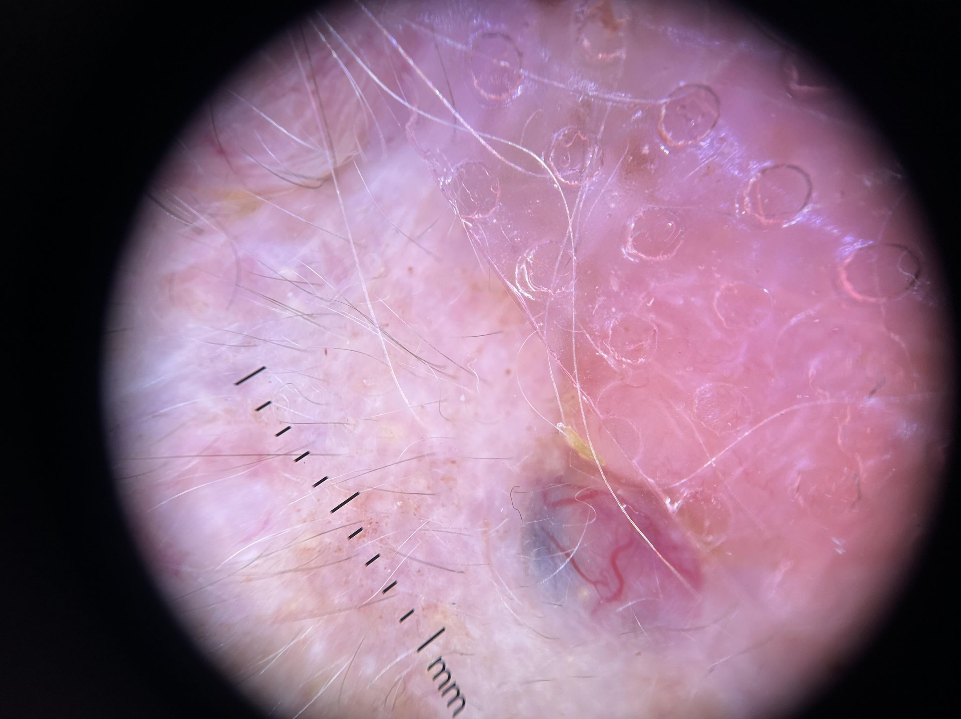
ba
a
Figure 4. a. Dermoscopic image (polarised light) of a scalp nodule in the index patient, showing a pink homogeneous background with arborising vessels of varying calibre on the tumour surface, without pigmented structures or ulceration, consistent with cylindroma. b. Dermoscopic image (polarised light) of a tender, violaceous scalp nodule in the index patient, showing a blue-to-violaceous homogeneous background with blue-red lacunae-like areas and linear irregular vessels, without arborising vessels.
Surgical Excision
Because of its recent rapid enlargement and the concern for possible malignant transformation, the dominant scalp nodule was selected for complete surgical excision and histopathological examination. The surgical specimen consisted of a skin flap measuring 16 × 12 × 12 mm, containing a well-delimited lesion of 14 × 11 × 7 mm. The specimen was entirely embedded in three paraffin blocks.
Histopathological Findings
Microscopic examination revealed a well-circumscribed intradermal nodular proliferation enclosed by a thin fibrous capsule, with lateral connection to the overlying epidermis, which showed superficial ulceration.
The proliferation was composed of a dual cell population without atypia, combining central clear cubic or epithelioid cells and peripheral dark basaloid/myoepithelial cells. A fine lymphocytic infiltrate and scattered eccrine ducts were noted within the lesion, set in a richly vascularised fibrous stroma. No mitotic figures, necrosis, or nuclear pleomorphism were identified.
These findings were diagnostic of a hybrid cylindrospiradenoma (spiradenocylindroma), in which a spiradenomatous component (well-circumscribed nodules with two cell populations and prominent lymphocytic infiltrate) coexisted with a cylindromatous component (basaloid nests in a jigsaw-like pattern surrounded by a thick hyaline basement membrane), each estimated to comprise more than 10% of the tumour volume (Figure 5).
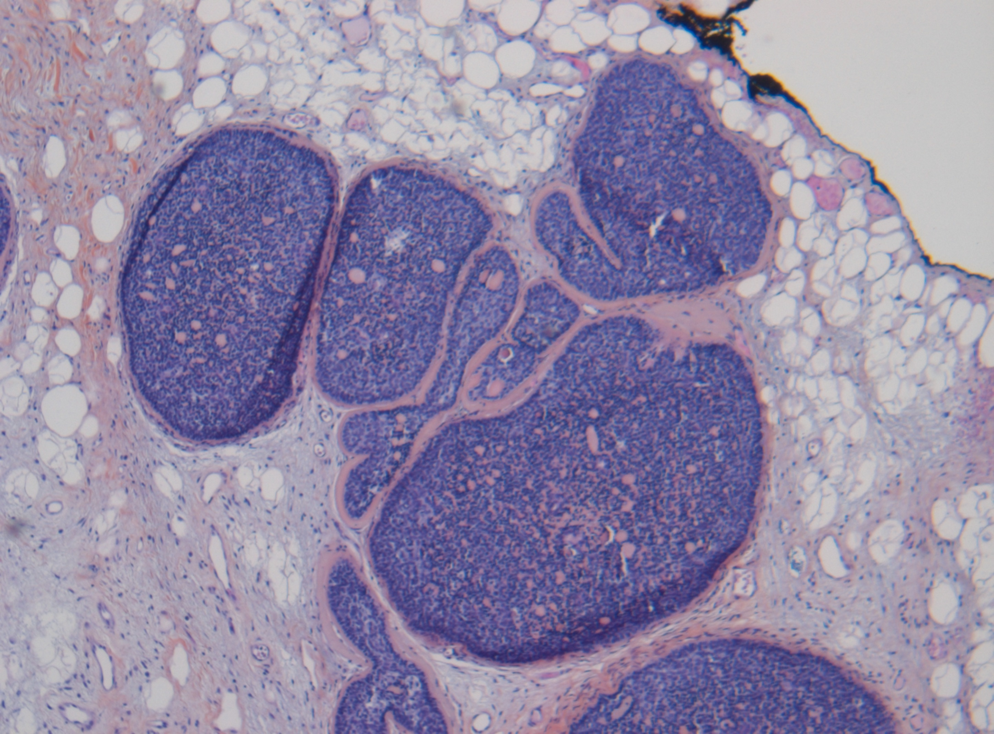
Figure 5. Low-power photomicrograph of the excised scalp lesion (haematoxylin-eosin, ×40). Well-circumscribed multinodular dermal adnexal neoplasm composed of basaloid cell islands arranged in a characteristic jigsaw puzzle pattern. The tumour lobules are surrounded by thick eosinophilic hyaline basement membrane material and contain scattered duct-like structures. This area corresponds to the cylindromatous component of the cylindrospiradenoma.
Expert review by the CARADERM network further characterised the lesion as a myoepithelial-epithelial tumour of the spiradenoma-cylindroma group: the dominant nodule was of spiradenoma type, while the dispersion of smaller nodules within the dermis showed cylindromatous features. The coexistence of both components within a single lesion was considered characteristic of a cylindrospiradenoma and strongly supportive of CYLD cutaneous syndrome. This histopathological finding correlated with the clinical observation of two distinct tumour morphologies (skin-coloured painless cylindromas and violaceous tender spiradenomas) at the bedside.
No histological evidence of malignant transformation was identified (no cytological atypia, elevated mitotic activity, or loss of the biphasic cell population).
Surgical resection margins were widely involved both laterally and in depth.
Immunohistochemistry
Immunohistochemical analysis, performed as part of the diagnostic pathological assessment by the CARADERM expert reference network, demonstrated negative BerEP4, focal positivity for epithelial membrane antigen (EMA), and negative androgen receptor expression. SOX10 showed diffuse positivity throughout all tumour nodules, while CD45 was negative, excluding a lymphoid proliferation. The Ki-67 proliferation index remained below 5% overall, with only focal elevation in superficially ulcerated areas.
This immunohistochemical profile supported the diagnosis of a benign cylindrospiradenoma and helped distinguish the lesion from basal cell carcinoma. The low Ki-67 proliferation index further supported the absence of significant proliferative activity or malignant transformation.
CARADERM Expert Consultation
Given the diagnostic complexity and the clinical context suggestive of a hereditary syndrome, the case was submitted to the CARADERM network (Centre de Référence des Cancers Rares de la Peau), the French national reference network for rare skin tumours affiliated with the INCa (Institut National du Cancer).
The expert review confirmed the diagnosis of cylindrospiradenoma within the clinicopathological spectrum of CYLD cutaneous syndrome and emphasised that the coexistence of spiradenoma and cylindroma components within the same excision should prompt discussion of CYLD cutaneous syndrome, and recommended correlation with the clinical and familial context, as well as genetic investigation.
Genetic Investigation
Molecular genetic testing for CYLD gene mutation (NGS panel, germline analysis) was initiated following the pathological diagnosis. Results were pending at the time of manuscript preparation. Cascade genetic testing of at-risk relatives will be considered if a pathogenic germline CYLD variant is identified.
The positive family history (two affected children, one with biopsy-confirmed cylindroma) supported the clinical diagnosis of CYLD cutaneous syndrome.
Clinical Course and Management
Given the widely involved surgical margins, the multifocal distribution of tumours (scalp, face, trunk, and extremities) encompassing both cylindromas and spiradenomas, and the clinical diagnosis of CYLD cutaneous syndrome, the patient was discussed in a multidisciplinary tumour board.
Close dermatological surveillance at six-month intervals with full-body skin examination was recommended to allow early detection of malignant transformation. Particular attention was directed toward the tender violaceous spiradenomas during follow-up. Systematic clinical examination of the patient's children and referral for genetic counselling were also arranged.
Re-excision of the index scalp lesion was discussed given the involved margins, favouring scalp-sparing strategies such as tumour enucleation and secondary intention healing. Radiotherapy was not considered as a treatment option. No indication for systemic therapy was identified at present.
The patient and her family were informed of the hereditary nature of the syndrome, the risk of malignant transformation, and the importance of long-term follow-up.
Patient Perspective
The patient expressed relief at finally obtaining a definitive diagnosis after more than six decades of progressive cutaneous involvement. She described the considerable aesthetic and psychological burden imposed by the tumours, particularly the scalp turban tumour, and the discomfort caused by the tender violaceous nodules. She was receptive to the proposed surveillance plan and agreed to involve her children in genetic counselling. She and her daughter consented to the publication of this case report

3. discussion

CYLD cutaneous syndrome is an exceptionally rare condition. The clinical spectrum is broad, ranging from isolated scalp cylindromas to the dramatic turban tumour phenotype illustrated by our case. CCS typically manifests in the second or third decade of life, as observed in our patient who first noted lesions at age 19. Tumours progressively accumulate through adulthood, with increased expressivity in females, and salivary gland tumours affect fewer than 5% of patients.

Our patient presented with two clinically distinct tumour morphologies at multiple anatomical sites: painless, skin-coloured cylindromas and tender, violaceous spiradenomas. This bedside distinction mirrors the established clinical descriptions of these two tumour types, with cylindromas typically appearing as painless skin-coloured nodules and spiradenomas as tender blue to violaceous nodules (Rajan & Ashworth, 2015). The concurrent finding of both tumour types at multiple body sites in a patient with a positive family history is a recognised clinical pointer toward CYLD cutaneous syndrome, and correlated in our case with the histological identification of a hybrid cylindrospiradenoma within the excised specimen. Clinical examination of the patient's daughter revealed, in addition to biopsy-confirmed cylindromas, multiple small skin-coloured papules on the central face clinically consistent with trichoepitheliomas, the third tumour type of the CCS triad. The presence of all three appendageal tumour types (cylindromas, spiradenomas, and trichoepitheliomas) across two generations further substantiated the familial diagnosis and the autosomal dominant inheritance pattern characteristic of CCS.

Dermoscopy provided additional support for the clinical distinction observed between the two tumour types in our patient. The pink background and arborising vessels seen in the cylindromatous lesions are consistent with descriptions in the literature, where cylindromas are characterised as pink, painless nodules with visible arborising vessels on their surface, in contrast to spiradenomas, which typically present as tender nodules with a blue to violaceous colour (Rajan & Ashworth, 2015). Rajan and Ashworth (2015) further noted that pink cylindromas can develop blue foci, possibly reflecting cystic degeneration or the emergence of a spiradenomatous component within a cylindroma, offering a morphological bridge between the two entities.

The dermoscopic literature specific to spiradenoma and cylindroma remains limited. In a systematic review of 372 cutaneous adnexal tumours, Lai et al. (2022) found that most dermoscopic patterns associated with these tumours were nonspecific and overlapped considerably with more common neoplasms, particularly basal cell carcinoma. Zaballos et al. (2018) similarly emphasised that this dermoscopic overlap between adnexal tumours and basal cell carcinoma poses considerable diagnostic difficulty. In a large dermatoscopic study of basal cell carcinoma, arborising telangiectasia was identified in 57.1% of 609 lesions (Altamura et al., 2010), underscoring the importance of clinicopathological correlation whenever this vascular pattern is observed in the context of multiple appendageal tumours. The distinction observed in our patient, arborising vessels on a pink background in cylindromas versus blue-violaceous structureless areas with linear vessels in spiradenomas, may represent a useful bedside clue for differentiating these two tumour types in CCS, although this observation would require validation in larger series.

The CYLD gene encodes a cytoplasmic deubiquitinase that removes K63-linked ubiquitin chains from NEMO, TRAF2, TRAF6, and BCL-3, thereby suppressing constitutive NF-κB activation (Bignell et al., 2000). The Knudson two-hit model applies: constitutional heterozygous mutation of one allele (germline) followed by somatic inactivation of the second allele drives tumourigenesis, frequently through loss of heterozygosity at the CYLD locus (Yurchenko et al., 2026). Recent work has identified recurrent somatic mutations in DNMT3A and BCOR in addition to biallelic CYLD loss, suggesting that epigenetic dysregulation may contribute to tumour pathogenesis (Yurchenko et al., 2026).

A recent integrative molecular analysis of 50 CCS tumours demonstrated specific activation of the noncanonical NF-κB pathway in cylindromas, confirmed by immunohistochemistry, highlighting this pathway as a potential therapeutic target (Yurchenko et al., 2026). Methylation profiling identified two distinct groups: cylindromas, which appeared to originate from apocrine sweat glands, and trichoepitheliomas, which clustered with basal cell carcinoma (Yurchenko et al., 2026). More broadly, contemporary molecular pathology has repositioned cylindroma and spiradenoma within a wider taxonomy of skin adnexal neoplasia defined by recurrent driver alterations, including CYLD, ALPK1, and various gene fusions, rather than by morphology alone (Plotzke et al., 2022).

The cylindrospiradenoma is a recognised histological entity within the CCS spectrum, defined by the coexistence of spiradenoma and cylindroma features within a single tumour mass, a morphologic continuum increasingly well documented in recent case reports (Kazakov et al., 2009; Sharma et al., 2025). Reconstruction of cylindromas from serial sections has shown contiguous growth between cylindromas and spiradenomas, consistent with the model that these represent histological extremes of the same tumour (Rajan & Ashworth, 2015). Both tumour types are now believed to arise from pluripotent cells of abortive adnexal primordial tissue, with positivity for CD200 (a hair follicle stem cell marker) supporting a common histogenesis from the hair follicle bulge (Sellheyer, 2015; Bell et al., 2019). The occurrence of multiple cylindrospiradenomas is strongly suggestive of CCS when identified in a patient with a positive family history (Sellheyer, 2015).

In our case, the CARADERM expert identified the dominant nodule as spiradenoma-type, with peripheral cylindromatous dispersion, a pattern well described in the literature as reflecting the shared differentiation programme of these two appendageal tumour types (Sellheyer, 2015; Bell et al., 2019).

The immunohistochemical profile observed in our patient (diffuse SOX10 positivity, focal EMA, negative BerEP4, negative androgen receptor, absent CD45, and a low Ki-67 index below 5%) is consistent with the established immunoprofile of spiradenoma and cylindroma and supports the absence of malignant transformation (Cassarino et al., 2017; Lezcano et al., 2017; Evangelista & North, 2017). The focally elevated Ki-67 in ulcerated zones reflects reactive proliferation secondary to surface trauma rather than true neoplastic atypia. Loss of MYB expression and elevated Ki-67 have been correlated with malignant transformation in spiradenocarcinoma and cylindrocarcinoma (Evangelista & North, 2017; van der Horst et al., 2015).

The widely involved surgical margins in our case represent a significant management challenge. Complete excision of all lesions in an advanced turban tumour is frequently impossible without extensive reconstructive surgery. Scalp-sparing strategies, including early primary excision, tumour enucleation, and secondary intention healing, are favoured, with recurrence rates around 35% after primary excision of cylindromas (Rajan & Ashworth, 2015). Total subgaleal scalp excision with a dermal substitute and split-thickness skin graft has been reported for extensive cases but should be reserved for situations where no other alternatives are feasible (Rajan & Ashworth, 2015; Karalija & Andersson, 2015). In this context, surveillance for early detection of malignant transformation becomes the primary therapeutic strategy. Radiotherapy is contraindicated in CCS, as it induces DNA damage that may promote further tumour formation or malignant transformation of existing lesions, consistent with the role of CYLD in the cellular DNA damage response demonstrated in murine models (Fernández-Majada et al., 2016).

Diagnostic features distinguishing malignant counterparts (cylindrocarcinoma, spiradenocarcinoma) from their benign precursors include cytological atypia, elevated mitotic count, loss of the lymphocytic infiltrate, and loss of the biphasic cell population; Ki-67 is typically elevated and MYB expression may be lost in malignant lesions (Kazakov et al., 2009; van der Horst et al., 2015). No such features were identified in our patient's excised specimen. Malignant transformation of cylindromas and spiradenomas is uncommon in CCS, considering the number of tumours that can arise (Rajan & Ashworth, 2015). Clinical features associated with malignant transformation include rapid growth, ulceration, bleeding, and increased surface vascularity (Rajan & Ashworth, 2015). As reviewed by Rajan and Ashworth (2015), malignant transformation of cylindroma has been reported in patients aged 51 to 78 years, with metastases occurring in 9 of 15 cases and death in 6 of 15. Kazakov et al. (2009) described 24 malignant neoplasms arising in preexisting spiradenoma, cylindroma, and spiradenocylindroma, demonstrating morphologic diversity of malignant components and a correlation between histological pattern and clinical course. Our patient's age (81 years) and the rapid growth of the index lesion warranted excision to exclude malignancy, which was not identified.

Systemic targeted therapies for CCS remain investigational. The most advanced clinical evidence comes from the TRAC randomised trial, which evaluated pegcantratinib, a topical tropomyosin receptor kinase (TRK) inhibitor, based on the discovery of TRK overexpression in CCS tumours; however, the trial did not meet its primary endpoint, as pegcantratinib-treated tumours failed to achieve a significant reduction in volume compared with placebo. The trial investigators reported that the drug penetrated tumour tissue but that the intratumoural concentrations achieved were likely too low to abrogate TRK signalling, and recommended future dose-escalation studies rather than concluding that TRK is an invalid therapeutic target (Danilenko et al., 2018). Additional targets under preclinical investigation include the noncanonical NF-κB pathway, specifically activated in cylindromas, and the CYLD-HDAC axis (Yurchenko et al., 2026). No phase III data are available for any systemic agent in CCS, and these approaches remain experimental.

The CARADERM network, operating under the auspices of the INCa, provides essential support for the diagnosis and management of rare cutaneous tumours in France. This case illustrates its value: the expert review provided a definitive histological subtype diagnosis (cylindrospiradenoma), confirmed the absence of malignant transformation, and guided further management including genetic investigation. Systematic referral of complex appendageal tumour cases to specialised networks is recommended

The discussion should not repeat the results, but provide detailed interpretation of data. This should interpret the significance of the findings of the work. Citations should be given in support of the findings. The results and discussion part can also be described as separate, if appropriate.

4. Conclusion

We report a case of CYLD cutaneous syndrome presenting with multifocal cylindromas and spiradenomas, including a long-standing scalp turban tumour, in an 81-year-old woman with a positive family history. Histopathological analysis of the index scalp lesion demonstrated a cylindrospiradenoma, a combined spiradenoma-cylindroma tumour, without malignant transformation, confirmed by expert review through the CARADERM network. The immunohistochemical profile (diffuse SOX10, focal EMA, negative BerEP4/AR/CD45, Ki-67 below 5%) further supported this diagnosis and excluded malignant transformation. Referral to the CARADERM network provided decisive expert confirmation and guided subsequent management, underscoring the value of specialised rare-tumour networks in the diagnosis of complex cutaneous appendageal lesions. Long-term dermatological surveillance, genetic counselling for at-risk relatives, and avoidance of radiotherapy remain the cornerstones of care in CYLD cutaneous syndrome.

Limitations
The principal limitation is that germline CYLD testing was still pending when the manuscript was prepared; therefore, the diagnosis was supported by the clinical, familial, histopathological, and immunohistochemical findings rather than molecular confirmation. In addition, histopathological assessment was limited to the excised dominant scalp lesion, and the dermoscopic observations were based on selected representative lesions. These findings should therefore be interpreted as a detailed single-case description rather than evidence of diagnostic performance or treatment effectiveness.

Competing interests

In compliance with the ICMJE uniform disclosure form, all authors declare the following. Payment/services info: no financial support was received from any organisation for the submitted work. Financial relationships: the authors have no financial relationships at present or within the previous three years with any organisations that might have an interest in the submitted work. Other relationships: there are no other relationships or activities that could appear to have influenced the submitted work. Authors have declared that no competing interests exist.

Consent

All authors declare that Written informed consent was obtained from the patient and from her affected daughter for publication of this case report and accompanying clinical and dermoscopic images.

Ethical approval

Informed consent for treatment and open-access publication was obtained or waived by all participants in this study. All authors hereby declare that this study was performed in accordance with the ethical standards laid down in the 1964 Declaration of Helsinki, and that human subjects were not exposed to any procedure beyond standard clinical care.
Declaration of AI Use

This manuscript was prepared through the combined contributions of all author(s), including contributions to the study design, data, content development, results, interpretation, and related scholarly work. The author(s) acknowledge the use of Grammarly and ChatGPT to assist with grammar checking, language refinement, reference formatting. These AI-assisted tools were not used as authors and did not replace the intellectual contributions or scholarly judgment of the author(s). All AI-assisted outputs, including content, references, and interpretations, were carefully reviewed, revised, verified, and approved by the author(s). The author(s) accept full responsibility for the accuracy, integrity, and final content of the manuscript.

Reference :

Bignell, G. R., Warren, W., Seal, S., Takahashi, M., Rapley, E., Barfoot, R., Green, H., Brown, C., Biggs, P. J., Lakhani, S. R., Jones, C., Hansen, J., Blair, E., Hofmann, B., Siebert, R., Turner, G., Evans, D. G., Schrander-Stumpel, C., Beemer, F. A., … Stratton, M. R. (2000). Identification of the familial cylindromatosis tumour-suppressor gene. Nature Genetics, 25(2), 160–165. https://doi.org/10.1038/76006
Rajan, N., & Ashworth, A. (2015). Inherited cylindromas: Lessons from a rare tumour. The Lancet Oncology, 16(9), e460–e469. https://doi.org/10.1016/S1470-2045(15)00245-4
Kazakov, D. V., Zelger, B., Rütten, A., Vazmitel, M., Spagnolo, D. V., Kacerovska, D., Vanecek, T., Grossmann, P., Sima, R., Grayson, W., Calonje, E., Koren, J., Mukensnabl, P., Danis, D., & Michal, M. (2009). Morphologic diversity of malignant neoplasms arising in preexisting spiradenoma, cylindroma, and spiradenocylindroma based on the study of 24 cases, sporadic or occurring in the setting of Brooke-Spiegler syndrome. The American Journal of Surgical Pathology, 33(5), 705–719. https://doi.org/10.1097/PAS.0b013e3181966762
Blake, P. W., & Toro, J. R. (2009). Update of cylindromatosis gene (CYLD) mutations in Brooke-Spiegler syndrome: Novel insights into the role of deubiquitination in cell signaling. Human Mutation, 30(7), 1025–1036. https://doi.org/10.1002/humu.21024
Yurchenko, A. A., Sharkhith, H., Rajabi, F., Bogiatzi, S., Wang, J., Huber, M., Hohl, D., & Nikolaev, S. I. (2026). Integrative molecular analysis of skin tumors from patients with CYLD cutaneous syndrome. Journal of Investigative Dermatology, 146(1), 130–138.e10. https://doi.org/10.1016/j.jid.2025.05.006
Lai, M., Muscianese, M., Piana, S., Chester, J., Borsari, S., Paolino, G., Pellacani, G., Longo, C., & Pampena, R. (2022). Dermoscopy of cutaneous adnexal tumours: A systematic review of the literature. Journal of the European Academy of Dermatology and Venereology, 36(9), 1524–1540. https://doi.org/10.1111/jdv.18210
Zaballos, P., Gómez-Martín, I., Martin, J. M., & Bañuls, J. (2018). Dermoscopy of adnexal tumors. Dermatologic Clinics, 36(4), 397–412. https://doi.org/10.1016/j.det.2018.05.007
Altamura, D., Menzies, S. W., Argenziano, G., Zalaudek, I., Soyer, H. P., Sera, F., Avramidis, M., DeAmbrosis, K., Fargnoli, M. C., & Peris, K. (2010). Dermatoscopy of basal cell carcinoma: Morphologic variability of global and local features and accuracy of diagnosis. Journal of the American Academy of Dermatology, 62(1), 67–75. https://doi.org/10.1016/j.jaad.2009.05.035
Plotzke, J. M., Adams, D. J., & Harms, P. W. (2022). Molecular pathology of skin adnexal tumours. Histopathology, 80(1), 166–183. https://doi.org/10.1111/his.14441
Sharma, S., Sharma, V., & Kaushik, S. (2025). Spiradenocylindroma: Morphology of a rare hybrid adnexal tumor. Diagnostic Cytopathology, 53(11), E203–E209. https://doi.org/10.1002/dc.70006
Sellheyer, K. (2015). Spiradenoma and cylindroma originate from the hair follicle bulge and not from the eccrine sweat gland: An immunohistochemical study with CD200 and other stem cell markers. Journal of Cutaneous Pathology, 42(2), 90–101. https://doi.org/10.1111/cup.12406
Bell, A. H., Prieto, V. G., Ferrarotto, R., Goepfert, R. P., Myers, J. N., Weber, R., & Bell, D. (2019). Magnifying glass on spiradenoma and cylindroma histogenesis and tumorigenesis using systematic transcriptome analysis. Annals of Diagnostic Pathology, 41, 14–23. https://doi.org/10.1016/j.anndiagpath.2019.04.015
Cassarino, D. S., Su, A., Robbins, B. A., Altree-Tacha, D., & Ra, S. (2017). SOX10 immunohistochemistry in sweat ductal/glandular neoplasms. Journal of Cutaneous Pathology, 44(6), 544–547. https://doi.org/10.1111/cup.12939
Lezcano, C., Ho, J., & Seethala, R. R. (2017). SOX10 and DOG1 expression in primary adnexal tumors of the skin. The American Journal of Dermatopathology, 39(12), 896–902. https://doi.org/10.1097/DAD.0000000000000872
Evangelista, M. T., & North, J. P. (2017). MYB, CD117 and SOX-10 expression in cutaneous adnexal tumors. Journal of Cutaneous Pathology, 44(5), 444–450. https://doi.org/10.1111/cup.12904
van der Horst, M. P., Marusic, Z., Hornick, J. L., Luzar, B., & Brenn, T. (2015). Morphologically low-grade spiradenocarcinoma: A clinicopathologic study of 19 cases with emphasis on outcome and MYB expression. Modern Pathology, 28(7), 944–953. https://doi.org/10.1038/modpathol.2015.48
Karalija, A., & Andersson, M. N. (2015). The surgical treatment of familial cylindromatosis through subgaleal scalp excision. Case Reports in Plastic Surgery and Hand Surgery, 2(3–4), 57–59. https://doi.org/10.3109/23320885.2015.1054392
Fernández-Majada, V., Welz, P. S., Ermolaeva, M. A., Schell, M., Adam, A., Dietlein, F., Komander, D., Büttner, R., Thomas, R. K., Schumacher, B., & Pasparakis, M. (2016). The tumour suppressor CYLD regulates the p53 DNA damage response. Nature Communications, 7, 12508. https://doi.org/10.1038/ncomms12508
Danilenko, M., Stamp, E., Stocken, D. D., Husain, A., Zangarini, M., Cranston, A., Stones, R., Sinclair, N., Hodgson, K., Bowett, S. A., Roblin, D., Traversa, S., Plummer, R., Veal, G., Langtry, J. A. A., Ashworth, A., Burn, J., & Rajan, N. (2018). Targeting tropomyosin receptor kinase in cutaneous CYLD defective tumors with pegcantratinib: The TRAC randomized clinical trial. JAMA Dermatology, 154(8), 913–921. https://doi.org/10.1001/jamadermatol.2018.1610
Marín-Rubio, J. L., Raote, I., Inns, J., Dobson-Stone, C., & Rajan, N. (2023). CYLD in health and disease. Disease Models & Mechanisms, 16(6), dmm050093. https://doi.org/10.1242/dmm.050093
Brambullo, T., De Lazzari, A., Franchi, A., Trevisson, E., Garau, M. L., Scarmozzino, F., Vindigni, V., & Bassetto, F. (2024). A misdiagnosed familiar Brooke–Spiegler syndrome: Case report and review of the literature. Journal of Clinical Medicine, 13(8), 2240. https://doi.org/10.3390/jcm13082240
Rodríguez Rojas, L. X., Vasquez-Forero, D., Albán, J. J., Doza, L., Murillo, S., Olave-Rodriguez, J. A., & Nastasi, J. (2024). Familiar cylindromatosis in a Colombian family caused by a mutation in CYLD. ecancermedicalscience, 18, 1768. https://doi.org/10.3332/ecancer.2024.1768

