Case report
Ear and Eye Involvement in Lichen Planus: An Underrecognized Association

Abstract
Aims: To describe a case of generalised lichen planus with concomitant auricular and ocular involvement and to emphasise the importance of recognising atypical extra-cutaneous manifestations. Presentation of Case: A 50-year-old woman with no significant medical history presented with generalised lichen planus of six months’ duration, progressive hearing loss, and increased tearing. Examination demonstrated diffuse pruritic violaceous papules and plaques, a whitish reticular network on the buccal mucosa, and Wickham’s striae on dermoscopy. Audiometric testing confirmed bilateral hearing loss, more pronounced on the right side. Ophthalmological assessment identified moderate ocular dryness with decreased visual acuity in the left eye. No alternative cause of the auditory or ocular findings was identified during the reported work-up. The patient received systemic corticosteroid therapy at 1 mg/kg/day together with dexamethasone-tobramycin eye drops. After two months, cutaneous disease activity and pruritus decreased, with concurrent improvement in auditory and ocular symptoms. Discussion: Auricular and ocular involvement in lichen planus is uncommon and may be overlooked because symptoms can be insidious. External auditory canal disease may progress to stenosis and hearing impairment, whereas ocular involvement may affect the ocular surface and lacrimal pathways. Conclusion: Targeted enquiry about hearing and ocular symptoms, with appropriate multidisciplinary assessment, may facilitate earlier recognition of these uncommon manifestations and reduce the risk of persistent functional impairment.
Keywords: Lichen planus; auricular involvement; ocular involvement; hearing loss; ocular dryness; Wickham's striae; mucosal disease; external auditory canal
Introduction
Lichen planus is a chronic inflammatory disorder driven by a T-cell-mediated immune response directed against basal keratinocytes, affecting both cutaneous and mucosal tissues. It affects approximately 0.3-1% of the general population, with a peak incidence between the fourth and sixth decades of life. The disease most frequently involves the skin of the flexural surfaces and the oral and genital mucosae, whereas extension to other epithelial sites, such as the conjunctiva, the upper aerodigestive tract, and the external auditory canal, is far less common and frequently under-recognised in routine practice. Recent reviews further describe lichen planus as clinically heterogeneous across cutaneous, appendageal, and mucosal sites, with oral disease requiring specific diagnostic and management considerations (Louisy et al., 2024; Tekin et al., 2024). Recent case reports also document reticular oral lichen planus with characteristic interlacing white striae or Wickham's striae, consistent with the oral mucosal phenotype described in the present case (Deokar et al., 2026; Gunanithi et al., 2026). Because these atypical localisations can progress silently before causing irreversible functional damage, systematic clinical screening beyond the skin and oral mucosa is increasingly emphasised in the literature. Extra-cutaneous manifestations may nevertheless occur and remain underrecognised. However, concomitant auricular and ocular involvement in generalised lichen planus remains sparsely documented. The objective of this report is to describe a case of generalised lichen planus with concomitant oral, auricular, and ocular involvement, and to underscore the importance of proactively screening for these atypical extra-cutaneous manifestations in routine clinical practice.
Presentation of Case
A 50-year-old woman with no significant medical history was admitted for the management of generalised lichen planus evolving over six months. In addition to the cutaneous eruption, she reported progressive hearing loss and increased tearing. Dermatological examination revealed diffuse pruritic violaceous papules and plaques. Examination of the oral cavity demonstrated a whitish network affecting the buccal mucosa (Figure 1). Dermoscopic evaluation showed the presence of Wickham's striae on the skin lesions (Figure 2). Audiometric testing confirmed bilateral hearing loss, predominant on the right side. Ophthalmological examination identified moderate ocular dryness associated with decreased visual acuity in the left eye. No other cause of hearing loss or ocular surface disease was identified on work-up, and in the setting of active cutaneous and oral lichen planus with classic clinical and dermoscopic features, these findings were attributed to auricular and ocular involvement of the disease. The patient was treated with systemic corticosteroid therapy at a dose of 1 mg/kg/day, combined with dexamethasone-tobramycin eye drops. After two months of treatment, marked clinical improvement was observed, with regression of auditory and ocular symptoms, disappearance of dermoscopic signs of disease activity, and significant reduction in pruritus.
Discussion
Mucosal involvement is common in patients with cutaneous lichen planus, with the oral cavity being the most frequently affected site, followed by the anogenital region. Other epithelial locations, including the conjunctiva, upper aerodigestive tract, and external auditory canal, are less frequently reported. Auricular involvement remains poorly documented, and its true prevalence in the general lichen planus population is unknown, largely because of its insidious onset and the nonspecific nature of early symptoms. The earliest descriptions, dating back to the mid-20th century, reported involvement of the tympanic membrane, with clinical manifestations such as otorrhea, tinnitus, pruritus, and progressive hearing loss (Warin et al., 1948). In the largest published case series to date, a ten-year retrospective review from the Mayo Clinic identified nineteen patients with otic lichen planus, most of whom presented with persistent otorrhea and hearing loss and were managed successfully with topical tacrolimus, underscoring both the chronicity of the condition and the value of early topical intervention (Sartori-Valinotti et al., 2013). More recently, a review of treatment options for otic lichen planus highlighted bone-anchored hearing devices as an effective solution for hearing restoration once irreversible conductive loss has occurred, reinforcing that timely recognition can change the therapeutic pathway available to the patient (Lazzerini et al., 2020). Chronic inflammation in the external auditory canal can lead to progressive narrowing, stenosis, and conductive hearing loss that may become refractory to medical treatment alone, occasionally requiring surgical calibration or meatoplasty. Management therefore depends on disease severity and ranges from topical corticosteroids or calcineurin inhibitors to systemic therapies in extensive forms, with auditory rehabilitation reserved for advanced, treatment-resistant cases (Lazzerini et al., 2020; Sartori-Valinotti et al., 2013; Warin et al., 1948; Yukkaldıran et al., 2022).
Ocular lichen planus represents a rare but potentially serious manifestation that can be visually devastating if left unrecognised. The earliest reported cases described conjunctival involvement, followed by eyelid involvement. A recent clinicopathological review emphasized that conjunctival disease typically predominates and often progresses to extensive scarring that can mimic other forms of cicatrising conjunctivitis, making histopathological confirmation essential to the diagnosis (Reekie et al., 2024). Isolated corneal involvement, independent of conjunctival scarring, has also been described using anterior segment optical coherence tomography, illustrating that the spectrum of ocular lichen planus is broader than traditionally appreciated and that multimodal imaging can support earlier diagnosis (Leitão & Cabral, 2024). Clinical manifestations may include ocular dryness, chronic blepharoconjunctivitis, keratitis, and involvement of the lacrimal pathways, which can lead to irreversible stenosis or visual impairment; a broader review of ocular involvement across vesiculobullous and lichenoid mucosal diseases similarly stresses the need for close ophthalmological follow-up whenever mucosal disease is present (Mortazavi et al., 2024). Topical corticosteroids and immunomodulatory agents constitute first-line treatment, while systemic immunosuppression may be required in severe or progressive cases. Our observation underscores the importance of heightened vigilance regarding these unusual locations, particularly when symptoms appear concurrently with active cutaneous involvement (Dhermy et al., 1983; Leitão & Cabral, 2024; Mohebbi et al., 2019; Mortazavi et al., 2024; Reekie et al., 2024; Sharma & Singhal, 2001).
The differential diagnosis of auricular lichen planus includes chronic otitis externa, eczematous otitis, and post-inflammatory medial meatal fibrosis, all of which can produce a similarly narrowed and inflamed external auditory canal; histopathological confirmation, showing a band-like lymphocytic infiltrate at the dermo-epidermal junction with associated basal vacuolar degeneration, remains the diagnostic gold standard when the clinical picture is ambiguous. Similarly, ocular lichen planus must be distinguished from other causes of cicatrising conjunctivitis, including mucous membrane pemphigoid, Stevens-Johnson syndrome/toxic epidermal necrolysis sequelae, and graft-versus-host disease, particularly in patients without a prior diagnosis of cutaneous lichen planus. From a practical standpoint, this case highlights the value of a multidisciplinary approach to lichen planus, involving dermatologists, otolaryngologists, and ophthalmologists whenever mucosal or extra-cutaneous symptoms are reported. Given that auditory and ocular sequelae of lichen planus are often insidious and only partially reversible once structural damage has occurred, a brief, targeted enquiry about hearing and ocular symptoms is worth incorporating into the routine follow-up of patients with active mucocutaneous lichen planus, even in the absence of overt complaints, so that treatment can be escalated before functional impairment becomes established.
Limitations
This report has some limitations. The diagnosis of auricular and ocular involvement was based on clinical, audiometric, and ophthalmological findings in the setting of classic clinical and dermoscopic features of cutaneous and oral lichen planus; no histopathological confirmation was obtained at any site, including the external auditory canal or conjunctiva. While consistent with lichen planus, this non-invasive diagnostic approach does not formally exclude the differential diagnoses discussed above, and biopsy would have strengthened diagnostic certainty, particularly for the auricular and ocular sites. Furthermore, as a single-patient observation, this report cannot establish the true prevalence or generalisability of this association.
Conclusion
This case demonstrates that lichen planus may involve the ear and eye in addition to its more familiar cutaneous and oral manifestations. The coexistence of progressive hearing loss, ocular symptoms, and active mucocutaneous disease in this patient highlights the clinical value of extending assessment beyond the skin and oral cavity when relevant symptoms are present. Audiometric and ophthalmological evaluation supported recognition of the associated auditory and ocular abnormalities, and improvement occurred after systemic corticosteroid treatment with adjunctive ophthalmic therapy. Because auricular and ocular involvement may develop insidiously and can be associated with persistent functional consequences, clinicians should maintain appropriate vigilance during the assessment and follow-up of patients with active lichen planus. A multidisciplinary approach involving dermatology, otolaryngology, and ophthalmology may be particularly useful when hearing or ocular complaints are reported. This observation supports targeted screening for such symptoms so that further evaluation and management can be undertaken before substantial functional impairment becomes established.

Competing Interests
The authors declare no conflicts of interest.
Consent
As per international standards or university standards, patient(s) written consent has been collected and preserved by the author(s).The patient described in this case report was informed that her clinical data and images would be submitted for publication.
Ethical Approval
This case report was conducted in accordance with the ethical principles of the Declaration of Helsinki. As this report concerns a single patient managed in the course of routine clinical care, formal approval from an institutional ethics committee was not required, in accordance with our institution's policy.
Declaration of AI Use

This manuscript was prepared through the combined contributions of all author(s), including contributions to the study design, data, content development, results, interpretation, and related scholarly work. The author(s) acknowledge the use of Grammarly and ChatGPT to assist with grammar checking, language refinement, and reference formatting. These AI-assisted tools were not used as authors and did not replace the intellectual contributions or scholarly judgment of the author(s). All AI-assisted outputs, including content, references, and interpretations, were carefully reviewed, revised, verified, and approved by the author(s). The author(s) accept full responsibility for the accuracy, integrity, and final content of the manuscript.

References
Deokar, I., Vaje, S., & Chavan, M. (2026). Management of symptomatic reticular oral lichen planus involving the buccal and labial mucosa: A case report. Journal of Disease and Global Health, 19(2), 54–60. https://doi.org/10.56557/jodagh/2026/v19i210772
Dhermy, P., Haye, C., Pouliquen, Y., Le Hoang, P., & Foels, A. (1983). Le lichen de la conjonctive [Lichen of the conjunctiva]. Journal Français d'Ophtalmologie, 6(1), 51–57. https://www.sciencedirect.com/journal/journal-francais-dophtalmologie/issues
Gunanithi, M., Tamilmani, S., Deivanayagi, M., Monisha, R., Elamparithi, B., & Chandran, N. (2026). A case report on oral lichen planus. Asian Journal of Medical Principles and Clinical Practice, 9(1), 221–227. https://doi.org/10.9734/ajmpcp/2026/v9i1393
Lazzerini, F., Bruschini, L., Berrettini, S., De Vito, A., & Forli, F. (2020). Lichen planus of the external auditory canal: Treatment options and review of literature. Clinical Case Reports, 8(10), 2017–2020. https://doi.org/10.1002/ccr3.3049
Leitão, M., & Cabral, D. (2024). Isolated corneal involvement by lichen planus: Multi-modal evaluation. European Journal of Ophthalmology, 34(1), NP48–NP53. https://doi.org/10.1177/11206721231174931
Louisy, A., Humbert, E., & Samimi, M. (2024). Oral lichen planus: An update on diagnosis and management. American Journal of Clinical Dermatology, 25(1), 35–53. https://doi.org/10.1007/s40257-023-00814-3
Mohebbi, M., Mirghorbani, M., Banafshe Afshan, A., & Towfighi, M. (2019). Lichen planus in ocular surface: Major presentations and treatments. Ocular Immunology and Inflammation, 27(6), 987–994. https://doi.org/10.1080/09273948.2018.1485955
Mortazavi, H., Hazrati, P., Koohi, H., Sarrafan-Sadeghi, T., & Moradian-Lotfi, S. (2024). Ocular involvement in oral vesiculobullous diseases: A review on reported cases in the literature. The Saudi Dental Journal, 36(4), 546–560. https://doi.org/10.1016/j.sdentj.2023.12.012
Reekie, I. R., Simpson, A., Erikitola, O., Lyall, D., & Roberts, F. (2024). Ocular lichen planus: A clinicopathologic review. European Journal of Ophthalmology, 34(5), 1318–1327. https://doi.org/10.1177/11206721241229128
Sartori-Valinotti, J. C., Bruce, A. J., Krotova Khan, Y., & Beatty, C. W. (2013). A 10-year review of otic lichen planus: The Mayo Clinic experience. JAMA Dermatology, 149(9), 1082–1086. https://doi.org/10.1001/jamadermatol.2013.4711
Sharma, R., & Singhal, N. (2001). Lichen planus of the eyelids: A report of 5 cases. Dermatology Online Journal, 7(1), 5. https://doi.org/10.5070/D31pf4k13c
Tekin, B., Xie, F., & Lehman, J. S. (2024). Lichen planus: What is new in diagnosis and treatment? American Journal of Clinical Dermatology, 25(5), 735–764. https://doi.org/10.1007/s40257-024-00878-9
Warin, R. P., Hall-Smith, P., & Daunt, F. O. N. (1948). Lichen planus of alimentary canal and tympanic membranes. British Journal of Dermatology and Syphilis, 60(7–8), 249. https://doi.org/10.1111/j.1365-2133.1948.tb11297.x
Yukkaldıran, A., Erdogan, O., Dundar, R., An, İ., & Aksoy, M. (2022). Evaluation of inner ear and hearing functions in lichen planus patients. Journal of Cosmetic Dermatology, 21(2), 776–780. https://doi.org/10.1111/jocd.14124

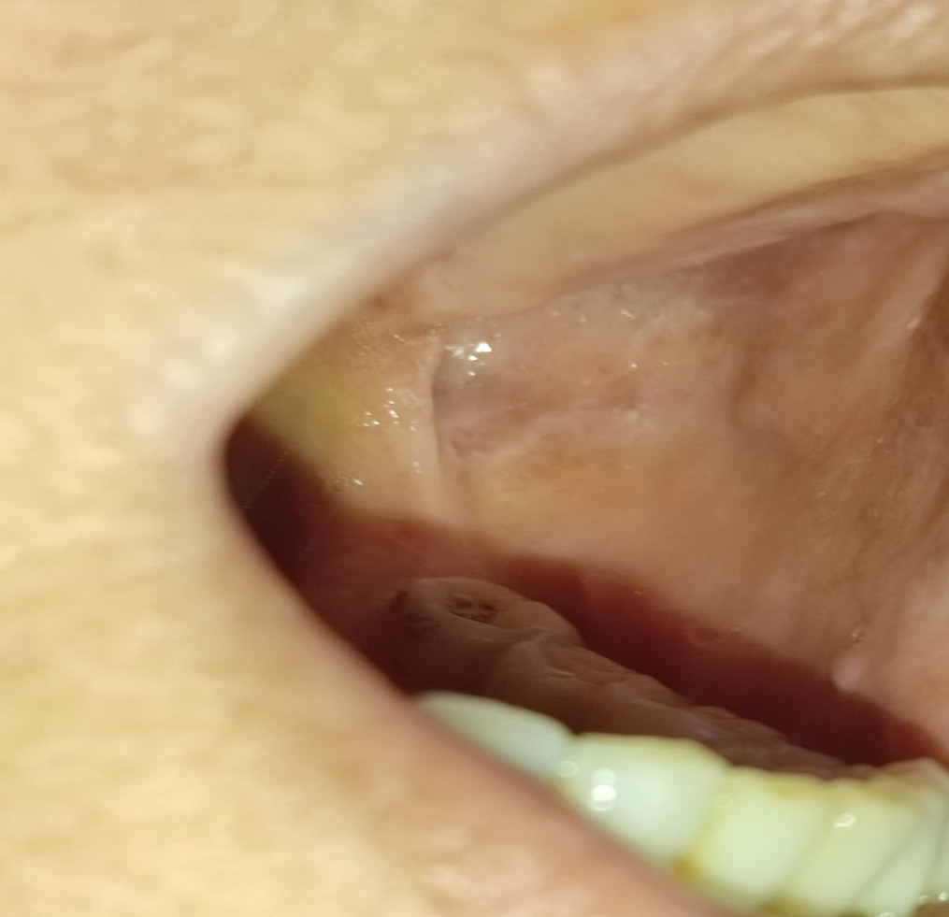
Figure 1: Reticulated whitish network on the oral mucosa, consistent with oral lichen planus.
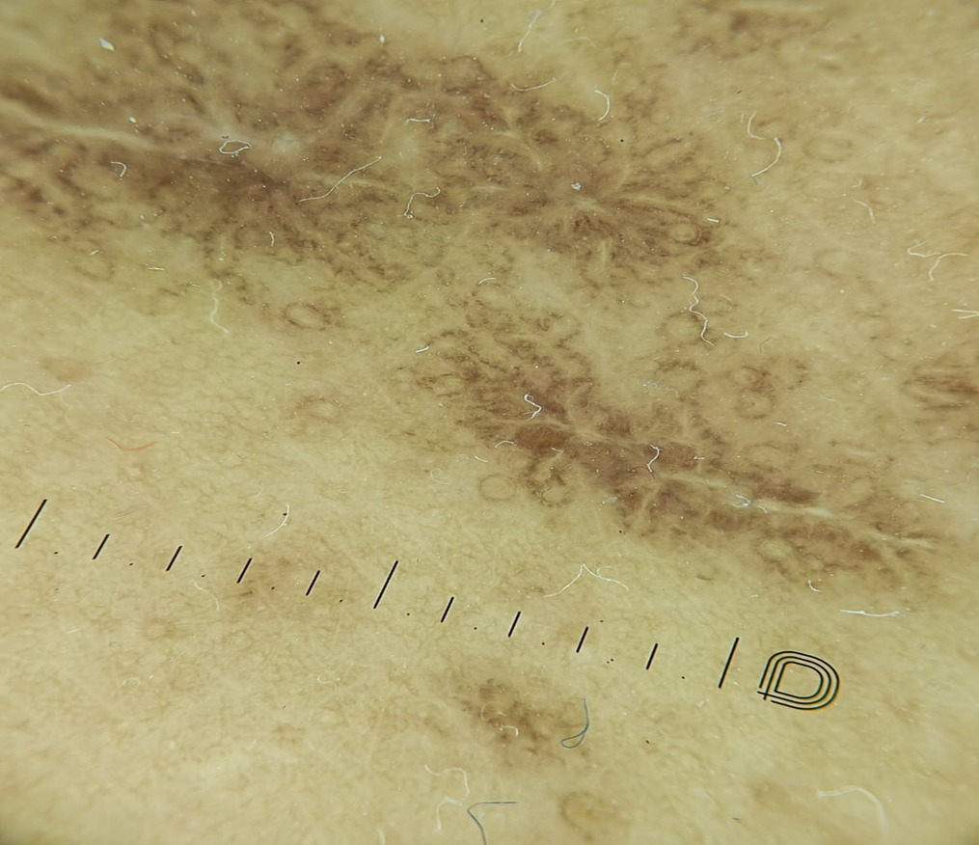
Figure 2: Dermoscopic view showing Wickham's striae on violaceous papules of the skin, suggestive of cutaneous lichen planus.

