Synthesis and Physicochemical Analysis of Cellulose Xanthate Derived from Pentaclethra macrophylla Benth Pods

Abstract
The indiscriminate disposal of Pentaclethra macrophylla Benth pods contributes to biomass waste, creating an opportunity for their conversion into value-added cellulose derivatives. This study prepared cellulose xanthate from cellulose isolated from Pentaclethra macrophylla Benth pods and evaluated its physicochemical characteristics using standard procedures. Cellulose was isolated through sequential treatment, converted to cellulose xanthate under alkaline conditions, and examined by proximate analysis, Fourier transform infrared spectroscopy (FTIR), and energy-dispersive X-ray spectroscopy (EDX). The moisture contents of cellulose and cellulose xanthate were 7.871% and 8.144%, respectively, while ash contents were 1.1805% and 1.083%. Volatile matter values were 0.154% and 0.700%, and fixed carbon contents were 55.17% and 55.073%, respectively. The corresponding pH values were 6.66 and 0.97, whereas iodine values were 204.944 and 152.916. FTIR analysis showed characteristic bands associated with cellulose and cellulose xanthate, including O-H, C-H, C=O, and C=S-related features. EDX analysis showed differences in elemental composition, including oxygen, silicon, calcium, sodium, iron, carbon, nickel, and copper. These changes indicate that the chemical treatments used during xanthation altered the physicochemical and elemental profiles of the cellulose-derived material. The findings support the potential utilisation of cellulose xanthate derived from oil bean pod biomass in polymers, binders, adsorbents, and composite materials. Overall, the study demonstrates biomass valorisation through cellulose derivatisation.
Keyword; Cellulose; cellulose xanthate; Pentaclethra macrophylla; oil bean pod; biomass valorisation; physicochemical analysis; FTIR; EDX; proximate analysis; xanthation

1.0 Introduction
Cellulose is a long-chain polysaccharide composed of β-D-glucopyranose units connected by β-1,4 glycosidic linkages (Aslam et al., 2023). The cellulose chain is unbranched, giving it a semicrystalline structure that includes both amorphous and crystalline phases (Harmsen et al., 2010). Hydroxyl (-OH) groups are evenly spaced along the cellulose structure and interact with one another, facilitating hydrogen-bond formation between cellulose molecules (Harmsen et al., 2010). These hydrogen bonds make cellulose insoluble in water and many organic solvents. Breaking these bonds requires the conversion of cellulose into cellulose xanthate (Pérez & Samain, 2010).
Cellulose has multiple applications across numerous fields. In addition to its use as a food additive, it has medicinal and adsorbent applications. Both its original form and chemically modified derivatives are useful (Orie & Okocha, 2024; Alothman et al., 2021). Because of its versatility, biodegradability, and reusability, cellulose stands out as an exceptional adsorbent (Beroual et al., 2021). The physical and chemical properties of cellulose can be improved, and its range of applications expanded, by converting it into several derivatives, one of which is cellulose xanthate (Beroual et al., 2021; Rosli et al., 2013). This derivative has greater crystallinity than natural cellulose and is non-flammable (Nsude & Orie, 2022). Recent research has focused on bleaching with acetic acid, hydrogen peroxide, sulphuric acid, and mild acids and bases to extract cellulose from various plant sources. Materials in this category include date palm, sugarcane bagasse, waste bamboo front, brochures, and fibres. The data also demonstrated a high alpha-cellulose yield percentage and an average crystallinity index of 52.27%.
Recent reviews and experimental studies further support agricultural residues as practical feedstocks for cellulose recovery, while indicating that extraction and processing routes influence the resulting material characteristics (Saberi-Riseh et al., 2024; Souza et al., 2025).
Cellulose xanthate is a cellulose derivative formed when cellulose reacts with carbon disulphide (CS₂) in an alkaline environment. It is an important intermediate in the production of viscose rayon and other cellulose-based fibres (Grandesso et al., 2011; Szabó et al., 2023). The process substitutes hydroxyl groups in cellulose with xanthate groups, making the material easier to dissolve in alkaline solutions. Cellulose xanthate comprises cellulose molecules in which some of the hydroxyl (-OH) groups on the glucose units are substituted with xanthate (-OCS₂Na) groups (Weißl et al., 2018; Nsude et al., 2022). Adding xanthate groups makes cellulose more soluble in sodium hydroxide solutions and facilitates its spinning into fibres. The textile sector primarily uses it to produce regenerated cellulose fibres such as viscose and lyocell. It can also be used to produce other cellulose derivatives, films, and coatings. The production method uses harmful chemicals, such as carbon disulphide, raising concerns about environmental effects and worker safety. Cellulose xanthate is important for converting natural cellulose into useful compounds for applications in different fields (Zhang et al., 2016).
Recent work has also demonstrated the conversion of plant-derived cellulose into cellulose xanthate from banana pseudocores and oil bean pod biomass, with structural characterisation confirming the formation of xanthated cellulose materials (Amaya, 2025; Nsude & Orie, 2026).
Cellulose extraction and FTIR characterisation have also been reported for fruit-waste biomass, illustrating the broader use of agro-waste as a cellulose feedstock (Akpan et al., 2025).
The subfamily Mimosoideae includes Pentaclethra macrophylla Benth, a member of the Leguminosae family (Asoegwu et al., 2006). The natural habitat of this tree includes parts of Nigeria's Middle Belt region and the coasts of West and Central Africa. The seeds are used as nutritional supplements after careful processing and fermentation. They contain minerals such as calcium and phosphorus (Aladekoyi et al., 2017), vitamins such as niacin, riboflavin, and thiamine (Nsude et al., 2022), and fatty acids (Okonkwo et al., 2016). The careless disposal of Pentaclethra macrophylla pods and husks by residents of eastern Nigeria has a negative impact on the local ecology. The potential of PMBP as an energy source was investigated by Madukasi et al. (2015). Based on its elemental composition, PMBP has also been reported to be environmentally safe and suitable as a feedstock material (Xu et al., 2021). Accordingly, a specific gap addressed in the present work is the physicochemical characterisation of cellulose xanthate prepared from Pentaclethra macrophylla Benth pod biomass using the treatment sequence adopted in this study. Therefore, the present study focused on the preparation and characterisation of cellulose xanthate from Pentaclethra macrophylla Benth pods.

2.0 MATERIAL AND METHODS
2.1 Materials
Sodium chlorite (NaClO), ethanol, toluene, acetic acid, potassium hydroxide (KOH), hydrochloric acid (HCl), and natural Pentaclethra macrophylla basil pod were the materials used. All chemicals were of analytical grade and were used as supplied. Deionised water was used in all experiments.
2.2 Sample collection and Preparation
Mature pods of Pentaclethra macrophylla, also known as oil beans, were sourced from Aku, Igbo Etiti Local Government Area, Enugu State. Their authenticity was verified by the Department of Botany of the University of Science and Technology in Enugu State. To remove soil adhering to the pods, they were rinsed with tap water and sun-dried for five to seven days. A fine powder was obtained by grinding the dried pods using a mechanical grinder and then passing the material through a 250 µm mesh filter to ensure a consistent particle size. The powdered sample was then sealed in an airtight container.

2.3 Isolation of Cellulose from Oil Bean Pod
To remove waxes, lipids, and oils, a 100 g portion of powdered pod was soaked in ethanol for 6 hours, following the method outlined by Nsude et al. (2022). Distilled water was used to remove the residue, which was then allowed to air-dry. The dewaxed material was reflux-heated with 1% NaOH at 80 °C for 2 hours to remove the lignin. The alkali-treated material was filtered, rinsed with hot water until the pH was neutral, and then bleached using a mixture of 1.7% sodium chlorite and 2% acetic acid at 80°C for 1 hour. Filtering, washing, and drying the bleached fibres in a 60 °C oven yielded refined cellulose.

2.4 Synthesis of Cellulose Xanthate
A 10 g portion of dried cellulose was placed in 200 mL of 18% (w/v) NaOH solution at room temperature (25 °C) and stirred continuously for 2 hours to mercerise. The excess NaOH was filtered off. The alkali-cellulose was then mixed with 20 mL of carbon disulphide (CS₂) and stirred continuously at 30 °C for one hour, producing orange cellulose xanthate. The reaction mixture was left for 30 minutes to allow xanthation to complete. Cellulose xanthate was precipitated by adding the reaction mixture dropwise to 0.5 M HCl under vigorous agitation. The precipitate was washed thoroughly with distilled water to remove residual chemicals and then air-dried.

2.5 Proximate Analysis of the Pod of PMB Samples
2.5.1 Determination of pH and conductivity
A 1.0 g biomass sample was weighed and transferred to a beaker. A specific volume of distilled water (100 ml) was added, and the beaker was swirled for one hour. After the samples had settled to a consistent state, their pH was measured. A conductivity metre and a Hansa pH-meter were used for the electrochemical measurements. The analyses were performed twice (Nsude et al., 2022).
2.5.2 Determination of the moisture content
In accordance with Abugu et al. (2015), the moisture content of the PMB pod sample was determined. The weighed sample was maintained at 105 ºC for three hours. The sample was quickly removed, placed in a desiccator to prevent absorption of atmospheric moisture, and reweighed. The procedure was repeated until a constant weight was achieved. The following formula was used to determine the moisture content: (9)
$$\% of moiture content=\frac{W2-W3}{W2-W1}X 100$$

2.5.3 Determination of the ash content
A known quantity of resin was weighed into a container and placed in a Biotech Muffle furnace. The biomass was maintained at 550 ºC for several hours. The sample was quickly removed, placed in a desiccator to prevent absorption of atmospheric moisture, and subsequently reweighed. The process was repeated until a constant weight was achieved. The ash content was then determined as follows:
$$\% of moiture content=\frac{W3-W1}{W2-W1}X 100$$
Where: W1 = Weight of container, W₂ = Weight of Container + Sample before ashing, W₂ – W₁ = Weight of Sample before drying, W₃ = Weight of container + Sample after ashing, W₃ = Weight of Ash in sample

2.5.4 Determination of the volatile matter
A known amount of biomass was placed in a container and then in the Biotech Muffle furnace. The biomass was maintained at 900 °C for three hours. The sample was quickly removed, placed in a desiccator to prevent absorption of atmospheric moisture, and subsequently reweighed. The process was repeated until a constant weight was achieved. Volatile matter was determined as follows:
$$\% of moiture content=\frac{W3-W1}{W2-W1}X 100$$

2.5.5 Determination of apparent density
Each dry PBM biomass sample was tightly packed into an empty, pre-weighed graduated cylinder. The cylinder was subsequently reweighed after packing with the sample. The apparent density was determined as follows:

$$Density(glcm3)=\frac{Weight of dry activated carbon}{Volume of dry material}X 100$$

2.5.6 Determination of Iodine Value
This determination followed the ASTM standard (ASTM, 2006). The iodine number was determined at room temperature using stored, cool, dry biomass material to estimate three carbon doses. The values presented in Table 3 were extrapolated using Equation 15.

$$E=\frac{[A-(DF)(C)(126.93]}{M}$$
M = carbon, g, A = (N2) (12693.0), DF = dilution factor, C = residual iodine

2.6 Synthesis of Cellulose Xanthate
Five grammes of cellulose were submerged in forty millilitres of twenty percent (b/v) sodium hydroxide for three hours. After pressing, the material was allowed to age for 60 hours at room temperature. The resulting alkaline cellulose was mixed with 2.5 mL of CS₂. The mixture was then homogenised by shaking it at a rate of 150 rpm in an incubator set at 25 ⁰C for three hours. The resulting product was cellulose xanthate. The suspension was then dissolved in NaOH (30 mL of 6% (w/w)) (Nsude & Orie, 2022).

2.7 FTIR analysis
Fourier transform infrared spectroscopy (FTIR) is a reliable method for predicting biomass chemical composition. By revealing underlying vibrations, an FTIR spectrum facilitates the distinction between structurally similar signals, such as the hydroxyls found in carbohydrate isomers. For FTIR analysis of the biomass samples dried at 50oC for 24 hours, IR-grade ATR was used to disperse 2 mg of the powdered biomass fibres. An Excalibur Bio-Rad spectrophotometer (Model FTS 3500 GX) was used to acquire the FTIR spectra at a resolution of 1 cm.

3.0 Result and Discussion
3.1 Xanthation of Cellulose
The cellulose used in this study was produced from the biomass of Pentaclethra macrophylla Benth pods. The pods were rinsed, dried, ground, and sieved. Isolated cellulose was obtained by dewaxing the powdered pod with toluene/ethanol, treating it with sodium hydroxide and sodium chloride, and then heating it at 70 degrees Celsius for a few minutes. Cellulose xanthate was produced through reactions involving cellulose and carbon disulphide (CS2) in a sodium hydroxide (NaOH) solution (Grandesso et al., 2011; Nsude et al., 2022). The reaction mechanism for the xanthation of cellulose from Pentaclethra macrophylla Benth pods using sodium hydroxide and carbon disulphide is shown in scheme 1. Xanthation of cellulose plays a vital role in converting natural cellulose into versatile materials used across various industrial applications.
Recent optimization of xanthated cellulose fiber preparation showed that NaOH concentration, alkali-treatment time, CS₂ dosage, and xanthation time influence the degree of xanthate substitution, supporting the strong process dependence of cellulose xanthation (Zhou et al., 2026).

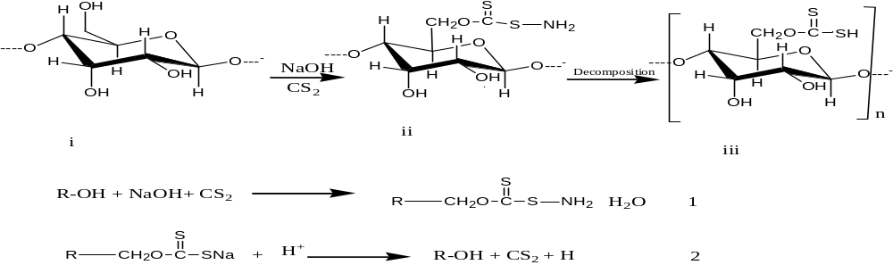
Scheme 1: Mechanism of cellulose xanthation
3.2 Proximate and Ultimate analysis of Modified and Unmodified PMBP
Table 1 presents the proximate analysis results for cellulose and cellulose xanthate obtained from the pod of Pentaclethra macrophylla Benth.
Table 1. Proximate analysis of cellulose and xanthate cellulose of Pentaclethra macrophylla Benth Pod
Materials | MC | AC | VM | FCC | D | pH | ID
Cellulose | 7.871 | 1.1805 | 0.154 | 55.17 | 0.473 | 6.66 | 204.944
Cellulose Xanthate | 8.144 | 1.083 | 0.700 | 55.073 | 0.638 | 0.97 | 152.916

The cellulose and xanthate cellulose in the Pentaclethra macrophylla Benth pod had moisture contents of 7.871% and 8.144%, respectively. The moisture content of xanthate cellulose was slightly higher than that of cellulose. This difference may be associated with the chemical treatments used to produce xanthate cellulose. It may also indicate that xanthate cellulose is more susceptible to degradation and bacterial attack than cellulose. This observation is consistent with the work of Grandesso et al. (2011), who reported that high moisture content slows carbon combustion and encourages bacterial activity. It is also consistent with the study by Nsude and Orie (2022) on microcrystalline cellulose from oil bean pods.
Table 1 shows ash values of 1.1805% for cellulose and 1.083% for xanthate cellulose. These values indicate the presence of inorganic mineral matter in both cellulose and xanthate cellulose. Table 1 also shows volatile matter values of 0.154% for cellulose and 0.700% for xanthate cellulose. These values indicate differences in volatile matter between the two materials, which may influence their suitability as a source of nutrients for bacteria (Brandt et al., 2013; Nsude et al., 2022).
The cellulose and xanthate cellulose had fixed carbon contents of 55.17% and 55.073%, respectively. The small differences in the attributes shown in Table 1 may be associated with the series of chemical treatments used to produce xanthate cellulose. Owing to the presence of lignin, hemicelluloses, and other contaminants that may have been removed during the cellulose xanthate process, cellulose may contain a trace amount of carbon. These observations were consistent with the findings of Brandt et al. (2013) and Nsude et al. (2022), who investigated the chemical and physical characteristics of specific lignocelluloses and celluloses derived from various biomass sources.
The measured pH values of cellulose and xanthate cellulose were 6.66 and 0.97, respectively. Cellulose was slightly acidic, whereas xanthate cellulose was strongly acidic. This finding is consistent with the work of Weißl et al. (2018) on homogeneous cellulose xanthate prepared from cellulose. The iodine values of cellulose and xanthate cellulose were 204.944 and 152.916, respectively. This suggests that cellulose contains more unsaturated compounds than cellulose xanthate. These unsaturated compounds could be due to the presence of impurities such as lignin and other lignocellulose compounds (Zhang et al., 2016; Xu et al., 2021).
Moisture, ash, volatile matter, fixed carbon, density, and elemental composition are established physicochemical descriptors of lignocellulosic biomass and are sensitive to feedstock composition and processing history, providing a useful basis for interpreting the differences between cellulose and cellulose xanthate in Table 1 (Cai et al., 2017).

3.3 FTIR Analysis of Cellulose and Xanthate Cellulose Pentaclethra macrophylla Benth Pod

Table 2 presents the FTIR analysis results for the Pentaclethra macrophylla Benth pod, indicating the functional moieties associated with cellulose and xanthate cellulose.

Table 2: FTIR analysis of Cellulose and Xanthate Cellulose
S/no. | Cellulose | Xanthate Cellulose
1 | 3250-3570 cm⁻¹ OH | 3399.00 cm⁻¹  OH
2 | 3041.734 cm⁻¹  C-H stretch of aliphatic | 2860.200 cm⁻¹  C-H stretch of aliphatic
3 | 1638.744 cm⁻¹  C=O at C-3 and C-C of cellulose | 1629.00 cm⁻¹  C=O at C-3 and C-C of cellulose
4 | ---- | ----
5 | 1398.895 cm⁻¹  C-H deformation in cellulose and hemicelluloses | 1386.20 cm⁻¹  C-H deformation in cellulose
6 | 1057.516 cm⁻¹  -Si-O-C-, stretching | 1292.00cm⁻¹  C=S
7 | 821.430 cm⁻¹  C-H crystalline & amorphous | 798.100  C-H (crystalline & amorphous

In contrast to xanthate cellulose, which showed a peak at 3399.00 cm−1, the OH peak of cellulose was observed at approximately 3250-357 cm−1. The C-H aliphatic stretching band appeared at 3041.734 cm-1 for cellulose and at 2860.200 cm-1 for cellulose xanthate. In cellulose and hemicelluloses, the peak between 1629.00 cm-1 and 1638.744 cm-1 was attributed to the C=O bond, while the peak around 1398.895 cm-1 was attributed to the C-H bond (Orie et al., 2021; Didigwu et al., 2024). Cellulose was found to contain -Si-O-C- at a vibration frequency of 1057.516 cm-1 and C=S at a frequency of 1292.00 cm-1 (Grandesso et al., 2011). The presence of this functional group was the most notable difference when the FTIR spectra of cellulose and its xanthate derivative were compared. The FTIR spectra of both cellulose and xanthate cellulose are shown in Figure 1.
Consistent with these spectral assignments, FTIR together with SEM and XPS characterization has been used to confirm successful xanthation of alkali-treated lignocellulosic cellulose and the formation of cellulose xanthate (Wang et al., 2018).

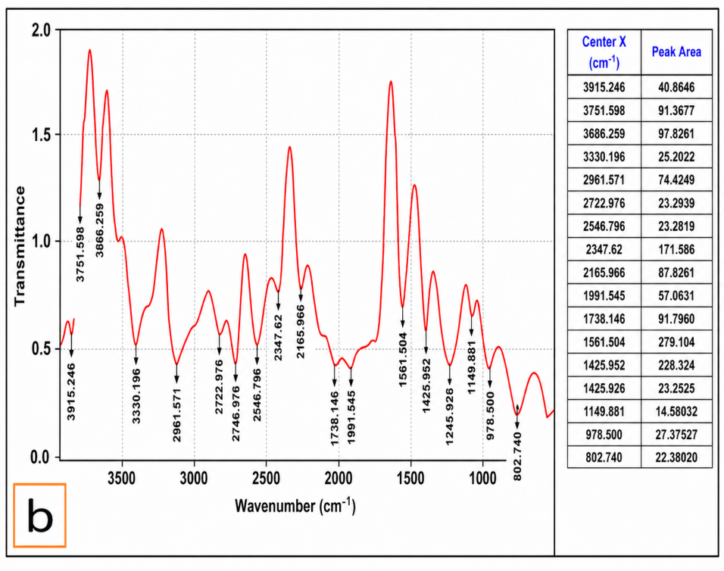
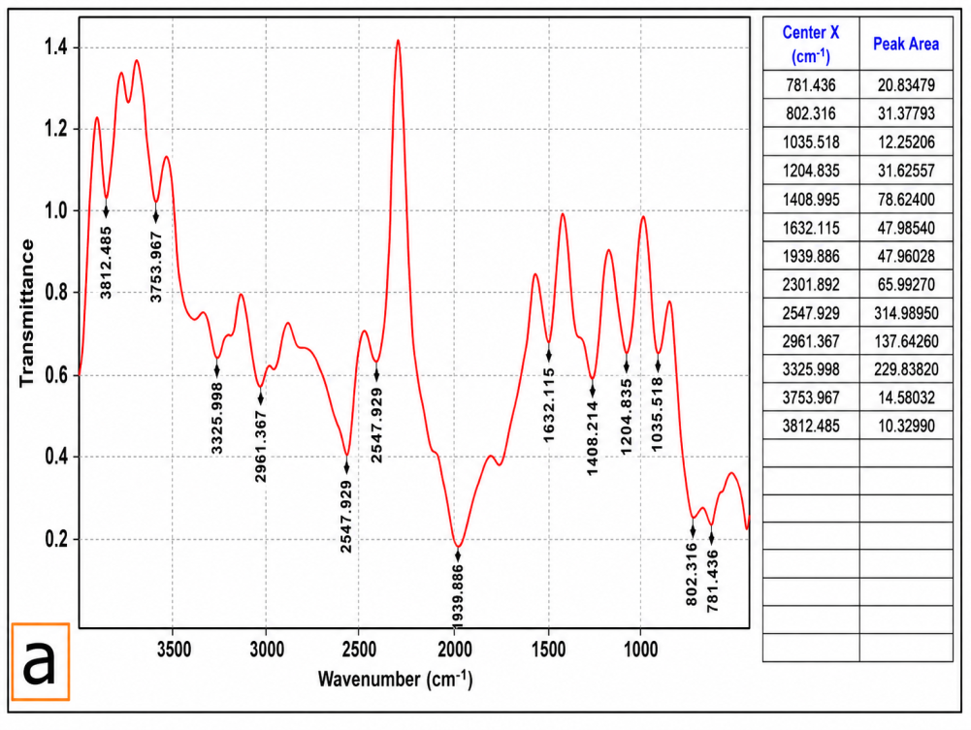

Figure 1: FTIR spectra of (a)Cellulose and (b)Xanthate Cellulose

3.4 Elemental analysis of Cellulose and Xanthate Cellulose
The elemental analyses of cellulose and xanthate cellulose from Pentaclethra macrophylla Benth pods are presented in Table 3. The two materials were found to contain the same elements, although in varying percentages.

Table 3: Elemental analysis of Cellulose and Xanthate Cellulose
 | Cellulose | Xanthate Cellulose
Oxygen (O) | 18.50 | 20.20
Aluminium (Al) | 17.10
Silicon (Si) | 40.72 | 65.40
Silver (Ag) | 7.00
Calcium (Ca) | 0.25 | 0.20
Sodium (Na) | 2.24 | 0.74
Magnesium (Mg) | 0.33
Iron (Fe) | 0.52 | 5.50
Manganese (Mn) | 0.10
Carbon (C) | 7.24 | 2.26
Nickel (Ni) | 2.20 | 2.46
Cupper (Cu) | 2.22 | 2.22
Zinc (Zn) |  | 0.70

The elemental analysis of cellulose and xanthate cellulose derived from Pentaclethra macrophylla Benth pods recorded oxygen (18.50 and 20.20), silicon (40.72 and 65.40), calcium (0.25 and 0.20), sodium (2.24 and 0.74), iron (0.52 and 5.50), carbon (~7.24 and 2.26), nickel (2.20 and 2.46), and copper (2.22 and 2.22). Xanthate cellulose showed higher concentrations of oxygen, silicon, and iron than cellulose, which may be associated with the procedure used in its preparation (Rohmatullah et al., 2020). High silicon content has been associated with benefits for bone, collagen, skin, and cardiovascular health (Nna et al., 2020). Madukasi et al. (2015), who studied the energy composition and components of oil bean husk, reported similar results. The presence of these minerals also suggests that the OBP material may be used as a feedstock. The EDS spectra of cellulose and xanthate cellulose are shown in Figure 2.
Elemental analysis of xanthate-functionalized cellulose has likewise demonstrated sulfur incorporation after reaction of cellulose with carbon disulfide under alkaline conditions, showing that xanthation can measurably alter the elemental profile of cellulose-based materials (Greis et al., 2019).

Figure 2: EDS spectra of (a) Cellulose and (b )Xanthate Cellulose

4.0 Conclusion
The utilisation of renewable biomass may contribute to addressing global energy challenges and environmental cleanup. This study describes the physicochemical characteristics and production technique of cellulose-xanthate from Pentaclethra macrophylla Benth pod. The proximate analysis indicated that the high moisture content, volatile content, and density of cellulose-xanthate were presumably associated with the xanthation process. A sharp decrease in iodine value and a decrease in pH were observed in cellulose xanthate. The higher iodine value of cellulose suggests that it contains more unsaturated compounds than cellulose xanthate, which could be explained by the presence of lignocellulose molecules.
The detection of thiosulate using FTIR was interpreted as confirmation of cellulose xanthate formation from the biomass residue. Isolated cellulose and cellulose xanthate are mineral materials with potential applications, such as polymer-reinforcement composites, because of their high silicon concentration. These materials may also serve as eco-friendly energy sources and cleansers.
Limitation
This study used Pentaclethra macrophylla Benth pods collected from a single location in Enugu State, which may limit the generalisability of the findings to biomass obtained from other geographical or environmental conditions. The investigation was restricted to cellulose and cellulose xanthate produced using the specified treatment sequence, without assessing variations in extraction or xanthation conditions. Characterisation was limited mainly to proximate analysis, FTIR, and EDX measurements. Future studies should examine biomass from multiple locations, optimise processing conditions, and evaluate additional structural, thermal, mechanical, and application-specific properties of the resulting cellulose xanthate.

Declaration of AI Use

This manuscript was prepared through the intellectual contributions of the author(s) to the study design, data analysis, interpretation of results, and scholarly content. Grammarly and ChatGPT were used solely to assist with grammatical refinement and reference formatting during manuscript revision. The author(s) accept full responsibility for the accuracy, integrity, and final content of the manuscript.

References
Abugu, H. O., Okoye, P. A. C., Ajiwe, V. I. E., Omuku, P. E., & Umeobika, U. C. (2015). Preparation and characterization of activated carbon produced from oil bean (Ugba or Ukpaka) and snail shell. Journal of Environmental Analytical Chemistry, 2(6), 165. https://doi.org/10.4172/2380-2391.1000165
Akpan, U. I., Osuji, L. C., & James, A. O. (2025). Extraction and characterisation of cellulose of Chrysophyllum albidum (African star apple) fruit waste using infrared spectroscopy. Journal of Applied Chemical Science International, 16(2), 266–273. https://doi.org/10.56557/jacsi/2025/v16i29896
Aladekoyi, G., Orungbemi, O. O., Karimu, O. A., & Aladejimokun, A. O. (2017). Comparative studies of the nutritional and phytochemical constituents of African oil baen (Pentaclethra macrophylla Benth) and African bean (Anthonotha macrophylla) for human consumption. Chemistry Research Journal, 2(3), 16–21. https://chemrj.org/download/vol-2-iss-3-2017/chemrj-2017-02-03-16-21.pdf
Alothman, O. Y., Kian, L. K., Saba, N., Jawaid, M., & Khiari, R. (2021). Cellulose nanocrystal extracted from date palm fibre: Morphological, structural and thermal properties. Industrial Crops and Products, 159, 113075. https://doi.org/10.1016/j.indcrop.2020.113075
Amaya, J. B. (2025). Synthesis of cellulose xanthate from banana pseudocores. Cellulose, 32, 5215–5226. https://doi.org/10.1007/s10570-025-06462-6
Aslam, A. A., Hassan, S. U., Saeed, M. H., Kokab, O., Ali, Z., Nazir, M. S., Siddiqi, W., & Aslam, A. A. (2023). Cellulose-based adsorbent materials for water remediation: Harnessing their potential in heavy metals and dyes removal. Journal of Cleaner Production, 421, 138555. https://doi.org/10.1016/j.jclepro.2023.138555
Asoegwu, S. N., Ohanyere, S. O., Kanu, O. P., & Iwueke, C. N. (2006). Physical properties of African oil bean seed (Pentaclethra macrophylla). Agricultural Engineering International: The CIGR Ejournal, 8, Manuscript FP 05 006.
ASTM International. (2006). Standard test method for determination of iodine number of activated carbon (ASTM D4607-94(2006)). https://doi.org/10.1520/D4607-94R06
Beroual, M., Trache, D., Mehelli, O., Boumaza, L., Tarchoun, A. F., Derradji, M., & Khimeche, K. (2021). Effect of the delignification process on the physicochemical properties and thermal stability of microcrystalline cellulose extracted from date palm fronds. Waste and Biomass Valorization, 12, 2779–2793. https://doi.org/10.1007/s12649-020-01198-9
Brandt, A., Gräsvik, J., Hallett, J. P., & Welton, T. (2013). Deconstruction of lignocellulosic biomass with ionic liquids. Green Chemistry, 15(3), 550–583. https://doi.org/10.1039/C2GC36364J
Cai, J., He, Y., Yu, X., Banks, S. W., Yang, Y., Zhang, X., Yu, Y., Liu, R., & Bridgwater, A. V. (2017). Review of physicochemical properties and analytical characterization of lignocellulosic biomass. Renewable and Sustainable Energy Reviews, 76, 309–322. https://doi.org/10.1016/j.rser.2017.03.072
Didigwu, S. O., Ezeh, E. C., Nsude, O. P., Udeozo, P. I., & Orie, K. J. (2024). Isolation and characterization of cellulose and microcrystal cellulose obtained from the pod of African locus bean (Parkia biglobosa). Journal of Applied Sciences and Environmental Management, 28(10), 3035–3038. https://doi.org/10.4314/jasem.v28i10.11
Grandesso, E., Gullett, B., Touati, A., & Tabor, D. (2011). Effect of moisture, charge size, and chlorine concentration on PCDD/F emissions from simulated open burning of forest biomass. Environmental Science & Technology, 45(9), 3887–3894. https://doi.org/10.1021/es103686t
Greis, K., Bethke, K., Stückrath, J. B., Ingber, T. T. K., Valiyaveettil, S., & Rademann, K. (2019). One-pot synthesis of xanthate-functionalized cellulose for the detection of micromolar copper(II) and nickel(II) ions. CLEAN – Soil, Air, Water, 47(9), 1900179. https://doi.org/10.1002/clen.201900179
Harmsen, P. F. H., Huijgen, W., Bermudez, L., & Bakker, R. (2010). Literature review of physical and chemical pretreatment processes for lignocellulosic biomass (Report No. 1184). Wageningen UR Food & Biobased Research. https://edepot.wur.nl/150289
Madukasi, E. I., Tojola, O. B., Oso, K., & Igwe, C. C. (2015). Thermo-chemical features of coating sludge and co-densification as alternative energy source. AASCIT Journal of Environment, 1(2), 28–34.
Nna, P. J., Legborsi, J., & Orie, K. J. (2020). Comparative study on the phytoconstituents and antimicrobial analysis of Jatropha curcas leaf and stem bark. Direct Research Journal of Chemistry and Material Science, 7(3), 37–43. https://doi.org/10.26765/DRJCMS7219803564
Nsude, O. P., & Orie, K. J. (2022). Microcrystalline cellulose of oil bean pod: Extraction, physico-chemical, Brunauer–Emmett–Teller (BET), and flow-ability analysis. Asian Journal of Applied Chemistry Research, 12(4), 1–12. https://doi.org/10.9734/ajacr/2022/v12i4226
Nsude, O. P., & Orie, K. J. (2026). Synthesis and structural characterization of cellulose xanthate obtained from oil bean pod biomass. Asian Journal of Applied Chemistry Research, 17(3), 270–282. https://doi.org/10.9734/ajacr/2026/v17i3414
Nsude, O. P., Orie, K. J., Udeozo, P. I., Ogbobe, O., & Chime, C. C. (2022). Isolation, physicochemical and BET analysis of cellulose from Pentaclethra macrophylla Benth (oil bean) pod biomass wastes. International Research Journal of Pure and Applied Chemistry, 23(5), 9–22. https://doi.org/10.9734/IRJPAC/2022/v23i530474
Okonkwo, C. J., Njoku, O. U., Okonkwo, T. J., Afieroho, O. E., & Proksch, P. (2016). Two new acylated flavonol glycosides from Mimosa pigra L. leaves sub-family Mimosoideae. Future Journal of Pharmaceutical Sciences, 2(2), 71–75. https://doi.org/10.1016/j.fjps.2016.08.003
Orie, K. J., & Okocha, B. I. (2024). Biosynthesis and antimicrobial studies of zinc oxide nanoparticles of Vernonia amygdalina leaf with varying concentration of zinc oxide. Inorganic Chemistry Communications, 162, 112178. https://doi.org/10.1016/j.inoche.2024.112178
Orie, K. J., Ike, C. D., & Nzeneri, J. U. (2021). Synthesis and characterization of metal complexes with 4-methyl-N-(p-methylphenylsulphonyl)-N-(pyridin-2-yl)benzene sulphonamide. Modern Chemistry, 9(3), 46–51. https://doi.org/10.11648/j.mc.20210903.11
Pérez, S., & Samain, D. (2010). Structure and engineering of celluloses. Advances in Carbohydrate Chemistry and Biochemistry, 64, 25–116. https://doi.org/10.1016/S0065-2318(10)64003-6
Rohmatullah, W. A. P., Yulianti, E., Khoiroh, L. M., & Mahmudah, R. (2020). Synthesis and characterization of alginate-cellulose xanthate beads from corn stalk with NaCl as porogen. Annales Bogorienses, 24(2), 59–65. https://doi.org/10.14203/ann.bogor.2020.v24.n2.59-65
Rosli, N. A., Ahmad, I., & Abdullah, I. (2013). Isolation and characterization of cellulose nanocrystals from Agave angustifolia fibre. BioResources, 8(2), 1893–1908. https://doi.org/10.15376/biores.8.2.1893-1908
Saberi-Riseh, R., Vazvani, M. G., Hassanisaadi, M., & Thakur, V. K. (2024). Agricultural wastes: A practical and potential source for the isolation and preparation of cellulose and application in agriculture and different industries. Industrial Crops and Products, 208, 117904. https://doi.org/10.1016/j.indcrop.2023.117904
Souza, P. S., Grisi, C. V. B., Monção, É. C., da Silva, M. V. S., & de Souza, A. L. (2025). Obtaining microcellulose from solid agro-waste by ball mill assisted by light acid hydrolysis process. ACS Omega, 10(1), 588–598. https://doi.org/10.1021/acsomega.4c07196
Szabó, L., Milotskyi, R., Sharma, G., & Takahashi, K. (2023). Cellulose processing in ionic liquids from a materials science perspective: Turning a versatile biopolymer into the cornerstone of our sustainable future. Green Chemistry, 25(14), 5338–5389. https://doi.org/10.1039/D2GC04730F
Wang, C., Wang, H., & Gu, G. (2018). Ultrasound-assisted xanthation of cellulose from lignocellulosic biomass optimized by response surface methodology for Pb(II) sorption. Carbohydrate Polymers, 182, 21–28. https://doi.org/10.1016/j.carbpol.2017.11.004
Weißl, M., Niegelhell, K., Reishofer, D., Zankel, A., Innerlohinger, J., & Spirk, S. (2018). Homogeneous cellulose thin films by regeneration of cellulose xanthate: Properties and characterization. Cellulose, 25, 711–721. https://doi.org/10.1007/s10570-017-1576-3
Xu, X., Yu, J., Liu, C., Yang, G., Shi, L., & Zhuang, X. (2021). Xanthated chitosan/cellulose sponges for the efficient removal of anionic and cationic dyes. Reactive and Functional Polymers, 160, 104840. https://doi.org/10.1016/j.reactfunctpolym.2021.104840
Zhang, Y., Luo, C., Wang, H., Han, L., Wang, C., Jie, X., & Chen, Y. (2016). Modified adsorbent hydroxypropyl cellulose xanthate for removal of Cu²⁺ and Ni²⁺ from aqueous solution. Desalination and Water Treatment, 57(56), 27419–27431. https://doi.org/10.1080/19443994.2016.1177733
Zhou, H., Sun, R., Sun, Y., Wang, H., Feng, N., Li, Y., & Wang, X. (2026). Research on optimization of substitution degree of xanthated cellulose fiber and pretreatment process for defibration. Journal of Engineered Fibers and Fabrics, 21, 1–17. https://doi.org/10.1177/15589250261422308

