Synthesis and Physicochemical Analysis of Cellulose Xanthate Derived from Pentaclethra macrophylla Benth Pods

Abstract
Pentaclethra Macrophylla Benth pods are a source of pollution due to the careless disposal of biomass. Using standard procedures, this study will produce and characterise cellulose xanthate from the benth pod of Pentaclethra macrophylla. Collecting as much cellulose as can be achieved is the objective. Water content (7.871% and 8.144%), ash content (1.180 and 1.083), volatile matter (0.154% and 0.70%), fixed carbon content (55.17% and 55.07%), and iodine value (204.944 and 152.916) were all determined by the proximate investigation for cellulose and cellulose xanthate. The presence of O-H, C-O-C, and S=O pyranose rings as well as cellulose β-glycosidic linkages were shown by the FTIR analysis. Analyses using energy dispersive X-ray spectroscopy (EDX) on cellulose and cellulose xanthate revealed the following elements: oxygen (18.50 and 20.20 percent), silicon (40.72% and 65.40 percent), calcium (0.25% and 0.20%), sodium (2.24% and 0.74%), iron (0.52% and 5.50%), carbon (7.24% and 2.26%), nickel (2.20% and 2.46%), and copper (2.22% and 2.22%). Alterations to the proportional mass of proximate and elemental investigations are associated with the formation of cellulose xanthate from various cellulose treatments. Thus, eco-friendly polymers, binders, adsorbents, and composites may benefit from using pure cellulose xanthate.
Keyword; Cellulose, Physicochemical properties, Pod, Synthesis, Xanthate

1.0 Introduction
Cellulose is a long-chain polysaccharide made up of β-D-glucopyranose units that are connected together by β-1,4 glycosidic linkages (Aslam et al., 2023). The cellulose chain does not have any branches, which gives it a semicrystalline structure that includes both amorphous and crystalline phases (Harmsen et al., 2010). There are hydroxyl (-OH) groups that react with each other evenly spaced along the structure of cellulose. This makes it easier for hydrogen bonds to form between cellulose molecules (Harmsen et al., 2010). These hydrogen bonds make cellulose insoluble in water and many organic solvents. To break these bonds, cellulose must be converted into cellulose xanthate (Perez & Samain, 2010).
In numerous domains, cellulose has multiple applications. Aside from being an addition to food, it also has medicinal and adsorbent uses. Both the original form and its chemically altered derivatives are useful (Orie & Okocha, 2024; Alothman et al., 2021). Because of its versatility, biodegradability, and endless reusability, cellulose stands out as an exceptional adsorbent [((Beroual et al., 202). The physical and chemical properties of cellulose are improved and its use increased by converting it into several derivatives, one of which is cellulose xanthate (Beroual et al., 2021; Rosli et al., 2013) . This byproduct has more crystals than natural cellulose and can't catch fire (Nsude & Orie, 2022). A lot of recent research has focused on how to bleach with acetic acid, hydrogen peroxide, sulphuric acid, and mild acids and bases in order to extract cellulose from various plant sources. Materials such as date palm, sugarcane bagasse, waste bamboo front, brochures, and fibres are included in this category. In addition to a high alpha-cellulose yield percentage, the data demonstrated an average crystallinity index of 52.27%.
Cellulose xanthate is a kind of cellulose that is made when cellulose reacts with carbon disulphide (CS₂) in an alkaline environment. It is an important step in making viscose rayon and other fibres made from cellulose (Grandesso et al., 2011; Szabó et al., 2023).. The technique replaces hydroxyl groups in cellulose with xanthate groups, which makes it easier to dissolve in alkaline solutions. Cellulose xanthate is made up of cellulose molecules that have had some of the hydroxyl (-OH) groups on the glucose units substituted with xanthate (-OCS₂Na) groups (Weißl et al., 2018; Nsude et al., 2022) [11, 12]. Adding xanthate groups makes cellulose more soluble in sodium hydroxide solutions, which makes it easier to spin cellulose into fibres. The textile sector mostly uses it to make regenerated cellulose fibres like viscose and lyocell. It can also be used to make other cellulose derivatives, films, and coatings. The production method uses harmful chemicals, like carbon disulphide, which makes many worry about the effects on the environment and the safety of workers. Cellulose xanthate is very important for turning natural cellulose into useful compounds that can be used in many different fields (Zhang et al., 2016).
The subfamily Mimosoideae includes Pentaclethra macrophylla Benth, a member of the Leguminosae family (Asoegwu et al., 2006). Natural habitats for this tree include parts of Nigeria's Middle Belt region and the coasts of West and Central Africa. The seeds are used as nutritional supplements after careful processing and fermentation. They contain minerals such as calcium and phosphorus (Aladekoyi et al., 2017), vitamins such as niacin, riboflavin, and thiamine (Nsude et al., 2022), and fatty acids (Okonkwo et al., 2016). The careless disposal of Pentaclethra macrophylla pods and husks by residents of eastern Nigeria is having a negative impact on the local ecology. The potential for PMBP as an energy source was investigated by Madukasi et al. (2015). Based on elemental composition, PMBP has also been reported to be environmentally safe and suitable as a feedstock material (Xu et al., 2021). Therefore, the present study focused on the preparation and characterization of cellulose xanthate from Pentaclethra macrophylla Benth pods.

2.0 MATERIAL AND METHODS
2.1 Materials
Sodium chlorite (NaClO), ethanol, toluene, acetic acid, potassium hydroxide (KOH), hydrochloric acid (HCl), and natural pentaclethra macrophylla basil pod were all components of the analytical grade chemicals. Each drug was administered precisely as directed. Deionised water was used in all of the experiments.
2.2 Sample collection and Preparation
Aku, Igbo Etiti Local Government Area, Enugu State is the source of the mature pods of Pentaclethra macrophylla, also known as oil beans. The University of Science and Technology in Enugu State's Department of Botany verified its authenticity. To remove any soil that had adhered to the pods, they were rinsed with tap water and then left to dry in the sun for five to seven days. A fine powder was obtained by grinding the dried pods using a mechanical grinder and then passing them through a 250 µm mesh filter to ensure a consistent particle size. Once the sample was ground into a powder, it was sealed in an airtight container.

2.3 Isolation of Cellulose from Oil Bean Pod
In order to remove waxes, lipids, and oils, the 100 g of powdered pod was soaked in ethanol for 6 hours, as per the method outlined by Nsude et al. (2022). We used distilled water to remove the residue and then allowed it to air dry. The dewaxed material was reflux-heated with 1% NaOH to 80 °C for 2 hours to remove the lignin. Filtered, rinsed with hot water until the pH was neutral, and then bleached using a mixture of 1.7% sodium chlorite and 2% acetic acid at 80°C for 1 hour, the material that had been treated with alkali underwent this process. Filtering, washing, and drying the bleached fibres in a 60 °C oven yielded refined cellulose.

2.4 Synthesis of Cellulose Xanthate
The 10 g of dried cellulose was put in 200 mL of 18% (w/v) NaOH solution at room temperature (25 °C) and stirred constantly for 2 hours to mercerise. We filtered out the extra NaOH. We next mixed the alkali-cellulose with 20 mL of carbon disulphide (CS₂) and stirred it constantly at 30 °C for an hour. This made orange cellulose xanthate. The reaction mixture was left to sit for 30 minutes so that the xanthation may finish. Adding the reaction mixture drop by drop to 0.5 M HCl while agitating it very hard caused the cellulose xanthate to develop. The precipitate was washed well with distilled water to get rid of any leftover chemicals, and then it was let to dry in the air.

2.5 Proximate Analysis of the Pod of PMB Samples
2.5.1 Determination of pH and conductivity
After measuring and moving the 1.0 g of biomass sample to a beaker, it was weighed. The beaker was whirled for one hour after a specific volume of distilled water (100 ml) was measured into it. Once the samples had settled to a consistent consistency, we checked their pH. A conductivity metre and a Hansa pH-meter were used for electrochemical pH measurement. We ran the analyses twice [12].
2.5.2 Determination of the moisture content
In accordance with Abugu et al. (2015)., the moisture content of the PMB pod sample was ascertained. The weighed sample was subjected to a continuous temperature of 105 ºC for a duration of three hours. The sample was reweighed after being quickly removed and placed in a desiccator to avoid atmospheric moisture absorption. Until a steady weight was achieved, the technique was repeated multiple times. The following is the formula for determining moisture content: (9)
$$\% of moiture content=\frac{W2-W3}{W2-W1}X 100$$

2.5.3 Determination of the ash content
The Biotech Muffle furnace was used to accomplish this after a known quantity of resin was weighed out into a container. The next step is to keep the biomass at a steady 550 ºC for a number of hours. Quickly removing the sample and placing it in a desiccator to avoid atmospheric moisture absorption allowed for a subsequent reweighing of the sample. Iterations of the process were carried out until a stable weight was achieved. So, this is how the ash content is determined:
$$\% of moiture content=\frac{W3-W1}{W2-W1}X 100$$
Where: W1 = Weight of container, W₂ = Weight of Container + Sample before ashing, W₂ – W₁ = Weight of Sample before drying, W₃ = Weight of container + Sample after ashing, W₃ = Weight of Ash in sample

2.5.4 Determination of the volatile matter
Placing a known amount of biomass into a container and then into the Biotech Muffle furnace was how this was accomplished. Keeping the biomass at a steady 900 °C for three hours is the heating process. Quickly removing the sample and placing it in a desiccator to avoid atmospheric moisture absorption allowed for a subsequent reweighing of the sample. Iterations of the process were carried out until a stable weight was achieved. To determine volatile matter, one must do the following:
$$\% of moiture content=\frac{W3-W1}{W2-W1}X 100$$

2.5.5 Determination of apparent density
Each dry Biomass of PBM sample was tightly packed into an empty, weighted graduated cylinder. It was subsequently reweighed to find the new when pack with sample. This is how the apparent density was determined:

$$Density(glcm3)=\frac{Weight of dry activated carbon}{Volume of dry material}X 100$$

2.5.6 Determination of Iodine Value
In order to determine this, we use the standards set out by the ASTM (ASTM, 2006). Room temperature iodine number determination was performed on stored cool dry biomass material in order to estimate three carbon doses. These values in Table 3 were extrapolated using Equation 15.

$$E=\frac{[A-(DF)(C)(126.93]}{M}$$
M = carbon, g, A = (N2) (12693.0), DF = dilution factor, C = residual iodine

2.6 Synthesis of Cellulose Xanthate
Over the course of three hours, five grammes of cellulose were submerged in forty millilitres of twenty percent (b/v) sodium hydroxide. After pressing, it was allowed to age for 60 hours at room temperature. The alkaline cellulose that was obtained was mixed with 2.5 mL of CS₂. The mixture was then homogenised by shaking it in an incubator set at 25 ⁰C for three hours at a rate of 150 rpm. The end result was cellulose xanthate. The next step was to dissolve the suspension in NaOH (30 mL of 6% (w/w)) (Nsude & Orie, 2022).

2.7 FTIR analysis
One reliable method for predicting biomass chemical composition is Fourier transform infrared spectroscopy (FTIR). By revealing the underlying vibrations, an FTIR spectrum helps to better distinguish between signals that are structurally similar, such as the hydroxyls found in carbohydrate isomers. For the purpose of conducting FTIR analysis on the biomass samples that were exposed to a drying process (50oC for 24 hours), IR grade ATR was used to disperse the powdered samples (2 mg) of biomass fibres. An Excalibur Bio-Rad spectrophotometer (Model FTS 3500 GX) was used to acquire the FTIR spectra, which had a resolution of 1 cm.

3.0 Result and Discussion
3.1 Xanthation of Cellulose
The biomass of Pentaclethra macrophylla benth pods was used to produce the cellulose used in this study. Before being ground and sieved, the pod was rinsed, dried, then ground again. Isolated cellulose was obtained by dewaxing the mesh powder pod with toluene/ethanol, treating it with sodium hydroxide and sodium chloride, and then heating it at 70 degrees Celsius for a few minutes. Chemical reactions involving cellulose and carbon disulphide (CS2) in a sodium hydroxide (NaOH) solution were used to produce cellulose xanthate (Grandesso et al., 2011; Nsude et al., 2022). The reaction mechanism of xanthation of cellulose of Pentaclethra macrophylla benth pod using sodium hydroxide and carbon disulphide is shown in scheme 1. Xanthation of cellulose plays a vital role in converting natural cellulose into versatile materials used across various industrial.

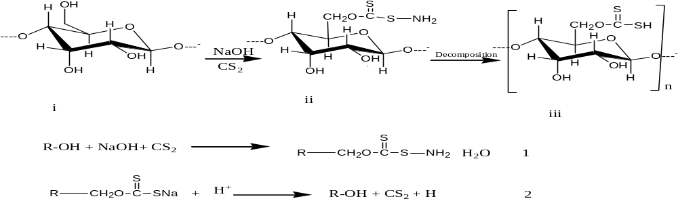
Scheme 1: Mechanism of cellulose xanthation
3.2 Proximate and Ultimate analysis of Modified and Unmodified PMBP
Table 1 displays the results of the proximate analysis of the cellulose and cellulose xanthate found in the pod of Pentaclethra macrophylla Benth.
Table 1. Proximate analysis of cellulose and xanthate cellulose of Pentaclethra macrophylla Benth Pod
Materials | MC | AC | VM | FCC | D | pH | ID
Cellulose | 7.871 | 1.1805 | 0.154 | 55.17 | 0.473 | 6.66 | 204.944
Cellulose Xanthate | 8.144 | 1.083 | 0.700 | 55.073 | 0.638 | 0.97 | 152.916

The cellulose and xanthate cellulose in the Pentaclethra macrophylla Benth pod had moisture levels of 7.871% and 8.144%, respectively. The amount of water in xanthate cellulose was a little higher than the amount in cellulose. This is because of the chemical treatments that go into making xanthate cellulose. It also means that xanthate cellulose is more likely to break down and be attacked by bacteria than cellulose. The study is in keeping with the work of Grandesso et al. (2011), which came to the same conclusion: high moisture content slows down the burning of carbon and encourages bacterial activity. It is also in line with the work of Nsude and Orie (2022), which looks at the microcrystalline cellulose of oil bean pods.
Table 1 shows that the cellulose has an ash level of 1.1805%, while the xanthate cellulose has a higher ash value of 1.083%. This means that xanthate cellulose and cellulose have minerals that aren't organic. Table 1 shows that the volatile matter in cellulose was 0.154% and the volatile matter in xanthate cellulose was 0.700%. This means that cellulose has more volatile chemical compounds and could be a suitable source of food for bacteria (Brandt et al., 2013; Nsude et al., 2022).
The cellulose and xanthate cellulose had a fixed carbon content of 55.17% and 55.073%, respectively. The small differences in the attributes shown in Table 1 were caused by the series of chemical treatments that turned xanthate cellulose into a solid. Due to the presence of lignin, hemicelluloses, and other contaminants that may have been removed during the cellulose xanthate process, cellulose may include a trace amount of carbon. It was consistent with the findings of Brandt et al. (2013) and Nsude et al. (2022), who investigated the chemical and physical characteristics of specific lignocelluloses and celluloses derived from various biomass sources.
We measured the pH of cellulose and xanthate cellulose at 6.66 and 0.97. The cellulose had a little bit of acid in it, and the xanthate cellulose had a lot of acid in it. Weißl et al. (2018) made homogenous cellulose xanthate from cellulose, which is in line with this. Another study found that the iodine value of cellulose and xanthate cellulose were 204.944 and 152.916, respectively. This means that cellulose has more unsaturated compounds than cellulose xanthate. These unsaturated compounds could be due to the presence of impurities such lignin and other lignocellulose compounds (Zhang et al., 2016; Xu et al., 2021).

3.3 FTIR Analysis of Cellulose and Xanthate Cellulose Pentaclethra macrophylla Benth Pod

Table 2 displays the results of the FTIR analysis of the Pentaclethra macrophylla Benth pod, which shows that the pod contains cellulose and xanthate cellulose, two functional moieties.

Table 2: FTIR analysis of Cellulose and Xanthate Cellulose
S/no. | Cellulose | Xanthate Cellulose
1 | 3250-3570 cm⁻¹ OH | 3399.00 cm⁻¹  OH
2 | 3041.734 cm⁻¹  C-H stretch of aliphatic | 2860.200 cm⁻¹  C-H stretch of aliphatic
3 | 1638.744 cm⁻¹  C=O at C-3 and C-C of cellulose | 1629.00 cm⁻¹  C=O at C-3 and C-C of cellulose
4 | ---- | ----
5 | 1398.895 cm⁻¹  C-H deformation in cellulose and hemicelluloses | 1386.20 cm⁻¹  C-H deformation in cellulose
6 | 1057.516 cm⁻¹  -Si-O-C-, stretching | 1292.00cm⁻¹  C=S
7 | 821.430 cm⁻¹  C-H crystalline & amorphous | 798.100  C-H (crystalline & amorphous

In contrast to xanthate cellulose, which showed a peak at 3399.00 cm−1, cellulose's OH peak was measured around 3250-357 cm−1. At 3041.734 cm-1, the C-H aliphatic stretch was found for cellulose, but at 2860.200 cm-1, it was found for cellulose xanthate. In cellulose and hemicelluloses, the C=O bond was thought to be responsible for the peak between 1629.00 cm-1 and 1638.744 cm-1, while the C-H bond was thought to be responsible for the peak around 1398.895 cm-1 (Orie et al., 2021; Didigwu et al., 2024). Cellulose was found to have -Si-O-C- at a vibration frequency of 1057.516 cm-1 and C=S at a frequency of 1292.00 cm-1 (Grandesso et al., 2011) . In comparing the Fourier transform infrared spectra of cellulose and its xanthate derivative, the existence of this functional group stood out the most. Both cellulose and xanthate cellulose's FTIR spectra are shown in Figure 1.

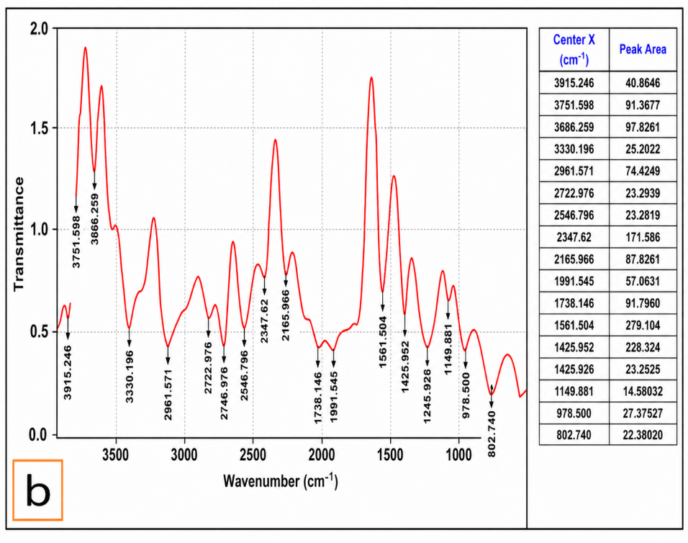
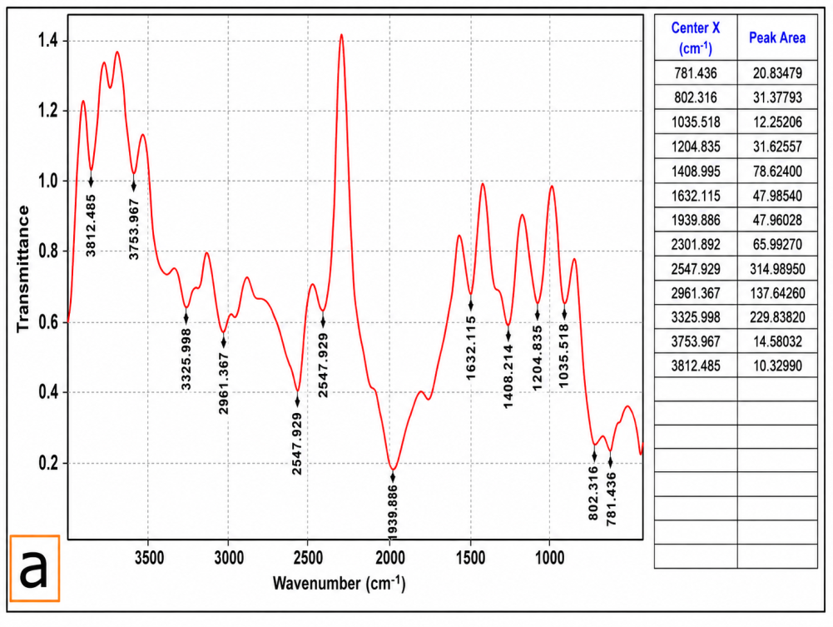

Figure 1: FTIR spectra of (a)Cellulose and (b)Xanthate Cellulose

3.4 Elemental analysis of Cellulose and Xanthate Cellulose
Pentaclethra macrophylla Benth pod cellulose and xanthate cellulose elemental analyses are presented in Table 3. Cellulose and xanthate cellulose were found to contain the same ingredient, although to varying percentages, according to the research.

Table 3: Elemental analysis of Cellulose and Xanthate Cellulose
 | Cellulose | Xanthate Cellulose
Oxygen (O) | 18.50 | 20.20
Aluminium (Al) | 17.10
Silicon (Si) | 40.72 | 65.40
Silver (Ag) | 7.00
Calcium (Ca) | 0.25 | 0.20
Sodium (Na) | 2.24 | 0.74
Magnesium (Mg) | 0.33
Iron (Fe) | 0.52 | 5.50
Manganese (Mn) | 0.10
Carbon (C) | 7.24 | 2.26
Nickel (Ni) | 2.20 | 2.46
Cupper (Cu) | 2.22 | 2.22
Zinc (Zn) |  | 0.70

Investigation of Pentaclethra macrophylla cellulose and xanthate cellulose The elements and their quantities were recorded by the bent pod, which included oxygen (18.50 and 20.20), silicon (40.72 and 65.40), calcium (0.25 and 0.20), sodium (2.24 and 0.74), iron (0.52 and 5.50), carbon (~7.24 and 2.26), nickel (2.20 and 2.46), and copper (2.22 and 2.22). Xanthate cellulose has a higher concentration of oxygen, silicon, and iron than regular cellulose because of the procedure involved in making it ((Rohmatullah et al., 2020). Bone, collagen, skin, and cardiovascular health can all benefit from the high silicon content (Nna et al., 2020). Madukasi et al. (2015) who studied the energy composition and components in oil bean husk, found results similar to these. Because of the minerals that are present, this also means that the OBP material can be used as a feedstock. Cellulose and xanthate ellulose EDS spectra are shown in Figure 2.

Figure 2: EDS spectra of (a) Cellulose and (b )Xanthate Cellulose

4.0 Conclusion
The utilisation of renewable biomass has the ability to address global energy challenges and promote environmental cleanup. The physiochemical characteristics and production technique of cellulose-xanthate from Pentaclethra macrophylla Benth pod are detailed in this study. The high moisture content, volatile content, and density of cellulose-xanthate are presumably caused by the xanthation process, according to the results of the proximate analysis. A sharp decrease in iodine value and an increase in pH were seen in the cellulose xanthate. Cellulose contains more unsaturated compounds, including cellulose xanthate, which could be explained by the presence of lignocelluloses molecules.
By detecting thiosulate using FTIR, the formation of cellulose xanthate from the biomass residue was confirmed. Isolated cellulose and cellulose xanthate are mineral materials with a lot of potential uses, such as polymer reinforcement composites, due to their high silicon concentration. In addition to being an eco-friendly energy source, it also serves as a cleanser.

Declaration of AI Use

This manuscript was prepared through the intellectual contributions of the author(s) to the study design, data analysis, interpretation of results, and scholarly content. Grammarly and ChatGPT were used solely to assist with grammatical refinement and reference formatting during manuscript revision. The author(s) accept full responsibility for the accuracy, integrity, and final content of the manuscript.

References
- Aslam, A. A., Hassan, S. U., Saeed, M. H., Kokab, O., Ali, Z., Nazir, M. S., ... & Aslam, A. A. (2023). Cellulose-based adsorbent materials for water remediation: Harnessing their potential in heavy metals and dyes removal. Journal of Cleaner Production, 421, 138555.
- Harmsen, P. F., Huijgen, W., Bermudez, L., & Bakker, R. (2010). Literature review of physical and chemical pretreatment processes for lignocellulosic biomass (No. 1184). Wageningen UR-Food & Biobased Research.
- Perez, S., & Samain, D. (2010). Structure and engineering of celluloses. Advances in carbohydrate chemistry and biochemistry, 64, 25-116.
- Orie, K. J., & Okocha, B. I. (2024). Biosynthesis and antimicrobial studies of zinc oxide nanoparticles of Vernonia amygdalina Leaf with varying concentration of zinc oxide. Inorganic Chemistry Communications, 162, 112178.
- Alothman, O. Y., Kian, L. K., Saba, N., Jawaid, M., & Khiari, R. (2021). Cellulose nanocrystal extracted from date palm fibre: Morphological, structural and thermal properties. Industrial Crops and Products, 159, 113075.
- Beroual, M., Trache, D., Mehelli, O., Boumaza, L., Tarchoun, A. F., Derradji, M., & Khimeche, K. (2021). Effect of the delignification process on the physicochemical properties and thermal stability of microcrystalline cellulose extracted from date palm fronds. Waste and Biomass Valorization, 12, 2779-2793.
- Rosli, N. A., Ahmad, I., & Abdullah, I. (2013). Isolation and Characterization of Cellulose Nanocrystals from Agave angustifolia Fibre. BioResources, 8(2).
- Nsude, O. P., & Orie, K. J. (2022). Microcrystalline cellulose of oil bean pod: Extraction, physico-chemical, brunauer–emmett–teller (BET), and flow-ability analysis. Asian Journal of Applied Chemistry Research, 12(4), 1-12.
- Grandesso E, Gullett B, Touati A, Tabor D. Effect of moisture, charge size, and chlorine concentration on PCDD/F emissions from simulated open burning of forest biomass. Environmental Science & Technology. 2011;45(9):3887-3894
- Szabó, L., Milotskyi, R., Sharma, G., & Takahashi, K. (2023). Cellulose processing in ionic liquids from a materials science perspective: turning a versatile biopolymer into the cornerstone of our sustainable future. Green Chemistry, 25(14), 5338-5389.
- Weißl, M., Niegelhell, K., Reishofer, D., Zankel, A., Innerlohinger, J., & Spirk, S. (2018). Homogeneous cellulose thin films by regeneration of cellulose xanthate: properties and characterization. Cellulose, 25, 711-721.
- Nsude, O. P., Orie, K. J., Udeozo, P. I., Ogbobe, O., & Chime, C. C. (2022). Isolation, physicochemical and BET analysis of cellulose from Pentaclethra macrophylla Benth (Oil Bean) pod biomass wastes. International Research Journal of Pure and Applied Chemistry, 23(5), 9-22
- Zhang, Y., Luo, C., Wang, H., Han, L., Wang, C., Jie, X., & Chen, Y. (2016). Modified adsorbent hydroxypropyl cellulose xanthate for removal of Cu2+ and Ni2+ from aqueous solution. Desalination and Water Treatment, 57(56), 27419-27431.
- Asoegwu, S., Ohanyere, S., Kanu, O., & Iwueke, C. (2006). Physical properties of African oil bean seed (Pentaclethra macrophylla).
- Okonkwo, C. J., Njoku, O. U., Okonkwo, T. J., Afieroho, O. E., & Proksch, P. (2016). Two new acylated flavonol glycosides from Mimosa pigra L. leaves sub-family Mimosoideae. Future Journal of Pharmaceutical Sciences, 2(2), 71-75.
- Aladekoyi, G., Orungbemi, O. O., Karimu, O. A., & Aladejimokun, A. O. (2017). Comparative studies of the nutritional and phytochemical constituents of African oil bean (Pentaclethra macrophylla Benth) and African bean (Anthonotha macrophylla) for human consumption. Chemistry Research Journal, 2(3), 16-21
- Madukasi, E. I., Tojola, O. B., Oso, K., & Igwe, C. C. (2015). Thermo-chemical features of coating sludge and codensification of ad alternative energy source. AASCIT Journal of Environment, 1(2), 28-34.
- Xu, X., Yu, J., Liu, C., Yang, G., Shi, L., & Zhuang, X. (2021). Xanthated chitosan/cellulose sponges for the efficient removal of anionic and cationic dyes. Reactive and Functional Polymers, 160, 104840.
- Abugu, H. O., Okoye, P. A. C., Ajiwe, V. I. E., Omuku, P. E., & Umeobika, U. C. (2015). Preparation and characterization of activated carbon produced from oil bean (Ugba or Ukpaka) and snail shell. Journal of Environmental Analytical Chemistry, 2(2), 67-76.
- Rohmatullah, W. A. P., Yulianti, E., Khoiroh, L. M., & Mahmudah, R. A. (2020). Synthesis and characterization of alginate-cellulose xanthate beads from corn stalk with NaCL as porogen. In Annales Bogorienses (Vol. 24, No. 2). LIPI.
- Brandt, A., Gräsvik, J., Hallett, J. P., & Welton, T. (2013). Deconstruction of lignocellulosic biomass with ionic liquids. Green chemistry, 15(3), 550-583.
- Orie, K. J., Ike, C. D., & Nzeneri, J. U. (2021). ‘Synthesis and characterization of metal complexes with 4-Methyl-N-(p-methylphenylsulphonyl)-N-(pyridin2-yl) benzene sulphonamide. Modern Chemistry, 9, 46.
- Didigwu, S. O., Ezeh, E. C., Nsude, O. P., Udeozo, P. I., & Orie, K. J. (2024). Isolation and Characterization of Cellulose and Microcrystal Cellulose Obtained from the Pod of African Locus Bean (Parkia Biglobosa). Journal of Applied Sciences and Environmental Management, 28(10), 3035-3038.
- Nna, P. J., Legborsi, J. and Orie, K. J. (2020). Comparative Study on the Phytoconstituents and Antimicrobial Analysis of Jatropha curcasLeaf and Stem Bark. Direct Res. J. Chem. Mater. Sci. Vol. 7(3), Pp. 37-43

