Protective Effects of Syzygium aromaticum Extract on Oxidative Stress Biomarkers in Male Wistar Rats Exposed to Aluminium and Benzo[a]pyrene individually and in Combination

ABSTRACT
Oxidative stress is a principal mechanism underlying the toxicity of environmental pollutants such as aluminium (Al) and benzo[a]pyrene (BaP), with co-exposure promoting excessive reactive oxygen species generation, lipid peroxidation, and depletion of antioxidant defenses. Syzygium aromaticum (clove), a phenolic-rich medicinal plant with documented antioxidant properties, has not been adequately evaluated against oxidative damage from combined Al and BaP exposure. This study investigated the protective effects of S. aromaticum aqueous extract on oxidative stress biomarkers in male Wistar rats exposed to combined Al (100mg/kg) and BaP (100mg/kg), individually and in combination, orally for 28 days. 54 rats were allocated into nine groups (n = 6): normal control, Al-treated, BaP-treated, Al+BaP-treated, Al+BaP with S. aromaticum (1000, 1500, or 2000 mg/kg), S. aromaticum alone, and Al+BaP with ascorbic acid. Malondialdehyde (MDA), superoxide dismutase (SOD), catalase (CAT), glutathione peroxidase (GPx), and reduced glutathione (GSH) were determined using standard spectrophotometric methods. Data were analysed by one-way ANOVA with Tukey's post hoc test (p < 0.05). Al and BaP individually significantly increased MDA (12.80 and 12.04 nmol/mg protein vs. 3.28 in control, p < 0.001), while combined exposure produced the greatest elevation (13.71 nmol/mg protein, p < 0.001), with corresponding significant reductions in SOD, GPx, and GSH (p < 0.05-0.001); catalase reductions did not reach statistical significance. S. aromaticum attenuated lipid peroxidation and restored antioxidant enzyme activities at all tested doses, with effects statistically comparable to the ascorbic acid standard group (p > 0.05). These findings suggest that S. aromaticum may confer protective effects against combined Al- and BaP-induced oxidative stress in this animal model, supporting further investigation of its potential as a natural antioxidant intervention.
Keywords: Syzygium aromaticum; aluminium; benzo[a]pyrene; oxidative stress; malondialdehyde; antioxidant enzymes; reactive oxygen species; Wistar rats.

INTRODUCTION
Environmental pollution has become a major global public health concern owing to the increasing release of toxic chemicals into the ecosystem through industrialization, urbanization, agricultural activities, and fossil fuel combustion. Chronic exposure to environmental contaminants has been implicated in the pathogenesis of numerous diseases affecting the nervous, cardiovascular, hepatic, renal, and reproductive systems. Among the various mechanisms responsible for toxicant-induced tissue injury, oxidative stress has emerged as one of the most extensively studied and universally accepted pathways (Adeniji et al., 2019; Amirdivani et al., 2019). Oxidative stress results from an imbalance between the production of reactive oxygen species (ROS) and the antioxidant defense system, leading to oxidative damage of lipids, proteins, nucleic acids, and cellular organelles. Persistent oxidative stress disrupts normal cellular homeostasis and contributes significantly to the initiation and progression of several pathological conditions.
Aluminium (Al) is one of the most abundant metallic elements in the Earth's crust and is extensively utilized in food packaging, pharmaceuticals, water treatment, cosmetics, construction materials, and numerous industrial applications. Consequently, human exposure to aluminium has become virtually unavoidable through dietary intake, drinking water, occupational exposure, and environmental contamination. Although aluminium possesses no known physiological function in humans, excessive accumulation within biological tissues has been associated with neurotoxicity, hepatotoxicity, nephrotoxicity, immunotoxicity, and reproductive dysfunction (Rajeswari & Sailaja, 2014; Mitra et al, 2022. Experimental evidence suggests that aluminium toxicity is mediated primarily through excessive generation of reactive oxygen species, mitochondrial dysfunction, lipid peroxidation, impairment of antioxidant enzymes, and activation of inflammatory pathways. These oxidative events ultimately result in structural and functional damage to susceptible tissues.
Benzo[a]pyrene (BaP) is a high-molecular-weight polycyclic aromatic hydrocarbon (PAH) generated during the incomplete combustion of organic materials. Major sources of exposure include cigarette smoke, automobile exhaust, industrial emissions, grilled and smoked foods, crude oil combustion, and biomass burning (Jorge et al, 2021). Following absorption, BaP undergoes metabolic activation by cytochrome P450 enzymes to produce highly reactive intermediates capable of generating excessive reactive oxygen species and forming DNA adducts (Traini et al, 2023). These metabolites induce oxidative stress, inflammation, apoptosis, and cellular dysfunction in multiple organs (Traini et al, 2023). Numerous toxicological studies have demonstrated that BaP exposure is associated with significant alterations in antioxidant defense mechanisms, increased lipid peroxidation, and progressive tissue injury (Traini et al., 2023; Jorge et al., 2021).
In real-world environmental settings, humans are seldom exposed to a single toxicant. Rather, simultaneous exposure to multiple pollutants occurs through contaminated air, food, water, and occupational environments. Such combined exposure may produce additive or synergistic toxic effects that exceed those produced by individual toxicants because several contaminants converge on common molecular pathways, particularly oxidative stress and inflammation (Zeng et al, 2022). Despite the widespread occurrence of both aluminium and benzo[a]pyrene, relatively few studies have investigated the biochemical consequences of their combined exposure. Understanding the interaction between these toxicants is essential for accurately assessing environmental health risks and identifying effective therapeutic interventions capable of mitigating their cumulative toxicity.
Oxidative stress represents a critical mechanism underlying the toxicity of both aluminium and benzo[a]pyrene. Reactive oxygen species generated following toxicant exposure readily attack membrane phospholipids, resulting in lipid peroxidation and formation of malondialdehyde (MDA), a widely recognized biomarker of oxidative damage (Dahiru et al., 2022). Concurrently, endogenous antioxidant defense systems become overwhelmed, leading to reduced activities of enzymatic antioxidants such as superoxide dismutase (SOD), catalase (CAT), and glutathione peroxidase (GPx), together with depletion of reduced glutathione (GSH), one of the principal non-enzymatic antioxidants responsible for maintaining intracellular redox homeostasis. The depletion of these antioxidant defenses further amplifies oxidative injury, perpetuating cellular dysfunction and tissue degeneration (Mannucci et al, 2022).
Because oxidative stress is central to the pathogenesis of toxicant-induced diseases, considerable attention has been directed toward identifying naturally occurring antioxidants capable of restoring redox balance and protecting biological systems from oxidative injury. Plant-derived phytochemicals have emerged as promising therapeutic agents because of their ability to scavenge free radicals, enhance endogenous antioxidant enzyme activities, inhibit lipid peroxidation, and modulate inflammatory signalling pathways (Taghipour et al., 2023). Their relative safety, accessibility, and broad pharmacological activities have stimulated increasing interest in their application as complementary strategies for the prevention and management of environmentally induced toxicity.
Syzygium aromaticum (L.) Merr. & L.M. Perry, commonly known as clove, is an aromatic medicinal plant belonging to the family Myrtaceae. Its dried flower buds are rich in bioactive phytochemicals, including eugenol, eugenyl acetate, β-caryophyllene, flavonoids, tannins, and phenolic acids (Taghipour et al., 2023). Among these constituents, eugenol is regarded as the principal bioactive compound responsible for many of the biological activities of clove (Khalil & Ashour, 2021). Numerous experimental studies have demonstrated that S. aromaticum exhibits potent antioxidant, anti-inflammatory, antimicrobial, anti-apoptotic, and cytoprotective properties. These pharmacological effects have largely been attributed to its capacity to neutralize reactive oxygen species, inhibit lipid peroxidation, preserve membrane integrity, and enhance endogenous antioxidant defense systems. Consequently, S. aromaticum has been investigated as a potential therapeutic agent against oxidative stress-mediated disorders affecting various organs.
Although previous investigations have reported the antioxidant activities of S. aromaticum in several experimental models, evidence regarding its protective efficacy against oxidative stress induced by the combined exposure to aluminium and benzo[a]pyrene remains limited (Taghipour et al., 2023; Akinwande et al., 2019). Most available studies have focused on single-toxicant exposure, which does not adequately reflect the complex environmental conditions encountered by human populations. Furthermore, limited information exists regarding the ability of S. aromaticum to restore both enzymatic and non-enzymatic antioxidant defense mechanisms following concurrent exposure to these environmentally relevant toxicants. Addressing this knowledge gap is important for advancing the understanding of natural antioxidant interventions against mixed toxicant exposure.
Therefore, the present study investigated the protective effects of Syzygium aromaticum extract on oxidative stress biomarkers in male Wistar rats exposed to aluminium and benzo[a]pyrene, administered individually and in combination. Specifically, the study evaluated alterations in malondialdehyde (MDA), superoxide dismutase (SOD), catalase (CAT), glutathione peroxidase (GPx), and reduced glutathione (GSH) following toxicant exposure and assessed the capacity of S. aromaticum to ameliorate oxidative damage through restoration of endogenous antioxidant defense systems. The findings of this study are expected to provide further insight into the therapeutic potential of S. aromaticum as a natural antioxidant against oxidative stress associated with environmental toxicant exposure.

Materials and Methods
Chemicals and Reagents
Analytical-grade aluminium chloride (AlCl₃) and benzo[a]pyrene (BaP) were used as the experimental toxicants. Ascorbic acid served as the reference antioxidant. All chemicals and reagents used for the biochemical analyses were of analytical grade and procured from certified commercial suppliers. Diagnostic assay reagents used for the estimation of oxidative stress biomarkers were prepared according to the manufacturers' instructions.
Dose Selection
The doses of AlCl₃ (100 mg/kg) and BaP (100 mg/kg) were selected based on previously validated protocols demonstrating reproducible induction of oxidative stress in rat models without excessive acute mortality (Kadhim et al., 2024; Weyand et al, 1995). The S. aromaticum extract doses (1000, 1500, and 2000 mg/kg) were selected based on prior studies demonstrating antioxidant efficacy of clove extract within this range without observed toxicity (Taghipour et al., 2023).
Collection and Authentication of Plant Material
Dried flower buds of Syzygium aromaticum (L.) Merr. & L.M. Perry were obtained from a certified herbal market in Nigeria. Botanical authentication was carried out by a qualified taxonomist in the Department of Plant Science and Biotechnology, University of Port Harcourt (UNIPORT), Nigeria.
Preparation of Syzygium aromaticum Extract
The dried flower buds were thoroughly cleaned, air-dried where necessary, and pulverized into a fine powder using an electric grinder. The powdered material was extracted using distilled water by maceration for 7 days with intermittent agitation. The extract was filtered through Whatman No. 1 filter paper and concentrated under reduced pressure using a rotary evaporator at controlled temperature. The concentrated extract was further dried to obtain a stable crude extract, which was stored at 4°C until use. Fresh suspensions were prepared daily in distilled water immediately before administration.
Experimental Animals
Fifty-four healthy adult male Wistar rats weighing approximately 160g were obtained from the Animal House of University of Port Harcourt (UNIPORT). Animals were housed in clean polypropylene cages under standard laboratory conditions (22 ± 2°C; relative humidity 50–60%; 12-hour light/12-hour dark cycle) with unrestricted access to standard laboratory feed and clean drinking water. The animals were acclimatized for two weeks before the commencement of the experiment.
Experimental Design
Following acclimatization, the animals were randomly assigned into nine experimental groups (n = 6 per group):
- Group I (Normal Control): Received distilled water only.
- Group II (Aluminium): Received aluminium chloride (100 mg/kg body weight).
- Group III (Benzo[a]pyrene): Received benzo[a]pyrene (100 mg/kg body weight).
- Group IV (Aluminium + Benzo[a]pyrene): Received aluminium chloride (100 mg/kg) and benzo[a]pyrene (100 mg/kg).
- Group V (Al + BaP + S. aromaticum 1000 mg/kg): Received aluminium chloride, benzo[a]pyrene, and Syzygium aromaticum extract (1000 mg/kg body weight).
- Group VI (Al + BaP + S. aromaticum 1500 mg/kg): Received aluminium chloride, benzo[a]pyrene, and Syzygium aromaticum extract (1500 mg/kg body weight).
- Group VII (Al + BaP + S. aromaticum 2000 mg/kg): Received aluminium chloride, benzo[a]pyrene, and Syzygium aromaticum extract (2000 mg/kg body weight).
- Group VIII (S. aromaticum only): Received Syzygium aromaticum extract (1000 mg/kg body weight).
- Group IX (Al + BaP + Ascorbic Acid Received aluminium chloride, benzo[a]pyrene, and ascorbic acid (100 mg/kg body weight).
All treatments were administered orally once daily for 28 days.
Sample Collection
Twenty-four hours after the final treatment, animals were fasted overnight and anaesthetized by inhalation of diethyl ether inside a certified, functional chemical fume hood to prevent vapor accumulation and protect laboratory personnel. Following anaesthesia, animals were euthanized by cervical dislocation, and blood samples were immediately collected by cardiac puncture into appropriately labelled EDTA and heparinized sample bottles for subsequent haematological and biochemical analyses. Serum was separated by centrifugation at 3000 rpm for 10 minutes. The testes were excised immediately, rinsed in ice-cold normal saline, blotted dry, weighed, and homogenized in phosphate-buffered saline (pH 7.4). The homogenates were centrifuged at 10,000 × g for 15 minutes at 4°C, and the resulting supernatants were collected and stored at −20°C until biochemical analyses.
Determination of Oxidative Stress Biomarkers
Lipid Peroxidation Assay
Lipid peroxidation was evaluated by determining malondialdehyde (MDA) concentration using the thiobarbituric acid reactive substances (TBARS) method (Aguilar & Borges, 2020). The assay is based on the reaction between malondialdehyde and thiobarbituric acid under acidic conditions and elevated temperature to produce a pink chromogen, the absorbance of which was measured spectrophotometrically at 532 nm. Results were expressed as nmol MDA/mg protein.
Superoxide Dismutase (SOD) Activity
Superoxide dismutase activity was determined using the method based on the enzyme's ability to inhibit the autoxidation of epinephrine under alkaline conditions (Sun et al, 1988). Absorbance changes were monitored spectrophotometrically, and enzyme activity was expressed as units per milligram of protein (U/mg protein).
Catalase (CAT) Activity
Catalase activity was estimated by measuring the rate of decomposition of hydrogen peroxide. The decrease in absorbance resulting from hydrogen peroxide degradation was monitored spectrophotometrically at 240 nm, and enzyme activity was expressed as U/mg protein (Hamza & Hadwan, 2020)
Glutathione Peroxidase (GPx) Activity
Glutathione peroxidase activity was determined by measuring the rate at which reduced glutathione was oxidized in the presence of hydrogen peroxide (Sattar et al, 2024). Enzyme activity was quantified spectrophotometrically according to the standard assay protocol and expressed as U/mg protein.
Reduced Glutathione (GSH)
Reduced glutathione concentration was determined using Ellman's reagent (5,5'-dithiobis-(2-nitrobenzoic acid), DTNB), which reacts with sulfhydryl groups to produce a yellow-colored chromophore measurable at 412 nm. GSH concentration was expressed as μmol/mg protein (Ellman, 1959).
Protein Estimation
Total protein concentration in tissue homogenates was determined by the Bradford method (Bradford, 1976), using bovine serum albumin as the standard, to allow expression of biomarker values per milligram of protein.
Statistical Analysis
All data were collected and expressed as Mean ± Standard Error of Mean (SEM). Statistical analysis was performed using IBM SPSS Statistics (Version 27) and GraphPad Prism (Version 10.4.2). To determine significant differences between group means, a One-way Analysis of Variance (ANOVA) was conducted. Where significant differences were observed, Tukey’s Multiple Comparisons Test (Tukey’s HSD) was used as the post-hoc test to separate the means. A probability value of less than 0.05 (p < 0.05) was considered statistically significant. The results were presented in graphical forms. A single asterisk (*) indicates an adjusted p-value ≤ 0.05; two asterisks (**) indicate p ≤ 0.01; three asterisks (***) indicate p ≤ 0.001; and four asterisks (****) indicate a highly significant difference at p ≤ 0.0001.

RESULTS
Effect on Superoxide Dismutase (SOD)
One-way ANOVA revealed a significant effect of treatment on SOD activity (F(8,45) = 28.48, p < 0.001). Exposure to aluminium alone (27.44 ± 2.49 U/mg protein) and benzo[a]pyrene alone (25.37 ± 3.43 U/mg protein) significantly reduced SOD activity compared with the normal control (66.98 ± 5.35 U/mg protein; p < 0.001 for both). Combined Al+BaP exposure produced the greatest reduction (18.70 ± 4.53 U/mg protein; p < 0.001 vs. control). Treatment with S. aromaticum extract at 1000, 1500, and 2000 mg/kg significantly restored SOD activity (79.19 ± 5.67, 68.92 ± 3.00, and 74.12 ± 2.87 U/mg protein, respectively; all p < 0.001 vs. Al+BaP group), with no significant difference from the normal control group at any dose (p > 0.05). SAE alone (75.24 ± 5.03) and the ascorbic acid-treated group (59.92 ± 6.55) also did not differ significantly from control.

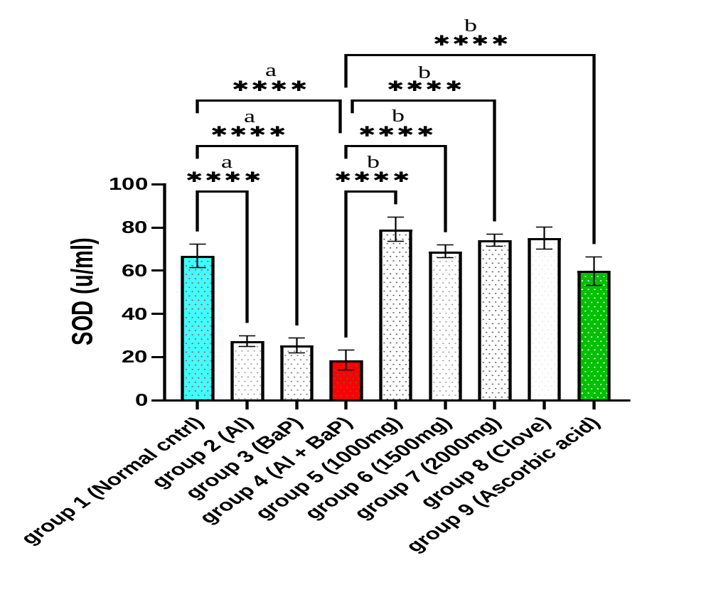
Figure 1: Effect of Extract on Superoxide Dismutase Level.
Data are presented as Mean ± SEM (n=6). “a” indicates significant difference (p < 0.05) compared to Normal Control (Group 1). “b” indicates significant difference (p < 0.05) compared to Negative Control (Group 4). A single asterisk (*) indicates an adjusted p-value ≤ 0.05; two asterisks (**) indicate p ≤ 0.01; three asterisks (***) indicate p ≤ 0.001; and four asterisks (****) indicate a highly significant difference at p ≤ 0.0001.

Effect on MDA
MDA levels differed significantly across groups (F(8,45) = 17.65, p < 0.001). Aluminium (12.80 ± 1.21 nmol/mg protein), BaP (12.04 ± 0.99 nmol/mg protein), and combined Al+BaP exposure (13.71 ± 1.81 nmol/mg protein) all produced significant elevations in MDA relative to control (3.28 ± 0.27 nmol/mg protein; p < 0.001 for all). Treatment with S. aromaticum extract at all three doses significantly reduced MDA relative to the Al+BaP group (p < 0.001), restoring levels that were not significantly different from control (1000 mg/kg: 3.97 ± 0.65; 1500 mg/kg: 5.65 ± 0.72; 2000 mg/kg: 5.60 ± 0.62 nmol/mg protein; all p > 0.05 vs. control).

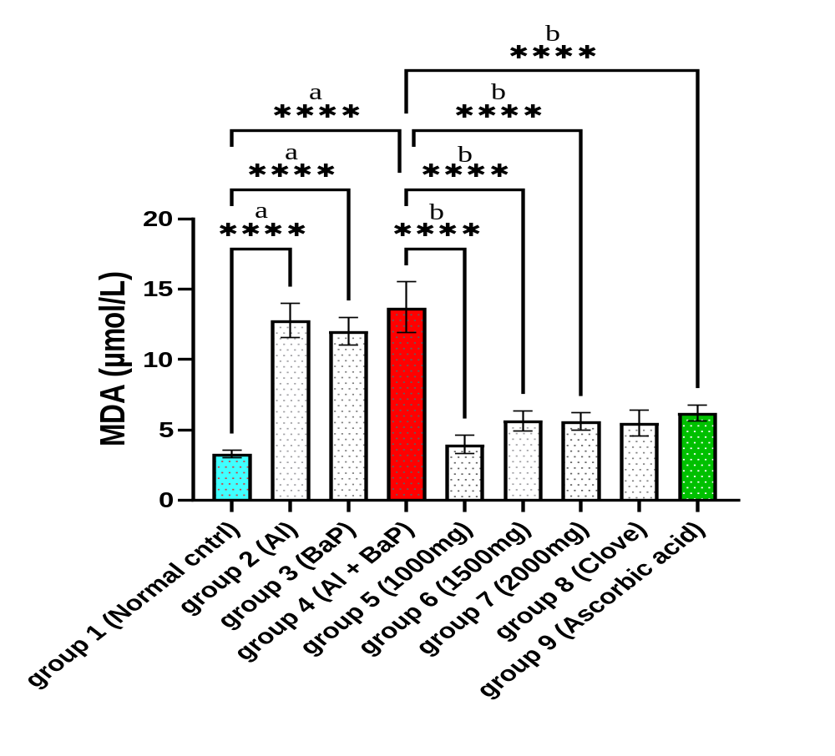
Figure 2: Effect of Syzygium aromaticum Extract on MDA level.
Data are presented as Mean ± SEM (n=6). “a” indicates significant difference (p < 0.05) compared to Normal Control (Group 1). “b” indicates significant difference (p < 0.05) compared to Negative Control (Group 4). A single asterisk (*) indicates an adjusted p-value ≤ 0.05; two asterisks (**) indicate p ≤ 0.01; three asterisks (***) indicate p ≤ 0.001; and four asterisks (****) indicate a highly significant difference at p ≤ 0.0001.

Effect on Catalase
A significant overall effect of treatment on catalase activity was observed (F(8,45) = 14.74, p < 0.001), driven primarily by differences among the S. aromaticum-treated groups rather than by toxicant-induced reductions relative to control. Although catalase activity was numerically lower following aluminium (18.55 ± 2.49 U/mg protein), BaP (24.92 ± 2.10 U/mg protein), and combined exposure (18.76 ± 1.67 U/mg protein) compared with control (43.74 ± 2.17 U/mg protein), these reductions did not reach statistical significance in post hoc comparisons (p = 0.050, 0.292, and 0.054, respectively). Treatment with S. aromaticum significantly increased catalase activity relative to the toxicant-exposed groups (p < 0.001-0.012), with the 1500 mg/kg group (70.81 ± 8.17 U/mg protein) showing activity significantly above control (p = 0.027).

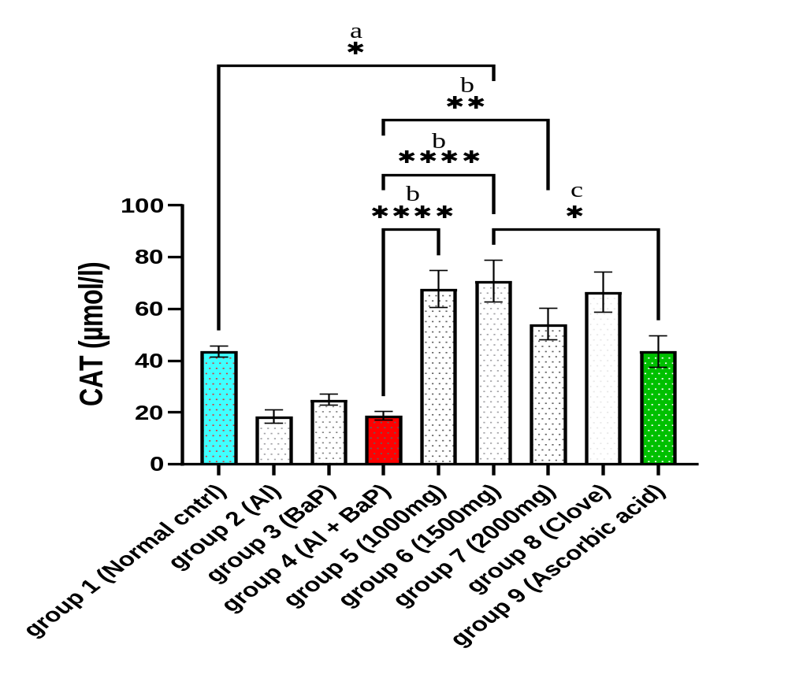
Figure 3: Effect of Syzygium aromaticum Extract on Catalase level.
Data are presented as Mean ± SEM (n=6). “a” indicates significant difference (p < 0.05) compared to Normal Control (Group 1). “b” indicates significant difference (p < 0.05) compared to Negative Control (Group 4). “c” indicates significant difference (p<0.05) compared to the Standard Drug (Group 9). A single asterisk (*) indicates an adjusted p-value ≤ 0.05; two asterisks (**) indicate p ≤ 0.01; three asterisks (***) indicate p ≤ 0.001; and four asterisks (****) indicate a highly significant difference at p ≤ 0.0001.

Effect on GPX
GPx activity differed significantly across groups (F(8,45) = 17.30, p < 0.001). BaP exposure produced the most pronounced reduction (28.67 ± 3.56 U/mg protein vs. 127.00 ± 7.21 in control; p < 0.001), followed by combined Al+BaP exposure (55.25 ± 5.80; p = 0.002) and aluminium alone (61.17 ± 3.49; p = 0.005); notably, the reduction in the combined Al+BaP group was less severe than in the BaP-only group. Treatment with S. aromaticum restored GPx activity to levels not significantly different from control at 1500 mg/kg (133.50 ± 4.83), 2000 mg/kg (127.67 ± 15.13), and in the SAE-alone (125.00 ± 13.72) and ascorbic acid (123.33 ± 13.88) groups (all p = 1.000). The 1000 mg/kg dose (178.33 ± 20.86) showed a non-significant trend toward exceeding control levels (p = 0.062).
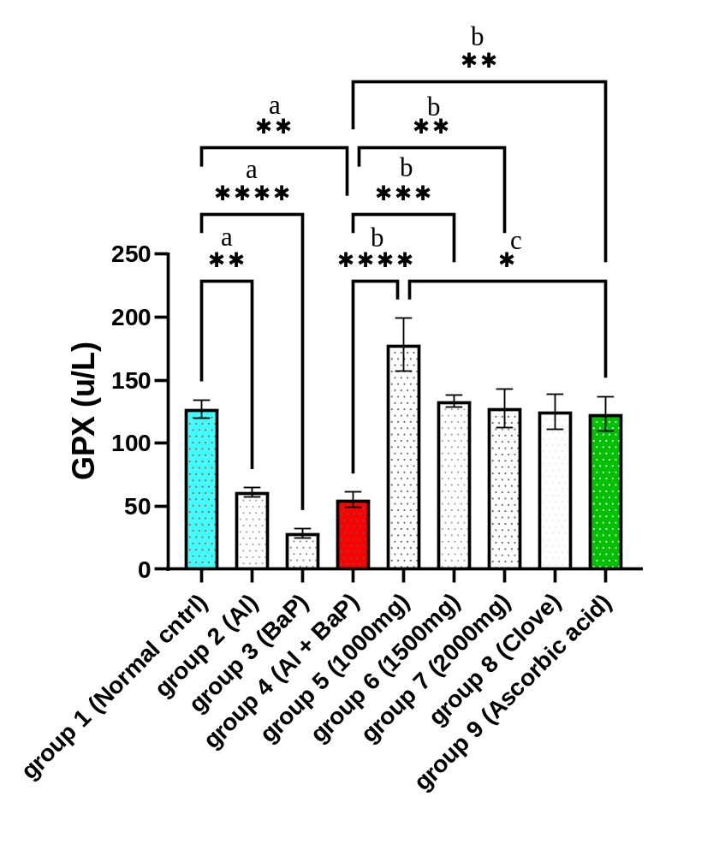
Figure 4: Effect of Syzygium aromaticum Extract on GPX level.
Data are presented as Mean ± SEM (n=6). “a” indicates significant difference (p < 0.05) compared to Normal Control (Group 1). “b” indicates significant difference (p < 0.05) compared to Negative Control (Group 4). “c” indicates significant difference (p < 0.05) compared to the Standard Drug (Group 9). A single asterisk (*) indicates an adjusted p-value ≤ 0.05; two asterisks (**) indicate p ≤ 0.01; three asterisks (***) indicate p ≤ 0.001; and four asterisks (****) indicate a highly significant difference at p ≤ 0.0001.

Effect on GSH
GSH concentration differed significantly across groups (F(8,45) = 15.96, p < 0.001). Aluminium (111.00 ± 9.80 μg/mg protein), BaP (132.50 ± 15.44), and combined Al+BaP exposure (70.00 ± 7.53, the greatest depletion) all significantly reduced GSH relative to control (267.83 ± 7.18; p < 0.001 for all). Treatment with S. aromaticum significantly improved GSH relative to the Al+BaP group at all doses (p < 0.001-0.007), with the 1500 mg/kg group showing the greatest recovery (197.83 ± 11.78). However, unlike SOD and MDA, GSH levels in all treatment groups, including the ascorbic acid standard (142.50 ± 18.51), remained significantly below control (p < 0.001-0.024), indicating only partial restoration of glutathione stores.

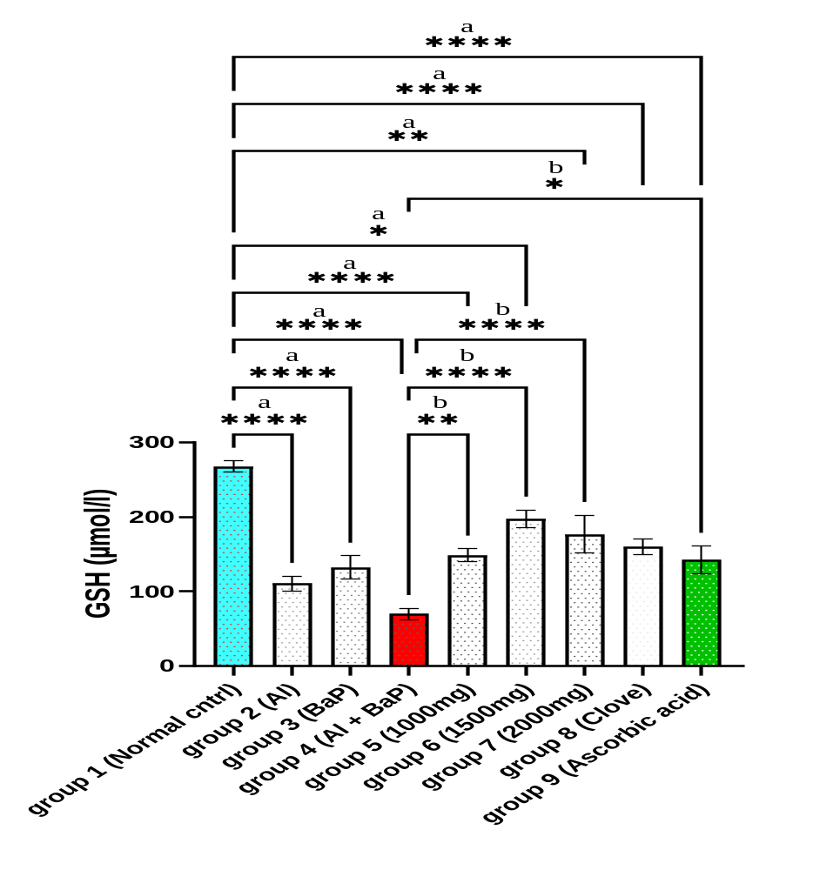
Figure 5: Effect of Extract on GSH level. Data are presented as Mean ± SEM (n=6). “a” indicates significant difference (p < 0.05) compared to Normal Control (Group 1). “b” indicates significant difference (p < 0.05) compared to Negative Control (Group 4). A single asterisk (*) indicates an adjusted p-value ≤ 0.05; two asterisks (**) indicate p ≤ 0.01; three asterisks (***) indicate p ≤ 0.001; and four asterisks (****) indicate a highly significant difference at p ≤ 0.0001.

DISCUSSION
The present study investigated the protective effects of Syzygium aromaticum extract against oxidative stress induced by aluminium and benzo[a]pyrene exposure in male Wistar rats. The findings demonstrated that exposure to either toxicant individually significantly disrupted the antioxidant defense system, and combined exposure generally produced the most pronounced oxidative imbalance, evidenced by elevated malondialdehyde (MDA) levels and concomitant reductions in superoxide dismutase (SOD), glutathione peroxidase (GPx), and reduced glutathione (GSH). Catalase (CAT) activity showed a similar downward trend following toxicant exposure, although this did not reach statistical significance. Notably, GPx reduction was less severe in the combined Al+BaP group than following BaP exposure alone, indicating that the interaction between these toxicants was not uniformly additive across all biomarkers assessed. Administration of S. aromaticum extract attenuated these alterations across all tested doses, indicating a substantial antioxidant and cytoprotective effect.
Lipid peroxidation is one of the earliest biochemical consequences of excessive reactive oxygen species (ROS) generation (Mannucci et al., 2022; Dahiru et al., 2022). In the present study, exposure to aluminium and benzo[a]pyrene significantly increased MDA concentrations, indicating enhanced oxidative degradation of membrane lipids. Malondialdehyde is a widely recognized biomarker of oxidative stress because it reflects the extent of free radical-mediated peroxidation of polyunsaturated fatty acids within cellular membranes. Elevated MDA levels suggest severe disruption of membrane integrity, increased cellular permeability, and impairment of normal cellular functions. The more pronounced increase observed following combined exposure indicates that aluminium and benzo[a]pyrene may exert additive effects through convergent oxidative pathways (Zeng et al, 2022). Aluminium has been shown to promote ROS generation through interference with mitochondrial electron transport and disruption of intracellular iron homeostasis, whereas benzo[a]pyrene undergoes cytochrome P450-mediated bioactivation to reactive metabolites capable of generating free radicals and initiating lipid peroxidation (Jorge et al., 2021; Traini et al., 2023). The interaction of these mechanisms likely accounts for the greater oxidative injury observed in animals exposed to both toxicants simultaneously.
The significant reduction in superoxide dismutase activity observed following toxicant exposure further confirms impairment of endogenous antioxidant defense mechanisms. Superoxide dismutase constitutes the first enzymatic line of defense against oxidative stress by catalysing the conversion of superoxide anions into hydrogen peroxide (Yu & Xiao, 2021). Reduced SOD activity therefore permits the accumulation of superoxide radicals, thereby amplifying oxidative damage and promoting secondary free radical reactions. Similar reductions in SOD activity have been reported in experimental models of aluminium and polycyclic aromatic hydrocarbon toxicity, where excessive ROS generation overwhelms endogenous antioxidant capacity (Olanrewaju et al., 2021; Zeng et al., 2022). Restoration of SOD activity following treatment with S. aromaticum indicates preservation of antioxidant enzyme function and enhanced scavenging of superoxide radicals, thereby limiting oxidative injury.
Catalase activity showed a numerical, though not statistically significant, reduction in toxicant-treated animals. Catalase plays an essential role in cellular antioxidant defense by rapidly converting hydrogen peroxide into water and molecular oxygen, thereby preventing the formation of highly reactive hydroxyl radicals through Fenton-type reactions (Yu & Xiao, 2021). Although the reductions observed in this study following aluminium, BaP, and combined exposure did not reach statistical significance, the consistent downward trend is in line with the pattern observed for the other antioxidant biomarkers. Administration of S. aromaticum significantly increased catalase activity relative to the toxicant-exposed groups, with the 1500 mg/kg dose producing activity significantly above the normal control, suggesting a potentially stimulatory effect on catalase at this dose. This finding is broadly consistent with previous reports demonstrating the ability of clove-derived phytochemicals to enhance endogenous antioxidant enzyme activities under conditions of oxidative stress (Taghipour et al., 2023; Akinwande et al., 2019).
Glutathione peroxidase and reduced glutathione constitute another critical component of intracellular antioxidant defense. Glutathione peroxidase utilizes reduced glutathione as a cofactor to detoxify hydrogen peroxide and lipid hydroperoxides, thereby protecting cellular membranes from oxidative injury (Mannucci et al., 2022). In the present study, significant reductions in GPx activity and GSH concentration following aluminium and benzo[a]pyrene exposure indicate depletion of intracellular antioxidant reserves as a consequence of sustained oxidative stress. Depletion of GSH compromises cellular redox homeostasis, enhances susceptibility to oxidative injury, and promotes mitochondrial dysfunction and apoptosis (Yu & Xiao, 2021). The ability of S. aromaticum extract to restore both GPx activity and GSH concentration suggests improved maintenance of intracellular redox balance and enhanced capacity to neutralize reactive oxygen species generated during toxicant exposure.
The antioxidant effects observed in the present study are likely attributable to the diverse phytochemical constituents of S. aromaticum, particularly eugenol, which has been extensively reported as one of the most potent naturally occurring phenolic antioxidants (Khalil & Ashour, 2021). Eugenol possesses a phenolic hydroxyl group capable of donating hydrogen atoms to neutralize free radicals, thereby terminating lipid peroxidation chain reactions. In addition to direct free radical scavenging, eugenol and other phenolic constituents of clove have been reported to enhance endogenous antioxidant enzyme activities, preserve glutathione homeostasis, inhibit inflammatory mediators, stabilize biological membranes, and reduce mitochondrial oxidative damage (Taghipour et al., 2023). Other bioactive compounds identified in S. aromaticum, including flavonoids, tannins, and β-caryophyllene, may also contribute synergistically to the observed antioxidant effects through complementary mechanisms involving radical scavenging, metal ion chelation, and modulation of oxidative stress signaling pathways (Taghipour et al., 2023). It should be noted that the S. aromaticum extract used in this study was not independently subjected to chemical characterization (either GC-MS or HPLC analysis); therefore, the attribution of the observed antioxidant effects to eugenol and other specific phytochemicals is based on the established phytochemical profile of S. aromaticum reported in the literature (Taghipour et al., 2023) rather than direct chemical confirmation in the present extract batch.
Administration of S. aromaticum extract produced a marked improvement in antioxidant biomarkers across all three tested doses (1000, 1500, and 2000 mg/kg), rather than a strictly monotonic dose-dependent pattern. For SOD and MDA, the 1000 mg/kg dose produced effects comparable to, or exceeding, those of the higher doses, while the 1500 mg/kg dose produced the greatest recovery in GSH. This suggests that the protective effect of S. aromaticum plateaus within the dose range tested, rather than increasing progressively with dose. Notably, across all biomarkers, the extract-treated groups produced antioxidant effects statistically comparable to those observed with ascorbic acid, a well-established antioxidant reference compound. This finding indicates that S. aromaticum possesses considerable antioxidant efficacy, even at the lowest dose tested, and may represent a promising natural alternative for mitigating oxidative stress associated with environmental toxicant exposure.
The present findings are consistent with previous reports demonstrating that natural antioxidant-rich plant extracts protect against chemically induced oxidative injury through enhancement of endogenous antioxidant defenses and suppression of lipid peroxidation (Akinwande et al., 2019; Falade et al., 2022). However, unlike many earlier investigations that evaluated single-toxicant exposure, the present study employed a combined aluminium and benzo[a]pyrene exposure model that more closely reflects real-life environmental conditions (Zeng et al., 2022; Mitra et al., 2022). This experimental design strengthens the translational relevance of the findings and provides additional evidence supporting the therapeutic potential of S. aromaticum under complex environmental exposure scenarios.
Although the present study demonstrates significant antioxidant effects of S. aromaticum, certain limitations should be acknowledged. The study primarily evaluated biochemical indices of oxidative stress without investigating molecular pathways regulating antioxidant responses, such as nuclear factor erythroid 2-related factor 2 (Nrf2), heme oxygenase-1 (HO-1), nuclear factor-kappa B (NF-κB), or apoptotic signaling proteins (Yu & Xiao, 2021). Furthermore, characterization of individual phytochemicals responsible for the observed biological effects was beyond the scope of this investigation. Future studies incorporating molecular analyses, gene and protein expression profiling, molecular dynamics simulations, and pharmacokinetic evaluation would provide a more comprehensive understanding of the mechanisms through which S. aromaticum confers protection against mixed environmental toxicant exposure.

CONCLUSION
The findings of the present study demonstrate that exposure to aluminium and benzo[a]pyrene, both individually and in combination, induces oxidative stress by disrupting the endogenous antioxidant defense system and promoting lipid peroxidation. The observed elevation in malondialdehyde levels, together with the depletion of superoxide dismutase, glutathione peroxidase, and reduced glutathione, confirms that oxidative stress is a major mechanism underlying the toxicity of these environmental contaminants; catalase showed a similar, though not statistically significant, downward trend. For most biomarkers assessed, combined exposure produced more severe oxidative damage than exposure to either toxicant alone, suggesting a predominantly additive interaction between aluminium and benzo[a]pyrene, although this pattern was not observed for glutathione peroxidase, where BaP alone produced the greatest reduction.
Administration of Syzygium aromaticum extract effectively ameliorated these alterations across all tested doses by suppressing lipid peroxidation and restoring both enzymatic and non-enzymatic antioxidant defenses, although the magnitude of protection did not increase in strict proportion to dose across all biomarkers. The improvement in oxidative stress biomarkers demonstrates the ability of S. aromaticum to preserve cellular redox homeostasis and protect biological tissues against free radical-mediated injury. These protective effects are presumed, based on the established literature, to be attributable in part to eugenol and other phenolic constituents of the extract, which possess potent free radical scavenging and antioxidant properties, although the extract used in this study was not independently chemically characterized.
Overall, the present study provides experimental evidence supporting the antioxidant potential of Syzygium aromaticum as a natural therapeutic agent against oxidative damage induced by mixed environmental toxicants. Given the increasing human exposure to multiple environmental pollutants, the use of antioxidant-rich medicinal plants such as S. aromaticum may represent a promising complementary strategy for reducing oxidative injury and its associated pathological consequences. Future studies should focus on elucidating the molecular mechanisms underlying these protective effects through gene and protein expression analyses, advanced computational modelling, and well-designed clinical investigations to facilitate the translation of these findings into preventive and therapeutic applications.

Ethical Approval
All experimental procedures involving animals were conducted in accordance with institutional and international guidelines for the care and use of laboratory animals. Ethical approval for this study was applied for and is pending from the University of Port Harcourt Research Ethics Committee, under the Office of the Deputy Vice Chancellor, Research and Development (approval number to be inserted upon issuance). Animals were monitored daily throughout the study for signs of distress or morbidity, and predefined humane endpoints (including greater than 20% body weight loss, severe lethargy, or inability to access food or water) were applied; no animals met these criteria during the study period.

DATA AVAILABILITY STATEMENT
The data supporting the findings of this study are available from the corresponding author upon reasonable request.
CONFLICT OF INTEREST
The authors declare that they have no known competing financial interests or personal relationships that could have appeared to influence the work reported in this paper.

Declaration of AI Use
This manuscript was prepared through the intellectual contributions of the author(s) to the study design, data analysis, interpretation of results, and scholarly content. Grammarly and ChatGPT were used solely to assist with grammatical refinement and reference formatting during manuscript revision. The author(s) accept full responsibility for the accuracy, integrity, and final content of the manuscript.

REFERENCES
Adeniji, A., Okoh, O. & Okoh, A. (2019). Levels of polycyclic aromatic hydrocarbons in the water and sediment of Buffalo River estuary, South Africa and their health risk assessment. Arch. Environ. Con. Tox., 76, 657-669.
Aguilar Diaz De Leon, J., & Borges, C. R. (2020). Evaluation of oxidative stress in biological samples using the thiobarbituric acid reactive substances assay. Journal of Visualized Experiments, (159), e61122. https://doi.org/10.3791/61122
Akinwande, D. V., Adeyemi, J. A., Olawuyi, S. T., Akinola, B. K., & Adedire, C. O. (2019). Protective effects of Camellia sinensis on Syzygium aromaticum- or chlorpyrifos-induced reproductive toxicity in male Wistar rats. Journal of Basic and Applied Zoology, 80, 9. https://doi.org/10.1186/s41936-019-0122-2
Amirdivani, S., Khorshidian, N., Ghobadi Dana, M., Mohammadi, R., Mortazavian, A.M., Quiterio de Souza, S.L., Barbosa Rocha, H. & Raices, R. (2019). Polycyclic aromatic hydrocarbons in milk and dairy products. Int. J. Diary Technol., 72. Doi:10.1111/1471-0307.12567.
Ellman, G. L. (1959). Tissue sulfhydryl groups. Archives of Biochemistry and Biophysics, 82(1), 70–77. https://doi.org/10.1016/0003-9861(59)90090-6
Falade, A. O., Adewole, K. E., Adekola, A. R., Ikokoh, H. A., Okaiyeto, K., & Oguntibeju, O. O. (2022). Aqueous extract of bay leaf (Laurus nobilis) ameliorates testicular toxicity induced by aluminum chloride in rats. Veterinary World, 15(11), 2525–2534. https://doi.org/10.14202/vetworld.2022.2525-2534
Hamza, T. A., & Hadwan, M. H. (2020). New spectrophotometric method for the assessment of catalase enzyme activity in biological tissues. Current Analytical Chemistry, 16(8), 1054–1062. https://doi.org/10.2174/1573411016666200116091238
Jorge, B. C., et al. (2021). Exposure to benzo(a)pyrene from juvenile period to peripubertal impairs male reproductive parameters in adult rats. Chemosphere, 263, 128016. Traini, G., et al. (2023). Effects of benzo[a]pyrene on human sperm functions: An in vitro study. International Journal of Molecular Sciences, 24(19), 14411.
Kadhim, M. J., et al. (2024). Assessment of histopathological alterations and oxidative stress in the liver and kidney of male rats following exposure to aluminum chloride. Journal of Toxicology, 2024, 3997463. https://doi.org/10.1155/2024/3997463
Khalil, N., & Ashour, M. (2021). Eugenol: A comprehensive review of its pharmacological activities.
Mannucci, A., Argento, F. R., Fini, E., Coccia, M. E., Taddei, N., Becatti, M., & Fiorillo, C. (2022). The impact of oxidative stress in male infertility. Frontiers in Molecular Biosciences, 8, 799294. https://doi.org/10.3389/fmolb.2021.799294
Mitra, S., Chakraborty, A. J., Tareq, A. M., Emran, T. B., Nainu, F., Khusro, A., Idris, A. M., Khandaker, M. U., Osman, H., Alhumaydhi, F. A., & Simal-Gandara, J. (2022). Impact of heavy metals on the environment and human health: Novel therapeutic insights to counter the toxicity. Journal of King Saud University – Science, 34(3), 101865. https://doi.org/10.1016/j.jksus.2022.101865
Olanrewaju, J. A., Akinpade, T. G., Olatunji, S. Y., Owolabi, J. O., Enya, J. I., Adelodun, S. T., Fabiyi, S. O., & Desalu, A. B. (2021). Observable protective activities of quercetin on aluminum chloride-induced testicular toxicity in adult male Wistar rat. Journal of Human Reproductive Sciences, 14(2), 113–120. https://doi.org/10.4103/jhrs.jhrs_190_20
Sattar, A. A., Matin, A. A., Hadwan, M. H., Hadwan, A. M., & Mohammed, R. M. (2024). Rapid and effective protocol to measure glutathione peroxidase activity. Bulletin of the National Research Centre, 48(1), 1–17. https://doi.org/10.1186/s42269-024-01250-x
Sun, Y., Oberley, L. W., & Li, Y. (1988). A simple method for clinical assay of superoxide dismutase. Clinical Chemistry, 34(3), 497–500. https://doi.org/10.1093/clinchem/34.3.497
Taghipour, Z., Bahmanzadeh, M., & Rahimi, R. (2023). The effects of clove and its constituents on reproductive system: A comprehensive review. Reproductive Sciences, 30(9), 2591–2614. https://doi.org/10.1007/s43032-023-01223-x
Traini, G., Tamburrino, L., Ragosta, M. E., Guarnieri, G., Morelli, A., Vignozzi, L., Baldi, E., & Marchiani, S. (2023). Effects of benzo[a]pyrene on human sperm functions: An in vitro study. International Journal of Molecular Sciences, 24(19), 14411. https://doi.org/10.3390/ijms241914411
Weyand, E. H., Chen, Y.-C., Wu, Y., Koganti, A., Dunsford, H. A., & Rodriguez, L. V. (1995). Differences in the tumorigenic activity of a pure hydrocarbon and a complex mixture following ingestion: Benzo[a]pyrene vs. manufactured gas plant residue. Chemical Research in Toxicology, 8(7), 949–954.
Yu, C., & Xiao, J. H. (2021). The Keap1-Nrf2 system: A mediator between oxidative stress and aging. Oxidative Medicine and Cellular Longevity, 2021, 6635460. https://doi.org/10.1155/2021/6635460
Zeng, H., Fang, B., Hao, K., Wang, H., Zhang, L., Wang, M., Hao, Y., Wang, X., Wang, Q., Yang, W., & Rong, S. (2022). Combined effects of exposure to polycyclic aromatic hydrocarbons and metals on oxidative stress among healthy adults in Caofeidian, China. Ecotoxicology and Environmental Safety, 230, 113168. https://doi.org/10.1016/j.ecoenv.2022.113168

