Biochemical Characterization of Japanese Spirulina sp. Microalgal Powder: Pigment, β-Carotene, and Phenolic Profiling with Antioxidant Assessment

Abstract
Background: Spirulina microalgae are filamentous, multicellular, blue–green cyanobacteria that serve as popular nutritional sources in medicine, the food industry and aquaculture. Spirulina has a high content of macro- and micronutrients, antioxidants and pigments such as carotene, chlorophyll and phycocyanin.
Aims: This study aimed to determine the pigment, β-carotene, phenolic, and antioxidant profile of Japanese Spirulina microalgal powder as a basis for evaluating its relevance to future functional food and nutraceutical development.
Materials and Methods: The characteristics of the powder were assessed by visual inspection and optical microscopy. Pigment (carotenoid and chlorophyll) contents were determined by UV-Vis spectrophotometry. β-carotene was quantified by reversed-phase HPLC using an isocratic elution programme with a mobile phase of dichloromethane:acetonitrile:methanol (40:45:15, v/v/v). Total phenolic content and antioxidant activity were assessed using the Folin-Ciocalteu and DPPH (2,2-diphenyl-1-picrylhydrazyl) assays, respectively.
Results: The microalgal powder was a uniform, homogeneous substance with a slightly fishy odour, appropriate for analysis. Total carotenoid and chlorophyll contents reached 3.306 mg/g DW and 6.471 mg/g DW, respectively. The retention time of β-carotene was approximately 11.827 minutes, and the linear regression equation showed statistical significance (R² = 0.9995); the β-carotene content of the microalgal powder was 2.677 mg/g DW. Total phenolic content was 0.444 mg GAE/g DW, and DPPH radical scavenging activity was 25%, equivalent to 2.487 µg/mL of vitamin C.
Conclusions: The Japanese Spirulina sp. microalgal powder possessed a stable, well-characterised biochemical composition — carotenoids, chlorophylls, β-carotene and phenolics — together with measurable in vitro antioxidant activity. These findings support its potential as a biochemically characterised ingredient for further investigation in functional food and nutraceutical research.

Keywords: Spirulina sp.; β-carotene; carotenoids; chlorophyll; total phenolic content; DPPH assay; antioxidant activity; HPLC; UV–Vis spectrophotometry; microalgal powder

1. Introduction
Spirulina, a filamentous cyanobacterium, is recognised for both its rich nutritional composition and the presence of diverse bioactive compounds and is considered a valuable candidate for use as a functional food, animal feed supplement, and therapeutic agent (Khan et al., 2005; Spínola et al., 2024). Arthrospira (Spirulina) platensis has a wide range of pigments, including chlorophyll a, total carotenoids and phycobiliproteins (protein-rich phycocyanin and phycoerythrin). The primary potential of these pigments lies in their use as natural dyes and in functional and pharmaceutical applications (İsar et al., 2022). The chemical composition of Spirulina, — characterised by high levels of protein, essential fatty acids, vitamins, minerals, and bioactive compounds such as phycocyanin, polysaccharides, and carotenoids — supports uses in food, feed, and medicine, with reported antioxidant, anti-inflammatory, immunomodulatory, antiviral, anticancer, antidiabetic and lipid-lowering effects (Spínola et al., 2024).
Spirulina preparations enhance the immune system by increasing macrophage phagocytic activity, stimulating antibody and cytokine production, and promoting activation of T and B cells. Spirulina plays a regulatory role in lipid and carbohydrate metabolism, helping to correct glucose and lipid profiles in diabetic patients and experimental animals, and is active against several enveloped viruses, including HIV, herpes virus, cytomegalovirus, and influenza virus (Khan et al., 2005). Free bilirubin is a potent physiological inhibitor of NADPH oxidase activity; this effect is replicated by phycocyanobilin (PCB), a chromophore abundant in Spirulina, likely because PCB is rapidly reduced to phycocyanorubin, a close structural homologue of bilirubin, within mammalian cells (McCarty, 2007).
Recent cultivation studies indicate that culture conditions and nutrient medium composition can influence Arthrospira platensis/Spirulina biomass production and pigment-related characteristics, including carotenoid and chlorophyll contents (Dan et al., 2026; Chaudhari & Manoj, 2024).
Recent studies also show that extraction strategy can affect the recovery and antioxidant behaviour of Spirulina pigments, while Spirulina biomass can be characterised in terms of phenolic compounds, carotenoids, and antioxidant activity (Alotaiby et al., 2024; Fernandes et al., 2024; Ladjal-Ettoumi et al., 2024).
Given these roles, Spirulina microalgae are increasingly used in functional foods and are widely applied in aquaculture, cosmetics and pharmaceuticals worldwide. Accordingly, the present study addresses the need for an integrated characterisation of chlorophylls, carotenoids, β-carotene, total phenolic content, and in vitro antioxidant activity in the Japanese Spirulina powder cultivated under the laboratory conditions described here. This study evaluates the contents of pigments (chlorophylls and carotenoids), β-carotene, phenolic compounds and antioxidant activity of Japanese Spirulina powder cultivated under laboratory conditions. The results provide a basis for characterising the biochemical relevance of this Spirulina powder for future functional food and pharmaceutical development.

2. Materials and Methods

2.1. Chemicals and instruments

β-carotene and vitamin C standards were purchased from Sigma-Aldrich and VWR & BDH, respectively. Absolute dichloromethane, acetonitrile, and methanol solvents used for HPLC, along with n-hexane and ethanol, were obtained from Merck, Germany. The gallic acid standard was sourced from a certified commercial supplier in India. Instrumentation comprised a UV-Vis spectrophotometer (Shimadzu, Japan), an HPLC system (Shimadzu, serial no. L214555, Japan), and a PDA detector.

2.2. Research object
Japanese Spirulina sp. microalgal powder was prepared from biomass cultivated in Zarrouk medium at the Laboratory of Biochemistry, Nguyen Tat Thanh University, Ho Chi Minh City, Vietnam.
Spirulina was cultivated in 1 L Erlenmeyer flasks in Zarrouk medium under continuous aeration and illumination at an intensity of 30 µmol photons/m²/s (12 h light: 12 h dark cycle), at a temperature of 25 ± 2 °C. After 7 days of cultivation, Spirulina biomass was harvested by filtration through a nylon membrane filter (25 µm pore diameter), dried at 60 °C to constant weight, and stored at −20 °C for subsequent analysis.

2.3. Research methods
2.3.1. Description of Spirulina sp. powder
The microalgal powder was ground to a fine, homogeneous consistency using a porcelain mortar and pestle, then examined under an optical microscope at 400× magnification.
2.3.2. Microalgal powder extraction
Microalgal powder (0.05 g) was extracted with 5 mL of n-hexane in a capped test tube at 50 °C for 15 minutes. The extract was centrifuged at 6000 rpm for 10 minutes and the supernatant was collected and evaporated to dryness. The pellet was subjected to further extraction until the solution became colourless; all extracts were pooled and evaporated to dryness for subsequent analysis.
2.3.3. Determination of chlorophyll and carotenoid contents
The extract was redissolved in 5 mL of n-hexane and subjected to spectrophotometric measurements at wavelengths of 450 nm, 662 nm, and 645 nm. Chlorophyll and carotenoid contents were calculated via the following equations (Prieto et al., 2011; Lichtenthaler & Wellburn, 1983):
Carotenoid (mg/g) = $\frac{A450*25.5*a}{m*1000}$
Chlorophyll a (mg/g) = $\frac{(11.75*A662-2.35*A645) x a}{m*1000}$
Chlorophyll b (mg/g) = $\frac{(18.61*A645-3.96*A662) x a}{m*1000}$
Total chlorophyll (mg/g) = Chlorophyll a + Chlorophyll b
Where:
A450, A645 and A662 absorbances were measured at the wavelengths of 450 nm, 645 nm and 662 nm, respectively.
a: dilution factor
m: mass of the weighed microalgal powder (g)
2.3.4. Determination of β-carotene content using HPLC
Chromatographic conditions: Luna® C18 column (4.6 × 250 mm), column temperature 30 °C, PDA detection at 476 nm, injection volume 30 µL, isocratic mobile phase dichloromethane:acetonitrile:methanol (40:45:15, v/v/v), flow rate 1 mL/min (Nguyen et al., 2025).
β-carotene standard solution: ~10 mg of β-carotene standard was accurately weighed into a 50 mL volumetric flask and dissolved and made up to volume with n-hexane. One millilitre of this solution was pipetted into a 20 mL volumetric flask and made up to volume with mobile phase, then filtered through a 0.45 µm membrane filter.
Calibration curve: standard solutions ranging from 4 to 14 µg/mL were prepared by diluting the stock solution (200 µg/mL), were injected under the chromatographic conditions above, and a linear regression equation (y = ax + b) was established from peak area versus concentration.
Sample extract: the extract from 1.5 g of microalgal powder was redissolved in 5 mL of n-hexane; 1 mL of this mixture was made up to 5 mL with mobile phase, filtered (0.45 µm), and injected in six replicates.
$β$- carotene (mg/g) = $\frac{St*Cc*C\%*a}{Sc*1000*m}$
where:
St: the peak area of the Spirulina sample (mAU)
Sc: the peak area of the $β$- carotene standard (mAU)
Cc: Concentration of the $β$- carotene standard ($μg/mL$)
C%: $β$- carotene standard content
a: dilution factor
m: mass of the weighed microalgal powder (g)
2.3.5. Determination of total phenolic content
Gallic acid calibration curve: standards from 10 to 50 µg/mL were prepared from a 200 µg/mL stock. A 0.5 mL aliquot of each standard was mixed with 0.5 mL Folin-Ciocalteu reagent and 0.5 mL 10% Na₂CO₃, incubated in the dark for 90 minutes, and the absorbance was measured at 750 nm; a linear regression equation (y = ax + b) was established.
Microalgal powder (0.05 g) was extracted with 5 mL of methanol, centrifuged at 5000 rpm for 15 minutes, and the supernatant was evaporated and redissolved in 5 mL of absolute methanol. A 0.5 mL aliquot was treated as above.
$$\text{Total phenolic content (}μgGAE/g)\text{ = }\frac{\text{C*a}}{\text{m}}$$
where: C: total phenolic content was determined from the calibration curve (µg GAE/mL)
a: dilution factor
m: mass of the weighed microalgal powder (g)
2.3.6. Determination of antioxidant capacity
DPPH reagent: 0.004 g of DPPH was dissolved in methanol and made up to 100 mL in a volumetric flask. Vitamin C standards (0.5–4.5 µg/mL, from a 10 µg/mL stock) were each prepared by mixing 0.5 mL of standard with 1 mL of DPPH reagent, vortexed, incubated in the dark for 30 minutes, and the absorbance was measured at 517 nm; a linear regression equation (y = ax + b) was established, where y is optical density (OD) and x is vitamin C concentration (µg/mL).
Microalgal powder (0.05 g) was extracted with 5 mL of ethanol, centrifuged at 5000 rpm for 10 minutes, evaporated, and redissolved in 5 mL of ethanol for analysis as above. Antioxidant capacity (I%) was calculated as:
I% = ($\frac{{\text{Α}}_{\text{Blank}}\text{ - }{\text{Α}}_{\text{sample}} }{{\text{Α}}_{\text{Blank}}}$) x 100
where: I%: inhibition percentage
A_{Blank}: Absorbance of the blank sample
A_{sample}: Absorbance of the microalgal extract sample
The vitamin C equivalent content was calculated from the linear regression equation of the vitamin C standard curve.
2.3. Data analysis
Data were analysed descriptively using Microsoft Excel 2025; results are reported as mean ± SD (n = 6 analytical replicates). Linear regressions were evaluated with P < .05 considered statistically significant.

3. Results and Discussion

3.1. Description of Spirulina sp. powder

Visually, the Spirulina microalgal powder was a fine, homogeneous, smooth, green substance with a slightly fishy odour (Figure 1a). Cells appeared intact, green and filamentous under the optical microscope at 400× magnification (Figure 1b). The powder therefore satisfied the characteristics required for analysis of chlorophyll, carotenoid, β-carotene, and phenolic content and antioxidant activity.

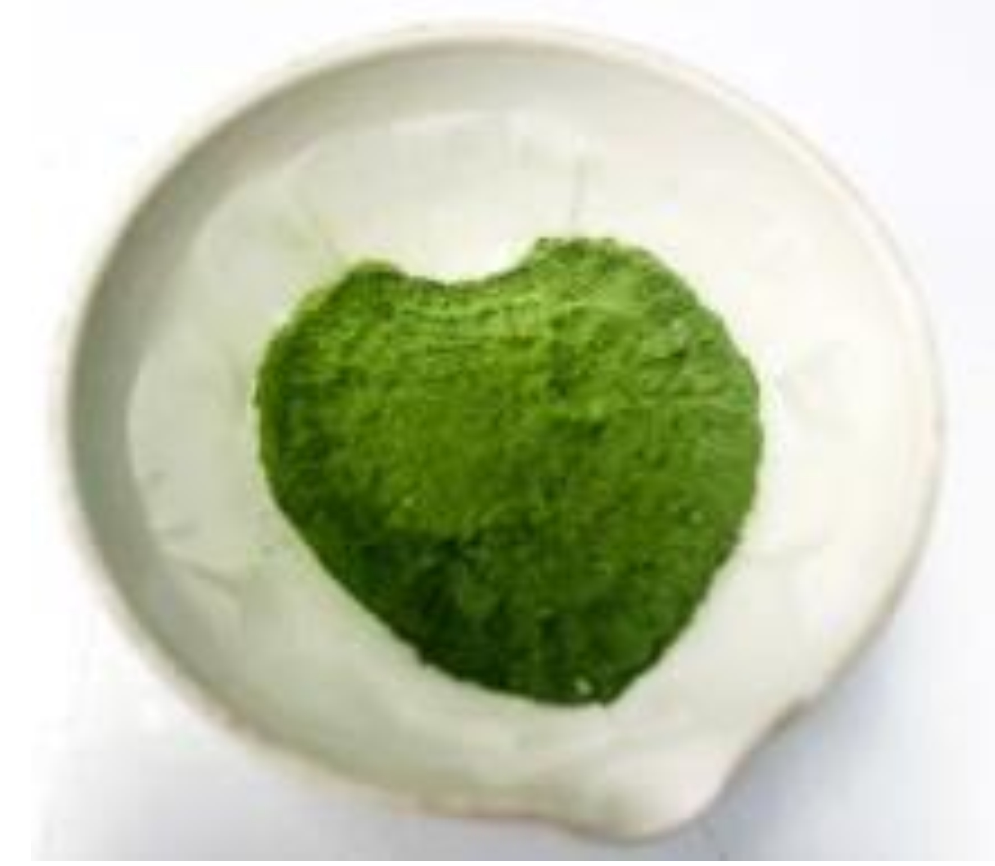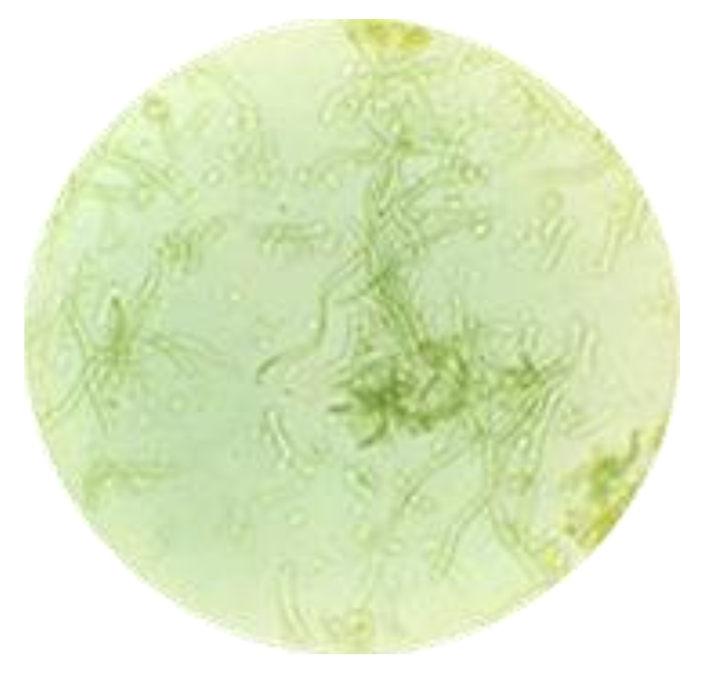
(a)
(b)

Figure.1. The Spirulina powder (a) and the cell under the optical microscope at 400X magnification (b)
  - Pigment contents of Spirulina sp. powder
Table 1 shows the pigment contents of Japanese Spirulina sp. powder. Chlorophyll a and b reached 2.446 ± 0.032 mg/g DW and 4.025 ± 0.066 mg/g DW, respectively; total chlorophyll was 6.471 ± 0.120 mg/g DW. Carotenoid content was 3.306 ± 0.061 mg/g DW.

Table.1. Pigment (chlorophyll and carotenoid) contents of Spirulina sp. microalgal powder
Pigments | Chlorophyll a | Chlorophyll b | Total Chlorophyll | Carotenoid
Content (mg/g) | 2.446 $±$ 0.032 | 4.025 $±$ 0.066 | 6.471 $±$ 0.120 | 3.306 $±$0.061
RSD% | 1.292 | 1.644 | 1.861 | 1.847

  - The β-carotene content of Spirulina sp. microalgal powder
The retention time of the 10 μg/mL β-carotene standard was approximately 11.827 minutes (Figure 2a). Linearity was demonstrated over 4–14 μg/mL, with regression equation y = 309758x − 444270, R² = 0.9995 (P < .05; Figures 3–4, Table 2). Analysis of the Japanese Spirulina sp. microalgal powder, with a retention time corresponding to that of the standard, gave a β-carotene content of 2.677 ± 0.089 mg/g DW (Figure 2b, Table 3).

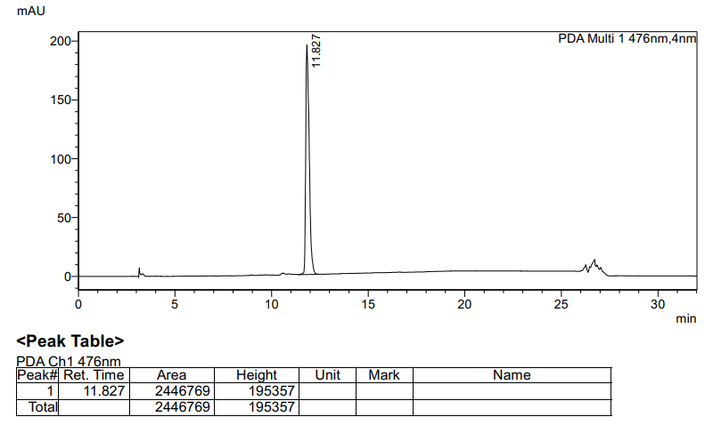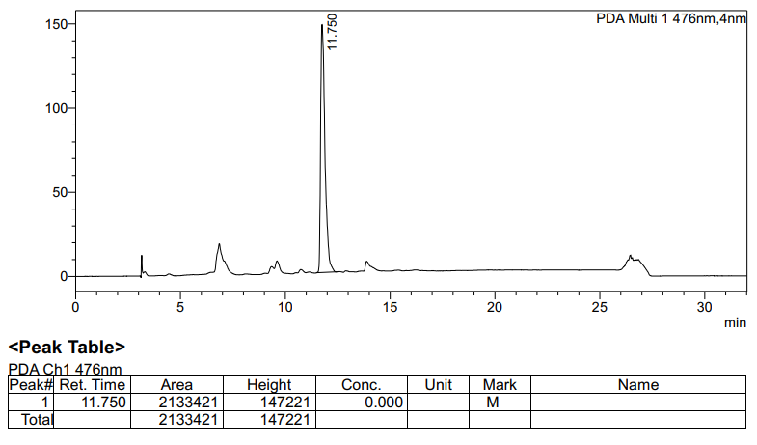
(a)
(b)

Figure.2a and 2b. $β- carotene$ standard chromatograms at concentration of 10 $μg/mL$ (a) and Spirulina microalgal powder (b)

Figure.3. $β- carotene$ standard chromatograms at concentration series ranging from 4 to 14 $μg/mL$

Figure 4. The linear regression equation of the $β- carotene$ standard at concentration series ranging from 4 to 14 $μg/mL$

Table.2. Analytical parameters for the linearity of $β- carotene$ and the gallic acid standard
Parameters | $$β- carotene$$ | Gallic acid
The linear regression equation | y = 309758x - 444270 | y = 0.0301x + 0.0352
Slope (a) | 309758 | 0.0301
Intercept (b) | - 444270 | 0.0352
R Square | 0.9995 | 0.9903
Adjusted R Square | 0.9993 | 0.9871
Significance F | < 0.05 | < 0.05
P-value | < 0.05 | < 0.05

Table.3. $β-carotene$, phenolic content and antioxidant capacity of Spirulina microalgal powder
Characteristics | Mean ± SD | RSD %
$β-carotene$ content (mg/g) | 2.677 $±$ 0.089 | 3.33
Phenolic content (mg/g) | 0.444 $±$ 0.088 | 19.9
Antioxidant capacity (I%) | 25.000 $±$ 0.499 | 1.734
  - Phenolic content of Spirulina microalgal powder

The gallic acid calibration spanned 10–50 μg/mL, giving y = 0.0301x + 0.0352, R² = 0.9903 (P < .05; Figure 5, Table 2). The total phenolic content of the Spirulina microalgal powder was 0.444 ± 0.088 mg GAE/g DW (Table 3).

Figure 5. The linear regression equation of gallic acid standard at concentration series ranging from 10 to 50 $μg/mL$
  - The antioxidant capacity of the Spirulina microalgal powder
The vitamin C positive control demonstrated linearity within the concentration range of 0.5 to 4.5 µg/mL, yielding the linear regression equation y = 3.1262x + 17.226, an R² value of 0.9919, and a p-value of < 0.05 (Figure 6). The antioxidant activity of Spirulina microalgal powder showed free-radical scavenging activity of 25% (Table 3), which was equivalent to 2.487 µg/mL of vitamin C (Figure 6).

Figure.6. The linear regression equation of vitamin C standard at concentration series ranging from 0.5 to 4.5 $μg/mL$

Spirulina is a highly nutritious microalga with extensive applications in the cosmetic and pharmaceutical industries. Its value derives from its diverse pigment content, including chlorophyll, carotenoids, and phycocyanin, alongside a rich nutritional profile, notably high protein content. The colour of the Spirulina microalgal powder examined here is largely dictated by its chlorophyll pigmentation. Total carotenoid, chlorophyll a and chlorophyll b contents reported for Spirulina extracts elsewhere were 3.5 ± 0.2, 5.7 ± 0.2 and 3.4 ± 0.3 mg/g DW, respectively (Marzorati et al., 2020), while phycocyanin and chlorophyll extraction efficiencies of up to 14.88 mg/g and 1.400 mg/g have been reported under varied thermal, ultrasonic, and solvent conditions (Nikolova et al., 2024).
The Japanese Spirulina powder examined here showed a total carotenoid concentration of 3.306 mg/g DW, with β-carotene accounting for 2.677 mg/g DW — 80.97% of the total. Park et al. (2018) similarly reported all-trans-β-carotene, all-trans-zeaxanthin, 9-cis-β-carotene, diatoxanthin and 13-cis-β-carotene as the major Spirulina carotenoids, with all-trans-β-carotene dominant in several of their samples and total carotenoid content reaching 4.43 ± 0.03 mg/g DW in their highest sample (AP-1). β-carotene has also been reported to represent approximately 80% of total carotenoids in Spirulina, followed by zeaxanthin, underscoring its role as a precursor for vitamin A synthesis (Valdez-Ortiz et al., 2025).
Carotenoids and phenolics are important antioxidant compounds. The Japanese Spirulina microalgal powder examined here had a phenolic content of 0.444 mg GAE/g DW and an antioxidant capacity of 25%, equivalent to 2.487 µg/mL of vitamin C. HPLC-DAD profiling of Spirulina phenolic extracts elsewhere has identified gallic, chlorogenic, cinnamic, pinostrobin and p-OH-benzoic acids as the most abundant constituents; these polyphenolics showed dose-dependent antioxidant effects against CCl₄-induced lipid peroxidation and DPPH radical scavenging (IC₅₀ 23.22–35.62 µg/mL), comparable to standard antioxidants BHT, BHA and α-tocopherol (IC₅₀ 13.22–23.62 µg/mL) (Abd El-Baky et al., 2009). Antioxidant and protective effects of Spirulina reported elsewhere are attributed to phycocyanins, β-carotene, and other vitamins and minerals it contains (Wu et al., 2016).

4. Conclusions
The present study characterised laboratory-cultivated Japanese Spirulina sp. microalgal powder through pigment, β-carotene, total phenolic, and antioxidant measurements. The powder showed a fine, homogeneous green appearance and intact filamentous cells under optical microscopy. Total carotenoid and total chlorophyll contents were 3.306 and 6.471 mg/g DW, respectively, while β-carotene was quantified at 2.677 mg/g DW. Total phenolic content was 0.444 mg GAE/g DW, and DPPH radical-scavenging activity reached 25%, corresponding to 2.487 µg/mL vitamin C. The chromatographic determination of β-carotene showed a retention time of approximately 11.827 minutes and a linear calibration response with R² = 0.9995. Collectively, these results establish a defined biochemical profile for the analysed powder and demonstrate measurable in vitro antioxidant activity. The findings support continued investigation of this material as a potential ingredient for functional food and nutraceutical applications. Further assessment of bioavailability, antioxidant activity using additional assays, and in vivo bioactivity is required before specific health or pharmaceutical applications can be substantiated.

Limitations
This study was limited to Japanese Spirulina sp. powder cultivated under the reported laboratory conditions and evaluated mainly through compositional analyses and a single in vitro antioxidant assay. Antioxidant activity was assessed by DPPH with vitamin C equivalence, so the result does not represent the full antioxidant profile of the material. The reported statistics were based on six analytical replicates and descriptive analysis. Bioavailability and in vivo biological activity were not evaluated. Further studies using complementary antioxidant assays and biological models are therefore needed to extend interpretation of the present biochemical findings.

Declaration of AI Use
This manuscript was prepared through the intellectual contributions of the author(s) to the study design, data analysis, interpretation of results, and scholarly content. Grammarly and ChatGPT were used solely to assist with grammatical refinement and reference formatting during manuscript revision. The author(s) accept full responsibility for the accuracy, integrity, and final content of the manuscript.

Competing Interests
Authors have declared that no competing interests exist.

Authors' Contributions
Trung Vo designed the study, performed the analyses, and wrote the first draft of the manuscript. Phuc Thi Hong Nguyen managed the literature searches and data analysis. All authors read and approved the final manuscript.

Acknowledgments
This research received no external funding.

References
Abd El-Baky, H. H., El Baz, F. K., & El-Baroty, G. S. (2009). Production of phenolic compounds from Spirulina maxima microalgae and its protective effects. African Journal of Biotechnology, 8(24), 7059–7067. https://doi.org/10.5897/AJB2009.000-9548
Alotaiby, S., Zhao, X., Boesch, C., & Sergeeva, N. N. (2024). Sustainable approach towards isolation of photosynthetic pigments from Spirulina and the assessment of their prooxidant and antioxidant properties. Food Chemistry, 436, 137653. https://doi.org/10.1016/j.foodchem.2023.137653
Chaudhari, A., & Manoj, K. (2024). Assessment of cow urine as a nutrient medium for indoor cultivation of Spirulina sp. Uttar Pradesh Journal of Zoology, 45(10), 84–90. https://doi.org/10.56557/upjoz/2024/v45i104052
Dan, P. V., Nguyen, H. D., Do, D. G., Le, Q. L., Tran, T. M. N., Vu, T. T. N., Tran, Q. V., Nguyen, T. T., & Tran, T. K. (2026). Optimization of culture conditions for Arthrospira platensis cultivation in closed tubular photobioreactors. Biotechnology Journal International, 30(3), 98–107. https://doi.org/10.9734/bji/2026/v30i3881
Fernandes, A. S., Caetano, P. A., Jacob-Lopes, E., Zepka, L. Q., & de Rosso, V. V. (2024). Alternative green solvents associated with ultrasound-assisted extraction: A green chemistry approach for the extraction of carotenoids and chlorophylls from microalgae. Food Chemistry, 455, 139939. https://doi.org/10.1016/j.foodchem.2024.139939
İsar, M., Cirik, S., & Turan, G. (2022). Production of natural and functional pigments in Arthrospira (Spirulina) platensis cultivated in laboratory conditions. Bulletin of Biotechnology, 3(1), 11–15. https://doi.org/10.51539/biotech.1033326
Khan, Z., Bhadouria, P., & Bisen, P. S. (2005). Nutritional and therapeutic potential of Spirulina. Current Pharmaceutical Biotechnology, 6(5), 373–379. https://doi.org/10.2174/138920105774370607
Ladjal-Ettoumi, Y., Hamadi, M., Hadjer Douik, L., Cherifi, Z., & Nazir, A. (2024). Physicochemical, functional, and nutraceutical properties of Spirulina and Chlorella biomass: A comparative study. Algal Research, 81, 103561. https://doi.org/10.1016/j.algal.2024.103561
Lichtenthaler, H. K., & Wellburn, A. R. (1983). Determinations of total carotenoids and chlorophylls a and b of leaf extracts in different solvents. Biochemical Society Transactions, 11(5), 591–592. https://doi.org/10.1042/bst0110591
Marzorati, S., Schievano, A., Idà, A., & Verotta, L. (2020). Carotenoids, chlorophylls and phycocyanin from Spirulina: Supercritical CO₂ and water extraction methods for added value products cascade. Green Chemistry, 22(1), 187–196. https://doi.org/10.1039/C9GC03292D
McCarty, M. F. (2007). Clinical potential of Spirulina as a source of phycocyanobilin. Journal of Medicinal Food, 10(4), 566–570. https://doi.org/10.1089/jmf.2007.621
Nguyen, P. T. H., Nguyen, D. T., & Vo, T. (2025). Determination of carotenoid and beta-carotene content in Dunaliella microalgae powder. European Journal of Medical and Health Research, 3(1), 21–26. https://doi.org/10.59324/ejmhr.2025.3(1).05
Nikolova, K., Petkova, N., Mihaylova, D., Gentscheva, G., Gavrailov, G., Pehlivanov, I., & Andonova, V. (2024). Extraction of phycocyanin and chlorophyll from Spirulina by “green methods.” Separations, 11(2), 57. https://doi.org/10.3390/separations11020057
Park, W. S., Kim, H.-J., Li, M., Lim, D. H., Kim, J., Kwak, S.-S., Kang, C.-M., Ferruzzi, M. G., & Ahn, M.-J. (2018). Two classes of pigments, carotenoids and C-phycocyanin, in spirulina powder and their antioxidant activities. Molecules, 23(8), 2065. https://doi.org/10.3390/molecules23082065
Prieto, A., Cañavate, J. P., & García-González, M. (2011). Assessment of carotenoid production by Dunaliella salina in different culture systems and operation regimes. Journal of Biotechnology, 151(2), 180–185. https://doi.org/10.1016/j.jbiotec.2010.11.011
Spínola, M. P., Mendes, A. R., & Prates, J. A. M. (2024). Chemical composition, bioactivities, and applications of spirulina (Limnospira platensis) in food, feed, and medicine. Foods, 13(22), 3656. https://doi.org/10.3390/foods13223656
Valdez-Ortiz, A., Meza-Ayala, K. A., García-Padilla, J. M., Valdez-Ortiz, R., & Germán-Báez, L. J. (2025). Pigments from microalgae: Chlorophyll, carotenoids, and phycobiliproteins as source of natural colorants for food. In D. U. Santos Ballardo & S. Rossi (Eds.), Microalgae as promising source of commercial bioproducts: Advances and emerging technologies in bioactive compounds, biofuels, food and biorefineries (pp. 153–175). Springer. https://doi.org/10.1007/978-3-031-86433-9_11
Wu, Q., Liu, L., Miron, A., Klímová, B., Wan, D., & Kuča, K. (2016). The antioxidant, immunomodulatory, and anti-inflammatory activities of Spirulina: An overview. Archives of Toxicology, 90(8), 1817–1840. https://doi.org/10.1007/s00204-016-1744-5

