Biochemical profiles of Spirulina microalgal powder: potential applications in functional foods and pharmaceuticals

Abstract
Background: Spirulina microalgae are filamentous, multicellular, blue–green cyanobacteria that are widely used as nutritional sources in medicine, the food industry, and aquaculture. Spirulina contains high levels of macro- and micronutrients, antioxidants, and pigments such as carotene, chlorophyll, and phycocyanin.
Aims: This study aimed to determine the valuable chemical components of Japanese Spirulina microalgal powder for potential applications in functional foods and pharmaceuticals.
Materials and Methods: The characteristics of the powder were initially validated via visual inspection and microscopy. The contents of pigments (carotenoid and chlorophyll) were subsequently determined using a UV-Vis spectrophotometric method. The HPLC method, which employed a gradient elution programme with a mobile phase consisting of dichloromethane:acetonitrile:methanol (40:45:15), was used to quantify the content of $β-carotene$. The total phenolic compound content and antioxidant activity were assessed using the Folin-Ciocalteu and DPPH (2,2-Diphenyl-1-picrylhydrazyl) reagents, respectively.
Results: The results indicated that the microalgal powder was a uniform and homogeneous substance with a fishy odour suitable for analysis. The total carotenoid and chlorophyll contents were 3.306 mg/g and 6.471 mg/g, respectively. The retention time of $β-carotene$ was approximately 11.827 minutes and the linear regression equation had (R² = 0.9995), and the $β-carotene$ content of the microalgal powder was recorded as 2.677 mg/g. The total phenolic content was 0.444 mg/g, and the antioxidant capacity was 25%, equivalent to 2.487 $μg/mL$ of vitamin C.
Conclusions: In conclusion, the Japanese Spirulina sp. microalgal powder contained chemical components, including carotenoids, chlorophylls, $β-carotene$ and phenolics, and exhibited antioxidant activity. These findings indicate the potential of Spirulina powder for application in the production of functional foods and pharmaceuticals.

Keywords: Spirulina, chlorophyll, carotenoids, $β-carotene$, phenolic compounds, antioxidant capacity.
INTRODUCTION
Spirulina, a filamentous cyanobacterium and prominent microalga recognised for its rich nutritional composition and diverse bioactive compounds, is considered a valuable candidate for use as a functional food, animal feed supplement, and therapeutic agent (Khan et al., 2005; Spínola et al., 2024). Arthrospira (Spirulina) platensis contains a wide range of pigments, including chlorophyll a, total carotenoids and phycobiliproteins (protein-rich phycocyanin and phycoerythrin). These pigments have potential for use as natural dyes, for functional health benefits, and in pharmaceutical applications (İsar et al., 2022). Spirulina contains high levels of protein, essential fatty acids, vitamins, minerals, and bioactive compounds, such as the phycocyanin pigment, polysaccharides, and carotenoids. These constituents support its use in food, feed, and medicine. These compounds exhibit various biological activities, including antioxidant, anti-inflammatory, immunomodulatory, antiviral, anticancer, antidiabetic, and lipid-lowering effects (Spínola et al., 2024).
Recent comparative characterisation indicates that Spirulina biomass has physicochemical, functional, and nutraceutical attributes relevant to food applications (Ladjal-Ettoumi et al., 2024). Its carotenoids, chlorophylls, and phycocyanin also differ in stability, solubility, and antioxidant properties (Alotaiby et al., 2024).
Spirulina preparations enhance the immune system by increasing the phagocytic activity of macrophages, stimulating the production of antibodies and cytokines, and promoting the activation and mobilisation of T and B cells. Spirulina also plays a regulatory role in lipid and carbohydrate metabolism, helping to correct glucose and lipid profiles in diabetic patients and experimental animals. Spirulina is active against several enveloped viruses, including HIV, herpes virus, cytomegalovirus, and influenza virus. Owing to its antioxidant properties, it can inhibit carcinogenesis (cancer development) and reduce toxicity in vital organs such as the liver, kidney, and testes (Khan et al., 2005). Free bilirubin is physiologically recognised as a potent inhibitor of NADPH oxidase activity; this effect is replicated by the phycocyanobilin (PCB) chromophore, a compound abundant in blue-green algae such as Spirulina, likely because PCB is rapidly reduced to phycocyanorubin, a close structural homologue of bilirubin, within mammalian cellular systems (McCarty, 2007).
Storage conditions can influence the biochemical stability of Spirulina and antioxidant retention (Jacob et al., 2025). Cultivation conditions can likewise affect Spirulina biomass and chlorophyll and carotenoid measurements (Chaudhari & Manoj, 2024).
Accordingly, the combined pigment, β-carotene, phenolic, and antioxidant profile of the Japanese Spirulina powder produced under the laboratory conditions used in this study requires direct characterisation before its potential applications can be assessed.
Given the broad applications of Spirulina microalgae, they have recently been used as functional foods, and are widely used in aquaculture, cosmetics and pharmaceuticals worldwide. This study aims to evaluate the contents of pigments (chlorophylls and carotenoids), $β$-carotene, phenolic compounds and the antioxidant activity of Japanese Spirulina powder cultivated under laboratory conditions. The results will serve as a basis for assessing the potential of Spirulina powder for applications in the production of functional foods and pharmaceuticals.
OBJECTIVE
The objective of this study was to evaluate chlorophylls, carotenoids, β-carotene, phenolic compounds, and antioxidant activity in Japanese Spirulina powder cultivated under laboratory conditions for potential functional-food and pharmaceutical applications.
MATERIALS AND METHODS
  - Chemicals and instruments

The $β$-carotene and vitamin C standards ﻿were purchased from Sigma-Aldrich and VWR & BDH, respectively. The absolute dichloromethane, acetonitrile, and methanol solvents used for HPLC, along with n-hexane and ethanol, were obtained from Merck, Germany. The gallic acid standard was obtained from India. The instruments used in this research included a UV-Vis spectrophotometer (Shimadzu, Japan), an HPLC system (Shimadzu serial L214555, Japan), and a PDA detector (Germany).
  - Research object
The Japanese Spirulina sp. microalgal powder was harvested from the microalgal biomass cultivated in Zarrouk medium at the Laboratory of Biochemistry of Nguyen Tat Thanh University in Vietnam.
  - Research methods
2.2.1. Description of Spirulina sp. powder
The microalgal powder was ground carefully into a fine, homogeneous powder using a porcelain mortar and pestle. The microalgal powder was subsequently examined under an optical microscope at a magnification of 400X.
    - Microalgal powder extraction
Microalgal powder (0.05 g) was extracted with 5 mL of n-hexane in capped test tubes at 50 ºC for 15 minutes. The resulting extract was centrifuged at 6000 rpm for 10 minutes and the supernatant was collected and evaporated to dryness. The pellet was subjected to further extraction until the solution became colourless. All extracts were pooled and evaporated to dryness for subsequent analysis.
    - Determination of the chlorophyll and carotenoid contents
The extract was redissolved in 5 mL of n-hexane and then subjected to spectrophotometric measurement at wavelengths of 450 nm, 662 nm, and 645 nm. The contents of chlorophyll and carotenoids were calculated via the following equations (Prieto et al., 2011; Lichtenthaler & Wellburn, 1983):
Carotenoid (mg/g) = $\frac{A450*25.5*a}{m*1000}$
Chlorophyll a (mg/g) = $\frac{(11.75*A662-2.35*A645) x a}{m*1000}$
Chlorophyll b (mg/g) = $\frac{(18.61*A645-3.96*A662) x a}{m*1000}$
Total chlorophyll (mg/g) = Chlorophyll a + Chlorophyll b
Where:
A450, A645, and A662 absorbances were measured at the wavelengths of 450 nm, 645 nm and 662 nm, respectively.
a: dilution factor
m: mass of the weighed microalgal powder (g)
    - Determination of $β$-carotene content using the HPLC method
The chromatographic conditions were as follows: chromatographic column Luna® C18 – 4.6 x 250 mm, temperature of 30 ºC, PDA detector, wavelength of 476 nm, injection volume of 30 µL, mobile phase of dichloromethane:acetonitrile:methanol (40:45:15, v/v/v), flow rate of 1 mL/min (Nguyen et al., 2025).
Preparation of the $β$-carotene standard solution: Approximately 10 mg of $β$-carotene standard was accurately weighed and transferred into a 50 mL volumetric flask. n-hexane was added to dissolve the compound and the solution was made up to the mark. Exactly 1 mL of this solution was then pipetted into a 20 mL volumetric flask, and the mobile phase was added to make up the volume. The final solution was filtered through a 0.45 µm membrane filter.
The $β$-carotene calibration curve: A series of $β$-carotene standard solutions with concentrations ranging from 4 to 14 µg/mL were prepared by diluting the initial stock solution (200 µg/mL). Each standard solution was injected into the system under the selected chromatographic conditions and the chromatogram was recorded. A linear regression equation (y = ax + b) was subsequently established, and a plot illustrating the correlation between peak area and $β$-carotene concentration was generated.
The extract of Spirulina microalgal powder: The extract from 1.5 g of the microalgal powder was redissolved with 5 mL of n-hexane. One millilitre of this extract was transferred into a 5 mL volumetric flask and the mobile phase was added to the mark. The final solution was filtered through a 0.45 µm membrane filter. The solution was injected into the chromatographic system and the chromatogram was recorded in six replicates.
$β$- carotene (mg/g) = $\frac{St*Cc*C\%*a}{Sc*1000*m}$
where:
St: the peak area of the Spirulina sample (mAU)
Sc: the peak area of the $β$-carotene standard (mAU)
Cc: concentration of the $β$-carotene standard ($μg/mL$)
C%: $β$-carotene standard content
a: dilution factor
m: mass of the weighed microalgal powder (g)

Determination of total phenolic content
The gallic acid calibration curve: A series of gallic acid standard solutions with concentrations ranging from 10 to 50 µg/mL were prepared by diluting the stock solution (200 µg/mL). A 0.5 mL aliquot of each standard solution was subsequently pipetted into a 2 mL Eppendorf tube, followed by the addition of 0.5 mL of Folin-Ciocalteu phenol reagent. Next, 0.5 mL of 10% Na₂CO₃ solution was slowly added. The mixture was incubated in the dark for 90 minutes. The absorbance was then measured at a wavelength of 750 nm. A linear regression equation (y = ax + b) was subsequently established.
Microalgal powder (0.05 g) was extracted with 5 mL of methanol and centrifuged at 5000 rpm for 15 minutes. The supernatant was evaporated to a dry residue, which was then dissolved in 5 mL of absolute methanol to obtain the extract solution for analysis. A 0.5 mL aliquot of the extract was pipetted into a 2 mL Eppendorf tube and the subsequent steps of the procedure were carried out as described above. The total phenolic content (µg GAE/g) was calculated based on the following equation:
$$\text{Total phenolic content (}μgGAE/g)\text{ = }\frac{\text{C*a}}{\text{m}}$$
where: C: total phenolic content determined from the calibration curve (µg GAE/mL)
a: dilution factor
m: mass of the weighed microalgal powder (g)

Determination of antioxidant capacity
Preparation of the DPPH reagent: DPPH (0.004 g) (1,1-diphenyl-2-picrylhydrazyl) was dissolved in methanol in a 100 mL volumetric flask, and methanol was then added to the mark.
A vitamin C (ascorbic acid) standard solution was used as a positive control to evaluate the antioxidant capacity of the microalgal powder. A series of vitamin C standard solutions with concentrations ranging from 0.5 to 4.5 $μg$/mL were prepared by diluting the stock solution (10 $μg$/mL). A 0.5 mL aliquot of each vitamin C standard solution was pipetted into a 2 mL Eppendorf tube, followed by the addition of 1 mL of DPPH reagent. The mixture was gently vortexed and then incubated in the dark for 30 minutes. The absorbance was measured at a wavelength of 517 nm. A linear regression equation (y = ax + b) was established, where y represents the optical density (OD) value and x represents the vitamin C concentration ($μg$/mL).
A 0.05 g portion of the microalgal powder was extracted with 5 mL of ethanol and then centrifuged at 5000 rpm for 10 minutes. The supernatant was evaporated to dryness, and then redissolved with 5 mL of ethanol to obtain the extract solution for analysis. This extract solution was prepared according to the procedure described above. The antioxidant capacity (I%) was calculated using the following equation:
I% = ($\frac{{\text{Α}}_{\text{Blank}}\text{ - }{\text{Α}}_{\text{sample}} }{{\text{Α}}_{\text{Blank}}}$) x 100
where: I%: inhibition percentage
A_{Blank}: Absorbance of the blank sample
A_{sample}: Absorbance of the microalgal extract sample
The vitamin C equivalent content was calculated on the basis of the linear regression equation derived from the vitamin C standard curve, where x represents the concentration of vitamin C, and y represents the DPPH radical scavenging activity.
2.3. Data analysis
The research data were analysed using Microsoft Office Excel 2025 and a paired-samples t-test performed using SPSS software (version 20.0); statistical significance was set at p < 0.05.
RESULTS AND DISCUSSION

3.1. Description of Spirulina sp. powder

Visually, the Spirulina microalgal powder appeared as a fine, homogeneous, smooth, green material with a slightly fishy odour (figure 1a). The cells appeared intact, green, and filamentous when observed under the optical microscope at 400X magnification (figure 1b). Consequently, the Spirulina microalgal powder exhibited characteristics suitable for the analysis of the chlorophyll, carotenoid, β-carotene, and phenolic contents and antioxidant activity.

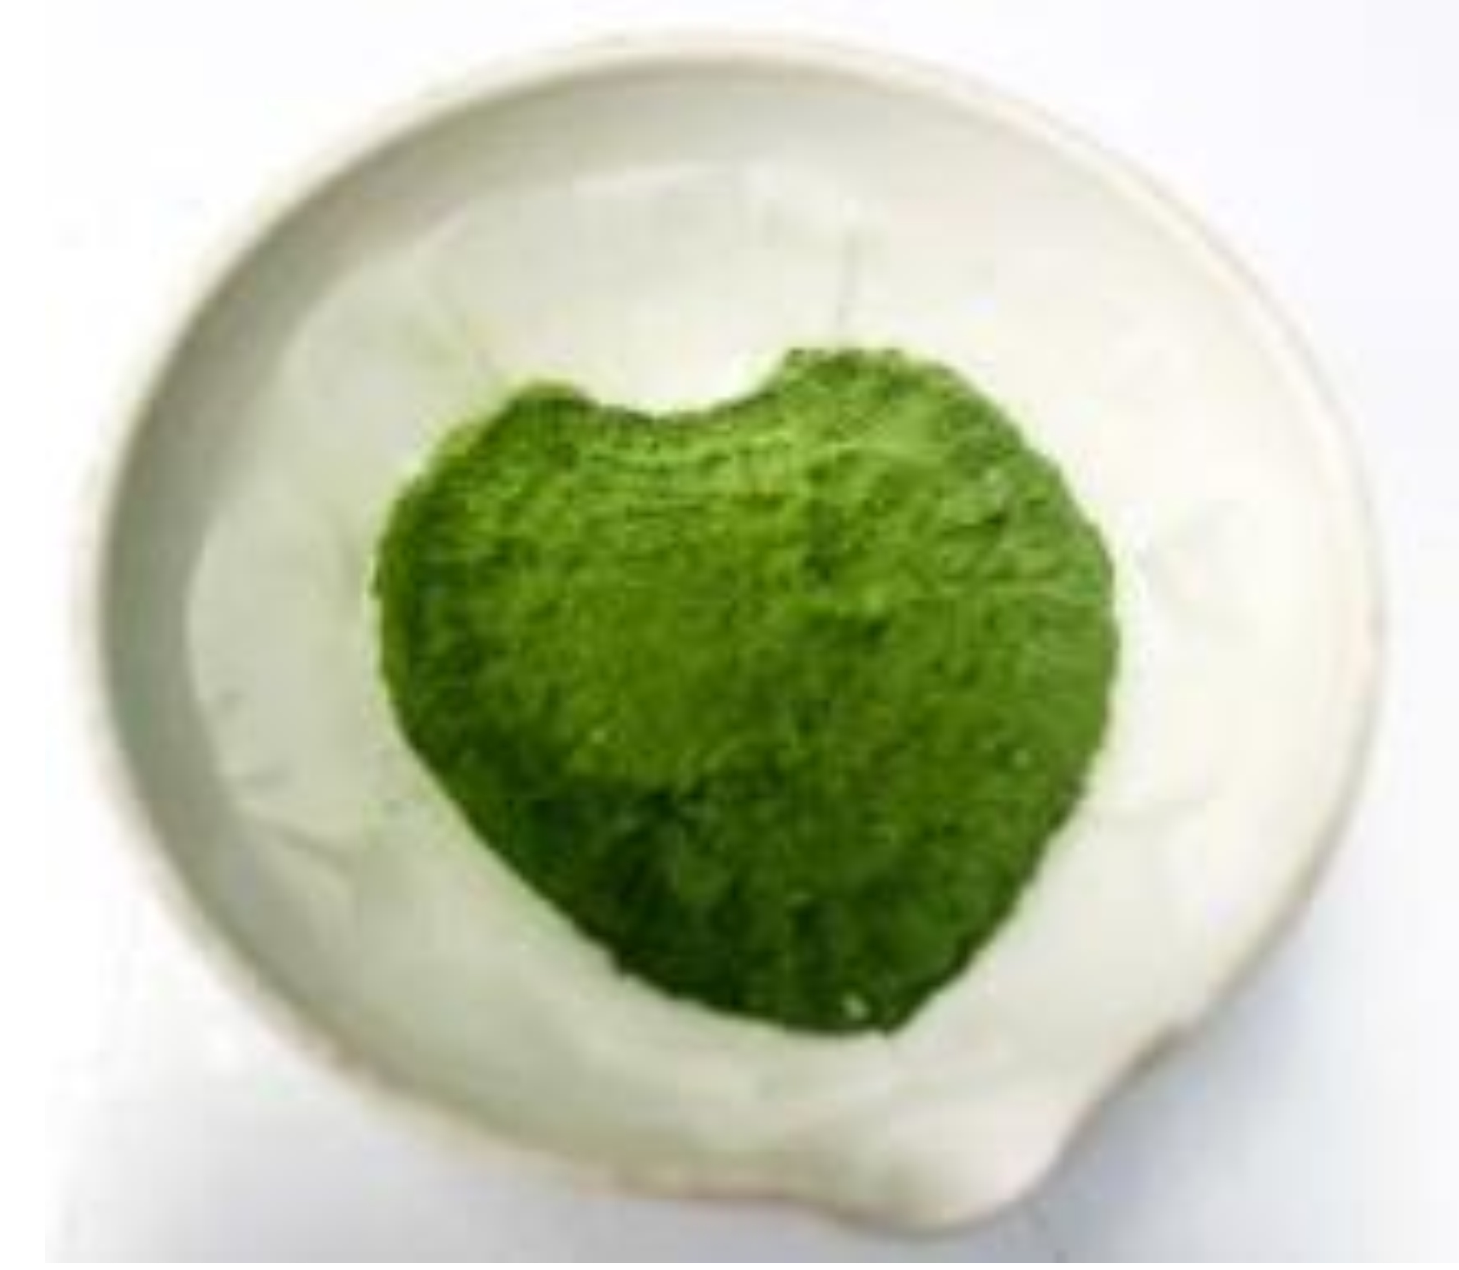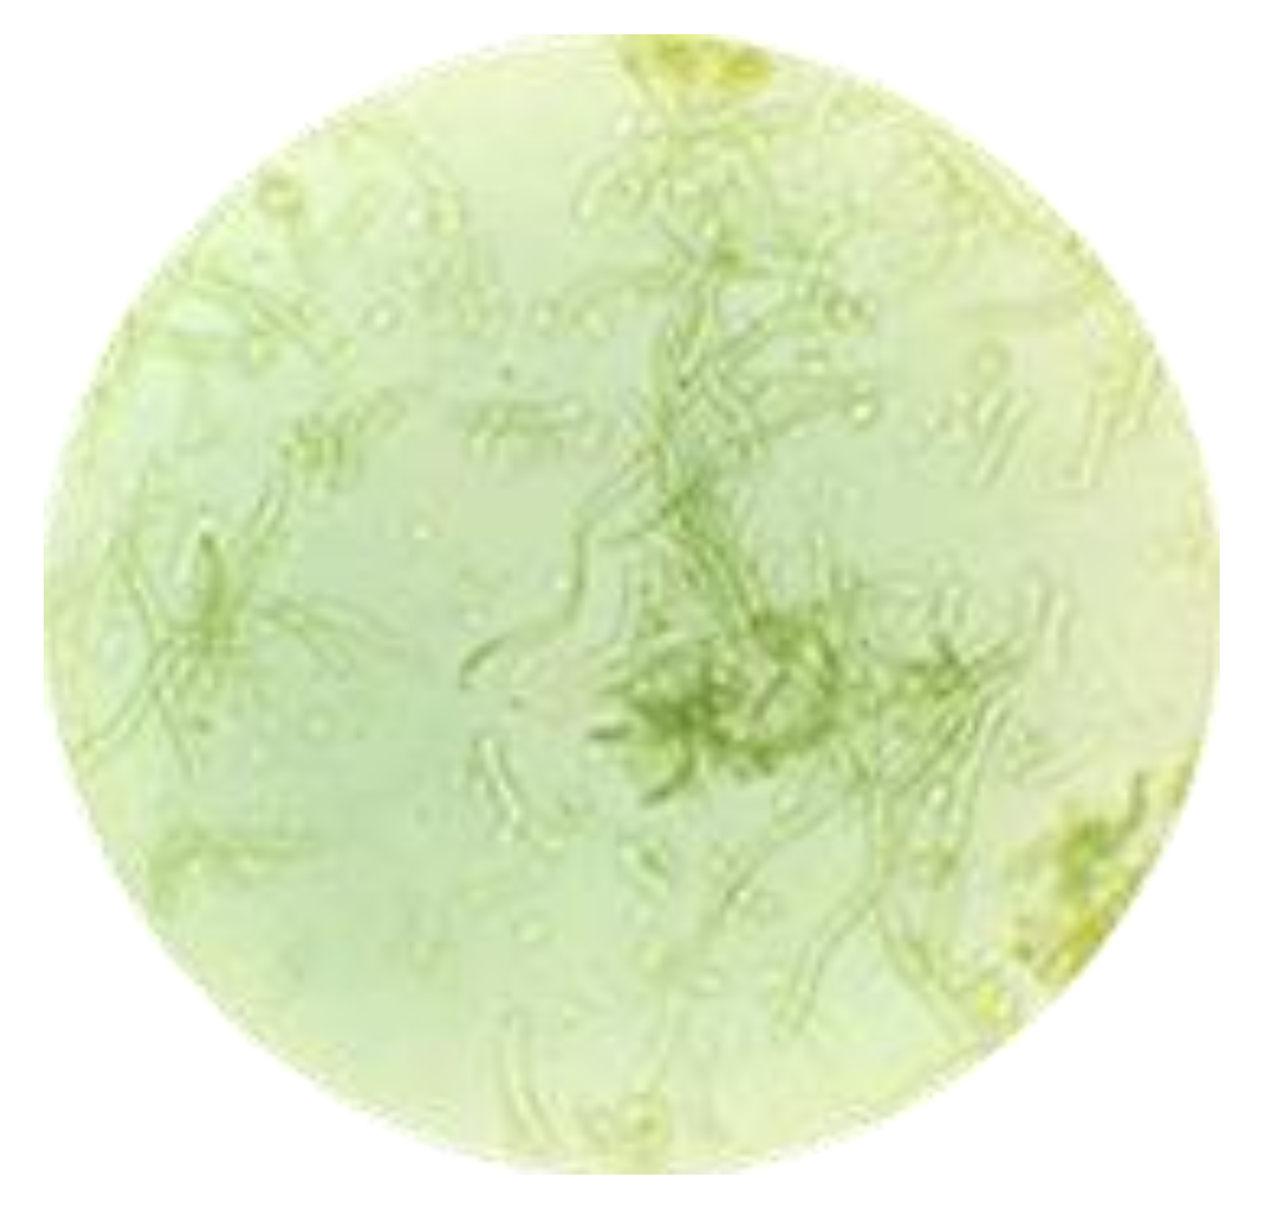
(a)
(b)

Figure.1. The Spirulina powder (a) and the cell under the optical microscope at 400X magnification (b)
  - Pigment contents of Spirulina sp. powder
Figure 2 illustrates the pigment (chlorophyll and carotenoid) contents of Japanese Spirulina sp. powder. The chlorophyll a and b contents in the microalgal powder reached values of 2.446 mg/g and 4.025 mg/g, respectively, and the total chlorophyll content was 6.471 mg/g. Conversely, the carotenoid content was recorded at 3.306 mg/g (Table 1).

Table.1. Pigment (chlorophyll and carotenoid) contents of Spirulina sp. microalgal powder
Pigments | Chlorophyll a | Chlorophyll b | Total Chlorophyll | Carotenoid
Content (mg/g) | 2.446 $±$ 0.032 | 4.025 $±$ 0.066 | 6.471 $±$ 0.120 | 3.306 $±$0.061
RSD% | 1.292 | 1.644 | 1.861 | 1.847

  - The $β-carotene$content of Spirulina sp. microalgal powder
The retention time of the 10 $μg/mL$ $β-carotene$standard in the chromatogram was approximately 11.827 minutes (Figure 2a). The linear range of $β-carotene$ was demonstrated over a concentration range of 4 to 14 $μg/mL$. The $β-carotene$ concentration achieved linearity with the following linear regression equation: y = 309758x – 444270, R2 value of 0.9995. The p-value (p < 0.05) confirmed a significant linear correlation between peak area and $β-carotene$ concentration (Figures 3 and 4 and Table 2). The analysis of the $β-carotene$ content in the Japanese Spirulina sp. microalgal powder using the established chromatographic conditions produced a retention time comparable to that of the standard sample and resulted in a value of 2.677 mg/g (Figure 2b and Table 3).

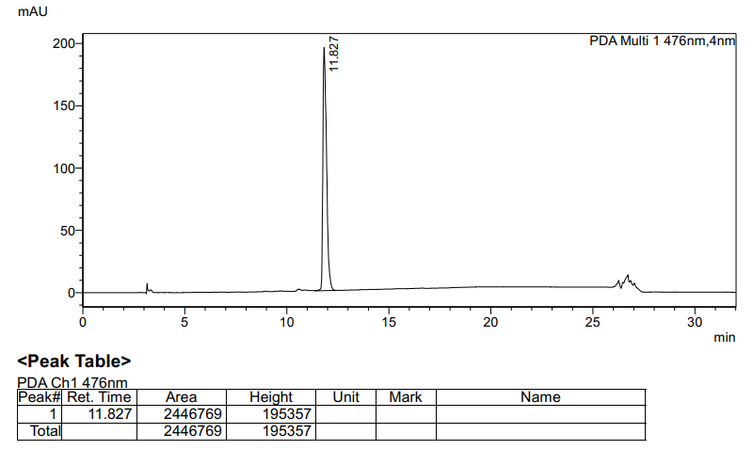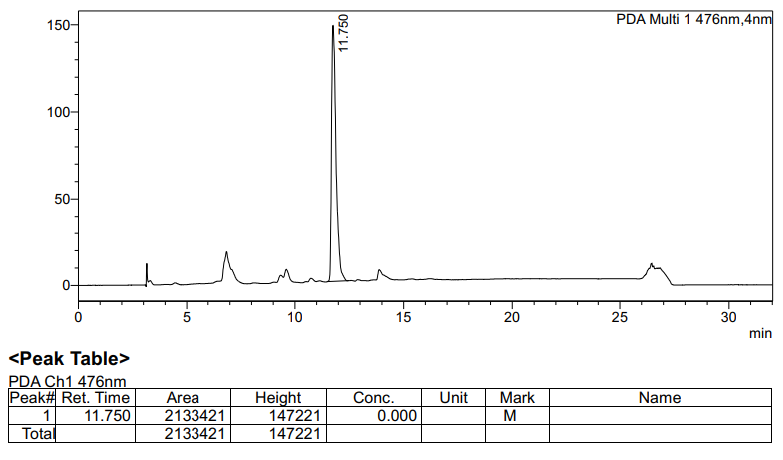
(a)
(b)

Figure.2a and 2b. $β- carotene$ standard chromatograms at concentration of 10 $μg/mL$ (a) and Spirulina microalgal powder (b)

Figure.3. $β- carotene$ standard chromatograms at concentration series ranging from 4 to 14 $μg/mL$

Figure 4. The linear regression equation of the $β- carotene$ standard at concentration series ranging from 4 to 14 $μg/mL$

Table.2. Analytical parameters for the linearity of $β- carotene$ and the gallic acid standard
Parameters | $$β- carotene$$ | Gallic acid
The linear regression equation | y = 309758x - 444270 | y = 0.0301x + 0.0352
Slope (a) | 309758 | 0.0301
Intercept (b) | - 444270 | 0.0352
R Square | 0.9995 | 0.9903
Adjusted R Square | 0.9993 | 0.9871
Significance F | < 0.05 | < 0.05
P-value | < 0.05 | < 0.05

Table.3. $β-carotene$, phenolic content and antioxidant capacity of Spirulina microalgal powder
Characteristics | Aver $±$ SD | RSD %
$β-carotene$ content (mg/g) | 2.677 $±$ 0.089 | 0.033
Phenolic content (mg/g) | 0.444 $±$ 0.088 | 0.199
Antioxidant capacity (I%) | 25.000 $±$ 0.499 | 1.734
  - Phenolic content of Spirulina microalgal powder

The linear range of gallic acid spanned the concentration range of 10 to 50 $μg/mL$, resulting in the linear regression equation: y = 0.0301x + 0.0352, R² value of 0.9903 with a p-value < 0.05, confirming linearity (Figure 5 and Table 2). The analysis of the total phenolic content of the Spirulina microalgal powder yielded a value of 0.444 mg/g (Table 3).

Figure 5. The linear regression equation of gallic acid standard at concentration series ranging from 10 to 50 $μg/mL$
  - The antioxidant capacity of the Spirulina microalgal powder
The vitamin C positive control demonstrated linearity within the concentration range of 0.5 to 4.5 µg/mL, yielding the linear regression equation y = 3.1262x + 17.226, R² value of 0.9919 and p-value (p < 0.05) (Figure 6). The antioxidant activity of Spirulina microalgal powder showed free-radical-scavenging activity of 25% (Table 3), which was equivalent to 2.487 µg/mL of vitamin C (Figure 6).

Figure.6. The linear regression equation of vitamin C standard at concentration series ranging from 0.5 to 4.5 $μg/mL$
DISCUSSION
Spirulina is a highly nutritious microalga with extensive global applications in the contemporary cosmetic and pharmaceutical industries. Its intrinsic value is derived from a diverse range of pigments—including chlorophyll, carotenoids, and phycocyanin—alongside a rich nutritional profile, most notably its high protein content. The results demonstrated that the colour of the Spirulina microalgal powder is largely determined by its chlorophyll pigmentation. The cyanobacterium Spirulina has gained substantial commercial interest as a functional food mainly because of its high protein content and high levels of pigments, including carotenoids, chlorophylls and phycocyanins. The total carotenoid, chlorophyll a and chlorophyll b contents in the extracts were 3.5 ± 0.2 mg/g, 5.7 ± 0.2 mg/g and 3.4 ± 0.3 mg/g, respectively (by dry Spirulina weight) (Marzorati et al., 2020). The extraction performance of phycocyanin and chlorophyll under diverse thermal, ultrasonic, and solvent conditions was evaluated, with maximum efficiencies reaching 14.88 mg/g and 1.400 mg/g, respectively (Nikolova et al., 2024).
Japanese Spirulina powder had a total carotenoid concentration of 3.306 mg/g, with β-carotene accounting for 2.677 mg/g—representing 80.974% of the total content. According to Park et al. (2018), all-trans-β-carotene, all-trans-zeaxanthin, 9-cis-β-carotene and diatoxanthin were found to be the major carotenoids present in spirulina. 13-cis-β-Carotene was also detected. The content of all-trans-β-carotene was highest among the four major carotenoids in AP-1, C1, C2 and C5, while that of all-trans-zeaxanthin was highest in the remaining samples. AP-1, C1 and C2 contained more than 1.6 mg/g dry weight of total carotenoids while the other samples contained less than 0.8 mg/g total carotenoid content. AP-1 showed the highest total carotenoid content of 4.43 ± 0.03 mg/g (Park et al., 2018). Using Jordan’s methodology, Spirulina was successfully cultivated in Iran. Analysis revealed that β-carotene constituted approximately 80% of the total carotenoid profile, followed closely by zeaxanthin; consequently, Spirulina serves as a precursor for vitamin A synthesis in various organisms (Valdez-Ortiz et al., 2025).
Carotenoids and phenolics constitute important antioxidant compounds in plants. Japanese Spirulina microalgal powder had a phenolic content of 0.444 mg GAE/g and an antioxidant capacity of 25%, a value equivalent to 2.487 µg/mL of vitamin C. All phenolic extracts of Spirulina demonstrated the presence of numerous phenolic acids and flavonoids as determined by HPLC-DAD profiling. Gallic, chlorogenic, cinnamic, pinostrobin and p-OH-benzoic were identified as the most abundant constituents among different extracts. Polyphenolic extracts of Spirulina exhibited antioxidant effects on CCI4-induced lipid peroxidation (inhibition %) in liver homogenate and on DPPH radical scavenging activity (with IC50 values ranging from 23.22 to 35.62 µg/ml), in a dose-dependent manner. Their protective potential was comparable to that of standard phenolic antioxidants (BHT, BHA and -tocopherol, with IC50 values ranging from 13.22 to 23.62 µg/ml). Thus, S. maxima can be considered a potent natural source of nutraceutical and functional ingredients (El-Baky et al., 2009). The antioxidant potential of Spirulina species has been evaluated. Many in vitro and in vivo studies have shown that treatment with Spirulina significantly reduces oxidative stress. These antioxidant and protective effects are mediated by phycocyanins, β-carotene, and other vitamins and minerals contained within Spirulina (Wu et al., 2016).
CONCLUSIONS
This study characterised selected biochemical components and antioxidant activity in Japanese Spirulina microalgal powder cultivated under laboratory conditions. Visual and microscopic examination showed a fine, homogeneous, green powder with intact filamentous cells. The powder contained 3.306 mg/g total carotenoids and 6.471 mg/g total chlorophyll, including 2.446 mg/g chlorophyll a and 4.025 mg/g chlorophyll b. HPLC analysis gave a β-carotene content of 2.677 mg/g, with a retention time of approximately 11.827 min and a calibration R² of 0.9995. The total phenolic content was 0.444 mg/g, while DPPH radical-scavenging activity reached 25%, corresponding to 2.487 µg/mL vitamin C. Together, these measurements describe the pigment, phenolic, and antioxidant profile of the analysed powder under the study conditions. The findings indicate that this laboratory-cultivated Spirulina powder contains biochemical constituents relevant to the proposed functional-food and pharmaceutical applications. However, the present results support compositional characterisation rather than direct evidence of product efficacy, and further validation would be required before specific applications are established.

Limitations
The study was limited to Japanese Spirulina powder cultivated under the stated laboratory conditions and to selected biochemical measurements, including pigments, β-carotene, total phenolic content, and DPPH antioxidant activity. The findings therefore describe the analysed material under these conditions and should not be generalised to other cultivation, processing, or storage conditions without additional validation. The study focused on compositional characterisation rather than the performance of the powder in finished functional-food or pharmaceutical products.

Declaration of AI Use

This manuscript was prepared through the combined contributions of all author(s), including contributions to the study design, data, content development, results, interpretation, and related scholarly work. The author(s) acknowledge the use of Grammarly and ChatGPT to assist with grammar checking, language refinement, reference formatting. These AI-assisted tools were not used as authors and did not replace the intellectual contributions or scholarly judgment of the author(s). All AI-assisted outputs, including content, references, and interpretations, were carefully reviewed, revised, verified, and approved by the author(s). The author(s) accept full responsibility for the accuracy, integrity, and final content of the manuscript.

REFERENCES
Alotaiby, S., Zhao, X., Boesch, C., & Sergeeva, N. N. (2024). Sustainable approach towards isolation of photosynthetic pigments from Spirulina and the assessment of their prooxidant and antioxidant properties. Food Chemistry, 436, 137653. https://doi.org/10.1016/j.foodchem.2023.137653
Chaudhari, A., & Manoj, K. (2024). Assessment of cow urine as a nutrient medium for indoor cultivation of Spirulina sp. Uttar Pradesh Journal of Zoology, 45(10), 84-90. https://doi.org/10.56557/upjoz/2024/v45i104052
El-Baky, H. H. A., El Baz, F. K., & El-Baroty, G. S. (2009). Production of phenolic compounds from Spirulina maxima microalgae and its protective effects. African Journal of Biotechnology, 8(24), 7059-7067. https://doi.org/10.5897/AJB2009.000-9548
İsar, M., Cirik, S., & Turan, G. (2022). Production of natural and functional pigments in Arthrospira (Spirulina) platensis cultivated in laboratory conditions. Bulletin of Biotechnology, 3(1), 11-15. https://doi.org/10.51539/biotech.1033326
Jacob, J. P., Senan, S. C., & Bhai, R. (2025). Storage-induced changes in raw vs. commercial Spirulina: A molecular, nutritional and microbial perspective. Asian Food Science Journal, 24(7), 95-104. https://doi.org/10.9734/afsj/2025/v24i7807
Khan, Z., Bhadouria, P., & Bisen, P. (2005). Nutritional and therapeutic potential of Spirulina. Current Pharmaceutical Biotechnology, 6(5), 373-379. https://doi.org/10.2174/138920105774370607
Ladjal-Ettoumi, Y., Hamadi, M., Hadjer Douik, L., Cherifi, Z., & Nazir, A. (2024). Physicochemical, functional, and nutraceutical properties of Spirulina and Chlorella biomass: A comparative study. Algal Research, 81, 103561. https://doi.org/10.1016/j.algal.2024.103561
Lichtenthaler, H. K., & Wellburn, A. R. (1983). Determinations of total carotenoids and chlorophylls a and b of leaf extracts in different solvents. Biochemical Society Transactions, 11(5), 591-592. https://doi.org/10.1042/bst0110591
Marzorati, S., Schievano, A., Idà, A., & Verotta, L. (2020). Carotenoids, chlorophylls and phycocyanin from Spirulina: supercritical CO₂ and water extraction methods for added value products cascade. Green Chemistry, 22(1), 187-196. https://doi.org/10.1039/c9gc03292d
McCarty, M. F. (2007). Clinical potential of Spirulina as a source of phycocyanobilin. Journal of Medicinal Food, 10(4), 566-570. https://doi.org/10.1089/jmf.2007.621
Nguyen, P. T., Nguyen, D. T., & Vo, T. (2025). Determination of carotenoid and beta-carotene content in Dunaliella microalgae powder. European Journal of Medical and Health Research, 3(1), 21-26. https://doi.org/10.59324/ejmhr.2025.3(1).05
Nikolova, K., Petkova, N., Mihaylova, D., Gentscheva, G., Gavrailov, G., Pehlivanov, I., & Andonova, V. (2024). Extraction of phycocyanin and chlorophyll from Spirulina by “green methods”. Separations, 11(2), 57. https://doi.org/10.3390/separations11020057
Park, W. S., Kim, H.-J., Li, M., Lim, D. H., Kim, J., Kwak, S.-S., Kang, C.-M., Ferruzzi, M. G., & Ahn, M.-J. (2018). Two classes of pigments, carotenoids and C-phycocyanin, in spirulina powder and their antioxidant activities. Molecules, 23(8), 2065. https://doi.org/10.3390/molecules23082065
Prieto, A., Cañavate, J. P., & García-González, M. (2011). Assessment of carotenoid production by Dunaliella salina in different culture systems and operation regimes. Journal of Biotechnology, 151(2), 180-185. https://doi.org/10.1016/j.jbiotec.2010.11.011
Spínola, M. P., Mendes, A. R., & Prates, J. A. (2024). Chemical composition, bioactivities, and applications of Spirulina (Limnospira platensis) in food, feed, and medicine. Foods, 13(22), 3656. https://doi.org/10.3390/foods13223656
Valdez-Ortiz, A., Meza-Ayala, K. A., García-Padilla, J. M., Valdez-Ortiz, R., & Germán-Báez, L. J. (2025). Pigments from microalgae: Chlorophyll, carotenoids, and phycobiliproteins as source of natural colorants for food. In D. U. Santos Ballardo & S. Rossi (Eds.), Microalgae as promising source of commercial bioproducts: Advances and emerging technologies in bioactive compounds, biofuels, food and biorefineries (pp. 153–175). Springer. https://doi.org/10.1007/978-3-031-86433-9_11
Wu, Q., Liu, L., Miron, A., Klímová, B., Wan, D., & Kuča, K. (2016). The antioxidant, immunomodulatory, and anti-inflammatory activities of Spirulina: An overview. Archives of Toxicology, 90(8), 1817-1840. https://doi.org/10.1007/s00204-016-1744-5

