Comparative effects of four liquid fertilizers on the growth and yield of pepper (Capsicum annuum L.) under soilless cultivation in southern Côte d’Ivoire

Abstract
In the face of growing demand for vegetable crops, particularly solanaceous species, the excessive use of synthetic fertilisers and the degradation of arable soils are major constraints on agricultural production in West African urban and peri-urban areas. Soilless cultivation is therefore gaining importance as an alternative production system that is less dependent on soil quality. This study compared the effects of four liquid fertilisers - two organic (a poultry manure extract and a manure-based fertiliser) and two mineral fertilisers (Nutrigofol 8-8-8 and NPK 12-22-22, with the latter serving as the control) - on the growth and yield of pepper grown under soilless conditions, with the broader aim of identifying nutrient solutions that could reduce growers’ dependence on chemical fertilisers. The trial followed a randomised complete block design with four replicates. Treatment had a significant effect on most growth and yield parameters (p < 0.001). The organic fertilisers, particularly the poultry manure extract, produced significantly higher values than the mineral fertilisers for floral bud number, fruit number, fruit mass, and estimated yield. Estimated yield reached 5.11 t ha⁻¹ with the poultry manure extract, followed by the manure-based fertiliser (3.69 t ha⁻¹), Nutrigofol 8-8-8 (2.81 t ha⁻¹), and NPK 12-22-22 (2.64 t ha⁻¹). Because no unfertilised control was included, these results describe the relative performance of the four fertilisers rather than their absolute agronomic efficiency. Within this comparative scope, the findings indicate that organic nutrient solutions derived from locally available livestock waste can support pepper productivity in soilless systems at least as well as, and for several parameters better than, the mineral fertilisers tested. Valorising such organic waste as low-cost biofertilisers could contribute to more affordable and resilient vegetable production for expanding West African cities, provided these trends are confirmed against an unfertilised control and under real production conditions.
Keywords: Fertilizers, pepper, yield, soilless cultivation, vegetable

Introduction
Rapid demographic growth is intensifying food-security challenges worldwide. Nearly 98% of undernourished people live in developing countries, mainly in sub-Saharan Africa (Wudil et al., 2022), where food insecurity is closely linked to climate change and its adverse effects on established agricultural production models. In Côte d’Ivoire, climate variability is already affecting the country’s various agricultural production systems (Timité et al., 2022). Current production models therefore need to be reconsidered to meet the food needs of the population, particularly urban populations, in both quantity and quality.
Côte d’Ivoire has committed to a more dynamic agricultural sector built on renewed production systems (United Nations Industrial Development Organization, 2022). Production systems historically centred on export crops such as cocoa, coffee, oil palm, rubber, and timber are being transformed through the introduction of technological farm-monitoring tools and diversified through agroecological, permanent market-gardening systems. These systems contribute to urban greening and to the health of urban and peri-urban populations, while also helping to mitigate and adapt to climate change, reduce carbon footprints, strengthen urban-rural links, and support sustainable urban development.
This diversification also gives urban populations access to fresh, nutritious food. It does so at a lower cost than food transported over long distances. Among the vegetables whose production needs to expand in urban areas, sweet pepper (Capsicum annuum L.), commonly known as capsicum, still occupies a marginal position (Diarra et al., 2018). Pepper production in Côte d’Ivoire is limited by several abiotic and biotic constraints that reduce yields (Gnimassoun et al., 2020; Yarou et al., 2017), including (i) the degradation and loss of arable land through soil artificialisation; (ii) pest pressure; (iii) the seasonal nature of production; and (iv) long distribution chains for perishable produce. The over-exploitation of arable land linked to population growth and shortened fallow cycles is also driving yield decline (Kassin, 2013). Fallowing remains the main natural mechanism for restoring soil fertility (Mosier et al., 2021), but high pressure on land tenure makes it increasingly difficult to leave land fallow.
Restoring the fertility of agricultural land, for instance through fast-growing trees, ground-cover legumes, or other soil-improvement practices, is one way to offset falling yields. Another common response is to intensify production, generally through heavy use of chemical fertilisers and pesticides to boost short-term yields (Kopittke et al., 2019). However, the overuse of mineral fertilisers tends to acidify and salinise the soil, accelerating rather than reversing the loss of fertility (Wang et al., 2022). Efficient techniques that overcome these constraints are therefore needed. Intensive urban soilless cultivation is one such alternative and could be extended to several vegetable crops, provided accessible, low-cost solutions are developed for growers, notably efficient nutrient solutions adapted to local conditions and the use of organic matter to manage substrate fertility. In urban and peri-urban areas, manure and other organic residues from animal husbandry are regularly discarded near production sites instead of being recycled, even though their nutrient content makes them potentially valuable fertilisers for quality vegetable production.
Recent evidence from soilless and protected Capsicum production indicates that biofertiliser-supported nutrient management can reduce reliance on conventional mineral fertilisation while maintaining crop performance, whereas excessive fertigation does not necessarily improve greenhouse capsicum performance (Dasgan et al., 2023; Dauda et al., 2025). A recent study in pepper further showed that corn steep liquor, an agro-industrial by-product, can support vegetative growth under reduced nitrogen supply (Navarro-Morillo et al., 2024). Field studies with sweet pepper have also documented positive growth and yield responses to poultry manure and other organic manures (Rufa’i et al., 2024; Rosyara et al., 2025).
Organic matter is recognised to play a key role in the soil fertility of urban vegetable systems (Gnimassoun, Bolou-Bi, & Konan, 2024; Kuma, 2024). However, urban farmers in Côte d’Ivoire remain reluctant to use these organic residues because of the long duration of the composting process. Despite this potential, the literature summarised above provides limited evidence on the comparative performance of a locally prepared liquid poultry-manure fertiliser against both organic and mineral nutrient solutions for soilless pepper production under urban conditions in southern Côte d’Ivoire. This study therefore aimed to assess the agronomic effectiveness of a liquid organic fertiliser derived from poultry-farming waste by comparing it with other organic and mineral nutrient solutions already available to growers, with a view to improving pepper production in urban areas of Côte d’Ivoire.
Materials and methods
Study area
The study area is located in the district of Abidjan, in southern Côte d’Ivoire, West Africa. The trial was carried out in an experimental growing shelter at the Université Nangui Abrogoua (UNA), located between 5°17’ and 5°3’ N and 3°45’ and 4°22’ W. The UNA campus is bounded to the north by the commune of Abobo, near the Banco Forest (Figure 1).
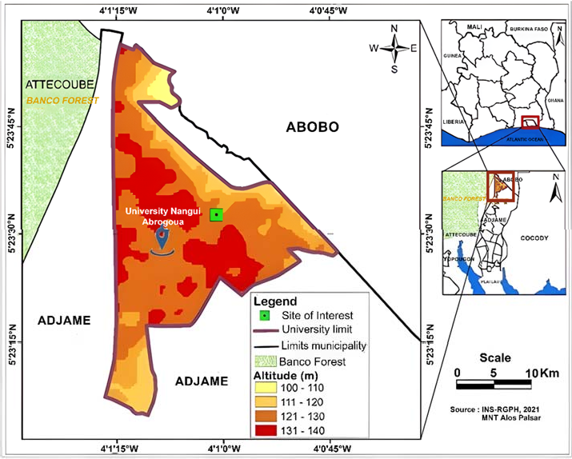
Figure 1. Location of the study site.

Nutrient solution preparation
The poultry-manure-based broth was prepared in a 100 L container. Five kilograms of poultry droppings, 1 kg of fresh neem leaves, 500 g of green papaya leaves, 1 kg of chopped lemongrass leaves, 4 garlic cloves, and 200 g of chilli powder were successively added to the container and topped up with 100 L of water. The mixture was homogenised, and the container was sealed hermetically to allow fermentation for 7 days. After fermentation, the solution was filtered through a 0.5 mm mesh and diluted to 20% before use as a plant nutrient solution. Because it combines neem, garlic, and chilli - ingredients also recognised for their pest-repellent properties - this broth is likely to provide biopesticidal as well as fertilising benefits, although the present study did not evaluate its effect on pest incidence.
The other nutrient solutions were obtained by diluting the respective fertilisers in water, and all solutions were applied to irrigate plants in the growing pots following the manufacturers’ recommendations. The doses used were as follows: (i) nutrient solution based on liquid organic fertiliser selected from purins, applied at 5% (50 mL of stock solution diluted in 1 L of water); (ii) nutrient solution based on Nutrigofol 8-8-8 liquid mineral fertiliser, applied at 1% (10 mL of stock solution diluted in 1 L of water); and (iii) nutrient solution based on NPK 12-22-22 mineral fertiliser as the control, applied at 1.4 g dissolved in 1 L of water.
Experimental set-up
The study evaluated the effect of nutrient solutions derived from different organic and mineral fertilisers on the growth and yield of pepper. Four treatments were applied: TM (NPK 12-22-22 mineral fertiliser, as the control), TC (poultry manure-based broth), TN (Nutrigofol 8-8-8 mineral fertiliser), and TP (organic fertiliser selected from liquid manure). The trial followed a randomised complete block design with 4 replicates of 16 individual plants per treatment (Figure 2), grown in pots filled with inert sand.

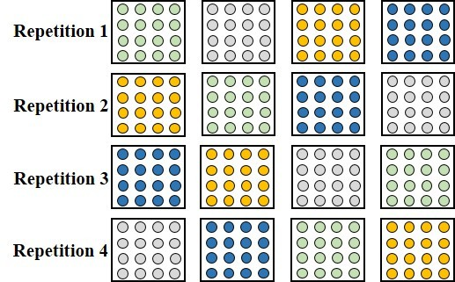

Figure 2. Experimental set-up with the four replicates (green: TM; grey: TC; blue: TN; orange: TP). Circles represent individual pepper plants within each growing pot.

Measurements of agromorphological parameters began two weeks after transplanting, using the four pepper plants located at the centre of each replicate. The parameters recorded were plant height, collar diameter, number of green leaves, number of branches, number of floral buds and flowers, fruit circumference, fruit mass, number of fruits harvested per treatment, and yield. Yield was estimated as:
Yield (kg ha⁻¹) = [yield (g plant⁻¹) × total plants per ha] / 1000
Data analysis
Data normality was assessed using the Shapiro-Wilk test and homogeneity of variance using Levene’s test. One-way analysis of variance (ANOVA) was then performed on normally distributed data and the Kruskal-Wallis test on non-parametric data, at a significance threshold of 0.05. Statistical analyses were performed in R (version 4.1.3, 64-bit). Where a significant treatment effect was detected (p < α, α = 0.05), means were compared pairwise using Tukey’s test to identify the treatment(s) responsible for the difference.

Results
Chemical composition of the poultry-manure-based broth
Table 1 shows the chemical composition of the poultry-manure-based broth obtained after fermentation of the organic matter. The broth was close to neutral pH and contained good levels of K, Ca, and Mg. Nitrogen and organic carbon contents were high, with a C/N ratio of 7.84 ± 1.84.

Table 1. Chemical composition of the poultry-manure-based broth.

pH | C (%) | N (%) | P (mg L⁻¹) | K (mg L⁻¹) | Ca (mg L⁻¹) | Mg (mg L⁻¹)
7.57 ± 0.28 | 2.43 ± 0.53 | 0.32 ± 0.08 | 2.13 ± 0.29 | 207.89 ± 21.55 | 74.00 ± 6.51 | 29.66 ± 2.67

Effect of fertilisers on vegetative parameters
Figure 3 shows changes in plant height after transplanting. Plants receiving the manure-based broth (TC) reached the greatest average heights, followed by those receiving liquid manure (TP), in contrast to plants fertilised with Nutrigofol (TN) and NPK (TM). However, analysis of variance showed no statistically significant difference in plant height among treatments (p = 0.17).
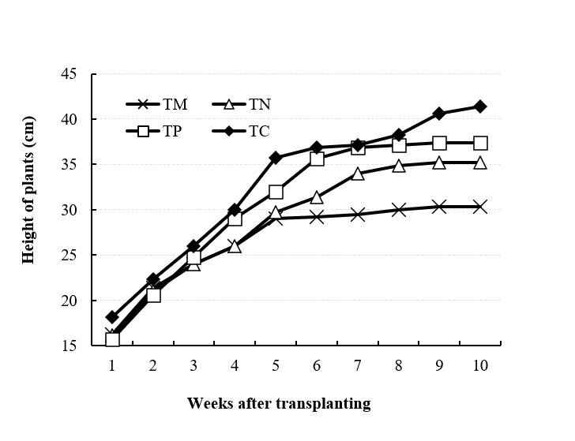
Figure 3. Evolution of average pepper plant height as a function of treatment over time. TM: NPK mineral fertilizer (1.4 g L⁻¹); TN: Nutrigofol 8-8-8 (1%); TP: purin liquid organic fertilizer (5%); TC: liquid compost (20%).

Changes in stem diameter are shown in Figure 4. Plants receiving the manure-based broth had the greatest average stem diameter, followed by those receiving liquid manure, whereas plants fertilised with Nutrigofol and NPK had smaller average stem diameters. In contrast to plant height, collar diameter showed a significant treatment effect from the first to the sixth week of cultivation (p < 0.05).
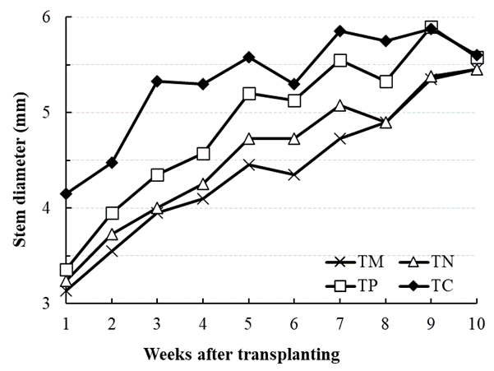
Figure 4. Changes in stem diameter of pepper plants as a function of treatment over time. TM: NPK mineral fertilizer (1.4 g L⁻¹); TN: Nutrigofol 8-8-8 (1%); TP: purin liquid organic fertilizer (5%); TC: liquid compost (20%).

Figure 5 shows the average number of branches per plant at 77 days after transplanting. Fertiliser had a significant effect on branch number (p < 0.05): TC gave the highest mean number of branches and TM the lowest, while TP was statistically intermediate and not significantly different from TN.
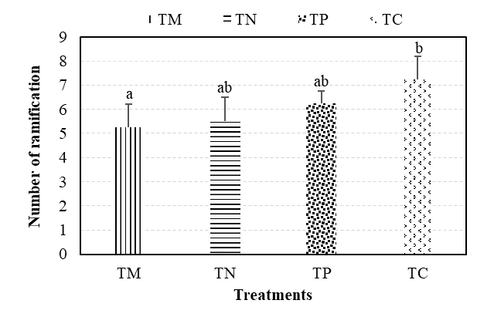
Figure 5. Change in number of branches as a function of treatment at 77 days after transplanting. Means sharing the same letter are not significantly different at the 5% level.

Leaf production per plant over the growing period is shown in Figure 6. Leaf number increased from about 6 to 25 between weeks 1 and 10 across all treatments, with the highest mean values recorded for plants receiving the manure-based broth and the lowest for those receiving NPK. However, this difference was not statistically significant (p > 0.05).
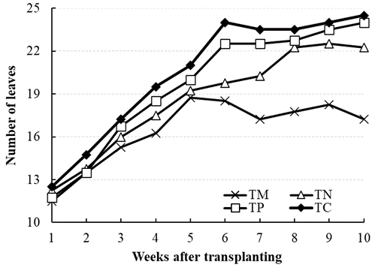
Figure 6. Evolution of the average number of leaves as a function of treatment over time.

Effect of fertilisers on yield parameters
Table 2 summarises pepper production parameters at 77 days after transplanting. Treatment had a highly significant effect on floral bud number and flower number (p < 0.001 for both). For both parameters, TC differed significantly from all other treatments (increases of 76–155% for buds and 72–192% for flowers relative to the other treatments), TP differed significantly from TM, and TN did not differ significantly from either TM or TP.
The number of fruits harvested per plant also differed significantly among treatments (p < 0.001). TC (26.50 ± 1.91) produced significantly more fruit than TM and TN (33–139% more) but was not significantly different from TP. TP itself did not differ significantly from either TM or TN, despite numerically higher mean values (66–81% higher).
Fruit diameter differed significantly among treatments overall (p = 0.029), but the pairwise comparisons showed a more nuanced pattern than for the other parameters: only TC differed significantly from TM, with TC producing larger fruit. TN and TP were statistically intermediate, not differing significantly from either TM or TC.
Fruit mass differed significantly among treatments (p < 0.001). TC produced significantly heavier fruit than all other treatments. TP produced significantly heavier fruit than TM but was not significantly different from TN. TN and TM did not differ significantly from each other.
Estimated yield differed significantly among treatments (p < 0.001). TC gave the highest yield, significantly greater than all other treatments: 38%, 82%, and 94% higher than TP, TN, and TM, respectively. TP gave a significantly higher yield than TM (40% higher) but was not significantly different from TN, despite a 31% numerical advantage. TN and TM did not differ significantly from each other.

Table 2. Descriptive statistics of pepper production parameters at 77 days after transplanting under the four experimental treatments.

Variable | Treatment* | Mean ± SD** | CV (%) | n | Min | Max
Number of floral buds | TM | 17.75 ± 1.00ª | 5.56 | 4 | 17.00 | 19.00
Number of floral buds | TN | 18.00 ± 5.00^{ab} | 27.78 | 4 | 13.00 | 23.00
Number of floral buds | TP | 26.25 ± 3.00^{b} | 11.54 | 4 | 23.00 | 29.00
Number of floral buds | TC | 45.50 ± 2.00^{c} | 4.35 | 4 | 44.00 | 48.00
Number of flowers | TM | 13.25 ± 5.05ª | 38.46 | 4 | 8.00 | 18.00
Number of flowers | TN | 15.00 ± 2.92^{ab} | 13.33 | 4 | 13.00 | 17.00
Number of flowers | TP | 22.25 ± 4.57^{b} | 22.73 | 4 | 17.00 | 27.00
Number of flowers | TC | 38.25 ± 0.50^{c} | 2.63 | 4 | 37.00 | 39.00
Number of fruits harvested | TM | 11.00 ± 7.00ª | 63.64 | 4 | 4.00 | 18.00
Number of fruits harvested | TN | 12.00 ± 2.44ª | 16.67 | 4 | 10.00 | 14.00
Number of fruits harvested | TP | 20.00 ± 5.41^{ab} | 25.00 | 4 | 15.00 | 25.00
Number of fruits harvested | TC | 26.50 ± 1.91^{b} | 5.80 | 4 | 25.00 | 28.00
Fruit diameter  (cm) | TM | 14.56 ± 0.89a | 5.52 | 4 | 13.70 | 15.30
Fruit diameter  (cm) | TN | 14.70 ± 0.70^{ab} | 4.76 | 4 | 14.00 | 15.40
Fruit diameter  (cm) | TP | 14.90 ± 1.62^{ab} | 10.00 | 4 | 13.50 | 16.50
Fruit diameter  (cm) | TC | 16.93 ± 0.68^{b} | 3.53 | 4 | 16.40 | 17.60
Fruit mass  (g) | TM | 75.37 ± 18.72ª | 24.00 | 4 | 57.00 | 93.00
Fruit mass  (g) | TN | 80.34 ± 8.88^{ab} | 10.00 | 4 | 72.00 | 88.00
Fruit mass  (g) | TP | 105.57 ± 12.28^{b} | 11.43 | 4 | 93.00 | 117.00
Fruit mass  (g) | TC | 145.90 ± 4.66^{c} | 3.45 | 4 | 140.00 | 150.00
Estimated yield  (kg ha⁻¹) | TM | 2605.70 ± 700ª | 26.92 | 4 | 1900 | 3300
Estimated yield  (kg ha⁻¹) | TN | 2811.90 ± 400^{ab} | 10.71 | 4 | 2500 | 3100
Estimated yield  (kg ha⁻¹) | TP | 3694.95 ± 400^{b} | 10.81 | 4 | 3300 | 4100
Estimated yield  (kg ha⁻¹) | TC | 5106.76 ± 200^{c} | 4.00 | 4 | 4800 | 5200
*TM: NPK mineral fertilizer (1.4 g L⁻¹); TN: Nutrigofol 8-8-8 liquid mineral fertilizer (1%); TP: purin liquid organic fertilizer (5%); TC: liquid compost (20%). **Means followed by the same letter, within a parameter, are not significantly different at the 5% probability level (Tukey’s test).

Discussion
Plant height and leaf number did not differ significantly among treatments. This could reflect either a genuinely similar effect of the different nutrient solutions on these two parameters or insufficient statistical power given the number of replicates. Zadi et al. (2018) similarly found that coconut seedlings fertilised organically at an average dose of 839 g grew at rates comparable to those receiving chemical fertiliser. Stem diameter and branch number, by contrast, differed significantly among treatments, with organic fertilisers (manure-based broth and liquid manure) outperforming the mineral fertilisers. This is consistent with the more readily available nutrients that organic amendments typically supply at early growth stages (Zhou et al., 2022). Wang et al. (2020) likewise found that organic fertiliser improved vegetative growth in maize, and Gnimassoun, Bolou-Bi, and Ouattara (2024) and Berhe et al. (2022) reported comparable results for pepper. Within the category of organic amendments, poultry droppings in particular have been shown to promote branching in pistachio (Mahmoudi Meimand et al., 2018), an effect attributed to the gradual release of minerals from poultry manure, which keeps nutrients available throughout much of the crop cycle (Thepsilvisut et al., 2022).
Fertiliser type also had a significant effect on yield parameters and fruit quality, with organic fertilisation generally favouring bud, flower, and fruit production over mineral fertilisation. In the present study, the highest values were obtained with the poultry-manure-based broth (TC, applied at 20%), followed by the liquid-manure fertiliser (TP, applied at 5%). Organic fertilisers are generally more soluble and therefore more readily assimilated by the plant (Shaji et al., 2021), which is consistent with several previous reports: Eze et al. (2024) found that compost enriched with poultry droppings significantly increased carrot yields; Gnimassoun (2021) and Nejati Sini et al. (2024) reported that organic fertilisation of pepper increased fresh and dry fruit weight, fruit number, and yield per plant; and Okoli et al. (2021) showed that organic fertilisation with pig dung and poultry droppings significantly increased the growth and yield of fluted pumpkin (Telfairia occidentalis) compared with NPK. Babu et al. (2021) attributed the high agronomic value of poultry manure to the fact that 60–90% of its nitrogen content is already in mineral form and therefore directly available to the plant. Because Gnimassoun (2021), Okoli et al. (2021), and Nejati Sini et al. (2024) each derived dosage guidelines for organic livestock residues applied to other vegetable species, guidelines that the present study also followed, it is plausible that other vegetable crops grown in similar soils or substrates could benefit from comparable organic amendments; this warrants dedicated testing rather than extrapolation from the present dataset.
These findings should, however, be interpreted within the limits of the experimental design. The trial did not include an unfertilised absolute control, so the four treatments can only be ranked relative to one another (TC > TP > TN ≈ TM for most reproductive and yield parameters); the data do not indicate whether, or to what extent, any of the fertilisers improved growth or yield compared with unfertilised plants, nor do they establish the fertilisers’ absolute agronomic efficiency. No economic analysis was performed either, so claims about the cost-effectiveness or profitability of the organic fertilisers relative to the mineral fertilisers cannot yet be supported. Confirming the agronomic and economic value of the poultry-manure-based broth will require follow-up trials that include an absolute control and a cost-benefit assessment, ideally conducted under real production conditions rather than in an experimental shelter.
Conclusion
This study compared four liquid fertilisers - two organic and two mineral - as nutrient solutions for pepper grown under soilless conditions in urban Côte d’Ivoire. The poultry-manure-based broth (TC) had a favourable chemical composition (near-neutral pH, adequate C/N ratio, and good K, Ca, and Mg content) and, among the four treatments tested, was consistently associated with the highest values for most reproductive and yield parameters - floral bud number, flower number, fruit number, fruit mass, and estimated yield - followed by the liquid-manure fertiliser (TP), while the two mineral fertilisers (TN and TM) generally gave the lowest values. This pattern is consistent with the more readily available nutrients typically supplied by organic fertilisers at early growth stages, as reported in other pepper and vegetable studies.
Because the trial did not include an unfertilised control, these conclusions describe the relative ranking of the four fertilisers and should not be read as evidence that any of them improves pepper growth or yield in absolute terms, nor as a demonstration of soil-fertility restoration, which was not directly assessed here. Within this comparative scope, the results nonetheless suggest that liquid organic fertilisers derived from locally available poultry waste are promising, low-cost alternatives to the mineral fertilisers currently used by soilless growers in and around Ivorian cities. Confirming this potential, together with its implications for organic-waste valorisation, production costs, and eco-friendly urban agriculture in Côte d’Ivoire and other tropical contexts, will require further trials that include an absolute control, an economic evaluation, and testing under real production conditions.
Limitations
The experiment compared four fertiliser treatments without an unfertilised control; therefore, it establishes only their relative performance and not absolute agronomic efficiency. The study was conducted in an experimental growing shelter rather than under commercial production conditions, and no economic analysis was undertaken. In addition, the potential biopesticidal effect of the poultry-manure-based broth was not evaluated. These constraints limit conclusions concerning absolute yield benefits, profitability, and performance under real production conditions.

Competing interests
The authors declare no conflicts of interest.
Data availability statement
The data presented in the tables and figures are available on request.
Declaration of AI Use

This manuscript was prepared through the intellectual contributions of the author(s) to the study design, data analysis, interpretation of results, and scholarly content. Grammarly and ChatGPT were used solely to assist with grammatical refinement and reference formatting during manuscript revision. The author(s) accept full responsibility for the accuracy, integrity, and final content of the manuscript.

References
Babu, A., Dadrwal, B. K., Singh, U. P., Jakhar, R. K., & Meena, R. (2021). Use of poultry manure as organic fertilizer in different crops. The Agriculture Magazine, 1(1), 14–15. https://theagricultureonline.com/wp-content/uploads/2021/12/8.pdf
Berhe, D. T., Zergaw, Y., & Kebede, T. (2022). Organic amendments: Direct application and residual effects on vegetative and reproductive growth of hot pepper. The Scientific World Journal, 2022, Article 2805004. https://doi.org/10.1155/2022/2805004
Dasgan, H. Y., Yilmaz, M., Dere, S., Ikiz, B., & Gruda, N. S. (2023). Bio-fertilizers reduced the need for mineral fertilizers in soilless-grown capia pepper. Horticulturae, 9(2), 188. https://doi.org/10.3390/horticulturae9020188
Dauda, S. O., Cortellazzi, C., Panchal, S. K., Yong, M., Babla, M., Donovan-Mak, M., Bose, J., Li, L., Liang, W., Tissue, D., Ahmed, T., Huda, S., He, J., & Chen, Z.-H. (2025). Large variation of fertiliser levels does not improve physiology, nutritional quality and economic return of greenhouse capsicum. Plant Growth Regulation, 105, 2215–2230. https://doi.org/10.1007/s10725-025-01403-6
Diarra, M., Kouadio, D. L., Aboua, N. K., Soro, D. B., Kouadio, A., Traoré, K. S., Koné, M., & Dembélé, A. (2018). Niveau de contamination du poivron (Capsicum L., 1753) par les pesticides. European Scientific Journal, 14(6), 432–442. https://doi.org/10.19044/esj.2018.v14n6p432
Eze, F. O., Mukosha, C. E., Anozie, C., Moudrý, J., Ali, S., Ghorbani, M., Amirahmadi, E., Baloch, S. B., & Baiyeri, K. P. (2024). Response of carrots (Daucus carota) on the growth, yield, and nutritional composition to varying poultry manure rates. Agricultural Research, 13, 841–850. https://doi.org/10.1007/s40003-024-00723-9
Gnimassoun, K. E.-G., Ettien, D. J. B., Bouadou, O. B. F., & Masse, D. (2020). Effect of empty fruit bunch compost on improving the productivity of two vegetables produced under sandy poor soil in organic matter in the south-west of Côte d’Ivoire. European Journal of Scientific Research, 157(2), 142–157. https://www.europeanjournalofscientificresearch.com/issues/PDF/EJSR_157_2_03.pdf
Gnimassoun, K. E.-G. (2021). Effets combinés du compost de rafles de palmier et de la fiente de volaille sur la fertilité des sols sableux sous culture de piment (Capsicum frutescens) et d’aubergine (Solanum aethiopicum anguivi) dans la localité de Grand-Lahou, sud-ouest de la Côte d’Ivoire [Doctoral dissertation, Université Félix Houphouët-Boigny].
Gnimassoun, K. E.-G., Bolou-Bi, E. B., & Konan, K. R. (2024). Effectiveness of organic fertilizers in improving soil fertility, productivity, and quality of carrots (Daucus carota) in Southern Côte d’Ivoire. Annual Research & Review in Biology, 39(9), 39–49. https://doi.org/10.9734/arrb/2024/v39i92116
Gnimassoun, K. E.-G., Bolou-Bi, E. B., & Ouattara, M. D. (2024). Effects of organic amendments on soil chemistry, fauna diversity, and pepper growth in Côte d’Ivoire, West Africa. International Journal of Plant & Soil Science, 36(7), 955–968. https://doi.org/10.9734/ijpss/2024/v36i74808
Kassin, K. E. (2013, February 4–6). Systèmes agricoles en danger: Actions prioritaires pour l’adaptation au changement climatique: Statut, besoins et priorités en matière de gestion durable des sols en Côte d’Ivoire [Conference presentation]. Regional Conference on the West and Central African Soil Partnership, Accra, Ghana. https://www.fao.org/fileadmin/user_upload/GSP/docs/West_africa_partner/CoteD_Ivoire_Assin.pdf
Kopittke, P. M., Menzies, N. W., Wang, P., McKenna, B. A., & Lombi, E. (2019). Soil and the intensification of agriculture for global food security. Environment International, 132, 105078. https://doi.org/10.1016/j.envint.2019.105078
Kuma, A. (2024). Effect of different types of organic manures and mulching materials on growth, yield and quality of carrot (Daucus carota L.) in Diguna Fango Woreda, South Ethiopia [Preprint]. Research Square. https://doi.org/10.21203/rs.3.rs-4512979/v1
Mahmoudi Meimand, M. J., Shamshiri, M. H., Roosta, H. R., & Khan, E. U. (2018). Poultry manure application time and pistachio (Pistacia vera L.) trees. Advances in Horticultural Science, 32(2), 177–183. https://doi.org/10.13128/ahs-21898
Mosier, S., Córdova, S. C., & Robertson, G. P. (2021). Restoring soil fertility on degraded lands to meet food, fuel, and climate security needs via perennialization. Frontiers in Sustainable Food Systems, 5, 706142. https://doi.org/10.3389/fsufs.2021.706142
Navarro-Morillo, I., Blasco, B., Cámara-Zapata, J. M., Muñoz-Acero, J., Simón-Grao, S., Alfosea-Simón, M., Plasencia, F., & García-Sanchez, F. (2024). Corn steep liquor application on pepper plants (Capsicum annum L.) stimulates growth under nitrogen-deficient growing conditions. Scientia Horticulturae, 328, 112955. https://doi.org/10.1016/j.scienta.2024.112955
Nejati Sini, H., Barzegar, R., Soodaee Mashaee, S., Ghasemi Ghahsare, M., Mousavi-Fard, S., & Mozafarian, M. (2024). Effects of biofertilizer on the production of bell pepper (Capsicum annuum L.) in greenhouse. Journal of Agriculture and Food Research, 16, 101060. https://doi.org/10.1016/j.jafr.2024.101060
Okoli, E. E., Ekesiobi, I. A., & Nworji, M. J. (2021). Effect of organic manure (poultry droppings, cow manure, and pig manure) and inorganic fertilizer (NPK 15:15:15) on the growth and yield of fluted pumpkin (Telfairia occidentalis). The International Journal of Science & Technoledge, 9(1), 32–36. https://doi.org/10.24940/theijst/2021/v9/i1/ST2101-013
Rosyara, U., Bam, R., Chaudhary, R., & Kathayat, L. (2025). Effects of different sources of organic manure on growth and yield performance of sweet pepper (Capsicum annuum L.). Asian Journal of Plant and Soil Sciences, 10(1), 94–105. https://doi.org/10.56557/ajopss/2025/v10i1119
Rufa’i, S., Bala, B., Shittu, E. A., Lado, A., Isa, H. M., & Bello, T. T. (2024). Effect of bioactive compound (poultry manure) on the yield and capsaicinoid content of sweet pepper (Capsicum annuum L.) cultivars. Asian Journal of Agricultural and Horticultural Research, 11(2), 42–51. https://doi.org/10.9734/ajahr/2024/v11i2312
Shaji, H., Chandran, V., & Mathew, L. (2021). Organic fertilizers as a route to controlled release of nutrients. In F. B. Lewu, T. Volova, S. Thomas, & K. R. Rakhimol (Eds.), Controlled release fertilizers for sustainable agriculture (pp. 231–245). Academic Press. https://doi.org/10.1016/B978-0-12-819555-0.00013-3
Thepsilvisut, O., Chutimanukul, P., Sae-Tan, S., & Ehara, H. (2022). Effect of chicken manure and chemical fertilizer on the yield and qualities of white mugwort at dissimilar harvesting times. PLoS ONE, 17(4), e0266190. https://doi.org/10.1371/journal.pone.0266190
Timité, N., Kouakou, A. T. M., Bamba, I., Yao, S. S. B., & Bogaert, J. (2022). Climate variability in the Sudanian zone of Côte d’Ivoire: Weather observations, perceptions, and adaptation strategies of farmers. Sustainability, 14(16), 10410. https://doi.org/10.3390/su141610410
United Nations Industrial Development Organization. (2022). Programme for Country Partnership Côte d’Ivoire: PCP industrial diagnostic study 2020. https://www.unido.org/sites/default/files/unido-publications/2023-01/PCP-diagnostics-Ivory-Coast-en.pdf
Wang, X., Yan, J., Zhang, X., Zhang, S., & Chen, Y. (2020). Organic manure input improves soil water and nutrients use for sustainable maize (Zea mays L.) productivity on the Loess Plateau. PLoS ONE, 15(8), e0238042. https://doi.org/10.1371/journal.pone.0238042
Wang, X., Wang, X., Sheng, H., Wang, X., Zhao, H., & Feng, K. (2022). Excessive nitrogen fertilizer application causes rapid degradation of greenhouse soil in China. Polish Journal of Environmental Studies, 31(2), 1527–1534. https://doi.org/10.15244/pjoes/143293
Wudil, A. H., Usman, M., Rosak-Szyrocka, J., Pilař, L., & Boye, M. (2022). Reversing years for global food security: A review of the food security situation in Sub-Saharan Africa (SSA). International Journal of Environmental Research and Public Health, 19(22), 14836. https://doi.org/10.3390/ijerph192214836
Yarou, B. B., Silvie, P., Assogba Komlan, F., Mensah, A., Alabi, T., Verheggen, F., & Francis, F. (2017). Plantes pesticides et protection des cultures maraîchères en Afrique de l’Ouest (synthèse bibliographique). Biotechnologie, Agronomie, Société et Environnement, 21(4), 288–304. https://doi.org/10.25518/1780-4507.16175
Zadi, M., Turquin, L., & Lekadou, T. T. (2018). Effets de deux types d’engrais organiques sur la croissance et le développement du cocotier hybride PB 113+ en pépinière. Agronomie Africaine, 30(3), 237–247. https://www.ajol.info/index.php/aga/article/view/181823
Zhou, Z., Zhang, S., Jiang, N., Xiu, W., Zhao, J., & Yang, D. (2022). Effects of organic fertilizer incorporation practices on crops yield, soil quality, and soil fauna feeding activity in the wheat-maize rotation system. Frontiers in Environmental Science, 10, 1058071. https://doi.org/10.3389/fenvs.2022.1058071

