Freshwater Malacofaunal diversity of Jabalpur division, Madhya Pradesh, India

.
ABSTRACT

Freshwater molluscs are important components of aquatic ecosystems and provide useful baseline information for biodiversity assessment and regional conservation planning. The present study documents the freshwater malacofaunal diversity of the Jabalpur division, Madhya Pradesh, India, covering the districts of Jabalpur, Katni, Narsinghpur, Chhindwara, Seoni, Balaghat, Mandla, and Dindori. The work was based on specimens preserved in the National Zoological Collection of the Zoological Survey of India, Central Zone Regional Centre, Jabalpur, supplemented by relevant literature and collections made by the author. Specimens were examined using standard taxonomic literature, and valid names and synonymies were verified using current taxonomic information. A total of 19 freshwater mollusc species belonging to 16 genera, 10 families, and 5 orders were recorded. The assemblage comprised 13 gastropod species and 6 bivalve species, with Gastropoda as the dominant group. Distribution records indicated that Jabalpur and Mandla districts had comparatively higher representation of freshwater mollusc species than the other surveyed districts. Filopaludina bengalensis and Melanoides tuberculata were among the most frequently recorded species, whereas Gyraulus convexiusculus and Physella acuta had restricted occurrences. The study also documents the occurrence of the invasive snail Physella acuta in the Jabalpur region. This inventory provides an updated taxonomic account of freshwater molluscs from the Jabalpur division and contributes baseline information for future regional biodiversity studies.

Keywords: Freshwater molluscs; malacofaunal diversity; Jabalpur division; Madhya Pradesh; Mahakoshal region; Gastropoda; Bivalvia; taxonomic inventory; district-wise distribution; invasive species

- INTRODUCTION

Faunal inventories are required for long-term biodiversity assessment and the sustainable management of natural ecosystems, as they provide important baseline information on species richness, distribution, and abundance. Freshwater molluscs are essential components of aquatic ecosystems and are among the most ecologically and economically important groups of aquatic invertebrates. They perform vital ecological services, including water filtration, nutrient cycling, and sediment modification, and are important freshwater bioindicators. Molluscs also play an important role in food webs, serving as a food source for fishes, birds, reptiles, and other organisms.
Freshwater biodiversity assessments are particularly important because inland aquatic systems support high biological richness while remaining vulnerable to habitat alteration, pollution, hydrological regulation, and biological invasions (Dudgeon et al., 2006). In this context, faunal inventories provide a defensible baseline for detecting spatial changes in species composition and prioritising conservation attention in poorly documented freshwater landscapes.
Recent synthesis of freshwater faunal conservation in India has likewise emphasised the need for updated biodiversity information to support ecosystem assessment and conservation planning (Dimri et al., 2025).
Freshwater habitats in India support a significant proportion of the country's biological diversity and represent most taxonomic groups. Approximately 9.7% of the total Indian fauna is associated with freshwater ecosystems (Chandra et al., 2017).
Phylum Mollusca is the second-largest animal phylum after Arthropoda (Lydeard et al., 2004; Sousa, 2024), with around 85,000 extant species (Tripathy et al., 2024). Molluscs represent 6% of the total described animal taxa worldwide (Rosenberg, 2014). Approximately 31,000 recognised non-marine species comprise both terrestrial and freshwater forms (Sousa, 2024). India is home to 4,422 molluscan species, comprising 1,138 terrestrial and 214 freshwater species (gastropods and bivalves). Indian freshwater molluscs are represented by the classes Gastropoda and Bivalvia, comprising 214 species (151 gastropods and 63 bivalves) (Tripathy et al., 2024). Knowledge of the malacofaunal diversity of central India was substantially advanced by Agrawal (1976, 1977a, 1977b, 1995) and Ramakrishna et al. (2006). Patil and Ramakrishna (2004) studied molluscan diversity in Pench National Park, Maharashtra, and reported 36 species of land and freshwater molluscs. Priyadarsini and Kushwaha (2023) reported 16 molluscan species from Pench Tiger Reserve, Madhya Pradesh. Agrawal (1995) reported nine freshwater mollusc species from Kanha Tiger Reserve. Ramakrishna and Dey (2007) reported 18 freshwater mollusc species from Jabalpur, while Patil and Talmale (2011) reported 72 species belonging to 38 genera and 24 families of freshwater and land molluscs from Madhya Pradesh, including Chhattisgarh.
A recent regional inventory from Andhra Pradesh documented a diverse freshwater molluscan assemblage and highlighted the continuing value of locality-based faunal surveys in India (Sulthana et al., 2023).
Freshwater gastropods and bivalves are widely recognised as important components of continental aquatic ecosystems; global syntheses have shown that freshwater gastropods and mussels represent taxonomically diverse lineages with marked regional endemism and conservation relevance (Bogan, 2008; Strong et al., 2008). Their ecological significance is further supported by their roles in filtration, nutrient cycling, substrate modification, and food-web functioning, especially in lentic and lotic habitats (Vaughn, 2018; Zieritz et al., 2022).

The Jabalpur division, situated in the Mahakoshal region of Madhya Pradesh, comprises eight districts: Jabalpur, Katni, Narsinghpur, Seoni, Chhindwara, Balaghat, Mandla, and Dindori. The division is ecologically significant because of its extensive forest cover and well-developed network of protected areas, including Kanha National Park, Pench National Park, parts of Nauradehi Wildlife Sanctuary, Phen Wildlife Sanctuary, and Pench Wildlife Sanctuary. The region lies within the Narmada River basin and contains a dense network of perennial and seasonal rivers, streams, and reservoirs, making it highly suitable for freshwater biodiversity.

Although the region contains diverse freshwater habitats, information on freshwater mollusc diversity remains scattered. Therefore, this study helps clarify the status of freshwater biodiversity in this biodiversity-rich region. The present study examines freshwater mollusc specimens preserved in the NZC of the CZRC, ZSI; updates their taxonomy according to the current classification; and documents their distribution within the Jabalpur division. It also provides an inventory of freshwater malacofauna based on faunal exploration surveys conducted by the Zoological Survey of India, Central Zone Regional Centre.
Because molluscs often have limited mobility and respond to habitat quality, their distributional records can complement freshwater monitoring and biodiversity documentation. Previous studies have also emphasised the usefulness of molluscs in the biological monitoring of aquatic systems and the value of regional inventories for improving taxonomic and distributional knowledge (Salánki et al., 2003; Sonowal et al., 2021).
Recent Indian studies indicate that freshwater gastropod assemblages vary among habitats and that updated surveys can reveal changes in native and non-native species representation (Roy et al., 2024; Bagade et al., 2024). Experimental work on the invasive snail Physella acuta further supports the importance of documenting its occurrence in freshwater habitats (Nandy et al., 2024).

Research gap: Although freshwater molluscs have been reported from parts of Madhya Pradesh and selected protected areas, the available information for the Jabalpur division remains dispersed across historical accounts, institutional collections and locality-based studies. A consolidated and taxonomically updated inventory covering all eight districts is therefore lacking.
Objective: The present study aims to inventory freshwater molluscs represented in the National Zoological Collection of the Zoological Survey of India, Central Zone Regional Centre; update the taxonomy of the recorded species using current classifications; and document their district-wise distribution within the Jabalpur division.
2. MATERIALS AND METHODS

The study was primarily based on specimens preserved in the National Zoological Collection (NZC) of the Zoological Survey of India, Central Zone Regional Centre (ZSI, CZRC), supplemented by a review of the literature and collections made by the author. More than 5,000 specimens collected from various freshwater habitats across the Jabalpur division were examined. The material represented collections made over several decades by different scientists and survey-party members.

Specimens were identified using standard taxonomic literature and verified using MolluscaBase to confirm valid names and synonymies. Older records from previous studies were cross-checked for comparison and validation. For each species, information on the district, collection locality, habitat, unidentified collection number, and other collection details was compiled. Species richness, family composition, and district-wise occurrence were summarised.

Identified specimens were sorted, labelled, stored in suitable containers, and preserved in the National Zoological Collection at the Central Zone Regional Centre, Zoological Survey of India, Jabalpur.

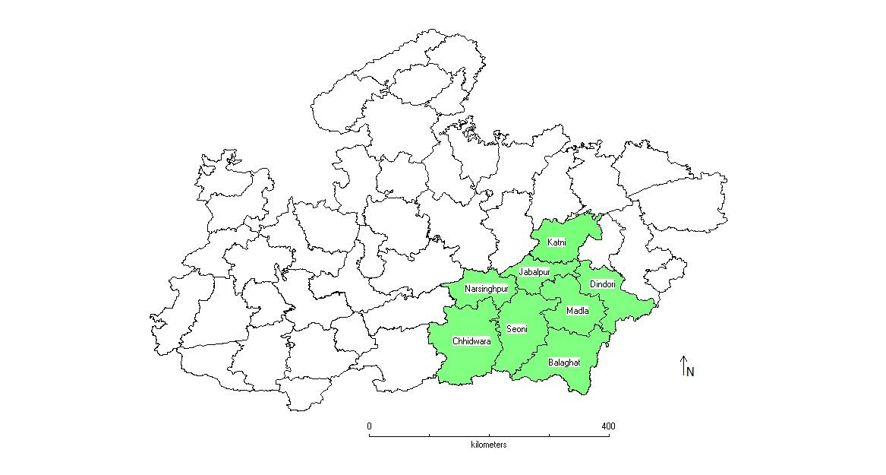
Figure 1. Sampling districts in Jabalpur division.

3. RESULTS AND DISCUSSION

Phylum Mollusca, the second-largest animal phylum after Arthropoda, comprises approximately 85,000 extant species worldwide (Tripathy et al., 2024), and its high taxonomic richness has also been documented by Zhang (2013). Globally, nearly 35,000 terrestrial gastropods and 8,765 freshwater molluscs have been reported (Lydeard et al., 2004). India, one of the world's megadiverse countries, is represented by 3,070 molluscan species comprising five classes. Of these, 214 freshwater species belonging to the classes Gastropoda and Bivalvia are included in the Fauna of India checklist (Tripathy et al., 2024).
In Madhya Pradesh, the most comprehensive account of malacofaunal diversity was provided in the State Fauna Series published by the Zoological Survey of India. Patil and Talmale (2011) reported a total of 72 species (45 freshwater and 26 land gastropods) from the state, including Chhattisgarh. Subsequent taxonomic revisions and synonymisation have reduced the number of freshwater mollusc taxa recorded from the region. According to the updated checklist of Tripathy et al. (2024), only 25 valid freshwater mollusc species are reported from Madhya Pradesh. Furthermore, Priyadarsini et al. (2024) reported one additional distributional record for Madhya Pradesh, increasing the known freshwater malacofaunal diversity to 26 species.

The present study was based on mollusc samples collected over the past six decades. Approximately 3,000 freshwater mollusc samples collected from the eight districts of the Jabalpur division—Jabalpur, Seoni, Katni, Chhindwara, Narsinghpur, Balaghat, Mandla, and Dindori—were examined.
The dominance of Gastropoda in the present assemblage is consistent with broader freshwater molluscan patterns, in which gastropods commonly show high habitat occupancy across shallow margins, wetlands, ponds, streams, and riverine microhabitats (Strong et al., 2008). The occurrence of both gastropods and bivalves across multiple districts suggests that the Jabalpur division contains a mosaic of freshwater habitats capable of supporting taxonomically varied molluscan communities, although the present data should be interpreted as collection-based evidence rather than as a standardised abundance survey.
The bivalve component of the record is also important because freshwater mussels are often sensitive to habitat degradation and hydrological change, and their regional records can contribute to broader conservation assessments (Bogan, 2008; Zieritz et al., 2022). Similar regional surveys from India have shown that local inventories can reveal substantial molluscan richness and provide useful distributional information for under-documented freshwater basins (Sonowal et al., 2021).

Table 1. List of freshwater molluscs from Jabalpur division.

Sl.No. | Family | species | Distribution in the Districts of Jabalpur Division, Madhya Pradesh
1 | Class: Gastropoda  Order: Architaenioglossa  Family: Viviparidae | Filopaludina bengalensis (Lamark,1822) | Jabalpur, Seoni, Katni, Narsingpur, chindwara, and Mandla.
2 |  | Idiopoma dissimilis (Muller,1774) | Jabalpur and Seoni.
3 | Family: Ampullaridae | Pila globosa (Swainson, 1822) | Jabalpur , Seoni and Katni.
4 | Order: Littorinimorpha  Family: Thiaridae | Mieniplotia scabra (Muller,1774) | Jabalpur, Seoni, Narsingpur.
5 | Order: Littorinimorpha  Family: Thiaridae | Melanoides tuberculata (Muller,1774) | Jabalpur, Seoni, Katni, Narsingpur, mandla and Dindori.
6 | Order: Littorinimorpha  Family: Thiaridae | Tarebia granifera (Lamark,1816) | Jabalpur and Narsinghpur.
7 | Order: Littorinimorpha  Family: Thiaridae | Tarebia lineata (Grey,1828) | Jabalpur, seoni, Narsingpur.
8 | Family: Bithynidae | Digoniostoma pulchella Benson,1836 | Jabalpur
9 | Order: Hygrophilla  Family: Lymnaeidae | Radix rufescens (gray,1822) | Jabalpur, Seoni, Narsinghpur, and Mandla.
10 | Order: Hygrophilla  Family: Lymnaeidae | Racesina luteola (Lamark,1822) | Jabalpur, Seoni, Chindwara, Balaghat, Mandla and Dindori.
11 | Family: Physidae | Physella acuta (Draparnaud, 1805) | Jabalpur
12 | Family: Planorbidae | Gyraulus convexiusculus (Hutton,1849) | Jabalpur
13 | Family: Bulinidae | Indoplanorbis exustus Deshayes,1834 | Jabalpur, Seoni, mandla and Dindori
14 | Class: Bivalvia  Order: Unionida  family: Unionidae | Lamellidens marginalis (Lamarck,1819) | Jabalpur, chindwara and Mandla.
15 | Class: Bivalvia  Order: Unionida  family: Unionidae | Lamellidens corrianus (Lea,1834) | Jabalpur and Mandla
16 | Class: Bivalvia  Order: Unionida  family: Unionidae | Parreysia corrugata (Muller,1774) | Jabalpur, seoni, Katni, Chindwara and Mandla.
17 | Class: Bivalvia  Order: Unionida  family: Unionidae | Indonaia gratiosa (Philippi, 1843) | Jabalpur, Seoni, Katni and Mandla
18 | Class: Bivalvia  Order: Unionida  family: Unionidae | Indonaia caerulea (Lea,1831) | Jabalpur, Katni, chindwara, Mandla
19 | Order: Veneroida  Family: Cyrenidae | Corbicula striatella Deshayes,1855 | Jabalpur, Seoni, Katni, chindwara, Mandla

The present study recognises a lower number of taxa than the report published by Patil and Talmale (2011) because several taxa reported in the earlier work have undergone taxonomic revision. For example, Indonaia occata has been treated as a junior synonym of Indonaia gratiosa (Philippi, 1843) (Bolotov et al., 2022). Similarly, Parreysia favidens (Benson, 1862) has been synonymised with Parreysia corrugata (Müller, 1774) (Bolotov et al., 2022). The status of the Indian freshwater clam Corbicula picta Clessin, 1878, is currently treated as uncertain (MolluscaBase Editors, 2025), whereas Corbicula occidens is considered an unaccepted name and a junior synonym of Corbicula striatella Deshayes, 1855 (MolluscaBase Editors, 2021). The previously recognised name Bellamya bengalensis (Lamarck, 1822) is currently unaccepted, and the valid name is Filopaludina bengalensis (Lamarck, 1822) (MolluscaBase Editors, 2025). Furthermore, Lymnaea acuminata Lamarck, 1822, and Lymnaea luteola Lamarck, 1822, have been synonymised as Radix rufescens (Gray, 1822) and Racesina luteola (Lamarck, 1822), respectively (MolluscaBase Editors, 2025).
The taxonomic updates presented here are therefore relevant for avoiding inflated species counts derived from older synonymies. Recent phylogenetic and taxonomic work on Oriental freshwater mussels has shown that re-evaluation of historical names is necessary for accurate interpretation of Indian freshwater bivalve diversity (Bolotov et al., 2022).

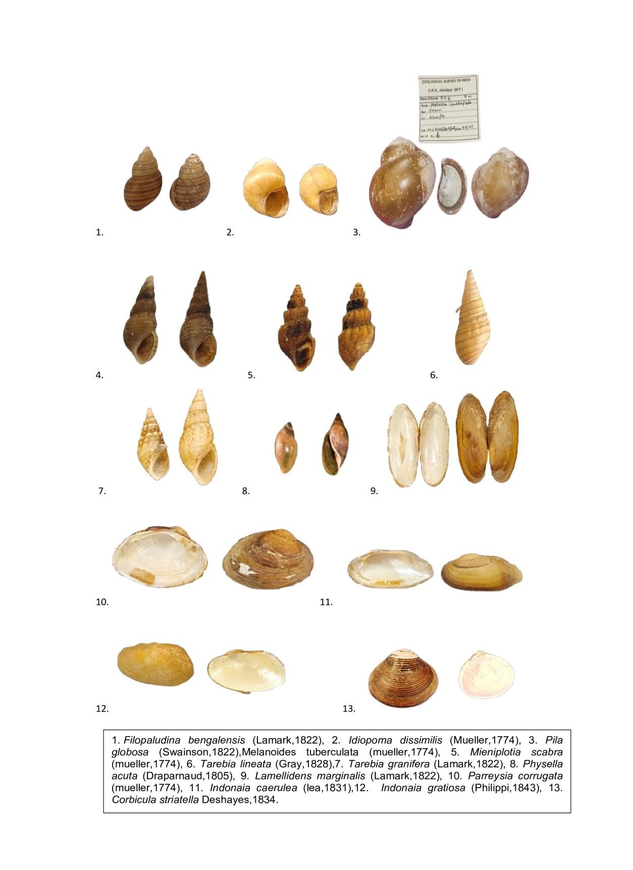
Figure 2. Freshwater molluscs.

4. CONCLUSION
The present study documents 19 freshwater mollusc species, comprising 13 gastropods and six bivalves belonging to 10 families and five orders. It is based on freshwater mollusc specimens collected over six decades from the Jabalpur division by different scientists during scientific expeditions to forests, wetlands, rivers, and protected areas. Among the surveyed districts, Jabalpur and Mandla showed comparatively higher species richness than the remaining districts. This greater richness may be associated with the presence of perennial lentic and lotic freshwater resources. Gastropoda was the dominant class, representing 13 of the 19 recorded species. Filopaludina bengalensis and Melanoides tuberculata were the most frequently recorded species, whereas Gyraulus convexiusculus and Physella acuta had the most restricted distributions. The study also documented the occurrence of the invasive snail Physella acuta (Draparnaud, 1805) in the Jabalpur region.

Limitation

This study is based primarily on preserved specimens collected over several decades, supplemented by literature and author-collected material. Sampling effort, collection period, habitat coverage, and locality representation were not standardised across districts. Consequently, the recorded occurrences should not be interpreted as estimates of present-day abundance or complete district-level richness. Differences in historical collection intensity may also influence the comparatively higher representation observed in Jabalpur and Mandla. Further standardised field surveys are required to evaluate current distribution patterns and confirm changes in native and non-native species representation.

Declaration of AI Use

This manuscript was prepared through the combined contributions of all author(s), including contributions to the study design, data, content development, results, interpretation, and related scholarly work. The author(s) acknowledge the use of Grammarly and ChatGPT to assist with grammar checking, language refinement, reference formatting. These AI-assisted tools were not used as authors and did not replace the intellectual contributions or scholarly judgment of the author(s). All AI-assisted outputs, including content, references, and interpretations, were carefully reviewed, revised, verified, and approved by the author(s). The author(s) accept full responsibility for the accuracy, integrity, and final content of the manuscript.

References

Agrawal, H. P. (1976). New records of freshwater gastropods from Madhya Pradesh, India. Newsletter—Zoological Survey of India, 2(5), 191–192.
Agrawal, H. P. (1977a). Fauna of Pench National Park, M.P.: Mollusca. Newsletter—Zoological Survey of India, 3(1), 33–36.
Agrawal, H. P. (1977b). A report on molluscs from Madhav National Park, Shivpuri, M.P. Newsletter—Zoological Survey of India, 3(5), 284–286.
Agrawal, H. P. (1995). Mollusca. In Fauna of Kanha Tiger Reserve, Madhya Pradesh (Conservation Area Series No. 7, pp. 33–39). Zoological Survey of India. https://zsi.gov.in/PDFVolumes/cas/007/index.pdf
Bagade, A., Kulkarni, M. R., Khandare, S., Khandagle, A., Aravind, N. A., Shinde, Y., & Padhye, S. M. (2024). Rapid declines in freshwater gastropods in Pune city, India. Biodiversity, 25(4), 343–356. https://doi.org/10.1080/14888386.2024.2410013
Bogan, A. E. (2008). Global diversity of freshwater mussels (Mollusca, Bivalvia) in freshwater. Hydrobiologia, 595, 139–147. https://doi.org/10.1007/s10750-007-9011-7
Bolotov, I. N., Pasupuleti, R., Subba Rao, N. V., Unnikrishnan, S. K., Chan, N., Lunn, Z., Win, T., Gofarov, M. Y., Kondakov, A. V., Konopleva, E. S., Lyubas, A. A., Tomilova, A. A., Vikhrev, I. V., Pfenninger, M., Düwel, S. S., Feldmeyer, B., Nesemann, H. F., & Nagel, K.-O. (2022). Oriental freshwater mussels arose in East Gondwana and arrived in Asia on the Indian Plate and Burma Terrane. Scientific Reports, 12(1), Article 1518. https://doi.org/10.1038/s41598-022-05257-0
Chandra, K., Gopi, K. C., Rao, D. V., Valarmathi, K., & Alfred, J. R. B. (Eds.). (2017). Current status of freshwater faunal diversity in India. Zoological Survey of India. https://searchworks.stanford.edu/view/12701447
Dimri, R., Roy, B. C., Das, K., Hossain, E., Kumar, S., & Saradar, B. (2025). A review on freshwater faunal diversity conservation in India and their relationship with plants: Status, challenges and future directions. Asian Journal of Environment & Ecology, 24(8), 34–44. https://doi.org/10.9734/ajee/2025/v24i8770
Dudgeon, D., Arthington, A. H., Gessner, M. O., Kawabata, Z.-I., Knowler, D. J., Lévêque, C., Naiman, R. J., Prieur-Richard, A.-H., Soto, D., Stiassny, M. L. J., & Sullivan, C. A. (2006). Freshwater biodiversity: Importance, threats, status and conservation challenges. Biological Reviews, 81(2), 163–182. https://doi.org/10.1017/S1464793105006950
Lydeard, C., Cowie, R. H., Ponder, W. F., Bogan, A. E., Bouchet, P., Clark, S. A., Cummings, K. S., Frest, T. J., Gargominy, O., Herbert, D. G., Hershler, R., Perez, K. E., Roth, B., Seddon, M. B., Strong, E. E., & Thompson, F. G. (2004). The global decline of nonmarine mollusks. BioScience, 54(4), 321–330. https://doi.org/10.1641/0006-3568(2004)054[0321:TGDONM]2.0.CO;2
MolluscaBase Editors. (2021). MolluscaBase. Retrieved July 22, 2026, from https://www.molluscabase.org/
MolluscaBase Editors. (2025). MolluscaBase. Retrieved July 22, 2026, from https://www.molluscabase.org/
Nandy, G., Paul, P., Tarannum, N., & Aditya, G. (2024). Effect of pollutants on the oviposition and embryo development of the invasive snail Physella acuta (Gastropoda: Physidae). Invertebrate Reproduction & Development, 68(1–2), 36–45. https://doi.org/10.1080/07924259.2024.2335923
Patil, S. G., & Ramakrishna. (2004). Mollusca. In Fauna of Pench National Park (Maharashtra) (Conservation Area Series No. 20, pp. 141–158). Zoological Survey of India. https://zsi.gov.in/PDFVolumes/cas/020/index.pdf
Patil, S. G., & Talmale, S. S. (2011). Land and freshwater Mollusca. In Fauna of Madhya Pradesh (including Chhattisgarh) (State Fauna Series No. 15, Part 3, pp. 1–30). Zoological Survey of India. https://zsi.gov.in/PDFVolumes/sfs/068/index.pdf
Priyadarsini, P., & Kushwaha, S. (2023). Diversity and distribution of freshwater molluscs in Pench Tiger Reserve, Madhya Pradesh, India. International Journal of Global Science Research, 10(1), 1992–2000. https://doi.org/10.26540/ijgsr.v10.i1.2023.231
Priyadarsini, P., Kushwaha, S., & Nair, A. (2024). Preliminary report on the occurrence of molluscs in the selected rice-field ecosystem in Jabalpur District, with a report on the occurrence of the exotic invasive snail Physella acuta (Draparnaud, 1805). International Journal of Global Science Research, 11(2), 2381–2387. https://doi.org/10.26540/ijgsr.v11.i2.2024.274
Ramakrishna, G., & Dey, A. (2007). Handbook on Indian freshwater molluscs. Zoological Survey of India.
Ramakrishna, G., Chandra, K., Nema, D. K., Ahirwar, S. C., & Alfred, J. R. B. (2006). Faunal resources of national parks of Madhya Pradesh and Chhattisgarh (Conservation Area Series No. 30). Zoological Survey of India. https://zsi.gov.in/PDFVolumes/cas/030/index.pdf
Rosenberg, G. (2014). A new critical estimate of named species-level diversity of the recent Mollusca. American Malacological Bulletin, 32(2), 308–322. https://doi.org/10.4003/006.032.0204
Roy, M., Aditya, G., & Nandi, N. C. (2024). Drivers of the diversity and spatial heterogeneity of aquatic snails in estuarine habitats: Evidence from West Bengal in India. Aquatic Ecology, 58(4), 1201–1216. https://doi.org/10.1007/s10452-024-10135-0
Salánki, J., Farkas, A., Kamardina, T., & Rózsa, K. S. (2003). Molluscs in biological monitoring of water quality. Toxicology Letters, 140–141, 403–410. https://doi.org/10.1016/S0378-4274(03)00036-5
Sonowal, J., Puzari, M., & Kardong, D. (2021). Diversity of freshwater molluscs from the upper Brahmaputra Basin, Assam, India. Journal of Threatened Taxa, 13(5), 18237–18246. https://doi.org/10.11609/jott.7144.13.5.18237-18246
Sousa, R. (2024). A brief global agenda for advancing the study of molluscs. Frontiers in Ecology and Evolution, 12, Article 1176380. https://doi.org/10.3389/fevo.2024.1176380
Strong, E. E., Gargominy, O., Ponder, W. F., & Bouchet, P. (2008). Global diversity of gastropods (Gastropoda; Mollusca) in freshwater. Hydrobiologia, 595, 149–166. https://doi.org/10.1007/s10750-007-9012-6
Sulthana, R., Padmavathi, P., & Deepa, J. (2023). Freshwater molluscs of Konaseema District, Andhra Pradesh, India. Uttar Pradesh Journal of Zoology, 44(11), 25–32. https://doi.org/10.56557/upjoz/2023/v44i113516
Tripathy, B., Tudu, P. C., Mukhopadhyay, A., Sajan, S. K., Sreeraj, C. R., Gurumayum, S. D., Ghosh, A., Sultana, R., Purushothaman, J., & Siddique, A. (2024). Checklist of fauna of India: Mollusca (Version 1.0). Zoological Survey of India. https://doi.org/10.26515/Fauna/1/2023/Mollusca
Vaughn, C. C. (2018). Ecosystem services provided by freshwater mussels. Hydrobiologia, 810, 15–27. https://doi.org/10.1007/s10750-017-3139-x
Zhang, Z.-Q. (2013). Animal biodiversity: An update of classification and diversity in 2013. Zootaxa, 3703(1), 5–11. https://doi.org/10.11646/zootaxa.3703.1.3
Zieritz, A., Sousa, R., Aldridge, D. C., Douda, K., Esteves, E., Ferreira-Rodríguez, N., Mageroy, J. H., Nizzoli, D., Österling, M., Reis, J., Riccardi, N., Daill, D., Gumpinger, C., & Vaz, A. S. (2022). A global synthesis of ecosystem services provided and disrupted by freshwater bivalve molluscs. Biological Reviews, 97(5), 1967–1998. https://doi.org/10.1111/brv.12878

Definitions, Acronyms, Abbreviations

ZSI: Zoological Survey of India; NZC: National Zoological Collection; CZRC: Central Zone Regional Centre.

