An integrated studies of Pharmacognostical, Physicochemical, Phytochemical evaluation and GC-MS profile for methanolic extract of whole plant Chlorophytum comosum (Thunb.) Jacques.

ABSTRACT
Aims: To carry out a comprehensive pharmacognostic, physicochemical, phytochemical and analytical evaluation of the whole plant of Chlorophytum comosum (Thunb.) Jacques (Green type), including thin-layer chromatographic and GC-MS profiling of its methanolic extract, to generate reference standards for its identification and quality control.
Study design: Experimental, descriptive pharmacognostic, phytochemical and analytical evaluation.
Place and Duration of Study: Department of Pharmacognosy, Adhiparasakthi College of Pharmacy, Melmaruvathur, Chengalpattu District, Tamil Nadu, India, during 2025–2026.
Methodology: Fresh whole-plant material was collected, authenticated (Specimen No. BSI/SRC/5/23/2025-26/Tech-533), shade-dried and powdered. Macroscopic and microscopic characters were recorded, and physicochemical parameters (ash values, extractive values, swelling and foaming indices, fluorescence behaviour) were determined by standard procedures. Successive Soxhlet extraction with petroleum ether and methanol yielded extracts that were screened qualitatively and profiled by TLC; the methanolic extract was further analysed by GC-MS.
Results: The powdered drug was free from foreign matter, with a loss on drying of 4.4% w/w and total ash 9.6% w/w (acid-insoluble 1.4%, water-soluble 12.1%, sulphated 3.9%, nitrated 7.9%). The swelling index (15 mL) and foaming index (>1000) indicated appreciable saponin content, and extraction gave the highest yield with the aqueous (12.5%) and methanolic (7.5%) fractions. Carbohydrates, flavonoids, glycosides, tannins/phenolics, phytosterols, alkaloids and proteins/amino acids were detected in the powdered drug and extract, while gums/mucilage and fixed oils were absent. TLC resolved alkaloids, saponins, flavonoids, tannins and phytosterols into multiple spots (Rf 0.03–1.0). GC-MS identified 41 components, 25 of them recognisable plant-derived constituents, led by 1,2,4-butanetriol (11.06%), n-hexadecanoic acid (4.31%) and octacosane, 2-methyl- (2.88%).
Conclusion: The pharmacognostic, physicochemical, phytochemical and analytical standards established in this study provide reliable reference parameters for the identification, authentication and quality control of C. comosum (Green type).

Keywords: Chlorophytum comosum; pharmacognosy; phytochemical screening; thin-layer chromatography; GC-MS; Safed Musli.
1. INTRODUCTION
Medicinal plants have been used for millennia across traditional systems such as Ayurveda, Siddha, Unani, and Traditional Chinese Medicine for their ability to prevent, alleviate, or treat disease (Marrelli, 2021; Sofowora et al., 2013). Their therapeutic value stems from phytochemicals like alkaloids, flavonoids, phenolics, tannins, glycosides, terpenoids, and saponins. These constituents exhibit antioxidant, anti-inflammatory, antimicrobial, anticancer, antidiabetic, and immunomodulatory activities and have contributed substantially to modern drug discovery. Their relatively low toxicity makes them attractive candidates for safe, effective medicines, provided their use is supported by scientific validation, standardisation, and conservation (Vaidya & Devasagayam, 2007). Chlorophytum comosum has attracted considerable interest due to its reported pharmacological activities and potential medicinal value.
Chlorophytum comosum belongs to the genus Chlorophytum (comprising more than 200 tropical and subtropical species), several members of which are used traditionally in India, China, and Africa and marketed as “Safed Musli” for their immunomodulatory, adaptogenic, aphrodisiac, antioxidant, and antimicrobial properties. Preparations from Chlorophytum species show antioxidant, anti-inflammatory, antibacterial, antidiabetic, hepatoprotective, and reproductive health-promoting effects (Rzhepakovsky et al., 2022).
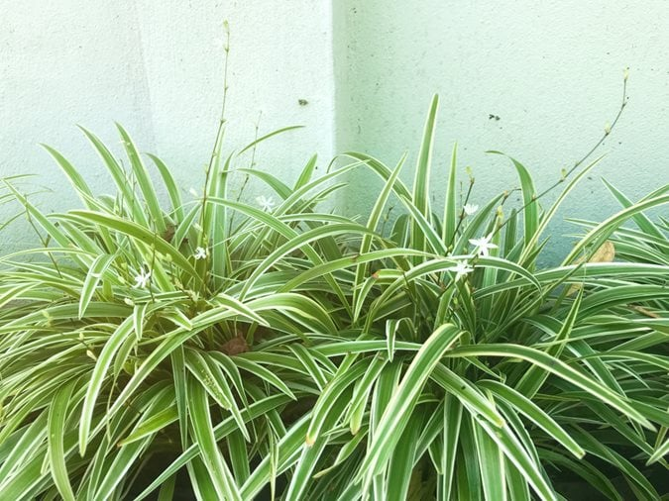
Fig. 1. Whole plant of Chlorophytum comosum (Green type)
Botanical Name & Synonyms
Chlorophytum comosum (Thunb.) Jacques. Major synonyms include Anthericum comosum Thunb., Anthericum sternbergianum Schult. & Schult.f., Caesia comosa (Thunb.) Spreng., Chlorophytum bukobense Engl., Chlorophytum kirkii Baker, Hartwegia comosa (Thunb.) Nees, and Phalangium comosum (Thunb.) Poir., among ~25 further taxonomic synonyms recorded in botanical databases.
Taxonomical Classification
Table 1. Taxonomical classification of Chlorophytum comosum (Green type)
Rank | Taxon
Kingdom | Plantae
Clade | Tracheophytes – Angiosperms – Monocots
Class / Subclass | Liliopsida / Liliidae
Order / Family | Asparagales / Asparagaceae
Subfamily | Agavoideae
Genus / Species | Chlorophytum / C. comosum
Authority | (Thunb.) Jacques

Vernacular Names
Table 2. Vernacular names of Chlorophytum comosum in different languages
Language | Name(s)
Tamil | Kodi kallu, Silanthi sedi, Ribbon seddi
English | Spider plant, airplane plant
Hindi | Safed musli, Makdi paudha
Bengali / Marathi / Telugu / Punjabi / Assam | Spider gach; Koli vanaspati; Spider plant; Makdi paudha; Makuri gachh

Distribution & Habitat
C. comosum is native to six of Africa’s ten phytogeographical regions (West, West-Central, Northeast, East, and South Tropical Africa, and Southern Africa) (India Biodiversity Portal, n.d.; World Flora Online, 2026). It is a herbaceous perennial growing to about 60 cm tall, descending several feet as a hanging plant.
Morphology
Leaves: Long, narrow, linear, solid green or white/yellow-variegated, forming a basal rosette (20–21 cm × 6–10 mm); single-layered cuticle-covered epidermis with stomata, chlorophyllous parenchyma, and needle-like oxalate crystals in the mesophyll.
Root: Fleshy, tuberous, 20–25 cm long, with typical monocot primary structure — numerous vascular bundles each bearing a few xylem/phloem elements.
Chemical Constituents
Alkaloids, flavonoids, glycosides, steroidal saponins, phenolics, tannins, 9,12-octadienoic acid, neophytadiene, n-hexadecanoic acid, sucrose, γ-sitosterol, octadecanoic acid, and stigmasterol.
The manuscript addresses an important topic in pharmacognosy, particularly the establishment of authentication and quality-control parameters for a medicinal plant material. The combination of macroscopic and microscopic evaluation, physicochemical testing, preliminary phytochemical screening, TLC fingerprinting and GC-MS profiling represents a potentially useful approach for developing a pharmacognostic and phytochemical reference profile for Chlorophytum comosum.

Recent pharmacognostic studies continue to integrate macroscopic, microscopic, physicochemical, phytochemical and chromatographic assessments when establishing reference parameters for medicinal plant identity and quality control (Limpabandhu et al., 2024; Sonibare et al., 2025; Sushma et al., 2026). Chromatographic fingerprinting has also been applied in herbal-medicine quality evaluation to support the detection of adulteration and improve authentication (Luo et al., 2024). GC-MS profiling is likewise used in medicinal-plant phytochemical characterisation to document identifiable constituents in extracts (Nisa et al., 2026). Within the scope of the present manuscript, an integrated reference profile that brings together pharmacognostic, physicochemical, preliminary phytochemical, TLC and GC-MS findings for the whole plant of C. comosum (Green type) is needed to support its identification and quality control. Accordingly, the present study aimed to carry out a comprehensive pharmacognostic, physicochemical, phytochemical and analytical evaluation of the whole plant of C. comosum (Green type), including TLC and GC-MS profiling of its methanolic extract, to generate reference standards for its identification and quality control.
2. MATERIALS AND METHODS
2.1 Collection and Authentication
Fresh whole-plant material of C. comosum (green type) was collected from Melmaruvathur, Chengalpattu district, Tamil Nadu, and authenticated by Dr. S. S. Hameed, Botanical Survey of India, Coimbatore (Specimen No. BSI/SRC/5/23/2025-26/Tech-533); the voucher was deposited at the Department of Pharmacognosy, Adhiparasakthi College of Pharmacy, Melmaruvathur. About 8 kg of fresh plant material was collected, dried to ≈ 4 kg, coarsely powdered, and stored in a light-resistant container.
2.2 Pharmacognostic Evaluation
Macroscopic (organoleptic and morphological) and microscopic evaluations (free-hand transverse sections and powder microscopy, glycerin-mounted) were carried out under a compound microscope. Physical parameters — foreign matter, loss on drying, total/acid-insoluble/water-soluble/sulphated/nitrated ash, extractable matter (hot and cold, aqueous and 90% methanolic), swelling index, foaming index, and fluorescence behaviour under day/UV light with acids, alkalis, and solvents — were determined by standard pharmacopoeial procedures (World Health Organization, 1998; Mukherjee, 2002; Khadabadi et al., 2019; Khandelwal, 2000).
2.3 Phytochemical Evaluation
Powdered drug and successive extracts were subjected to standard qualitative chemical tests (Shaikh & Patil, 2020) for carbohydrates, alkaloids, flavonoids, glycosides, tannins/phenolics, phytosterols, proteins/amino acids, and gums/mucilage/fixed oils, as summarised in the following table.
Table 3. Qualitative tests used for preliminary phytochemical screening
Phytoconstituent | Representative Test(s) | Positive Inference
Carbohydrates | Molisch’s; Fehling’s | Violet ring / red precipitate
Alkaloids | Dragendorff’s; Mayer’s | Orange-red / creamy-white precipitate
Flavonoids | Alkaline reagent; Lead acetate | Intense yellow colour / precipitate
Glycosides | Borntrager’s; Keller–Kiliani | Colour change; bluish-green layer
Tannins & Phenolics | Ferric chloride; Gelatin | Green colour; precipitate
Phytosterols | Liebermann–Burchard; Salkowski | Brown ring/green layer; red layer
Proteins & Amino Acids | Biuret; Ninhydrin | Violet; blue colour
Gums/Mucilage & Fixed Oils | Ruthenium red; Stain test | Pink colour; oily/translucent stain

2.4 Analytical Evaluation
2.4.1 Thin Layer Chromatography
Extracts were screened by TLC on silica gel G plates (20 × 6 cm) with solvent systems selected for each class of compound (Abrika et al., 2013; Sureshkumar, 2021; Chauhan et al., 2020; Sharma et al., 2012); a 5–10 µL sample was spotted, developed (30–60 min), air-dried, and visualised with an appropriate spray reagent; spot colour, Rf, and distance travelled were recorded.
2.4.2 GC-MS Study
GC-MS of the methanolic extract was performed on a Clarus 680 GC fitted with an Elite-5MS column (30 m × 0.25 mm ID × 250 µm df), with helium as the carrier gas (1 mL/min), an injector temperature of 260 °C, an oven temperature ramp of 60→300 °C (10 °C/min, held for 6 min), EI ionisation (70 eV), and a mass range of m/z 40–600. Components were identified against the NIST (2008) library.
3. RESULTS AND DISCUSSION
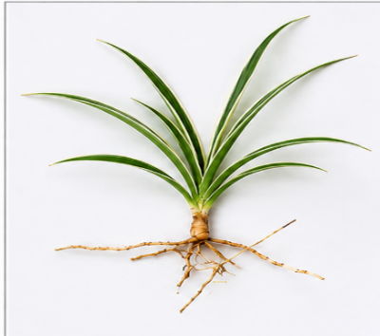
3.1 Pharmacognostic Evaluation
Macroscopy

Leaf and root macroscopic characters are summarised in the following table.
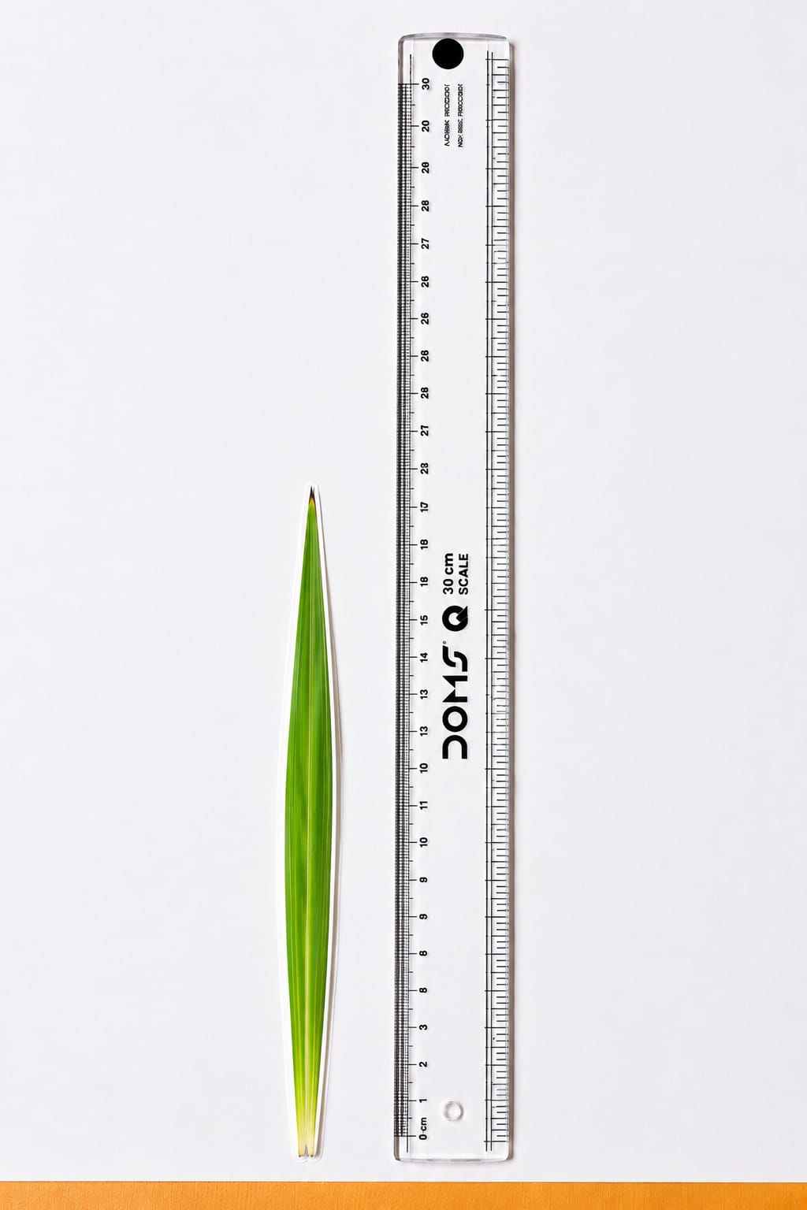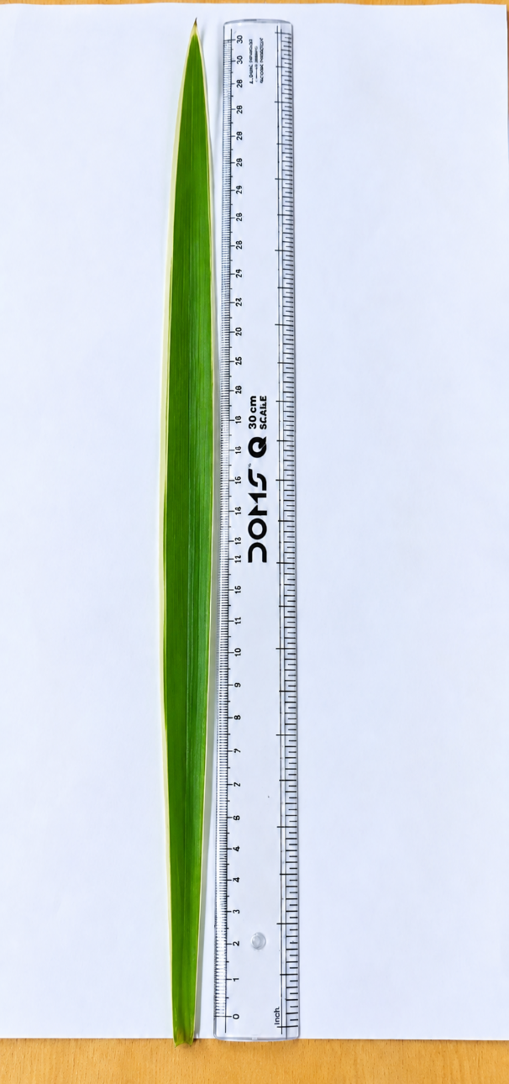
Fig. 2. Leaf of C. comosum — small and large leaf
Table 4. Macroscopic characters of the leaf of C. comosum
Leaf Character | Observation
Colour / Type / Arrangement | Bright green with yellowish-white; simple; rosulate
Shape / Margin | Linear to linear-lanceolate; entire
Size / Number | 21–40 cm × 0.6–2.5 cm; 10–30 leaves/plant
The macroscopic characters recorded for the leaf — its bright green colour with yellowish-white variegation, simple rosulate arrangement, linear to linear-lanceolate shape with an entire margin, and a size range of 21–40 cm × 0.6–2.5 cm bearing 10–30 leaves per plant — are consistent with the reported morphology of C. comosum (Green type) and serve as reliable organoleptic markers for field-level identification of the crude drug.

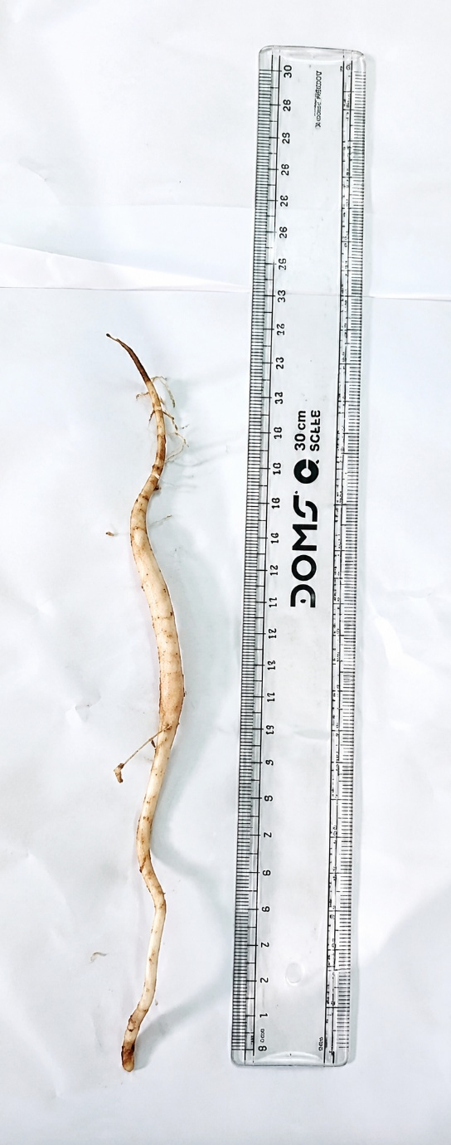
Fig. 3. Root of C. comosum
Table 5. Macroscopic characters of the root of C. comosum
Root Character | Observation
Colour / Texture | White to brown; thick, fleshy, succulent, spongy
Shape / Size | Spindle-like, tuberous; 20–25 cm × ≈10 mm
The root characters, comprising a white-to-brown, thick, fleshy and spongy texture with a spindle-shaped tuberous form measuring 20–25 cm in length and ≈10 mm in diameter, are typical of the tuberous roots associated with the ‘Safed Musli’ group of plants and provide a useful diagnostic feature to distinguish genuine root material from adulterants.
Comparative evaluation of five Chlorophytum species, including C. comosum, likewise demonstrated species-distinctive tuber morphology and anatomy, reinforcing the diagnostic value of the root macroscopic characters recorded here for authentication (Deore et al., 2015).

Microscopy — Transverse Section

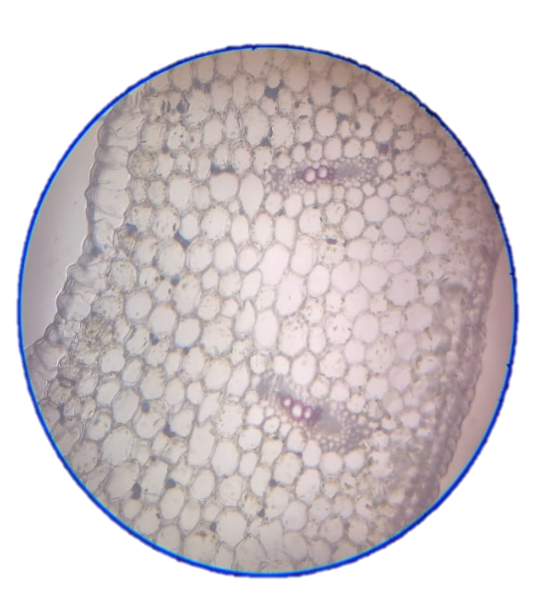
cuticle
Bulbus upper epidermis
Palisade mesophyll cell
(contain chloroplasts)

phloem
xylem
mesophyll cells
Lower epidermis

Fig. 4. T.S. of C. comosum leaf
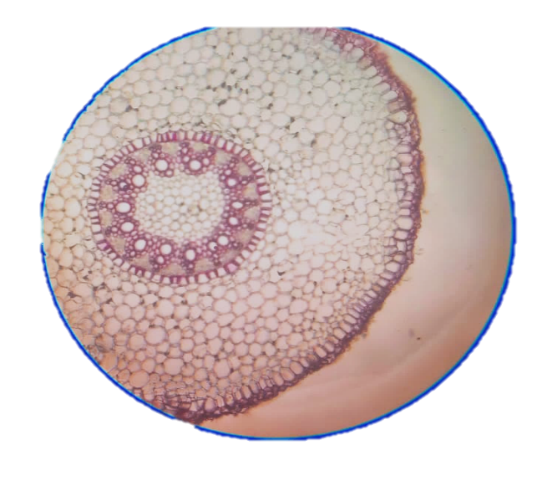
rhizodermis
Cortial fiber
endodermis

pith
Root hairs
cortex
epidermis

Fig. 5. T.S. of C. comosum root

Table 6. Transverse-section (T.S.) microscopic characters of leaf and root of C. comosum
Tissue | Leaf (T.S.) | Root (T.S.)
Epidermis | Single-layered, thin cuticle | Rhizodermis with root hairs
Ground tissue | Chlorenchymatous mesophyll | Broad starch-bearing cortex
Endodermis | Indistinct bundle sheath | Distinct, Casparian strips
Vascular bundle | Collateral, closed | Radial arrangement
Pith | Absent | Well-developed, starch-rich
The transverse-sectional anatomy clearly differentiates the two organs: the leaf is characterised by a thin, single-layered cuticle-covered epidermis, chlorenchymatous mesophyll and an indistinct bundle sheath, whereas the root shows a rhizodermis bearing root hairs, a broad starch-storing cortex, a distinct endodermis with Casparian strips, radially arranged collateral vascular bundles and a well-developed, starch-rich pith. These anatomical features, particularly the absence of a pith in the leaf, contrasted with its clear presence in the root, offer confirmatory microscopic evidence for authenticating the two organs of C. comosum. Deore et al. (2015) also documented distinct microscopic and anatomical features among Chlorophytum tubers, including C. comosum, supporting the use of organ-level anatomy as a species-authentication criterion within the genus.
Powder Microscopy
Diagnostic powder characters included polygonal epidermal cells with stomata, spirally/pitted-thickened lignified vessels, suberised cork cells, prismatic calcium oxalate crystals, thin-walled parenchyma, and tapering lignified fibres.
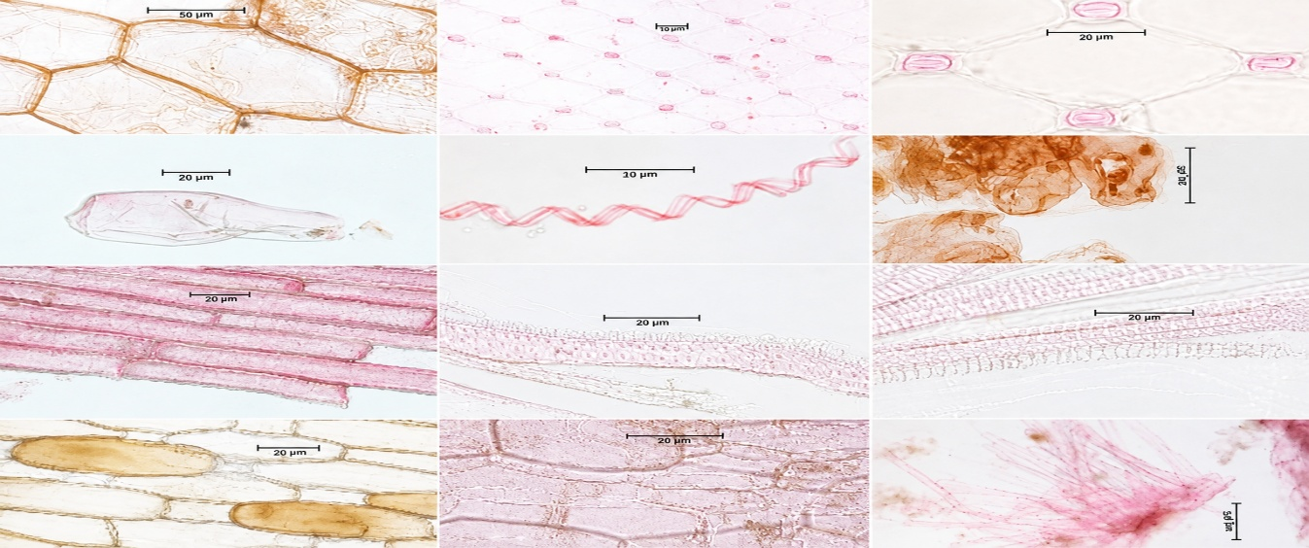

Fig. 6. Powder microscopy of the root and leaf of Chlorophytum comosum

List 1. Diagnostic powder-microscopic characteristics of the whole plant of Chlorophytum comosum

SNO | POWDER CHARACTERISTICS | OBSERVATION
 |  | FRESH WHOLE PLANT
1. | Epidermis | Single-layered, polygonal, compactly arranged cells with distinct cell walls and a thin cuticle and Stomata are present.
2. | Vessels | Long, tubular, lignified cells showing spiral and pitted wall thickening with a wide lumen.
3. | Cork cells | Cork cells are rectangular or polygonal, compactly arranged dead cells with thick, suberized cell walls.
4. | Calcium oxalate crystals | Prismatic, colorless, highly refractive crystals present in idioblasts
5. | Parenchyma cells | Thin-walled, polygonal living cells with intercellular spaces,
6. | Fibres | Long, slender, lignified cells with thick walls, tapering ends, and a narrow lumen
Powder microscopy revealed diagnostic elements — polygonal epidermal cells bearing stomata, spirally and pitted lignified vessels, suberised rectangular-to-polygonal cork cells, refractive prismatic calcium oxalate crystals within idioblasts, thin-walled parenchyma and tapering lignified fibres — that together constitute a characteristic powder profile useful for the microscopical identification of C. comosum in its powdered form, particularly for detecting adulteration. Comparative pharmacognostic work on Chlorophytum species has similarly identified powder-microscopical parameters as useful standards for differentiating and authenticating species, supporting the diagnostic role of the powder characters observed in the present material (Deore et al., 2015).

Physical Evaluation
The powdered drug was found to be completely free from foreign matter such as sand, soil, other plant parts, or insect fragments, confirming the purity of the sample. The loss on drying (LOD) value of 4.4% w/w, well within the pharmacopoeial limit of less than 5%, indicates the percentage of residual moisture present and reflects the good stability and shelf-life expected of the herbal material.
The total ash value (9.6% w/w) indicates the presence of inorganic constituents such as minerals and salts within limits acceptable for herbal drugs, suggesting the sample is relatively free from inorganic impurities. The acid-insoluble ash (1.4% w/w), representing silicates, phosphates and other acid-insoluble inorganic matter, was comparatively low, while the water-soluble ash (12.1% w/w) reflects a moderate content of water-soluble salts and minerals. The sulphated ash (3.9% w/w) and nitrated ash (7.9% w/w) were both consistent with expected standards for herbal materials. Together, these ash values give an indication of the earthy matter or inorganic composition and other impurities present along with the drug, and support the suitability of C. comosum (Green type) for use in herbal formulations (Table 7).
The extractable matter content varied with the extraction method and solvent used: cold-maceration extractives (aqueous 12.5% w/w, methanol 7.5% w/w, petroleum ether 1.1% w/w, ethyl acetate 2.8% w/w and chloroform 7.7% w/w) were consistently lower than those obtained by hot (Soxhlet) extraction, indicating that cold extraction is less effective at solubilising the plant's constituents; the aqueous and methanolic fractions gave the highest yields, consistent with the largely polar nature of the extractable constituents.
The swelling index is a measure of a substance's ability to absorb water and swell, and the value obtained (15 mL) indicates a high swelling capacity for the sample.
The foaming index measures a substance's ability to produce foam when shaken with water, and the value obtained (>1000) indicates a high foaming capacity, which is indicative of prominent saponin content and corroborates the detection of saponins/glycosides on phytochemical screening.

S.NO: | PARAMETER | VALUE
1. | Foreign matter | Absence of foreign matter
2. | Loss on drying | 4.4%
3. | Ash value
 | - Total ash | 9.6%w/w
 | - Acid insoluble ash | 1.4%w/w
 | - Water soluble ash | 12.1%w/w
 | - Sulphated ash | 3.9%w/w
 | - Nitrated ash | 7.9%w/w
4. | Swelling index | 15ml
65. | Foaming index | >1000

Table 7. Physical evaluation parameters of C. comosum powdered drug
Overall, the low loss-on-drying and ash values, together with the pronounced foaming index, confirm that the powdered drug meets the general pharmacopoeial quality benchmarks expected for herbal materials and reflect its inherent saponin-rich composition (Table 7).
Across five Chlorophytum species, ash values, loss on drying, swelling index, foaming index, and total saponin content varied appreciably, underscoring the relevance of these physicochemical parameters for species-specific quality standards (Deore et al., 2015).

Fluorescence analysis
The fluorescence analysis of the powdered drug and various extracts of the whole plant of Chlorophytum comosum using various solvents should clearly state the observed fluorescence colours under both visible and UV light.
Effect of daylight and UV radiation on crude drug and various extracts
Table 8. Fluorescence characteristics of C. comosum powdered drug under day light and UV light
S.no: | REAGENT | DAY LIGHT | UV LIGHT
1. | 10%Conc. HCL | Green | Dark green
2. | Conc. H2S04 | Green | Green
3. | Conc . HNO3 | Green | Yellow
4. | KOH  Solution (5%W/ W) | Green | Dark green
5. | 1Naq.NaoH | Light Green | Dark green
6. | Alcoholic NaoH | Green | Yellowish green
7. | Dil. HCL | Green | No fluorescence
8. | Dil. H2SO4 | Green | No fluorescence
9. | Toluene | Green | Light green
10. | Chloroform | Green | Greenish yellow
11. | Ethyl acetate | Green | Pale green
12. | Acetone | Green | Light green
The fluorescence behaviour of the powdered drug varied with the reagent used, ranging from green to dark green, yellow, or no visible fluorescence under UV light, while daylight fluorescence remained largely green across treatments. Such reagent-specific colour changes constitute a simple, reproducible physicochemical fingerprint that can be used to detect adulteration and to distinguish C. comosum powder from morphologically similar plant materials.
Reagent-dependent fluorescence of powdered plant materials and extracts has been demonstrated as a useful differentiating parameter in pharmacognostic standardisation when interpreted alongside microscopic and physicochemical characteristics (Alam & Najum us Saqib, 2015).

3.2 Phytochemical Studies
Cold extraction:
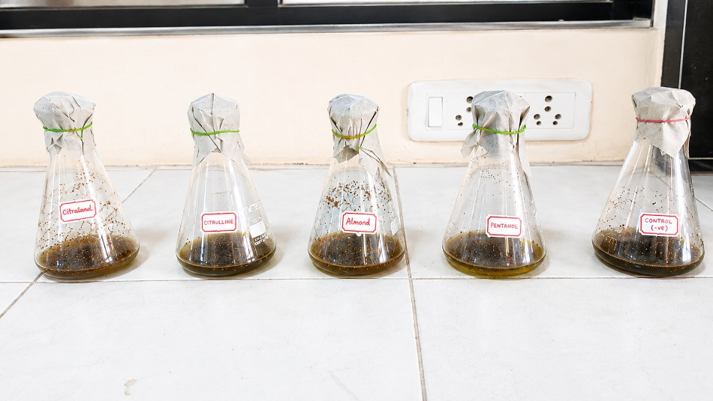

Fig 7 cold extraction of whole plant
List 2. Characteristics and yields of whole-plant C. comosum extracts obtained by cold extraction
s.no: | Extracts | Colour | Nature of Extract | Yield(g) | Yield%
1. | Aqueous | Dark brown | Non sticky | 0.125g | 12.5%w/w
2. | Chloroform | Dark green | Sticky | 0.007g | 7.7%w/w
3. | Ethyl acetate | Dark green | Non sticky | 0.028g | 2.8%w/w
4. | Methanol | Dark green | Sticky | 0.075g | 7.5%w/w
5. | Pet.ether | Dark green | Non sticky | 0.011g | 1.1%w/w
Among the five solvents used for cold (maceration) extraction, the aqueous extract gave the highest yield (12.5% w/w), followed by chloroform (7.7%) and methanol (7.5%), while petroleum ether gave the lowest yield (1.1%). This trend indicates that the majority of extractable constituents of C. comosum are polar to moderately polar in nature, favouring extraction with water and polar organic solvents over non-polar solvents such as petroleum ether.
Extraction efficiency is strongly influenced by the plant matrix, solvent characteristics, and operating conditions, so the solvent-dependent yield pattern observed here is consistent with established principles governing recovery of bioactive compounds from plant materials (Azmir et al., 2013). Recent work on C. comosum likewise reported solvent-dependent differences in extract yield for both roots and leaves, with water giving the highest yield and hexane the lowest (Kavya et al., 2024).

Picture 1 : Hot Extraction (Soxhlet)
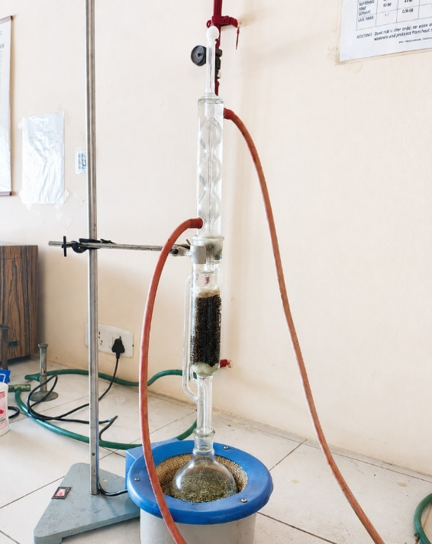

Soxhlet extraction was chosen as it is suitable for heat-stable constituents and for active constituents that are less soluble in the menstruum in the absence of heat. Successive Soxhlet extraction (20 g drug, 450 mL solvent, 8–12 h) gave a dark-green, greasy, low-yielding petroleum ether extract; a sticky, dark-green alcoholic (methanolic) extract; and a reddish-brown, non-sticky aqueous extract (Table 9).
Table 9. Yield of successive Soxhlet extraction of C. comosum powdered drug
Extract | Colour | Nature | Yield %
Methanol | Dark green | Sticky | 21.71
Petroleum ether | Dark green | Non-sticky | 3.041
The markedly higher yield obtained with methanol (21.71%) compared with petroleum ether (3.041%) under hot (Soxhlet) extraction reaffirms the predominance of polar phytoconstituents in C. comosum and supports the selection of the methanolic extract for further phytochemical and GC-MS analysis.
Soxhlet extraction remains a conventional reference technique for plant bioactive recovery because repeated solvent reflux promotes transfer of soluble constituents from the plant matrix, although extraction performance depends on the chemistry of the target compounds and the operating conditions (Azmir et al., 2013).
Preliminary Phytochemical Screening
Carbohydrates, flavonoids, glycosides, tannins/phenolics, phytosterols, and proteins/amino acids were present in both the powdered drug and methanolic extract; alkaloids, gums/mucilage, and fixed oils/fats were absent (Table 10).
Table 10. Preliminary phytochemical screening of powdered drug and methanolic extract of C. comosum
Phytoconstituent | Powder  drug | Methanol  extract
Carbohydrates | + | +
Alkaloids | + | +
Flavonoids | + | +
Glycosides | + | +
Tannins & Phenolics | + | +
Phytosterols | + | +
Proteins & Amino Acids | + | +
Gums & Mucilage | – | –
Fixed Oils & Fats | – | –
The concordant presence of carbohydrates, flavonoids, glycosides, tannins/phenolics, phytosterols and proteins/amino acids in both the powdered drug and its methanolic extract, together with the consistent absence of gums/mucilage and fixed oils/fats, confirms that methanol effectively extracts the major polar-to-moderately-polar phytoconstituents of the plant and validates methanol as an appropriate solvent for its subsequent chromatographic and spectrometric characterisation.
Independent phytochemical analysis of C. comosum root and leaf extracts has also shown a broad array of constituents, including flavonoids, phenolics, proteins, tannins, glycosides, carbohydrates, and quinones, with the methanolic root extract additionally showing saponins and phytosterols (Kavya et al., 2024).
3.3 Analytical Studies
3.3.1 Thin Layer Chromatography
TLC of the extract confirmed the presence of alkaloids, saponins, flavonoids, tannins, and phytosterols, each resolving into multiple spots with characteristic colours and Rf values (Table 11).

S.NO | CLASS OF COMPOUNDS | SOLVENT SYSTEM | DISTANCE TRAVELLED BY SOLVENT (CM) | DISTANCE TRAVELLED BY SOLUTE (CM) | DETECTING AGENT | No. OF SPOTS | COLOUR OF SPOTS | Rf Value
1 | Alkaloids | Toluene: ethyl acetate: diethyl amine (70:20:10) | 10 cm | 0.3 cm  7 cm  9.5 cm | Iodine Vapour | 3 | Dark green  Yellowish green  Light brown | 0.03  0.7  0.95
2 | Saponins | Chloroform: ethanol: water  (55:37:7) | 4 cm | 1.7 cm  2.4 cm  2.7 cm  3.3 cm | Anisaldehyde Sulphuric acid reagent | 4 | Dark brown with green  Light brown  Dark green  Light green | 0.4  0.6  0.67  0.8
3 | Flavonoids | n-butanol: ethyl acetate: water (1:2:3) | 5 cm | 0.2 cm  3 cm  4.2 cm | 3%boric acid and 10%oxalic acid reagent | 3 | Green  Yellow  Brown | 0.04  0.6  0.84
4 | Tannins | Chloroform: ethyl acetate: methanol (5:3:2) | 9 cm | 1 cm  8.5 cm  8.8 cm  9 cm | 5%ferric chloride solution | 4 | Brown  Light Green  Green  Dark green | 0.11  0.85  0.88  1
5 | Phytosterol | Hexane: ethyl acetate (6:4) | 10.5 cm | 0.5 cm  9 cm  10 cm | Anisaldehyde Sulphuric acid reagent | 3 | Blue  Yellow  Brown | 0.04  0.85  0.95

Table 11. Thin-layer chromatography (TLC) results of the methanolic extract of C. comosum
The resolution of alkaloids, saponins, flavonoids, tannins and phytosterols into multiple, well-separated spots (Rf 0.03–1.0) with class-specific spray reagents demonstrates the chemical complexity of the methanolic extract and provides a reliable TLC fingerprint — solvent system, spot colour and Rf value — that can serve as a quality-control tool for identifying and standardising C. comosum extract.
Current reviews of herbal-medicine fingerprinting identify TLC/HPTLC as established tools for botanical identification and quality control, and describe chromatographic fingerprints in terms of retention/Rf position and response intensity, with whole-profile comparison used to support authentication and standardisation (Noviana et al., 2022).
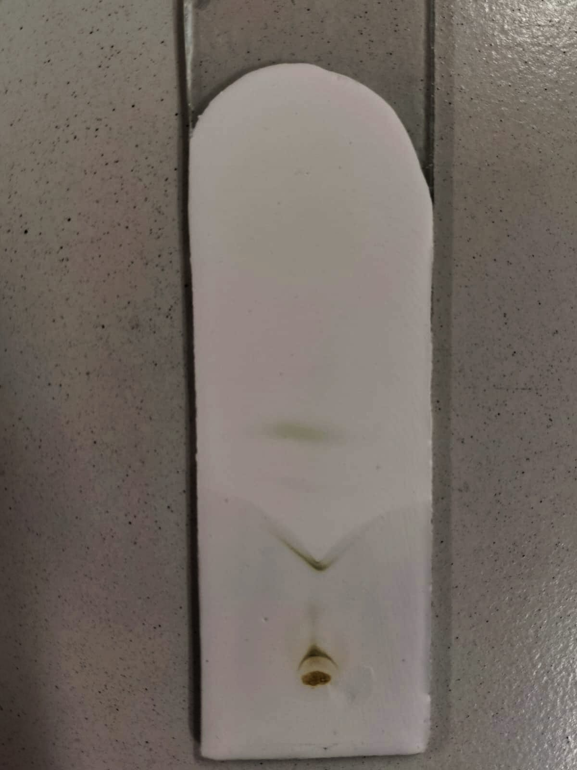
Fig. 7a. TLC of saponins in the methanolic extract of C. comosum (visible light)
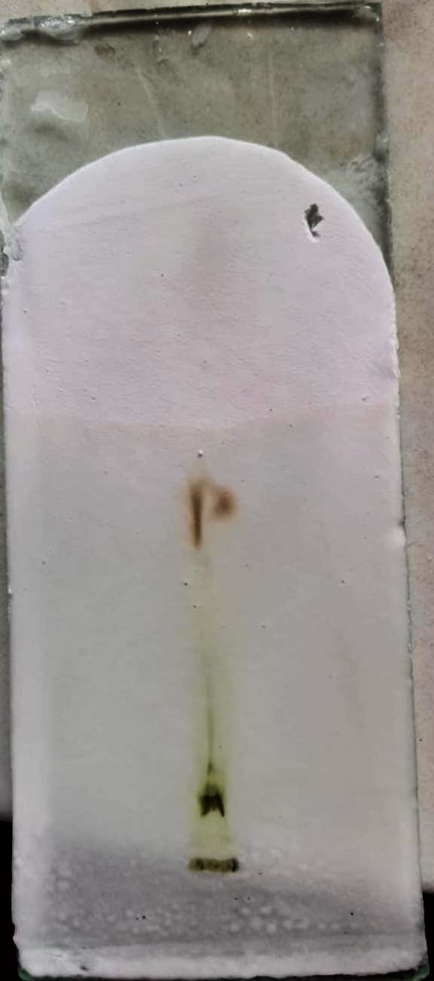
Fig. 8. TLC of tannins in the methanolic extract of C. comosum (visible light)
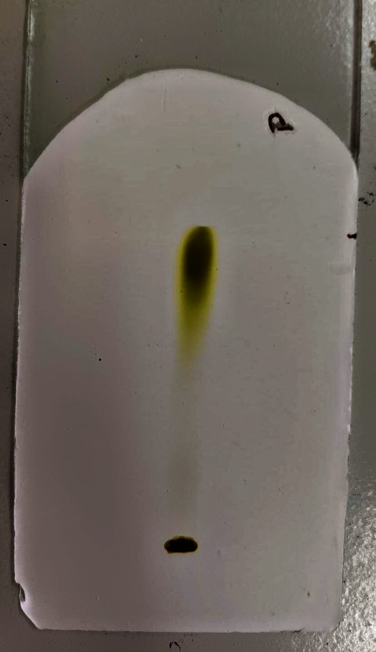
Fig. 9. TLC of phytosterols in the methanolic extract of C. comosum (visible light)
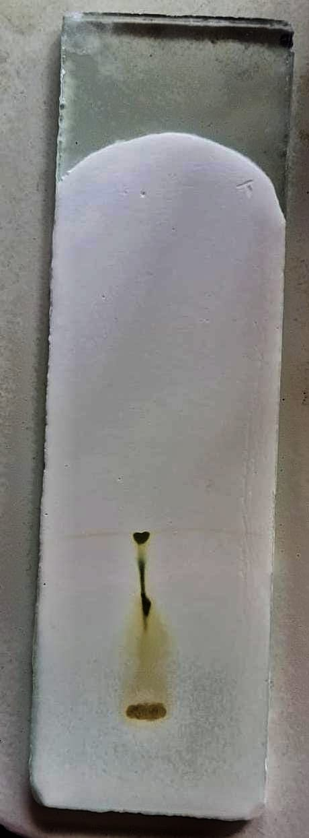
Fig. 10. TLC of flavonoids in the methanolic extract of C. comosum (visible light)
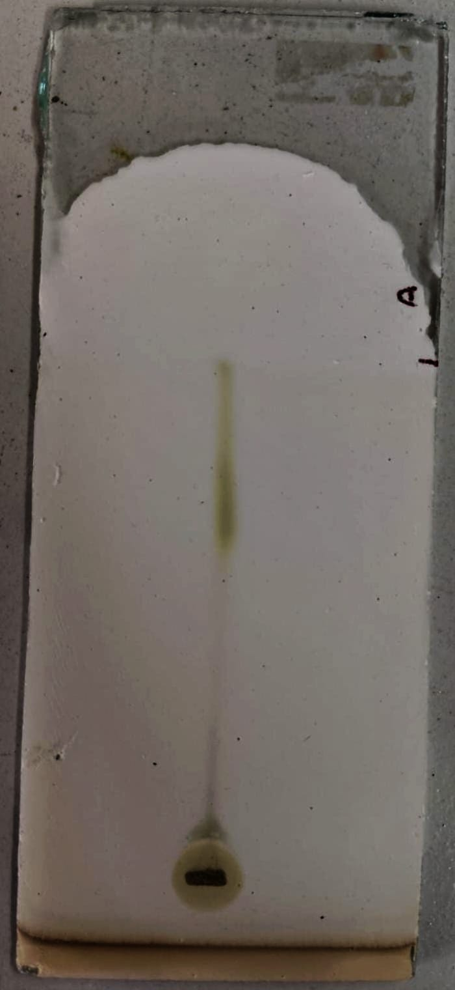
Fig. 11. TLC of alkaloids in the methanolic extract of C. comosum (visible light)

3.3.2 GC-MS Study of the Methanolic Extract
GC-MS identified 41 components; of these, 25 peaks corresponded to recognisable plant-derived constituents — fatty acids/esters, fatty alcohols and aldehydes, isoprenoids/terpenoids, long-chain wax hydrocarbons, a steroidal sapogenin, phytosterols, and phenolics — and are listed in Table 12, led by 1,2,4-butanetriol (11.06%), n-hexadecanoic acid (4.31%), and octacosane, 2-methyl- (2.88%). The remaining peaks corresponded to non-plant artefacts (siloxanes, sulfurous-acid esters, phthalates and similar) or could not be confidently assigned to a plant metabolite class, and are omitted here; full peak data are available on request.
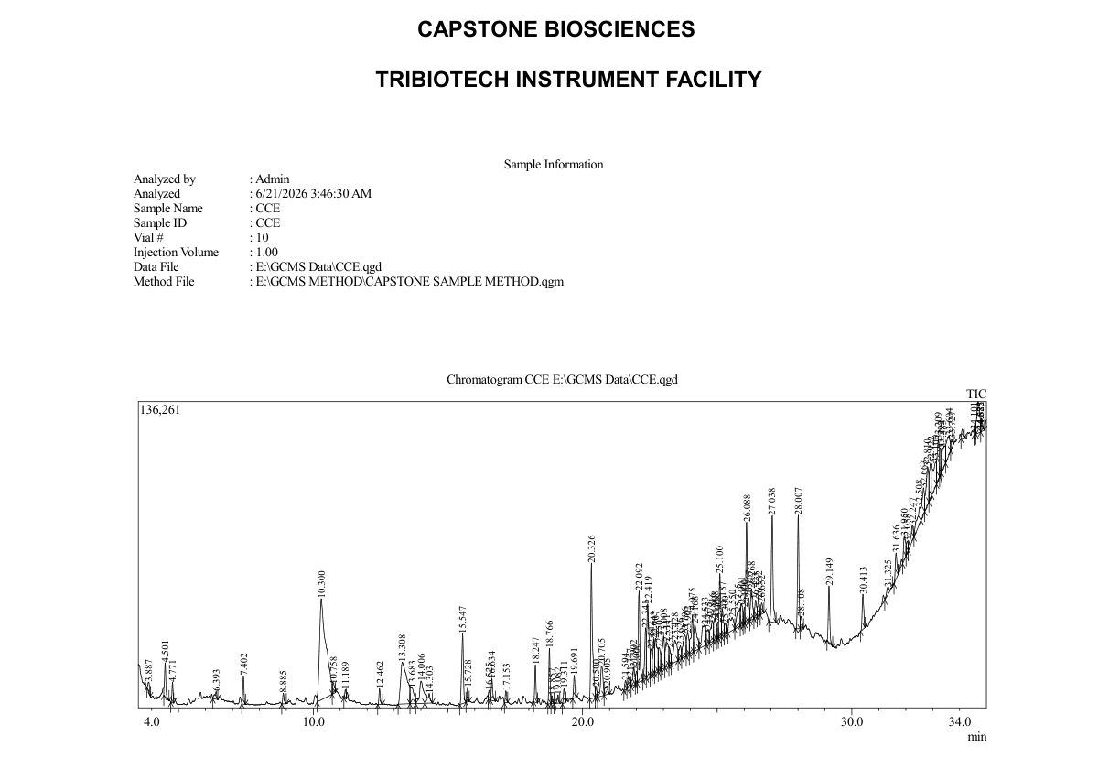
Fig. 12. GC-MS chromatogram of the methanolic extract of C. comosum
Table 12. GC-MS profile of the methanolic extract of C. comosum
S.NO | Peak | RT (min) | Area % | Compound Name
 | 7 | 10.300 | 11.06 | 1,2,4-Butanetriol
 | 26 | 20.326 | 4.31 | n-Hexadecanoic acid
 | 68 | 27.038 | 2.88 | Octacosane, 2-methyl-
 | 69 | 28.007 | 2.86 | 2-Methyltetracosane
 | 62 | 26.088 | 2.69 | Octacosane, 2-methyl-
 | 34 | 22.092 | 2.45 | 3,7,11,15-Tetramethyl-2-hexadecen-1-ol
 | 80 | 32.810 | 1.71 | Tritetracontane
 | 55 | 25.100 | 1.66 | Octacosane, 2-methyl-
 | 90 | 34.682 | 1.56 | 9,19-Cycloergost-24(28)-en-3-ol, 4,14-dimethyl-, acetate, (3β,4α,5α)-
 | 84 | 33.209 | 1.55 | Ergostane-3,6-dione, 25-(acetyloxy)-5-hydroxy-, (5α)-
 | 35 | 22.341 | 1.37 | Pentadecanal-
 | 28 | 20.705 | 1.36 | Docosanoic acid, ethyl ester
 | 42 | 23.111 | 1.30 | Heptadecane, 2,6,10,15-tetramethyl-
 | 21 | 18.766 | 1.21 | Neophytadiene
 | 79 | 32.663 | 1.14 | 1-Eicosanol, TMS derivative
 | 38 | 22.643 | 1.03 | Decanal
 | 75 | 31.950 | 0.79 | Spirostan-3-ol, (3α,5β,25S)-
 | 65 | 26.423 | 0.59 | 2-Methyltetracosane
 | 18 | 16.634 | 0.57 | 1-Undecanol
 | 63 | 26.167 | 0.46 | 2-Methyltetracosane
 | 24 | 19.311 | 0.39 | 6-Octen-1-ol, 3,7-dimethyl-, propanoate
 | 10 | 12.462 | 0.37 | Undecane, 3,7-dimethyl-
 | 76 | 32.058 | 0.34 | 2,6-Dihydroxybenzoic acid, 3TMS derivative
 | 89 | 34.575 | 0.33 | 3-(6,7-Dimethoxy-2H-1,3-benzodioxol-5-yl)-1-phenylprop-2-en-1-one
 | 9 | 11.189 | 0.19 | Phenol, 5-ethenyl-2-methoxy-
Among the 41 components detected, the predominance of 1,2,4-butanetriol (11.06%), n-hexadecanoic acid (4.31%) and octacosane, 2-methyl- (2.88%), alongside several long-chain hydrocarbons, fatty acids and terpenoid derivatives, reflects a chemical profile broadly consistent with reports on other Chlorophytum species and points to compounds with known antioxidant, antimicrobial and anti-inflammatory relevance, supporting the plant’s traditional therapeutic use.

Table 13. Structural characterisation of the top 10 GC-MS peaks (methanolic extract) — retention time, molecular formula, molecular weight, structure and peak area (%)

s.no | Peak | RT  (min) | Compound Name | Molecular  Formula | Molecular  Weight  (g/mol) | Peak  Area  (%) | Structure
 | 7 | 10.300 | 1,2,4-Butanetriol | C4H10O3 | 106.12 | 11.06 | 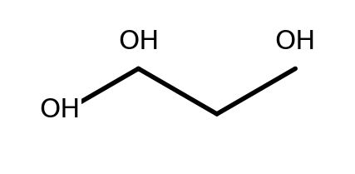
 | 26 | 20.326 | n-Hexadecanoic acid (Palmitic acid) | C16H32O2 | 256.42 | 4.31 | 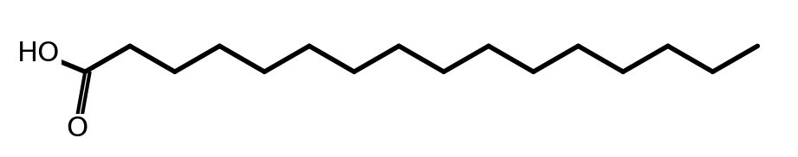
 | 68 | 27.038 | Octacosane, 2-methyl- | C29H60 | 408.80 | 2.88 | 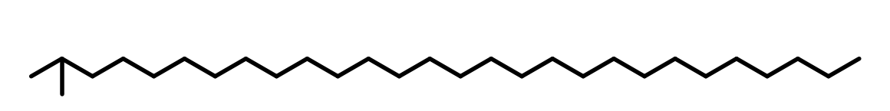
 | 69 | 28.007 | 2-Methyltetracosane | C25H52 | 352.68 | 2.86 | 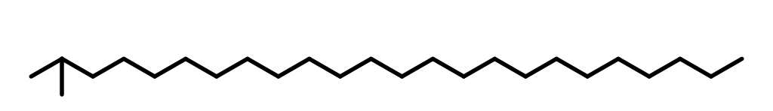
 | 62 | 26.088 | Octacosane, 2-methyl- | C29H60 | 408.80 | 2.69
 | 34 | 22.092 | 3,7,11,15-Tetramethyl-2-hexadecen-1-ol (Phytol isomer) | C20H40O | 296.53 | 2.45 | 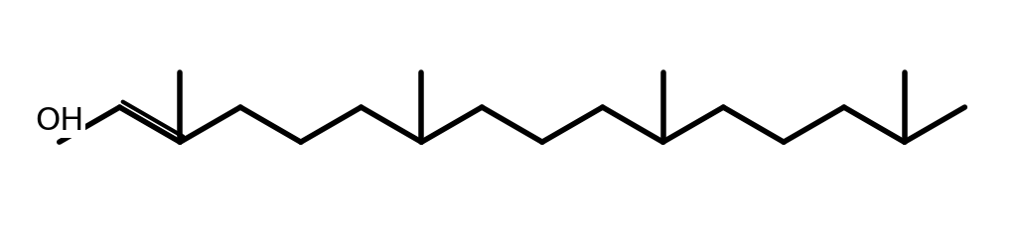
 | 80 | 32.810 | Tritetracontane | C43H88 | 605.16 | 1.71
 | 55 | 25.100 | Octacosane, 2-methyl- | C29H60 | 408.80 | 1.66
 | 90 | 34.682 | 9,19-Cycloergost-24(28)-en-3-ol, 4,14-dimethyl-, acetate, (3β,4α,5α)- (Cycloeucalenyl acetate) | C32H52O2 | 468.75 | 1.56 | 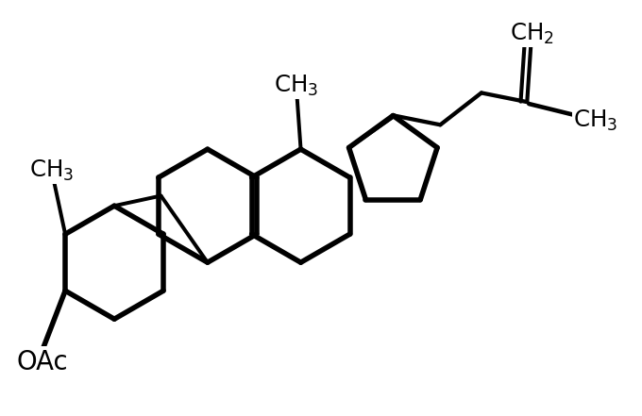
 | 84 | 33.209 | Ergostane-3,6-dione, 25-(acetyloxy)-5-hydroxy-, (5α)- | C30H48O5 | 488.71 | 1.55 | 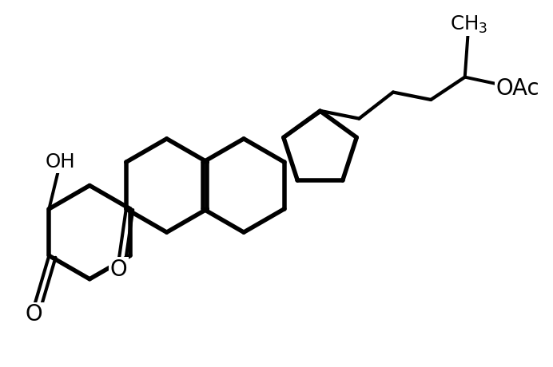
The structural elucidation of the ten most abundant peaks confirms the identities assigned through matching with the NIST library and highlights the presence of pharmacologically relevant classes such as fatty acids (n-hexadecanoic acid), branched long-chain hydrocarbons (octacosane, 2-methyl-; 2-methyltetracosane; tritetracontane), a phytol isomer (3,7,11,15-tetramethyl-2-hexadecen-1-ol) and steroidal constituents (ergostane- and cycloergostane-type derivatives), underscoring the phytochemical richness of the methanolic extract of C. comosum.
A recent GC-MS investigation of C. comosum root and leaf ethyl-acetate extracts independently demonstrated multiple identifiable plant-derived constituents and organ-dependent chemical profiles, supporting GC-MS as an informative approach for characterising the extract chemistry of this species (Kavya et al., 2024).

4. CONCLUSION
This study establishes an integrated set of pharmacognostic, physicochemical, phytochemical and analytical characteristics for the whole plant of Chlorophytum comosum (Thunb.) Jacques (Green type). Macroscopic and microscopic observations provide organ-level diagnostic features, while loss on drying, ash values, extractive values, swelling and foaming indices, and fluorescence behaviour contribute measurable quality-control parameters. Solvent-dependent extraction yields and preliminary phytochemical screening demonstrate the range of extractable constituents under the stated conditions. TLC provides class-based chromatographic fingerprints for alkaloids, saponins, flavonoids, tannins and phytosterols. GC-MS further characterises the methanolic extract, with 41 detected components and 25 recognisable plant-derived constituents; 1,2,4-butanetriol, n-hexadecanoic acid and octacosane, 2-methyl- were the most abundant identified components reported. Taken together, these observations provide a consolidated reference profile for identification, authentication and quality-control assessment of C. comosum (Green type). The findings should be interpreted as descriptive chemical and pharmacognostic evidence within the analytical scope of the study rather than as direct evidence of therapeutic efficacy.

Limitations
This study is limited to the descriptive pharmacognostic, physicochemical, preliminary phytochemical, TLC and GC-MS evaluation of one authenticated Chlorophytum comosum (Green type) plant collection under the stated analytical conditions. Consequently, the reported values and chromatographic profile are specific to the material and procedures examined. The GC-MS results describe constituents detected in the methanolic extract and should be interpreted as a chemical fingerprint. The study provides quality-control reference parameters but does not, by itself, establish biological or therapeutic efficacy.

COMPETING INTERESTS
We have declared that no competing interests exist.
ETHICAL Approval
The plant specimen was collected and authenticated in accordance with the institutional and national guidelines applicable to plant material.

Declaration of AI Use

This manuscript was prepared through the intellectual contributions of the author(s) to the study design, data analysis, interpretation of results, and scholarly content. Grammarly and ChatGPT were used solely to assist with grammatical refinement and reference formatting during manuscript revision. The author(s) accept full responsibility for the accuracy, integrity, and final content of the manuscript.

REFERENCES

Abrika, O. S. S., Yam, M. F., Asmawi, M. Z., Sadikun, A., Dieng, H., & Hussain, E. A. (2013). Effects of extracts and fractions of Gynura procumbens on rat atrial contraction. Journal of Acupuncture and Meridian Studies, 6(4), 199–207. https://doi.org/10.1016/j.jams.2013.01.020
Alam, F., & Najum us Saqib, Q. (2015). Pharmacognostic standardization and preliminary phytochemical studies of Gaultheria trichophylla. Pharmaceutical Biology, 53(12), 1711–1718. https://doi.org/10.3109/13880209.2014.1003355
Azmir, J., Zaidul, I. S. M., Rahman, M. M., Sharif, K. M., Mohamed, A., Sahena, F., Jahurul, M. H. A., Ghafoor, K., Norulaini, N. A. N., & Omar, A. K. M. (2013). Techniques for extraction of bioactive compounds from plant materials: A review. Journal of Food Engineering, 117(4), 426–436. https://doi.org/10.1016/j.jfoodeng.2013.01.014
Chauhan, N. N., Vasava, P., & Patel, M. S. (2020). Isolation and identification of tannins and polyphenol from the methanol extract stems of Samanea saman (Jacq.) Merr. by using TLC, UV, IR and GC-MS methods. International Journal of Creative Research Thoughts, 8(2), 40–47. https://ijcrt.org/papers/IJCRT2002007.pdf
Deore, S. L., Jajoo, N. B., Chittam, K. P., & Deshmukh, T. A. (2015). Comparative pharmacognostic, phytochemical and biological evaluation between five Chlorophytum species. Pharmacognosy Journal, 7(5), 317–325. https://doi.org/10.5530/pj.2015.5.12
India Biodiversity Portal. (n.d.). Chlorophytum comosum (Thunb.) Jacques. Retrieved July 26, 2026, from https://indiabiodiversity.org/species/show/229155
Kavya, P., Theijeswini, R. C., & Gayathri, M. (2024). Phytochemical analysis, identification of bioactive compounds using GC-MS, in vitro and in silico hypoglycemic potential, in vitro antioxidant potential, and in silico ADME analysis of Chlorophytum comosum root and leaf. Frontiers in Chemistry, 12, 1458505. https://doi.org/10.3389/fchem.2024.1458505
Khadabadi, S. S., Deore, S. L., & Baviskar, B. A. (2019). Experimental phytopharmacognosy: A comprehensive guide. Nirali Prakashan.
Khandelwal, R. K. (2000). Practical pharmacognosy: Techniques and experiments (2nd ed.). Nirali Prakashan.
Limpabandhu, T., Suwatronnakorn, M., Widoyanti, A. A. E., Issaravanich, S., Zongrum, O., & Prasansuklab, A. (2024). Pharmacognostic standardization and phytochemical evaluation of Ficus rumphii Blume leaves in Thailand. Phytomedicine Plus, 4(4), 100661. https://doi.org/10.1016/j.phyplu.2024.100661
Luo, Y., Yang, H., & Tao, G. (2024). Systematic review on fingerprinting development to determine adulteration of Chinese herbal medicines. Phytomedicine, 129, 155667. https://doi.org/10.1016/j.phymed.2024.155667
Marrelli, M. (2021). Medicinal plants. Plants, 10(7), 1355. https://doi.org/10.3390/plants10071355
Mukherjee, P. K. (2002). Quality control of herbal drugs: An approach to evaluation of botanicals. Business Horizons.
National Institute of Standards and Technology. (2008). NIST/EPA/NIH mass spectral library (NIST 08) [Mass spectral database]. https://chemdata.nist.gov/mass-spc/ms-search/docs/Ver20Man.pdf
Nisa, M. M. U., Sofi, P. A., Peerzada, I. A., & Bhat, T. B. (2026). Integrative ethnobotanical and GC-MS analysis of Valeriana jatamansi Jones: Pharmacological potential and conservation importance. Plant Cell Biotechnology and Molecular Biology, 27(1–2), 1–11. https://doi.org/10.56557/pcbmb/2026/v27i1-210130
Noviana, E., Indrayanto, G., & Rohman, A. (2022). Advances in fingerprint analysis for standardization and quality control of herbal medicines. Frontiers in Pharmacology, 13, 853023. https://doi.org/10.3389/fphar.2022.853023
Rzhepakovsky, I. V., Areshidze, D. A., Avanesyan, S. S., Grimm, W. D., Filatova, N. V., Kalinin, A. V., Kochergin, S. G., Kozlova, M. A., Kurchenko, V. P., Sizonenko, M. N., Terentiev, A. A., Timchenko, L. D., Trigub, M. M., Nagdalian, A. A., & Piskov, S. I. (2022). Phytochemical characterization, antioxidant activity, and cytotoxicity of methanolic leaf extract of Chlorophytum comosum (Green type) (Thunb.) Jacq. Molecules, 27(3), 762. https://doi.org/10.3390/molecules27030762
Shaikh, J. R., & Patil, M. K. (2020). Qualitative tests for preliminary phytochemical screening: An overview. International Journal of Chemical Studies, 8(2), 603–608. https://doi.org/10.22271/chemi.2020.v8.i2i.8834
Sharma, O. P., Kumar, N., Singh, B., & Bhat, T. K. (2012). An improved method for thin-layer chromatographic analysis of saponins. Food Chemistry, 132(1), 671–674. https://doi.org/10.1016/j.foodchem.2011.10.069
Sofowora, A., Ogunbodede, E., & Onayade, A. (2013). The role and place of medicinal plants in the strategies for disease prevention. African Journal of Traditional, Complementary and Alternative Medicines, 10(5), 210–229. https://doi.org/10.4314/ajtcam.v10i5.2
Sonibare, M. A., Ayo-Ayinde, M. A., Akinmurele, O. J., & Ogunlakin, A. D. (2025). Pharmacognostic standardization, morphometric analysis, and multivariate analysis of Croton lobatus L. and Croton zambesicus Mull. Arg. Microscopy Research and Technique, 88(4), 1128–1141. https://doi.org/10.1002/jemt.24771
Sureshkumar, V. (2021). Phytochemical screening and thin-layer chromatography profiling of various extracts of Achyranthes aspera and Cissus quadrangularis. The Journal of Phytopharmacology, 10(4), 225–229. https://doi.org/10.31254/phyto.2021.10402
Sushma, Kumar, G., Kumar, A., & Behera, B. (2026). Pharmacognostic standardization and HPTLC fingerprint profiling of Nardostachys jatamansi DC. rhizome with comparative phytochemical analysis of extracts. Journal of Advances in Medicine and Medical Research, 38(5), 1–11. https://doi.org/10.9734/jammr/2026/v38i56130
Vaidya, A. D. B., & Devasagayam, T. P. A. (2007). Current status of herbal drugs in India: An overview. Journal of Clinical Biochemistry and Nutrition, 41(1), 1–11. https://doi.org/10.3164/jcbn.2007001
World Flora Online. (2026). Chlorophytum comosum (Thunb.) Jacques. Retrieved July 26, 2026, from https://www.worldfloraonline.org/taxon/wfo-0000763291
World Health Organization. (1998). Quality control methods for medicinal plant materials. World Health Organization. https://www.who.int/publications/i/item/9241545100

ABBREVIATIONS
GC-MS: Gas Chromatography–Mass Spectrometry
TLC: Thin-Layer Chromatography
T.S.: Transverse Section
w/w: weight by weight
Rf: Retention factor
NIST: National Institute of Standards and Technology
EI: Electron Ionization
BSI: Botanical Survey of India
UV: Ultraviolet
mL / µL: millilitre / microlitre
°C: degree Celsius

