Ethnobotanical Survey of Medicinal Plants Used in the Management of Common Diseases in Ogbia Local Government Area, Bayelsa State, Nigeria

Abstract

Abstract
Background: Traditional medicine remains an important component of healthcare in many rural communities, particularly where access to orthodox healthcare is limited. This study documented the medicinal plants used and characterised ethno-medicinal practices among residents of Ogbia Local Government Area, Bayelsa State, Nigeria.

Methods: A cross-sectional ethnobotanical survey was conducted among 50 respondents using structured questionnaires, oral interviews, and field observations. Information on medicinal plants, their local uses, parts utilised, methods of preparation, routes of administration, and ailments treated was collected. Plant specimens were collected, identified, and authenticated. Data were analysed using descriptive statistics and presented as frequencies and percentages.

Results: A total of 50 medicinal plant species belonging to 47 genera and 34 families were documented. Euphorbiaceae, Gramineae, and Rutaceae were among the most represented families. Female respondents constituted the majority of participants, while knowledge of medicinal plants was more concentrated among older respondents. Malaria was the most frequently reported ailment treated with medicinal plants, followed by fever and cough. Herbs constituted the predominant growth form, leaves were the most commonly utilised plant part, and oral administration was the principal route of administration.

Conclusion: Traditional medicine remains widely utilised in Ogbia Local Government Area, largely due to its affordability, accessibility, and cultural acceptance. The concentration of ethnomedicinal knowledge among older individuals underscores the need for systematic documentation, preservation of indigenous knowledge, and scientific investigation of commonly used medicinal plants to establish
their safety and therapeutic potential.

Keywords
Ethnomedicinal practices, plant-based healthcare, indigenous healing knowledge, medicinal plant diversity, Ogbia, Bayelsa State.

- Introduction
Traditional medicine remains an important component of healthcare systems globally, particularly in developing countries where medicinal plants are commonly used in disease prevention and treatment (Asigbaase et al., 2024; Rafiu et al., 2025). It encompasses indigenous knowledge, beliefs, and practices applied in maintaining health and managing illnesses through naturally derived substances and culturally accepted therapeutic approaches. Although orthodox medicine has advanced considerably, traditional medicine continues to provide essential healthcare support owing to its affordability, accessibility, and cultural compatibility (Asigbaase et al., 2024; Nwosu, 1998; Rafiu et al., 2025).
The use of medicinal plants for therapeutic purposes dates back thousands of years and forms the basis of many contemporary pharmaceutical discoveries (Petrovska, 2012; Rafiu et al., 2025). Historical records from ancient civilisations, including China, Egypt, Greece, and India, demonstrate extensive reliance on herbal remedies for disease treatment (Petrovska, 2012). Many modern drugs have similarly been developed from plant-derived compounds, emphasising the scientific relevance of indigenous medicinal knowledge (Petrovska, 2012; Rafiu et al., 2025).

Ethnobotany, the scientific study of interactions between humans and plants, plays an important role in documenting medicinal plant use and preserving indigenous healthcare knowledge (Ouédraogo et al., 2020; Rafiu et al., 2025). Ethnobotanical investigations help identify plants used for disease management, methods of preparation, plant parts utilised, and cultural practices associated with healing (Asigbaase et al., 2024; Nwosu, 1998; Tukur et al., 2024). Such studies also contribute to pharmacological research through the identification of bioactive compounds that may support future drug development (Maiyo et al., 2024; Maroyi, 2013).
Recent community-based investigations have likewise combined interviews, field observations, and quantitative ethnobotanical measures to document medicinal plant use and associated indigenous knowledge (Beressa et al., 2024; Mahara & Ojha, 2024).

In many African communities, particularly rural areas, traditional medicine remains widely practised because of limited access to healthcare infrastructure, economic constraints, and sociocultural acceptance (Maiyo et al., 2024; Maroyi, 2013; Nwosu, 1998). However, indigenous medicinal knowledge is increasingly threatened by poor documentation, modernisation, and declining intergenerational transfer of knowledge. Consequently, systematic ethnobotanical studies are essential for preserving traditional therapeutic knowledge and promoting scientific validation of medicinal resources.
Recent analyses also indicate that the distribution of medicinal-plant knowledge can vary across socio-demographic groups, underscoring the value of documenting knowledge holders alongside plant-use patterns (Tamene et al., 2024).

This study therefore aimed to document medicinal plants used in the treatment of diseases among indigenous populations in Ogbia Local Government Area, identify common disease conditions managed with herbal remedies, and evaluate patterns of medicinal plant utilisation within the study area.

1.2 Modern Ethnobotany
Modern ethnobotany has evolved considerably from simple descriptive documentation to a multidisciplinary scientific field involving botany, anthropology, pharmacology, linguistics, ecology, and public health. The twentieth century witnessed a methodological transformation in ethnobotanical studies, emphasising rigorous data collection, cultural interpretation, and scientific validation of indigenous knowledge. Among the pioneers of modern ethnobotany is Richard Evans Schultes, whose extensive fieldwork significantly advanced the discipline and contributed to the understanding of indigenous medicinal plant use. Modern ethnobotanical investigations require expertise in plant identification and preservation, cultural interpretation, language documentation, and community engagement to ensure accurate recording of indigenous knowledge systems.

A major challenge in ethnobotanical studies concerns access to indigenous medicinal knowledge. Traditional healers may be reluctant to disclose information due to concerns about intellectual exploitation, loss of cultural heritage, or misuse of traditional practices. Consequently, successful ethnobotanical research often depends on trust-building, long-term interaction, and respectful collaboration with indigenous communities. Despite these challenges, traditional medicinal knowledge remains an invaluable resource for scientific advancement. Many contemporary medicines are derived from plant compounds initially identified through ethnobotanical observations, reinforcing the relevance of indigenous healthcare systems in pharmaceutical development.

1.3 Relevance of Ethnobotany
Ethnobotany plays a significant role in scientific research, healthcare advancement, and biodiversity conservation (Maroyi, 2013; Simbo, 2010). One of its major contributions is the establishment of a knowledge base for future investigations into medicinal plants and their therapeutic properties. Information obtained through ethnobotanical surveys serves as an important repository for identifying plant species with medicinal potential. Such data may facilitate phytochemical screening, pharmacological testing, toxicity studies, and the eventual development of safer and more effective pharmaceutical preparations.

Ethnobotanical studies also contribute to preserving indigenous cultural knowledge by documenting traditional therapeutic practices before they disappear through modernisation or generational shifts (Ouédraogo et al., 2020). Furthermore, ethnobotany encourages sustainable utilisation and conservation of medicinal plants by highlighting their social, economic, and therapeutic significance. The discipline additionally provides insight into local health challenges and treatment preferences, thereby supporting culturally sensitive healthcare planning and integration of beneficial traditional practices into broader healthcare systems.
Comparable ethnobotanical surveys have documented diverse medicinal-plant growth forms and multiple administration routes, with oral use frequently reported, supporting systematic recording of preparation and administration practices (Mekuria & Abduro, 2022).

Although the manuscript documents the broader relevance of ethnobotanical research, a context-specific account integrating medicinal plant identity, ailments treated, plant parts used, preparation methods, routes of administration, cultural practices, perceived acceptability, and the demographic distribution of knowledge in Ogbia Local Government Area remains limited. This gap provides the basis for the present study.
1.4 Aim and Objectives
The aim of this study was to identify, document, and characterise the use of medicinal plants and ethnomedicinal practices among indigenous communities in Ogbia Local Government Area of Bayelsa State, Nigeria. The specific objectives of the study were to: characterise the ethnomedicinal uses of the documented plants, including the ailments treated, plant parts utilised, methods of preparation, and routes of administration; determine the commonly reported ailments for which medicinal plants are used and identify the medicinal plants associated with their management; examine the influence of indigenous beliefs and cultural practices on the use and acceptance of medicinal plants and traditional medicine; assess the perceived relevance, acceptability, accessibility, and perceived effectiveness of traditional medicine among the study participants; assess the association between respondents’ demographic characteristics and their knowledge and utilisation of medicinal plants; and document the distribution of ethnomedicinal knowledge among respondents according to age, sex, educational level, occupation, and other relevant demographic characteristics.

2. METHODOLOGY

2.1 Study Area
Bayelsa State is located in the Niger Delta region of southern Nigeria, with Yenagoa as its capital, and is characterised by extensive mangrove forest, rivers, creeks, and swamps. The state comprises eight Local Government Areas (LGAs), including Ogbia, which was selected as the study location. Ogbia Local Government Area is situated at approximately 4°39′N and 6°16′E, covers an estimated land area of about 695 km² and is bounded by Yenagoa, Nembe, Brass, Southern Ijaw, and Rivers State. The native flora comprises diverse mangrove, freshwater swamp, and rainforest vegetation, including red mangrove (Rhizophora spp.), black mangrove (Avicennia germinans), white mangrove (Laguncularia racemosa), Nypa palm (Nypa fruticans), oil palm (Elaeis guineensis), and various herbs and climbers, with red mangrove (Rhizophora spp.) being among the most abundant and widely distributed plants in the coastal environment; the area is predominantly inhabited by indigenous Ijaw and Ekpeye communities whose major occupations include fishing, farming, canoe carving, palm wine tapping, and hunting.

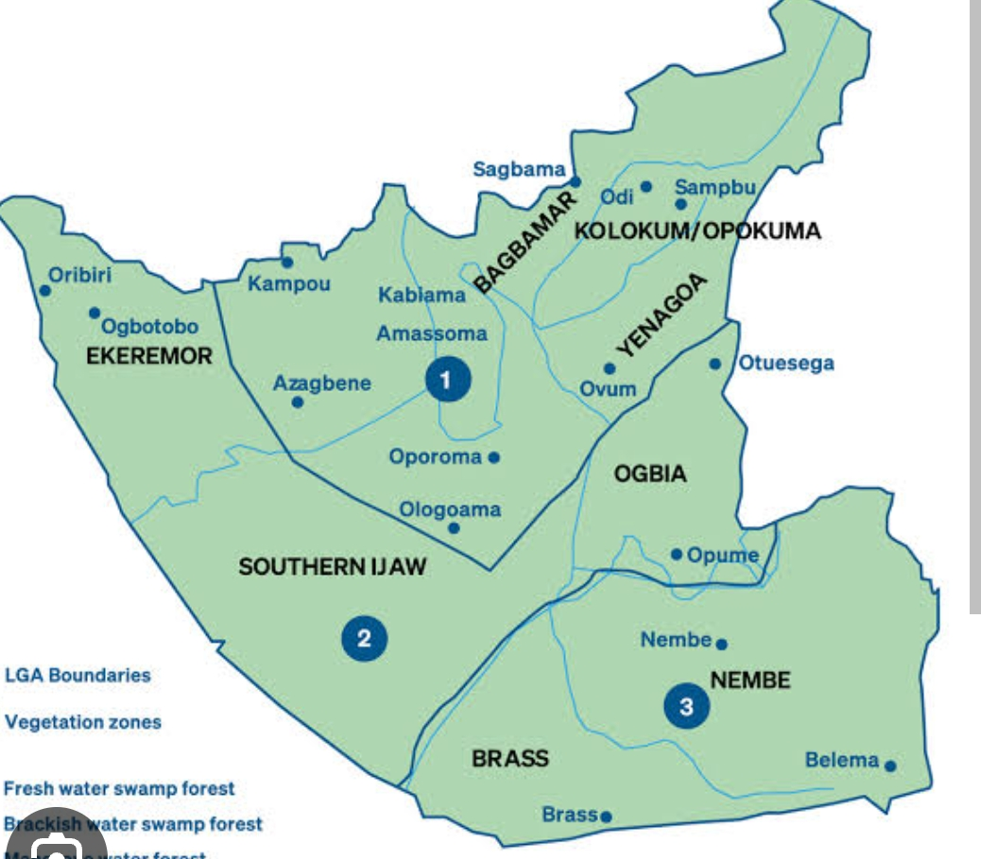

Fig. 1. Map of Bayelsa State showing the Local Government Areas.

2.3 Method of Study

Data for this study were collected primarily through the administration of structured questionnaires, following approaches recommended in previous ethnobotanical studies by Halliru et al. (2024) and Tukur et al. (2024). In addition to questionnaires, field visits and oral interviews were conducted to obtain detailed information regarding indigenous medicinal plants and their traditional uses.

Participants were selected randomly from individuals considered knowledgeable about indigenous medicinal plants. Interviews were conducted with the assistance of local interpreters and literate community members to facilitate communication and ensure accuracy of responses.

Information collected included local names of medicinal plants, plant growth forms (such as shrubs, trees, climbers, and herbs), plant parts utilised, therapeutic applications, methods of preparation, and routes of administration. Respondents included community elders knowledgeable in herbal medicine, individuals previously treated using herbal remedies, and persons familiar with traditional medicinal practices.
Plant specimens identified during the ethnobotanical survey, alongside their reported medicinal uses and local names, were collected, preserved, and deposited in the herbarium of the Department of Pharmacognosy and Herbal Medicine, Faculty of Pharmacy, Niger Delta University.

3. Results and Discussion
The results of the ethnobotanical survey conducted in Ogbia Local Government Area are discussed with emphasis on respondents’ demographic characteristics, prevalent disease conditions, medicinal plant families, plant forms and plant parts utilised, and methods of administration of traditional remedies. Comparisons are also made with findings from similar ethnobotanical studies conducted in other regions to establish similarities and differences in medicinal plant utilisation.

3.1 Demographic Characteristics of Respondents
The demographic survey conducted during the study revealed that a total of fifty respondents participated in the ethnobotanical investigation. Among these, women constituted the majority, accounting for 64% of respondents, while men represented 36%.
Female respondents were predominantly within the age range of 35-70 years, whereas male respondents were aged between 45 and 73 years.
The greater involvement of women in traditional medicinal knowledge observed in this study may be associated with their active role in household caregiving, childcare, and family health management. Women often serve as primary caregivers and are therefore more likely to possess practical knowledge relating to disease management and the use of medicinal plants. This observation is consistent with findings from ethnobotanical studies in Namibia, which similarly reported substantial female participation in indigenous healthcare knowledge systems.
Furthermore, the study showed that individuals possessing extensive knowledge of medicinal plants were largely above the age of 40 years. This finding suggests that ethnomedicinal knowledge in the study area remains concentrated among older populations, thereby raising concerns regarding possible loss of indigenous knowledge due to inadequate transfer to younger generations. Similar observations have been documented in studies conducted in Cameroon, where elderly individuals were reported to be the principal custodians of medicinal plant knowledge (Simbo, 2010).
Table 1: Demographic Distribution of Respondents

Gender | Age Range | Frequency(n) | Percentage %
Female | 35-70 | 32 | 64
Male | 46-73 | 18 | 36

A total of fifty respondents participated in the study. Females constituted the majority of respondents, accounting for 64%, while males accounted for 36%.

3.2 Prevalent Disease Conditions
The study identified several disease conditions commonly managed using medicinal plants within the study area. These included malaria, fever, cough, stomach pain, diarrhoea, wounds, measles, piles, ulcers, and anaemia. Among these conditions, malaria emerged as the most prevalent disease, accounting for approximately 42.90% of reported cases.
The high prevalence of malaria within the study area may be linked to the ecological characteristics of the region. Ogbia Local Government Area is characterised by riverine environments, swamps, stagnant water bodies, and dense vegetation, which create favourable breeding conditions for mosquitoes, particularly malaria vectors. Given that Nigeria is recognised as a malaria-endemic country, the findings of this study are unsurprising and may reflect broader epidemiological trends within tropical environments (Olorunnisola et al., 2013).
Fever and cough were also frequently reported disease conditions. Their prevalence may be associated with environmental and sanitation-related factors, including poor hygiene, inadequate waste disposal, overcrowding, and exposure to environmental pollutants commonly observed in rural settings.
Comparatively, the disease profile reported in this study differs from findings in Namibia, where mental disorders constituted the most frequently treated conditions using traditional medicine. However, similarities were observed regarding the treatment of wounds and external injuries. Likewise, studies conducted in Palestinian communities identified gastric disorders among commonly treated illnesses, corresponding partly with the occurrence of stomach-related ailments reported in the present study.

Table 2: Common Diseases Treated Using Medicinal Plants

Disease Condition | Frequency of citation (n) | Percentage citation (%)
Malaria | 133 | 42.90
Fever | 112 | 39.35
Cough | 82 | 26.45
Stomach Pain | 74 | 23.87
Diarrhoea | 51 | 16.45
Wound | 51 | 15.45
Measles | 48 | 15.48
Pile | 39 | 12.58
Ulcer | 36 | 11.61
Anaemia | 36 | 11.61

Malaria was identified as the most prevalent disease condition, accounting for 42.90%.

3.3 Medicinal Plants Documented in the Study Area
The ethnobotanical survey documented 50 medicinal plant taxa belonging to several botanical families and growth forms. The documented plants comprised herbs, shrubs, trees, and climbers, with leaves representing the most frequently reported plant part utilised. Various preparation methods were reported, including decoction, crushing, squeezing, chewing, soaking, and direct application. Oral administration was the predominant route of administration, although topical, ophthalmic, nasal, and other routes were also reported.
The medicinal plants identified by the respondents, together with their local names, growth forms, reported therapeutic uses, plant parts utilised, preparation methods, mode of administration, and reported abundance are reported in Table 3.

Table.3 Medicinal plants documented and their ethnomedicinal uses in Ogbia Local Government Area, Bayelsa State, Nigeria.

S/N | Family | Scientific name | Local Names/ Ijaw) | Growth form | Reported medicinal use | Part Used | Preparation | Administration | Reported Status
1. | Acanthacea | Brillantaisi patula T. Anderson |  | Herb | Eye Problem | Leave | Juice squeezed from leaves | Ophthalmic | Less abundant
2. | Acanthacea | Acanthus montanus | Alayanpog | Herb | Boils | Leave | Pounded and applied to affected area | Topical | Abundant
3. | Agavaceae | Dracaena mannii Vand. ex L | Etegbu | Herb | Witchcraft-related fever, poisoning | Leave | Squeeze with water | Oral | Less abundant
4. | Anacardiac | Magnifera indica L | Ome | Tree | Malarial | Stembark, Leave | Decoction prepared with pawpaw leaf and Lemon grass | Oral | Abundant
5. | Anacardiacae | Spondias spp |  | Herb | Constipation | Leave | Leaves chewed | Oral | Abundant
6. | Annonacea | Monodara spp | Ootoro | Tree | Aphrodisiac, nerve and dental complaints | Leave,Root,Stem | Boil and consume | Oral | Abundant
7. | Asteraceae | Ageratum conyziodes L. |  | Herb | Nerve and uterine complaints | Leave | Boiled and consumed | Oral | Abundant
8. | Asteraceae | Gutenbergia nigretana | Bowologbo | H | Oedema, mealses, constipation | Leaves | Juice squeezed from leaves; decoction | Topical, oral, rectal | Abundant
9. | Asteraceae | Vernonia spp | Olugbo | Shrub | Malaria, typhoid, menstrual pain, blood boaster, infertility, ulcer stomach ache, vomiting, measles | Leaves | Squeeze and Filter; other preparations reported | Oral, intra-vagina | A
10. | Apocynaceae | Rauvolfia vomitoria Afzel. |  | Herb | Fever, malaria, rheumatism | L | Leaves cooked; roots pounded with alligator pepper | Oral Topical | Abundant
11. | Bignoniacea | Newbouldia laevis Seem.ex Bureau | Erurum | Tree | Cough | Stembark | Pound with water and Salt, then Filter | Oral | Abundant
12. | Bromeliacea | Anama comosus (L.) Merr. | Pineapple | Shrub | Energy, general health, eye complaints | Leaves,Stem,root, fruit | Pealed and eaten | Oral | Less abundant
13. | Burseracea | Dacryodes edulis | Ebea | Tree | Waist pain, Malaria | Leaves | Cooked with other plant materials and consumed | Oral | S
14. | Caricaceae | Carica papaya L | Ogurubeke | Tree | Eye complaints, cattarh, measeles, malaria | Leaves | Boiled and consumed; juice Squeezed | Oral | Abundant
15. | Caesalpiniacea | Senna alata L.Roxb. | San | Shrub | Anti HIV | Leaves | Pound with potash and water | Oral | Abundant
16. | Commelinacaea | Commelina diffusa Burm.f. | Iyenbigi | Herb | Convulsion | Leaves | Soaked in water/ alcohol and used for bathing | Topical LA | Abundant
17. | Compositae | Melantera scandens (Schumach & Thonn,) Roberty | Opoh | Herb | Uterine complaints, malaria | Leaves | Soaked and used for bathing, cooked and consumed | Topical Oral | Abundant
18. | Compositae | Aspillia africana (Pers.) C.D. Adams | Epiwe | Tree | Wound healing, Cough | Leaves | Squeeze + Old Alligator Pepper chew | Oral, Topical | Abundant
19. | Convolvulaceae | Ipomoae batatas (L.) Lam | Brobomgbo | Herb | Blood building, recovery from illness | Leaves | Squeeze and filtered Juice consumed | Oral | Less abundant
20. | Cucurbitaceae | Cucurbita pepo L. | Ogu | Herb | Malaria, typhoid, menstrual pain, blood building | Leaves | Squeezed, Filtered and mixed with milk | Oral | Less abundant
21. | Crassulaceae | Bryophyllum pinnatum (Lam.) Oken | Never-die Amador | Herb | Navel pain, asthama, boils, Wounds, cough, | Leaves | Heated, squeezed with salt, or applied after heating. | Topical, oral, steam bath | A
22. | Euphorbiaceae | Alchornea Cordifolia Schum & Thonn | Epenye | Herb | Diarrhoea & Malaria | Leaves | Chew Cook + H2O + Drink | Oral | A
23. | Euphorbiaceae | Jatropha Curcas L. | Hospital too far | Herb | Blood boaster | Leaves | Squeezed, Filter and Milk | Oral | A
24. | Euphorbiaceae | Phyllatus amarus Schrum & Thonn | Tonkabein | Herb | Rheumatism | Leaves | Boil | Oral | LA
25. | Euphorbiaceae | Manihot esculantum Crantz | Adiabo | Shrub | Anthihelminthic | Leaves | Squeezed and apply | Ophthalmic | LA
26. | Harugaceae | Harunganamadagascariensis Lam | Obilemidey | Tree | Malaria | Stem | Cooked and consumed | Oral | A
27. | Graminae | Cymbopogon CitratusStapf | Lemon Grass | Herb | Malarial Chronic fever | Leaves | Decoction + Lime, soup + palm wine | Oral | LA
28. | Graminae | Cynodon | Esisa | Herb | Hernia | Leaves | Pound + Rub on pubic region | Topical | LA
29. | Graminae | Saccharum | Sugar Cane | Shrub | Swelling at public region, malaria, hermorrhage | Leaves | Cut the swelling region, chew | Topical Oral | A
30. | Graminae | Zea ways | Ebukpa | Shrub | Swelling of Jaw | Dry seed | Ground + rub on Jaw | Topical | S
31. | Gutiferae | Garcinia cola L | Igbe | Tree | Chest Pain, neutralise drug | Seed | Chew | Oral | S
32. | Lamiaceae | Ocimum gratissimum L | Anadudu | Shrub | Fainting, Fever, Cough, Stomach Pain, Convulsion,Tuberculosis Constipation, eye turning, Dysentry, Pile, Cough | Leaves | Squeeze Juice Squeeze + Salt + Ogu+ Bitter Leaf Chew Leaf | Oral Ophthalmic Nasal | A
33. | Lamiaceae | Salomostenum monostachyus P.Beauv. | Epelipe | Herb | Stomach upset, fever | Leaves | Cook + drink | Oral | LA
34. | Loganiacea | Anthocleista Vogelii Planchon | Okokwo | Tree | For Nerves, Manpower | Root | Soak with Alcohol | Oral | A
35. | Meliaceae | Entandrophragma spp. | Mahogany | Tree | Labour induction, nerve complaints, Malaria | Root | Ground and Squeezed, soaked with water and alcohol | Oral | S
36. | Menispermaceae | Tinospora Cordifolia (Wild.)Hook.f. & Thomson |  | Shrub | Chest Pain | Leaves | Squeezed with water | Oral | Scarce
37. | Melestomataceae | Dissostis rotundifolia (Sm.) Triana |  | Herb | Cough | Leaves | Cooked and consumed or Squeezed and consumed | Oral | Less abundant
38. | Moraceae | Musaga cecropioides R.Br. & Tadlie | Oboin | Tree | Infertility related complaints | Root | Cooked with water | Topical, Oral | Abundant
39. | Musaceae | Musa paradisiaca L. | Plantain | Tree | Eczema, Piles, Pain, aphrodisiac, hyena, Malaria, Ulcer. | Sucker | Dried, burn to ashes rub on Skin. | Oral | Abundant
40. | Myrtaceae | Psidium guajava L | guava | Tree | Malaria, typhoid, low sperm count | Leaves | Boiled with other plant material or squeezed and filtered | Oral | Less abundant
41. | Nymphaea | Nymphaea lotus L. | Aguelele | Herb | Ulcer | Leaves | Leaves Cooked and consumed | Oral | Abundant
42. | Palmae | Elaeis guineesis Jacq. | Palm Tree | Tree | Convulsion | Oil | Ground with Garlic | Oral | Abundant
43. | Palmae | Cocos Nucifera L. | Coconut | Tree | Convulsion poisoning | Coconut Juice | Boiled and consumed | Topical | Less abundant
44. | Piperraceae | Piper gulneense Schumach. And Thonn. | Osisa | Climber | Fever | Leaves | Pounded and applied topical | Oral | Scarce
45. | Piperaceae | Piper umbellatum L. | Otubari | Herb | Uterine complaints, swelling and stomach complaints | Leaves | Cooked with plantain and consumed | Oral | Lesss abundant
46. | Rutaceae | Citrus aurantifolia (Christm.) Swingle | Lime | Tree | Cough, malarial, typhoid | Fruit | Juice squeezed and add honey, boiled with lemongrass | Oral | Abundant
47. | Rutaceae | Citrus aurantium L. | Orange | Tree | Chronic malaria | Leaves | Boiled with mango bark and plantain leaves and consumed | Oral | Abundant
48. | Rutaceae | Citrus paradisa Macfad. | Grape | Tree | Malaria | Fruit | Extract consumed | Oral | Less abundant
49. | Urticaceae | Laportea Ovalifolia | Enofa | Herb | To cut Plancenta | Leaves | Cooked and consumed | Oral | Scarce
50. | Vitaceae | Cisus quandrangularis L. | Odifi or sapo | Climber | Hernia Hypertension, diabetes, stomach pain | Shrub | Cooked and consumed | Oral | Less abundant

Table 5. The prevalent disease conditions

S/N | DISEASE | NO OF CITATIONS | % CITATION
1 | Malaria | 133 | 42.90
2. | Fever | 112 | 39.35
3. | Cough | 82 | 26.45
4. | Stomach Pain | 74 | 23.87
5. | Diarrhea | 51 | 16.45
6. | Wound Healing | 51 | 16.45
7. | Measles | 48 | 15.48
8. | Pile | 39 | 12.58
9. | Ulcer | 36 | 11.61
10. | Anaemia | 36 | 11.61

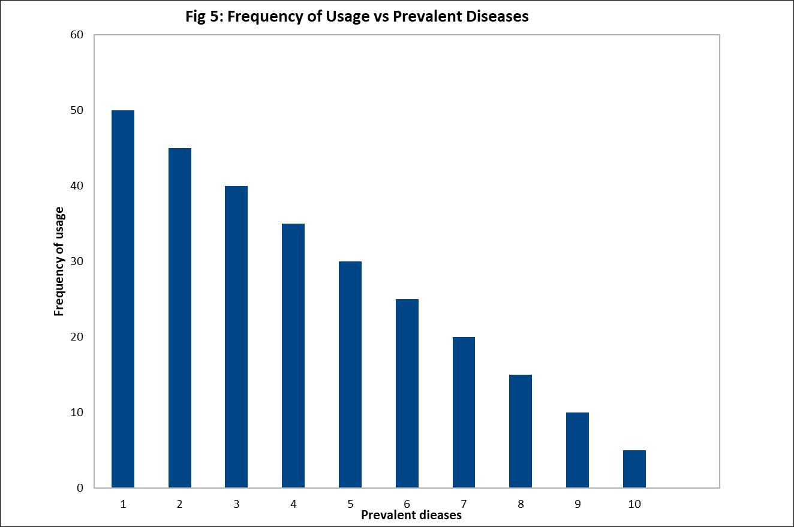

Figure 1. Frequency of Usage vs Prevalent Diseases from the study carried out

KEYS
1. Malaria 2.Fever 3.Cough 4.Stomach Pain 5.Diarrhoea 6.Wound 7.Measles 8.Pile 9.Ulcer
10.Anaemia

Table 6. The list of the most prevalent plant families

S/N | PLANT FAMILY | FREQUENCY | % OF PLANT FAMILY
1. | Acanthaceae | 2 | 8.70
2. | Anacardiaceae | 2 | 8.70
3. | Compositae | 3 | 17.39
4. | Euphorbiaceae | 2 | 8.70
5. | Euphorbiaceae | 4 | 17.39
6. | Graminae | 4 | 17.39
7. | Lamiaceae | 2 | 8.70
8. | Rutaceae | 4 | 17.39

Table 7. The frequency of the plant forms used in the treatment of record ailment shown below.

S/N | Plant Form | Frequency | %Frequency
1. | Herb | 24 | 45.28
2. | Tree | 18 | 33.96
3. | Shrub | 8 | 8.00
4. | Climber | 3 | 5.66

Table 8. Age distribution of respondents

Age interval | Frequency | % Frequency
0-19 | 4 | 8
20-39 | 15 | 30
40-50 | 28 | 56
51-75 | 3 | 6

Figure 2. Barchart showing acquisition of plant knowledge by respondents

The findings of the ethnobotanical survey conducted in Ogbia Local Government Area are presented with emphasis on respondents’ demographic characteristics, prevalent disease conditions, medicinal plant families, plant forms and plant parts utilised, and methods of administration of traditional remedies. Comparisons are also made with findings from similar ethnobotanical studies conducted in other regions to establish similarities and differences in medicinal plant utilisation and healthcare practices.

5.1 Demographic Characteristics of Respondents
The demographic survey conducted during the study revealed that a total of fifty respondents participated in the ethnobotanical investigation. Among these, women constituted the majority, accounting for 64% of respondents, while men represented 36%. Female respondents were predominantly within the age range of 35–70 years, whereas male respondents were aged between 45 and 73 years.

The greater involvement of women in traditional medicinal knowledge observed in this study may be associated with their active role in household caregiving, childcare, and family health management. Women often serve as primary caregivers and are therefore more likely to possess practical knowledge relating to disease management and the use of medicinal plants. This observation is consistent with findings from ethnobotanical studies in Namibia, which similarly reported substantial female participation in indigenous healthcare knowledge systems.

Furthermore, the study showed that individuals possessing extensive knowledge of medicinal plants were largely above the age of 40 years. This finding suggests that ethnomedicinal knowledge in the study area remains concentrated among older populations, thereby raising concerns regarding possible loss of indigenous knowledge due to inadequate transfer to younger generations. Similar observations have been documented in studies conducted in Cameroon, where elderly individuals were reported to be the principal custodians of medicinal plant knowledge (Simbo, 2010).

5.2 Prevalent Disease Conditions
The study identified several disease conditions commonly managed using medicinal plants within the study area. These included malaria, fever, cough, stomach pain, diarrhoea, wounds, measles, piles, ulcers, and anaemia. Among these conditions, malaria emerged as the most prevalent disease, accounting for approximately 42.90% of reported cases.

The high prevalence of malaria within the study area may be linked to the ecological characteristics of the region. Ogbia Local Government Area is characterised by riverine environments, swamps, stagnant water bodies, and dense vegetation, which create favourable breeding conditions for mosquitoes, particularly malaria vectors. Given that Nigeria is recognised as a malaria-endemic country, the findings of this study are unsurprising and may reflect broader epidemiological trends within tropical environments (Olorunnisola et al., 2013).

Fever and cough were also frequently reported disease conditions. Their prevalence may be associated with environmental and sanitation-related factors, including poor hygiene, inadequate waste disposal, overcrowding, and exposure to environmental pollutants commonly observed in rural settings.

Comparatively, the disease profile reported in this study differs from findings in Namibia, where mental disorders constituted the most frequently treated conditions using traditional medicine. However, similarities were observed regarding the treatment of wounds and external injuries. Likewise, studies conducted in Palestinian communities identified gastric disorders among commonly treated illnesses, corresponding partly with the occurrence of stomach-related ailments reported in the present study.

5.3 Prevalent Plant Families
The ethnobotanical survey documented fifty medicinal plant species distributed across thirty-four plant families and forty-seven genera used in the treatment of different ailments. Several plant families demonstrated greater representation than others, suggesting their importance in indigenous therapeutic practices within the study area.

Among the documented families, Euphorbiaceae, Graminae, and Rutaceae emerged as the most represented groups, while Asteraceae, Acanthaceae, Lamiaceae, Anacardiaceae, and Compositae also contributed significantly to medicinal plant use.

The prominence of these plant families may be attributed to their abundance within the local environment, accessibility, and the presence of pharmacologically active constituents with therapeutic relevance. Many species belonging to these families are widely recognised in ethnomedicine for their antimicrobial, antipyretic, anti-inflammatory, analgesic, and antiparasitic activities. Their repeated occurrence in medicinal applications further highlights the importance of biodiversity in supporting indigenous healthcare systems.

5.4 Plant Parts and Plant Growth Forms Used
The findings revealed that various plant parts were utilised in traditional healthcare, including leaves, roots, stems, fruits, and bark. Among these, leaves were identified as the most frequently used plant part.

The frequent use of leaves may be explained by several factors. Leaves are generally more accessible, easier to harvest, and can often be collected without destroying the plant, thereby promoting sustainability. Additionally, leaves are recognised as major sites of biosynthesis and storage of bioactive phytochemical compounds, which may contribute to their medicinal value.

Regarding plant growth forms, herbs constituted the most frequently utilised category, accounting for the largest proportion of medicinal species documented in the study. Trees ranked second, followed by shrubs and climbers.

The predominance of herbs may be attributed to their availability, rapid growth, ease of harvesting, and widespread occurrence within local ecosystems. This finding aligns with reports from Cameroon, where herbs were similarly identified as dominant medicinal plant forms (Simbo, 2010). However, the observation contrasts with studies from Namibia, which reported trees as the most commonly used plant category, suggesting regional variations in vegetation patterns and ethnomedicinal preferences.

5.5 Mode of Administration of Traditional Remedies
The findings further demonstrated that oral administration was the predominant route through which traditional medicines were administered. Herbal remedies were commonly prepared in crude forms such as decoctions, infusions, and concoctions and subsequently consumed orally.

The preference for oral administration may be explained by its simplicity, convenience, affordability, and ease of preparation. Unlike injectable formulations, oral preparations require minimal technical expertise, specialised equipment, or professional supervision. This mode of administration is also widely accepted because it allows for easy preparation and use in household settings.

The predominance of oral administration observed in this study is consistent with ethnobotanical findings reported in Ethiopia, where oral intake similarly constituted the major route of herbal medicine administration (Tadesse et al., 2024; Zemede et al., 2024).

6. Conclusion
This ethnobotanical study documented fifty medicinal plant species belonging to thirty-four plant families and forty-seven genera utilised in the treatment of various ailments in Ogbia Local Government Area. Among the identified plant families, Euphorbiaceae, Graminae, and Rutaceae were the most represented, indicating their importance in indigenous therapeutic practice.

Malaria emerged as the most prevalent disease condition managed with medicinal plants, reflecting the ecological and epidemiological realities of the study environment. Herbs and leaves were the most commonly utilised plant forms and plant parts, respectively, while oral administration constituted the predominant mode of treatment delivery.

The findings further indicate that traditional medicine remains widely accepted within the study area because of its accessibility, affordability, cultural relevance, and convenience when compared with orthodox healthcare services. However, the concentration of ethnomedicinal knowledge among older generations highlights the urgent need for documentation, preservation, and scientific evaluation of indigenous medicinal practices to prevent the loss of valuable traditional knowledge.

Limitation

This cross-sectional ethnobotanical survey involved only 50 respondents from Ogbia Local Government Area, limiting representativeness and generalisability beyond the surveyed communities. Participants were selected from individuals considered knowledgeable about medicinal plants, which may have introduced selection bias. Reliance on questionnaires and oral interviews may also be affected by recall, interviewer, and reporting biases. The descriptive analysis did not control for potential confounding factors or establish causal relationships. Reported medicinal uses were not clinically evaluated for efficacy, safety, or dosage standardisation. Future studies should include larger, more diverse samples, inferential analyses, and pharmacological and toxicological validation.

Consent
Written informed consent was obtained from all respondents before interviews were conducted. Confidentiality and anonymity of participants were maintained throughout the study. Traditional knowledge was documented with the consent of knowledge holders and used solely for academic purposes.

Declaration of AI Use

This manuscript was prepared through the combined contributions of all author(s), including contributions to the study design, data, content development, results, interpretation, and related scholarly work. The author(s) acknowledge the use of Grammarly and ChatGPT to assist with grammar checking, language refinement, and reference formatting. These AI-assisted tools were not used as authors and did not replace the intellectual contributions or scholarly judgment of the author(s). All AI-assisted outputs, including content, references, and interpretations, were carefully reviewed, revised, verified, and approved by the author(s). The author(s) accept full responsibility for the accuracy, integrity, and final content of the manuscript.

References
Asigbaase, M., Adusu, D., Musah, A. A., Anaba, L., Nsor, C. A., Abugre, S., & Derkyi, M. (2024). Ethnobotanical and ethnopharmacological survey of medicinal tree species used in the treatment of diseases by forest-fringe communities of Southwestern Ghana. Heliyon, 10(1), e23645. https://doi.org/10.1016/j.heliyon.2023.e23645
Beressa, T. B., Gadisa, D. A., Mammo, S., Umeta, G. T., Meskele, L. B., Gudeta, B. M., & Taye, G. M. (2024). Ethnobotanical study of traditional medicinal plants used to treat human ailments in West Shewa community, Oromia, Ethiopia. Frontiers in Pharmacology, 15, 1369480. https://doi.org/10.3389/fphar.2024.1369480
Halliru, B. S., Wada, N., Dogara, A. M., Mahmud, A. A., Danladi, M. D., Labaran, I., & Danlami, H. (2024). Ethnobotanical survey of medicinal plants used in the treatment of transmissible diseases. Journal of Science and Technology, 16(1), 45–55. https://doi.org/10.30880/jst.2024.16.01.005
Mahara, A., & Ojha, N. (2024). Ethnobotanical study of medicinal plants in Kepilasgadhi Rural Municipality of Khotang District, Nepal. European Journal of Medicinal Plants, 35(6), 105–131. https://doi.org/10.9734/ejmp/2024/v35i61212
Maiyo, Z. C., Njeru, S. N., Toroitich, F. J., Indieka, S. A., & Obonyo, M. A. (2024). Ethnobotanical study of medicinal plants used by the people of Mosop, Nandi County in Kenya. Frontiers in Pharmacology, 14, 1328903. https://doi.org/10.3389/fphar.2023.1328903
Maroyi, A. (2013). Traditional use of medicinal plants in south-central Zimbabwe: Review and perspectives. Journal of Ethnobiology and Ethnomedicine, 9, Article 31. https://doi.org/10.1186/1746-4269-9-31
Mekuria, T., & Abduro, H. (2022). Ethnobotanical study on medicinal plants used by local communities in Shashemene District, West Arsi Zone of Oromia Region, Ethiopia. Asian Journal of Plant and Soil Sciences, 7(1), 158–170. https://doi.org/10.56557/ajopss/2022/v7i173
Nwosu, M. O. (1998). Aspects of ethnobotanical medicine in southeast Nigeria. The Journal of Alternative and Complementary Medicine, 4(3), 305–310. https://doi.org/10.1089/acm.1998.4.3-305
Olorunnisola, O. S., Adetutu, A., Balogun, E. A., & Afolayan, A. J. (2013). Ethnobotanical survey of medicinal plants used in the treatment of malaria in Ogbomoso, Southwest Nigeria. Journal of Ethnopharmacology, 150(1), 71–78. https://doi.org/10.1016/j.jep.2013.07.038
Ouédraogo, L., Endl, J., Sombié, P. A. E. D., Schaefer, H., & Kiendrebeogo, M. (2020). Ethnobotanical use and conservation assessment of medicinal plants sold in markets of Burkina Faso. Ethnobotany Research and Applications, 20, 1–25. https://doi.org/10.32859/era.20.39.1-25
Petrovska, B. B. (2012). Historical review of medicinal plants’ usage. Pharmacognosy Reviews, 6(11), 1–5. https://doi.org/10.4103/0973-7847.95849
Rafiu, B. O., Omotayo, A. O., Lawal, I. O., & Aremu, A. O. (2025). Ethnobotanical uses of plants in Nigeria: An analysis of current research trends and patterns. Journal of Ethnobiology and Ethnomedicine, 21, Article 57. https://doi.org/10.1186/s13002-025-00788-y
Simbo, D. J. (2010). An ethnobotanical survey of medicinal plants in Babungo, Northwest Region, Cameroon. Journal of Ethnobiology and Ethnomedicine, 6, Article 8. https://doi.org/10.1186/1746-4269-6-8
Tadesse, D., Masresha, G., & Lulekal, E. (2024). Ethnobotanical study of medicinal plants used to treat human ailments in Quara district, northwestern Ethiopia. Journal of Ethnobiology and Ethnomedicine, 20, Article 75. https://doi.org/10.1186/s13002-024-00712-w
Tamene, S., Negash, M., Makonda, F. B., & Chiwona-Karltun, L. (2024). Influence of socio-demographic factors on medicinal plant knowledge among three selected ethnic groups in south-central Ethiopia. Journal of Ethnobiology and Ethnomedicine, 20, Article 29. https://doi.org/10.1186/s13002-024-00672-1
Tukur, K., Musawa, B. B., Abubakar, M. L., Muhammad, M. S., & Abba, H. S. (2024). Ethnobotanical survey of medicinal plants used traditionally for the management of various ailments in Kaura Namoda, Zamfara State, Nigeria. FUDMA Journal of Sciences, 8(2), 188–195. https://doi.org/10.33003/fjs-2024-0802-2277
Zemede, J., Mekuria, T., Ochieng, C. O., Onjalalaina, G. E., & Hu, G.-W. (2024). Ethnobotanical study of traditional medicinal plants used by the local Gamo people in Boreda Abaya District, Gamo Zone, southern Ethiopia. Journal of Ethnobiology and Ethnomedicine, 20, Article 28. https://doi.org/10.1186/s13002-024-00666-z

