The Coordination Compression Trap: A Dynamic Model of AI-Enabled Productivity, Verification Debt, and Organisational Resilience in Global Knowledge Firms

ABSTRACT
Aims: This study develops a dynamic explanation for the gap between task-level artificial intelligence productivity and durable enterprise value. It introduces verification debt, the accumulated stock of unverified assumptions, weak review, concealed dependencies, deferred validation, and capability loss.
Study design: Analytical model development with longitudinal Monte Carlo simulation, policy-space search, and structural-heterogeneity robustness analysis.
Place and Duration of Study: Singapore; model development, simulation, and revision were conducted in July 2026.
Methodology: The model links automation, governance, verification, task fit, uncertainty, expertise, resilience, and shocks. Five stylised regimes were simulated for 5,000 firms over 60 periods. A three-dimensional search evaluated 3,375 fixed policies before boundary refinement. The analysis also incorporated moderate firm-specific heterogeneity and paired comparisons using common random numbers.
Results: Verified autonomy produced the highest mean cumulative value among the five named regimes at 454.93 units, compared with 419.97 for debt-responsive governance and 3.77 for acceleration-first adoption. Acceleration-first peaked in period 23, generated fragility in 82.94% of base trajectories, and ended with negative values in 41.40%. The full search did not confirm verified autonomy as optimal over the expanded grid. The highest evaluated fixed policy was $\left(a,g,v\right)=\left(1.00,0.30,0.7625\right)$, with a mean value of 608.92 and no fragile trajectories under the base model. Under synthetic cross-firm heterogeneity, the five-regime ranking persisted and paired comparisons remained strongly favourable to verified autonomy over the other named regimes.
Conclusion: The coordination compression trap is conditional on inadequate assurance, not automation alone. Extensive automation can remain valuable when verification is strong, while weakly verified acceleration creates debt, deskilling, and shock sensitivity. Numerical optima remain model-dependent and require empirical calibration.
Keywords: Artificial intelligence; verification debt; coordination compression; organisational resilience; AI governance; knowledge firms; Monte Carlo simulation; human–AI collaboration; automation; enterprise value

1. INTRODUCTION
Generative and agentic artificial intelligence have shifted the managerial question from whether machines can assist knowledge work to how organisations should redesign authority, verification, and learning around machine-generated outputs. Controlled studies demonstrate that generative AI can improve the speed and quality of selected writing and customer-support tasks (Noy & Zhang, 2023; Brynjolfsson et al., 2025). Yet the productivity effect is uneven. Performance varies with task structure, worker experience, model capability, organisational context, and whether a task falls inside or outside the technology’s competence boundary (Dell’Acqua et al., 2023). At the macroeconomic level, the translation from technical capability to aggregate productivity is also constrained by adoption timing, task exposure, complementary investment, and institutional absorption (Acemoglu, 2024; OECD, 2025a). Recent firm-level evidence also suggests that AI investment can support sales, employment, market valuation, and product innovation, while sector-specific studies report gains in organisational performance and revenue outcomes; however, these benefits remain contingent on implementation context and complementary capabilities (Babina et al., 2024; Kawadkar, 2026; Andavar & Rajaraman, 2026).
This unevenness creates a central problem for global knowledge firms. Artificial intelligence can remove friction from search, drafting, summarisation, translation, scheduling, documentation, handoffs, and routine analysis. These gains can be described as coordination compression, meaning a reduction in the time and effort required to connect information, people, decisions, and workflows. Coordination compression is strategically valuable because a substantial portion of knowledge work is not direct production. It consists of locating context, reconciling versions, waiting for responses, preparing materials, translating expert knowledge, and moving work across organisational boundaries.
However, the same mechanisms can weaken the organisation’s ability to know whether work is correct. Machine-generated outputs may contain subtle factual errors, unsupported assumptions, omitted constraints, or plausible but unsuitable recommendations. When output volume rises faster than review capacity, the organisation may record immediate time savings while accumulating obligations that have not been properly checked. Conventional technical-debt research shows that short-term system expediency can produce long-term maintenance burdens (Sculley et al., 2015). Organisational research similarly shows that automation can generate new monitoring burdens, alter professional jurisdiction, and redistribute control rather than simply eliminate work (Bainbridge, 1983; Kellogg et al., 2020; van den Broek et al., 2021). These observations suggest a distinct stock variable that is not adequately captured by model error rates, compliance checklists, or labour-substitution measures. Recent governance scholarship further emphasises that generative AI introduces interconnected risks involving hallucination, validation, opacity, control, and implementation, which require adaptive and proactive governance arrangements rather than relying on output speed alone (Taeihagh, 2025).
This paper defines verification debt as the accumulated stock of unverified assumptions, insufficiently reviewed outputs, concealed system dependencies, weak evidence trails, deferred exception handling, and eroded human capability that must eventually be repaid through checking, correction, retraining, redesign, or incident recovery. Verification debt is organisational rather than merely technical. It can arise even when the underlying AI model is functioning as designed. For example, a persuasive market analysis may be accepted without source inspection, a policy draft may propagate an outdated requirement, or an AI agent may coordinate several locally reasonable actions whose combined consequence is inappropriate. Each individual output can appear efficient while the enterprise system becomes less inspectable and less resilient.
The concept addresses a gap between task-level productivity and system-level value. Prior research has explained human-AI complementarity (Jarrahi, 2018; Dellermann et al., 2019), the automation-augmentation paradox (Raisch & Krakowski, 2021), algorithmic control (Kellogg et al., 2020), organisational decision structures for AI (Shrestha et al., 2019), and the need to coordinate human and machine learning (Sturm et al., 2021). Recent work by Tan (2026a) formalised an AI productivity-governance frontier in which value depends jointly on autonomy, absorptive capacity, human judgement, and governance. Tan (2026b) further showed that runtime assurance can reduce autonomy-risk exposure by separating planning from execution authority. The present study extends these lines of inquiry by adding an endogenous debt stock and modelling how that stock interacts with expertise, resilience, and shocks over time. Recent analytical evidence also indicates that the relative value of automation and augmentation depends on the form of human-AI complementarity and on how tasks are allocated between human and machine contributors (Fügener et al., 2026).
The study is guided by five research questions:
- How do automation intensity, governance, verification, and human expertise jointly determine cumulative organisational value?
- Under what conditions does beneficial coordination compression become a coordination compression trap?
- Which governance regimes best balance productivity, assurance cost, learning, and resilience?
- Are comparative regime rankings robust to plausible changes in key structural parameters and cross-firm heterogeneity?
- What fixed policy configuration performs best when automation, governance, and verification are allowed to vary independently across the admissible policy space?
The paper makes five contributions. First, it introduces verification debt as a measurable dynamic construct connecting AI productivity, organisational learning, and resilience. Second, it distinguishes coordination compression from net value, thereby preventing time savings from being treated as equivalent to realised enterprise gains. Third, it formalises an assurance threshold that separates debt-repaying from debt-accumulating configurations. Fourth, it provides a reproducible computational experiment comparing five strategically interpretable governance regimes, a full three-dimensional policy-space search, and a structural-heterogeneity extension. Fifth, it develops managerial and policy implications for firms operating across jurisdictions, where language, regulation, time zones, and distributed decision rights can amplify both AI value and verification difficulty.

2. LITERATURE REVIEW
2.1 AI Productivity and Coordination Compression
Evidence on generative AI shows meaningful but heterogeneous task-level productivity effects. Controlled experiments report faster completion and, for bounded tasks, higher average quality (Noy & Zhang, 2023; Brynjolfsson et al., 2025). The gains depend on task fit, worker experience, and whether the task lies inside the system’s competence boundary (Dell’Acqua et al., 2023). These findings are consistent with a longer literature in which automation changes task composition rather than simply replacing labour (Autor, 2015). At the firm and economy levels, value also depends on complementary investment, organisational redesign, absorptive capacity, and implementation timing (Acemoglu, 2024; OECD, 2025a; Tan, 2026c).
This paper uses the term coordination compression for reductions in the effort needed to locate information, reconcile versions, prepare documents, translate knowledge, coordinate handoffs, and move decisions through distributed workflows. Coordination compression is narrower than productivity. It is an intermediate mechanism that can release capacity, but released capacity becomes durable value only when quality, accountability, and downstream integration are preserved.
2.2 Technical Debt, Quality Erosion, and Capability Traps
Verification debt is related to, but distinct from, technical debt. Machine-learning systems can accumulate hidden dependencies, feedback loops, data entanglement, and maintenance obligations that are not visible in conventional model-performance measures (Sculley et al., 2015). Data cascades similarly show how neglected upstream work can propagate through high-stakes AI systems (Sambasivan et al., 2021). Verification debt extends these ideas beyond software and data. It includes deferred source checking, unsupported assumptions, weak exception handling, missing evidence trails, and declining human capacity to contest outputs.
System-dynamics research provides a direct antecedent for the proposed trap mechanism. Oliva and Sterman (2001) showed how short-term corner cutting can generate persistent service-quality erosion. Repenning and Sterman (2002) formalised capability traps in which immediate operating pressure crowds out improvement activity, producing delayed deterioration that reinforces the original pressure. The present model transfers this temporal structure to AI-enabled knowledge work. Rapid output can be genuine in the short run while the organisation simultaneously underinvests in verification, documentation, and capability renewal.
2.3 Human Expertise, Learning, and Organisational Resilience
Organisational learning requires a balance between exploitation and exploration (March, 1991). AI can support learning by diffusing expert practices, but it can also reduce opportunities for independent diagnosis and practice. Human-AI complementarity therefore depends on how tasks and decision rights are allocated, not simply on access to a model (Jarrahi, 2018; Dellermann et al., 2019; Raisch & Krakowski, 2021). Coordinated human and machine learning is particularly important when users must detect exceptions, update routines, and preserve understanding over time (Sturm et al., 2021).
Resilience research treats adaptive capacity as a capability that is developed before, during, and after disruption (Lengnick-Hall et al., 2011; Duchek, 2020). Long-term resilience can improve organisational performance, but its benefits often appear with delay (Ortiz-de-Mandojana & Bansal, 2016). Recent research on dynamic-capability erosion further emphasises that capabilities are not self-sustaining and may weaken gradually until shocks expose the loss (Silveira & De Paula, 2026). This supports modelling expertise and resilience as endogenous stocks rather than fixed background conditions.
2.4 Governance, Verification, and the Research Gap
Research on algorithmic control and AI-enabled decision structures shows that automation redistributes authority, monitoring, and professional jurisdiction (Faraj et al., 2018; Kellogg et al., 2020; Shrestha et al., 2019; van den Broek et al., 2021). AI capability is also organisational, involving resources, routines, coordination, and managerial capacity rather than a model alone (Mikalef & Gupta, 2021). Governance frameworks consequently emphasise lifecycle risk management, documentation, measurement, and human oversight (Tabassi, 2023; Autio et al., 2024; European Parliament and Council of the European Union, 2024).
Existing work does not yet provide a unified dynamic model linking immediate coordination gains, deferred verification obligations, expertise erosion, resilience, and shock-amplified loss. Nor does it clearly separate the performance of a few illustrative governance regimes from optimisation across the full policy space. This study addresses both gaps by introducing verification debt as an endogenous stock, deriving flow and stock assurance thresholds, comparing stylised regimes, searching automation, governance, and verification independently, and testing whether the comparisons survive moderate synthetic cross-firm heterogeneity.

3. METHODOLOGY
3.1 Research Design
The study uses analytical model development followed by a longitudinal Monte Carlo computational experiment. Computational modelling is appropriate because verification debt is a newly proposed stock-and-flow construct and no established firm-level panel dataset measures its full accumulation, repayment, capability, and shock pathways. The objective is not to estimate real-world causal coefficients. It is to evaluate internal logic, derive comparative implications, identify boundary conditions, and expose claims that depend on the selected parameterisation. The design follows the principle that a transparent model should distinguish conceptual assumptions, parameter choices, stochastic inputs, and numerical findings rather than treating simulated outputs as empirical estimates.
The unit of analysis is a synthetic global knowledge firm. Each firm represents an organisation whose output depends materially on research, documentation, communication, professional judgement, analytical coordination, or digitally mediated services. Examples include consulting, financial services, education, legal services, technology, public administration, healthcare administration, and multinational corporate functions. Firms are simulated for 60 periods. A period may be interpreted as a month or quarter depending on the operational cadence, but the numerical results are dimensionless and should not be read as forecasts for a particular calendar horizon.
All monetary and productivity outcomes are expressed as normalised incremental value units relative to a baseline output index of 100 per period. The simulation uses synthetic distributions rather than observed firm data. It does not create estimates of actual accident probability, profitability, labour displacement, or regulatory risk. Its purpose is structured theory testing and decision comparison.
Figure 1 summarises the proposed causal architecture. AI-enabled delegation creates a positive pathway through coordination compression and gross productivity. It also creates a negative pathway through verification debt, error propagation, expertise erosion, and shock-amplified fragility. Governance, verification, and expertise form an assurance loop that can repay debt, preserve adaptive capacity, and support safer delegation.
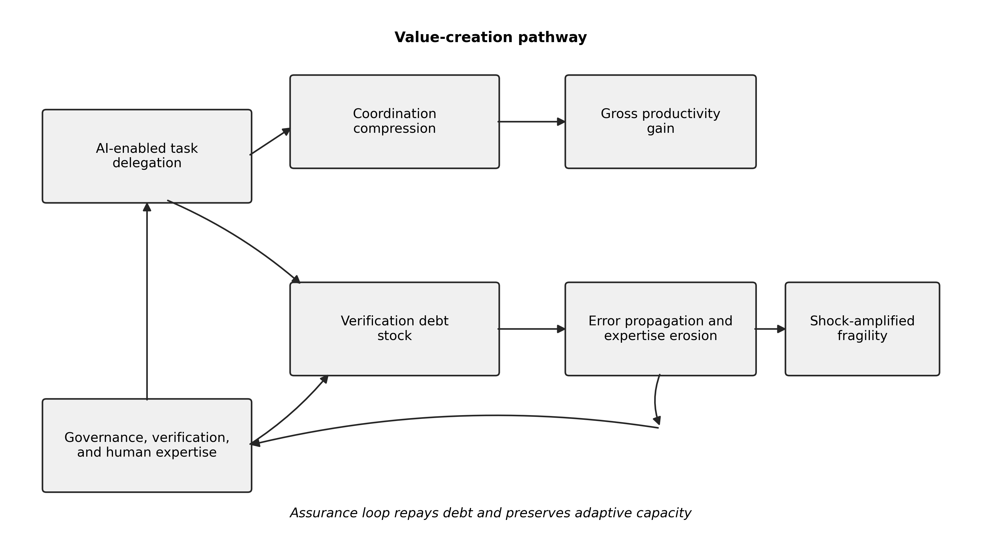
Figure 1. Conceptual model of coordination compression, verification debt, and the assurance loop.
3.2 Constructs and State Variables
Table 1 defines the principal variables. Automation intensity, governance intensity, and verification intensity are decision variables bounded between zero and one. Verification debt, human expertise, and organisational resilience are endogenous state variables. Their operationalisation draws on AI capability research, lifecycle risk management, organisational learning, and resilience theory (Mikalef & Gupta, 2021; Tabassi, 2023; Autio et al., 2024; Duchek, 2020). Task fit and environmental uncertainty vary stochastically by firm and period. A shock process converts latent fragility into realised loss.
Table 1. Model constructs and operational definitions
Symbol | Construct | Operational meaning | Range
aₜ | Automation intensity | Share and consequentiality of work delegated to AI-enabled systems | [0, 1]
gₜ | Governance intensity | Strength of decision rights, policy gates, logging, escalation, and accountability | [0, 1]
vₜ | Verification intensity | Proportion and depth of output checking, evidence review, testing, and challenge | [0, 1]
fₜ | Task fit | Suitability of the current task portfolio for reliable AI delegation | [0, 1]
uₜ | Environmental uncertainty | Volatility, ambiguity, novelty, and external change affecting the task environment | [0, 1]
Dₜ | Verification debt | Accumulated unverified assumptions, weak review, hidden dependencies, and deferred validation | [0, ∞)
Hₜ | Human expertise | Retained capability to understand, verify, contest, and correct AI-mediated work | [0.18, 0.98]
Rₜ | Organisational resilience | Capacity to absorb shocks, recover, and continue effective operations | [0.05, 0.98]
NVₜ | Net incremental value | Gross AI-enabled gain less governance, verification, debt, and shock costs | Real-valued
3.3 Core Assumptions
Six assumptions structure the model.
A1: Delegation has immediate productive potential. For suitable tasks, greater automation reduces coordination time and increases output. This assumption is consistent with evidence that generative AI can improve task speed and quality in bounded settings (Noy & Zhang, 2023; Brynjolfsson et al., 2025).
A2: Productive gains depend on task fit and retained expertise. AI assistance is not equally useful for all tasks. Human expertise improves task framing, contextual judgement, error detection, and integration. The model therefore rejects a uniform productivity coefficient across tasks and firms.
A3: Verification debt accumulates nonlinearly. High automation combined with weak governance and verification creates debt at a more-than-proportionate rate because errors and assumptions can propagate across linked workflows. The convex automation exponent represents scaling complexity, not a claim about a universal empirical law.
A4: Verification can produce learning. Verification is not treated only as a cost. When humans inspect outputs, compare evidence, diagnose failure, and revise workflows, they can strengthen expertise and organisational learning. This assumption follows research on hybrid intelligence and coordinated human-machine learning (Dellermann et al., 2019; Sturm et al., 2021).
A5: Unverified delegation can erode expertise. Repeated answer-first use reduces opportunities for practice, independent reasoning, and diagnostic feedback. This mechanism reflects the classic ironies of automation, in which operators may be asked to intervene precisely after routine involvement has declined (Bainbridge, 1983; Parasuraman & Riley, 1997).
A6: Shocks reveal accumulated fragility. Verification debt may remain latent during normal operations. Environmental shocks, unusual cases, regulatory changes, adversarial conditions, or correlated system failures expose hidden assumptions and magnify losses. Resilience reduces but does not eliminate these losses, consistent with capability-based accounts in which preparedness and adaptive capacity shape recovery (Lengnick-Hall et al., 2011; Duchek, 2020; Silveira & De Paula, 2026).
3.4 Coordination Compression and Gross Productivity
Coordination compression is defined as:
$$C_{t}=a_{t}f_{t}\left(α_{0}+α_{H}H_{t}\right)\left(1-α_{G}g_{t}\right).$$ | (1)
The term $a_{t}f_{t}$ captures the amount of suitable work delegated. The expertise term recognises that skilled workers can prompt, contextualise, combine, and evaluate AI outputs more effectively. The governance term introduces modest process friction because controls, documentation, and approvals consume time. Governance therefore reduces raw compression, although it can increase net value by reducing debt and shock losses.
Gross productivity gain is:
$$P_{t}=Y_{0}\left[β_{C}C_{t}+β_{H}a_{t}H_{t}+β_{A}a_{t}g_{t}v_{t}\right],$$ | (2)
where $Y_{0}=100$ is the baseline output index. The first component is direct coordination compression. The second represents expertise-enabled complementarity. The third represents an assurance-enabled scalability premium: governed and verified systems can be used more extensively in consequential workflows because their actions are more inspectable and defensible.
The model therefore separates gross productivity from net incremental value. A strategy can produce high $P_{t}$ while destroying value through verification costs, debt accumulation, expertise erosion, or shock losses. This distinction is central to the coordination compression trap.
3.5 Verification Debt Dynamics
Verification debt evolves according to:
$$D_{t+1}=\text{max}\{0,\left(1-δ_{D}\right)D_{t}+I_{t}^{D}-Q_{t}^{D}\}.$$ | (3)
The debt-inflow component is:
$$I_{t}^{D}=λa_{t}^{ρ}{\left(1-v_{t}\right)}^{σ}{\left(1-g_{t}\right)}^{ω}\left(1+ϕu_{t}\right)\left(1.10-0.35H_{t}\right).$$ | (3a)
The assurance-repayment component is:
$$Q_{t}^{D}=μg_{t}v_{t}\left(0.55+0.45H_{t}\right).$$ | (3b)
The first term in Equation (3) allows a fraction $δ_{D}$ of debt to decay through ordinary correction and obsolescence. Debt inflow increases with automation and uncertainty, and decreases with governance, verification, and expertise. Exponents $ρ$, $σ$, and $ω$ permit nonlinear accumulation. Repayment represents deliberate assurance work, including source checking, red-team review, testing, approval, exception analysis, audit logging, and corrective learning.
An assurance adequacy ratio can be defined as:
$$AAR_{t}=\frac{μg_{t}v_{t}\left(0.55+0.45H_{t}\right)}{λa_{t}^{ρ}{\left(1-v_{t}\right)}^{σ}{\left(1-g_{t}\right)}^{ω}\left(1+ϕu_{t}\right)\left(1.10-0.35H_{t}\right)+ε},$$ | (4)
where $ε>0$ is a small stabilising constant. When $AAR_{t}≥1$, current assurance repayment equals or exceeds current debt inflow. Existing debt then declines through the depreciation term, subject to the non-negativity constraint. When $AAR_{t}<1$, debt can accumulate, particularly when the gap is persistent.
Proposition 1: Unique flow-balance threshold and state-dependent stock threshold. Fix $a_{t}∈\left(0,1\right]$, $g_{t}∈\left(0,1\right]$, $u_{t}∈\left[0,1\right]$, and $H_{t}∈\left(0,1\right)$. Let $I_{t}^{D}\left(v\right)$ and $Q_{t}^{D}\left(v\right)$ denote the inflow and repayment functions in Equations (3a) and (3b). There exists a unique $v_{t}^{flow}∈\left(0,1\right)$ satisfying $I_{t}^{D}\left(v_{t}^{flow}\right)=Q_{t}^{D}\left(v_{t}^{flow}\right)$.
Proof. $I_{t}^{D}\left(v\right)$ is continuous and strictly decreasing on $\left[0,1\right]$, with $I_{t}^{D}\left(0\right)>0$ and $I_{t}^{D}\left(1\right)=0$. $Q_{t}^{D}\left(v\right)$ is continuous and strictly increasing, with $Q_{t}^{D}\left(0\right)=0$ and $Q_{t}^{D}\left(1\right)>0$ when $g_{t}>0$. The intermediate value theorem gives existence, and strict monotonicity gives uniqueness.
The threshold for preventing an increase in the existing stock is different. From Equation (3), before the non-negativity projection, debt is non-increasing when
$$Q_{t}^{D}\left(v\right)≥I_{t}^{D}\left(v\right)-δ_{D}D_{t}.$$
Accordingly, the stock-stabilising threshold $v_{t}^{stock}\left(D_{t}\right)$ is state-dependent and satisfies $v_{t}^{stock}\left(D_{t}\right)≤v_{t}^{flow}$ for $D_{t}>0$. The assurance adequacy ratio in Equation (4) evaluates current flow balance, while the stock condition additionally recognises natural debt decay. Both thresholds rise with automation and uncertainty and fall with stronger governance or expertise, subject to the stated functional form.
3.6 Human Expertise Dynamics
Human expertise evolves as:
$$H_{t+1}=Π_{[.18,.98]}\{H_{t}+τ_{1}v_{t}a_{t}\left(1-χg_{t}\right)+τ_{2}v_{t}\left(1-a_{t}\right)-τ_{3}a_{t}\left(1-v_{t}\right)-δ_{H}\left(H_{t}-.65\right)\}.$$ | (5)
where $Π$ projects the state into the admissible interval. The first positive term represents verified learning while using AI. The second represents capability maintenance through verified human-led work. The negative term captures deskilling when automation is high and verification is weak. The final term provides mean reversion toward a baseline capability level.
Governance slightly attenuates the learning benefit of verified use through $χ$ because overly procedural review can become box-ticking rather than substantive learning. This does not imply that governance is harmful. It captures the difference between an assurance process that invites diagnosis and one that only documents compliance. The compliance-heavy regime can therefore preserve safety while producing less net value than a more balanced regime.
3.7 Organisational Resilience and Shock Loss
The desired resilience level is:
$$R_{t}^{⋆}=0.34+0.34H_{t}+0.27g_{t}v_{t}-0.055\text{min}\left(D_{t},5\right).$$ | (6)
Actual resilience adjusts gradually and can be reduced by realised shocks:
$$R_{t+1}=Π_{[0.05,0.98]}\left\{R_{t}+0.12\left(R_{t}^{⋆}-R_{t}\right)-0.055I_{t}S_{t}\left(0.5+0.1D_{t}\right)\right\}.$$ | (7)
The shock indicator $I_{t}$ follows:
$$\text{Pr}\left(I_{t}=1\right)=\text{clip}\left[0.035+0.13u_{t}+0.018a_{t}\left(1-g_{t}\right),0,0.25\right].$$ | (8)
Conditional shock severity $S_{t}$ is lognormally distributed. Realised shock loss is:
$$L_{t}^{S}=Y_{0}I_{t}S_{t}\left(0.055+0.045D_{t}^{1.35}\right){\left(1.12-R_{t}\right)}^{1.15}.$$ | (9)
Debt increases shock loss because unresolved assumptions and weak evidence make unusual events harder to diagnose and contain. Resilience reduces the amplification. The model thereby distinguishes shock exposure from shock absorption. Governance contributes to both by lowering the probability of uncontrolled action and strengthening the organisation’s response capacity.
3.8 Net Incremental Value and the Trap Condition
Net incremental value is:
$$NV_{t}=P_{t}-Y_{0}K_{t}-L_{t}^{S}+ϵ_{t}.$$ | (10)
The normalised operating and debt-cost function is:
$$K_{t}=0.022a_{t}^{2}+0.008a_{t}^{4}+0.022g_{t}^{2}+0.026v_{t}^{2}+0.012a_{t}v_{t}+0.010D_{t}+0.006D_{t}^{2}.$$ | (10a)
Here, $ϵ_{t}$ is a zero-mean productivity noise term. Automation, governance, and verification all have costs. Automation includes a convex scaling cost to represent integration complexity. Governance and verification have direct operating costs. The interaction $a_{t}v_{t}$ captures the greater verification workload created when more work is delegated. Debt generates routine rework and coordination costs even before a major incident occurs.
Cumulative value under regime $r$ is:
$$V^{\left(r\right)}=\sum_{t=1}^{60}{N}V_{t}^{\left(r\right)}.$$ | (11)
A coordination compression trap exists when increasing automation has a positive immediate effect on gross productivity but a negative effect on expected cumulative value over the relevant horizon:
$$T_{t}=1\left\{\frac{∂P_{t}}{∂a_{t}}>0 ∧ \frac{∂E[V]}{∂a_{t}}<0\right\}.$$ | (12)
The first inequality is readily satisfied for suitable tasks. The second can arise because higher automation raises debt inflow, verification workload, scaling cost, deskilling, and shock amplification. The trap is therefore a dynamic reversal: the organisation observes faster work and interprets it as durable productivity, while the model’s state variables are moving toward lower future value.
Proposition 2: Sufficient condition for dynamic reversal. Define the expected discounted value over horizon $K$ as
$$W_{t}^{K}=E_{t}\left[\sum_{s=0}^{K-1}{η^{s}}NV_{t+s}\right], 0<η≤1.$$
For a marginal increase in automation at time $t$, holding the contemporaneous state and assurance settings fixed, a coordination compression trap occurs when
$$\frac{∂P_{t}}{∂a_{t}}>0 \text{and} \frac{∂W_{t}^{K}}{∂a_{t}}<0.$$
A sufficient condition for the second inequality is that the discounted marginal increase in operating cost, expected debt-related loss, expected shock loss, and future productivity loss caused by lower expertise exceeds the contemporaneous marginal productivity gain. Under Equations (3a), (5), and (9), this condition becomes more likely when governance and verification remain below their stock-stabilising levels, uncertainty is high, debt inflow is strongly convex in automation, expertise erosion is large, and shock loss is sensitive to debt. This is a conditional proposition, not a claim that higher automation is generally harmful.
3.9 Governance Regimes
Five regimes were selected to represent common strategic postures. Table 2 shows their settings. The first four use fixed policies. The fifth adjusts automation, governance, and verification in response to debt, uncertainty, and resilience.
Table 2. Governance regimes evaluated in the computational experiment
Regime | Automation ($a$) | Governance ($g$) | Verification ($v$) | Strategic interpretation
Acceleration-first | 0.90 | 0.25 | 0.30 | Maximise speed and delegation with limited assurance
Compliance-heavy | 0.55 | 0.85 | 0.82 | Emphasise formal controls and extensive review
Verified autonomy | 0.78 | 0.68 | 0.72 | Scale automation with strong but selective assurance
Human-centred augmentation | 0.62 | 0.58 | 0.88 | Preserve human judgement through intensive verification
Debt-responsive governance | Adaptive | Adaptive | Adaptive | Increase assurance and moderate automation as debt and uncertainty rise
The adaptive regime follows:
$$g_{t}=\text{clip}\left[0.42+0.32\frac{D_{t}}{D_{t}+2.5}+0.20u_{t},0,0.92\right],$$ | (13)

$$v_{t}=\text{clip}\left[0.52+0.30\frac{D_{t}}{D_{t}+2.0}+0.14u_{t},0,0.95\right],$$ | (14)

$$a_{t}=\text{clip}\left[0.86-0.18\frac{D_{t}}{D_{t}+3.0}-0.10u_{t}+0.05\left(R_{t}-0.5\right),0.35,0.90\right].$$ | (15)
This policy is intentionally simple and interpretable. It does not optimise using foresight. It behaves as a feedback controller: debt and uncertainty trigger stronger governance and verification, while automation is moderated when debt rises or resilience weakens.
3.10 Parameterisation and Stochastic Inputs
Table 3 reports all coefficients and distributions needed to reconstruct the base model. Values were selected to generate internally coherent dynamics across the admissible state space, not to reproduce a specific industry. Initial conditions were $D_{0}=0.35$, $H_{0}=0.82$, and $R_{0}=0.72$. Task fit followed $\text{Beta}\left(5.0,2.2\right)$, environmental uncertainty followed $\text{Beta}\left(2.2,5.0\right)$, shock severity followed $\text{Lognormal}\left(-0.15,0.55\right)$ on the log scale, and productivity noise followed $N\left(0,{0.70}^{2}\right)$.
Table 3. Complete base-model parameterisation
Component | Symbol or rule | Value | Role
Baseline output | $$Y_{0}$$ | 100.000 | Output index per period
Compression | $$α_{0},α_{H},α_{G}$$ | 0.620, 0.380, 0.130 | Base, expertise, and governance effects
Productivity | $$β_{C},β_{H},β_{A}$$ | 0.155, 0.055, 0.028 | Compression, complementarity, and assurance-enabled scale
Operating cost | $$c_{a2},c_{a4},c_{g},c_{v},c_{av}$$ | 0.022, 0.008, 0.022, 0.026, 0.012 | Automation, scaling, governance, verification, and interaction costs
Routine debt loss | $$κ_{1},κ_{2}$$ | 0.010, 0.006 | Linear and quadratic debt-loss coefficients
Debt dynamics | $$δ_{D},λ,ρ,σ,ω,ϕ,μ$$ | 0.085, 0.440, 1.650, 1.350, 1.150, 1.150, 0.240 | Decay, inflow, nonlinearities, uncertainty, and repayment
Expertise dynamics | $$τ_{1},τ_{2},τ_{3},χ,δ_{H},\overset{‾}{H}$$ | 0.030, 0.012, 0.052, 0.150, 0.010, 0.650 | Verified learning, maintenance, deskilling, attenuation, and mean reversion
Expertise bounds | $$\left[H_{min},H_{max}\right]$$ | [0.18, 0.98] | Admissible expertise range
Resilience target | intercept, $H$, $gv$, debt | 0.340, 0.340, 0.270, -0.055 | Desired resilience function
Resilience adjustment | speed, shock erosion | 0.120, 0.055 | Adjustment and realised-shock effect
Resilience bounds | $$\left[R_{min},R_{max}\right]$$ | [0.05, 0.98] | Admissible resilience range
Shock probability | intercept, uncertainty, automation-governance | 0.035, 0.130, 0.018 | Shock-arrival rule, clipped to [0, 0.25]
Shock loss | base, debt, debt exponent, resilience exponent | 0.055, 0.045, 1.350, 1.150 | Shock-loss amplification
Initial states | $$D_{0},H_{0},R_{0}$$ | 0.350, 0.820, 0.720 | Base starting values
Task fit | $$f_{t}$$ | Beta (5.0, 2.2) | Stochastic task suitability
Uncertainty | $$u_{t}$$ | Beta (2.2, 5.0) | Stochastic environmental uncertainty
Shock severity | $$S_{t}$$ | Lognormal (-0.15, 0.55) | Conditional shock severity
Productivity noise | $$ϵ_{t}$$ | $$N\left(0,{0.70}^{2}\right)$$ | Zero-mean period noise
Fragility rule | loss, resilience, terminal value | -15, 0.22, 0 | Composite thresholds
Simulation design | $N,T$, seed | 5,000, 60, 20260730 | Firms, periods, and fixed random seed
3.11 Simulation Protocol, Policy Search, and Robustness Extensions
The base experiment simulated 5,000 firms under each of five regimes for 60 periods, producing 25,000 firm-regime trajectories and 1.5 million firm-period observations. A fixed seed of 20260730 generated common arrays for task fit, uncertainty, shock occurrence, shock severity, and productivity noise. Common random numbers ensured that the regimes faced identical stochastic sequences. This design supports paired firm-by-firm contrasts and reduces comparison noise.
The primary outcome was cumulative incremental value. Secondary outcomes were final and cumulative verification debt, cumulative debt cost, cumulative shock loss, expertise, resilience, maximum drawdown, and negative terminal value. A trajectory was classified as fragile when the minimum one-period net value fell below -15 units, the minimum resilience fell below 0.22, or terminal cumulative value was negative. Percentile intervals are descriptive simulation intervals, not confidence intervals from observed data.
Three additional analyses were conducted. First, a full fixed-policy search allowed automation, governance, and verification to vary independently. The coarse grid evaluated ${15}^{3}=3,375$ configurations over $a∈\left[0.25,0.95\right]$, $g∈\left[0.20,0.90\right]$, and $v∈\left[0.20,0.90\right]$. A local boundary refinement then examined $a$ up to 1.00 at 0.0125 increments around the best coarse region. The selected configuration was re-evaluated with 5,000 firms. The result is a grid optimum conditional on the model and search domain, not a universal empirical optimum.
Second, the structural-heterogeneity extension assigned each firm fixed multipliers for productivity potential, debt propensity, shock exposure, governance cost, verification cost, and learning, together with heterogeneous initial states. Multipliers were drawn from mean-one lognormal distributions with coefficients of variation of approximately 10% to 20% and were moderately truncated. Initial debt, expertise, and resilience were drawn from truncated normal distributions. These distributions are transparent robustness assumptions, not estimates of real firms.
Third, paired differences were calculated for every synthetic firm because the same random sequences and, in the heterogeneity extension, the same structural profile were used under each regime. One-way sensitivity analysis retained the plus-or-minus 20% perturbations for debt accumulation, shock loss, governance cost, verification cost, verified learning, and coordination-compression productivity. State-boundary diagnostics recorded the proportion of firm-periods at the debt floor or expertise ceiling and the proportion for which repayment equalled or exceeded current debt inflow.

4. RESULTS AND DISCUSSION
4.1 Base-Case Comparison of Five Stylised Regimes
Table 4A reports the controlled base-case comparison. Verified autonomy generated the largest mean cumulative value among the five pre-specified regimes at 454.93 units. Debt-responsive governance ranked second at 419.97 units, followed by human-centred augmentation at 343.98 and compliance-heavy governance at 264.02. Acceleration-first adoption ended at only 3.77 units and produced a negative terminal value in 41.40% of trajectories. These are comparisons among the selected regimes and should not be interpreted as optimisation over all feasible policies.
Table 4A. Base-case cumulative value and risk outcomes
Regime | Mean cumulative value | 2.5th percentile | 97.5th percentile | Mean maximum drawdown | Fragility incidence (%) | Negative value (%)
Acceleration-first | 3.77 | -86.91 | 71.27 | 106.14 | 82.94 | 41.40
Compliance-heavy | 264.02 | 241.27 | 286.07 | 0.22 | 0.00 | 0.00
Verified autonomy | 454.93 | 424.64 | 484.46 | 0.05 | 0.00 | 0.00
Human-centred augmentation | 343.98 | 318.46 | 368.85 | 0.12 | 0.00 | 0.00
Debt-responsive governance | 419.97 | 388.05 | 450.33 | 0.29 | 0.02 | 0.00
Figure 2 shows the timing of the reversal. Acceleration-first reached a mean peak of 103.92 units in period 23, then declined to 3.77 by period 60. The initial gain was therefore real, not an artefact of presentation, but it was not durable. Verified autonomy and debt-responsive governance created value throughout the horizon. The adaptive regime led at periods 12, 24, and 36, but its reactive policy later allowed the fixed verified-autonomy regime to overtake it.
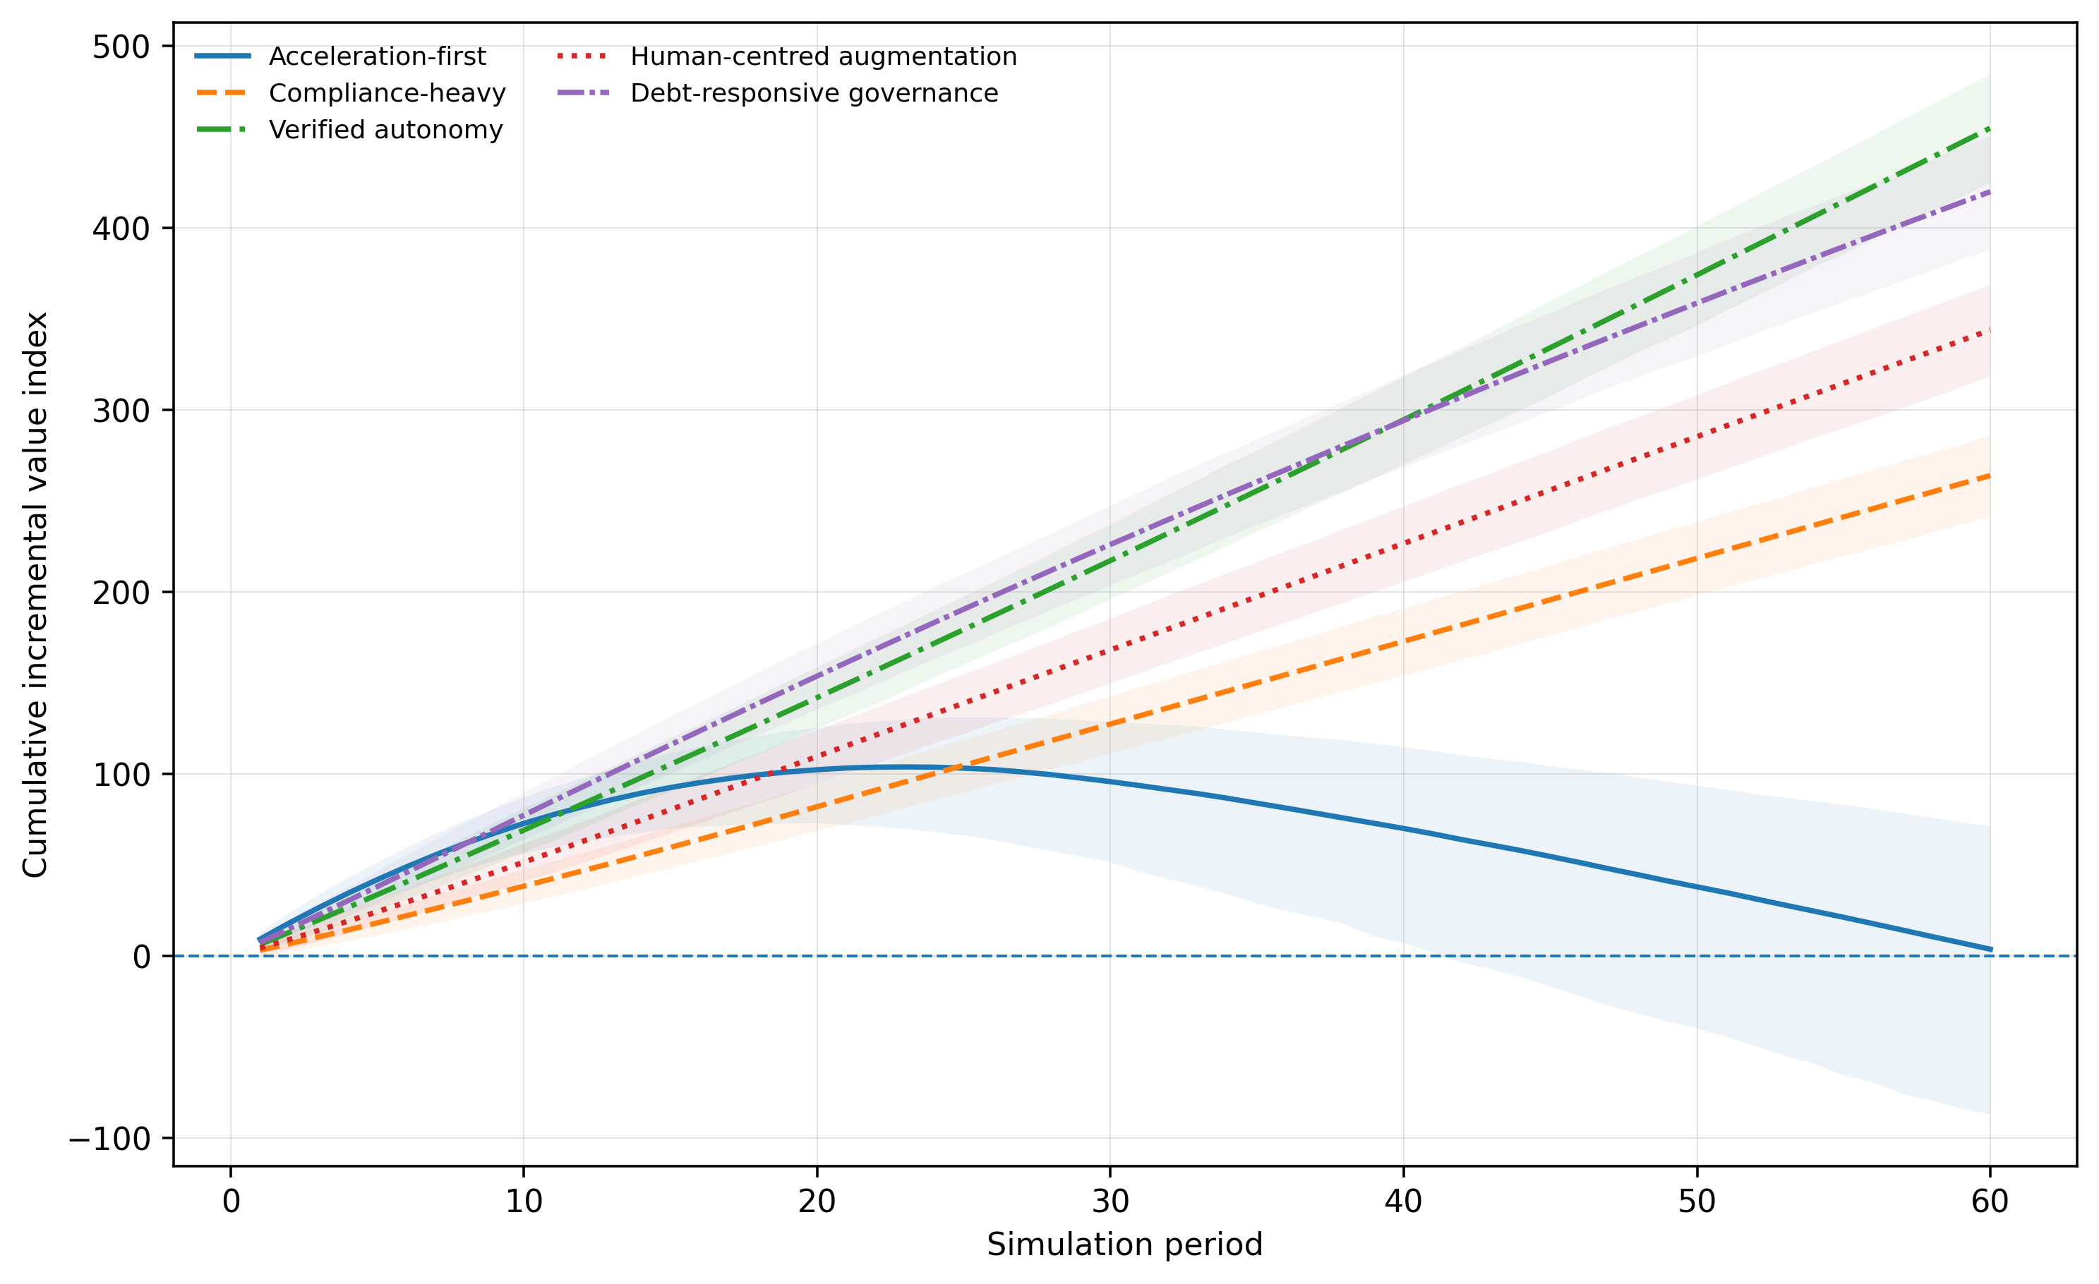
Figure 2. Mean cumulative incremental value by governance regime. Shaded bands represent the 2.5th to 97.5th percentile interval across synthetic firms.
The result supports a conditional coordination compression trap. High automation is not itself sufficient for reversal. Reversal occurs when delegated scope expands while verification and governance remain too weak to contain debt, preserve expertise, and limit shock amplification. The compliance-heavy regime demonstrates the opposite inefficiency: very strong controls preserve states but impose costs and forgo productive delegation.
4.2 State Trajectories and Boundary Diagnostics
Tables 4B and 4C report terminal states together with path-integrated diagnostics. The three strongly assured fixed regimes reach zero terminal debt and the expertise ceiling, which confirms that terminal states alone cannot distinguish their mechanisms. The revised analysis therefore reports cumulative debt exposure, cumulative debt cost, assurance-flow adequacy, and the share of firm-periods at each boundary.
Table 4B. Verification-debt exposure and accumulated loss diagnostics
Regime | Final debt | Cumulative debt exposure | Debt cost | Shock loss | Flow adequate (%)
Acceleration-first | 2.551 | 119.602 | 276.193 | 66.448 | 0.00
Compliance-heavy | 0.000 | 0.520 | 0.611 | 6.390 | 100.00
Verified autonomy | 0.000 | 0.707 | 0.819 | 8.246 | 100.00
Human-centred augmentation | 0.000 | 0.648 | 0.753 | 7.733 | 100.00
Debt-responsive governance | 0.049 | 3.001 | 3.260 | 11.953 | 45.82
Table 4C. Terminal organisational states and boundary diagnostics
Regime | Final expertise | Final resilience | Debt floor (%) | Expertise ceiling (%)
Acceleration-first | 0.180 | 0.254 | 0.00 | 0.00
Compliance-heavy | 0.980 | 0.844 | 96.67 | 70.00
Verified autonomy | 0.980 | 0.785 | 95.00 | 15.00
Human-centred augmentation | 0.980 | 0.793 | 96.67 | 80.00
Debt-responsive governance | 0.545 | 0.588 | 6.55 | 0.00
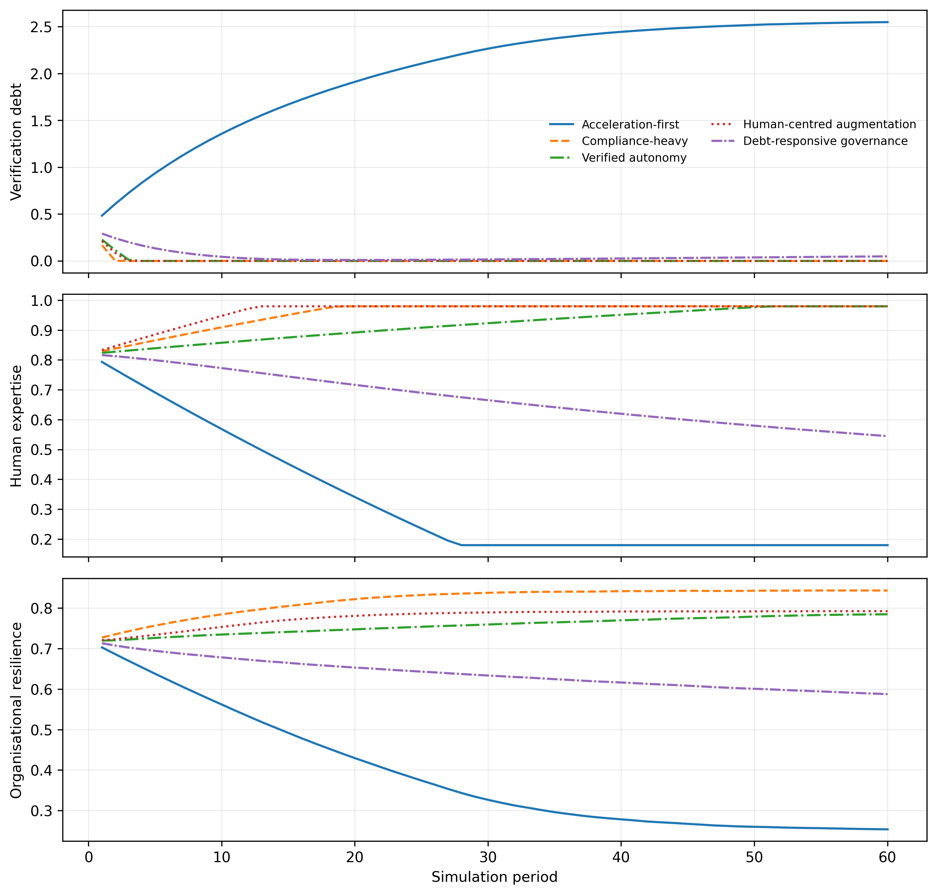
Figure 3. Mean trajectories of verification debt, human expertise, and organisational resilience.
Boundary saturation does not make all mechanisms identical, but it limits what can be inferred from terminal values. Compliance-heavy governance spends 70% of firm-periods at the expertise ceiling, compared with 15% for verified autonomy, and it carries lower cumulative debt exposure but substantially lower value. Human-centred augmentation spends 80% of firm-periods at the expertise ceiling, indicating overprovision of learning and verification under the chosen cost function. These findings support reporting path-integrated states and costs rather than attributing value differences to terminal debt alone.
The adaptive regime’s average governance and verification intensities are below those of verified autonomy, yet it ends with near-zero debt. This does not contradict the threshold logic because its settings are state-contingent. It begins with flow-adequate assurance for all firms, then reduces the proportion of adequate firm-periods as debt and uncertainty evolve. Its 45.82% overall flow-adequacy share and cumulative debt exposure of 3.00 show that averages conceal timing. The policy can repay much of the stock through periods of strong assurance without continuously satisfying current flow balance.
4.3 Full Three-Dimensional Policy-Space Search
An initial two-dimensional phase diagram imposed $g=v$ and could not establish whether the best named regime was optimal. The expanded search evaluated automation, governance, and verification independently. The best coarse-grid configuration was $\left(a,g,v\right)=\left(0.95,0.30,0.75\right)$ with a mean cumulative value of 586.40. Boundary refinement increased automation to the model limit and identified $\left(1.00,0.30,0.7625\right)$ as the highest evaluated fixed policy. Re-evaluation with 5,000 firms produced a mean cumulative value of 608.92, a 2.5th to 97.5th percentile interval of 569.29 to 648.08, and no fragile or negative trajectories.
Table 5A. Policy-space search and cumulative-value benchmarks
Configuration | Automation | Governance | Verification | Mean value | 2.5th percentile | 97.5th percentile
Best evaluated fixed policy | 1.000 | 0.300 | 0.7625 | 608.92 | 569.29 | 648.08
Verified autonomy | 0.780 | 0.680 | 0.7200 | 454.93 | 424.64 | 484.46
Debt-responsive governance | Adaptive | Adaptive | Adaptive | 419.97 | 388.05 | 450.33
Acceleration-first | 0.900 | 0.250 | 0.3000 | 3.77 | -86.91 | 71.27
Table 5B. State and assurance diagnostics for policy benchmarks
Configuration | Final debt | Final expertise | Final resilience | Flow adequate (%) | Fragility (%)
Best evaluated fixed policy | 0.0001 | 0.980 | 0.715 | 92.86 | 0.00
Verified autonomy | 0.0000 | 0.980 | 0.785 | 100.00 | 0.00
Debt-responsive governance | 0.0492 | 0.545 | 0.588 | 45.82 | 0.02
Acceleration-first | 2.5509 | 0.180 | 0.254 | 0.00 | 82.94
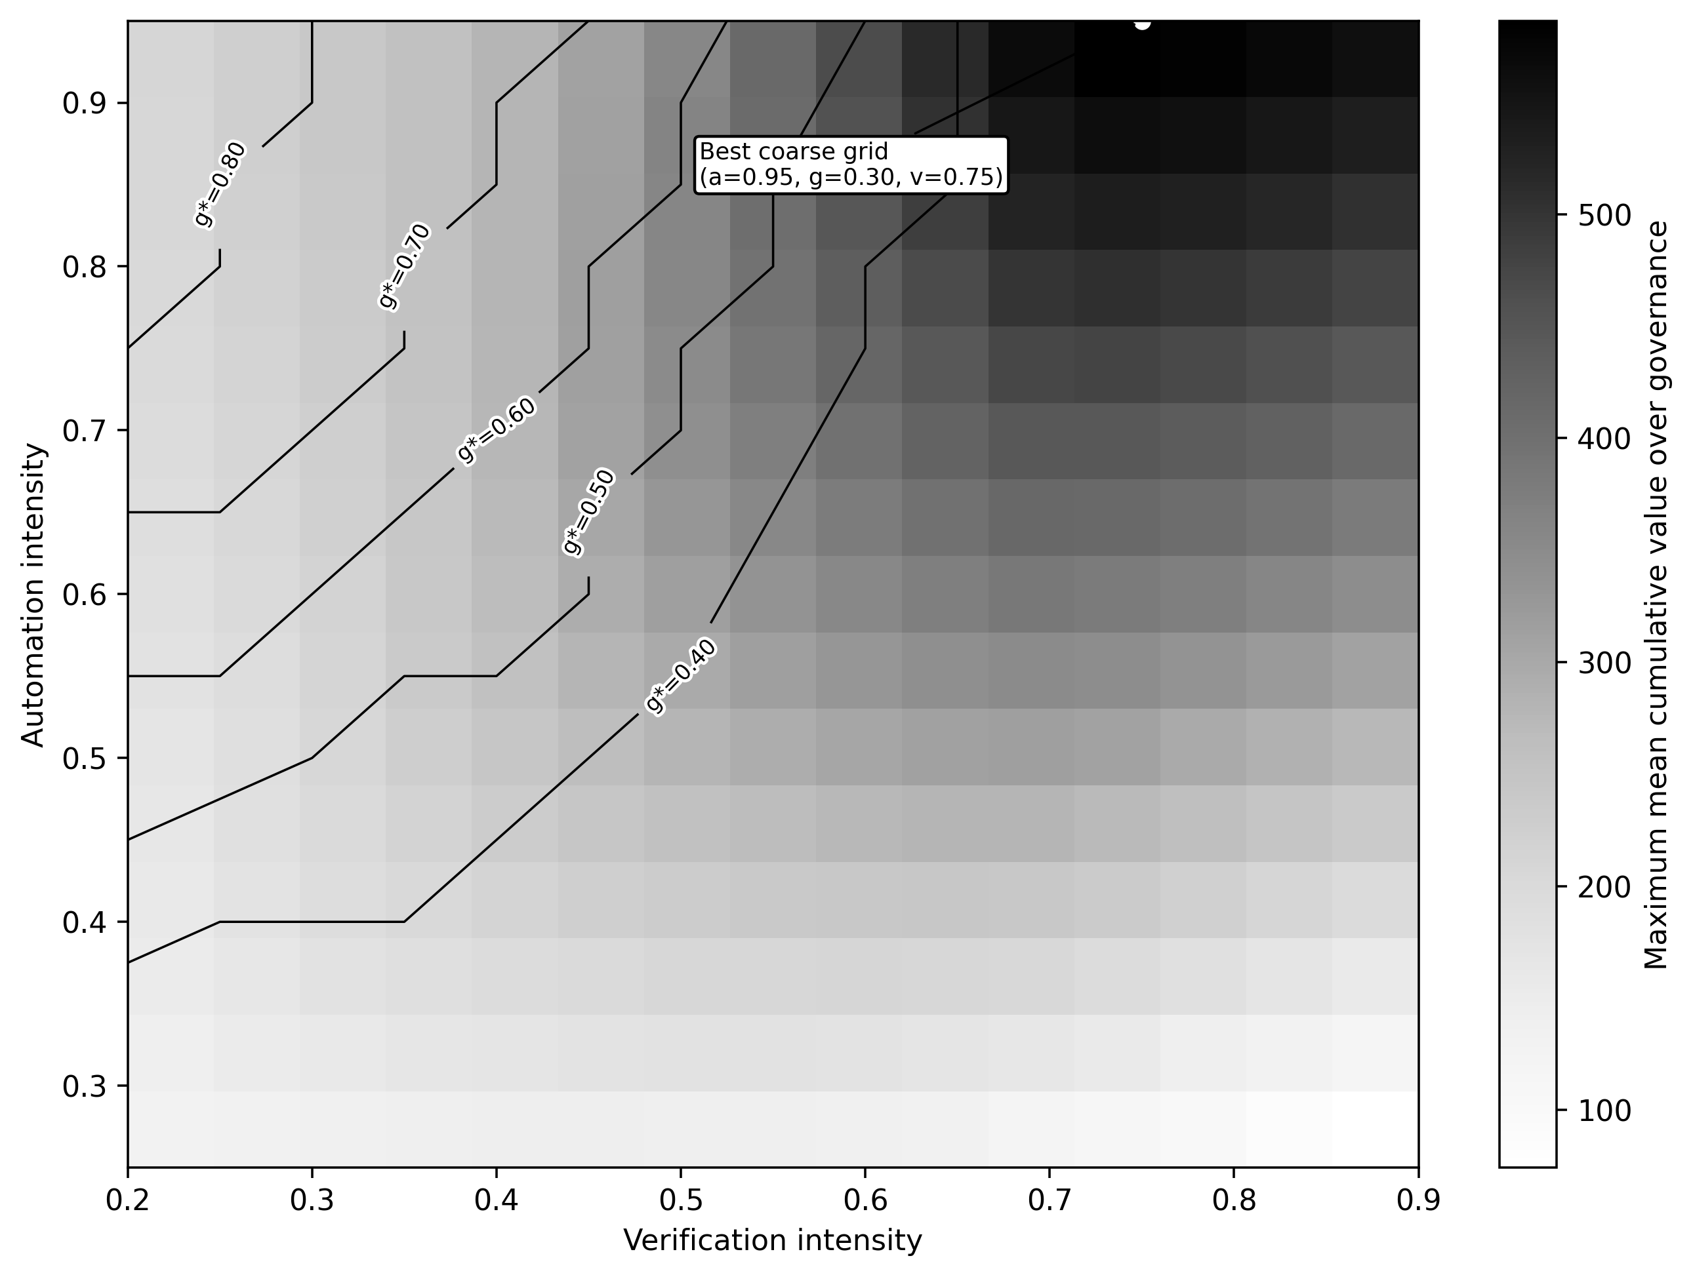
Figure 4. Profiled fixed-policy search. Each automation-verification cell shows the highest mean cumulative value across the evaluated governance levels; contour labels report the governance level that maximises value within that cell.
The full search changes the interpretation of the model. Verified autonomy is the best of the five named regimes, but it is not the highest-value policy over the expanded grid. Under the base coefficients, the value-maximising region combines very high automation, high verification, and moderate governance. The objective continues to rise to the automation boundary, so the model does not establish an interior optimum for automation. This is an important negative result. It means the defensible claim is not that maximal automation is inherently inefficient. The defensible claim is that maximal or near-maximal automation becomes destructive when verification is weak, while strong verification can support extensive delegation.
Governance and verification also play different roles. The best evaluated policy uses verification of 0.7625 but governance of only 0.30. In the model, verification directly repays debt and maintains expertise, whereas governance introduces coordination friction and cost while also reducing debt and shocks. The optimum therefore favours targeted verification over broad procedural intensity. This numerical conclusion is conditional on the cost and effectiveness coefficients and should not be generalised without empirical calibration.
4.4 Cross-Firm Structural Heterogeneity and Paired Comparisons
The base percentile bands represent stochastic outcome dispersion, not parameter uncertainty or observed cross-firm variation. The heterogeneity extension addresses this distinction by assigning persistent firm-specific differences in productivity, debt propensity, shock exposure, control costs, learning, and initial states. Table 6 shows that heterogeneity substantially widens outcome intervals but preserves the ranking of the five named regimes.
Table 6. Results with moderate synthetic cross-firm heterogeneity
Regime | Mean value | 2.5th percentile | 97.5th percentile | Final debt | Final expertise | Fragility (%)
Acceleration-first | 1.10 | -230.24 | 192.18 | 2.550 | 0.180 | 80.82
Compliance-heavy | 264.49 | 156.88 | 384.95 | 0.000 | 0.980 | 0.00
Verified autonomy | 451.71 | 307.76 | 615.73 | 0.000 | 0.955 | 0.00
Human-centred augmentation | 344.84 | 226.58 | 480.63 | 0.000 | 0.980 | 0.00
Debt-responsive governance | 420.89 | 287.16 | 576.40 | 0.054 | 0.548 | 0.04
Best evaluated fixed policy | 606.33 | 424.11 | 816.87 | 0.003 | 0.978 | 0.00
Paired firm-by-firm differences provide a more precise comparison than overlapping marginal intervals. Under heterogeneity, debt-responsive governance trails verified autonomy by a mean of 30.83 units, with a paired 2.5th to 97.5th percentile interval of -53.55 to -0.69; it exceeds verified autonomy in 2.36% of firms. Human-centred augmentation, compliance-heavy governance, and acceleration-first trail verified autonomy in every paired trajectory. The best evaluated fixed policy exceeds verified autonomy in every paired trajectory, with a mean advantage of 154.62 units and a paired interval of 111.09 to 205.69.
These results still do not establish external validity. The firm-specific distributions are synthetic and moderate by design. They show that the base ranking is not solely an artefact of identical structural parameters, but they do not identify the ranking that would prevail in any observed sector.
4.5 Sensitivity Analysis and Conditional Interpretation
One-way sensitivity analysis retains verified autonomy as the first-ranked named regime and debt-responsive governance as the second-ranked named regime in all 18 plus-or-minus 20% scenarios. Table 7 summarises their ranges. The sensitivity analysis does not re-optimise the full policy space, so it supports robustness of the five-regime comparison rather than robustness of the grid optimum.
Table 7. One-way sensitivity of the two leading named regimes
Parameter varied | Verified autonomy range | Debt-responsive range | First named regime | Second named regime
Debt accumulation coefficient | 454.67 to 454.72 | 418.45 to 420.28 | Verified autonomy | Debt-responsive governance
Shock-loss multiplier | 453.02 to 456.37 | 417.29 to 422.15 | Verified autonomy | Debt-responsive governance
Governance cost coefficient | 442.49 to 466.90 | 413.42 to 426.02 | Verified autonomy | Debt-responsive governance
Verification cost coefficient | 438.52 to 470.87 | 409.57 to 429.87 | Verified autonomy | Debt-responsive governance
Verified learning coefficient | 422.69 to 467.72 | 387.94 to 451.44 | Verified autonomy | Debt-responsive governance
Compression productivity coefficient | 365.83 to 543.56 | 331.36 to 508.08 | Verified autonomy | Debt-responsive governance
Acceleration-first remains highly sensitive to debt accumulation. Its mean cumulative value changes from 100.23 under the low debt coefficient to -110.39 under the high coefficient. The strongest general result is therefore conditional and relational: automation intensity must be evaluated jointly with verification, governance, expertise, and time horizon. No single numerical policy should be treated as universally optimal.
4.6 Theoretical Contributions
4.6.1 Verification debt as an organisational stock
The first contribution is the treatment of verification debt as a stock rather than a contemporaneous error rate. Most AI governance systems focus on incidents, model metrics, compliance documentation, or individual output approval. These measures are necessary but may not reveal cumulative degradation. Debt can grow while incident counts remain low because favourable operating conditions have not yet exposed weak assumptions.
The stock perspective connects several previously separate literatures. Hidden technical debt explains how machine-learning systems accumulate maintenance burdens (Sculley et al., 2015). Organisational resilience explains how capabilities allow firms to anticipate, cope, and adapt (Duchek, 2020). Algorithmic work research explains how control and expertise are redistributed around learning systems (Faraj et al., 2018; Kellogg et al., 2020). Verification debt integrates these insights by showing how deferred assurance changes future costs and capabilities.
4.6.2 Coordination compression is not equivalent to productivity
The second contribution is a distinction between coordination compression and realised productivity. Time saved is an intermediate output. It creates value only when the organisation can reuse the released capacity, preserve decision quality, and avoid downstream rework. This distinction helps reconcile apparently conflicting evidence. Task experiments can correctly identify productivity gains while firms still experience weak aggregate returns because complementary redesign and assurance are missing (Acemoglu, 2024; OECD, 2025a; Tan, 2026c).
The model suggests that early productivity dashboards are systematically biased toward the positive pathway. They measure response time, output volume, or labour hours saved immediately. Debt, deskilling, and resilience effects emerge later and often belong to different reporting systems. A finance function may record lower processing costs while risk, legal, cybersecurity, or operations teams absorb future verification burdens. The coordination compression trap is partly an accounting problem because benefits are local and immediate, while costs are distributed and delayed.
4.6.3 Assurance as a productive capability
The third contribution is the assurance threshold. Governance and verification are frequently framed as constraints on innovation. In the model, they have direct costs and reduce raw speed, but they also enable scalability by repaying debt and preserving expertise. This produces a nonlinear relation. Below the threshold, each additional unit of automation makes the system more fragile. Above the threshold, automation and assurance become complements.
This interpretation aligns with runtime assurance, which places controls at the point of action rather than relying only on policy documents (Tan, 2026b), and with NIST’s emphasis on govern, map, measure, and manage functions across the AI lifecycle (National Institute of Standards and Technology, 2023, 2024). It also extends hybrid-intelligence research by identifying assurance as the mechanism that maintains complementarity over time.
4.6.4 Expertise as infrastructure
The fourth contribution is the modelling of human expertise as productive infrastructure. Expertise does not merely provide residual labour after automation. It improves task selection, contextualisation, verification, error diagnosis, and shock recovery. When expertise erodes, the organisation loses the capacity to recognise when the model is outside its competence boundary.
This dynamic helps explain the ironies of automation. The more reliable a system appears during routine conditions, the less opportunity humans have to practise. Yet unusual conditions demand precisely the capabilities that have atrophied. The model’s acceleration-first trajectory is an extreme representation of this process. Human-centred augmentation avoids it, but at a cost. The base verified-autonomy regime illustrates one such design, while the policy-space search shows that even higher automation can remain viable when verification is strong and governance is targeted rather than absent.
4.7 Managerial Implications
Managers should replace adoption metrics with assurance-adjusted value metrics. The number of users, prompts, automated tasks, or hours saved provides an incomplete view. A balanced dashboard should include at least five elements: validated time saved, verification workload, detected correction rate, expertise retention, and resilience or incident-recovery indicators. Organisations should track debt inflow and repayment as flows, then estimate the remaining stock.
A practical verification-debt register can classify obligations into four categories. Epistemic debt concerns unsupported facts, assumptions, or reasoning. Process debt concerns undocumented handoffs, unclear decision rights, and untested exceptions. Capability debt concerns loss of human understanding or review skill. Evidence debt concerns missing provenance, logs, approvals, and reproducibility. Each category requires a responsible owner, ageing measure, risk tier, and repayment action.
Automation should be scaled through assurance gates rather than annual policy reviews alone. Low-consequence, reversible tasks can operate with light sampling. High-consequence or externally facing tasks require evidence-backed validation, bounded authority, and escalation. Agentic systems require runtime controls because risk emerges through action sequences, tool use, and changing context, not merely through text quality (Tan, 2026b).
Firms should also distinguish verification that creates learning from verification that only creates paperwork. Reviewers should be required to record why an output failed, what contextual cue was missed, and how the workflow should change. These observations can update task routing, retrieval sources, prompts, policies, or model selection. Verification then becomes a feedback system that reduces future workload.
For global knowledge firms, localisation increases verification complexity. The same output may be appropriate in one jurisdiction and unsuitable in another because of differences in law, language, culture, professional standards, or market structure. A central AI platform should therefore be combined with local assurance ownership. Global governance can define minimum controls and evidence formats, while local experts validate context-specific claims and exceptions.
The adaptive regime suggests that debt-responsive control is valuable but insufficient when used alone. Organisations should maintain a baseline verification level that preserves expertise, then add responsive assurance as uncertainty or debt rises. Waiting for incidents may be too late because capability erosion is gradual and difficult to reverse quickly.
4.8 Policy Implications
Public policy should encourage assurance capacity rather than treating AI governance only as a restriction. Smaller firms may recognise the need for verification but lack specialist staff, testing infrastructure, legal interpretation, or audit tools. Shared assurance services, sectoral testbeds, standardised evidence templates, and workforce training can lower the fixed cost of verified adoption. This is particularly important for small open economies, where productivity gains depend on institutional absorptive capacity and international interoperability (Tan, 2026c).
Regulators should avoid a false choice between innovation and oversight. The simulation indicates that well-designed assurance can increase long-run value by enabling safe scale. Rules that require traceability, risk management, human oversight, and post-market monitoring can support productive confidence when they are proportionate to risk and integrated into operational systems. The European Union Artificial Intelligence Act adopts a risk-based structure (European Parliament and Council of the European Union, 2024), while the NIST AI Risk Management Framework provides voluntary lifecycle guidance. Survey evidence also indicates that smaller firms face uneven capability and workforce constraints in adopting generative AI (OECD, 2025b). These approaches can be strengthened through metrics that reveal accumulating organisational debt rather than only documented compliance.
Labour and education policy should treat verification expertise as a strategic capability. Workers need more than generic AI literacy. They require domain knowledge, source evaluation, statistical reasoning, exception handling, and the authority to contest automated outputs. Training should therefore combine tool proficiency with independent problem solving. A workforce that can generate quickly but cannot verify independently increases national and organisational dependence on opaque systems.

5. CONCLUSION
Artificial intelligence can compress the coordination burden of knowledge work, but compression is not automatically durable productivity. When delegated scope expands faster than verification and governance capacity, organisations accumulate verification debt, lose diagnostic capability, and become more vulnerable to shocks. The acceleration-first regime demonstrates this mechanism by leading early, peaking in period 23, and then losing almost all accumulated value.
The expanded analyses materially qualify the five-regime comparison. Verified autonomy is the strongest of the five named regimes, and its advantage survives moderate parameter perturbations and synthetic cross-firm heterogeneity. It is not, however, the highest-value policy in the expanded fixed-policy grid. Under the base parameterisation, the highest evaluated fixed configuration uses automation at the upper boundary, strong verification, and moderate governance. The model therefore does not show that maximal automation is intrinsically inefficient or that value is maximised at an interior balance. It shows that under-assured automation is dangerous, while extensive automation can remain valuable when outputs are systematically verified and expertise is preserved.
The central managerial implication is to measure assurance-adjusted value rather than hours saved alone. Verification debt should be tracked as a stock, expertise should be treated as productive infrastructure, and assurance should be designed around risk, evidence, and learning rather than paperwork. The central research implication is that future empirical work must estimate the relative effectiveness and cost of verification and governance, because those coefficients determine whether the optimum is interior, boundary-seeking, sector-specific, or dynamically adaptive.

6. LIMITATIONS AND FUTURE RESEARCH
The study has eight principal limitations. First, the coefficients are theory-informed but not empirically calibrated. All numerical values illustrate the model’s logic and should not be interpreted as forecasts of profits, accident rates, or optimal policy for a real firm.
Second, the full policy search identifies a boundary optimum for automation under the base coefficients. This is a diagnostic result rather than proof that firms should automate all work. It indicates that the present cost function and task-fit distribution do not impose a sufficiently strong marginal penalty on high, well-verified automation to generate an interior optimum. Empirical calibration, task-specific feasibility constraints, correlated model failures, or stronger integration costs may change the result.
Third, the five named regimes are stylised coordinates selected for interpretation. Their ranking is conditional on those coordinates. The full fixed-policy search addresses this limitation, but the adaptive regime is still a simple feedback rule rather than an optimised dynamic controller.
Fourth, the cross-firm heterogeneity distributions are synthetic robustness assumptions. They widen dispersion and test paired comparisons, but they do not represent estimated industry variation. Future work should infer structural distributions from longitudinal data on firms, workflows, incidents, and audits.
Fifth, several state variables use hard bounds. The expertise ceiling and debt floor create terminal saturation in strongly assured regimes. Path-integrated diagnostics reduce the resulting interpretive problem, but smoother diminishing-return functions and empirically grounded state ranges would be preferable.
Sixth, governance and verification are scalar intensities. Real assurance differs in timing, independence, competence, architecture, and decision rights. Future models should separate preventive controls, runtime gates, sampling, adversarial review, provenance, escalation, and post-incident learning.
Seventh, the firm is represented by aggregate expertise and resilience. Actual organisations contain heterogeneous specialists, teams, bottlenecks, and networks. Agent-based extensions could model reviewer queues, knowledge concentration, staff turnover, local-global coordination, and unequal authority to contest AI outputs.
Eighth, shocks are primarily exogenous and competition is omitted. Shared models, vendors, retrieval sources, and supply chains can create correlated failures, while competitive pressure may induce collective underinvestment in verification. Network and game-theoretic models could examine these externalities.
Empirical testing can proceed through mixed methods. A verification-debt scale could combine audit backlogs, unresolved exceptions, provenance gaps, correction effort, reviewer capacity, repeat-error rates, and expertise-retention measures. Longitudinal case studies could test whether early time savings predict later rework or capability loss. Field experiments could compare answer-first, verified-drafting, adversarial-review, and bounded-agent workflows. These studies would allow the model’s coefficients, thresholds, heterogeneity, and policy constraints to be estimated rather than assumed.

ACKNOWLEDGEMENTS
OpenAI ChatGPT was used to assist with language drafting, structural editing, code review, and robustness-analysis implementation. The author independently verified the model, equations, simulation outputs, citations, and final text and assumes full responsibility. No external funding was received for this study.

COMPETING INTERESTS
The author has declared that no competing interests exist.

AUTHOR’S CONTRIBUTIONS
Kwan Hong Tan conceived the study, developed the theoretical framework and mathematical model, designed and executed the computational experiment and robustness extensions, analysed the results, prepared the figures and tables, and wrote and approved the final manuscript.

CONSENT
Not applicable.

ETHICAL APPROVAL
Not applicable.

DATA AND CODE AVAILABILITY
The Python simulation code, complete parameter table, base-case results, paired differences, structural-heterogeneity outputs, full policy-grid results, boundary refinement, sensitivity analysis, and publication figures are provided as supplementary files. The fixed seed and common-random-number protocol permit independent reproduction of the reported results.
Declaration of AI Use
This manuscript was prepared through the combined contributions of all author(s), including contributions to the study design, data, content development, results, interpretation, and related scholarly work. The author(s) acknowledge the use of Grammarly and ChatGPT to assist with grammar checking, language refinement, and reference formatting. These AI-assisted tools were not used as authors and did not replace the intellectual contributions or scholarly judgment of the author(s). All AI-assisted outputs, including content, references, and interpretations, were carefully reviewed, revised, verified, and approved by the author(s). The author(s) accept full responsibility for the accuracy, integrity, and final content of the manuscript.

REFERENCES
Acemoglu, D. (2024). The simple macroeconomics of AI (NBER Working Paper No. 32487). National Bureau of Economic Research. https://doi.org/10.3386/w32487
Andavar, V., & Rajaraman, S. R. (2026). Artificial intelligence for revenue growth in developing economies: Results from a structured business survey in Uganda’s hospitality and tourism sector. Asian Journal of Economics, Finance and Management, 8(1), 544–558. https://doi.org/10.56557/ajefm/2026/v8i1389
Autor, D. H. (2015). Why are there still so many jobs? The history and future of workplace automation. Journal of Economic Perspectives, 29(3), 3–30. https://doi.org/10.1257/jep.29.3.3
Babina, T., Fedyk, A., He, A., & Hodson, J. (2024). Artificial intelligence, firm growth, and product innovation. Journal of Financial Economics, 151, Article 103745. https://doi.org/10.1016/j.jfineco.2023.103745
Bainbridge, L. (1983). Ironies of automation. Automatica, 19(6), 775–779. https://doi.org/10.1016/0005-1098(83)90046-8
Brynjolfsson, E., Li, D., & Raymond, L. R. (2025). Generative AI at work. The Quarterly Journal of Economics, 140(2), 889–942. https://doi.org/10.1093/qje/qjae044
Dell’Acqua, F., McFowland, E., III, Mollick, E. R., Lifshitz-Assaf, H., Kellogg, K. C., Rajendran, S., Krayer, L., Candelon, F., & Lakhani, K. R. (2023). Navigating the jagged technological frontier: Field experimental evidence of the effects of artificial intelligence on knowledge worker productivity and quality (Harvard Business School Working Paper No. 24-013). Harvard Business School. https://www.hbs.edu/faculty/Pages/item.aspx?num=64700
Dellermann, D., Ebel, P., Söllner, M., & Leimeister, J. M. (2019). Hybrid intelligence. Business & Information Systems Engineering, 61(5), 637–643. https://doi.org/10.1007/s12599-019-00595-2
Duchek, S. (2020). Organizational resilience: A capability-based conceptualization. Business Research, 13(1), 215–246. https://doi.org/10.1007/s40685-019-0085-7
European Parliament & Council of the European Union. (2024). Regulation (EU) 2024/1689 of the European Parliament and of the Council of 13 June 2024 laying down harmonised rules on artificial intelligence and amending Regulations (EC) No. 300/2008, (EU) No. 167/2013, (EU) No. 168/2013, (EU) 2018/858, (EU) 2018/1139, and (EU) 2019/2144 and Directives 2014/90/EU, (EU) 2016/797, and (EU) 2020/1828 (Artificial Intelligence Act). Official Journal of the European Union, L, 2024/1689. https://eur-lex.europa.eu/eli/reg/2024/1689/oj
Faraj, S., Pachidi, S., & Sayegh, K. (2018). Working and organizing in the age of the learning algorithm. Information and Organization, 28(1), 62–70. https://doi.org/10.1016/j.infoandorg.2018.02.005
Fügener, A., Walzner, D. D., & Gupta, A. (2026). Roles of artificial intelligence in collaboration with humans: Automation, augmentation, and the future of work. Management Science, 72(1), 538–557. https://doi.org/10.1287/mnsc.2024.05684
Jarrahi, M. H. (2018). Artificial intelligence and the future of work: Human–AI symbiosis in organizational decision making. Business Horizons, 61(4), 577–586. https://doi.org/10.1016/j.bushor.2018.03.007
Kawadkar, H. (2026). AI adoption in accounting and finance: Impact on organizational performance. Asian Journal of Economics, Business and Accounting, 26(1), 421–428. https://doi.org/10.9734/ajeba/2026/v26i12151
Kellogg, K. C., Valentine, M. A., & Christin, A. (2020). Algorithms at work: The new contested terrain of control. Academy of Management Annals, 14(1), 366–410. https://doi.org/10.5465/annals.2018.0174
Lengnick-Hall, C. A., Beck, T. E., & Lengnick-Hall, M. L. (2011). Developing a capacity for organizational resilience through strategic human resource management. Human Resource Management Review, 21(3), 243–255. https://doi.org/10.1016/j.hrmr.2010.07.001
March, J. G. (1991). Exploration and exploitation in organizational learning. Organization Science, 2(1), 71–87. https://doi.org/10.1287/orsc.2.1.71
Mikalef, P., & Gupta, M. (2021). Artificial intelligence capability: Conceptualization, measurement calibration, and empirical study on its impact on organizational creativity and firm performance. Information & Management, 58(3), Article 103434. https://doi.org/10.1016/j.im.2021.103434
Tabassi, E. (2023). Artificial intelligence risk management framework (AI RMF 1.0) (NIST AI 100-1). National Institute of Standards and Technology. https://doi.org/10.6028/NIST.AI.100-1
Autio, C., Schwartz, R., Dunietz, J., Jain, S., Stanley, M., Tabassi, E., Hall, P., & Roberts, K. (2024). Artificial intelligence risk management framework: Generative artificial intelligence profile (NIST AI 600-1). National Institute of Standards and Technology. https://doi.org/10.6028/NIST.AI.600-1
Noy, S., & Zhang, W. (2023). Experimental evidence on the productivity effects of generative artificial intelligence. Science, 381(6654), 187–192. https://doi.org/10.1126/science.adh2586
OECD. (2025a). The adoption of artificial intelligence in firms: New evidence for policymaking. OECD Publishing. https://doi.org/10.1787/f9ef33c3-en
OECD. (2025b). Generative AI and the SME workforce: New survey evidence. OECD Publishing. https://doi.org/10.1787/2d08b99d-en
Oliva, R., & Sterman, J. D. (2001). Cutting corners and working overtime: Quality erosion in the service industry. Management Science, 47(7), 894–914. https://doi.org/10.1287/mnsc.47.7.894.9807
Ortiz-de-Mandojana, N., & Bansal, P. (2016). The long-term benefits of organizational resilience through sustainable business practices. Strategic Management Journal, 37(8), 1615–1631. https://doi.org/10.1002/smj.2410
Parasuraman, R., & Riley, V. (1997). Humans and automation: Use, misuse, disuse, abuse. Human Factors, 39(2), 230–253. https://doi.org/10.1518/001872097778543886
Raisch, S., & Krakowski, S. (2021). Artificial intelligence and management: The automation–augmentation paradox. Academy of Management Review, 46(1), 192–210. https://doi.org/10.5465/amr.2018.0072
Repenning, N. P., & Sterman, J. D. (2002). Capability traps and self-confirming attribution errors in the dynamics of process improvement. Administrative Science Quarterly, 47(2), 265–295. https://doi.org/10.2307/3094806
Sambasivan, N., Kapania, S., Highfill, H., Akrong, D., Paritosh, P., & Aroyo, L. M. (2021). “Everyone wants to do the model work, not the data work”: Data cascades in high-stakes AI. In Proceedings of the 2021 CHI Conference on Human Factors in Computing Systems (Article 39). Association for Computing Machinery. https://doi.org/10.1145/3411764.3445518
Sculley, D., Holt, G., Golovin, D., Davydov, E., Phillips, T., Ebner, D., Chaudhary, V., Young, M., Crespo, J.-F., & Dennison, D. (2015). Hidden technical debt in machine learning systems. In C. Cortes, N. Lawrence, D. Lee, M. Sugiyama, and R. Garnett (Eds.), Advances in Neural Information Processing Systems 28 (pp. 2503–2511). Curran Associates. https://proceedings.neurips.cc/paper/2015/hash/86df7dcfd896fcaf2674f757a2463eba-Abstract.html
Shrestha, Y. R., Ben-Menahem, S. M., & von Krogh, G. (2019). Organizational decision-making structures in the age of artificial intelligence. California Management Review, 61(4), 66–83. https://doi.org/10.1177/0008125619862257
Silveira, L. G. D. P., & De Paula, E. V. (2026). Dynamic capabilities erosion: A systematic review, integrative framework, and research agenda. Future Business Journal, 12(1), Article 100. https://doi.org/10.1186/s43093-026-00800-1
Sturm, T., Gerlach, J. P., Pumplun, L., Mesbah, N., Peters, F., Tauchert, C., Nan, N., & Buxmann, P. (2021). Coordinating human and machine learning for effective organizational learning. MIS Quarterly, 45(3), 1581–1602. https://doi.org/10.25300/MISQ/2021/16543
Taeihagh, A. (2025). Governance of generative AI. Policy and Society, 44(1), 1–22. https://doi.org/10.1093/polsoc/puaf001
Tan, K. H. (2026a). The AI productivity-governance frontier: A theoretical model for enterprise value creation under agentic automation. International Journal of Science and Research Archive, 20(1), 52–60. https://doi.org/10.30574/ijsra.2026.20.1.1434
Tan, K. H. (2026b). Runtime assurance for enterprise agentic AI systems: A policy-gated control model with quantitative autonomy-risk scoring. World Journal of Advanced Research and Reviews, 31(1), 512–522. https://doi.org/10.30574/wjarr.2026.31.1.1872
Tan, K. H. (2026c). The AI productivity transmission gap in small open economies: A dynamic institutional absorptive capacity model. International Journal of Progressive Research in Engineering Management and Science, 6(7), 187–194. https://doi.org/10.58257/IJPREMS54160
van den Broek, E., Sergeeva, A., & Huysman, M. (2021). When the machine meets the expert: An ethnography of developing AI for hiring. MIS Quarterly, 45(3), 1557–1580. https://doi.org/10.25300/MISQ/2021/16559

APPENDIX A: REPRODUCIBILITY PROTOCOL
The supplementary program implements the following sequence:
- Set the random seed to 20260730 and generate common arrays for environmental uncertainty, task fit, shock occurrence, shock severity, and productivity noise.
- Initialise the homogeneous base firms with $D_{0}=0.35$, $H_{0}=0.82$, and $R_{0}=0.72$.
- Simulate each named regime under identical stochastic arrays and export firm-level and period-level outcomes.
- Record cumulative debt exposure, cumulative debt cost, cumulative shock loss, flow-adequacy shares, debt-floor shares, and expertise-ceiling shares.
- Calculate paired firm-by-firm cumulative-value differences using the common-random-number design.
- Generate persistent firm-specific multipliers and initial states for the structural-heterogeneity extension, then rerun every regime with the same profile assigned to a given firm across regimes.
- Search 3,375 coarse fixed-policy coordinates with automation, governance, and verification varied independently; refine the highest-value boundary region; and re-evaluate the selected policy with 5,000 firms.
- Export the base-case, heterogeneity, paired-comparison, policy-grid, boundary-refinement, sensitivity, and figure files.
The program uses NumPy, pandas, and Matplotlib and does not require proprietary data or software. The full-policy result is conditional on the stated model, parameterisation, random seed, and search domain.

