Enhancement of Antioxidant Activity and Fermentation Kinetics of Kombucha using Graviola Cheong: A Comparative Study
.

ABSTRACT

Aims: This study focused on the fermentation of kombucha using graviola (Annona muricata) fruit infusion/Cheong and aimed to develop a layered fermentation approach for kombucha production through secondary fermentation using an ancient Korean fermentation syrup known as Cheong, with comparative evaluation of its antioxidant properties and bioactivity against standard kombucha.
Study design: This study employed an experimental design to evaluate the effects of incorporating graviola (Annona muricata) Cheong during secondary fermentation. Primary fermentation was carried out using a symbiotic culture of bacteria and yeast in tea infusions containing sugar for 7 days. Comparative studies were performed between standard kombucha and graviola Cheong-infused kombucha, which were subjected to quantitative and qualitative analyses, including pH, specific gravity, Brix, titratable acidity, total phenolic content, antioxidant properties, microbial analysis, and sensory evaluation of the layered kombucha.
Place and Duration of Study: Department of Food, Padmashree Institute of Management and Sciences, between January 2025 and February 2026.
Methodology: Primary fermentation was carried out using a symbiotic culture of bacteria and yeast for 7 days at room temperature. On Day 7, graviola (Annona muricata) Cheong, prepared using a 50:50 ratio of graviola concentrate and sugar, was incorporated, followed by secondary fermentation for an additional 7 days, resulting in a total fermentation period of 14 days.
Results: The layered fermentation demonstrated significant improvements in antioxidant activity and enhanced sensory complexity compared with standard kombucha formulations. The incorporation of Cheong was associated with increased bioactive compound retention and the development of a unique flavour profile while maintaining a long shelf life and microbial stability of the fermented product.
Conclusion: This study demonstrates the potential of layered fermentation as an innovative approach for developing value-added kombucha beverages with improved functional properties and potential commercial applications in the fermented beverage industry.

15
16 Kombucha fermentation, Layered fermentation, graviola cheong, Annona muricata, Antioxidant property,

1. INTRODUCTION
19
20
21
18 Annona muricata is a member of the Annonaceae family and is a fruit tree with a history of use in traditional medicine. Annona muricata is locally referred to as soursop or graviola and is an evergreen plant that is widely distributed in tropical and subtropical regions around the world. The fruit of Annona muricata is mainly heart-shaped, with the leaves, roots, and seeds known to have beneficial properties in traditional medicine. The fruit of Annona

muricata is exclusively used in the preparation of syrups, candies, beverages, ice creams and shakes. It has also been used in brewing wine in several countries, such as South America and Indonesia, etc. (Moghadamtousi et al., 2015; Menezes et al., 2019).
A wide array of ethnomedicinal activities has been studied and reported for different parts of Annona muricata, and indigenous communities in Africa and South America extensively use this plant in their folk medicine. Numerous investigations have substantiated these activities, including anticancer, anti-arthritic, antiparasitic, antimalarial, hepatoprotective and antidiabetic activities. Recent studies have shown antidepressant properties in extracts of Annona muricata leaves and fruit pulps. Phytochemical studies reveal that annonaceous acetogenins are the major constituents of Annona muricata. Recent studies have identified more than 100 annonaceous acetogenins that are generally characterised as a family of natural products with antitumour, anti-diabetic and antidepressant activities. Roots, leaves, bark, fruits and seeds of graviola have been widely used in alternative medicine for many purposes (Moghadamtousi et al., 2015).
A recent compositional investigation of Annona muricata fruit also reported diverse phytochemical constituents and in vitro antioxidant activity across fruit tissues, supporting its relevance as a bioactive fruit ingredient (Mosimabale et al., 2025).
In the Peruvian Andes, for example, graviola leaves are used to combat parasites and treat diabetes. Reports in the literature indicate that seventy-four of these bioactive compounds exhibit a variety of anticancer effects in preclinical cell culture and animal model systems. Several dozen annonaceous acetogenins have been studied. In addition, extracts from fungi (Periconia sp.) collected on A. muricata that contain bioactive compounds have been tested for their anticancer properties and other health benefits. Despite the documented nutritional and therapeutic properties of Annona muricata, its application in fermented functional beverages remains limited. Kombucha, a tea-fermented probiotic beverage, provides an ideal medium for incorporating bioactive fruit derivatives. In this study, a layered fermentation technique involving the incorporation of graviola Cheong during secondary fermentation was used to develop a differentiated functional beverage with enhanced antioxidant and physicochemical properties.

1.1 Background of the Study

The global demand for functional foods has surged as consumers increasingly seek dietary options that offer therapeutic benefits beyond basic nutrition. Fermented beverages have emerged as a prominent market. Kombucha, a sparkling beverage produced through the fermentation of sweetened tea by a Symbiotic Culture of Bacteria and Yeast, is valued for its probiotic properties, essential organic acids, and metabolic enzymes that support gut health and mobility (Abaci et al., 2022; Antolak et al., 2021). Annona muricata has attracted considerable attention in nutritional science because of its exceptional phytochemical profile, which is associated with potent antioxidant and anti-inflammatory properties, primarily attributed to its elevated concentrations of bioactive secondary metabolites. These phytochemicals actively scavenge reactive oxygen species and downregulate cellular inflammatory pathways, presenting significant utility in mitigating oxidative stress-mediated chronic conditions. Despite these profound therapeutic attributes, the commercial, industrial, and clinical exploitation of soursop is severely restricted by its intrinsic physiological and agronomic vulnerabilities. The fruit is strictly seasonal and has a very short post-harvest shelf life, making it susceptible to rapid microbial spoilage and enzymatic degradation. Furthermore, conventional thermal preservation methodologies, such as pasteurisation or dehydration, frequently induce irreversible thermal degradation that can affect bioactive components and their functional properties. Therefore, the present study aimed to develop a layered fermentation approach for kombucha using graviola (Annona muricata) Cheong during secondary fermentation and to compare the developed kombucha with standard kombucha. The study further evaluated the physicochemical characteristics, fermentation behaviour, antioxidant activity, nutritional composition, microbiological quality, and sensory acceptability of the developed product.
A recent study on kombucha enriched with strawberry and Ashoka flower reported antioxidant activity in the resulting kombucha-based formulation (Faroliu et al., 2025).
Recent mechanistic evidence indicates that kombucha fermentation can alter polyphenol and flavonoid profiles and increase antioxidant activity through microbial biotransformation (Liang et al., 2024).
Similarly, enrichment of kombucha with plant-based flavouring ingredients has been associated with differences in phenolic composition, vitamin C, acidity, and antioxidant responses, indicating that added botanical materials can influence the functional profile of the beverage (Jakubczyk et al., 2025).

1.2 Botanical Description and Distribution

Annona muricata, also known as guanabana, paw-paw, sirsak, or soursop, belongs to the family Annonaceae, which comprises 130 genera and 2300 species. Annona muricata is widely distributed throughout the subtropical and tropical regions of the world across North and South America, including South Asian countries such as India, Malaysia, and Indonesia. Graviola is an evergreen, terrestrial, erect tree growing up to 5-8 m in height, featuring an open, roundish canopy with dark and glossy leaves.

1.2.1 Ethnomedicinal Uses
Annona muricata and other Annona species, such as A. squamosa and A. reticulata, are mainly used in traditional medicine for several non-communicable diseases, such as cancer, diabetes, parasitic infections, arthritis, insomnia, and headaches.
In tropical Africa, it is used as an astringent, insecticide, and piscicide to treat coughs, pain, and several skin diseases. In India, the fruit and flower are employed as remedies against catarrh, while the root-bark and leaves are believed to have antiphlogistic and anthelmintic activities. In Malaysia, the crushed leaf mixture of A. muricata together with A. squamosa and Hibiscus rosa-sinensis is applied as a juice to the head to protect against fainting. In South America and tropical Africa, including Nigeria, leaves of A. muricata are used as an ethnomedicine against tumours and cancer.

1.2.2 Annonaceous Acetogenins
AGEs are a unique class of C-35/C37 secondary metabolites derived from long-chain (C-32/C34) fatty acids in the polyketide pathway. They are usually characterised by a combination of fatty acids with a 2-propanol unit at C-2 that forms a methyl-substituted α, β-unsaturated γ-lactone. Since the discovery of uvaricin from Uvaria accuminata in 1982, more than 500 AGEs have been identified from different parts of the plants in the Annonaceae family (Moghadamtousi et al., 2015). Due to their special structures and extensive biological activities, AGEs have attracted significant scientific interest in recent years. Various biological activities have been reported for AGEs, including antimalarial, antiparasitic and pesticidal activities.




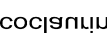

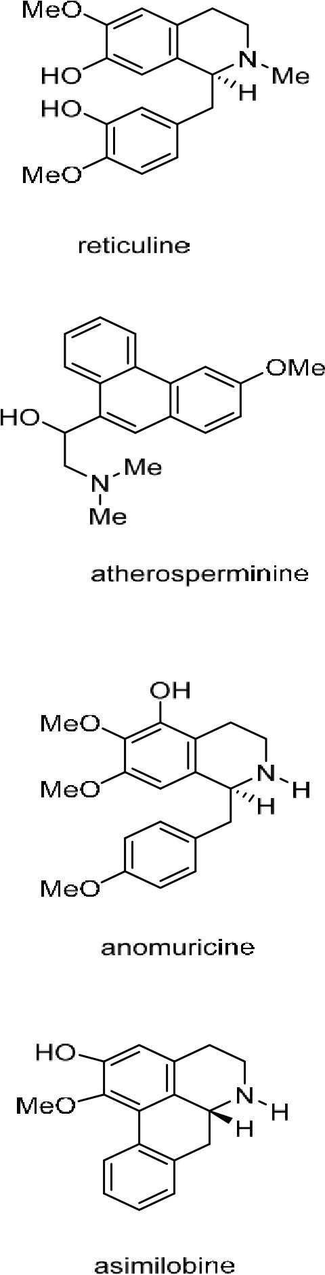


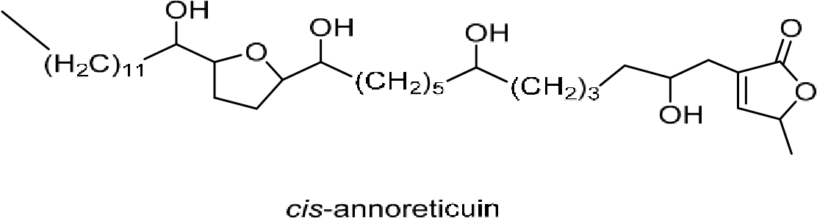

1.3 Research Gap and Study Objective
However, evidence remains limited on the use of graviola Cheong as a secondary-fermentation substrate in kombucha and on how this layered approach influences fermentation behaviour, antioxidant activity, nutritional composition, microbiological quality, and sensory acceptability relative to standard kombucha.
Accordingly, the present study aimed to develop a layered kombucha using graviola (Annona muricata) Cheong during secondary fermentation and to compare it with standard kombucha by evaluating physicochemical characteristics, fermentation behaviour, antioxidant activity, nutritional composition, microbiological quality, and sensory acceptability.

2. MATERIALS AND METHODS

2.1 Glassware and Instruments
Standard laboratory glassware, including conical flasks, beakers, test tubes, volumetric flasks, pipettes, burettes, and measuring cylinders, was used throughout the study. All glassware was washed with detergent, rinsed with distilled water, and oven-dried at 80 °C prior to use to avoid contamination. The major instruments used are listed below:
- Hot air oven (Lab Line, India; calibrated at 60 ± 2 °C)
- Magnetic stirrer
- Vacuum oven
- Analytical balance (Shimadzu AY220, Japan; ± 0.1 mg precision)
- UV–Visible spectrophotometer (Shimadzu UV-1800, Japan; 1 cm cuvette)
- Water bath (Remi WB-12, India)
- Hydrometer
- pH Meter
All equipment was calibrated prior to experimentation.

2.2 Collection and Preparation of Fruit Sample

Fresh and ripe Annona muricata fruits that were devoid of visible damage were collected from a farm located in Bengaluru, Karnataka, during the month of March to avoid microbial infestation. The fruits were washed thoroughly under running water to remove dust and foreign particles and then rinsed with distilled water. The outer covering of the fruit was removed, the pulp was extracted, and the seeds were removed. The deseeded pulp was layered with sugar for storage until infusion. A symbiotic culture of bacteria and yeast was used as the starter culture.

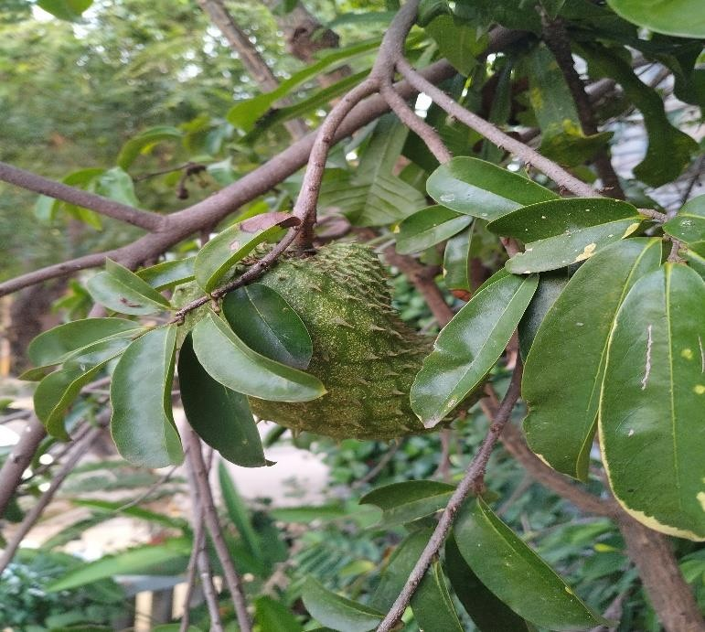
Figure 1Annona muricata fruit before sample collection

2.3 Preparation of Tea for Kombucha Fermentation

2.3.1 Materials required
- Black tea leaves
- Granulated sugar
- Distilled water
- SCOBY (Symbiotic Culture of Bacteria and Yeast)
- Starter kombucha liquid
- Glass fermentation jars
- Muslin cloth and rubber bands

2.3.2 Fermentation of Kombucha
Prior to fermentation, the fermentation setup was pasteurised with hot water to remove any residual detergent and allowed to air-dry completely. Sweetened tea can conventionally be prepared from green or oolong tea; however, black tea is commonly used in kombucha tea preparation. About 6.5 g of black tea powder was infused in 1000 mL of boiled water at 90 °C for 30 minutes. The tea leaves were then filtered, followed by the addition of 40-60 g of sugar. The tea infusion was cooled to 20 °C, followed by the addition of a symbiotic culture of bacteria and yeast. The vessel was then covered with a clean cotton cloth to minimise the entry of external contaminants while permitting adequate air exchange during fermentation. Optimum fermentation occurs at 20-30 °C but is dependent on the composition of the symbiotic culture of bacteria and yeast. Primary fermentation was carried out for 7 days. During fermentation, samples required for the analysis of parameters such as pH, specific gravity and other physicochemical characteristics were collected through the tap attached to the fermentation vessel. On Day 7, Annona muricata/graviola Cheong was incorporated into the fermented kombucha, followed by secondary fermentation for 7 days under the same conditions, resulting in a total fermentation period of 14 days. Within the symbiotic culture of bacteria and yeast, the yeast metabolises monosaccharides, producing ethanol and CO_{2.} The bacteria in the symbiotic culture of bacteria and yeast, mainly acetic acid bacteria/Acetobacter aceti, convert ethanol to organic acids or acetic acid, leading to a gradual decrease in pH and giving kombucha its characteristic tangy flavour. Secondary fermentation of kombucha is optional and can enhance flavour, antioxidant properties and bioactivity of the kombucha.

2.3.3 Preparation of Graviola Cheong
Fresh graviola (Annona muricata) fruit was thoroughly washed, and the pulp was separated from the seeds. The seeds were removed from the pulp, and 250 g of prepared graviola pulp was weighed. An equal quantity of 250 g of jaggery was measured, maintaining a 1:1 ratio of graviola pulp to jaggery. A clean, washed, and sterilised glass jar was used for preparation. The graviola pulp and jaggery were added alternately in layers, with a layer of graviola pulp followed by a layer of jaggery. This layering was continued until all the fruit pulp was incorporated. Care was taken to ensure that the top layer consisted of jaggery, completely covering the fruit pulp.
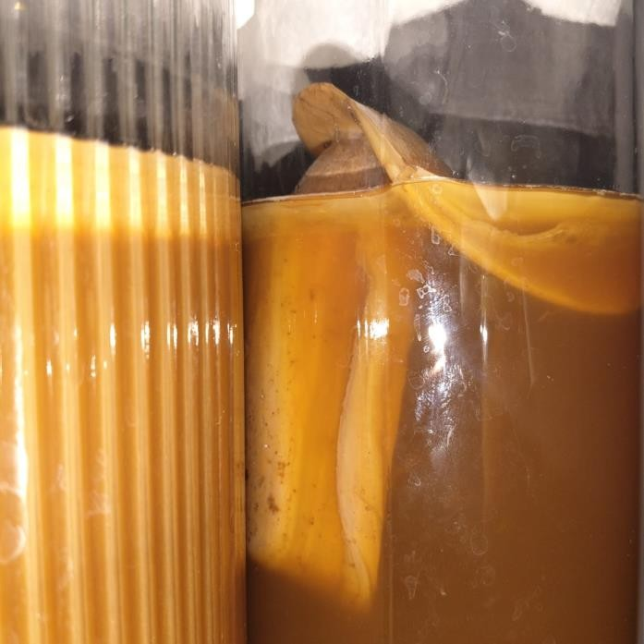
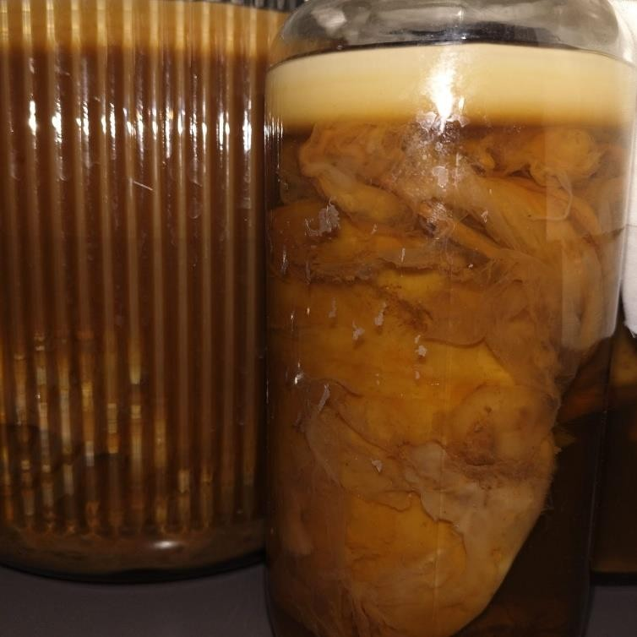
Figure
2

Kombucha fermentation setup

2.4 Physicochemical Analysis

2.4.1 pH Value

The pH value of kombucha was recorded during the fermentation period to observe changes in acidity levels and to monitor the fermentation process and sensory acceptability of the kombucha. Trials were performed to optimise the process with respect to changes in acidity, flavour profile, and sensory acceptability before and after secondary fermentation using graviola infusion/Cheong. The pH value of the fermentation brew was determined using a pH meter at room temperature in triplicate once every 24 hours until the completion of fermentation, including the graviola Cheong-layered kombucha samples. The pH meter was calibrated using standard buffer solutions of pH 4.0 and 7.0.

2.4.2 Specific Gravity

To systematically monitor sugar consumption and fermentation processes, specific gravity was evaluated at 48-hour intervals during sample collection from the fermentation vessel/chamber. Each collected sample was filtered and cooled to 15-20 °C. Once cooled, the sample was further agitated vigorously to degas CO₂. At 20.0 °C, the sample was transferred into a measuring cylinder, where the glass hydrometer was submerged in the sample. Regression analysis was performed to evaluate the relationship between fermentation time and specific gravity during fermentation. The specific gravity values were recorded to track real-time fermentation kinetics.

2.4.3 Total Soluble Solids (Brix)

To assess variations in total soluble solids at different production stages using a refractometer, total soluble solids were systematically evaluated for the standard kombucha sample, layered kombucha, and graviola Cheong. The soluble sugar concentration was measured. The observed differences reflected formulation characteristics and changes in fermentation. A 2 mL sample was used to determine TSS; measurements were performed in triplicate, and the results were expressed as mean values.

2.5 Proximate Analysis

The moisture and ash content of the sample were analysed according to IS 3752 - 2005 (Reaffirmed 2020). The fat and protein contents were determined using Soxhlet extraction and the Kjeldahl method, respectively. The carbohydrate composition was determined by calculating the remaining percentage after all other components had been accounted for, and reducing sugars were estimated by the DNS method. Proximate analysis was carried out by an external laboratory. The analyses were performed in triplicate, and the results were reported as mean values.

2.6 Titratable Acidity

The titratable acidity of kombucha was estimated on days 1, 7, 14, 30, and 45 of kombucha fermentation by titrating 10 mL of kombucha sample with 1-2 drops of phenolphthalein reagent against 0.1 N NaOH; the titration values were obtained in triplicate, and the mean acidity value was calculated using the formula.

Titratable acidity % = Volume of NaOH × Normality of NaOH × Equivalent weight (acetic acid)
Volume of sample

2.7 Estimation of Vitamin C (Ascorbic Acid)

Ascorbic acid content was determined by iodometric titration according to standard methods, with minor modifications. Standard iodine solution was prepared by dissolving 5.0 g of potassium iodide (KI) and 0.268 g of potassium iodate (KIO₃) in distilled water, acidifying with 3 M sulfuric acid (H₂SO₄), and diluting to a final volume of 500 mL. For analysis, 10 mL of kombucha sample (or 𝐿-ascorbic acid standard solution) was transferred to a conical flask, followed by the addition of 1–2 drops of 1% (w/v) soluble starch indicator. The mixture was titrated against the prepared iodine solution until the persistent appearance of a bluish-black end-point. Sampling was carried out across primary fermentation on days 1, 7, 14, 30, and 45. Graviola fruit infusion (Cheong) was introduced on Day 7 for secondary fermentation and enhancement of bioactive compounds and antioxidant properties, and subsequent measurements were taken on days 30 and 45 to evaluate the shelf-life stability of vitamin C and associated bioactive compounds. All determinations were performed in triplicate, and vitamin C concentrations were expressed as mg/100 mL of sample using standard stoichiometric calculations.

2.8 Antioxidant Properties

2.8.1 Total Phenolic Content
The total phenolic content of standard kombucha and graviola-infused layered kombucha was determined using the Folin-Ciocalteu reagent. The Folin-Ciocalteu reagent was prepared by dissolving 10 mL of Folin-Ciocalteu reagent in 90 mL of distilled water, and gallic acid was used as a standard. A 0.01 mL aliquot of centrifuged sample was added to 10 mL of methanol, and a 0.5 mL sample aliquot was mixed with 2.5 mL of Folin-Ciocalteu reagent and incubated for 5 min. Then, 2.0 mL of 7.5% sodium carbonate solution was added. The mixture was mixed and stored at room temperature in the dark for 2 h. The absorbance was measured at 765 nm using a spectrophotometer. The analysis was performed in duplicate, and the results were expressed as mean values in µg GAE/g.

2.8.2 Determination of DPPH Radical Scavenging Activity

The antioxidant activity of the samples was measured in terms of hydrogen-donating or radical-scavenging ability using the DPPH reagent. First, a 0.2 mM DPPH solution was prepared by dissolving 0.0078 g in 100 mL of ethanol. Then, 0.01 g of the extract was added to 10 mL of ethanol to obtain a concentration of 1 mg/mL. Approximately 2 mL of the sample aliquot was added to 2 mL of DPPH in ethanol and shaken well before incubation in the dark for 30 min. The absorbance of the solution was measured at 517 nm using a spectrophotometer. The analysis was performed in duplicate, and the results were expressed as mean percentage inhibition.

Inhibition % = Absorbance of control – Absorbance of sample × 100
Absorbance of control

2.9 Sensory Evaluation

Sensory analysis of the layered and base kombucha samples was performed for taste, aroma, colour, appearance and overall acceptance by 50 untrained students using a 9-point hedonic scale, with 1 being the least likeable and 9 being the most likeable. The kombucha samples were coded with three-digit random numbers and presented on trays in individual booths for the panellists; observations were then recorded and documented. In this sensory evaluation, water was provided to each panellist between samples as a palate cleanser.

2.10 Microbial Analysis
Microbiological quality was assessed using the pour-plate method with Nutrient Agar for total plate count and Potato Dextrose Agar for yeast and mould. Samples were inoculated and incubated at 37 °C for 48–72 h and at room temperature for 5 days, respectively. Coliforms and E. coli were also assessed using standard microbiological procedures. Microbial growth was further examined microscopically after Gram staining and safranin staining.

3. RESULTS AND DISCUSSION

3.1 Physicochemical Analysis

3.1.1 pH Value
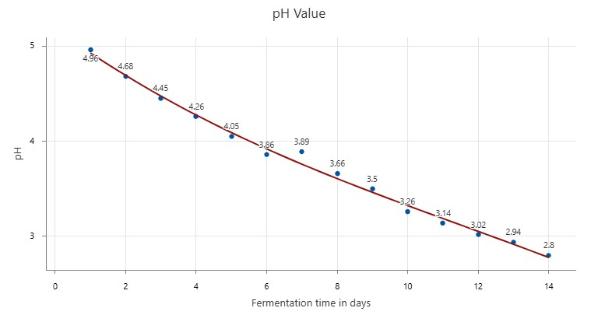
Figure 3 Changes in pH during fermentation represent mean values of triplicate measurements (N=42). The trendline indicates statistically significant relationship, R² = 0.6019, p < 0.001

The initial pH of the fermentation tea was 4.96, and a gradual decrease in pH was observed throughout the fermentation, indicating an increase in acidity as a result of the effective breakdown of sugars into alcohol and the subsequent production of organic acids by the symbiotic culture of bacteria and yeast. The decrease in pH is mainly attributed to acetic acid production by Acetobacter and Gluconobacter bacteria. According to Jayabalan et al. (2014), the pH decreases from 5.44 to 3.0 after 5 to 7 days of fermentation (Dartora et al., 2023).
Sreeramulu et al. (2000), Tanticharakunsiri et al. (2021), Aung and Eun (2021).It is also believed that the decrease in pH was caused by organic acids, such as acetic acid or gluconic acid, produced by microorganisms, and this result was similar to that of Sreeramulu et al. (2000), Tanticharakunsiri et al. (2021), and Aung and Eun (2021). During secondary fermentation, the base kombucha showed a further decrease, whereas a temporary increase in pH was observed in the graviola-infused layered kombucha following the addition of Annona muricata (graviola) Cheong, suggesting that the fruit infusion altered the fermentation matrix through the fruit's biomass. By the end of fermentation, the pH had decreased to 2.80.

3.1.2 Specific Gravity

The specific gravity of the initial tea brew was 1.028 and was recorded as the original gravity of the fermentation medium, indicating a high amount of dissolved sugars. A gradual drop in specific gravity was observed as a result of ethanol production by yeast and the bacterial conversion of ethanol into organic acids present in the symbiotic culture of bacteria and yeast. The specific gravity increased temporarily on the seventh day of fermentation due to the addition of Annona muricata (graviola) Cheong, which contributed additional sugars and dissolved fruit infusions. As fermentation progressed, the specific gravity progressively decreased, indicating the utilisation of additional sugars in secondary fermentation. By the end of fermentation, the specific gravity dropped to 1.018. Regression analysis showed a strong relationship between fermentation time and specific gravity (R² = 0.892, p < 0.001), indicating a consistent decline in specific gravity with fermentation time.

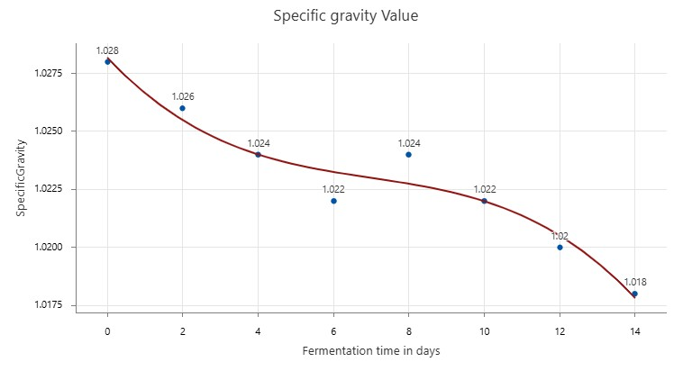
Figure 4 Changes in specific gravity during fermentation (N=24). The trendline indicates a statistically significant relationship (R² = 0.892, p < 0.001).

3.1.3 Total Soluble Solids

Total soluble solids (TSS, °Brix) were determined to evaluate changes in soluble sugar concentration during kombucha fermentation and secondary infusion with Annona muricata (graviola) Cheong. The graviola Cheong exhibited the highest TSS due to its high sucrose concentration, while the standard kombucha showed comparatively lower values, as fermentable sugars had already been utilised during primary fermentation. Following the addition of Cheong during secondary fermentation, the TSS of the graviola-infused kombucha increased temporarily due to the incorporation of fruit-derived soluble solids and sugars. As fermentation progressed, a gradual decline in TSS was observed, reflecting the continued utilisation of fermentable sugars by the microbial consortium.

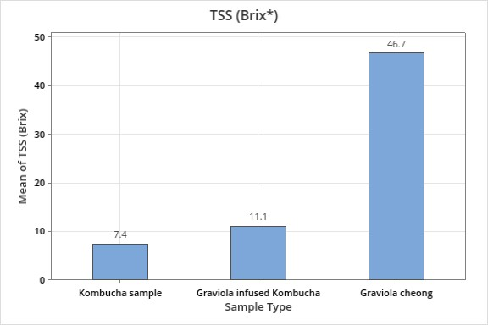
Figure 5 Comparison of TSS in kombucha samples

3.2 Proximate Analysis
According to the data presented in the table, graviola-infused kombucha has a higher ash content than base kombucha due to its high inorganic residual compounds, including high fibre content. The crude protein content in both graviola-infused kombucha and base kombucha showed no significant difference, as did the total fat content. However, the final kombucha formulation exhibits a total sugar concentration of 6.05%, with a 10% (v/v) graviola infusion/Cheong addition consisting of a 50:50 fruit and sucrose infusion. Chromatographic analysis reveals that reducing sugars (glucose and fructose) account for only 1.59% of the total matrix, indicating a mature primary kombucha fermentation in which residual simple sugars were largely depleted by the symbiotic culture of bacteria and yeast. The final matrix also contains the natural monosaccharide payload introduced by the graviola infusion/Cheong during secondary fermentation. Rather than relying on thermal pasteurisation or chemical additives, this concentrated sucrose matrix functions as a natural preservative and may contribute to improved stability and nutrient retention.

Table 1. Proximate composition of base kombucha and graviola-infused kombucha

Sample | Moisture  Content (%) | Ash  Content  (%) | Total  Fat  Content  (%) | Crude  Protein  Content  (%) | Carbohydrate Content (%) | Crude  Fibre  Content  (%) | Total  Sugar  (%)
Test method | FSSAI manual for  analysis of fruit  2016 | IS3752-2005  (Reaffirmed  2020) | SMSLA/  FD/SOP  /0422024 | AOAC  22nd edition  2001.11.  2023 | IS1656- 2022 | IS2026  (part1)-1982  (Reaffirmed  2020) | SMSLA/LS /SOP/019-  2024
Base kombucha | 96.63 | 0.15 | <10 | <10 | 5.46 | 0.11 | 4.20
Graviola infused kombucha | 93.95 | 0.56 | <10 | <10 | 6.05 | 0.259 | 5.50
Note: Values are expressed as mean of triplicate determinations.

3.2.1 Determination of Reducing Sugar Content (DNS Method)
The reducing sugar content of the fermented kombucha samples was determined using the 3,5-dinitrosalicylic acid (DNS) colorimetric method. The method is based on the reduction of 3,5-dinitrosalicylic acid by reducing sugars under alkaline conditions to form 3-amino-5-nitrosalicylic acid, producing an orange-red coloured complex. Briefly, 0.5 mL of appropriately undiluted sample and a 1:10 diluted sample were mixed with 3 mL of DNS reagent and heated in a boiling water bath for 5 min. After cooling to room temperature, 0.5 mL of distilled water was added, and the absorbance was measured at 540 nm using a UV–Visible spectrophotometer. A calibration curve was prepared using glucose as the reference standard (0–1.0 mg mL⁻¹). All analyses were performed in triplicate, and the reducing sugar concentration was determined from the calibration curve and expressed as mg glucose equivalent (GE) mL⁻¹ of sample.

Figure 6 Standard calibration curve for estimation of reducing sugars using glucose as the standard. Values represent the mean of triplicate determinations. The glucose standard curve showed a strong linear relationship (R² = 0.9973)

3.3 Titratable Acidity

The titratable acidity was estimated on fermentation days 1, 7 and 14, followed by analysis of titratable acidity post-bottling on days 30 and 45, mainly to observe the stability of the acidity of the fermented kombucha. Titratable acidity progressively increased during primary fermentation from 0.162% on Day 1 to 0.342% on Day 7 and reached a maximum of 0.98% on Day 14 after secondary fermentation following the addition of graviola infusion/Cheong. The increase in titratable acidity indicates the progressive accumulation of organic acids as fermentation proceeded, corresponding with the reduction in pH observed during the fermentation period. This increase may be attributed to the metabolic activity of the symbiotic culture of bacteria and yeast consortium, in which yeast metabolises fermentable sugars and produces ethanol, followed by the conversion of ethanol and other substrates into organic acids by acetic acid bacteria. The titratable acidity declined following bottling and storage to 0.781% on Day 30 and further declined to 0.498% on Day 45. The reduction in titratable acidity during storage may be associated with changes in the organic acid profile and continued microbial metabolism. The decrease in acidity was accompanied by relatively stable pH values during the later storage period. All titratable acidity determinations were performed in triplicate, and the results were expressed as mean values.

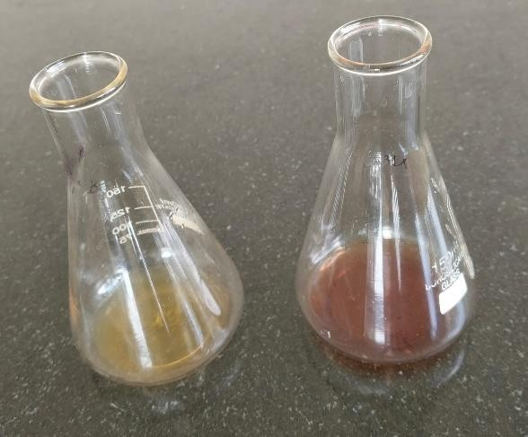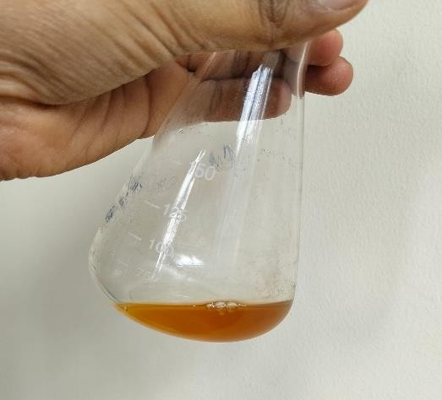
Figure 7 Showing before and after titration

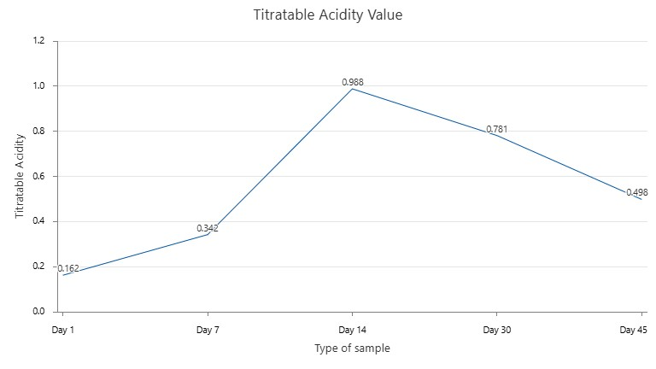
Figure 8 Changes in titratable acidity during fermentation and refrigerated storage. Values represent mean values of triplicate determinations (N = 15). Titratable acidity is expressed as percentage (%) of acidity.

3.4 Vitamin C (Ascorbic Acid) Estimation
The vitamin C (ascorbic acid) content of base kombucha and graviola-infused kombucha was estimated throughout the fermentation process and refrigerated storage to evaluate the retention of ascorbic acid and its stability during storage. The initial vitamin C concentration was 0.21 mg/100 mL on Day 1 and later increased to 0.26 mg/100 mL on the seventh day of fermentation. After the infusion of graviola Cheong on the seventh day of fermentation, the vitamin C concentration increased on Day 14 to 0.82 mg/100 mL, indicating effective incorporation of vitamin C from graviola Cheong infusion into kombucha. During refrigerated storage, the vitamin C concentration gradually decreased to 0.41 mg/100 mL on Day 30 and 0.35 mg/100 mL on Day 45, reflecting the susceptibility of ascorbic acid to oxidative degradation during storage (Jakubczyk et al., 2022). A similar decrease in vitamin C concentration with increasing fermentation time was reported for kombucha prepared using moringa leaves (Zahra et al., 2022). All determinations were performed in triplicate, and the results were expressed as mean values in mg/100 mL of sample.

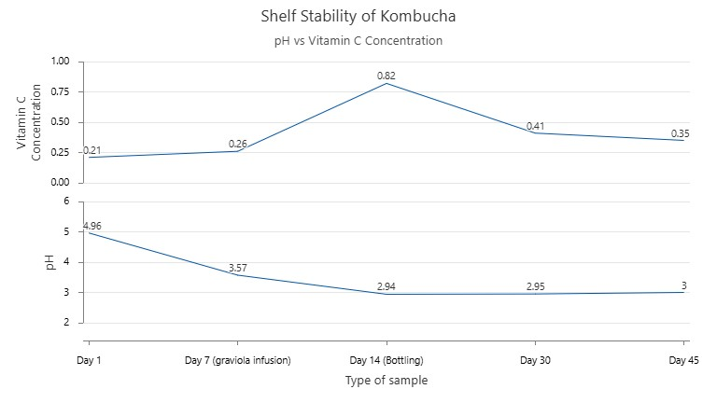

Figure 9Changes in vitamin C concentration and pH during refrigerated storage. Vitamin C values represent mean values of triplicate determinations.

3.5 Total Phenolic Content

Total phenolic content was determined using the Folin–Ciocalteu colorimetric method and expressed as µg gallic acid equivalents per gram (µg GAE/g) of sample. The standard kombucha exhibited a total phenolic content of 780 µg GAE/g, whereas the graviola Cheong-infused kombucha showed a higher value of 980 µg GAE/g. Thus, incorporation of graviola resulted in an approximately 25.6% increase in the measured total phenolic content compared with the standard kombucha. The higher TPC observed in the graviola-infused kombucha may be attributed to the contribution of phenolic compounds naturally present in Annona muricata (graviola) fruit, in addition to the phenolic constituents already present in the tea-based kombucha.
The increase suggests that incorporation of graviola provided an additional source of phenolic compounds to the beverage matrix.
Phenolic compounds in tea, including flavonoids and phenolic acids, contributed an important fraction of its antioxidant constituents. During kombucha fermentation, microbial activity may also influence the transformation and availability of phenolic compounds, contributing to changes in total phenolic content. The higher value observed in the infused formulation may therefore reflect both the contribution of the added graviola infusion/Cheong and changes occurring during fermentation. The TPC value of 980 µg GAE/g in the graviola-infused kombucha indicates an enrichment in phenolic constituents relative to the standard formulation. Values are expressed as the mean of duplicate determinations.

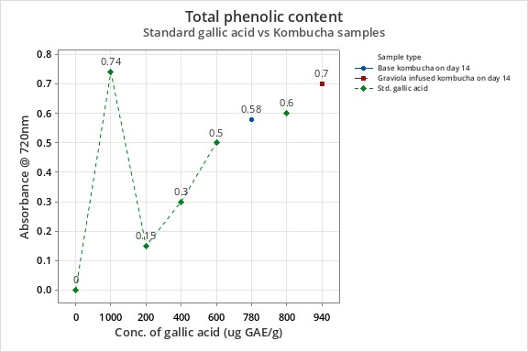
Figure 10 Gallic acid calibration curve for determination of total phenolic content. The calibration curve was prepared from 12 standard determinations (N = 12) and showed a linear relationship (R² = 0.994). Kombucha sample values represent duplicate determinations (N = 4).

3.6 DPPH Radical Scavenging Assay

The DPPH assay was used to evaluate the antioxidant activity of the kombucha samples by measuring their ability to scavenge DPPH free radicals. Antioxidants donate hydrogen atoms or electrons to DPPH radicals, resulting in a decrease in the intensity of the purple colour of the DPPH solution. This reduction is reflected by a lower absorbance value, while a higher percentage of inhibition indicates stronger radical-scavenging activity. The antioxidant activity of kombucha samples was evaluated using a DPPH radical-scavenging assay at different stages of fermentation. During primary fermentation, 46% inhibition was observed on Day 7 of fermentation, which may be attributed to the microbial biotransformation of tea polyphenols and production of antioxidant metabolites by the symbiotic culture of bacteria and yeast consortium. This was followed by the addition of graviola Cheong.
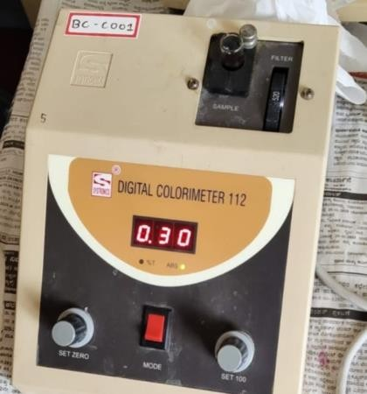
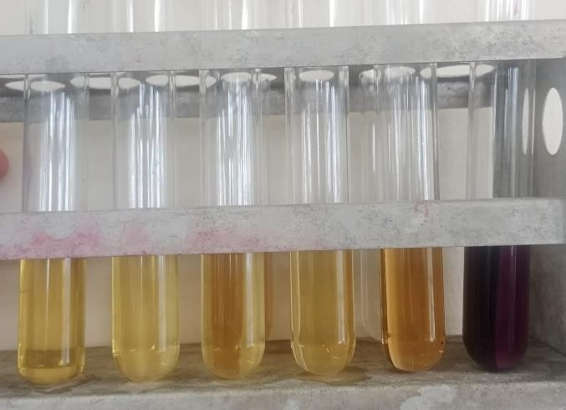
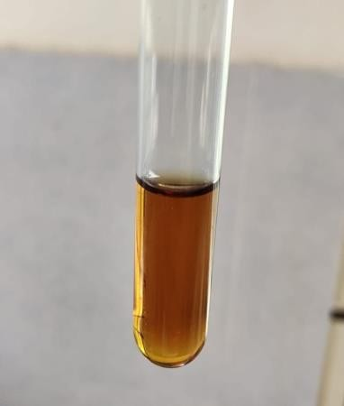

Figure 11 DPPH radicle scavenging assay procedure

During secondary fermentation, an increase in inhibition was observed in both base kombucha and graviola-infused kombucha on Day 14. Base kombucha showed 57% inhibition, indicating a progressive enhancement in antioxidant activity during fermentation, whereas the Annona muricata (graviola) Cheong-infused kombucha exhibited a significantly higher radical-scavenging activity of 80% inhibition on Day 14, demonstrating that secondary fermentation with graviola Cheong enhanced the antioxidant potential of the beverage. Jayabalan et al. (2014) reported similar increases in DPPH radical-scavenging activity during kombucha fermentation and attributed the enhanced antioxidant capacity to microbial fermentation. DPPH radical-scavenging activity was determined in duplicate, and the mean value was used for reporting the percentage of inhibition.

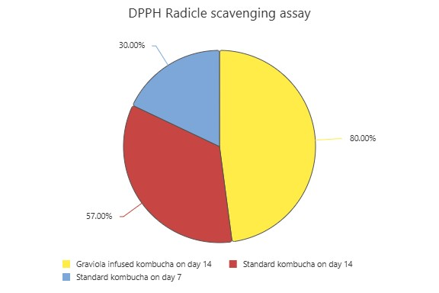

Figure 13: Pie chart with percentage of inhibition

Figure 12: Calibration curve of ascorbic acid for determination of DPPH radical scavenging activity. Values represent mean percentage inhibition of duplicate determinations. The calibration curve showed a strong linear relationship (R² = 0.99).

3.7 Microbial Analysis

Microbial analysis of the fermented kombucha was carried out by standard plate count and yeast and mould enumeration. For standard plate count, 1 mL of the liquid test sample at a dilution of 10⁻⁴ was aseptically transferred into two sterile Petri dishes using a sterile pipette. Approximately 15–20 mL of Nutrient Agar, autoclaved at 121 °C for 15 min and maintained at 45–50 °C, was poured into the Petri dishes. The inoculum was carefully mixed with the medium and allowed to solidify on a cool horizontal surface. A control plate containing the sterile medium was prepared to check the sterility of the medium. The plates were inverted and incubated at 37 °C for 48–72 h. For yeast and mould enumeration, 1 mL of the liquid test sample was similarly transferred into sterile Petri dishes, followed by the addition of 15–20 mL of Potato Dextrose Agar (PDA) maintained at 45–50 °C. The inoculum was mixed carefully with the medium and allowed to solidify. A control plate containing sterile medium was prepared, and the plates were inverted and incubated at room temperature for 5 days. The colonies were observed and recorded using a colony counter, and for the identification of microbial strains, selected colonies were subjected to Gram staining and safranin staining for microscopic observation and characterisation of the observed microorganisms.
Microbial parameter | Dilution Factor | Volume plated | Mean microbial count (CFU/g)
Standard Plate Count | 10⁻⁴ | 1ml | 1.8 × 10⁵
Yeast & Mould Count | 10⁻⁴ | 1ml | 1.2 × 10⁵
Enumeration of E. coli | 10⁻⁴ | 1ml | <1 CFU/mL
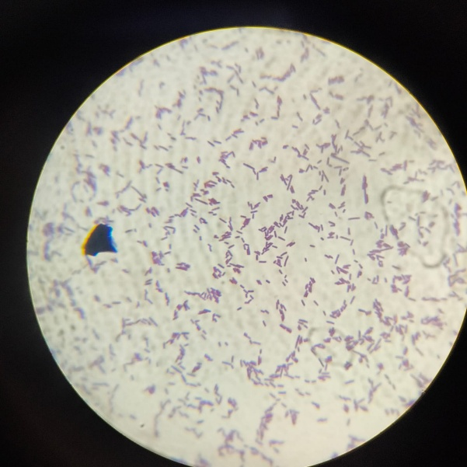

Figure 13: Microscopic observation of microbial isolates after staining, showing yeast-like oval cells and gram negative rod-shaped bacterial cells.

Table 2. Microbiological quality of fermented kombucha based on standard plate count, yeast and mould count, and E. coli enumeration

Note: Microbiological results represent duplicate determinations (n = 2). TPC is expressed as CFU/mL; <LOD indicates below the detection limit of the method.

3.8 Fermentation Kinetics

The fermentation kinetics of kombucha demonstrated progressive changes in physicochemical parameters during primary and secondary fermentation (Diez-Ozaeta & Juaristi Astiazaran, 2022; Tran et al., 2020; Vorobyeva et al., 2022). The fermentation process was considered a two-step fermentation model, comprising primary fermentation for the initial 7 days followed by secondary fermentation after incorporation of graviola (Annona muricata) Cheong on Day 7. During the initial 7 days of primary fermentation, the decrease in pH and specific gravity, together with the increase in titratable acidity, indicated progressive substrate utilisation and acid development by the fermentation culture. The pH decreased from 4.96 initially to 2.80 by Day 14, while specific gravity decreased from 1.028 to 1.018 over the fermentation period. During primary fermentation, specific gravity decreased from 1.028 to 1.022, corresponding to an apparent decline of 0.001 SG units day⁻¹. The pH decreased from 4.96 to 3.89, corresponding to an apparent decline of 0.178 pH units day⁻¹, while titratable acidity increased from 0.162% on Day 1 to 0.342% on Day 7, corresponding to an apparent increase of 0.030% day⁻¹. The addition of graviola (Annona muricata) Cheong on Day 7 marked the transition from primary to secondary fermentation and introduced additional soluble sugars and fruit-derived solids into the fermented beverage. This was reflected by the temporary increase in specific gravity and TSS following Cheong incorporation. During the measured secondary fermentation period, specific gravity decreased from 1.024 to 1.018, corresponding to an apparent decline of 0.001 SG units day⁻¹. The pH further decreased from 3.89 to 2.80, corresponding to an apparent decline of 0.156 pH units day⁻¹, while titratable acidity increased from 0.342% to 0.988%, corresponding to an apparent increase of 0.092% day⁻¹. These changes indicate continued utilisation of the newly introduced soluble substrates and acid development during secondary fermentation (Chen et al., 2024). Thus, the combined changes in pH, specific gravity, TSS and titratable acidity demonstrate the progression of the two-step fermentation process, with Cheong addition modifying the fermentation matrix and providing additional substrates for subsequent microbial activity.

3.9 Sensory Evaluation
Sensory evaluation was conducted to compare the sensory acceptability of standard kombucha and graviola-infused (Annona muricata) layered kombucha using a 9-point hedonic scale, where 1 represented “dislike extremely” and 9 represented “like extremely.” A total of 50 untrained student panellists evaluated the samples based on appearance, colour, odour, sourness, sweetness, flavour, and overall acceptability. The sensory profile demonstrated that the layered kombucha generally received favourable scores across the evaluated attributes compared with the standard kombucha. The layered formulation showed improved perception of flavour and sweetness, which may be associated with the incorporation of graviola Cheong during secondary fermentation and the resulting balance between fruit-derived sweetness and the characteristic acidity of kombucha. The layered kombucha also exhibited favourable scores for appearance and colour, indicating that the fruit infusion contributed positively to the visual characteristics of the beverage. In comparison, the standard kombucha showed a relatively more pronounced perception of sourness, consistent with its characteristic acidic profile. The odour and overall acceptability scores of both formulations were favourable, suggesting that the incorporation of graviola Cheong did not negatively affect consumer acceptance. Overall, the sensory evaluation indicated that the layered fermentation approach produced a more complex and balanced sensory profile, particularly in terms of flavour and sweetness, while maintaining good overall acceptability among the panellists. These findings support the potential of graviola Cheong as a secondary fermentation ingredient for improving the sensory characteristics of kombucha.

Figure 14 Sensory evaluation comparison between standard and graviola Cheong-infused kombucha using a 9-point hedonic scale. Values represent mean scores from 50 untrained panelists (N = 50).

3.10 Limitations of the Study
The present study has certain limitations that should be considered when interpreting the findings. Fermentation behaviour was evaluated using selected physicochemical parameters, such as pH, specific gravity, total soluble solids, and titratable acidity, and therefore does not provide a complete characterisation of all biochemical changes occurring during fermentation. Although the study demonstrated an increase in total phenolic content and DPPH radical-scavenging activity in the graviola-infused kombucha, comprehensive identification and quantification of individual phenolic compounds and other bioactive constituents were not performed. Similarly, the microbiological assessment provides information on the microbial quality of the tested product, but does not provide detailed identification or characterisation of the microbial communities responsible for the fermentation. The storage study was also conducted using selected parameters, including vitamin C and physicochemical changes, and therefore the observed storage behaviour should not be interpreted as establishing the complete long-term shelf life of the product. In addition, sensory evaluation was conducted using 50 untrained student panellists, which provides an indication of consumer acceptability but may not represent the preferences of the wider consumer population. Further studies addressing these aspects would provide a more comprehensive understanding of the fermentation process, product stability, microbial characteristics, and consumer acceptability.

4. CONCLUSION

The present study demonstrated the potential of a layered fermentation approach using Annona muricata (graviola) Cheong as a secondary fermentation substrate for the development of a value-added kombucha beverage with enhanced nutritional, functional, and sensory characteristics. Primary fermentation of black tea using a SCOBY resulted in progressive physicochemical changes associated with microbial activity and substrate utilisation (de Miranda et al., 2022; Gantner et al., 2025), including reductions in pH, specific gravity, and total soluble solids, accompanied by an increase in titratable acidity during active fermentation, reflecting continued microbial metabolism and utilisation of fermentable substrates by the symbiotic culture of bacteria and yeast consortium. The temporary increase in soluble solids and specific gravity following incorporation of graviola Cheong further demonstrated the contribution of fruit-derived sugars and soluble constituents to the secondary fermentation matrix and their subsequent utilisation during fermentation. The incorporation of graviola Cheong enhanced the functional properties and antioxidant potential of the developed kombucha, as evidenced by the higher DPPH radical-scavenging activity observed in the infused kombucha compared with the standard fermented kombucha (Jakubczyk et al., 2020; Jakubczyk et al., 2024). The enhanced antioxidant potential may also be attributed to the combined contribution of tea-derived polyphenols, fruit-derived bioactive compounds, vitamin C, and continued microbial biotransformation during fermentation. Vitamin C analysis further demonstrated that the infused kombucha retained appreciable amounts of ascorbic acid throughout refrigerated storage, indicating satisfactory shelf stability under acidic conditions, although a gradual decline was observed with prolonged storage. The use of graviola Cheong therefore extends the concept of fruit incorporation beyond simple flavour modification by introducing an additional fermentation stage through which fruit-derived constituents interact with the ongoing microbial fermentation process. These findings demonstrate that thoughtful fermentation design, rather than ingredient selection alone, can significantly influence the nutritional quality, functional properties, and sensory experiences of modern fermented beverages. This study demonstrates that layered fermentation is more than a flavouring strategy; it represents a novel fermentation design approach capable of enhancing the nutritional profile, antioxidant potential, and sensory characteristics of kombucha through the synergistic interaction of microbial fermentation and fruit-derived bioactive compounds (Emiljanowicz & Malinowska-Pańczyk, 2020; Uțoiu et al., 2018; Velićanski et al., 2014). Overall, the study suggests that graviola Cheong is a promising natural ingredient for the development of value-added functional kombucha with enhanced antioxidant properties and improved nutritional quality (Esatbeyoglu et al., 2024; Li et al., 2025; Prajapati et al., 2024). Further studies involving comprehensive phytochemical profiling, microbial characterisation, and extended shelf-life evaluation are recommended to validate the commercial potential of the developed beverage.

COMPETING INTRESTS

The authors declare that they have no competing interests.
Declaration of AI Use
This manuscript was prepared through the intellectual contributions of the author(s) to the study design, data analysis, interpretation of results, and scholarly content. Grammarly and ChatGPT were used solely to assist with grammatical refinement and reference formatting during manuscript revision. The author(s) accept full responsibility for the accuracy, integrity, and final content of the manuscript.

REFERENCES

Abaci, N., Senol Deniz, F. S., & Orhan, I. E. (2022). Kombucha—An ancient fermented beverage with desired bioactivities: A narrowed review. Food Chemistry: X, 14, 100302. https://doi.org/10.1016/j.fochx.2022.100302
Antolak, H., Piechota, D., & Kucharska, A. (2021). Kombucha tea—A double power of bioactive compounds from tea and symbiotic culture of bacteria and yeasts (SCOBY). Antioxidants, 10(10), 1541. https://doi.org/10.3390/antiox10101541
Aung, T., & Eun, J.-B. (2021). Production and characterization of a novel beverage from laver (Porphyra dentata) through fermentation with kombucha consortium. Food Chemistry, 350, 129274. https://doi.org/10.1016/j.foodchem.2021.129274
Chen, J., Huang, Y., Wang, X., He, J., Li, W., Lu, M., Sun, X., & Yin, Y. (2024). Revealing core functional microorganisms in the fermentation process of Qicaipaojiao (Capsicum annuum L.) based on microbial metabolic network. Food Research International, 187, 114315. https://doi.org/10.1016/j.foodres.2024.114315
Dartora, B., Hickert, L. R., Fabricio, M. F., Ayub, M. A. Z., Furlan, J. M., Wagner, R., Perez, K. J., & Sant’Anna, V. (2023). Understanding the effect of fermentation time on physicochemical characteristics, sensory attributes, and volatile compounds in green tea kombucha. Food Research International, 174(Pt. 1), 113569. https://doi.org/10.1016/j.foodres.2023.113569
de Miranda, J. F., Ruiz, L. F., Silva, C. B., Uekane, T. M., Silva, K. A., Gonzalez, A. G. M., Fernandes, F. F., & Lima, A. R. (2022). Kombucha: A review of substrates, regulations, composition, and biological properties. Journal of Food Science, 87(2), 503–527. https://doi.org/10.1111/1750-3841.16029
Diez-Ozaeta, I., & Juaristi Astiazaran, O. (2022). Recent advances in kombucha tea: Microbial consortium, chemical parameters, health implications and biocellulose production. International Journal of Food Microbiology, 377, 109783. https://doi.org/10.1016/j.ijfoodmicro.2022.109783
Emiljanowicz, K. E., & Malinowska-Pańczyk, E. (2020). Kombucha from alternative raw materials—The review. Critical Reviews in Food Science and Nutrition, 60(19), 3185–3194. https://doi.org/10.1080/10408398.2019.1679714
Esatbeyoglu, T., Sarikaya Aydin, S., Gültekin Subasi, B., Erskine, E., Gök, R., Ibrahim, S. A., Yilmaz, B., Özogul, F., & Capanoglu, E. (2024). Additional advances related to the health benefits associated with kombucha consumption. Critical Reviews in Food Science and Nutrition, 64(18), 6102–6119. https://doi.org/10.1080/10408398.2022.2163373
Gantner, M., Piotrowska, A., Kostyra, E., Hallmann, E., Ponder, A., Sionek, B., & Neffe-Skocińska, K. (2025). Influence of herbal additives on the physicochemical, microbiological, polyphenolic, and sensory profile of green tea-based kombucha. Foods, 14(20), 3497. https://doi.org/10.3390/foods14203497
Jakubczyk, K., Kałduńska, J., Kochman, J., & Janda, K. (2020). Chemical profile and antioxidant activity of the kombucha beverage derived from white, green, black and red tea. Antioxidants, 9(5), 447. https://doi.org/10.3390/antiox9050447
Jakubczyk, K., Kupnicka, P., Melkis, K., Mielczarek, O., Walczyńska, J., Chlubek, D., & Janda-Milczarek, K. (2022). Effects of fermentation time and type of tea on the content of micronutrients in kombucha fermented tea. Nutrients, 14(22), 4828. https://doi.org/10.3390/nu14224828
Jakubczyk, K., Łopusiewicz, Ł., Kika, J., Janda-Milczarek, K., & Skonieczna-Żydecka, K. (2024). Fermented tea as a food with functional value—Its microbiological profile, antioxidant potential and phytochemical composition. Foods, 13(1), 50. https://doi.org/10.3390/foods13010050
Jayabalan, R., Malbaša, R. V., Lončar, E. S., Vitas, J. S., & Sathishkumar, M. (2014). A review on kombucha tea—Microbiology, composition, fermentation, beneficial effects, toxicity, and tea fungus. Comprehensive Reviews in Food Science and Food Safety, 13(4), 538–550. https://doi.org/10.1111/1541-4337.12073
Li, X., Tso, N., Huang, S., Wang, J., Zhou, Y., & Liu, R. (2025). A comprehensive evaluation of microbial synergistic metabolic mechanisms and health benefits in kombucha fermentation: A review. Biology, 14(8), 952. https://doi.org/10.3390/biology14080952
Menezes, E. G. T., Oliveira, É. R., Carvalho, G. R., Guimarães, I. C., & Queiroz, F. (2019). Assessment of chemical, nutritional and bioactive properties of Annona crassiflora and Annona muricata wastes. Food Science and Technology, 39(Suppl. 2), 662–672. https://doi.org/10.1590/fst.22918
Moghadamtousi, S. Z., Fadaeinasab, M., Nikzad, S., Mohan, G., Ali, H. M., & Kadir, H. A. (2015). Annona muricata (Annonaceae): A review of its traditional uses, isolated acetogenins and biological activities. International Journal of Molecular Sciences, 16(7), 15625–15658. https://doi.org/10.3390/ijms160715625
Prajapati, K., Prajapati, J., Patel, D., Patel, R., Varshnei, A., Saraf, M., & Goswami, D. (2024). Multidisciplinary advances in kombucha fermentation, health efficacy, and market evolution. Archives of Microbiology, 206(9), 366. https://doi.org/10.1007/s00203-024-04086-1
Sreeramulu, G., Zhu, Y., & Knol, W. (2000). Kombucha fermentation and its antimicrobial activity. Journal of Agricultural and Food Chemistry, 48(6), 2589–2594. https://doi.org/10.1021/jf991333m
Tanticharakunsiri, W., Mangmool, S., Wongsariya, K., & Ochaikul, D. (2021). Characteristics and upregulation of antioxidant enzymes of kitchen mint and oolong tea kombucha beverages. Journal of Food Biochemistry, 45(1), e13574. https://doi.org/10.1111/jfbc.13574
Tran, T., Grandvalet, C., Verdier, F., Martin, A., Alexandre, H., & Tourdot-Maréchal, R. (2020). Microbiological and technological parameters impacting the chemical composition and sensory quality of kombucha. Comprehensive Reviews in Food Science and Food Safety, 19(4), 2050–2070. https://doi.org/10.1111/1541-4337.12574
Uțoiu, E., Matei, F., Toma, A., Diguță, C. F., Ștefan, L. M., Mănoiu, S., Vrăjmașu, V. V., Moraru, I., Oancea, A., Israel-Roming, F., Cornea, C. P., Constantinescu-Aruxandei, D., Moraru, A., & Oancea, F. (2018). Bee collected pollen with enhanced health benefits, produced by fermentation with a kombucha consortium. Nutrients, 10(10), 1365. https://doi.org/10.3390/nu10101365
Velićanski, A. S., Cvetković, D. D., Markov, S. L., Tumbas Šaponjac, V. T., & Vulić, J. J. (2014). Antioxidant and antibacterial activity of the beverage obtained by fermentation of sweetened lemon balm (Melissa officinalis L.) tea with symbiotic consortium of bacteria and yeasts. Food Technology and Biotechnology, 52(4), 420–429. https://doi.org/10.17113/ftb.52.04.14.3611
Vorobyeva, V. M., Vorobyeva, I. S., Sarkisyan, V. A., Frolova, Y. V., & Kochetkova, A. A. (2022). Technological features of fermented beverages production using kombucha. Voprosy Pitaniia, 91(4), 115–120. https://doi.org/10.33029/0042-8833-2022-91-4-115-120
Zahra, F., Harun, N., & Hamzah, F. (2022). Lama waktu fermentasi terhadap sifat fisiko-kimia teh kombucha dari daun kelor. JOMFAPERTA (Jurnal Online Mahasiswa (JOM) Bidang Pertanian), 9. https://cloud.unri.ac.id/direktori/epublicjournals/item?id=33726
Mosimabale, M. M., Akinola, O. O., Orji, I. G., Manuel-Mosi, E. D., Olatunji, I. I., Famuti, A., & Ladokun, O. (2025). Chemical composition and in vitro antioxidant studies on Annona muricata fruit. Journal of Complementary and Alternative Medical Research, 26(9), 88–102. https://doi.org/10.9734/jocamr/2025/v26i9710
Faroliu, G., Putriani, K., Rahayu, Y., Tri Cahyaningrum, N. R., & Jannah, M. (2025). Development and characterization of a kombucha-based gel enriched with strawberry (Fragariavesca) and Ashoka flower (Ixora coccinea L.): Evaluation of antioxidant and antibacterial activity against S. aureus and S. epidermidis. Asian Journal of Microbiology and Biotechnology, 10(2), 11–20. https://doi.org/10.56557/ajmab/2025/v10i29460
Liang, W., Wang, X., Zhang, L., Jiao, S., Song, H., Sun, J., & Wang, D. (2024). Changes and biotransformation mechanism of main functional compounds during kombucha fermentation by the pure cultured tea fungus. Food Chemistry, 458, 140242. https://doi.org/10.1016/j.foodchem.2024.140242
Jakubczyk, K., Melkis, K., Maciejewska-Markiewicz, D., Muzykiewicz-Szymańska, A., Nowak, A., & Skonieczna-Żydecka, K. (2025). Innovative approaches to enhancing kombucha through flavour additives: A phytochemical and antioxidant analysis. Food & Function, 16(4), 1442–1457. https://doi.org/10.1039/D4FO05135A

