Original Research Article
Techno-Economic Evaluation and Preliminary Packaging Feasibility of an Optimized Corn Starch-Based Bio-composite Film Reinforced with Sunflower Seed Hull Powder and Thyme Essential Oil

Abstract
Increasing environmental concerns associated with petroleum-based plastic packaging have accelerated the search for biodegradable and economically feasible alternatives for food-packaging applications. The present study evaluated the techno-economic feasibility, commercial potential, and practical packaging performance of an optimised corn starch-based bio-composite film reinforced with sunflower seed hull powder and thyme essential oil. An optimised bio-composite formulation (OBF) containing 5 g corn starch, 0.50 g sunflower seed hull powder, 2.5 mL glycerol, 3.0 mL white vinegar, 0.25 mL thyme essential oil, and 50 mL distilled water was selected for economic evaluation. The production cost was estimated under laboratory-scale conditions by considering raw-material, energy, labour, and equipment costs. The total production cost of one laboratory-scale batch, which produced a single optimised film sheet (20.7 × 15.5 cm), was estimated at ₹13.00, corresponding to a production cost of ₹406.25 m⁻². Raw materials constituted the largest share of the total production cost (approximately 77%), whereas energy, labour, and equipment accounted for the remaining manufacturing expenditure. Comparative cost analysis indicated that the developed bio-composite film had a higher production cost than conventional petroleum-based plastic films because of laboratory-scale production and manual processing. However, the use of inexpensive corn starch, sunflower seed hull powder as an agricultural by-product, and naturally derived thyme essential oil may enhance the film's environmental sustainability and commercial potential. The optimised film also demonstrated preliminary packaging feasibility, with satisfactory flexibility, structural integrity, handling characteristics, and wrapping performance during 15 days of ambient storage when used as a secondary packaging material for commercially packaged Mango Bite candies. Overall, the developed bio-composite film showed potential as a sustainable alternative to conventional plastic packaging. Nevertheless, further pilot-scale production, comprehensive performance evaluation, and industrial-scale validation are required before commercial implementation.
Keywords: Corn starch; Bio-composite film; Sunflower seed hull powder; Thyme essential oil; Biodegradable packaging; Techno-economic evaluation; Production cost; Secondary packaging; Agricultural-waste valorisation; Sustainable food packaging

Introduction
The global food packaging sector is undergoing a significant transformation as industries seek environmentally sustainable alternatives to conventional petroleum-based plastics. The extensive use of synthetic packaging materials has contributed to increasing environmental pollution, the depletion of non-renewable resources, and the accumulation of persistent plastic waste in terrestrial and aquatic ecosystems (V. Gupta et al., 2022). Growing public awareness, stringent environmental regulations, and demand for sustainable products have accelerated the transition towards biodegradable packaging materials that can safely decompose after disposal while reducing ecological impacts. In addition to environmental protection, biodegradable packaging offers advantages such as renewability, a reduced carbon footprint, compatibility with circular-economy principles, and the potential to utilise agricultural residues and other renewable resources. These attributes make biodegradable packaging an attractive option for achieving sustainable food systems without compromising product safety and quality (Dirpan et al., 2023).
Recent reviews indicate that starch-based edible films can be tailored through compositional modification and the incorporation of bioactive components, although moisture sensitivity and limited barrier performance remain important constraints for food-packaging applications (Wang et al., 2025). Recent work has demonstrated that a starch-based functional film can incorporate a polyphenolic extract recovered from plant-processing waste, illustrating a route for combining waste valorisation with active-packaging development (Nandi & Guha, 2024). Thyme essential oil has also been investigated for antimicrobial and antioxidant activities relevant to food-packaging applications, supporting its consideration as a naturally derived functional additive, although further formulation and safety validation remain necessary (Afam-Ezeaku et al., 2024).
Despite these environmental and functional benefits, the commercialisation of biodegradable food packaging remains limited because its production cost is comparatively higher than that of conventional plastic packaging (Moshood et al., 2022; Muñoz et al., 2026). The manufacture of biodegradable films often involves biopolymers, natural additives, plasticisers, and specialised processing techniques, all of which contribute to increased production expenses (Muñoz et al., 2026; Sabet, 2025). Furthermore, many biodegradable packaging materials are currently produced on laboratory or pilot scales, where limited production volumes increase the cost per unit. The incorporation of natural bioactive compounds to impart antimicrobial or antioxidant functionality further increases manufacturing costs. Consequently, although biodegradable films provide environmental and health advantages, their economic competitiveness remains a major challenge to large-scale industrial adoption (Bócoli et al., 2025; Muñoz et al., 2026). Therefore, reducing production costs while maintaining desirable packaging performance has become a critical research priority for the successful commercialisation of sustainable packaging materials (Bócoli et al., 2025; Westlake et al., 2023).
A comprehensive economic assessment is essential before biodegradable packaging can be considered a practical replacement for conventional plastic materials (Drago et al., 2024; Tassinari et al., 2023). Comparative cost analysis enables researchers and manufacturers to identify the major cost-contributing components, evaluate the affordability of different formulations, and estimate their commercial feasibility under actual production conditions (Tassinari et al., 2023). Such analyses also provide valuable information for optimising raw-material selection, minimising manufacturing expenses, and improving scalability (Drago et al., 2024; Tassinari et al., 2023). In addition, comparing the production costs of biodegradable films with those of commercially available plastic packaging offers a realistic perspective on their economic viability and highlights the opportunities and challenges associated with industrial implementation (Tassinari et al., 2023). Alongside economic evaluation, practical food-packaging trials are equally important for demonstrating whether biodegradable films can protect food products during storage while maintaining structural integrity, handling characteristics, and consumer acceptability (Drago et al., 2024; Mangaraj et al., 2019).
A recent techno-economic analysis of starch-containing biodegradable films further indicates that formulation choices and material substitutions can influence variable production costs and break-even requirements, reinforcing the need to evaluate economic performance alongside packaging functionality (Adsare et al., 2025).
Recent evidence indicates that biodegradable packaging films developed from renewable polysaccharides can incorporate essential oils and other functional constituents, although their packaging performance remains dependent on matrix composition and processing conditions (Chen et al., 2024; Dhalsamant et al., 2025; Sathiamurthy et al., 2024; Singh et al., 2026).
For the formulation examined in this study, a specific evidence gap remains regarding the combined assessment of laboratory-scale production costs, commercial feasibility, and practical secondary-packaging performance. Addressing these dimensions within a single evaluation is necessary to clarify the formulation's practical relevance without extending the conclusions beyond the conditions investigated.
Therefore, the present study aims to compare the costs of corn starch-based bio-composite films reinforced with sunflower seed hull powder and thyme essential oil and to evaluate the techno-economic and preliminary packaging feasibility of the optimised bio-composite film relative to conventional plastic packaging materials. The study further examines the practical application of the optimised biodegradable film as a secondary packaging material for Mango Bite candies to assess its suitability for practical food-packaging applications. The outcomes may provide insights into the commercial prospects of biodegradable packaging systems and contribute to the development of cost-effective, sustainable alternatives to conventional food packaging.
2. Materials and Methods
2.1 Materials
Food-grade corn starch, glycerol, white vinegar, and thyme essential oil were procured from commercial suppliers in India. Sunflower seeds were purchased from a local market in Varanasi, Uttar Pradesh, India, and the hulls were manually separated to obtain sunflower seed hull (SSH) powder as the reinforcing material. Distilled water was used throughout the study. Commercially available Mango Bite candies (Parle Products Pvt. Ltd., India) were selected as the model confectionery product for evaluating the packaging performance of the developed bio-composite film.
2.2 Optimised Bio-composite Film Formulation
The optimised corn starch-based bio-composite film formulation (OBF) was selected for the present study based on its suitability for economic evaluation and packaging application. The formulation consisted of 5 g corn starch, 0.50 g sunflower seed hull powder, 2.5 mL glycerol, 3.0 mL white vinegar, 0.25 mL thyme essential oil, and 50 mL distilled water. The preparation process is illustrated in Figure 1. The composition of the optimised formulation is presented in Table 1.
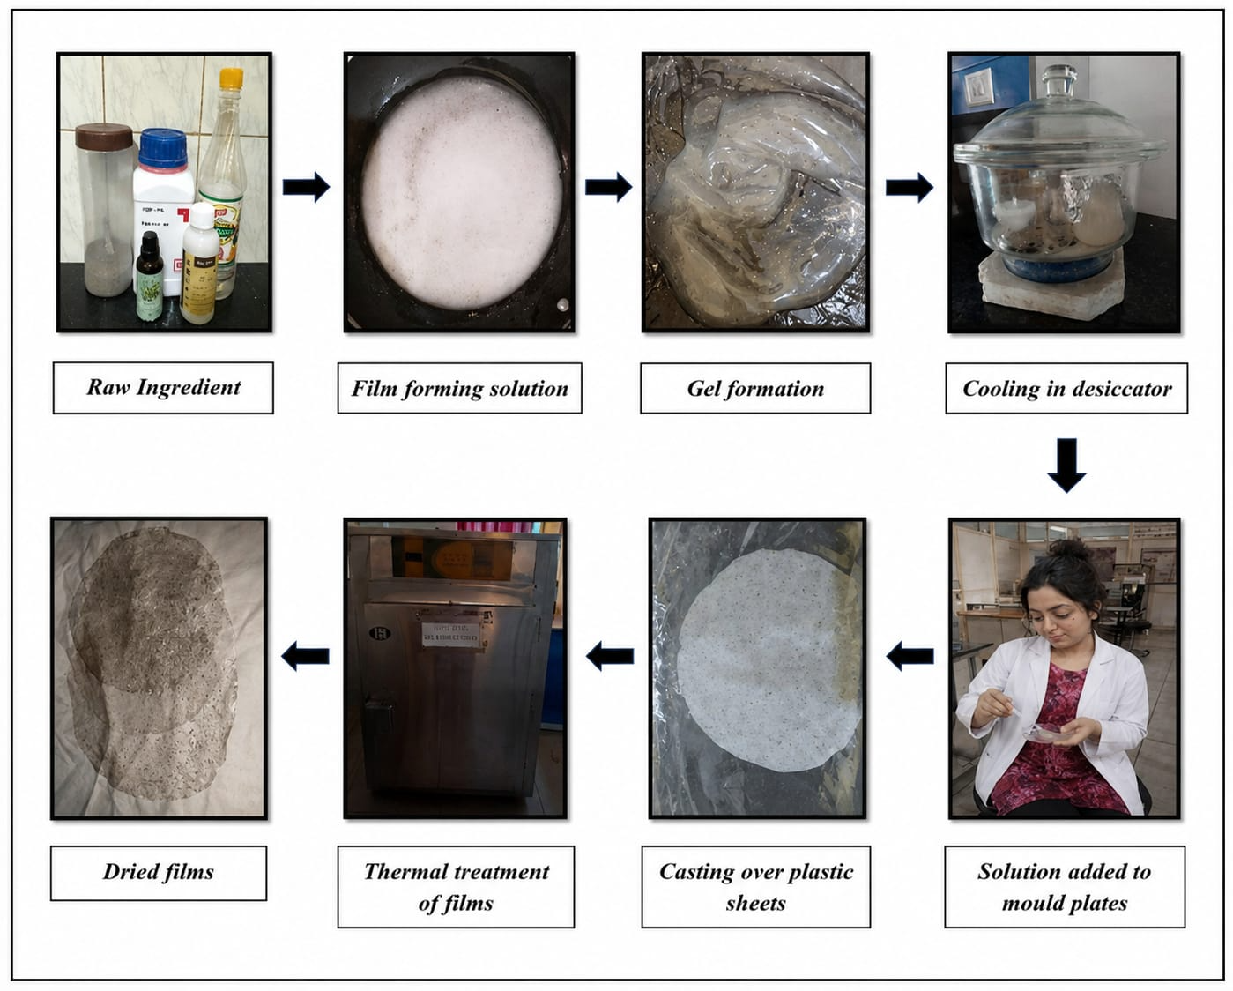
Figure 1. Schematic representation of the preparation process of the optimized corn starch-based bio-composite film.
Table 1. Composition of the OBF
Ingredient | Quantity
Corn starch | 5.0 g
Sunflower seed hull powder | 0.50 g
Glycerol | 2.5 mL
White vinegar | 3.0 mL
Thyme essential oil | 0.25 mL
Distilled water | 50 mL

2.3 Production Cost Estimation
The production cost of the optimised bio-composite film (OBF) was estimated under laboratory-scale conditions by accounting for all expenditures associated with film preparation. The analysis included raw-material costs, energy consumption, labour costs, and equipment depreciation. Market prices of the ingredients were obtained from commercial suppliers, whereas operational costs were estimated based on laboratory processing conditions. The total production cost was calculated using Equation (1). All cost estimates were prepared under laboratory-scale production conditions using the optimised film formulation. Market prices of raw materials were obtained from local commercial suppliers during the study period. Energy consumption was estimated from the rated power consumption and operating time of the laboratory equipment used during film preparation. Labour charges were estimated by considering the time required for weighing, mixing, heating, casting, drying, peeling, and conditioning the films. Equipment depreciation was calculated using the straight-line method, assuming normal laboratory use. The estimated costs represent laboratory-scale production and may vary under industrial manufacturing conditions because of economies of scale, automation, and regional market differences.
TPC = RMC + EC + LC + EqC (1)
where:
TPC = Total production cost (₹)
RMC = Raw material cost (₹)
EC = Energy cost (₹)
LC = Labour cost (₹)
EqC = Equipment cost (₹)
2.4 Raw Material Cost Analysis
The raw-material cost was estimated by calculating the cost of each ingredient according to the quantity used in the optimised formulation. The costs of corn starch, glycerol, white vinegar, thyme essential oil, and sunflower seed hull powder were determined from their respective market prices. The total raw-material cost was obtained by summing the individual cost contributions of the components.
2.5 Energy, Labour, and Equipment Cost Analysis
The energy cost was estimated based on the electricity consumed during the heating and drying operations involved in film preparation. Labour costs included manual activities such as weighing, mixing, casting, drying, peeling, and conditioning the films. Equipment costs were estimated using the depreciation method and considering the laboratory instruments used during film production, including the magnetic stirrer, hot-air oven, and other accessories. The electricity tariff used for energy-cost estimation was based on the prevailing commercial rate. Labour costs were estimated from the average time required for each processing step and the corresponding local wage. Equipment depreciation was apportioned to each production batch according to the expected service life of the equipment. These assumptions were used to obtain an approximate laboratory-scale production cost.
2.6 Total Production Cost and Cost per Unit Area
The total production cost was obtained by summing the raw-material, energy, labour, and equipment costs. The production cost was subsequently normalised according to the surface area of the prepared film and expressed as the cost per square metre (₹/m²) to facilitate comparison with commercially available packaging materials.
2.7 Comparative Cost Analysis with Conventional Packaging Materials
The production cost of the optimised bio-composite film (OBF) was compared with that of commercially available packaging materials. The comparison considered the production cost per unit area, source of raw materials, packaging functionality, and environmental sustainability.
2.8 Commercial Feasibility Assessment
The commercial feasibility of the optimised bio-composite film was qualitatively evaluated by considering raw-material availability, the use of sunflower seed hull powder as an agro-industrial by-product, production costs, manufacturing requirements, scalability, market potential, and environmental benefits. The feasibility assessment was conducted by comparing the developed biodegradable film with conventional petroleum-based packaging materials.
2.9 Preliminary Packaging Feasibility Assessment
The practical applicability of the optimised bio-composite film (OBF) was evaluated as a secondary packaging material using commercially available Mango Bite candies. The commercially packaged candies were wrapped with the developed bio-composite film and stored under ambient laboratory conditions for 15 days. Packaging performance was assessed through visual observations on days 0, 5, 10, and 15. Parameters, including wrapper integrity, flexibility, ease of handling, dimensional stability, surface appearance, moisture condensation on the outer surface, and overall packaging performance, were recorded. Commercial cling film was used as the reference secondary packaging material. The assessment was qualitative and intended solely to demonstrate the preliminary feasibility of the optimised film as a secondary packaging material.
2.10 Industrial Scalability Assessment
The industrial scalability of the optimised bio-composite film (OBF) was qualitatively assessed based on raw-material availability, manufacturing-process adaptability, production requirements, economic feasibility, and commercialisation potential. Particular emphasis was placed on the availability of corn starch and sunflower seed hull powder as renewable resources, the suitability of the film formulation for large-scale manufacturing using conventional casting or extrusion technologies, opportunities for process automation, and potential reductions in production costs through bulk procurement of raw materials. Potential industrial challenges, including drying time, moisture sensitivity, storage stability, and process standardisation, were also evaluated based on previously published literature. The assessment was intended to determine the feasibility of translating laboratory-scale production into commercial manufacturing.
2.11 Environmental Sustainability Assessment
The environmental sustainability of the optimised bio-composite film was qualitatively evaluated by considering the renewable origin of the raw materials, the use of agricultural waste, the potential reduction in petroleum-based plastic consumption, and the contribution to circular-bioeconomy principles. A qualitative sustainability assessment was performed by comparing the film with conventional petroleum-based plastic packaging using information obtained from previously published literature. No quantitative life-cycle assessment was conducted.
2.12 Functional Packaging Performance Assessment
The functional suitability of the optimised bio-composite film for commercial packaging was qualitatively assessed based on flexibility, ease of handling, wrapping performance, dimensional stability, structural integrity, and overall suitability as a secondary food-packaging material. These observations were made during the packaging of commercially available Mango Bite candies under ambient laboratory conditions. Additional functional attributes, such as antimicrobial and antioxidant potential, were considered in relation to the incorporation of thyme essential oil and the previously reported performance of the optimised formulation.
3. Results and Discussion
3.1 Selection of the Optimised Bio-composite Film Formulation
The present study focused on the techno-economic assessment and packaging application of a single optimised corn starch-based bio-composite film (OBF). Rather than evaluating multiple formulations, one representative formulation was selected to estimate the production cost and assess its potential commercial feasibility under laboratory-scale conditions. The optimised formulation served as a model system for determining raw-material expenditure, energy requirements, labour costs, equipment costs, and overall production costs. Furthermore, the selected formulation was used to demonstrate the practical applicability of the developed film as a sustainable secondary packaging material for confectionery products.
This approach provided an estimate of the economic viability of the developed bio-composite film and facilitated comparison with a conventional plastic packaging material under identical dimensional conditions.
3.2 Optimised Bio-composite Film Formulation
The optimised bio-composite film (OBF) exhibited a translucent appearance and a uniform, continuous structure. The film was sufficiently flexible to be folded and wrapped around the confectionery product without visible cracking or tearing during handling. The incorporation of sunflower seed hull powder imparted a characteristic light-brown, speckled appearance because of the dispersed plant particles, giving the film a natural bio-composite appearance. Furthermore, the film possessed sufficient integrity to maintain its shape during handling and packaging, indicating its suitability for laboratory-scale packaging applications. These characteristics enabled straightforward handling and demonstrated the preliminary practical feasibility of the developed film as a sustainable secondary packaging material for confectionery products.
3.3 Production Cost Estimation of the Optimised Bio-composite Film
The production cost of the optimised corn starch-based bio-composite film (OBF) was estimated under laboratory-scale conditions to evaluate its economic feasibility as a sustainable alternative to conventional food-packaging materials. The developed film measured 20.7 × 15.5 cm, corresponding to a total surface area of 320.85 cm², which served as the basis for subsequent cost normalisation and comparison with conventional packaging materials. The production-cost estimate included all major cost components associated with film fabrication, namely raw materials, energy consumption, labour, and equipment use. Evaluating the production costs of biodegradable packaging materials is essential for determining their economic feasibility and commercial viability, as manufacturing costs remain a major factor influencing industrial adoption and market competitiveness (Moshood et al., 2022; Tassinari et al., 2023). Furthermore, laboratory-scale cost estimation provides information on the contribution of individual production components and helps identify opportunities for cost reduction through process optimisation, automation, bulk procurement of raw materials, and large-scale manufacturing (Mohammed et al., 2023; Tassinari et al., 2023). Therefore, production-cost analysis represents a fundamental step in assessing the commercialisation potential of newly developed biodegradable packaging systems and facilitating their transition from laboratory research to industrial application (Mohammed et al., 2023; Moshood et al., 2022).
3.4 Raw Material Cost Analysis
The raw-material cost of the optimised bio-composite film (OBF) was estimated based on the market price and quantity of each ingredient used in the formulation. As presented in Table 2, the total raw-material cost required to produce one batch of the optimised film was ₹10.01. Corn starch accounted for the highest proportion of the raw-material cost because it served as the primary film-forming polymer and was incorporated in the largest quantity. Glycerol represented the second-highest cost component owing to its role as a plasticiser, whereas white vinegar and thyme essential oil contributed comparatively smaller amounts to the total material cost. Sunflower seed hull powder contributed minimally to the overall production cost because it was derived from an abundant agricultural by-product that is readily available and economically accessible. The findings indicate that the selection of raw materials plays a crucial role in determining the overall production cost and commercial feasibility of biodegradable packaging materials (George & George, 2023; Weligama Thuppahige & Karim, 2022). The incorporation of sunflower seed hull powder not only provides a value-added application for an underutilised agro-industrial residue but also represents an economical alternative to commercially available reinforcing materials, thereby supporting resource efficiency and waste valorisation (Birania et al., 2022; Kossalbayev et al., 2025). Furthermore, the use of agricultural waste-derived reinforcing materials enhances both the economic and environmental sustainability of biodegradable packaging systems by reducing dependence on virgin raw materials and promoting circular-bioeconomy principles (Cristofoli et al., 2023; Selvam et al., 2025).
Table 2. Estimated Raw Material Cost of OBF
Raw Material | Estimated Cost (₹)
Corn starch | 8.35
Glycerol | 4.00
Vinegar | 0.16
Thyme essential oil | 0.50
SSH powder | Nil
Effective raw material contribution | 10.01

3.5 Energy, Labour, and Equipment Cost Analysis
The energy, labour, and equipment costs associated with producing the optimised bio-composite film (OBF) were estimated to obtain a comprehensive assessment of manufacturing expenditure. As presented in Table 3, the estimated energy cost for producing one batch of the film was ₹0.80, primarily because of the electricity consumed during heating and drying operations. The labour cost was estimated at ₹1.20 and included weighing the ingredients, mixing, film casting, drying, peeling, and conditioning. Equipment use contributed approximately ₹0.99 to the total production cost, based on the depreciation costs of the laboratory instruments used during film preparation. Although these components represented a relatively small proportion of the overall production cost compared with raw-material costs, they remain important contributors to total manufacturing expenditure (Muñoz et al., 2026; Yang et al., 2025). Efficient energy use, optimisation of labour requirements, and appropriate equipment management may improve the economic feasibility of biodegradable packaging production, particularly during large-scale industrial manufacturing (Yang et al., 2025; Yudanto & Opaprakasit, 2023). Furthermore, technological advances, process automation, and continuous production systems may reduce operational costs and enhance the commercial competitiveness of biodegradable packaging materials (Muñoz et al., 2026; Yang et al., 2025).
Table3. Estimated Energy, Labour, and Equipment of OBF
Cost Parameter | Component/Activity | Estimated Cost (₹)
Energy Cost | Hot plate magnetic stirrer | 0.50
 | Drying oven | 0.30
 | Total Energy Cost | 0.80
Labour Cost | Raw material preparation | 0.30
 | Mixing and casting | 0.40
 | Drying and peeling | 0.30
 | Packaging and conditioning | 0.20
 | Total Labour Cost | 1.20
Equipment Cost | Magnetic stirrer | 0.40
 | Drying oven | 0.30
 | Measuring instruments | 0.29
 | Total Equipment Cost | 0.99

The relatively low contribution of energy, labour, and equipment costs compared with raw-material expenditure suggests that future cost-reduction strategies should primarily focus on optimising raw-material procurement and improving production efficiency. Industrial automation and continuous manufacturing technologies may further reduce operational expenditure, thereby enhancing the commercial viability of biodegradable packaging materials.
3.6 Total Production Cost and Cost per Unit Area
The total production cost of the optimised bio-composite film (OBF) was determined by combining the costs of raw materials, energy consumption, labour, and equipment use. As shown in Table 4, the total production cost of one batch of the optimised film (20.7 × 15.5 cm) was estimated at ₹13.00. Although the production cost of the optimised film was estimated under laboratory-scale conditions, cost reductions may be achieved under industrial-scale production through bulk procurement of raw materials, automation, improved process efficiency, and higher production volumes. Similar observations have been reported for other biodegradable packaging systems. Based on the measured film dimensions, the production cost was normalised to a unit surface area and calculated as ₹406.25 m⁻². Cost normalisation based on surface area provides a practical approach for evaluating biodegradable packaging materials because commercial packaging products are commonly marketed and compared on an area basis rather than per individual film (Hussain et al., 2024; Weligama Thuppahige & Karim, 2022). The results indicate that the developed bio-composite film has a higher production cost under laboratory-scale conditions; however, such costs may decrease with large-scale manufacturing, improved process efficiency, and bulk procurement of raw materials (Drago et al., 2024; Tassinari et al., 2023). Therefore, the cost per unit area is a useful economic indicator for comparing biodegradable films with conventional packaging materials and assessing their commercial feasibility (Nirvana et al., 2025; Tassinari et al., 2023).
Table 4. Total Production Cost of OBF
Cost Component | Estimated Cost (₹)
Raw material cost | 10.01
Energy cost | 0.80
Labour cost | 1.20
Equipment cost | 0.99
Total Production Cost | 13.00

3.7 Comparative Cost Analysis with Conventional Packaging Materials
The production cost of the optimised bio-composite film (OBF) was compared with that of commercially available conventional packaging materials to evaluate its economic competitiveness. As presented in Table 5, the developed bio-composite film had a higher production cost than conventional petroleum-based plastic packaging under laboratory-scale conditions. This difference can primarily be attributed to the use of food-grade biopolymers, natural bioactive additives, manual processing, and small-scale batch production (de Jong et al., 2025; Schick et al., 2024).
In contrast, conventional plastic packaging benefits from highly optimised industrial manufacturing processes, continuous production systems, and economies of scale, resulting in considerably lower production costs (Crank et al., 2005; Schick et al., 2024). Despite its relatively higher production cost, the developed bio-composite film offers several advantages over conventional packaging materials, including the utilisation of renewable resources, the incorporation of agricultural waste, and reduced environmental impact (Bie et al., 2025; Jha et al., 2024). Furthermore, the presence of thyme essential oil provides additional functional benefits through its active-packaging potential, which would require additional chemical modification in conventional plastic films. Therefore, although the present laboratory-scale production cost remains higher than that of conventional plastics, further optimisation of raw-material sourcing, process efficiency, and industrial-scale manufacturing could improve the economic competitiveness of the developed bio-composite film (Possidónio et al., 2025; Schick et al., 2024).
Table 5. Comparison of Developed OBF and Conventional Plastic Film
Parameter | Developed OBF | Conventional Plastic Film
Length | 20.7 cm | 20.7 cm
Width | 15.5 cm | 15.5 cm
Thickness | 0.029 cm | 0.029 cm
Surface area | 320.85 cm² | 320.85 cm²
Volume | 9.30 cm³ | 9.30 cm³
Density | Variable (biopolymer density) | Approximately 0.92 g/cm³
Estimated weight | 8.56 g | —
Production cost | ₹13.00 | ₹1.20 (industrial scale)
Production scale | Laboratory scale | Industrial scale
Environmental impact | Eco-friendly | Environmentally hazardous
Waste utilization | Sunflower seed hull powder (agricultural waste) utilized | No waste utilization
Antimicrobial activity | Present due to thyme essential oil | Generally absent
Renewable resource utilization | Yes | No
Plastic pollution potential | Negligible | High
Sustainability potential | High | Low

The comparison presented in this study should be interpreted in light of the differences in production scale and functional characteristics between biodegradable and petroleum-based packaging materials. Although conventional plastics benefit from mature industrial manufacturing and lower production costs, biodegradable films provide additional environmental advantages, including renewability, agricultural-waste utilisation, and potential active-packaging functionality. Therefore, the economic comparison should be viewed within the broader context of sustainability rather than production cost alone.
3.8 Commercial Feasibility Assessment
The commercial feasibility of the optimised bio-composite film (OBF) was evaluated by considering raw-material availability, production costs, manufacturing requirements, scalability, and potential industrial applications. Corn starch is an inexpensive and widely available renewable biopolymer, whereas sunflower seed hull powder represents an abundant agricultural by-product that can be used as a reinforcing material, thereby promoting waste valorisation and resource efficiency (Onyeaka et al., 2022; Varghese et al., 2023). The incorporation of sunflower seed hull powder not only reduces dependence on synthetic reinforcing agents but also contributes to the development of environmentally sustainable packaging materials (P. Gupta et al., 2022; Selvam et al., 2025). Although the laboratory-scale production cost of the developed film was higher than that of conventional plastic packaging, large-scale manufacturing may reduce production costs through bulk procurement of raw materials, process automation, and improved manufacturing efficiency (Possidónio et al., 2025; Schick et al., 2024). Furthermore, growing consumer demand for environmentally friendly packaging materials and increasingly stringent environmental regulations may support the commercialisation of biodegradable packaging technologies (Boz et al., 2020; Branca et al., 2024). Therefore, the optimised bio-composite film (OBF) indicates commercial potential as a sustainable alternative to conventional petroleum-based food-packaging materials. In addition to economic feasibility, successful commercialisation will depend on regulatory approval, consumer acceptance, product standardisation, quality assurance, and compatibility with existing food-packaging systems. Addressing these aspects may facilitate the transition of laboratory-developed biodegradable films towards industrial production.
3.9 Preliminary Packaging Feasibility
The optimised film demonstrated preliminary feasibility as a secondary packaging material for commercially packaged Mango Bite candies. Throughout the 15-day storage period, the film exhibited satisfactory flexibility and could be wrapped around the packaged candies without visible tearing or structural damage. The film maintained its structural integrity during storage, with no noticeable cracking, deformation, excessive moisture condensation, or loss of wrapping performance. The developed film also demonstrated satisfactory handling characteristics during packaging and storage. Compared with conventional cling film, the optimised bio-composite film appeared to provide comparable secondary packaging performance while offering the additional advantages of biodegradability and the use of renewable raw materials (V. Gupta et al., 2022; Mangaraj et al., 2019). These observations suggest that the developed OBF has potential as a sustainable secondary packaging material for confectionery products (Din et al., 2020; V. Gupta et al., 2022). Therefore, the optimised corn starch-based film may represent an alternative to conventional packaging materials available in the market.
Although the present packaging trial was qualitative, the observed flexibility, handling characteristics, and structural integrity support the preliminary practical applicability of the optimised film as a secondary packaging material. The packaging application is shown in Figure 2. Future investigations should include quantitative barrier-property evaluation, microbial-challenge studies, shelf-life assessment, and consumer sensory evaluation to further validate its suitability for industrial application.
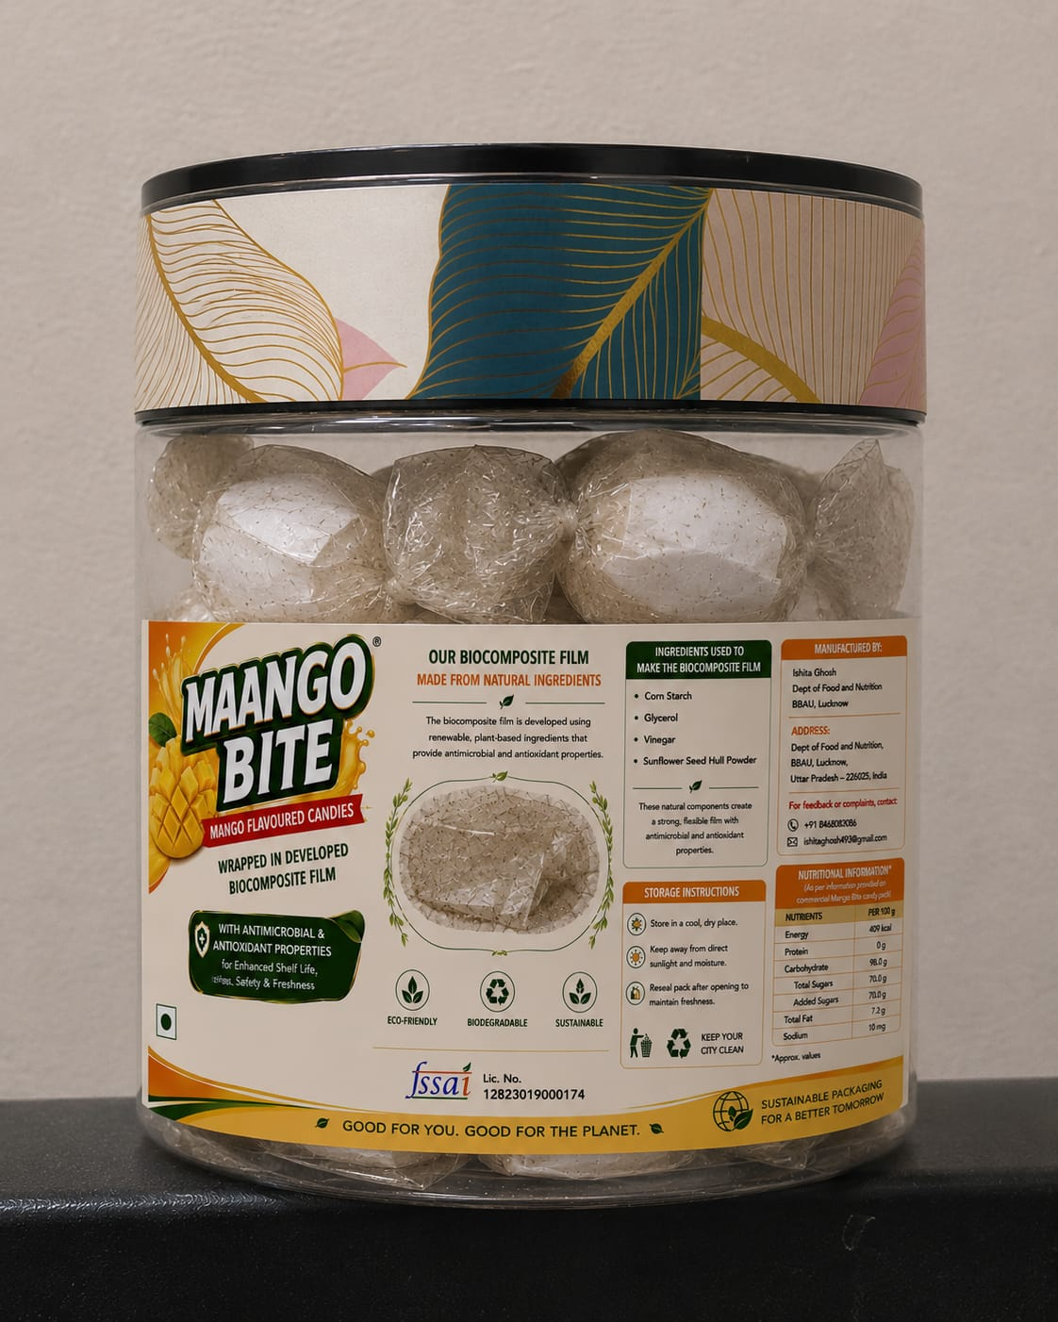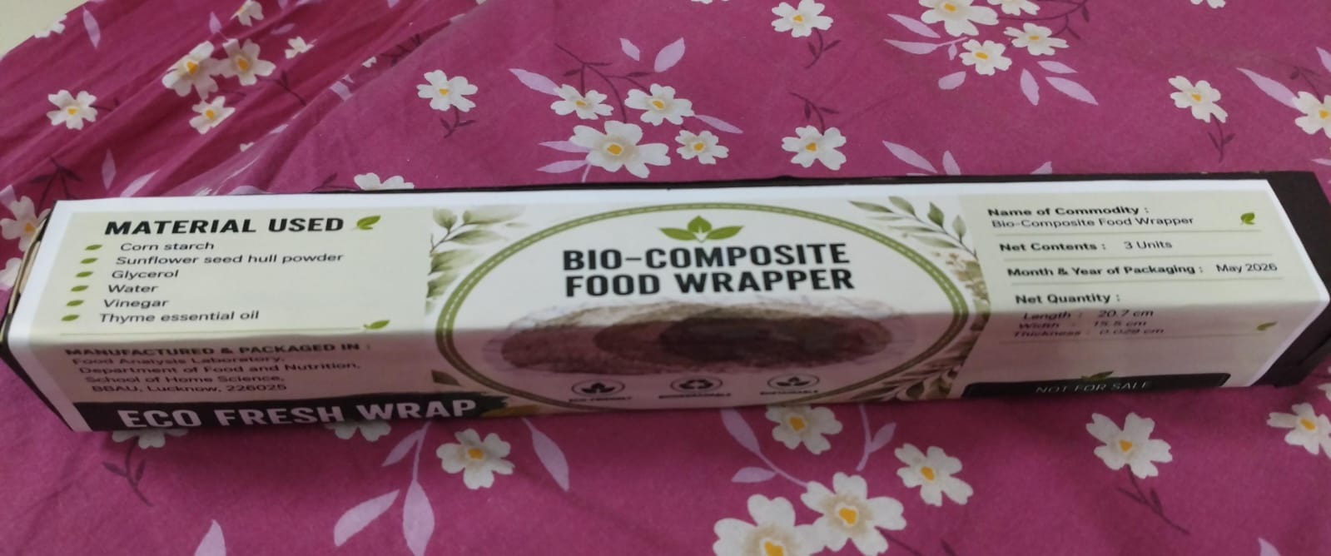
Figure 2. Packaging application of the optimized bio-composite film for commercially packaged Mango Bite candies and the developed food wrapper
Note: The product label shown is an original photograph prepared for this study. The product label was designed solely for academic research and documentation as part of the M.Sc. dissertation submitted to the Department of Food and Nutrition, Babasaheb Bhimrao Ambedkar University, Lucknow. The figure does not contain any third-party copyrighted material and is not intended for commercial branding, marketing, or promotional use.
3.10 Industrial Scalability Assessment
The optimised bio-composite film showed potential for industrial-scale production owing to the use of renewable and readily available raw materials. Corn starch is widely recognised as a suitable biodegradable polymer for commercial packaging applications because of its abundance, cost-effectiveness, and compatibility with conventional film-processing techniques, whereas sunflower seed hull powder represents an inexpensive agro-industrial by-product that supports waste valorisation and resource efficiency (Onyeaka et al., 2022; Varghese et al., 2023). Although the present investigation was conducted under laboratory-scale conditions, the production process could be adapted to continuous casting or extrusion systems for large-scale manufacturing, thereby reducing labour requirements and improving production efficiency (Schick et al., 2024; Yang et al., 2025). Furthermore, bulk procurement of raw materials and process optimisation may lower the overall production cost and improve commercial competitiveness (Possidónio et al., 2025). However, challenges related to filler dispersion, moisture management, process standardisation, and quality control should be addressed before industrial implementation. Overall, the developed bio-composite film shows potential for scalability and commercialisation as a sustainable alternative to conventional petroleum-based packaging materials (Boz et al., 2020; Branca et al., 2024).
3.11 Environmental Sustainability Assessment
The environmental sustainability assessment indicated that the optimised bio-composite film may offer several ecological advantages over conventional petroleum-based plastic packaging. Corn starch, the primary film-forming polymer, is a renewable and biodegradable material widely recognised for sustainable food-packaging applications, whereas sunflower seed hull powder represents an agricultural by-product whose use promotes resource efficiency and adds value to agro-food waste (Carnaval et al., 2024; Onyeaka et al., 2022). The incorporation of sunflower seed hull powder into the film matrix contributes to agricultural-waste valorisation and supports circular-bioeconomy principles by converting underutilised biomass into value-added packaging materials. Compared with conventional petroleum-derived plastics, the developed bio-composite film has the potential to reduce persistent plastic waste and contribute to more sustainable packaging systems (Carnaval et al., 2024; Paudel et al., 2025). Furthermore, the incorporation of thyme essential oil provides opportunities for developing active biodegradable packaging using naturally derived antimicrobial compounds instead of synthetic additives (Carpena et al., 2021; Casalini & Giacinti Baschetti, 2023).
Although a comprehensive life-cycle assessment (LCA) was beyond the scope of the present investigation, the use of renewable feedstocks, agricultural waste, and biodegradable materials suggests favourable environmental prospects. Future studies should incorporate standardised ISO-based LCA to quantify greenhouse-gas emissions, carbon footprint, energy consumption, and other environmental impacts associated with industrial-scale production (Bilal et al., 2025; Kakadellis & Harris, 2020).
3.12 Preliminary Functional Packaging Assessment
The optimised bio-composite film showed preliminary suitability for secondary food-packaging applications. The film exhibited adequate flexibility, allowing it to be wrapped easily around the packaged confectionery product without tearing or visible structural damage. During the storage period, the wrapper maintained its dimensional stability and structural integrity, indicating satisfactory handling performance. The incorporation of thyme essential oil may enhance the commercial relevance of the developed film because its well-documented antimicrobial and antioxidant properties support potential application in active food-packaging systems (Carpena et al., 2021; Casalini & Giacinti Baschetti, 2023). Furthermore, the incorporation of sunflower seed hull powder contributed to reinforcing the starch matrix while promoting the use of agricultural waste as a sustainable bio-based resource (Maraveas, 2020).
Although quantitative microbiological evaluation, sensory analysis, and shelf-life studies were beyond the scope of the present techno-economic investigation, the satisfactory packaging performance observed during storage supports the preliminary applicability of the optimised film as a sustainable secondary packaging material. Future investigations should include quantitative shelf-life validation, microbial-challenge studies, and consumer sensory evaluation before commercial implementation.
4. Conclusion
The present study provides a preliminary techno-economic evaluation and packaging-feasibility assessment of an optimised corn starch-based bio-composite film reinforced with sunflower seed hull powder and thyme essential oil. Laboratory-scale cost analysis indicated a production cost of ₹13.00 per batch, with raw materials constituting the major component of the overall manufacturing cost. Although the estimated production cost was higher than that of conventional petroleum-based plastic packaging, the use of renewable corn starch, sunflower seed hull powder derived from an agricultural by-product, and naturally derived thyme essential oil indicates the environmental and economic potential of the developed bio-composite film. The preliminary packaging-feasibility assessment demonstrated that the optimised film exhibited satisfactory flexibility, structural integrity, handling characteristics, and wrapping performance when used as a secondary packaging material for commercially packaged confectionery products under ambient laboratory conditions. Furthermore, the techno-economic analysis, together with the industrial-scalability and environmental-sustainability assessments, suggests that process optimisation, bulk procurement of raw materials, and large-scale manufacturing could improve the commercial viability of the developed film.
Overall, the findings indicate that the optimised bio-composite film represents a potential sustainable alternative to conventional plastic-based packaging materials. However, the results should be interpreted within the scope of this preliminary laboratory-scale investigation. Further studies involving pilot-scale production, comprehensive barrier-property evaluation, antimicrobial and biodegradability validation, life-cycle assessment, migration studies, shelf-life evaluation, and industrial-scale techno-economic analysis are required before commercial implementation.
Study Limitations
The present study was conducted under laboratory-scale conditions and was primarily intended as a preliminary techno-economic and packaging feasibility assessment of the optimized corn starch-based bio-composite film. Consequently, the production cost estimates and commercial feasibility analysis may differ under pilot- or industrial-scale manufacturing. The packaging evaluation was qualitative and focused on demonstrating the practical feasibility of the film as a secondary packaging material under ambient laboratory conditions. Comprehensive experimental validation, including antimicrobial activity, biodegradability assessment, quantitative life-cycle assessment (LCA), barrier property evaluation, migration studies, and long-term shelf-life validation, was beyond the scope of the present investigation. In addition, formal consumer sensory evaluation was not performed, as the developed film was intended solely as a secondary packaging material and not as an edible product or direct-contact sensory attribute. Future research should include these investigations together with pilot-scale production and industrial-scale techno-economic validation to further establish the commercial applicability of the developed bio-composite film.

Conflict of Interest
The authors declared no potential conflict of interest with respect to the authorship and publication.
Ethics approval
Not applicable. No ethical approvals were required for this study as it did not involve human or animal subjects.
Consent to participate
Not applicable. This research did not involve human participants.
Consent for publication
All authors provide their consent for publication of this manuscript.
Permission to Reproduce Material from Other Sources
No material reproduced from third-party sources requiring copyright permission has been included in this manuscript. All figures and tables are original unless otherwise indicated.
Availability of data and material
The datasets generated and analysed during the current study are available from the corresponding author on reasonable request.
Code availability
Not applicable. No software applications or custom codes were used in this research.
Declaration of AI Use

This manuscript was prepared through the combined contributions of all author(s), including contributions to the study design, data, content development, results, interpretation, and related scholarly work. The author(s) acknowledge the use of Grammarly and ChatGPT to assist with grammar checking, language refinement, and reference formatting. These AI-assisted tools were not used as authors and did not replace the intellectual contributions or scholarly judgment of the author(s). All AI-assisted outputs, including content, references, and interpretations, were carefully reviewed, revised, verified, and approved by the author(s). The author(s) accept full responsibility for the accuracy, integrity, and final content of the manuscript.

COMPETING INTERESTS DISCLAIMER:
Authors have declared that they have no known competing financial interests OR non-financial interests OR personal relationships that could have appeared to influence the work reported in this paper.

References
Adsare, A. D., Shukla, R. N., Immanuel, G., Singh, A. K., & Mishra, A. A. (2025). Techno-economic evaluation of polybutylene adipate terephthalate (PBAT)–starch–nanoclay biodegradable films for sustainable packaging applications. Journal of Scientific Research and Reports, 31(9), 729–736. https://doi.org/10.9734/jsrr/2025/v31i93538
Afam-Ezeaku, C. E., Eze, H. N., Anyanele, W. C., & Ajah, N. (2024). Antimicrobial activity and antioxidant activity of clove (Syzygium aromatium) and thyme (Thymus vulgaris) traditionally used as food packaging against foodborne pathogens. Asian Journal of Research in Biology, 7(1), 71–88. https://doi.org/10.56557/ajrib/2024/v7i140
Bie, M., Zhao, W., Dong, H., Gu, Y., Yuan, S., & Song, K. (2025). From agricultural waste to recyclable biodegradable packaging: A systematic and bibliometric review. Sustainability, 17(23), Article 10742. https://doi.org/10.3390/su172310742
Bilal, M., Arslan, M., Khan, S., Shi, J., Li, Z., Guo, Y., Sun, X., & Zou, X. (2025). Sustainable food packaging: Life cycle assessment, recycling innovations, and Pestalotiopsis microspora in biodegradable solutions. Trends in Food Science & Technology, 166, Article 105400. https://doi.org/10.1016/j.tifs.2025.105400
Birania, S., Kumar, S., Kumar, N., Attkan, A. K., Panghal, A., Rohilla, P., & Kumar, R. (2022). Advances in development of biodegradable food packaging material from agricultural and agro-industry waste. Journal of Food Process Engineering, 45(1), Article e13930. https://doi.org/10.1111/jfpe.13930
Bócoli, P. F. J., Gomes, V. E. D. S., Maia, A. A. D., & Marangoni Júnior, L. (2025). Perspectives on eco-friendly food packaging: Challenges, solutions, and trends. Foods, 14(17), Article 3062. https://doi.org/10.3390/foods14173062
Boz, Z., Korhonen, V., & Koelsch Sand, C. (2020). Consumer considerations for the implementation of sustainable packaging: A review. Sustainability, 12(6), Article 2192. https://doi.org/10.3390/su12062192
Branca, G., Resciniti, R., & Babin, B. J. (2024). Sustainable packaging design and the consumer perspective: A systematic literature review. Italian Journal of Marketing, 2024(1), 77–111. https://doi.org/10.1007/s43039-023-00084-1
Carnaval, L. D. S., Jaiswal, A. K., & Jaiswal, S. (2024). Agro-food waste valorization for sustainable bio-based packaging. Journal of Composites Science, 8(2), Article 41. https://doi.org/10.3390/jcs8020041
Carpena, M., Nuñez-Estevez, B., Soria-Lopez, A., Garcia-Oliveira, P., & Prieto, M. A. (2021). Essential oils and their application on active packaging systems: A review. Resources, 10(1), Article 7. https://doi.org/10.3390/resources10010007
Casalini, S., & Giacinti Baschetti, M. (2023). The use of essential oils in chitosan or cellulose-based materials for the production of active food packaging solutions: A review. Journal of the Science of Food and Agriculture, 103(3), 1021–1041. https://doi.org/10.1002/jsfa.11918
Chen, G., Wang, K., Chen, P., Cai, D., Shao, Y., Xia, R., Li, C., Wang, H., Ren, F., Cheng, X., & Yu, Y. (2024). Fully biodegradable packaging films for fresh food storage based on oil-infused bacterial cellulose. Advanced Science, 11(23), Article 2400826. https://doi.org/10.1002/advs.202400826
Crank, M., Patel, M. K., Marscheider-Weidemann, F., Schleich, J., Hüsing, B., & Angerer, G. (2005). Techno-economic feasibility of large-scale production of bio-based polymers in Europe (PRO-BIP). Department of Science, Technology and Society, Copernicus Institute. https://research-portal.uu.nl/en/publications/techno-economic-feasibility-of-large-scale-production-of-bio-base
Cristofoli, N. L., Lima, A. R., Tchonkouang, R. D., Quintino, A. C., & Vieira, M. C. (2023). Advances in the food packaging production from agri-food waste and by-products: Market trends for a sustainable development. Sustainability, 15(7), Article 6153. https://doi.org/10.3390/su15076153
de Jong, E., Goumans, I., Visser, R., Puente, Á., & Gruter, G. J. (2025). The opportunities and challenges of biobased packaging solutions. Polymers, 17(16), Article 2217. https://doi.org/10.3390/polym17162217
Dhalsamant, K., Dalai, A., Pattnaik, F., & Acharya, B. (2025). Biodegradable carbohydrate-based films for packaging agricultural products—A review. Polymers, 17(10), Article 1325. https://doi.org/10.3390/polym17101325
Din, M. I., Ghaffar, T., Najeeb, J., Hussain, Z., Khalid, R., & Zahid, H. (2020). Potential perspectives of biodegradable plastics for food packaging application-review of properties and recent developments. Food Additives & Contaminants: Part A, 37(4), 665–680. https://doi.org/10.1080/19440049.2020.1718219
Dirpan, A., Ainani, A. F., & Djalal, M. (2023). A review on biopolymer-based biodegradable film for food packaging: Trends over the last decade and future research. Polymers, 15(13), Article 2781. https://doi.org/10.3390/polym15132781
Drago, E., Campardelli, R., & Perego, P. (2024). Sustainable development of biodegradable antimicrobial electrospun membranes for active food packaging and economic analysis. Advanced Sustainable Systems, 8(12), Article 2400360. https://doi.org/10.1002/adsu.202400360
George, A. S., & George, A. S. H. (2023). Biodegradable ecofriendly sustainable tableware and packaging: A comprehensive review of materials, manufacturing, and applications. Partners Universal International Research Journal, 2(2), 202–228. https://doi.org/10.5281/zenodo.8051038
Gupta, P., Toksha, B., & Rahaman, M. (2022). A review on biodegradable packaging films from vegetative and food waste. The Chemical Record, 22(7), Article e202100326. https://doi.org/10.1002/tcr.202100326
Gupta, V., Biswas, D., & Roy, S. (2022). A comprehensive review of biodegradable polymer-based films and coatings and their food packaging applications. Materials, 15(17), Article 5899. https://doi.org/10.3390/ma15175899
Hussain, M. A., Mishra, S., Agrawal, Y., Rathore, D., & Chokshi, N. P. (2024). A comparative review of biodegradable and conventional plastic packaging. Interactions, 245, Article 126. https://doi.org/10.1007/s10751-024-01968-0
Jha, S., Akula, B., Enyioma, H., Novak, M., Amin, V., & Liang, H. (2024). Biodegradable biobased polymers: A review of the state of the art, challenges, and future directions. Polymers, 16(16), Article 2262. https://doi.org/10.3390/polym16162262
Kakadellis, S., & Harris, Z. M. (2020). Don’t scrap the waste: The need for broader system boundaries in bioplastic food packaging life-cycle assessment—A critical review. Journal of Cleaner Production, 274, Article 122831. https://doi.org/10.1016/j.jclepro.2020.122831
Kossalbayev, B. D., Belkozhayev, A. M., Abaildayev, A., Kadirshe, D. K., Tastambek, K. T., Kurmanbek, A., & Toleutay, G. (2025). Biodegradable packaging from agricultural wastes: A comprehensive review of processing techniques, material properties, and future prospects. Polymers, 17(16), Article 2224. https://doi.org/10.3390/polym17162224
Mangaraj, S., Yadav, A., Bal, L. M., Dash, S. K., & Mahanti, N. K. (2019). Application of biodegradable polymers in food packaging industry: A comprehensive review. Journal of Packaging Technology and Research, 3(1), 77–96. https://doi.org/10.1007/s41783-018-0049-y
Maraveas, C. (2020). Production of sustainable and biodegradable polymers from agricultural waste. Polymers, 12(5), Article 1127. https://doi.org/10.3390/polym12051127
Mohammed, A., Ward, K., Lee, K. Y., & Dupont, V. (2023). The environmental impact and economic feasibility assessment of composite calcium alginate bioplastics derived from Sargassum. Green Chemistry, 25(14), 5501–5516. https://doi.org/10.1039/D3GC01019H
Moshood, T. D., Nawanir, G., & Mahmud, F. (2022). Sustainability of biodegradable plastics: A review on social, economic, and environmental factors. Critical Reviews in Biotechnology, 42(6), 892–912. https://doi.org/10.1080/07388551.2021.1973954
Muñoz, F. L., Gaiardo, R. B., Bahú, J. O., Ribeiro, V. S., Carvalho, R. M., Sato, A. Y., Almeida, M. G., Cozzolino, G. F., Carvalho, L. F., Yoshida, C. M., & Souto, E. B. (2026). Biodegradable food packaging: Carbon footprint reduction, technical and market challenges. Sustainable Futures, 11, Article 101748. https://doi.org/10.1016/j.sftr.2026.101748
Nandi, S., & Guha, P. (2024). Development, characterization and application of starch-based film containing polyphenols of Piper betle L. waste in chicken meat storage. Food Chemistry, 431, Article 137103. https://doi.org/10.1016/j.foodchem.2023.137103
Nirvana, J. R. K., Amrullah, S., & Abiyyuddin, M. F. (2025). Preliminary techno-economic feasibility of biodegradable food packaging from Luffa acutangula peel in Indonesia. Buletin Penelitian Sosial Ekonomi Pertanian Fakultas Pertanian Universitas Haluoleo, 27(2), 199–212. https://doi.org/10.37149/bpsosek.v27i2.2285
Onyeaka, H., Obileke, K., Makaka, G., & Nwokolo, N. (2022). Current research and applications of starch-based biodegradable films for food packaging. Polymers, 14(6), Article 1126. https://doi.org/10.3390/polym14061126
Paudel, S., Regmi, S., Bhattarai, S., Fennell, A., & Janaswamy, S. (2025). Valorization of grapevine agricultural waste into transparent and high-strength biodegradable films for sustainable packaging. Sustainable Food Technology, 3(4), 1218–1231. https://doi.org/10.1039/D5FB00211G
Possidónio, C., Farias, A. R., Domingos, S., Cruz, B., Luís, S., & Loureiro, A. (2025). Exploring supply-side barriers for commercialization of new biopolymer production technologies: A systematic review. Sustainability, 17(3), Article 820. https://doi.org/10.3390/su17030820
Sabet, M. (2025). Exploring biodegradable polymer composites for sustainable packaging: A review on properties, manufacturing techniques, and environmental impacts. Iranian Polymer Journal, 34(1), 123–142. https://doi.org/10.1007/s13726-024-01365-y
Sathiamurthy, J., Geetha, R. V., & Gopal, R. K. (2024). Production and evaluation of a seaweed-based bioplastic sheet for food packaging. Uttar Pradesh Journal of Zoology, 45(14), 108–115. https://doi.org/10.56557/upjoz/2024/v45i144184
Schick, S., Heindel, J., Groten, R., & Seide, G. H. (2024). Overcoming challenges in the commercialization of biopolymers: From research to applications—A review. Polymers, 16(24), Article 3498. https://doi.org/10.3390/polym16243498
Selvam, T., Rahman, N. M. M. A., Olivito, F., Ilham, Z., Ahmad, R., & Wan-Mohtar, W. A. A. Q. I. (2025). Agricultural waste-derived biopolymers for sustainable food packaging: Challenges and future prospects. Polymers, 17(14), Article 1897. https://doi.org/10.3390/polym17141897
Singh, J., Biju, B., Kajala, S., Debbarma, B., & Thakur, V. (2026). Development and characterization of rice starch–lemon essential oil nano-emulsion-based biodegradable films for active food packaging. Journal of Advances in Biology & Biotechnology, 29(3), 467–475. https://doi.org/10.9734/jabb/2026/v29i33751
Tassinari, G., Bassani, A., Spigno, G., Soregaroli, C., & Drabik, D. (2023). Do biodegradable food packaging films from agro-food waste pay off? A cost-benefit analysis in the context of Europe. Science of the Total Environment, 856, Article 159101. https://doi.org/10.1016/j.scitotenv.2022.159101
Varghese, S. A., Pulikkalparambil, H., Promhuad, K., Srisa, A., Laorenza, Y., Jarupan, L., Nampitch, T., Chonhenchob, V., & Harnkarnsujarit, N. (2023). Renovation of agro-waste for sustainable food packaging: A review. Polymers, 15(3), Article 648. https://doi.org/10.3390/polym15030648
Wang, Y., Ju, J., Diao, Y., Zhao, F., & Yang, Q. (2025). The application of starch-based edible film in food preservation: A comprehensive review. Critical Reviews in Food Science and Nutrition, 65(14), 2731–2764. https://doi.org/10.1080/10408398.2024.2349735
Weligama Thuppahige, V. T., & Karim, M. A. (2022). A comprehensive review on the properties and functionalities of biodegradable and semibiodegradable food packaging materials. Comprehensive Reviews in Food Science and Food Safety, 21(1), 689–718. https://doi.org/10.1111/1541-4337.12873
Westlake, J. R., Tran, M. W., Jiang, Y., Zhang, X., Burrows, A. D., & Xie, M. (2023). Biodegradable biopolymers for active packaging: Demand, development and directions. Sustainable Food Technology, 1(1), 50–72. https://doi.org/10.1039/D2FB00004K
Yang, Y., Seo, K., Kim, J., & Won, W. (2025). Biodegradable plastic production: Economic and environmental perspective. ACS Sustainable Chemistry & Engineering, 13(2), 923–935. https://doi.org/10.1021/acssuschemeng.4c07893
Yudanto, Y. A., & Opaprakasit, P. (2023). A preliminary review of poly(lactic acid)-based biodegradable foam and its techno-economic model. E3S Web of Conferences, 448, Article 03076. https://doi.org/10.1051/e3sconf/202344803076

