Original Research Article

Characterization of Botanical Starches and Plant Extracts as Raw Materials for Antioxidant-Based Edible Film Production

ABSTRACT
This study comprehensively characterised starches from locally abundant botanical sources—plantain (Musa paradisiaca) and yam (Dioscorea rotundata), using commercial corn starch (Zea mays) as a control—to evaluate their suitability as biopolymer matrices for edible films. Concurrently, the antioxidant potential of extracts from avocado (Persea americana), ginger (Zingiber officinale), and garlic (Allium sativum) was assessed to identify effective natural additives for developing active packaging systems. Starches were isolated using a standardised aqueous sedimentation method, whereas bioactive extracts were obtained through solvent-assisted maceration and hexane extraction. The materials were subjected to physicochemical characterisation (pH, moisture content, swelling power, and solubility), structural analysis using Fourier transform infrared spectroscopy (FTIR), morphological examination using scanning electron microscopy (SEM), and antioxidant assays (DPPH, ABTS, and FRAP). The results revealed statistically significant (p < 0.05) differences in the functional properties of the starches. Notably, plantain starch exhibited the lowest swelling power (1.05 mL/g) and moderately favourable solubility (10.87%), indicating a high degree of granular rigidity and potential for forming a water-resistant, cohesive film. This functional balance was supported by structural analysis; SEM micrographs showed that plantain starch granules were oval, smooth, and structurally intact, in contrast to the irregular, porous granules of yam and the smaller, polygonal granules of corn. FTIR analysis further indicated a well-ordered molecular structure in plantain starch, supporting its potential to form a cohesive and stable film matrix. Antioxidant assays indicated that all three plant extracts possessed antioxidant activity, with ginger extract showing the strongest responses in the DPPH and FRAP assays. Overall, plantain starch appeared to be a promising biopolymer candidate for edible-film production because of its balanced physicochemical properties and granular morphology. Incorporating an antioxidant extract, such as ginger extract, into a plantain-starch matrix may provide a basis for developing active, biodegradable packaging materials. This preliminary phase of raw-material characterisation provides a foundation for the valorisation of local agricultural resources and the future development of alternatives to synthetic plastics.
Keywords: Starch characterization, plant extracts, antioxidant activity, plantain starch, edible film, biodegradable packaging.

Introduction
The 21st century is marked by substantial technological progress, but it also faces a widespread environmental problem: plastic waste. Petroleum-based synthetic plastics, such as polyethylene and polypropylene, have been major components of the global food-packaging industry for decades. These materials have gained popularity because of their affordability, adaptability, and durability, which enable them to protect food products effectively (Sanyang et al., 2016). However, the same durability that makes them commercially attractive also contributes to a substantial and persistent environmental crisis. Synthetic polymers can remain in the environment for hundreds to thousands of years because they are inherently resistant to degradation.
Owing to its persistence, plastic debris has accumulated extensively in terrestrial and aquatic ecosystems, creating large oceanic garbage patches and contaminating landscapes on a broad scale (Geyer et al., 2017). These materials break down into smaller particles known as microplastics, which enter soil, water systems, and the global food chain, thereby worsening the problem and posing risks to human health and biodiversity (Sharma et al., 2021). Plastic pollution is particularly serious in developing countries such as Nigeria. Plastic waste, especially from single-use packaging, is overwhelming municipal systems because of rapid urbanisation and inadequate waste-disposal infrastructure (Salami et al., 2019).
Plastic packaging is a major contributor to environmental deterioration and accounts for a substantial proportion of the country's plastic consumption. Discarded plastic bags, bottles, and food wrappers clog urban drainage systems, exacerbate seasonal flooding, and create breeding grounds for disease vectors. This plastic waste eventually enters marine habitats in coastal and riverine communities, endangering aquatic life and the livelihoods of people who depend on these ecosystems (Yalwaji et al., 2022). The urgent need to address these interconnected environmental, social, and public-health consequences has prompted a global shift in scientific and industrial attention towards sustainable, environmentally friendly alternatives derived from renewable resources.
Biodegradable and edible films made from natural biopolymers have emerged as promising responses to this global need (Falguera et al., 2011). These materials, derived from biological sources such as lipids, proteins, and polysaccharides, are designed to degrade naturally and reintegrate into the environment without leaving hazardous residues. Among these biopolymers, starch has attracted considerable interest as a suitable material for environmentally friendly packaging (Bangar et al., 2021). As one of the most abundant organic substances on Earth, starch is an inexpensive and readily available raw material. Its renewable nature and inherent biodegradability align well with the principles of the circular economy and make it appropriate for packaging applications (Zhao et al., 2021). Furthermore, the molecular structure of starch provides film-forming capability, enabling it to be processed into thin, transparent, and flexible layers suitable for packaging applications (Zhao et al., 2021). Recent reviews indicate that edible films and coatings based on renewable biopolymers can reduce dependence on conventional packaging; however, moisture sensitivity, mechanical weakness, and the need for safety evaluation remain important limitations in their development and application (Basiak et al., 2018; Kumar et al., 2022; Matloob et al., 2023). Nigeria's staple crops, which are essential to national food security, provide a substantial and largely underexplored source of starch. Crops such as corn, yam, and plantain are widely cultivated throughout the country (Falade & Oyeyinka, 2015). However, a considerable proportion of this agricultural produce is lost after harvest. The valorisation of these crops for non-food applications offers an opportunity to develop new value chains, reduce waste, and support rural economies (Falade & Ayetigbo, 2015). The ratio of linear amylose to highly branched amylopectin determines the mechanical properties, water resistance, and overall stability of starch-based films, making botanical origin important to functional performance (Pelissari et al., 2012; Wang et al., 2015).
Although natural starch films can serve as physical barriers, their performance can be enhanced through the development of active-packaging systems. Active packaging extends beyond passive containment by contributing to the maintenance of food quality and the extension of the shelf life of packaged products (Otoni et al., 2017). This functionality can be achieved by incorporating bioactive substances, particularly antioxidants, into the film matrix (Ofoedum et al., 2023). Oxidative deterioration is a major cause of food spoilage and can lead to off-flavours, nutrient degradation, and reduced product quality. Antioxidants inhibit this process by neutralising free radicals and interrupting oxidative chain reactions (Jongjareonrak et al., 2008).
Growing consumer demand for clean-label and minimally processed foods has increased interest in natural antioxidants derived from plant extracts rather than synthetic alternatives. Locally available sources such as avocado (Persea americana), ginger (Zingiber officinale), and garlic (Allium sativum) contain antioxidant compounds. Garlic is known for its organosulphur compounds, including allicin; avocado oil contains carotenoids and tocopherols; and ginger contains phenolic compounds such as gingerols (Shang et al., 2019; Mao et al., 2019; Dugasani et al., 2010). Incorporating these extracts into starch-based films may transform a biodegradable wrapper into a delivery system that contributes to food preservation. Because processing conditions influence the recovery and measured antioxidant activity of plant-derived preparations, preliminary characterisation under defined analytical conditions is necessary before incorporation into active-film matrices (Mokhtar et al., 2025). Recent physicochemical and structural characterisation of avocado seed biomass has also demonstrated properties relevant to biodegradable polymer composites, supporting the assessment of avocado-derived resources for sustainable-material development (Okey-Onochie et al., 2026). Accordingly, this study undertook a preliminary investigation of the antioxidant capacity of avocado, ginger, and garlic extracts and systematically characterised starches from plantain, yam, and corn. Its broader purpose was to generate basic scientific information for assessing the feasibility of these locally available raw materials in the future production of antioxidant-based edible films. Replacing synthetic plastics with biodegradable starch-based films represents a potential step towards environmental sustainability. However, substantial functional and technical challenges remain. Despite their environmental advantages, native starch films often have inherent limitations that restrict their wider industrial application (Cui et al., 2021).
When used to package high-moisture foods, the hydrophilic nature of starch films makes them highly susceptible to moisture, resulting in loss of mechanical integrity and barrier function. They may also exhibit poor mechanical properties, including low tensile strength and brittleness, which reduce durability during handling, transport, and storage (Jiménez et al., 2012). These limitations require modification to bring their performance into line with that of synthetic counterparts. Beyond these structural constraints, both basic biopolymer films and conventional plastic packaging are functionally passive. They primarily serve as physical barriers and do not directly address the chemical and biological processes that contribute to food deterioration, such as oxidation and microbial growth (Ofoedum et al., 2025a; Ofoedum et al., 2025b).
Most packaging materials lack this active preservation capacity, although preventing oxidative deterioration is important for maintaining the nutritional value, sensory quality, and shelf life of food products. Incorporating natural antioxidant extracts into the film matrix provides a practical means of adding this functionality. Despite their potential, the systematic and comparative characterisation of starches from important Nigerian agricultural staples—plantain, yam, and corn—for this specific application remains limited. Selecting an appropriate biopolymer matrix for a particular application is difficult because the distinct physicochemical and structural properties of starches from these sources have not been well documented within a comparative framework (Alagbaoso et al., 2026; Uzoukwu et al., 2025).
Furthermore, limited information is available on the compatibility and potential interactions between these starches and locally relevant antioxidant extracts, including those from avocado, ginger, and garlic. Understanding how the inherent properties of the starch matrix influence the stability and effectiveness of incorporated antioxidants is essential. By providing a systematic assessment of these raw materials, this study addresses this evidence gap. Such an assessment is a necessary preliminary step towards formulating functional, bioactive edible films that utilise local resources. The study therefore aimed to assess the antioxidant capacity of avocado, ginger, and garlic extracts for potential use in antioxidant-based edible films and to characterise the physicochemical and structural properties of starches derived from plantain, yam, and corn.
This investigation focused on the characterisation and assessment of raw materials intended for the development of antioxidant-based edible films. Specifically, the study examined extracts from avocado (Persea americana), ginger (Zingiber officinale), and garlic (Allium sativum), together with starches obtained from plantain (Musa paradisiaca), yam (Dioscorea rotundata), and corn (Zea mays).
Research Gap
Although starch-based films and plant-derived antioxidants have been widely investigated, direct comparative evidence remains limited for plantain, yam, and corn starches evaluated alongside avocado, ginger, and garlic extracts within a common analytical framework. This evidence gap limits the rational selection of locally available starch matrices and antioxidant sources for subsequent edible-film formulation.

Objectives
The objective of this study was to characterise the physicochemical, structural, and morphological properties of plantain, yam, and corn starches and to evaluate the antioxidant activities of avocado, ginger, and garlic extracts as preliminary raw materials for the future development of antioxidant-based edible films.

Materials and Methods

Materials
Fresh unripe plantain fingers (Musa paradisiaca), white yam tubers (Dioscorea rotundata), and dry corn grains (Zea mays) were procured from Eziobodo Market, a major local market in Owerri, Imo State, Nigeria. After procurement, all samples were carefully sorted and selected according to uniform physiological maturity, freshness, and the absence of physical damage or microbial decay. Fresh garlic bulbs (Allium sativum), ginger rhizomes (Zingiber officinale), and ripe avocado fruits (Persea americana) were purchased from Onitsha Main Market, Anambra State, Nigeria. These materials were similarly selected for quality and freshness and served as sources of the natural bioactive extracts.
All chemicals and reagents used in this study were of analytical grade to ensure the accuracy of the experimental results. Food-grade ethanol (95%) and n-hexane (99%) were obtained from the central repository of the Food Science and Technology Laboratory, Federal University of Technology, Owerri (FUTO). Reagents for the antioxidant assays, including 2,2-diphenyl-1-picrylhydrazyl (DPPH), 2,2'-azino-bis(3-ethylbenzothiazoline-6-sulfonic acid) (ABTS), and components of the Ferric Reducing Antioxidant Power (FRAP) reagent, were procured from certified chemical suppliers. Distilled water was used as the solvent and dispersing medium for all aqueous preparations. All glassware was meticulously cleaned, rinsed with distilled water, and oven-dried at 105 °C prior to use to prevent any potential contamination. The methodologies for sourcing and preparing raw materials were consistent with established protocols reported in similar studies (Bello-Pérez et al., 1999; Zhang et al., 2005).
A combination of general and specialised laboratory equipment was used in the experiment. The basic equipment comprised a magnetic stirrer with an integrated hot plate (VELP Scientifica, Italy) for controlled heating and mixing, a high-speed blender (Binatone, Nigeria) for homogenising plant tissues, a hot-air oven (Memmert UN55, Germany) for drying samples, and a precision analytical balance (Mettler Toledo, Switzerland) for gravimetric measurements.
Specialised analytical instruments were employed for structural and functional characterisation. Molecular functional-group analysis was performed using a Fourier transform infrared (FTIR) spectrophotometer (PerkinElmer Spectrum 100, USA). The surface morphology of the starch granules was visualised using a scanning electron microscope (SEM) (Zeiss EVO MA10, Germany). Antioxidant activity was determined using a UV–visible spectrophotometer (Shimadzu UV-1800, Japan).
All FTIR and SEM analyses were conducted at the state-of-the-art facilities of the African Centre of Excellence in Future Energies and Electrochemical Systems (ACE-FUELS), FUTO, Nigeria. The antioxidant assays were performed at the Biochemistry and Food Chemistry Research Laboratory, Michael Okpara University of Agriculture, Umudike (MOUAU), Nigeria.

Preparation and Extraction of Starches
Native starches were extracted from plantain and yam using a modified aqueous sedimentation method designed to maximise purity while preserving the native granular structure. The protocols were adapted from Zhang et al. (2005), as follows:
Preparation: Freshly purchased unripe plantain fingers and yam tubers were thoroughly washed under running tap water to remove soil and surface impurities. They were then peeled and cut into small cubes or slices approximately 2–3 mm thick to increase the surface area for effective mixing.
Homogenisation: The sliced material was homogenised with distilled water at a 1:2 (w/v) ratio in a high-speed blender for five minutes to produce a fine, uniform slurry. This step disrupted the plant cell walls and released the intracellular starch granules.
Filtration: The resulting slurry was filtered through two layers of muslin cloth to separate the starch-rich aqueous filtrate from the coarse fibrous residue.
Sedimentation and Purification: The filtrate was collected in large beakers and left undisturbed at room temperature for six hours. During this period, gravity caused the denser starch granules to settle at the bottom. The supernatant, which contained proteins, soluble carbohydrates, and other contaminants, was carefully decanted and discarded. This washing and decantation procedure was repeated three times using fresh distilled water to improve the purity of the starch sediment.
Drying and Pulverisation: The final purified starch sediment was spread thinly on stainless-steel trays and dried for 24 hours in a hot-air oven at a controlled temperature of 50 °C.
This relatively low temperature was selected to prevent premature gelatinisation and thermal deterioration of the starch. The dried starch cake was then ground into a fine powder using a clean ceramic mortar and pestle and sieved through a 250 µm mesh to ensure a uniform particle size. The final starch powder was stored at room temperature in airtight, labelled plastic containers until required for analysis.

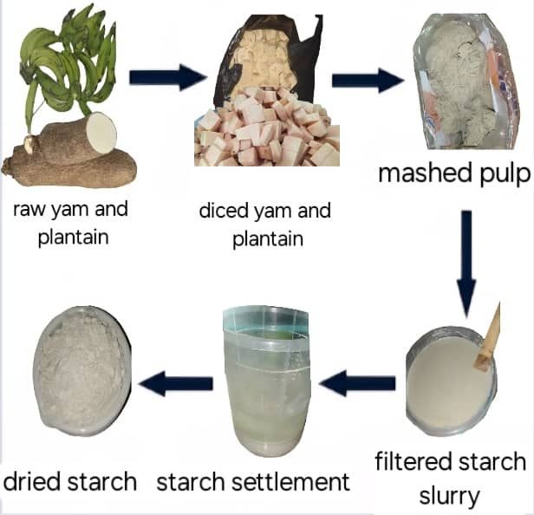

Figure.1: Starch Preparation and Extraction
Commercially available food-grade maize starch (Zea mays) served as the control sample in this comparative investigation. It was purchased from a commercial supplier and used directly without further extraction or modification. Corn starch was selected as the control because it is widely studied and used industrially, enabling the properties of the less conventional plantain and yam starches to be compared and assessed.
Extraction of Plant-Based Bioactive Extracts
The methods described by Ofoedum et al. (2026) and Odeyemi et al. (2026) were adopted for the extraction process. Bioactive compounds were recovered from avocado, garlic, and ginger using solvent-assisted maceration and hexane extraction techniques to isolate target antioxidant compounds while minimising their degradation. An ethanolic maceration method, modified from Kuttan and Thejass (2009) and Varakumar et al. (2017), was used to extract polar and semi-polar bioactive compounds from ginger and garlic. Garlic cloves and fresh ginger rhizomes were cleaned, peeled, and ground into a fine paste. A weighed quantity of each paste (1250 g of ginger and 1000 g of garlic) was soaked in 95% food-grade ethanol at a 1:5 (w/v) ratio. To improve solvent penetration and promote the mass transfer of bioactive compounds, the mixtures were kept in sealed containers at room temperature for 72 hours with periodic stirring.
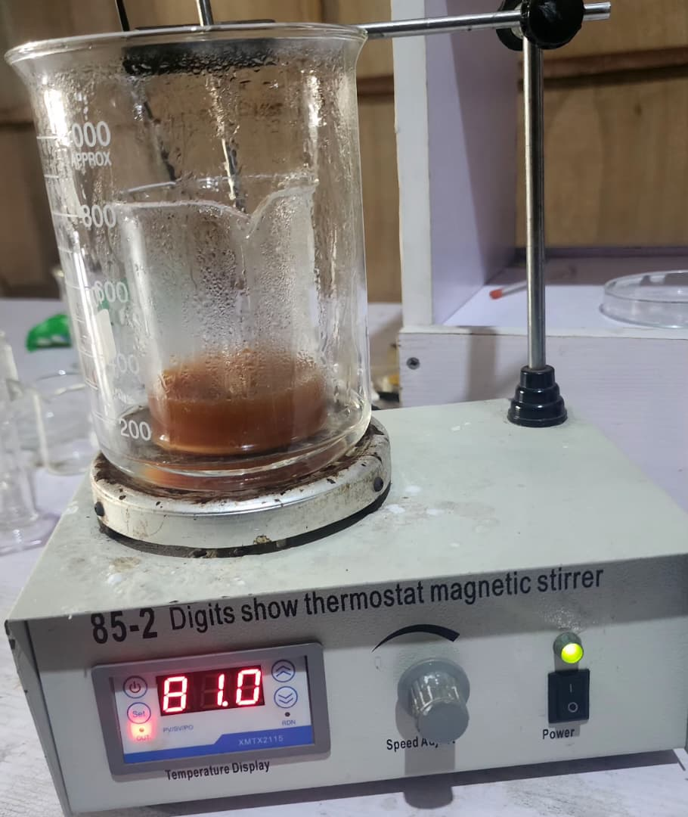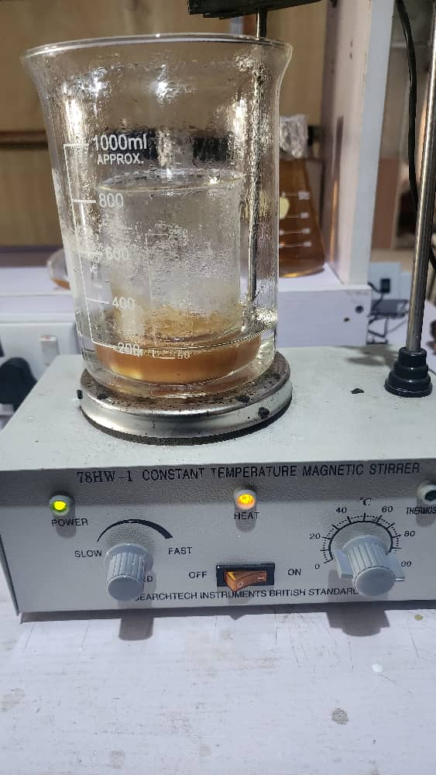
Figure 2. Ginger extract Figure 3: Garlic extract
After maceration, the mixtures were filtered to separate the solid plant residue from the ethanolic extract. The resulting filtrate was concentrated under reduced pressure using a rotary evaporator operated at 40 °C. The remaining traces of solvent were removed by gently heating the water bath to 60 °C. The viscous, concentrated extracts were transferred to sealed amber-glass bottles and stored at 4 °C until required for antioxidant analysis to minimise photodegradation and thermal degradation of labile bioactive compounds. The lipid-soluble fraction, mainly oil, was extracted from ripe avocado fruit using hexane, a non-polar solvent, according to a method modified from Dreher and Davenport (2013). To reduce surface moisture, the pulp was removed from ripe avocados, spread thinly on a tray, and briefly air-dried.
A known mass of the pulp was then soaked in analytical-grade n-hexane at a 1:2 (w/v) ratio for 48 hours. The mixture was filtered, and the solvent was removed from the filtrate using a rotary evaporator to recover crude avocado oil. The oil was stored under the same conditions as the other extracts.
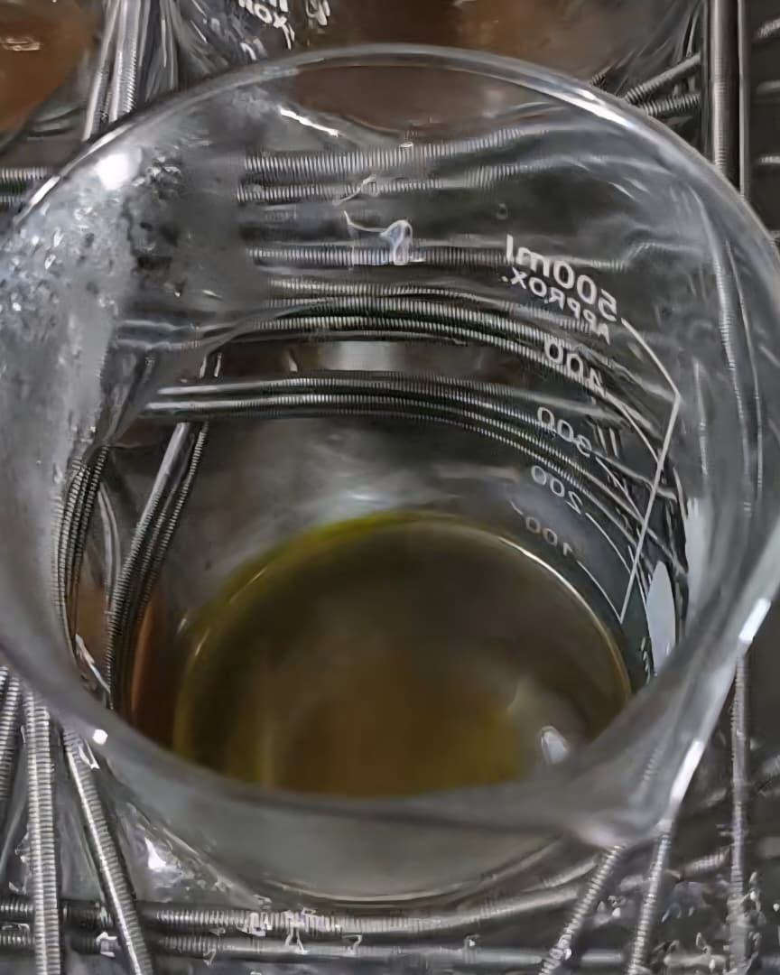

Figure 4: Avocado extract

Physicochemical Characterization of Starch Samples
The pH of the starch samples was determined according to AOAC International (2016) official method. A 10% (w/v) starch slurry was prepared by dispersing 10 g of each starch sample in 100 mL of distilled water. The suspension was stirred continuously for 30 minutes and allowed to equilibrate at room temperature for one hour. The pH of the supernatant was measured using a calibrated digital pH meter (Hanna Instruments, HI 2211).
The moisture content of the starch samples was determined using the conventional oven-drying gravimetric method (AOAC International, 2016). Precisely 2 g of each starch sample was placed in a pre-dried, tared crucible. The samples were then dried in a hot-air oven at 105 °C for approximately 24 hours until a constant mass was obtained.
The crucibles were cooled to room temperature in a desiccator before final weighing. Moisture content was calculated as the percentage loss in mass.
The swelling power and solubility of the starch samples were determined simultaneously using the method described by Leach et al. (1959), with slight modifications. A 1% (w/v) aqueous starch suspension (1 g in 100 mL of distilled water) was prepared in a centrifuge tube. The suspension was heated at 85 °C for 30 minutes in a thermostatically controlled water bath with continuous gentle stirring. After cooling to room temperature, the tubes were centrifuged at 3000 rpm for 15 minutes. The supernatant was carefully decanted into a pre-weighed evaporating dish, and the mass of the swollen sediment was recorded. Swelling power (g/g) was calculated by dividing the mass of the swollen sediment by the initial dry mass of starch. The decanted supernatant was then evaporated to dryness in an oven at 105 °C. The mass of the dried residue represented the solubilised starch. Solubility (%) was calculated as the percentage of this residue relative to the initial dry mass of starch.
Structural and Morphological Analysis
A PerkinElmer Spectrum 100 FTIR spectrophotometer was used to examine the molecular functional groups and chemical structure of the native starch samples. For analysis, approximately 2 mg of dry starch powder was thoroughly mixed with 200 mg of spectroscopic-grade potassium bromide (KBr). The mixture was then compressed into a thin, transparent pellet using a hydraulic press. The FTIR spectrum of each sample was recorded at a resolution of 4 cm⁻¹ over the mid-infrared range of 4000–400 cm⁻¹. The resulting spectra were analysed to identify the characteristic absorption bands corresponding to the functional groups present in starch.
A Zeiss EVO MA10 scanning electron microscope was used to analyse the surface morphology, size, and shape of the native starch granules. Dry starch powder was mounted on an aluminium stub using double-sided adhesive carbon tape. The samples were then sputter-coated with a thin layer of gold under vacuum to make them electrically conductive and prevent charging under the electron beam. The coated samples were examined using an accelerating voltage of 15 kV. High-resolution digital micrographs were captured at magnifications ranging from ×500 to ×2000 to visualise the granular architecture in detail.

Determination of Antioxidant Activity
The antioxidant capacity of the ginger, garlic, and avocado extracts was evaluated using three complementary spectrophotometric assays: DPPH, ABTS, and FRAP.
The ability of the extracts to scavenge the stable 2,2-diphenyl-1-picrylhydrazyl (DPPH) free radical was evaluated using the method described by Brand-Williams et al. (1995). Briefly, 1 mL of each appropriately diluted extract was mixed with 1 mL of a 0.1 mM methanolic DPPH solution. The mixture was vortexed and incubated in the dark at room temperature for 30 minutes. The reduction in the DPPH radical was determined by measuring absorbance at 517 nm against a methanol blank. Scavenging activity was calculated as the percentage inhibition of the DPPH radical.
The ABTS assay was conducted using the method of Re et al. (1999). The ABTS radical cation (ABTS•⁺) was generated by mixing an aqueous ABTS solution with potassium persulphate and allowing the mixture to stand in the dark for 12–16 hours. The resulting blue-green ABTS•⁺ solution was diluted with methanol to obtain an absorbance of 0.70 ± 0.02 at 734 nm. One millilitre of each extract was reacted with 1 mL of the diluted ABTS•⁺ solution, and absorbance was measured after six minutes. Scavenging activity was calculated as percentage inhibition.
The reducing power of the extracts was determined using the FRAP assay described by Benzie and Strain (1996). The FRAP reagent was prepared by combining acetate buffer (300 mM, pH 3.6), 10 mM TPTZ in 40 mM HCl, and 20 mM FeCl₃•6H₂O in a 10:1:1 ratio. The freshly prepared reagent was preheated to 37 °C. For the assay, 0.1 mL of each extract was mixed with 3.0 mL of the FRAP reagent. After incubation for four minutes, the absorbance of the reaction mixture was measured at 593 nm. The results were expressed as molar equivalents of a standard antioxidant, such as Trolox or FeSO₄.

Statistical Analysis
Each experiment was conducted in triplicate (n = 3), and the results were expressed as mean ± standard deviation (SD). The data were statistically analysed using IBM SPSS Statistics software (Version 25). One-way analysis of variance (ANOVA) was used to determine whether the means of the sample groups differed significantly. When significant differences were identified, post hoc pairwise comparisons were performed using Tukey's honestly significant difference (HSD) test. A p value of less than 0.05 (p < 0.05) was considered statistically significant.

Results and Discussion
This section presents the experimental findings from the characterisation of starches extracted from plantain (Musa paradisiaca), yam (Dioscorea rotundata), and corn (Zea mays), together with the evaluation of the antioxidant properties of extracts from avocado (Persea americana), ginger (Zingiber officinale), and garlic (Allium sativum). The results are presented systematically, interpreted, and discussed in relation to their implications for the development of antioxidant-based edible films. All analyses were performed in triplicate, and the data were subjected to one-way analysis of variance (ANOVA) to determine statistical significance (p < 0.05).

Physicochemical Properties of Starch Samples
pH and Moisture Content
The pH of a starch slurry and the moisture content of the dry powder are fundamental indicators of purity, stability, and suitability for processing. The mean values of these two physicochemical parameters for the plantain (SPS), yam (SYS), and corn (SCS) starch samples are presented in Table 1.

Table 1: Physicochemical Properties of Starch Samples
Starch samples | pH | Moisture (%)
Plantain Starch | 6.68ª ± 0.04 | 15.50ª ± 0.71
Yam starch | 7.38ª ± 0.04 | 12.50^{b} ± 0.71
Control | 6.88ª ± 0.04 | 15.50ª ± 0.71
LSD | 1.05 | 1.66
Mean values in the same column followed by different superscript letters (a, b, c) are significantly different (p < 0.05).
The results indicate statistically significant differences among the samples for both parameters. Regarding pH, yam starch (SYS) was slightly alkaline (7.38), whereas corn (SCS) and plantain (SPS) starches were near neutral to slightly acidic (6.88 and 6.68, respectively). Plantain and corn starches had significantly higher moisture contents (15.50%) than yam starch (12.50%).
One-way analysis of variance (ANOVA) was used to assess the statistical significance of these observations; the results are presented in Table B-3 in the Appendix. P values below 0.05 indicate statistically significant differences among group means. The ANOVA results indicate that starch source had a significant effect on both pH (F(2,3) = 208.000, p = 0.001) and moisture content (F(2,3) = 49.333, p = 0.005). All samples exhibited near-neutral to slightly alkaline pH values, which may indicate good purity and suggest that acidic contaminants were removed during extraction and washing (Olatunde et al., 2017).
For edible-film production, a near-neutral pH is desirable because it supports the chemical stability of starch glycosidic linkages and limits acid-catalysed hydrolytic degradation during heat-intensive gelatinisation (Bello-Pérez et al., 1999). The statistically significant differences may be attributable to the botanical origins of the starches. Findings for some tuber starches indicate that trace mineral ions may influence pH, which could explain the slight alkalinity of yam starch (Riley et al., 2008). Fruit-derived starches, including plantain starch, are often slightly acidic. Functionally, the slightly acidic to neutral pH of plantain and maize starches may favour the incorporation of pH-sensitive bioactive substances such as gingerols, which are more stable under these conditions.
The stability of these phenolic compounds may be adversely affected by the slightly alkaline nature of yam starch (Zhu, 2015b). Consequently, plantain and maize starches exhibit more favourable pH characteristics for developing stable, antioxidant-rich edible films. To reduce the risk of microbial contamination and subsequent starch degradation during storage, a moisture content below 15% is generally recommended (Lawal, 2004). Yam starch (12.50%) was within this range, whereas plantain and corn starches (15.50%) were slightly above it. This finding suggests that plantain and maize starch powders may require stricter control of ambient humidity during long-term storage to prevent deterioration.
Functionally, the higher intrinsic moisture contents of corn and plantain starches have important implications for film properties. Water acts as a natural plasticiser in starch. A higher initial moisture content can lower the glass-transition temperature (Tg) of the final film matrix, suggesting that films produced from corn and plantain starches may exhibit greater elongation at break and inherent flexibility (Zeleznak & Hoseney, 1987). However, this increased molecular mobility often produces a less dense polymer network, which may lead to poorer barrier properties, particularly a higher water-vapour transmission rate (WVTR), which is undesirable for many food-packaging applications (Zhu, 2015a). The lower moisture content of yam starch suggests that it may produce a denser and more rigid film with improved barrier properties.

Physicochemical Properties: Swelling Power and Solubility
Swelling Power and Solubility
Functionally, the higher intrinsic moisture contents of corn and plantain starches have important implications for film properties. Water acts as a natural plasticiser in starch. A higher initial moisture content can lower the glass-transition temperature (Tg) of the final film matrix, suggesting that films produced from corn and plantain starches may exhibit greater elongation at break and inherent flexibility (Zeleznak & Hoseney, 1987). However, this increased molecular mobility often produces a less dense polymer network, which may lead to poorer barrier properties, particularly a higher water-vapour transmission rate (WVTR), which is undesirable for many food-packaging applications (Zhu, 2015a). The lower moisture content of yam starch suggests that it may produce a denser and more rigid film with improved barrier properties.

Table 2: Physicochemical Properties (Swelling Power and Solubility) of Starch Samples
Sample Code | Starch Source | Mean Swelling Power (ml/g) | Mean Solubility (%)
SYS | Yam Starch | 1.40ᵃ ± 0.14 | 9.63ᶜ ± 0.05
SCS | Corn Starch (Control) | 1.15ᵇ ± 0.07 | 12.45ᵃ ± 0.03
SPS | Plantain Starch | 1.05ᶜ ± 0.07 | 10.87ᵇ ± 0.04
Mean values in the same column followed by different superscript letters (a, b, c) are significantly different (p < 0.05).
The results demonstrate a distinct hierarchy for both properties. Plantain starch (SPS) had the lowest swelling power (1.05 mL/g), whereas yam starch (SYS) had the highest value (1.40 mL/g). The starches showed the opposite trend for solubility, with yam starch being the least soluble (9.63%) and maize starch (SCS) the most soluble (12.45%). One-way analysis of variance (ANOVA) was used to assess the statistical significance of these observations. The ANOVA indicated that solubility differed significantly among starch sources (p < 0.001). Although the p value for swelling power (0.081) was slightly above the conventional 0.05 threshold, post hoc testing supported the reported categories (see Table 3).
The interaction among granular architecture, amylose content, and crystalline structure controls the swelling and solubility properties of starch (Hoover, 2001). The findings provide a comparison of the functional differences among the three starches. In contrast to the dense A-type structure of maize starch, the more open and hydrated B-type crystalline structure of yam starch permits greater water penetration and may explain its higher swelling power (Zavareze & Dias, 2011). Its lower solubility, however, suggests a strong internal granular network that limits the leaching of amylose chains despite swelling. By contrast, plantain starch had the lowest swelling power (1.05 mL/g), which was an important functional finding.
Among the three samples, this finding indicates the greatest granular rigidity and resistance to thermal disruption. Strong intermolecular interactions, which are characteristic of starches with high amylose contents and well-organised B/C-type crystalline structures, may account for this integrity (Otegbayo et al., 2010). Low swelling power may indicate favourable film-forming behaviour. It suggests that the granules may retain sufficient structure to form a dense, interconnected polymer network after drying rather than disintegrating completely into a weak paste. Such density may reduce free volume in the final film and contribute to mechanical strength and low water-vapour permeability.
The relatively low swelling power of plantain starch was complemented by its moderate solubility (10.87%). Although low solubility is desirable for water resistance, some amylose must leach from the granules to form the continuous polymer network that gives the film its structure. The intermediate solubility of plantain starch suggests a balance between releasing sufficient amylose to form a cohesive film matrix and avoiding excessive water sensitivity, which is a common limitation of more soluble starches (Mali et al., 2004). In summary, the combination of low swelling power and moderate solubility indicates that plantain starch may be a promising option for producing edible films with favourable mechanical and barrier properties relative to yam and maize starches.

Structural and Morphological Analysis
Fourier Transform Infrared (FTIR) Spectroscopy Analysis
The FTIR spectra of all three starch samples displayed characteristic bands for O–H, C–H, and C–O–C glycosidic bonds, confirming their typical polysaccharide structures. The ratio of absorbance at 1047 cm⁻¹, which represents ordered crystalline structure, to that at 1022 cm⁻¹, which represents amorphous structure, is an analytical indicator of short-range molecular order.
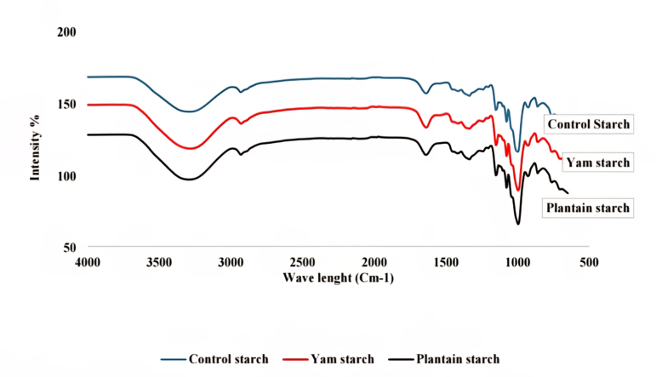

Figure 5: FTIR Analysis of Corn Starch, Yam Starch and Plantain Starch
Visual inspection of the spectra (Figure 5) suggested that corn starch had the highest intensity ratio, followed by yam starch and plantain starch. This pattern may indicate that corn starch, which has a dense A-type crystalline arrangement, had the highest degree of short-range order. Plantain and yam starches, which have B/C-type structures, appeared to have lower initial molecular order. This lower order may reduce the energy required for gelatinisation. However, because the more mobile polymer chains can reassociate more strongly, it may also be associated with more rapid retrogradation during cooling (Wang et al., 2015).
For film formation, this retrogradation behaviour suggests that plantain and yam starches may produce films that are stronger and more rigid and have better barrier properties than films produced from maize starch.
Scanning Electron Microscopy (SEM) Analysis
SEM examination confirmed substantial morphological differences among the botanical sources. Corn starch contained uniformly small, distinctly polygonal granules, whereas yam starch contained large, oval, and frequently clustered granules. Figures 6(a)–(c) show the SEM micrographs of corn, plantain, and yam starches, and Table 3 summarises their morphological characteristics.
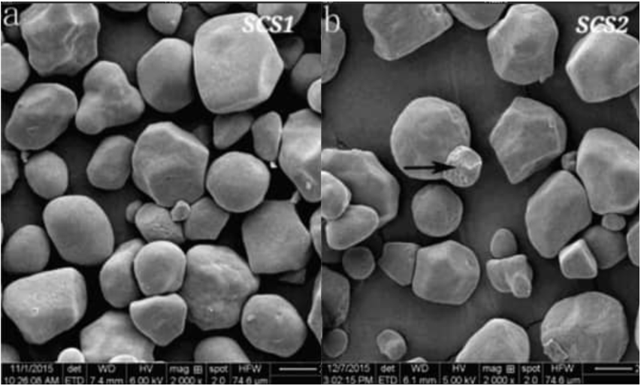

Figure 6a: SEM Micrographs for Corn

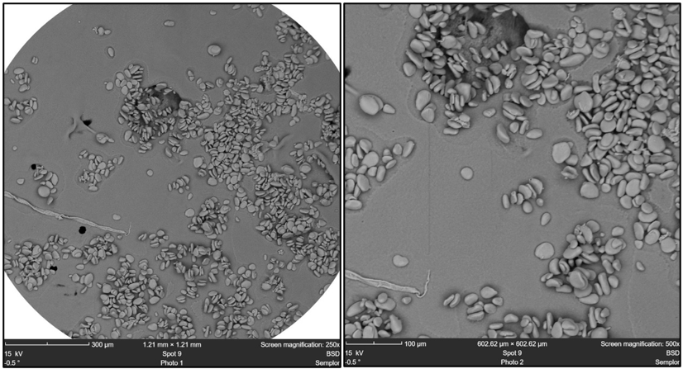

Figure 6b: SEM Micrographs for Plantain

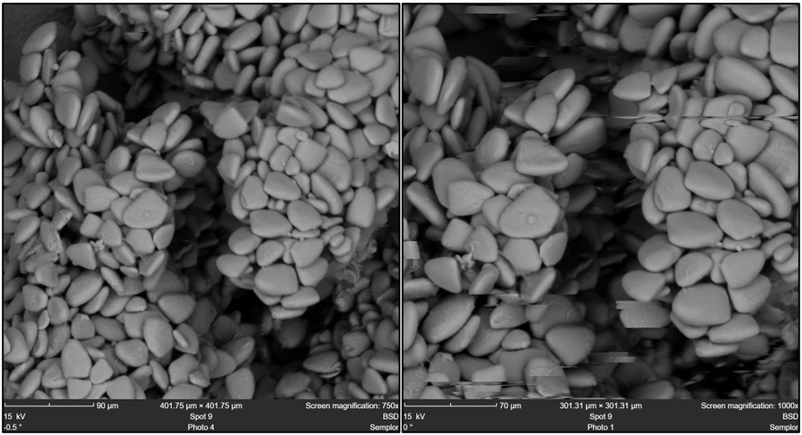
Figure 6c: SEM Micrographs for Yam

Table 3: Summary of SEM Observations of Starch Granules
Sample | Source | Morphology Description
SPS | Plantain Starch | Predominantly small, irregular, oval, or kidney-shaped granules.
SYS | Yam Starch | Large, oval, or kidney-shaped granules, often appearing clustered.
SCS | Corn Starch (Control) | Small, polygonal (mostly angular) granules.

Most notably, the plantain-starch granules were small, irregular, and frequently oval or kidney-shaped. This morphology may be favourable for film development. Smaller and more irregularly shaped granules may pack more efficiently during film drying, thereby reducing interstitial gaps. After gelatinisation and retrogradation, this packing behaviour may support the formation of a cohesive, uniform, and continuous film matrix. By reducing potential structural discontinuities, improved packing efficiency may contribute to mechanical integrity and barrier performance (Zavareze & Dias, 2011). The combination of this packing morphology and the high inherent granular rigidity indicated by the low swelling power supports the potential use of plantain starch in dense film matrices.

Antioxidant Properties of Plant-Based Extracts
The antioxidant capacities of the avocado (AQA), ginger (GOA), and garlic (GRA) extracts were evaluated using three complementary assays: DPPH, ABTS, and FRAP. The results, expressed as mg/mL (with lower values indicating higher activity for DPPH and ABTS, and higher values for FRAP), are summarized in Table 4.

Table 4: Antioxidant Properties of Plant-Based Extracts
Assay | Avocado (AOA) | Ginger (GOA) | Garlic (GRA)
DPPH (IC₅₀ mg/mL) | 71.47 ± 0.40ᵇ | 46.79 ± 0.69ᵃ | 78.75 ± 0.04ᶜ
ABTS (IC₅₀ mg/mL) | 48.59 ± 0.06ᵃ | 50.60 ± 0.21ᵇ | 50.56 ± 0.05ᵇ
FRAP (IC₅₀ mg/mL) | 22.72 ± 0.61ᶜ | 16.39 ± 0.26ᵃ | 21.09 ± 0.21ᵇ
For all assays, lower IC₅₀ values indicate higher antioxidant efficacy. Mean values in the same row followed by different superscript letters are significantly different (p < 0.05) according to post-hoc analysis.
Key: DPPH - 2-Diphenyl-1-picrylhydrazyl Radical Scavenging Activity
ABTS - 2,2’-Azino-bis(3-ethylbenzothiazoline-6-sulphonic acid) Radical Cation
FRAPS - Ferric Reducing Antioxidant Power
AQA- Oil extracted from Avocado fruit
GOA- ethanolic extracts from Ginger
GRA- ethanolic extracts from Garlic
The results indicate that ginger extract (GOA) exhibited the strongest antioxidant activity across the assays, with the lowest IC₅₀ values reported for DPPH (46.79 ± 0.69 mg/mL), ABTS (50.60 ± 0.21 mg/mL), and FRAP (16.39 ± 0.26 mg/mL). Avocado (AOA) and garlic (GRA) had comparatively higher IC₅₀ values, indicating lower antioxidant activity. The statistical differences (p < 0.05) confirm variation in antioxidant efficacy among the extracts.
The antioxidant analysis indicated that ginger extract (GOA) possessed broad antioxidant activity. It outperformed the other extracts in the DPPH assay, which measures hydrogen-atom transfer (HAT), and the FRAP assay, which measures electron transfer (ET) (Prior et al., 2005). This performance may be attributable to its phenolic compounds, including gingerols and shogaols, which contain hydroxyl groups capable of donating hydrogen atoms and electrons. In the ABTS assay, avocado oil showed substantial activity, which may reflect its capacity to limit oxidation in systems containing lipid and aqueous phases. This profile may be associated with fat-soluble antioxidants, particularly α-tocopherol. The comparatively weaker direct radical-scavenging response of garlic oil suggests that its protective effects may involve other antioxidant or antimicrobial mechanisms. Overall, the findings indicated that ginger extract had the broadest antioxidant activity among the three extracts and may therefore be suitable for further evaluation in active-film formulations.

Conclusions
The study demonstrated that plantain, yam, and corn starches differed in their physicochemical and morphological characteristics, while avocado, ginger, and garlic extracts showed different antioxidant responses. Plantain starch combined the lowest swelling power with intermediate solubility, whereas yam starch had the highest swelling power and lowest solubility. Corn starch showed the highest solubility. FTIR spectra confirmed the characteristic functional groups of starch, and SEM examination showed source-dependent differences in granule shape and organisation. Ginger extract produced the strongest responses in the DPPH and FRAP assays, while avocado extract showed the strongest ABTS response. These findings provide preliminary evidence for selecting starch matrices and antioxidant sources for further edible-film development. Subsequent research should determine mechanical strength, water-vapour and gas-barrier properties, optical and thermal behaviour, antioxidant retention, migration, food-contact safety, sensory acceptability, and preservation performance in relevant food systems.

Recommendations
The findings of this preliminary characterisation study support further research and development. Future work should prioritise plantain starch for film formulation; comprehensively characterise composite films in terms of mechanical, barrier, optical, and physical properties; optimise plasticiser and antioxidant-extract concentrations; evaluate the films in real food systems through shelf-life studies; and investigate advanced characterisation and enhancement strategies.

Limitations
The study evaluated starches and plant extracts separately and did not formulate or test edible films. Mechanical, barrier, optical, thermal, sensory, and shelf-life properties were therefore not determined. Amylose content, crystalline structure, total phenolic content, and extract yield were also not measured. The extracts were obtained using different solvents, which limits direct comparison of their antioxidant values. In addition, residual solvent, migration, and food-contact safety were not assessed. The findings should therefore be regarded as preliminary raw-material characterisation rather than confirmation of edible-film performance.

Declaration of AI Use

This manuscript was prepared through the combined contributions of all author(s), including contributions to the study design, data, content development, results, interpretation, and related scholarly work. The author(s) acknowledge the use of Grammarly and ChatGPT to assist with grammar checking, language refinement, reference formatting. These AI-assisted tools were not used as authors and did not replace the intellectual contributions or scholarly judgment of the author(s). All AI-assisted outputs, including content, references, and interpretations, were carefully reviewed, revised, verified, and approved by the author(s). The author(s) accept full responsibility for the accuracy, integrity, and final content of the manuscript.

References
Alagbaoso, S. O., Ofoedum, A. F., Njoku, N. E., Uzoukwu, A. E., Eluchie, C. N., Nwakaudu, A. A., Akajiaku, L. O., Iroagba, L. N., & Mmuoasinam, B. C. (2026). Shelf-life extension of roasted breadfruit seed (Artocarpus altilis) using acha (Digitaria exilis) and finger millet composite based edible coating. Asian Journal of Dairy and Food Research. Advance online publication. https://doi.org/10.18805/ajdfr.DRF-678
AOAC International. (2016). Official methods of analysis of AOAC International (20th ed.). AOAC International. https://www.aoac.org/official-methods-of-analysis/
Bangar, S. P., Purewal, S. S., Trif, M., Maqsood, S., Kumar, M., Manjunatha, V., & Rusu, A. V. (2021). Functionality and applicability of starch-based films: An eco-friendly approach. Foods, 10(9), 2181. https://doi.org/10.3390/foods10092181
Basiak, E., Lenart, A., & Debeaufort, F. (2018). How glycerol and water contents affect the structural and functional properties of starch-based edible films. Polymers, 10(4), 412. https://doi.org/10.3390/polym10040412
Bello-Pérez, L. A., Agama-Acevedo, E., Sánchez-Hernández, L., & Paredes-López, O. (1999). Isolation and partial characterization of banana starches. Journal of Agricultural and Food Chemistry, 47(3), 854–857. https://doi.org/10.1021/jf980828t
Benzie, I. F. F., & Strain, J. J. (1996). The ferric reducing ability of plasma (FRAP) as a measure of ‘antioxidant power’: The FRAP assay. Analytical Biochemistry, 239(1), 70–76. https://doi.org/10.1006/abio.1996.0292
Brand-Williams, W., Cuvelier, M. E., & Berset, C. (1995). Use of a free radical method to evaluate antioxidant activity. LWT—Food Science and Technology, 28(1), 25–30. https://doi.org/10.1016/S0023-6438(95)80008-5
Cui, C., Ji, N., Wang, Y., Liu, X., & Sun, Q. (2021). Bioactive and intelligent starch-based films: A review. Trends in Food Science & Technology, 116, 854–869. https://doi.org/10.1016/j.tifs.2021.08.024
Dreher, M. L., & Davenport, A. J. (2013). Hass avocado composition and potential health effects. Critical Reviews in Food Science and Nutrition, 53(7), 738–750. https://doi.org/10.1080/10408398.2011.556759
Dugasani, S., Pichika, M. R., Nadarajah, V. D., Balijepalli, M. K., Tandra, S., & Korlakunta, J. N. (2010). Comparative antioxidant and anti-inflammatory effects of [6]-gingerol, [8]-gingerol, [10]-gingerol and [6]-shogaol. Journal of Ethnopharmacology, 127(2), 515–520. https://doi.org/10.1016/j.jep.2009.10.004
Falade, K. O., & Ayetigbo, O. E. (2015). Effects of annealing, acid hydrolysis and citric acid modifications on physical and functional properties of starches from four yam (Dioscorea spp.) cultivars. Food Hydrocolloids, 43, 529–539. https://doi.org/10.1016/j.foodhyd.2014.07.008
Falade, K. O., & Oyeyinka, S. A. (2015). Color, chemical and functional properties of plantain cultivars and cooking banana flour as affected by drying method and maturity. Journal of Food Processing and Preservation, 39(6), 816–828. https://doi.org/10.1111/jfpp.12292
Falguera, V., Quintero, J. P., Jiménez, A., Muñoz, J. A., & Ibarz, A. (2011). Edible films and coatings: Structures, active functions and trends in their use. Trends in Food Science & Technology, 22(6), 292–303. https://doi.org/10.1016/j.tifs.2011.02.004
Geyer, R., Jambeck, J. R., & Law, K. L. (2017). Production, use, and fate of all plastics ever made. Science Advances, 3(7), e1700782. https://doi.org/10.1126/sciadv.1700782
Hoover, R. (2001). Composition, molecular structure, and physicochemical properties of tuber and root starches: A review. Carbohydrate Polymers, 45(3), 253–267. https://doi.org/10.1016/S0144-8617(00)00260-5
Jiménez, A., Fabra, M. J., Talens, P., & Chiralt, A. (2012). Edible and biodegradable starch films: A review. Food and Bioprocess Technology, 5(6), 2058–2076. https://doi.org/10.1007/s11947-012-0835-4
Jongjareonrak, A., Benjakul, S., Visessanguan, W., & Tanaka, M. (2008). Antioxidative activity and properties of fish skin gelatin films incorporated with BHT and α-tocopherol. Food Hydrocolloids, 22(3), 449–458. https://doi.org/10.1016/j.foodhyd.2007.01.002
Kumar, L., Ramakanth, D., Akhila, K., & Gaikwad, K. K. (2022). Edible films and coatings for food packaging applications: A review. Environmental Chemistry Letters, 20, 875–900. https://doi.org/10.1007/s10311-021-01339-z
Kuttan, G., & Thejass, P. (2009). Diallyl sulfide from garlic. In B. B. Aggarwal & A. B. Kunnumakkara (Eds.), Molecular targets and therapeutic uses of spices: Modern uses for ancient medicine (pp. 197–224). World Scientific. https://doi.org/10.1142/9789812837912_0008
Lawal, O. S. (2004). Composition, physicochemical properties and retrogradation characteristics of native, oxidised, acetylated and acid-thinned new cocoyam (Xanthosoma sagittifolium) starch. Food Chemistry, 87(2), 205–218. https://doi.org/10.1016/j.foodchem.2003.11.013
Leach, H. W., McCowen, L. D., & Schoch, T. J. (1959). Structure of the starch granule. I. Swelling and solubility patterns of various starches. Cereal Chemistry, 36(6), 534–544. https://onlinelibrary.wiley.com/page/journal/19433638/homepage/classic-papers.html
Mali, S., Grossmann, M. V. E., García, M. A., Martino, M. N., & Zaritzky, N. E. (2004). Barrier, mechanical and optical properties of plasticized yam starch films. Carbohydrate Polymers, 56(2), 129–135. https://doi.org/10.1016/j.carbpol.2004.01.004
Mao, Q.-Q., Xu, X.-Y., Cao, S.-Y., Gan, R.-Y., Corke, H., Beta, T., & Li, H.-B. (2019). Bioactive compounds and bioactivities of ginger (Zingiber officinale Roscoe). Foods, 8(6), 185. https://doi.org/10.3390/foods8060185
Matloob, A., Ayub, H., Mohsin, M., Ambreen, S., & Khan, F. A. (2023). A review on edible coatings and films: Advances, composition, production methods, and safety concerns. ACS Omega, 8(32), 28985–29006. https://doi.org/10.1021/acsomega.3c03459
Mokhtar, T. N., Ismail, N., Mohd Arshad, M. H., & Salahuddin, M. A. H. (2025). Impact of infusion time on the physical characteristics, antioxidant properties, and in vitro antidiabetic activity of roselle tisane herbal drink blends. Asian Food Science Journal, 24(10), 34–45. https://doi.org/10.9734/afsj/2025/v24i10821
Odeyemi, T. A., Owuamanam, C. I., Ofoedum, A. F., Ugwoezuonu, J. N., Elemuo, G. K., Iroagba, L. N., Okezie, F. P., & Eze, O. J. (2026). Characterization of cellulose and assessment of plant extracts for antioxidant-based edible film. Journal of Food and Biotechnology, 7(1), 48–57. https://doi.org/10.51470/FAB.2026.7.1.48
Ofoedum, A. F., Owuamanam, C. I., Ndukauba, O. E., Iroagba, L. N., Ugwoezuonu, J. N., Abbah, E. C., & Anaeke, J. E. (2023). Phytochemicals from selected tropical spices and agro-food wastes: Utilization and applications in health sectors—A review. European Journal of Theoretical and Applied Sciences, 1(5), 681–696. https://doi.org/10.59324/ejtas.2023.1(5).58
Ofoedum, A. F., Owuamanam, C. I., Iwouno, J. O., Olawuni, I. A., Abbah, E. C., Uyanwa, N. C., Anaeke, E. J., & Ofoedum, S. L. (2025a). Functional and storage stabilities of functional beverages developed from crude extracts from tropical spices (Zingiber officinale, Monodora myristica and Tetrapluera tetraptera). Journal of Food Legumes, 38(4), 624–632. https://doi.org/10.53550/jfl.v38i4.2169
Ofoedum, A. F., Owuamanam, C. I., Iwouno, J. O., Ofoedu, C. E., Chikelu, E. C., Odimegwu, E. N., Alagbaoso, S. O., Njoku, N. E., & Anaeke, E. J. (2025b). Physicochemical and shelf life studies of functional beverages developed from crude extracts from tropical spices (Zingiber officinale, Monodora myristica and Tetrapluera tetraptera). Asian Journal of Dairy and Food Research, 44(5), 799–806. https://doi.org/10.18805/ajdfr.DRF-478
Ofoedum, A. F., Owuamanam, C. I., Iwouno, J. O., Olawuni, I. A., Anaeke, E. J., Emejulu, C. O., Mofunanya, G. N., & Abbah, E. C. (2026). Evaluation of bioactive compounds from selected tropical spices extracted using microwave-assisted extraction technology. Journal of Advances in Food Science & Technology, 13(3), 187–203. https://doi.org/10.56557/jafsat/2026/v13i310816
Okey-Onochie, N. O., Onuegbu, T. U., & Muofunanya, E. O. (2026). Comprehensive characterization of avocado pear (Persea americana) seed powder for application in biodegradable polymer composites and functional materials. Journal of Applied Chemical Science International, 17(1), 48–58. https://doi.org/10.56557/jacsi/2026/v17i110239
Olatunde, G. O., Arogundade, L. K., & Orija, O. I. (2017). Chemical, functional and pasting properties of banana and plantain starches modified by pre-gelatinization, oxidation and acetylation. Cogent Food & Agriculture, 3(1), 1283079. https://doi.org/10.1080/23311932.2017.1283079
Otegbayo, B., Lana, O., & Ibitoye, W. (2010). Isolation and physicochemical characterization of starches isolated from plantain (Musa paradisiaca) and cooking banana (Musa sapientum). Journal of Food Biochemistry, 34(6), 1303–1318. https://doi.org/10.1111/j.1745-4514.2010.00354.x
Otoni, C. G., Avena-Bustillos, R. J., Azeredo, H. M. C., Lorevice, M. V., Moura, M. R. de, Mattoso, L. H. C., & McHugh, T. H. (2017). Recent advances on edible films based on fruits and vegetables—A review. Comprehensive Reviews in Food Science and Food Safety, 16(5), 1151–1169. https://doi.org/10.1111/1541-4337.12281
Pelissari, F. M., Andrade-Mahecha, M. M., Sobral, P. J. do A., & Menegalli, F. C. (2012). Isolation and characterization of the flour and starch of plantain bananas (Musa paradisiaca). Starch/Stärke, 64(5), 382–391. https://doi.org/10.1002/star.201100133
Prior, R. L., Wu, X., & Schaich, K. (2005). Standardized methods for the determination of antioxidant capacity and phenolics in foods and dietary supplements. Journal of Agricultural and Food Chemistry, 53(10), 4290–4302. https://doi.org/10.1021/jf0502698
Re, R., Pellegrini, N., Proteggente, A., Pannala, A., Yang, M., & Rice-Evans, C. (1999). Antioxidant activity applying an improved ABTS radical cation decolorization assay. Free Radical Biology and Medicine, 26(9–10), 1231–1237. https://doi.org/10.1016/S0891-5849(98)00315-3
Riley, C. K., Adebayo, S. A., Wheatley, A. O., & Asemota, H. N. (2008). Surface properties of yam (Dioscorea sp.) starch powders and potential for use as binders and disintegrants in drug formulations. Powder Technology, 185(3), 280–285. https://doi.org/10.1016/j.powtec.2007.10.028
Salami, H. A., Adegite, J. O., Bademosi, T. T., Lawal, S. O., Olutayo, O. O., & Olowosokedile, O. (2019). A review on the current status of municipal solid waste management in Nigeria: Problems and solutions. Journal of Engineering Research and Reports, 3(4), 1–16. https://doi.org/10.9734/JERR/2018/v3i416884
Sanyang, M. L., Sapuan, S. M., Jawaid, M., Ishak, M. R., & Sahari, J. (2016). Recent developments in sugar palm (Arenga pinnata) based biocomposites and their potential industrial applications: A review. Renewable and Sustainable Energy Reviews, 54, 533–549. https://doi.org/10.1016/j.rser.2015.10.037
Shang, A., Cao, S.-Y., Xu, X.-Y., Gan, R.-Y., Tang, G.-Y., Corke, H., Mavumengwana, V., & Li, H.-B. (2019). Bioactive compounds and biological functions of garlic (Allium sativum L.). Foods, 8(7), 246. https://doi.org/10.3390/foods8070246
Sharma, S., Basu, S., Shetti, N. P., Nadagouda, M. N., & Aminabhavi, T. M. (2021). Microplastics in the environment: Occurrence, perils, and eradication. Chemical Engineering Journal, 408, 127317. https://doi.org/10.1016/j.cej.2020.127317
Uzoukwu, A. E., Uzomah, A., Akunna, I. C., Nnorom, O. O., Udemba, C. O., Emena, E. E., Odimegwu, E. N., Njoku, N. E., & Ofoedum, A. F. (2025). Valorization of plantain and banana biomass for production of sodium carboxymethyl cellulose. Asian Journal of Dairy and Food Research. Advance online publication. https://doi.org/10.18805/ajdfr.DRF-592
Varakumar, S., Umesh, K. V., & Singhal, R. S. (2017). Enhanced extraction of oleoresin from ginger (Zingiber officinale) rhizome powder using enzyme-assisted three phase partitioning. Food Chemistry, 216, 27–36. https://doi.org/10.1016/j.foodchem.2016.07.180
Wang, S., Li, C., Copeland, L., Niu, Q., & Wang, S. (2015). Starch retrogradation: A comprehensive review. Comprehensive Reviews in Food Science and Food Safety, 14(5), 568–585. https://doi.org/10.1111/1541-4337.12143
Yalwaji, B., John-Nwagwu, H. O., & Sogbanmu, T. O. (2022). Plastic pollution in the environment in Nigeria: A rapid systematic review of the sources, distribution, research gaps and policy needs. Scientific African, 16, e01220. https://doi.org/10.1016/j.sciaf.2022.e01220
Zavareze, E. da R., & Dias, A. R. G. (2011). Impact of heat-moisture treatment and annealing in starches: A review. Carbohydrate Polymers, 83(2), 317–328. https://doi.org/10.1016/j.carbpol.2010.08.064
Zeleznak, K. J., & Hoseney, R. C. (1987). The glass transition in starch. Cereal Chemistry, 64(2), 121–124. https://onlinelibrary.wiley.com/page/journal/19433638/homepage/classic-papers.html
Zhang, P., Whistler, R. L., BeMiller, J. N., & Hamaker, B. R. (2005). Banana starch: Production, physicochemical properties, and digestibility—A review. Carbohydrate Polymers, 59(4), 443–458. https://doi.org/10.1016/j.carbpol.2004.10.014
Zhao, Y., Li, B., Li, C., Xu, Y., Luo, Y., Liang, D., & Huang, C. (2021). Comprehensive review of polysaccharide-based materials in edible packaging: A sustainable approach. Foods, 10(8), 1845. https://doi.org/10.3390/foods10081845
Zhu, F. (2015a). Composition, structure, physicochemical properties, and modifications of cassava starch. Carbohydrate Polymers, 122, 456–480. https://doi.org/10.1016/j.carbpol.2014.10.063
Zhu, F. (2015b). Interactions between starch and phenolic compound. Trends in Food Science & Technology, 43(2), 129–143. https://doi.org/10.1016/j.tifs.2015.02.003

