First Antibacterial Evaluation of an Anthraquinone–Triphenylphosphonium Conjugate (SH1) Against Sensitive and Drug-Resistant Staphylococcus aureus and Escherichia coli

Abstract
Background: Antimicrobial resistance (AMR) was directly attributable to an estimated 1.27 million deaths in 2019 and is projected to cause 1.91 million attributable deaths annually by 2050, creating sustained demand for antibacterial scaffolds that act through mechanisms distinct from conventional target inhibition. Anthraquinone–delocalised lipophilic cation (DLC) conjugates, in which a triphenylphosphonium (TPP⁺) or related cationic group drives electrostatic, membrane-targeted accumulation, are one such scaffold. SH1 (1-[(5-triphenylphosphonium-pentyl)oxy]anthraquinone) was previously synthesised and shown to accumulate selectively in the mitochondria of PC-3 prostate cancer cells, but its antibacterial activity has not previously been reported.
Aim: To our knowledge, following a structured search of PubMed and Scopus that identified no prior antibacterial data for this compound, this study presents the first antibacterial evaluation of SH1.
Methods: SH1 was assessed by broth microdilution in accordance with EUCAST guidelines against sensitive and drug-resistant strains of Staphylococcus aureus and Escherichia coli.
Results: SH1 demonstrated a minimum inhibitory concentration (MIC) of 1.6 mg/L against both antibiotic-sensitive (NCTC 6571) and methicillin-resistant (NCTC 13616) S. aureus, with a minimum bactericidal concentration (MBC) of 3.2 mg/L, indicating equipotent bactericidal activity against MRSA. Against E. coli (ATCC 47055, sensitive; LIB213, resistant), SH1 showed an MIC and MBC of 25.6 mg/L for both strains.
Conclusion: These results identify SH1 as a previously uncharacterised antibacterial agent active against MRSA and support the anthraquinone–DLC pharmacophore as a membrane-active scaffold warranting further structural optimisation. Halogenated analogues, including the arginine-conjugated derivative VO6 synthesised as part of this programme, remain candidates for future evaluation once solubility constraints are addressed. The study was limited to four bacterial strains, and comparator antibiotics were considered using published breakpoint data rather than side-by-side testing; these constraints are discussed further in the Limitations section.
Keywords: anthraquinone; triphenylphosphonium; antibacterial; MRSA; antimicrobial resistance; drug repurposing

1. Introduction
Bacterial pathogens have posed a persistent threat to human health since antiquity, and the discovery of antibiotics in the early twentieth century, beginning with arsphenamine in 1910 and penicillin in 1928, marked the beginning of humanity's most effective defence against infectious bacterial disease [15,17]. The period from the early twentieth century to the mid-1960s represented a golden age of antibiotic discovery, during which numerous structurally diverse antibiotic classes were identified and developed into clinical therapeutics. From the late 1960s onwards, however, the rate of antibiotic discovery declined precipitously due to a convergence of scientific, economic and regulatory barriers [9], and the easily accessible chemical scaffolds amenable to conventional screening approaches had, by that point, been largely exhausted [3].
The consequences of this discovery gap are now firmly established in the global health literature. A landmark global burden study estimated that bacterial antimicrobial resistance was directly attributable to 1.27 million deaths and associated with 4.95 million deaths in 2019 alone, with the highest death rates concentrated in sub-Saharan Africa and South Asia [16]. A subsequent 2024 update projected that deaths directly attributable to bacterial antimicrobial resistance could rise to 1.91 million annually by 2050, with 8.22 million deaths associated with resistance in that year [8]. The World Health Organization has designated the ESKAPE pathogens, comprising Enterococcus faecium, Staphylococcus aureus, Klebsiella pneumoniae, Acinetobacter baumannii, Pseudomonas aeruginosa and Enterobacter species, as priority status organisms on account of their capacity for rapid resistance acquisition and the paucity of effective therapeutic options available against them [23,20]. Among these, methicillin-resistant Staphylococcus aureus (MRSA) remains among the most clinically significant, causing bacteraemia, infective endocarditis and surgical site infections with substantially higher attributable mortality than infections caused by methicillin-susceptible strains [20].
The dominant resistance mechanism shared by both Gram-positive and Gram-negative pathogens is limitation of drug permeability and uptake across the bacterial cell membrane, frequently compounded by active efflux [20,3]. Antibacterial agents whose physicochemical properties facilitate direct membrane disruption, bypassing the target-mediated resistance mechanisms that compromise conventional antibiotics, therefore represent a strategically important class for confronting the resistance crisis. Anthraquinones, a structurally diverse pharmacophore class built on the 9,10-dioxoanthracene framework, are among the scaffolds explored for this purpose. Their diverse physiological activities depend on the number of anthraquinone rings and the substituents attached to the ring system [12], and they have attracted medicinal interest for antidiarrhoeal, anti-inflammatory, antifungal, antibacterial and anticancer activity [13]. Representative pharmacologically active anthraquinones, including the natural products emodin and chrysophanol, the semisynthetic anti-inflammatory agent diacerein, and the bacterially derived anticancer agent daunorubicin, are shown in Figure 1, illustrating the structural diversity and substitution patterns characteristic of this pharmacophore class.
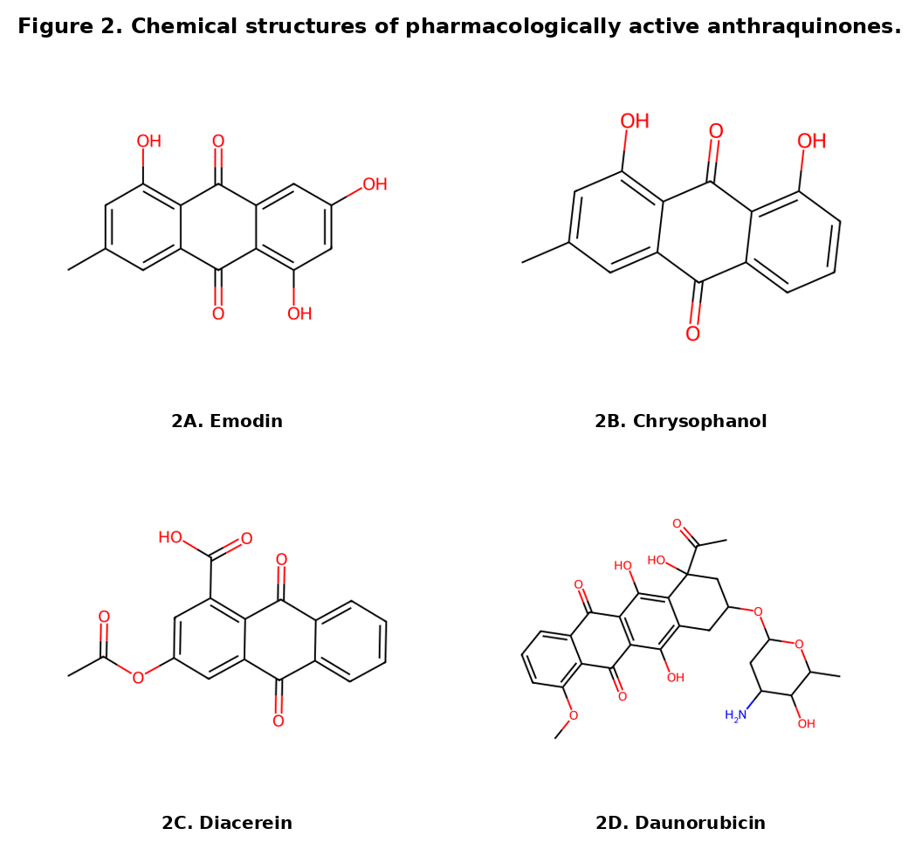
Figure 1. Chemical structures of representative pharmacologically active anthraquinones: (A) emodin, an antidiarrhoeal and antibacterial natural anthraquinone from Cassia obstufolia; (B) chrysophanol, from Aloe vera; (C) diacerein, a semisynthetic anti-inflammatory derivative of rhein; (D) daunorubicin, a bacterially derived anthracycline anticancer agent.
1.1 Literature Review: Anthraquinone–TPP⁺ Antibacterial Agents and Strain-Specific Resistance
The two organisms evaluated in this study exemplify contrasting resistance strategies against which a membrane-active scaffold must be tested. Methicillin-resistant S. aureus acquires resistance through the mecA-encoded penicillin-binding protein PBP2a, a target-modification mechanism that leaves membrane permeability unaltered, whereas resistant E. coli more commonly relies on outer-membrane impermeability, porin loss and constitutive efflux-pump expression, mechanisms that act directly on compound entry rather than on a specific molecular target [20]. This distinction motivates paired sensitive/resistant testing in both organisms, since a genuinely membrane-active agent such as SH1 would be expected to retain potency against the target-modification resistance of MRSA while remaining more vulnerable to the permeability-based resistance of E. coli.
Several studies have established that cationic anthraquinone analogues possess significant, tunable antibacterial activity, with structure-activity relationship studies consistently identifying the cationic side chain as the primary determinant of membrane-active antibacterial potency [11,7]. Shrestha et al. [21] demonstrated that a cationic anthraquinone analogue disrupts bacterial membranes and exhibits antibacterial activity against both Gram-negative and Gram-positive bacteria, while a structurally related intermediate lacking the cationic group showed no antibacterial activity even at concentrations as high as 5 mg/mL, underscoring the critical importance of the cationic group for antibacterial efficacy. The delocalised lipophilic cation (DLC) triphenylphosphonium (TPP⁺) is among the most extensively studied cationic vectors for this purpose. TPP⁺ achieves selective accumulation across highly polarised membranes through electrostatic attraction between its delocalised positive charge and the substantial negative membrane potential of the target membrane [24]. Because the mitochondrial inner membrane and the bacterial cell membrane share a common evolutionary origin and broadly similar electrochemical properties, TPP⁺ conjugates developed for mitochondrial targeting are mechanistically plausible candidates for bacterial membrane targeting, although this transfer of activity cannot be assumed and requires direct experimental testing [25]. Most recently, Surendran et al. [22] reported that purpose-designed anthraquinone-TPP⁺ conjugates achieved minimum inhibitory concentrations as low as 1 μg/mL against MRSA NCTC 13616, confirming that the anthraquinone-DLC architecture is a high-priority scaffold for drug-resistant pathogen targeting in the current literature.
Recent evidence further supports the antibacterial relevance of phosphonium-containing scaffolds. Triphenylphosphonium-functionalised pyrimidines showed activity against methicillin-resistant Staphylococcus aureus and inhibited biofilm formation by Staphylococcus aureus and Escherichia coli, whereas bis-triphenylphosphonium nanovesicles exhibited antibacterial activity against clinically relevant multidrug-resistant isolates [26,27]. Complementary studies outside the anthraquinone–TPP⁺ class reported antibacterial activity of metal–salen complexes against Staphylococcus aureus and Escherichia coli [28] and bactericidal activity of crude Hottentotta tamulus venom against a panel of multidrug-resistant pathogens that included MRSA and Escherichia coli [29].
A previous study conducted at Edinburgh Napier University's drug design laboratory reported the synthesis of SH1 (1-[(5-triphenylphosphonium-pentyl)oxy]anthraquinone), an anthraquinone conjugated to TPP⁺ via a five-carbon ether-linked spacer [14]. SH1 was shown by confocal microscopy to accumulate rapidly and preferentially in the mitochondria of PC-3 prostate cancer cells, with no evidence of nuclear or lysosomal accumulation, and demonstrated anticancer activity in this context [14]. However, the antibacterial potential of SH1 was not assessed in that study, and, to our knowledge, no subsequent report has evaluated SH1 against bacterial pathogens. Given the mechanistic precedent for anthraquinone-TPP⁺ conjugates as membrane-active antibacterial agents [22] and the validated membrane-targeting behaviour already demonstrated for SH1 in a mammalian cellular context [14], SH1 represented a compelling and readily available candidate for antibacterial repurposing evaluation.
1.2 Aim and Hypothesis
The aim of this study was to determine, for the first time, the antibacterial activity of SH1 against sensitive and drug-resistant Gram-positive and Gram-negative bacterial pathogens using broth microdilution minimum inhibitory concentration and minimum bactericidal concentration assays, and to interpret these findings in the context of the wider anthraquinone-DLC structure-activity relationship literature. Given that the anthraquinone-TPP⁺ pharmacophore is membrane-active and that the target strains share a common susceptibility to membrane-disrupting agents irrespective of their resistance mechanism to conventional antibiotics, it was hypothesised that SH1 would retain antibacterial potency against methicillin-resistant S. aureus and multidrug-resistant E. coli that was comparable to its potency against the corresponding antibiotic-sensitive strains.
2. Experimental Section
2.1 General Remarks
SH1 was available from a prior synthetic programme at this laboratory [14] and was used without further modification. 1,5-Dichloroanthraquinone, 1,4-diaminobutane, di-tert-butyl dicarbonate, trifluoroacetic acid (TFA), Fmoc-PMC-L-arginine, PyBOP, HOBt, DIPEA, piperidine, dimethylformamide (DMF), dichloromethane (DCM) and diethyl ether used in the synthesis of VO6 (Section 2.4, Figure 5) were purchased from commercial suppliers (Sigma-Aldrich, Fisher Scientific) and used without further purification unless otherwise stated. Mass spectra were recorded using high-resolution nanoelectrospray ionisation (ESI) on an Orbitrap-class instrument.
2.2 DMSO Tolerance Assay
The maximum non-inhibitory DMSO concentration was determined by broth microdilution in 96-well microtitre plates. Two-fold serial dilutions of DMSO from 32% to 0.0625% were prepared in Mueller-Hinton broth and inoculated with 5 × 10⁵ CFU/mL of each test organism. Plates were incubated at 37°C for 18 h. Growth was assessed visually and confirmed by OD₄₅₀ measurement.
2.3 Minimum Inhibitory Concentration (MIC) and Minimum Bactericidal Concentration (MBC) Assays
SH1 was evaluated by broth microdilution in accordance with EUCAST guidelines. Two-fold serial dilutions of SH1 from 51.2 to 0.1 mg/L were prepared in Mueller-Hinton broth containing 1% DMSO. Test organisms were Staphylococcus aureus NCTC 6571 (sensitive) and NCTC 13616 (MRSA) for Gram-positive testing, and Escherichia coli ATCC 47055 (sensitive) and LIB213 (resistant) for Gram-negative testing. Inocula were standardised to 5 × 10⁵ CFU/mL by OD₄₅₀ measurement. Plates were incubated at 37°C for 18 h. Each concentration was tested in triplicate (rows A–C for Gram-positive sensitive strains, F–H for Gram-positive resistant strains). Growth controls (no antibiotic) and sterility controls (no bacteria) were included on each plate. MBC was determined by subculturing all clear wells onto Mueller-Hinton agar and incubating at 37°C for 18 h; the MBC was defined as the lowest concentration at which no colony growth occurred, corresponding to a 99.9% or greater reduction in the initial inoculum.
2.4 Synthesis of VO6 (Supporting Structural Analogue)
VO6 was synthesised in six steps from 1,5-dichloroanthraquinone (Figure 5): (i) regioselective nucleophilic aromatic substitution with excess 1,4-diaminobutane (80°C, DMSO) afforded VO1; (ii) Boc-protection (Boc₂O, Et₃N, DCM) afforded VO2; (iii) TFA-mediated Boc removal (DCM, rt, 30 min) afforded VO3; (iv) one-pot PyBOP/HOBt-mediated coupling with Fmoc-PMC-L-arginine (DIPEA, DMF, rt, overnight) afforded VO4, confirmed by HRMS (ESI) calcd. for C₅₃H₅₉ClN₆O₈S [M+H]⁺ 973.3720, found 973.3714; (v) piperidine-mediated Fmoc removal (DMF, rt, 15 min) afforded VO5; (vi) TFA/H₂O-mediated PMC removal (rt, 72 h), with product isolation by diethyl ether precipitation, afforded VO6 as its TFA salt, confirmed by HRMS (ESI) calcd. for C₂₄H₃₁ClN₆O₃ [M+H]⁺ 485.2062, found 485.2058. Full intermediate characterisation data are available from the corresponding author upon request. Physicochemical prediction (SwissADME) indicated a logP of 1.12 and poor aqueous solubility for VO6; experimental solubility attempts in DMSO, water and ethanol were unsuccessful, and VO6 was therefore not carried forward to antibacterial testing in this study.
2.5 Ethical Statement
This study did not involve human participants, human tissue, or live animals. All bacterial strains used (S. aureus NCTC 6571 and NCTC 13616; E. coli ATCC 47055 and LIB213) were obtained from established culture collections. No institutional ethical approval was therefore required for this work.

3. Results and Discussion
3.1 Chemical Structure of SH1
SH1 (Figure 2) comprises an unsubstituted anthraquinone core linked via a five-carbon ether spacer at position 1 to a triphenylphosphonium cation. This architecture places SH1 within the established anthraquinone-DLC pharmacophore class (Section 1) but, notably, without a ring halogen substituent, a structural feature reported elsewhere to enhance antibacterial potency through increased membrane-penetrating hydrophobicity [5]. SH1 was available from a prior synthetic programme at our laboratory [14] and was used in this study without further modification.
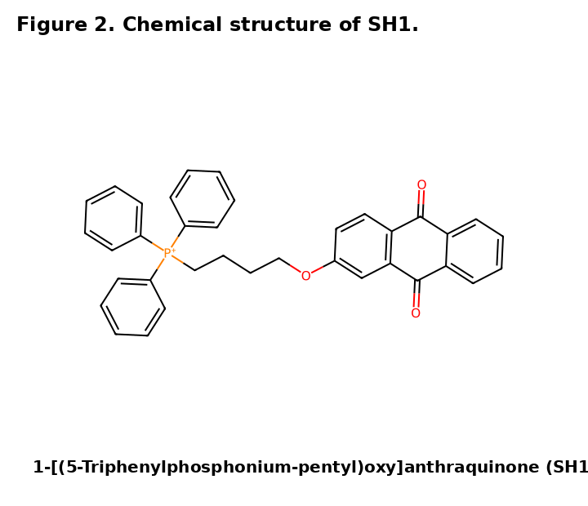

Figure 2. Chemical structure of SH1, 1-[(5-triphenylphosphonium-pentyl)oxy]anthraquinone.

3.2 DMSO Tolerance Assay
The maximum non-inhibitory DMSO concentration for the antimicrobial assay was first determined by broth microdilution across a two-fold serial dilution range of 32% to 0.0625% DMSO in Mueller-Hinton broth. DMSO concentrations of 32%, 16% and 8% inhibited growth of both Staphylococcus aureus and Escherichia coli test organisms, whereas concentrations of 4% and below showed no inhibitory effect (Table 1). All SH1 stock solutions were accordingly prepared in 1% DMSO, consistent with established guidance that DMSO concentrations below 2% do not materially affect antimicrobial susceptibility testing outcomes [19].
Table 1. DMSO tolerance assay results for S. aureus and E. coli test organisms.
DMSO (%) | 32 | 16 | 8 | 4 | ≤2
S. aureus (rows A–C) | No growth | No growth | No growth | Growth | Growth
E. coli (rows F–H) | No growth | No growth | No growth | Growth | Growth
Growth scored as no growth (inhibited) or growth (not inhibited) following 18 h incubation at 37°C.
3.3 Antibacterial Activity of SH1 Against Gram-Positive Pathogens
SH1 demonstrated equipotent antibacterial activity against both the antibiotic-sensitive (NCTC 6571) and methicillin-resistant (NCTC 13616) strains of S. aureus, with a minimum inhibitory concentration of 1.6 mg/L for both strains and a minimum bactericidal concentration of 3.2 mg/L, yielding an MBC:MIC ratio of 2:1 that classifies SH1 as bactericidal against S. aureus [18]. The equipotent activity against susceptible and MRSA strains is mechanistically significant, since the methicillin resistance mechanism, mediated by the penicillin-binding protein PBP2a, confers resistance through a target-modification pathway that does not affect membrane-active agents operating through direct membrane disruption [20]. Direct potency comparisons with ampicillin, cefuroxime and ciprofloxacin cannot be made because these comparator antibiotics were not tested under identical conditions; the published EUCAST values are therefore presented only as contextual benchmarks [6]. The Gram-positive growth inhibition data are shown in Figure 3A.

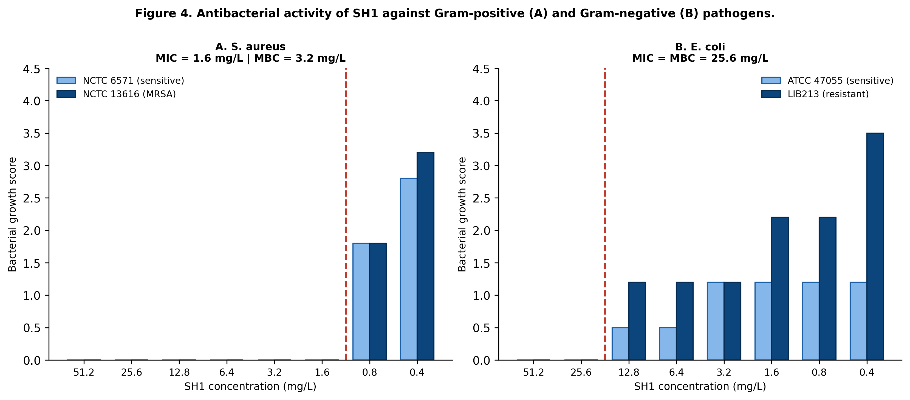
Figure 3. Antibacterial activity of SH1 against Gram-positive (A, S. aureus) and Gram-negative (B, E. coli) pathogens across two-fold serial dilutions. Growth scores represent visual and spectrophotometric assessment. Dashed red lines indicate the MIC. MRSA, methicillin-resistant S. aureus.
3.4 Antibacterial Activity of SH1 Against Gram-Negative Pathogens
Against E. coli, SH1 exhibited an MIC and MBC of 25.6 mg/L for both the sensitive (ATCC 47055) and resistant (LIB213) strains (Table 2; Figure 3B). The equipotent MIC and MBC indicate that SH1 is bactericidal against Gram-negative pathogens at the same concentration required for growth inhibition. However, the Gram-negative MIC is 16-fold higher than the Gram-positive MIC, reflecting the additional barrier presented by the outer membrane lipopolysaccharide layer of Gram-negative bacteria, which significantly restricts the permeability of hydrophobic compounds and also supports active drug efflux mechanisms [10,2]. Published EUCAST clinical breakpoints for ampicillin, cefuroxime and ciprofloxacin against E. coli are shown comparatively in Figure 4 [6]; however, because the comparator antibiotics were not tested in parallel, this comparison is descriptive and does not establish relative clinical efficacy. The higher concentration required against E. coli is consistent with the absence of a ring halogen, which is reported elsewhere to enhance hydrophobicity and membrane penetration [5].

Table 2. Summary of MIC and MBC values for SH1 against Gram-positive and Gram-negative pathogens, with EUCAST comparator data for clinically used antibiotics.
Compound / Organism | MIC (mg/L) | MBC (mg/L) | MBC:MIC | Activity
SH1 vs S. aureus NCTC 6571 (sensitive) | 1.6 | 3.2 | 2:1 | Bactericidal; exceeds ampicillin, cefuroxime vs MRSA
SH1 vs S. aureus NCTC 13616 (MRSA) | 1.6 | 3.2 | 2:1 | Equipotent vs sensitive strain
SH1 vs E. coli ATCC 47055 (sensitive) | 25.6 | 25.6 | 1:1 | Bactericidal; exceeds ampicillin, cefuroxime
SH1 vs E. coli LIB213 (resistant) | 25.6 | 25.6 | 1:1 | Equipotent vs sensitive strain
Ampicillin vs S. aureus (EUCAST) | 0.25 | — | — | MRSA non-susceptible
Ciprofloxacin vs S. aureus (EUCAST) | 0.001 | — | — | MRSA MIC 1 mg/L
EUCAST, European Committee on Antimicrobial Susceptibility Testing; MBC, minimum bactericidal concentration; MIC, minimum inhibitory concentration; MRSA, methicillin-resistant S. aureus.

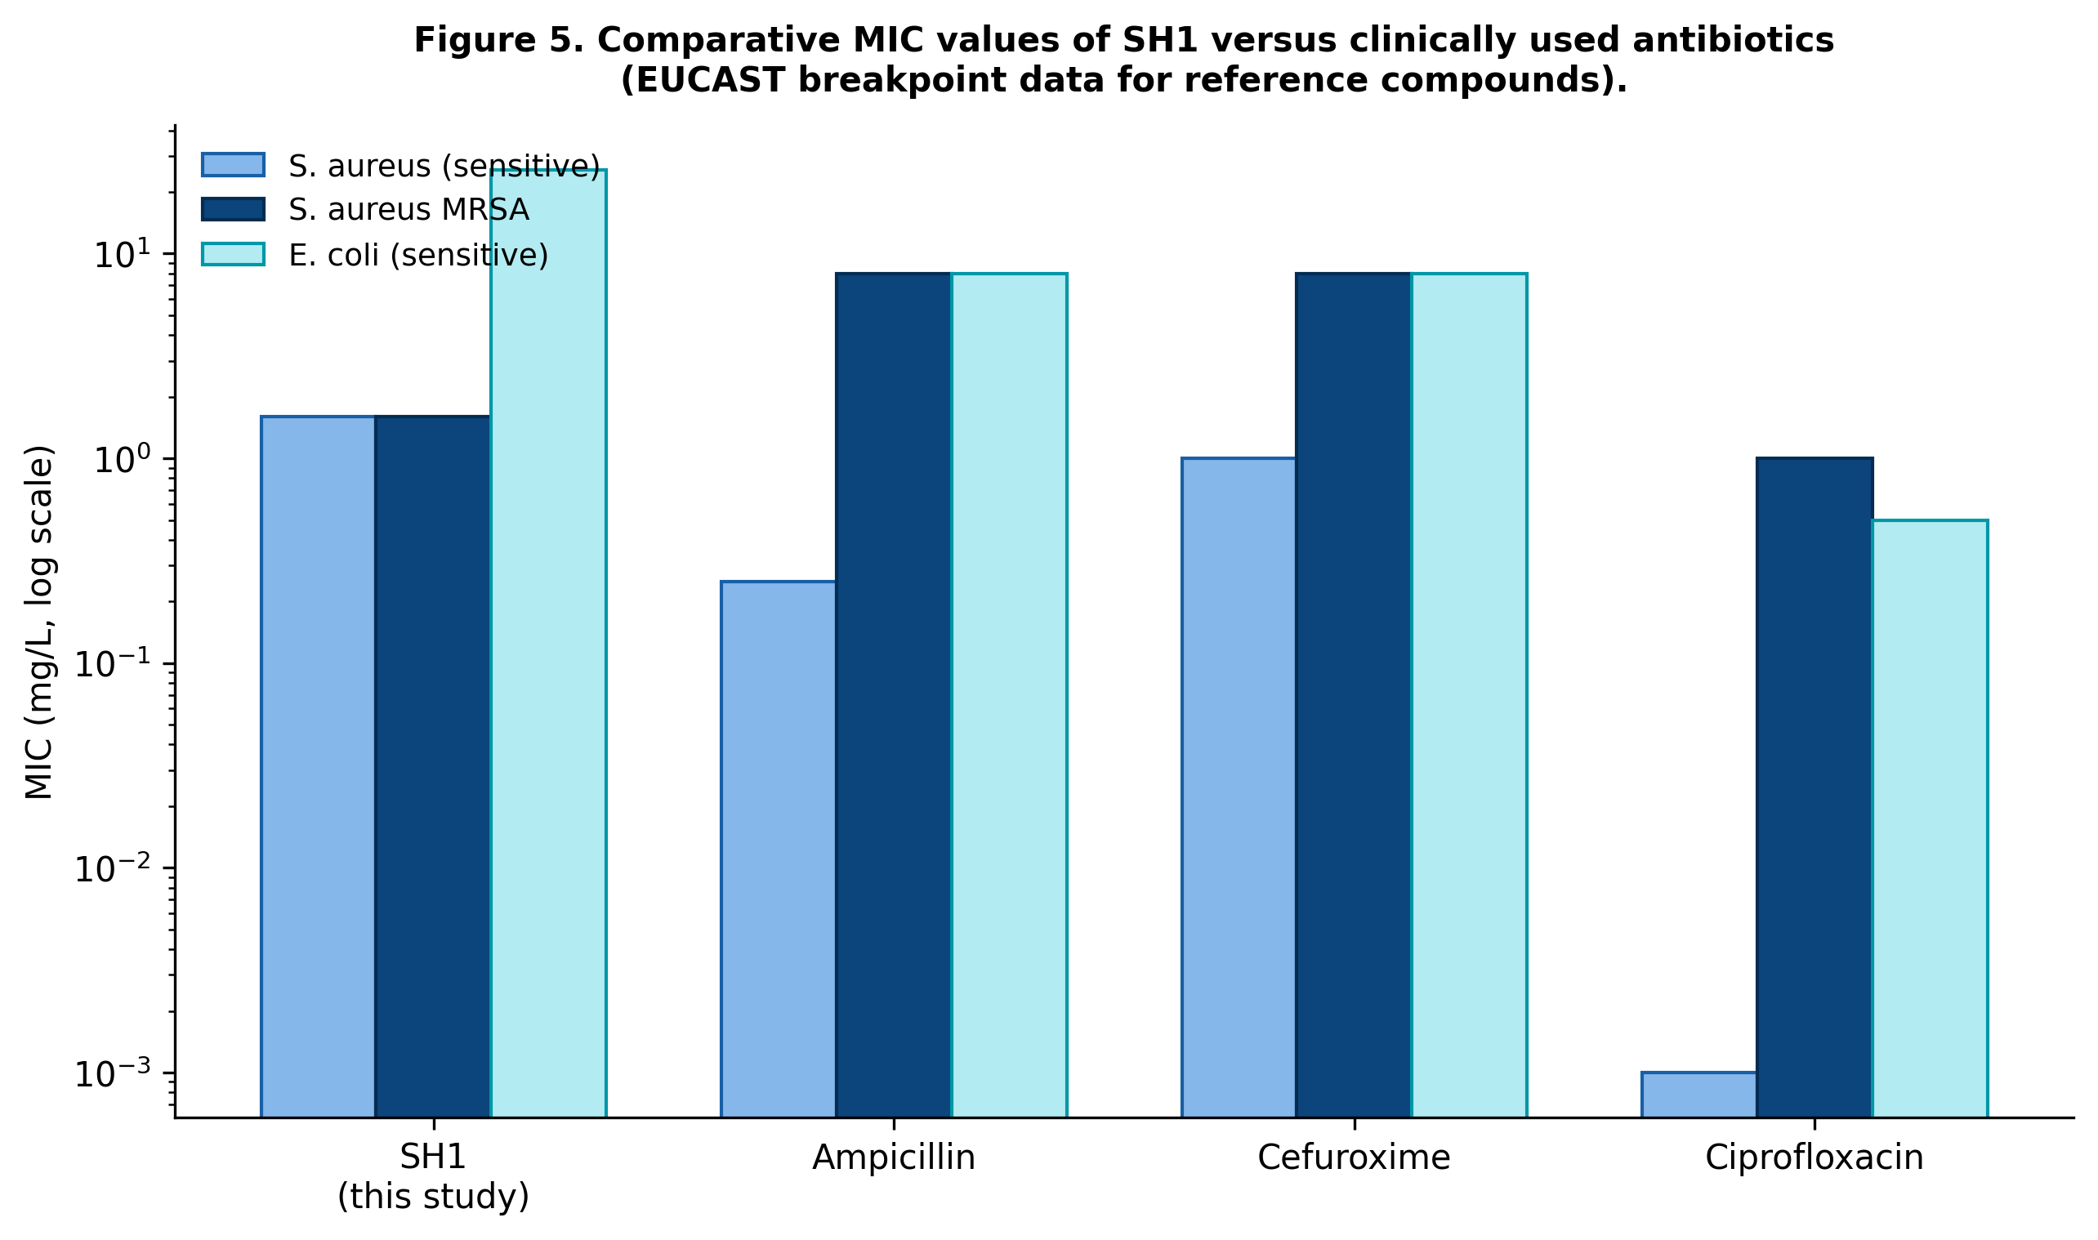
Figure 4. Comparative MIC values (log scale) of SH1 versus clinically used antibiotics against sensitive S. aureus, MRSA and sensitive E. coli, using EUCAST breakpoint data for ampicillin, cefuroxime and ciprofloxacin.
3.5 Structure-Activity Implications and Future Optimisation
The antibacterial activity of SH1 reported here is, to our knowledge, the first such evaluation of this compound and adds a new, repositioned agent to the anthraquinone-DLC structure-activity relationship literature. The result is consistent with the broader pattern established for this pharmacophore class: cationic anthraquinone-DLC conjugates are intrinsically membrane-active against Gram-positive pathogens including MRSA, with comparatively weaker Gram-negative potency attributable to the outer membrane permeability barrier [21,22]. As part of the same synthetic programme, a halogenated anthraquinone-arginine conjugate, VO6 (1-{4-(N-α-L-arginine)amino-butylamino}5-chloroanthraquinone), was synthesised in six steps from 1,5-dichloroanthraquinone and structurally confirmed by high-resolution mass spectrometry (m/z 485.2058, theoretical 485.2062; full synthetic route and characterisation provided in the Experimental Section and Supporting Information, Figure 5). VO6 was designed to test whether ring halogenation and a biogenic cationic amino acid in place of TPP⁺ could further enhance potency and selectivity relative to SH1, drawing on precedent that halogenation enhances anthraquinone antibacterial activity [4,5] and that arginine's guanidinium group supports stable membrane-targeted electrostatic interactions [1]. However, VO6 was predicted by SwissADME and found experimentally to have poor aqueous solubility, and could not be dissolved in DMSO, water or ethanol at concentrations sufficient for antibacterial testing; it is therefore reported here as a synthesised but not yet bioassayed structural analogue, motivating future solubility optimisation (for example by cyclodextrin complexation, alternative salt formation, or polar substituent introduction) rather than as a tested compound. The antibacterial data and structure-activity conclusions of the present study rest entirely on SH1.

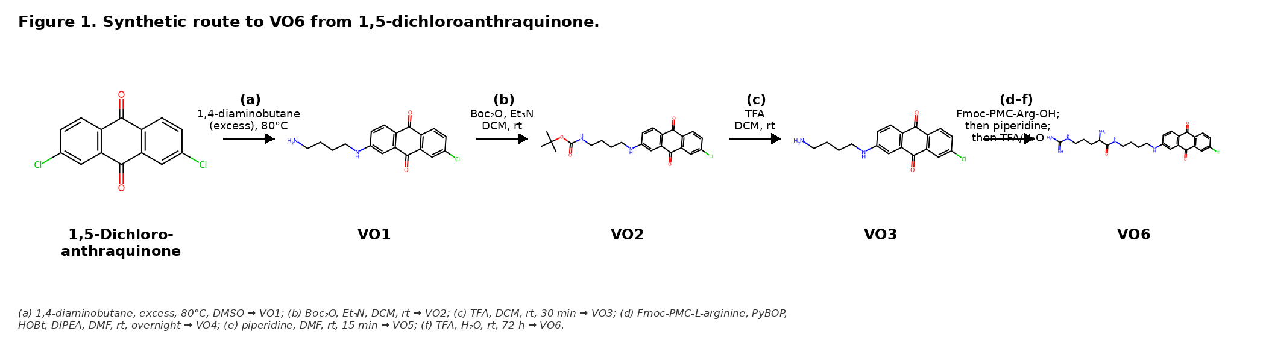
Figure 5. Six-step synthetic route to the halogenated analogue VO6 from 1,5-dichloroanthraquinone, synthesised as part of this programme but not yet evaluated for antibacterial activity due to solubility constraints (see Section 2.4). Boc, tert-butyloxycarbonyl; DCM, dichloromethane; DIPEA, diisopropylethylamine; DMF, dimethylformamide; Fmoc, 9-fluorenylmethoxycarbonyl; HOBt, hydroxybenzotriazole; PMC, 2,2,5,7,8-pentamethylchroman-6-sulfonyl; PyBOP, benzotriazol-1-yl-oxytripyrrolidinophosphonium hexafluorophosphate; TFA, trifluoroacetic acid.

4. Conclusion
This study provides the first antibacterial evaluation of SH1, an anthraquinone–triphenylphosphonium conjugate, against paired antibiotic-sensitive and drug-resistant strains of Staphylococcus aureus and Escherichia coli. SH1 was bactericidal against both S. aureus strains, including methicillin-resistant S. aureus, with an MIC of 1.6 mg/L and an MBC of 3.2 mg/L. It also inhibited and killed both E. coli strains at 25.6 mg/L. The equivalent activity observed within each sensitive–resistant strain pair indicates that the tested resistance phenotypes did not reduce SH1 potency under the assay conditions. Nevertheless, the sixteen-fold higher MIC against E. coli demonstrates substantially weaker activity against the tested Gram-negative organisms. These findings support further investigation of SH1 as an antibacterial lead rather than as a clinically validated agent. Subsequent work should include a larger and more diverse bacterial panel, direct testing against comparator antibiotics, cytotoxicity and selectivity assessment, time-kill and resistance-development studies, mechanistic confirmation, and structural optimisation aimed at improving Gram-negative activity and physicochemical properties.

Strengths and Limitations
The principal strength of this study is that it provides the first reported antibacterial data for SH1, generated using paired sensitive and resistant strains representing a Gram-positive organism (S. aureus) and a Gram-negative organism (E. coli) in EUCAST-aligned broth microdilution assays, with bactericidal activity confirmed by MBC determination in addition to MIC. Benchmarking against EUCAST breakpoint data for clinically used antibiotics provides an immediate clinical frame of reference for the observed potency. This study was limited to four bacterial strains and therefore does not establish the full antibacterial spectrum of SH1. Comparator antibiotics were discussed using published breakpoint information rather than being tested experimentally under identical assay conditions. The study also did not include cytotoxicity testing, selectivity assessment, resistance-development studies, time-kill kinetics, or direct mechanistic confirmation of membrane disruption. In addition, VO6 was synthesised but could not be evaluated biologically because of solubility limitations. These limitations should be addressed before stronger conclusions can be made regarding the therapeutic potential of SH1.

Competing Interest
The author declares that he has no known competing financial interests or personal relationships that could have appeared to influence the work reported in this paper.
Declaration of AI Use

This manuscript was prepared through the combined contributions of all author(s), including contributions to the study design, data, content development, results, interpretation, and related scholarly work. The author(s) acknowledge the use of Grammarly and ChatGPT to assist with grammar checking, language refinement, reference formatting. These AI-assisted tools were not used as authors and did not replace the intellectual contributions or scholarly judgment of the author(s). All AI-assisted outputs, including content, references, and interpretations, were carefully reviewed, revised, verified, and approved by the author(s). The author(s) accept full responsibility for the accuracy, integrity, and final content of the manuscript.

References
- Armstrong, C. T., Mason, P. E., Anderson, J. L. R., & Dempsey, C. E. (2016). Arginine side chain interactions and the role of arginine as a gating charge carrier in voltage-sensitive ion channels. Scientific Reports, 6, Article 21759. https://doi.org/10.1038/srep21759
- Delcour, A. H. (2009). Outer membrane permeability and antibiotic resistance. Biochimica et Biophysica Acta (BBA)–Proteins and Proteomics, 1794(5), 808–816. https://doi.org/10.1016/j.bbapap.2008.11.005
- Dodds, D. R. (2017). Antibiotic resistance: A current epilogue. Biochemical Pharmacology, 134, 139–146. https://doi.org/10.1016/j.bcp.2016.12.005
- Duan, F., Li, X., Cai, S., Xin, G., Wang, Y., Du, D., He, S., Huang, B., Guo, X., Zhao, H., Zhang, R., Ma, L., Liu, Y., Du, Q., Wei, Z., Xing, Z., Liang, Y., Wu, X., Fan, C., . . . Huang, W. (2014). Haloemodin as novel antibacterial agent inhibiting DNA gyrase and bacterial topoisomerase I. Journal of Medicinal Chemistry, 57(9), 3707–3714. https://doi.org/10.1021/jm401685f
- Duan, F., Xin, G., Niu, H., & Huang, W. (2017). Chlorinated emodin as a natural antibacterial agent against drug-resistant bacteria through dual influence on bacterial cell membranes and DNA. Scientific Reports, 7, Article 12721. https://doi.org/10.1038/s41598-017-12905-3
- European Committee on Antimicrobial Susceptibility Testing. (2021). Breakpoint tables for interpretation of MICs and zone diameters (Version 11.0). https://www.eucast.org/fileadmin/eucast/pdf/Document_Archive/bacteria/breakpoint_tables/v_11.0_Breakpoint_Tables.pdf
- Fosso, M. Y., Chan, K. Y., Gregory, R., & Chang, C.-W. T. (2012). Library synthesis and antibacterial investigation of cationic anthraquinone analogs. ACS Combinatorial Science, 14(3), 231–235. https://doi.org/10.1021/co2002075
- GBD 2021 Antimicrobial Resistance Collaborators. (2024). Global burden of bacterial antimicrobial resistance 1990–2021: A systematic analysis with forecasts to 2050. The Lancet, 404(10459), 1199–1226. https://doi.org/10.1016/S0140-6736(24)01867-1
- Hutchings, M. I., Truman, A. W., & Wilkinson, B. (2019). Antibiotics: Past, present and future. Current Opinion in Microbiology, 51, 72–80. https://doi.org/10.1016/j.mib.2019.10.008
- Lambert, P. A. (2002). Cellular impermeability and uptake of biocides and antibiotics in Gram-positive bacteria and mycobacteria. Journal of Applied Microbiology, 92(Suppl. 1), 46S–54S. https://doi.org/10.1046/j.1365-2672.92.5s1.7.x
- Qun, T., Zhou, T., Hao, J., Wang, C., Zhang, K., Xu, J., Wang, X., & Zhou, W. (2023). Antibacterial activities of anthraquinones: Structure–activity relationships and action mechanisms. RSC Medicinal Chemistry, 14(8), 1446–1471. https://doi.org/10.1039/D3MD00116D
- Li, Y., & Jiang, J.-G. (2018). Health functions and structure–activity relationships of natural anthraquinones from plants. Food & Function, 9(12), 6063–6080. https://doi.org/10.1039/C8FO01569D
- Malik, E. M., & Müller, C. E. (2016). Anthraquinones as pharmacological tools and drugs. Medicinal Research Reviews, 36(4), 705–748. https://doi.org/10.1002/med.21391
- Mohammed, O., Hussain, S., Mincher, D., & Turnbull, A. (2016). Design, synthesis and evaluation of novel and clinically used anti-cancer agents targeted to mitochondria [Conference abstract]. European Journal of Cancer, 61(Suppl. 1), S126. https://doi.org/10.1016/S0959-8049(16)61446-6
- Mohr, K. I. (2016). History of antibiotics research. Current Topics in Microbiology and Immunology, 398, 237–272. https://doi.org/10.1007/82_2016_499
- Antimicrobial Resistance Collaborators. (2022). Global burden of bacterial antimicrobial resistance in 2019: A systematic analysis. The Lancet, 399(10325), 629–655. https://doi.org/10.1016/S0140-6736(21)02724-0
- Nicolaou, K. C., & Rigol, S. (2018). A brief history of antibiotics and select advances in their synthesis. The Journal of Antibiotics, 71(2), 153–184. https://doi.org/10.1038/ja.2017.62
- Pankey, G. A., & Sabath, L. D. (2004). Clinical relevance of bacteriostatic versus bactericidal mechanisms of action in the treatment of Gram-positive bacterial infections. Clinical Infectious Diseases, 38(6), 864–870. https://doi.org/10.1086/381972
- Pottz, G. E., Rampey, J. H., & Benjamin, F. (1967). The effect of dimethyl sulfoxide (DMSO) on antibiotic sensitivity of a group of medically important microorganisms: Preliminary report. Annals of the New York Academy of Sciences, 141(1), 261–272. https://doi.org/10.1111/j.1749-6632.1967.tb34888.x
- Reygaert, W. C. (2018). An overview of the antimicrobial resistance mechanisms of bacteria. AIMS Microbiology, 4(3), 482–501. https://doi.org/10.3934/microbiol.2018.3.482
- Shrestha, J. P., Baker, C., Kawasaki, Y., Subedi, Y. P., Vincent de Paul, N. N., Takemoto, J. Y., & Chang, C.-W. T. (2017). Synthesis and bioactivity investigation of quinone-based dimeric cationic triazolium amphiphiles selective against resistant fungal and bacterial pathogens. European Journal of Medicinal Chemistry, 126, 696–704. https://doi.org/10.1016/j.ejmech.2016.12.008
- Surendran, A., Turnbull, A., Flockhart, A., Findlay-Greene, F., Nowosielska, M., Morrison, D., Mincher, D. J., & Donnellan, S. (2024). Design of a new class of broad-spectrum therapeutics targeted to drug-resistant bacteria. All Life, 17(1), Article 2379309. https://doi.org/10.1080/26895293.2024.2379309
- Tacconelli, E., Carrara, E., Savoldi, A., Harbarth, S., Mendelson, M., Monnet, D. L., Pulcini, C., Kahlmeter, G., Kluytmans, J., Carmeli, Y., Ouellette, M., Outterson, K., Patel, J., Cavaleri, M., Cox, E. M., Houchens, C. R., Grayson, M. L., Hansen, P., Singh, N., . . . WHO Pathogens Priority List Working Group. (2018). Discovery, research, and development of new antibiotics: The WHO priority list of antibiotic-resistant bacteria and tuberculosis. The Lancet Infectious Diseases, 18(3), 318–327. https://doi.org/10.1016/S1473-3099(17)30753-3
- Zielonka, J., Joseph, J., Sikora, A., Hardy, M., Ouari, O., Vasquez-Vivar, J., Cheng, G., Lopez, M., & Kalyanaraman, B. (2017). Mitochondria-targeted triphenylphosphonium-based compounds: Syntheses, mechanisms of action, and therapeutic and diagnostic applications. Chemical Reviews, 117(15), 10043–10120. https://doi.org/10.1021/acs.chemrev.7b00042
- Zimorski, V., Ku, C., Martin, W. F., & Gould, S. B. (2014). Endosymbiotic theory for organelle origins. Current Opinion in Microbiology, 22, 38–48. https://doi.org/10.1016/j.mib.2014.09.008
- Muzychka, L. V., Humeniuk, N. I., Boiko, I. O., Vrynchanu, N. O., & Smolii, O. B. (2024). Synthesis and in vitro evaluation of antibacterial and antibiofilm activities of novel triphenylphosphonium-functionalized substituted pyrimidines. Chemical Biology & Drug Design, 103(2), e14483. https://doi.org/10.1111/cbdd.14483
- Alfei, S., Zuccari, G., Bacchetti, F., Torazza, C., Milanese, M., Siciliano, C., Athanassopoulos, C. M., Piatti, G., & Schito, A. M. (2024). Synthesized bis-triphenyl phosphonium-based nano vesicles have potent and selective antibacterial effects on several clinically relevant superbugs. Nanomaterials, 14(16), Article 1351. https://doi.org/10.3390/nano14161351
- Salma, U., Rana, M. S., Ferdous, J., Hossen, M. F., Kudrat-E-Zahan, M., Zamir, R., & Asraf, M. A. (2022). Metal-salen complexes: Structural characterization and antibacterial activity. Asian Journal of Chemical Sciences, 12(4), 45–56. https://doi.org/10.9734/ajocs/2022/v12i4228
- Singh, J. P., Patel, D. P., Ray, D., Tripathy, S., Singh, C., Singh, A. K., Sahu, P. K., & Dipika, K. M. (2025). Evaluation of antimicrobial efficacy of crude venom from the Indian red scorpion (Hottentotta tamulus) against multidrug-resistant pathogens. Uttar Pradesh Journal of Zoology, 46(20), 131–140. https://doi.org/10.56557/upjoz/2025/v46i205308

