Original Research Article
ROS-Induced Lipid Peroxidation and Upregulated Antioxidant activity in Lemna minor under Heavy Metal and Herbicide Stress

.
ABSTRACT
An increase in the concentration of contaminants such as heavy metals and herbicides in aquatic systems through runoff disturbs aquatic ecosystems. The present in vitro study investigates oxidative stress and antioxidant responses in Lemna minor after 96 h of exposure to graded concentrations of cadmium (Cd) (0, 0.1, 0.5, 1, 1.5 and 2 mg/L) and paraquat dichloride (0, 0.5, 1, 1.5, 2 and 2.5 mg/L). Lipid peroxidation, expressed as malondialdehyde (MDA) equivalents, increased under both stressors in a dose-dependent manner (cadmium: +42% to +121%; paraquat: +28% to +200%), indicating increased production of reactive oxygen species (ROS). Activities of major antioxidant enzymes, including superoxide dismutase (SOD), peroxidase (POD), ascorbate peroxidase (APX) and glutathione reductase (GR), generally increased with pollutant concentration, indicating an induced enzymatic defence response. SOD activity was elevated under both cadmium and paraquat exposure, while APX and GR activities gradually increased during treatment. CAT activity increased at low to moderate cadmium concentrations and decreased at the highest cadmium concentration (2 mg/L), which may indicate enzyme inhibition or an overloaded scavenging capacity under severe metal stress. Paraquat caused a consistent increase in CAT activity. Overall, the results show that L. minor initiates a coordinated antioxidant response to diminish ROS generated by cadmium and paraquat exposure, but very high metal stress may impair specific defences. These results suggest the potential of L. minor as a bioindicator of pollutant-induced oxidative stress. Furthermore, the antioxidant responses to Cd and paraquat dichloride may inform its use in phytoremediation studies.

Keywords: Lemna minor, Cadmium, Paraquat dichloride, Oxidative stress, Antioxidant enzymes, Bioindicator.

1. INTRODUCTION
Water is crucial for agriculture, industry and human well-being. However, over the last few decades, industrialisation, urbanisation, wastewater discharge and unchecked agricultural activities have led to overexploitation of natural resources and serious water pollution. Human activities continuously introduce heavy metals and pesticides at levels that are harmful to human health (Zhang et al., 2009; Ishaq & Khan, 2013; Arora et al., 2018). Point-source contaminants are generated by industrial activities, such as metal smelting and mining, whereas non-point-source pollutants are derived from agricultural runoff, including fertilisers and pesticides (D. Kumar et al., 2018). Each pollutant affects plants and animals in different ways, but the entry of heavy metals and pesticides into aquatic ecosystems is an increasing problem. Flora and fauna assimilate highly toxic heavy metals such as lead (Pb), mercury (Hg), arsenic (As), copper (Cu), zinc (Zn) and cadmium (Cd). Heavy metals in soils, aquatic systems and biota are naturally derived through rock degradation, volcanic activity, wildfire, biological processes and marine salts from the oceans (Shahzad et al., 2024; Zaynab et al., 2022). However, anthropogenic activities such as mining, industrial processes, agriculture, waste disposal, biosolid addition, pesticide application, coal-burning residues and petrochemical compounds have increased the levels of these metals, causing considerable worldwide concern (Wuana & Okieimen, 2011). The amounts of heavy metals in volcanic rocks or ash vary. Copper, lead and zinc are generally found at concentrations of 1.2–47.8 μg g⁻¹, 8.4–36 mg kg⁻¹ and 15–73 mg kg⁻¹, respectively. Cadmium concentrations in volcanic rocks are in the range of 0.1-0.5 ppm, while those in oceanic waters span from <5 to 110 ng L⁻¹ (Novoselov et al., 2022; Torres et al., 2023). Anthropogenic sources release higher concentrations of heavy metals because they emit large volumes of these pollutants in more dangerous and mobile forms. This is especially relevant in aquatic ecosystems, where heavy metals can remain for long periods in suspended matter, sediment layers, aquatic vegetation and fish (Kolarova & Napiórkowski, 2021). Most metals introduced into an aquatic system are adsorbed onto suspended particles and precipitated into sediments. Cadmium is ranked third on the 2025 ATSDR Substance Priority List (Agency for Toxic Substances and Disease Registry [ATSDR], 2026). Bioremediation is an eco-friendly decontamination method that uses microorganisms (Andreazza et al., 2011), mainly plants (phytoremediation) (Afonso et al., 2019; Xin et al., 2020), or a combination of both methods (Islam et al., 2014) to remove metals from soil and water. Aquatic plants such as Lemna minor (Jayasri & Suthindhiran, 2017) and Hydrocotyle ranunculoides (Demarco et al., 2023) are suitable species for phytoremediation. Recent work with aquatic macrophytes has likewise demonstrated cadmium removal and accumulation from contaminated water, supporting their use in metal phytoremediation (Maurya et al., 2025). Under ideal conditions, Lemna minor can double its biomass within a few days, is highly adaptable to a wide pH range and shows considerable tolerance to abiotic factors (Sosa et al., 2024). Lemna minor has demonstrated potential for removing heavy metals from liquids, producing bioethanol and contributing to a circular economy (Shafiq et al., 2026; Obando et al., 2026). Additionally, it thrives in nutrient-rich waters and plays a major role in regulating the pH of aquatic systems (Sharba et al., 2024). Pesticides, including endosulfan, dichlorodiphenyltrichloroethane (DDT), mevinphos, ethion and copper sulfate, are highly harmful to flora and fauna (D. Kumar et al., 2016; N. Kumar et al., 2018). Duckweeds can help address a major modern environmental problem, namely contamination of the hydrosphere with harmful substances (Ziegler et al., 2016). Duckweeds are macrophytes that can take up heavy metals from water and are used to remove heavy metals from aquatic environments (Rai, 2009). Cadmium (Cd) pollution is a major global environmental problem because of rapid industrial development and the extensive use of chemical fertilisers, pesticides and herbicides in agriculture (Folgar et al., 2009). The contaminants indicated above could biomagnify in food and may be harmful to human health (Miretzky et al., 2004). Metals such as lead (Pb), mercury (Hg) and cadmium (Cd) are non-essential and highly toxic even at low concentrations (Nagajyoti et al., 2010; Prasad, 2011; Chibuike & Obiora, 2014; Rezania et al., 2016). Cadmium toxicity leads to oxidative stress, which damages cell membranes and electron transport, disrupts enzyme activity, and interferes with nucleic acids and photosynthesis, ultimately reducing development (Sarkar et al., 1998; Lu et al., 2010). Consistent with this response pattern, cadmium-stressed duckweeds have shown increased malondialdehyde and antioxidant enzyme activities together with inhibited growth and reduced chlorophyll content (Cao et al., 2025). Recent work in L. minor under combined contaminant exposure further reported increased ROS markers and antioxidant enzyme activities alongside reduced biomass and photosynthetic pigments (Farid et al., 2026). Oxidative stress is usually associated with excessive accumulation of reactive oxygen species such as the superoxide ion (O₂⁻), hydrogen peroxide (H₂O₂) and hydroxyl radical (OH⁻), which facilitate the conversion of fatty acids into harmful lipid peroxides and endanger biological membranes (Weckx et al., 1996; Martín-Closas et al., 2017; Marron, 2015; Rai et al., 2016). A recent synthesis also identifies excessive ROS formation relative to antioxidant capacity as a central mechanism of pollutant-associated oxidative stress (Marcel et al., 2025). In contrast, non-radical reactive oxygen species (ROS), such as hypochlorous acid (HOCl), hydrogen peroxide (H₂O₂), singlet oxygen ⁽¹O₂) and peroxynitrite (ONOO⁻), are generally stable and have a long half-life. The most reactive type of oxygen species is the superoxide anion (O₂⁻). Hydrogen peroxide (H₂O₂) is produced by the rapid one-electron reduction of molecular oxygen, either spontaneously or through the dismutation of the superoxide anion catalysed by superoxide dismutase (SOD) (Balakhnina et al., 2005; Zhang et al., 2009). Herbicides also increase ROS levels. Methyl viologen, also known as 1,1′-dimethyl-4,4′-bipyridinium dichloride, is an organic broad-spectrum herbicide generally referred to as paraquat (PQ) and used to manage weeds and grasses. It acts rapidly in plants but is highly dangerous to humans and animals (Peacock, 1978). PQ is harmful to cellular health because it disrupts the redox cycle by accepting and donating electrons (Homer et al., 1960). Reactive oxygen species (ROS) accumulate in chloroplasts and damage proteins, enzymes and lipid membranes. PQ also limits the availability of NADPH, an essential component of the Calvin Cycle in plants (Perales-Vela et al., 2021). PQ inhibits photosynthesis, creates severe oxidative stress in cells, alters the enzymatic framework, causes cell death and ultimately causes plant death. A specific gap addressed in this study is the limited comparative characterisation, within a common short-term experimental framework, of lipid peroxidation and SOD, POD, CAT, APX and GR responses in L. minor exposed to graded cadmium and paraquat dichloride. In the present study, we investigated changes in antioxidant enzyme activity and oxidative stress generated by cadmium and paraquat dichloride in the duckweed species Lemna minor, a plant used in the phytoremediation of polluted surface waters.

2. Material and methods
2.1. Plant material
Samples of Lemna minor were collected from the surface water of a pond at Roxburgh Botanical Garden, Department of Botany, University of Allahabad, Prayagraj, Uttar Pradesh, India (25° 27’ 42.2352” N, 81°5’ 7.278” E). The plant samples were authenticated by the Botanical Survey of India, Central Regional Center, Prayagraj, Uttar Pradesh, India.
The plants were then washed several times to ensure thorough cleaning before the roots and fronds were transferred into 250 ml flasks containing half-strength Hutner's medium (Brain & Solomon, 2007). The pH was adjusted to [ 6.5 ± 0.1] using KOH/HCl before sterilization and use in the experiment with 10 g of sucrose. Cultures were incubated in the growth chamber at 25°C under cold fluorescent light (constant light intensity 6,800 lux; ASTM International, 1998) for 24–48 h. A stock solution of 1000 ppm cadmium was prepared as CdCl₂ (MW=183.32 g mol⁻¹; purity=99%; Sigma Aldrich). Paraquat dichloride (24% SL) was purchased as All Clear (chemical fertilizer) from HPM Chemicals & Fertilizers Ltd, Pitampura, New Delhi. From this stock solution, aliquots of different concentrations of cadmium (0.1, 0.5, 1.0, 1.5 and 2.0 mg/L) and paraquat dichloride (0.5, 1.0, 1.5, 2.0 and 2.5 mg/L) were prepared in 100 ml flasks containing nutrient medium. The flasks containing the plants were then incubated in a plant growth chamber for 4 days. After 4 days, the plants were screened for changes in metabolic activity, including oxidative stress and antioxidant activity.
2.2. Oxidative stress
2.2.1. Lipid peroxidation assay
Lipid peroxidation was evaluated as malondialdehyde (MDA) equivalents according to the method of Heath and Packer (1968). One hundred milligrams of plant material were ground into a fine powder and extracted in 1 mL of 0.1% trichloroacetic acid (TCA). The extract was centrifuged in an Eppendorf centrifuge 5920 R for 15 min at 10,000 × g at 4 °C. The supernatant was then mixed with 0.5% TBA and 20% TCA. The mixture was heated at 95°C for 30 min and then rapidly cooled on ice. Absorbance at 532 and 600 nm was measured using a UV-VIS spectrophotometer (Schimadzu, Japan). The concentration of MDA equivalents was calculated using an extinction coefficient of 155 mM⁻¹ cm⁻¹ and expressed as nmol g⁻¹ FW.
2.3. Antioxidant enzyme activity
2.3.1. Superoxide dismutase (SOD) activity
The activity of superoxide dismutase (SOD; EC 1.15.1.1) was estimated by measuring the inhibition of nitro blue tetrazolium-chloride (NBT) reduction using the method described by Giannopolitis and Ries (1977). Each sample (100 mg of plant material) was homogenised with 100 mM EDTA—phosphate buffer (pH 7.8) under ice-cold conditions for the extraction and assay of the SOD enzyme. The homogenate was centrifuged at 10,000 g for 20 min, and the supernatant was used for the enzyme assay. The assay was carried out in a total volume of 3 ml containing 1.3 mM riboflavin, 13 mM L-methionine, 0.05 M Na₂CO₃ (pH 10.2), 63 µM NBT and 0.1 ml crude extract. Test tubes containing a similar reaction mixture were irradiated (100 mol photon m⁻² s⁻¹) for 20 min, and absorbance was recorded at 560 nm.

2.3.2. Catalase (CAT) activity

The plant material (100 mg) was homogenised in 1 ml of 50 mM PPB + 1 mM EDTA (pH 7.0). The supernatant was collected and used for the catalase activity assay after centrifugation at 10,000 g for 15 min. The reaction mixture consisted of 0.5 ml 40 mM H₂O₂ and 1.3 ml 50 mM potassium phosphate buffer (pH 7.0) containing 1 mM EDTA. The reaction was started by adding 0.2 ml crude extract. The absorbance of the solution was measured at 240 nm after one minute at room temperature. The amount of H₂O₂ consumed was determined using the extinction coefficient (ε=39.4 mM⁻¹ cm⁻¹). One unit of CAT activity is defined as the amount of enzyme decomposing 1 nmol H₂O₂ min⁻¹ (Aebi, 1984).

2.3.3. Peroxidase (POD) activity

One hundred milligrams of fresh plant material was homogenised in 2 ml of 50 mM PPB, pH 6.1. The crude enzyme extract was obtained from the supernatant after centrifugation of the homogenate at 10,000 g. Peroxidase activity was measured using guaiacol as the substrate in a total volume of 3 ml. The reaction mixture contained 50 mM PPB (pH 6.1), 1% guaiacol, 0.4% H₂O₂ and enzyme extract. The increase in absorbance at 470 nm was due to the oxidation of guaiacol (ε=25.5 mM⁻¹ cm⁻¹). One unit of POD activity corresponds to the amount of enzyme needed to oxidise 1 nmol of guaiacol min⁻¹ (Zhang, 1992).

2.3.4. Ascorbate peroxidase (APX) activity

Plant material (100 mg) was homogenised in 1 ml of ice‐cold 50 mM potassium phosphate buffer (pH 7.0) containing 1 mM EDTA and 1 mM ascorbate. The mixture was centrifuged for 15 min at 10,000 g. The resulting supernatant was stored in potassium phosphate buffer and used to estimate ascorbate peroxidase activity. The reaction mixture consisted of 0.5 ml 0.4 mM H₂O₂, 0.5 ml 2 mM ascorbate, 0.8 ml 50 mM potassium phosphate buffer, pH 7.0 and 0.2 ml crude extract. The reaction was initiated by adding the enzyme extract. The absorbance of the solution was recorded at 290 nm for one minute at 25°C using a UV—VIS spectrophotometer (Schimadzu, Japan). Ascorbate peroxidase activity was quantified using the extinction coefficient (ε=2.8 mM⁻¹ cm⁻¹). One unit of APX activity was defined as the amount of enzyme that oxidises 1 nmol of ascorbate min⁻¹ (Nakano & Asada, 1981).

2.3.5. Glutathione reductase (GR) activity

The activity of glutathione reductase (GR; EC 1.6.4.2) was determined as described by Schaedle and Bassham (1977). Homogenised leaves (100 mg), treated and untreated, were kept at 4 °C with 1 ml of cooled potassium phosphate buffer (2 mM EDTA, pH 7.8), and the leaves were centrifuged for 15 min at 10,000 g. The resulting supernatant was used for the assay of glutathione reductase activity. The reaction mixture contained 0.8 ml of 50 mM potassium phosphate buffer (pH 7.8) containing 2 mM EDTA, 0.5 ml of 2 mM GSSG, 0.2 ml of crude extract and 0.5 ml of 0.6 mM NADPH. The reaction began with the addition of NADPH. The decrease in absorbance was followed at 340 mM for 1 min at 25 ºC using a UV-VIS spectrophotometer (Schimadzu, Japan). GR activity was calculated using the extinction coefficient of 6.2 mM-1 cm⁻¹. One unit of GR activity is the amount of enzyme required to oxidise one nmol of NADPH per minute.

2.4. Statistical analysis
The significance of differences between the control and treatment means was analysed using one-way ANOVA followed by Tukey’s post hoc analysis in SPSS version 16 (SPSS Inc., 2007), and graphs were prepared using SigmaPlot version 10 (Systat Software, Inc., 2006).

3. Results and discussion

3. Results
3.1. Oxidative stress
3.1.1. Lipid peroxidation
We measured the malondialdehyde (MDA) equivalents in the duckweed species Lemna minor to determine the extent of ROS-induced lipid peroxidation. Duckweed was exposed to various concentrations of cadmium for 96 h (Figure (1A)). After 96 h of treatment, the MDA equivalent content in Lemna minor increased with increasing cadmium concentration. The MDA equivalent content of Lemna minor increased by 42%, 67%, 79.17%, 100% and 121% in the presence of cadmium concentrations of 0.1, 0.5, 1.0, 1.5 and 2 mg/L, respectively. Figure (1B) showed an increase in MDA equivalent content in Lemna minor after 96 hours of exposure to the herbicide paraquat dichloride (0 mg/L to 2.5 mg/L). The MDA equivalent content in Lemna minor increased by 28%, 96%, 175%, 196% and 200% at paraquat dichloride concentrations of 0.5 mg/L, 1 mg/L, 1.5 mg/L, 2 mg/L and 2.5 mg/L, respectively.

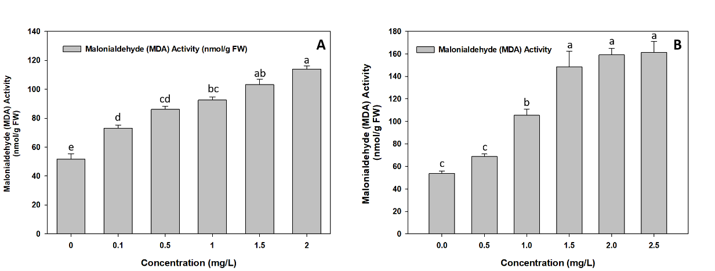
Figure. 1 Malondialdehyde (MDA) Activity (nmol/gm FW (Fresh weight) after 4th day of treatment) in Lemna minor (A) cadmium (Tukey HSD p value for non-homogenous group a = 0.138, b = 0.238, c = 0.589, and d = 0.056 whereas e < 0.05 represent homogenous group) (B) paraquat dichloride (Tukey HSD p value for non-homogenous group a = 0.679, and c = 0.538 whereas b < 0.05 represent homogenous group). Data are means ± SE.

3.2. Antioxidant activity

3.2.1. Superoxide dismutase (SOD) activity
Figure (2A) shows the results of the SOD activity assay in the duckweed species Lemna minor after 96 hours of exposure to different cadmium concentrations. SOD activity in Lemna minor increased by 45%, 53%, 60%, 68% and 80% at cadmium (Cd) concentrations of 0.1, 0.5, 1, 1.5 and 2 mg/L, respectively, within the 0 to 2 mg/L range. After 96 hours of treatment with different concentrations of the herbicide paraquat dichloride, Lemna minor showed higher SOD activity, as shown in Figure (2B). At paraquat dichloride concentrations of 0.5, 1, 1.5, 2 and 2.5 mg/L, SOD activity in Lemna minor increased by 4%, 8%, 35%, 31.25% and 47%, respectively.

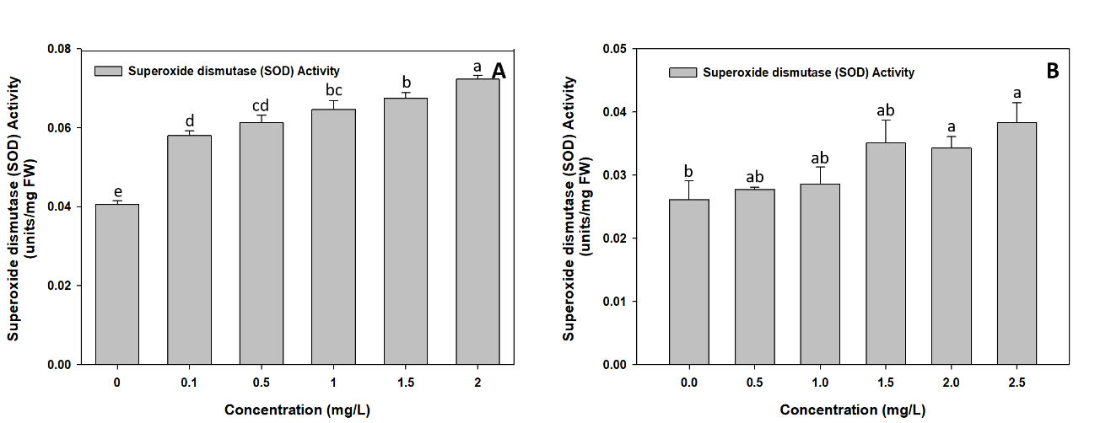
Figure. 2 Superoxide dismutase (SOD) Activity (units/mg FW (fresh weight after 4th day of treatment) in Lemna minor (A) cadmium (Tukey HSD p value for non-homogenous group b = 0.266, c = 0.143, and d = 0.141 whereas a and e = <0.05 represent homogenous groups) (B) paraquat dichloride (Tukey HSD p value for non-homogenous group a = 0.091, and b = 0.088). Data are means ± SE.

3.2.2. Peroxidase (POD) activity
Figure (3A) shows the data for POD activity. Different cadmium concentrations in the duckweed species Lemna minor after 96 hours of treatment led to a marked increase in POD activity. POD activity in Lemna minor increased by 0.17%, 57.49%, 75%, 92.30% and 97.56% at cadmium concentrations of 0.1, 0.5, 1, 1.5 and 2 mg/L, respectively, over the 0 to 2 mg/L range. Figure (3B) shows that different concentrations of the herbicide paraquat dichloride in the duckweed species Lemna minor after 96 hours of treatment led to higher POD activity. At higher concentrations, i.e., 2 and 2.5 mg/L, POD activity increased significantly in Lemna minor. POD activity in Lemna minor increased by 3%, 4.01%, 8.40%, 27% and 41.44% at paraquat dichloride concentrations of 0.5 mg/L, 1 mg/L, 1.5 mg/L, 2 mg/L and 2.5 mg/L, respectively.
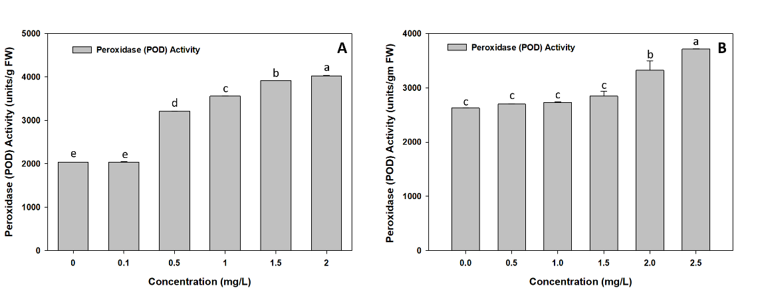
Figure. 3 POD (Peroxidase) Activity (units/gm FW (fresh weight) after 4th day) in Lemna minor (A) cadmium (Tukey HSD p value for non-homogenous group e = 0.997 whereas a, b, c, and d < 0.05 represent homogenous groups) (B) paraquat dichloride (Tukey HSD p value for non-homogenous group c = 0.428 whereas a and b < 0.05 represent homogenous groups). Data are means ± SE.
3.2.3. Catalase (CAT) activity
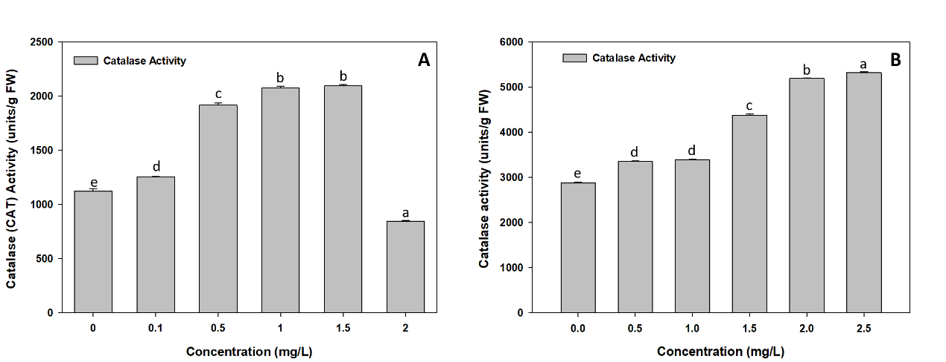
Figure (4A) shows the results for CAT activity in the duckweed species Lemna minor after 96 hours of treatment with different cadmium concentrations. The results indicated increased activity at cadmium concentrations of 0.1, 0.5, 1 and 1.5 mg/L in Lemna minor; however, at 2 mg/L, activity declined. At cadmium concentrations of 0.1, 0.5, 1, 1.5 and 2 mg/L in Lemna minor, activity increased by 12%, 71%, 85% and 86.36%, but then decreased by 25%. Figure (4B) shows that the duckweed species Lemna minor had higher CAT activity after exposure to different concentrations of the herbicide paraquat dichloride for 96 hours. The findings demonstrate that at paraquat dichloride concentrations of 0.5 mg/L, 1 mg/L, 1.5 mg/L, 2 mg/L and 2.5 mg/L in Lemna minor, activity increased by 16.39%, 18%, 52.05%, 80.44% and 85%, respectively.
Figure. 4 Catalase (CAT) Activity (units/gm FW (fresh weight) after 4th day of treatment) in Lemna minor (A) cadmium (Tukey HSD p value for non-homogenous group b = 0.879 whereas a, c, d, and e < 0.05 represent homogenous groups) (B) paraquat dichloride (Tukey HSD p value for non-homogenous group d = 0.498 whereas a, b, c, and e < 0.05 represent homogenous groups]). Data are means ± SE.
3.2.4. Ascorbate peroxidase (APX) activity
Figure (5A) shows the results for APX activity in the duckweed species Lemna minor. Changes in cadmium concentration had a marked effect on Lemna minor. Across the cadmium concentration range of 0 to 2 mg/L, APX activity increased as cadmium levels rose. After 96 hours of treatment, activity increased significantly by 4%, 7%, 40.29%, 49.27% and 64.16% at concentrations of 0.1, 0.5, 1, 1.5 and 2 mg/L, respectively. A similar upward trend was observed in Lemna minor exposed to paraquat dichloride concentrations between 0 and 2.5 mg/L, with activity increasing at higher paraquat dichloride concentrations, as shown in Figure (5B). After 96 hours of treatment, activity increased significantly by 5.09%, 40%, 46%, 68% and 99% at concentrations of 0.5, 1, 1.5, 2 and 2.5 mg/L, respectively.
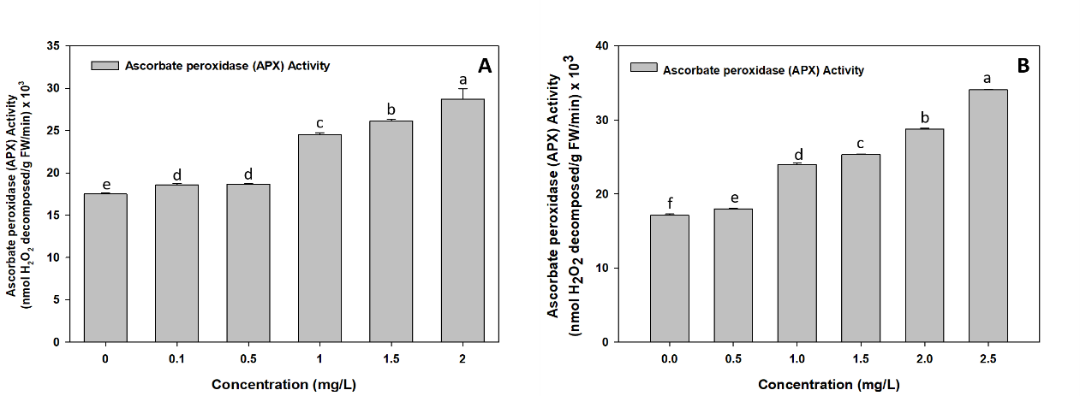
Figure. 5 Ascorbate peroxidase (APX) Activity (nmol H₂O₂ decomposed/gm (fresh weight) FW/min *10³ after 4th day of treatment) in Lemna minor (A) cadmium (Tukey HSD p value for non-homogenous group d = 0.999 whereas a, b, c, and e < 0.05 represent homogenous groups) (B) paraquat dichloride (Tukey HSD p value for a, b, c, d, e, and f < 0.05 represent homogenous groups). Data are means ± SE.

3.2.5. Glutathione reductase (GR) activity
Figure (6A) shows the results for GR activity in the duckweed species Lemna minor. Different cadmium concentrations had a marked effect on Lemna minor. Across the cadmium concentration range of 0 to 2 mg/L, GR activity increased as cadmium levels rose. After 96 hours of treatment, activity increased significantly by 23%, 26%, 36.11%, 37% and 65% at concentrations of 0.1, 0.5, 1, 1.5 and 2 mg/L, respectively. Lemna minor exhibited a comparable upward trend under herbicide exposure, as shown in Figure (6B). Across the paraquat dichloride concentration range of 0 to 2.5 mg/L, GR activity increased with increasing paraquat dichloride levels. After 96 hours of treatment, activity increased significantly by 6.11%, 10.29%, 25%, 49% and 51.12% at concentrations of 0.5 mg/L, 1 mg/L, 1.5 mg/L, 2 mg/L and 2.5 mg/L, respectively.
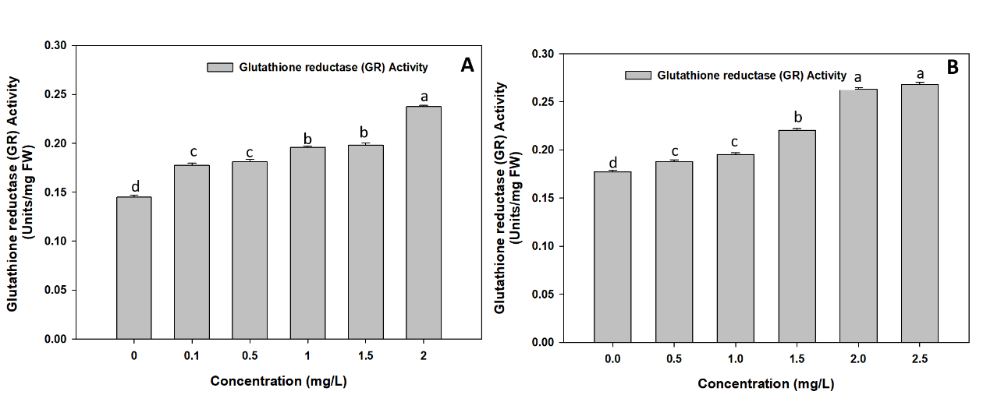
Figure. 6 Glutathione Reductase (GR) Activity (units/mg FW (fresh weight) after 4th day of treatment) in Lemna minor (A) cadmium (Tukey HSD p value for non-homogenous group b = 0.979, and c = 0.789 whereas a, and d < 0.05 represent homogenous groups) (B) paraquat dichloride (Tukey HSD p value for non-homogenous group a = 0.490, and c = 0.092 whereas b, and d < 0.05 represent homogenous groups). Data are means ± SE.

Table 1. Cadmium stress on Lemna minor antioxidant activity and oxidative stress.

Concentration  (mg/L) | Superoxide dismutase (SOD) Activity (units/mg FW) | Peroxidase (POD) Activity (units/g FW) | Catalase (CAT) Activity (units/g FW) | Ascorbate peroxidase (APX) Activity (nmol H₂O₂/g FW/min ×10³) | Glutathione Reductase (GR) Activity (Units/mg FW) | Malondialdehyde MDA (nmol/g FW)
0 | 0.040  ±0.01 | 2037.47  ±5.30 | 1124.0  ±18.84 | 17.492  ±0.10 | 0.144  ±0.01 | 51.6  ±3.73
0.1 | 0.058  ±0.01 | 2041  ±7.98 | 1255.4  ±3.38 | 18.111  ±0.27 | 0.177  ±0.02 | 73.1  ±2.15
0.5 | 0.061  ±0.01 | 3208.71  ±4.61 | 1918.7  ±15.50 | 18.650  ±0.14 | 0.181  ±0.02 | 86.00  ±2.15
1.0 | 0.064  ±0.02 | 3557.298  ±11.42 | 2074.4  ±16.14 | 24.539  ±0.29 | 0.196  ±0.01 | 92.45  ±2.15
1.5 | 0.067  ±0.01 | 3918.08  ±2.30 | 2094.7  ±11.84 | 26.111  ±0.29 | 0.197  ±0.02 | 103.2  ±3.72
2.0 | 0.072  ±0.01 | 4025.27  ±7.13 | 846.02  ±6.77 | 28.714  ±0.25 | 0.237  ±0.01 | 113.95  ±2.15

Table 2. Paraquat dichloride stress on Lemna minor antioxidant activity and oxidative stress.

Concentration  (mg/L) | Superoxide dismutase (SOD) Activity (units/mg FW) | Peroxidase (POD)Activity (units/g FW) | Catalase (CAT) Activity (units/g FW) | Ascorbate peroxidase (APX) Activity (nmol H₂O₂/g FW/min ×10³) | Glutathione Reductase (GR) Activity (Units/mg FW) | Malondialdehyde (MDA)  (nmol/g FW)
0 | 0.026  ±0.002 | 2626.58  ±4.611 | 2879.865  ±16.141 | 17.142  ±0.164 | 0.177  ±0.001 | 53.75  ±2.15
0.5 | 0.027  ±0.000 | 2698.039  ±10.884 | 3351.95  ±11.844 | 18.015  ±0.057 | 0.187  ±0.001 | 69.000  ±2.15
1.0 | 0.028  ±0.002 | 2732.026  ±12.354 | 3390.86  ±8.792 | 23.984  ±0.183 | 0.195  ±0.001 | 105.35  ±5.688
1.5 | 0.035  ±0.003 | 2847.059  ±90.448 | 4379.02  ±22.383 | 25.333  ±0.072 | 0.220  ±0.001 | 148.35  ±14.098
2.0 | 0.034  ±0.001 | 3323.747  ±174.345 | 5196.277  ±4.476 | 28.777  ±0.082 | 0.263  ±0.001 | 159.1  ±5.688
2.5 | 0.038  ±0.003 | 3715.033  ±5.442 | 5323.181  ±19.948 | 34.063  ±0.082 | 0.267  ±0.002 | 161.25  ±9.852

Discussion
The present study demonstrates that both cadmium (Cd) and paraquat dichloride (PQ) induce a dose-dependent enzymatic response in Lemna minor. Heavy metals cause substantial lipid peroxidation that can be initiated by reactive oxygen species (O•⁻², OH• and ¹O₂) or lipoxygenase (Singh et al., 2006). The highest MDA content was observed in Lemna plants treated with Cd on the 4th day of the experiment. This indicates that the metal caused oxidative damage. Cd toxicity leads to oxidative stress, as previously reported (Singh et al., 2006; Gratão et al., 2008; Tkalec et al., 2008). The marked increase in MDA equivalents observed here after exposure to paraquat suggests the possibility of an oxidative mode of phytotoxicity for this herbicide. Increased MDA levels are an indicator of membrane damage, which can lead to functional impairment of the cell, growth arrest and potentially plant death if antioxidant defences are overwhelmed (Haro Girón et al., 2023). Monitoring MDA levels may help in assessing environmental risk and the effects of agrochemicals on aquatic ecosystems through oxidative stress. Plant responses to ROS are governed by various pathways involving antioxidant enzymes. Superoxide dismutases (SODs) catalyse the dismutation of superoxide (O₂•−) to molecular oxygen and hydrogen peroxide, protecting cells against superoxide toxicity (Cakmak, 2005). In Lemna minor, short-term Cd exposure strongly inhibits CAT relative to other antioxidant enzymes, and total antioxidative potential collapses at higher Cd levels, consistent with a transition from compensated to decompensated oxidative stress. Microalgae and other aquatic plants show comparable trends, with initial upregulation of CAT followed by suppression as Cd accumulates and cellular damage progresses (Farias et al., 2024; Razinger et al., 2008). Catalases (CAT) and peroxidases (APX and GPX) decompose H₂O₂ to H₂O and O₂. GR activity was significantly increased at high Cd concentrations, in agreement with recent data in duckweed and other aquatic plants, where GR activity is strongly enhanced as part of a general antioxidative response. The ability of the plant to cope with acute oxidative stress caused by metals is associated with increased GR activity (Li et al., 2018; Yang et al., 2023; Moravčíková & Žiarovská, 2023). The dose-dependent increase in antioxidant enzyme activities indicates that Lemna minor is efficient in scavenging reactive oxygen species (ROS). The marked elevation of SOD in Lemna minor confirms its role as a sensitive biomarker of herbicide toxicity (Manna et al., 2020). Paraquat induces oxidative stress through redox cycling and reactive oxygen species (ROS) generation (Donaher & Van den Hurk, 2023). An increase in SOD activity from 6.25% to 47% was observed. This is compatible with the sensitivity of aquatic plants (EC50 = 28–280 μg/L). A high SOD response at low paraquat concentrations (0.5-2.5 mg/L) indicates the high toxicity of this chemical (Donaher & Van den Hurk, 2023). At higher paraquat concentrations (2 and 2.5 mg/L), significant increases in POD activity were observed in Lemna minor, indicating an active antioxidant response to reduce cellular damage caused by reactive oxygen species (ROS). The increase in POD activity is probably an attempt to protect the plant from oxidative damage caused by paraquat. As the concentration of paraquat dichloride increased, CAT activity in Lemna minor increased significantly (16.39%-85%). According to Tagun (2014), increased CAT activity is a common self-protection mechanism in plants. It catalyses the breakdown of hydrogen peroxide, a by-product of reactive oxygen species (ROS), thereby protecting cells from oxidative damage. Lemna minor has been found to be very sensitive to paraquat, and its growth is rapidly inhibited with the occurrence of physiological changes (Tagun, 2014). Increasing paraquat dichloride exposure in Lemna minor increased ascorbate peroxidase (APX) activity. APX expression is differentially regulated during normal plant growth and development and in response to environmental stresses (Pandey et al., 2017). Cellular stress causes a rapid disturbance of the redox balance and accumulation of reactive oxygen species (Halliwell, 2006). The level of APX expression (Tang et al., 2006) is directly related to the duration and intensity of stress and to different types of stress. GR plays a very important role in the cellular scavenging system that eliminates reactive oxygen species (ROS) in plants. It uses NADPH as an electron donor to reduce oxidised glutathione or glutathione disulfide (GSSG) to reduced glutathione (GSH). This process is required to maintain cellular redox levels by keeping the GSH/GSSG ratio low in cells under normal or oxidative stress (Anjum et al., 2012). The present study suggests an increase in GR activity, which is consistent with the findings of other studies.

4. Conclusion

The present work shows that the oxidative balance of Lemna minor is substantially disrupted by exposure to cadmium and paraquat. This is evidenced by the high level of lipid peroxidation and the significant changes recorded in antioxidant enzyme activity. Pollutants may cause the accumulation of malondialdehyde (MDA), a marker of serious membrane damage. This damage results from the overproduction of reactive oxygen species (ROS) under stress conditions. Elevated levels of malondialdehyde (MDA) may indicate the breakdown of membrane lipids, which can affect membrane integrity, cellular compartmentalisation, nutrient transport and general physiological function. The activities of superoxide dismutase (SOD), catalase (CAT), ascorbate peroxidase (APX), peroxidase (POD), glutathione peroxidase (GPX) and glutathione reductase (GR) are considerably enhanced in L. minor, demonstrating the activation of a coordinated enzymatic defence system. CAT, APX, GPX and POD are responsible for detoxifying hydrogen peroxide into water and oxygen or other molecules with lower reactivity. In contrast, SOD forms the first line of defence by converting highly harmful superoxide radicals into hydrogen peroxide. Increased glutathione reductase (GR) activity also contributes to maintaining reduced glutathione pools, which are important for scavenging reactive oxygen species (ROS), redox control and protecting cellular macromolecules. To summarise, L. minor employs an integrated antioxidative mechanism to protect itself against oxidative damage and restore redox homeostasis under cadmium and paraquat exposure. However, the simultaneous increases in MDA concentration and antioxidant activity indicate that the induced defence mechanisms may not fully prevent cellular damage. The results obtained in the present study demonstrate the sensitivity of L. minor and support its use as a feasible bioindicator for monitoring contaminant toxicity and oxidative stress in aquatic media.

Limitations
This study was limited to a 96 h in vitro exposure of Lemna minor to graded concentrations of cadmium and paraquat dichloride and focused on lipid peroxidation and selected antioxidant enzymes. Therefore, the findings represent short-term biochemical responses under controlled conditions and do not establish longer-term responses, recovery patterns, or performance under natural field conditions. Further work would be needed to determine how these responses translate to more complex aquatic environments.

Competing interests
The authors have no relevant financial or non-financial interests to disclose.

Declaration of AI Use
This manuscript was prepared through the intellectual contributions of the author(s) to the study design, data analysis, interpretation of results, and scholarly content. Grammarly and ChatGPT were used solely to assist with grammatical refinement and reference formatting during manuscript revision. The author(s) accept full responsibility for the accuracy, integrity, and final content of the manuscript.

References
Aebi, H. (1984). Catalase in vitro. Methods in Enzymology, 105, 121–126. https://doi.org/10.1016/S0076-6879(84)05016-3
Afonso, T. F., Demarco, C. F., Pieniz, S., Camargo, F. A. O., Quadro, M. S., & Andreazza, R. (2019). Potential of Solanum viarum Dunal in use for phytoremediation of heavy metals to mining areas, southern Brazil. Environmental Science and Pollution Research, 26(23), 24132–24142. https://doi.org/10.1007/s11356-019-05460-z
Andreazza, R., Okeke, B. C., Pieniz, S., Brandelli, A., Lambais, M. R., & Camargo, F. A. O. (2011). Bioreduction of Cu(II) by cell-free copper reductase from a copper resistant Pseudomonas sp. NA. Biological Trace Element Research, 143(2), 1182–1192. https://doi.org/10.1007/s12011-010-8899-3
Anjum, N. A., Ahmad, I., Mohmood, I., Pacheco, M., Duarte, A. C., Pereira, E., Umar, S., Ahmad, A., Khan, N. A., Iqbal, M., & Prasad, M. N. V. (2012). Modulation of glutathione and its related enzymes in plants’ responses to toxic metals and metalloids—A review. Environmental and Experimental Botany, 75, 307–324. https://doi.org/10.1016/j.envexpbot.2011.07.002
Arora, N. K., Fatima, T., Mishra, I., Verma, M., Mishra, J., & Mishra, V. (2018). Environmental sustainability: Challenges and viable solutions. Environmental Sustainability, 1(4), 309–340. https://doi.org/10.1007/s42398-018-00038-w
ASTM International. (1998). ASTM E1415-91(1998): Standard guide for conducting static toxicity tests with Lemna gibba G3. https://www.astm.org/e1415-91r98.html
Balakhnina, T. I., Kosobryukhov, A. A., Ivanov, A. A., & Kreslavskii, V. D. (2005). The effect of cadmium on CO₂ exchange, variable fluorescence of chlorophyll, and the level of antioxidant enzymes in pea leaves. Russian Journal of Plant Physiology, 52(1), 15–20. https://doi.org/10.1007/s11183-005-0003-z
Brain, R. A., & Solomon, K. R. (2007). A protocol for conducting 7-day daily renewal tests with Lemna gibba. Nature Protocols, 2(4), 979–987. https://doi.org/10.1038/nprot.2007.146
Cakmak, I. (2005). The role of potassium in alleviating detrimental effects of abiotic stresses in plants. Journal of Plant Nutrition and Soil Science, 168(4), 521–530. https://doi.org/10.1002/jpln.200420485
Cao, Q., Tan, A.-J., Lan, Y., Zou, W.-B., & Yang, G.-L. (2025). Effects of duckweed species diversity on physiological responses and removal efficiency under cadmium stress. Water, Air, & Soil Pollution, 236, Article 820. https://doi.org/10.1007/s11270-025-08478-x
Chibuike, G. U., & Obiora, S. C. (2014). Heavy metal polluted soils: Effect on plants and bioremediation methods. Applied and Environmental Soil Science, 2014, Article 752708. https://doi.org/10.1155/2014/752708
Demarco, C. F., Bonemann, D. H., Ribeiro, A. S., Cadaval, T. R. S., Jr., Gelesky, M. A., Godinho, M., Quadro, M. S., Pieniz, S., & Andreazza, R. (2023). Resistance mechanisms of Hydrocotyle ranunculoides to Cr(VI): A biolfilter plant. Journal of Cleaner Production, 405, 136721. https://doi.org/10.1016/j.jclepro.2023.136721
Donaher, S. E., & Van den Hurk, P. (2023). Ecotoxicology of the herbicide paraquat: Effects on wildlife and knowledge gaps. Ecotoxicology, 32(9), 1187–1199. https://doi.org/10.1007/s10646-023-02714-y
Farias, J. P., Okeke, B. C., Demarco, C. F., Carlos, F. S., da Silva, R. F., da Silva, M. A., Quadro, M. S., Pieniz, S., & Andreazza, R. (2024). Cadmium contamination in aquatic environments: Detoxification mechanisms and phytoremediation approach. Sustainability, 16(22), 10072. https://doi.org/10.3390/su162210072
Farid, M., Irshad, S., Ullah, Q., Haider, W., Asam, Z. U. Z., Zubair, M., Alasmari, A., Alomrani, S. O., Munir, M., & Ali, S. (2026). Biochemical and physiological insights into Lemna minor as a remediator of multi metal–microplastic contaminated waters. BMC Plant Biology, 26, Article 447. https://doi.org/10.1186/s12870-026-08268-5
Folgar, S., Torres, E., Pérez-Rama, M., Cid, A., Herrero, C., & Abalde, J. (2009). Dunaliella salina as marine microalga highly tolerant to but a poor remover of cadmium. Journal of Hazardous Materials, 165(1–3), 486–493. https://doi.org/10.1016/j.jhazmat.2008.10.010
Ishaq, F., & Khan, A. (2013). Heavy metal analysis of River Yamuna and their relation with some physicochemical parameters. Global Journal of Environmental Research, 7(2), 34–39. https://doi.org/10.5829/idosi.gjer.2013.7.2.74175
Giannopolitis, C. N., & Ries, S. K. (1977). Superoxide dismutases: I. Occurrence in higher plants. Plant Physiology, 59(2), 309–314. https://doi.org/10.1104/pp.59.2.309
Gratão, P. L., Monteiro, C. C., Antunes, A. M., Peres, L. E. P., & Azevedo, R. A. (2008). Acquired tolerance of tomato (Lycopersicon esculentum cv. Micro-Tom) plants to cadmium-induced stress. Annals of Applied Biology, 153(3), 321–333. https://doi.org/10.1111/j.1744-7348.2008.00299.x
Halliwell, B. (2006). Oxidative stress and neurodegeneration: Where are we now? Journal of Neurochemistry, 97(6), 1634–1658. https://doi.org/10.1111/j.1471-4159.2006.03907.x
Haro Girón, S., Monserrat Sanz, J., Ortega, M. A., Garcia-Montero, C., Fraile-Martínez, O., Gómez-Lahoz, A. M., Boaru, D. L., de Leon-Oliva, D., Guijarro, L. G., Atienza-Perez, M., Diaz, D., Lopez-Dolado, E., & Álvarez-Mon, M. (2023). Prognostic value of malondialdehyde (MDA) in the temporal progression of chronic spinal cord injury. Journal of Personalized Medicine, 13(4), 626. https://doi.org/10.3390/jpm13040626
Heath, R. L., & Packer, L. (1968). Photoperoxidation in isolated chloroplasts: I. Kinetics and stoichiometry of fatty acid peroxidation. Archives of Biochemistry and Biophysics, 125(1), 189–198. https://doi.org/10.1016/0003-9861(68)90654-1
Homer, R. F., Mees, G. C., & Tomlinson, T. E. (1960). Mode of action of dipyridyl quaternary salts as herbicides. Journal of the Science of Food and Agriculture, 11(6), 309–315. https://doi.org/10.1002/jsfa.2740110604
Islam, F., Yasmeen, T., Ali, Q., Ali, S., Arif, M. S., Hussain, S., & Rizvi, H. (2014). Influence of Pseudomonas aeruginosa as PGPR on oxidative stress tolerance in wheat under Zn stress. Ecotoxicology and Environmental Safety, 104, 285–293. https://doi.org/10.1016/j.ecoenv.2014.03.008
Jayasri, M. A., & Suthindhiran, K. (2017). Effect of zinc and lead on the physiological and biochemical properties of aquatic plant Lemna minor: Its potential role in phytoremediation. Applied Water Science, 7(3), 1247–1253. https://doi.org/10.1007/s13201-015-0376-x
Kolarova, N., & Napiórkowski, P. (2021). Trace elements in aquatic environment. Origin, distribution, assessment and toxicity effect for the aquatic biota. Ecohydrology & Hydrobiology, 21(4), 655–668. https://doi.org/10.1016/j.ecohyd.2021.02.002
Kumar, D., Bharti, S. K., Anand, S., & Kumar, N. (2018). Bioaccumulation and biochemical responses of Vetiveria zizanioides grown under cadmium and copper stresses. Environmental Sustainability, 1(2), 133–139. https://doi.org/10.1007/s42398-018-0009-z
Kumar, D., Singh, D. P., Barman, S. C., & Kumar, N. (2016). Heavy metal and their regulation in plant system: An overview. In A. Singh, S. M. Prasad, & R. P. Singh (Eds.), Plant responses to xenobiotics (pp. 19–38). Springer. https://doi.org/10.1007/978-981-10-2860-1_2
Kumar, N., Kulsoom, M., Shukla, V., Kumar, D., Priyanka, Kumar, S., Tiwari, J., & Dwivedi, N. (2018). Profiling of heavy metal and pesticide residues in medicinal plants. Environmental Science and Pollution Research, 25(29), 29505–29510. https://doi.org/10.1007/s11356-018-2993-z
Li, B., Gu, B., Yang, Z., & Zhang, T. (2018). The role of submerged macrophytes in phytoremediation of arsenic from contaminated water: A case study on Vallisneria natans (Lour.) Hara. Ecotoxicology and Environmental Safety, 165, 224–231. https://doi.org/10.1016/j.ecoenv.2018.09.023
Lu, Y., Li, X., He, M., Zhao, X., Liu, Y., Cui, Y., Pan, Y., & Tan, H. (2010). Seedlings growth and antioxidative enzymes activities in leaves under heavy metal stress differ between two desert plants: A perennial (Peganum harmala) and an annual (Halogeton glomeratus) grass. Acta Physiologiae Plantarum, 32(3), 583–590. https://doi.org/10.1007/s11738-009-0436-7
Manna, B., Dutta, S. M., Dalapati, S., & Maiti, S. (2020). Oxidative stress-induced toxicity and DNA stability in some agri-field based livestock/insect by widely used pesticides. Combinatorial Chemistry & High Throughput Screening, 23(9), 972–980. https://doi.org/10.2174/1386207323666200415110745
Marcel, H., Durodola, T. A., Idowu, D. A., Larweh, B. M., Idoko, A., Giwa, H. J., Igiekhumhe, O. G., & Oko, E. O. (2025). Antioxidant phytochemicals in environmental toxicology: Protective roles against oxidative stress from pollutants and heavy metals. Journal of Biology and Nature, 17(2), 614–631. https://doi.org/10.56557/joban/2025/v17i29878
Marron, N. (2015). Agronomic and environmental effects of land application of residues in short-rotation tree plantations: A literature review. Biomass and Bioenergy, 81, 378–400. https://doi.org/10.1016/j.biombioe.2015.07.025
Martín-Closas, L., Costa, J., & Pelacho, A. M. (2017). Agronomic effects of biodegradable films on crop and field environment. In M. Malinconico (Ed.), Soil degradable bioplastics for a sustainable modern agriculture (pp. 67–104). Springer. https://doi.org/10.1007/978-3-662-54130-2_4
Maurya, N. K., Shivakumar, M., Bhooleshwari, Samal, K., Jayaswal, R., Lakshmipathi, M. T., Kumar, V., & Annappaswamy, T. S. (2025). Phytoremediation of metal contamination: Evaluating Pistia stratiotes and Eichhornia crassipes for lead and cadmium removal. International Journal of Environment and Climate Change, 15(4), 205–221. https://doi.org/10.9734/ijecc/2025/v15i44804
Miretzky, P., Saralegui, A., & Cirelli, A. F. (2004). Aquatic macrophytes potential for the simultaneous removal of heavy metals (Buenos Aires, Argentina). Chemosphere, 57(8), 997–1005. https://doi.org/10.1016/j.chemosphere.2004.07.024
Moravčíková, D., & Žiarovská, J. (2023). The effect of cadmium on plants in terms of the response of gene expression level and activity. Plants, 12(9), 1848. https://doi.org/10.3390/plants12091848
Nagajyoti, P. C., Lee, K. D., & Sreekanth, T. V. M. (2010). Heavy metals, occurrence and toxicity for plants: A review. Environmental Chemistry Letters, 8(3), 199–216. https://doi.org/10.1007/s10311-010-0297-8
Nakano, Y., & Asada, K. (1981). Hydrogen peroxide is scavenged by ascorbate-specific peroxidase in spinach chloroplasts. Plant and Cell Physiology, 22(5), 867–880. https://doi.org/10.1093/oxfordjournals.pcp.a076232
Novoselov, A. A., Hodson, M. E., Tapia-Gatica, J., Dovletyarova, E. A., Yáñez, C., & Neaman, A. (2022). The effect of rock lithology on the background concentrations of trace elements in alluvial soils: Implications for environmental regulation. Applied Geochemistry, 146, 105440. https://doi.org/10.1016/j.apgeochem.2022.105440
Obando, J. M. C., Heitzman, B., Toniato, M., dos Santos, T. C., Matos, F. T., Machado, L. P., & Bueno, G. W. (2026). Advancements in duckweed (Lemna minor) research: Exploring sustainable applications bioproducts and cultivation strategies as potential drivers to circular economy. Circular Economy and Sustainability, 6, Article 44. https://doi.org/10.1007/s43615-026-00756-y
Pandey, S., Fartyal, D., Agarwal, A., Shukla, T., James, D., Kaul, T., Negi, Y. K., Arora, S., & Reddy, M. K. (2017). Abiotic stress tolerance in plants: Myriad roles of ascorbate peroxidase. Frontiers in Plant Science, 8, 581. https://doi.org/10.3389/fpls.2017.00581
Peacock, F. C. (Ed.). (1978). Jealott’s Hill: Fifty years of agricultural research, 1928–1978. Imperial Chemical Industries. https://agris.fao.org/search/en/providers/122535/records/65dde911b766d82b18fafe7c
Perales-Vela, H. V., Salcedo-Álvarez, M. O., Parra-Marcelo, R., Gaviria-González, L. C., & de Jesús Martínez-Roldán, A. (2021). Growth and metabolic responses to methyl viologen (1,1′-dimethyl-4,4′-bipyridinium dichloride) on Chlorella vulgaris. Chemosphere, 281, 130750. https://doi.org/10.1016/j.chemosphere.2021.130750
Prasad, R. (2011). Aerobic rice systems. In D. L. Sparks (Ed.), Advances in agronomy (Vol. 111, pp. 207–247). Academic Press. https://doi.org/10.1016/B978-0-12-387689-8.00003-5
Rai, P. K. (2009). Heavy metal phytoremediation from aquatic ecosystems with special reference to macrophytes. Critical Reviews in Environmental Science and Technology, 39(9), 697–753. https://doi.org/10.1080/10643380801910058
Rai, R., Agrawal, M., & Agrawal, S. B. (2016). Impact of heavy metals on physiological processes of plants: With special reference to photosynthetic system. In A. Singh, S. M. Prasad, & R. P. Singh (Eds.), Plant responses to xenobiotics (pp. 127–140). Springer. https://doi.org/10.1007/978-981-10-2860-1_6
Razinger, J., Dermastia, M., Koce, J. D., & Zrimec, A. (2008). Oxidative stress in duckweed (Lemna minor L.) caused by short-term cadmium exposure. Environmental Pollution, 153(3), 687–694. https://doi.org/10.1016/j.envpol.2007.08.018
Rezania, S., Ponraj, M., Din, M. F. M., Chelliapan, S., & Sairan, F. M. (2016). Effectiveness of Eichhornia crassipes in nutrient removal from domestic wastewater based on its optimal growth rate. Desalination and Water Treatment, 57(1), 360–365. https://doi.org/10.1080/19443994.2014.967305
Sarkar, S., Yadav, P., & Bhatnagar, D. (1998). Lipid peroxidative damage on cadmium exposure and alterations in antioxidant system in rat erythrocytes: A study with relation to time. BioMetals, 11(2), 153–157. https://doi.org/10.1023/A:1009286130324
Schaedle, M., & Bassham, J. A. (1977). Chloroplast glutathione reductase. Plant Physiology, 59(5), 1011–1012. https://doi.org/10.1104/pp.59.5.1011
Shafiq, F., Ud Din, I., Khattak, A. A., & Afzal, M. (2026). Evaluating Lemna minor for bioethanol production and bioremediation of petrochemical wastewater. Biomass and Bioenergy, 208, 108826. https://doi.org/10.1016/j.biombioe.2025.108826
Shahzad, A., Zahra, A., Li, H. Y., Qin, M., Wu, H., Wen, M. Q., Ali, M., Iqbal, Y., Xie, S. H., Sattar, S., & Zafar, S. (2024). Modern perspectives of heavy metals alleviation from oil contaminated soil: A review. Ecotoxicology and Environmental Safety, 282, 116698. https://doi.org/10.1016/j.ecoenv.2024.116698
Sharba, F. Y. J., Mohammed, Z. A. A., Salman, F. S., & Zwayen, T. F. G. (2024). Role of Lemna minor (L.) plant in change of pH values of aquatic system. Journal La Lifesci, 5(6), 529–536. https://doi.org/10.37899/journallalifesci.v5i6.1694
Singh, S., Eapen, S., & D’Souza, S. F. (2006). Cadmium accumulation and its influence on lipid peroxidation and antioxidative system in an aquatic plant, Bacopa monnieri L. Chemosphere, 62(2), 233–246. https://doi.org/10.1016/j.chemosphere.2005.05.017
Sosa, D., Alves, F. M., Prieto, M. A., Pedrosa, M. C., Heleno, S. A., Barros, L., Feliciano, M., & Carocho, M. (2024). Lemna minor: Unlocking the value of this duckweed for the food and feed industry. Foods, 13(10), 1435. https://doi.org/10.3390/foods13101435
SPSS Inc. (2007). SPSS for Windows (Version 16.0) [Computer software]. SPSS Inc.
Agency for Toxic Substances and Disease Registry. (2026, April 13). Substance priority list. https://www.atsdr.cdc.gov/programs/substance-priority-list.html
Systat Software, Inc. (2006). SigmaPlot for Windows (Version 10.0) [Computer software]. Systat Software, Inc.
Tagun, R. (2014). The effects of mixtures of pesticides, in use in Thailand, on the aquatic macrophyte Lemna minor [Doctoral dissertation, University of York]. White Rose eTheses Online. https://etheses.whiterose.ac.uk/id/eprint/8246/
Tang, L., Kwon, S. Y., Kim, S. H., Kim, J. S., Choi, J. S., Cho, K. Y., Sung, C. K., Kwak, S. S., & Lee, H. S. (2006). Enhanced tolerance of transgenic potato plants expressing both superoxide dismutase and ascorbate peroxidase in chloroplasts against oxidative stress and high temperature. Plant Cell Reports, 25(12), 1380–1386. https://doi.org/10.1007/s00299-006-0199-1
Tkalec, M., Prebeg, T., Roje, V., Pevalek-Kozlina, B., & Ljubešić, N. (2008). Cadmium-induced responses in duckweed Lemna minor L. Acta Physiologiae Plantarum, 30(6), 881–890. https://doi.org/10.1007/s11738-008-0194-y
Torres, P., Llopis, A. L., Melo, C. S., & Rodrigues, A. (2023). Environmental impact of cadmium in a volcanic archipelago: Research challenges related to a natural pollution source. Journal of Marine Science and Engineering, 11(1), 100. https://doi.org/10.3390/jmse11010100
Weckx, J. E., & Clijsters, H. M. (1996). Oxidative damage and defense mechanisms in primary leaves of Phaseolus vulgaris as a result of root assimilation of toxic amounts of copper. Physiologia Plantarum, 96(3), 506–512. https://doi.org/10.1111/j.1399-3054.1996.tb00465.x
Wuana, R. A., & Okieimen, F. E. (2011). Heavy metals in contaminated soils: A review of sources, chemistry, risks and best available strategies for remediation. ISRN Ecology, 2011, Article 402647. https://doi.org/10.5402/2011/402647
Xin, J., Ma, S., Li, Y., Zhao, C., & Tian, R. (2020). Pontederia cordata, an ornamental aquatic macrophyte with great potential in phytoremediation of heavy-metal-contaminated wetlands. Ecotoxicology and Environmental Safety, 203, 111024. https://doi.org/10.1016/j.ecoenv.2020.111024
Yang, G.-L., Huang, L., Yang, X., Li, Z., Liao, H.-M., Mao, K., Liu, Z.-J., Geng, H.-Y., Cao, Q., & Tan, A.-J. (2023). Transcriptomic and functional analyses of two cadmium hyper-enriched duckweed strains reveal putative cadmium tolerance mechanisms. International Journal of Molecular Sciences, 24(15), 12157. https://doi.org/10.3390/ijms241512157
Zaynab, M., Al-Yahyai, R., Ameen, A., Sharif, Y., Ali, L., Fatima, M., Khan, K. A., & Li, S. (2022). Health and environmental effects of heavy metals. Journal of King Saud University - Science, 34(1), 101653. https://doi.org/10.1016/j.jksus.2021.101653
Zhang, X. Z. (1992). The measurement and mechanism of lipid peroxidation and SOD, POD and CAT activities in biological system. In X. Z. Zhang (Ed.), Research methodology of crop physiology (pp. 208–211). Agriculture Press.
Zhang, X., Zhao, F. J., Huang, Q., Williams, P. N., Sun, G. X., & Zhu, Y. G. (2009). Arsenic uptake and speciation in the rootless duckweed Wolffia globosa. New Phytologist, 182(2), 421–428. https://doi.org/10.1111/j.1469-8137.2008.02758.x
Ziegler, P., Sree, K. S., & Appenroth, K.-J. (2016). Duckweeds for water remediation and toxicity testing. Toxicological & Environmental Chemistry, 98(10), 1127–1154. https://doi.org/10.1080/02772248.2015.1094701

