Histopathological and Morphometric Evidence of Cadmium-Induced Testicular Damage in Syrian Golden Hamsters (Mesocricetus auratus)

Abstract
Cadmium (Cd) is a persistent environmental pollutant known to impair male reproductive function following bioaccumulation. This study evaluated the histopathological and morphometric effects of acute cadmium exposure on the testes of adult Syrian golden hamsters (Mesocricetus auratus). Animals (n = 5 per group, with each group assessed in triplicate) received intraperitoneal cadmium chloride at 0.5, 1.0, or 2.0 mg/kg body weight for 10 consecutive days; control animals received saline. Histological examination revealed dose-dependent seminiferous tubule degeneration, pyknotic nuclei, germ-cell exfoliation, luminal cellular debris, widening of the interstitial spaces, epithelial thinning, and reduced luminal spermatozoal density, with the most severe changes observed at 2.0 mg/kg. Morphometric analysis using ImageJ corroborated these findings: seminiferous tubule area decreased from 579,418.6 ± 35,325.6 µm² in the control group to 389,477.6 ± 53,283.5 and 294,111.8 ± 52,149.5 µm² in the low- and high-dose groups, respectively (P < 0.05); tubule diameter decreased from 889.2 ± 62.8 to 615.2 ± 68.0 µm, and epithelial height decreased from 292.2 ± 49.6 to 140.0 ± 25.5 µm, with significant reductions only at the high dose; the spermatogonia count decreased from 381.4 ± 21.1 to 249.4 ± 31.6, 226.8 ± 22.3, and 140.2 ± 25.3 across the treated groups (P < 0.05). These findings indicate progressive, dose-related disruption of testicular architecture and spermatogenesis and support the suitability of the Syrian golden hamster as a model for heavy-metal-induced reproductive toxicity.
Keywords: Cadmium, Testis, Histopathology, Syrian golden hamster, Spermatogenesis, Seminiferous tubules, Gonadotoxicity.
Introduction
Heavy metals represent a major class of environmental pollutants characterised by their persistence, non-biodegradability, and capacity to bioaccumulate within biological systems without any beneficial biological function (Ali et al., 2019). Among them, cadmium (Cd) is particularly important because of its widespread industrial use in batteries, paints, pigments, coatings, and electronic equipment. Mining activities and tobacco smoking are also important sources of human exposure (Genchi et al., 2020). Cadmium has been reported to leach from contaminated soil into groundwater (Jebril et al., 2022). A recent synthesis of cadmium toxicity similarly emphasised environmental exposure, oxidative stress, and multi-organ injury as important toxicological concerns (Purushottam & Reddy, 2024).
Cadmium poses a significant toxicological concern because of its exceptionally long biological half-life (10–35 years in humans), which results from its strong binding to metallothioneins (metal-transport proteins) and facilitates prolonged retention and bioaccumulation in tissues (World Health Organization, 2011). Human and animal exposure occurs through contaminated food, drinking water, and air, leading to the gradual accumulation of cadmium in vital organs, including the liver, kidneys, heart, and reproductive tissues (Babaknejad et al., 2018; Xiong et al., 2021). The severity of cadmium toxicity depends on the route, duration, and dose of exposure. Inhalation of cadmium-containing dust and fumes, including tobacco smoke, is considered the most hazardous route because of the high pulmonary absorption of cadmium, whereas dietary intake is the predominant source in the general population (Charkiewicz et al., 2023). Both acute and chronic exposure can adversely affect biological systems, and even relatively low doses have been reported to impair male reproductive function (Laskey et al., 1984). Cadmium exposure has also been associated with mitochondrial dysfunction, increased reactive oxygen species production, and apoptosis across biological systems (Deshwal et al., 2021).
Although cadmium affects most biological systems, it is increasingly recognised as an important reproductive toxicant (Kumar et al., 2019; Xiong et al., 2021). In males of different species, cadmium is associated with reduced sperm quality and androgen production, structural damage to and histopathological changes in the testes, and impaired overall fertility (Bhardwaj et al., 2021; Massányi et al., 2020). The mammalian testis is highly sensitive to cadmium toxicity, which can alter its structure and function (Zhu et al., 2020).
Several studies have reported that acute and chronic cadmium exposure induces numerous histological alterations in the testes, including degeneration and disorganisation of the seminiferous tubules, depletion of germ cells, interstitial oedema, vascular congestion, and necrosis of spermatogenic cells (Iqbal et al., 2021; Shojaeepour et al., 2021). The integrity of the blood–testis barrier (BTB), which separates the testicular microenvironment from the rest of the body, is also compromised by cadmium (Ali et al., 2022; Jiang et al., 2024).
Updated evidence indicates that cadmium-mediated testicular injury involves coordinated disruption of the blood-testis barrier, seminiferous tubules, Sertoli and Leydig cell function, ionic homeostasis, vascular integrity, and epigenetic regulation (Bhardwaj et al., 2024). Experimental observations further show that cadmium can induce apoptosis and fibrotic remodelling in the testicular lamina propria (Wang et al., 2025). Chronic low-dose exposure has also been shown to damage Sertoli-cell ectoplasmic specialisation through endoplasmic reticulum stress, thereby disrupting spermatogenesis (Li et al., 2026).
The mechanism of cadmium-induced testicular toxicity is multifactorial. A central mechanism involves the generation of reactive oxygen species (ROS), leading to oxidative stress, lipid peroxidation, protein oxidation, and DNA damage within testicular cells (Antar et al., 2024; Xiong et al., 2021). Cadmium also interferes with the cellular antioxidant defence system (Štajn et al., 1997) and alters the expression of genes involved in apoptosis and cell survival, including the upregulation of pro-apoptotic genes (Bax and p53) and the downregulation of anti-apoptotic genes (Bcl-2), resulting in germ-cell death and impaired spermatogenesis (Antar et al., 2024; Eleawa et al., 2014; Venditti et al., 2021; Zhu et al., 2020). In Leydig cells, Cd interferes with steroidogenesis by downregulating genes such as StAR, CYP11A1, 3β-HSD, and 17β-HSD, leading to decreased testosterone synthesis (Ji et al., 2024). Additionally, Cd activates innate immune pathways, including the TLR4/MAPK/NF-κB axis and the AIM2 inflammasome, thereby promoting inflammation, pyroptosis, and testicular injury (Li et al., 2022; Zhou et al., 2022). Furthermore, cadmium-induced vascular damage (Angeli et al., 2013) and ischaemia within the testes lead to necrosis (Mason et al., 1964) and degeneration of testicular tissue (Wang et al., 2017). These combined effects result in both structural and functional impairment of the testes.
Heavy-metal toxicity has been studied primarily in fish, birds, rodents, rabbits, and humans (Chandel et al., 2014). Among these, rodents are the most common animal models, although most research has been restricted to rats and mice (Gad, 2019). The use of hamsters in toxicological research remains limited. However, hamsters have been shown to be highly sensitive to chemical pollutants, including heavy metals (Wlodarczyk et al., 1995).
Reproductive organs may serve as sensitive indicators of the harmful effects of environmental pollution on human and animal health because their responses to hazardous compounds differ from those of other target organs (Massányi et al., 2020). Nevertheless, research on heavy-metal toxicity in hamsters remains limited, and the histopathological and morphometric effects of acute cadmium exposure on the testes of Syrian golden hamsters have not been adequately characterised. Therefore, this study aimed to evaluate cadmium-induced histopathological changes in the testes of Syrian golden hamsters (Mesocricetus auratus) through qualitative histological examination and morphometric analysis, thereby improving understanding of the effects of cadmium on male reproductive health.
Materials and Methods
Experimental Animals and Their Maintenance
Adult male Syrian golden hamsters (Mesocricetus auratus) were used as experimental subjects. Animals aged 90–100 days and weighing 100–130 g were housed in polypropylene cages under controlled environmental conditions at 25 ± 2 °C, with a 12.5 h light/11.5 h dark cycle. They were fed standard commercial rodent pellets and provided with drinking water ad libitum.
Chemicals
Analytical-grade cadmium chloride (98% pure CdCl₂·H₂O; CAS No. 35658-65-2) powder was purchased from Cynor Laboratories, Surat, Gujarat, India. Regular table salt (NaCl crystals) was purchased locally for the preparation of normal saline.
Experimental Design
Adult male golden hamsters were randomly divided into four groups (n = 5 per group). Group I served as the control (vehicle-treated), whereas Groups II, III, and IV received cadmium chloride (CdCl₂·H₂O) at doses of 0.5, 1.0, and 2.0 mg/kg body weight, respectively. All doses (100 µL) were administered once daily at a fixed time via the intraperitoneal route. The control group received 100 µL of normal saline. Treatments were administered for 10 days. The entire experimental protocol was independently repeated three times under identical conditions, resulting in a total of 60 animals (5 animals × 3 replicates = 15 animals per group).
Histological Preparation
After 10 consecutive days of treatment, the hamsters were anaesthetised, and the testes from all experimental groups were excised and fixed in Bouin’s fixative for 24 h. The fixed tissues were dehydrated through a graded alcohol series, cleared in xylene, and embedded in paraffin wax. Sections 5 µm thick were cut using a microtome. The sections were then stained with haematoxylin and eosin (H&E) according to the procedure described by Cardiff et al. (2014). The slides were examined under a light microscope at 200× and 400× magnification; photomicrographs were captured, and the images were randomly analysed for histopathological alterations.
Use of ImageJ for Morphometric Analysis
Four parameters—the area and diameter of the seminiferous tubules, epithelial height, and number of spermatogonia—were measured from histological images using ImageJ software (version 1.52a) (Schneider et al., 2012). Five replicate measurements for each parameter were obtained randomly from images captured at 400× magnification for each group.
Statistical Analysis
Statistical analyses and histogram preparation were performed using GraphPad Prism 8 (version 8.0.2; GraphPad Software, San Diego, CA, USA). Data were analysed using one-way analysis of variance (ANOVA), followed by Dunnett’s multiple-comparisons test, which compared the mean of each treatment group with that of the control group. Values are presented as mean ± standard deviation (SD). Differences were considered statistically significant at P < 0.05 (95% confidence level).

Ethical Approval
All animal experiments were conducted in accordance with the guidelines of the Committee for Control and Supervision of Experiments on Animals (CCSEA), Government of India, and were approved by the Departmental Animal Ethics Committee (DAEC), vide Approval No. TDC/DoZ/DAEC/2023-24/01.
Results

I. Histopathological Assessment:
Photomicrographs of histological sections from the control and Cd-treated groups are presented as a composite in Figure 1 at 200× and 400× magnification. Histological examination of the control testes revealed normally arranged, compact seminiferous tubules with narrow interstitial spaces and an intact germinal epithelium. Spermatogonia were round and contained prominent nuclei. Leydig cells were readily observed within the interstitial tissue, mostly in triangular clusters. Sertoli cells were abundant and clearly identifiable. The tubular lumina were densely packed with mature spermatozoa.
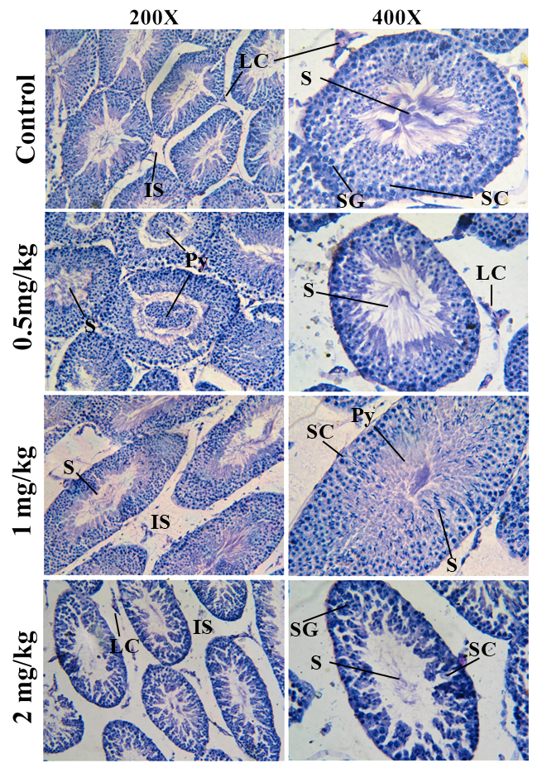
Figure 1: Histological slides of control and cadmium-treated Syrian golden hamsters (Mesocricetus auratus) at 200× and 400× magnification, showing dose-dependent alterations in seminiferous tubule architecture and spermatogenic organization and visible sperm density. Abbreviations: S=spermatozoa; SG= spermatogonia; SC=Sertoli cells; LC=Leydig cells; IS= interstitial space; Py= pyknotic cells.

Histopathological alterations were evident in all cadmium-treated groups, and their severity generally increased with the dose. The 0.5 mg/kg (low-dose) group showed mild germ-cell degeneration, characterised by pyknotic nuclei and occasional exfoliation of germ cells into the tubular lumen. Dead-cell debris was readily visible in the lumen. The area and diameter of the seminiferous tubules, as well as the luminal diameter, were markedly reduced compared with the control. The densities of spermatogenic cells and luminal spermatozoa also appeared lower than those in the control.
In the 1 mg/kg (medium-dose) group, the seminiferous tubules showed a further reduction in germinal epithelial height and in the number of spermatogonia. Spermatogonia were more sparsely distributed, and sperm density was also lower. The interstitial spaces were widened, and the seminiferous tubules displayed irregular shapes with increased area and diameter, which may indicate tubular deformity. The tubules contained abundant, very lightly stained debris from disintegrating, anucleate cells associated with pyknosis. Overall, the effects of cadmium were more pronounced in the 1 mg/kg group than in the 0.5 mg/kg group.
The 2 mg/kg (high-dose) group showed the most severe histopathological damage among the treated groups. Extensive germ-cell depletion, thinning of the seminiferous epithelium, and tubular distortion were observed, and spermatozoa were rarely visible in the lumen. The tubules were widely separated because of loss of interstitial tissue and widening of the interstitial spaces. The spermatogonia appeared severely compromised, with entire cells staining darkly and lacking distinct nuclei. Vacuolisation was also visible in the spermatogonial epithelial layer. These microscopic findings were consistent with the morphometric data, which showed significant reductions in seminiferous tubule area, diameter, and epithelial height. Collectively, these findings indicate that acute cadmium exposure disrupts seminiferous tubule architecture and impairs spermatogenesis in Syrian golden hamsters.
II. Morphometric Assessment:
The morphometric data are presented in Charts 1–5 within Figure 2. The seminiferous tubule area decreased from 579,418.6 ± 35,325.6 µm² in the control group to 389,477.6 ± 53,283.5 µm², 510,827.2 ± 52,815.1 µm², and 294,111.8 ± 52,149.5 µm² in the low-, medium-, and high-dose groups, respectively. The reductions were statistically significant in the low- and high-dose groups (P < 0.05), whereas the medium-dose group did not differ significantly from the control.
The seminiferous tubule diameter declined from 889.2 ± 62.8 µm in the control group to 786.0 ± 53.8 µm, 746.8 ± 95.3 µm, and 615.2 ± 68.0 µm in the low-, medium-, and high-dose groups, respectively. However, a statistically significant reduction was observed only in the high-dose group (P < 0.05).
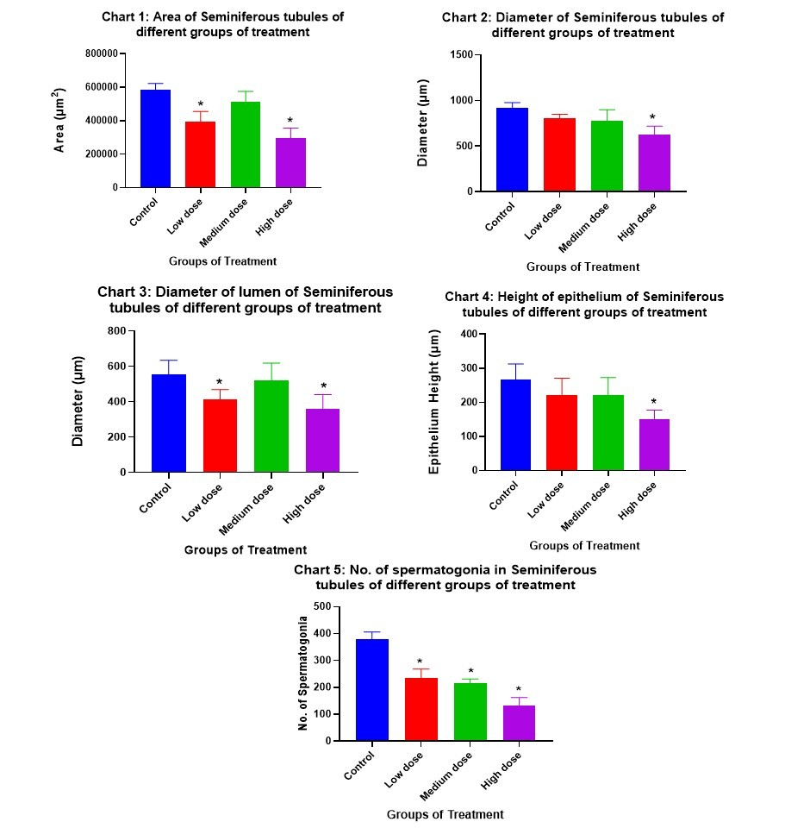
Figure 2: Morphometric analysis of seminiferous tubules in control and cadmium-treated Syrian golden hamsters (Mesocricetus auratus), showing changes in seminiferous tubule area, tubular diameter, luminal diameter, germinal epithelial height, and number of spermatogonia following exposure to 0.5, 1.0, and 2.0 mg/kg body weight CdCl₂. Values represent measurements (Mean ± SD) obtained from H&E-stained testicular sections using ImageJ.
The luminal diameter measured 534.8 ± 62.9 µm in the control group and 438.0 ± 55.9 µm, 542.8 ± 79.0 µm, and 435.8 ± 118.7 µm in the low-, medium-, and high-dose groups, respectively. Significant reductions were observed in the low- and high-dose groups (P < 0.05), whereas the medium-dose group remained comparable to the control, possibly because of tubular deformity.
Similarly, the germinal epithelial height decreased from 292.2 ± 49.6 µm in the control group to 216.0 ± 37.3 µm, 215.4 ± 38.0 µm, and 140.0 ± 25.5 µm in the low-, medium-, and high-dose groups, respectively. A statistically significant reduction was detected only in the high-dose group (P < 0.05).
The number of spermatogonia also declined markedly from 381.4 ± 21.1 in the control group to 249.4 ± 31.6, 226.8 ± 22.3, and 140.2 ± 25.3 in the low-, medium-, and high-dose groups, respectively. In contrast to the other morphometric parameters, all three cadmium-treated groups exhibited significantly lower spermatogonia counts than the control (P < 0.05).
Overall, these quantitative findings corroborate the histopathological evidence of cadmium-induced disruption of seminiferous tubule architecture and spermatogenesis.
Discussion
Studies in several animal species have established that cadmium adversely affects the testes (Marettová et al., 2015; Maurya et al., 2026). In the present study, acute cadmium exposure in Syrian golden hamsters resulted in significant morphometric and histological changes in the testes, indicating progressive deterioration of testicular architecture and spermatogenesis. Cadmium-treated hamsters showed seminiferous tubule degeneration, reduced epithelial height, germ-cell depletion, increased pyknosis and cell death, widening of the interstitial spaces, significant reductions in seminiferous tubule diameter, and reduced sperm density. These findings indicate substantial disruption of normal spermatogenic activity.
Cadmium is recognised as a potent environmental testicular toxicant because it accumulates in reproductive organs and promotes excessive reactive oxygen species (ROS) generation (Jahan et al., 2014). Numerous studies have shown that ROS induce extensive intracellular oxidative stress, promoting plasma-membrane lipid peroxidation, protein oxidation, DNA damage, and mitochondrial dysfunction. These processes trigger apoptosis, necrosis, and autophagy and may ultimately cause irreversible germ-cell damage (Ali et al., 2022; Rinaldi et al., 2017; Zhu et al., 2020). Nuclear condensation (pyknosis), one of the earliest morphological signs of irreversible cell death (Hirako et al., 2017; Morsi et al., 2020), was commonly observed in the present study.
The presence of detached or exfoliated germ cells and cellular debris in the seminiferous tubule lumen was one of the most notable findings of this study. Under normal physiological conditions, developing or immature germ cells remain attached to Sertoli cells, whereas mature spermatozoa are released into the lumen of the seminiferous tubules (Alves et al., 2013). In the present experiment, spermatogonia were prematurely exfoliated into the lumen, probably because of disruption of the blood–testis barrier and impairment of Sertoli-cell junctional complexes (Bekheet et al., 2010; Hew et al., 1993; Zhu et al., 2020). The accumulation of detached germ cells observed in this study therefore reflects loss of Sertoli-cell support and normal spermatogenic organisation.
The progressive thinning of the germinal epithelium and reduction in the number of spermatogonia were corroborated by reductions in tubular area and diameter and by alterations in luminal diameter. Together, these changes indicate suppression of germ-cell proliferation. Values in all treated groups remained below those of the control, and the highest dose caused the most severe structural degradation of the tubules, although the 1 mg/kg group showed somewhat greater morphometric values than the low-dose group.
The marked reduction in sperm density within the seminiferous tubule lumen further confirms impairment of spermatogenesis and, as suggested by previous research, is likely to result from both reduced germ-cell proliferation and increased degeneration of differentiating spermatogenic cells (Adamkovicova et al., 2014). This may adversely affect semen quality in adult animals and ultimately reduce male fertility.
Vascular damage, interstitial oedema, and seminiferous tubule degeneration and shrinkage—all recognised effects of cadmium toxicity—likely contributed to the widening of the interstitial spaces observed in this study (Adamkovicova et al., 2014; Obianime et al., 2010). Cadmium-induced vascular injury compromises the testicular blood supply, resulting in hypoxia that may exacerbate germ-cell deterioration.
Several studies have reported that cadmium reduces testosterone concentrations in both serum and testicular tissue (Bhardwaj et al., 2021; Ji et al., 2010). This finding is consistent with the present observations, in which the structural integrity of Leydig cells appeared compromised. Therefore, cadmium may adversely affect both the spermatogenic and endocrine functions of the testes, potentially resulting in subfertility or infertility (Ali et al., 2022; Zhu et al., 2020).
Conclusion
Acute cadmium exposure produced clear histopathological and morphometric alterations in the testes of adult Syrian golden hamsters. The observed changes included seminiferous tubule degeneration, germ-cell depletion, pyknosis, exfoliation of germ cells, widening of interstitial spaces, thinning of the germinal epithelium, and reduced spermatozoal density. Quantitative measurements supported these observations by demonstrating reductions in seminiferous tubule area, tubular diameter, epithelial height, and spermatogonia counts, with the most severe structural damage generally occurring at 2.0 mg/kg body weight. The significant reduction in spermatogonia across all treated groups indicates that even the lower exposure levels affected the spermatogenic compartment. Although the medium-dose group showed some non-linear morphometric values, the overall pattern was consistent with progressive disruption of testicular organisation and spermatogenesis. Within the conditions of this acute exposure experiment, the findings confirm the gonadotoxic potential of cadmium and indicate that the Syrian golden hamster is responsive to cadmium-induced testicular injury. This model may therefore be useful for further controlled investigations of heavy-metal-related male reproductive toxicity.

Limitation
The study evaluated acute cadmium exposure over 10 days in a controlled experimental setting and used histological and morphometric endpoints. Functional reproductive outcomes, including serum testosterone, sperm motility, sperm morphology, fertility, oxidative-stress biomarkers, and post-exposure recovery, were not assessed. The findings should therefore be interpreted within the tested doses, exposure route, duration, and animal model, and should not be directly extrapolated to chronic environmental exposure or human reproductive risk.

Declaration of AI Use
This manuscript was prepared through the combined contributions of all author(s), including contributions to the study design, data, content development, results, interpretation, and related scholarly work. The author(s) acknowledge the use of Grammarly and ChatGPT to assist with grammar checking, language refinement, reference formatting. These AI-assisted tools were not used as authors and did not replace the intellectual contributions or scholarly judgment of the author(s). All AI-assisted outputs, including content, references, and interpretations, were carefully reviewed, revised, verified, and approved by the author(s). The author(s) accept full responsibility for the accuracy, integrity, and final content of the manuscript.

Competing Interests
Authors have declared that no competing interests exist.
References
Adamkovicova, M., Toman, R., Cabaj, M., Massányi, P., Martiniakova, M., Omelka, R., Krajcovicova, V., & Duranova, H. (2014). Effects of subchronic exposure to cadmium and diazinon on testis and epididymis in rats. The Scientific World Journal, 2014, Article 632581. https://doi.org/10.1155/2014/632581
Ali, H., Khan, E., & Ilahi, I. (2019). Environmental chemistry and ecotoxicology of hazardous heavy metals: Environmental persistence, toxicity, and bioaccumulation. Journal of Chemistry, 2019, Article 6730305. https://doi.org/10.1155/2019/6730305
Ali, W., Ma, Y., Zhu, J., Zou, H., & Liu, Z. (2022). Mechanisms of cadmium-induced testicular injury: A risk to male fertility. Cells, 11(22), 3601. https://doi.org/10.3390/cells11223601
Alves, M. G., Rato, L., Carvalho, R. A., Moreira, P. I., Socorro, S., & Oliveira, P. F. (2013). Hormonal control of Sertoli cell metabolism regulates spermatogenesis. Cellular and Molecular Life Sciences, 70(5), 777–793. https://doi.org/10.1007/s00018-012-1079-1
Angeli, J. K., Cruz Pereira, C. A., de Oliveira Faria, T., Stefanon, I., Padilha, A. S., & Vassallo, D. V. (2013). Cadmium exposure induces vascular injury due to endothelial oxidative stress: The role of local angiotensin II and COX-2. Free Radical Biology and Medicine, 65, 838–848. https://doi.org/10.1016/j.freeradbiomed.2013.08.167
Antar, S. A., Halouani, A., Gad, C., & Al-Karmalawy, A. A. (2024). An overview of the mechanisms of cadmium-induced toxicity in the male reproductive system. Pharmaceutical Sciences, 30(1), 36–53. https://doi.org/10.34172/PS.2023.10
Babaknejad, N., Bahrami, S., Moshtaghie, A. A., Nayeri, H., Rajabi, P., & Iranpour, F. G. (2018). Cadmium testicular toxicity in male Wistar rats: Protective roles of zinc and magnesium. Biological Trace Element Research, 185(1), 106–115. https://doi.org/10.1007/s12011-017-1218-5
Bekheet, S. H. M. (2010). Cadmium chloride rapidly alters both BTB tight junction proteins and germ cells in young rat testes. Egyptian Academic Journal of Biological Sciences, B. Zoology, 2(1), 59–64. https://doi.org/10.21608/eajbsz.2010.15916
Bhardwaj, J. K., Panchal, H., & Saraf, P. (2021). Cadmium as a testicular toxicant: A review. Journal of Applied Toxicology, 41(1), 105–117. https://doi.org/10.1002/jat.4055
Bhardwaj, J. K., Siwach, A., Sachdeva, D., & Sachdeva, S. N. (2024). Revisiting cadmium-induced toxicity in the male reproductive system: An update. Archives of Toxicology, 98, 3619–3639. https://doi.org/10.1007/s00204-024-03871-7
Cardiff, R. D., Miller, C. H., & Munn, R. J. (2014). Manual hematoxylin and eosin staining of mouse tissue sections. Cold Spring Harbor Protocols, 2014(6), 655–658. https://doi.org/10.1101/pdb.prot073411
Chandel, M., & Jain, G. C. (2014). Toxic effects of transition metals on male reproductive system: A review. Journal of Environmental and Occupational Science, 3(4), 204–213. https://doi.org/10.5455/jeos.20140929042630
Charkiewicz, A. E., Omeljaniuk, W. J., Nowak, K., Garley, M., & Nikliński, J. (2023). Cadmium toxicity and health effects—A brief summary. Molecules, 28(18), 6620. https://doi.org/10.3390/molecules28186620
Deshwal, A., Kaur, N., Mehta, P., & Thakur, N. (2021). A review on the effects of cadmium toxicity on living beings. Journal of Pharmaceutical Research International, 33(57A), 300–305. https://doi.org/10.9734/jpri/2021/v33i57A34000
Eleawa, S. M., Alkhateeb, M. A., Alhashem, F. H., Bin-Jaliah, I., Sakr, H. F., Elrefaey, H. M., Elkarib, A. O., Alessa, R. M., Haidara, M. A., Shatoor, A. S., & Khalil, M. A. (2014). Resveratrol reverses cadmium chloride-induced testicular damage and subfertility by downregulating p53 and Bax and upregulating gonadotropins and Bcl-2 gene expression. Journal of Reproduction and Development, 60(2), 115–127. https://doi.org/10.1262/jrd.2013-097
Gad, S. C. (2019). Rodent models for toxicity testing and biomarkers. In R. C. Gupta (Ed.), Biomarkers in toxicology (2nd ed., pp. 7–73). Academic Press. https://doi.org/10.1016/B978-0-12-814655-2.00002-5
Genchi, G., Sinicropi, M. S., Lauria, G., Carocci, A., & Catalano, A. (2020). The effects of cadmium toxicity. International Journal of Environmental Research and Public Health, 17(11), 3782. https://doi.org/10.3390/ijerph17113782
Hew, K. W., Heath, G. L., Jiwa, A. H., & Welsh, M. J. (1993). Cadmium in vivo causes disruption of tight junction-associated microfilaments in rat Sertoli cells. Biology of Reproduction, 49(4), 840–849. https://doi.org/10.1095/biolreprod49.4.840
Hirako, A., Takeoka, Y., Furukawa, S., & Sugiyama, A. (2017). Effects of cadmium exposure on medaka (Oryzias latipes) testes. Journal of Toxicologic Pathology, 30(3), 255–260. https://doi.org/10.1293/tox.2017-0015
Iqbal, T., Cao, M., Zhao, Z., Zhao, Y., Chen, L., Chen, T., Li, C., & Zhou, X. (2021). Damage to the testicular structure of rats by acute oral exposure of cadmium. International Journal of Environmental Research and Public Health, 18(11), 6038. https://doi.org/10.3390/ijerph18116038
Jahan, S., Zahra, A., Irum, U., Iftikhar, N., & Ullah, H. (2014). Protective effects of different antioxidants against cadmium-induced oxidative damage in rat testis and prostate tissues. Systems Biology in Reproductive Medicine, 60(4), 199–205. https://doi.org/10.3109/19396368.2014.912363
Jebril, N. M. T., Boden, R., & Braungardt, C. (2022). The groundwater contaminated with cadmium: A systematic review. Anbar Journal of Agricultural Sciences, 20(2), 504–515. https://doi.org/10.32649/ajas.2024.137950.1026
Ji, H., Fan, W., Kakar, M., Alajmi, R. A., Bashir, M. A., & Shakir, Y. (2024). Effect of cadmium on the regulatory mechanism of steroidogenic pathway of Leydig cells during spermatogenesis. Journal of Experimental Zoology Part A: Ecological and Integrative Physiology, 341(1), 31–40. https://doi.org/10.1002/jez.2758
Ji, Y.-L., Wang, H., Liu, P., Wang, Q., Zhao, X.-F., Meng, X.-H., Yu, T., Zhang, H., Zhang, C., Zhang, Y., & Xu, D.-X. (2010). Pubertal cadmium exposure impairs testicular development and spermatogenesis via disrupting testicular testosterone synthesis in adult mice. Reproductive Toxicology, 29(2), 176–183. https://doi.org/10.1016/j.reprotox.2009.10.014
Jiang, L., Yang, F., Liao, H., Chen, W., Dai, X., Peng, C., Li, Z., Wang, H., Zhang, T., & Cao, H. (2024). Molybdenum and cadmium cause blood–testis barrier dysfunction through ROS-mediated NLRP3 inflammasome activation in sheep. Science of the Total Environment, 906, 167267. https://doi.org/10.1016/j.scitotenv.2023.167267
Kumar, S., & Sharma, A. (2019). Cadmium toxicity: Effects on human reproduction and fertility. Reviews on Environmental Health, 34(4), 327–338. https://doi.org/10.1515/reveh-2019-0016
Laskey, J. W., Rehnberg, G. L., Laws, S. C., & Hein, J. F. (1984). Reproductive effects of low acute doses of cadmium chloride in adult male rats. Toxicology and Applied Pharmacology, 73(2), 250–255. https://doi.org/10.1016/0041-008X(84)90330-2
Li, Y., Li, Z.-F., Qiu, B., Chen, K., Zhang, T.-L., Wang, H.-P., & Wang, L. (2026). Chronic exposure to low-dose cadmium disrupts spermatogenesis in mice through ectoplasmic specialisation damage. Journal of Environmental Sciences, 164, 632–643. https://doi.org/10.1016/j.jes.2025.06.062
Li, Y., Zhang, Y., Feng, R., Zheng, P., Huang, H., Zhou, S., Ji, W., Huang, F., Liu, H., & Zhang, G. (2022). Cadmium induces testosterone synthesis disorder by testicular cell damage via TLR4/MAPK/NF-κB signaling pathway leading to reduced sexual behavior in piglets. Ecotoxicology and Environmental Safety, 233, 113345. https://doi.org/10.1016/j.ecoenv.2022.113345
Marettová, E., Maretta, M., & Legáth, J. (2015). Toxic effects of cadmium on testis of birds and mammals: A review. Animal Reproduction Science, 155, 1–10. https://doi.org/10.1016/j.anireprosci.2015.01.007
Mason, K. E., Brown, J. A., Young, J. O., & Nesbit, R. R. (1964). Cadmium-induced injury of the rat testis. The Anatomical Record, 149(1), 135–148. https://doi.org/10.1002/ar.1091490112
Massányi, P., Massányi, M., Madeddu, R., Stawarz, R., & Lukáč, N. (2020). Effects of cadmium, lead, and mercury on the structure and function of reproductive organs. Toxics, 8(4), 94. https://doi.org/10.3390/toxics8040094
Maurya, R., Kumar, J., Kushwaha, S. K., & Verma, S. K. (2026). Acute effect of cadmium on testicular and seminal structures: A morphometric and index-based study in hamster. The Academic: International Journal of Multidisciplinary Research, 3(12), 610–625. https://doi.org/10.5281/zenodo.18219059
Morsi, A. A., Shawky, L. M., & El Bana, E. A. (2020). The potential gonadoprotective effects of grape seed extract against the histopathological alterations elicited in an animal model of cadmium-induced testicular toxicity. Folia Morphologica, 79(4), 767–776. https://doi.org/10.5603/FM.a2020.0003
Obianime, A. W., & Roberts, I. I. (2010). Antioxidants, cadmium-induced toxicity, serum biochemical and the histological abnormalities of the kidney and testes of the male Wistar rats. Nigerian Journal of Physiological Sciences, 24(2), 177–185. https://doi.org/10.4314/njps.v24i2.52910
Purushottam, B., & Reddy, R. A. (2024). Cadmium toxicity: Sources, mechanisms and human health implications: A comprehensive review. Uttar Pradesh Journal of Zoology, 45(15), 442–450. https://doi.org/10.56557/upjoz/2024/v45i154260
Rinaldi, M., Micali, A., Marini, H., Adamo, E. B., Puzzolo, D., Pisani, A., Trichilo, V., Altavilla, D., Squadrito, F., & Minutoli, L. (2017). Cadmium, organ toxicity and therapeutic approaches: A review on brain, kidney and testis damage. Current Medicinal Chemistry, 24(35), 3879–3893. https://doi.org/10.2174/0929867324666170801101448
Schneider, C. A., Rasband, W. S., & Eliceiri, K. W. (2012). NIH Image to ImageJ: 25 years of image analysis. Nature Methods, 9(7), 671–675. https://doi.org/10.1038/nmeth.2089
Shojaeepour, S., Dabiri, S., Dabiri, B., Imani, M., Fekri Soofi Abadi, M., & Hashemi, F. (2021). Histopathological findings of testicular tissue following cadmium toxicity in rats. Iranian Journal of Pathology, 16(4), 348–353. https://doi.org/10.30699/IJP.20201.130581.2443
Štajn, A., Žikić, R. V., Ognjanović, B., Saičić, Z. S., Pavlović, S. Z., Kostić, M. M., & Petrović, V. M. (1997). Effect of cadmium and selenium on the antioxidant defense system in rat kidneys. Comparative Biochemistry and Physiology Part C: Pharmacology, Toxicology and Endocrinology, 117(2), 167–172. https://doi.org/10.1016/S0742-8413(97)00063-7
Venditti, M., Ben Rhouma, M., Romano, M. Z., Messaoudi, I., Reiter, R. J., & Minucci, S. (2021). Altered expression of DAAM1 and PREP induced by cadmium toxicity is counteracted by melatonin in the rat testis. Genes, 12(7), 1016. https://doi.org/10.3390/genes12071016
Wang, Y.-J., Yan, J., Yin, F., Li, L., Qin, Y.-G., Meng, C.-Y., Lu, R.-F., & Guo, L. (2017). Role of autophagy in cadmium-induced testicular injury. Human & Experimental Toxicology, 36(10), 1039–1048. https://doi.org/10.1177/0960327116678300
Wang, D., Xiang, Y., Zhu, Z., Liu, J., Wang, Y., Xu, Z., Chen, S., Dai, C., Feng, J., Chen, J., Ma, Q., & Yang, P. (2025). Cytological effects of cadmium poisoning and the protective effect of quercetin: A mechanism exploration based on the testicular lamina propria. Microscopy and Microanalysis, 31(1), ozae103. https://doi.org/10.1093/mam/ozae103
Wlodarczyk, B., Biernacki, B., Minta, M., Kozaczynski, W., & Juszkiewicz, T. (1995). Male golden hamster in male reproductive toxicology testing: Assessment of protective activity of selenium in acute cadmium intoxication. Bulletin of Environmental Contamination and Toxicology, 54(6), 907–912. https://doi.org/10.1007/BF00197977
World Health Organization. (2011). Cadmium in drinking-water: Background document for development of WHO guidelines for drinking-water quality. https://cdn.who.int/media/docs/default-source/wash-documents/wash-chemicals/cadmium.pdf
Xiong, L., Zhou, B., Liu, H., & Cai, L. (2021). Comprehensive review of cadmium toxicity mechanisms in male reproduction and therapeutic strategies. In P. de Voogt (Ed.), Reviews of environmental contamination and toxicology (Vol. 258, pp. 151–193). Springer. https://doi.org/10.1007/398_2021_75
Zhou, J., Zeng, L., Zhang, Y., Wang, M., Li, Y., Jia, Y., Wu, L., & Su, P. (2022). Cadmium exposure induces pyroptosis in testicular tissue by increasing oxidative stress and activating the AIM2 inflammasome pathway. Science of the Total Environment, 847, 157500. https://doi.org/10.1016/j.scitotenv.2022.157500
Zhu, Q., Li, X., & Ge, R.-S. (2020). Toxicological effects of cadmium on mammalian testis. Frontiers in Genetics, 11, 527. https://doi.org/10.3389/fgene.2020.00527

