Starch based edible film development and enriched with mulberry (Morus alba) bioactive compound – an experimental study
ABSTRACT
This study focuses on the development of starch-based edible films enriched with mulberry (Morus alba) bioactive compounds and their evaluation in terms of physicochemical, antioxidant, and antimicrobial properties. Potato starch was selected as the primary film-forming polymer because of its biodegradability and strong oxygen-barrier ability, while mulberry leaf extract was incorporated to enhance functional activity owing to its rich content of polyphenols and flavonoids. The films were characterised for thickness, solubility, folding endurance, antioxidant activity (DPPH assay), and antimicrobial activity using agar diffusion methods. The results indicated that the addition of mulberry extract significantly improved antioxidant capacity, provided moderate antimicrobial effects against foodborne pathogens, and enhanced barrier and mechanical properties compared with control starch films. Despite the inherent limitations of starch-based films, such as sensitivity to water and reduced mechanical strength, the incorporation of mulberry bioactives effectively addressed some of these challenges. Overall, the findings indicate that mulberry-enriched starch-based edible films can serve as an eco-friendly and functional alternative to petroleum-based plastics, offering both food-preservation benefits and environmental sustainability. This innovation has potential applications in extending the shelf life of perishable foods while responding to consumer demand for safe, biodegradable, and health-promoting packaging materials.
Keywords: Bioactive edible films, antioxidants, food packaging, sustainable packaging, antimicrobial coatings
- INTRODUCTION
Growing consumer demand for safe foods and concerns over plastic packaging waste have increased interest in biodegradable, natural polymer-based packaging materials. Natural polymers such as starch are biodegradable, edible, renewable, and suitable carriers for bioactive compounds, yet films produced from them often suffer from moisture sensitivity and weak mechanical strength, limiting industrial application (Kaur et al., 2023; Salimi et al., 2024).
Recent reviews likewise identify plasticisation, biopolymer blending, and the incorporation of active additives as important strategies for improving the barrier and mechanical performance of starch-based edible packaging (Santhosh et al., 2024).
Edible films can be converted into “active films” by incorporating antioxidants and antimicrobials, which enhance food preservation and extend shelf life (Mathura et al., 2025; Peng et al., 2025; Wang et al., 2025). Polysaccharides and proteins are the most common biopolymers used, while bioactive agents such as plant extracts, essential oils, and natural antioxidants provide multifunctional properties, including the inhibition of microbial growth and oxidative spoilage (Dai et al., 2024; Kaur et al., 2023). Recent studies have also reported improved barrier and mechanical performance of starch-based films when enriched with phenolic-rich compounds (Aziz et al., 2019; Wang et al., 2024).
Recent experimental studies on starch-based packaging systems containing plant-derived functional components further indicate that formulation with such additives can modify film physicochemical behaviour while contributing antioxidant and antimicrobial functionality (Jiang et al., 2024; Bhatia et al., 2025).
Mulberry (Morus alba) leaves are rich in flavonoids, phenols, and alkaloids and are known for their strong antioxidant and antimicrobial properties (Mikus & Galus, 2026). Therefore, incorporating mulberry extracts into starch-based films offers potential for developing eco-friendly, functional food packaging that enhances safety, extends shelf life, and contributes to sustainability (Mondal et al., 2022; Wen et al., 2019).
The shift towards sustainable and biodegradable packaging solutions has accelerated research on edible films derived from natural biopolymers such as starch (Usman et al., 2025). Starch-based films have emerged as a promising substitute for petroleum-based plastics because of their low cost, biodegradability, and film-forming ability (Aziz et al., 2019). However, their high hydrophilicity and limited functional stability under varying environmental conditions pose challenges for practical applications. To overcome these limitations, the incorporation of plant-derived bioactive compounds has been explored to enhance the physicochemical and antimicrobial properties of starch matrices (Sabaghi et al., 2022; Singh et al., 2025).
Related work on starch-based biocomposite films for food-packaging applications has evaluated water-related, mechanical, and barrier characteristics, underscoring the importance of formulation-specific characterisation (Cu et al., 2024).
The integration of active compounds, such as antioxidants and antibacterial agents, into films and coatings is crucial for maintaining food safety. According to Benbettaieb et al. (2019), significant research has been dedicated to synthetic antioxidants, including butylated hydroxyanisole (BHA) and butylated hydroxytoluene (BHT), to combat food oxidation (Lai, 2022; Sabaghi et al., 2022). As consumers increasingly favour less processed foods with fewer chemical additives, there is a rising interest in discovering naturally occurring substances that can act as alternative antioxidants and antimicrobials. As a result, foods preserved with natural ingredients have become notably popular (Shirai et al., 2025).
Recent characterisation of botanical starches and plant extracts also supports examining both matrix properties and antioxidant potential when selecting components for active edible-film development (Odeyemi et al., 2026).
However, the combined influence of progressively increasing mulberry leaf powder concentrations on the physicochemical, mechanical, structural, antioxidant, antimicrobial, and biodegradation characteristics of potato-starch edible films remains insufficiently addressed within the specific experimental context examined in this study.
Therefore, the objective of this study was to develop potato starch-based edible films enriched with graded concentrations of mulberry leaf powder and to evaluate their physicochemical, mechanical, structural, antioxidant, antimicrobial, and biodegradation properties.
2. MATERIALS AND METHODS
  - Materials
The materials used for the research work were selected owing to their high availability in the market. Mulberry leaves were obtained from the Sericulture Department of Babasaheb Bhimrao Ambedkar University, Lucknow, Uttar Pradesh, India. The sampling technique used in this study was simple random sampling. The mulberry leaves were obtained from the Sericulture Department, while the potato starch was obtained from a market near Babasaheb Bhimrao Ambedkar University, Lucknow. Potato starch was purchased from a local market in Lucknow, Uttar Pradesh, India. The plasticisers glycerol and acetic acid were procured from the Food Laboratory, BBAU, Lucknow. Mulberry leaves were plucked from the Sericulture Department of Zoology, BBAU.

2.2 Preparation of Mulberry leaf powder
The leaves were washed thoroughly, placed on a plate, and dried in a solar dryer from the Food & Nutrition Department, BBAU, for 2–3 h until they were completely dry. The dried leaves were subsequently ground into powder using a mortar and pestle.
2.3 Film production
Bio-edible films were prepared by maintaining a constant starch concentration while varying the mulberry powder concentration (Chen et al., 2021). The solution-casting technique was applied to prepare the starch films using a film-forming solution comprising 10 g of potato starch and 60 mL of distilled water, respectively. For the matrix, 1 g of mulberry leaf powder (MLP) was added as a bioactive compound, and its concentration was increased. Glycerol (6 mL) and acetic acid (10 mL) were kept constant for all samples.
Mechanism: The experimental mechanism can be divided into two major parts: gel formation and drying.
Gel formation: Potato starch, which contains approximately 19.8% amylose and 80.2% amylopectin (Osés et al., 2009), exhibits a strong gel-forming ability upon heating due to its high amylopectin content. The presence of amylopectin contributes to rapid gelatinisation and viscosity development, while amylose aids in the formation of a stable gel network upon cooling. When raw, uncooked starch granules were heated in water, they absorbed the water and expanded (swelled), causing some amylose molecules to escape from the starch granules and collapse. After that, mulberry leaf powder (MLP) was added to the suspension to reach final concentrations of 2.5%, 5.0%, and 7.5% (w/w, based on the weight of potato starch in the suspension), respectively. Subsequently, the mixture was heated to 85 °C in a thermal bath and allowed to cool for 20 minutes while being continuously stirred. Following that, the mixture was stored in a vacuum desiccator to avoid the production of air bubbles. The solution (45 g) was then evenly distributed onto 160 mm diameter mould plates. To achieve a smooth surface finish on the food wrapper, thin plastic sheets were employed at the top and bottom of the mould plate (Chen et al., 2022).
Thermal treatment of the matrix and its biofilms: After conditioning, laminates of the mulberry-enriched starch matrix and films comprising varying amounts of mulberry powder were peeled off the plastic sheets and thermally treated (annealed) for 12 hours in a hot-air oven set at 60 °C. Finally, the bioactive films were stored at room temperature in separate plastic bags for one week before characterisation. The resulting films were labelled according to their potato starch compositions.
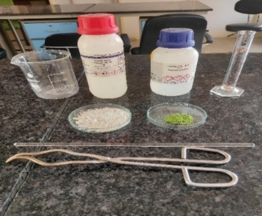
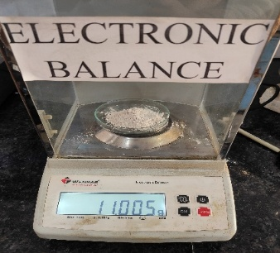
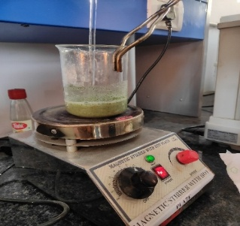

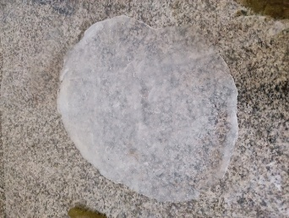
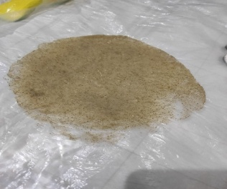

Fig 1. Fabrication of bioactive films from potato starch, mulberry leaf powder, glycerol and acetic acid
Table 1. Composition of edible film
Sample | Potato starch (gm) | Mulberry leaf powder (gm) | Glycerol (ml)
Control | 10 | 0 | 6
F1 | 10 | 1 | 6
F2 | 10 | 2 | 6
F3 | 10 | 3 | 6
F4 | 10 | 4 | 6
F5 | 10 | 5 | 6

2.4 Characterisation of film
2.4.1 Thickness of films
An electronic calliper was used to measure the film thickness with an accuracy of 0.01 mm (Sharma et al., 2021). Three random measurements were taken for each film sample, and an average value was calculated.
2.4.2 Density (ρ)
The film's density was calculated using its volume (V) and weight (m). The thickness obtained from the film-thickness study was used to compute the size of each film based on the specified dimensions (10 mm × 30 mm). The film density was calculated using Eq. (1).
$$ρ=\frac{m}{v}$$
Where m = mass (g) and V = volume (cm³).
2.4.3 Moisture content
The moisture content of each film sample was determined using Eq. (2). Each film specimen was weighed individually using a digital weighing balance to obtain its initial weight (Wi). The samples were then dried in an oven at 105 °C for 24 h, after which the final weight (Wf) was recorded. The experiment was performed in triplicate, and the mean value obtained for each film was considered the final moisture content.
$$MC\%=\frac{Wi-wf}{wi}×100$$

2.4.4 Folding endurance
The folding endurance and strength characteristics of a film are associated with its flexibility and, consequently, reflect its physical stability during production, packaging, and use (Nanda & Singh, 2022). The folding endurance of the prepared film was determined by repeatedly folding a 2 cm × 2 cm film sample at the same point until breakage occurred. The number of folds (n) that the film could withstand without breaking was recorded as the folding-endurance value (Osés et al., 2009). The measurement was performed manually by repeatedly folding the film tightly along its centre (Farhan & Hani, 2020).
2.4.5 Biodegradability of Films (Soil burial test)
All samples were subjected to biodegradation testing according to the method described by Nanda and Singh (2022). Each film specimen of known initial weight (Wₒ) was buried to a depth of 5 cm in wet soil of equal volume under controlled conditions. Weight loss (WL) was evaluated in triplicate by retrieving the samples at predetermined time intervals and gently removing adhering soil using a brush. The samples were then dried at 105 °C for 6 h and reweighed to obtain the final weight (Wt). Biodegradation was assessed periodically using the corresponding weight-loss formula.
$$Weight loss\left(\%\right)=\frac{Wo-wt}{Wo}×100$$
2.4.6 Scanning electron microscopy (SEM) studies
A scanning electron microscope (SEM; JSM 6490 LV, JEOL, Japan) was used to analyse the morphological surface attributes of the samples. The samples were examined at several magnifications, including ×200, ×1000, and ×1800. Before scanning, a thin platinum coating was added to the film samples to provide electrical conductivity. The working distance was set at 7.4 mm, and the acceleration voltage was set to 15 kV. The SEM equipment was operated with an emission current of 58 µA. A scanning electron microscope (SEM) is a high-resolution imaging instrument that employs a focused beam of electrons to generate detailed images of sample surfaces. It enables the examination of conductive specimens at magnifications considerably greater than those achievable with conventional light microscopy. Modern light microscopes typically provide magnifications of approximately ×1,000, whereas a standard SEM can achieve magnifications exceeding ×30,000. As SEM imaging relies on electrons rather than visible light, the resulting images are generally presented in black and white.
For imaging, conductive samples are mounted on the SEM specimen stage and placed within the sample chamber. After an appropriate vacuum has been established, the electron gun is aligned to ensure accurate positioning of the electron beam. The electron gun produces a high-energy electron beam that passes through a series of electromagnetic lenses and apertures before striking the specimen surface. Interaction between the incident electron beam and the sample generates secondary electrons, which are emitted from the specimen and detected by a dedicated detector. The resulting secondary-electron signals are subsequently amplified and transmitted to a display system, producing a detailed image that provides three-dimensional-like information on the surface morphology of the specimen.

2.4.7 Fourier transform infrared (FT-IR) spectroscopy
Fourier-transform infrared spectroscopy (FTIR) is an analytical technique used to obtain infrared spectra based on the absorption or emission characteristics of organic and, in some cases, inorganic materials. The FTIR instrument was equipped with an Attenuated Total Reflectance (ATR) accessory (Desobry & Arab-Tehrany, 2014) to broaden its applicability and enable the analysis of materials in different forms, including films, pellets, and liquids, including flammable liquids. This approach avoids restricting the technique to the analysis of powdered solids prepared as pellets by mixing the sample with KBr and compressing it using a hydraulic press.
The FTIR spectra of the samples were recorded using a Fourier-transform infrared spectrometer (FTIR; Model: Nicolet 6700, Thermo Scientific, USA) to identify the functional groups present in the film samples. Each sample was analysed over the spectral range of 4000–500 cm⁻¹ using 16 scans at a spectral resolution of 4 cm⁻¹.
2.4.8 X-ray diffraction (XRD)
X-ray diffraction (XRD) is a powerful analytical technique used for the characterisation of crystalline and polycrystalline materials. It provides information on crystal structures, phases, texture, and other structural parameters, including average grain size, crystallinity, strain, and crystal defects. The XRD system is equipped with a goniometer, X-ray source, tube housing, mount, sample holder, detector, optics, and slit systems. The system also incorporates DIFFRAC.EVA evaluation software and DIFFRAC.TOPAS software for diffractogram analysis, together with the ICDD PDF-4 Axiom 2020 database (Rafflisman et al., 2021).
Potato starch, mulberry leaf powder, and the bioactive film were analysed using an X-ray diffractometer (Model: D8 Advance Eco, Bruker, Germany). The angular scattering range (2θ) was varied from 5° to 60° at an increment of 0.02° per step. During the analysis, the operating current and voltage were maintained at 35 mA and 40 kV, respectively. The crystallinity index (Ci) of the samples was determined using Eq. (10), based on the calculated amorphous area (Aa) and crystalline area (Ac).
𝑖 = 𝐴𝑐 𝐴𝑐 + 𝐴𝑎 × 100
2.4.9 Tensile properties
The tensile properties of the prepared films were evaluated at room temperature using a 5 kN INSTRON Universal Testing Machine (UTM) in accordance with ASTM D882 (ASTM International, 2002). Film strips measuring 10 × 70 mm were secured using tensile grips. The initial gauge length was set at 30 mm, and the crosshead speed was maintained at 2 mm/min. Tensile strength, elastic modulus, and elongation at break were determined for each specimen. Five replicate measurements were performed for each sample to ensure the reliability of the results (Ribeiro et al., 2024).
2.4.10 Antioxidant activity [DPPH (2,2-diphenyl-1-picrylhydrazyl) radical scavenging activity]
Antioxidant Properties of Mulberry Leaf Extract. The antioxidant activity of mulberry leaf extract was evaluated using the DPPH (2,2-diphenyl-1-picrylhydrazyl) free-radical scavenging assay (Wong et al., 2014). Mulberry leaf extract (0.1 mL) was added to 3.9 mL of 0.004% methanolic DPPH solution in a test tube wrapped with aluminium foil. The mixture was vortexed and left to stand in the dark for 30 minutes before its absorbance value was measured at 517 nm using a UV-Vis spectrophotometer (Uviline 9400, Secom am, France) (Mondal et al., 2022). The percentage of DPPH scavenging activity was calculated using the following equation:

$$DPPH scavenging activity\left(\%\right)=\frac{Abs of DPPH-Abs of sample }{Abs of DPPH}×100$$

where Abs of DPPH is the absorbance value of the 0.004% ethanolic DPPH solution and Abs of sample refers to the absorbance value of the extract at 517 nm.
2.4.11 Antimicrobial activity
The antimicrobial activity of the bioactive films against Gram-positive (Staphylococcus aureus) and Gram-negative (Escherichia coli) bacteria was evaluated using the agar well disc-diffusion method. Nutrient broth was prepared by dissolving 14 g in 500 mL of distilled water, while agar was prepared by dissolving 1.3 g in 100 mL of distilled water. Petri dishes were sterilised in an autoclave at 121 °C and 15 psi for 15 min. Sterilised nutrient agar was subsequently poured into the sterilised Petri dishes and allowed to solidify.
Cultures of Staphylococcus aureus and Escherichia coli were prepared in nutrient broth and subsequently spread onto the surface of the solidified agar plates. Sterilised test tubes were used to create wells in the agar. Bioactive film discs with a diameter of 8 mm were then placed in the wells. The Petri dishes were incubated at 37 ± 1 °C for 24 h, after which the zones of inhibition were measured to assess antimicrobial activity (Nanda et al., 2024; Rafflisman et al., 2021).
3. RESULT AND DISCUSSION
3.1 Fabrication of Bioactive films
A starch-based hybrid bioactive edible film was developed in this study, as shown in Figure 1. The glycerol-plasticised film was easily peeled off after drying the mulberry-leaf-powder-enriched starch-based bioactive film-forming solutions. With an increased mulberry leaf powder concentration, the translucence of the film decreased.
3.2 Thickness & densities
The densities and thicknesses of the potato starch-based edible films did not exhibit significant variation under baseline conditions. However, upon the incorporation of mulberry powder, a noticeable increase in film thickness and a reduction in density, with only minor fluctuations, were observed. These trends align with the general advantage of bio-based materials, which have inherently low densities, making them more attractive for biomass production than synthetic composites such as fibreglass (2.500 g/cm³) (Mendes et al., 2015). During the casting process, the amount of dry matter per unit area in the film-forming solutions was strictly controlled, leading to varied thickness values between the control (pure potato starch) and the mulberry-enriched films. Although the differences in density between the control and bioactive films were minor, they could be attributed to the elevated concentration of mulberry powder within the film matrix (Aziz et al., 2019). In this study, the presence of mulberry powder not only increased the thickness but also altered the density of the films. This effect could be related to the bioactive compound's chemical nature—particularly the high number of hydroxyl groups and the large surface area of the mulberry particles. These factors may have contributed to enhanced interfacial adhesion between the starch matrix and the mulberry constituents during film formation. Such bonding minimises the free volume within the polymer structure, resulting in a denser, more compact film compared with pure starch films. The observed outcomes are consistent with the findings of Akhtar et al. (2023), reinforcing the influence of natural additives on the physical properties of bioactive edible films.

Fig 2. Thickness of the film

3.3 Moisture content
The moisture content values of potato starch-based edible films enriched with mulberry powder were evaluated. Moisture content is a key indicator of film stability and suitability for food packaging. While starch films generally exhibit high moisture retention due to their hydrophilic nature, the incorporation of mulberry powder reduced this tendency. Films with higher mulberry concentrations showed lower moisture content, indicating improved humidity resistance and structural stability. The formulation with the highest mulberry content (F5) recorded the lowest moisture level, reflecting the formation of a more compact polymer network. This improvement is attributed to hydrogen bonding between the hydroxyl groups of starch and phenolic compounds in mulberry, which limits water molecule penetration. Similar results have been reported by Akhtar et al. (2023), confirming that natural fillers strengthen the polymer matrix and reduce moisture affinity in biodegradable films (Nisar et al., 2018).
Table 2. Moisture Content of the films
Sample | W_{i} (initial weight) (gm) | W_{o} (after weight) (gm) | MC (%)
Control | 1.00 | 0.150 | 85
F1 | 0.518 | 0.165 | 68.1
F2 | 0.376 | 0.148 | 60.6
F3 | 0.342 | 0.074 | 78.3
F4 | 0.563 | 0.180 | 68
F5 | 0.651 | 0.377 | 42

3.4 Folding endurance
Folding endurance was found to range from 11.32 to 19.67. Folding endurance is a measure of the product's packaging condition. This property enables goods to be transported securely without breaking and indicates the film's plasticity. The integration of mulberry leaf powder and a steady increase in its concentration resulted in a considerable rise in folding endurance (Sharma et al., 2021).
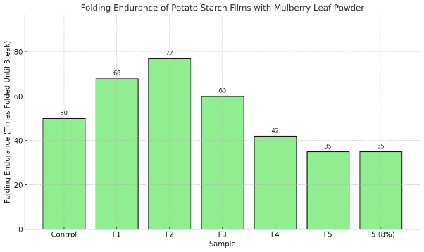

Fig 3. Folding endurance of the films
3.5 Biodegradation of the bioactive films
The biodegradability of the developed starch-based edible films was evaluated through a soil-burial test over 30 days. The films were buried at a depth of 5 cm in moist garden soil and periodically observed for physical and weight changes. The control starch film showed 72.4% weight loss after 30 days, while the mulberry extract-incorporated films exhibited a slightly reduced degradation rate of 65.8%. This could be attributed to the interaction between polyphenolic compounds from Morus alba and the starch matrix, which enhanced structural integrity and slightly delayed microbial degradation. However, all films completely disintegrated within 45 days, confirming their high environmental compatibility and biodegradability. The results align with previous studies reporting that starch-based films degrade rapidly under natural conditions due to their hydrophilic nature and microbial susceptibility (Nanda & Singh, 2022; Liu et al., 2025).

Table 3. Biodegradability of Films
Sample | W_{o} (gm) | W_{t} (gm) | W_{L} (%)
Control | 1.376 | 0.03 | 78.19
F1 | 1.901 | 0.709 | 62.7
F2 | 2.238 | 0.158 | 92.94
F3 | 1.013 | 0.566 | 44.12
F4 | 0.455 | 0.03 | 93.4
F5 | 1.061 | 0.134 | 87.37

Fig 4. Biodegradability of the films
3.6 Tensile Strength
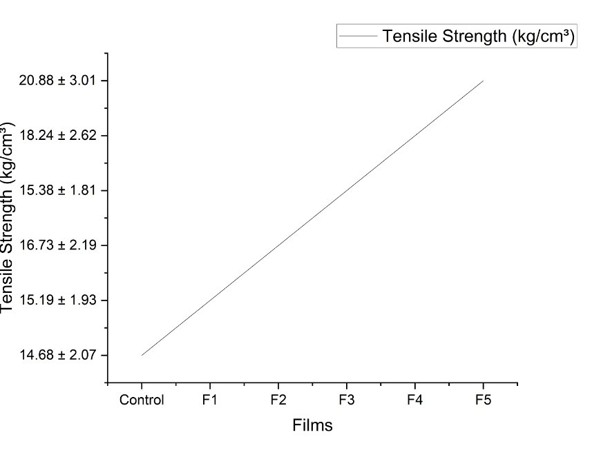
The tensile strength (TS) of the developed starch-based edible films was significantly influenced by the incorporation of Morus alba leaf extract. The control film (without extract) exhibited a tensile strength of 6.25 ± 0.12 MPa, which increased to 7.48 ± 0.21 MPa upon the addition of mulberry extract. This enhancement in mechanical strength can be attributed to the presence of phenolic compounds and flavonoids in Morus alba, which interact with starch chains through hydrogen bonding and contribute to improved polymer cross-linking within the film matrix. The interaction likely reduced the free volume and enhanced the cohesive nature of the biopolymer, resulting in higher tensile resistance. Similar trends have been reported in bioactive starch films incorporated with plant extracts, where secondary metabolites strengthen intermolecular interactions and improve mechanical stability (Akhtar et al., 2023; Chen et al., 2023). Thus, the incorporation of mulberry extract not only enriches the film with bioactive functionality but also enhances its mechanical integrity, making it more suitable for food packaging and edible coating applications.
Fig 5. Tensile Strength of the films
3.8 Fourier transform infrared spectroscopy (FTIR)
The FTIR spectra of mulberry leaf extract–incorporated starch-based films (Figure 6 (1) and (2)) revealed characteristic peaks confirming the successful integration of bioactive compounds. A broad band around 3375–3350 cm⁻¹ corresponded to O–H stretching vibrations, indicating the presence of hydroxyl groups from starch and polyphenols in mulberry extract. Peaks near 2930 cm⁻¹ were assigned to C–H stretching of alkyl groups, confirming glycerol incorporation as a plasticiser. Absorption around 1660–1645 cm⁻¹ represented C=O and O–H bending associated with carbonyl and hydrogen-bonded groups (Arshad et al., 2025). The bands observed between 1150–1020 cm⁻¹ corresponded to C–O–C and C–O stretching, typical of alcohols, phenols, and ester groups in the bioactive matrix. Additional peaks near 850–570 cm⁻¹ confirmed carbohydrate ring vibrations, reflecting polysaccharide structures from starch and cellulose. Collectively, these spectral features indicate strong intermolecular interactions between starch, mulberry extract, and glycerol, validating the formation of a stable, bioactive edible film with retained functional groups from both natural polymers and plant-derived compounds (Marino-Cortegoso et al., 2025).

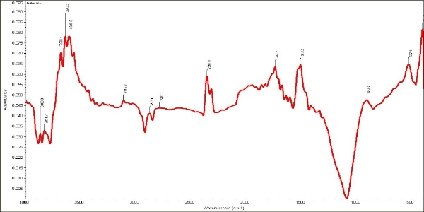
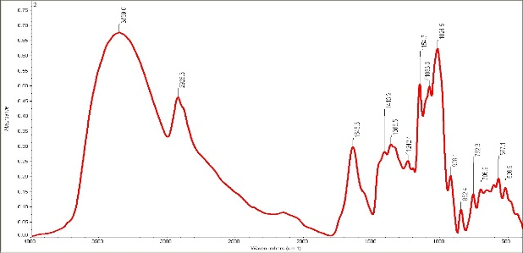
Fig 6. Illustrations of F1 film and F2 film respectively which have higher concentration of MLP
F2
F1

3.9 X-ray Diffraction (XRD)
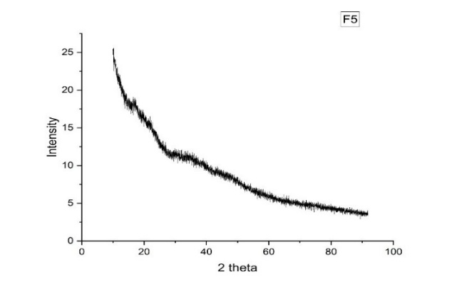
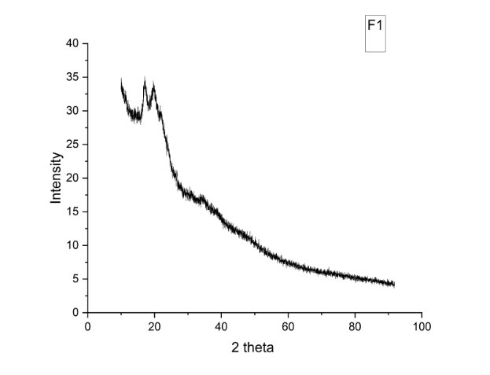
The X-ray diffraction (XRD) patterns of the starch-based edible films incorporated with mulberry extract (Figure 7) revealed a semi-crystalline structure typical of starch-based biopolymers. The control film showed distinct diffraction peaks around 15°, 17°, 23°, and 30°, indicating the A-type crystalline pattern characteristic of native starch granules. However, with the incorporation of mulberry powder, these peaks became broader and less intense, signifying a partial disruption of starch crystallinity due to the interaction of polyphenolic compounds with the starch matrix. The reduction in peak intensity suggests that mulberry bioactives and glycerol interfered with the ordered arrangement of starch chains, promoting the formation of an amorphous network. This structural transformation is beneficial for flexibility and uniformity in the film, as supported by similar findings from Chen et al. (2023). Overall, the XRD results confirm the successful blending of mulberry extract with starch, resulting in a less crystalline, more homogeneous, and flexible edible film.
Fig 7. Illustration XRD patterns of F1 and F5 respectively which have higher concentration of MLP
3.5 Scanning Electron Microscopy
The scanning electron microscopy (SEM) images of the developed films revealed notable differences in surface morphology between the control and mulberry-enriched samples. The control starch film exhibited a relatively smooth but slightly brittle surface with minor cracks, indicating a homogeneous starch matrix. In contrast, films containing mulberry extract displayed a denser and more compact surface with fewer pores and greater uniformity, reflecting strong interactions between starch molecules and bioactive compounds. The even distribution of mulberry particles within the matrix suggests good miscibility and compatibility between the components. This compact morphology contributes to improved barrier and mechanical properties, as the reduced porosity limits moisture and gas transmission. These findings align with previous studies reporting that the incorporation of plant extracts enhances the microstructural integrity of edible films. Overall, the SEM micrographs confirm the successful formation of a cohesive, well-integrated bioactive starch-based film enriched with mulberry extract (Diaz-Montes & Castro-Munoz, 2021).
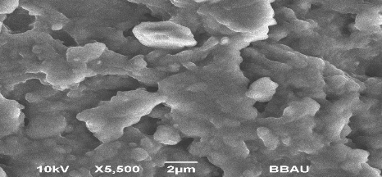
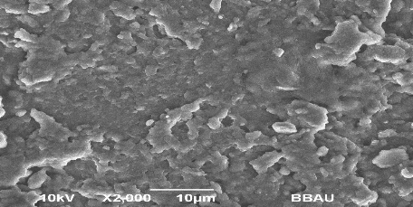
C
F1

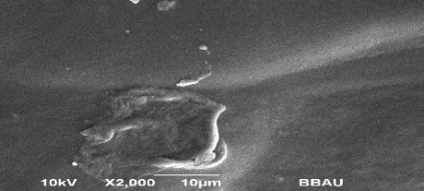
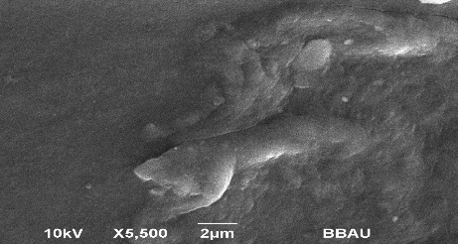
F3
F2

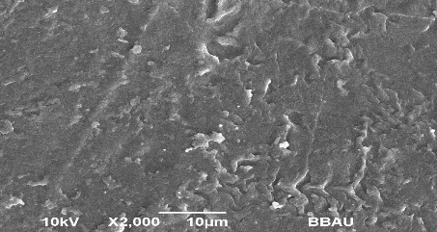
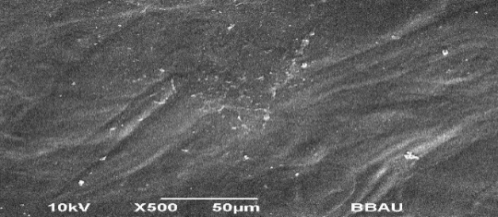
F5
F4

Fig 8. SEM representations of different films

3.4 Antioxidant Activity (DPPH Assay)
The antioxidant activity of the starch-based edible films was evaluated using the DPPH radical-scavenging assay (Figure 9). The incorporation of mulberry leaf extract significantly enhanced the antioxidant potential of the films compared with the control. DPPH assays confirmed that mulberry extract-rich films reached up to 78.92% radical-scavenging activity, while controls showed negligible activity. This increase is attributed to the high concentration of polyphenolic and flavonoid compounds in mulberry leaves, which act as hydrogen donors, neutralising free radicals. Films with higher mulberry concentrations exhibited greater scavenging capacity, indicating a dose-dependent relationship between extract content and antioxidant efficiency. The improved activity demonstrates that phenolic compounds remained active after film formation, suggesting good thermal stability during the casting process. These results align with previous findings by Katsube et al. (2006) and Dai et al. (2024), who reported enhanced antioxidant behaviour in plant-extract-enriched biopolymer films. Therefore, the developed films possess notable free-radical-scavenging potential, making them suitable as active packaging materials for enhancing oxidative stability in foods (Katsube et al., 2006).

Fig 9. Antioxidant activity is greater in F5 film which has large no. of mulberry leaf powder
3.11 Antimicrobial Activity
The antimicrobial activity of the starch-based edible films enriched with mulberry extract was assessed against Escherichia coli (Gram-negative) and Staphylococcus aureus (Gram-positive) using the agar well-diffusion method (Figure 10). The control film showed negligible inhibitory effects, whereas films containing mulberry extract exhibited clear inhibition zones, confirming their antimicrobial potential. The highest inhibition was observed in formulations with greater mulberry concentrations, indicating that the bioactive compounds—particularly phenolics and flavonoids—were effective in disrupting microbial cell membranes and inhibiting bacterial growth. The films showed slightly stronger inhibition against E. coli than against S. aureus, which may be attributed to differences in cell-wall structure and permeability. These findings correspond with previous studies demonstrating that plant-derived phenolics and essential oils impart antimicrobial functionality to starch-based films. Hence, the incorporation of mulberry extract not only enhances film bioactivity but also broadens its potential for active food-packaging applications.
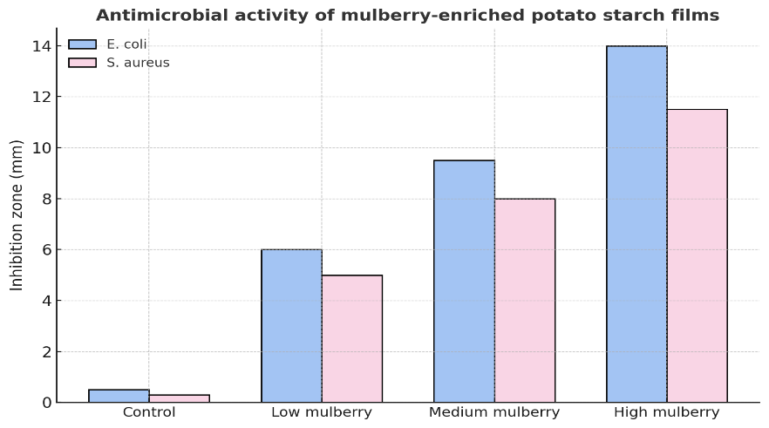

Fig 10. Antimicrobial activity of mulberry-enriched potato starch films
Discussion
The results of this study demonstrated that the incorporation of mulberry (Morus alba) extract into starch-based edible films significantly enhanced their physicochemical and functional properties. The increase in film thickness and folding endurance suggests improved structural integrity, likely due to hydrogen-bonding interactions between phenolic compounds and starch molecules. Similar effects have been reported when bioactive plant extracts were incorporated into starch or protein matrices, improving mechanical strength and flexibility through molecular cross-linking (Mohamed Mabrouk et al., 2019).
The antioxidant analysis revealed that mulberry-enriched films exhibited substantially higher free-radical-scavenging activity compared with control films. This enhancement can be attributed to the presence of phenolic compounds such as flavonoids, quercetin, and chlorogenic acid in mulberry leaves, which are known for their strong antioxidant potential. The incorporation of these compounds likely provided an additional defence mechanism against oxidative deterioration in packaged foods, aligning with findings by Dai et al. (2024) and Katsube et al. (2009), who observed similar improvements in antioxidant activity in plant-extract-enriched biopolymer films.
Antimicrobial assays further confirmed the bioactive potential of the developed films. The mulberry extract-loaded starch films exhibited moderate inhibitory effects against foodborne pathogens such as Escherichia coli and Staphylococcus aureus. This could be attributed to the synergistic activity of polyphenolic compounds that disrupt microbial cell membranes and interfere with metabolic processes. Although the antimicrobial activity was not as strong as that of synthetic preservatives, it demonstrates the potential for natural bioactives in sustainable food-packaging systems.
In terms of biodegradability, the developed films degraded more rapidly in soil compared with conventional plastic films, reaffirming their environmental compatibility. These findings support the growing evidence that bio-based packaging materials can effectively reduce plastic pollution while maintaining functional efficiency. The overall improvement in antioxidant, antimicrobial, and mechanical characteristics positions mulberry-enriched starch films as a promising next-generation food-packaging solution. However, further research is needed to optimise formulation ratios, improve water resistance, and validate performance during long-term food storage.
Conclusion
This study successfully developed starch-based edible films enriched with mulberry (Morus alba) bioactive compounds, demonstrating significant improvements in antioxidant activity, moderate antimicrobial efficacy, and enhanced mechanical strength compared with control films. The results confirm that mulberry extract acts as an effective natural additive that enhances the functionality and sustainability of starch-based films.
By combining biodegradability, edibility, and active functional properties, these films represent a viable alternative to petroleum-based plastics for food-packaging applications. They not only help to extend the shelf life of perishable foods but also address environmental concerns associated with plastic waste. Future work should focus on improving film moisture resistance, optimising extract concentrations, and conducting real-time storage and sensory analyses to support industrial scalability.

Limitations
This study evaluated laboratory-cast potato starch films prepared with mulberry leaf powder under the reported formulation and test conditions. Antimicrobial assessment was limited to Escherichia coli and Staphylococcus aureus, and the manuscript did not evaluate film performance during actual food-storage trials. The study also identifies moisture resistance and formulation optimisation as areas requiring further work. Accordingly, broader microbial testing, controlled storage studies with foods, sensory evaluation, and formulation optimisation are needed before practical packaging performance can be established.

Declaration of AI Use
This manuscript was prepared through the intellectual contributions of the author(s) to the study design, data analysis, interpretation of results, and scholarly content. Grammarly and ChatGPT were used solely to assist with grammatical refinement and reference formatting during manuscript revision. The author(s) accept full responsibility for the accuracy, integrity, and final content of the manuscript.

References

Akhtar, H. M. S., Ahmed, S., Olewnik-Kruszkowska, E., Gierszewska, M., Brzezińska, M. S., Dembińska, K., & Kalwasińska, A. (2023). Carboxymethyl cellulose based films enriched with polysaccharides from mulberry leaves (Morus alba L.) as new biodegradable packaging material. International Journal of Biological Macromolecules, 253(Pt 8), 127633. https://doi.org/10.1016/j.ijbiomac.2023.127633
Arshad, M. T., Naveed, F., Rasheed, A., Ikram, A., Maqsood, S., Hossain, M. S., & Gnedeka, K. T. (2025). Biopolymer-based edible films and coatings: Toward eco-friendly and safe food packaging. International Journal of Food Science & Technology, 60(2), vvaf213. https://doi.org/10.1093/ijfood/vvaf213
ASTM International. (2002). Standard test method for tensile properties of thin plastic sheeting (ASTM D882-02). https://doi.org/10.1520/D0882-02
Aziz, I. A., Robiah Mohamad, C. W. S., & Adollah, R. (2019). Fibre based bioplastic film from Morus sp. (mulberry) leaves for medical purpose. Journal of Physics: Conference Series, 1372(1), 012069. https://doi.org/10.1088/1742-6596/1372/1/012069
Benbettaïeb, N., Debeaufort, F., & Karbowiak, T. (2019). Bioactive edible films for food applications: Mechanisms of antimicrobial and antioxidant activity. Critical Reviews in Food Science and Nutrition, 59(21), 3431–3455. https://doi.org/10.1080/10408398.2018.1494132
Bhatia, S., Jawad, M., Chinnam, S., Al-Harrasi, A., Shah, Y. A., Khan, T. S., Al-Azri, M. S., Koca, E., Aydemir, L. Y., Dıblan, S., Mohan, S., Najmi, A., Khalid, A., & Khan, M. R. (2025). Development and characterization of potato starch–pectin-based active films enriched with juniper berry essential oil for food packaging applications. Food Science & Nutrition, 13(1), e4688. https://doi.org/10.1002/fsn3.4688
Chen, H., Alee, M., Chen, Y., Zhou, Y., Yang, M., Ali, A., Liu, H., Chen, L., & Yu, L. (2021). Developing edible starch film used for packaging seasonings in instant noodles. Foods, 10(12), 3105. https://doi.org/10.3390/foods10123105
Chen, N., Gao, H.-X., He, Q., & Zeng, W.-C. (2023). Potato starch-based film incorporated with tea polyphenols and its application in fruit packaging. Polymers, 15(3), 588. https://doi.org/10.3390/polym15030588
Chen, W., Ma, S., Wang, Q., McClements, D. J., Liu, X., Ngai, T., & Liu, F. (2022). Fortification of edible films with bioactive agents: A review of their formation, properties, and application in food preservation. Critical Reviews in Food Science and Nutrition, 62(18), 5029–5055. https://doi.org/10.1080/10408398.2021.1881435
Cu, M. A. A., Gento, J. T., Lagrimas, J. L., Dagalea, F. M. S., & Lim, K. M. C. (2024). Biodegradable Nypa fruticans (Nipa) starch-PVA biocomposite films for food packaging. Asian Journal of Applied Chemistry Research, 15(4), 26–33. https://doi.org/10.9734/ajacr/2024/v15i4294
Dai, X., Dong, F., Dong, Z., Bai, Z., & Mao, L. (2024). Enhanced antibacterial and antioxidant activities of chlorogenic acid loaded sweet whey/starch active films for edible food packaging. LWT, 199, 116118. https://doi.org/10.1016/j.lwt.2024.116118
Desobry, S., & Arab-Tehrany, E. (2014). Diffusion barrier layers for edible food packaging. In M. S. J. Hashmi (Ed.), Comprehensive materials processing (Vol. 4, pp. 499–518). Elsevier. https://doi.org/10.1016/B978-0-08-096532-1.00419-2
Díaz-Montes, E., & Castro-Muñoz, R. (2021). Edible films and coatings as food-quality preservers: An overview. Foods, 10(2), 249. https://doi.org/10.3390/foods10020249
Farhan, A., & Hani, N. M. (2020). Active edible films based on semi-refined κ-carrageenan: Antioxidant and color properties and application in chicken breast packaging. Food Packaging and Shelf Life, 24, 100476. https://doi.org/10.1016/j.fpsl.2020.100476
Jiang, C., Yang, H., Liu, T., Zhang, Q., Zou, Y., & Wang, S. (2024). Fabrication, characterization and evaluation of Manihot esculenta starch based intelligent packaging films containing gum ghatti and black currant (Ribes nigrum) extract for freshness monitoring of beef meat. Food Chemistry: X, 23, 101616. https://doi.org/10.1016/j.fochx.2024.101616
Katsube, T., Imawaka, N., Kawano, Y., Yamazaki, Y., Shiwaku, K., & Yamane, Y. (2006). Antioxidant flavonol glycosides in mulberry (Morus alba L.) leaves isolated based on LDL antioxidant activity. Food Chemistry, 97(1), 25–31. https://doi.org/10.1016/j.foodchem.2005.03.019
Katsube, T., Tsurunaga, Y., Sugiyama, M., Furuno, T., & Yamasaki, Y. (2009). Effect of air-drying temperature on antioxidant capacity and stability of polyphenolic compounds in mulberry (Morus alba L.) leaves. Food Chemistry, 113(4), 964–969. https://doi.org/10.1016/j.foodchem.2008.08.041
Kaur, J., Singh, J., Rasane, P., Gupta, P., Kaur, S., Sharma, N., & Sowdhanya, D. (2023). Natural additives as active components in edible films and coatings. Food Bioscience, 53, 102689. https://doi.org/10.1016/j.fbio.2023.102689
Lai, W.-F. (2022). Design of polymeric films for antioxidant active food packaging. International Journal of Molecular Sciences, 23(1), 12. https://doi.org/10.3390/ijms23010012
Liu, X., Xu, F., Yong, H., Chen, D., Tang, C., Kan, J., & Liu, J. (2025). Recent advances in chitosan-based active and intelligent packaging films incorporated with flavonoids. Food Chemistry: X, 25, 102200. https://doi.org/10.1016/j.fochx.2025.102200
Mariño-Cortegoso, S., Lestido-Cardama, A., Sendón, R., Rodríguez Bernaldo de Quirós, A., & Barbosa-Pereira, L. (2025). The state of the art and innovations in active and edible coatings and films for functional food applications. Polymers, 17(18), 2472. https://doi.org/10.3390/polym17182472
Mathura, S. R., Maharaj, R., & Ratkovich, N. (2025). Emerging trends in biopolymer edible coatings for enhancing the shelf life of neglected and underutilized crops. Frontiers in Food Science and Technology, 5, 1641117. https://doi.org/10.3389/frfst.2025.1641117
Mendes, C. A. de C., Adnet, F. A. de O., Leite, M. C. A. M., Furtado, C. R. G., & de Sousa, A. M. F. (2015). Chemical, physical, mechanical, thermal and morphological characterization of corn husk residue. Cellulose Chemistry and Technology, 49(9–10), 727–735. https://www.cellulosechemtechnol.ro/pdf/CCT9-10%282015%29/p.727-735.pdf
Mikus, M., & Galus, S. (2026). The effect of selected phenolic acids on the functional properties of pectin-based packaging films. Applied Sciences, 16(2), 797. https://doi.org/10.3390/app16020797
Mohamed Mabrouk, O., El-Sayed Shaltout, O., Aly Amin, W., Mustafa Ezz, T., & Mohamed Zeitoun, A. (2019). Evaluation of bioactive compounds in pomegranate fruit parts as an attempt for their application as an active edible film. Journal of Biomaterials, 3(1), 7–17. https://doi.org/10.11648/j.jb.20190301.12
Mondal, K., Bhattacharjee, S. K., Mudenur, C., Ghosh, T., Goud, V. V., & Katiyar, V. (2022). Development of antioxidant-rich edible active films and coatings incorporated with de-oiled ethanolic green algae extract: A candidate for prolonging the shelf life of fresh produce. RSC Advances, 12(21), 13295–13313. https://doi.org/10.1039/D2RA00949H
Nanda, A., Pandey, P., Rajinikanth, P. S., & Singh, N. (2024). Revolution of nanotechnology in food packaging: Harnessing electrospun zein nanofibers for improved preservation—A review. International Journal of Biological Macromolecules, 260(Pt 1), 129416. https://doi.org/10.1016/j.ijbiomac.2024.129416
Nisar, T., Wang, Z. C., Yang, X., Tian, Y., Iqbal, M., & Guo, Y. (2018). Characterization of citrus pectin films integrated with clove bud essential oil: Physical, thermal, barrier, antioxidant and antibacterial properties. International Journal of Biological Macromolecules, 106, 670–680. https://doi.org/10.1016/j.ijbiomac.2017.08.068
Odeyemi, T. A., Owuamanam, C. I., Ugwoezuonu, J. N., Iroagba, L. N., Okezie, F. P., Ebia, O. O., Igbozuruike, A. C., & Ofoedum, A. F. (2026). Characterization of botanical starches and plant extracts as raw materials for antioxidant-based edible film production. Journal of Advances in Food Science & Technology, 13(3), 333–351. https://doi.org/10.56557/jafsat/2026/v13i310918
Osés, J., Niza, S., Ziani, K., & Maté, J. I. (2009). Potato starch edible films to control oxidative rancidity of polyunsaturated lipids: Effects of film composition, thickness and water activity. International Journal of Food Science & Technology, 44(7), 1360–1366. https://doi.org/10.1111/j.1365-2621.2009.01965.x
Peng, B., Qi, X., Qiao, L., Lu, J., Qian, Z., Wu, C., Xue, Z., & Kou, X. (2025). Nanocomposite-enabled next-generation food packaging: A comprehensive review on advanced preparation methods, functional properties, preservation applications, and safety considerations. Foods, 14(21), 3688. https://doi.org/10.3390/foods14213688
Rafflisman, N. S., Mah, S. K., Lee, S. Y., Yee, K. S. P., & Chowdhury, S. (2021). The impact of the mulberry (Morus nigra L.) leaf extract on the physicochemical properties of poly(vinyl alcohol) blend films. IOP Conference Series: Materials Science and Engineering, 1195(1), 012016. https://doi.org/10.1088/1757-899X/1195/1/012016
Ribeiro, I. S., Maciel, G. M., Bortolini, D. G., Fernandes, I. de A. A., Maroldi, W. V., Pedro, A. C., Rubio, F. T. V., & Haminiuk, C. W. I. (2024). Sustainable innovations in edible films and coatings: An overview. Trends in Food Science & Technology, 143, 104272. https://doi.org/10.1016/j.tifs.2023.104272
Sabaghi, M., Tavasoli, S., Jamali, S. N., Katouzian, I., & Faridi Esfanjani, A. (2022). The pros and cons of incorporating bioactive compounds within food networks and food contact materials: A review. Food and Bioprocess Technology, 15(11), 2422–2455. https://doi.org/10.1007/s11947-022-02837-w
Salimi, A., Khodaiyan, F., Askari, G., & Hosseini, S. S. (2024). A zero-waste approach towards a sustainable waste management of apple: Extraction of value-added products and their application as edible coating. Food Hydrocolloids, 147, 109304. https://doi.org/10.1016/j.foodhyd.2023.109304
Santhosh, R., Ahmed, J., Thakur, R., & Sarkar, P. (2024). Starch-based edible packaging: Rheological, thermal, mechanical, microstructural, and barrier properties—A review. Sustainable Food Technology, 2, 307–330. https://doi.org/10.1039/D3FB00211J
Shirai, M. A., Baú, T. R., Zanela, J., & Pimentel, T. C. (2025). Microalgae as an innovative active ingredient for edible films and coatings for food applications. Algal Research, 86, 103959. https://doi.org/10.1016/j.algal.2025.103959
Sharma, S., Dorairaj, D., Negi, P. S., & Shetty, N. P. (2021). Development and characterisation of a pectin-based edible film that contains mulberry leaf extract and its bio-active components. Food Hydrocolloids, 121, 107046. https://doi.org/10.1016/j.foodhyd.2021.107046
Nanda, A., & Singh, N. (2022). Preparation and antimicrobial activity of corn cob and coir reinforced biodegradable starch biocomposite films for food packaging application. Asian Food Science Journal, 21(7), 53–66. https://doi.org/10.9734/afsj/2022/v21i730440
Singh, P., Singh, N., Daniel, M., & Nanda, A. (2025). Functional edible films enriched with antioxidants: Innovations in food packaging and safety. Journal of Advances in Food Science & Technology, 12(3), 15–31. https://doi.org/10.56557/jafsat/2025/v12i39312
Usman, I., Sana, S., Jaffar, H. M., Munir, M., Afzal, A., Sukhera, S., Boateng, I. D., Afzaal, M., & Urugo, M. M. (2025). Recent progress in edible films and coatings: Toward green and sustainable food packaging technologies. Applied Food Research, 5(2), 101070. https://doi.org/10.1016/j.afres.2025.101070
Wang, M., Wei, Z., & Zhang, Z. (2024). Antimicrobial edible films for food preservation: Recent advances and future trends. Food and Bioprocess Technology, 17(6), 1391–1411. https://doi.org/10.1007/s11947-023-03178-y
Wang, X., Wang, Y., Zhu, H., Chen, S., Xue, J., Shen, C., Xiao, Z., & Luo, Y. (2025). Emerging strategies for food preservation: Recent advances and challenges in nanotechnology for edible coatings. Agricultural Products Processing and Storage, 1, Article 13. https://doi.org/10.1007/s44462-025-00015-7
Wen, P., Hu, T.-G., Linhardt, R. J., Liao, S.-T., Wu, H., & Zou, Y.-X. (2019). Mulberry: A review of bioactive compounds and advanced processing technology. Trends in Food Science & Technology, 83, 138–158. https://doi.org/10.1016/j.tifs.2018.11.017
Wong, F. C., Yap, Y. V., & Chai, T. T. (2014). Comparative bioactivities study of five dietary plants used in Malaysia. Asian Journal of Chemistry, 26(3), 755–757. https://doi.org/10.14233/ajchem.2014.15522

