Comparative Analysis of the Growth Performance of African Catfish (Clarias gariepinus) Fed with Different Standard Commercial Feeds

Abstract
Feed cost and quality remain the single largest constraint on profitable African catfish (Clarias gariepinus) production in Nigeria, yet farmers have little independent, comparative evidence on how the standard commercial feeds available to them actually perform. This study therefore compared the growth performance, feed utilisation, and water quality outcomes of African catfish fed three standard commercial feeds widely marketed in northeastern Nigeria. Post-fingerlings with a mean initial weight of 5.52 ± 0.00 g were assigned to three treatments T1 (LZG Star Fish Feed), T2 (Blue Crown fish feed), and T3 (Eco fish feed) in a completely randomised design with three replicates per treatment (20 fish per replicate; 180 fish in total). Fish were stocked in concrete ponds (2 × 2 × 3 m) and fed at 5% of body weight daily for twelve weeks following a five (5)-day acclimatisation period. Growth (weight and length), survival, feed conversion ratio (FCR), specific growth rate (SGR), the proximate composition of the three feeds, and water quality parameters (pH, temperature, and dissolved oxygen) were assessed, with data analysed by one-way analysis of variance (ANOVA) and Duncan's multiple range test. Fish fed LZG Star Fish Feed achieved the best overall growth performance, with the highest final body weight (75.55 ± 1.10 g), final length (20.72 ± 0.02 cm), and specific growth rate (3.20 ± 0.01%/day), and the lowest feed conversion ratio (19.55 ± 0.01), followed by fish fed Blue Crown (73.20 ± 0.44 g), while fish fed Eco Feed recorded the lowest final weight (64.11 ± 0.30 g) (p < .05). Proximate analysis showed that LZG Star Fish Feed contained the highest crude protein (45.50 ± 1.01%) and ether extract (11.30 ± 0.79%) among the three feeds, which corresponded directly with its superior growth outcomes and was consistent with the established protein and energy requirements of the species. Survival rate, mortality rate, and all monitored water quality parameters did not differ significantly among treatments (p > .05), indicating that the observed differences in growth were driven primarily by feed nutritional quality rather than by differences in rearing conditions. These findings suggest that LZG Star Fish Feed offers the best growth returns among the three feeds evaluated and provide farmers, feed manufacturers, and extension agencies with independently verified, comparative evidence to guide feed selection for catfish production in the study area.
Keywords: African catfish; Clarias gariepinus; commercial feeds; growth performance; feed utilisation; feed conversion ratio; specific growth rate; proximate composition; water quality

Introduction
The fisheries sector plays an important role in the economic development of many countries, employing an estimated 40 million people directly across artisanal fishing, aquaculture, processing, and marketing. Fish is a source of high-quality protein that can be produced more affordably than most other forms of animal protein (Gaya et al., 2005). In Nigeria, despite substantial investment in commercial agriculture by government, aid agencies, multilateral organisations, and individuals, livestock production has not met the country's protein demand (Oluwatayo & Adedeji, 2019). Nigeria's growing population means that conventional livestock production and already overexploited artisanal fisheries are unlikely to meet the country's rising protein needs (Umaru et al., 2016). Nationally, domestic fish production continues to fall well short of demand, and the resulting deficit is bridged largely through imports (Food and Agriculture Organization, 2022), underscoring the urgent need for holistic and innovative strategies to strengthen food security, particularly protein intake (Ubesie & Ibeziakor, 2012). Fish culture, particularly of the African sharptooth catfish (Clarias gariepinus), holds considerable promise in addressing this need.
Clarias gariepinus is among the most widely cultured fish species in developing countries such as Nigeria, Cameroon, the Democratic Republic of Congo, Tanzania, and Uganda (Limbu, 2020). Its popularity stems from its fast growth rate, disease resistance, tolerance of harsh environmental conditions, and strong market value (Amisah et al., 2009; Farahiyah et al., 2016). However, effective production of C. gariepinus in Nigeria has been constrained by the high cost of imported feed and the limited availability of affordable, high-quality locally produced feed (Yakubu et al., 2015). Feed accounts for 40–60% of total production costs in sustainable fish culture systems and must be supplied in the correct proportions and nutritional composition, as it directly determines growth performance and survival (Dorothy et al., 2018; Toutou et al., 2018). Because commercial catfish diets are typically formulated to protein levels of 40–50% for juveniles and 30–40% for adults (Langi et al., 2024), even modest differences in the actual, as-analysed nutrient content of competing commercial brands can translate into measurable differences in growth outcomes over a production cycle.
Efforts to provide adequate feed for C. gariepinus have led to the formulation of numerous local alternatives to expensive imported commercial feeds, resulting in the proliferation of fish feed manufacturers in Nigeria (Mustapha et al., 2014). Consequently, the Nigerian market now offers farmers a wide range of imported and locally manufactured catfish feed brands (Agokei et al., 2010; Mustapha et al., 2014). Unfortunately, the absence of adequate legislation and regulatory oversight of feed composition and quality means that farmers must rely largely on manufacturer-supplied label information, without independent verification. Few studies in Nigeria have examined the proximate composition of standard commercial feeds alongside their corresponding growth response in African catfish, despite the country's substantial investment in aquaculture (Ajayi et al., 2016; Umaru et al., 2016).
Independent verification of feed nutrient content is important because manufacturer-declared values do not always match analysed composition. Ayuba and Iorkohol (2013) analysed several commercial fish feed brands sold in Nigeria and found that, while most contained crude protein levels above 40% as recommended for catfish production, there was measurable variation between analysed and company-declared values, particularly for protein and lipid content. This finding reinforces the importance of independent proximate analysis as conducted in the present study rather than reliance on label claims alone when evaluating or selecting a commercial feed.
Recent controlled feeding studies further indicate that changes in practical diet composition can influence growth and feed-use responses in C. gariepinus (Fanizza et al., 2024; Roslan et al., 2025). Consistent with this pattern, Ekanem et al. (2024) observed significant differences in growth parameters among C. gariepinus fed farm-made and commercial feed types under different culture systems. Subandiyono et al. (2023) also reported that probiotic supplementation of commercial feed affected feed-utilisation efficiency and relative growth rate in African catfish.
A location-specific evidence gap therefore remains regarding whether the analysed nutrient composition of the three commercial feeds considered in the present study corresponds with differences in growth performance when C. gariepinus are reared under the same experimental conditions in northeastern Nigeria.

Objective
Against this background, the present study evaluated the growth performance of African catfish (Clarias gariepinus) fed three different standard commercial feeds—LZG Star Fish Feed, Blue Crown, and Eco Feed—that are widely available to farmers in Yobe State and the wider northeastern region of Nigeria but have not previously been subjected to independent comparative evaluation. The findings are intended to provide baseline information to assist farmers, regulatory agencies, feed manufacturers, and other stakeholders within the fisheries industry.

Methodology

Study Site, Experimental Fish, and Test Feeds
The study was conducted at the Yobe State College of Agriculture, Science and Technology, Gujba, Yobe State, Nigeria. A total of 180 post-fingerlings of Clarias gariepinus with an initial mean body weight of 5.52 ± 0.00 g were procured from the National Institute for Freshwater Fisheries Research (NIFFR), Niger State, and transported to the experimental site in open plastic buckets covered with nylon netting. On arrival, fish were transferred to holding tanks and acclimatised for five (5) days prior to the start of the experiment. Holding tanks were cleaned and the water renewed every three days (Odioko et al., 2016). Three standard commercial feeds (LZG Star Fish Feed, Blue Crown, and Eco Feed), each with a pellet size of 2 mm, were procured from Mairima Agronomics Limited, a commercial feed dealer in Damaturu.

Experimental Design
The feeding trial lasted twelve weeks. A total of 180 Clarias gariepinus were used, distributed evenly across three treatments: T1 (LZG Star Feed), T2 (Blue Crown), and T3 (Eco Feed), with three replicates per treatment and 20 fish per replicate. Concrete ponds measuring 2 × 2 × 3 m were used, and the design was completely randomised. Fish were fasted for 24 hours before the trial began. Initial mean weight and total length were recorded using a digital weighing balance and a metre rule, respectively. Fish were fed twice daily, between 9:00 a.m. and 5:00 p.m., at 5% of body weight. Faecal waste and uneaten feed were siphoned from the ponds daily, and pond water was replaced with clean borehole water every three days. Ponds were covered with netting to prevent the fish from escaping.

Measurement of Growth Parameters
Body weight and total length were measured weekly using a digital weighing balance and a metre rule to monitor weight gain and length increase throughout the trial. Growth performance was determined using the following formulae:
Weight gain (WG) = Wf – Wi, where Wf = final body weight and Wi = initial body weight.
Average daily length gain (ADLG) = (final length – initial length) ÷ total number of days.
Mortality rate (%) = (number of dead fish at the end of the experiment ÷ initial number of fish stocked) × 100.
Survival rate (%) = (number of fish surviving ÷ initial number of fish stocked) × 100.
Specific growth rate (SGR, %/day) = [(ln Wf – ln Wi) ÷ number of days] × 100, where ln = natural logarithm.
Feed conversion ratio (FCR) = feed consumed ÷ weight gained, where feed consumed = 5% × body weight × number of days.

Water Quality Parameters
Temperature, pH, and dissolved oxygen (DO) were monitored weekly at 8:00 a.m. Temperature (°C) was measured with a mercury-in-glass thermometer, pH with a pocket-sized pH meter (Milwaukee pH600 Tester Kit), and dissolved oxygen with a portable DO meter (Milwaukee MW600).

Proximate Analysis
Proximate analysis of the three trial feeds was conducted at the Biotechnology Laboratory of Rivers State University under airtight conditions, following standard procedures (AOAC International [AOAC], 2000) to determine moisture, crude protein, ether extract, crude fibre, and ash content.

Statistical Analysis
All data were subjected to one-way analysis of variance (ANOVA) to determine significant differences (p < .05) among treatments. Duncan's multiple range test was used to separate treatment means. All analyses were performed using the Statistical Package for the Social Sciences (SPSS), version 21.

Results
Final length differed significantly among treatments (p < .05), with T1 recording the highest value (20.72 ± 0.02 cm), followed by T2 (19.11 ± 0.55 cm) and T3 (17.17 ± 0.59 cm). Final weight also differed significantly (p < .05): T1 recorded 75.55 ± 1.10 g, T2 recorded 73.20 ± 0.44 g, and T3 recorded 64.11 ± 0.30 g, representing weight gains of 70.03 ± 1.10 g, 67.68 ± 0.44 g, and 58.59 ± 0.30 g, respectively. Feed conversion ratio (FCR) followed the inverse pattern, at 19.55 ± 0.01 for T1, 20.28 ± 0.12 for T2, and 20.52 ± 0.55 for T3, indicating that T1 converted feed into body mass most efficiently of the three treatments even though FCR did not differ significantly among groups. Specific growth rate (SGR) was 3.20 ± 0.01%/day for T1, 3.10 ± 0.01%/day for T2, and 3.01 ± 0.01%/day for T3. Mortality rate was 3.00 ± 1.01% for T1, 5.00 ± 1.43% for T2, and 3.55 ± 1.44% for T3, while survival rate was 90.00 ± 4.00% for T1, 80.00 ± 5.65% for T2, and 82.23 ± 5.11% for T3. Survival rate, mortality rate, and feed conversion ratio did not differ significantly among treatments (p > .05), as shown in Table 1. Overall, the growth data show a consistent ranking across every measured parameter—length, weight gain, FCR, and SGR—with T1 outperforming T2 and both outperforming T3, indicating that the growth advantage of LZG Star Fish Feed was not confined to a single metric but was reflected uniformly across the full growth profile of the fish.

Table 1
Mean Growth Performance and Feed Utilization of African Catfish Post-Fingerlings Fed Different Standard Feeds
Parameter | T1 (LZG Star Feed) | T2 (Blue Crown) | T3 (Eco Feed)
Final length (cm) | 20.72 ± 0.02 | 19.11 ± 0.55 | 17.17 ± 0.59
Length gain (cm) | 15.20 ± 0.02 | 13.59 ± 0.05 | 11.65 ± 0.59
Initial weight (g) | 5.52 ± 0.00 | 5.52 ± 0.00 | 5.52 ± 0.00
Final weight (g) | 75.55 ± 1.10 | 73.20 ± 0.44 | 64.11 ± 0.30
Weight gain (g) | 70.03 ± 1.10 | 67.68 ± 0.44 | 58.59 ± 0.30
Total feed intake (g) | 1342.32 ± 13.20 | 1320.62 ± 20.50 | 1098.03 ± 11.53
Feed conversion ratio | 19.55 ± 0.01 | 20.28 ± 0.12 | 20.52 ± 0.55
Specific growth rate (%/day) | 3.20 ± 0.01 | 3.10 ± 0.01 | 3.01 ± 0.01
Survival rate (n) | 16.00 ± 1.00 | 14.00 ± 1.73 | 16.33 ± 1.55
Mortality rate (n) | 3.00 ± 1.01 | 5.00 ± 1.43 | 3.55 ± 1.44
Survival (%) | 90.00 ± 4.00 | 80.00 ± 5.65 | 82.23 ± 5.11
Mortality (%) | 21.00 ± 4.00 | 31.00 ± 7.66 | 19.33 ± 6.45

Fig 1 : Growth Performance and feed Utilization of African Catfish by treatment

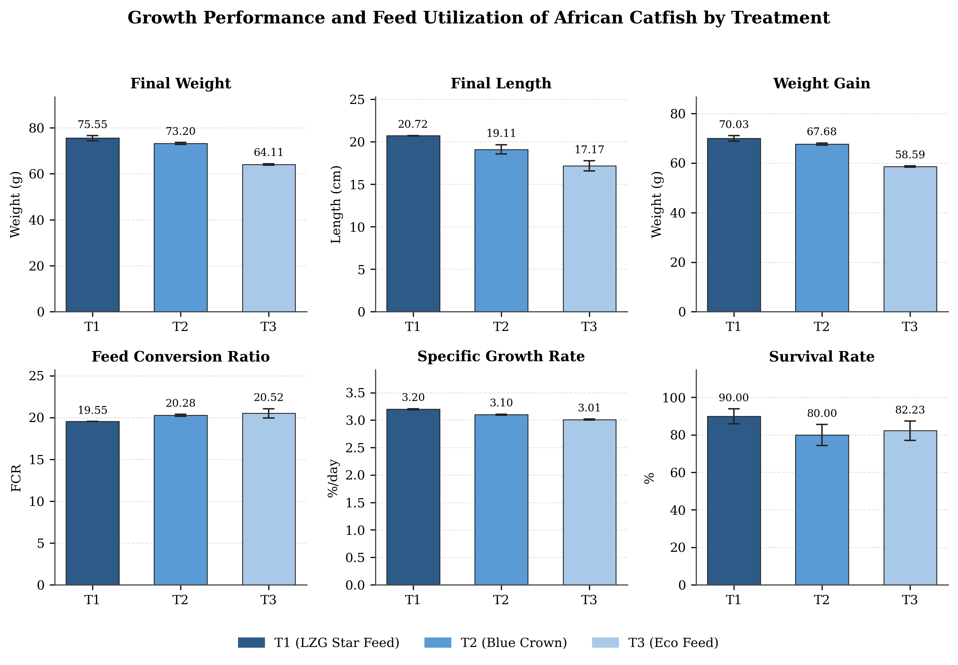

The proximate composition of the standard feeds is presented in Table 2. LZG Star Feed (T1) contained a higher mean crude protein content (45.50 ± 1.01%) than Blue Crown (43.50 ± 0.23%) and Eco Feed (41.30 ± 0.23%). Ether extract followed the same pattern, with T1 recording the highest value (11.30 ± 0.79%), followed by T2 (7.00 ± 0.11%) and T3 (6.00 ± 0.13%). Crude fibre was highest in T2 (4.00 ± 0.14%), followed by T3 (2.50 ± 0.18%) and T1 (1.20 ± 0.03%). Moisture content was highest in T3 (8.90 ± 0.24%), followed by T2 (7.71 ± 0.25%) and T1 (6.53 ± 0.24%). Macronutrient composition differed significantly among the three feeds (p < .05). Notably, the ranking of the three feeds by crude protein and ether extract content (T1 > T2 > T3) exactly mirrors the ranking obtained for final weight, weight gain, and specific growth rate in Table 1, pointing to a direct, dose-dependent relationship between feed nutrient density and realised growth performance.

Table 2
Proximate Composition of the Standard Feeds Used (%)
Parameter (%) | T1 (LZG Star Feed) | T2 (Blue Crown) | T3 (Eco Feed)
Moisture | 6.53 ± 0.24 | 7.71 ± 0.25 | 8.90 ± 0.24
Crude protein | 45.50 ± 1.02 | 43.50 ± 0.23 | 41.30 ± 0.23
Ether extract | 11.30 ± 0.79 | 7.00 ± 0.11 | 6.00 ± 0.13
Ash | 9.00 ± 0.32 | 8.00 ± 0.12 | 7.50 ± 0.12
Crude fibre | 1.20 ± 0.03 | 4.00 ± 0.14 | 2.50 ± 0.18
Nitrogen-free extract | 21.20 ± 0.71 | 34.20 ± 0.21 | 25.23 ± 1.29

Fig 2: Relative Proximate Composition of the Standard Feeds
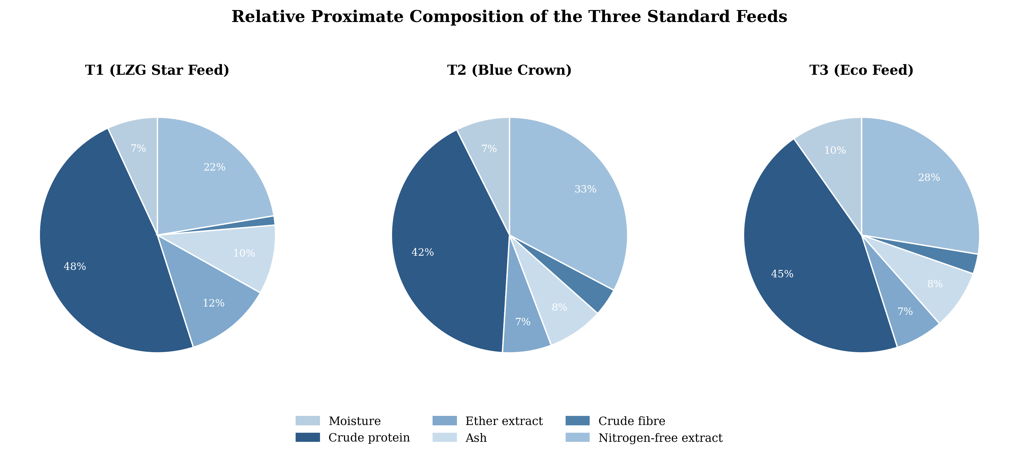

Water quality parameters are summarised in Table 3. Water temperature was highest in T3 (35.87 ± 0.14 °C), followed by T2 (35.71 ± 0.12 °C) and T1 (35.60 ± 0.20 °C). Dissolved oxygen was highest in T3 (2.25 ± 0.55 mg/L), followed by T1 (2.15 ± 0.05 mg/L) and T2 (2.11 ± 0.71 mg/L). Mean pH was 6.55 ± 0.28 for T1, 6.31 ± 0.12 for T2, and 6.52 ± 0.51 for T3. None of the physicochemical water parameters differed significantly among treatments (p > .05). Because water quality was statistically uniform across all three ponds, it is unlikely to account for the significant differences in growth performance observed among treatments, which instead point to feed nutrient composition as the primary driver of the results.

Table 3
Mean Physicochemical Parameters of Pond Water across Treatments
Parameter | T1 (LZG Star Feed) | T2 (Blue Crown) | T3 (Eco Feed)
Temperature (°C) | 35.60 ± 0.20 | 35.71 ± 0.12 | 35.87 ± 0.14
Dissolved oxygen (mg/L) | 2.15 ± 0.05 | 2.11 ± 0.71 | 2.25 ± 0.55
pH | 6.55 ± 0.28 | 6.31 ± 0.12 | 6.52 ± 0.51
Note. In each row, means sharing a common superscript letter are not significantly different (p > .05).
Fig 3: Mean Physicochemical Parameters of Pond Water by Treatments
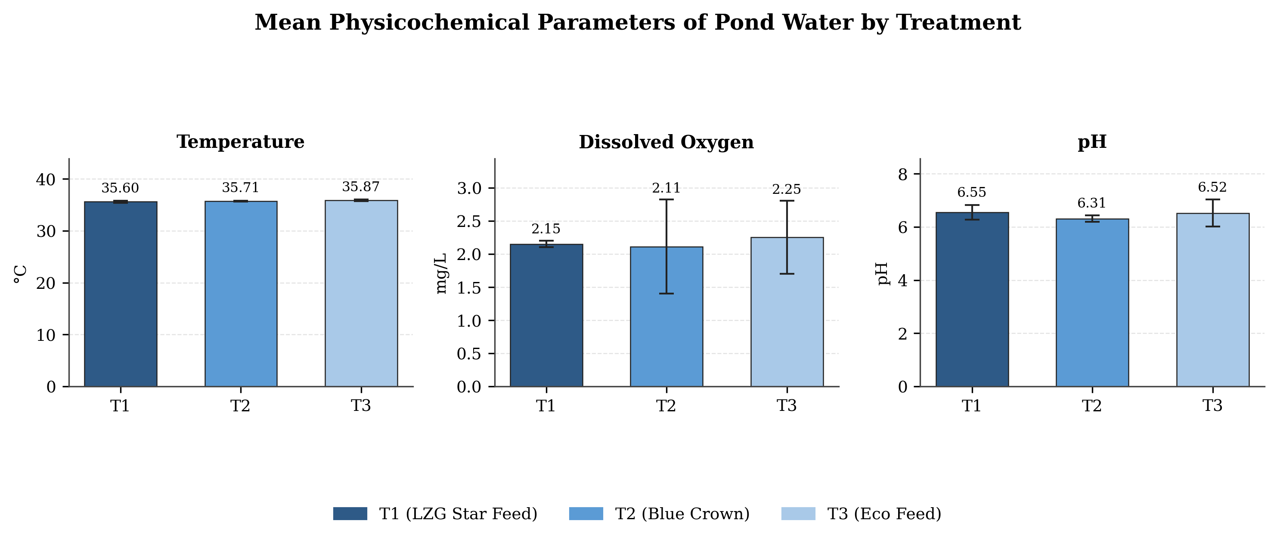

Discussion
Feed is one of the most critical agro-inputs in fish culture, directly influencing growth performance and survival (Putra et al., 2017). The growth parameters recorded in this study (Table 1) show that fish fed T1 (LZG Star Feed) achieved the best overall performance in terms of weight gain, length gain, final weight, final length, feed conversion ratio, and specific growth rate, followed by fish fed T2 (Blue Crown), while fish fed T3 (Eco Feed) recorded the lowest performance. This pattern is consistent with the findings of Umaru et al. (2016), Agokei et al. (2010), and, more recently, Wokeh et al. (2020), all of whom reported significant differences in growth response among competing standard or commercial feed brands in feeding trials involving Clarias gariepinus. The magnitude of the difference between the best- and worst-performing feeds in the present study (a weight-gain advantage of approximately 20% for T1 over T3) is broadly comparable to the treatment differences reported by Mustapha et al. (2014) and Ajayi et al. (2016) when comparing feed brands of differing nutrient density, reinforcing that feed brand choice alone, independent of husbandry practice, can meaningfully affect production outcomes.
A substantial body of Nigerian and regional research has compared the growth response of C. gariepinus to different commercial feed brands, generally confirming that feed choice has a strong and consistent effect on growth outcomes. Mustapha et al. (2014) compared an imported feed (Skretting) with a Nigerian-manufactured local feed (Blue Crown) and found that the imported feed produced significantly better growth, which the authors linked to its higher crude protein content. Similarly, Agokei et al. (2010) evaluated five commercial feed brands and reported significant differences in weight gain and survival among treatments, while Ajayi et al. (2016) found that among five imported feeds (Coppens, Aqua, Ranna, Pira, and Durante), Coppens consistently produced superior growth performance. Umaru et al. (2016) similarly reported that imported feeds outperformed local alternatives in floating bamboo cage culture, while Wokeh et al. (2020) compared three standard feeds (Coppens, Vital, and Multifeed) under a very similar experimental design to the present study and likewise found significant treatment differences in final weight and length, reinforcing that feed brand, and by extension its underlying nutrient composition, is a major determinant of growth performance even when feeds are marketed under the same ‘standard’ or ‘commercial’ label.
The differences in growth performance among treatments likely reflect differences in the nutritional composition of the feeds used (Mustapha et al., 2014). The proximate analysis (Table 2) showed that LZG Star Feed contained higher levels of key macronutrients than Blue Crown and Eco Feed, and this greater nutrient availability, particularly crude protein and lipid, likely accounts for the corresponding growth response (Ajayi et al., 2016). This interpretation is consistent with the established nutritional requirements of C. gariepinus, which specify optimal juvenile dietary protein levels of 40–50% (Langi et al., 2024), a range that T1 (45.50%) most closely approximated among the three feeds tested. It is also consistent with experimental evidence that C. gariepinus growth rate and feed conversion ratio improve as dietary protein-to-energy ratio increases towards an optimum near 43% crude protein (Ali & Jauncey, 2005), which closely matches the protein level recorded for T1 in this study. Because manufacturer-declared feed composition does not always match analysed values (Ayuba & Iorkohol, 2013), the independent proximate analysis conducted here provides farmers with a more reliable basis for feed selection than label information alone. Feed conversion ratio was relatively high across all treatments, exceeding the maximum value of 2 recommended by Houlihan et al. (2001), since FCR serves as an indicator of feed efficiency in experimental trials; this elevated FCR across all three treatments suggests that factors beyond feed formulation alone, potentially including the low dissolved oxygen levels discussed below, may have constrained overall feed utilisation efficiency in this trial.
The mechanistic basis for these growth differences lies in the fish's nutritional physiology. A recent comprehensive review of the nutritional requirements of C. gariepinus concluded that dietary crude protein should range from 40–50% for juveniles and 30–40% for adults, with methionine and lysine requirements of 18.7–29.7 g/kg and 44.9–62.2 g/kg of dietary protein, respectively, and recommended lipid inclusion of 5–15% for juveniles (Langi et al., 2024). Consistent with this, Ali and Jauncey (2005) demonstrated experimentally that C. gariepinus growth rate and feed conversion efficiency improve significantly when dietary protein-to-energy ratio is optimised, with diets containing approximately 43% crude protein producing the best growth response among the levels tested. These findings provide a physiological explanation for why feeds with higher analysed crude protein and lipid content, such as those recorded for T1 in the present study, would be expected to support superior weight gain, length gain, and feed conversion relative to lower-protein feeds.
The water quality parameters recorded in this study (Table 3) indicate that temperature and pH remained within the appropriate range for efficient catfish growth under culture conditions (Musiba et al., 2014), and fell within the broader tolerance ranges reported for the species (temperature 18–32°C; pH 5.0–9.0) (Păpuc et al., 2019). Dissolved oxygen levels, however, were generally low across all treatments and fell below the 5 mg/L threshold considered suitable for optimal fish growth and development (Okey-Wokeh et al., 2020), consistent with the broader principle that dissolved oxygen is often the most limiting water quality variable in intensive pond culture (Boyd, 2020). This relatively low dissolved oxygen concentration may have contributed to the elevated FCR values and mortality observed during the trial (Yakubu et al., 2015). The low dissolved oxygen levels recorded may be attributable to the closed nature of the experimental ponds, which limited exposure to atmospheric air. Importantly, because dissolved oxygen and the other water quality parameters did not differ significantly among the three treatment groups, the significant differences observed in growth performance cannot be attributed to differential rearing conditions; they are more plausibly explained by the differences in feed nutrient composition documented in Table 2, in line with the nutritional evidence discussed above.
Water quality is widely recognised as a co-determinant of growth performance alongside feed quality. Dissolved oxygen in particular is considered one of the most limiting water quality variables in intensive pond aquaculture, with concentrations below approximately 5 mg/L associated with feeding stress, reduced growth, and increased susceptibility to disease (Boyd, 2020). A review of the environmental tolerance ranges of C. gariepinus similarly reported that, while the species can tolerate temperatures between 18–32°C and pH values between 5.0 and 9.0, sustained low dissolved oxygen remains a key constraint on optimal growth even when other parameters are within tolerable ranges (Păpuc et al., 2019).

Conclusion
The findings of this study demonstrate that African catfish (Clarias gariepinus) fed LZG Star Fish Feed exhibited better growth performance across final weight, final length, weight gain, feed conversion ratio, and specific growth rate than those fed Blue Crown or Eco Feed, a difference attributable to its higher crude protein and lipid content, as confirmed by proximate analysis and consistent with the established nutritional requirements of the species. Because water quality parameters were statistically uniform across treatments, feed nutrient composition, rather than rearing conditions, is identified as the primary driver of the observed growth differences. Fish farmers are therefore encouraged to consider LZG Star Fish Feed, given its favourable growth outcomes, local availability, lower transport costs, and domestic production within Nigeria. Feed manufacturers and regulatory agencies should also consider routine independent proximate analysis of commercial feeds, given the documented potential for divergence between declared and analysed nutrient content in the Nigerian feed market.
Limitations
The study was conducted at a single location over a 12-week period with modest replication, which may limit the generalisability of the findings to other production environments and longer culture periods. Proximate composition was assessed using the tested feed samples only, so potential variation among production batches was not evaluated. In addition, the feeds differed simultaneously in several nutritional components, limiting attribution of growth responses to individual nutrients. Relatively low dissolved oxygen across treatments may also have influenced overall performance. Future studies should employ longer, multi-site trials with greater replication and multiple feed batches.

Acknowledgements
We wish to acknowledge Tertiary Education Trust Fund (tetfund) for sponsoring this research. We are very grateful to all the participants for their valuable contributions.
Declaration of AI Use
This manuscript was prepared through the intellectual contributions of the author(s) to the study design, data analysis, interpretation of results, and scholarly content. Grammarly and ChatGPT were used solely to assist with grammatical refinement and reference formatting during manuscript revision. The author(s) accept full responsibility for the accuracy, integrity, and final content of the manuscript.

Competing Interests
Authors have declared that they have no known competing interests.

References
Agokei, E. O., Oparah, C. A., Aranyo, A. A., Alozie-Chidi, V. C., & Apapa, U. A. (2010). Growth of Clarias gariepinus juveniles fed five commercial feed. In Proceedings of the 25th Annual International Conference and Exhibition of the Fisheries Society of Nigeria (pp. 526–530). Fisheries Society of Nigeria. https://agris.fao.org/search/en/providers/124471/records/66743fd0eb5a381a338109c0
Ajayi, O. T., Ojo, S. O., Adeleke, B., & Oluyisola, O. O. (2016). The growth performance of African catfish (Clarias gariepinus) fed commercially prepared imported fish feeds. International Journal of Agricultural Economics, 1(3), 57–61. https://doi.org/10.11648/j.ijae.20160103.11
Ali, M. Z., & Jauncey, K. (2005). Approaches to optimizing dietary protein to energy ratio for African catfish Clarias gariepinus (Burchell, 1822). Aquaculture Nutrition, 11(2), 95–101. https://doi.org/10.1111/j.1365-2095.2004.00325.x
Amisah, S., Oteng, M. A., & Ofori, J. K. (2009). Growth performance of the African catfish, Clarias gariepinus, fed varying inclusion levels of Leucaena leucocephala leaf meal. Journal of Applied Sciences and Environmental Management, 13(1), 21–26. https://doi.org/10.4314/jasem.v13i1.55257
AOAC International. (2000). Official methods of analysis of AOAC International (17th ed.; W. Horwitz, Ed.). AOAC International. https://hero.epa.gov/reference/7970345/
Ayuba, V. O., & Iorkohol, E. K. (2013). Proximate composition of some commercial fish feeds sold in Nigeria. Journal of Fisheries and Aquatic Science, 8(1), 248–252. https://doi.org/10.3923/jfas.2013.248.252
Boyd, C. E. (2020). Dissolved oxygen and other gases. In Water quality: An introduction (3rd ed., pp. 135–162). Springer. https://doi.org/10.1007/978-3-030-23335-8_7
Dorothy, M. S., Raman, S., Nautiyal, V., Singh, K., Yogananda, T., & Kamei, M. (2018). Use of potential plant leaves as ingredient in fish feed: A review. International Journal of Current Microbiology and Applied Sciences, 7(7), 112–125. https://doi.org/10.20546/ijcmas.2018.707.014
Ekanem, I. E., Nlewadim, A. A., & Uka, A. (2024). Evaluation of the impact of feed types on reproductive performance and growth of Clarias gariepinus under different culture systems. Asian Journal of Fisheries and Aquatic Research, 26(4), 19–28. https://doi.org/10.9734/ajfar/2024/v26i4753
Fanizza, C., Trocino, A., Stejskal, V., Prokešová, M., Zare, M., Tran, H. Q., Brambilla, F., Xiccato, G., & Bordignon, F. (2024). Inclusion of different blends of poultry processed proteins in practical diets for African catfish (Clarias gariepinus) reared in RAS: Effects on nutrient digestibility, growth performance and fillet quality. Aquaculture Reports, 39, 102447. https://doi.org/10.1016/j.aqrep.2024.102447
Farahiyah, I. J., Zainal, A. A. R., Ahmad, A., Mardhati, M., Thayalini, K., & Yong, S. T. (2016). Evaluation of local feed ingredients based diets on growth performance of African catfish, Clarias gariepinus. Malaysian Journal of Animal Science, 19(2), 39–46. https://www.mjas.my/mjas-v2/rf/pages/viewpaper.php?id=171
Food and Agriculture Organization. (2022). The state of world fisheries and aquaculture 2022: Towards blue transformation. https://doi.org/10.4060/cc0461en
Gaya, H. I. M., Mohammed, S. T., & Bawa, D. B. (2005). Economic analysis of fish marketing in Yola-North Local Government Area, Adamawa State. University of Maiduguri Press.
Houlihan, D., Boujard, T., & Jobling, M. (Eds.). (2001). Food intake in fish. Blackwell Science. https://doi.org/10.1002/9780470999516
Langi, S., Maulu, S., Hasimuna, O. J., Kaleinasho Kapula, V., & Tjipute, M. (2024). Nutritional requirements and effect of culture conditions on the performance of the African catfish (Clarias gariepinus): A review. Cogent Food & Agriculture, 10(1), Article 2302642. https://doi.org/10.1080/23311932.2024.2302642
Limbu, S. M. (2020). The effects of on-farm produced feeds on growth, survival, yield and feed cost of juvenile African sharptooth catfish (Clarias gariepinus). Aquaculture and Fisheries, 5(1), 58–64. https://doi.org/10.1016/j.aaf.2019.07.002
Musiba, M. J., Ngupula, G. W., Kashindye, B. B., Elison, M., Shoko, A. P., Ndikumana, J., Zziwa, E., & Katunzi, E. F. B. (2014). Performance of locally formulated feeds for rearing of African catfish in Tanzania. African Crop Science Journal, 22(Supplement s4), 979–986. https://www.ajol.info/index.php/acsj/article/download/108550/98351
Mustapha, M. K., Akinware, B. F., Faseyi, C. A., & Alade, A. A. (2014). Comparative effect of local and foreign commercial feeds on the growth and survival of Clarias gariepinus juveniles. Journal of Fisheries, 2(2), 106–112. https://doi.org/10.17017/j.fish.76
Odioko, E., Sikoki, F. D., Vincent-Akpu, I. F., & Utibe, D. I. (2016). Acute toxicity of sponge plant (Luffa cylindrica) fruit extract on African catfish (Clarias gariepinus, Buchell 1822) juveniles. International Journal of Life Sciences Research, 4(1), 148–159. https://www.researchpublish.com/papers/acute-toxicity-of-sponge-plant-luffa-cylindrica-fruit-extract-on-african-catfish-clarias-gariepinus-buchell-1822-juveniles
Okey-Wokeh, C. G., Obunwo, C. C., & Boisa, N. (2020). Assessment of physicochemical characteristics of Mini-Ezi Stream in Elele-Alimini, Emohua Local Government Area of Rivers State, Nigeria. International Journal of Advances in Scientific Research and Engineering, 6(1), 196–202. https://doi.org/10.31695/IJASRE.2020.33700
Oluwatayo, I. B., & Adedeji, T. A. (2019). Comparative analysis of technical efficiency of catfish farms using different technologies in Lagos State, Nigeria: A data envelopment analysis (DEA) approach. Agriculture & Food Security, 8, Article 8. https://doi.org/10.1186/s40066-019-0252-2
Păpuc, T., Petrescu-Mag, I. V., Gavriloaie, C., Botha, M., Kovacs, E., & Coroian, C. O. (2019). Swimming in the mud—A short review of environmental parameter ranges tolerated by Clarias gariepinus. ELBA Bioflux, 11(1), 9–17. https://elba.bioflux.com.ro/docs/2019.9-17.pdf
Putra, I., Rusliadi, R., Fauzi, M., Tang, U. M., & Muchlisin, Z. A. (2017). Growth performance and feed utilization of African catfish Clarias gariepinus fed a commercial diet and reared in the biofloc system enhanced with probiotic. F1000Research, 6, Article 1545. https://doi.org/10.12688/f1000research.12438.1
Roslan, N. A., Kari, Z. A., Sukri, S. A. M., Khoo, M. I., Sani, N. I. M., Rashid, R., Kabir, M. A., Nandi, S. K., Zakaria, N. N. A., Ghosh, K., Harun, H. C., & Eissa, E.-S. H. (2025). Fermented spent coffee ground in African catfish (Clarias gariepinus) diets: Effects on growth performance, digestive enzyme, protein digestibility, amino acid profile, and immune-related gene. Aquaculture, 603, 742383. https://doi.org/10.1016/j.aquaculture.2025.742383
Subandiyono, Lestari, N. D., Chilmawati, D., & Nugroho, R. A. (2023). Influence of probiotic on feed utilization efficiency, growth performance and survival of Clarias gariepinus. Asian Journal of Research in Biology, 6(1), 87–93. https://doi.org/10.56557/ajrib/2023/v6i121
Toutou, M. M., Soliman, A. A., Elokaby, M. A., & Abdel-Rahim, M. M. (2018). Impacts of using fresh aquatic plants as a total substitute for formulated feed on performance, health and economic efficiency of grass carp, Ctenopharyngodon idella (Valenciennes, 1844) fingerlings. AACL Bioflux, 11(6), 1892–1907. https://bioflux.com.ro/docs/2018.1892-1907.pdf
Ubesie, A. C., & Ibeziakor, N. C. (2012). High burden of protein energy malnutrition in Nigeria: Beyond the health care setting. Annals of Medical and Health Sciences Research, 2(1), 66–69. https://doi.org/10.4103/2141-9248.96941
Umaru, J., Auta, J., Oniye, S. J., & Bolorunduro, P. I. (2016). Growth and economic performance of African catfish, Clarias gariepinus (Burchell, 1822) juveniles to imported and local feeds in floating bamboo cages. International Journal of Fisheries and Aquatic Studies, 4(2), 221–226. https://www.fisheriesjournal.com/archives/?ArticleId=692&issue=2&part=C&vol=4&year=2016
Wokeh, O. K., Woke, G. N., Orose, E., & Odioko, E. (2020). Comparison of growth performance of African catfish (Clarias gariepinus) fed with different standard feed. International Journal of Fisheries and Aquatic Studies, 8(5), 394–397. https://www.fisheriesjournal.com/archives/?ArticleId=2350&issue=5&part=E&vol=8&year=2020
Yakubu, A. F., Nwogu, N. A., Olaji, E. D., & Adams, T. E. (2015). Impact of three-different commercial feed on the growth and survival of Clarias gariepinus Burchell, 1822 fry in aquaria glass tanks. Journal of Experimental Agriculture International, 9(1), 1–6. https://doi.org/10.9734/AJEA/2015/16342

